Florida Power Corporation
Docket No. 010001-EI

CERTIFICATE OF SERVICE

I HEREBY CERTIFY that a true copy of Florida Power Corporations Petition for Mid-Course Correction has been furnished to the following individuals by regular U.S. Mail this ____ day of February, 2001.

W. Cochran Keating, Esquire
Division of Legal Services
Florida Public Service Commission
2540 Shumard Oak Blvd.
Tallahassee, FL 32399-0850

Stephen C. Burgess, Esquire
Office of the Public Counsel
c/o The Florida Legislature
111 West Madison Street, Room 812
Tallahassee, FL 32399-1400

Lee L. Willis, Esquire
James D. Beasley, Esquire
Ausley & McMullen
P.O. Box 391
Tallahassee, FL 32302

Matthew M. Childs, Esquire
Steel, Hector & Davis
215 S. Monroe Street, Suite 601
Tallahassee, Florida 32301

Jeffrey A. Stone, Esquire
Russell A. Badders, Esquire
Beggs & Lane
P. O. Box 12950
Pensacola, FL 32576-2950

Norman Horton, Jr., Esquire
Messer, Caparello & Self
P. O. Box 1876
Tallahassee, FL 32302

John W. McWhirter, Jr., Esquire
McWhirter, Reeves, et al.
100 N. Tampa Street, Suite 2900
Tampa, FL 33602

Joseph A. McGlothlin, Esquire
Vicki Gordon Kaufman, Esquire
McWhirter, Reeves, et al.
117 S. Gadsden Street
Tallahassee, FL 32301

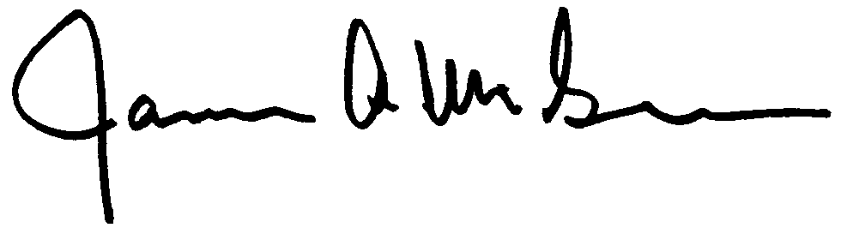

Attorney

