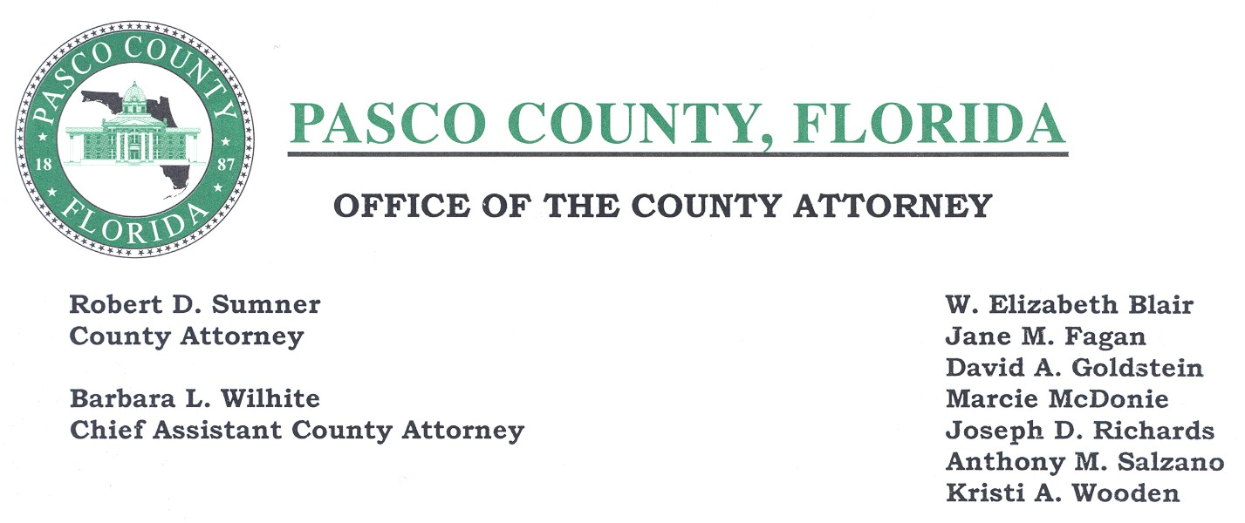

VIA E-MAIL

June 15, 2004

Division of the Commission Clerk and
Administrative Services
Florida Public Service Commission
2540 Shumard Oak Boulevard
Tallahassee, Florida 32399-0850

Re: Docket No. 030458-WU, Application for Transfer of Majority Organizational Control of Holiday Utility Company, Inc. in Pasco County to Holiday Waterworks Corp., and Amendment of Certificate No. 224-W--Notice of appearance and request for formal hearing

Dear Director:

Please accept this as formal notification of Pasco County’s objection to Holiday Utility Company’s (hereinafter “Holiday”) request for transfer of majority organizational control and amendment of certificate as described in the May 18, 2004, Legal Notice. Pasco County received a copy of the notice on or about May 27, 2004.

Pursuant to Section 367.045, Florida Statutes, when applying for an amendment of a certificate of authorization, a utility shall provide information, which “may include . . . the need for service in the area involved, and the existence or nonexistence of service from other sources within geographical proximity to the area in which the applicant seeks to provide service.” Sec. 357.045(2)(b), Fla. Stat.

The Legal Notice provides little or no information as to the nature of the amendment and the legal description included is not specific as to the areas served or to be served by Holiday. Pasco County maintains water lines in or adjacent to the area in question. Pasco County also provides wastewater service to the area. Pasco County objects to any expansion of the current service area. Any area not within the certificated service area of a private utility or within a municipality is in the service area of Pasco County and the County is willing and better able to serve the areas adjacent to and neighboring Holiday’s current service area.

Because Holiday's proposed expansion encroaches into Pasco County's Service area and because of Pasco County’s existing lines and ability to provide service, Pasco County objects to the application to amend the certificate of authorization.

Please accept this as Pasco County’s request for a formal hearing regarding Holiday’s Application for Amendment of Certificate to provide service in Pasco County. This letter also serves as our notice of appearance for this hearing.

Thank you for your attention to this matter.

Respectfully submitted,

/s/

Joseph D. Richards,
Assistant County Attorney

cc: John J. Gallagher, Pasco County Administrator
Douglas Bramlett, Pasco County Utilities
Bruce Kennedy, Pasco County Utilities
Katherine Fleming, PSC Office of General Counsel
Holiday Waterworks Corp. 4939 Cross Bayou Boulevard,
New Port Richey, Florida 34652

