BEFORE THE FLORIDA PUBLIC SERVICE COMMISSION

In re: Petition for Determination
of Need for Hines Unit 4 Power Plant
DOCKET NO.
Submitted for filing:

DIRECT TESTIMONY
OF JOHN M. ROBINSON

ON BEHALF OF
PROGRESS ENERGY FLORIDA

JAMES A. MCGEE GARY L. SASSO
Associate General Counsel Florida Bar No. 622575
PROGRESS ENERGY SERVICE JAMES MICHAEL WALLS
COMPANY, LLC Florida Bar No. 706272
P.O. Box 14042 JOHN T. BURNETT
St. Petersburg, Florida 33733 Florida Bar No. 173304
Telephone: (727) 820-5184 CARLTON FIELDS, P.A.
Facsimile: (727) 820-5519 Post Office Box 3239
Tampa, FL 33601 Telephone: (813) 223-7000 Telecopier: (813) 229-4133

IN RE: PETITION FOR DETERMINATION OF NEED
BY PROGRESS ENERGY FLORIDA

FPSC DOCKET NO. ________

DIRECT TESTIMONY OF JOHN M. ROBINSON

I. INTRODUCTION AND QUALIFICATIONS

Q. Please state your name, your employer, and business address.
A. My name is John M. Robinson and I am employed by Progress Energy Carolinas (PEC). My business address is 410 S. Wilmington Street, Raleigh, North Carolina, 27601.

Q. Please state your position with PEC and describe your duties and responsibilities in that position.
A. I am employed by PEC as Manager, Engineering & Commercial Support. In this position, I am responsible for the overall management of licensing, engineering, equipment procurement, and construction contracting activities associated with new supply-side, generation projects at the Hines Energy Complex (HEC). This includes the Hines Unit 4 combined cycle generation unit.

Q. Please summarize your educational background and work experience.
A. I received a Bachelor of Science Degree in Electrical Engineering from North Carolina State University in 1970. I am a Registered Professional Engineer in the State of North Carolina. I joined PEC in 1970. I have served in numerous management positions responsible for engineering, construction, operations and maintenance of transmission lines, and the engineering, modification and construction of fossil fuel and gas-fired power plants.

II. PURPOSE AND SUMMARY OF TESTIMONY

Q. What is the purpose of your testimony in this proceeding?
A. I am testifying on behalf of Progress Energy Florida (PEF or the Company), in support of its Petition for Determination of Need for the Hines 4 unit, by describing (1) the site and unit characteristics for the Hines 4 combined cycle unit, including its size, equipment configuration, fuel type, and supply modes, (2) the estimated costs of Hines 4, and (3) the unit’s projected in-service date.

Q. Are you sponsoring any sections of PEF’s Need Study?
A. Yes, in Section II of the Need Study, I am sponsoring the “Projected Costs” and “Projected Performance” sections under the Hines Unit 4 heading.

Q. Are you sponsoring any exhibits to your testimony?
A. Yes. I am sponsoring the following exhibits to my testimony:

JMR-1 Hines Energy Complex Map.
JMR-2 Site Arrangement – Overall Plan.
JMR-3 Site Arrangement – Power Block Area.
JMR-4 Typical Combined Cycle Schematic.
JMR-5 Projected Cost Estimate for Hines Unit 4.
JMR-6 Project Schedule for Hines 4.

Each of these exhibits was prepared under my direction, and each is true and accurate.

Q. Please summarize your testimony.
A. The Company plans to build Hines 4 at the HEC, its existing generation site in Polk County, Florida. That site contains the Hines 1 and 2 combined cycle generation units and their associated facilities. Hines Unit 3 is currently under construction with an expected commercial operation date in December 2005. In 1994, the Governor and Cabinet, sitting as the Siting Board, certified the HEC for construction and operation of the Hines Unit 1 and for 3,000 megawatts (MW) of ultimate generation capacity at the site. In 2001, the Governor and Cabinet certified the addition of Hines 2. In 2003, the Governor and Cabinet certified the addition of Hines 3.
Hines 4 will provide for an expected 517 MW (winter rating) of capacity at the site, and it will share many of the existing facilities at the site with Hines 1, 2, and 3. The ability to share facilities at the site adds to the cost-effectiveness of Hines 4. The Company and its customers will reap the benefit of the cost savings associated with the economies of scale achieved from using the existing facilities for the operation of the combined Hines units 1, 2, 3, and 4.
Hines 4 is a sister unit to Hines 1, 2, and 3. It is a state-of-the art, highly efficient combined cycle unit that will operate on natural gas, with the capability to operate on distillate fuel oil. The unit’s beneficial heat rate, availability, and responsiveness, among other attributes, provide the Company with a low-cost, highly flexible source of power. Hines 4, therefore, enhances the overall operation and efficiency of the Company’s system to the direct economic benefit of the Company and its customers. Hines 4 is scheduled to come on line in December 2007.
Apart from the cost savings achieved by placing in operation a state-of-the-art, highly efficient generation unit, the Company and its customers will further benefit from a competitive initial cost for the unit. The total projected cost for Hines 4 is estimated to be $221.5 million excluding transmission costs and AFUDC. AFUDC is estimated to be approximately $27 million, giving a total installed cost of $248.5 million, excluding transmission.
There are a number of factors why Hines 4 is the most cost-effective alternative. First, Progress Energy Florida is able to take advantage of its prior investment in infrastructure at the HEC. Second, by virtue of owning and operating three other power stations on the same site, PEF will need to add a much smaller number of new employees to operate the four units at the HEC than bidders would have to employ to operate a greenfield facility. Third, a significant advantage is due in part to the Company negotiating favorable equipment terms for the major equipment during a time when the power plant equipment market was depressed. Finally, Progress Energy Florida has as good, or better, credit rating than many of the IPPs today. Thus, the Company has a financing advantage.
In summary, Hines 4 allows the Company to meet its reliability needs with the most efficient technology on the market at a below market cost, giving the Company and its customers substantial economic benefits in terms of technology, efficiency, and flexibility in operation, and cost of generating power.

III. DESCRIPTION OF THE HINES 4 SITE

Q. Please describe the location of the HEC.
A. The HEC is an 8200 acre site located in southwest Polk County, Florida, approximately 40 miles east of Tampa, 7 miles south of Bartow, and approximately 3.5 miles northwest of Ft. Meade. County Road 640 is on the northern boundary of the HEC, and County Road 555 runs through the site north to south. The location of the HEC is shown in Exhibit ____ (JMR-1).

Q. Please describe the location of Hines 4 at the HEC.
A. Exhibit ___ (JMR-2) is the HEC site plan and shows the development of the site. It depicts the relationship of the current power blocks to the existing cooling ponds and water treatment and wastewater disposal areas for the units. It also shows the existing rail lines, state roads, and access roads that will serve all units, and the existing dikes and former phosphate mining areas on the HEC site. Exhibit ___ (JMR-3) is the power block layout for Hines 4 in relation to the existing power blocks.

Q. What are the benefits to Progress Energy Florida and its customers from locating the Hines 4 unit at the HEC?
A. The location of the Hines 4 unit at the HEC offers the Company and its customers the ability to achieve economies of scale by using existing infrastructure at the site for operation of the Hines 4 unit. By building Hines 4 at the HEC, the Company will be able to use the existing access road, cooling pond, reclaimed water supply pipeline, water treatment and wastewater disposal facilities, gas laterals, and transmission facilities, among other site facilities, for the Hines 1, 2, and 3 units and the proposed Hines 4 unit. Because the Company can use the existing site facilities for the four units, the Company will only have to design and construct enhancements to these facilities for the Hines 4 unit. The location of the Hines 4 unit at the HEC will save site development costs the Company otherwise would have incurred. As a result, the Company and its customers will save additional engineering and construction costs by locating Hines 4 at the HEC.

IV. DESCRIPTION OF THE HINES 4 UNIT

Q. Please describe the proposed design of the Hines 4 unit.
A. Hines 4 is a state-of-the-art combined cycle unit similar to the Hines 1, Hines 2, and Hines 3 units. It consists of two combustion turbines, two unfired heat recovery steam generators, one steam turbine, and a recirculating water cooling system. The unit is a dual-fuel generation system, meaning that the combustion turbines can be operated on natural gas or distillate fuel oil. For Hines 4, natural gas is the primary fuel, and low sulfur (0.05 percent) distillate fuel oil is the alternative fuel.
The combustion turbines and steam turbine for the Hines 4 unit are configured in sequential stages, as shown in the typical schematic for a combined cycle unit in Exhibit ___ (JMR-4). The first stage includes the combustion turbines, much like utility peaking units, which generate electricity. In the second stage of the process, hot gas from the combustion turbines is passed through the heat recovery steam generator, where steam is produced and fed into the steam turbine to generate additional electricity -- hence, the term “combined cycle” generation technology.

Q. What are the advantages of combined cycle technology for PEF?
A. Combined cycle generation technology is very efficient because it generates electricity from the input fuel both directly, with the combustion turbines turning a generator, and indirectly, by using the waste heat from the combustion turbines to produce steam, which powers a steam turbine that turns another generator. Combined cycle technology makes the most of the input fuel, achieving increased efficiency in the generation of electricity from the available fuel source. For these reasons, the modern combined cycle power facility is one of the most efficient power technologies available today.
Another advantage of the combined cycle design is that it allows for greater flexibility in matching system operating characteristics over time. Because of its technological efficiency, it can readily be called on to meet varying operational load requirements in an economical manner. Thus, the Hines 4 combined cycle unit can function as a baseload or intermediate unit, as required by the Company’s system.
In addition to its high efficiency, Hines 4 will have a low environmental impact. Combined cycle units operating on natural gas, like Hines 4, are one of the cleanest sources of fossil generation. Whether the unit is burning natural gas or distillate fuel oil, flue gas is the only byproduct of the combustion process that would leave the HEC. Both are low sulfur, low ash fuels. Thus, sulfur and particulate emissions are virtually nonexistent. Nitrogen oxides will be controlled by selective catalytic reduction and water injection. Airborne emissions, therefore, will be minimized by the use of a relatively clean fuel and the appropriate application of control technologies.

Q. How will fuel be provided and handled for the Hines 4 unit?
A. Natural gas is currently delivered by pipeline to the HEC by Florida Gas Transmission (FGT) and Gulfstream Natural Gas System (GNGS). In addition, there are other proposals to transport gas to the HEC for Hines 4. These additional options are discussed by Pamela R. Murphy in her testimony. No additional gas lateral is necessary at the HEC. Enhancements will be required to the metering and regulation stations for the addition of Hines 4.
An additional storage tank and fuel oil unloading facility for the backup fuel are necessary for the Hines 4 unit. The distillate fuel oil for the HEC units is delivered to the HEC by tanker trucks.

Q. How does the Company plan to construct Hines 4?
A. PEF will maintain direct overall management of the project, including participation in construction management functions, by having a substantial presence onsite during the construction and startup phase. PEF may elect to competitively select equipment suppliers, the architect/engineering (A/E) firm, and the constructors, or the Company may opt to contract for a design-build, turn-key approach. The exact method will be evaluated considering the competitive market while minimizing the Company’s risk.

Q. What will it cost the Company to build Hines 4?
A. The total projected cost for the Hines 4 unit is approximately $221.5 million (excluding AFUDC and transmission costs) in nominal dollars. This cost was developed on the basis of replicating the design and layout of our Hines 1, 2, and 3 units. A breakdown of the major cost items for the Hines 4 unit is included in Exhibit ____ (JMR-5).
The project cost for Hines 4 reflects competitive equipment pricing because the Company was able (1) to benefit from a depressed power equipment market at the time the equipment negotiations occurred, and (2) to share common site utilities and facilities with the Hines 1, 2, and 3 units, thus reducing or eliminating site development and construction costs and associated facilities costs the Company would have otherwise incurred.

Q. What will it cost the Company to operate the Hines 4 unit?
A. The estimated incremental annual fixed operation and maintenance (O&M) cost for Hines 4 is $1.29/kW-Yr (based on winter capacity of the unit and expressed in 2007 dollars). The largest fixed costs are wages and wage-related overheads for the permanent plant staff, as well as expenses for unplanned equipment maintenance. Six employees are expected to be added to the staff at the HEC upon the addition of Hines 4 (five Operations and Control Personnel and one Planner).
Variable O&M costs, which vary as a function of unit generation, include consumables, chemicals, lubricants, water, and major maintenance costs such as planned equipment inspections and overhauls. The estimated non-maintenance variable O&M cost is $0.30/MWh and the estimated major maintenance variable O&M costs is $2.14/MWh (both based on the 489 MW average capacity of the unit, operating at 67 percent capacity factor, and expressed in 2007 dollars).

Q. When Hines 4 is constructed and in operation, what operational characteristics will it have?
A. As noted above, Hines 4 will have state-of-the-art, combined cycle technology. As a result, it will be a highly efficient unit with an excellent heat rate, operating with an average summer full load heat rate of approximately 7079 BTU/kWh and an expected average winter full load heat rate of approximately 7062 BTU/kWh (HHV). The Hines 4 unit will have an expected equivalent forced outage rate of approximately three percent. Hines 4 is expected to operate in a capacity factor range of 50 percent to 70 percent, averaging 67 percent over its expected 25-year life. When placed in operation, Hines 4 will be one of the most efficient units on the Company’s system.

V. PROPOSED SCHEDULE

Q. What is the in-service date for the Hines 4 unit?
A. Hines 4 is scheduled to come on line in December 2007.

Q. Will the Company meet that in-service date?
A. Yes, barring any unforeseen and significant delays. The proposed schedule for the permitting and construction of the Hines 4 unit is contained in Exhibit ____ (JMR-6). In my opinion, this schedule is reasonable and can be met by the Company.

Q. Does this conclude your direct testimony?
A. Yes.

Exhibit___ (JMR-1)
Hines Energy Complex Map

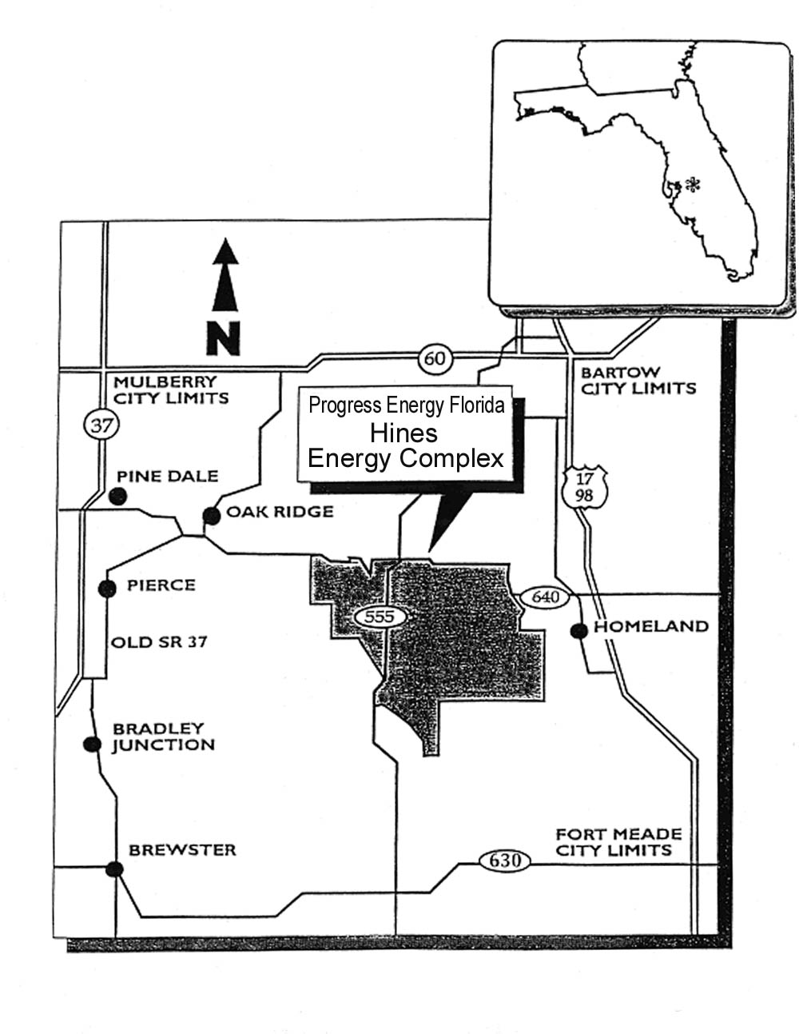

Exhibit___ (JMR-2)

Site Arrangement – Overall Plan
ref: ISTA-S100x
Exhibit___ (JMR-3)
Site Arrangement -- Power Block Area
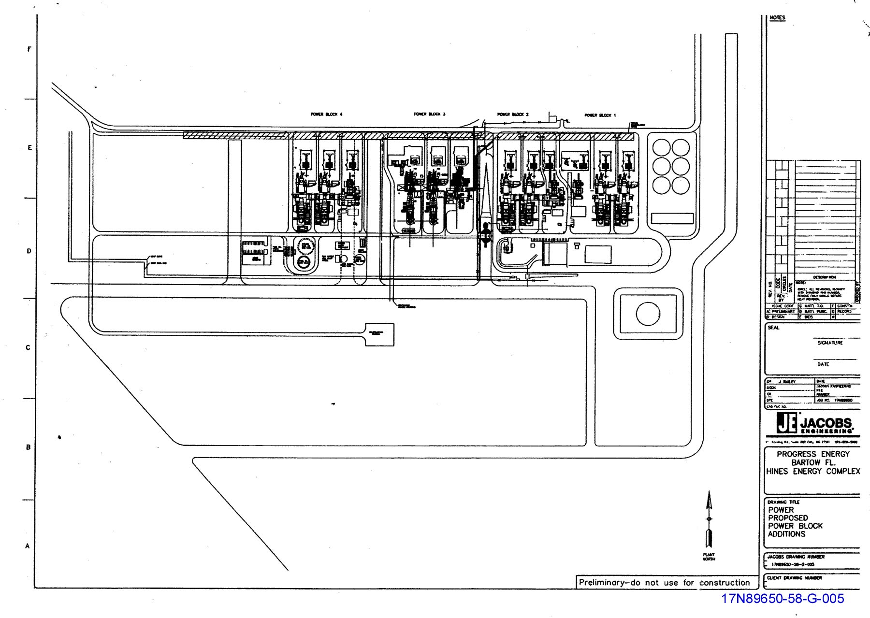

Exhibit___ (JMR-4)
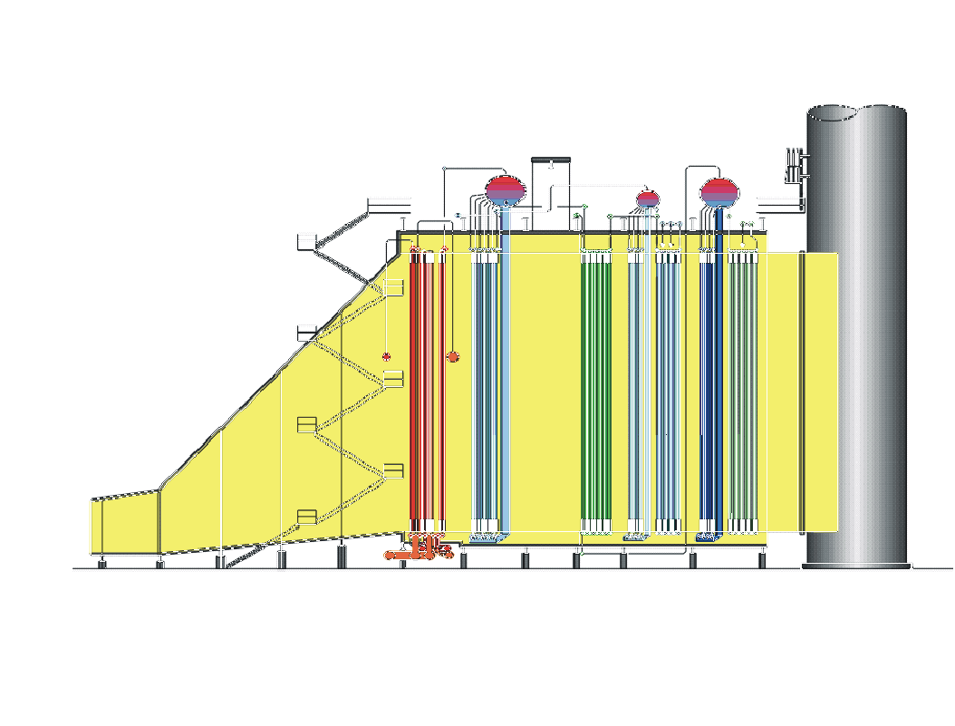

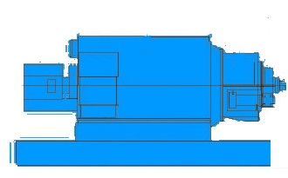
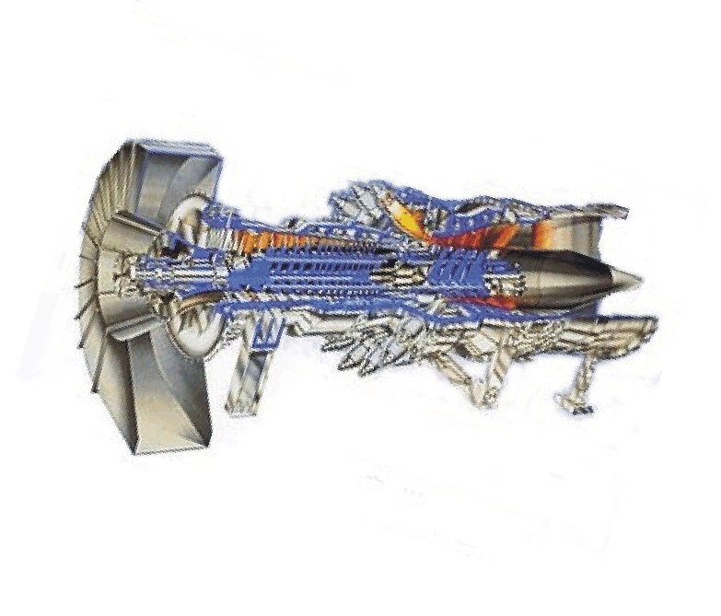
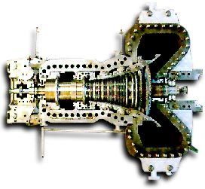
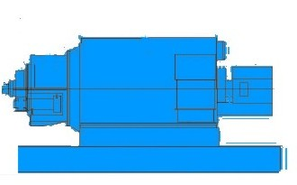
Typical Combined Cycle Schematic
Hines Energy Complex
Gas
Turbines
Steam Turbine
Heat Recovery
Steam Generators
Generators
Generator
(2-on-1)

Exhibit___ (JMR-5)
Projected Cost Estimate for Hines Unit 4
($ Thousands)

EPC Contractor and Equipment Contracts | $188,450
Contingency | 4,289
Licensing, Permits and Site Certificates | 500
PEF Internal Costs | 28,280
Total Project Cost – Excluding Transmission | $221,519
AFUDC | 27,014
Total Installed Cost – Excluding Transmission | $248,533

Exhibit___ (JMR-6)
Project Schedule for Hines 4

Award Purchase Order Contracts for Major Equipment | February 28, 2005
Award EPC Contract | February 28, 2005
Supplemental Site Certification Approval | September 30, 2005
Begin Construction | January 2, 2006
Construction Complete | November 1, 2007
Commercial Operation | December 1, 2007

