State of Florida
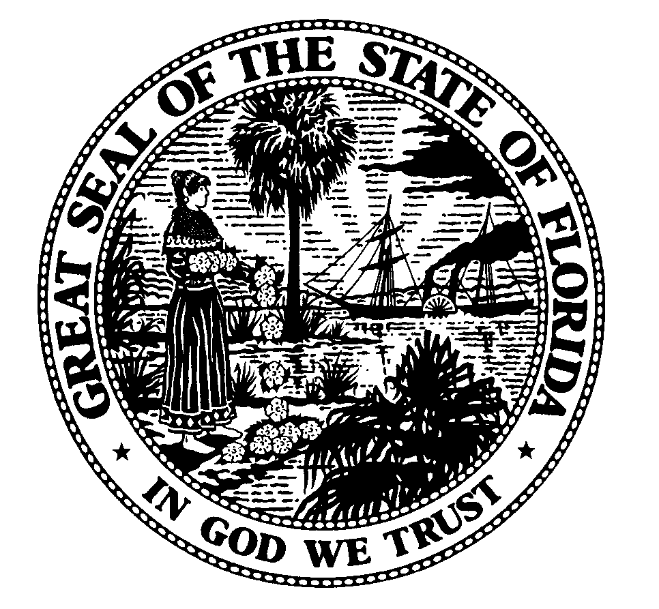

Public Service Commission
-M-E-M-O-R-A-N-D-U-M-

DATE: January 14, 2005

TO: All Parties and Interested Persons

FROM: Jennifer Brubaker, Senior Attorney, Office of the General Counsel

RE: DOCKET NO. 041272-EI Petition for approval of storm cost recovery clause for recovery of extraordinary expenditures related to Hurricanes Charley, Frances,
Jeanne, and Ivan, by Progress Energy Florida, Inc.

VIA FACSIMILE

There will be an informal meeting in the above-referenced docket at the following time and place:

Wednesday, January 19, 2005, at 10:00 a.m.
Florida Public Service Commission
Room 154, Gerald Gunter Building
2540 Shumard Oak Boulevard
Tallahassee, Florida 32399-0850

The purpose of this meeting is to discuss the issues involved in this docket. All interested persons are invited to attend.

NOTE: Any person who is unable to attend may participate via telephone by dialing (850) 487-9552 or SUNCOM 277-9552 at the date and time specified above.

If you have any questions about this meeting, please call Jennifer Brubaker at (850)
413-6228.

JSB

cc: Division of the Commission Clerk and Administrative Services
Office of the Public Counsel (Christensen & McLean)
McWhirter Law Firm (J. W. McWhirter, Jr., Kaufman & Perry)
Carlton Fields Law Firm (Sasso, Walls & Burnett)
Progress Energy Florida, Inc. (Davis)
Michael B. Twomey, Esq.

I:041272InformalMtg1-19-05.jsb.doc

