BEFORE THE PUBLIC SERVICE COMMISSION

In re: Joint application for approval of transfer of control of ALLTEL Florida, Inc., holder of ILEC Certificate No. 10 and PATS Certificate No. 5942, from Alltel Corporation to Valor Communications Group, and for waiver of carrier selection requirements of Rule 25-4.118, F.A.C., due to transfer of long distance customers of ALLTEL Communications, Inc. to Alltel Holding Corporate Services, Inc. | DOCKET NO. 050938-TP  ORDER NO. PSC-06-0425-PAA-TP  ISSUED: May 19, 2006

The following Commissioners participated in the disposition of this matter:

LISA POLAK EDGAR, Chairman
J. TERRY DEASON
ISILIO ARRIAGA
MATTHEW M. CARTER II
KATRINA J. TEW

NOTICE OF PROPOSED AGENCY ACTION ORDER
APPROVING TRANSFER OF CONTROL AND GRANTING
WAIVER OF THE CARRIER SELECTION REQUIREMENTS
OF RULE 25-4.118, FLORIDA ADMINSTRATIVE CODE

BY THE COMMISSION:

NOTICE is hereby given by the Florida Public Service Commission that the action discussed herein is preliminary in nature and will become final unless a person whose interests are substantially affected files a petition for a formal proceeding, pursuant to Rule 25-22.029, Florida Administrative Code.

I. Case Background
On December 22, 2005, ALLTEL Florida, Inc., ALLTEL Communications, Inc. (ACI), Alltel Holding Corp., Valor Communications Group (Valor), and Alltel Holding Corporate Services, Inc. (collectively, Applicants) submitted an application requesting approva1 by the Florida Public Service Commission (Commission) for the transfer of control of ALLTEL Florida, Inc. from Alltel Corporation (Alltel) to the entity resulting from the merger of Alltel Holding Corp., Valor, and Alltel Holding Corporate Services. Inc., respectively. The Applicants also seek a waiver of the carrier selection requirements in Rule 25-4.118, Florida Administrative Code, to facilitate the orderly transfer of long distance customers of ACI to Alltel Holding Corporate Services, Inc. These transactions are part of a plan to move Alltel's wireline incumbent local exchange company (ILEC), pay telephone services company (PATS) and intrastate interexchange company (IXC) to a wireline focused entity. On May 1, 2006, the Applicants filed an amended petition to include a request for name changes for the company on its local and pay telephone certificates, and to incorporate additional conditions. The new name for the wireline controlling entity is Windstream Corporation (Windstream) and each subsidiary incorporates Windstream, respectively, into their names.

ALLTEL Florida, Inc. is a local exchange telecommunications company (LEC) that was issued a certificate to provide local service in Florida on May 3, 1956. It also has a certificate to provide pay telephone services, and operates 79 pay telephones within its LEC territory. As of June 30, 2005, ALLTEL Florida, Inc. had 94,212 local access lines in 27 exchanges, or 1% of the total number of local access lines in Florida. ALLTEL Florida, Inc. and its affiliates serve approximately three million local access lines in 15 states.

ACI is an IXC registered to provide long distance telecommunications service in Florida since July 24, 1996. As of June 30, 2005, ACI had approximately 81,400 long distance customers in Florida. Approximately 65.5% of those ACI long distance customers are provided local service by ALLTEL Florida, Inc. All of the long distance customers will ultimately transfer from ACI to Alltel Holding Corporate Services, Inc., a subsidiary of Alltel Holding Corp. ALLTEL Florida, Inc. and ACI are currently wholly-owned subsidiaries of Alltel.

Valor is a Delaware corporation that owns rural LECs in Arkansas, New Mexico, Oklahoma and Texas. It was formed in 2000 with the acquisition of GTE Southwest Corporation. As of June 30, 2005, Valor’s subsidiaries had approximately 530,000 local access lines in those states.

As a result of changes in the telecommunications industry, Alltel is separating its wireline business from its wireless business and merging the wireline business with Valor. The merged wireline business will be known as Windstream. Following this merger, the shareholders of Alltel will own 85% of Windstream, and the shareholders of Valor will own 15%. The principal officers of Windstream will be certain current officers of Alltel. Windstream will adopt a corporate logo that is presently being determined. The corporate offices of Windstream will be located in Little Rock, Arkansas. The Applicants state that the end user customers will continue to receive the same rates and quality of service from the same local operations, so the transfer will appear to customers to be only a name change.

The Federal Communications Commission and the regulatory agencies of Mississippi, North Carolina, Georgia, Missouri and Nebraska have approved the merger of Alltel Holding Corp. into Valor, and the Federal Trade Commission has granted early termination in its review of the proposed transaction, which indicates no objections to the merger.

II. Analysis
A. Transfer of Control
1. Jurisdiction
We are vested with jurisdiction over this matter pursuant to Sections 364.01, 364.33, 364.335 and 364.603, Florida Statutes.

We have authority under Section 364.33, Florida Statutes, to approve an application for transfer of control. However, we note that this provision does not provide specific standards we may follow in making our decision to approve a transfer of control. That being said, Section 364.01, Florida Statutes, implies a public interest standard that we may follow when deciding whether to approve or deny transfers of control, among other transactions.

The legislative intent in Section 364.01, Florida Statutes, is clear: we must exercise our jurisdiction in order to protect “the public health, safety, and welfare” as it relates to basic local telecommunications services. Based on the clear intent of the Florida Legislature, our decisions to grant applications for transfers of control should be based on whether such transactions satisfy the public interest. There is little guidance on what constitutes the “public interest.” It appears that in most cases that what is in the public interest is left up to the interpretation of the particular administrative body charged with upholding that interest.

2. Management Capability
As outlined in the Case Background, Alltel is separating its wireless and wireline businesses in two steps. Alltel Holding Corp. was formed to serve as the new parent company of ALLTEL Florida Inc., Alltel Holding Corporate Services, Inc., and its other ILEC subsidiaries. Attachment A, attached hereto and incorporated herein, are Alltel Exhibits 1, 2 and 3. Exhibit 1 shows the corporate structure of Alltel before the separation of ACI. Exhibit 2 shows the post-separation corporate structure of the wireless and wireline businesses and the merger of the separated wireline business with Valor, and Exhibit 3 shows the corporate structure of Windstream.
Currently, ALLTEL Florida, Inc. is a wholly owned subsidiary of Alltel and is authorized by this Commission pursuant to ILEC Certificate No. 10 to provide local exchange telecommunications services, and pursuant to PATS Certificate No. 5942 to provide pay telephone services. Additionally, Alltel Holding Corporate Services, Inc. is an indirect wholly-owned subsidiary of Alltel and is a registered IXC, Registration No. TK045. ACI will remain under the control of Alltel and will no longer provide telecommunications services in Florida, but will transfer its long distance customers to Alltel Holding Corporate Services, Inc.
Under the control of Windstream, ALLTEL Florida, Inc., will not change or become a new entity. The company will become a subsidiary of Windstream. ALLTEL Florida, Inc. will continue operating in Florida and will be led by a management staff that is currently involved in the day-to-day management of the Alltel wireline operations. The Applicants claim that the new company will have the same management capabilities to provide service as it had under the control of Alltel. The Applicants state that Windstream will not increase rates for basic local service for three years from the date this Order is issued, and it will not use this transaction to petition for a rate increase due to changed circumstances under Section 364.051(4)(a), Florida Statutes. Under Windstream, Alltel Holding Corporate Services, Inc. will likewise maintain the quality of service provided to its long distance customers by ACI. It is Alltel’s belief that the establishment of Alltel’s wireline business as an independent, stand-alone corporation, separate from its wireless business, will serve the public interest by creating a company whose primary strategic focus will be building upon its wireline capabilities by providing services to residential and business customers in its local franchised territory.
3. Technical Capability
The Applicants claim that the same networks that currently serve Florida customers will continue to serve them after the merger has been completed. ALLTEL Florida Inc.’s past performance with respect to this Commission’s service standards is generally indicative of an acceptable level of service. Also, it appears that Valor’s LECs have acceptable performance records in the states in which they provide wireline services. The Applicants state that there are no anticipated problems with its technical workforce, represented or otherwise.
Windstream has agreed to initiate a Service Guarantee Plan (SGP), Attachment B, attached hereto and incorporated herein, in its franchised territory, in addition to this Commission’s rules regarding customer service. Windstream states that its quality of service will not decline below ALLTEL Florida Inc.’s current level.
Additionally, Windstream committed to building out its broadband network in Florida to meet the following capabilities:
- 75% addressability by December 31, 2006
- 80% addressability by December 31, 2007
- 85% addressability by December 31, 2008
Thus, the merger of these entities should not lessen the Applicants’ capability to provide quality service to Florida’s citizens.
4. Financial Capability
The Applicants state that Windstream will have the requisite financial capability to fully support its operations subsequent to the transfer of control. Windstream will be one of the nation’s largest independent local exchange carriers and it has commitments for debt financing from JP Morgan and Merrill Lynch. The Applicants state that Windstream expects to have ample cash flow and will pay an attractive dividend to investors.
The Applicants have provided this Commission with information on expected cash flow, capital expenditures, special dividends, and balance sheet accounts for Windstream. Portions of this information were filed under claim of confidentiality. Our staff reviewed Valor’s Registration Statement (SEC Form S-4) filed with the Securities and Exchange Commission regarding the merger. The Registration Statement contains detailed financial information on Windstream and is not confidential.

On a book value basis, Windstream is expected to have an 8.6% equity ratio based on the pro forma combined balance sheet as of December 31, 2005. Compared with other rural local exchange carriers (RLECs), this is a very low equity ratio. Our staff estimated the market value equity ratio for Windstream at 50.8% based on the current Valor stock price of $12 per share. This market value equity ratio is reasonable in comparison with other RLECs. The market value equity ratio represents investors’ perceptions of the market value of the wireline assets.

It appears that Windstream will have a non-investment grade bond rating, i.e., no higher than BB+. In contrast, Alltel Corporation has an A- rating from Standard and Poor’s (S & P) and Valor has a BB- rating from S & P. In its January 18, 2006, report on Alltel Corporation, S & P states:

Debt spun off to the new merged wireline business, which includes debt at the operating subsidiary ALLTEL Georgia Communications Corp. and ALLTEL Communications Holdings of the Midwest, Inc. (formerly Aliant Communications, Inc.), is likely to be lowered to non-investment grade, in line with expectations for the ratings of the new wireline company.

In addition, S & P states that it expects Windstream’s dividend policy to be fairly aggressive.

FitchRatings expects a BBB- rating for the new wireline company, with a Rating Watch Negative designation, indicating the possibility of a downgrade. With a non-investment grade bond rating, Windstream may have difficulty issuing long-term debt at reasonable rates in times of distressed financial markets. However, Windstream has commitments from JP Morgan and Merrill Lynch for term loans – a five year loan for $500 million and a seven year loan for $2.8 billion.

We note that Windstream, like wireline telecommunications networks in general, faces significant competition from wireless companies and cable companies. Windstream has lost access lines due to wireless and broadband substitution, which, in turn, has decreased revenue.

The Applicants provided projected information that they believe shows Windstream will have the necessary cash flow to meet its debt service and dividend requirements and to fund capital expenditures. Based on this information, we believe that Windstream will have some cushion in meeting its debt service requirements because it can reduce its dividend if necessary.

After meeting with our staff on April 26, 2006, Windstream modified its application to include a set of conditions, Attachment C, attached hereto and incorporated herein, including financial conditions. Under these conditions, the assets and cash flow of Alltel Florida, Inc. will be protected by the elimination of liens on Florida assets and by restrictions on dividends paid to Windstream. The Applicants have agreed to provide our staff with credit rating reports and financial information, which can be used to monitor Windstream’s financial condition. Finally, Windstream agreed that its debt covenants will be consistent with the April 12, 2006, commitment letter from J.P. Morgan and Merrill Lynch. Windstream will have no additional financial covenants other than a maximum leverage ratio and a minimum interest coverage ratio.

We believe these conditions help mitigate concerns regarding Windstream’s financial capability. In discussions with our staff, Windstream representatives stated their belief that the company will obtain debt at rates that are approximately that of an investment grade company and that the debt covenants will be favorable. Given the conditions discussed above, the Applicants’ representations regarding sufficient cash flow, and commitments for debt financing from major banks, we believe that Windstream has the necessary financial capability to support its operations.

B. Waiver of Carrier Selection Requirements
Pursuant to Rule 25-4.118(1), Florida Administrative Code, a customer’s carrier cannot be changed without the customer’s authorization. Rule 25-4.118(2), Florida Administrative Code, provides that a carrier shall submit a change request only if one of the following has occurred:
(a) The provider has a letter of agency (LOA) . . . from the customer requesting the change;
(b) The provider has received a customer-initiated call for service . . . ;
(c) A firm that is independent and unaffiliated with the provider . . . has verified the customer’s requested change . . .
Pursuant to Rule 25-24.475(3), Florida Administrative Code, Rule 25-4.118, Florida Administrative Code, is incorporated into Chapter 25-24, and applies to IXCs.
Rule 25-24.455(2), Florida Administrative Code, states:
An IXC may petition for a waiver of any provision of this Part. The waiver shall be granted in whole, granted in Part or denied based on the following:
(a) The factors enumerated in Section 364.337(4), Florida Statutes;
(b) The extent to which competitive forces may serve the same function as, or obviate the necessity for, the provision sought to be waived;
(c) Alternative regulatory requirements for the company which may serve the purposes of this part; and
(d) Whether the waiver is in the public interest.
The authority for Rule 25-4.118, Florida Administrative Code, is found in Section 364.603, Florida Statutes, which is a section this Commission is authorized to waive.
Alltel Corporate Holding Services, Inc. has attested that it will provide for a seamless transition while ensuring that the affected customers understand available choices with the least amount of disruption to the customers. The customers should not experience any interruption of service, rate increase, or switching fees.
In addition, Alltel Corporate Holding Services, Inc. states in its application that it will be responsible for any outstanding complaints from the affected former ACI customers after the date of the transfer.

Further, neither ACI nor Alltel Corporate Holding Services, Inc. has any outstanding regulatory assessment fees, penalties or interest associated with its IXC registration.
We believe that in this instance it is appropriate to waive the carrier selection requirements of Rule 25-4.118, Florida Administrative Code. If prior authorization is required in this event, customers may fail to respond to a request for authorization, neglect to select another carrier, and lose their long distance services. Furthermore, we find that granting this waiver will avoid unnecessary slamming complaints during this transition.
III. Decision

Based upon the foregoing analysis, we hereby approve Windstream’s amended petition for transfer of control of Alltel’s wireline entities to Valor. The amended petition has added safeguards that will protect consumers. Furthermore, based upon the past performance of the companies controlled by the Applicants, and the management, technical, and financial analysis, the transfer of control of ALLTEL Florida, Inc. from Alltel Corporation to Windstream Corporation would be in the public interest. The Applicants appear to have the necessary prerequisites to provide quality telecommunications services to Florida customers at fair prices. In addition, we hereby approve the waiver of the carrier selection requirements of Rule 25-4.118, Florida Administrative Code, in the transfer of ALLTEL Communications, Inc.’s customers to Alltel Corporate Holding Services, Inc.
This Order shall become final and effective upon issuance of a Consummating Order, unless a person whose substantial interests are affected by our decision files a protest that identifies with specificity the issues in dispute, in the form provided by Rule 28-106.201, Florida Administrative Code, within 21 days of the issuance of this Order. If this Order is not protested, this Docket shall close administratively upon issuance of a Consummating Order.
Based upon the foregoing, it is
ORDERED by the Florida Public Service Commission that the joint application for approval of transfer of control of ALLTEL Florida, Inc., holder of incumbent local exchange company Certificate No. 10 and pay telephone services Certificate No. 5942, from Alltel Corporation to Windstream Corporation is hereby approved. It is further
ORDERED that the carrier selection requirements in Rule 25-4.118, Florida Administrative Code, are waived in this instance for ALLTEL Communications, Inc. and Alltel Corporate Holding Services, Inc. It is further
ORDERED that this Order shall become final and effective upon issuance of a Consummating Order, unless a person whose substantial interests are affected by our decision files a protest that identifies with specificity the issues in dispute, in the form provided by Rule 28-106.201, Florida Administrative Code, within 21 days of the issuance of this Order. It is further
ORDERED that if this Order is not protested, this Docket shall close administratively upon issuance of a Consummating Order.
By ORDER of the Florida Public Service Commission this 19th day of May, 2006.

/s/ Blanca S. Bayó
BLANCA S. BAYÓ, Director
Division of the Commission Clerk
and Administrative Services

This is a facsimile copy. Go to the Commission's Web site, http://www.floridapsc.com or fax a request to 1-850-413-7118, for a copy of the order with signature.

( S E A L )

KS

NOTICE OF FURTHER PROCEEDINGS OR JUDICIAL REVIEW

The Florida Public Service Commission is required by Section 120.569(1), Florida Statutes, to notify parties of any administrative hearing that is available under Section 120.57, Florida Statutes, as well as the procedures and time limits that apply. This notice should not be construed to mean all requests for an administrative hearing will be granted or result in the relief sought.

Mediation may be available on a case-by-case basis. If mediation is conducted, it does not affect a substantially interested person's right to a hearing.

The action proposed herein is preliminary in nature. Any person whose substantial interests are affected by the action proposed by this order may file a petition for a formal proceeding, in the form provided by Rule 28-106.201, Florida Administrative Code. This petition must be received by the Director, Division of the Commission Clerk and Administrative Services, 2540 Shumard Oak Boulevard, Tallahassee, Florida 32399-0850, by the close of business on June 9, 2006.
In the absence of such a petition, this order shall become final and effective upon the issuance of a Consummating Order.

Any objection or protest filed in this/these docket(s) before the issuance date of this order is considered abandoned unless it satisfies the foregoing conditions and is renewed within the specified protest period.
ATTACHMENT A

ATTACHMENT A
ATTACHMENT A
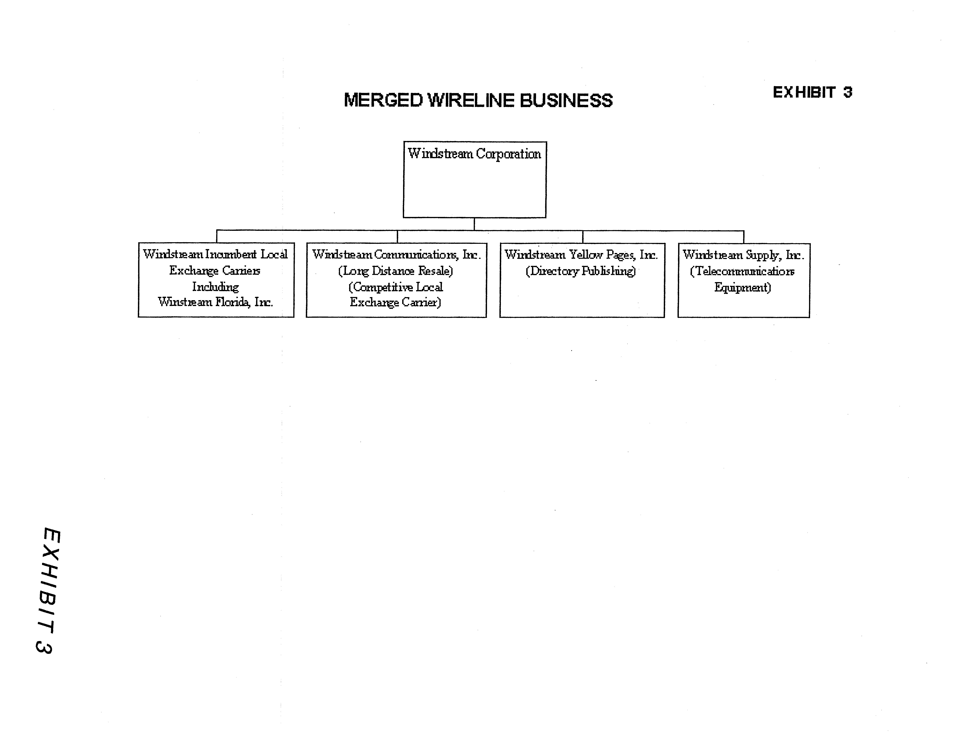
ATTACHMENT B

Windstream Service Guarantee Program

Repair of Out of Service Troubles as Reported by Customer

Windstream shall make automatic credits in the amounts specified below for out of service troubles as reported by the customer:

Duration
24 to 48 hours $ 12
> 2 days to 5 days $ 16
> 5 days $ 40

Sundays or holidays are not covered by the SGP and will be calculated and credited to customers consistent with Rule 25-4.110(6), F.A.C.

Customer Installations

Windstream shall make an automatic credit to the customer in the amount of $25 for failure to install service on the agreed upon commitment date. Negotiated commitment dates shall not exceed 5 business days. Windstream shall continue to meet Rule 25-4.066, F.A.C.

Answer Time

Windstream shall establish a Community Service Fund (CSF) in the form of a corporate undertaking. Pursuant to the Service Guarantee Program, Windstream shall make credits to the CSF and such funds shall be disposed of in coordination with the Commission staff to promote Windstream’s Lifeline service.

90% of all calls to the business and repair offices shall be answered by a live attendant prepared to give immediate assistance within 55 seconds of being transferred to the attendant. Windstream shall maintain 100% accessibility.

The amount of CSF credits shall be determined in accordance with the following parameters:

Less than 90%, but greater or equal to 80% - $2,000
Less than 80%, but greater or equal to 70% - $5,000
Less than 70% - $7,000

Force Majeure

In the event of named tropical or hurricane storms, Windstream may invoke Force Majeure by contacting the Director of the Division of Competitive Markets & Enforcement. Windstream shall at that time be relieved of the requirements of this SGP until Force Majeure is canceled.
ATTACHMENT C
ALLTEL Spin Off

1. Financial Conditions associated with the merger/spin-off transaction:
a. The liens and guarantees for Florida must be eliminated.
b. Dividends to parent restricted to 90% of Florida net income (net income is calculated as operating revenue minus operating expenses plus/minus non-operating income/expense minus fixed charges minus income taxes). Upstream loans/advances to parent, temporary cash investments, or any other method cannot be used to circumvent the 90% dividend requirement.
c. Must file all credit rating reports with the PSC until as long as the company remains the carrier of last resort.
d. Within 30 days after the close of the transactions, Alltel Florida shall file with the PSC all the final terms and conditions of this financing as described in the application including, but not limited to the following: the aggregate principal amount to be sold or borrowed, price information, estimated expenses, loan or indenture agreement concerning each issuance.
e. Covenants will be consistent with those found in Exhibit A to the April 12, 2006, Commitment letter. There will be no additional Financial Covenants other than the Maximum Leverage Ratio (debt/EBITDA, no more restrictive than 4.5X) and a Minimum Interest Coverage Ratio (EBITDA/interest expense, no more restrictive than 2.75X).

2. Rates:
a. No basic local telecommunications services rates increased for 3 years.
b. Transaction will not be a changed circumstance under 364.051 (4)(a), F.S., in order to increase rates.

3. Quality of Service:
a. SGP in addition to rules regarding customer service.
- Items as presented in the proposed SGP.
c. Commitment that quality of service will not decline below its current level.

4. Broadband:
a. 75% addressability by December 31, 2006
b. 80% addressability by December 31, 2007
c. 85% addressability by December 31, 2008

Clarify that the SGP applies to residential customers and the amounts would be as follows:
24 to 48 hours $12
>2 days to 5 days $16
>5 days $40

The name change request will be handled administratively in accordance with Section 2.07.C.2.a, Administrative Procedures Manual.
The request for waiver of the carrier selection requirements of Rule 25-4.118, Florida Administrative Code, is discussed below in Section II., B.
Although it will have no customers or active pay telephones after the merger is complete, ACI will retain IXC registration TI498, PATS Certificate No. 5405 and competitive local exchange telecommunications company (CLEC) Certificate No. 5205.

