D.5.0 RCID’s Economic Analysis

A detailed economic analysis was performed to evaluate the cost-effectiveness of RCID’s participation in TEC and to determine the least-cost capacity expansion plan to meet RCID’s forecast capacity requirements during the planning horizon, as presented in Section D.4.0. This section presents the assumptions and methodology used in the economic analysis, as well as the results of the base case analysis.
The economic analysis described herein compares the economics of the least-cost capacity expansion plan, including RCID’s share of capacity and energy from TEC, versus the economics of the least-cost expansion plan for RCID’s system that does not include participation in TEC. The capacity associated with RCID’s share of TEC, as well as the construction of any of the supply-side alternatives presented in Section A.6.0, is only sufficient to satisfy RCID’s forecast capacity requirements for a portion of the expansion planning horizon. To meet the forecast capacity requirements, multiple unit additions were selected from RCID’s supply-side alternatives considered for individual participation that passed the supply-side screening described in Section A.6.6. Analyses of RCID’s joint participation in supply-side alternatives other than TEC are presented as sensitivity cases in Section D.6.0.

D.5.1 Expansion Planning and Production Costing Methodology
The supply-side evaluations of generating unit alternatives were performed using POWROPT, an optimal generation expansion model that Black & Veatch developed as an alternative to other optimization programs. POWROPT has been benchmarked against other optimization programs and has proven to be an effective modeling program. Both POWROPT and its detailed chronological production costing module, POWRPRO, have been used in numerous Need for Power Applications filed with the Florida Public Service Commission (FPSC), including FMPA’s Treasure Coast Energy Center (TCEC) Unit 1 Need for Power Application approved in July 2005, and the Orlando Utilities Commission (OUC) Stanton B Need for Power Application approved in May 2006.
POWROPT operates on an hourly chronological basis and is used to determine a set of optimal capacity expansion plans to satisfy forecast capacity requirements, simulate the operation of each of these plans, and select the most desirable plan based on cumulative present worth revenue requirements. POWROPT evaluates all combinations of generating unit alternatives and purchase power options, in conjunction with existing capacity resources, while maintaining user-defined reliability criteria. All capacity expansion plans were analyzed over a 30 year period from 2006 through 2035.
After the optimal generation expansion plan was selected using POWROPT, Black & Veatch’s POWRPRO was used to obtain the annual production cost for the expansion plan. POWRPRO is a computer-based chronological production costing model developed for use in power supply systems planning. POWRPRO simulates the hour-by-hour operation of a power supply system over a specified planning period. Required inputs are carried forward from those used in POWROPT and include the performance characteristics of generating units, fuel costs, and the system hourly load profile for each year.
POWRPRO summarizes each unit’s operating characteristics for every year of the planning horizon. These characteristics include, among others, each unit’s annual generation, fuel consumption, fuel cost, average net operating heat rate, the number of hours the unit was on line, the capacity factor, variable operations and maintenance (O&M) costs, and the number of starts and associated costs. Fixed O&M costs were included only for new unit additions, since fixed O&M costs for existing units are generally considered sunk costs that will not vary from one expansion plan to another. The annual capacity charges for RCID’s power purchases from TECO, PEF, and OCL were not included, since they also represent sunk costs. Similarly, fixed costs for firm natural gas transportation capacity from Florida Gas Transmission Company (FGT) for existing units are considered sunk costs and were not included. The operating costs of each unit were aggregated to determine the annual operating costs for each year of the expansion plan. Capital costs, fixed O&M costs, and incremental costs for natural gas transportation (for combined cycle capacity addition alternatives) were then added for each capacity addition selected, at which point the cumulative present worth cost (CPWC) of each expansion plan was calculated.
The CPWC calculation accounts for annual system costs (fuel and energy, fixed O&M for capacity additions, nonfuel variable O&M, startup, and levelized capital) for each year of the expansion planning period and discounts each back to 2006 at the present worth discount rate of 5.0 percent. These annual present worth costs were then summed over the 2006 through 2035 period to calculate the total CPWC of the expansion plan being considered. Such analysis allows for a comparison of CPWCs between various capacity expansion plans, and the plan with the lowest CPWC is considered the least-cost capacity expansion plan.

D.5.2 Least-Cost Capacity Expansion Analysis
The economic analysis consisted of comparing the economics of the optimal capacity expansion plan, including RCID’s participation in TEC, versus the optimal capacity expansion plan not including participation in TEC. As described previously in this section, Black & Veatch first used its optimum generation expansion program, POWROPT, to select unit additions from RCID’s supply-side alternatives considered for individual participation, which was presented in Section A.6.0. Once the least-cost expansion plan for each case was determined, POWRPRO was used to determine the annual total system costs and to develop a comparison of CPWCs associated with each expansion plan.

D.5.2.1 Peak Demand and Energy Growth
As presented in Section D.3.0, a forecast of peak demand and NEL was provided for RCID’s system through 2025. For evaluation purposes (as discussed in Section A.8.0), it has been assumed that there would be no load growth beyond 2025.

D.5.2.2 Supply-Side Candidate Unit Additions
As described in Section D.4.0, RCID’s forecast capacity requirements are dictated by projected capacity shortfalls in the summer season of each year of the planning period. On a weather-normalized basis, RCID’s summer peak typically occurs in June, July, or August of a given calendar year; however, RCID’s actual summer peak could occur as early as May. To ensure that new capacity additions are available to meet forecast summer reserve margin requirements, all unit additions considered for RCID’s individual ownership (as presented in Section A.6.0) are assumed to be installed by May 1.
As stated in Section A.6.0, for the purposes of this analysis, RCID will consider only LM6000 1x1 combined cycle brownfield unit additions at the CEP. Section A.6.0 presented the estimated cost and performance characteristics for the LM6000 1x1 combined cycle unit considered by RCID. The LM6000 1x1 combined cycle unit was assumed to be available beginning in 2011.

D.5.2.3 Fuel Prices and Natural Gas Transportation
As described in Section A.4.0 of this Application, projections of delivered fuel prices were developed by the TEC Fuels Committee. The base case fuel price projections presented in Section A.4.0 have been used for the evaluation presented in this section.
For all capacity expansion plan evaluations, it was necessary to account for natural gas transportation capacity associated with the new combined cycle unit alternatives. RCID currently has a contract in place with FGT for firm natural gas transportation to fuel its existing natural gas fired unit, which is located at CEP. For the LM6000 1x1 combined cycle option considered by RCID in this analysis, it was assumed that RCID would purchase firm transportation in accordance with FGT’s tariff so that 6.0 percent of the daily natural gas transportation allocation would be adequate to operate the unit at full load for an hour, based on the performance at average ambient conditions. This would require 8,452 MBtu of firm natural gas per day. Using the Firm Transportation Service (FTS) reservation charge of $0.769 per MBtu (pursuant to FGT’s April 2006, effective rates for incremental Firm Market Area Transportation), firm transportation costs of $3.34 per kW-month were added to the fixed O&M costs of the LM6000 1x1 combined cycle alternative. Any natural gas required in addition to the firm natural gas transportation for the existing and new units is priced at an interruptible service rate of $0.37 per MBtu, which was added to the annual commodity price forecasts for natural gas presented in Section A.4.0.

D.5.2.4 Emission Cost Considerations
To reflect the economic effects of the Clean Air Interstate Rule (CAIR) and the Clean Air Mercury Rule (CAMR) (as described in Section A.5.0), the forecast prices of emissions allowances were incorporated into the fuel costs for each unit, including existing units that will be regulated under CAIR and CAMR, beginning with the first phases of CAIR and CAMR. The allowance price forecast presented in Section A.5.0 provides emissions costs on a dollar per ton (dollar per pound for mercury [Hg]) basis. These costs were used to calculate a fuel cost adder for both existing units and candidate units, based on the emissions rates of each individual unit. As a result, each generating unit was modeled using different prices for fuel because of differences in emissions rates.
The forecast market value of the allowances allocated to RCID’s existing generating units was not included in the economic analysis, since it represents the same credit for each capacity expansion plan. Since complete emissions control strategies, the resulting reductions in emissions rates, and the generating unit output and performance impacts from potential emissions control measures are not entirely known, no changes in emissions rates or unit output and performance for RCID’s existing generating units were considered in this analysis. Table D.5-1 presents the emissions cost adders for RCID’s existing units, as well as for TEC and the LM6000 1x1 combined cycle unit.

D.5.2.5 Dispatch Assumptions
Nonfuel variable O&M and forecast emissions allowance costs were included in the unit dispatch modeling in POWROPT and POWRPRO, along with the fuel costs. These costs were included in the dispatch modeling to ensure the most cost-effective dispatch of both existing and new generating units.

Table D.5-1
Combined SO₂, NO_{x}, and Hg Emissions Cost Adders
(Nominal $/MBtu)
 | CEP | ECEP | ECEP
Calendar Year | Existing LM6000 CC | Existing Diesel Unit 1⁽¹⁾ | Existing Diesel Unit 2⁽¹⁾ | Joint Candidate TEC | Candidate LM6000 Combined Cycle
2009 | $0.01 | $0.00 | $0.00 | $0.08 | $0.01
2010 | $0.01 | $0.00 | $0.00 | $0.15 | $0.01
2011 | $0.01 | $0.00 | $0.00 | $0.16 | $0.01
2012 | $0.01 | $0.00 | $0.00 | $0.16 | $0.01
2013 | $0.01 | $0.00 | $0.00 | $0.17 | $0.01
2014 | $0.01 | $0.00 | $0.00 | $0.18 | $0.01
2015 | $0.02 | $0.00 | $0.00 | $0.28 | $0.02
2016 | $0.02 | $0.00 | $0.00 | $0.30 | $0.02
2017 | $0.02 | $0.00 | $0.00 | $0.27 | $0.02
2018 | $0.02 | $0.00 | $0.00 | $0.30 | $0.02
2019 | $0.03 | $0.00 | $0.00 | $0.36 | $0.03
2020 | $0.03 | $0.00 | $0.00 | $0.42 | $0.03
2021 | $0.03 | $0.00 | $0.00 | $0.42 | $0.03
2022 | $0.03 | $0.00 | $0.00 | $0.41 | $0.03
2023 | $0.04 | $0.00 | $0.00 | $0.54 | $0.04
2024 | $0.06 | $0.00 | $0.00 | $0.74 | $0.06
2025 | $0.07 | $0.00 | $0.00 | $0.84 | $0.07
2026 | $0.07 | $0.00 | $0.00 | $0.90 | $0.07
2027 | $0.08 | $0.00 | $0.00 | $0.98 | $0.08
2028 | $0.08 | $0.00 | $0.00 | $1.05 | $0.08
2029 | $0.09 | $0.00 | $0.00 | $1.13 | $0.09
2030 | $0.09 | $0.00 | $0.00 | $1.21 | $0.09
2031 | $0.10 | $0.00 | $0.00 | $1.29 | $0.10
2032 | $0.11 | $0.00 | $0.00 | $1.39 | $0.11
2033 | $0.12 | $0.00 | $0.00 | $1.48 | $0.12
2034 | $0.12 | $0.00 | $0.00 | $1.59 | $0.12
2035 | $0.13 | $0.00 | $0.00 | $1.70 | $0.13
⁽¹⁾ These diesel units, with a nameplate capacity less than 25 MW, are not regulated by CAIR or CAMR.

D.5.2.6 Analysis of RCID’s Participation in TEC
The evaluation of RCID’s participation in TEC was performed by modeling a capacity expansion plan that included the purchase of additional capacity for 2011 through 2017 from RCID’s existing agreement with TECO. The annual capacity purchased from TECO, in combination with participation in TEC beginning May 1, 2012, was adjusted to satisfy RCID’s forecast annual capacity reserve requirements.
POWROPT was used to determine the set of optimum capacity additions (after the expiration of the TECO agreement) from the conventional technologies considered for individual ownership by RCID, as presented in Section A.6.0. In addition to the capacity purchased from TECO, RCID is projected to require capacity in the summer of 2011 to satisfy forecast capacity requirements. As discussed previously, the only generating alternative considered by RCID in the base case economic analysis, besides TEC, was the LM6000 1x1 combined cycle option. Therefore, POWROPT selected additional LM6000 1x1 combined cycle units as needed to satisfy the forecast capacity requirements in 2011 and after the expiration of the TECO agreement.
D.5.2.6.1 TEC Capital Cost. As described in Sections A.3.0 and A.8.0, the installed capital cost for TEC is $1,752.4 million in 2012 dollars, inclusive of escalation and interest during construction. It was assumed that RCID would be responsible for a percentage of the capital costs equal to RCID’s ownership share of 9.3 percent. RCID’s total share of TEC’s installed cost is approximately $163.0 million in 2012 dollars, which includes the costs for engineering, procurement, and construction (EPC); allowance for funds used during construction (AFUDC); land; community contribution; initial coal inventory; and owner’s costs for TEC. Table D.5-2 presents a summary of RCID’s share of the capital costs for TEC.
D.5.2.6.2 Transmission Considerations. As described in Section A.3.0, RCID will be utilizing the transmission system of PEF for delivery from the Perry Substation to RCID’s transmission system. RCID will be required to pay transmission tariff charges to PEF. The transmission tariff assumed for RCID’s use of the PEF transmission system is $1,193.00 per MW-month. It was assumed that RCID would purchase firm transmission for 71.2 MW, which will ensure that enough firm transmission is available for RCID to receive its full entitlement of capacity and energy from TEC in both the winter and summer seasons. The annual transmission tariff that RCID will pay to PEF is $1,019,142. This cost is included as an additional cost to RCID starting on May 1, 2012, and does not escalate with inflation.

Table D.5-2
TEC Capital Cost – RCID’s Share
(All Costs in 2012 Dollars)

Description | Entire Unit  ($1,000s) | RCID’s Share⁽¹⁾  ($1,000s)
EPC Cost | $1,420,892 | $132,143
AFUDC | $135,413 | $12,594
Owner’s Cost | $116,994 | $10,880
Initial Coal Inventory | $39,010 | $3,628
Community Contribution | $20,000 | $1,860
Land Cost | $20,100 | $1,869
Total | $1,752,409 | $162,974
⁽¹⁾Reflects RCID’s 9.3 percent ownership share of TEC.

The line losses for the PEF transmission system are assumed to be 2.10 percent. These losses were considered when modeling RCID’s participation in TEC; the resulting net output and net plant heat rates for RCID are summarized in Table D.5-3.

Table D.5-3
RCID’s Share of TEC (Average Ambient Conditions)
Output and Performance Considering Transmission Losses

Without Transmission Losses |  | Including Transmission Losses⁽¹⁾
Output  (MW) | Net Plant Heat Rate  (Btu/kWh) | Output  (MW) | Net Plant Heat Rate  (Btu/kWh)
71.2 | 9,238 | 69.7 | 9,436
69.5 | 9,238 | 68.1 | 9,436
55.1 | 9,428 | 54.0 | 9,630
36.5 | 9,933 | 35.8 | 10,146
25.3 | 10,535 | 24.8 | 10,760
⁽¹⁾Assumes losses of approximately 2.10 percent.

D.5.2.6.3 Operations and Maintenance Costs. Section A.3.0 presented the fixed and non-fuel variable O&M costs for TEC. It was assumed that RCID would be responsible for a share of the O&M costs for TEC equal to RCID’s ownership share of 9.3 percent. Total fixed O&M costs for TEC include an adder for ongoing capital expenditures of $2.97 per kW-year in 2012 dollars, which escalates 2.0 percent higher than the general inflation rate. Excluding the adder for ongoing capital expenditures, the total annual cost for TEC’s fixed O&M is $17.7 million in 2005 dollars. RCID’s share of the fixed O&M cost for TEC is $1.6 million or about $23.62 per kW-year (net after considering transmission losses) in 2005 dollars. Section A.3.0 presented the nonfuel variable O&M cost for TEC before transmission losses as $1.36 per MWh. With transmission losses considered, RCID’s net non-fuel variable O&M cost for TEC is $1.39 per MWh in 2005 dollars.
D.5.2.6.4 TEC Scheduled Maintenance and Forced Outages. As presented in Section A.3.0, TEC is expected to have an average of 16 scheduled maintenance days per year. Scheduled maintenance is assumed to begin October 1 of every year after 2012. The scheduled maintenance period is consistent for all of the economic evaluations presented in this Application. TEC is assumed to have an equivalent forced outage rate of 5.23 percent.
D.5.2.6.5 Community Contribution. For the purposes of this analysis, the TEC Participants are assumed to pay a community contribution of $2.5 million per year, in addition to an initial contribution of $20.0 million (included in the capital cost) described previously in this section. Similar to the other fixed costs for TEC, it was assumed that RCID would be responsible for a percentage of the annual community contribution proportionate to its ownership share of TEC. RCID’s share of the annual community contribution is approximately $232,500 in 2012 dollars. The community contribution is included as an additional annual cost to RCID, escalated at the general inflation rate of 2.5 percent per year after May 1, 2012.

D.5.2.7 Analysis of Alternative Expansion Plans to Participation in TEC
Black & Veatch utilized POWROPT to determine the least-cost capacity expansion plan not including RCID’s participation in TEC. Similar to the analysis described in Subsection D.5.2.7, it has been assumed that RCID would increase the capacity purchased under its existing agreement with TECO by up to 75 MW between 2011 and 2017. Given this assumption, RCID is still forecasted to require additional capacity beginning in the summer of 2011 and continuing thereafter. The 2011 capacity requirement, and all subsequent needs for additional capacity after the expiration of the TECO agreement, will be satisfied by the addition of brownfield LM6000 1x1 combined cycle units.

D.5.3 Cumulative Present Worth Cost Analysis
The previous sections described the assumptions and methodology that were used in POWROPT to select least-cost capacity expansion plans for a scenario that included RCID’s participation in TEC and another scenario in which it was assumed that TEC would not be constructed. Once these least-cost capacity expansion plans were identified, POWRPRO was used to determine the total annual system costs and to develop a comparison of CPWCs associated with each expansion plan.

D.5.3.1 Analysis of the Capacity Expansion Plan with TEC
The least-cost capacity expansion plan, assuming that RCID participates in TEC, includes the extension of the TECO agreement through 2017, a brownfield LM6000 1x1 combined cycle unit in 2011, followed by TEC in 2012, and the addition of two brownfield LM6000 1x1 combined cycle units in 2018.

D.5.3.2 Analysis of Alternative Capacity Expansion Plan
The least-cost capacity expansion plan without RCID’s participation in TEC includes the extension of the TECO agreement through 2017, a brownfield LM6000 1x1 combined cycle unit in 2011, a brownfield LM6000 1x1 combined cycle unit in 2014, and two brownfield LM6000 1x1 combined cycle units in 2018.

D.5.3.3 Comparison of Cumulative Present Worth Costs
As shown in Table D.5-4, the CPWC of the least-cost capacity expansion plan that includes RCID’s participation in TEC is $1,771.2 million. Table D.5-5 indicates that the CPWC of the least-cost capacity expansion plan without TEC is $2,042.1 million. A comparison of the CPWCs of the two plans demonstrates that the expansion plan with RCID’s participation in TEC is the least-cost plan by $270.9 million over the 2006 through 2035 planning period.

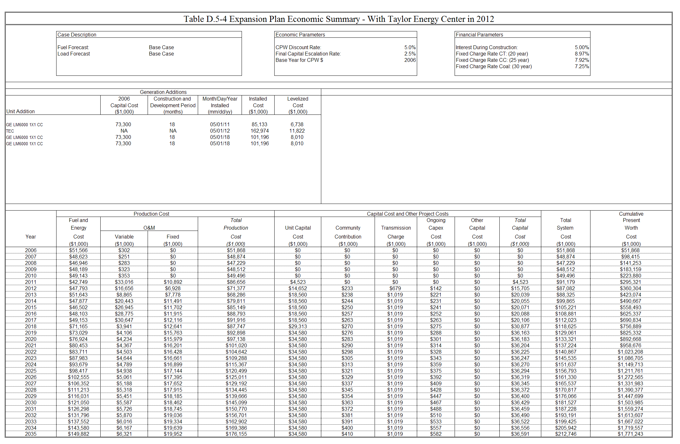
Table D.5-4 Expansion Plan Economic Summary - With Taylor Energy Center in 2012
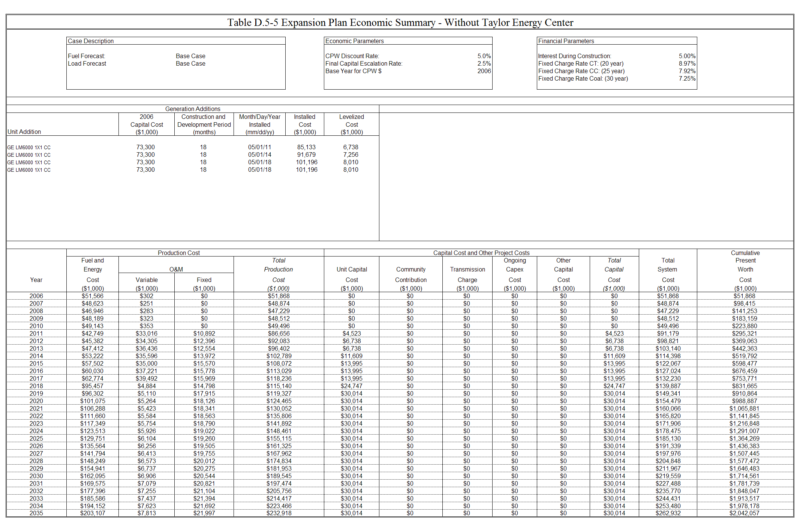
Table D.5-5 Expansion Plan Economic Summary - Without Taylor Energy Center

