BEFORE THE FLORIDA PUBLIC SERVICE COMMISSION
DIRECT TESTIMONY OF WILLIAM S. MAY
ON BEHALF OF
FLORIDA MUNICIPAL POWER AGENCY
DOCKET NO. ________
SEPTEMBER 19, 2006

Q. Please state your name and business address.

A. My name is William S. May. My business address is 8553 Commodity Circle, Orlando, Florida 32819.

Q. By whom are you employed and in what capacity?
- I am employed by Florida Municipal Power Agency (FMPA) as the Manager of the Planning and Contracts Department.

- Please describe your responsibilities in that position.
A. As the Manager of the Planning and Contracts Department for FMPA, I have responsibility for managing the planning functions for its expanding All-Requirements Power (ARP) Supply Project including production of annual load forecasts, annual reporting to regulatory bodies, transmission planning and load-flow studies, demand-side planning, and generation expansion planning. I manage the development, issuance, and evaluation of requests for proposals involving both short-term and long-term purchases and generation construction options. I am also responsible for negotiation and implementation of purchase power contracts. I direct the analysis and implementation of integrated resource plans and review analysis results. I represent FMPA on the Florida Reliability Coordinating Council (FRCC) Planning Committee and oversee FMPA representation on the FRCC Load and Resource Working Group, Transmission Working Group, and Stability Working Group. In addition, I am a member of the FMPA Risk Management Group.

- Please state your educational background and professional experience.
A. I received Bachelor of Science degrees in Electrical Engineering and Applied Mathematics from North Carolina State University, Raleigh, North Carolina, and a Master of Science degree in Electrical Engineering with emphasis in power systems modeling from Georgia Institute of Technology, Atlanta, Georgia. I am a member of the Institute for Electronic & Electrical Engineers (IEEE). My 31 years in the electric utility industry have encompassed many facets of the business, including experience as a consultant to the power industry, a power systems engineer, an energy market price forecaster, a transmission planning engineer, a substation design engineer, and a designer of simulation software. Before joining FMPA, I was a self-employed entrepreneur in the field of electric power supply systems modeling, power plant value analysis, and litigation consulting.

Q. What is the purpose of your testimony in this proceeding?
- The purpose of my testimony is to provide a description of FMPA and its ARP. I will summarize FMPA’s existing generation system as well as available purchase power resources. I will discuss FMPA’s expected need for capacity and provide an overview of the demand-side management (DSM) programs currently offered by FMPA’s members. I also will discuss strategic considerations that support FMPA’s decision to participate in the Taylor Energy Center (TEC). Finally, I will discuss FMPA’s ability to finance its ownership share of TEC.

- Are you sponsoring any exhibits as part of your testimony?
A. Yes. I am sponsoring Exhibit __ [WSM-1], entitled “ARP Member Cities,” Exhibit __ [WSM-2], entitled “Percentages of ARP, Member, Nuclear, and Purchase Power Capacity,” Exhibit __ [WSM-3], entitled “ARP’s Existing Resource Capacity,” and Exhibit __ [WSM-4], which is a copy of my resume. These exhibits are attached to and included in my pre-filed testimony.

Q. Are you sponsoring any sections of Exhibit __ [TEC-1], the Taylor Energy Center Need for Power Application?
A. Yes. I am sponsoring Sections B.1.0, B.2.0, B.4.0, B.7.1, B.8.0, and B.10, all of which were either prepared by me or under my direct supervision.

Q. Please describe the purpose and structure of FMPA.
A. FMPA is a wholesale power company composed of 30 municipal electric utilities. FMPA provides economies of scale in power generation and related services to support community-owned electric utilities. FMPA was created on February 24, 1978, under the provisions of the Florida Constitution, the Joint Power Act, and the Florida Interlocal Cooperation Act of 1969. FMPA was formed to allow its members to cooperate with each other, on the basis of mutual advantage, to provide services and facilities in a manner and in a form of governmental organization that will accord best with geographic, economic, population, and other factors influencing the needs and development of local communities. Specifically, FMPA is involved in the joint financing, constructing, acquiring, managing, operating, utilizing, and owning of electric power plants for its municipal members. FMPA is governed by a Board of Directors consisting of one representative from each of the 30 municipal members.

As a joint operating agency engaged in the business of generating and transmitting electric energy, the FMPA is an “Electric Utility” under 403.503(14), Florida Statutes, and, therefore, is an “applicant” as defined by Section 403.503(4), Florida Statutes. The Public Service Commission previously has held that FMPA is a proper applicant for a determination of need pursuant to Section 403.519, Florida Statutes.

Q. Please describe the ARP.
A. The ARP was formed on May 1, 1986, initially with five municipal participants. The purpose of ARP is to secure an adequate, economical, and reliable supply of electric capacity and energy to meet the entire needs of the ARP Members.
Several other municipals have joined over time. The 15 current ARP participants include the following:
- City of Bushnell
- City of Clewiston
- City of Fort Meade
- Fort Pierce Utilities Authority
- City of Green Cove Springs
- Town of Havana
- City of Jacksonville Beach
- City of Key West
- City of Leesburg
- City of Newberry
- Ocala Electric Utility
- City of Starke
- City of Vero Beach
- City of Lake Worth
- City of Kissimmee
The Members of ARP are shown in Exhibit __ [WSM-1], which is attached to and included in my pre-filed testimony. ARP Members are classified as either generating or non-generating members. All ARP Members are required to purchase all of their capacity and energy from the ARP with the exception of excluded resources that are the Members’ ownership share of Crystal River 3 and St. Lucie 2. Generating Members get reimbursements in the form of credits for their capacity contributions to the ARP. Once a municipal utility has joined the ARP, a contract is signed for a term of approximately 30 years, and this contract is automatically renewed unless the member elects otherwise. Exhibit __ [WSM-2] displays the percentage of existing ARP power supply resources that are owned, purchased from ARP Members, and purchased under other contracts.

Q. Please summarize the capacity resources currently available to FMPA’s ARP.
A. The ARP’s existing capacity resources (summer rating) are presented in Exhibit __ [WSM-3]. The exhibit illustrates that the ARP’s capacity resources decrease as many of the ARP’s purchase power contracts will expire in the near-term.

- What reserve margin does FMPA use for planning purposes?
A. FMPA has established a 15 percent minimum planned reserve margin criteria for the winter period and an 18 percent reserve margin criteria for the summer period for planning purposes.

Q. Please describe FMPA’s expected need for additional capacity to satisfy reserve margin requirements under the base case load forecast.
A. Considering the base case load forecast summarized in the testimony of Jonathan Nunes of R.W. Beck, Inc., and the ARP capacity resources discussed previously in my testimony, winter reserve margins are expected to fall below the required 15 percent minimum in the winter of 2012/13. At this time, FMPA’s reserve margin is projected to fall to 11.4 percent, or 52 MW below the capacity required to maintain a 15 percent reserve margin. In the following winter season, 2013/14, FMPA’s reserve margin is projected to fall to a negative 0.2 percent (net capacity less than projected load), or 227 MW below the capacity required to maintain a 15 percent reserve margin. Projected winter capacity deficits continue to increase beyond 2013/14.

Summer reserve margins are forecast to fall below the 18 percent level in the summer of 2007. At this time, FMPA’s reserve margin is projected to fall to 16.6 percent, or 20 MW below the capacity required to maintain an 18 percent reserve margin. FMPA would likely enter into a short-term seasonal purchase to maintain its reserve margin in 2007. The addition of the 296 MW Treasure Coast Energy Center combined cycle unit in June 2008 raises FMPA’s projected reserve margin above 18 percent in 2008 and 2009. The addition of simple cycle combustion turbines in the summer of 2010 will satisfy forecast capacity requirements for FMPA until the summer of 2011. In the summer of 2011, FMPA’s reserve margin is projected to decrease to 13.9 percent, or 59 MW below the capacity required to maintain an 18 percent reserve margin. Projected summer capacity deficits continue to increase beyond 2011.

Tables B.4-1 and B.4-2 of Exhibit __ [TEC-1] present the projected reliability levels for the winter and summer seasons, respectively, under the base case load forecast.

Q. Please explain how DSM is conducted by FMPA.
A. FMPA is a wholesale supplier of electricity to the ARP Members. As such, FMPA does not directly implement DSM to retail customers. The individual ARP Members actually provide the DSM programs to their customers. FMPA fully supports DSM and provides assistance to ARP Members implementing DSM programs.

Q. Are ARP Members offering any DSM programs currently?
A. Yes. Several ARP members offer various DSM programs, including the following:
- Energy Audits
- High Pressure Sodium Outdoor Lighting Conversions
- Energy Star® Programs
- Energy Services for Energy Upgrades
- Green Energy Programs
- Load Profiling for Commercial Customers
- Fix-Up Program for the Elderly and Handicapped

Q. Did FMPA consider new DSM measures as alternatives to participation in TEC in this Application?
A. Yes. FMPA’s analysis of potentially cost-effective new DSM measures is discussed in the testimony of Bradley Kushner of Black & Veatch.

Q. Are there any advantages that the installation of TEC will have on fuel diversity?
A. Yes. TEC will increase fuel diversity for FMPA and the State of Florida as a whole. The project will have the ability to source solid fuels from both domestic and international coal producing regions including the Powder River Basin (PRB), Central Appalachia, Latin American, and other regions, as well as petroleum coke from the Gulf Coast region and the Caribbean. Historically, coals from these regions and petroleum coke have experienced significantly lower prices on a $/MBtu basis than oil and natural gas. As a result, TEC will not only provide solid fuel capacity for FMPA and the State of Florida, but it will also provide further fuel diversification through the capability to source coal and petroleum coke from numerous different regions, which will help mitigate exposure to high natural gas and fuel oil prices. The low cost baseload energy from TEC will help FMPA and the State of Florida reduce dependence on higher cost energy from natural gas and oil.

Q. Are there any advantages that the installation of TEC will have on fuel reliability?
A. Yes. The addition of solid fueled generation increases the reliability of FMPA’s fuel supply. Coal and petroleum coke inventory for up to approximately 90 days of operation can be stored onsite at TEC, reducing the potential supply disruptions associated with natural gas like those resulting from hurricanes in the Gulf Coast. Furthermore, the ability to store up to approximately 90 days of fuel mitigates potential transportation disruption.

Q. Are there any advantages that the installation of TEC will have on the stability of FMPA’s electric rates?
A. Yes. TEC will help to satisfy the need for low cost, baseload energy within FMPA’s service territory and the State of Florida as a whole. Additional low cost, baseload energy from TEC will help to limit electric rate increases for consumers and businesses. Electric rate stability will be beneficial in long-term planning, and should also help facilitate more stable growth within the economy.

Q. Will the economic advantages of TEC end after 2035?
A. No. Although economic evaluations have been conducted through 2035 for this TEC Need for Power Application (Exhibit __ [TEC-1]), TEC will be designed for, and is expected to have, a service life significantly greater than the 23 years of operation captured by the analysis period. The benefits of TEC’s expected actual service life of 35 to 50 years or more have not been captured in the economic analysis, but are expected to be realized by FMPA and the other project participants. Therefore, the total cost savings and benefits of TEC are understated in the economic analysis.

Q. Are there any advantages that the installation of TEC will have on geographic diversity?
A. Yes. For FMPA, the other project participants, and the State of Florida as a whole, TEC will provide geographic diversity because it will be constructed on a greenfield site. The greenfield site provides FMPA with additional baseload generation without increasing the concentration of its generation resources at one location. This diversity should increase reliability and availability of generating resources, particularly if a hurricane or other extreme condition causes forced outages in a localized area.

Q. Are there other important factors that FMPA considered in its decision to participate in TEC?
A. Yes. As discussed in the testimony of Paul Hoornaert, TEC will utilize proven supercritical technology and include the Best Available Control Technology to minimize plant emissions. It was important to FMPA that TEC utilize proven and reliable technology, and also minimize impacts to the environment.

Q. How does FMPA intend to finance the construction of TEC?
A. FMPA has several funding sources available that may be used to finance the development and construction of TEC. These sources include internal funds, pooled loans, and new long-term debt issuances. During preliminary design, engineering, and permitting, FMPA may draw on its working capital within the ARP fund. As the initial development concludes and construction commences, FMPA may rely on its pooled loan commercial paper to get the construction process under way. The pooled loans could be expected to be used for financing up to the first $100 million of costs. Once the project is well defined and construction under way, FMPA would need to initiate a revenue bond issuance for long-term project funding. For large projects such as a coal fired power plant, FMPA would expect to issue either fixed or floating rate revenue bonds with a term of 30 years. FMPA has a credit rating of A+ from Fitch and an A1 from Moody’s Investors Service. Typically, FMPA purchases bond insurance on its long-term bonds to increase its rating to AAA and Aaa, respectively. In addition, to protect against fluctuations in the interest rate, FMPA employs interest rate swap contracts based on well established indices for its floating rate debt.

Q. Will FMPA be able to obtain the financing for the construction of TEC?
A. Yes. Based on the project’s favorable economics and its excellent credit rating, FMPA believes there will be no problems issuing debt to cover its share of the TEC project costs. FMPA has recently initiated bond offerings with tax-exempt interest rates well below the rates assumed for the economic analysis.

Q. Does this conclude your testimony?
A. Yes.
ARP Members

The figure below shows the ARP Member city locations.

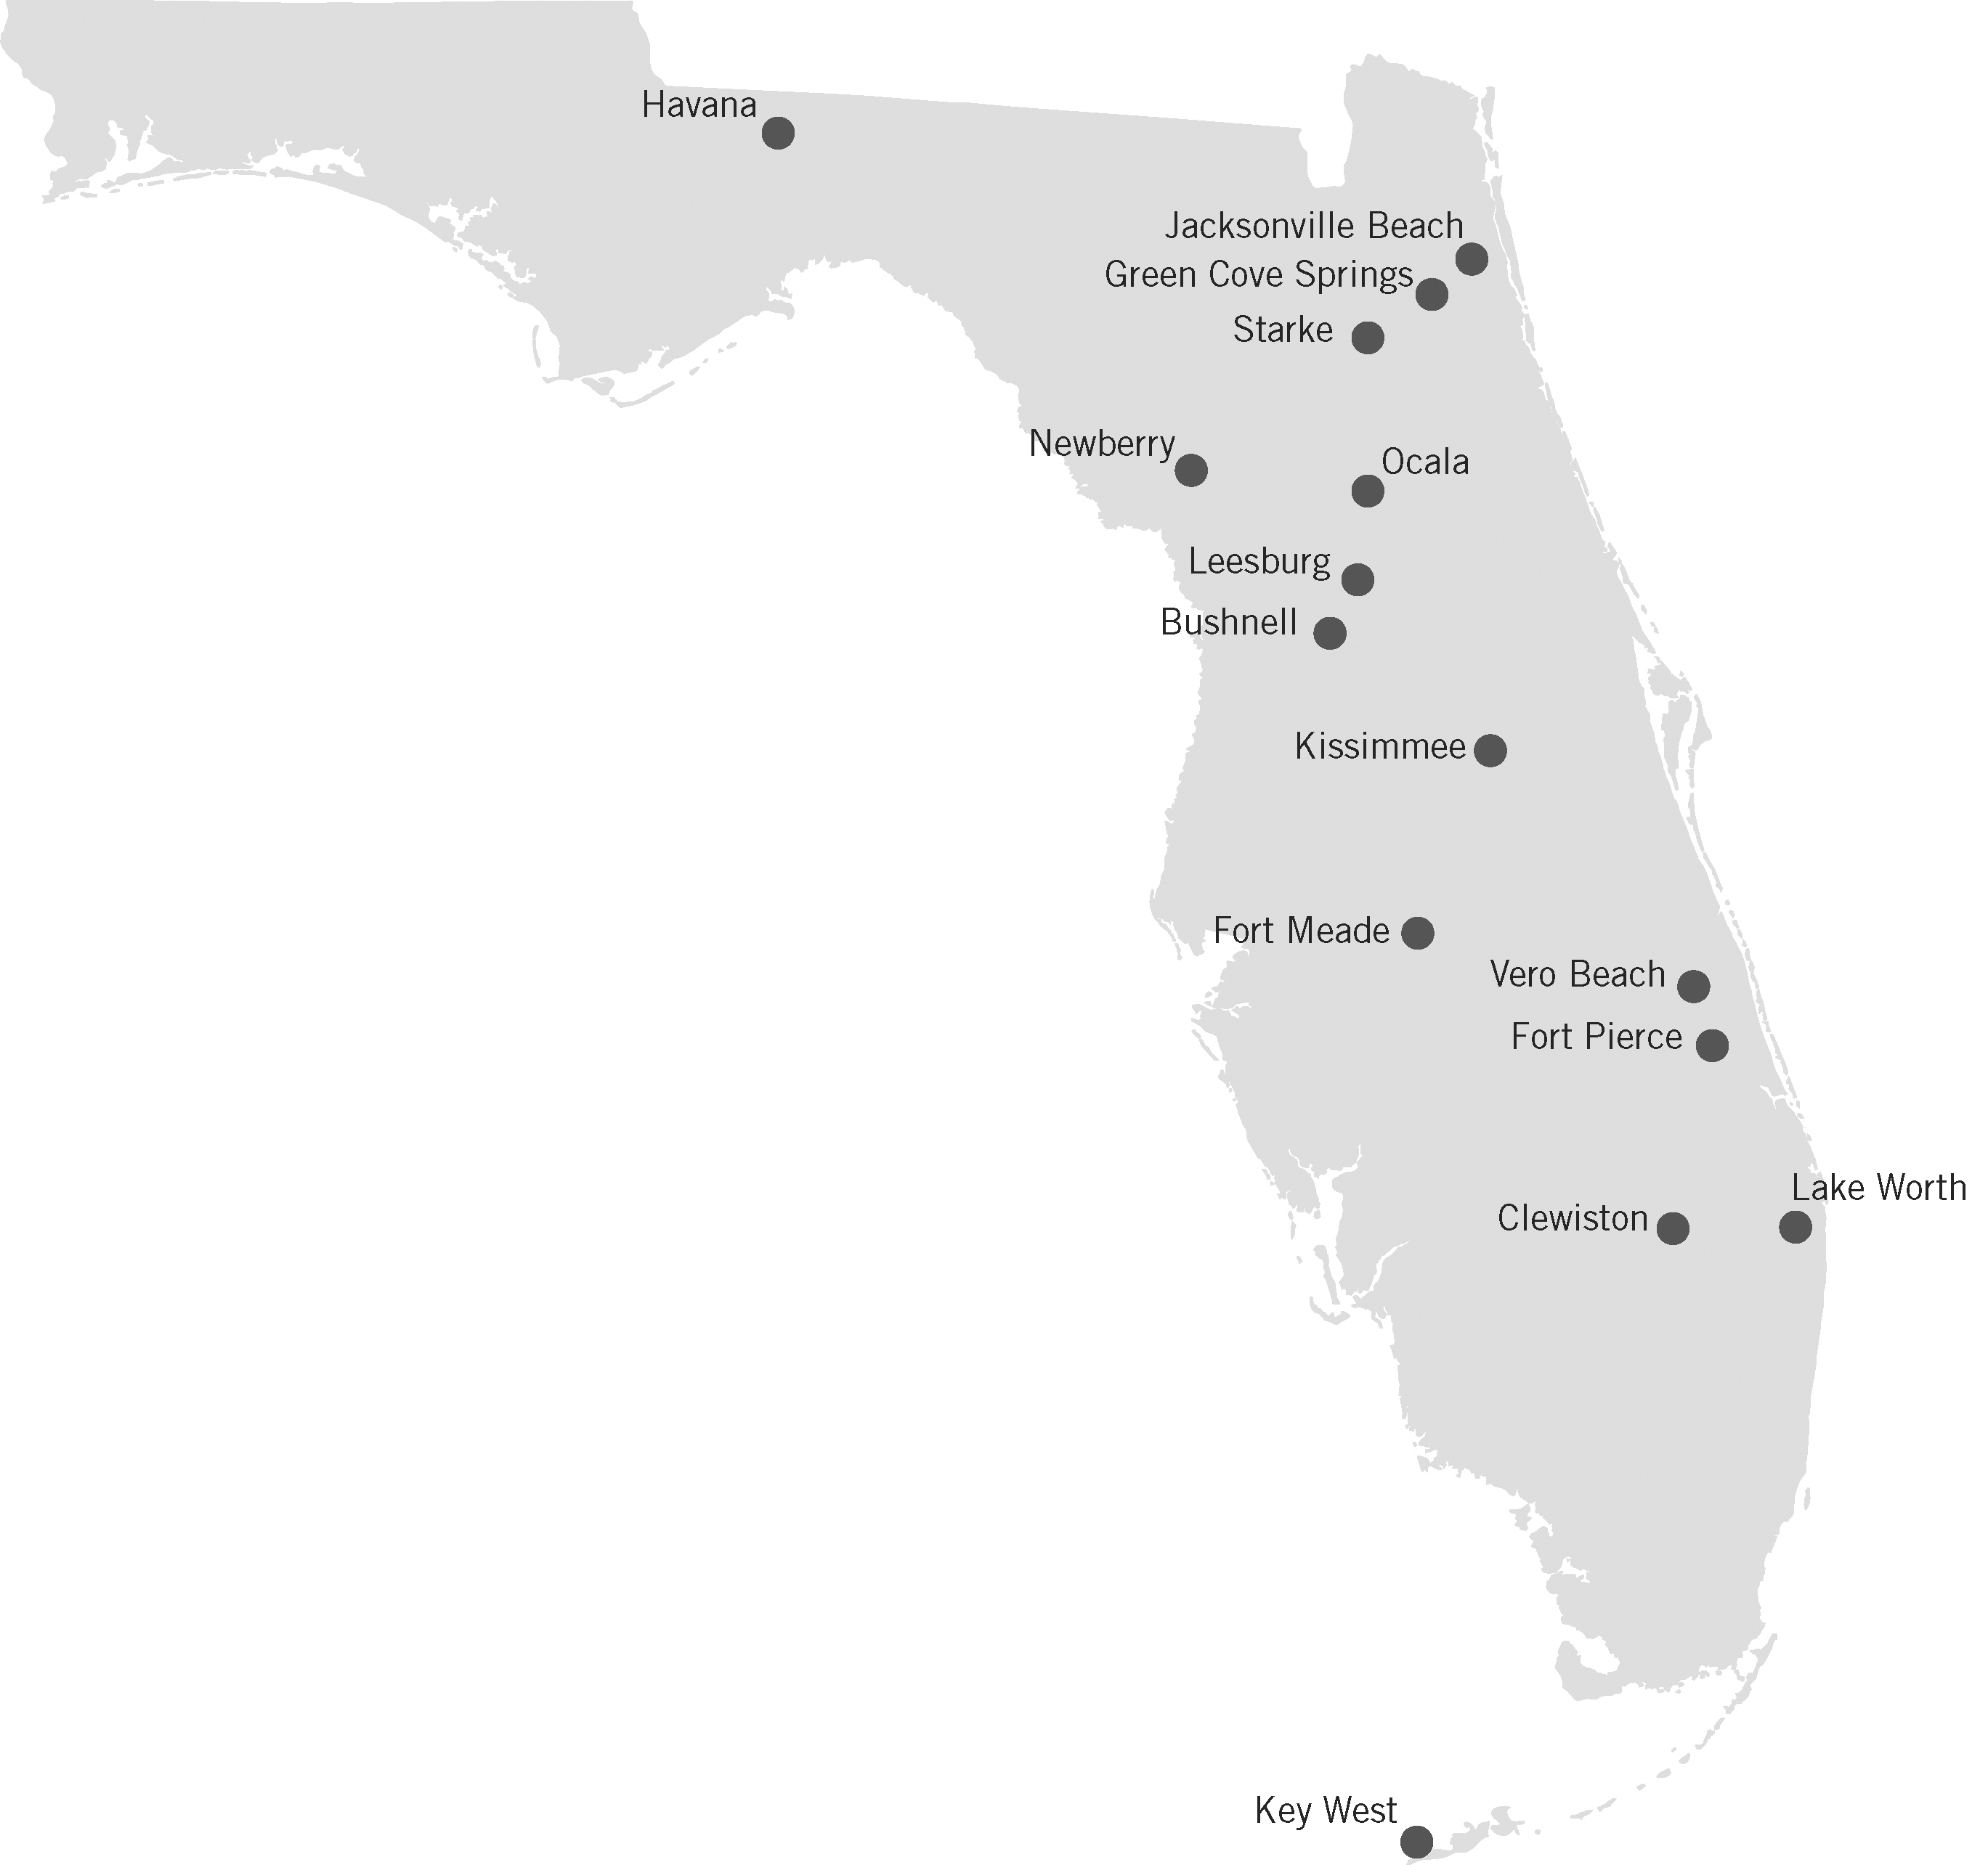

Percentages of ARP, Member, Nuclear, and Purchase Power Capacity

Type | Capacity Summary Unit | 2007 MW Summer | 2007 % Summer
Jointly Owned Nuclear Capacity | CR3 | 23 | 1.3
Jointly Owned Nuclear Capacity | St. Lucie Project | 60 | 3.4
Jointly Owned Nuclear Capacity | Total Nuclear | 83 | 4.8
Owned Capacity | Stanton Coal Plant | 203 | 11.7
Owned Capacity | Stanton CC Unit A | 21 | 1.2
Owned Capacity | Cane Island 1-3 | 194 | 11.1
Owned Capacity | Indian River CTs | 72 | 4.1
Owned Capacity | Key West CTs 2 and 3 | 31 | 1.8
Owned Capacity | Stock Island CT 4 | 42 | 2.4
Owned Capacity | Total Owned | 562 | 32.3
Member Generation | Ft. Pierce | 110 | 6.3
Member Generation | Key West | 41 | 2.4
Member Generation | KUA/Hansel | 48 | 2.8
Member Generation | Lake Worth | 87 | 5.0
Member Generation | Vero Beach | 137 | 7.9
Member Generation | Cane Island 1,2,3 | 194 | 11.1
Member Generation | Stanton CC | 21 | 1.2
Member Generation | KUA Stanton 1 | 21 | 1.2
Member Generation | KUA Indian River CTs | 10 | 0.6
Member Generation | Total Member | 668 | 38.3
Purchased Power | PEF PR | 30 | 1.7
Purchased Power | FPL LT | 45 | 2.6
Purchased Power | FPL PR | 75 | 4.3
Purchased Power | Lakeland Purchase | 100 | 5.7
Purchased Power | Calpine Purchase | 100 | 5.7
Purchased Power | Stanton A Purchase | 80 | 4.6
Purchased Power | Total Purchase Power | 430 | 24.7
Total Capacity | Total Capacity | 1,742 | 100.0

ARP’s Existing and Approved/Planned Resource Capacity⁽¹⁾
 | Summer Rating
Generating Resources | 2006 | 2007 | 2008 | 2009 | 2010 | 2011 | 2012 | 2013 | 2014-  2035
Excluded Resources (Nuclear) ⁽²⁾ | 84 | 83 | 83 | 83 | 72 | 72 | 72 | 72 | 72
Stanton Coal Plant⁽²⁾ | 224 | 224 | 224 | 224 | 186 | 186 | 186 | 186 | 186
Stanton CC Unit A⁽³⁾ | 42 | 42 | 42 | 42 | 42 | 42 | 42 | 42 | 42
Cane Island 1-3 | 388 | 388 | 388 | 388 | 388 | 388 | 388 | 388 | 388
Indian River CTs | 82 | 82 | 82 | 82 | 82 | 82 | 82 | 82 | 82
Key West Units 2&3 | 31 | 31 | 31 | 31 | 31 | 31 | 31 | 31 | 31
Ft. Pierce Native Generation | 110 | 110 | 0 | 0 | 0 | 0 | 0 | 0 | 0
Key West Native Generation | 41 | 41 | 41 | 41 | 41 | 41 | 41 | 41 | 41
Kissimmee Native Generation | 48 | 48 | 48 | 48 | 48 | 48 | 0 | 0 | 0
Lake Worth Native Generation | 87 | 87 | 87 | 87 | 87 | 87 | 0 | 0 | 0
Vero Beach Native Generation | 137 | 137 | 137 | 137 | 0 | 0 | 0 | 0 | 0
Stock Island Unit 4 | 42 | 42 | 42 | 42 | 42 | 42 | 42 | 42 | 42
Treasure Coast Energy Center | 0 | 0 | 296 | 296 | 296 | 296 | 296 | 296 | 296
New Peaking Capacity | 0 | 0 | 0 | 0 | 84 | 84 | 84 | 84 | 84
Total Generating Capacity⁽⁴⁾ | 1,313 | 1,313 | 1,499 | 1,499 | 1,397 | 1,397 | 1,264 | 1,264 | 1,264
Purchased Power
PEF Partial Requirements | 40 | 30 | 30 | 60 | 40 | 0 | 0 | 0 | 0
FPL Long-Term Partial Requirements | 45 | 45 | 45 | 45 | 45 | 45 | 45 | 0 | 0
FPL Partial Requirements | 75 | 75 | 0 | 0 | 0 | 0 | 0 | 0 | 0
OUC Indian River Purchase | 22 | 0 | 0 | 0 | 0 | 0 | 0 | 0 | 0
Starke (GRU) | 3 | 0 | 0 | 0 | 0 | 0 | 0 | 0 | 0
Lakeland Purchase | 100 | 100 | 0 | 0 | 0 | 0 | 0 | 0 | 0
Calpine Purchase | 75 | 100 | 100 | 100 | 0 | 0 | 0 | 0 | 0
Stanton A Purchase⁽⁵⁾ | 80 | 80 | 80 | 80 | 80 | 80 | 80 | 80 | 0
SPC PPA | 0 | 0 | 157 | 157 | 157 | 157 | 157 | 157 | 157
Total Purchased Power Resources⁽⁴⁾ | 439 | 430 | 412 | 442 | 322 | 282 | 282 | 237 | 157
Total Resources⁽⁴⁾ | 1,753 | 1,742 | 1,910 | 1,940 | 1,719 | 1,679 | 1,545 | 1,500 | 1,421
⁽¹⁾ Planned capacity prior to commercial operation of Taylor Energy Center.
⁽²⁾ Reduction in 2010 reflects the withdrawal of Vero Beach from the ARP.
⁽³⁾ Includes FMPA and KUA ownership capacity.
⁽⁴⁾ Sums may not match totals due to rounding.
⁽⁵⁾ Includes FMPA and KUA capacity purchased from Southern Company Florida, LLC.

RESUME OF

William S. May,

Manager of the Planning and Contracts Department

Florida Municipal Power Agency (FMPA)

Qualifications and Experience:
Since December of 2004, Mr. May has served as the Manager of the Planning and Contracts Department of FMPA. Mr. May has used his management, organizational, simulation software knowledge, and planning skills, and electric utility experience to direct the evaluation, negotiation, and execution of power supply contracts, load forecasting, and generation and transmission planning activities. Mr. May has negotiated contracts for software licenses and consulting engagements with electric utilities, independent power producers, and law firms representing electric providers. He has made presentations to a wide range of audiences including peers, company management, executive committees, the Board of directors, and the Florida PSC. From January 2003 to December 2004, Mr. May supervised and participated in the generation and transmission planning and load forecasting activities of FMPA. In the prior seven years Mr. May was a self-employed entrepreneur in the field of electric power supply systems modeling, power plant value analysis, and litigation consulting. Altogether, he has over 30 years experience as a consultant to the power industry, a power systems engineer, an energy market price forecaster, a transmission planning engineer, a substation design engineer, and a designer of simulation software.

Mr. May has negotiated contracts for software licenses and consulting engagements with electric utilities, independent power producers, and law firms representing electric providers. He has communicated with all levels of company employees through marketing activities, contract negotiations, and product support efforts. Mr. May has acted as an expert witness in confidential litigation activities. He has also performed transmission studies using power flow simulations and has designed transmission substations.

Mr. May has Bachelor of Science degrees in Electrical Engineering and Applied Mathematics from North Carolina State University, Raleigh, NC. and a Master of Science degree in Electrical Engineering with emphasis in Power Systems Simulation from Georgia Institute of Technology, Atlanta, GA.

Electric Utility Planning

Mr. May has been involved in many aspects of electric utility planning, including:
- directing the development, issuance, and analysis of requests for proposals and the negotiation and implementation of purchased power agreements.
- directing the analysis and implementation of integrated resource plans and review of analysis results.
- directing the development of the long term load forecast for member cities and FMPA.
- directing the development of software tools that are used in conjunction with other software models to facilitate load forecasts, generation planning analysis, and reporting.
- directing transmission network studies as they involve business activities of FMPA.
- representing FMPA on the FRCC Planning Committee.
- overseeing FMPA representation on the FRCC Load and Resource Working Group, Transmission Working Group, and Stability Working Group.
- participating as a member of the FMPA Risk Management Group.
- directing participants from member cities, consulting firms, and FMPA to produce an Integrated Resource Plan involving load, fuel price, market price, and capacity cost forecasts which were used to evaluate expansion scenarios based on risk factors, transmission impact, net present value of benefits, location marginal pricing, and rate impact.
- composing an RFP for short-term power purchases and evaluated the proposals.
- using and directing the use of the PROSYM production costing model to evaluate multiple purchased power and expansion alternatives.
- conducting consulting studies including studies using the PROMOD III multi-area transmission and production costing model
- serving as an expert witness providing written testimony; reviewing data, analytical processes, and generation and transmission contracts; participating in depositions; and testified under direct and cross-examination.
- preparing numerous market price forecasts.
- developing cost/benefit analysis studies for existing and new generation.
- preparing investment risk assessments of future generating capacity.
- providing training in market-based methodologies.

Electric Utility Planning Software Development

Mr. May directed the development of the PROMOD IV hourly transmission and generation dispatch model including organization, design, and implementation. He was also involved in sales presentations and product training. Mr. May also directed the development of the FUELPLAN optimal fuel contract and dispatch model including market research, preparation of requirements specification, implementation, client training, and support.

Transmission Planning Engineer

Mr. May prepared operational and long-term transmission load-flow studies including system voltage drop, system security, new-capacity connection, and loss of load probability analysis. He also has designed lightning and fire protection systems for substations and performed reliability studies of transmission interconnections. Mr. May has engineered design drawings for the construction of new substations and additions to existing substations.

Employment
History: | 2003-Present | FMPA
 | 1996-2003 | Utility Systems Associates
 | 1980-1996 | EDS/Energy Management Associates
 | 1975-1980 | Georgia Power Company
Education: | M.S. | Electrical Engineering, Georgia Institute of Technology, Atlanta, GA
 | B.S. | Electrical Engineering, North Carolina State University, Raleigh, NC.
 | B.S. | Applied Mathematics, North Carolina State University, Raleigh, NC.

