State of Florida   |  | Public Service Commission  Capital Circle Office Center ● 2540 Shumard Oak Boulevard  Tallahassee, Florida 32399-0850  -M-E-M-O-R-A-N-D-U-M-
DATE: | February 1, 2007
TO: | Director, Division of the Commission Clerk & Administrative Services (Bayó)
FROM: | Division of Economic Regulation (Kummer)  Office of the General Counsel (Helton)
RE: | Docket No. 070022-EU – Recommendation on Commission action regarding adoption of PURPA Standard 14, "Time-based Metering and Communications."
AGENDA: | 02/13/07 – Proposed Agency Action – Interested Persons May Participate
COMMISSIONERS ASSIGNED: |  |  | All Commissioners
PREHEARING OFFICER: |  |  | Administrative
CRITICAL DATES: |  |  | None
SPECIAL INSTRUCTIONS: |  |  | None
FILE NAME AND LOCATION: |  |  | S:\PSC\ECR\WP\070022.RCM.DOC

Case Background
The Energy Policy Act of 2005 (EPAct) amended the Public Utilities Regulatory Policies Act (PURPA) to add five new standards. Each state regulatory body is required to evaluate the new standards, just as they did in 1980 with the original nine standards, to determine if the states should adopt those policies for their subject utilities. This recommendation addresses PURPA Standard 14, “Time-based Metering and Communications.” The recommendation discusses whether further action is necessary on this standard, or if the Commission has already addressed the issue sufficiently to comply with the PURPA requirement. Based on the data presented in the Statistics of the Florida Electric Utility Industry, compiled by the Florida Public Service Commission (PSC) Office of Standards Control and Reporting, Florida has twenty-five utilities subject to PURPA.
Discussion of Issues
ISSUE 1: Should the Commission adopt new PURPA Standard 14?

STAFF RECOMMENDATION: No. Under the guidance of the PSC, Florida utilities already offer a variety of time sensitive rates and load management options where such programs are cost effective. Adoption of Standard 14 will not materially further this activity and may result in requests for installation of equipment where it may not be cost effective.

STAFF ANALYSIS: Effective August 8, 2005, Section 1252 (Attachment A) of the EPAct modified the Public Utilities Regulatory Policies Act of 1978 to add paragraph (14), Time-based Metering and Communications (PURPA Standard 14):

Not later than 18 months after the date of enactment of this paragraph, each electric utility shall offer each of its customer classes, and provide individual customers upon customer request, a time-based rate schedule under which the rate charged by the electric utility varies during different time periods and reflects the variance, if any, in the utility’s costs of generating and purchasing electricity at the wholesale level. The time-based rate schedule shall enable the electric consumer to manage energy use and cost through advanced metering and communications technology.

The EPAct further required state regulatory bodies to “conduct an investigation and issue a decision whether or not it is appropriate for electric utilities to provide and install time-based meters and communications devices for each of their customers which enable such customers to participate in time-based pricing rate schedules and other demand response programs.”

The Commission is not required to adopt any PURPA standard in order to comply with the EPAct. Federal law requires only that “each State regulatory authority… consider each standard … and make a determination concerning whether or not it is appropriate to implement such standard…(16 U.S.C. §§2621(a).” Amendments to PURPA sections 111(d), and 112 provide the time frames within which a state must complete these activities. New EPAct Section 1252(i) lists three conditions under which a state is exempt from the “consideration and determination” requirement for the time-based metering standard: (1) the state has already implemented the standard or a comparable standard; (2) the state regulatory authority has conducted a proceeding to consider implementation of the standard or a comparable standard within the previous three years; or (3) the state legislature has voted on implementation of the standard or a comparable standard within the previous three years.

The PSC initiated an investigation into the subject at the March 7, 2006 Internal Affairs when it approved staff’s proposal to survey Florida electric utilities to determine the current status of time-sensitive rates in Florida. The recommendation before the Commission in this docket addresses that survey and proposes the standard not be adopted based on the survey results. It is staff’s opinion that EPAct Section 1252 was intended to break down regulatory or institutional barriers to the provision of time sensitive rates. Based on the survey, staff contends that Florida utilities, even those not subject to PURPA, have considered and implemented where appropriate, time sensitive rates and load management programs which comply with the spirit of Section 1252. It is staff’s recommendation that Florida is already in substantive compliance with the new PURPA Standard 14 under existing rules and regulations and no further action is necessary to meet the intent of the standard. Further, adoption of the broad standard as written could result in service requirements that are not cost effective for the general body of ratepayers.

Provisions of Section 1252 of EPAct

Section 1252(a) of the EPAct adds a new standard, entitled “Time-Based Metering and Communications,” to the list of standards established for consideration under PURPA. It also requires that each electric utility subject to this standard provide each customer requesting a time-based rate with a time-based meter capable of enabling the utility and customers to offer and receive such rate.

States are not required to adopt PURPA standards but under PURPA section 112, state regulatory authorities are required to consider whether adopting PURPA standards is appropriate. Existing PURPA section 115(b) states that analysis should include the cost to implement the standard compared to the benefits realized. EPAct section 1252 (b) also added PURPA section 115(i) which states that each state regulatory body “shall conduct an investigation and issue a decision whether or not it is appropriate for electric utilities to provide and install time-based meters and communications devices for each of their customers which enable such customers to participate in time-based pricing rate schedules and other demand response programs.” The nature of that investigation is not specified.

The time frames to be used for that investigation are somewhat contradictory. EPAct section 1252(a) added paragraphs (14)(A-F) to section 111(d) of PURPA, requiring electric utilities to offer time-based rates and meters upon customer request within 18 months. EPAct Section 1252 (g) added subparagraphs (4)(A) and (4)(B) to PURPA section 112(b) specifically stating that states must begin investigating new standard (14) within 1 year and complete the investigation within 2 years of the enactment of EPAct. Subparagraph (F) of Standard (14) PURPA section 111(d) under EPAct section 1252(a), however, states that, notwithstanding subsections (b) and (c) of PURPA section 112, states must conduct their investigation of standard (14) and issue a decision within 18 months. It is unclear why language would be added to PURPA section 112 specifically to address the time frame for consideration of PURPA section 111(d)(14) when section (14) itself contains a different time frame for consideration. Consideration of the issue at this Agenda is well within the two year time frame and within a week of the more conservative 18 month time frame.

Staff believes exemption (1) applies and no proceeding is required for the purposes of considering and determining whether or not it is appropriate to adopt the Time-Based Metering and Communications standard set forth in 1252(a). The original time-of-day rate standard adopted by the Commission in 1981 (Order No. 10179) is substantially similar and comparable to the new time-based metering and communications standard in EPAct Section 1252. Further, the Commission’s actions subsequent to Order No. 10179 provide ample proof of this Commission’s continued commitment to providing customers time-based and demand response rate options.

To ensure that the Commission complies with PURPA Standard 14 staff surveyed all Florida electric utilities to determine what time-based or demand reduction rate offerings had been considered or are available to customers and what proportion of customers have taken advantage of those offerings. Staff further believes that if the Commission accepts staff’s recommendation in this docket, the order issued herein is sufficient to meet the “consideration and determination” as required by PURPA section 115(i).

History

Under the 1978 PURPA Act, each state regulatory authority (i.e., public utility commission or public service commission) was required to consider a list of “standards” aimed at energy conservation, efficient use of facilities and resources by utilities, and equitable rates. These standards included six ratemaking standards: (1) time-of-day rates; (2) seasonal rates; (3) interruptible rates; (4) load management techniques; (5) prohibition of declining block rates; and (6) cost-of-service rates. With respect to each electric utility over which it had ratemaking authority, each state commission was required to give public notice and conduct a hearing to consider and determine whether or not it was appropriate to implement each of the standards. Each state regulatory authority was free to make a determination that implementation of any particular standard was inappropriate, provided that it met the requirements of public notice and hearing and, based on the evidence presented at hearing, issued a written decision providing its rationale.

In 1981, the FPSC conducted proceedings to consider each of PURPA’s ratemaking standards and determine whether each particular standard was appropriate for implementation in Florida. The time of use standard in the 1978 PURPA reads:

The rates charged by any electric utility for providing electric service to each class of electric consumers shall be on a time-of-day basis which reflects the costs of providing electric service to such class of electric consumers at different times of the day unless such rates are not cost-effective with respect to such class….

PURPA stated that a time-of-day rate charged to a class of consumers would be considered cost-effective with respect to each such class “if the long run benefits of such rate to the electric utility and its electric consumers in the class concerned are likely to exceed the metering costs and other costs associated with the use of such rates.”

In Order No. 10179, the Commission determined that a modified version of the PURPA standard was appropriate. The Commission-approved standard reads:

When such rates are cost-effective, the rates charged by an electric utility for each group of customers shall be time-differentiated in order to reflect the cost of providing service to such customers at different times of the day. “Cost-effective” means that the long run benefits to the utility and its customers exceed the cost of meters and other associated costs. Specific cost effectiveness methodologies may be prescribed by the Commission. [Order 10179, p. 9]

FERC study

Pursuant to EPAct Section 1252(e)(3), the Federal Energy Regulatory Commission (FERC) was required to prepare an assessment of demand response resources, including those available from all consumer classes. This comprehensive survey looked at both demand response and advanced metering. The survey was sent to 3,365 organizations in all 50 states representing IOU’s, municipals, rural cooperatives, power marketers, state and federal regulatory agencies, and unregulated demand response providers. Approximately 55% of those receiving surveys responded. The FERC study shows only a six percent penetration rate nationwide for smart meters. The FERC study definition of smart metering, however, was quite narrow: “…a metering system that records customer consumption [and possibly other parameters] hourly or more frequently and that provides for daily or more frequent transmittal of measurements over a communication network to a central collection point.” The study goes on to elaborate that, for the purposes of the survey, advanced metering includes more than just a “smart meter” and must include the communications networks and data management, to qualify under the FERC’s definition. Further, the FERC study required not only the capability to measure but that the meters actually be used to measure data intervals of an hour or less and collect data at least daily. Based on these definitions, the study shows a smart meter penetration rate for Florida of 2.5 %.

In contrast, the EPAct language is much broader than the FERC survey. PURPA Standard 14 requires a utility to offer each of its customers “…a time-based rate schedule under which the rate charged by the electric utility varies during different time periods and reflects the variance, if any, in the utility’s costs of generating and purchasing electricity at the wholesale level. The time-based rate schedule shall enable the electric consumer to manage energy use and cost through advanced metering and communications technology.” Staff believes that the data presented below shows that Florida customers enjoy a wide variety of time-responsive rate options. While the extensive data networks necessary to meet the FERC criteria used in its study may not be in place, staff recommends that the Commission find Florida utilities have demonstrated a commitment to customer pricing options for over twenty-five years consistent with both the new and existing PURPA standards, and that the Commission continues to endorse new technology to offer more programs in the future to the extent such programs are cost effective. Therefore, formal adoption of PURPA standard (14) is not necessary.

Discussion of utility rates and programs

PURPA Section 101 states that utilities are subject to PURPA requirements if the utility exceeds 500 million kWhs during any calendar year beginning after December 31, 1975. Based on the information provided in the 2005 Statistics of the Florida Electric Utilities Industry, in addition to the five investor-owned electric utilities, thirteen municipal utilities and seven rural cooperatives met that criterion. Staff, however, sent a data request to all Florida electric utilities to collect information on smart metering and load management programs offered to customers in order to develop a comprehensive statewide picture of time responsive options in Florida. The responses are summarized below and the responses of the investor-owned electric companies are attached as Attachment B.

Section 1252(a) of the EPAct list four specific categories of time-based rate schedules that meet the criteria set forth in the standard:

(i) time-of-use pricing whereby electricity prices are set for a specific time period on an advance or forward basis, typically not changing more often than twice a year, based on the utility’s cost of generating and/or purchasing such electricity at the wholesale level for the benefit of the consumer. Prices paid for energy consumed during these periods shall be pre-established and known to consumers in advance of such consumption, allowing them to vary their demand and usage in response to such prices and manage their energy costs by shifting usage to a lower cost period or reducing their consumption overall;

(ii) Critical peak pricing whereby time-of-use prices are in effect except for certain peak days, when prices may reflect the costs of generating and/or purchasing electricity at the wholesale level, and when consumers may receive additional discounts for reducing peak period energy consumption;

(iii) Real-time pricing whereby electricity prices are set for a specific time period on an advanced or forward basis, reflecting the utility’s cost of generating and/or purchasing electricity at the wholesale level, and may change as often as hourly; and

(iv) Credits for consumers with large loads who enter into pre-established peak load reduction agreements that reduce a utility’s planned capacity obligations.

Florida electric utilities offer, or have offered in the past, most of these types of rate options. As would be expected, the four major investor-owned utilities have the broadest array of time and demand responsive programs. Because IOUs generate the bulk of the electricity delivered to their customers, changes in demand can be realized almost immediately, making such options more likely to be cost effective. Smaller utilities who purchase all or most of their power may have fewer opportunities to realize benefits from time-of-use or load management programs. Many wholesale purchased power contracts bill on the city or cooperative’s demand at the time of the peak demand of the supplier, which may not necessarily be the peak demand of the purchaser. If the reduction from a utility’s time responsive rate does not occur during the wholesale billing peak, the purchaser may realize only a revenue loss from lower off peak rates and no commensurate cost savings in power purchases, making such a rate non-cost effective.

Investor-owned rate options

All IOUs offer time differentiated rates to their customers. These rates typically consist of a two part (on peak and off peak) energy charge and may also include a two part demand charge for commercial customers. Seasonal on- and off-peak periods are pre-set and approved by the Commission. Standard time-of-use rate design is based on data from the load research studies required under Rule 25-6.0437, Florida Administrative Code, Cost of Service Load Research. Under this rule, IOUs must place time recording meters on a statistically valid sample of their customers in each customer class to measure usage on a time sensitive basis for 12 months. This load data is submitted every three years to the Commission in support of a number of recovery clauses as well as to determine the on- and off-peak load for designing time-of-use rates in a rate case.

Residential. Three of the five IOUs, FPL, PEF and TECO, offer residential customers a standard time-of-use option. Participation in residential time-of-use rates is typically quite small, averaging less than 1% across all IOUs. This is most likely because the broad on-peak periods are difficult to avoid for most households. The Summer peak period (April through October) begins at noon and runs until 9 p.m. The Winter peak period (November through March) has two peak periods, from six to 9 a.m. and from 6-10 p.m. Peak pricing does not apply to weekends or certain holidays. Peak periods are based on the utility’s cost of service. While shortening the peak periods may encourage higher participation rates, it could also cause customers to shift usage just outside the peak periods creating shoulder peaks which may not reduce the utility’s overall costs of generation.

Gulf has closed its standard residential time-of-use tariff in favor of a four part variable pricing structure. The rate schedules establish four pricing tiers based on the company’s cost to produce power. The prices change as the load on the system changes. A smart thermostat in the customer’s home indicates the current pricing block and a customer has the choice to continue using electricity at the same level or to reduce usage, based on willingness to pay the applicable rate. Gulf reports 3.4% of eligible residential customers participate in its residential variable pricing options. TECO currently has a similar program in a pilot stage which is not yet available to all customers. Florida Public Utilities does not offer a residential time of use rate. Its small customer base plus the fact that it purchases all of its power makes it look more like a small municipal utility for whom such rates are generally not cost effective.

Another pricing option approved for residential customers by the Commission for implementation on a small scale was pre-paid meters. While not strictly a time-of-use application, it did involve more sophisticated metering and provided an option for customers to monitor and control their usage through metering technology. FPL offered this option to selected customers in a limited geographical area to assist customers who experienced continued difficulty in paying monthly bills. These pre-pay meters allowed customers to “purchase” electricity by having credits loaded onto a credit card type device which was inserted into the meter or control box at the residence. A read-out device in the home showed how much usage was left on the current card and the rate at which electricity was being consumed.

The customer could monitor his usage rate on a daily or even hourly basis and turn off appliances to reduce usage. When the credits ran out, the customer was able to immediately go to a local payment location to buy more. This allowed the customer to “buy” electricity as it was used, rather than face a large end-of-the-month bill and to see how energy was being used on a real time basis. About the same time frame, PEF also implemented a limited pilot with PEF employees to test the pre-pay metering equipment. Although the program was popular and showed promise for wider application, FPL experienced difficulties with their equipment supplier and was forced to terminate the program. PEF was likewise unable to find another equipment supplier and ultimately did not roll out the program to its general body of ratepayers.

Commercial and Industrial. Standard time-of-use rates are also offered to IOU commercial and industrial customers. Penetration rates vary significantly. Rates applicable to smaller commercial customers typically show low take rates, while larger commercial and industrial customers who may have more flexibility in structuring their load show penetration rates up to 75%. In addition to standard time-of-use rates, for larger customers Gulf currently offers a Real Time Pricing (RTP) rate option which provides hourly price signals a day ahead to allow customers to manage their load in a cost effective manner. Gulf’s RTP rate is derived primarily from its marginal operating costs with some adjustment for embedded costs. Although RTP was designed to encourage load shifting, any customer may find Gulf’s RTP rate advantageous, even though usage may not change. Gulf reports that 43.2% of the eligible customers take service on its RTP rate.

Although neither currently offer a RTP option, both PEF and FPL also previously requested and received approval for a Real Time Pricing tariff rate. FPL received approval in 1995 for a proposal which set a customer-specific baseline. In order to realize savings, a customer needed to change his usage patterns. Despite numerous modifications to the qualification criteria and rate calculations, participation in FPL’s program steadily declined. Most of the customers taking service on the rate were not able to shift usage and did not realize any savings. In 2002, the rate was closed to new customers and in 2003 the rate was allowed to expire and the remaining customers moved to other rate schedules. FPL currently offers a high load factor time-sensitive rate and a seasonal demand rate to recognize the difference in usage patterns and cost causation of some commercial and industrial customers. The high load factor option shows a penetration rate of 1.8% and the seasonal demand offering take rate is less than 1%.

To further encourage customers to adopt load management measures, FPL developed new programs to allow rate reductions for customers willing to install and use on-site generation when FPL experienced high load periods. Another program was also developed to protect customers who installed demand side management measures from being billed under a higher rate simply because of the installation of the load management measures reduced their billing kW.

PEF received approval for a limited four-year RTP pilot in 1996, but petitioned to close the rate in January 1999, when no customers expressed interested in taking service under the rate.

Other options for large commercial customers are Curtailable and Interruptible rate options. These may be standard or time-of-use options. Both allow the customer to contract for a set amount of firm power and a specified amount of interruptible load. In times of high system demand, the utility may request or require these customers to reduce their load. Under Curtailable rates, customers are asked to curtail specified load during system shortages and face significant penalties if they do not do so. Most Interruptible load is served through under-frequency relays in which the utility controls the interruption.

In return for their willingness to be interrupted in times of system need, Curtailable and Interruptible customers receive a significant credit or discount from the otherwise applicable firm rate. Customers make an economic choice to pay a lower rate in exchange for the possibility of interruption. The per kW credit is based on avoided generation and is not related to the number or frequency of interruptions experienced. Interruptions may occur only when the capacity is needed to serve firm customers. Neither Curtailable nor Interruptible load may be interrupted for economic reasons.

Interruptible and Curtailable tariffs set a minimum total load and minimum load that must be available for interruption or curtailment to ensure that the rate will be cost effective. Typically, only very large commercial or industrial customers are eligible to participate. For FPL’s Curtailable rate options, it reports participation rates ranging from less than 1% to 4.3% of eligible customers. PEF reports a participation rate for its Curtailable service of 55% of eligible customers. PEF and TECO offer utility-controlled Interruptible service. PEF reports 100% of eligible customers take service under its interruptible rates. Participation in TECO’s interruptible programs ranges from 69% to 85%, however, TECO’s Interruptible rate schedules are both closed to new participants. TECO now offers an Industrial Load Management Rider which operates in much the same manner but instead of a fixed rate reflecting the average cost savings associated with avoided cost, customers receive a payment based on a formula which is customer specific. Gulf does not offer interruptible or curtailable rate options

Other tools. Utilities are also required to offer energy audits to assist customers in identifying load management programs that may be cost effective. Conservation programs for residential customers include rebates for efficient equipment, weatherization and duct testing and repair. Direct load control options allow residential customers to sign up for rebates in return for allowing certain appliances to be interrupted. Residential load management can be applied only on heating/air conditioning units, pool pumps and hot water heaters. For subscribed customers, the utility sends a radio signal to each appliance which activates a shut down switch. The duration of load management operation is limited as specified in the tariff. Like all load management credits, the level of the credit takes into the account the load being interrupted and the utility’s avoided cost of power production.

Commercial customers also have a variety of programs to assist them in managing their energy costs such as building envelope analysis, efficient lighting change-out programs, rebates for more efficient equipment. Various types of commercial load management is also available. Load management has advantages over more global programs such as Curtailable and Interruptible loads because a specific appliance or machine can be targeted. Under Interruptible load, especially, all loads behind a given meter will be interrupted. A separate meter is required for any load the customer wants to protect.

Rate options summary. The above discussion presents a general overview of the types of programs available to Florida investor-owned utility consumers to assist them in managing the cost of electricity. All load management and time of use rates are currently optional and participation varies from relative low for standard residential time of use rates to very high for commercial and industrial time of use and load management options. In all cases, the utilities supply the metering equipment necessary to take service on the rate options. Any customer who meets the eligibility criteria may take service on a time sensitive rate, subject to the cost effectiveness constraints outlined in Rule 25-6.0438, F.A.C. Non-Firm Electric Service - Terms and Conditions. Staff believes this information demonstrates that Florida utilities are actively pursuing, and this Commission is consistently approving, new and innovative approaches to allowing customers more options to control their electric usage through time sensitive metering and load management programs. Attachment B contains a more detailed discussion of these rates provided by each of the major IOU’s in response to the survey. The PSC also encourages utilities to explore new customer energy management options for customers by allowing the cost of research and development for such programs to be recovered through the Energy Conservation Cost Recovery clause.

Meter upgrades. In addition to the rate and load management incentives, two IOUs, PEF and TECO, have recently completed installation on new remote read meters for residential customers. While the primary purpose of these meters today is to streamline meter reading and improve accuracy of meter readings, PEF reports that its meters are capable of more extensive information gathering. However, the meters are not currently programmed or equipped for such advance activities. FPL is currently evaluating various advanced metering options which would allow hourly or daily readings. In 2004, FPL installed a pilot program consisting of 50,000 advanced meters to determine their feasibility and capability. The pilot included meters which automatically send data electronically to a central data base as well as the radio frequency technology installed by PEF and TECO. Data can then be analyzed on multiple levels to determine usage patterns and cost impacts on varying time intervals. FPL’s experience with these meters has been positive and it plans to continue roll-out of the technology through 2012.

PEF also notes that it participated in a two year program with the University of Florida to test whether customers would be willing to reduce demand in exchange for payment at a market price. Payments of up to $2.00 per kWh were offered to nine commercial and industrial customers. Unfortunately, the pilot drew little interest and indicated that customers were not interested in reducing load at typical market prices of $0.20 to $0.40 per kWh. The program did, however, identify key areas for study in future projects. For example, more efficient automated response capabilities would allow customers to respond faster. To measure effectiveness of the program, customer baselines would have to be identified with a goal of reducing demand by at least 15% of that baseline to achieve meaningful results. Also, the level of incentives needs to be re-examined as well as better identification of appropriate customers who have the ability to reduce their load in response to incentives.

Municipals and Rural Cooperatives

The Commission on its own motion opened Docket No. 73694-EU to investigate the rate structures of the (then) six investor-owned electric utilities to determine if existing rate structures encouraged wasteful use of energy. Before the Commission could conclude that investigation, the Florida Legislature brought certain aspects of utility regulation under the Commission’s jurisdiction in 1977, and PURPA was adopted in 1978. With oil prices continuing to rise, the Commission initiated Docket No.790859-EU to consolidate all of these elements into a single forum. However, Order 10179 recognized that PURPA enforcement only applied to utilities over which the Commission had ratemaking authority. Section 366.04(2) specifically limited Commission jurisdiction over municipal and rural cooperative electric utilities to rate structure. A compromise to which all parties agreed was struck in the following language:

Under Section 366.04(2)(b), Florida Statutes, this Commission has jurisdiction over all electric utilities, including the municipals and rural electric cooperatives (REA), to prescribe a rate structure. In the exercise of its authority with regard to PURPA standards, the Commission will confine itself to its statutory authority to prescribe a rate structure. Thus, our order regarding the adoption of rejection of the six standards will include municipals and REA’s to the extent such standards relate to rate structure.

(Order No. 10437, Responding to Petitions for Reconsideration and/or Clarification of Order No. 10179, p. 1)

Since the Commission does not have ratemaking authority over municipal and rural cooperative electric utilities in Florida, under PURPA, these utilities are charged with conducting their own investigation of the standards. Florida rural cooperatives report that they are working with their national association to review the standards. Florida municipals are similarly coordinating with their members concerning the review requirements of Standard 14 in compliance with EPAct. Discussions of these utilities’ efforts in this area are included here simply to present a more statewide perspective. Eight of the sixteen retail rural cooperatives responded, as did 27 of the 34 municipal utilities. A summary of the responses to staff’s data request are presented below to reinforce the concept that Florida as a whole endorses time-sensitive rates where such rates are cost effective.

As noted above, a major reason for the lack of time sensitive offerings by municipal and rural cooperative utilities is that many of the small utilities do not generate their own power but purchase all their energy needs from other entities. For example, the Florida Municipal Power Agency is a consortium of municipalities who pool resources to build or acquire power plants to serve its members. Seminole Electric Cooperative serves a similar function for many of the rural electric cooperative utilities. A single utility is commonly billed on its system peak at the time of the provider’s peak, which may or may not be the peak for the purchasing utility. Management of an individual utility’s peak may not, therefore, result in any significant purchased power savings if it doesn’t reduce the billing peak. Municipal and Rural Cooperative wholesale contracts are not subject to either FERC or Commission jurisdiction, so there are few means to bring pressure on wholesalers to offer such incentives. For example, KUA (Kissimmee Utilities) noted in its response that it had offered a load management program in the past, but since it joined an “all Requirements Project,” where a joint action agency provided all its power needs, the load management program was no longer cost effective. Fort Pierce Utilities also noted that while it has seriously considered time differentiated rates, due to the structure of its wholesale rates, there is no advantage to either the utility or its customers.

Municipals. Of the respondents, nine municipal utilities reported some variations of time-sensitive rate options. Five offered such rate options to residential customers while eight reported time of use rate options for commercial or industrial customers. Most reported negligible participation rates; however, the City of New Smyrna Beach reports a 10% participation rate in its residential load management program. The City of Tallahassee also offers both Curtailable and Interruptible rate options.

Municipal utilities are also aware of the benefits of new metering technologies and most report having conducted some type of investigation into the costs and benefits of installing new automated meters. Of the municipal utilities subject to PURPA, some, like Kissimmee Utility Authority (KUA) and the City of Tallahassee, have begun pilot programs to study the new meters. KUA currently has approximately 10,500 automated meters in place, serving approximately 18% of its customers. KUA is currently evaluating the results of those initial pilot installations. The City of Tallahassee has three pilot projects underway, utilizing approximately 200 meters. While the primary purpose is water metering, electric and gas metering is also being examined. In addition, it has installed approximately 25 “drive-by” meters which allow remote readings in locations where physically reading the meter was difficult. While not providing additional time sensitive information, like PEF and TECO, Tallahassee finds that the more accurate readings and fewer estimated bills allowed by the new meters to be beneficial. The City of Ocala also has a pilot project underway to collect time interval data to assist it in evaluating the cost effectiveness of time sensitive rates.

The City of Leesburg reports that it is currently phasing in automated meters, as is Keys Energy (City of Key West). Keys Energy contracted with an outside engineering firm to evaluate the costs and benefits of a wholesale change-out to automated meters. The findings showed that the savings from more detailed information and implementation of time sensitive rates did not outweigh the cost of installing the meters on a system-wide basis. However, Keys Energy continues to install automated meters as part of its normal meter replacement program. GRU (City of Gainesville) also reported that it is scheduled to begin installation of automated meters in 2007. Several utilities reported that they are evaluating the technology.
As further evidence of the favorable climate in Florida for new technology and innovative rate design, seven of the non-PURPA jurisdictional municipal utilities report some consideration or progress in installing newer metering technology. The City of Bartow currently installs automated meters in all new subdivisions which have the capability to record time differentiated usage. The City of Green Cove Springs is currently installing automated meters and the City of Mt. Dora reports that it has replaced approximately 50% of its meters with newer automated technology. The City of Lake Worth, the City of New Smyrna Beach, the City of Newberry, and the City of Clewiston have all been reviewing the potential application of the new metering technology. Clewiston indicates that while no firm plans are in place, it is considering replacing existing meters over the next two to five years.

Rural Cooperatives. Data provided by the rural cooperative electric utilities show similar patterns to those of municipal utilities. Four Cooperatives reported time-of-use rates. Those who offer time-of-use rates show little or no customer participation in the options. Clay Electric Rural Cooperative (Clay), Lee County Rural Electric Cooperative (Lee County), and Sumter Rural Electric Cooperative (Sumter) also offer some type of interruptible service. Clay conditions the offer of interruptible service on its ability to secure a corresponding interruptible rate from its power supplier. Withlacoochee River Electric Cooperative (WREC) and Lee County also offer what they term a distributed generation service. This program places a utility-owned remote generator on a specific customer’s property which may be used to reduce system load or be dispatched by the utility to facilitate load management. The utility’s general body of ratepayers incurs the cost of these generators since they can reduce the overall cost of power to the systems.

With respect to advanced metering, several cooperatives have investigated the option and some have begun installation of some version of automated technology. In 2006, Lee County completed a five-year project to replace all customer meters with automated meters. The technology employed uses the more sophisticated power line carrier option, similar to the pilot in place by FPL, rather than the more common radio carrier technology used by PEF and TECO. Lee County’s system has the capability to provide hourly data, but Lee County is still studying the application of that capability. WREC reports that 85% of its customers enjoy the use of automated meters. It currently has a pilot project underway to determine how best to use the time differentiated data provided by the new meters. Peace River Rural Electric Cooperative also indicated installation of a limited number of automated meters by the end of 2006. It is still studying the results to determine further action. Florida Keys Electric Cooperative also indicated a multi-year phase out of existing electro-mechanical meters for automated meters, however, the new meters do not allow for time differentiated data collection.

Most of the smaller utilities note two controlling factors in not pursuing new technology. The first is the cost. System-wide change-outs are very expensive unless done in the normal cycle of meter replacement. Small systems which may be struggling already with higher fuel costs are reluctant to saddle their ratepayers with additional, optional costs. Second, as indicated above, there is little interest, especially from residential and small commercial customers, who make up the majority of the municipal and rural cooperative customer base, for time sensitive rates. Low penetration rates prevail even for IOUs who have long offered time-of-use options.

Other Commission activities

In 1980, the Florida Legislature adopted the Florida Energy Efficiency and Conservation Act (FEECA). The purpose of FEECA was to reduce growth rates of weather-sensitive peak demand, reduce and control the growth rates of electricity consumption and reduce consumption of expensive resources used to generate electricity. The Commission was required to set conservation goals for each subject utility. Goal attainment is monitored on a continuous basis, through annual review of utilities Ten Year Site Plans and review of costs associated with conservation programs which the utilities seek to recover through the Energy Conservation Cost Recovery Clause. Comprehensive goal setting is reviewed every five years. Utility conservation performance is also reviewed whenever a utility seeks approval for new plant construction.

At the December 18, 2006 Internal Affairs, the Commission also formally voted to endorse the National Action Plan for Energy Efficiency. The letter reiterates Florida’s commitment to energy efficiency and notes the savings achieved under the Florida Energy Efficiency and Conservation Act adopted by the Florida Legislature in 1980. In its memo recommending endorsement of the NAPEE, staff stated:

“We believe that such an endorsement on the part of the PSC would lend higher visibility to achieving the NAP recommendations. Moreover, it would identify Florida as a leader in this area”

Summary

The avowed purpose of adding the standard on time-based metering and communications in PURPA was to “enable the electric consumer to manage energy use and cost through advanced metering and communications.” Staff believes the intent was to remove any regulatory or institutional barriers to the provision of such services to customers, where customers desire such options. As the above discussion demonstrates, the Florida Public Service Commission and its jurisdictional utilities have actively continued to explore and implement a wide variety of options for customers to monitor and control their usage on both a time differentiated basis and through response to load control incentives, where these options are cost effective. For those utilities where such rates or programs are not now available, many of them have considered the options and determined that they are not cost effective and/or that their customer base does not see a need for such rates.

Staff believes that when the Florida Commission adopted the PURPA time-of-use standard in 1981, it adopted more than just the limited options envisioned at that time. The Commission pursued the spirit of efficiency, conservation and customer options which underlay the original standards and continues to encourage those principles today, including smart metering and telecommunications where such technology is cost effective. Therefore staff recommends that, having considered the Smart Metering Standard, the Commission does not find it necessary or appropriate to formally adopt the standard.
ISSUE 2: Should this docket be closed?

STAFF RECOMMENDATION: Yes, if no protest is received, after issuance of the consummating order, the docket should be closed.

STAFF ANALYSIS: If the Commission accepts staff’s recommendation, no further action is necessary and the docket can be closed, if no appeal is filed.

Subtitle E Amendments to PURPA

SEC. 1252. SMART METERING.
(a) IN GENERAL.—Section 111(d) of the Public Utility Regulatory Policies Act of 1978 (16 U.S.C. 2621(d)) is amended by adding at the end the following:
“(14) TIME-BASED METERING AND COMMUNICATIONS.—(A) Not later than 18 months after the date of enactment of this paragraph, each electric utility shall offer each of its customer classes, and provide individual customers upon customer request, a time-based rate schedule under which the rate charged by the electric utility varies during different time periods and reflects the variance, if any, in the utility’s costs of generating and purchasing electricity at the wholesale level. The time-based rate schedule shall enable the electric consumer to manage energy use and cost through advanced metering and communications technology.
“(B) The types of time-based rate schedules that may be offered under the schedule referred to in subparagraph (A) include, among others—
(i) time-of-use pricing whereby electricity prices are set for a specific time period on an advance or forward basis, typically not changing more often than twice a year, based on the utility’s cost of generating and/or purchasing such electricity at the wholesale level for the benefit of the consumer. Prices paid for energy consumed during these periods shall be pre-established and known to consumers in advance of such consumption, allowing them to vary their demand and usage in response to such prices and manage their energy costs by shifting usage to a lower cost period or reducing their consumption overall;
‘‘(ii) critical peak pricing whereby time-of-use prices are in effect except for certain peak days, when prices may reflect the costs of generating and/or purchasing electricity at the wholesale level and when consumers may receive additional discounts for reducing peak period energy consumption;
‘‘(iii) real-time pricing whereby electricity prices are set for a specific time period on an advanced or forward basis, reflecting the utility’s cost of generating and/or purchasing electricity at the wholesale level, and may change as often as hourly; and
(iv) credits for consumers with large loads who enter into pre-established peak load reduction agreements that reduce a utility’s planned capacity obligations.
“(C) Each electric utility subject to subparagraph (A) shall provide each customer requesting a time-based rate with a time-based meter capable of enabling the utility and customer to offer and receive such rate, respectively.
‘‘(D) For purposes of implementing this paragraph, any reference contained in this section to the date of enactment of the Public Utility Regulatory Policies Act of 1978 shall be deemed to be a reference to the date of enactment of this paragraph.
‘‘(E) In a State that permits third-party marketers to sell electric energy to retail electric consumers, such consumers shall be entitled to receive the same time-based metering and communications device and service as a retail electric consumer of the electric utility.
‘‘(F) Notwithstanding subsections (b) and (c) of section 112, each State regulatory authority shall, not later than 18 months after the date of enactment of this paragraph conduct an investigation in accordance with section 115(i) and issue a decision whether it is appropriate to implement the standards set out in subparagraphs (A) and (C).’’.

(b) STATE INVESTIGATION OF DEMAND RESPONSE AND TIMEBASED
METERING.—Section 115 of the Public Utility Regulatory Policies Act of 1978 (16 U.S.C. 2625) is amended as follows:
“(1) By inserting in subsection (b) after the phrase ‘‘the standard for time-of-day rates established by section 111(d)(3)’’ the following: ‘‘and the standard for time-based metering and communications established by section 111(d)(14)’’.
(2) By inserting in subsection (b) after the phrase ‘‘are likely to exceed the metering’’ the following: ‘‘and communications’’.
(3) By adding at the end the following:
(i) TIME-BASED METERING AND COMMUNICATIONS.—In making a determination with respect to the standard established by section 111(d)(14), the investigation requirement of section 111(d)(14)(F) shall be as follows: Each State regulatory authority shall conduct an investigation and issue a decision whether or not it is appropriate for electric utilities to provide and install time-based meters and communications devices for each of their customers which enable such customers to participate in time-based pricing rate schedules and other demand response programs.’’.
(c) FEDERAL ASSISTANCE ON DEMAND RESPONSE.—Section 132(a) of the Public Utility Regulatory Policies Act of 1978 (16 U.S.C. 2642(a)) is amended by striking ‘‘and’’ at the end of paragraph (3), striking the period at the end of paragraph (4) and inserting ‘‘; and’’, and by adding the following at the end thereof: ‘‘(5) technologies, techniques, and rate-making methods related to advanced metering and communications and the use of these technologies, techniques and methods in demand response programs.’’.
(d) FEDERAL GUIDANCE.—Section 132 of the Public Utility Regulatory Policies Act of 1978 (16 U.S.C. 2642) is amended by adding the following at the end thereof:
‘(d) DEMAND RESPONSE.—The Secretary shall be responsible for —
(1) educating consumers on the availability, advantages, and benefits of advanced metering and communications technologies, including the funding of demonstration or pilot projects;
‘‘(2) working with States, utilities, other energy providers and advanced metering and communications experts to identify and address barriers to the adoption of demand response programs; and
‘‘(3) not later than 180 days after the date of enactment of the Energy Policy Act of 2005, providing Congress with a report that identifies and quantifies the national benefits of demand response and makes a recommendation on achieving specific levels of such benefits by January 1, 2007.’’.
(e) DEMAND RESPONSE AND REGIONAL COORDINATION.—IN GENERAL.—
(1) It is the policy of the United States to encourage States to coordinate, on a regional basis, State energy policies to provide reliable and affordable demand response services to the public.
(2) TECHNICAL ASSISTANCE.—The Secretary shall provide technical assistance to States and regional organizations formed by two or more States to assist them in—
(A) identifying the areas with the greatest demand response potential;
(B) identifying and resolving problems in transmission and distribution networks, including through the use of demand response;
(C) developing plans and programs to use demand response to respond to peak demand or emergency needs; and
(D) identifying specific measures consumers can take to participate in these demand response programs.
(3) REPORT.—Not later than 1 year after the date of enactment of the Energy Policy Act of 2005, the Commission shall prepare and publish an annual report, by appropriate region, that assesses demand response resources, including those available from all consumer classes, and which identifies and reviews—
(A) saturation and penetration rate of advanced meters and communications technologies, devices and systems;
(B) existing demand response programs and time-based rate programs;
(C) the annual resource contribution of demand resources;
(D) the potential for demand response as a quantifiable, reliable resource for regional planning purposes;
(E) steps taken to ensure that, in regional transmission planning and operations, demand resources are provided equitable treatment as a quantifiable, reliable resource relative to the resource obligations of any load-serving entity, transmission provider, or transmitting party; and
(F) regulatory barriers to improve customer participation in demand response, peak reduction and critical period pricing programs.
(f) FEDERAL ENCOURAGEMENT OF DEMAND RESPONSE DEVICES.—It is the policy of the United States that time-based pricing and other forms of demand response, whereby electricity customers are provided with electricity price signals and the ability to benefit by responding to them, shall be encouraged, the deployment of such technology and devices that enable electricity customers to participate in such pricing and demand response systems shall be facilitated, and unnecessary barriers to demand response participation in energy, capacity and ancillary service markets shall be eliminated. It is further the policy of the United States that the benefits of such demand response that accrue to those not deploying such technology and devices, but who are part of the same regional electricity entity, shall be recognized.
(g) TIME LIMITATIONS.—Section 112(b) of the Public Utility Regulatory Policies Act of 1978 (16 U.S.C. 2622(b)) is amended by adding at the end the following:
‘‘(4)(A) Not later than 1 year after the enactment of this paragraph, each State regulatory authority (with respect to each electric utility for which it has ratemaking authority) and each nonregulated electric utility shall commence the consideration referred to in section 111, or set a hearing date for such consideration, with respect to the standard established by paragraph (14) of section 111(d).
‘‘(B) Not later than 2 years after the date of the enactment of this paragraph, each State regulatory authority (with respect to each electric utility for which it has ratemaking authority), and each nonregulated electric utility, shall complete the consideration, and shall make the determination, referred to in section 111 with respect to the standard established by paragraph (14) of section 111(d).’’.
(h) FAILURE TO COMPLY.—Section 112(c) of the Public Utility Regulatory Policies Act of 1978 (16 U.S.C. 2622(c)) is amended by adding at the end the following: ‘‘In the case of the standard established by paragraph (14) of section 111(d), the reference contained in this subsection to the date of enactment of this Act shall be deemed to be a reference to the date of enactment of such paragraph (14).’’.
(i) PRIOR STATE ACTIONS REGARDING SMART METERING STANDARDS.—
(1) IN GENERAL.—Section 112 of the Public Utility Regulatory Policies Act of 1978 (16 U.S.C. 2622) is amended by adding at the end the following:
‘‘(e) PRIOR STATE ACTIONS.—Subsections (b) and (c) of this section shall not apply to the standard established by paragraph (14) of section 111(d) in the case of any electric utility in a State if, before the enactment of this subsection—
‘‘(1) the State has implemented for such utility the standard concerned (or a comparable standard);
‘‘(2) the State regulatory authority for such State or relevant nonregulated electric utility has conducted a proceeding to consider implementation of the standard concerned (or a comparable standard) for such utility within the previous 3 years; or
‘‘(3) the State legislature has voted on the implementation of such standard (or a comparable standard) for such utility within the previous 3 years.’’.
(2) CROSS REFERENCE.—Section 124 of such Act (16 U.S.C. 2634) is amended by adding the following at the end thereof: ‘‘In the case of the standard established by paragraph (14) of section 111(d), the reference contained in this subsection to the date of enactment of this Act shall be deemed to be a reference to the date of enactment of such paragraph (14).’’.

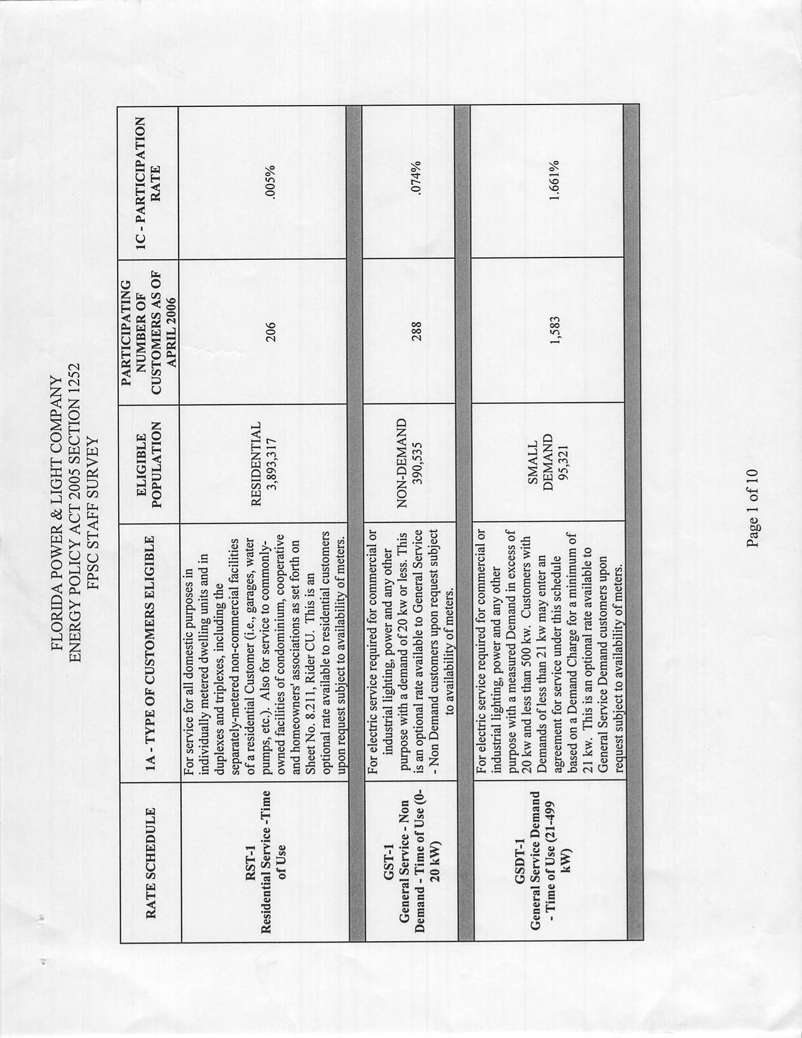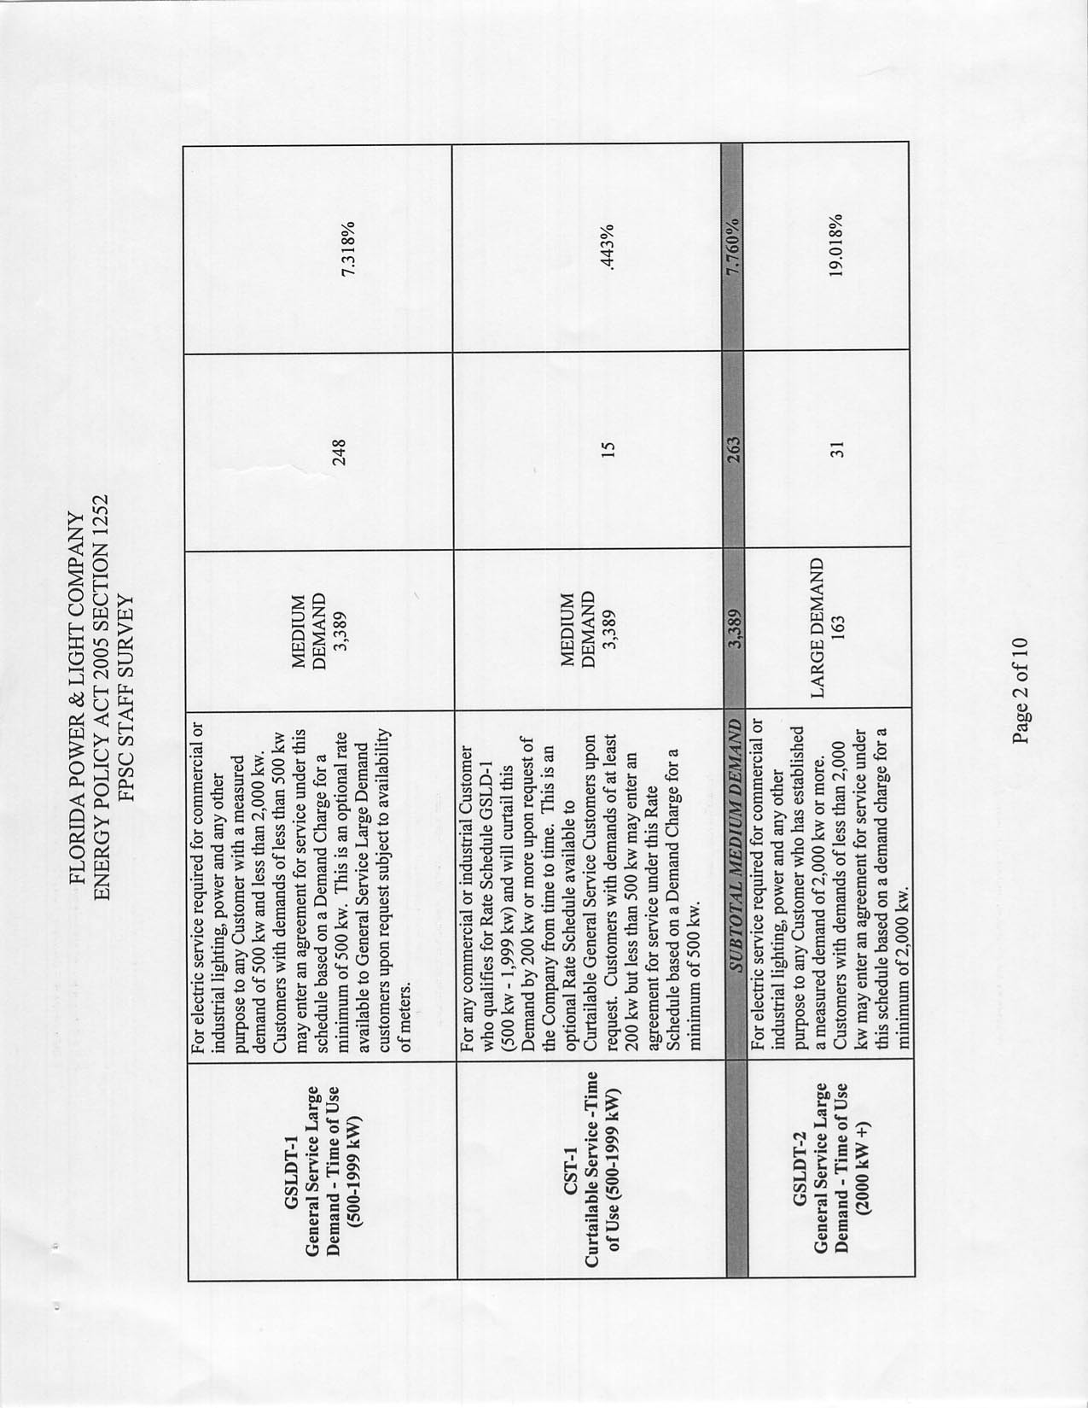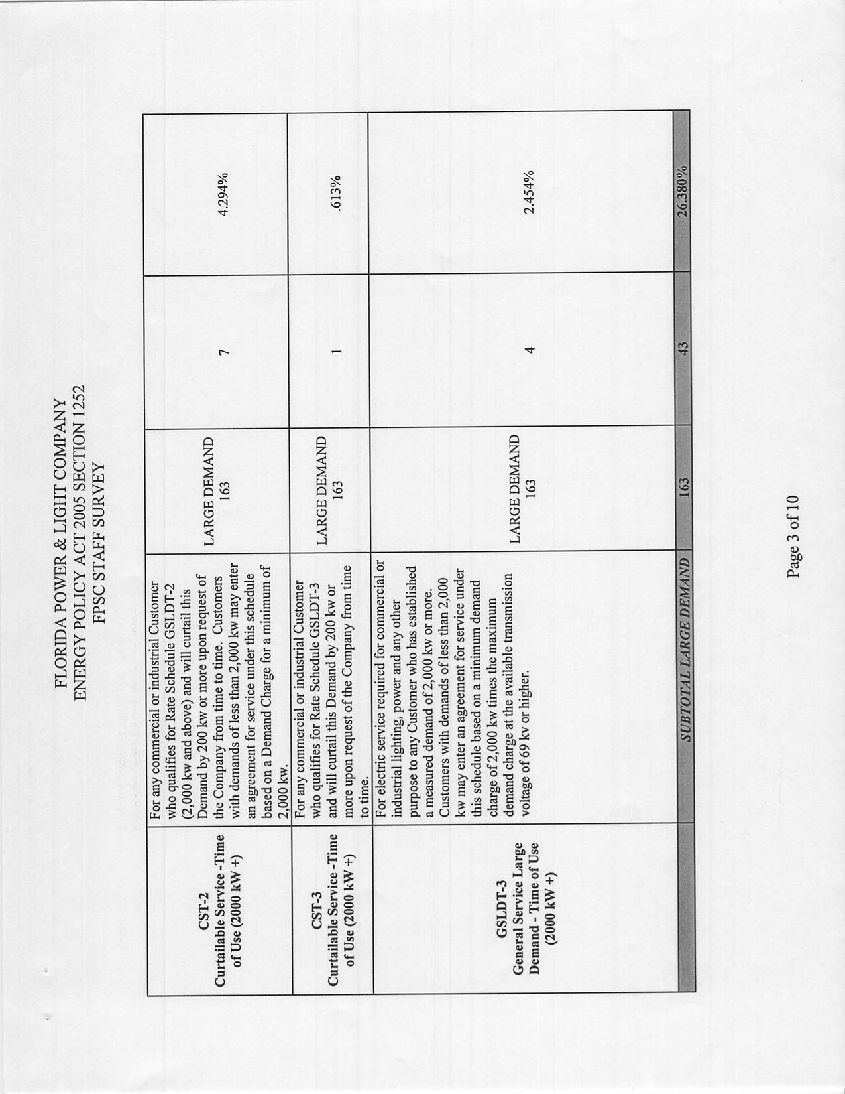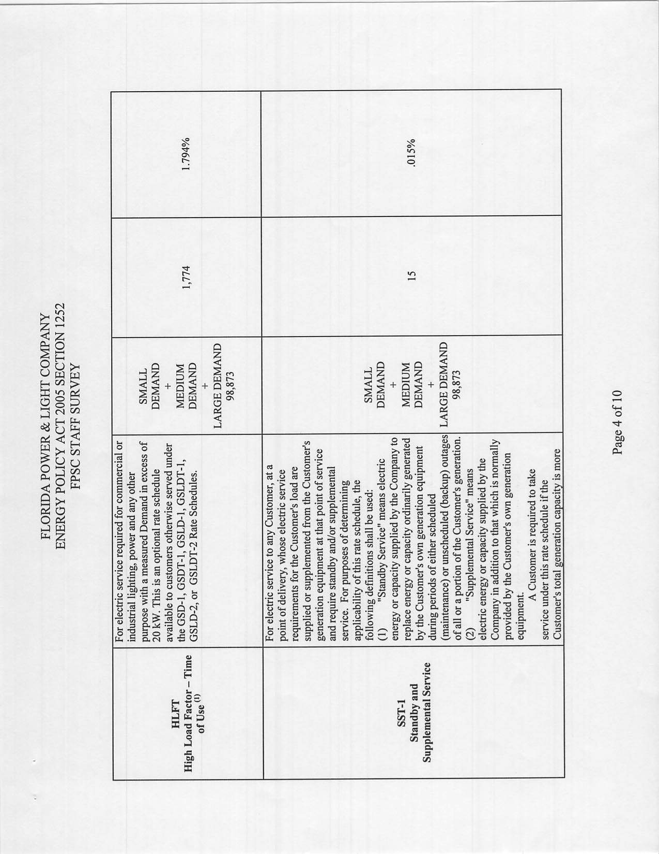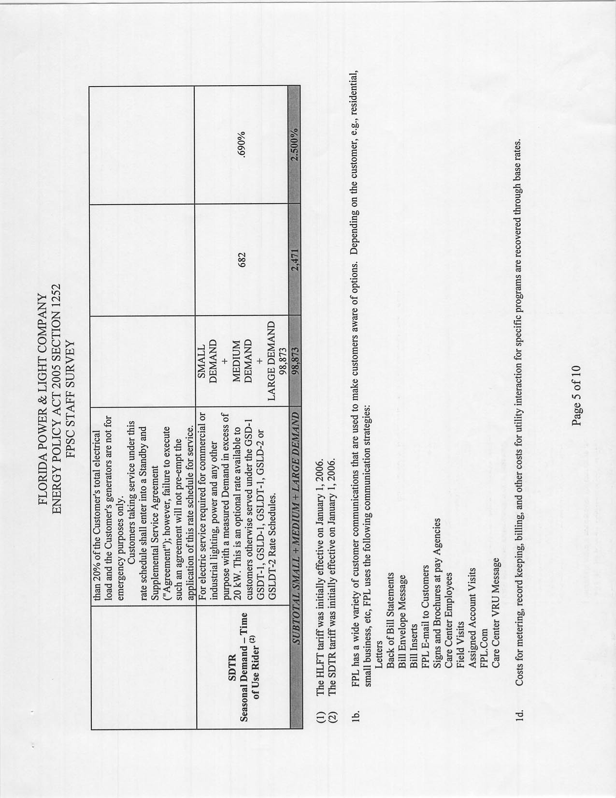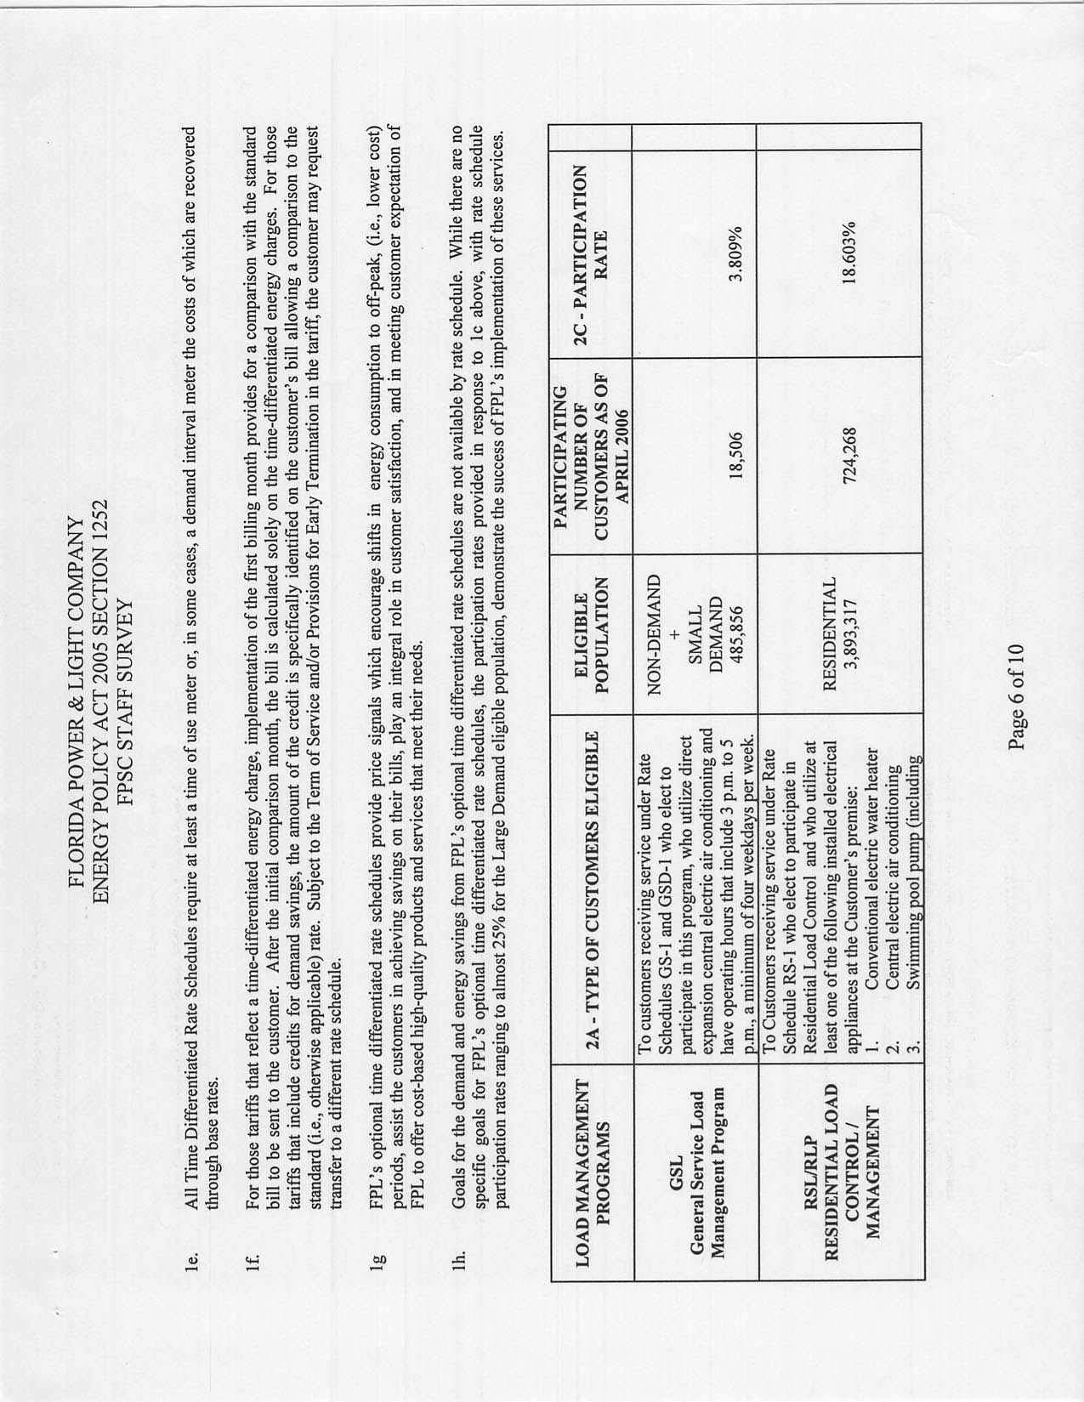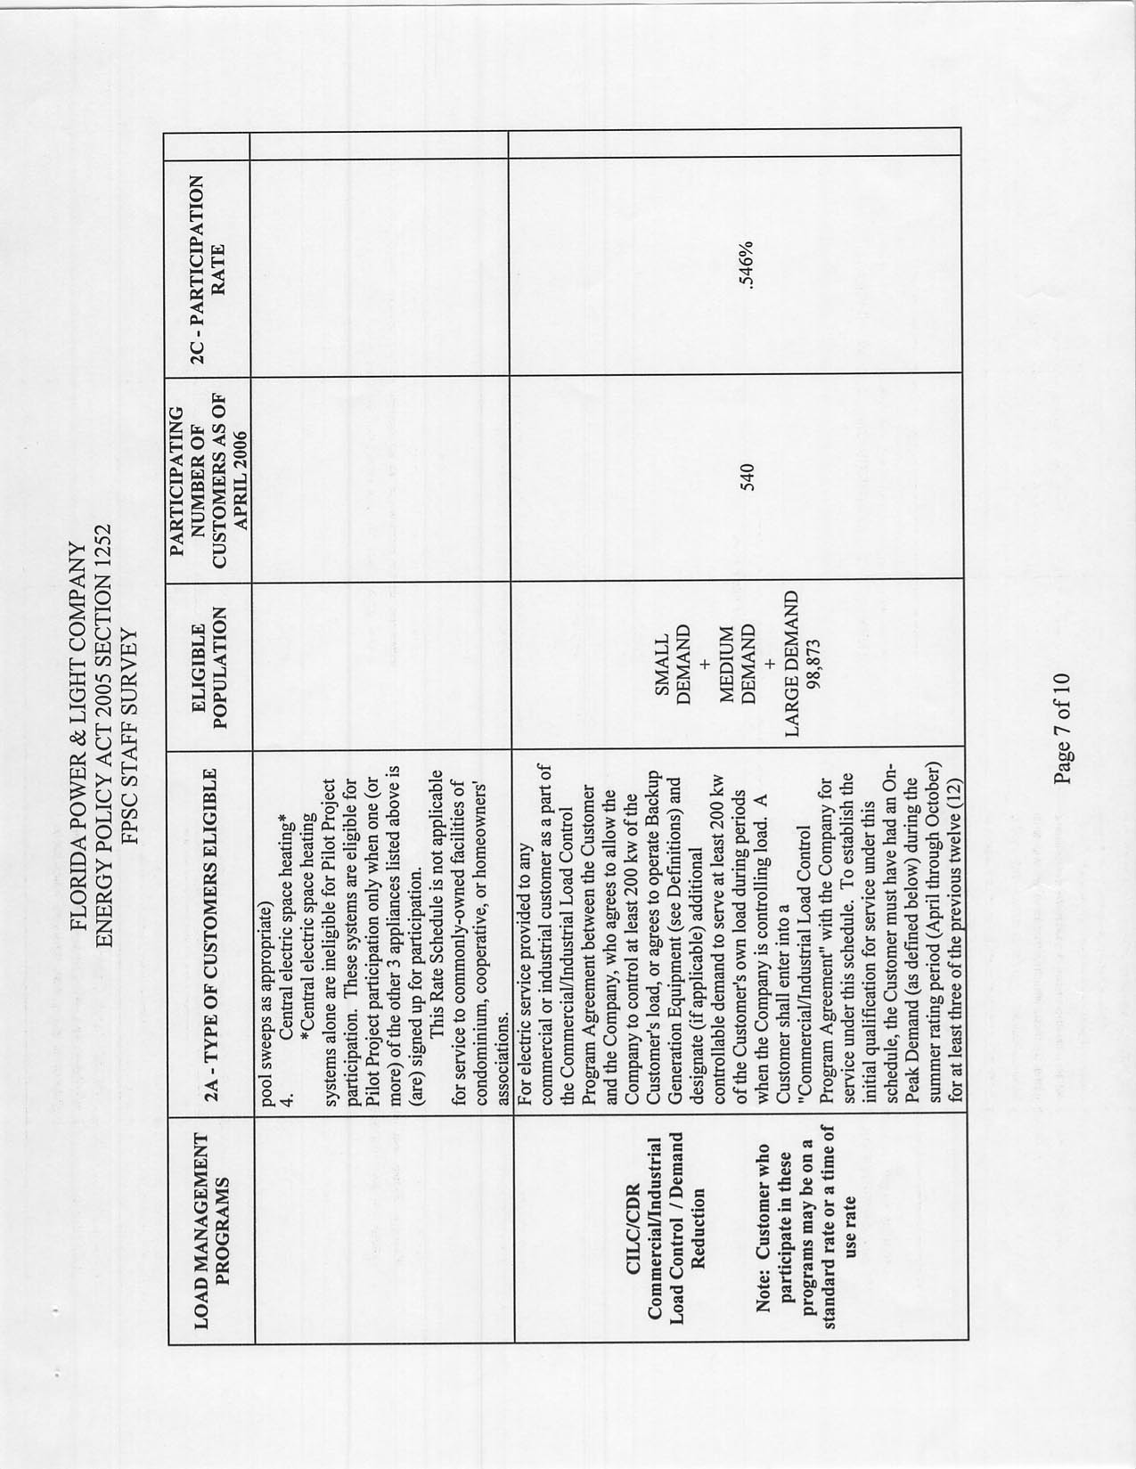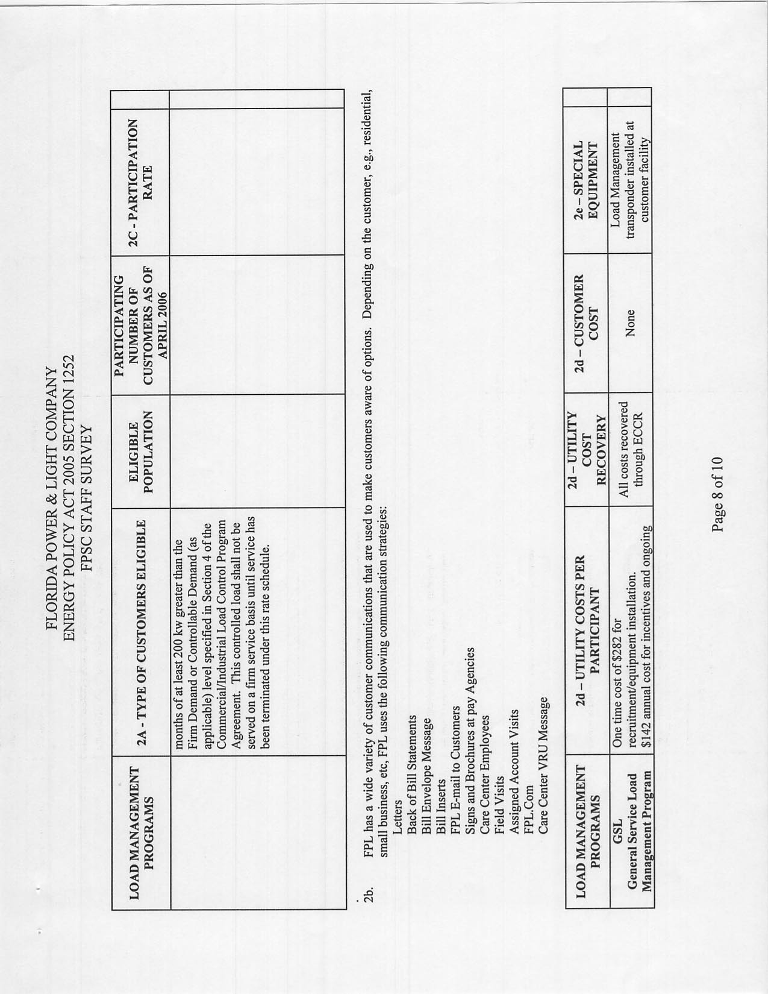
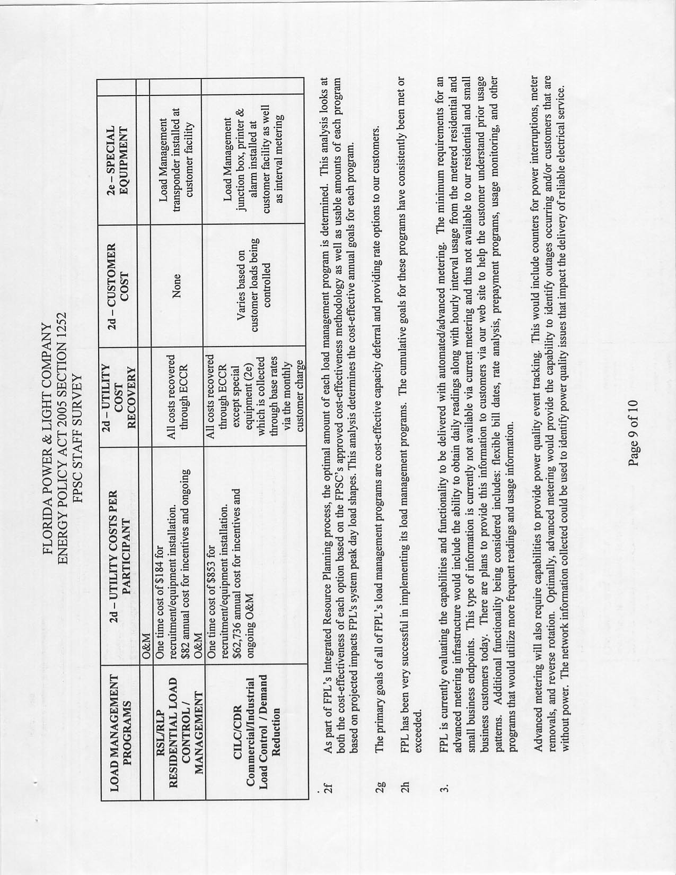
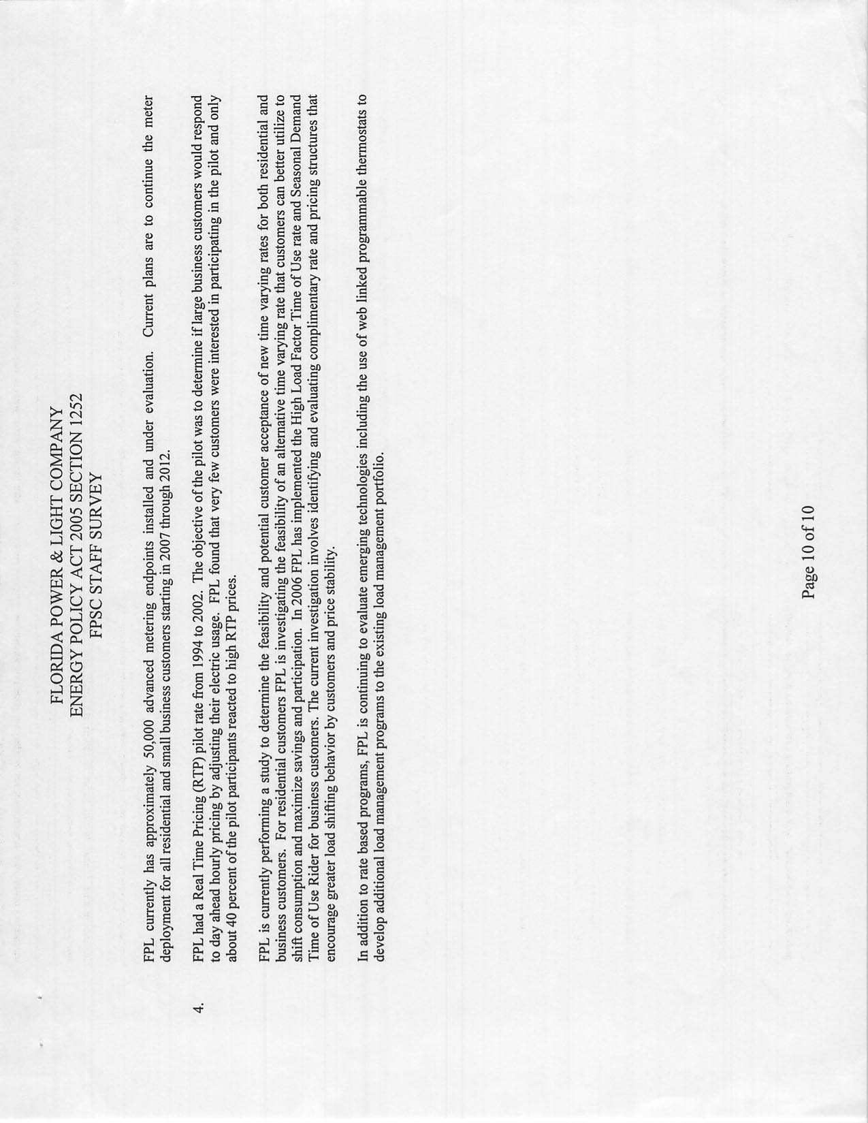
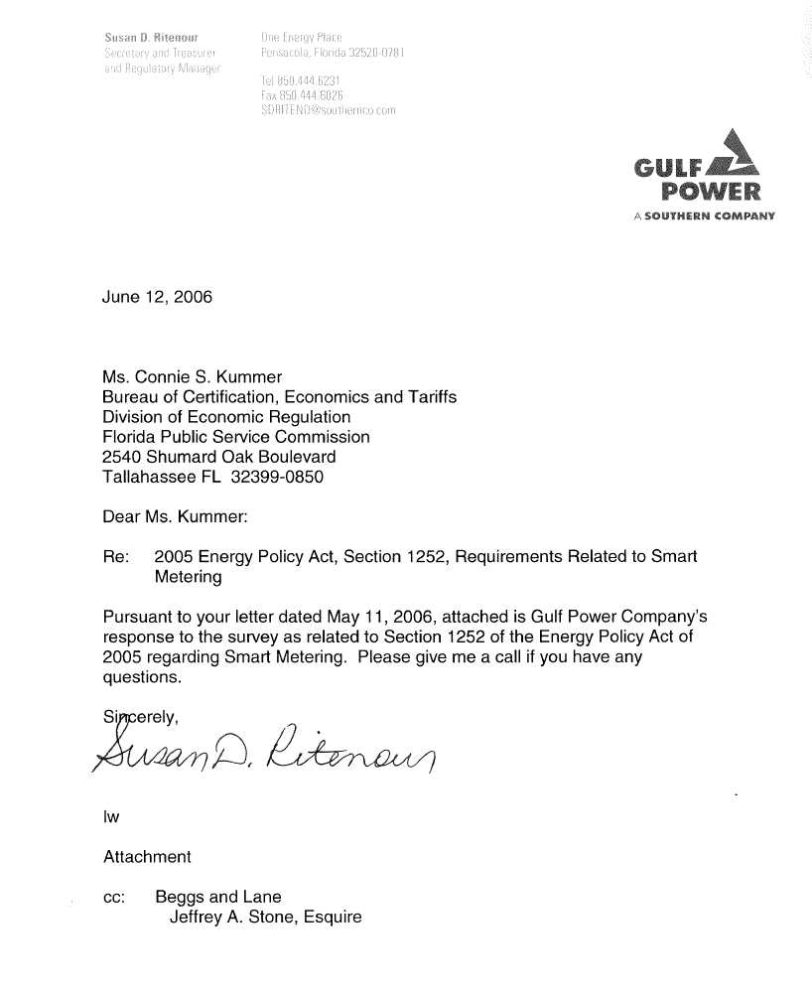
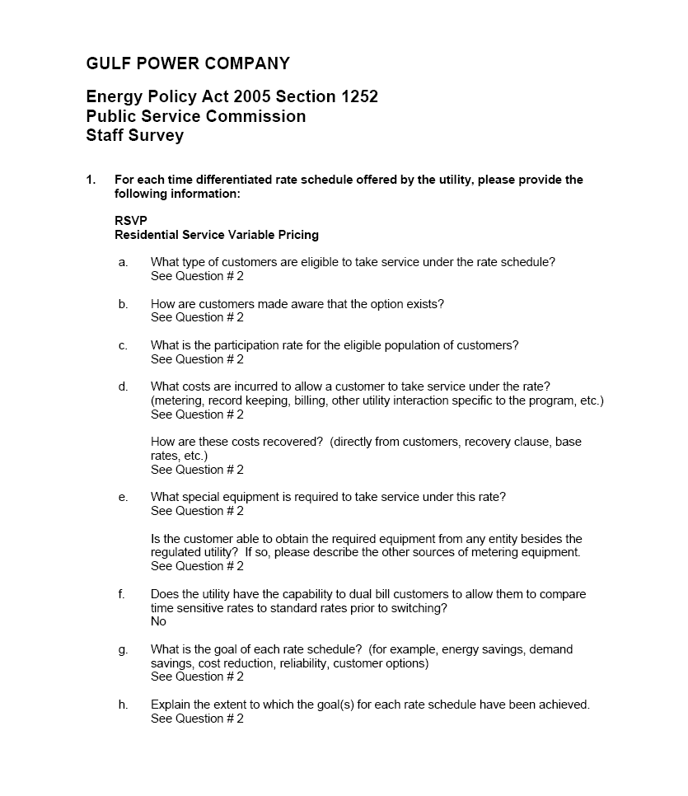
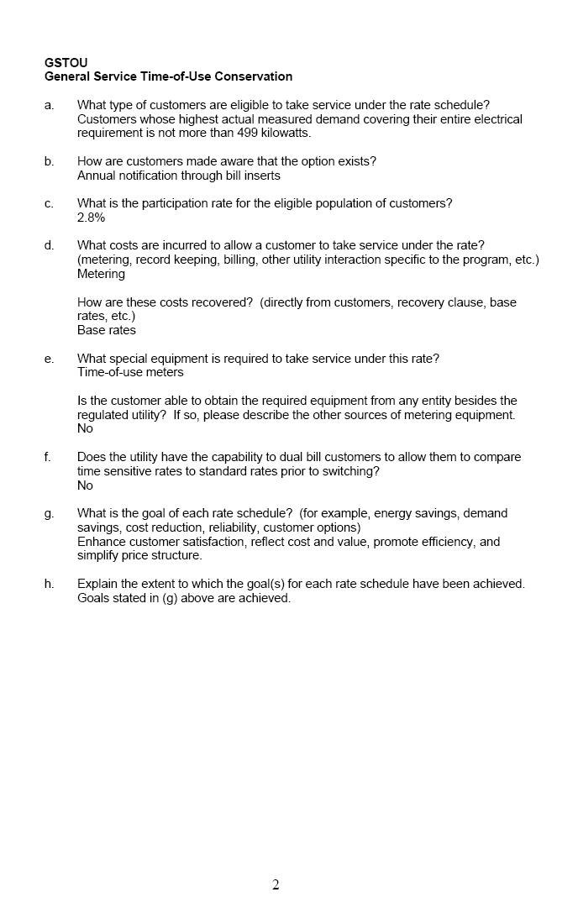
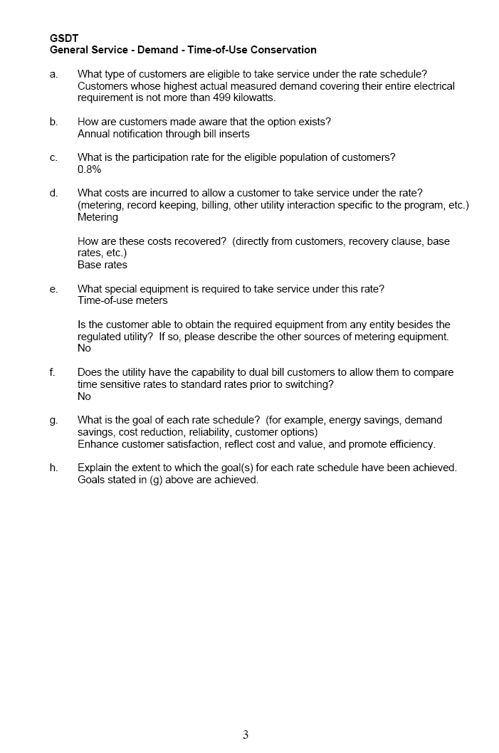
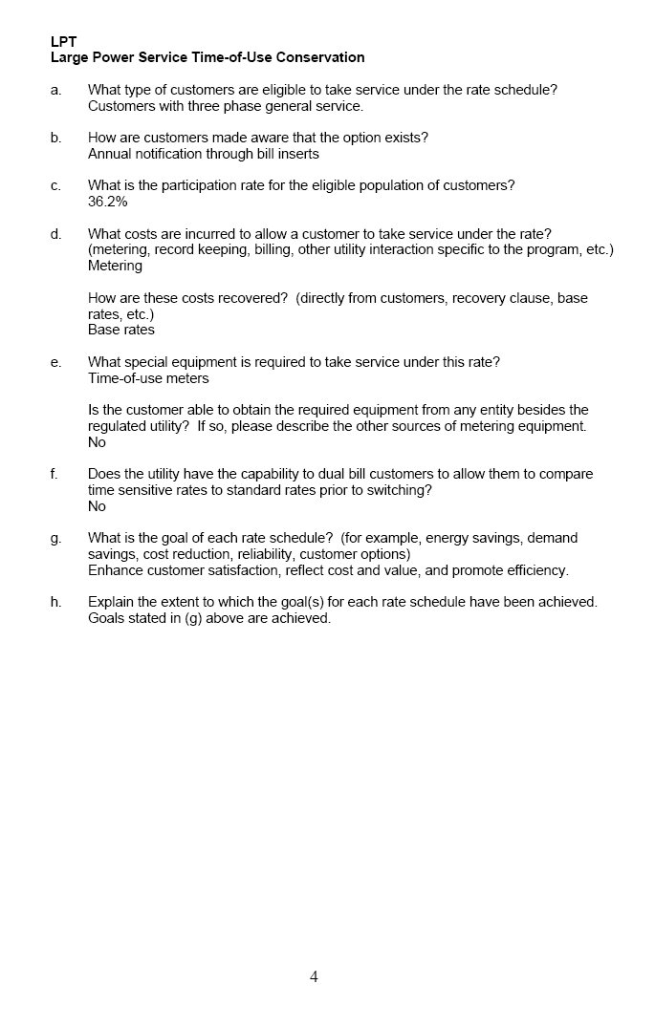
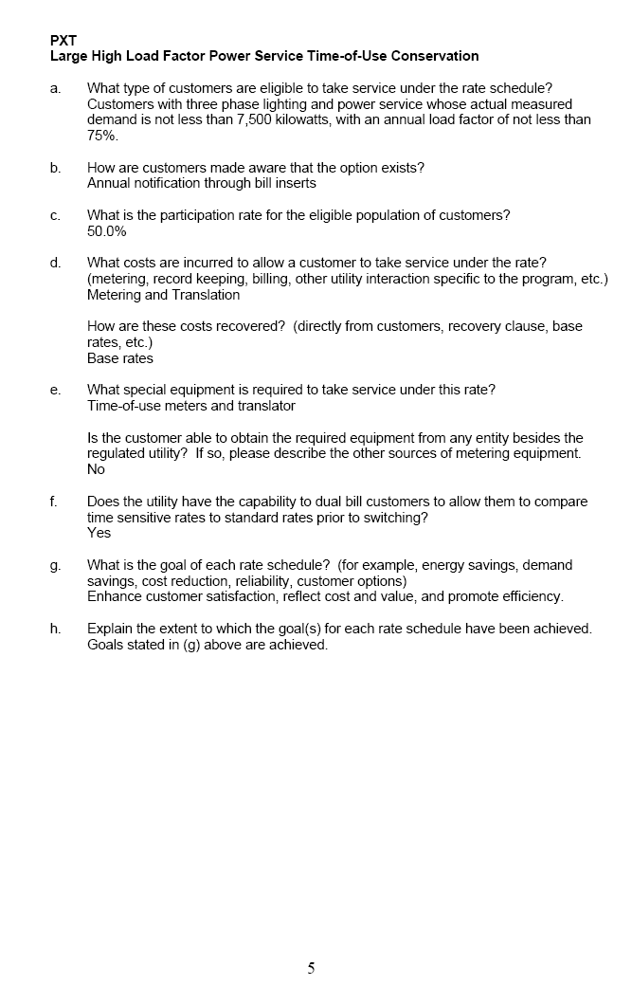
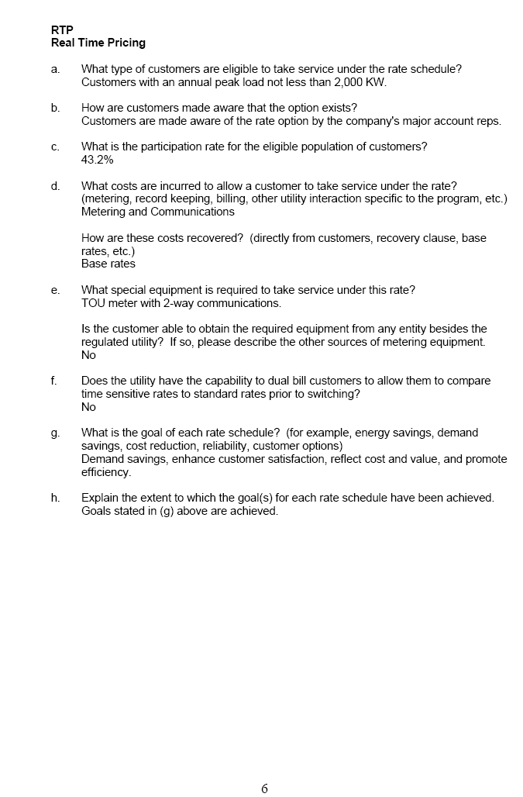
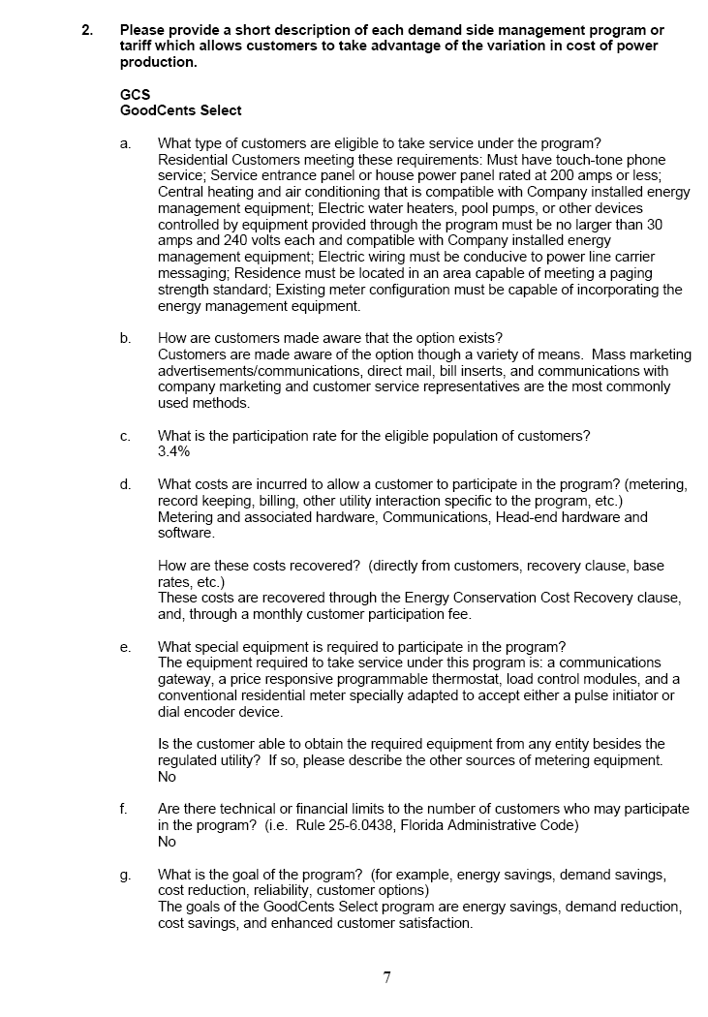
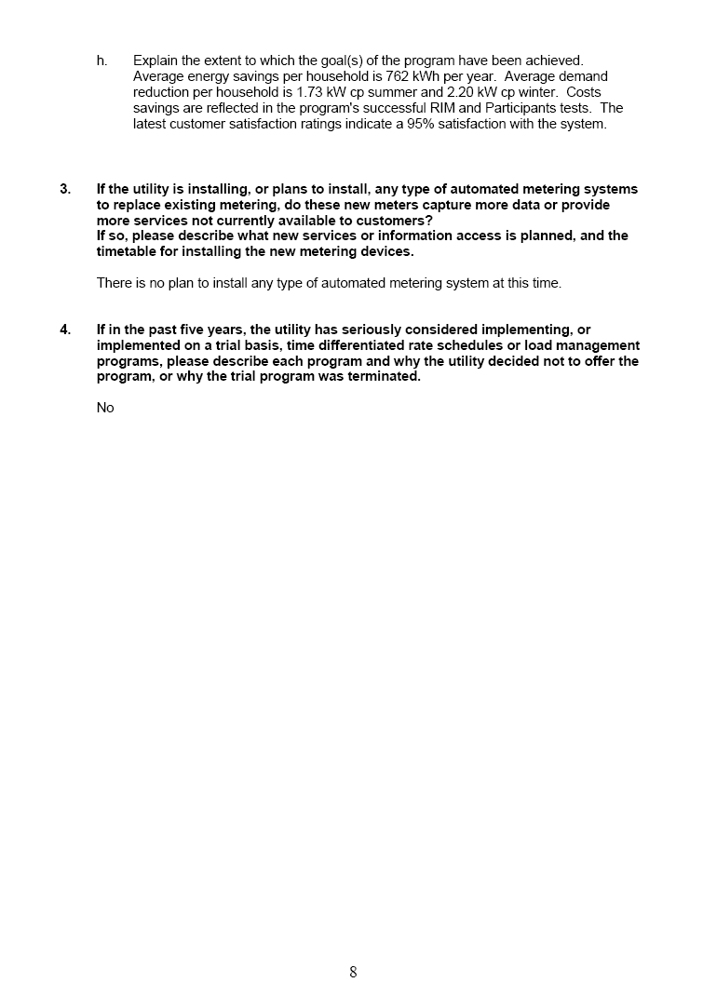

PEF’s Responses to EPAct Survey, Section 1252, Smart Metering

Q1. For each time differentiated rate schedule offered by the utility, please provide the following information:
a. What type of customers are eligible to take service under the rate schedule?
b. How are customers made aware of that the option exists?
c. What is the participation rate for the eligible population of customers?
d. What costs are incurred to allow a customer to take service under the rate? (metering, record keeping, billing, other utility interaction specific to the program, etc.) How are these costs recovered? (directly from customers, recovery clause, base rates, etc.)
e. What special equipment is required to take service under this rate? Is the customer able to obtain the required equipment from any entity besides the regulated utility? If so, please describe the other sources of metering equipment.
f. Does the utility have the capability to dual bill customers to allow them to compare time sensitive rates to standard rates prior to switching.
g. What is the goal of each rate schedule? (for example, energy savings, demand savings, cost reduction, reliability, customer options).
h. Explain the extent to which the goal(s) for each rate schedule have been achieved.
Answer:
Rate Schedule – RST-1 – Residential Service – Optional Time of Use Rate
- All residential customers otherwise eligible for service under Rate Schedule RS-1 are eligible to take service under Rate Schedule RST-1.
- Customers are made aware that Rate Schedule RST-1 is available through the Company’s tariffs, regular bill inserts, customer service contacts upon initial service, complaint resolutions, and other general customer service programs.
- The participation rate for the eligible population of customers is less than 1%.
- The cost incurred to take service under Rate Schedule RST-1 is the cost associated with a Time of Use (TOU) meter, (excluding the initial billing program development not specifically identified in our Customer Billing System’s development). The cost of the TOU meter is recovered directly from customers as part of the RST-1 customer charge. The customer charge for a TOU meter is meter is approximately twice that of a non-TOU meter. At the customer’s option an initial Contribution in Aid of Construction (CIAC) payment can be made and the non-TOU customer charge will apply.
- The only special equipment required to take service under Rate Schedule RST-1 is a meter capable of metering time differentiated use (i.e. TOU meter). The customer can only obtain a TOU meter from the Company.
- The Company does not have the ability to dual bill; however, if a customer has a TOU meter installed, the Company can provide tariff comparison data to determine the most advantageous tariff for the customer. The Company’s RST-1 tariff has certain term of service limitations for switching between TOU and non-TOU tariffs.
- The goals of Rate Schedule RST-1 are demand savings, cost reductions, customer choice, price awareness, as well as the ability of the Company to improve overall system load factor.
- The Company is providing customer choice and is helping customers understand the price impacts and the benefit of shifting usage to off-peak periods.
Rate Schedule – GST-1 – General Service-Non Demand – Optional Time of Use Rate
- All non-residential customers otherwise eligible for service under Rate Schedule GS-1 are eligible to take service under Rate Schedule GST-1.
- Customers are made aware that Rate Schedule GST-1 is available through the Company’s tariffs, regular bill inserts, customer service contacts upon initial service, complaint resolutions, periodic rate application reviews and other general customer service programs.
- The participation rate for the eligible population of customers is less than 1%.
- The cost incurred to take service under Rate Schedule GST-1 is the cost associated with a TOU meter, (excluding the initial billing program development not specifically identified in our Customer Billing System’s development). The cost of the TOU meter is recovered directly from customers as part of the GST-1 customer charge. The customer charge for a TOU meter is approximately twice that of a non-TOU meter. At the customer’s option an initial CIAC payment can be made and the non-TOU customer charge will apply.
- The only special equipment required to take service under Rate Schedule GST-1 is a meter capable of metering time differentiated use (i.e. TOU meter). The customer can only obtain a TOU meter from the Company.
- The Company does not have the ability to dual bill; however, if a customer has a TOU meter installed, the Company can provide tariff comparison data to determine the most advantageous tariff for the customer. The Company’s GST-1 tariff has certain term of service limitations for switching between TOU and non-TOU tariffs.
- The goals of Rate Schedule GST-1 are demand savings, cost reductions, customer choice, price awareness, as well as the ability of the Company to improve overall system load factor.
- The Company is providing customer choice and is helping customers understand the price impacts and the benefit of shifting usage to off-peak periods.

Rate Schedule – GSDT-1 – General Service-Demand – Optional Time of Use Rate
- All customers otherwise eligible for service under Rate Schedule GSD-1 are eligible to take service under Rate Schedule GSDT-1.
- Customers are made aware that Rate Schedule GSDT-1 is available through the Company’s tariffs, regular bill inserts, customer service contacts upon initial service, complaint resolutions, periodic rate application reviews and other general customer service programs.
- The participation rate for the eligible population of customers is approximately 18%.
- The cost incurred to take service under Rate Schedule GSDT-1 is the cost associated with a TOU meter, (excluding the initial billing program development not specifically identified in our Customer Billing System’s development). The cost of the TOU meter is recovered directly from customers as part of the GSDT-1 customer charge. The customer charge for a TOU meter is meter is approximately twice that of a non-TOU meter. At the customer’s option an initial CIAC payment can be made and the non-TOU customer charge will apply.
- The only special equipment required to take service under Rate Schedule GSDT-1 is a meter capable of metering time differentiated use (i.e. TOU meter). The customer can only obtain a TOU meter from the Company.
- The Company does not have the ability to dual bill; however, if a customer has a TOU meter installed, the Company can provide tariff comparison data to determine the most advantageous tariff for the customer. The Company’s GSDT-1 tariff has certain term of service limitations for switching between TOU and non-TOU tariffs.
- The goals of Rate Schedule GSDT-1 are demand savings, cost reductions, customer choice, price awareness, as well as the ability of the Company to improve overall system load factor.
- The Company is providing customer choice and is helping customers understand the price impacts and the benefit of shifting usage to off-peak periods. Although the Company does not specifically measure these goals in isolation, the participation level for the eligible customer population would indicate that the goals of demand savings, cost reductions and improvement to overall system load factor have been met.

Rate Schedules – CST-1, CST-2 & CST-3 – Curtailable General Service – Optional Time of Use Rates
- All customers otherwise eligible for service under Rate Schedule CS-1, CS-2 and CS-3 are eligible to take service under Rate Schedules CST-1, CST-2 or CST-3, respectively.
- Customers are made aware that Rate Schedules CST-1, CST-2 and CST-3 are available through the Company’s tariffs, regular bill inserts, customer service contacts upon initial service, complaint resolutions, periodic rate application reviews and other general customer service programs.
- The participation rate for the eligible population of customers is approximately 55%.
- The incremental cost incurred to take service under Rate Schedule CST-1, CST-2 and CST-3 is negligible (excluding the initial billing program development not specifically identified in our Customer Billing System’s development).
- The only special equipment required to take service under Rate Schedule CST-1, CST-2 and CST-3 is a meter capable of metering time differentiated use (i.e. TOU meter). The customer can only obtain a TOU meter from the Company.
- The Company does not have the ability to dual bill; however, if a customer has a TOU meter installed, the Company can provide tariff comparison data to determine the most advantageous tariff for the customer. The Company’s CST-1, CST-2 and CST-3 tariffs have certain term of service limitations for switching between TOU and non-TOU tariffs.
- The goals of Rate Schedule CST-1, CST-2 and CST-3 are demand savings, cost reductions, customer choice, price awareness, as well as the ability of the Company to improve overall system load factor.
- The Company is providing customer choice and is helping customers understand the price impacts and the benefit of shifting usage to off-peak periods. Although the Company does not specifically measure these goals in isolation, the participation level for the eligible customer population would indicate that the goals of demand savings, cost reductions and improvement to overall system load factor have been met.

Rate Schedules – IST-1, IST-2 & IST-3 – Interruptible General Service – Optional Time of Use Rate
- All customers otherwise eligible for service under Rate Schedule IS-1, IS-2 and IS-3 are eligible to take service under Rate Schedules IST-1, IST-2 or IST-3, respectively.
- Customers are made aware that Rate Schedules IST-1, IST-2 and IST-3 are available through the Company’s tariffs, regular bill inserts, customer service contacts upon initial service, complaint resolutions, periodic rate application reviews and other general customer service programs.
- The participation rate for the eligible population of customers is 100%.
- The incremental costs incurred to take service under Rate Schedule IST-1, IST-2 and IST-3 is negligible (excluding the initial billing program development not specifically identified in our Customer Billing System’s development).
- The only special equipment required to take service under Rate Schedule IST-1, IST-2 and IST-3 is a meter capable of metering time differentiated use (i.e. TOU meter). The customer can only obtain a TOU meter from the Company.
- The Company does not have the ability to dual bill; however, if the customer has a TOU meter installed, the Company can provide tariff comparison data to determine the most advantageous tariff for the customer. The Company’s IST-1, IST-2 and IST-3 tariffs have certain term of service limitations for switching between TOU and non-TOU tariffs.
- The goals of Rate Schedule IST-1, IST-2 and IST-3 are demand savings, cost reductions, customer choice, price awareness, as well as the ability of the Company to improve overall system load factor.
- The Company is providing customer choice and is helping customers understand the price impacts and the benefit of shifting usage to off-peak periods. Although the Company does not specifically measure these goals in isolation, the participation level for the eligible customer population would indicate that the goals of demand savings, cost reductions and improvement to overall system load factor have been met.
Q2. Please provide a short description of each demand side management program or tariff which allows customers to take advantage the variation in cost of power production.
a. What type of customers are eligible to take service under the program?
b. How are customers made aware that the option exists?
c. What is the participation rate for the eligible population of customers?
d. What costs are incurred to allow a customer to participate in the program? (metering, record keeping, billing, other utility interaction specific to the program, etc.) How are these costs recovered? (directly from customers, recovery clause, base rates, etc.)
e. What special equipment is required to participate in the program? Is the customer able to obtain the required equipment from any entity besides the regulated utility? If so, please describe the other sources of metering equipment.
f. Are there technical or financial limits to the number of customers who may participate in the program? (i.e. Rule 25-6.0438, Florida Administrative Code)
g. What is the goal of the program? (for example, energy savings, demand savings, cost reduction, reliability, customer options)
h. Explain the extent to which the goal(s) of the program have been achieved.
Answer:
PEF does not have any Demand Side Management (DSM) programs or DSM tariffs that allow customers to take advantage of the variation in cost of power production.

Q3. If the utility is installing, or plans to install, any type of automated metering systems to replace existing metering, do these new meters capture more data or provide more services not currently available to customers? If so, please describe what new services or information access is planned, and the timetable for installing the new metering devices.
Answer:
The Company is installing 1.5 million (non-demand) electronic meters manufactured by Itron as part of its Mobile Meter Reading (MMR) Project. Florida installations are scheduled to be completed in September, 2006.
The vast majority of the meters being installed are CENTRON® R300’s. This is a solid-state, residential meter that transmits cumulative energy consumption and tamper data via high-powered radio frequencies. The data is collected using drive-by receivers called mobile data collectors. These MMR meters have the capability to collect and transmit more detailed information to an automated meter reading system through a fixed communications network.

Q4. If in the past five years, the utility has seriously considered implementing, or implemented on a trial basis, time differentiated rate schedules or load management programs, please describe each program and why the utility decided not to offer the program, or why the trial program was terminated.
Answer:
PEF ran a pilot program for researching a new load management program in collaboration with the University of Florida and Universidad Politécnica de Valencia from January 1, 2003 to February 28, 2005. This program, called the Demand Response Opportunity Pilot (DROP), enabled pilot customers to decide when and if they could reduce load, and at what price they wanted to participate in the Demand Response (DR) event. The results of the DROP program showed that a voluntary pay per use demand response program using market based prices would be ineffective in obtaining any significant load relief during peak load periods from the customer class that participated in the pilot. Prices of up to $2.00 per kWh were offered to nine (commercial, industrial and governmental customers) accounts and minimal participation produced very little peak load reduction. The typical high market value of $0.20 to $0.40 per kWh was well below most of the participant’s threshold for action.
Some issues identified during the pilot that would be critical for successful implementation include:
- Automated customer response to enable shorter response times.
- Baseline accuracy is necessary to correctly calculate the demand response incentive.
- Customer load reduction greater than 15% of baseline.
- Strong customer incentives to motivate customer response.
- Accurate selection of market (Retail facilities have limited demand reduction capabilities in their present state).

While such a program is ineffective at this time, PEF will continue to look at time differentiated rate schedules as technology evolves and processes are automated.

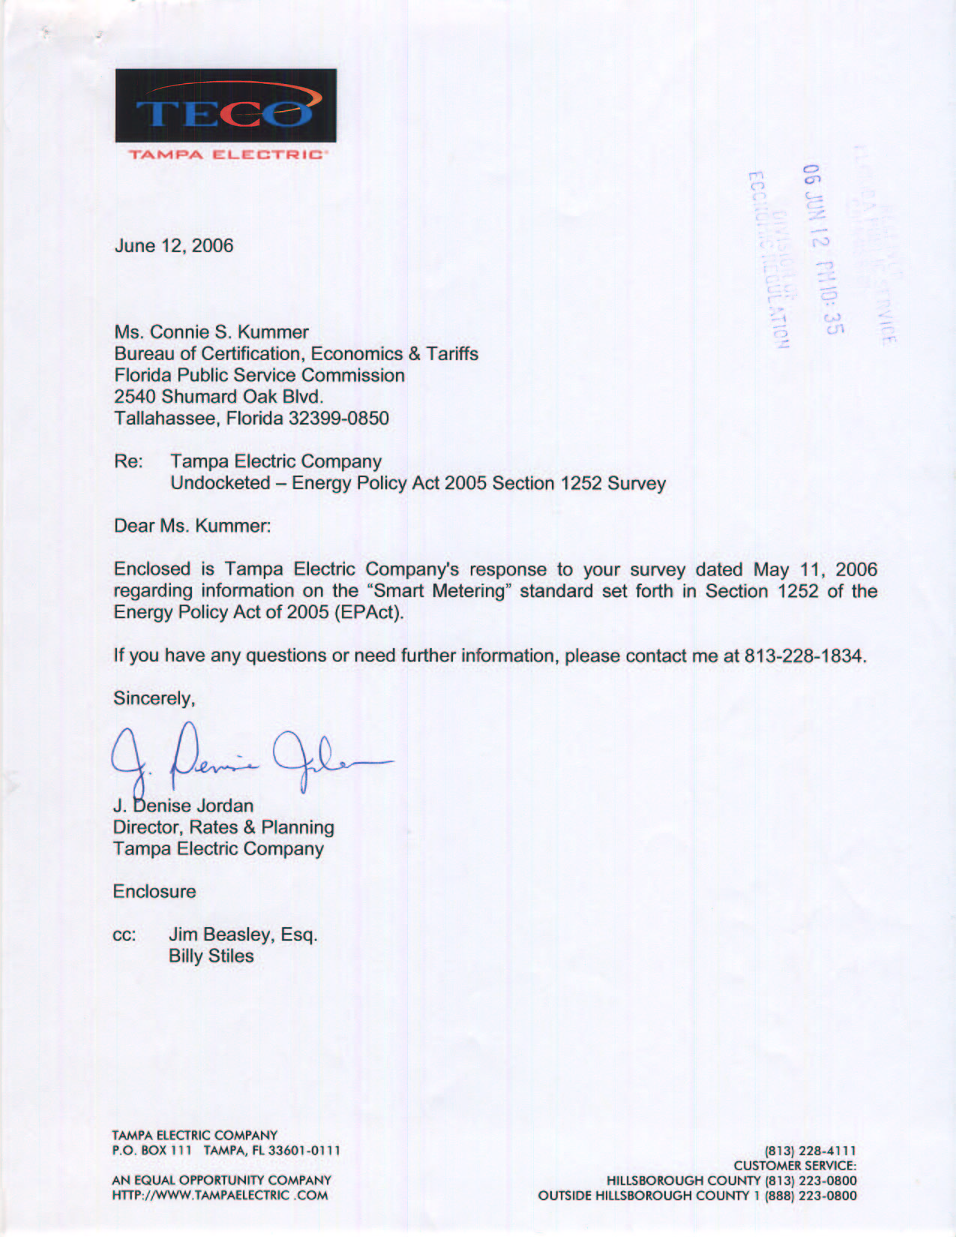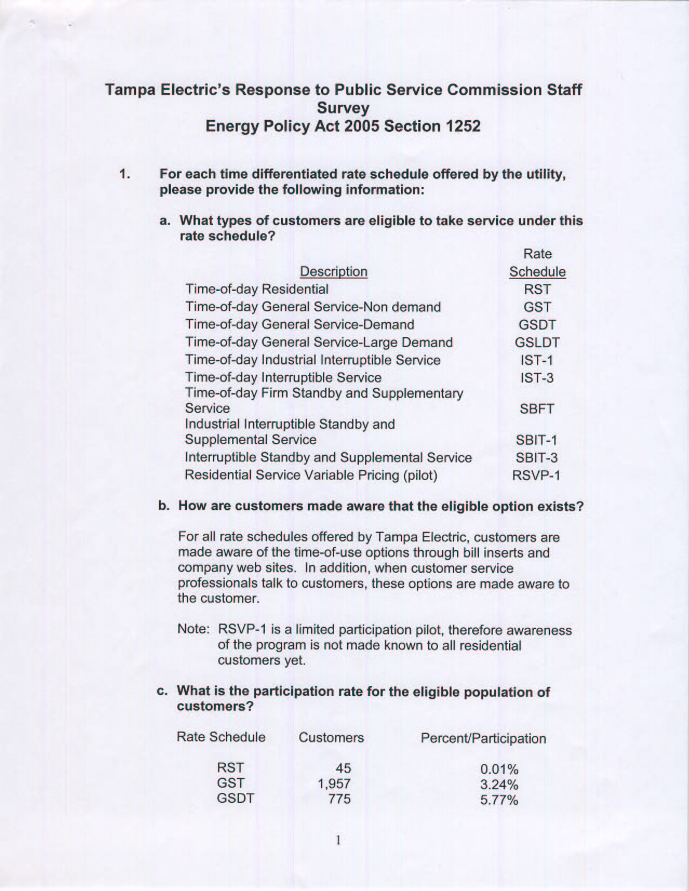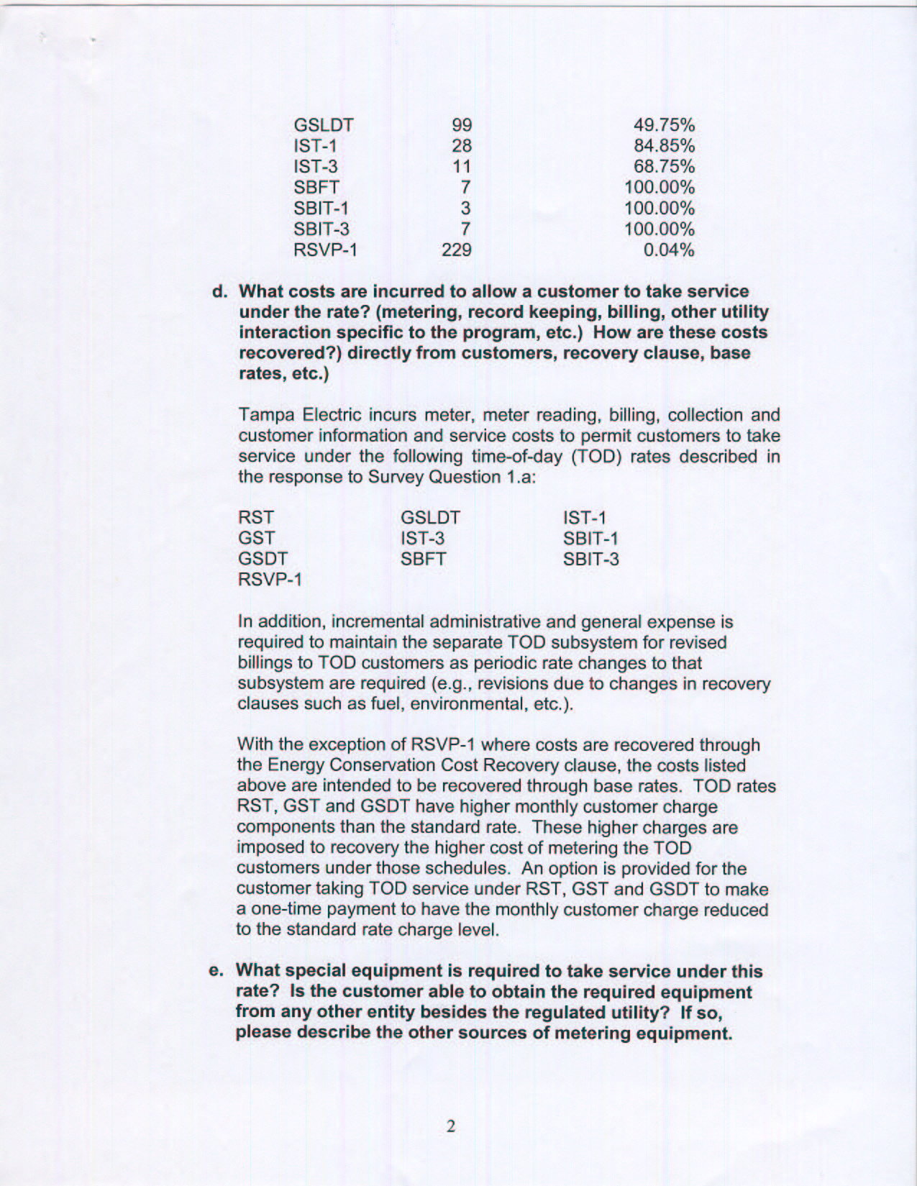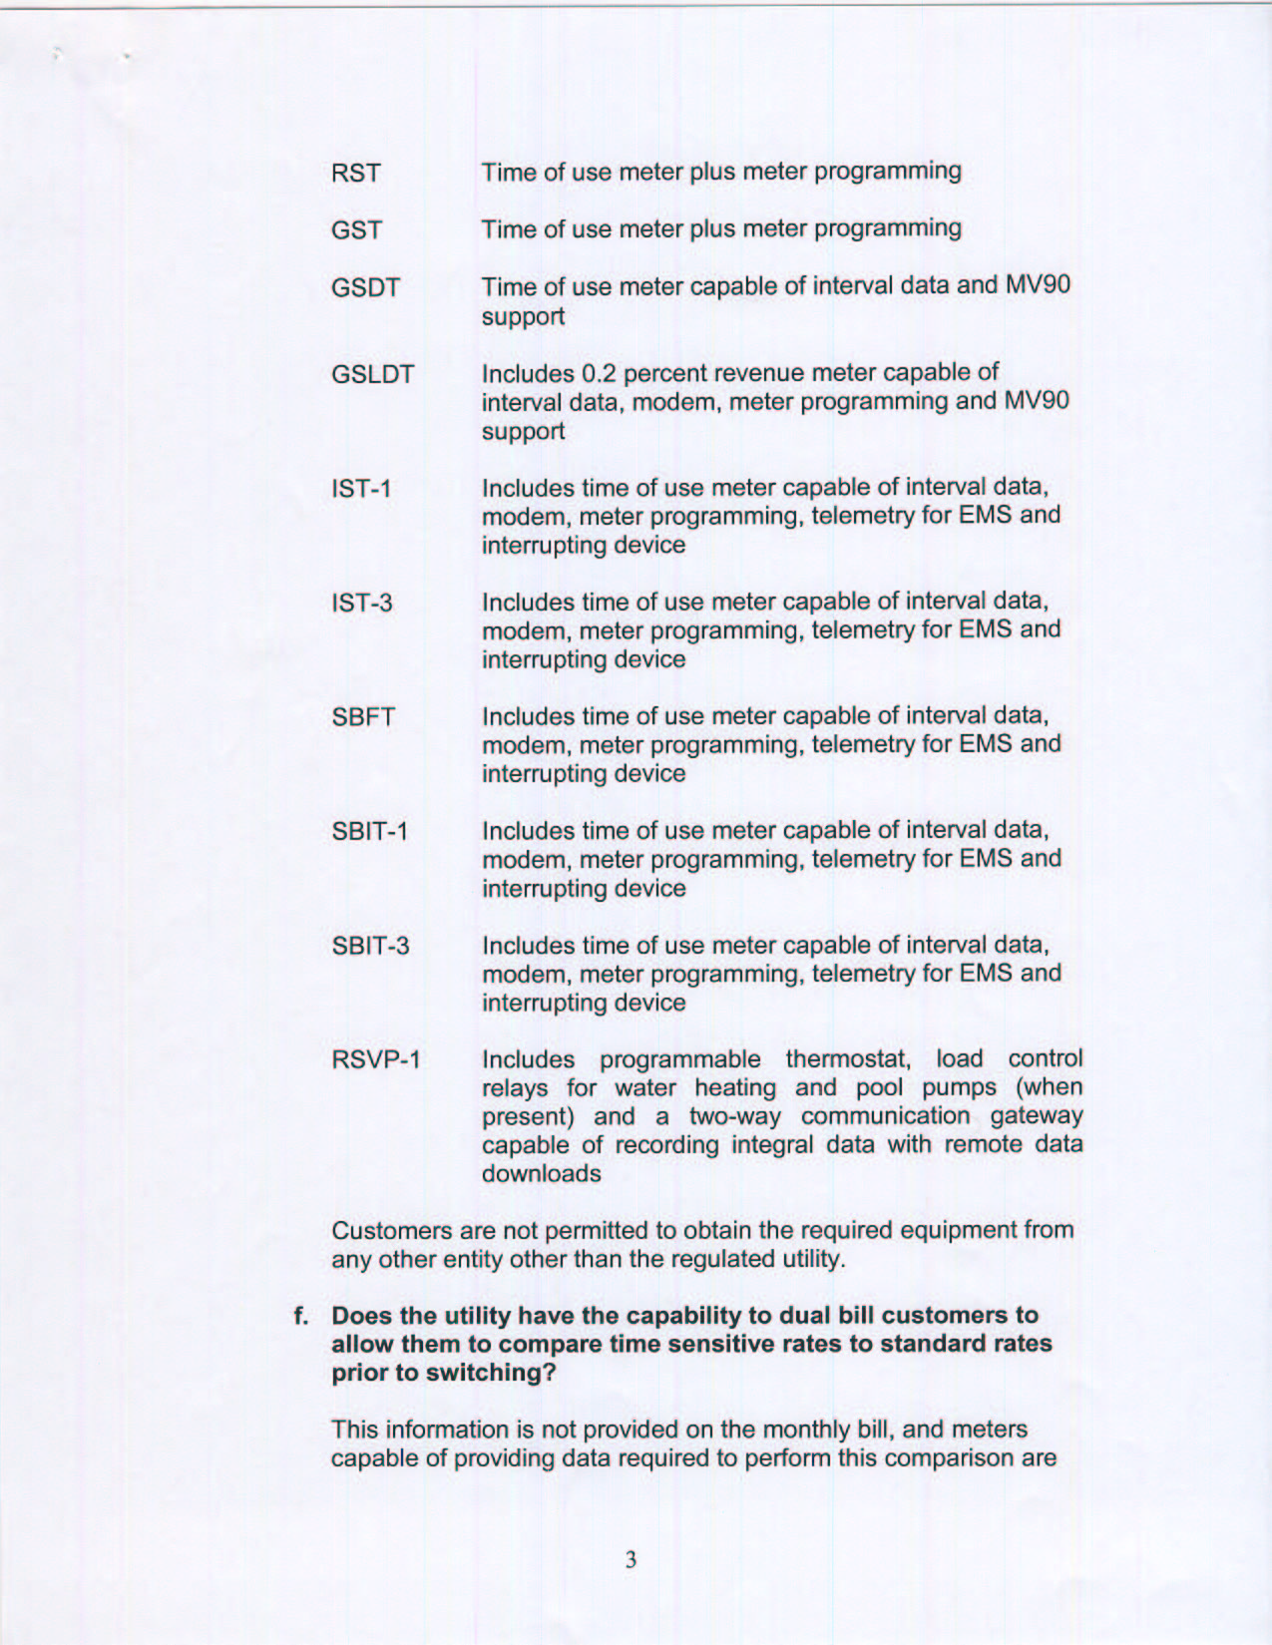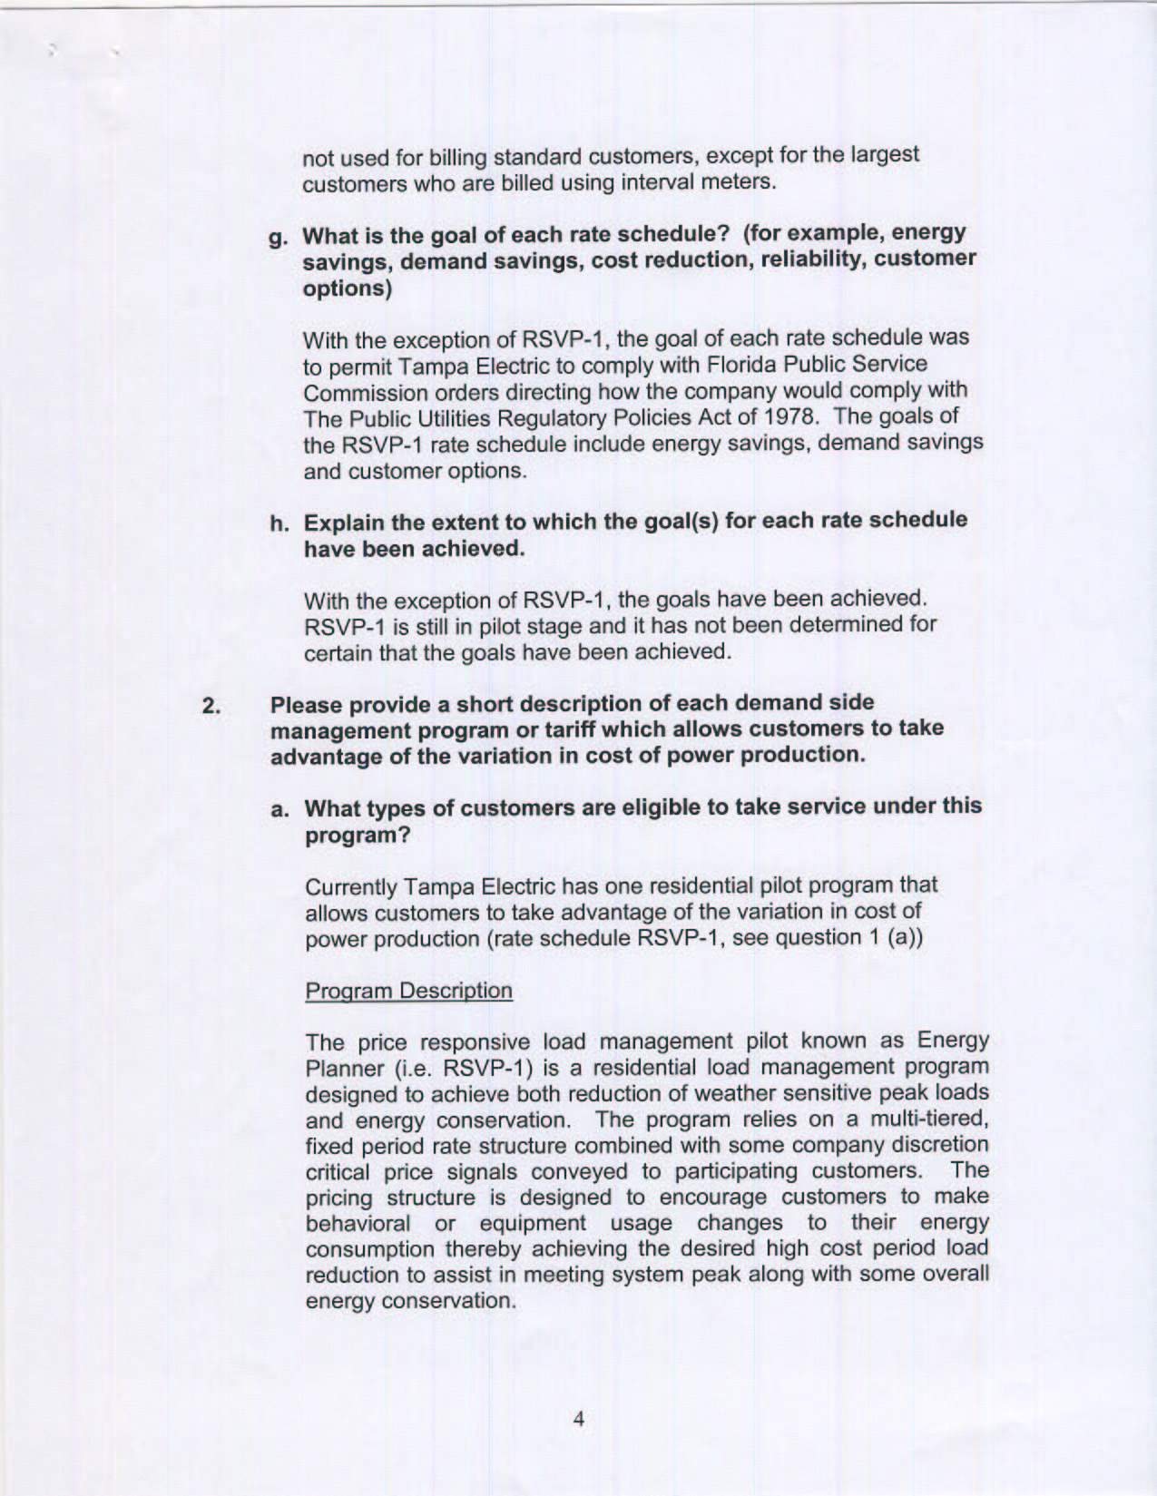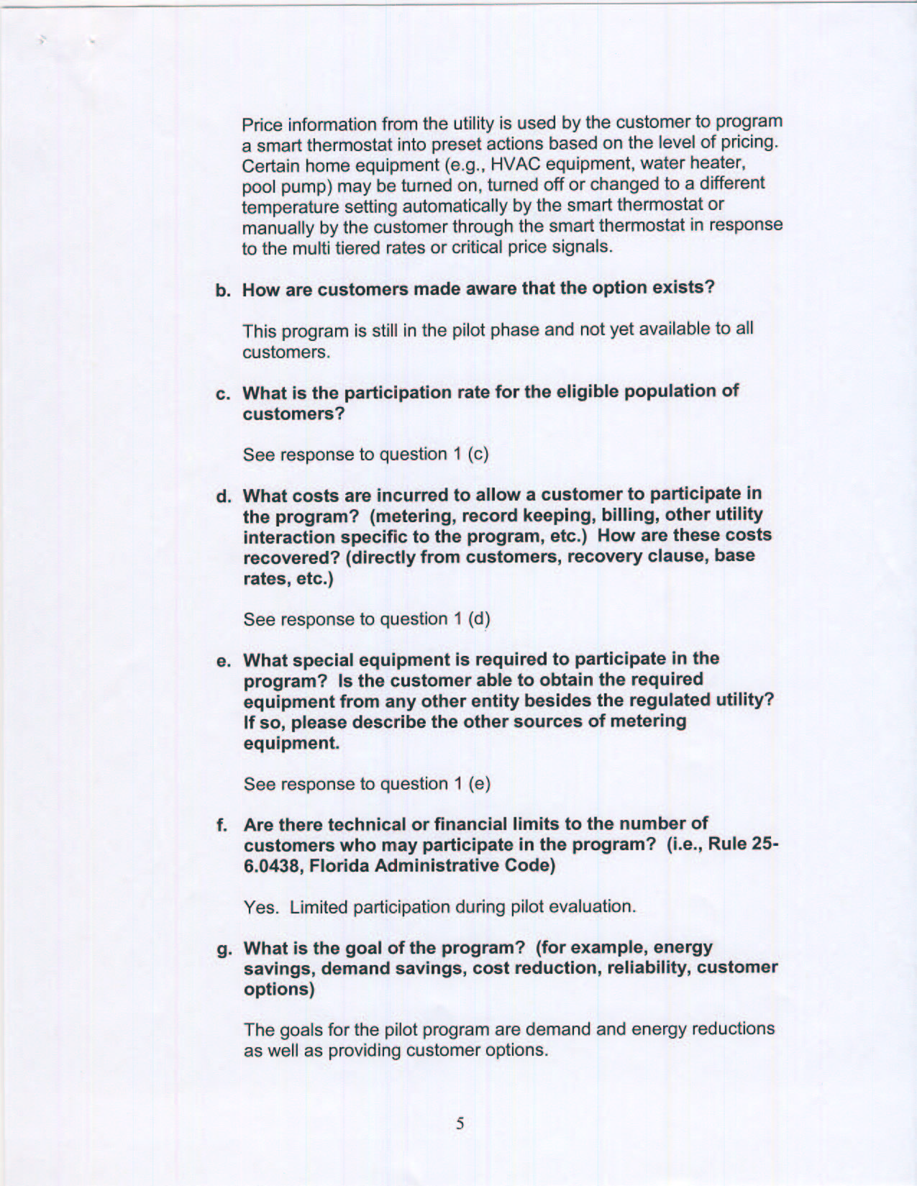
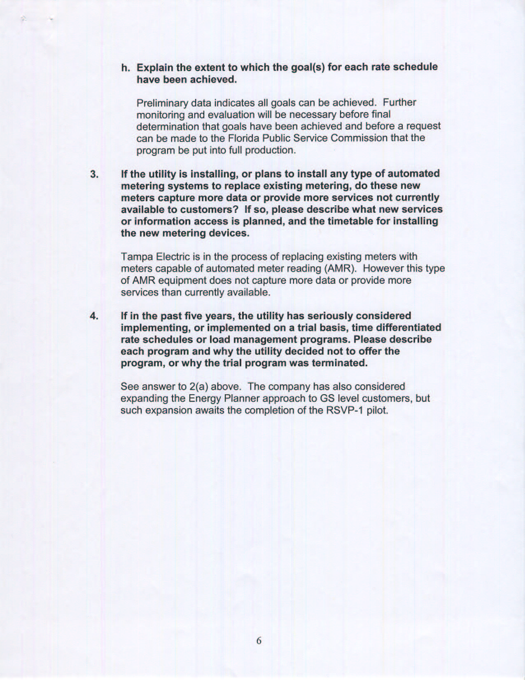

EPAct, Section 1252 (a)(14)(C)
Order 10179, issued on August 2, 1981, in Dockets 780793-EU, 790571-EU, 790593-EU, 790594-EU, and 790859-EU, In re: Consideration of PURPA Standards in the following dockets: Peal Load Pricing, Declining Block Rates, Cost of Service, Load Management, Decision Making.
Ibid, Section 1252(a)(14)(C)
IOU’s: Florida Power& Light, Progress Energy, Gulf Power, Tampa Electric, Florida Public Utilities Municipals: Beaches Energy, Ft. Pierce, GRU, JEA, City of Key West, KUA, Lakeland, Leesburg, Ocala, OUC, Reedy Creek, Tallahassee, Vero Beach Rural Cooperatives: Clay, Florida Keys, Lee County, Peace River, Sumter, Talquin, Withlacoochee River
Section 111 (a) differentiates between utilities for which the regulatory body has ratemaking authority and those for which it does not. It further charges each “nonregulated” utility to conduct a review on its own, similar to that required for PSC rate regulated utilities.. .
JEA, City of Lakeland, GRU, City of Ocala, and City of New Smyrna Beach.
JEA, City of Lakeland, OUC, GRU, TLH, City of Ocala, KUA, and City of New Smyrna Beach.

