State of Florida   |  | Public Service Commission  Capital Circle Office Center ● 2540 Shumard Oak Boulevard  Tallahassee, Florida 32399-0850  -M-E-M-O-R-A-N-D-U-M-
DATE: | April 12, 2007
TO: | Commission Clerk (Cole)
FROM: | Division of Economic Regulation (Baxter)  Office of the General Counsel (Holley)
RE: | Docket No. 070040-EI – Petition for approval to amend Rate Schedules CS-1 and LS-1, by Progress Energy Florida, Inc.
AGENDA: | 04/24/07 – Regular Agenda – Tariff Filing – Interested Persons May Participate
COMMISSIONERS ASSIGNED: |  |  | All Commissioners
PREHEARING OFFICER: |  |  | Administrative
CRITICAL DATES: |  |  | 09/08/07 (8-Month Effective Date)
SPECIAL INSTRUCTIONS: |  |  | None
FILE NAME AND LOCATION: |  |  | S:\PSC\ECR\WP\070040.RCM.DOC

Case Background
On January 11, 2007 Progress Energy Florida (PEF or company) filed a petition for Approval to Amend Rate Schedules SC-1 (Tariff Sheets 6.110 and 7.112) and LS-1 (Tariff Sheet 6.284). On March 2, 2007, the Commission issued Order No. PSC-07-0194-PCO-EI, suspending the proposed changes to PEF’s Rate Schedules SC-1 and LS-1.
The proposed change to rate schedule SC-1 would alter the application of the reconnection of service charge for nonpayment of bills for accounts with lighting fixtures. The dollar amount of the charge would not change, but its application would expand from the present single charge per account basis to a multiple charges per lighting installation basis.
The proposed change to rate schedule LS-1 would have restricted new lighting service taken after June 1, 2007, to PEF-owned, non-metered lighting and metered roadway lighting of federal, state, and local governments. PEF withdrew its requested change to rate schedule LS-1 on April 9, 2007.
The Commission has jurisdiction over these issues pursuant to Sections 366.04, 366.05, and 366.06, Florida Statutes.

Discussion of Issues
Issue 1: Should PEF’s petition to amend rate schedule SC-1 be approved?
Recommendation: Yes. Staff finds that the proposed change to the SC-1 rate schedule more equitably assigns reconnection costs to customers causing the expenses, and minimizes the amounts being shifted to other rate classes. PEF should notify its lighting customers in a mailing before the change in policy is implemented, and should also provide a sample calculation of the current and proposed reconnection charge amounts. (Baxter, Holley)
Staff Analysis: On January 11, 2007, PEF filed a petition to amend rate schedule SC-1. The rate schedule lists charges for activities such as initial connection of service to a premise and reconnection of service. PEF proposes to change the charges assessed for reconnection of service for accounts with lighting fixtures after disconnection for nonpayment of bills or violation of company or Commission rules. The present charges are $40.00 per account for a reconnection during business hours (Monday-Friday, 7 A.M. to 7 P.M.) and $50.00 for reconnection at any other time. PEF’s proposed change would not alter the dollar amount of the charges, but would give the Company the option of assessing the charge for each lighting fixture on an account, rather than assessing a single reconnection charge per account.
In response to staff inquiries, PEF stated that the proposed change was due to the large number of lighting reconnections they had to perform and the costs incurred for the reconnections. According to PEF, the reconnections typically occurred on accounts with multiple lighting fixtures, such as lighting accounts from suburban homeowners associations and housing developments. PEF stated that they were reconnecting 3-4 accounts per week, with a total of 15-50 fixtures. Based on PEF’s figures, the number of fixtures reconnected annually works out to a range between a minimum of 2,340 (3 x 15 x 52) fixtures and a maximum of 10,400 (4 x 50 x 52) fixtures. More precise figures were not available as PEF does not keep records of the exact number of lighting fixtures disconnected and reconnected. PEF incurred costs between $56.68 and $52.21 per fixture for disconnection and reconnection, with costs decreasing slightly as the number of fixtures reconnected for a particular account rose. Nearly 60% of the costs for disconnecting and reconnecting a fixture came from labor costs and the use of a bucket truck to remove and replace each fixture’s light bulb. PEF stated that they removed the light bulb from light fixtures, instead of shutting off power to them, since street lighting is typically on the same lines and circuits that provide service to homes and businesses, and not on a discrete circuit of its own. A development of the service charge can be found in Attachment A to this recommendation with costs provided for sample reconnections with 10, 20, 30, 50 and 90 fixtures. The costs are similar to what PEF provided to the Commission in its last rate case.
PEF asserts that the Company is presently incurring annual costs between $132,631 ($56.68 x 2,340) and $542,984 ($52.21 x 10,400) for disconnection and reconnection of lights for nonpayment of bills. Under the present service charges, PEF is presently receiving revenues between $6,240 (3 x 40 x 52) and $8,320 (4 x 40 x 52) to cover those costs. PEF stated that the amount presently collected per account is closer to $40 as PEF tries to schedule most of the reconnection work during normal business hours. By subtracting present revenues from present costs, PEF is presently losing between $126,391 and $534,664 annually for disconnection and reconnection of lights due to nonpayment of bills. PEF’s proposed amendment to rate schedule SC-1 would lower the Company’s losses to between $39,031 ($132,631 – (2,340 x $40)) and $126,984 ($542,984 – (10,400 x $40)). PEF’s proposed change to rate schedule SC-1 will lessen the losses that PEF is presently incurring.
Although the proposed change in the application of reconnection charges will result in increased charges to customers reconnecting, the increased cost is easy for a customer to avoid by simply paying their bill on time. Staff recommends approval of the proposed rate schedule since PEF’s proposed change more equitably assigns costs for disconnecting and reconnecting light fixtures to the customers causing the expenses, and lessens the amounts being shifted to other rate classes and customers. Staff recommends that PEF notify its lighting customers in a mailing before the change in policy is implemented, and provide a sample calculation of the current and proposed reconnection charge amounts.

Issue 2: Should this docket be closed?
Recommendation: Yes. If Issue 1 is approved, the revised Tariff Sheets Nos. 6.110 and 7.112 should become effective on June 1, 2007. PEF should notify its lighting customers in a mailing before the revised Tariff Sheets become effective, and also should provide a sample calculation of the current and proposed reconnection charge amounts. If a protest is filed within 21 days of the issuance of the order, the tariffs should remain in effect with any increase held subject to refund pending resolution of the protest. If no timely protest is filed, this docket should be closed upon the issuance of a consummating order. (Holley)
Staff Analysis: If Issue 1 is approved, the revised Tariff Sheets Nos. 6.110 and 7.112 should become effective on June 1, 2007. PEF should notify its lighting customers in a mailing before the revised Tariff Sheets become effective, and also should provide a sample calculation of the current and proposed reconnection charge amounts. If a protest is filed within 21 days of the issuance of the order, the tariffs should remain in effect with any increase held subject to refund pending resolution of the protest. If no timely protest is filed, this docket should be closed upon the issuance of a consummating order.
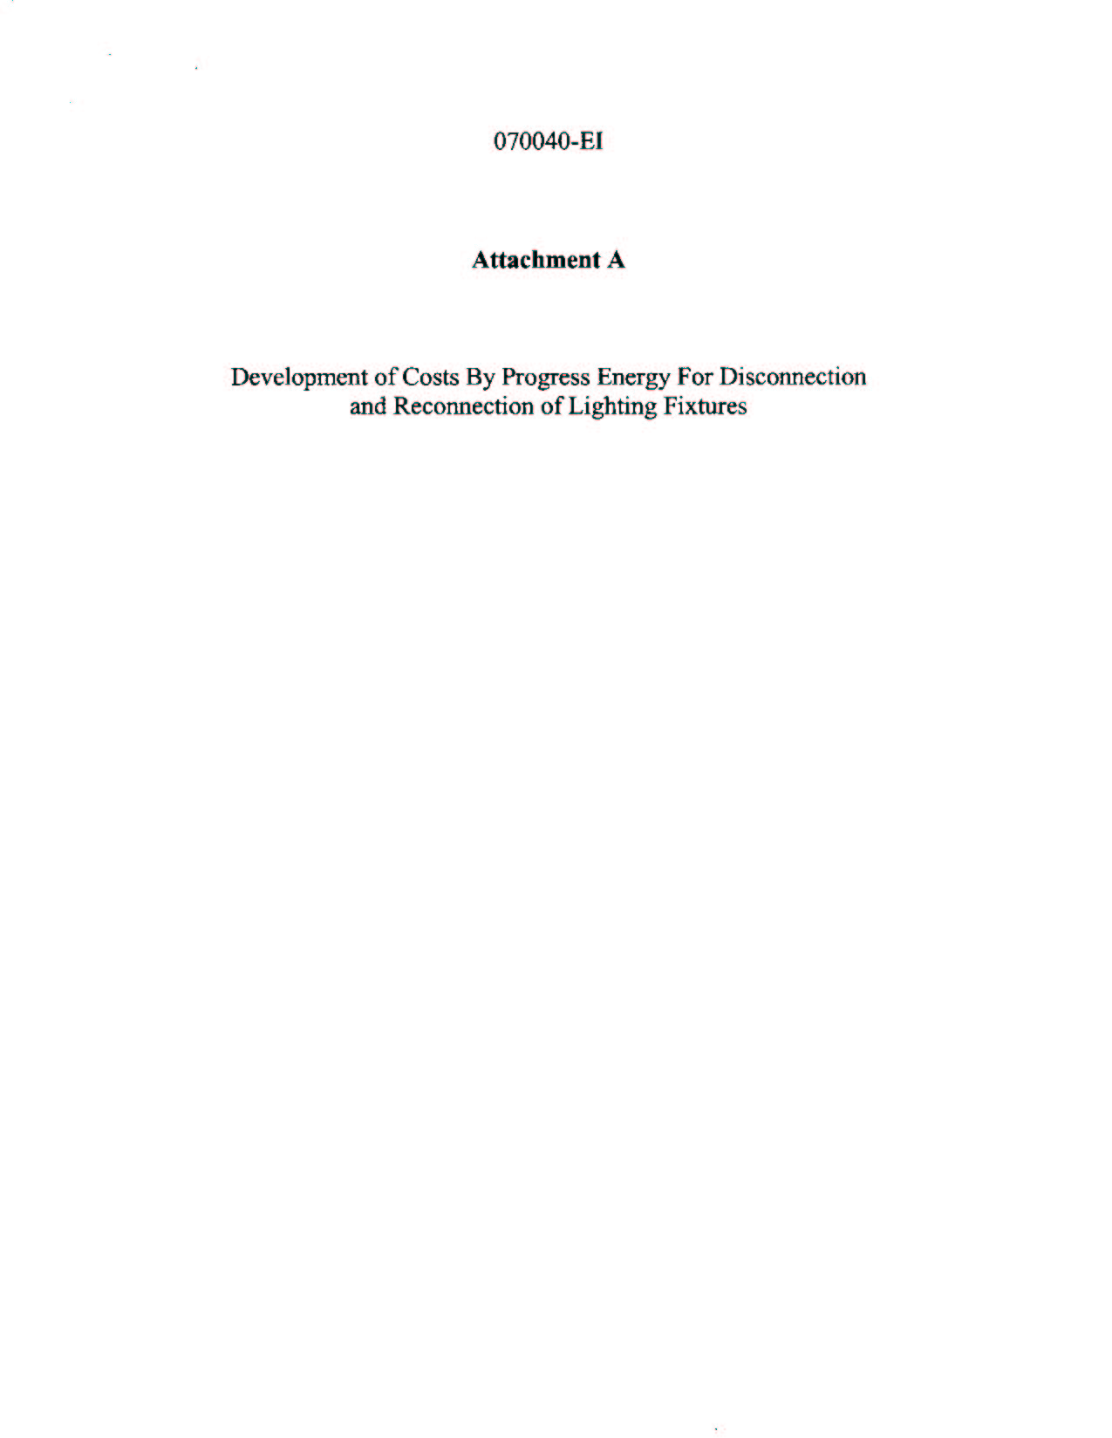
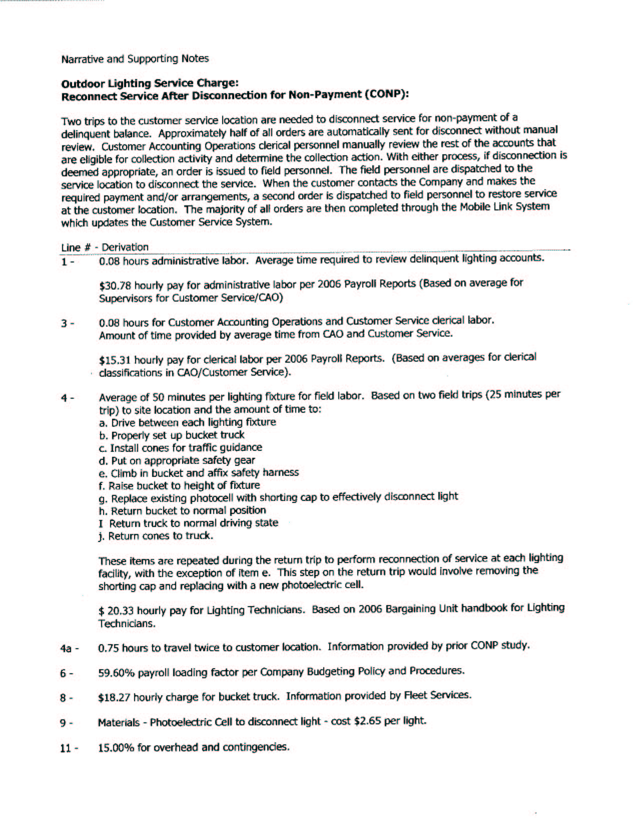
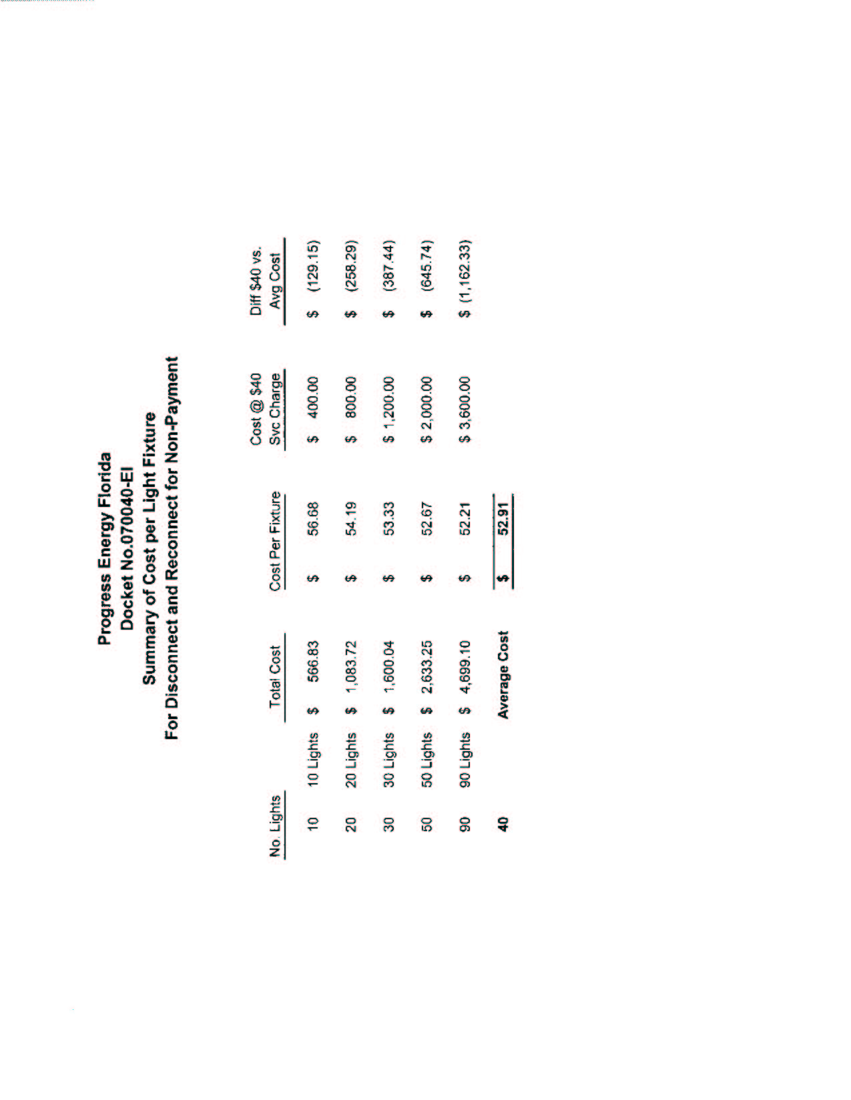
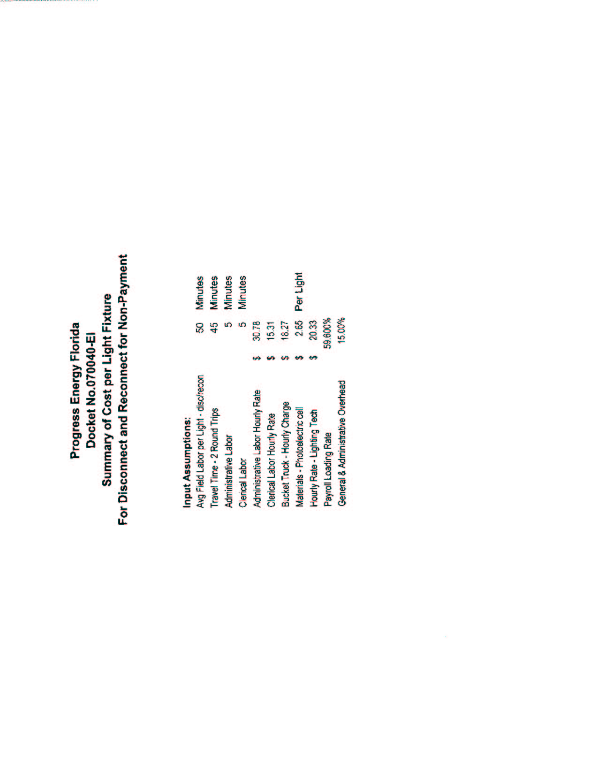
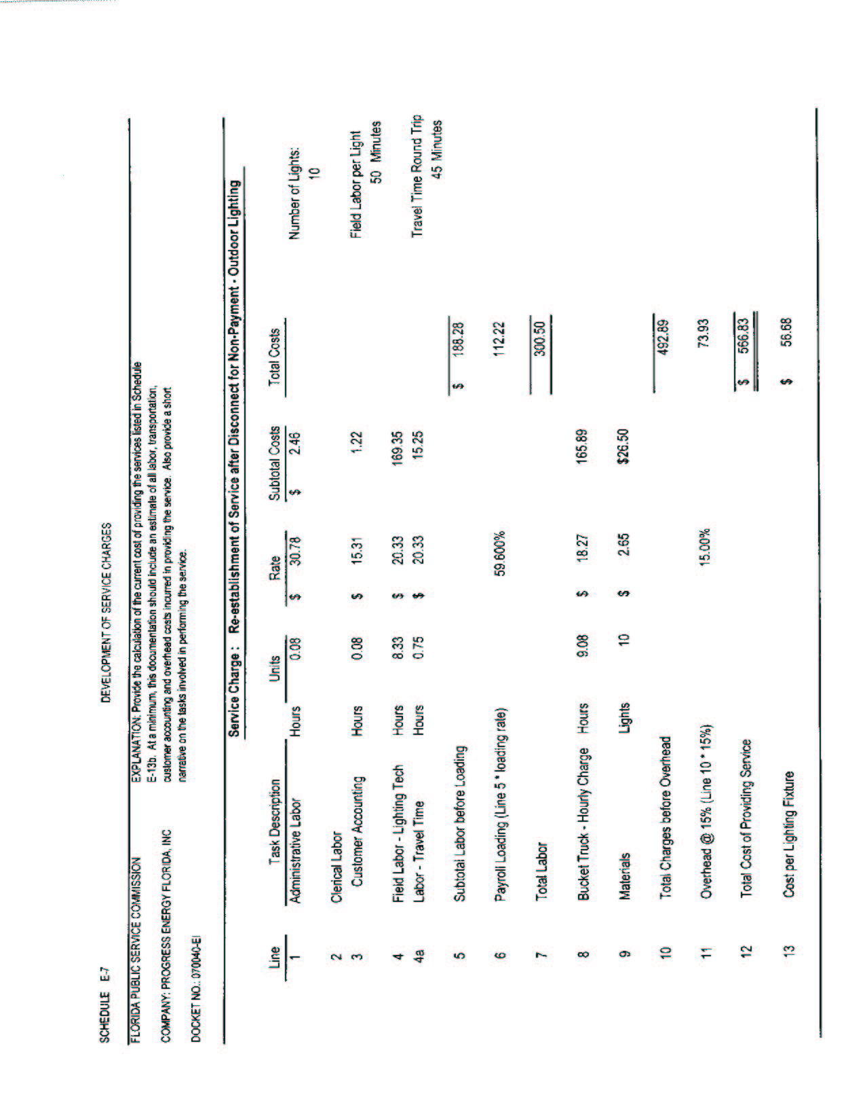
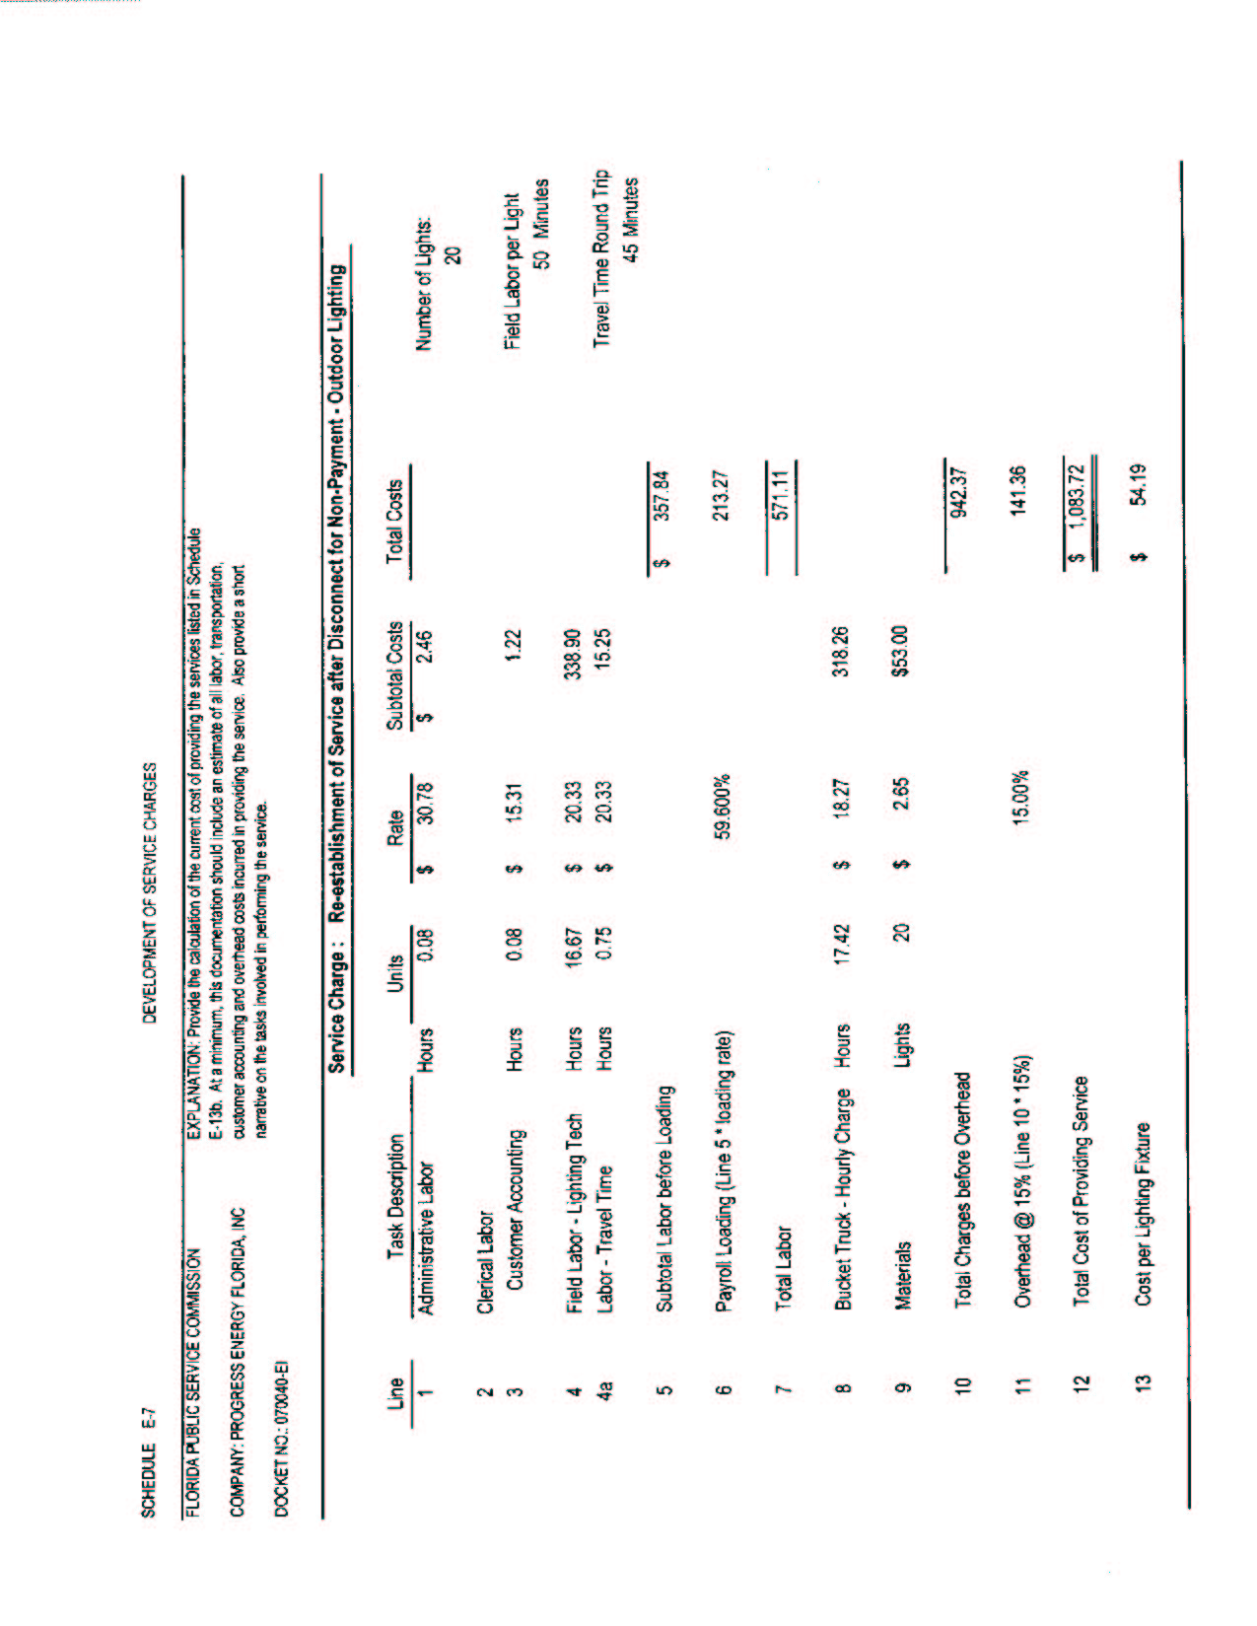
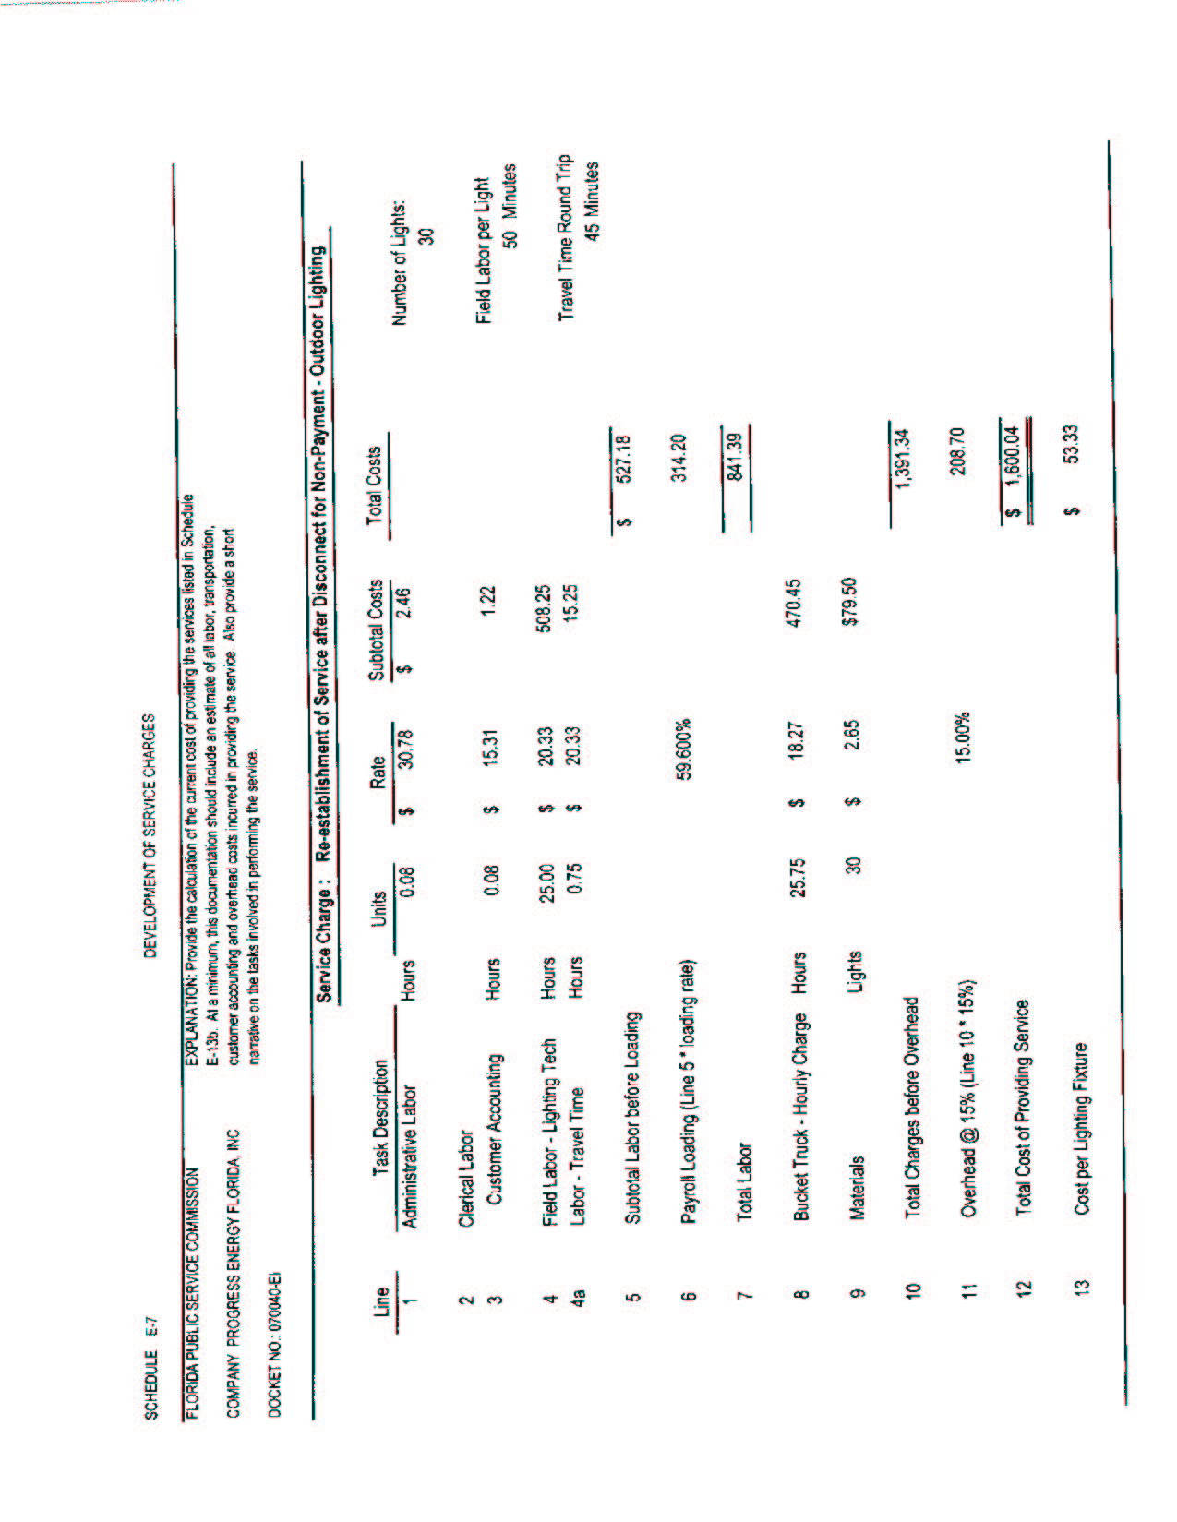
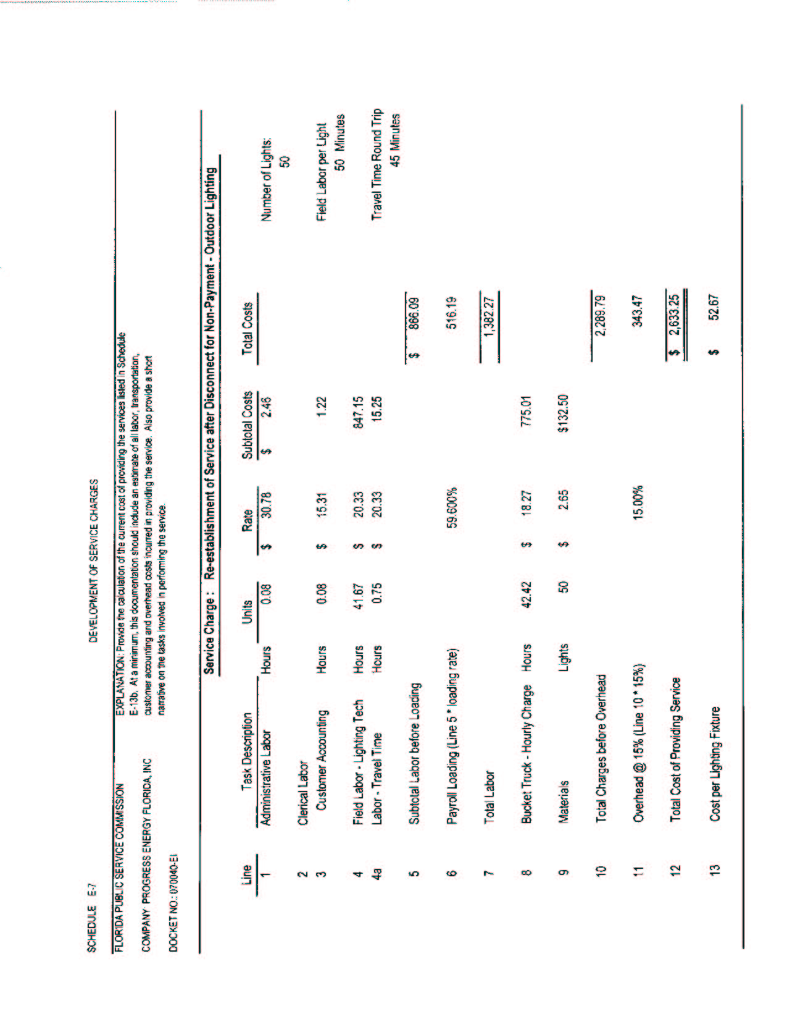
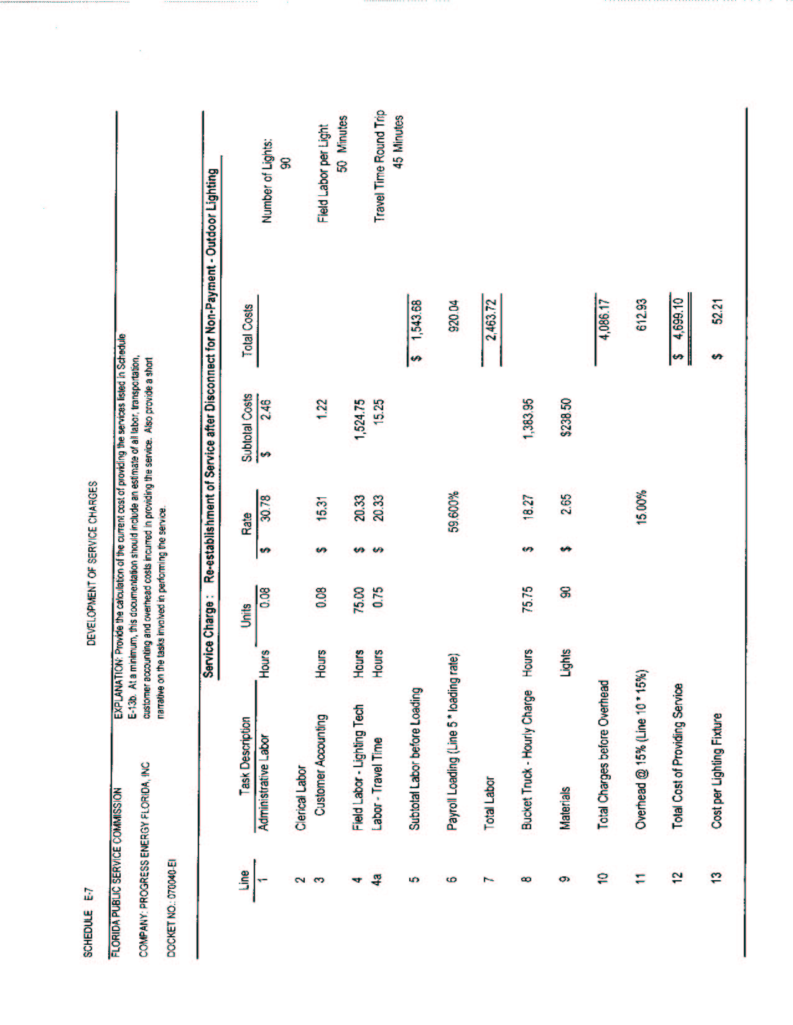

See Order No. PSC-05-0945-S-EI, issued on September 28, 2005, in Docket No. 050078-EI, In Re: Petition for rate increase by Progress Energy Florida, Inc.

