215 SOUTH MONROE STREET
SUITE 815
TALLAHASSEE, FLORIDA 32301
______________________
(850) 412-2000
FAX: (850) 412-1307
KATHRYN.COWDERY@RUDEN.COM
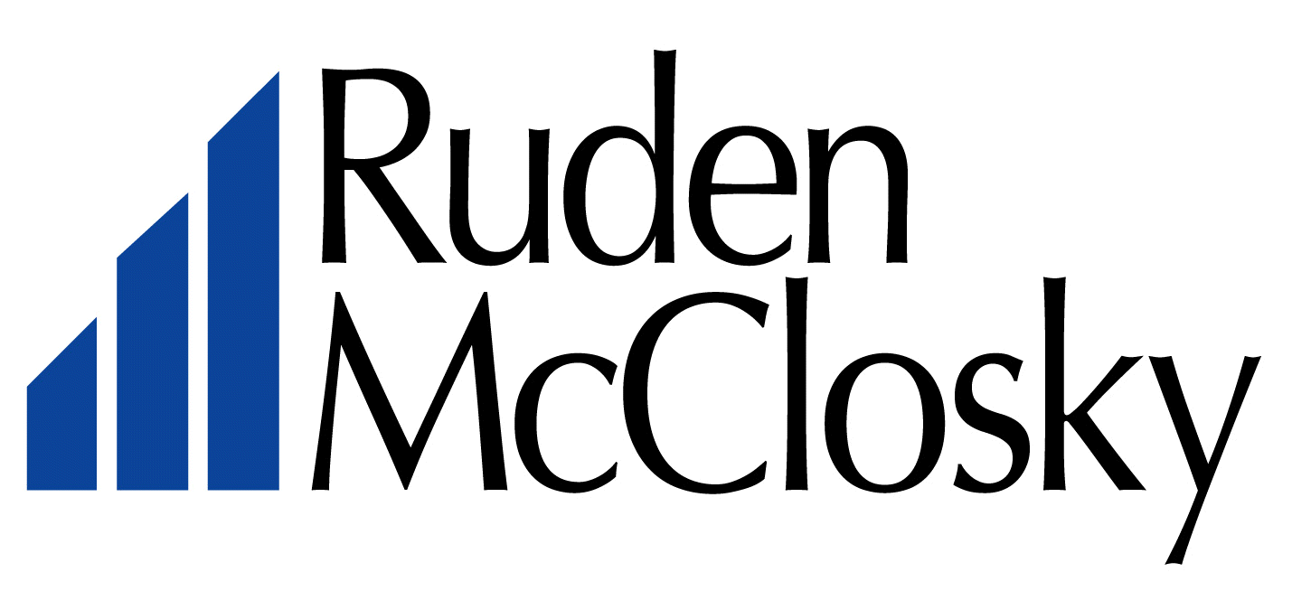

June 4, 2007

Troy Rendell
Division of Economic Regulation
Florida Public Service Commission
2540 Shumard Oak Boulevard
Tallahassee, Florida 32399-0850

Re: 60 day waiver of statutory time frame
Docket No. 060747 – Application for a Staff-Assisted Rate Case in Highlands County by Mink Associates II, LLC d/b/a Crystal Lake Club Utilities

Dear Mr. Rendell:

In order to allow Staff additional time to review certain issues and questions which have and are being discussed by Staff and, Mink Associates II d/b/a Crystal Lake Club Utilities (the “Utility”), the Utility by this letter requests that the statutory time period in this docket be waived up to and including the August 14, 2007 agenda date. It is my understanding that it may be possible for the issues to be reviewed and resolved such that this docket may be heard at the July 31, 2007 agenda. However, the Utility would request that the matter not be heard at the July 31, 2007 agenda conference unless the Utility’s rate consultant, Mr. Gary Morse, and Staff find and agree that there is sufficient time to review and have answered all outstanding questions relating to the several issues previously discussed.

Please let me know if you have any questions.

Sincerely,

s/ Kathryn G.W. Cowdery

