State of Florida   |  | Public Service Commission  Capital Circle Office Center ● 2540 Shumard Oak Boulevard  Tallahassee, Florida 32399-0850  -M-E-M-O-R-A-N-D-U-M-
DATE: | September 27, 2007
TO: | Office of Commission Clerk (Cole)
FROM: | Division of Economic Regulation (Baxter, Colson)  Office of the General Counsel (Jaeger)
RE: | Docket No. 070231-EI – Petition for approval of 2007 revisions to underground residential and commercial distribution tariff, by Florida Power & Light Company.
AGENDA: | 10/09/07 – Regular Agenda – Tariff Filing – Interested Persons May Participate
COMMISSIONERS ASSIGNED: |  |  | All Commissioners
PREHEARING OFFICER: |  |  | Administrative
CRITICAL DATES: |  |  | 12/04/07 (8-Month Effective Date)
SPECIAL INSTRUCTIONS: |  |  | Should be taken up with Docket No. 070242-EI – Request for revisions to underground residential differential, by Gulf Power Company.
FILE NAME AND LOCATION: |  |  | S:\PSC\ECR\WP\070231A.RCM.DOC

Case Background
Rule 25-6.078, Florida Administrative Code (F.A.C.), defines investor-owned utilities’ (IOU) responsibilities for filing updated underground residential distribution (URD) tariffs. This rule requires IOUs to file updated URD charges for Commission approval at least every three years, or sooner if a utility’s underground cost differential for the standard low-density subdivision varies from the last approved charge by 10 percent or more. The rule requires IOUs to file on or before October 15 of each year a schedule showing the increase or decrease in the differential for the standard low-density subdivision.
On October 13, 2006, Florida Power and Light Company (FPL) notified the Commission, pursuant to Rule 25-6.078, F.A.C., that its underground cost differential for the standard low-density subdivision varied from the last approved differential by 31.01 percent. FPL’s current URD charges were approved in 2005.
To comply with the 10 percent filing requirement of Rule 25-6.078, F.A.C., FPL filed this petition for approval of 2007 revisions to FPL’s URD and underground commercial/industrial distribution tariffs and their associated charges on April 4, 2007. The Commission suspended the tariff in Order No. PSC-07-0484-PCO-EI, issued June 8, 2007. On June 15 and July 30, 2007, FPL filed responses to the staff’s data requests that contained clarifications and additional documentation.
The Commission has jurisdiction over this matter pursuant to Sections 366.03, 366.04, 366.05, and 366.06, Florida Statutes.
Discussion of Issues
Issue 1: Should the Commission approve FPL’s revised Underground Residential Distribution tariffs and their associated charges?
Recommendation: Yes. The resulting differentials will be $562.80 per lot for the low-density subdivision, $86.70 per lot for the high-density subdivision, and $0.00 per lot for the grouped meter subdivision. (Baxter, Colson, Jaeger)
Staff Analysis: The URD charges represent the additional costs FPL incurs to provide underground distribution service in place of overhead service, and are calculated as differentials between the cost of underground and overhead service. Costs for underground service have historically been higher than for standard overhead construction. The URD differential is paid by the applicant as a contribution-in-aid-of-construction (CIAC). The URD tariffs provide standard charges for certain types of underground service, and apply to new residential developments such as subdivisions and townhouses.
FPL developed the URD charges based on the platted design model of the following three residential subdivisions: (1) a 210-lot low-density standard Commission approved subdivision with a density of one or more, but less than six dwelling units per acre; (2) a 176-lot high-density subdivision with a density of six or more dwelling units per acre; and (3) a high-density subdivision where service is provided using grouped meter pedestals. Examples of the grouped meter pedestals subdivision include mobile home and R.V. parks. All four major investor-owned electric utilities use the same three standardized platted designed subdivision to develop their URD charges, as required by Rule 25-6.078(2), F.A.C. (See Attachment A) FPL’s current costs for the URD differential per lot by type of subdivisions are: $444.01 for the 210-lot low-density subdivision; $236.29 for the 176-lot high-density subdivision; and $41.31 for the high-density subdivision where service is provided using grouped meter pedestals. The type and cost of materials used in building the standardized subdivisions are based on the square footage of the homes connected, the wire size used in the overhead and underground feeders, the size and number of transformers used, the number of homes connected to each transformer serving the subdivision, and the total power usage of all homes in the subdivision. The assumptions are detailed in Attachment B.

According to Rule 25-6.115, F.A.C., the URD differential is developed by estimating the cost per lot of both underground service and overhead service, and is based on the utility’s standard engineering and design practices. The difference between the cost per lot of overhead service and underground service is the per lot charge that an applicant must pay when requesting underground service in lieu of standard overhead service. The cost of both underground and overhead service include the material and labor costs to provide primary, secondary, and service distribution lines and transformers. The cost to provide underground service also includes the cost of trenching and backfilling.

Three main factors impacted FPL’s proposed URD differentials for 2007: a design change for the overhead high-density and grouped meter subdivisions, increased transformer and material costs, and increased labor costs. Increases in material and labor cost were higher for underground service than for corresponding overhead service, resulting in an increase in the low density subdivision differential. The low-density design was not affected by the rear to front-lot design change which affected costs for high-density and grouped meter designs. For high-density and grouped meters, the move from rear-lot line to front-lot line service resulted in the need for more poles and larger transformers for overhead service, which narrowed the difference between the cost of overhead and underground installed.

The following table shows FPL’s current and proposed URD differentials:
Type of Subdivision | Current URD differential per lot | Proposed URD differential per lot | Percent Change
210-lot low-density | $444.01 | $562.80 | +27%
176-lot high-density | $236.29 | $86.70 | -63%
Grouped meter pedestals | $41.31 | $0.00 | -100%

Impacts to all URD Differentials.
Transformer and Material Costs. FPL has experienced increased costs for many of the materials used in the construction of its model subdivisions, especially transformers, since its last URD filing in 2005. Wire and cable costs for overhead subdivisions have gone up 24% while wire and conduit costs for underground subdivisions have gone up 31%. In response to staff inquiries, FPL states that it has used competitive bidding and a range of three to six suppliers for most commodities to control costs and receive the most competitive price possible.
FPL’s transformer costs are found in the table below, with the costs the same for both high and low-density subdivisions.
Type of Subdivision | KVA per Transformer | 2005 Cost | 2007 Cost | Percentage Change
Overhead | 25 | $396.37 | $481.04 | +21%
Overhead | 50 | $561.49 | $695.71 | +24%
Overhead | 75 | N/A | $1178.01 | N/A
Underground | 25 | $798.98 | $1265.05 | +58%
Underground | 50 | $1022.30 | $1607.74 | +57%
Underground | 75 | $1235.71 | $1770.48 | +43%
In response to staff inquiries, FPL stated that the increased costs for transformers were caused by product shortages and a substantial rise in worldwide demand for the raw material commodities used in the manufacture of the transformers, such as steel, aluminum, copper, and oil. Similar to its sourcing on other types of supplies, FPL stated that it attempted to keep the cost of materials down by requiring competitive bidding. Specifically for transformers, FPL stated that it solicited bids from two to 10 suppliers from an approved list of suppliers who meet the company’s safety, reliability, and cost criteria. FPL stated that it had recently approved new manufacturers in Mexico and South Korea to supplement, diversify, and broaden the company’s current domestic supplier base.
Labor Costs. FPL uses a mixture of company personnel and outside contractors to do its overhead and underground service work. Three quarters of the underground and nearly half of the overhead service work is performed by contractors, with the rest of the work being done by company personnel and a mix of contractors and personnel. FPL’s labor rates are based on a blended analysis of the in-house and contract labor costs. FPL’s hourly overhead labor rates rose by approximately 25% from 2005 to 2007, increasing from $80.21 to $100.25 per hour. FPL’s hourly underground labor rates rose by approximately 15% from 2005 to 2007, increasing from $78.20 to $89.82 per hour. FPL uses short-term (3-year) labor contracts for much its contract labor force, with many of the current contracts signed in 2006 and running through 2009. The increased labor costs have been driven by shortages of trained personnel stemming from the highly active 2004 and 2005 storm seasons. FPL asserted that even with the increases in labor costs, it was still more cost efficient to use a blend of in-house and contractor labor, since the amount of additional company employees required to perform all of the overhead and underground work throughout FPL’s service territory would cause significant increases in personnel and benefits costs.
Increases in costs for material, transformers, and labor contributed to the rise in the differential of the low-density subdivision. Unlike the high-density and grouped meter subdivisions, the low-density subdivision did not have a change in design or types of transformers used from 2005 to 2007, causing there to be no offset to the significant increases in the costs for underground transformers. Also, though underground labor costs did not increase as quickly as overhead costs, the amount of underground construction man hours required increased slightly (up 3.25% from 2005) while overhead hours decreased (down 0.04%). The result of all of these factors were that costs for the underground low-density subdivision rose faster (up 21% from 2005 to 2007) than the costs for the overhead low-density subdivision (up 19%), increasing the amount of the differential.
Impacts to the High-Density and Grouped Meter URD Differentials.

Design Change. In January of 2007, the Commission adopted Rule 25-6.0341, F.A.C., which governs the location of a utility’s electric distribution facilities. Rule 25-6.0341(1), F.A.C., states:
In order to facilitate safe and efficient access for installation and maintenance, to the extent feasible and cost-effective, electric distribution facilities shall be placed adjacent to a public road, normally in front of the applicant’s premises. (emphasis added)

FPL had previously used rear-lot construction for overhead low and high density distribution services, finding that particular type of design to be more efficient, reliable, and cost effective. But, in order to comply with the new rule, FPL redesigned its model for the overhead high density and grouped meter residential subdivisions to front-lot construction. In a response to a staff data request, FPL stated that the front-lot construction requires secondary road crossings to serve applicants on the opposite side of the street from the overhead pole line. In order to meet voltage drop and flicker guidelines as set forth in Rules 25-6.034 and 25-6.026, F.A.C., the additional secondary conductor requires some changes in the number, sizes and spacing of overhead transformers which results in a difference in lateral loading. The elimination of the use of the rear-lot lines caused numerous changes in the physical layout of the overhead high-density subdivision design and the chart below shows the changes.

Overhead High Density

Changes in physical Layout | 2005  Rear-lot design | 2007  Front-lot design
Feeder phase | 3 | 2
Number of poles | 61 | 86
Height of poles | 35’-5” | 40’-5”
Number of transformers | 18 | 21
Size of transformers  25KVA  50KVA  75KVA | 2  16  0 | 2  7  12
Secondary conductor footage | 6289’ | 7124’

In addition to the changes in the physical layout, labor costs for the installation of the overhead primary, secondary, poles, and transformers have also increased from 2005 to 2007. As shown in the chart above the change to the front-lot line construction design required the use of three additional transformers than the 2005 rear-lot design. In some cases the transformer sizes were also increased to accommodate the additional secondary conductors needed to serve homes on the opposite side of the street from the primary pole line. The additional transformer, pole, and wiring requirements in the new front-lot design has also caused an 18.7% increase in the amount of construction man-hours of the overhead high-density subdivision (to 797 hours from 672 in 2005).

The net effect of the extra poles, transformers, and the increased man-hours required to install them caused the costs of the overhead high-density subdivision to rise faster (increasing 45% from 2005 to 2007) than the costs of the underground high-density subdivision (which increased 19%), lowering the total amount of the differential between the underground and overhead subdivisions.
The model grouped meter subdivision also experienced increased overhead costs due to a shift to front-lot design. The effect of the increased overhead costs was to eliminate the differential for model grouped meter subdivisions, meaning that new mobile home and R.V. parks will not pay an extra CIAC amount to receive underground service. It should be noted that the overhead and underground costs for the model grouped meter subdivision have historically been modest compared to other types of subdivisions.
Other Changes. In addition to the charges to its standard subdivision differentials, FPL proposed revisions to the charges for applicants requesting new underground service laterals from overhead distribution systems, and underground service laterals replacing existing services. FPL’s URD tariff also provides credits to applicants who do their own trenching or installation of an FPL-provided conduit. FPL has proposed increases to those credits.
FPL has also proposed to modify its Performance Guaranty Agreement for Residential Subdivision Developments (PGAR). The PGAR is required of all subdivisions who wish to receive underground service, but whose projected two-year revenues may not be certain enough to cover the cost of installing underground facilities. The PGAR requires that an amount be paid in cash, surety bond, or irrevocable letter of credit over and above the CIAC for all transformers in the subdivision which will not be utilized, in the opinion of FPL, within two years of installation. FPL proposes to change the conditions under which transformers are considered utilized. The company seeks to alter the utilization threshold from one installation of service per transformer to two, and remove streetlights from being considered as an installation of service. In response to staff inquiries, FPL stated that sufficient revenue justification for purposes of the agreement now required that two homes be connected per transformer instead of one. The company also stated that since street lights were regulated under tariff sheet SL-1, and revenues were already being generated to cover the street lighting costs, counting the street light revenues again for purposes of justifying the cost of a subdivision underground system constituted effective double counting of the revenues, causing the amount of the PGAR to be lower than it should.
The staff has reviewed the proposed charges and their accompanying workpapers, and believes that they are reasonable. Accordingly, staff believes that FPL’s proposed URD tariff sheets and charges should be approved.
Issue 2: Should the Commission approve FPL’s revised tariff sheets and charges associated with the installation of underground commercial/industrial distribution (UCD) facilities?
Recommendation: Yes. (Baxter, Colson, Jaeger)
Staff Analysis: FPL’s proposed UCD tariff contains revised standard charges for new commercial and industrial applicants who request underground distribution service in lieu of standard overhead service. The tariff provisions are patterned after those that are required by rule to be filed for underground residential service. Rule 25-6.078, F.A.C., does not require tariffed differentials for commercial and industrial applicants.
The UCD tariff contains charges for commercial underground distribution facilities such as laterals, risers, pad-mounted transformers, and handholes. In addition, the UCD tariff provides for credits that apply if the applicant provides trenching and backfilling. The charges are derived from cost estimates of underground commercial distribution facilities and their equivalent overhead design. The estimates were made using standard FPL design and 2007 labor and material costs. FPL’s current UCD tariff is based on 2004/05 cost data.
The proposed revisions to the UCD charges and credits reflect updated labor and material costs, resulting in increases to the differentials for commercial underground distribution facilities, and increases to the credits provided for work performed by the applicant. In addition, FPL has proposed increased differential charges for small commercial 2-wire and 3-wire underground service and pad-mounted secondary junction cabinets.
The staff has reviewed the proposed charges and their accompanying workpapers, and believes that they are reasonable. There is no Commission requirement that UCD tariffs with specific standardized charges be filed by investor-owned utilities. However, staff believes that standard charges promote efficiency and avoid controversy which may result from applicant-specific estimates of undergrounding costs. Accordingly, staff believes that the proposed tariff sheets and charges are reasonable and should be approved.
Issue 3: Should this docket be closed?
Recommendation: Yes. If Issues 1 and 2 are approved, the tariffs should become effective on October 9, 2007. If a protest is filed within 21 days of the issuance of the order, the tariffs should remain in effect, with any revenues held subject to refund, pending resolution of the protest. If no timely protest is filed, this docket should be closed upon the issuance of a consummating order. (Jaeger)
Staff Analysis: If Issues 1 and 2 are approved, the tariffs should become effective on October 9, 2007. If a protest is filed within 21 days of the issuance of the order, the tariffs should remain in effect, with any revenues held subject to refund, pending resolution of the protest. If no timely protest is filed, this docket should be closed upon the issuance of a consummating order.

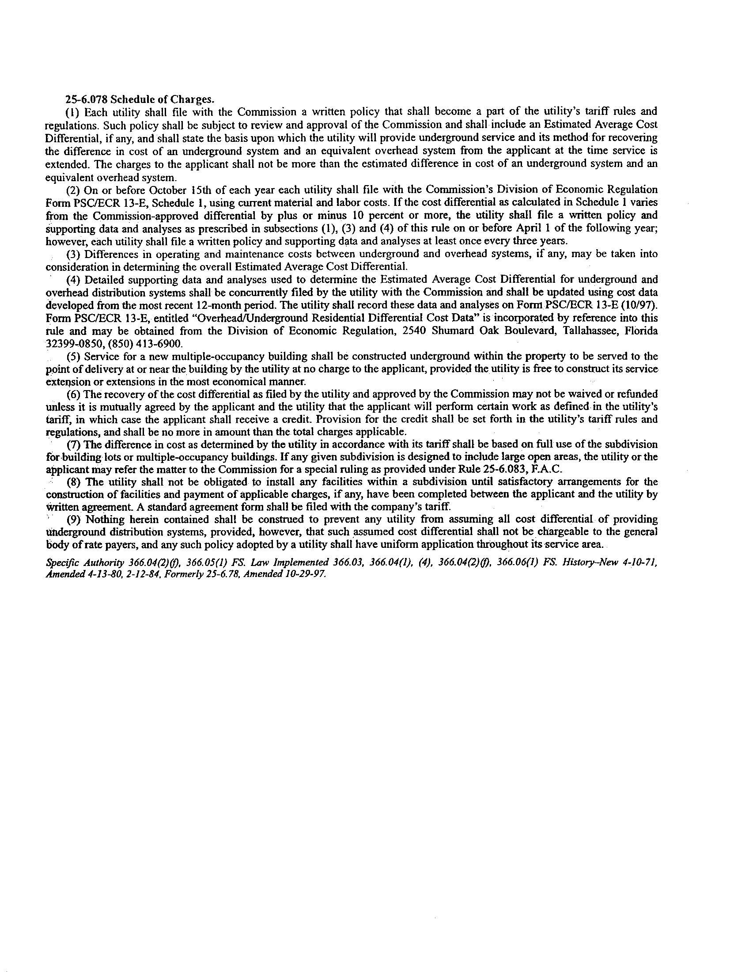
FPL’s Design Assumptions for overhead and underground

OVERHEAD DESIGN | LOW DENSITY  (210 Lot) | HIGH DENSITY  (176 Lot)
a. A/C or Heat Pump (tons) | 3.5 | 2.5
b. Heat Strips (kW) | 5 | 5
c. Subdivision Total Power Usage (kva) | 1650 | 1300
d. Total Transformers | 61 | 21
e. Average Homes per Transformer | 3.4 | 8.4
f. Size of Home (sq. ft.) | 2100 | 1500
g. Total Cable Feet | 43682 | 25575
h. Number of Phases | 3 | 2

UNDERGROUND DESIGN | LOW DENSITY  (210 Lot) | HIGH DENSITY  (176 Lot)
a. A/C or Heat Pump (tons) | 3.5 | 2.5
b. Heat Strips (kW) | 5 | 5
c. Subdivision Total Power Usage (kva) | 1250 | 700
d. Total Transformers | 24 | 12
e. Average Homes per Transformer | 8.8 | 14.6
f. Size of Home (sq. ft.) | 2100 | 1500
g. Total Cable Feet | 48486 | 25839
h. Number of Phases | 2 | 2
i. Loop Design | Yes | Yes
j. Cable in Conduit | Yes | Yes

Staff notes that Rule 25-6.078, F.A.C., was recently amended by the Commission as part of its rulemaking proceedings to require electric utilities to strengthen Florida’s electrical infrastructure. The amended rule became effective on February 1, 2007. However, because FPL initiated this matter by its notification to the Commission on October 13, 2006, the prior rule governs in this instance. A copy of the applicable version of the rule is attached to this recommendation as Attachment A.
See Order No. PSC-05-0952-TRF-EI, issued October 6, 2005, in Docket No. 050226-EI, In re: Petition for approval of 2005 revisions to residential and commercial distribution tariff by Florida Power & Light Company.
See Order No. PSC-07-0043-FOF-EU, issued January 16, 2007, in Docket No. 060172-EU, In re: Proposed rules governing placement of new electric distribution facilities underground, and conversion of existing overhead distribution facilities to underground facilities, to address effects of extreme weather events, and Docket No. 060173-EU, In re: Proposed amendments to rules regarding overhead electric facilities to allow more stringent construction standards than required by the National Electric Safety Code.

