State of Florida   |  | Public Service Commission  Capital Circle Office Center ● 2540 Shumard Oak Boulevard  Tallahassee, Florida 32399-0850  -M-E-M-O-R-A-N-D-U-M-
DATE: | June 5, 2008
TO: | Office of Commission Clerk (Cole)
FROM: | Division of Economic Regulation (Slemkewicz, Baxter, Dickens, Draper, Gardner, Kaproth, Kyle, Marsh, Maurey, Springer)  Office of the General Counsel (Brown)
RE: | Docket No. 070592-GU – Petition for rate increase by St. Joe Natural Gas Company, Inc.
AGENDA: | 06/17/08 – Regular Agenda – Proposed Agency Action (excluding Issue No. 39) – Interested Persons May Participate
COMMISSIONERS ASSIGNED: |  |  | All Commissioners
PREHEARING OFFICER: |  |  | Argenziano
CRITICAL DATES: |  |  | 06/17/08 (5-Month Effective Date (PAA Rate Case))
SPECIAL INSTRUCTIONS: |  |  | None
FILE NAME AND LOCATION: |  |  | S:\PSC\ECR\WP\070592.RCM.DOC

Case Background
This proceeding commenced on December 21, 2007, with the filing of a petition for a permanent rate increase by St. Joe Natural Gas Company, Inc. (SJNG or Company). SJNG requested an increase in its retail rates and charges to generate $624,166 in additional gross annual revenues. This increase would allow the Company to earn an overall rate of return of 6.14 percent or an 11.50 percent return on equity (range 10.50 percent to 12.50 percent). The Company based its request on a projected test year ending December 31, 2008. SJNG stated that this test year is the appropriate period because it represents the conditions to be faced by the Company, and is representative of the customer base, investment requirements, throughput levels, and overall cost of service to be realized under the new rates. Per Rule 25-7.140(1)(d), Florida Administrative Code, SJNG has elected to use the five month Proposed Agency Action process authorized in Section 366.06(4), Florida Statutes. By letter dated April 30, 2008, SJNG waived the five month deadline and extended it to June 17, 2008.

The Commission last granted SJNG a $327,149 rate increase by Order No. PSC-01-1274-PAA-GU. In that order, the Commission found the Company’s jurisdictional rate base to be $4,061,937 for the projected test year ended December 31, 2001. The allowed overall rate of return was 5.96 percent for the test year using an 11.50 percent return on equity.

By Order No. PSC-08-0135-PCO-GU, issued March 3, 2008, the Commission suspended SJNG’s proposed permanent rate increase and authorized an interim increase of $157,775. As required by Section 366.071(5)(b)3., Florida Statutes, the applicable ROE for purposes of an interim increase is the minimum of the range of return as authorized in the Company’s last rate proceeding. The Commission granted the $157,775 interim increase on the appropriate return on equity and overall cost of capital of 10.50 percent and 5.60 percent, respectively.

Customer meetings were held in Port St. Joe, Florida, on April 21, 2008 and May 19, 2008. No customers attended either of the customer meetings.

This recommendation addresses SJNG’s requested permanent rate increase. The Commission has jurisdiction pursuant to Sections 366.06(2) and (4), and 366.071, Florida Statutes.
Discussion of Issues
Issue 1:1
Should an adjustment be made to plant, depreciation expense, and accumulated depreciation to correct the budgeted plant additions for the projected test year?

Recommendation:
Yes. Staff recommends that plant, depreciation expense, and accumulated depreciation be reduced by $2,128, $454, and $454, respectively, to correct the plant additions for the projected test year. (Gardner)
Staff Analysis:
Based on its past purchasing experience, SJNG included $8,700 in its 2008 projected plant additions for six pressure temperature units. SJNG purchased these units in 2008 at an actual cost of $10,889. Staff increased Account 387, Other Equipment, by $2,189 ($10,889-$8,700) to account for the increase in cost. Staff also increased the related depreciation expense and accumulated depreciation each by $231.
Also, the Company projected $16,000 in its 2008 plant additions for a new billing insert machine. SJNG received a price quote from Pitney Bowes of $14,361. Staff made a reduction to Account 391.2, Office Equipment, of $4,317 ($16,000-$14,361) to correct the overstatement. Staff also reduced the associated accumulated depreciation and depreciation expense each by $685.
The impact of staff’s recommended adjustments are shown in the following chart:
2008 Projected Plant Additions-Adjustments
Account Number | Description | Reason | Plant | Accumulated Depreciation | Depreciation  Expense
387.0 | Other Equipment | Audit Finding 2 | $2,189 | $231 | $231
391.2 | Office Equipment | Audit Finding 3 | (4,317) | (685) | (685)
Total |  |  | ($2,128) | ($454) | ($454)
Issue 2:2
Should an adjustment be made to Accumulated Depreciation for equipment no longer in service?
Recommendation:
Yes. Accumulated Depreciation should be increased by $31,692 for the retirement of four vehicles. (Gardner)
Staff Analysis:
Staff’s audit review shows that the Company retired and sold three trucks without recording any salvage to Account 392.0, Transportation. On MFR Schedule G-1, page 176, the projected retirements for this account included the following: (1) a 1999 Chevrolet Pickup sold on January 16, 2008, for $1,870, (2) a 2002 Silverado Chevrolet truck sold on January 29, 2008, for $8,000, and (3) a 2002 Chevrolet 2500 truck expected to be retired in 2008 with an expected salvage value of $5,000. The company should have recorded total salvage of $14,870.

In addition, a 2001 Silverado Chevrolet truck was purchased for $22,629 and placed in service on August 31, 2001. The truck was retired on December 31, 2003 and was given to the General Manager as a retirement gift. At that time, the truck was 2.3 years of age, and had accumulated $5,807 in depreciation expense. The average service life of this plant account is 8 years with an average remaining life rate of 10.3 percent. Also, with the early retirement of this truck, there existed an unrecovered investment of $16,822. The Company should have recorded the amount to accumulated depreciation as salvage. This salvage amount equates to a remaining life of 7.2 years for the plant investment.

Staff recommends that accumulated depreciation be increased by $31,692 for the retirement of the four trucks which includes $14,870 ($1,870+$8,000+$5,000) and $16,822 for salvage that should be booked to Account 392, Transportation.

Account Number | Description | Audit  Finding | Accumulated  Depreciation
392 | Transportation | 4 | $14,870
 |  | 5 | 16,822
Total |  |  | $31,692

Issue 3:3
What adjustments, if any, should be made to accumulated depreciation to reflect the Commission’s decision in Docket No. 070737-GU setting new depreciation rates?
Recommendation:
The appropriate adjustment to accumulated depreciation to reflect the Commission’s decision in Docket No. 070737-GU is a reduction of $6,658. (Gardner)
Staff Analysis:
This is a calculation based upon the decision made by the Commission in Order No. PSC-08-0259-PAA-GU, issued April 25, 2008, in Docket No. 070737-GU, In re: Application for approval of new depreciation rates, effective January 1, 2008, by St Joe Natural Gas Company, Inc. The impact of the new depreciation rates on the test year is a $6,658 reduction to accumulated depreciation for 2008.
Issue 4:4
Is SJNG’s Natural Gas Plant in Service of $6,437,506 for the December 2008 projected test year appropriate?
Recommendation:
No. The appropriate amount of Gas Plant in Service for the December 2008 projected test year is $6,435,378. (Gardner)
Staff Analysis:
This is a fallout issue. Based on staff’s recommendations in Issue 1, the appropriate 13-month average amount of Gas Plant in Service for the December 2008 projected test year is $6,435,378. (See Schedule 1)
Issue 5:5
Is SJNG’s Accumulated Depreciation of Gas Plant in Service of $3,255,779 for the December 2008 projected test year appropriate?
Recommendation:
No. The appropriate Accumulated Depreciation of Gas Plant in Service for the December 2008 projected test year is $3,280,359. (Gardner)
Staff Analysis:
This is a fallout issue. Based on staff’s recommendations in Issues 1, 2, and 3, the appropriate 13-month average amount of Accumulated Depreciation of Gas Plant in Service for the projected test year is $3,280,359. (See Schedule 1)
Issue 6:6
Should Working Capital be adjusted to remove non-utility activities?

Recommendation:
Yes. Working Capital should be increased by $13,465 for the year ended December 31, 2008, to remove non-utility activities from Miscellaneous Current Liabilities. (Marsh)

Staff Analysis:
The Company did not remove non-utility activity in Miscellaneous Current Liabilities and Taxes Accrued-General when calculating working capital for the year ended December 31, 2008. Staff noted that the thirteen-month average balances of $29,165 and $16,944, respectively, consisted of the co-mingling of utility and non-utility activity. In calculating the working capital allowance, adjustments for non-utility activity should be consistent throughout the applicable general ledger accounts.

The Company estimates that the amount of non-utility Miscellaneous Current Liabilities is $11,795 and the amount of non-utility Accrued Taxes is $1,670. Staff recommends that working capital be increased by $13,465 ($11,795 + $1,670) for the year ended December 31, 2008, to remove non-utility activities.
Issue 7:7
Should Operation and Maintenance Expense and working capital be adjusted to reflect a service agreement that was recorded as maintenance of structures and improvements expense?

Recommendation:
Yes. Operation and Maintenance Expense Account 886 should be increased by $766 for 2008. In addition, working capital should be increased by $263 for 2008. (Marsh)

Staff Analysis:
As discussed in Audit Finding No. 10, the Company recorded $1,411 in Account 886, Maintenance of Structures and Improvements. This amount represents the cost of a service agreement with Pitney Bowes for a folding machine maintenance contract for the period August 1, 2006, through July 31, 2007. This type of machine is used in the preparation of bills. The Company misclassified the cost of the service agreement in Account 886, Maintenance of Structures and Improvements. Additionally, only a portion of the amount was applicable to 2006. The Company agrees with this audit finding.

While the audit addressed the amount paid in 2006, the amounts paid in other years were not discussed. The Company paid $1,265.22 in 2005 and $1,468.04 in 2007. No expense was included in 2008. Consistent treatment for those years would be to include a portion of the 2005 payment for 2006, and a portion of 2007 for 2008, with corresponding adjustments to the working capital 13-month average.

Staff recommends that Operation and Maintenance Expense Account 886 for 2006 should be $1,326, resulting in a reduction of $85. The trended reduction for 2008 is $90 ($85 x 1.0586). For 2008, expense should be increased by $856, resulting in a net increase of $766 ($865 - $90). In addition, working capital should be increased by $263 for 2008.

Issue 8:8
What is the appropriate amount of Working Capital Allowance for the December 2008 projected test year?
Recommendation:
The appropriate amount of Working Capital Allowance for the December 2008 projected test year is ($130,363). (Marsh)
Staff Analysis:
This is a fallout issue. This is a calculation based upon the recommended adjustments in Issues 6 and 7. Based on those adjustments, the appropriate level of projected test year Working Capital Allowance is ($130,363). (See Schedule 1)
Issue 9:9
Is SJNG’s requested rate base in the amount of $3,037,636 for the December 2008 projected test year appropriate?
Recommendation:
No. The appropriate amount of rate base for the December 2008 projected test year is $3,024,656. (Slemkewicz)
Staff Analysis:
This is a fallout issue. Based on staff’s recommended adjustments, staff recommends that the appropriate amount of rate base for the projected test year is $3,024,656. (See Schedule 1)
Issue 10:10
What is the appropriate return on common equity for the projected test year?
Recommendation:
The appropriate return on common equity for the projected test year is 11.00 percent, with a range of plus or minus 100 basis points. (Springer)
Staff Analysis:
SJNG’s currently authorized return on equity (ROE) of 11.50 percent was last established in 2001 by Order No. PSC-01-1274-PAA-GU. In its petition, SJNG requests the Commission maintain this same return for purposes of this proceeding.

Citing the high cost of retaining an expert cost of capital witness, SJNG did not file traditional cost of capital testimony with its petition in this case. However, the Company did offer pre-filed testimony on what it believes is the appropriate cost rate for common equity. In his testimony, Mr. Stuart Shoaf, President of SJNG, states that SJNG shares many of the same operating characteristics and overall financial risks as Indiantown Gas Company, Sebring Gas System, and Chesapeake Utilities Corporation Florida Division. Mr. Shoaf recommends the Commission set SJNG’s ROE based on his assessment of the Company’s business risk, financial risk, and comparability with other similarly-situated natural gas utilities.

SJNG’s President provides a general assessment of the Company’s business risk factors. He notes that SJNG is highly sensitive to loss of customers, a slow down in the economy, increased operating expenses, and declining gas consumption. SJNG is heavily dependent on one large volume industrial customer, Arizona Chemical Company (Arizona), for a significant percentage of its throughput. As discussed in Issue 30, Arizona provides approximately 20 percent of SJNG’s total revenues at present rates. However, Arizona has been reducing its annual volume usage. Between 2002 and 2006, Arizona reduced its usage by 33 percent. Moreover, the President states that Arizona was acquired by a private equity firm in 2007 and its future as a customer of SJNG is uncertain. Finally, he states that SJNG is an extremely small company relative to other regulated natural gas distribution companies. Based on these factors, Mr. Shoaf contends SJNG is exposed to greater business risk than the average natural gas distribution company.

Mr. Andy Shoaf, Manager of Corporate Services, however, notes in his pre-filed testimony that although SJNG faces certain business risks, the market also provides various opportunities for the Company. The Manager identifies a housing development that should lead to new customer growth. SJNG has the potential to add 1,500 new residential accounts and numerous new commercial accounts during the ten year time frame the Windmark development is projected to be built.

Regarding financial risk, the Company has an equity ratio as a percentage of investor supplied capital of 84.4 percent. This level of equity capitalization is much greater than the relative level of equity capital maintained by the other natural gas distribution companies. A high equity ratio indicates SJNG is exposed to less financial risk than the average natural gas distribution company.

Staff agrees with the Company that SJNG and the other small Florida natural gas distribution companies share similar business risks and opportunities. Historically, the returns authorized for natural gas distribution companies and transmission and distribution electric utilities have been very similar. The following table shows the returns authorized by the Commission for Florida natural gas distribution companies and the Electric Division of Florida Public Utilities Company (FPUC) since 2000. As this table shows, the level of returns has remained relatively stable over the past 8 years.

Company | Order No. | Issued | ROE
FPUC Electric | PSC-08-0327-FOF-EI | May 19, 2008 | 11.00%
Sebring Gas | PSC-04-1260-PAA-GU | December 20, 2004 | 11.50%
FPUC Gas | PSC-04-1110-PAA-GU | November 8, 2004 | 11.25%
Indiantown Gas | PSC-04-0565-PAA-GU | June 2, 2004 | 11.50%
FPUC Electric | PSC-04-0369-AS-EI | April 6, 2004 | 11.50%
Florida City Gas | PSC-04-0128-PAA-GU | February 9, 2004 | 11.25%
Peoples Gas | PSC-03-0038-FOF-GU | January 6, 2003 | 11.25%
Indiantown Gas | PSC-02-1666-PAA-GU | November 26, 2002 | 11.50%
St. Joe Gas | PSC-01-1274-PAA-GU | June 8, 2001 | 11.50%
Florida City Gas | PSC-01-0316-PAA-GU | February 5, 2001 | 11.50%
Chesapeake Gas | PSC-00-2263-FOF-GU | November 28, 2000 | 11.50%

The most recent case where the Commission heard testimony on the appropriate rate of return on equity was in the proceeding for the Electric Division of FPUC. In that case, the Commission approved an ROE of 11.00 percent.

Since the time of the Commission’s decision in SJNG’s last rate case in May 2001, the Federal Reserve has lowered short-term interest rates by 250 basis points. In addition, the long-term BBB corporate bond yield has declined 176 basis points. Over this same period, the thirty-year Treasury bond yield has declined 120 basis points. These changes in interest rates influence the required rate of return a company would need to attract capital under reasonable terms.

Based on the analysis outlined above, staff recommends an authorized ROE of 11.00 percent for SJNG, with a range of plus or minus 100 basis points.
Issue 11:11
What is the appropriate capital structure for the projected test year ending December 31, 2008?
Recommendation:
The appropriate capital structure for the projected test year ending December 31, 2008, should consist of no more than 60 percent common equity as a percentage of investor supplied capital. (Springer)
Staff Analysis:
In its MFRs, SJNG filed a projected capital structure with an equity ratio of 84.4 percent as a percentage of investor supplied capital. However, the Commission has previously found that an appropriate capital structure for ratemaking purposes for this Company should consist of no more than 60 percent equity as a percentage of investor sources of capital.

Normally, a company with a high equity ratio is considered to have less financial risk than a comparable company with a lower equity ratio. The higher equity ratio reduces the company’s risk of default on its bond payments and thus reduces its overall financial risk. However, because equity capital is more expensive than debt, a company must reach a balance between equity and debt to minimize its overall cost of capital. To the extent a utility is able to use lower cost debt to leverage its operations, it can lower its overall cost of capital.

Staff believes by approving an ROE of 11.00 percent with an equity ratio of no greater than 60 percent as a percentage of investor capital, the Commission is sending the proper signal that the Company has a responsibility to minimize its overall cost of capital. Staff believes that by allowing SJNG an equity ratio that is greater than the average equity ratio maintained by other natural gas distribution companies offsets the business risks facing a small, privately-held utility that is exposed to the financial and business risks discussed in Issue 10. This adjustment is consistent with previous Commission Orders and with the decision in SJNG’s last rate case.

Therefore, staff recommends the appropriate capital structure for SJNG’s projected test year ending December 31, 2008 should consist of no more than 60 percent equity as a percentage of investor capital.
Issue 12:12
What is the appropriate weighted average cost of capital for the projected test year?
Recommendation:
The appropriate weighted average cost of capital for the projected test year is 5.44 percent. This is a calculation based upon decisions in preceding issues. (Springer, Slemkewicz)
Staff Analysis:
Based upon decisions in preceding issues and the proper components, amounts, and cost rates associated with the capital structure for the test year ending December 31, 2008, staff recommends a weighted average cost of capital of 5.44 percent. (See Schedule 2)

The 13-month average per book amounts are taken directly from the Company's MFR filing. Staff agrees with and uses the respective cost rates provided by SJNG in its MFR filing with one exception. As discussed in Issue 10, staff recommends a return on common equity of 11.00 percent. In addition, as discussed in Issue 11, staff adjusted SJNG’s capital structure to reflect a 60 percent equity ratio as a percentage of investor capital. After these specific adjustments, a pro rata adjustment is made over investors’ sources of capital to reconcile rate base and capital structure.

The net effect of these adjustments is a reduction in the overall cost of capital from the 6.14 percent return requested by the Company to a return of 5.44 percent. Schedule 2 shows the components, amounts, cost rates, and weighted average cost of capital associated with the test year capital structure. Based upon the proper components, amounts, and cost rates associated with the capital structure for the test year ending December 31, 2008, staff recommends that the appropriate weighted average cost of capital for SJNG is 5.44 percent. (See Schedule 2)
Issue 13:13
Should an adjustment be made to remove Purchased Gas Adjustment revenues and expenses from the December 2008 projected test year income statement?
Recommendation:
Yes. Operating revenues, O&M Expense – Cost of Gas, and taxes other than income should be reduced by $1,055,904, $1,050,619 and $5,285, respectively, to remove Purchased Gas Adjustment revenues and expenses for 2008. (Slemkewicz)
Staff Analysis:
In its filing, SJNG included the revenues and expenses related to the Purchased Gas Adjustment clause (PGA) in the 2008 projected income statement. For ratemaking purposes, the amounts related to PGA are excluded from the income statement because they are not included in base rates. Therefore, an adjustment should be made to remove any amounts related to the PGA for the 2008 projected test year. Staff recommends that operating revenues be reduced by $1,055,904, O&M Expense – Cost of Gas be reduced by $1,050,619, and taxes other than income be reduced by $5,285. The net effect on net operating income is zero for the 2008 projected test year.
Issue 14:14
Should Operating Revenues be adjusted for interest income earned on cash attributable to non-utility activities?

Recommendation:
Yes. The Company should remove $3,457 of interest income attributable to non-utility activates from Operating Revenues for 2008. (Marsh)

Staff Analysis:
The Company included interest income of $7,202 in operating revenues in the Minimum Filing Requirements (MFRs) for the year ended December 31, 2008. This amount represents interest earned on the cash recorded in Account 131.4, Cash. As noted in Audit Finding No. 7, this account consists of both utility and non-utility activities. The Company stated that 48 percent of this amount is attributable to non-utility activities. The Company agrees with the Audit Finding.

Staff recommends that $3,457 ($7,202 x 48 percent) of interest income attributable to non-utility activities be removed from Operating Revenues for 2008.
Issue 15:15
Is SJNG's projected level of Total Operating Revenues in the amount of $2,132,307 for the 2008 projected test year appropriate?
Recommendation:
No. The appropriate level of SJNG’s Total Operating Revenues for the 2008 projected test year is $1,072,946. (Slemkewicz)
Staff Analysis:
This is a fallout issue based on the determinations made in other issues. Based on staff’s recommended adjustments, $1,072,946 is the appropriate projected level of Total Operating Revenues for the December 2008 projected test year. (See Schedule 3)
Issue 16:16
Should an adjustment be made to Account 880, Other Expense, for 2008 lease rental expense for a new warehouse?
Recommendation:
Yes. Account 881, Rent Expense, should be increased by $16,800 to reflect the monthly lease rental expense of $1,400. Account 880, Other Expenses, should be reduced by $25,000 to remove the misclassified lease rental expense. This results in a net expense reduction of $8,200. (Kaproth)
Staff Analysis:
For the 2008 projected test year, SJNG included lease rental expense of $25,000 for a metal warehouse. The warehouse is to be used by SJNG to store equipment, fittings, plastic pipe and other utility-related items. In response to a data request, the Company explained that it originally planned to lease a 4,200 square foot building at $6 per square foot for a total expense of $25,200. After the MFRs were filed, the property owner found out that the maximum size building suitable for use on the property was 3,200 square feet due to government regulations. Based on the reduced square footage of the building, SJNG entered into a 3-year lease agreement on March 25, 2008, at $1,400 per month (3,200 sq. ft. x $5.25 per sq. ft.), or an annual expense of $16,800.
In the MFRs, the Company recorded warehouse rental lease expense under Distribution Expense, in Account 880, Other Expenses. The Uniform System of Accounts defines Account 880 as Other Expenses that should include expenses associated with systems operations not provided elsewhere in the utility’s accounting system. Account 881, Rents, should include rents for property of others used, occupied or operated in connection with the operation of the distribution system. Therefore, staff believes that the rental lease expense should be recorded in Account 881, Rents.
Based on the above, staff recommends that Account 881, Rent Expense, should be increased by $16,800 to reflect the monthly lease rental expense of $1,400. In addition, Account 880, Other Expenses, should be reduced by $25,000 to remove the misclassified lease rental expense. The net effect is an $8,200 reduction to expenses for the test year.
Issue 17:17
Should an adjustment be made to Account 904, Uncollectible Accounts Expense?
Recommendation:
Yes. Uncollectible Accounts Expense, Account 904, should be reduced by $4,357 for the 2008 projected test year. (Kaproth)
Staff Analysis:
In Audit Finding No. 11, staff noted that the Company reported $11,429 in write-offs for the year ended December 31, 2006. The $11,429 represents the write-off of uncollectible accounts for the year ended December 31, 2005. Audit Finding No. 11 found that the actual write-off of uncollectible accounts was $7,314 for the year ended December 31, 2006. Staff recommends that 2006 Uncollectible Accounts Expense, Account 904, be reduced by $4,116 ($11,429 - $7,314). The Company agrees that the actual expense is $7,314 for 2006. Based on the above, staff recommends that the 2008 Uncollectible Accounts Expense, Account 904, be reduced by the 2008 trended amount of $4,357 ($4,116 x 1.0586).
Issue 18:18
Should an adjustment be made to Account 913, Advertising Expense?

Recommendation:
Yes. Account 913, Advertising Expense, should be reduced by $95 for 2008 to remove donation expenses and an associated miscellaneous expense. (Kaproth)
Staff Analysis:
In the 2006 historical test year, SJNG included a donation of $10 to the Gulf County Schools Gold Card Club and $80 for a lunch with a donation to the Habitat for Humanity. Charitable contributions and miscellaneous expenses associated with the contribution should not be recovered through base rates. The Uniform System of Accounts states that all payments or donations for charitable, social or community welfare purposes should be recorded in Account 426.1, Donations, which is not an operating expense account. Account 426.1 is classified as a “below-the-line” expense account and is not included in the determination of net operating income for ratemaking purposes. Based on the above, staff recommends that Account 913, Advertising Expense, should be reduced by $90 for 2006 and by the trended amount of $95 ($90 x 1.0586) for 2008 to remove donation expenses and an associated miscellaneous expense.
Issue 19:19
Should an adjustment be made to Outside Services Employed, Account 923?
Recommendation:
Yes. Outside Services Employed, Account 923, should be increased by $2,388 for the 2008 projected test year. (Kaproth)
Staff Analysis:
Audit Finding No. 12 states that the 2006 Outside Services Employed, Account 923, should be reduced by $2,000 for services that were rendered on February 9, 2006, to prepare the 2005 Financial Audit. In response to Audit Finding No. 12, the Company agreed that the $2,000 for services was to prepare the 2005 Financial Audit. Also, SJNG stated that the auditors missed a payment of $14,985 on May 18, 2006, for the 2005 audit work. Therefore, a total reduction of $16,985 should be made to Account 923, Outside Services Employed, for 2006.
In addition, the Company explained that it inadvertently omitted its actual 2006 outside service expenses of $19,240 for its outside auditing and financial report expenses. The 2006 outside auditing and financial expenses were paid on March 9, 2007, ($5,000) and May 25, 2007 ($14,240). The Company explained that it uses the accrual method of accounting to account for its expenses. However, some expenses for a particular year may not be known until the following year. Once the actual expense amount is known, the Company records the expense in the appropriate year. The Company provided the supporting documentation, in a letter dated May 15, 2008, for the 2006 actual expense of $19,240. The 2006 net increase of $2,255 ($19,240 - $16,985) should be trended up for the inflation factors of 3.48 percent for 2007 and 2.30 percent for a 2008 net increase of $2,388.
Based on the above, staff recommends that the 2006 Outside Services Employed, Account 923, should be decreased by $16,985 for the 2005 expenses. In addition, the actual 2006 expenses of $19,240 should be included resulting in a net increase of $2,255 for 2006 and a trended net increase of $2,388 ($2,255 x 1.0586) for 2008.
Issue 20:20
What is the appropriate total amount, amortization period and test year expense for Rate Case Expense for the December 2008 projected test year?
Recommendation:
The appropriate amount of rate case expense is $55,003, amortized over four years, which results in an annual expense of $13,751. Therefore, the Company’s requested rate case expense should be reduced by $22,997 and the annual accrual should be reduced by $5,749. (Kaproth)
Staff Analysis:
In the MFRs, SJNG requested $78,000 in rate case expense to be amortized over four years. The four year amortization period is consistent with the Company’s previous rate case. In response to staff discovery requested May 2, 2008, the Company provided documentation to support its rate case expense. SJNG explained that the $78,000 was based on the following: $42,500 for the consultant; $25,000 based on the legal fees incurred by Indiantown Gas Company in its 2003 rate case and the attorney’s $150 hourly fee included in the 2004 Sebring Gas System, Inc. rate case; $2,000 estimated expenses for the accountant; and $8,500 for estimated miscellaneous expenses and overtime labor.
Staff has made the following adjustments to SJNG’s requested rate case expense:
1. According to the discovery, SJNG’s actual rate case expense to date is $51,894. Staff has reduced the Company’s requested rate case expense by $26,106 to reflect the actual amount expended.
2. The final payment to the rate case consultant, Mr. Householder, in the amount of $5,000 was not included in the current rate case expense total because the payment is not due until the permanent rates have been approved and implemented. The Professional Services Agreement dated August 3, 2007, states that the maximum owed under this agreement is $42,500. The current amount expensed to the consultant is $37,500.
3. The Company included an expense of $106.49 for a Star customer notice for a customer meeting on April 11, 2008. SJNG did not include the customer notice expense for April 17, 2008 and May 1, 2008 because the Company had not received the bill. Therefore, staff increased rate case expense by $213 ($106.49 x 2).
4. Staff removed the overtime expense for Stuart Shoaf, President of St. Joe Natural Gas Company. The overtime hours of management should not be allowed because overtime hours are covered by management’s annual compensation as discussed in Order No. PSC-08-0327-FOF-EI. The Company included $5,104 in overtime (68.92 hours x $74.06 per hour). Staff believes that it is Mr. Shoaf’s responsibility to perform his duties at his current compensation with no additional overtime pay.
5. In order to complete the case, SJNG will incur additional expenses for attorney’s fees, noticing requirements, and other miscellaneous expenses. Staff believes that an additional $3,000 in rate case expense should be sufficient to cover these additional costs.
Based on the above, staff recommends the appropriate amount of test year rate case expense is $52,003 ($78,000 - $25,997). The appropriate amortization period is four years. Therefore, the annual accrual should be reduced by $6,499.
Staff’s recommended adjustments are calculated as follows:
Rate Case Expense Requested $78,000
Staff Adjustments:
1. Reduction for Actual Expenses (26,106)
2. Rate Case Consultant – Final Payment 5,000
3. Customer Meeting Notices 213
4. SJNG President’s Overtime Pay (5,104)
5. Expenses to Complete Case 3,000
Total Staff Adjustments (22,997)
Staff Adjusted Rate Case Expense $55,003

Requested Amortization ($78,000/4 years) $19,500
Staff Adjusted Amortization ($55,003/4 years) 13,751
Amortization Adjustment ($5,749)
Issue 21:21
Is SJNG’s requested level of O&M Expense – Other in the amount of $913,680 for the December 2008 projected test year appropriate?
Recommendation:
No. The appropriate level of O&M Expense – Other for the December 2008 projected test year is $898,433. (Slemkewicz)
Staff Analysis:
This is a fallout issue. Based on staff’s recommended adjustments, the projected 2008 O&M Expense – Other of $913,680 should be reduced by $15,247 to an adjusted amount of $898,433. (See Schedule 3)
Issue 22:22
What adjustments, if any should be made to the depreciation expense to reflect the Commission’s decision in Docket No. 070737-GU?
Recommendation:
The appropriate adjustment for depreciation expense to reflect the Commission’s decision in Docket No. 070737-GU is a reduction of $13,440. (Gardner)
Staff Analysis:
SJNG projected test year depreciation expense was recalculated using the new depreciation rates approved by the Commission in Order No. PSC-08-0259-PAA-GU, issued April 25, 2008, in Docket No. 070737-GU, In re: Application for approval of new depreciation rates, effective January 1, 2008, by St Joe Natural Gas Company, Inc. The impact of the new depreciation rates on the test year is a $13,440 reduction in depreciation expense for 2008.
Issue 23:23
Should the current amortization of investment tax credits (ITC) and flowback of excess deferred income taxes be revised to reflect the depreciation rates and recovery schedules approved by the Commission in Docket No. 070737-GU?
Recommendation:
Yes. The current amortization of investment tax credits (ITC) and the flowback of excess deferred income taxes (EDIT) should be revised to match the actual recovery periods for the related property. On an annual basis, SJNG should include detailed calculations of the revised ITC amortization and the flowback of EDIT in its December earnings surveillance reports beginning with the annual period ending December 31, 2008. (Kyle)
Staff Analysis:
In Order No. PSC-08-0259-PAA-GU, the Commission approved the Company's proposed remaining lives, to be effective January 1, 2008. Revising a utility's book depreciation lives generally results in a change in its rate of ITC amortization and flowback of EDIT in order to comply with the normalization requirements of the Internal Revenue Code (IRC) and its underlying Regulations (REGs) found in Sections 46, 167, and 168, and 1.46, 1.67, and 1.68, respectively.
Staff, the Internal Revenue Service, and independent outside auditors examine a company's books and records and the orders and rules of the jurisdictional regulatory authorities to determine if the books and records are maintained in the appropriate manner and to determine the intent of the regulatory bodies in regard to normalization. Therefore, staff recommends the current amortization of ITC and the flowback of EDIT be revised to reflect the approved remaining lives.
Section 46(f)(6), IRC, states that “the amortization of ITC should be determined by the period of time actually used in computing depreciation expense for ratemaking purposes and on the regulated books of the utility.” Since the Company’s proposed remaining lives have been approved, it is also important to change the amortization of ITC to avoid violation of the provisions of Sections 46, IRC and 1.46, REGs.
Section 203(3) of the Tax Reform Act of 1986 (the Act) prohibits rapid flowback of depreciation related (protected) EDIT. Further, Rule 25-14.013, F.A.C., Accounting for Deferred Income Taxes Under Statement of Financial Accounting Standards (SFAS) 109, generally prohibits EDIT from being written off any faster than allowed under the Act. The Act, SFAS 109, and Rule 25-14.013, F.A.C., regulate the flowback of EDIT. Therefore, staff recommends that the flowback of EDIT be adjusted to comply with the Act, SFAS 109, and Rule 25-14.013, F.A.C.
Issue 24:24
Is SJNG’s requested level of Depreciation and Amortization Expense in the amount of $260,105 for the December 2008 projected test year appropriate?
Recommendation:
No. The appropriate level of Depreciation and Amortization Expense for the December 2008 projected test year is $246,211. (Slemkewicz)
Staff Analysis:
This is a fallout issue. Based on staff’s recommended adjustments, the projected 2008 Depreciation and Amortization Expense of $260,105 should be reduced by $13,894 to an adjusted amount of $246,211. (See Schedule 3)
Issue 25:25
:25
Is SJNG’s requested level of Taxes Other Than Income in the amount of $63,387 for the December 2008 projected test year appropriate?
Recommendation:
No. The appropriate level of Taxes Other Than Income for the December 2008 projected test year is $58,085. (Slemkewicz, Kyle)
Staff Analysis:
This is a fallout issue. Based on staff’s recommended adjustments, the projected 2008 Taxes Other Than Income of $63,387 should be reduced by $5,302 to an adjusted amount of $58,085. (See Schedule 3)
Issue 26:26
Is SJNG’s requested level of Total Income Taxes in the amount of $45,351 for the December 2008 projected test year appropriate?
Recommendation:
No. The appropriate level of Total Income Taxes for the December 2008 projected test year is $43,188. (Slemkewicz, Kyle)
Staff Analysis:
This is a fallout issue. Based on staff’s recommended adjustments, the projected 2008 income taxes of $45,351 should be reduced by $2,163 to an adjusted amount of $43,188. (See Schedule 3) The $2,163 reduction is the net of a $9,671 income tax increase due to the revenue and expense adjustments recommended by staff and a $11,834 income tax reduction due to the interest synchronization adjustment (Schedule 2) related to the capital structure adjustments.
Issue 27:27
Is SJNG’s projected Net Operating Income in the amount of ($200,835) for the December 2008 projected test year appropriate?
Recommendation:
No. The appropriate Net Operating Income for the December 2008 projected test year is ($172,972). (Slemkewicz)
Staff Analysis:
This is a fallout calculation based on the decisions in the preceding issues. Based on staff’s recommended adjustments, the appropriate Net Operating Income for the December 2008 projected test year is ($172,972). (See Schedule 3)
Issue 28:28
Is SJNG's requested net operating income multiplier of 1.6114 appropriate?
Recommendation:
Yes, 1.6114 is the appropriate net operating income multiplier. (Slemkewicz)
Staff Analysis:
SJNG provided the calculation of its 1.6114 net operating income multiplier on MFR Schedule G-4. Staff has reviewed the calculation and has determined that the calculation is both correct and appropriate. Therefore, staff recommends approval of the 1.6114 net operating income multiplier.
Issue 29:29
Is SJNG's requested annual operating income increase of $624,166 for the December 2008 projected test year appropriate?
Recommendation:
No. The appropriate annual operating income increase for the December 2008 projected test year is $543,868. (Slemkewicz)
Staff Analysis:

This is a fallout calculation based on the decisions in the preceding issues. Based on staff’s recommended adjustments, the appropriate Net Operating Income for the December 2008 projected test year is $543,868. The following schedule shows the calculation of the revenue requirements.
Calculation of Revenue Requirements
December 31, 2008 Test Year
 | SJNG | STAFF
Rate Base  Rate of Return | $3,037,636  x 6.14% | $3,024,656  x 5.44%
Required NOI  Adjusted Achieved NOI (Loss) | $186,511  (200,835) | $164,541  (172,972)
NOI Deficiency  Revenue Expansion Factor | $387,346  x 1.6114 | $337,513  x 1.6114
Total Revenue Increase | $624,166 | $543,868

Issue 30:30
What is the appropriate cost of service methodology to be used in allocating costs to the rate classes?
Recommendation:
The appropriate methodology is contained in Schedule 4 and reflects the recommended adjustments to rate base, expenses, rate of return, and net operating income. (Draper)
Staff Analysis:
The purpose of a cost of service study is to allocate the total base rate costs of the utility system among the various rate classes. The results of the cost of service study are used to determine how any revenue increase granted by the Commission will be allocated to the rate classes. Once this determination is made, base rates are designed for each rate class that recovers the total revenue requirement attributable to that class. Base rates for SJNG include the monthly fixed customer charge which is addressed in Issue 31, and the variable per-therm charge, which is addressed in Issue 32. The Company’s proposed cost of service study is contained in MFR Schedule H.

Witness Householder states that he used the standard methodology traditionally used in natural gas rate cases as the basis for SJNG’s cost of service study. However, SJNG proposed specific adjustments to the initial cost allocations. The main adjustment to the cost of service study was done to the cost to serve the proposed FTS-5 rate class, which serves Arizona Chemical Company (Arizona). As shown in SJNG’s Response No. 4 to Staff’s First Set of Interrogatories, Exhibit A, the cost to serve Arizona is $820,095. Arizona’s current revenues are $219,065. SJNG’s proposed target revenue for the FTS-5 rate class is $285,509. This represents a $66,444 increase from Arizona’s revenues at present rates ($219,065).

Arizona is SJNG’s largest customer. For 2008, SJNG projects that Arizona will consume 4.9 billion therms, which represents 77 percent of SJNG’s gas throughput. Arizona provides approximately 20 percent of SJNG’s total revenues at present rates for the test period. Witness Shoaf in his testimony expresses concern about SJNG being heavily dependent on Arizona’s revenues and about Arizona’s future as a customer of SJNG. Arizona’s therm consumption has decreased in recent years and Arizona is located less than 1,000 feet from a Florida Gas Transmission (FGT) pipeline lateral. Arizona could potentially by-pass SJNG’s distribution facilities and directly connect to FGT. FGT already provides direct connect service to an industrial customer near the Arizona plant.

On May 12, 2008, Arizona met with SJNG and staff and expressed concern about the proposed $66,444 increase in its revenue requirement and about SJNG’s proposed significant increase in the customer charge (see Issue 31), while decreasing the therm charge. Arizona also informed staff that it currently produces and sells biofuel. However, Arizona has the option of using a portion of the biofuel to burn at its plant and generate up to 20 percent of its energy instead of selling the biofuel.

Witness Householder based Arizona’s proposed revenue requirement on Arizona’s cost to bypass SJNG. In response to Staff’s First Set of Interrogatories, No. 3, SJNG shows that the approximate cost for Arizona to by-pass SJNG and directly interconnect with the FGT pipeline would be $435,000 with an additional $5,000 to $10,000 annual O&M cost. The $435,000 includes an FGT pipeline tap, a gate station, 1,000 feet of main, and engineering and permitting costs. Witness Householder further states that in his experience most industrial customers look for a payback on capital expenditures of 24 months or less. Therefore, SJNG first adjusted Arizona’s revenue requirement to $227,500 ($435,000/2 + $10,000). Witness Householder believes that if Arizona were to by-pass, Arizona would incur higher capacity rates payable to FGT, resulting in approximately $58,000 per year in incremental capacity costs. Thus, SJNG’s proposed target revenue for Arizona is $285,500 ($227,500 + $58,000). Arizona believes that its by-pass cost could be lower. If the Commission were to approve a lower target revenue for Arizona, the remaining rate classes would see an increase in their base rates.

Staff recognizes that the loss of Arizona could result in rate increases to the remaining customers. Staff recommends that Arizona’s target revenues be set at $285,011, based on the by-pass analysis done by SJNG. Staff notes that in 1999, SJNG lost its then-largest customer, Florida Coast Paper Company, which was a major factor contributing to SJNG’s 2001 rate case (Docket No. 001447-GU). SJNG’s proposed target revenue for the FTS-5 rate class enables SJNG to retain Arizona, who even at reduced rates, makes contributions to the recovery of fixed costs.

It is fairly common in the gas industry for large volume industrial customers who have alternative fuel options to receive a rate or special contract that is designed to retain the customer. In SJNG’s last rate case, in which the Commission granted an overall rate increase, the Commission granted Arizona’s rate class a 6.3 percent revenue decrease, recognizing the need to offer competitive rates to Arizona. The 6.3 percent decrease included the effect of separately billing the Gross Receipts Tax of 2.5 percent, which previously had been included in base rates.

Staff’s recommended cost of service study as shown in Schedule 4, pages 1-15, reflects the recommended adjustments to rate base, expenses, rate of return, and net operating income.
Issue 31:31
What are the appropriate Customer Charges?
Recommendation:
Staff’s recommended customer charges are as follows:

Rate Class | Staff  Recommended  Customer Charge
RS-1 | $13.00
RS-2 | $16.00
RS-3 | $20.00
GS-1/FTS-1 | $20.00
GS-2/FTS-2 | $70.00
GS-3/FTS-3 | $500.00
GS-4/FTS-4 | $2,000.00
GS-5/FTS-5 | $3,000.00
(Baxter)
Staff Analysis:
The customer charge is a fixed charge that applies to each customer’s bill, no matter the quantity of gas used for the month. The customer charge is typically designed to recover costs such as metering and billing that are incurred whether any gas is consumed or not. For any given revenue requirement, any customer related costs that are not recovered through the customer charge are recovered through the therm charge. Therefore, a higher customer charge results in a lower therm base charge. This shift in cost recovery may benefit larger users who can offset the overall bill increase due to the higher customer charge with lower per therm charges. Small users, however, cannot benefit to the same extent from the lower therm charge. Small customers may see larger increases overall from shifting cost recovery from the variable therm charge to the fixed customer charge than larger customers. The shift to a higher fixed charge also reduces the small customer’s ability to affect his overall bill. Staff has evaluated the utility’s proposed customer charges in light of these trade-offs for different usage levels.

Staff’s recommended customer charges are contained in the table below. The table also shows the present customer charges and the company-proposed charges.

Proposed  Rate Class Titles | Current  Customer  Charge | Company  Proposed  Customer  Charge | Staff  Recommended  Customer  Charge
RS-1  (presently in GS-1) | $9.00 | $16.50 | $13.00
RS-2  (presently in GS-1) | $9.00 | $20.25 | $16.00
RS-3  (presently in GS-1) | $9.00 | $24.00 | $20.00
GS-1/FTS-1  (presently GS-2/TS-2) | $9.00 | $25.00 | $20.00
GS-2/FTS-2  (presently GS-3/TS-3) | $40.00 | $70.00 | $70.00
GS-3/FTS-3  (presently GS-4/TS-4) | $360.00 | $925.00 | $500.00
GS-4/FTS-4  (presently GS-5/TS-5) | $1,000.00 | $5,000.00 | $2,000.00
GS-5/FTS-5  (presently GS-6/TS-6) | $1,000.00 | $6,000.00 | $3,000.00

As shown in the table, staff is recommending lower charges than what the Company proposed for most rate classes, due to staff’s concern that large increases in the customer charges may result in large percentage increases in some bills, particularly for low-use residential and small commercial customers. Staff notes that the Company currently does not have any customers taking service under the proposed GS-3, GS-4, GS-5, FTS-1, FTS-2, and FTS-3 rate classes.

Staff is cognizant of witness Householder’s arguments on behalf of shifting costs under the Straight Fixed Variable (SFV) basis from the variable per therm charge to the fixed monthly customer charge. There is some merit in his argument that an LDC experiences very little variable cost for building and maintaining infrastructure. SFV cost allocations are consistent with the pricing schemes approved by the Federal Energy Regulatory Commission for interstate pipelines. The customer still experiences variability due to fluctuations in the cost of gas itself, but purchased gas costs are addressed in the annual Purchased Gas Adjustment proceedings. This docket only addresses the base rate portion of the company’s costs that recovers the infrastructure and daily operating expenses of the utility.

Section 366.06(1), Florida Statutes, states that the Commission shall “to the extent practicable, consider the cost of providing service to the class, as well as the rate history, value of service and experience of the public utility...” The term “rate history” has been interpreted to be consideration of rate shock or abnormally large increases to customers’ bills. As noted by witness Householder, a complete shift to an SFV rate structure is not practical at this time. A shift of most of the Company’s base rate costs from the variable per therm charge to a large fixed customer charge would unduly penalize small use customers who may not benefit from the correspondingly lower therm charge resulting from such a shift. It also sends a price signal that could discourage growth of the customer base on SJNG’s system, which witness Stuart Shoaf has identified as vital to the Company’s long term success.

Staff believes a fairer approach is to set the customer charge to minimize the impact on very low users and let the therm charge capture the balance of the class revenue requirement, because that is what the customer can control. Staff is recommending rates that would recover a greater proportion of the base rate costs through the customer charge than current rate design as a step towards recognizing the operating characteristics of LDCs while providing some stability to customer rates and minimizing impacts on low users.

A similar approach was taken for the commercial classes. The level of the customer charge was set to more equally allocate the increase across all customer usage levels, as opposed to very high increases for small users and much smaller increases for very large users in each class. Staff is recommending that the utility’s proposed customer charge for the GS-2 class be accepted as it results in impacts similar to what staff is recommending for the other classes. Lowering the GS-2 customer charge would result in larger customers receiving a larger percentage increase than smaller customers which is contrary to the goal of attracting and retaining larger commercial customers. Customer charges for the Firm Transportation rates mirror the charges for the comparable non-transportation only classes.
Issue 32:32
What are the appropriate per therm Gas Delivery Service Rates?
Recommendation:
The appropriate per therm Gas Delivery Service Rates are shown in the table below:

Rate Schedule | Recommended rate (cents per therm)
RS-1 | 70.441
RS-2 | 56.729
RS-3 | 50.381
GS-1/FTS-1 | 43.981
GS-2/FTS-2 | 31.801
GS-3/FTS-3 | 6.610
GS-4/FTS-4 | 11.749
GS-5/FTS-5 | 3.554
(Draper)

Staff Analysis:
SJNG has proposed to rename the Non-Fuel Charge Gas Delivery Service Rate. The Gas Delivery Service Rate (therm charge) is the variable per-therm charge, and recovers SJNG’s cost of providing distribution service. The therm charge does not include the actual gas commodity, as that is shown separately on the bill and determined in the annual Purchased Gas Adjustment (PGA) Proceedings. As discussed in Issue 31, the therm charges are calculated to recover the revenues that remain after subtracting the revenues generated by staff’s recommended customer charges.

Residential customers take sales service, while non-residential customers elect either sales or transportation service. Sales customers receive their gas supply directly from SJNG and take service under the GS rate schedules. Transportation customers take service under the FTS rate schedules. Transportation customers arrange for the purchase of their gas through a gas marketer for delivery to SJNG’s system, and SJNG provides only the transportation of the gas to the customer. At present, only Gulf Correctional Institute and Arizona take transportation service. Arizona is served by three meters.

SJNG’s tariff provides separate rate schedules for sales and transportation customers to reflect that sales customers in addition to base rates are responsible for the PGA charge. The PGA charge does not apply to transportation customers because they purchase their own gas. The customer and therm charges that are at issue in this proceeding are the same for sales and transportation service, i.e., a GS-1 customer pays the same customer and therm charge as a FTS-1 customer.

The table below shows the therm charges that were in effect prior to the interim increase, the interim charges (effective March 13, 2008), the SJNG proposed charges, and the staff-recommended charges. All charges are shown in cents per therm. The staff-recommended charges are subject to change based on the Commission’s vote in other issues.

Current rate schedule | Proposed rate schedule | Prior to interim | Interim | SJNG proposed | Staff recommended
GS-1 | RS-1 | 38.086 | 50.218 | 46.972 | 70.441
GS-1 | RS-2 | 38.086 | 50.218 | 46.880 | 56.729
GS-1 | RS-3 | 38.086 | 50.218 | 46.903 | 50.381
GS-2/TS-2 | GS-1/FTS-1* | 38.086 | 47.569 | 38.488 | 43.981
GS-3/TS-3 | GS-2/FTS-2* | 20.665 | 25.068 | 33.790 | 31.801
GS-4/TS-4 | GS-3*/FTS-3* | 4.210 | n/a | 6.610 | 6.610
GS-5/TS-5 | GS-4*/FTS-4 | 8.091 | 9.735 | 3.748 | 11.749
GS-6/TS-6 | GS-5*/FTS-5 | 3.676 | 4.313 | 1.406 | 3.554

Staff notes that no customers take service under the proposed rate schedules that are marked with an asterisk.

Staff’s recommended therm charges are higher than most SJNG’s proposed charges, because staff is recommending lower customer charges (see discussion in Issue 31) than SJNG proposed. For any given revenue requirement for a rate class, lowering the customer charge increases the per therm charge. For example, for the RS-1 class, staff proposed a $13 customer charge, resulting in a 70.441 cents per therm charge. Increasing the customer charge to $14, would reduce the therm charge to 56.247 cents per therm.
Schedule 5, pages 1-7, contains a comparison of monthly bills for various levels of consumption for all rate schedules with customers SJNG is currently serving. As shown on page 2 of 7 of Schedule 5, a residential customer using 22 therms per month currently pays $36.71 (including PGA costs). Under the proposed RS-2 rates, the customer would see a $11.10 increase.
Issue 33:33
What are the appropriate Miscellaneous Service Charges?
Recommendation:
Staff’s recommended miscellaneous service charges are as follows:

Service Charge | Staff Recommendation
Residential Connect and Reconnect | $40.00
Non-residential Connect and Reconnect | $60.00
Change of Account | $26.00
Collection in Lieu of Disconnect | $0.00
Returned Check Charge | Greater of $25.00 or 5%
Late Payment Charge | Greater of $3.00 or 1 ½ %
(Baxter)
Staff Analysis:
The miscellaneous service charges are fixed charges that are paid when a specified activity occurs, such as the initial connection of a residence or business, a change of account, or a late payment. The miscellaneous service charges are designed to recover the billing, personnel, and other overhead costs associated with the specific charge.

Staff’s recommended miscellaneous service charges are contained in the table below. The table also shows the present miscellaneous service charges and the company-proposed charges.

Miscellaneous  Service Charge | Present  Miscellaneous  Service Charge | Company  Proposed Miscellaneous  Service Charge | Staff  Recommended  Miscellaneous  Service Charge
Residential Connect and Reconnect | $30.00 | $40.00 | $40.00
Non-residential Connect and Reconnect | $60.00 | $60.00 | $60.00
Change of Account | $20.00 | $30.00 | $26.00
Collection in Lieu of Disconnect | $15.00 | $0.00 | $0.00
Returned Check Charge | Greater of $25.00  or 5% | Greater of $25.00  or 5% | Greater of $25.00  or 5%
Late Payment Charge | Greater of $3.00  Or 1 ½% | Greater of $3.00  or 1 ½% | Greater of $3.00  or 1 ½%

As shown in the table, staff is recommending the same miscellaneous service charges as the Company has proposed except for the Change of Account charge. During staff discovery, it was determined that the calculations of the cost to provide the Change of Account contained an error that caused the proposed amount to be overstated by $4.00. Staff has thus adjusted the proposed Change of Account charge to $26.00.
The Collection in Lieu of Disconnect charge is being eliminated. In discussions with SJNG, it was determined that the charge had never been collected due to security and liability concerns about Company personnel accepting cash and monetary payments in the field. Annual reconnects for SJNG from 2005-2007 were between 1.09 percent and 1.15 percent of billed customers, which encompasses both reconnects for nonpayment of bills and reconnects for customers leaving their premises for a vacation or other residence. A customer seeking to avoid disconnection for nonpayment of bills can contact SJNG via phone or email and pay the arrears at a Company office. Given the liability concerns, modest amount of reconnects, and the ability to contact the Company and resolve billing arrears, staff recommends elimination of the Collection in Lieu of Disconnect charge.

Issue 34:34
Is SJNG’s proposal to stratify its current single residential service class into three individual classes appropriate?
Recommendation:
Yes. (Draper)
Staff Analysis:
Currently, residential customers are served under rate schedule GS-1. SJNG has proposed to rename and stratify its current single residential class into three individual classes depending on annual therm usage: RS-1, RS-2, and RS-3. The customer and therm charge would vary among the proposed three residential classes.

The RS-1 class will be available to residential customers whose annual usage is less than 150 therms. The RS-2 class will be available to residential customers who use 150-299 therms annually. The RS-3 class will be available to residential customers who use over 300 therms annually. Based on 2007 data, witness Householder states that approximately 38 percent of customers would be assigned to the RS-1 class, 33 percent to the RS-2 class, and 29 percent to the RS-3 class. SJNG projects to serve 2,820 residential customers in 2008.

Witness Householder states that SJNG is proposing to restructure its existing residential class to achieve greater stratification within the class and to group customers based on common usage characteristics. Witness Householder states that it is typical to find a wide volumetric therm range within a company’s single residential class, with the class exhibiting significant subsidization within the class. A RS-1 customer typically has a single appliance, usually cooking, or is a seasonal resident. RS-1 consumers generally are not heating their homes with gas. A RS-2 customer typically operates multiple gas appliances such as a water heater and cooking or clothes drying appliances and may be using gas to heat their homes. A RS-3 customer’s residence would include gas heating equipment and all of the above appliances. High-use RS-3 customers may also have pool heating, grills, etc.

Staff believes that that goal of rate design it to more closely align rates with actual cost to serve them. The costs of providing gas service are typically divided into customer, commodity, and capacity (or demand) costs. Based on the cost of service filed by SJNG, customer costs do not vary much among low-use and high-use residential customers. Commodity costs are variable and relate to volume of gas sold. Those costs are minor, since SJNG experiences very little variable costs in providing distribution service. Both the customer and commodity costs therefore do not form a reasonable basis to stratify the residential rate class.

However, capacity costs do vary between low-use and high-use residential customers. Capacity costs are fixed costs that the gas company incurs to ensure that the system is ready to serve customers at peak requirement levels. SJNG has allocated capacity costs on the basis of peak and average monthly sales, which is the traditional method of allocating capacity costs for gas utilities. That method essentially allocates capacity costs based on monthly therms consumed. Customers with multiple gas appliances, or who use gas to heat their homes, use more therms, thus get allocated a larger percentage of the gas pipelines. As shown in Schedule H-2, page 1 of 5, the capacity allocation factors vary among the three proposed residential rate classes, being lowest for the proposed RS-1 class, and highest for the proposed RS-3 class, and therefore form a reasonable basis to stratify the current single residential class into three rate classes.

The Commission has approved similar rate restructuring for other gas utilities. In the 2003 City Gas rate case, the Commission approved five volumetric rate classes for residential customers, depending on how many therms they use annually. City Gas’s GS-1 rate serves customers using between 0 and 99 therms per year, the GS-100 rate serves customers using between 100 and 219 therms per year, etc. The Florida Division of Chesapeake Utilities Corporation (Chesapeake) serves customers using 0 to 500 therms per year under three rate schedules.

Staff believes that the proposed replacement of the existing residential rate class with three rate classes yields a more equitable distribution of the costs of serving various residential customers. The proposed residential classes more accurately reflect similar use patterns or assignment of capacity costs. For these reasons, staff believes that the proposed residential rate classes are appropriate, and recommends that they be approved.

Issue 35:35
Is SJNG’s proposal to close the proposed RS-1 and RS-2 classes to new customers following the effective date of the order in this docket appropriate?
Recommendation:
No. (Draper)
Staff Analysis:
SJNG proposed to restrict the availability of the proposed RS-1 and RS-2 residential rates to premises that currently take service under those rate schedules. New customers who move into existing premises that were billed under the RS-1 or RS-2 rates could continue to receive service under those rates. However, once a customer’s usage at a specific premises exceeds 300 therms per year, the customer residing at that premises will be permanently reclassified as an RS-3 customer. Any customers using between 0 and 300 therms per year who move into newly constructed premises will be classified as RS-3 customers.

In support of its proposal, SJNG states that historically, the rates of return for small volume residential customers have been set at levels that do not recover the company’s cost to serve. SJNG further states that the subsidization affects the company’s competitive position since rates for larger customers are higher to support the subsidy and closing the RS-1 and RS-2 rate class will take a step toward ensuring that all future residential customer additions provide an appropriate recovery of costs.

SJNG further asserts that the proposed change is virtually identical to the Chesapeake tariff approved by the Commission. In Docket No. 040956-GU, Chesapeake received approval to close the existing FTS-A (0-130 therms) and FTS-B (131-250 therms) rate schedules to new premises and to serve any new customers using between 0 and 500 therms under the FTS-1 rate. Chesapeake’s rate schedules are based on annual therm usage, rather than end-use, i.e., residential or commercial.

Schedule H-3, page 2 of 5, of the MFRs filed by SJNG, shows that the forecast rate of return at present rates is negative for all rate classes, including the residential rate classes, indicating the current rates for all classes are too low to recover SJNG’s cost to serve. However, since all rate classes, including the RS-1 and RS-2 classes, receive an increase in this proceeding, the RS-1 and RS-2 class will pay their fair share of the cost to serve and are no longer being subsidized. Chesapeake’s petition involved a revenue-neutral restructuring, not a base rate increase.

For the reasons discussed above, staff believes the Commission should deny SJNG’s proposal to close the proposed RS-1 and RS-2 classes to new customers following the effective date of the order in this docket.
Issue 36:36
Is SJNG’s proposed Area Extension Program appropriate?
Recommendation:
Yes, the proposed Area Extension Program equitably distributes the costs to be recovered among the customers who are paying for the extension of facilities. (Baxter)
Staff Analysis:
SJNG’s current tariff does not offer an Area Extension Program (AEP). The AEP is a method of collecting a contribution in aid of construction (CIAC) that can be assessed when the cost to serve a customer requires an extension of facilities exceeding the Maximum Allowable Construction Cost (MACC), which is four times the estimated gas revenues expected from the facilities needed to connect a customer less the cost of gas. The AEP is usually applied to condominiums, multi-family residences and single family subdivisions, as commercial and industrial customers are required to pay up front the CIAC required. The AEP is applied at the Company’s discretion.
Current Tariff Overview
The current tariff states that when the extension costs are greater than the MACC, the person requesting the extension must pay a CIAC equal to the difference between the estimated costs and the MACC. The person paying the CIAC is entitled to a refund of any excess MACC used to determine the CIAC if the MACC turns out to be higher than initially calculated. The person paying the CIAC is also entitled to a refund of any excess MACC that exceeds the connection cost for each additional customer on an extension within 5 years from the date of construction.
The current policy can place inordinate financial burdens on the first customers who move into the subdivision since they are responsible for paying for the costs of extending gas service to the entire subdivision. The mains, regulators, and other equipment required to extend gas service to a subdivision are substantially more robust and expensive than what is required to serve a single residence. While additional customers moving into a subdivision can provide for a refund of some of the CIAC, the initial cost to the first customers moving in can be substantial. Should the Company assume the risk and not charge the customers a CIAC, then the Company has placed all of its customers at financial risk if the subdivision or development does not build out as planned.
Proposed Charge Overview
SJNG proposes to create a new Area Extension Policy that would divide the difference between the construction costs and the MACC by the number of premises projected to be served at the end of the fifth year from the in-service date of the extension. The cost would be a fixed per premise charge and be assessed over an amortization period not to exceed 120 months. If a premises became inactive or vacant during that period, the AEP charge would be suspended until the premises was reoccupied and gas service reactivated. SJNG would true up the AEP charge at the end of the fifth year following the in-service date of the extension. The Company would calculate the cost difference between the original MACC based on estimated costs and revenues, and a recalculated MACC, using the Company’s actual capital investment costs and the actual gas delivery service revenues. The amount remaining to be credited or collected would be charged to the actual number of customer premises for which gas service had been activated by the end of year 5 for the remainder of the 120 month amortization period.
The cost of the expansion is known when a subdivision or development is placed into service. Under a per therm charge, which other gas utilities in Florida have used to recover extension costs, a unit with four appliances would potentially pay four times the amount of a unit with only one appliance when the cost of installing the facilities does not vary with usage. SJNG’s proposed AEP surcharge is designed to recover the fixed cost of extending facilities which provide equal benefits in terms of access to all units no matter how much gas they actually use. This is consistent with the treatment the Commission has approved for Peoples Gas System and the Florida Division of Chesapeake Utilities Corporation.
Conclusion
SJNG’s proposed AEP charge will equitably distribute the fixed costs of extending facilities to a development or subdivision customer on a per premises basis. By equitably allocating the costs of extending service and eliminating from those costs variables such as usage and weather, the proposed AEP charge diminishes the potential for default and eliminates having a variable charge that would unevenly collect fixed costs. Staff therefore recommends approval of the Area Extension Program Charge.
Issue 37:37
Is SJNG’s proposed tariff provision to allow for the recovery of its installation costs associated with converting a customer’s premises to natural gas appropriate?
Recommendation:
Yes. The charge to the customer who chooses to contract with SJNG for the installation costs should be stated separately on the gas bill, and not be included in the Gas Delivery Service Rate (therm charge). (Draper)
Staff Analysis:
SJNG has included a provision in its tariff that would allow the Company to enter into an agreement with a customer who chooses to contract with SJNG to convert the premises to natural gas use. That is an optional service. Customers have the choice of financing the conversion through SJNG or hiring and paying a licensed contractor (plumber, gas fitter, A/C contractor, etc). SJNG states that typically commercial customers choose to convert to natural gas by re-doing the piping. For example, a restaurant that currently uses propane to cook and heat water might want to switch to natural gas due to the high prices of propane. SJNG does not expect residential customers to switch their premises to natural gas.

SJNG proposed to adjust the therm charge to reflect the costs incurred by SJNG in providing the conversion to natural gas. At such time as SJNG has recovered its costs, bills rendered shall return to the therm charge stated in the tariff. Staff believes a cleaner approach is to show the conversion costs as a separate line item on the gas bill, as opposed to rolling the costs into the therm charge. Staff believes showing the conversion costs as a separate line item will clearly show the customer the conversion costs, thus avoid customer confusion.

SJNG’s proposed tariff provision is identical to language in Florida City Gas’ and Chesapeake Utilities Corporation’s current tariffs. While both Florida City Gas and Chesapeake’s approved tariffs allow the conversion costs to be reflected as an adjustment to the variable therm charge, staff believes it is more appropriate to show the conversion costs as a separate line item on the gas bill to clearly show the customer the conversion costs.
Issue 38:38
What is the appropriate effective date for St Joe’s revised rates and charges?
Recommendation:
The revised rates and charges should become effective for meter readings on or after 30 days following the date of the Commission vote approving the rates and charges. SJNG should file revised tariffs to reflect the Commission-approved final rates and charges for administrative approval within five (5) business days of issuance of the PAA order. Pursuant to Rule 25-22.0406(8), F.A.C., customers should be notified of the revised rates in their first bill containing the new rates. A copy of the notice should be submitted to staff for approval prior to its use. (Draper, Baxter)

Staff Analysis:
All new rates and charges should become effective for meter readings on or after 30 days from the date of the Commission vote approving them. This will insure that customers are aware of the new rates before they are billed for usage under the new rates.

SJNG should file revised tariffs to reflect the Commission-approved final rates and charges for administrative approval within five (5) business days of issuance of the PAA order. Pursuant to Rule 25-22.0406(8), F.A.C., customers should be notified of the revised rates in their first bill containing the new rates. A copy of the notice should be submitted to staff for approval prior to its use.
Issue 39:39
Should any of the $157,775 interim rate increase granted by Order No. PSC-08-0135-PCO-GU be refunded to the ratepayers?
Recommendation:
No. The proper refund amount should be calculated by using the same data used to establish final rates, excluding rate case expense and other items not in effect during the interim period. This revised revenue requirement for the interim collection period should be compared to the amount of interim revenues granted. Based on this calculation, no refund is required. Further, upon issuance of the Consummating Order in this docket, the corporate undertaking should be released. (Slemkewicz)
Staff Analysis:
By Order No. PSC-08-0135-PCO-GU, issued March 3, 2008, the Commission authorized the collection of interim rates, subject to refund, pursuant to Section 366.071, F.S. The approved interim revenue requirement was $1,265,568, which represents an increase of $157,775 or 14.24 percent. The interim collection period is March 2008 through July 2008.
According to Section 366.071, F.S., any refund should be calculated to reduce the rate of return of the utility during the pendency of the proceeding to the same level within the range of the newly authorized rate of return. Adjustments made in the rate case test period that do not relate to the period interim rates are in effect should be removed. Rate case expense is an example of an adjustment which is recovered only after final rates are established.

In this proceeding, the test period for establishment of interim and final rates is the 12-month period ending December 31, 2006. SJNG’s approved interim rates did not include any provisions for pro forma or projected operating expenses or plant. The interim increase was designed to allow recovery of actual interest costs, and the lower limit of the last authorized range for return on equity.

To establish the proper refund amount, staff has calculated a revised interim revenue requirement utilizing the same data used to establish final rates for the 2008 projected test year. Rate case expense was excluded because this item is prospective in nature and did not occur during the interim collection period. Using the principles discussed above, because the $1,265,568 revenue requirement granted in Order No. PSC-08-0135-PCO-GU, for the 2006 interim test year is less than the revenue requirement for the 2008 interim collection period of $1,616,814, staff recommends that no refund is required. Further, upon issuance of the Consummating Order in this docket, the corporate undertaking should be released.
Issue 40:40
Should SJNG be required to file, within 90 days after the date of the final order in this docket, a description of all entries or adjustments to its annual report, earnings surveillance reports, and books and records that will be required as a result of the Commission’s findings in this docket?
Recommendation:
Yes. (Slemkewicz)
Staff Analysis:
SJNG should be required to file, within 90 days after the date of the final order in this docket, a description of all entries or adjustments to its annual report, earnings surveillance reports, and books and records that will be required as a result of the Commission’s findings in this docket.
Issue 41:41
Should this docket be closed?
Recommendation:
If no person whose substantial interests are affected by the proposed agency action files a protest within 21 days of the issuance of the order, this docket should be closed upon the issuance of a consummating order. (Brown)
Staff Analysis:
At the conclusion of the protest period, if no protest is filed this docket should be closed upon the issuance of a consummating order.

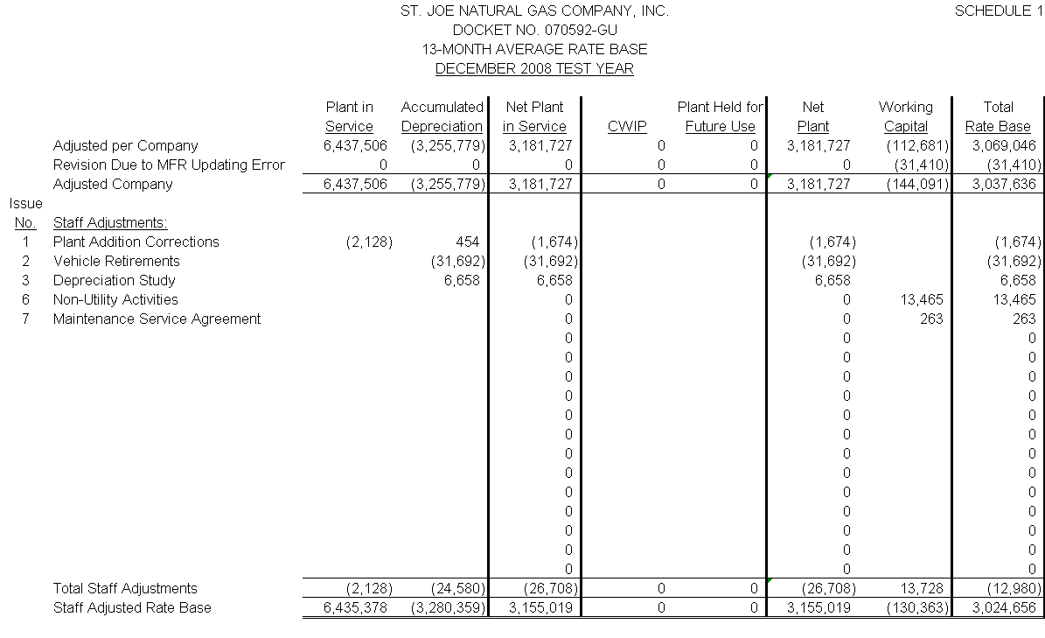

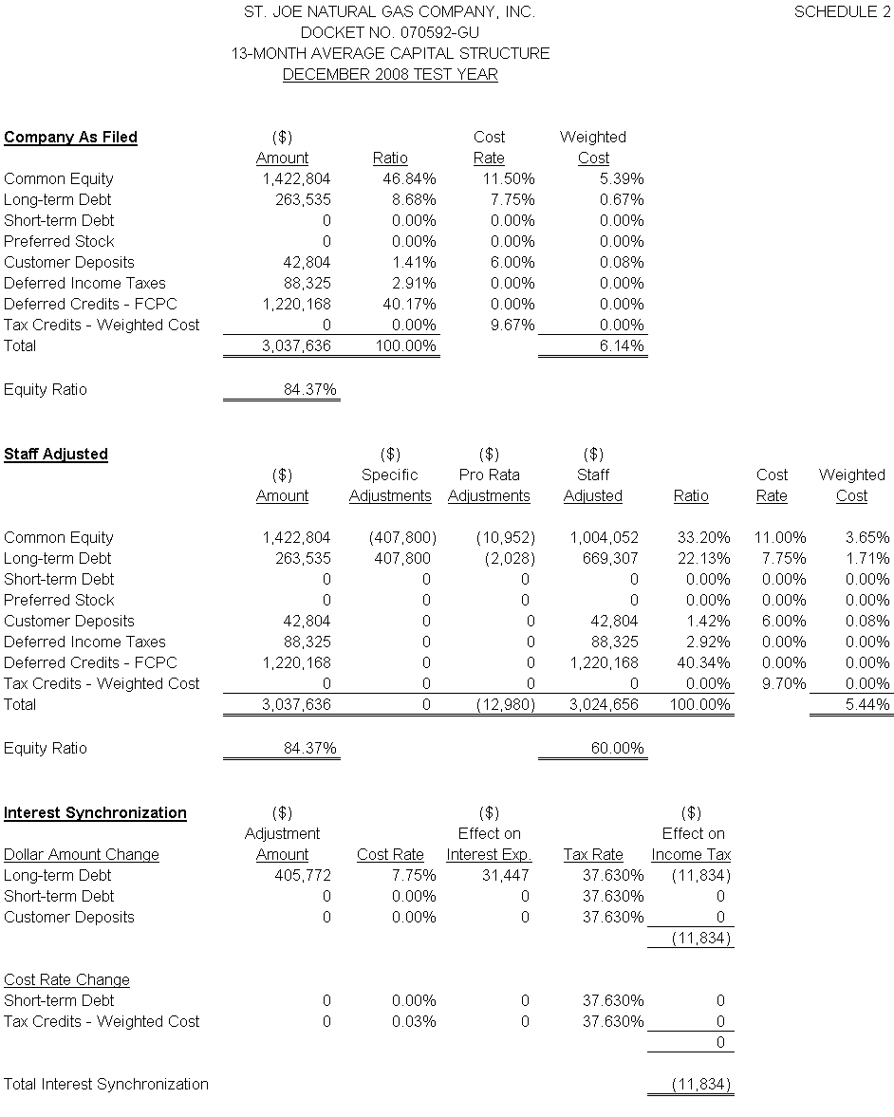

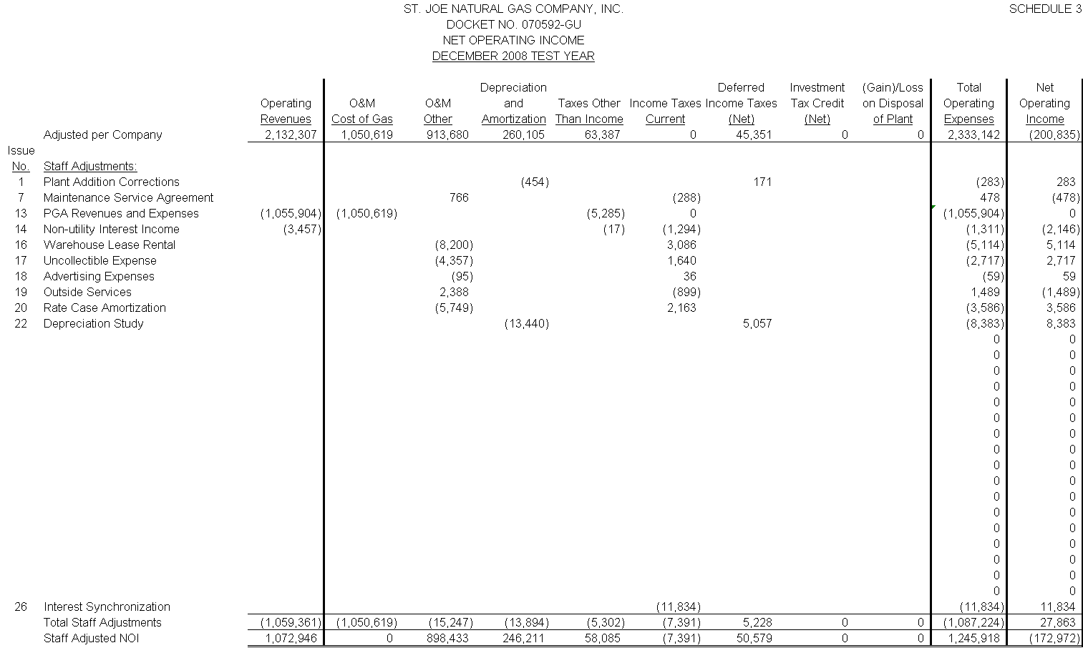
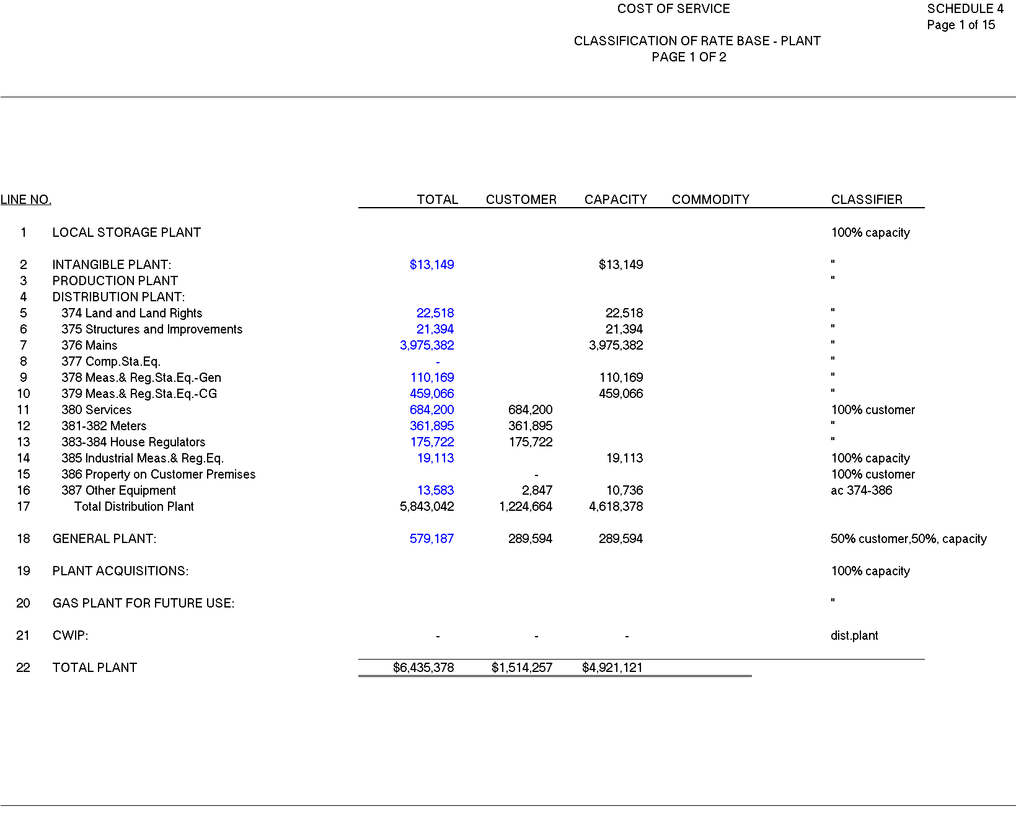
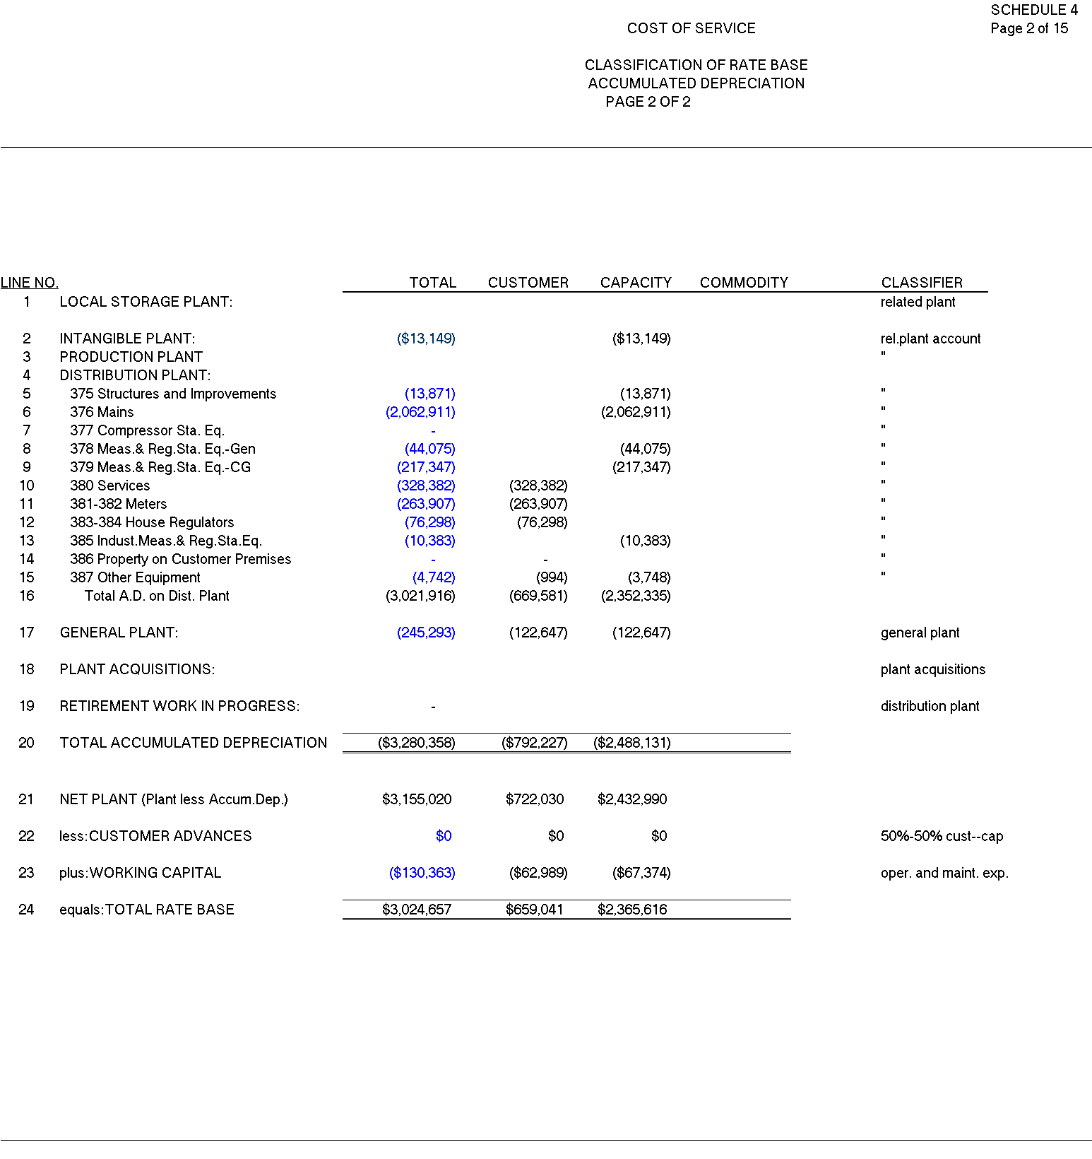
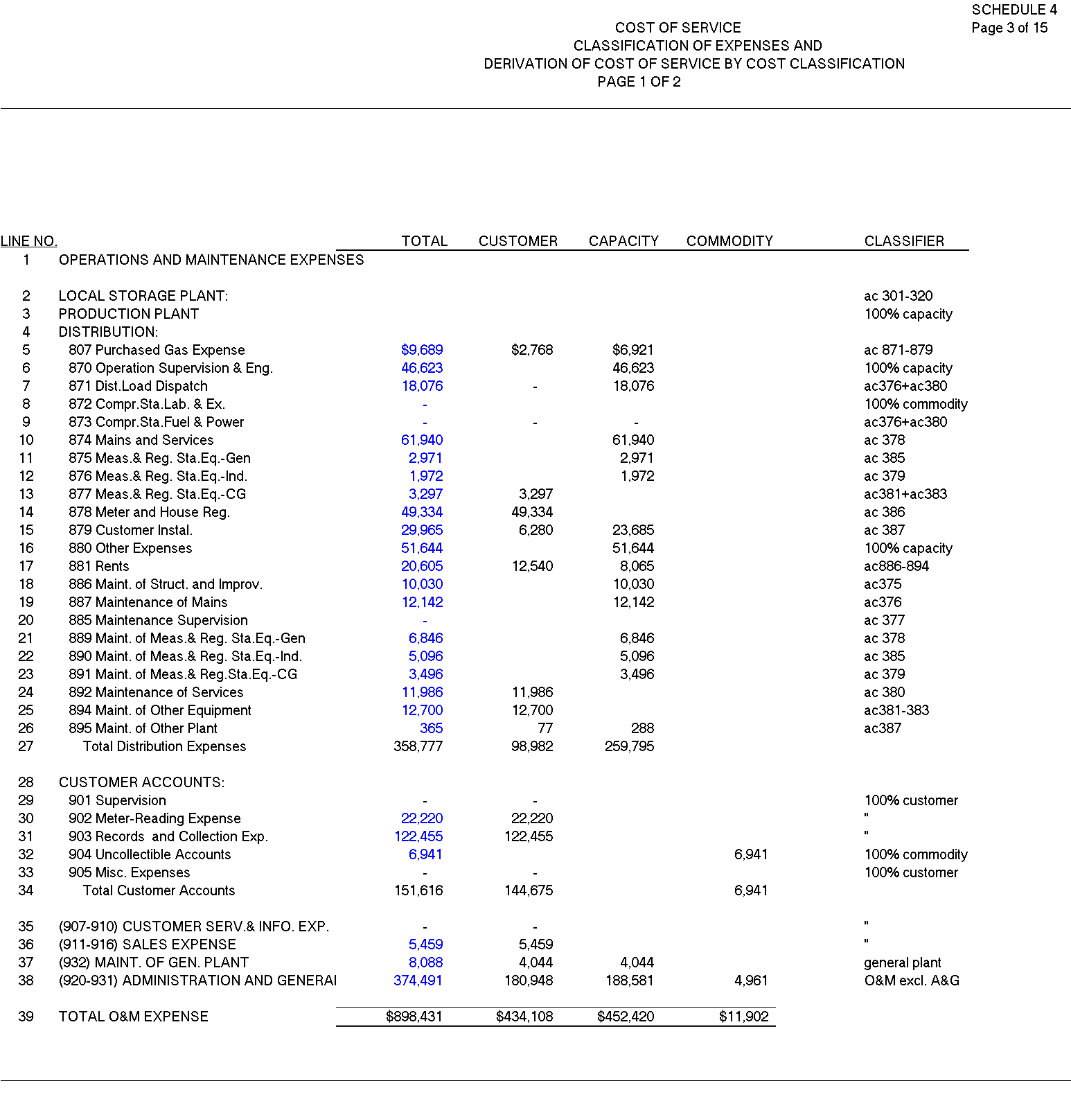
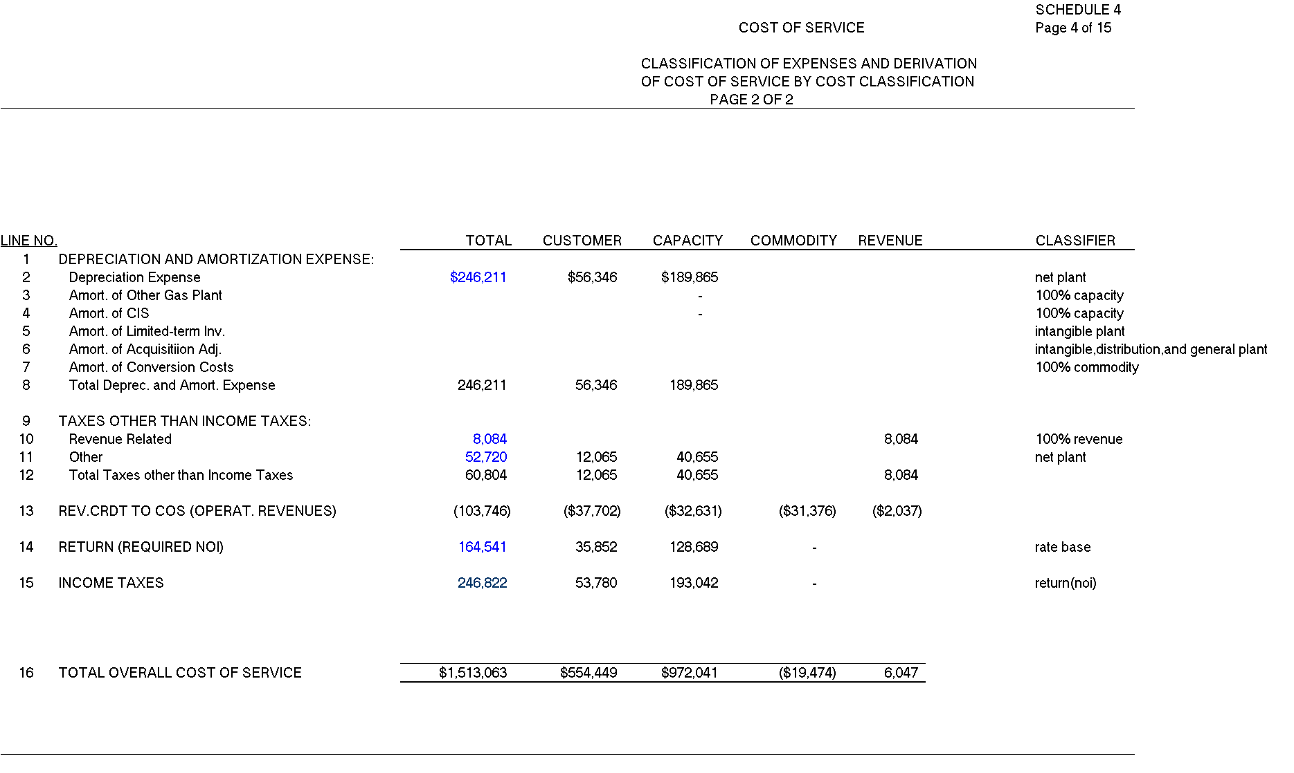
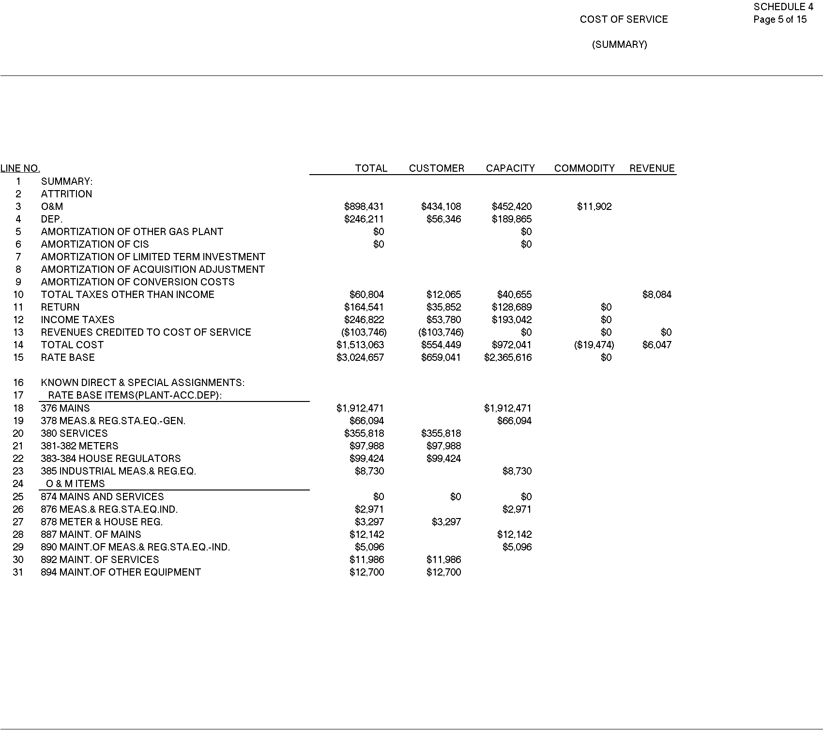
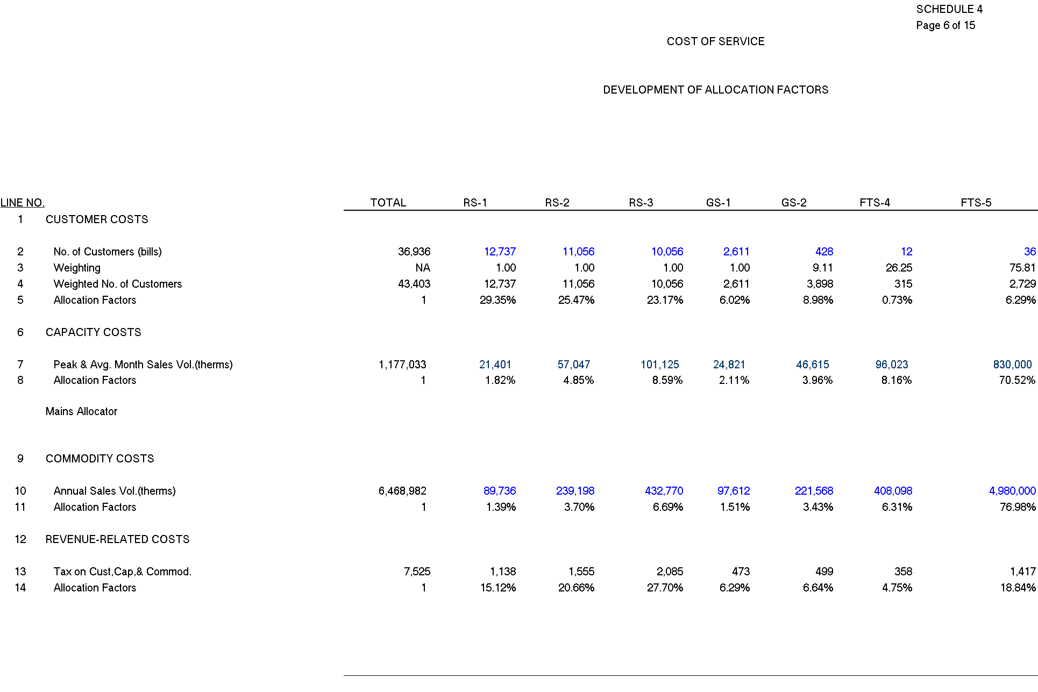
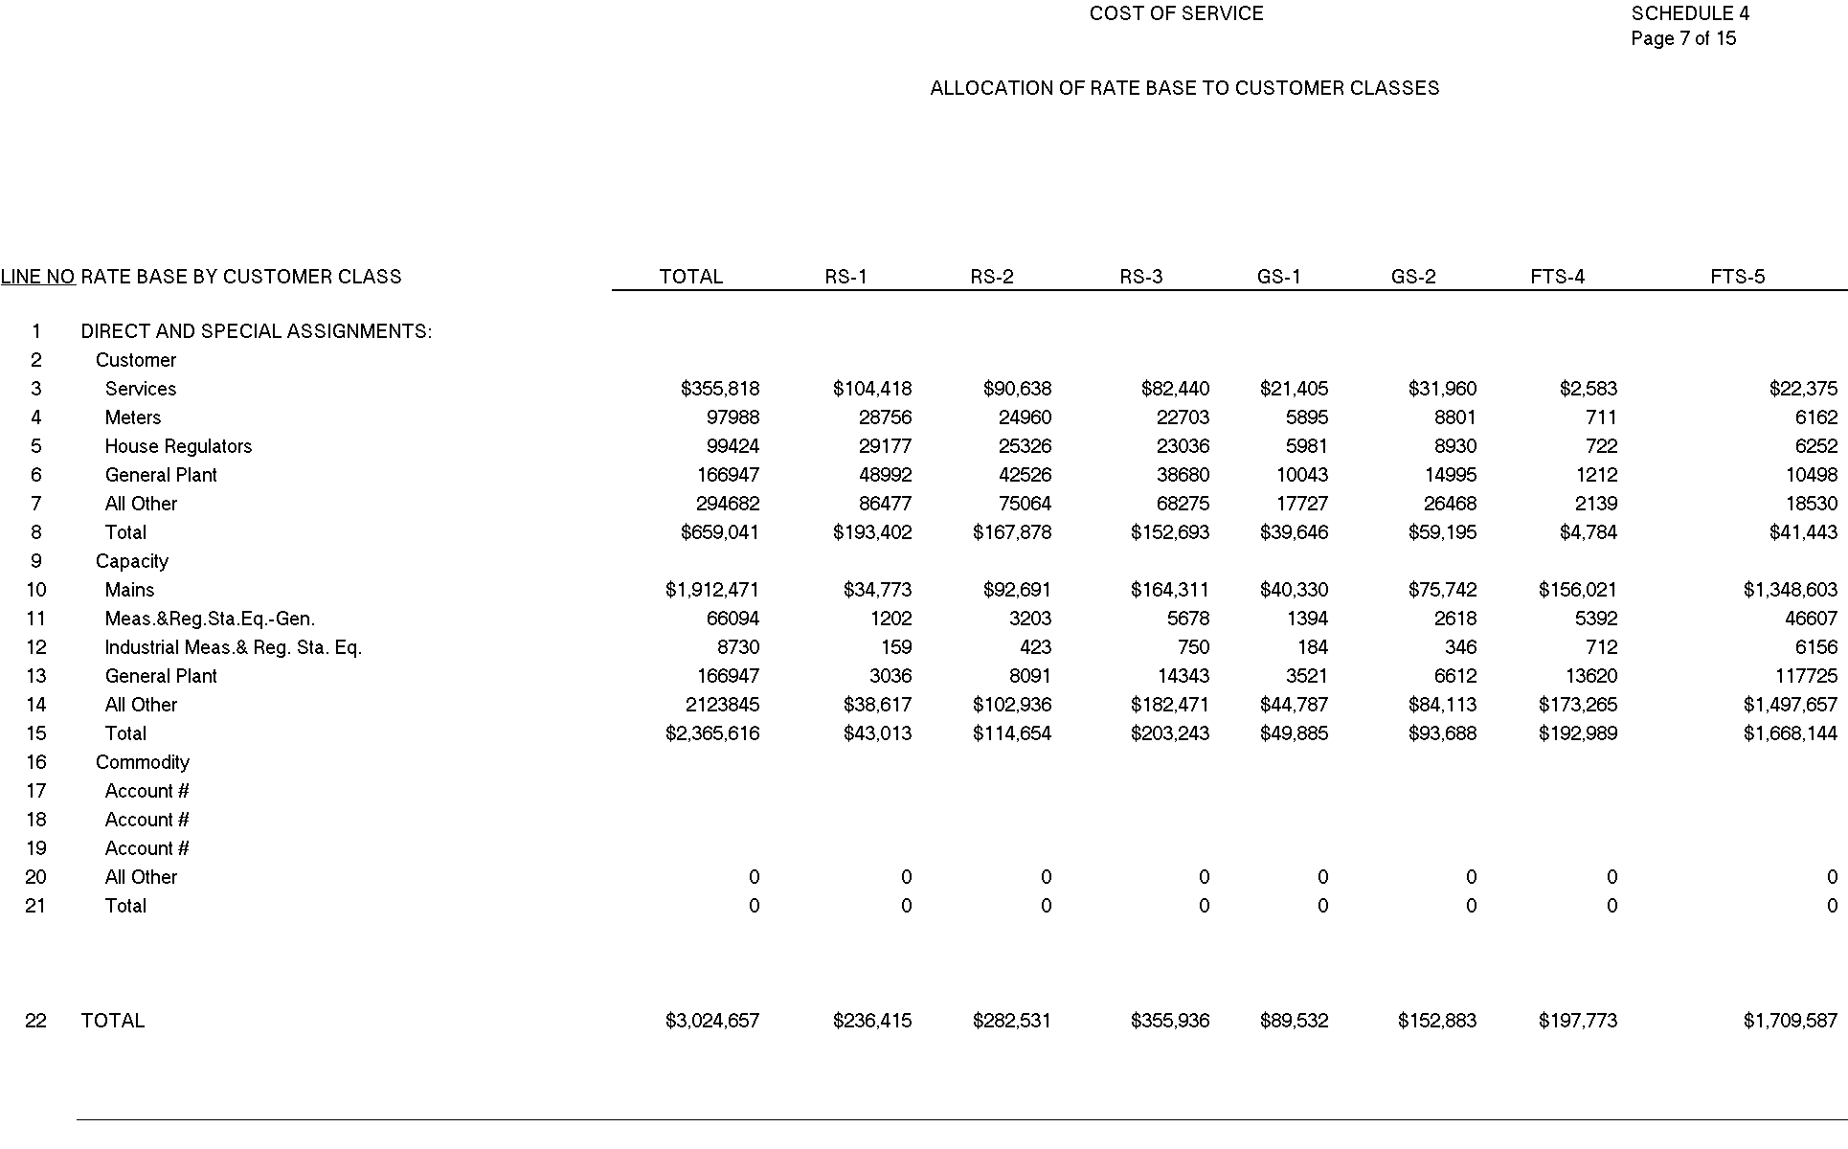

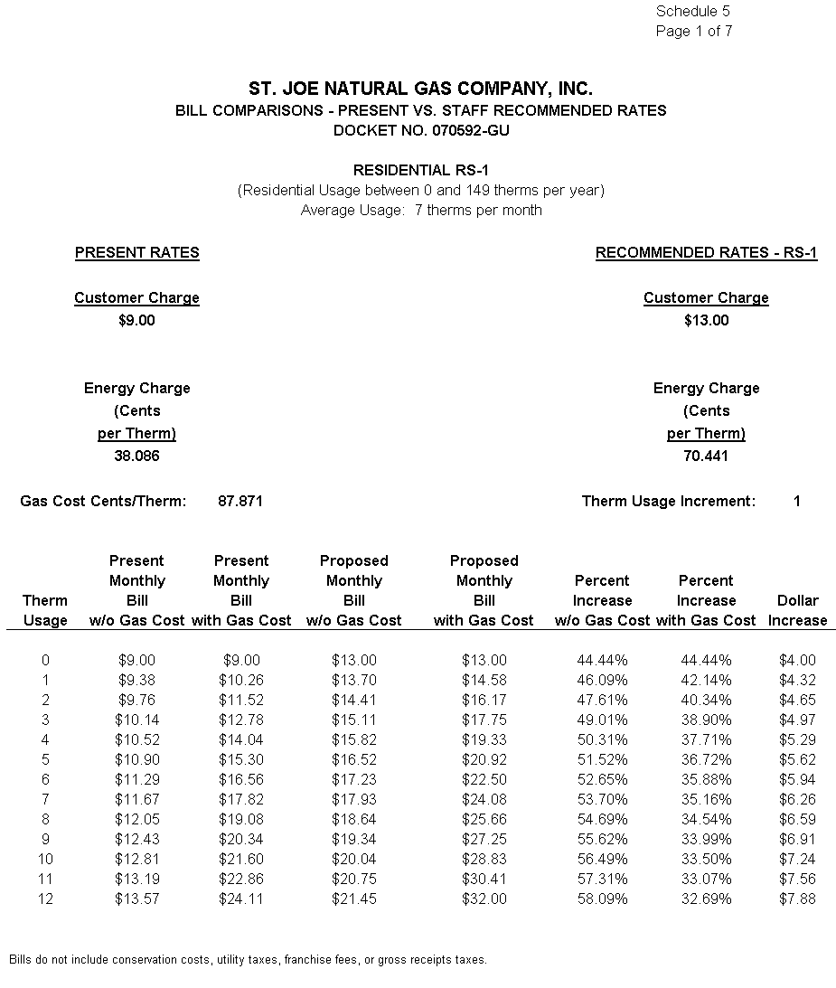
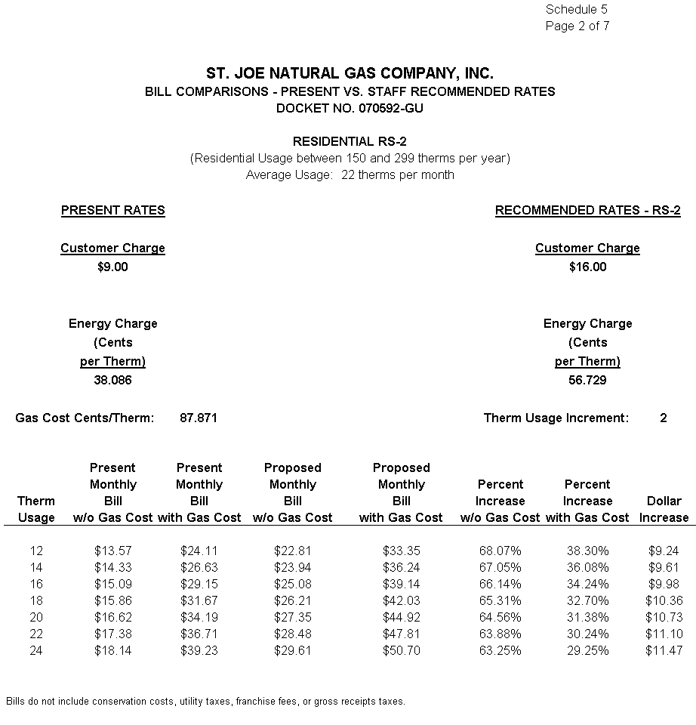
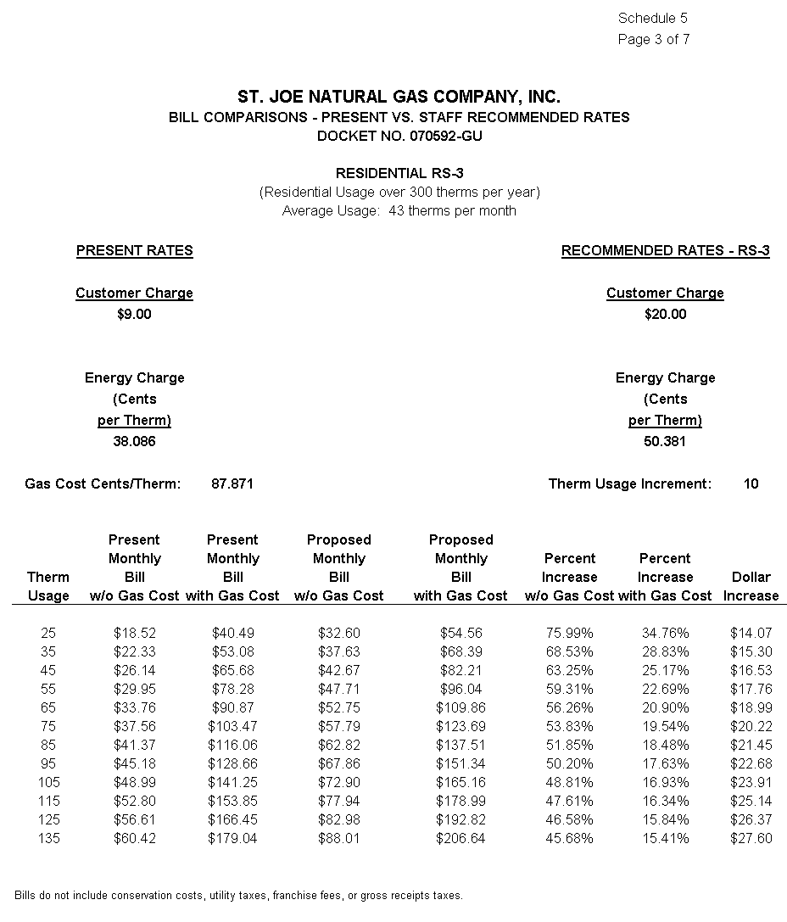
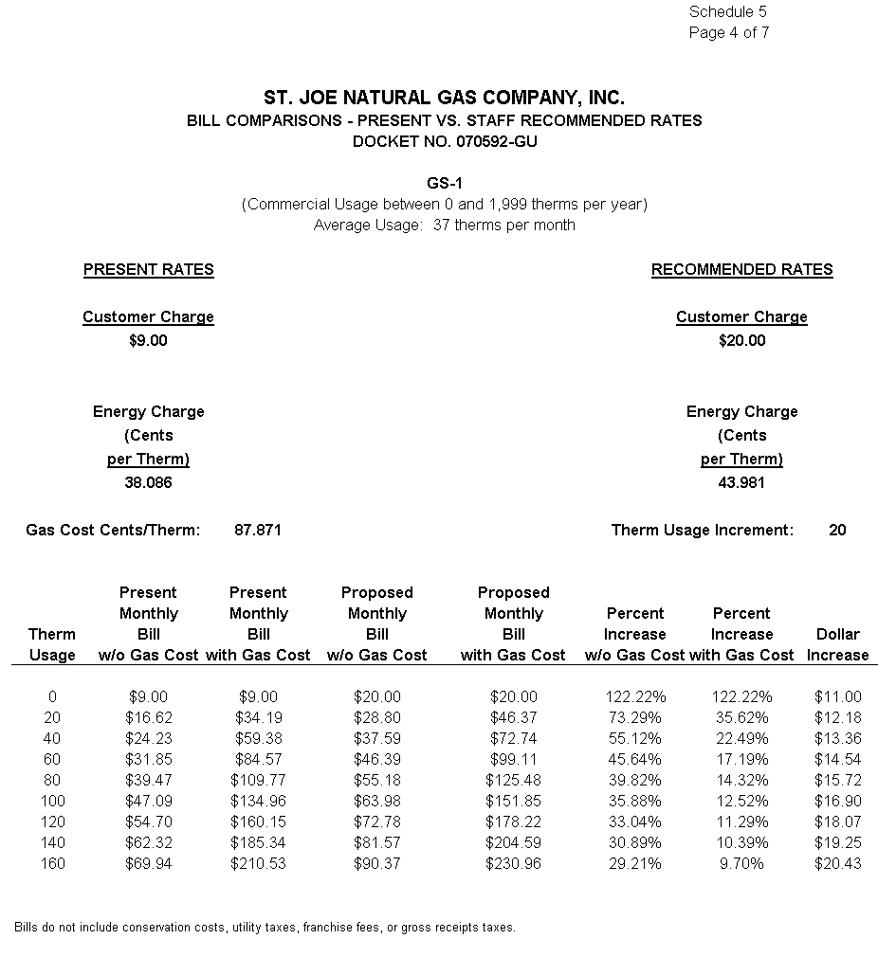
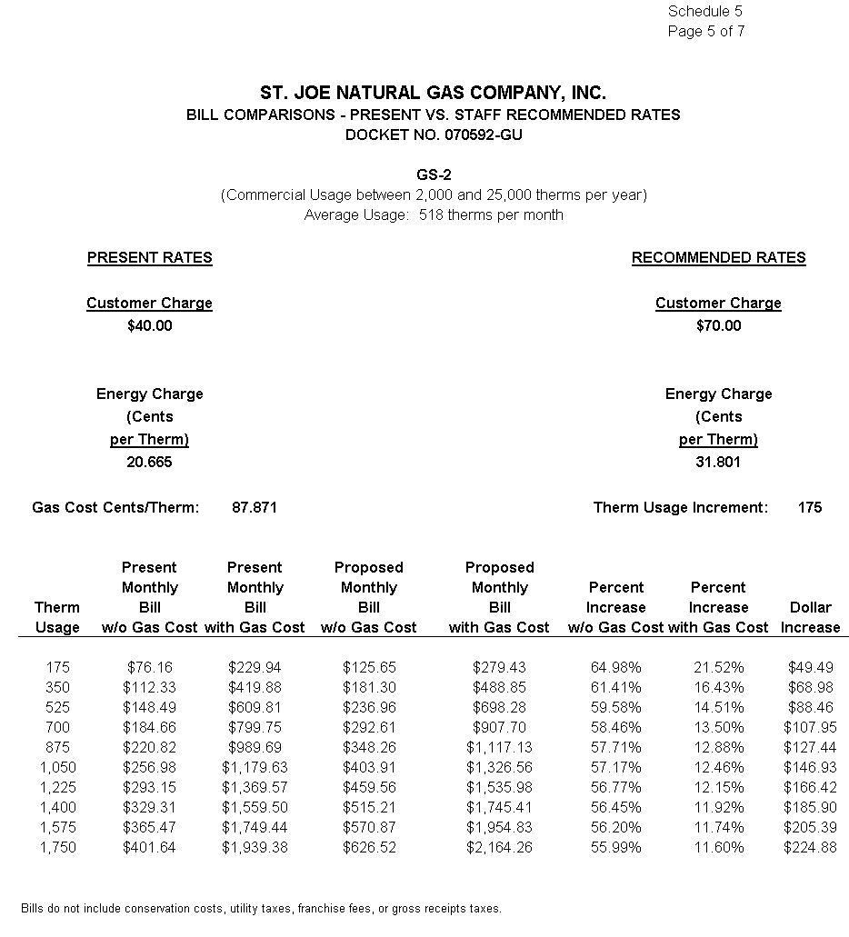
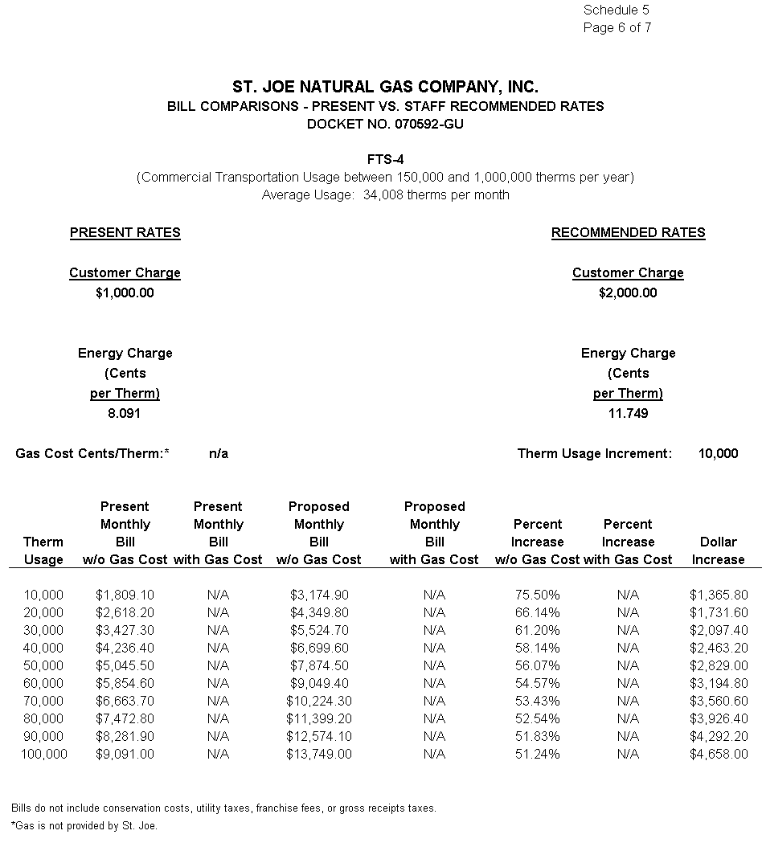
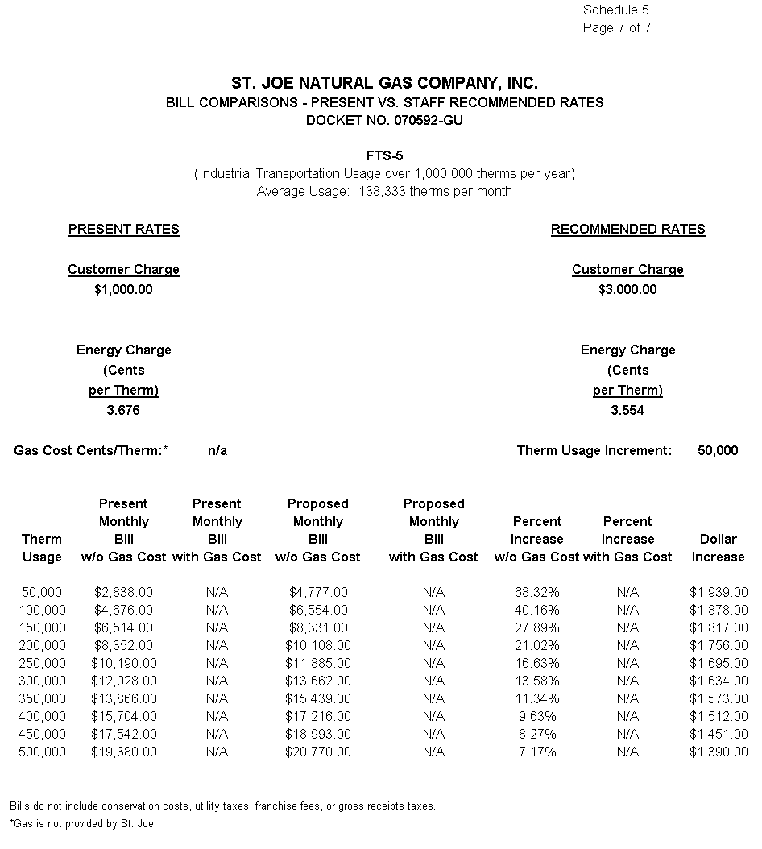

Order No. PSC-01-1274-PAA-GU, issued June 8, 2001, in Docket No. 001447-GU, In re: Request for rate increase by St. Joe Natural Gas Company, Inc..
Order No. PSC-01-1274-PAA-GU, issued June 8, 2001, in Docket No. 014447-GU, In re: Request for rate increase by St. Joe Natural Gas Company, Inc.
Order No. PSC-08-0327-FOF-EI, issued May 19, 2008, in Docket No. 070300-EI, In re: Petition for rate increase by Florida Public Utilities Company.
Order No. PSC-01-1274-PAA-GU, issued June 8, 2001, in Docket No. 001447-GU, In re: Request for rate increase by St. Joe Natural Gas Company, Inc.
Order No. PSC-01-1274-PAA-GU, issued June 8, 2001, in Docket No. 001447-GU, In re: Request for rate increase by St. Joe Natural Gas Company, Inc.
Order No. PSC-04-0565-PAA-GU, issued June 2, 2004, in Docket No. 030954-GU, In re: Petition for rate increase by Indiantown Gas Company; and Order No. PSC-04-1260-PAA-GU, issued December 20, 2004, in Docket No. 040270-GU, In re: Application for rate increase by Sebring Gas System, Inc.
Order No. PSC-08-0327-FOF-EI, issued May 19, 2008, in Docket No. 070304-EI, In re: Petition for rate increase by Florida Public Utilities Company.
See Order No. PSC-01-1274-PAA-GU, at p 27
See Order No. PSC-04-0128-PAA-GU, issued February 9, 2004, in Docket No. 030569-GU, In re: Application for rate increase by City Gas Company of Florida.
Order No. PSC-05-0208-PAA-GU, issued February 22, 2005, in Docket No. 040956-GU, In re: Petition for authorization to establish new customer classifications and restructure rates, and for approval of proposed revised tariff sheets by Florida Division of Chesapeake Utilities Corporation.
Order No.PSC-08-0103-TRF-GU, issued February 18, 2008, in Docket No. 070688-GU, In Re: Petition for approval of tariff modifications relating to main and service extension amortization surcharge, by Peoples Gas System., p. 1-3.
Order No. PSC-07-0427-TRF-GU, issued May 15, 2007, in Docket No. 060675-GU, In Re: Petition for authority to implement phase two of experimental transitional transportation service pilot program and for approval of new tariff to reflect transportation service environment, by Florida Division of Chesapeake Utilities Corporation., p. 6-7.

