Short-Term Energy Outlook, May 2008
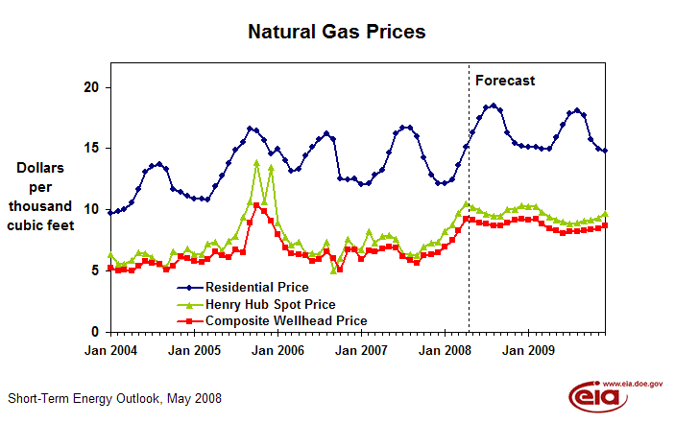
 | Residential | Henry Hub | Wellhead
Month | Price | Price | Price
Jan 2004 | 9.71 | 6.32 | 5.21
Feb 2004 | 9.85 | 5.54 | 5.02
Mar 2004 | 10.03 | 5.56 | 5.12
Apr 2004 | 10.54 | 5.88 | 5.03
May 2004 | 11.63 | 6.53 | 5.40
Jun 2004 | 13.08 | 6.45 | 5.82
Jul 2004 | 13.54 | 6.10 | 5.62
Aug 2004 | 13.74 | 5.57 | 5.52
Sep 2004 | 13.31 | 5.31 | 5.06
Oct 2004 | 11.69 | 6.58 | 5.43
Nov 2004 | 11.44 | 6.21 | 6.21
Dec 2004 | 11.09 | 6.81 | 6.01
Jan 2005 | 10.90 | 6.34 | 5.80
Feb 2005 | 10.87 | 6.32 | 5.73
Mar 2005 | 10.84 | 7.17 | 5.95
Apr 2005 | 11.88 | 7.38 | 6.57
May 2005 | 12.74 | 6.67 | 6.25
Jun 2005 | 13.79 | 7.40 | 6.09
Jul 2005 | 14.86 | 7.86 | 6.71
Aug 2005 | 15.51 | 9.37 | 6.48
Sep 2005 | 16.56 | 10.66 | 8.95
Oct 2005 | 16.44 | 13.83 | 10.33
Nov 2005 | 15.64 | 10.63 | 9.89
Dec 2005 | 14.60 | 13.44 | 9.08
Jan 2006 | 14.94 | 8.92 | 8.02
Feb 2006 | 14.00 | 7.76 | 6.86
Mar 2006 | 13.19 | 7.10 | 6.44
Apr 2006 | 13.29 | 7.38 | 6.38
May 2006 | 14.43 | 6.45 | 6.24
Jun 2006 | 15.09 | 6.39 | 5.78
Jul 2006 | 15.73 | 6.35 | 5.92
Aug 2006 | 16.19 | 7.35 | 6.56
Sep 2006 | 15.73 | 5.04 | 6.06
Oct 2006 | 12.52 | 6.02 | 5.09
Nov 2006 | 12.47 | 7.61 | 6.72
Dec 2006 | 12.54 | 6.90 | 6.76
Jan 2007 | 12.09 | 6.75 | 5.92
Feb 2007 | 12.12 | 8.24 | 6.66
Mar 2007 | 12.86 | 7.32 | 6.56
Apr 2007 | 13.27 | 7.83 | 6.84
May 2007 | 14.61 | 7.87 | 6.98
Jun 2007 | 16.20 | 7.57 | 6.86
Jul 2007 | 16.65 | 6.40 | 6.19
Aug 2007 | 16.64 | 6.37 | 5.90
Sep 2007 | 15.94 | 6.26 | 5.61
Oct 2007 | 14.25 | 6.94 | 6.25
Nov 2007 | 12.82 | 7.31 | 6.37
Dec 2007 | 12.17 | 7.32 | 6.53
Jan 2008 | 12.12 | 8.25 | 6.99
Feb 2008 | 12.46 | 8.76 | 7.55
Mar 2008 | 13.66 | 9.74 | 8.29
Apr 2008 | 15.13 | 10.49 | 9.22
May 2008 | 16.31 | 10.20 | 9.17
Jun 2008 | 17.49 | 9.91 | 8.90
Jul 2008 | 18.33 | 9.61 | 8.86
Aug 2008 | 18.51 | 9.46 | 8.70
Sep 2008 | 18.07 | 9.51 | 8.66
Oct 2008 | 16.28 | 9.99 | 8.95
Nov 2008 | 15.39 | 10.02 | 9.14
Dec 2008 | 15.20 | 10.32 | 9.25
Jan 2009 | 15.12 | 10.28 | 9.16
Feb 2009 | 15.11 | 10.24 | 9.26
Mar 2009 | 14.94 | 9.78 | 8.87
Apr 2009 | 14.97 | 9.41 | 8.46
May 2009 | 15.91 | 9.19 | 8.28
Jun 2009 | 16.93 | 8.99 | 8.05
Jul 2009 | 17.83 | 8.88 | 8.22
Aug 2009 | 18.10 | 8.89 | 8.21
Sep 2009 | 17.72 | 9.10 | 8.29
Oct 2009 | 15.73 | 9.12 | 8.34
Nov 2009 | 14.99 | 9.34 | 8.44
Dec 2009 | 14.77 | 9.73 | 8.68
Month | Forecast
Apr 2008 | 0
Apr 2008 | 1

