State of Florida   |  | Public Service Commission  Capital Circle Office Center ● 2540 Shumard Oak Boulevard  Tallahassee, Florida 32399-0850  -M-E-M-O-R-A-N-D-U-M-
DATE: | September 4, 2008
TO: | Office of Commission Clerk (Cole)
FROM: | Office of Strategic Analysis and Governmental Affairs (Brown)  Division of Economic Regulation (Draper)  Office of the General Counsel (Hartman)
RE: | Docket No. 080367-EG – Petition for approval to modify renewable energy program by Tampa Electric Company.
AGENDA: | 09/16/08 – Regular Agenda – Tariff Filing - Interested Persons May Participate
COMMISSIONERS ASSIGNED: |  |  | All Commissioners
PREHEARING OFFICER: |  |  | Administrative
CRITICAL DATES: |  |  | 02/23/09 (8 month effective date)
SPECIAL INSTRUCTIONS: |  |  | None
FILE NAME AND LOCATION: |  |  | S:\PSC\SGA\WP\080367.RCM.DOC

Case Background
Tampa Electric Company’s (TECO or Company) renewable energy program gained Commission approval for permanent status in December 2006. TECO’s renewable energy program is a voluntary program which allows its customers the option to purchase an unlimited amount of renewable energy consisting of 200 kilowatt-hour (kWh) blocks for $5.00 per block. Pursuant to Order No. PSC-06-1063-TRF-EG, revenues and expenses of the renewable energy program are recorded in accounts associated with TECO’s Energy Conservation Cost Recovery (ECCR) clause. Any excess revenues are placed in Account 253, Other Deferred Credits, an account established as a revenue tracking account. TECO states that during 2007, revenues were approximately $18,000 short of making the program self-sustaining. The company notes, however, that by June 2008, revenues were able to make the program self-sustaining and TECO’s Renewable Energy Plan began to experience a positive balance in Account 253. As of June 2008, the account had a positive balance of $22,000, and TECO estimates that by year end, the balance is projected to be approximately $93,000.
Under the current program, customers are required to participate in the program for a minimum term of one year. TECO does not outsource its renewable energy program. All renewable energy for TECO’s program is produced in its local area or within the State of Florida. The renewable energy sources consist of photovoltaic arrays, biomass fuel, and landfill gas.
On June 23, 2008, TECO filed a petition to modify its Renewable Energy Program. TECO is requesting to eliminate the one year term of service required under the current program.
The Commission has jurisdiction under Section 366.04, 366.05. 366.06, 366.80, 366.81 and 366.82, Florida Statues.
Discussion of Issues
Issue 1:1
Should the Commission approve TECO’s petition to modify its Renewable Energy Program?
Recommendation:
Yes. Modifying TECO’s Renewable Energy Program will eliminate the mandatory one year term of participation requirement and allow for increased participation in the program. (Brown, Draper)
Staff Analysis:
TECO’s permanent Renewable Energy Program became effective in January 2007. All of the company’s renewable energy for its program is produced locally or within the state of Florida and is derived from photovoltaic arrays, biomass fuel, or landfill gas. TECO currently requires participation in its Renewable Energy Program for a period of one year. After the initial twelve months, the customer can terminate participation after giving a two months’ termination notice. TECO’s customers are allowed to purchase increments of 200 kWh blocks of renewable generation for $5.00 per block per month. The program is available to residential, commercial, and industrial customers. As of May 2008, 3,143 customers were currently participating in the program. In addition, a total of 4,169 blocks of renewable energy have been purchased. Revenues from January 2007 through June 2008 are $260,593 and expenses are $176,720.
TECO is proposing to modify its Renewable Energy Program to remove the twelve month participation requirement. The company believes doing so will result in additional participation from residential and commercial customers who wish to not be tied to the mandatory one year participation requirement. In support of its request to modify the program, TECO states that it has received several inquiries from residential and commercial customers regarding the possibility of making one time purchases of renewable energy on a periodic basis rather than the one year minimum term of service. Those commercial customers include convention centers, hotels with large scale conference facilities, and sporting event venues that regularly host clients that want to promote the use of renewable energy during their events.
If granted approval to modify its Renewable Energy Program, TECO states that all other conditions and provisions approved by Order No. PSC-06-1063-TRF-EG will remain in place. TECO will continue to provide reports on the program’s progress every six months, which will include the participation levels achieved, energy produced, and cost and revenue estimates. Excess revenues will continue to be placed in Account 253, Other Deferred Credits. In addition, revenues and expenses for the Renewable Energy Program will continue to be recorded separately in TECO’s ECCR clause. Moreover, TECO will continue to provide a summary of the program’s progress in its testimony, which is submitted during the true-up proceedings in the ECCR docket. TECO will continue to use excess revenues from the program toward investigating the potential of new renewable resources, efforts to increase program participation, reduction of monthly fees to participants, program administration, marketing, and continued education of customers on the attributes of renewable energy. The only change will be the removal of the one year participation requirement.
The customer’s costs and guidelines of the modified Renewable Energy program will be established by tariff titled the Renewable Energy Program Fourth Revised Tariff Sheet No. 6400. This tariff sheet is included as Attachment A.
In conclusion, staff recommends that TECO’s petition to modify its Renewable Energy Program be approved. The proposed tariff states that participation in the program is based on a first-come, first-serve basis for a minimum term of one billing period and subject to availability of renewable energy. Removing the one year participation requirement will allow residential customers who might not be able to participate in the program on an annual basis, to be able to make a one-time purchase of a 200 kWh block of renewable energy for $5.00 per block when feasible. In addition, customers will not be required to give a two-months termination notice regarding participation in the program. Also, organizations conducting conventions, meetings, and other events will be able to make one-time purchases of renewable energy for their events as well. In addition, removing the one year participation requirement could also allow for increased participation in the program and increased production of renewable energy in the state of Florida.
Issue 2:2
Should this docket be closed?
Recommendation:
Yes. If Issue 1 is approved, this tariff should become effective on October 30, 2008. If a protest is filed within 21 days of the issuance of the order, this tariff should remain in effect with any increase held subject to refund pending resolution of the protest. If no timely protest is filed, this docket should be closed upon the issuance of a consummating order. (Hartman, Draper)
Staff Analysis:
If Issue 1 is approved, this tariff should become effective on October 30, 2008. If a protest is filed within 21 days of the issuance of the order, this tariff should remain in effect with any increase held subject to refund pending resolution of the protest. If no timely protest is filed, this docket should be closed upon the issuance of a consummating order.

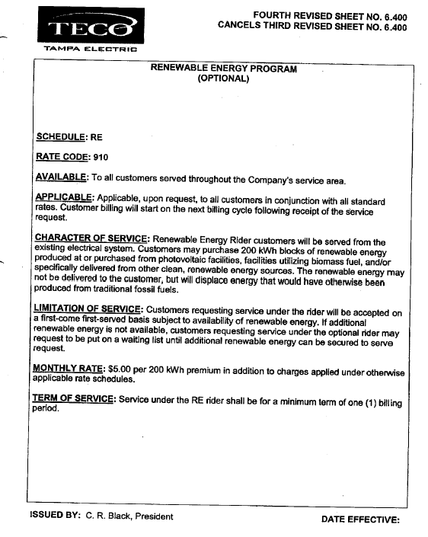

Order No. PSC-06-1063-TRF-EG, issued December 26, 2006, in Docket No. 060678-EG, In Re: Petition for approval to make renewable energy pilot program (f/k/a green energy rate rider) permanent, by Tampa Electric Company.

