BEFORE THE FLORIDA PUBLIC SERVICE COMMISSION

In re: Establishment of a rule on renewable portfolio standard | DOCKET NO. 080503-EI  Filed: September 5, 2008

POST WORKSHOP COMMENTS OF
FLORIDA MUNICIPAL ELECTRIC ASSOCIATION, INC.,

- Introduction
Florida Municipal Electric Association, Inc. (“FMEA”), by and through undersigned counsel, hereby submits its post workshop comments on behalf of its thirty-four municipal electric utility members in Florida. These comments are in response to the rule development workshop held on August 20, 2008, and continued on August 26, 2008. FMEA members may also file individual comments in this docket.
FMEA commends the PSC staff on thorough and diligent work on the proposed rules, and offers in these comments some minor changes that will add clarity to the renewable portfolio standard (“RPS”) rules.
While the proposed rules are generally directed toward to the investor-owned utilities (“IOUs”), the RPS adopted by these rules, and specifically the renewable energy credit (“REC”) market component, will have a direct and substantial impact on municipal electric utilities in the development and implementation of their own renewable portfolio standards.
House Bill 7135 requires municipal electric utilities and rural electric cooperatives to “develop standards for the promotion, encouragement, and expansion of the use of renewable energy resources and energy conservation and efficiency measures….” § 366.92(5), Florida Statutes (2007). It further requires municipal electric utilities and rural electric cooperatives to annually file with the Commission a “report that identifies such standards.” Id.
FMEA members are developing their own standards in parallel with the Commission’s rule in this docket, and anticipate, as appropriate, modeling those standards after the rules that are developed as part of this rulemaking proceeding. Further, the ability of FMEA’s members to achieve compliance with their own renewable standards, and the Commission’s RPS rules are inextricably linked. The Commission’s rules provide for the market for the purchase and sale of RECs in Florida, and will specify the renewable resources that qualify for certification as a REC in that market. In complying with their renewable standards, municipal electric utilities will be participants in the Florida REC market – both as buyers and sellers of RECs. Therefore, municipal electric utilities will be both effected by, and have an effect on, that market. Because of this, FMEA offers the following recommendations in an effort to add additional clarity to staff’s proposed rules.
- Proposed Rule 25-17.410, Florida Renewable Energy Credit Market
FMEA understands that it was staff’s intent to welcome and encourage municipal electric utility participation in the development and administration of the REC market in Florida. Consistent with this intent, and to help avoid any ambiguity in the rule, FMEA recommends a clarifying change to Rule 25-17.410(1)(b) whereby instead of encouraging municipal electric utilities to participate, the rule grants municipal electric utilities the right to participate. This change is also consistent with the intent of the rule, which directs the IOUs to establish the REC market and provides guidance to the IOUs in this regard. A provision directing the IOUs to allow stakeholder participation in this process will help to ensure a fair, equitable, and transparent REC market. Accordingly, the following amended language will clarify this rule:
(b) The investor-owned utilities shall allow Mmunicipal electric utilities and rural electric cooperatives are encouraged to participate in the development, administration, and governance of the Florida Renewable Energy Credit Market on a fair and equitable basis.

- Rule 25-17.400, Florida Renewable Portfolio Standard

- Solar Thermal Energy

FMEA also strongly advocates, consistent with staff’s proposed rules, that solar thermal energy should qualify as a renewable energy resource, and should remain in the list of accepted renewable energy technologies to achieve RPS goals.
Section 366.92(2)(a), Florida Statutes, which directs the Commission to establish an RPS, defines the term “Florida renewable energy resources” to include solar thermal energy, among others. This definition was not “orphaned” by House Bill 7135, as Gulf Power suggested during the August 26 rulemaking workshop. In fact, the opposite is true. The Legislature amended the term “Florida renewable energy resources” in HB 7175 – a clear signal of the Legislative intent to keep this definition in section 366.92. Staff’s proposed rule correctly incorporates this definition into proposed Rule 25-17.400, and, consistent with clear legislative intent, properly adopts clarifying definitions such as “solar energy system,” “solar thermal system,” and “equivalent solar thermal energy” to include solar thermal energy as a qualified renewable technology.
Solar water heating is a renewable technology. Water is heated by the sun, just as electrons are excited by the sun using photovoltaic energy. In fact, solar water heating is one of the most cost-effective renewable energy technologies available in Florida, and any suggestion to limit its consideration in an RPS would make the goals of an RPS significantly more difficult to achieve. To disqualify solar water heating would be to discourage further development of what is a proven, viable and effective renewable resource. In nearly every case of its application in Florida (except when replacing nuclear energy), solar water heating replaces fossil fuel resources that contribute to greenhouse gas emissions.
Attached is a copy of an actual Renewable Energy Credit (REC) certificate, made available by Lakeland Electric, which was produced by providing 50% solar-heated water to a residence, thus replacing an electric water heater, and 50% photovoltaic energy. Other utilities such as Orlando Utilities Commission and Keys Energy Services are trading solar hot water Renewable Energy Credits via their local Green Energy Marketing programs. Clearly, RECs derived from solar water heating have and are being actively traded in the Florida voluntary green energy marketplace. The Commission should continue the promotion of this positive renewable energy contribution – and expand it further – to take advantage of the great potential this important renewable resource has for Florida.
- Yard Waste
Finally, energy produced from yard waste should qualify as renewable energy. Yard waste is a form of biomass, and is intended to be included as such in the proposed rule. The definition of the term “biomass” in Rule 25-17.400(2)(c) contains a nonexclusive list of power sources. Yard waste generally includes tree branches, brush, and other yard clippings – clearly a renewable resource intended to be included in the nonexclusive definition of the term “biomass.” However, in order to avoid any ambiguity, FMEA recommends adding the term “yard waste” to the definition of “biomass” in Rule 25-17.400(2)(c). Thus, FMEA suggests the following amended language be incorporated in the rule:
(c) “Biomass,” means a power source that is comprised of, but not limited to, combustible residues or gases from forest products manufacturing, waste, or co-products form agricultural and orchard crops, waste or co-products from livestock and poultry operations, waste or byproducts from food processing, urban wood and yard waste, municipal solid waste, municipal liquid waste treatment operations, and landfill gas.

RESPECTFULLY submitted this 5th day of September 2008.

/s/
FREDERICK M. BRYANT
JODY LAMAR FINKLEA
DANIEL B. O’HAGAN
2061-2 Delta Way (32303)
Post Office Box 3209
Tallahassee, Florida 32315-3209
Telephone (850) 297-2011
Facsimile (850) 297-2014
Email: fred.byrant@fmpa.com
jody.lamar.finklea@fmpa..com
Dan.ohagan@fmpa.com
Florida Bar No. 33504

Attorneys for Florida Municipal Electric Association, Inc.

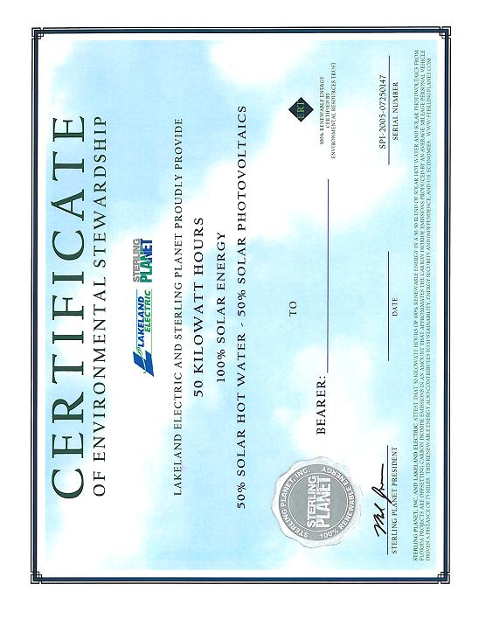

FMEA is comprised of the following municipal electric utility members: City of Alachua, City of Bartow, City of Blountstown, City of Bushnell, City of Chattahoochee, City of Clewiston, City of Fort Meade, Fort Pierce Utilities Authority, City of Gainesville d/b/a Gainesville Regional Utilities, City of Green Cove Springs, Town of Havana, City of Homestead d/b/a Homestead Energy Services, JEA, City of Jacksonville Beach d/b/a Beaches Energy Services, Utility Board of the City of Key West, Florida d/b/a Keys Energy Services, Kissimmee Utility Authority, City of Lake Worth, City of Lakeland d/b/a Lakeland Electric, City of Leesburg, City of Moore Haven, City of Mount Dora, Utilities Commission of the City of New Smyrna Beach, City of Newberry, City of Ocala d/b/a Ocala Electric Utility, Orlando Utilities Commission, City of Quincy, Reedy Creek Improvement District, City of St. Cloud, City of Starke, City of Tallahassee, City of Vero Beach, City of Wauchula, City of Williston, and City of Winter Park.
The Legislative change to the definition in HB 7135 is as follows: “(a) ‘Florida renewable energy resources’ means shall mean renewable energy, as defined in s. 377.803, that is produced in Florida.”

