Florida House of Representatives
Representative Gary Aubuchon
District 74
Committees & Councils:  Health Care Services, Chair  Human Services Appropriations, Vice Chair  General Government & Health Care Appropriations  Health and Family Services Policy Council | Energy & Utilities  Roads, Bridges & Ports

January 13, 2009

The Honorable Matthew M. Carter II, Chairman
Florida Public Service Commission
2540 Shumard Oak Boulevard
Tallahassee, FL 32399-0850

Re: DOCKET NO. 080665-EI - Petition of Florida Power & Light Company
For Approval of Long-Term Agreement for Full Requirements Electric Service with Lee County Electric Cooperative

Dear Chairman Carter:

As the State Representative of District 74, I represent customers of Lee County Electric Cooperative, Inc. (LCEC) and Florida Power and Light (FPL) throughout Southwest Florida. It is my understanding that as a result of many years of study and consultation with industry experts, LCEC has determined it is in the best interest of its customers to begin receiving wholesale power from a larger, more diverse power supplier such as FPL. LCEC subsequently reached an agreement with their current power supplier, Seminole Electric Cooperative, for early termination of their all-requirements contract and has entered into a long-term agreement for full power requirements with Florida Power and Light (FPL).
In an effort to validate that FPL retail customers would not be disadvantaged by adding LCEC as a wholesale customer, a condition was placed on the agreement that led FPL to petition the FPSC for approval of the agreement prior to its commencement.
I support the FPL request for approval from the FPSC and believe your review will ensure the proposed agreement is in the best interests of both FPL and LCEC customers. As a member of the House Committee on Energy, I have a continued interest in ensuring diverse energy resources are available to customers throughout the state. This agreement takes a step in the right direction toward promoting energy security and affordability by encouraging diversification. As you know, a prompt decision allowing FPL to serve LCEC customers is critical to ensuring a continued reliable source of energy at a competitive price for all customers. Thank you in advance for your timely consideration in this matter.

Sincerely,
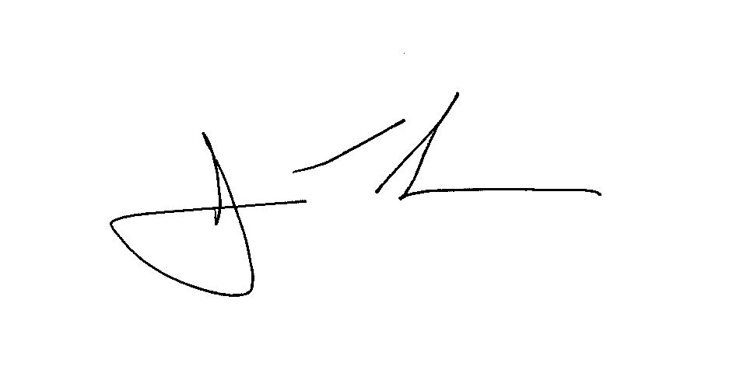
Gary Aubuchon

cc: The Honorable Lisa P. Edgar, Commissioner
cc: The Honorable Nathan A. Skop, Commissioner
cc: The Honorable Katrina J. McMurrian, Commissioner
cc: The Honorable Nancy Argenziano, Commissioner
cc: Dr. Mary Bane, Executive Director, Florida Public Service Commission
cc: Patrick Booter Imhof, General Counsel, Florida Public Service Commission
cc: J.R. Kelly, Esquire, Office of Public Counsel

