State of Florida   |  | Public Service Commission  Capital Circle Office Center ● 2540 Shumard Oak Boulevard  Tallahassee, Florida 32399-0850  -M-E-M-O-R-A-N-D-U-M-
DATE: | February 20, 2009
TO: | Office of Commission Clerk (Cole)
FROM: | Division of Economic Regulation (Kummer, Lee)  Office of the General Counsel (Bennett)  Office of Strategic Analysis and Governmental Affairs (Graves)
RE: | Docket No. 080665-EI – Petition of Florida Power & Light Company for approval of long-term agreement for full requirements electric service with Lee County Electric Cooperative.
AGENDA: | 03/03/09 – Regular Agenda – Proposed Agency Action - Interested Persons May Participate
COMMISSIONERS ASSIGNED: |  |  | All Commissioners
PREHEARING OFFICER: |  |  | Edgar
CRITICAL DATES: |  |  | None
SPECIAL INSTRUCTIONS: |  |  | This recommendation has been revised to address FPL’s Supplement to its November 10, 2008 Petition.
FILE NAME AND LOCATION: |  |  | S:\PSC\ECR\WP\080665.RCM.DOC

Case Background

On August 21, 2007, Florida Power & Light (FPL) signed an agreement with Lee County Electric Cooperative (LCEC) for a long-term wholesale power sales agreement to provide full requirements electric service to LCEC. On September 2, 2008, FPL filed for Commission approval of the sales agreement in Docket No. 080001-EI. At the Prehearing Conference in Docket No. 080001-EI on October 20, 2008, FPL agreed to remove this issue from consideration in the fuel docket and file a separate petition, on the understanding that the matter would be heard expeditiously so as to meet the December 31, 2009, deadline for regulatory approval stated in the Agreement. FPL filed the separate petition on November 10, 2008, in Docket No. 080665-EI.

Staff’s January 29, 2009 recommendation addresses FPL’s November petition. FPL requested that this item be deferred from the February 10, 2009 Agenda to allow FPL to file a Supplemental Petition. FPL filed the Supplement on February 12, 2009. (Attachment B) This recommendation revises Staff’s recommendation submitted on January 29, 2009, to incorporate the information provided in the Supplement and further discussions with the utility.
LCEC currently purchases its wholesale power from Seminole Electric Cooperative (Seminole). As LCEC’s purchased power contract with Seminole neared its expiration date, LCEC approached FPL, seeking to purchase wholesale power to serve LCEC’s retail load. LCEC requested that FPL begin serving up to 300 Megawatts (MWs) of LCEC’s load in 2010, but the bulk of the total load of 1,100 MWs would not be required until 2014, when LCEC would become a full requirements wholesale customer. FPL has entered into a short term wholesale agreement for the load between 2010 and 2014, and is not seeking Commission approval of that contract.

In its November 10, 2008 petition, FPL sought Commission approval of the long-term sales agreement (Agreement) beginning in January 2014, when the full 1,100 MWs of load would become FPL’s responsibility. The initial term of the Agreement is for twenty years (ending December 31, 2033), and continues for an additional 20 years (ending December 31, 2053), unless either party chooses to terminate it. In the Supplement to the petition, FPL clarifies that it is no longer asking the Commission to determine that the specific terms and conditions of the Agreement are prudent, which was addressed in Issue 1 of the January 29 recommendation. FPL agrees with staff that those issues are more properly before the Federal Energy Regulatory Commission (FERC). Instead, FPL asks the Commission to evaluate FPL’s decision to serve LCEC’s load on a long term basis, and to find that FPL’s entering into the Agreement and its proposed regulatory treatment is prudent and consistent with the interests of FPL’s retail ratepayers. Staff has revised the recommendation to eliminate the discussion on prudence and address only the reasonableness of the regulatory treatment of the costs and benefits to retail ratepayers.
Under the Agreement, LCEC’s load would be treated on an equal footing with FPL’s retail load. It is a system sale, which means LCEC will be assigned costs at system average cost for both capacity and fuel, just as retail ratepayers are. FPL will also include LCEC’s load in its Ten Year Site Plan (TYSP) when planning plant additions. FPL states that the rate charged to LCEC is consistent with the FERC requirements, and that LCEC has secured firm transmission service for the load under FPL’s FERC Open Access Transmission Tariff (OATT).

FPL represents that it has performed a system cost analysis, using the same methodology used in its TYSP, both with and without the LCEC load. The benefits to FPL’s retail ratepayers, according to the petition, result from netting increased fuel costs against reduced base rate costs to retail customers. The increase in fuel costs results from the need to run higher cost generation to serve the increased total load. The decrease in base rate costs results from a higher jurisdictional separation factor, which removes more generation costs from the revenue requirement used to set retail base rates. FPL also contends that the sale will allow it to leverage its economies of scale to spread costs of new plant over more load, as well as provide a reliable, efficient, cost effective and environmentally friendly source of power to LCEC’s retail customers.

FPL is not obligated by law to obtain Commission approval to enter into either a short or long-term wholesale contract with LCEC. However, FPL included a provision in the Agreement which requires Commission approval of the Agreement prior to execution. Wholesale contracts are at the discretion of the utility, subject to review by FERC. The Agreement would only trigger Commission action at the time the utility seeks recovery of any costs in a clause proceeding, or when costs are allocated in a base rate case. FPL states that it is seeking a Commission determination that the Agreement was “prudent and consistent with the interests of FPL’s retail customers” due to the duration of the Agreement.

LCEC filed a letter supporting the Agreement and urging approval of FPL’s petition for approval as a “win” for both utilities’ customers. Representative Gary Aubuchon also filed a letter in support of the Agreement as a means of promoting the availability of diverse energy resources throughout the state. The letters are included as Attachment A.
The Supplemental Petition makes three changes to the proposed regulatory treatment. First, FPL offers to move the end point for the initial phase of the contract to 2026 with the review by parties to take place in 2022. Second, FPL agreed to establish a fixed per unit credit used to reflect the base rate impact of the separation factor. Third, FPL agrees that during a need determination the Commission could review both base rate and fuel regulatory treatment.
In this matter, the Commission has jurisdiction over the rates and charges to FPL’s retail customers pursuant to Sections 366.05 and 366.06, Florida Statutes, but the terms and conditions of the Agreement for wholesale power are subject to FERC jurisdiction.
Discussion of Issues
Issue 1:1
Should the Commission approve FPL’s proposed regulatory treatment of the fuel costs and base rate benefits associated with the proposed Wholesale Power Agreement with Lee County Electric Cooperative?
Recommendation: Yes, if Staff’s additional condition is included as part of the Order. Staff recommends the Commission approve the following changes to the regulatory treatment proposed by FPL
: (1) shortening the initial term of the contract from 2033 to 2026, with the initial review by the Commission in 2021 and by the parties in 2022; (2) implementing a fixed per unit credit through the Capacity Cost Recovery Clause to recognize the base rate benefits of the change in the Separation Factor; and (3) providing for Commission review of the regulatory treatment of both fuel and base rate impacts during any need determination proceeding during the term of the Agreement.

Because of the discretionary nature of this Agreement, staff believes ratepayers should not be harmed. Therefore, staff recommends an additional condition: In the year the cumulative Net Present Value (NPV) becomes negative, the retail portion of the fuel adjustment shall be reduced by the annual shortfall. In any subsequent year that the cumulative NPV again becomes positive, FPL will be permitted to increase the fuel clause to the extent of the prior year’s reduction, up to the level of the benefit.

Staff also recommends that the approved regulatory treatment continue only through 2026. (Kummer, Lee, Graves)

Staff Analysis: Staff agrees with FPL that jurisdiction over the terms and conditions of any wholesale sales agreement rests with FERC and that the Commission has jurisdiction through the fuel clause over the inclusion of fuel revenues and expenses associated with separated wholesale sales. The Commission also has jurisdiction to determine the portion of total system cost which is assigned to retail and included in retail rate setting, i.e., the separation factor between wholesale and retail customers. Therefore, this recommendation will address only the regulatory treatment of costs and benefits to FPL’s retail ratepayers.

The LCEC sale is styled as a “system sale.” This means that LCEC’s rates reflect the same average costs used to set retail rates. Although both LCEC and FPL’s retail ratepayers pay the same average fuel costs, the incremental fuel cost to serve LCEC is higher than the average fuel cost to serve FPL’s retail load in the absence of LCEC. As a result, the average fuel costs for both wholesale and retail ratepayers will be higher with the Agreement than without it. This wholesale agreement will require FPL to use more of its higher-costing generating units (intermediate and peak load units) resulting in a higher fuel cost. In addition, FPL’s generation expansion plans indicates that it will need to bring new plants on line sooner than in the absence of LCEC’s load.

Staff believes FPL is seeking formal approval of this Agreement because of the risk of disallowance of the increased cost resulting from the LCEC sale. FPL has stated that it has the ability to go ahead with the Agreement in the absence of Commission approval, and also has the right to terminate the Agreement if the Commission fails to approve the proposed regulatory treatment. If the Commission does not approve the proposed regulatory treatment, FPL would risk absorbing those higher fuel costs if it cannot collect them from LCEC. If the proposed treatment is approved by the Commission, the risk associated with the higher fuel costs and any commensurate base rate benefits shifts from FPL and LCEC to FPL’s retail ratepayers.

Summary of proposals

Original filing. FPL’s petition filed November 10, 2008, requested that the Commission approve FPL’s decision to enter into a forty-year wholesale sales agreement with LCEC. Under the Agreement, the average fuel cost charged to FPL’s retail ratepayers would be greater than in the absence of the Agreement. Retail ratepayers would, however, receive a base rate benefit though assignment of a larger percentage of base rate costs to wholesale load. The parties would review the Agreement no later than 2026 to determine if the contract would continue past the initial twenty year period (2033). FPL’s original petition did not address the manner in which the base rate benefits would be recognized. Based on discussions with staff, FPL later agreed to apply a fixed dollar amount credit through the Capacity Cost Recovery Clause equal to the amount of the decrease in base rate costs due to the higher separations factor. The dollar amount of the credit would be determined in 2013 for the 2014 factors, and the dollar amount of the credit would remain constant throughout the life of the contract.

Supplemental Petition. After staff filed its recommendation for the February 10, 2009, Agenda Conference, FPL requested a deferral of the item to address issues raised by staff. FPL filed a Supplemental Petition on February 12, 2009, which made modifications to the Agreement addressed in staff’s January 29, 2009, recommendation. The two changes proposed by FPL were: (1) shortening the initial term for review of the contract to 2026 with initial review in 2022; and (2) fixing a per kilowatt-hour (or per kilowatt) credit to be applied through the Capacity Clause instead of fixing a dollar amount.

The recommendation addresses three main topics: (1) past regulatory treatment of costs and benefits of wholesale sales; (2) a discussion of the stream of costs and benefits associated with the Agreement as presented by FPL; and (3) FPL’s alternative to reducing base rates to recognize the separations factor impact.

Past Regulatory Treatment

Two prior Commission orders addressed the regulatory treatment of wholesale sales with regard to matching of fuel costs and base rate benefits. Order PSC-97-0262-FOF-EI stated that, as generic policy, long-term wholesale sales were to be separated on average system cost for both base rate and fuel costs. If a utility chose to enter into an agreement which did not recover those average costs, average cost would still be credited to fuel as if the utility had recovered the average cost of fuel from the wholesale customer. The order goes on to say that the utility’s shareholders will, in effect, be required to pay for any shortfall associated with fuel revenues on the wholesale side. The order did, however, leave the door open for different treatment of fuel costs on a case-by-case basis if an overall benefit to the retail ratepayers could be demonstrated.

Based on the exemption in Order No. PSC-97-0262-FOF-EI, Tampa Electric Company (TECO), in a later docket, requested the Commission determine the treatment of fuel and non-fuel costs associated with sales to Florida Municipal Power Associations (FMPA) and Lakeland. For the FMPA/Lakeland sale, the average fuel cost was higher than the incremental fuel to serve the wholesale load. In order not to discourage wholesale sales, the Commission allowed TECO to credit the retail fuel and environmental clauses with the lower incremental cost of serving the wholesale load. TECO was then allowed to make up any difference between the incremental and the average costs from operating revenues because the Commission determined that retail ratepayers received a net benefit from the sale even after considering the amount necessary to make the cost recovery clauses whole.

While this Agreement presents a slightly different situation, staff believes the same principles of ratepayer protection should prevail. Here, the incremental cost to add LCEC is higher than average, resulting in higher average system costs to both LCEC and FPL’s retail load. To remain consistent with Order No. PSC-97-0262-FOF-EU, the regulatory treatment of the wholesale agreement should require FPL to credit the fuel clause with the incremental, not average, fuel costs in order to hold the retail ratepayers harmless. Order No. PSC-97-1273-FOF-EU, however, allows the higher cost to be included in retail rates as long as the net benefits to the ratepayers remain positive.

Agreement Cost and Benefits Stream

FPL justifies approval of its Agreement on three bases: (1) retail customers will benefit by spreading the cost of generation over more kilowatts (kWs) through a higher jurisdictional separations factor; (2) LCEC customers will receive reliable and cost-effective service and benefit from FPL’s fuel diversity; and (3) the agreement will enhance FPL’s generating resources by building cost-effective and environmentally sound new generation to serve the greater needs of all Floridians, not just FPL’s retail customers. Staff does not dispute that there are potential benefits to LCEC or to the state as a whole. Such benefits, however have not been quantified in this docket. In FPL’s response to staff dated February 17, 2009, LCEC failed to quantify any benefits they perceive under the Agreement but bases its decision to pursue the Agreement with FPL as much on the advantage of a “large, diverse and reliable system” as on projected costs for purchased power. Similarly, benefits accrue to FPL’s shareholders as a result of the wholesale sale. These also are absent from either petition. As a result, the Commission has no basis to weigh those benefits against the increased costs to FPL’s retail load. Therefore the Commission can only make a determination based on the impact to FPL’s retail ratepayers.

To project the costs and benefits to retail load associated with the Agreement, FPL used the computerized generation expansion simulation model used to develop TYSP projections. This model uses inputs on anticipated plant additions, expected load, fuel prices, and other associated operating costs. In all scenarios, FPL performed this analysis twice - both with and without the average LCEC load of approximately 1,100 MWs.

FPL’s original analysis filed with the petition was performed when the Agreement was negotiated in 2007. Subsequent to the 2007 analysis, FPL requested and received approval of a revision to its generation expansion plan. In order to analyze this Agreement, staff requested that FPL re-run the retail impact calculations using updated assumptions and a more recent resource plan. The four forecasts discussed below are: (1) August 2008 load forecast and fuel forecast; (2) August 2008 load forecast and October 2008 fuel forecast; (3) October 2008 load and fuel forecasts; and (4) October 2008 load and fuel forecasts with 100 MWs of solar generation added each year 2010-2040.

The analysis FPL presented with the November 10, 2008, petition showed net cumulative benefits to retail ratepayers, but only looked at costs and benefits over the first 10 years, not the full forty years of the Agreement. FPL’s analysis provided on December 23, 2008, showed that the cumulative impact on the retail load turned negative beginning in 2024 for three of the four fuel forecast scenarios, and remained negative through the end of the initial term. The results of FPL’s analysis for the initial term through 2033 are illustrated below in Table 1.

Table 1: FPL NPV Retail Impact Analysis through 2033 ($Mil)
 | August 2008 Load Forecast and Fuel Forecast | August 2008 Load Forecast and Oct. 2008 Fuel Costs | October 2008 Load and Fuel Forecast | October 2008 Load and Fuel Forecast w/Solar Additions
2033 | ($434.0) | ($288.7) | ($298.0) | $75.4

Even though it did not originally submit a forty-year analysis when it filed in November 2008, FPL argues that retail base rate benefits will exceed the incremental fuel cost if the Agreement is evaluated over the longer time horizon. Table 2 shows the positive benefits FPL projects, based on the longer time frame and the early termination scenario. FPL’s analysis through 2060 shows positive cumulative benefits for retail ratepayers in three of the four scenarios. However, this net benefit occurs only if the contract terminates after the initial twenty-year term. FPL did not provide an analysis showing the costs and benefit if the contract continues for the full forty years.
Table 2: FPL NPV Retail Impact Analysis through 2060, Assuming Agreement Termination in 2033 ($Mil)
 | August 2008 Load Forecast and Fuel Forecast | August 2008 Load Forecast and Oct. 2008 Fuel Costs | October 2008 Load and Fuel Forecast | October 2008 Load and Fuel Forecast w/Solar Additons
2060 | ($105.9) | $39.4 | $23.0 | $380.8

Even assuming the early termination of the Agreement, the large negative cumulative impacts during the early years of the Agreement delay cumulative benefits to retail ratepayers until 2054 under the third scenario which uses the most recent fuel forecast. The complete yearly analysis of the cumulative NPV of costs and benefits is shown in Attachment D.

Although the cumulative net benefits arise only if the contract is terminated early, there is little reason to believe either party will seek changes to the Agreement terms later if the proposed treatment is approved. FPL will recover all of its costs, either through base rates or through fuel. LCEC will receive power at less than incremental cost because FPL’s retail ratepayers are sharing the burden of higher fuel costs required to serve LCEC’s load. Therefore, staff does not find FPL’s arguments for looking at the cumulative net impacts over the forty year term persuasive in justifying the approval of the treatment as requested.

Adjustment of Initial Review Period

The original petition described the Agreement as a forty year contract (2053) with an opportunity for either party to terminate the agreement after the initial twenty years (2033). Both parties would review the Agreement to determine whether to terminate the contract, no later than 2026, giving a seven year window for LCEC to make other power supply arrangements if necessary. Staff expressed concerns that the cost and benefit stream analysis described above showed a significant negative cumulative NPV impact on retail ratepayers if the contract continued to 2033.

FPL offers in its Supplemental Petition to move the initial term of the contract to 2026, with an initial review date in 2022, although the total term of the Agreement remains at forty years. Shortening the time frame mitigates some of staff’s concerns with the Commission’s inability to change regulatory treatment until the negative cumulative impacts on ratepayers approaches $300 million. The cumulative NPV remains positive until 2025, and the cumulative NPV for 2026 is negative $13 million. A review in 2021 (one year prior to the required decision by the parties on whether to continue the Agreement past 2026) would afford the Commission the opportunity to review then-current fuel forecasts and generation expansion plans, as well as renewable generation options. The Commission could then make an informed decision on current costs and benefits in determining whether to continue the prescribed regulatory treatment, prior to large negative impacts on retail load. The benefits cited by FPL on fuel diversity and stability should still exist for LCEC and FPL’s shareholders, through this time frame, so neither FPL nor LCEC will be harmed during time leading up to this earlier review. The parties would also have updated information on whether to continue the contract. The parties would also have updated information to determine whether to continue the contract.

FPL has also agreed that the Commission has the authority to review the Agreement with LCEC in any future need determination proceeding. Data filed in this docket shows a new combined-cycle generating plant being added in the year 2022, which would normally result in a need determination in 2018. During the need determination proceeding, the Commission would review the need for the plant, the projected fuel costs, and the base rate impact, with and without the LCEC load. Such a review would be used to address the future cost allocation of such proposed generating facility or future recovery of fuel costs associated with the continuation of the LCEC Agreement.

Balancing of Costs and Benefits

In the January 29, 2009, staff recommendation, staff advocated a year by year accounting and true-up of costs and benefits for retail ratepayers. Under that proposal, incremental fuel costs recovered from retail ratepayers would be limited to the amount of base rate benefits received on an annual basis. FPL argues, in its Supplemental Petition, that it is unreasonable to require benefits to retail customers be positive in all years of the analysis. It maintains that such a requirement would stifle many long-term projects such as nuclear and solar investment, which promise both economic and environmental benefits to both FPL’s ratepayers and the state as a whole. It further states that it would be unreasonable to either approve or disapprove a project solely because some of the years are negative, and that is why the Commission routinely looks at the cumulative net present value where positive and negative yearly impacts are offset against each other.

Based on further analysis, staff accepts FPL’s argument that the Commission should evaluate the costs and benefits based on the cumulative NPV of costs and benefits, instead of a year by year balancing. For example, Attachment D shows positive cumulative NPV benefit of $46 million for year 2025. Year 2026 shows a negative cumulative NPV of $13 million. The reason for this reversal in impact is the additional plant proposed to come on line in 2022. Attachment E shows the actual annual cumulative costs and benefits. This chart indicates that the incremental fuel costs begin exceeding the base rate benefits in 2024 but preceding benefits keep the cumulative NPV positive until 2026. Staff believes using the cumulative NPV figure gives a fairer assessment of the impact on retail ratepayers. Table 3 shows the impact through 2026.
Table 3: FPL NPV Retail Impact Analysis through 2026 ($Mil)
 | August 2008 Load Forecast and Fuel Forecast | August 2008 Load Forecast and Oct. 2008 Fuel Costs | October 2008 Load and Fuel Forecast | October 2008 Load and Fuel Forecast w/Solar Additions
2026 | ($106) | ($64) | ($13) | $263

FPL also argues that staff’s position in the January 29, 2009, recommendation results in asymmetrical treatment of excess costs and benefits. In those years in which incremental fuel costs exceeded base rate benefits, FPL would have to absorb (or collect from LCEC) the excess amount while in years that benefits exceed incremental costs, neither FPL nor LCEC received any credits. To address this concern, staff has modified its recommendation to support what it believes is appropriate, given that this is a discretionary sale. In those years the incremental costs exceed base rate benefits, FPL would absorb the cost by crediting the fuel clause with the cumulative negative amount. If the cumulative NPV is positive in the following year, FPL would be permitted to debit the fuel clause for the amount it absorbed the preceding year. No matter the size of the incremental benefits, FPL would never be allowed to recover more than the costs it incurred to make the retail ratepayers whole. Given the speculative nature of the benefits over the forty-year life of the Agreement, staff believes a more realistic assessment is to look at short term cumulative costs and benefits through 2026.

If FPL believes that net benefits will accrue to retail ratepayers over the life of the Agreement, staff’s proposal simply shifts the risk for FPL’s projections from retail ratepayers to FPL. At such time the cumulative NPV impact is positive, FPL will be able to recoup the amount it has absorbed. Under this proposal, and based on the information provided, FPL will incur only a $13 million shortfall prior to the time it can terminate the contract in 2026. FPL can then decide, based on its forecasts in 2022 and the prescribed treatment, whether it is cost effective for it to continue the Agreement beyond 2026. Staff would not at this point preclude FPL from requesting recovery of the $13 million in a future fuel proceeding, if it can demonstrate that the contract did provide additional benefits.

Implementation of Separation Factor

Another concern is the timing of costs and benefits to retail ratepayers. FPL’s retail ratepayers will pay higher fuel costs each year due to the contract. The benefits from the proposed sale rest on the sharing of demand related costs through the higher separations factor. Jurisdictional separation studies generally take place in a full rate case. In the absence of a base rate proceeding, the benefits evaporate until the next rate case. If retail customers are to realize the benefits used to justify the Agreement, rates must be adjusted to recognize the removal of the 1,100 MWs from the retail cost responsibility when LCEC becomes a full requirements customer in 2014. This would normally be reflected in a reduction in retail base rates commensurate with the removal of the cost responsibility. If base rates are not adjusted, retail customers see only higher fuel costs with no offsetting benefits.

As an alternative to a base rate reduction, FPL proposed to credit an amount equivalent to the base rate reduction through the Capacity Cost Recovery Clause, beginning in January 2014, and continuing until FPL’s next rate case. In the next rate case, base rate costs would be separated on the full jurisdiction separation factor. In its response to staff dated December 23, 2008, FPL states that it “will commit to make an adjustment in the 2013 capacity cost recovery clause proceedings to credit customers, effective January 1, 2014, by the amount of reduced annual cost responsibility resulting from the lower jurisdictional separation factors...”

In its January 29, 2009, recommendation, staff was concerned FPL’s Capacity Clause treatment using a fixed dollar credit would result in ever declining per kWh credits over time. In contrast, a base rate adjustment remains fixed on a unit basis until the utility’s next rate case. Staff recommended that, at a minimum, the credit applied to the Capacity Clause factor should remain constant.

FPL clarified in its Supplemental Petition that it will fix a cents per kWh or dollar per KW for 2014. FPL noted that currently, the capacity factor is stated on a cents/kWh basis for non-demand classes and a dollar/KW for demand metered classes. That fixed per unit amount will reduce the Capacity Cost Recovery Factor that would otherwise apply to customers’ bills each year. As a result the dollar amount of the credit will increase as usage increases, so the per unit credit remains the same over the life of the contract similar to a base rate reduction. Staff agrees that the credit should reflect the basis upon which the Capacity clause factor is currently applied. The Separation Factor used to calculate retail responsibility for the clauses and for surveillance would be the same as if base rates had been reduced.

The Commission approved the Generation Base Rate Adjustment (GBRA) factor in FPL’s last rate case. Staff sees the base reduction arising from the change in the Separation Factor as very similar to the GBRA in reverse. FPL believes the Capacity Clause treatment is more efficient because the mechanism is already established. Like the GBRA, any procedure to adjust base rates in 2014 would likely require at least a limited proceeding to establish the mechanism for calculating and applying the reduction. FPL points out that it is often difficult to limit the issues raised in a limited proceeding and thus it could become a timely and costly proceeding for both the utility and the Commission.

If the Commission prefers a base rate adjustment, staff suggests that the issue could be included in FPL’s upcoming rate case. The methodology could be settled and then applied in 2014 without further action by any party. This is how the GBRA operates - the amount to be included in base rates is determined by a formula approved in 2005. When the new plant comes on line, the utility simply submits a cover memo with updated tariff sheets. The matter is not required to go back to Agenda for Commission review.

Although staff believes FPL’s objections to a base rate reduction could be overcome, given the changes proposed in the Supplemental Petition, Staff believes FPL’s use of the Capacity Clause will accomplish the same monetary impact as a base rate reduction.

Staff is recommending that the approved regulatory treatment expire in 2026. Uncertainties in the market not only for fuel but also RPS and other regulatory concerns makes projections beyond ten years highly uncertain. If FPL wishes to continue the regulatory treatment of this Agreement, it must file a new petition requesting continuation.

Recovery of Nuclear Costs

Concerns have been raised in other dockets about whether the pre-payment of nuclear costs will be properly recovered from any wholesale customers who benefit from the lower cost nuclear power. In 2009, retail ratepayers will begin paying part of the total cost of new nuclear plants through the Capacity Cost Recovery Clause, pursuant to Rule 25-6.0423, Florida Administrative Code. Since the wholesale load will benefit from the lower fuel costs, it is only fair that wholesale load contribute equitably to the cost of the plant which will generate that lower fuel costs.

After discussions with FPL, staff is comfortable with FPL’s assertion that retail load will pay only its appropriate separated portion of the total plant costs, just as it would have done in the absence of the pre-payment structure. It is staff’s understanding that the separation factor will be applied to the total plant costs before any pre-payment credits. Then, the entire amount of credits collected from ratepayers will be credited against only the portion of total costs which would have been borne by retail load in the absence of any pre-payments. As a result, when the plant goes on line, the amount included in retail rate base will be the jurisdictional share of the total costs less the pre-payments. The wholesale share of the costs will continue to reflect the full separation factor multiplied by the unadjusted plant costs, prior to any separation or crediting of pre-payments. Attachment C illustrates the calculations.

Summary
Staff’s position is based on the belief that FPL’s retail ratepayers should be held harmless under this discretionary wholesale Agreement.
Staff rejects FPL’s assertion that costs and benefits must be netted over the entire forty-year life of the contract, because the benefits cited by FPL depend on early termination of the Agreement. Staff accepts, however, that cumulative values as of a specific date may be used in lieu of the annual adjustment discussed in the January 29, 2009, recommendation. Using cumulative values recognizes the annual net positive impacts as well as annual net negative impacts received by ratepayers during the evaluation period.
Staff believes that symmetry in the treatment of costs and benefits should be considered by the Commission. However, because this is a discretionary wholesale sale, procedures normally followed for retail cost and benefit analysis should be modified. If FPL is required to absorb any fuel costs in excess of the benefits received in any one year, it should be allowed to recover that amount the next year if cumulative NPV impacts are positive. This offset could only occur in consecutive years, not over the life of the Agreement.
The proposed shortening of the initial contract review period reduces the likelihood that FPL’s retail ratepayers will experience years of significant cumulative negative impacts from the contract by allowing the Commission to reassess the value of the Agreement while cumulative impacts are still positive. FPL should provide information comparable to the fuel cost and generation expansion plans discussed here, no later than twelve months prior to the 2022 review date by the parties to the Agreement, to allow the Commission to determine if the approved regulatory treatment should continue past 2026. Absent Commission approval, the recommended regulatory treatment should not continue beyond 2026.
Staff sees advantages and disadvantages with both the one time base rate reduction and the annual Capacity Clause adjustment to recognize the base rate benefits to retail ratepayers. Staff believes either approach would accomplish the essential goal of matching costs and benefits on a reasonable time frame. Staff would prefer the one-time base rate reduction to maintain the separation of clause revenues and base rate costs, but can accept the Capacity Clause treatment proposed by FPL.
Accordingly Staff recommends the Commission approve the following changes to the regulatory treatment proposed by FPL
: (1) shortening the initial term of the contract from 2033 to 2026, with the initial review by the Commission in 2021 and by the parties in 2022; (2) implementing a fixed per unit credit through the Capacity Cost Recovery Clause to recognize the base rate benefits of the change in the Separation Factor; and (3) providing for Commission review of the regulatory treatment of both fuel and base rate impacts during any need determination proceeding during the term of the Agreement.

Because of the discretionary nature of this Agreement, staff believes ratepayers should not be harmed. Therefore, staff recommends an additional condition: In the year the cumulative Net Present Value (NPV) becomes negative, the retail portion of the fuel adjustment shall be reduced by the annual shortfall. In any subsequent year that the cumulative NPV again becomes positive, FPL will be permitted to increase the fuel clause to the extent of the prior year’s reduction, up to the level of the benefit.

Staff also recommends that the approved regulatory treatment continue only through 2026. (Kummer, Lee, Graves)

.
Issue 2: Should this docket be closed?
Recommendation:
Yes. Upon Commission vote on Issue 1, if no person whose substantial interests are affected by the proposed agency action files a protest within 21 days of the issuance of the order, this docket should be closed upon the issuance of a consummating order. (Bennett)
Staff Analysis:
Upon Commission vote on Issue 1, if no person whose substantial interests are affected by the proposed agency action files a protest within 21 days of the issuance of the order, this docket should be closed upon the issuance of a consummating order.
before the florida public service commission
IN RE: Approval of Long-Term ) DOCKET NO. 080665-EI
Agreement for Full Requirements )
Electric Service with Lee County ) FILED: February 12, 2009
Electric Cooperative. )

SUPPLEMENT TO PETITION OF FLORIDA POWER & LIGHT COMPANY

FOR APPROVAL OF LONG-TERM AGREEMENT FOR FULL REQUIREMENTS ELECTRIC SERVICE WITH LEE COUNTY ELECTRIC COOPERATIVE

Florida Power & Light Company (“FPL”) hereby files this supplement (the “Supplement”) to its petition dated November 10, 2008 (the “Petition”) for approval of FPL’s Long-term Agreement for Full Requirements Electric Service with Lee County Electric Cooperative (“LCEC”), dated August 21, 2007 (the “Agreement”) and states as follows:
1. On January 29, 2009, the Commission Staff issued a recommendation (the “Staff Recommendation”) recommending denial of the Petition in its original form. Staff’s recommendation expressed the concern that the impact on retail customers would not be positive for all years of the study period in the economic sensitivity analyses that FPL had provided to Staff. The Commission was scheduled to vote on the Staff Recommendation at the February 10, 2009, Agenda Conference, but the decision was deferred to the March 3, 2009 Agenda Conference in order to give FPL a chance to supplement its original petition in writing. This pleading is FPL’s supplement.
2. FPL respectfully submits that the test implicitly reflected in the Staff Recommendation – that the Agreement must be beneficial to customers in all years of the analysis period – is unrealistic and its application would result in stifling, if not foregoing, many long-term projects (nuclear, solar) which promise both economic and environmental benefits for FPL’s customers and the State of Florida. Such projects frequently have years when there are positive impacts and other years with negative impacts. It would be unreasonable to either approve a project solely because some of the years have positive impacts or to disapprove it solely because some of the years are negative. That is why the Commission routinely looks at long-term projects on a cumulative net present value basis, so that the positive and negative yearly impacts are offset against each other and a clearer view of the overall impact emerges. By this standard Commission economic test, FPL has demonstrated convincingly that the Agreement is beneficial to retail customers.
3. There is good reason to expect the Agreement to benefit FPL’s retail customers. At the same time, LCEC enthusiastically supports the Agreement as a benefit to its nearly 200,000 customers. See January 13, 2009 letter to Chairman Carter from William D. Hamilton, the Executive Vice President and Chief Executive Officer of LCEC. This is clearly a “win-win” opportunity that should not be foregone by imposing an unrealistically restrictive test on the economics of the Agreement.
4. Nonetheless, to address Staff’s concern, FPL has worked with LCEC to develop an amendment that would reduce the minimum term of the Agreement, as well as the required termination notice period. As originally proposed, the minimum term of the Agreement is 20 years, until 2033, and termination notice must be given at least seven years in advance, which would be 2026. Under the proposed amendment, the minimum term would end on December 31, 2026, with termination notice required by no later than December 31, 2022. Attachment 1 to this Supplement shows the CPVRR impact to FPL’s retail customers through the 2026 minimum term. Two of four scenarios show CPVRR benefits from the inception of the long-term contract through all but two years of the minimum term. A third scenario shows a small negative impact on a CPVRR basis in only the final year of the minimum term, and a fourth scenario that reflects the effects of Florida’s and emerging national renewable energy policies shows benefits throughout the minimum term. Note that the fourth scenario includes only a modest level of renewables (100 MW) being added each year and is therefore very conservative as to the expected retail customer benefits. At higher levels of penetration for renewables that are consistent with the state energy policy reflected in the Commission’s recent draft rule submitted to the Legislature, the retail customer benefits of the Agreement would be even greater.
5. FPL would like to clarify that it is not asking the Commission to determine that specific terms and conditions of the Agreement are prudent. FPL agrees with Staff that, as a wholesale power contract, the Agreement’s terms are more properly the subject of scrutiny by the Federal Energy Regulatory Commission. In contrast, what FPL asks the Commission to evaluate is the impact of the Agreement on retail customers and hence FPL’s undertaking to serve LCEC’s load on a long-term basis as a separated sale. FPL has demonstrated that this impact will be positive, i.e., that retail customers are reasonably projected to be better off if LCEC shares in supporting the costs of FPL’s electric generating system than they would be if LCEC did not share those costs. FPL believes that this question is properly within the Commission’s jurisdiction, and that the data and analyses FPL has presented fully support the conclusion that entering into the Agreement and treating it as a long-term separated wholesale sale for retail ratemaking purposes is consistent with the interests of retail customers. Moreover, the Commission should also consider the interests of the LCEC member customers, as well as the rate stability, power supply and fuel diversity, and environmental benefits that will arise from this Agreement and benefit FPL’s customers, LCEC’s member customers and the State of Florida as a whole. Therefore, FPL requests that the Commission approve as appropriate and prudent FPL’s decision to enter into the Agreement and proceed with serving LCEC, including the regulatory treatment of allowing recovery of fuel costs associated with the Agreement through the fuel cost recovery clause and the flow-through of the retail rate base benefits as fully described below.
6. In Issue 2 of the Staff Recommendation, Staff recommends specific changes to FPL’s original proposal (Staff Recommendation, page 10). Given the proposed amendment to the Agreement discussed above, it is not clear that Staff would now recommend those same changes. However, in the interest of clarification, FPL will address each of Staff’s recommended changes below.
7. Staff Change No. 1: The fuel cost charged to retail ratepayers should be adjusted on an annual basis so the incremental fuel cost is no greater than the base rate benefit. The effect of this change would be to prohibit FPL from charging retail customers for incremental fuel costs incurred in a particular year, to the extent that the fuel costs exceed the base rate benefit credit that FPL has agreed to flow back to retail customers through the capacity cost recovery clause (see discussion of the base rate benefit credit in connection with Staff Change No. 2 below). This would be extremely unfair to FPL’s shareholders and/or LCEC’s member customers, because it would give FPL retail customers a large and unjustified subsidy. This subsidy would result from the fact that Staff’s recommendation works only one way: Staff does not suggest that FPL should increase its retail fuel charges in years when the incremental fuel costs are less than the base rate credit. This asymmetry would make Staff Change No. 1 an enormously expensive and unacceptable proposition for whoever would be called upon to fund the subsidy, be it LCEC’s member customers or FPL’s shareholders. In short, Staff Change No. 1 would be a deal-breaker, because neither FPL nor LCEC could justify proceeding with the Agreement if the Commission were to impose it.
8. As discussed above, the economics of the Agreement, like many long-term projects, shift back and forth from positive to negative retail rate impacts over time. The well-accepted test to measure the economics of a long-term project is whether the cumulative present value of all the positive and negative years is positive, and FPL has demonstrated that the LCEC contract is beneficial to retail customers by this measure. Staff Change No. 1 would drastically alter these economics, however, by requiring LCEC’s member customers and/or FPL’s shareholders to subsidize retail customers in all the individual years that have negative results. For example, in Table 2-2 of FPL’s response to Staff’s Second Data Request, retail customers are projected to receive a cumulative net present value net benefit of $39 million over the study period. If Staff Change No. 1 were adopted, however, FPL shareholders or LCEC’s member customers would have to transfer an additional $2.2 billion to retail customers in the form of artificially reduced fuel adjustment charges, which would make the Agreement grossly uneconomic for LCEC’s member customers and/or FPL’s shareholders in the process.
9. To further illustrate the asymmetry that would result from application of Staff Change No. 1, assume that the economic analysis of the Agreement shows that in years one through ten, FPL’s retail customers realize a cumulative benefit of $100 million. Assume further that, in year 11 of the Agreement, there is a net negative annual impact to retail customers of $10 million. Under Staff’s approach, FPL would be required to credit $10 million to FPL’s retail customers in year 11 irrespective of the $100 million of net benefits realized by FPL’s retail customers in years one through ten and the fact that the cumulative net benefit to retail customers is still approximately $90 million in this hypothetical example even with the one negative year. The Staff Recommendation proposes that this incremental amount ($10 million in this example) be collected from either LCEC’s member customers or FPL’s shareholders and then contributed to FPL’s retail customers in the form of reduced fuel charges (Staff Recommendation, page 11). The Commission should not approve either option: collecting the incremental amount from LCEC could cause significant bill impacts and instability on a system as small as LCEC’s; and alternatively requiring a contribution from FPL’s shareholders, would effectively kill the Agreement between FPL and LCEC and would have a chilling effect on future deals of a similar nature. This would be an unfortunate result, because these deals could have significant statewide benefits beyond FPL’s service area and allow more efficient use of existing and future generating resources.
10. Staff Change No. 2: The credit through the Capacity Cost Recovery Clause recognizing the base rate benefit should be fixed on a per kWh basis, not a dollar basis, as would be done if base rates were adjusted. As a result of the discussions with Staff and OPC, FPL agreed to establish a “base rate benefit credit” through the capacity cost recovery (“CCR”) clause to help ensure that retail customers immediately get the benefit of spreading more fixed-cost responsibility to LCEC when FPL begins serving the full LCEC load in 2014. See FPL’s response to Question No. 3 in Staff’s Second Data Request. Staff Change No. 2 seeks to confirm that this base rate benefit credit would be fixed on a per-kWh basis, so that the total dollar amount of the credit collected each year will vary up or down depending upon changes in FPL’s sales of electricity from year to year. Staff believes that this is more consistent with the way that elements of base rates are recovered and is thus more appropriate for the base rate benefit credit.
11. With one minor refinement, FPL has agreed with Staff to clarify the base rate benefit proposal so that the credit is expressed on a per-kWh basis. The refinement is to recognize that CCR costs are collected from demand-metered classes using factors that apply to customers’ kW billing demand rather than their kWh consumption. Accordingly, FPL agrees to modify the final paragraph of its base rate benefit credit proposal to read as follows:
However, in the interest of clarifying the benefits associated with the proposed LCEC Agreement, if the Commission agrees to approve the regulatory treatment of the costs associated with the agreement, FPL will commit to make an adjustment in the 2013 capacity cost recovery (“CCR”) clause proceeding to credit customers, effective January 1, 2014, by the amount of reduced cost responsibility resulting from the lower jurisdictional separation factors that reflect the second, higher stage of LCEC load (the “base rate benefit credit”). The base rate benefit credit will be calculated using data and projections for 2014 that are current at the time of the 2013 CCR proceeding and will be expressed as a per-kWh (or, as appropriate, a per-kW) factor that reduces the CCR factors that otherwise would apply to customer bills. The per-kWh and per-kW factors will remain constant for each year throughout the period that the base rate benefit credit is in effect. FPL will continue to apply those factors to the calculation of CCR factors for retail customers each year until new base rates are determined or stipulated in a subsequent base rate proceeding. The total amount by which CCR revenues are reduced by the base rate benefit credit may be higher or lower than the 2014 base rate benefit that was projected at the time the Commission approved the regulatory treatment for the LCEC Agreement in 2009.

12. Staff Change No. 3: FPL should provide notice to the Commission if there is a change in circumstance regarding the effect the regulatory treatment has on ratepayers. Based on discussions with Staff and OPC, FPL understands that the concern underlying Staff Change No. 3 is to make it clear that the finality of any approval of the Agreement (or the regulatory treatment for the Agreement) is subject to the exceptions enumerated in the case law on administrative finality. FPL has no objection to the Commission’s order in this docket incorporating by reference the case law on administrative finality, including the exceptions to finality.
13. Staff Change No. 4: FPL should be required to bring this issue back to the Commission at least 12 months prior to the scheduled review by the parties to renew or terminate the Agreement. As discussed above, FPL and LCEC have agreed to revise the Agreement to provide for the possibility of early termination as soon as 2026, with a four-year minimum notice period. FPL believes that this should alleviate Staff’s concerns over the possibility of the Agreement remaining in place for many years of negative retail impacts if conditions turn out differently than expected. And more fundamentally, FPL is confident that the Agreement’s economics for retail customers will turn out to be at least as good and perhaps much better than indicated by FPL’s sensitivity analyses. Either way, the decision points in the Agreement will be well known to the Commission, and FPL certainly will cooperate with any Commission requests for updates on the projected economics of the Agreement as those decision points approach.
WHEREFORE, for the reasons set forth in the Petition as further clarified and supported by this Supplement, FPL respectfully requests that this Commission find that FPL’s entering into the Agreement and treating the Agreement as a long-term separated wholesale sale for retail ratemaking purposes is prudent and consistent with the interests of FPL’s retail customers.

Respectfully submitted,

R. Wade Litchfield, Esq. Vice President and Chief Regulatory Counsel
John T. Butler, Esq.
Managing Attorney
Florida Power & Light Company
700 Universe Boulevard
Juno Beach, FL 33408-0420
Telephone: (561) 304-5639
Facsimile: (561) 691-7135

By: /s/ John T. Butler
John T. Butler
Fla. Bar No. 283479

CERTIFICATE OF SERVICE

Docket No. 080665-EI

I HEREBY CERTIFY that a true and correct copy of the foregoing has been furnished by electronic mail on February 12, 2009, to the following:

Lisa Bennett, Esq. Joseph A. McGlothlin, Esq.
Division of Legal Services Office of Public Counsel
Florida Public Service Commission c/o The Florida Legislature
2540 Shumard Oak Blvd. 111 West Madison Street, Room 812
Tallahassee, Florida 32399-0850 Tallahassee, Florida 32399

By: __/s/ John T. Butler____________
John T. Butler
Fla. Bar No. 283479

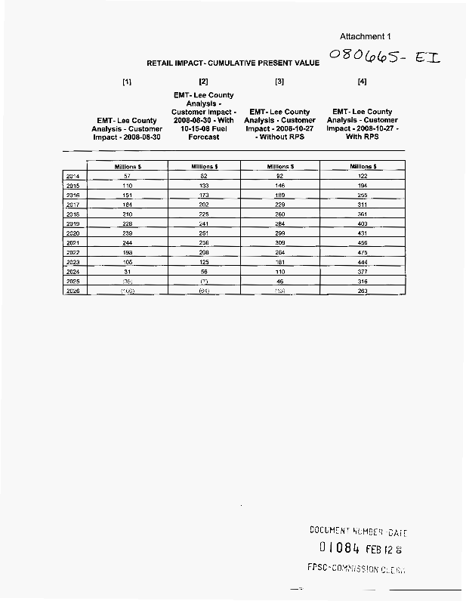
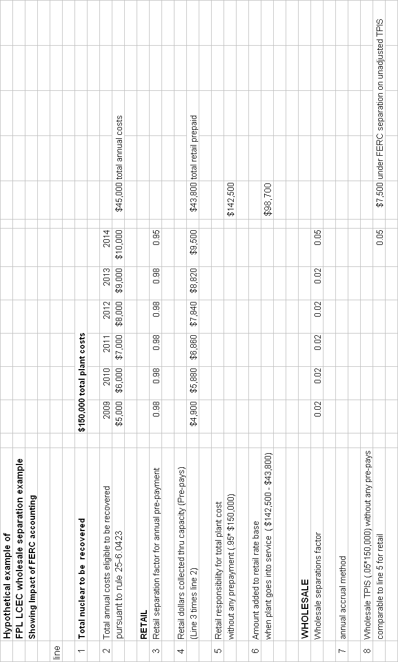
FPL’s Annual Projected Net Present Value of Retail Ratepayer Impacts

 | August 2008 Load Forecast and High Fuel Forecast | August 2008 Load Forecast and Base Fuel Costs | October 2008 Load  and Base Fuel Forecast | October 2008 Load and Base Fuel Forecast w/RPS
 | Millions $ | Millions $ | Millions $ | Millions $
2010 | (21) | (1) | 4 | 7
2011 | (14) | 9 | 14 | 22
2012 | (6) | 20 | 26 | 37
2013 | 6 | 32 | 40 | 54
2014 | 57 | 82 | 92 | 122
2015 | 110 | 133 | 146 | 194
2016 | 151 | 173 | 189 | 255
2017 | 184 | 202 | 229 | 311
2018 | 210 | 225 | 260 | 361
2019 | 228 | 241 | 284 | 400
2020 | 239 | 251 | 299 | 431
2021 | 244 | 256 | 309 | 456
2022 | 193 | 208 | 264 | 475
2023 | 105 | 125 | 181 | 444
2024 | 31 | 56 | 110 | 377
2025 | (39) | (7) | 46 | 316
2026 | (106) | (64) | (13) | 263
2027 | (170) | (117) | (66) | 214
2028 | (235) | (171) | (116) | 167
2029 | (291) | (213) | (159) | 129
2030 | (338) | (244) | (186) | 107
2031 | (378) | (267) | (208) | 89
2032 | (412) | (283) | (266) | 77
2033 | (434) | (289) | (298) | 75
2034 | (431) | (286) | (340) | 76
2035 | (397) | (252) | (331) | 108
2036 | (367) | (221) | (294) | 136
2037 | (339) | (194) | (261) | 162
2038 | (314) | (169) | (230) | 185
2039 | (292) | (146) | (203) | 206
2040 | (271) | (126) | (179) | 225
2041 | (253) | (107) | (156) | 243
2042 | (236) | (91) | (136) | 258
2043 | (221) | (76) | (118) | 272
2044 | (208) | (62) | (102) | 285
2045 | (196) | (50) | (87) | 296
2046 | (185) | (40) | (74) | 307
2047 | (174) | (29) | (61) | 315
2048 | (163) | (18) | (48) | 325
2049 | (154) | (8) | (37) | 334
2050 | (145) | (0) | (27) | 342
2051 | (138) | 7 | (19) | 349
2052 | (132) | 13 | (11) | 356
2053 | (127) | 19 | (5) | 361
2054 | (122) | 23 | 1 | 365
2055 | (118) | 27 | 6 | 369
2056 | (114) | 31 | 10 | 373
2057 | (111) | 34 | 15 | 376
2058 | (108) | 37 | 19 | 379
2059 | (107) | 38 | 21 | 380
2060 | (106) | 39 | 23 | 381

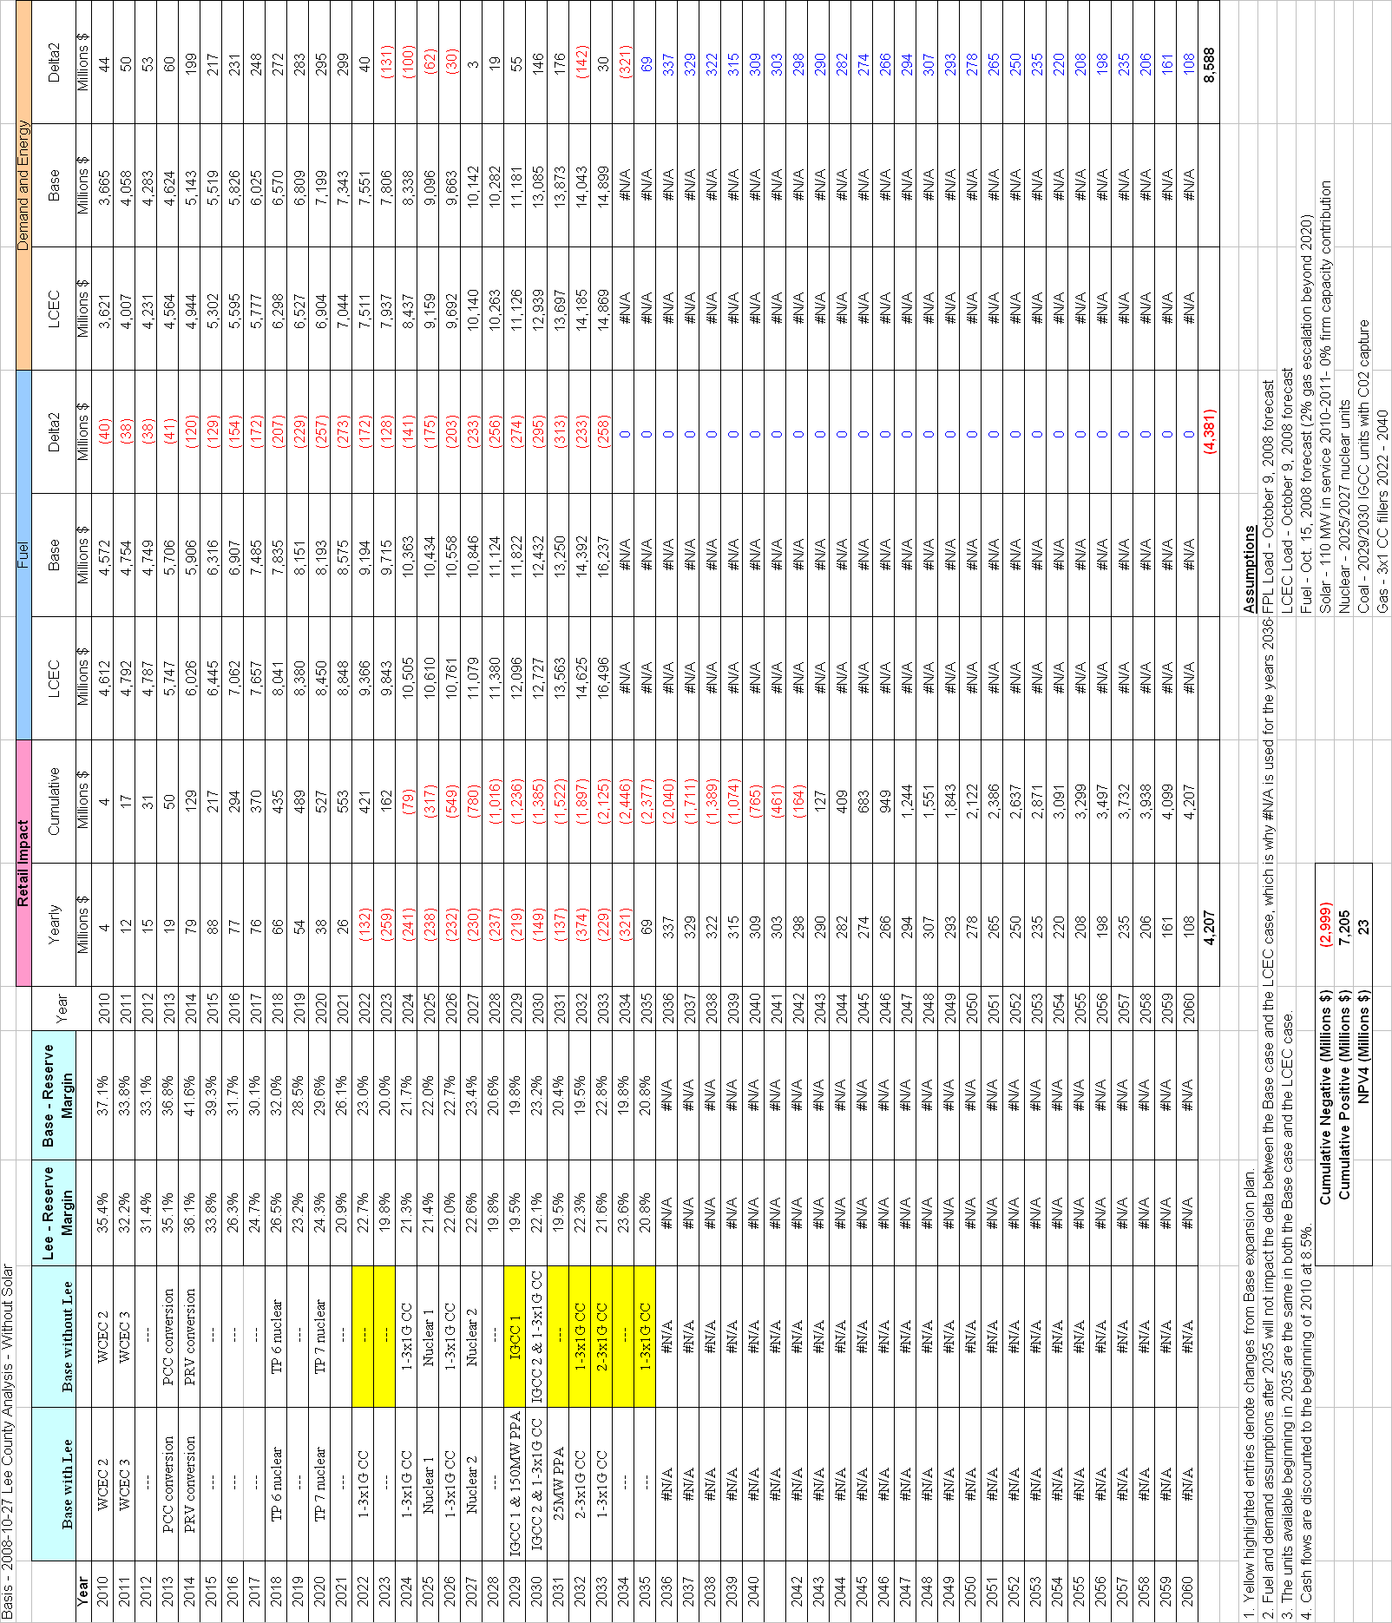

Docket No. 080001-EI, In re: Fuel and Purchased Power Cost Recovery Clause with Generating Performance Incentive Factor.
Supplement to Petition of Florida Power & Light Company’s for Approval of Long Term Agreement for full Requirements Electric Service with Lee Count Electric Cooperative, filed February 12, 2009, Docket No. 080665-EI, In re: Approval of Long Term Agreement for Full Requirements Electric Service with Lee County Electric Cooperative, petition at p. 1.
Docket No. 080665-EI, In re: Approval of Long-Term Agreement for Full Requirements Electric Service with Lee County Electric Cooperative, petition at p.1
FPL Response to Staff’s Second Data Request, dated December 23, 2008, in Docket No. 080665-EI, In re: Petition of Florida Power & Light Company for approval of long-term agreement for full requirements electric service with Lee County Electric Cooperative, at Question No. 3, page 2 of 2.
Issued on March 11, 1997, in Docket No. 970001-EI, In re: Fuel and purchased power cost recovery clause and generating performance incentive factor.
Issued October 15, 1997, in Docket No. 970171-EU, In re: Determination of appropriate cost allocation and regulatory treatment of total revenues associated with wholesale sales to Florida Municipal Power Agency and City of Lakeland by Tampa Electric.
Docket No. 080665-EI, In re: Petition of Florida Power & Light company for Approval of Long-Term Agreement for Full Requirements Electric Service with Lee County Electric Cooperative, petition at p.3.
FPL’s response to Staff Third Data requested dated February 17, 2009, in Docket No. 080664-EI, In re: Petition of Florida Power & Light company for Approval of Long-Term Agreement for Full Requirements Electric Service with Lee County Electric Cooperative.
Order No. PSC-08-0591-FOF-EI issued September 12, 2008, in Docket No. 080203-EI, In re: Petition to determine need for West County Energy center Unit 3 electrical power plant, by Florida Power & Light Company; Docket No. 080245-EI, In re: Petition for determination of need for conversion of Riviera Plant in Palm Beach County, by Florida Power & Light Company; Docket No. 080246-EI, In re: Petition for determination of need for conversion of Cape Canaveral Plant in Brevard County, by Florida Power & Light Company
Supplement to Petition, p. 1
FPL Response to Staff’s Second Data Request, dated December 23, 2008, in Docket No. 080665-EI, In re: Petition of Florida Power & Light Company for approval of long-term agreement for full requirements electric service with Lee County Electric Cooperative, at Question No. 3, page 2 of 2.
Supplement to Petition of Florida Power & Light Company’s for Approval of Long Term Agreement for full Requirements Electric Service with Lee Count Electric Cooperative, Docket No. 080665-EI, In re: Approval of Long Term Agreement for Full Requirements Electric Service with Lee County Electric Cooperative, petition at p. 7
Order No. PSC-05-0902-S-EI, issued September 14, 2005 in Docket No. 050045-EI, In re: Petition for rate increase of Florida Power & Light Company
Order No. PSC-08-0749-FOF-EI, issued Nov. 12, 2008, in Docket No. 080009-EI, In re: Nuclear Cost Recovery Clause; and Order No. PSC-08-0824-FOF-EI, issued Dec. 22, 2008, in Docket No. 080001-EI, In re: Fuel and purchased power cost recovery clause and generating performance incentive factor.
Specifically, the proposed amendment would add the following sentence at the beginning of Section 2.2(b) of the Agreement: “This Agreement may be terminated effective on December 31, 2026 at HE2400 by either party giving the other Party at least four (4) years prior written notice (i.e., the written notice of termination must be given on or before December 31, 2022).” The current first sentence would then be revised to read “In addition, this Agreement may be terminated effective on the last day of any Calendar Year ….”
$2.2 billion is the total of the negative individual yearly results in nominal dollars that appear on Table 2-2 for the years 2022-2033. Of course, Table 2-2 also shows a total of more than $6 billion in positive individual yearly results from the other years of the study period, but there is no credit given to FPL under Staff Change No. 1 for all of those positive benefits that flow to, and stay with, the retail customers.
FPL would oppose, however, placing Staff’s proposed notification obligation on FPL, as the language is vague and does not put FPL on notice of what circumstances would give rise to triggering the obligation. Based on discussions with Staff and OPC, as referenced above, FPL believes we have worked out a favorable resolution to this that suits all involved.
FPL also notes that, per the Agreement, either party can terminate the agreement in any year after the minimum contract term, on seven years’ notice to the other party.
In this regard, FPL notes that the “with LCEC” expansion plans in most of the sensitivity analyses contemplate a new generating unit coming into service in approximately 2022. In conjunction with the need determination proceeding for that unit, the Commission would have an opportunity to evaluate the economics of allowing the Agreement to remain in effect after the initial early-termination date of 2026.

