State of Florida   |  | Public Service Commission  Capital Circle Office Center ● 2540 Shumard Oak Boulevard  Tallahassee, Florida 32399-0850  -M-E-M-O-R-A-N-D-U-M-
DATE: | March 26, 2009
TO: | Office of Commission Clerk (Cole)
FROM: | Division of Economic Regulation (Draper, Kummer)  Office of the General Counsel (Young, Brown)
RE: | Docket No. 080317-EI – Petition for rate increase by Tampa Electric Company.
AGENDA: | 04/07/09 – Regular Agenda – Post-Hearing Decision – Participation is Limited to Commissioners and Staff
COMMISSIONERS ASSIGNED: |  |  | All Commissioners
PREHEARING OFFICER: |  |  | Skop
CRITICAL DATES: |  |  | 04/13/09 (8-Month Effective Date)
SPECIAL INSTRUCTIONS: |  |  | None
FILE NAME AND LOCATION: |  |  | S:\PSC\ECR\WP\080317A.RCM.DOC

Case Background
This proceeding commenced on August 11, 2008, with the filing of a petition for a permanent rate increase by Tampa Electric Company (TECO or Company). The Company is engaged in business as a public utility providing electric service as defined in Section 366.02, Florida Statutes (F.S.), and is subject to the jurisdiction of the Commission. A hearing was conducted on January 20-21, and 27-30, 2009. At the March 17, 2009, Agenda Conference, the Commission approved an increase to operating revenue of $104,268,536 for the 2009 projected test year. TECO requested an increase of $228,167,000.
The Commission also approved an additional increase in base rates, effective January 1, 2010, of $33,561,370 to recover the cost of the five combustion turbine (CT) units and the Big Bend Rail Facilities, subject to the condition that these investments are needed and in commercial operation by December 31, 2009. The final revenue requirements and step increase calculations are contained in Schedule 1.

This recommendation addresses the issues that were not addressed at the March 17, 2009, Agenda Conference, and which set the final rates (Issues 101, 102, and 107). In Issue 108 the recommendation addresses the Capacity Cost Recovery, Energy Conservation Cost Recovery (ECCR), and Environmental Cost Recovery Clause (ECRC) factors that will change based on the Commission’s vote in various cost of service and rate design issues. New Issue 114A addresses how the increase in revenue requirements effective January 1, 2010, be collected from the customers. Based on the Commission vote at the March 17, 2009, Agenda Conference, TECO filed a compliance cost of service study on March 25, 2009, to be used to establish revenue requirements for each rate class and final rates and charges.

Staff’s recommendation on Issue 86, approved by the Commission on March 17, 2009, establishes the method by which any increase in revenue requirements is allocated to the various customer classes to set new rates. That decision set certain parameters for designing new rates: (1) to the extent possible, consistent with other parameters, the revenue increase should be allocated so as to bring all rate classes as close to parity as practicable; (2) no class should receive an increase greater that 1.5 times the system average increase; and (3) no class should receive a decrease. The final class revenue requirements are shown in Schedule 2.

Several interim steps are necessary to establish final rates. First, to determine the increase by class, the present revenues must be restated to reflect the change in rate structure for the interruptible (IS) class approved in Issue 87. Because production demand costs will now be allocated to the IS class based on its actual measured 12 Coincident Peak load responsibility, demand costs to all other rate classes are reduced. However, the ECCR charge for all classes will increase to reflect the demand-side management (DSM) credits payable to IS customers, in lieu of the reduced base rate. If current revenues are not adjusted to reflect the IS rate restructuring, firm customers will see an increase in their total bills (base rates plus clauses) simply due to the restructuring, even without any change in total revenue requirements.

Second, the unadjusted revenue requirement by class is determined by subtracting the revenues at current rates (determined in Step 1) by class, from the revenue requirement shown in the compliance cost of service study. This unadjusted result must then be evaluated against the parameters set forth in Issue 86. If the increase to any class is greater than 1.5 times the system average increase (11.6 percent), revenue requirements will be shifted to other classes to meet that constraint. Also, since no class is granted a decrease in a general rate increase, the surplus shown for the IS class is reallocated to reduce the increase to other classes. Class revenue requirements are then adjusted to recognize unbilled revenues (Issue 85) to arrive at the final revenue requirement by rate class.

The final step is to translate the class revenue requirement into actual rates. The total revenue requirement for each rate class is first reduced by the customer charge revenue approved in Issue 100. The proposed energy and demand charges are designed to provide approximately the same percentage increase in energy and demand charge revenues as the overall percentage increase in class revenues. All other rates, charges, and credits reflect the decisions made on March 17, 2009. Final rates, charges, and credits by rate class are contained in Schedule 3.

Pursuant to the Commission vote in Issue 88, TECO also developed rates and charges for the new firm IS and IS standby and supplemental rate schedule. The IS customer charge is based on the approved GSD customer charges for primary and subtransmission level (Issue 100) plus the cost of interruptible equipment. IS service is only provided at primary or higher level. TECO proposed to keep the current IS-1 and IS-3 demand charge of $1.45 per kW at the same level, while increasing the non-fuel energy charge. The dollar increase in the energy charge will be offset by the per kW DSM credit interruptible customers will now receive under the GSLM-2 and GSLM-3 load management riders. Since the DSM credit is a load factor adjusted credit, increasing the energy charge in lieu of the demand charge will ensure that the base rate component of bills for all IS customers with varying load factors will remain unchanged.

Schedule 5 contains a calculation of TECO’s 1,000 kilowatt-hour (kWh) monthly residential bill at both present and recommended rates. While the base rate component of the bill will increase by $1.45, overall bills will decrease due to projected lower fuel costs for the remainder of 2009. TECO filed a petition for a modification to its fuel and purchased power cost recovery factors in Docket No. 090001-EI, which is also scheduled for the April 7, 2009, Agenda Conference. Staff notes that TECO proposed in its midcourse correction petition to adjust fuel factors by the 2009 estimated over-recovery of $190 million. Staff recommends in Docket No. 090001-EI that TECO also include the final 2008 true-up of $35 million in its calculation of the May through December 2009 fuel factors. Thus, the Commission’s decision in the fuel docket will impact the final bill calculations.

TECO proposes that the revised fuel factors be effective May 7, 2009, coincident with the Company’s base rate changes approved in this docket. Based on the staff-recommended fuel factor, the 1,000 kWh residential bill will decrease from $128.44 to $114.06, a $14.38 decrease. Schedule 5 also contains residential bill calculations at various other usage levels based on staff’s recommended base rates and fuel adjustment.

Based upon the stipulation approved in Issue 111 in this docket, the revised rates will be effective for meter readings taken on or after May 7, 2009. The Commission has jurisdiction pursuant to Sections 366.06(2) and (4), and 366.071, F. S.
Discussion of Issues
Issue 101:0
What are the appropriate demand charges?
Recommendation:
The appropriate demand charges are shown in Schedule 3. Staff requests that the Commission grant staff the authority to administratively approve the tariffs filed to implement the rates, charges, and credits presented in Schedule 3. (Draper)
Staff Analysis:
The appropriate demand charges are shown in Schedule 3. The demand charges were set at a level that, in combination with the remaining rate components, will result in the recovery of the total revenues allocated to each rate class. Staff requests that the Commission grant staff the authority to administratively approve the tariffs filed to implement the rates presented in this recommendation.
Issue 102:0
What are the appropriate Standby Service charges?
Recommendation:
The appropriate Standby Service charges are shown in Schedule 3. (Draper)
Staff Analysis:
The appropriate Standby Service charges are shown in Schedule 3. These rates are calculated using the revenue requirement approved, consistent with Commission Order 17159, issued February 6, 1987, in Docket No. 850673-EU, In re: Generic Investigation of Standby Rates for Electric Utilities.
Issue 107: 0 What are the appropriate energy charges?
Recommendation:
The appropriate energy charges are shown in Schedule 3. (Draper)
Staff Analysis:
The appropriate energy charges are shown in Schedule 3. The energy charges were set at a level that, in combination with the remaining rate components, will result in the recovery of the total revenues allocated to each rate class.

Issue 108:0
What changes in allocation and rate design should be made to TECO’s rates established in Docket Nos. 080001-EI, 080002-EG, and 080007-EI, to recognize the decisions in various cost of service rate design issues in this docket? (Stipulated)
Recommendation:
The methodology for adjusting the affected cost recovery clause factors was stipulated in Issue 108. Pursuant to the stipulation, the revised factors are shown in Schedule 4 and should be approved. The revised factors should become effective May 7, 2009. (Draper)
Staff Analysis:
The Commission approved the following language in Issue 108:
The changes in allocation and rate design to TECO’s capacity cost recovery factors established in Docket No. 080001-EI, conservation cost recovery factors established in Docket No. 080002-EI, and environmental cost recovery factors established in Docket No. 080007-EI should reflect the Commission vote in Issues 83, 87, and 88. In addition, the capacity cost recovery clause and energy conservation cost recovery clause factors should be recovered on demand basis rather than an energy basis as it is currently done.
The current factors need to be revised for four reasons. First, the Commission approved in Issue 83 a change in cost of service methodology from 12 CP and 1/13 Average Demand (AD) to 12 CP and 25 percent AD to allocate production demand costs. This change in cost of service methodology applies to both base rates and cost recovery clause factors. Second, pursuant to the Commission’s approval of staff’s recommendation in Issue 87, interruptible customers will now be responsible for their full 12 CP load share of production capacity related costs in base rates and cost recovery clause factors. Third, the DSM credits payable to interruptible customers will be recovered from all rate classes through the ECCR clause. Finally, as approved in Issue 108, the capacity and ECCR factors will be recovered on a demand basis from the demand rate classes rather than an energy basis as it is currently done.
Pursuant to the approved language in Issue 108, TECO revised the factors in the above dockets. Staff has reviewed the calculation and recommends approval of the factors by rate class as shown in Schedule 4. The factors should become effective May 7, 2009.
New Issue 114A:0
How should the step increase in revenue requirements effective January 1, 2010, be collected from the customers?
Recommendation:
The total step increase in revenue requirements should be allocated to all customer classes based on the cost of service study approved in this docket. The energy charge, or energy and demand for demand metered classes, and non-clause recoverable credits should be increased by the percentage increase in each class’s revenue requirements. Staff further requests that the Commission grant staff the authority to approve the step increase rates administratively, once the dollar amount of the increase has been verified and staff has confirmed the new plant and facilities are in service by December 31, 2009. (Kummer)
Staff Analysis:
The Commission voted to authorize an additional increase in base rates of $33.5 million, effective January 1, 2010, provided that the investments in the five Combustion Turbines and the Big Bend Rail facilities are in service by December 31, 2009. The Commission further stated that such costs should be allocated to rate classes consistent with the cost of service methodology approved in Issue 83.

In order to retain the relative class relationships developed in the current cost of service study, staff believes the incremental costs should first be allocated to each rate class, consistent with the 12 CP and 25 percent AD cost methodology approved in this docket. Once the dollar increase per class is established, staff recommends that the base rate energy, or energy and demand charges, be increased by the percentage increase in class revenues. In addition, non-clause recoverable credits should also be increased by a similar amount to retain the relationship between the charges and credits approved in the current cost study.

Staff further requests that the Commission grant staff the authority to approve the step increase rates administratively, once the dollar amount of the increase has been verified and staff has confirmed the new plant and facilities are in service by December 31, 2009.
Issue 114:0
Should this docket be closed?
Recommendation:
The docket should be closed upon the expiration of the time for filing an appeal. (Young, Brown)
Staff Analysis:
The docket should be closed upon the expiration of the time for filing an appeal.
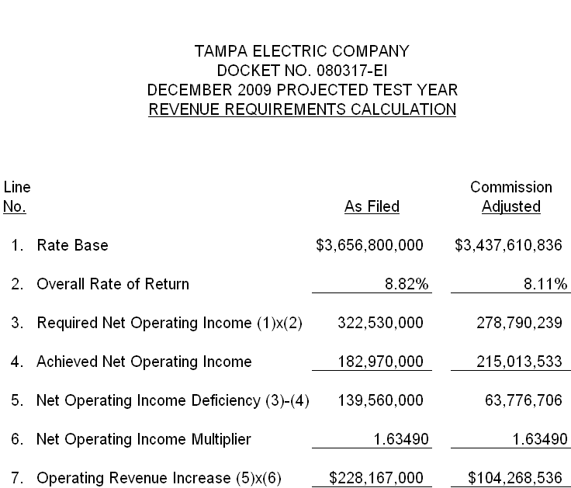

 | TAMPA ELECTRIC COMPANY
 | DOCKET NO. 080317-EI
 | CALCULATION OF JANUARY 1, 2010 STEP INCREASE
 | Step Increase Revenue Requirement
 | Big Bend Rail Facility | $7,006,720
 | May 2009 CTs | 7,924,344
 | September 2009 CTs | 18,630,306
 | Total Step Increase | $33,561,370
Line |  | Big Bend | May CTs | September CTs | Total CTs
No. |  | Rail Facility | (2 Units) | (3 Units | (5 Units)
1 | Net Plant in Service | $44,754,000 | $36,125,000 | $94,563,000 | $130,688,000
2 | Rate Of Return | 8.11% | 8.11% | 8.11% | 8.11%
3 | Required Return (2x3) | 3,629,549 | 2,929,738 | 7,669,059 | 10,598,797
4 | O&M Expenses | 0 | 212,000 | 658,000 | 870,000
5 | Depreciation | 906,000 | 1,391,000 | 4,034,000 | 5,425,000
6 | Taxes Other Than Income | 1,039,000 | 2,226,000 | 3,227,000 | 5,453,000
7 | Income Taxes (4+5+6) x (-.38575) | (750,284) | (1,477,037) | (3,054,754) | (4,531,791)
8 | Income Tax Effect of Interest | (538,548) | (434,711) | (1,137,925) | (1,572,636)
 | [(1) x 3.12% x (-.38575)] | ------ | ------ | ------ | ------
9 | Total NOI Requirement (3+4+5+6+7+8) | 4,285,718 | 4,846,990 | 11,395,380 | 16,242,370
10 | NOI Multiplier | 1.6349 | 1.6349 | 1.6349 | 1.6349
11 | Revenue Requirement (9x10) | $7,006,720 | $7,924,344 | $18,630,306 | $26,554,650
 |  | ($)
 |  | Amount | Ratio | Cost Rate | Weighted Cost
 | Common Equity | 1,585,140,254 | 53.97% | N/A | N/A
 | Long Term Debt | 1,344,280,696 | 45.77% | 6.80% | 3.11%
 | Short Term Debt | 7,430,567 | 0.25% | 2.75% | 0.01%
 | Total | 2,936,851,516 | 100.00% |  | 3.12%

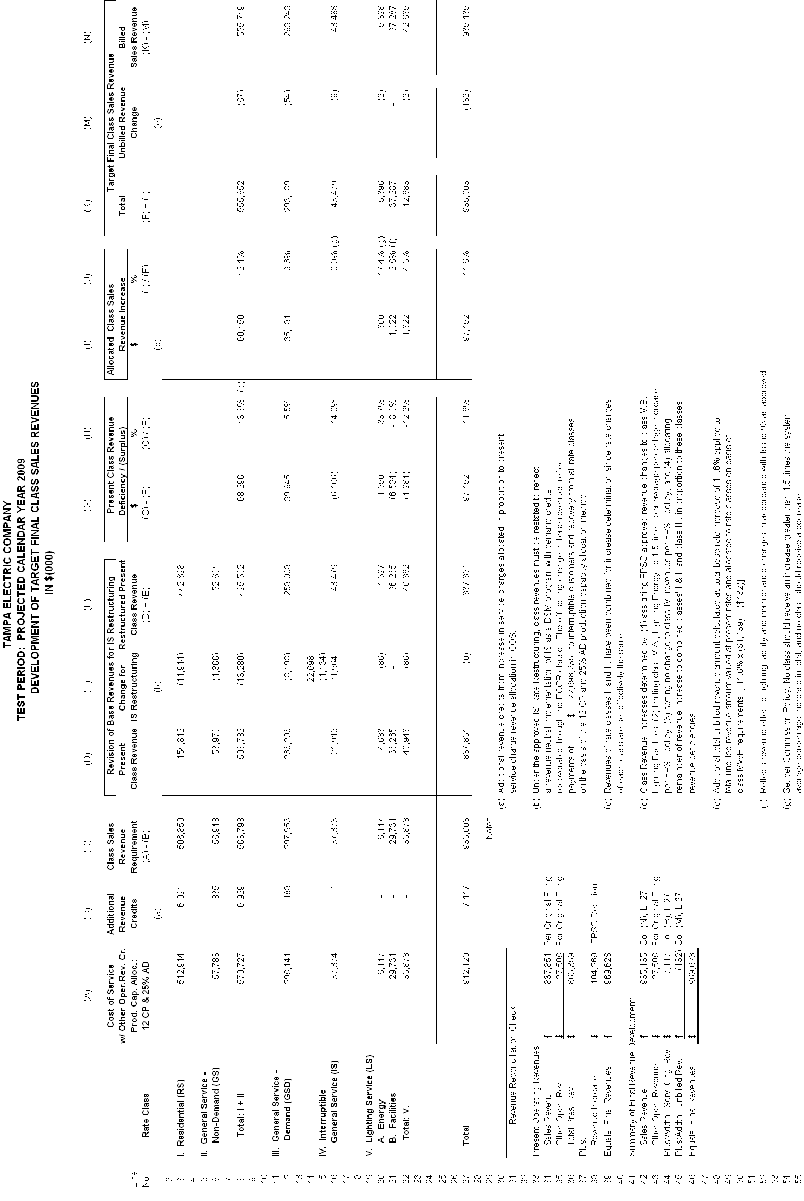

Base rates, other charges, and credits for all rate schedules – effective May 7, 2009

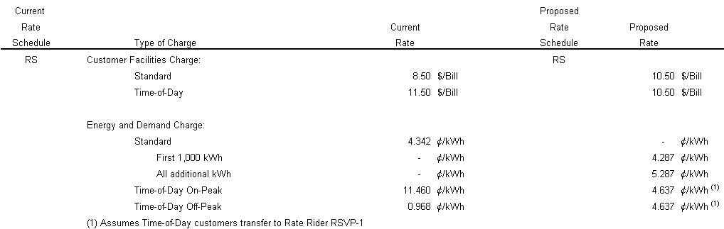

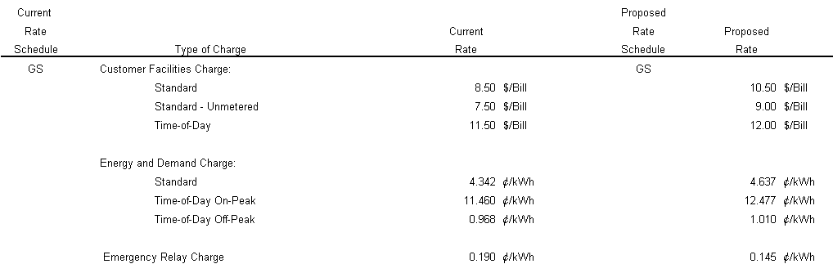

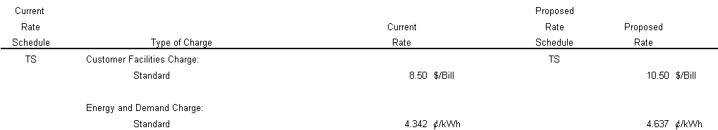

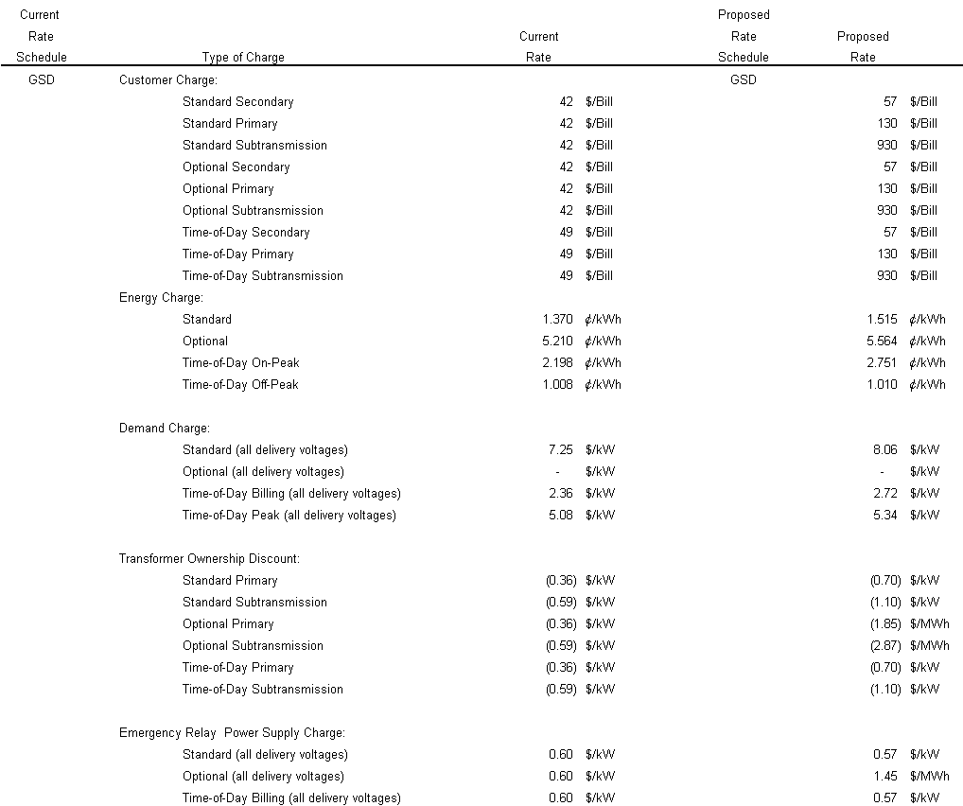
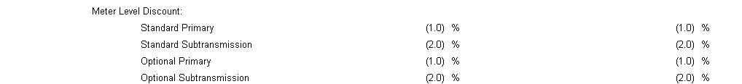

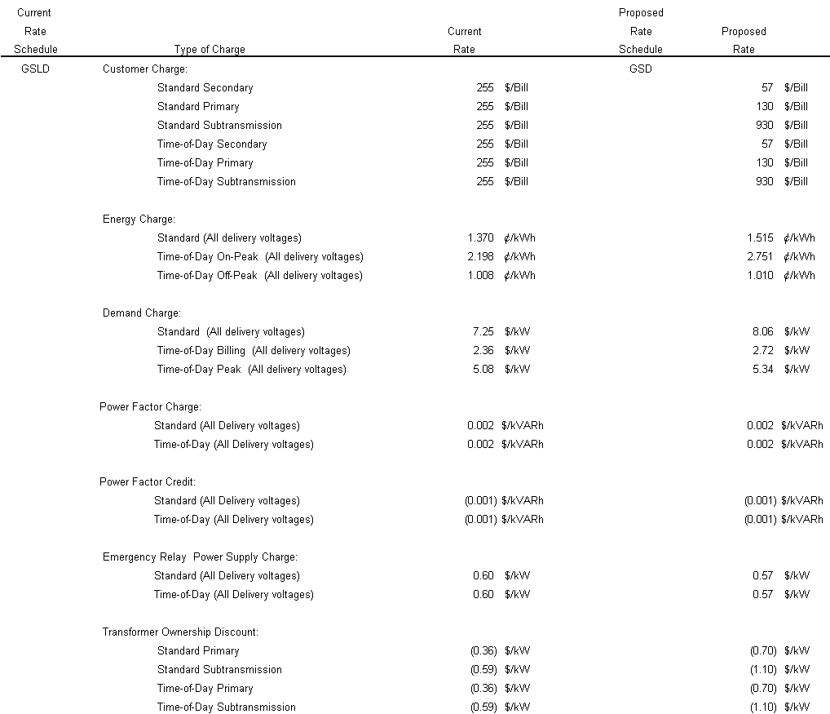
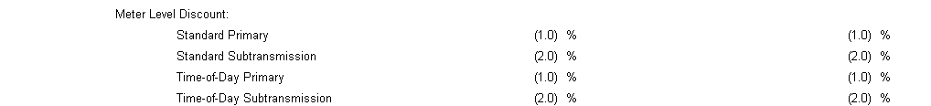
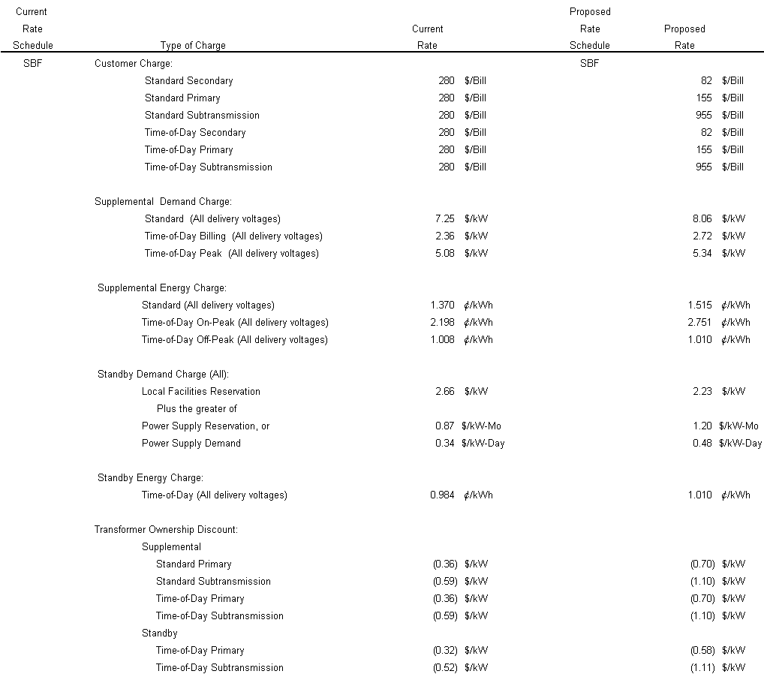
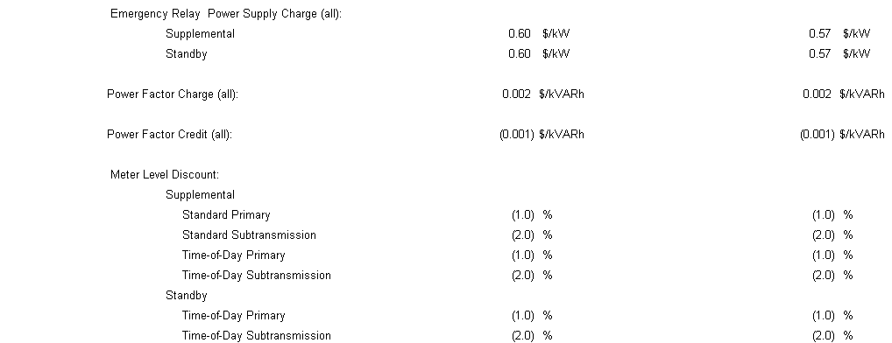

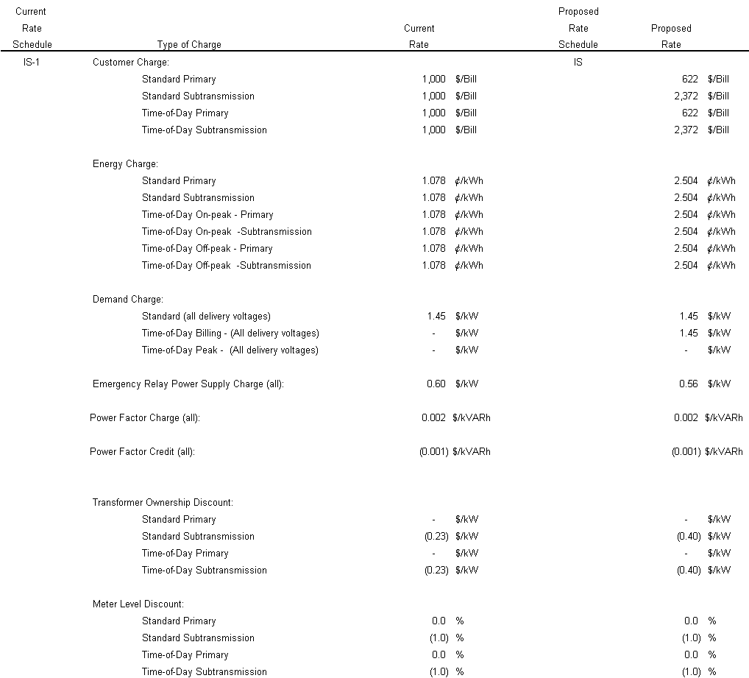

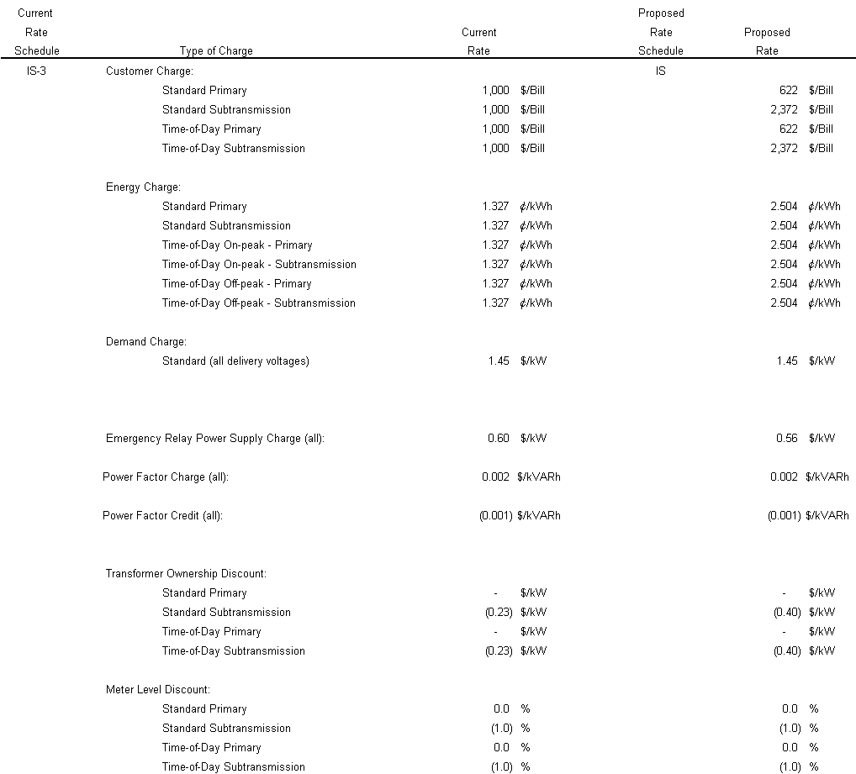

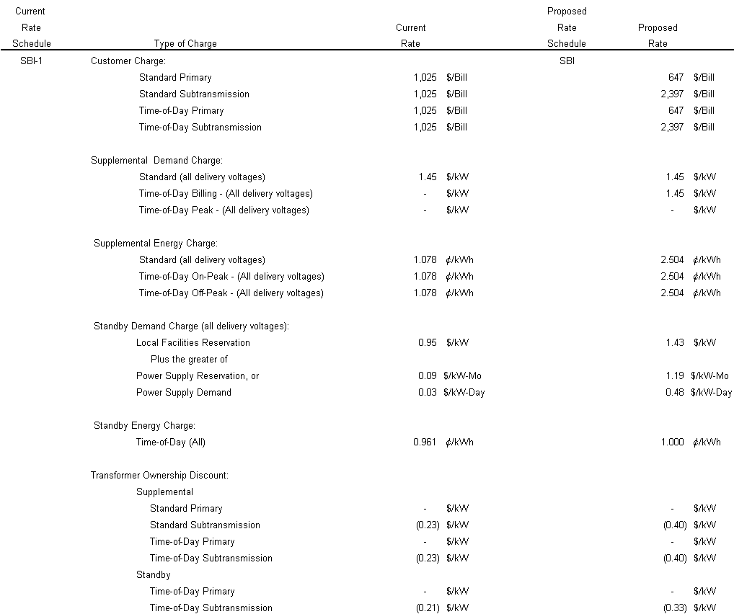
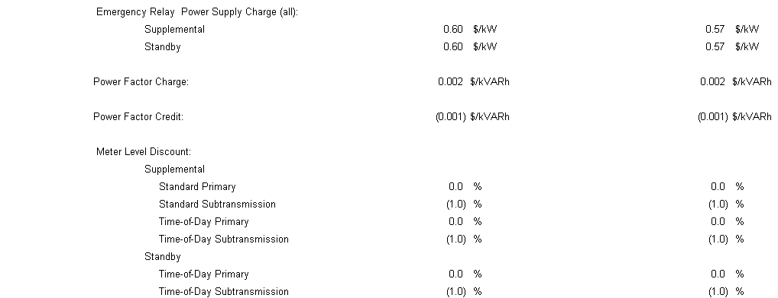

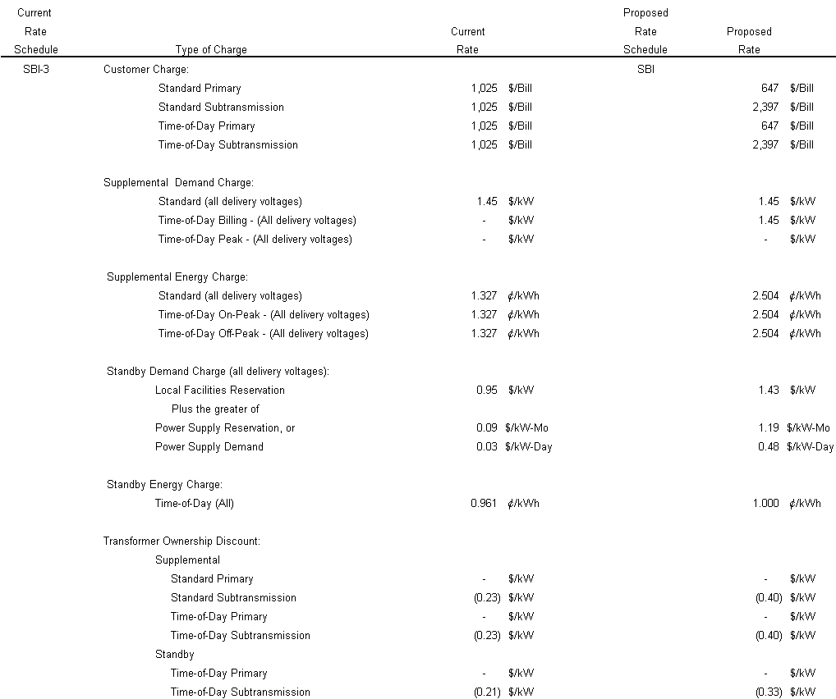

Rates for LS-1 lighting rate schedule

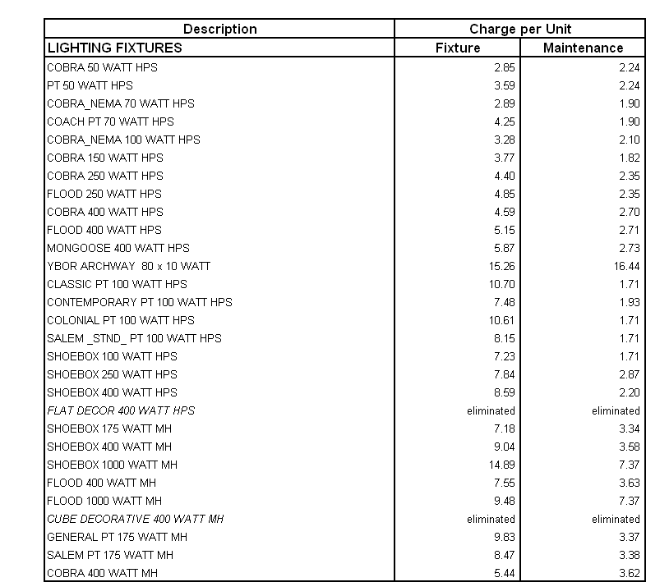

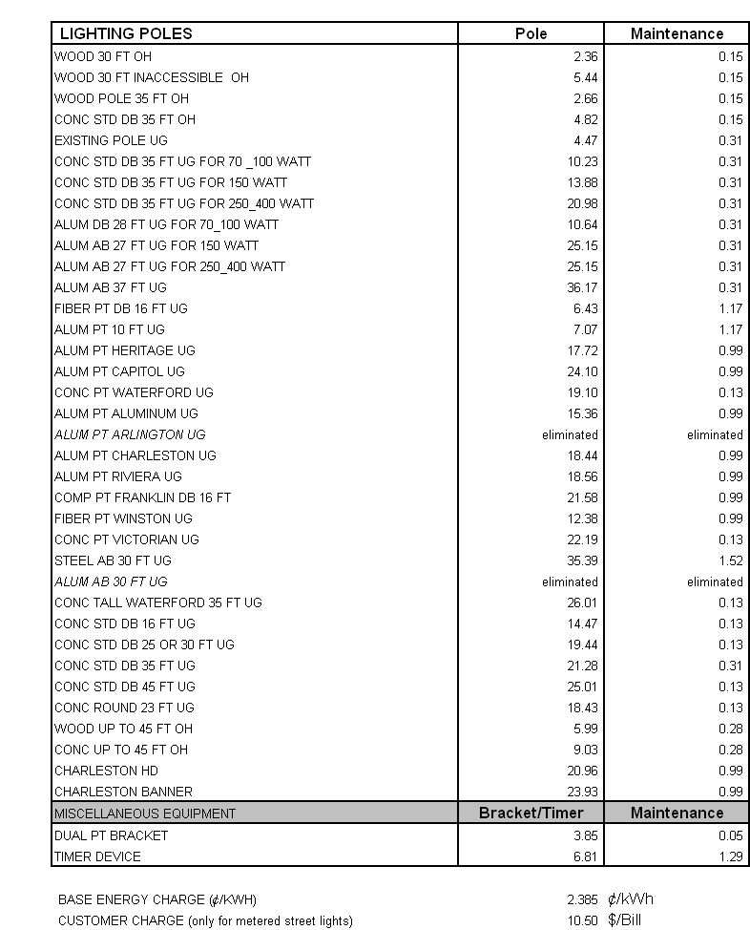

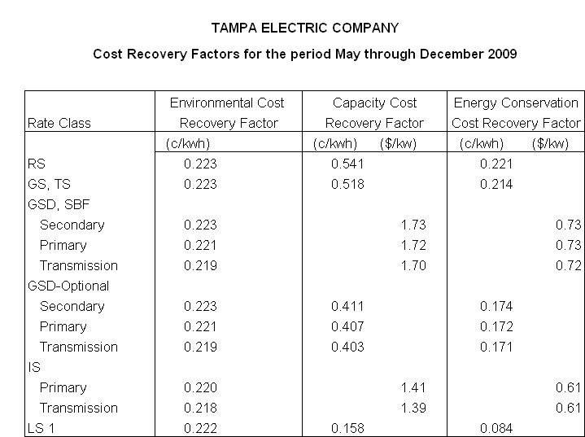

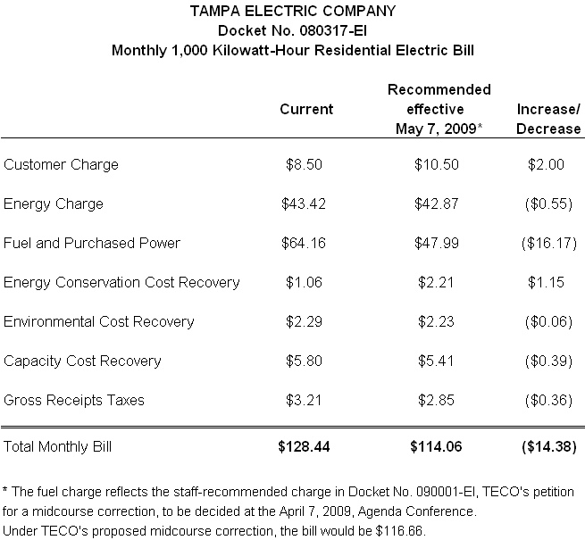

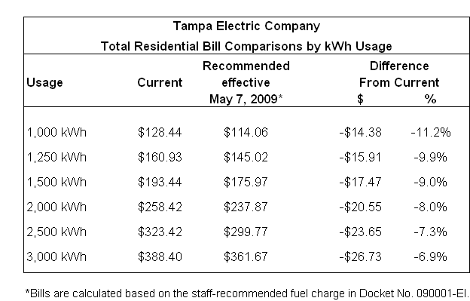

Charges and credits approved in Issues 93, 104, and 105 have been adjusted consistent with the Compliance Cost study. This adjustment was contemplated in the Commission’s vote on these issues on March 17, 2009.
Staff would note that this apparent surplus for the IS class is likely the result of the one-time change from a discount base rate to the treatment of this rate group as a DSM program. There is no way to know if the credit built into the existing base rate was greater or less than the currently available credit used to adjust current revenues for the structure change, and that relationship determines if the class is shown as under- or over-earning in this analysis.
Under TECO’s proposed fuel factor in Docket No. 090001-EI, the residential bill would be $116.66.

