State of Florida   |  | Public Service Commission  Capital Circle Office Center ● 2540 Shumard Oak Boulevard  Tallahassee, Florida 32399-0850  -M-E-M-O-R-A-N-D-U-M-
DATE: | March 26, 2009
TO: | Office of Commission Clerk (Cole)
FROM: | Division of Economic Regulation (Brady, Kaproth, Redemann)  Office of the General Counsel (Hartman)
RE: | Docket No. 080268-WS – Joint Application for transfer of the Springside water and wastewater systems from Par Utilities, Inc. in Levy County to FIMC Hideaway, Inc.; amendment of Certificates 426-W and 362-S held by FIMC Hideaway, Inc.; and amendment of Certificate 428-W and cancellation of Certificate 366-S held by Par Utilities, Inc.  County: Levy
AGENDA: | 04/07/09 – Regular Agenda – Proposed Agency Action for Issue 3 -- Interested Persons May Participate
COMMISSIONERS ASSIGNED: |  |  | All Commissioners
PREHEARING OFFICER: |  |  | Argenziano
CRITICAL DATES: |  |  | None
SPECIAL INSTRUCTIONS: |  |  | None
FILE NAME AND LOCATION: |  |  | S:\PSC\ECR\WP\080268.RCM.DOC

Case Background
On May 9, 2008, a joint application was filed for the transfer of the Springside Mobile Home Community’s water and wastewater systems, called Springside, from Par Utilities, Inc. (Par or Seller) to FIMC Hideaway, Inc. (FIMC or Buyer) in Levy County. Par has an additional water system called Inglewood, which FIMC is not purchasing. FIMC has an existing water and wastewater system called Hideaway. If the transfer of Springside is approved, Par will amend its water certificate to reflect the deletion of the Springside water system and the retention of the Inglewood water system. Par’s wastewater certificate will be cancelled as Inglewood has no wastewater systems. FIMC will amend its water and wastewater certificates to reflect the addition of the Springside water and wastewater systems.

The closing on the sale of Springside took place on June 19, 2007, subject to approval by the Commission. Springside is located in the Suwannee River Water Management District which is not a critical water use area. According to the 2007 Annual Report filed by FIMC, Springside had approximately 74 water and wastewater customers, with combined gross revenues of $37,774 and a combined net operating loss of $9,977. FIMC’s existing Hideaway systems had approximately 112 water and wastewater customers, with combined gross revenues of $47,186 and a combined net operating income of $1,668.

The certification history for the Springside systems indicates that they were granted original Certificates Nos. 435-W and 366-S in 1985 under the name of Springside, Inc. A transfer of certificates from Springside, Inc. to Springside at Manatee, Ltd. was approved by the Commission in 1991. Subsequently, the Commission acknowledged the abandonment of the Springside in 1999 and the appointment of a receiver by the Circuit Court in 2000. The Circuit Court transferred the Springside systems to Par in 2002, terminating the receivership. The Commission recognized that transfer in 2004.

There were a number of timely protests by customers of the Springside and Hideaway systems to the current application to transfer Springside from Par to FIMC. On November 5, 2008, with the Office of Public Counsel’s (OPC) assistance, Par, FIMC, and a customer objector filed a joint motion requesting Commission approval of a Settlement Agreement. On December 23, 2008, the OPC filed a Notice of Intervention in this proceeding. The Commission acknowledged OPC’s intervention by Order No. PSC-09-0102-PCO-WS, issued February 17, 2009. On March 2, 2009, the remaining objectors filed a letter indicating that they agree with the Settlement Agreement and would withdraw their objections if the Settlement Agreement is approved.

An additional request for approval of a late fee was filed by the Buyer on November 24, 2008. It was subsequently amended on February 19, 2009.

This recommendation addresses the Settlement Agreement, the transfer, and FIMC’s request to establish late fees. The Commission has jurisdiction pursuant to Sections 367.161, 367.071 and 367.091, Florida Statutes (F.S.).
Discussion of Issues
Issue 1:1
Should the Settlement Agreement among Par Utilities, Inc., FIMC Hideaway, Inc., and the objecting customers be approved?
Recommendation:
Yes. The Settlement Agreement appended to this recommendation as Attachment A, should be approved as a reasonable resolution of this matter and should be taken into consideration in the determination of whether the transfer should be approved in Issue 2. (Hartman, Brady, Redemann)
Staff Analysis:
As noted in the case background, there were a number of customer protests to the joint application for the transfer of Springside from Par to FIMC. Of primary concern to customers was the condition of the systems under the operation of FIMC. Some of the customers indicated a willingness to pursue the protest to hearing. On October 23, 2008, staff had an informal meeting with the customers and OPC. On November 5, 2008, to avoid the time, expense, and uncertainty associated with adversarial litigation, Par, FIMC, and one of the objecting customers filed a Joint Motion Requesting Commission Approval of Settlement Agreement appended to this recommendation as Attachment A. This Settlement Agreement was subsequently ratified by the remaining customer objectors. Their letter is attached to this recommendation as Attachment B.
According to the Settlement Agreement, FIMC agreed to inspect and clean the Springside water storage tank prior to December 31, 2008, to provide back-up electric generation on or before the date established by the Florida Department of Environmental Protection (FDEP), and to locate and make operable all of the isolation valves for the Springside water system. Staff notes that the Springside storage tank has been inspected and cleaned and the isolation valves for the Springside water system have been located and tested as operable. FDEP has not yet set a date for FIMC to provide back-up electric generation. FDEP intends to inspect the work done on the systems soon and make a determination on a date to provide back-up generation.
In the Settlement Agreement, FIMC also agreed to not request an acquisition adjustment for the transfer nor seek an increase in water or wastewater rates for the Springside systems for three years from the date of the Commission’s Order granting the transfer, except for annual index rate increases. Staff has verified that the agreement also precludes FIMC from filing for a pass-through index during the three year period. In the abundance of caution, staff confirmed that the buyer understood this exclusion and agrees to it.
The Settlement Agreement further provides that it must be approved in total by the Commission, without modification, or it will be considered null and void by the parties. If approved in total and without modification, the Settlement Agreement will become effective on the date the Commission issues a final order approving the Settlement Agreement.
Staff believes the conditions agreed to by the parties are reasonable and do not conflict with the Commission’s governing statutes or implementing rules. Further, approval of the Settlement Agreement would obviate the need for potentially costly and time-consuming litigation of the customers’ objections. Therefore, staff recommends that the Settlement Agreement appended to this recommendation as Attachment A be approved as a reasonable resolution of this matter, and should be taken into consideration in the determination of whether the transfer should be approved in Issue 2.
Issue 2:2
Should the transfer of the Springside water and wastewater systems from Par Utilities, Inc. to FIMC Hideaway, Inc., the amendment of Certificates 428-W, 426-W, and 362-S, and cancellation of Certificate 366-S be approved?
Recommendation:
Yes. The transfer of the Springside water and wastewater systems from Par to FIMC is in the public interest and should be approved. No acquisition adjustment should be made pursuant to Rule 25-30.0371, Florida Administrative Code (F.A.C.). The effective date of transfer should be the date of the Commission vote. Certificate No. 428-W held by Par should be amended to remove the Springside service area, and Certificate No. 366-S held by Par should be cancelled. Certificates Nos. 426-W and 362-S held by FIMC should be amended to add the Springside service area. The resultant order should serve as Par’s water certificate and FIMC’s water and wastewater certificates and should be retained by the Seller and Buyer. The territory being transferred is described in Attachment C. The tariff pages reflecting the transfer should be effective for services provided or connections made on or after the stamped approval date on the tariff sheets pursuant to Rule 25-30.475, F.A.C. (Brady, Kaproth, Redemann, Hartman)
Staff Analysis:

As stated in the case background, on May 9, 2008, FIMC and Par filed a joint application for approval of the transfer of the Springside water and wastewater systems in Levy County from Par to FIMC. The closing on the sale of Springside took place on June 19, 2007, subject to approval by the Commission as provided in Section 367.071(1), F.S. Subsequent to the transfer, Par continues to own and operate the Inglewood water system under Certificate No. 428-W.
The filing requirements for the application were completed on November 18, 2008. As such, the application is in compliance with the governing statute, Section 367.071, F.S., and Rule 25-30.037, F.A.C., pertaining to an application for the sale, assignment, or transfer of certificates of authorization. The territory being transferred is described in Attachment C along with FIMC’s and Par’s amended certificates. The application contains Warranty Deeds which show that FIMC owns the land upon which the water and wastewater plants are located pursuant to Rule 25-30.0037(2)(q), F.A.C.
The application contains a copy of the Closing Statement. The purchase price of $80,000 was financed by the Buyer with $50,000 in cash and $30,000 in mortgage. According to the application, there are no customer deposits, guaranteed revenue contracts, developer agreements, customer advances, or utility debt or leases to be disposed of as part of the transfer.
Pursuant to Rule 25-30.030, F.A.C., the application contained the requisite proof of noticing. Multiple objections to the transfer were timely filed by customers of Springside and Hideaway. As noted in Issue 1, a Settlement Agreement to resolve the objections was filed by Par, FIMC, and one of the customer objectors for Commission approval. As noted previously, the remaining customer objectors have indicated their support of the Settlement Agreement by letter dated March 2, 2009 (Attachment B).
As a statement indicating how the transfer is in the public interest, the application indicates that FIMC is operating its existing water and wastewater systems in close proximity to the Springside water and wastewater systems. It is expected that the efficiency developed by combining the systems will result in lower operating expenses for both utilities. The Buyer has been operating the Hideaway systems since 2005 when the Commission approved a transfer of majority organizational control. At approximately the same time, Springside’s and Hideaway’s water systems were interconnected for back-up reliability. As a result of the interconnection, Hideaway’s ground storage tanks will be kept in service, new electronic value has been installed to fill the tank, and Hideaway’s wells have been retired.
The application contains a statement that the Buyer, after reasonable investigation, found the Springside systems being acquired in satisfactory condition and in compliance with all applicable standards set by the FDEP. However, of primary concern to the customers who filed objections to the transfer was the deterioration in the condition of the systems under operation by the Buyer. Staff verified with the FDEP that both the Springside and Hideaway wastewater systems were significantly out of compliance such that enforcement action was being contemplated and that FDEP was working with FIMC to bring the Hideaway and Springside water systems into compliance. While the Buyer had FDEP licensed operators, the Buyer admitted that he had not been closely monitoring their performance.
During the pendency of the docket, the Buyer replaced the water and wastewater operators and entered into an consent order with the FDEP which included a timeline for compliance and the payment of a significant fine. The customers’ remaining issues were addressed in the Settlement Agreement in Issue 1. Staff has verified with FDEP that, with the exception of the additional payments FIMC is required to pay FDEP under the consent order, FIMC’s Springside and Hideaway water and wastewater systems are currently in compliance with FDEP regulations, rules, and statutes. Also the Buyer has entered into a Settlement by which the customers agree to withdraw their objections. For these reasons, staff recommends that the Commission give weight to the Settlement Agreement and determine that the transfer is in the public interest.
Pursuant to Section 367.071, F.S., the Commission may set rate base in transfer dockets. Rate base was last set for Springside at $22,803 and $48,096 for water and wastewater, respectively, as of December 31, 1990. According to the application, the current net book value of the Springside water and wastewater systems, including the last working capital allowance allowed by the Commission, is $35,609 and $15,721, respectively.
The purchase price for Springside of $80,000 is more than the estimated net book value and there does not appear to be any extraordinary circumstances that would justify an acquisition adjustment. In addition, as part of the Settlement Agreement discussed in Issue 1, FIMC has agreed not to request an acquisition adjustment for this transfer. Therefore, no acquisition adjustment should be made pursuant to Rule 25-30.0371, F.A.C.
According to the application, the Buyer, in cooperation with the Seller, has obtained the books and records as well as the federal tax returns of the Seller. The Buyer understands the need to maintain such records for inspection by Commission. However, as noted in Issue 1, FIMC has agreed not to file for a rate proceeding for the Springside systems for three years from the Commission’s order approving the transfer.
FIMC has no outstanding regulatory assessment fees (RAFs), and no fines or refunds are owed. FIMC paid the 2007 RAFs and filed the 2007 annual reports for both the Springside and Hideaway water and wastewater systems. FIMC should be responsible for filing the 2008 and all future annual reports for Springside, as well as remitting the 2008 and all future RAFs.
Springside’s existing rates and charges were established pursuant to Order No. PSC-92-0190-FOF-WS. Rule 25-9.044(1), F.A.C., provides that in the case of a change of ownership or control of a utility, the rates, classifications, and regulations of the former owner must continue unless authorized to change by the Commission. Springside’s existing rates, as shown on Schedule 1, should continue in effect.
Based on the foregoing, staff recommends that the application for transfer of Springside’s water and wastewater systems from Par to FIMC is in the public interest and should be approved. No acquisition adjustment should be made pursuant to Rule 25-30.0371, F.A.C. The effective date for the transfer should be the date of the Commission vote. Certificate No. 428-W held by Par should be amended to remove the Springside service area, and Certificate No. 366-S held by Par should be cancelled. Certificates Nos. 426-W and 362-S held by FIMC should be amended to add the Springside service area. The resultant order should serve as Par’s amended water certificate and FIMC’s amended water and wastewater certificates and should be retained by the Seller and Buyer. The territory being transferred is described in Attachment C. The tariff pages reflecting the transfer should be effective for services provided or connections made on or after the stamped approval date on the tariff sheets pursuant to Rule 25-30.475, F.A.C.

Issue 3:3
Should FIMC’s request for a company-wide $5.00 late payment charge be approved?
Recommendation:
Yes. FIMC’s request for a company-wide $5.00 late payment charge is consistent with Commission rules and recent Commission orders and should be approved. Within five working days of the issuance of the Proposed Agency Action (PAA) order, staff recommends that FIMC be required to file a proposed customer notice of the approved late payment charge. Once staff has approved the proposed customer notice, FIMC may either choose to mail the notice separately to its customers or insert it with the next billing cycle. The tariff sheets containing late payment charge should become effective for services rendered on or after the stamped approval date on the tariff, pursuant to Rule 25-30.475, F.A.C. (Brady)

Staff Analysis:
On November 24, 2008, FIMC filed a request for Commission approval of a company-wide $10.00 late payment charge pursuant to Section 367.091, F.S. This statute authorizes the Commission to establish, increase, or change a rate or charge other than monthly rates or service availability charges. The request included the justification for the charge. On February 19, 2008, FIMC modified the request to a $5.00 late payment charge and included additional information on the cost basis for the charge.

In its request for a late payment charge, FIMC indicated that late payments amount to hundreds of dollars each month for the Springside and Hideaway systems. FIMC indicated that it bills a total of 188 customers a month for both systems and approximately 10 percent of the customers are late paying those bills.
The cost basis for a $5.00 late payment charge provided by FIMC includes approximately 15 minutes of employee labor to research, review, and verify that payment has not been received and the costs of stationary and postage to print and mail the bill. These costs are consistent with recent Commission decisions.
Cost Basis for $5.00 Late Payment Fee
$ 3.75 Labor – 1/4 Hour
$ .44 ` Postage
$ .81 Cost of envelope, paper, and printing
$5.00

Staff recommends that FIMC’s proposed $5.00 late payment charge, as shown on Schedule No. 1, is consistent with Commission rules and recent Commission orders and should be approved. Within five working days of the issuance of the PAA order, staff recommends that FIMC be required to provide a proposed customer notice for staff’s review and approval. Once staff has approved the proposed customer notice, FIMC may either choose to mail the notice separately to customers or insert it with the next billing cycle. The tariffs approving the late payment charge will not be stamped approved until after FIMC files an affidavit that notice has been given to customers of the approved late payment charge. The tariff containing the late payment charge will then become effective for services rendered on or after the stamped approval date on the tariff sheets, pursuant to Rule 25-30.475, F.A.C.
Issue 4:4 Should the docket be closed?

Recommendation:
No. If no protest to the proposed agency action issue is filed by a substantially affected person within 21 days of the date of the order, a consummating order should be issued. However, the docket should remain open pending staff’s verification that notice of the late payment charge has been given to customers after which the docket should be administratively closed. (Hartman)
Staff Analysis:
If no protest to the proposed agency action issue is filed by a substantially affected person within 21 days of the date of the order, a consummating order should be issued. However, the docket should remain open pending staff’s verification that notice of the late payment charge has been given to customers after which the docket should be administratively closed.
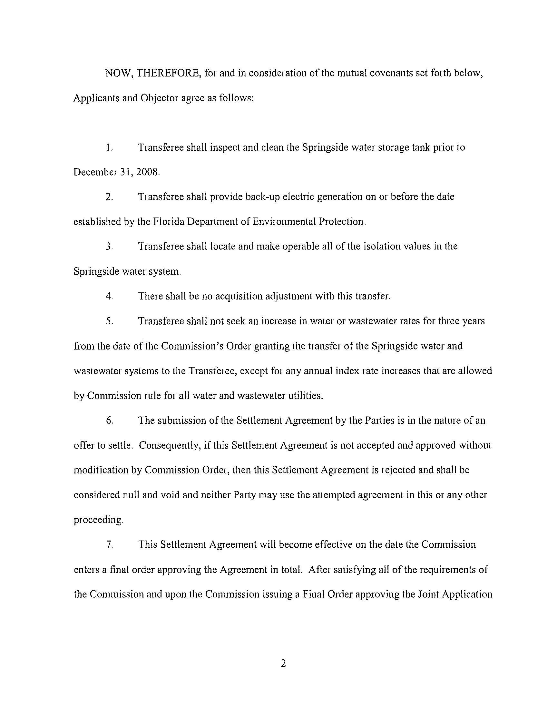
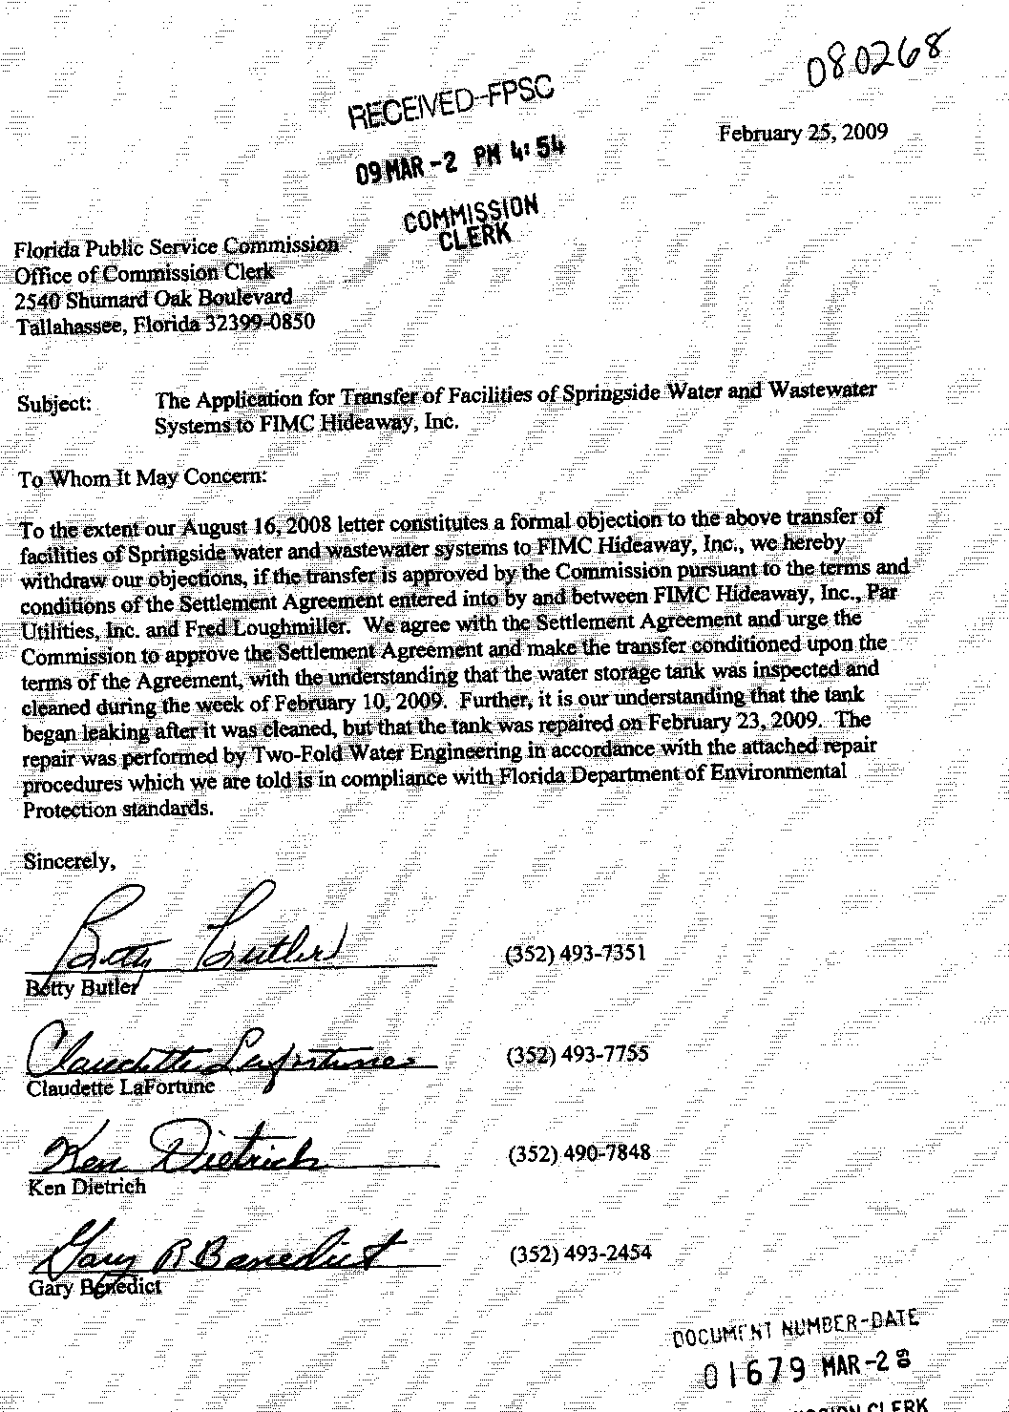
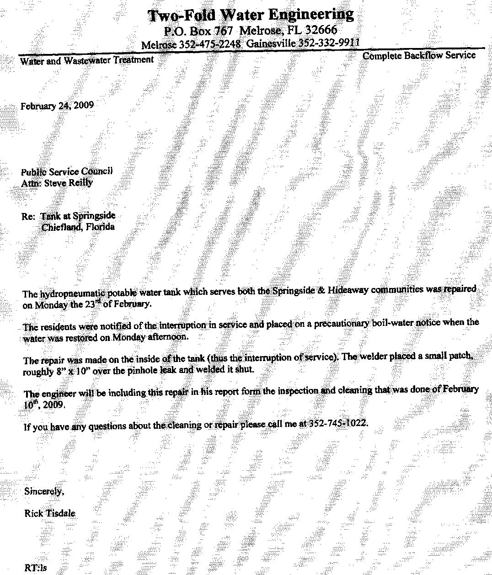
TERRITORY DESCRIPTION
FIMC HIDEAWAY, INC.
Springside System
Levy County
Water and Wastewater Service

Township 11 South, Range 13 East

Section 25

The North 75 feet of the South 1/2 of the Southeast 1/4 of said Section 25.

And

The Northwest 1/4 of the Southeast 1/4 of said Section 25.

Less

The North 790 feet of the West 760 feet of the North 1/2 of the Southeast 1/4, and the West 200 feet of the East 600 feet of the North 1/2 of the Southeast 1/4 of the said Section 25.
FLORIDA PUBLIC SERVICE COMMISSION
authorizes

Par Utilities, Inc.
pursuant to
Certificate Number 428-W

to provide water service in Levy County in accordance with the provisions of Chapter 367, Florida Statutes, and the Rules, Regulations, and Orders of this Commission in the territory described by the Orders of this Commission. This authorization shall remain in force and effect until superseded, suspended, cancelled or revoked by Order of this Commission.

Order Number Date Issued Docket Number Filing Type

13961 01/03/85 840031-WU Grandfather certificate
16863 11/19/86 860866-WU Transfer of Majority Control
PSC-00-0682-FOF-WU 04/12/00 990253-WU Transfer of Certificate
PSC-00-2093-FOF-WU 11/03/00 001557-WU Name Change
PSC-04-0610-PAA-WS 06/21/04 030407-WS Transfer of Certificates
* * 080268-WS Transfer System

*Order Number and date to be provided at time of issuance.
FLORIDA PUBLIC SERVICE COMMISSION
authorizes

FIMC Hideaway, Inc.
pursuant to
Certificate Number 426-W

to provide water service in Levy County in accordance with the provisions of Chapter 367, Florida Statutes, and the Rules, Regulations, and Orders of this Commission in the territory described by the Orders of this Commission. This authorization shall remain in force and effect until superseded, suspended, cancelled or revoked by Order of this Commission.

Order Number Date Issued Docket Number Filing Type

13497 07/10/84 830552-WS Grandfather Certificate
15432 12/09/85 840235-WS Original Certificate
23970 01/08/91 900408-WS Transfer Certificate
25584 01/08/92 910672-WS Transfer Certificate
PSC-99-2112-FOF-WS 10/25/99 991206-WS Abandonment
PSC-00-0088-PAA-WS 01/10/00 991206-WS Appointment Receiver
PSC-04-0610-PAA-WS 06/21/04 030407-WS Transfer System
PSC-05-0298-PAA-WS 03/18/05 040152-WS Transfer Majority Control
* * 080268-WS Transfer System

*Order Number and date to be provided at time of issuance.
FLORIDA PUBLIC SERVICE COMMISSION

authorizes

FIMC Hideaway, Inc.
pursuant to
Certificate Number 362-S

to provide wastewater service in Levy County in accordance with the provisions of Chapter 367, Florida Statutes, and the Rules, Regulations, and Orders of this Commission in the territory described by the Orders of this Commission. This authorization shall remain in force and effect until superseded, suspended, cancelled or revoked by Order of this Commission.

Order Number Date Issued Docket Number Filing Type

13497 07/10/84 830552-WS Grandfather Certificate
15432 12/09/85 840235-WS Original Certificate
23970 01/08/91 900408-WS Transfer Certificate
25584 01/08/92 910672-WS Transfer Certificate
PSC-99-2112-FOF-WS 10/25/99 991206-WS Abandonment
PSC-00-0088-PAA-WS 01/10/00 991206-WS Appointment Receiver
PSC-04-0610-PAA-WS 06/21/04 030407-WS Transfer System
PSC-05-0298-PAA-WS 03/18/05 040152-WS Transfer Majority Control
* * 080268-WS Transfer System

*Order Number and date to be provided at time of issuance.
Schedule 1
Page 1 of 2

FIMC HIDEAWAY, INC.

SPRINGSIDE WATER AND WASTEWATER SYSTEMS

Monthly Service Rates

Water Residential and General Service

 | Meter Size:
 | 5/8" x 3/4" | $ 8.07
 | 3/4” | 12.12
 | 1" | 20.30
 | 1 ½” | 40.36
 | 2" | 64.58
 | 3" | 129.17
 | 4” | 201.81
 | Gallonage Charge per 1,000 gallons | $2.82

Wastewater Residential Service
 | All Meter Sizes | $16.56

 | Charge per 1,000 gallons  (10,000 gallon maximum) | $5.33

Wastewater General Service

 | Meter Size:
 | 5/8" x 3/4" | $ 16.56
 | 3/4” | 24.83
 | 1" | 41.38
 | 1 ½” | 82.75
 | 2" | 132.41
 | 3" | 264.82
 | 4” | 413.78
 | Gallonage Charge per 1,000 gallons | $ 6.41

Schedule 1
Page 2 of 2

Irrigation Service
 | Charge per 1,000 gallons |  | $1.61
Miscellaneous Service Charges
 |  | Water |  |  | Wastewater
 | Initial Connection Fee | $15.00 |  |  |  | $15.00
 | Normal Reconnection Fee | 15.00 |  |  |  | 15.00
 | Violation Reconnection Fee | 15.00 |  |  |  | Actual Cost
 | Premises Visit Fee  (in lieu of disconnection) | 10.00 |  |  |  |  | 10.00
 | Late Payment Fee | 5.00 |  |  |  | 5.00

Service Availability Charges
 |  |  | Water | Wastewater
 | Meter Installation Fee 5/8”x3/4” | $100.00 |  | N/A
 | Plant Capacity Charge | $325.00 |  | $950.00
 | Per Water ERC (350 GPD) | $ 0.93
 | Per Wastewater ERC (280 GPD) |  |  |  | $ 3.39

Order No. 15432, issued December 9, 1985, in Docket No. 840235-WS, In Re: Application of Springside, Inc., for certificates to operate a water and sewer utility pursuant to Section 367.171, Florida Statutes.
Order No. 23970, issued January 8, 1991, in Docket No. 900408-WS, In Re: Application for transfer of Certificates Nos. 435-W and 366-S from Springside, Inc. to Springside at Manatee, Ltd. in Levy County.
Order No. PSC-99-2112-FOF-WS, issued October 25, 1999, in Docket No. 991206-WS, In Re: Notice of abandonment of Springside at Manatee, Ltd. in Levy County by Mr. Kenneth Drummond.
Order No. PSC-00-0088-PAA-WS, issued January 10, 2000, in Docket No. 991206-WS, In Re: Notice of abandonment of Springside at Manatee, Ltd. in Levy County by Mr. Kenneth Drummond.
Order No. PSC-04-0610-PAA-WS, issued June 21, 2004, in Docket No. 030407-WS, In Re: Application for transfer of water and wastewater facilities and Certificate No. 366-S in Levy County from Springside at Manatee, LTD. to Par Utilities, Inc. for cancellation of Certificate No. 435-W held by Springside, and for amendment of Certificate No. 428-W held by Par.
Order No. PSC-05-0298-PAA-WS, issued March 18, 2005, in Docket No. 040152-WS, In Re: Application for transfer of majority organizational control of FIMC Hideaway, Inc. in Levy County from Florida Investors Mortgage Corporation, a Florida corporation, to Robert and Janet McBride.
Order No. PSC-92-0190-FOF-WS, issued April 13, 1992, in Docket No. 910909-WS, In re: Application for a staff-assisted rate case in Levy County by Springside at Manatee, Ltd.
Order No. PSC-06-0823-TRF-WU, issued October 6, 2006, in Docket No. 060506-WU, In Re: Request for approval of tariff amendment to include a late payment fee of $5 in Osceola County by O&S Water Company, Inc.

