BEFORE THE FLORIDA PUBLIC SERVICE COMMISSION

In re: Joint Application for transfer of the Springside water and wastewater systems from Par Utilities, Inc. in Levy County to FIMC Hideaway, Inc.; amendment of Certificates 426-W and 362-S held by FIMC Hideaway, Inc.; and amendment of Certificate 428-W and cancellation of Certificate 366-S held by Par Utilities, Inc. | DOCKET NO. 080268-WS  ORDER NO. PSC-09-0279-PAA-WS  ISSUED: April 29, 2009

The following Commissioners participated in the disposition of this matter:

MATTHEW M. CARTER II, Chairman
LISA POLAK EDGAR
KATRINA J. McMURRIAN
NANCY ARGENZIANO
NATHAN A. SKOP

NOTICE OF PROPOSED AGENCY ACTION
ORDER APPROVING LATE PAYMENT CHARGE
AND
FINAL ORDER APPROVING SETTLEMENT AGREEMENT,
APPROVING THE AMENDMENT OF CERTIFICATES 428-W, 426-W, and 362-S, AND CANCELLING OF CERTIFICATE 366-S

BY THE COMMISSION:

NOTICE is hereby given by the Florida Public Service Commission that the action discussed herein as to approval of a late payment charge is preliminary in nature and will become final unless a person whose interests are substantially affected files a petition for a formal proceeding, pursuant to Rule 25-22.029, Florida Administrative Code.

Background
On May 9, 2008, a joint application was filed for the transfer of the Springside Mobile Home Community’s water and wastewater systems, (Springside), from Par Utilities, Inc. (Par or Seller) to FIMC Hideaway, Inc. (FIMC or Buyer) in Levy County. Par has an additional water system called Inglewood, which FIMC did not purchase. FIMC has an existing water and wastewater system called Hideaway.

The closing on the sale of Springside took place on June 19, 2007, subject to approval by us. Springside is located in the Suwannee River Water Management District which is not a critical water use area. According to the 2007 Annual Report filed by FIMC, Springside had approximately 74 water and wastewater customers, with combined gross revenues of $37,774 and a combined net operating loss of $9,977. FIMC’s existing Hideaway systems had approximately 112 water and wastewater customers, with combined gross revenues of $47,186 and a combined net operating income of $1,668.

The certification history for the Springside systems indicates that they were granted original Certificates Nos. 435-W and 366-S in 1985 under the name of Springside, Inc. A transfer of certificates from Springside, Inc. to Springside at Manatee, Ltd. was approved by the Commission in 1991. Subsequently, we acknowledged the abandonment of the Springside in 1999 and the appointment of a receiv er by the Circuit Court in 2000. The Circuit Court transferred the Springside systems to Par in 2002, terminating the receivership. We recognized that transfer in 2004.

There were a number of timely protests by customers of the Springside and Hideaway systems to the current application to transfer Springside from Par to FIMC. On November 5, 2008, with the Office of Public Counsel’s (OPC) assistance, Par, FIMC, and a customer objector filed a joint motion requesting Commission approval of a Settlement Agreement. On December 23, 2008, OPC filed a Notice of Intervention in this proceeding. We acknowledged OPC’s intervention by Order No. PSC-09-0102-PCO-WS, issued February 17, 2009. On March 2, 2009, the remaining objectors filed a letter indicating that they agreed with the Settlement Agreement and would withdraw their objections if the Settlement Agreement were approved.

An additional request for approval of a late fee was filed by the Buyer on November 24, 2008. It was subsequently amended on February 19, 2009.

This Order addresses the Settlement Agreement, the transfer, and FIMC’s request to establish late fees. We have jurisdiction pursuant to Sections 367.161, 367.071, and 367.091, Florida Statutes (F.S.).
Settlement Agreement

As noted earlier, there were a number of customer protests to the joint application for the transfer of Springside from Par to FIMC. Of primary concern to customers was the condition of the systems under the operation of FIMC. Some of the customers indicated a willingness to pursue the protest to hearing. On October 23, 2008, Commission staff had an informal meeting with the customers and OPC. On November 5, 2008, to avoid the time, expense, and uncertainty associated with adversarial litigation, Par, FIMC, and one of the objecting customers filed a Joint Motion Requesting Commission Approval of Settlement Agreement, which is attached to and incorporated in this Order as Attachment A. The Settlement Agreement was subsequently ratified by the remaining customer objectors. Their letter is attached to and incorporated in this Order as Attachment B.
According to the Settlement Agreement, FIMC agreed to inspect and clean the Springside water storage tank prior to December 31, 2008, to provide back-up electric generation on or before the date established by the Florida Department of Environmental Protection (FDEP), and to locate and make operable all of the isolation valves for the Springside water system. We note that the Springside storage tank has been inspected and cleaned and the isolation valves for the Springside water system have been located and tested as operable. FDEP has not yet set a date for FIMC to provide back-up electric generation. FDEP intends to inspect the work done on the systems soon and make a determination on a date to provide back-up generation.
In the Settlement Agreement, FIMC also agreed to not request an acquisition adjustment for the transfer nor seek an increase in water or wastewater rates for the Springside systems for three years from the date our Order granting the transfer, except for annual index rate increases. We have verified that the agreement also precludes FIMC from filing for a pass-through index during the three year period. In the abundance of caution, we confirmed that the buyer understood this exclusion and agrees to it.
The Settlement Agreement further provides that it must be approved in total by us, without modification, or it will be considered null and void by the parties. If approved in total and without modification, the Settlement Agreement shall become effective on the date we issue a final order approving the Settlement Agreement.
We find the conditions agreed to by the parties are reasonable and do not conflict with the our governing statutes or implementing rules. Further, approval of the Settlement Agreement would obviate the need for potentially costly and time-consuming litigation of the customers’ objections. Therefore, we find that the Settlement Agreement appended to this Order and incorporated as Attachment A is a reasonable resolution of this matter, and shall therefore be taken into consideration in our determination of whether the transfer shall be approved.
Transfer of Springside
As stated above, on May 9, 2008, FIMC and Par filed a joint application for approval of the transfer of the Springside water and wastewater systems in Levy County from Par to FIMC. The closing on the sale of Springside took place on June 19, 2007, subject our approval as provided in Section 367.071(1), F.S. Subsequent to the transfer, Par continues to own and operate the Inglewood water system under Certificate No. 428-W.
The filing requirements for the application were completed on November 18, 2008. As such, we find the application is in compliance with the governing statute, Section 367.071, F.S., and Rule 25-30.037, F.A.C., pertaining to an application for the sale, assignment, or transfer of certificates of authorization. The territory being transferred is described in Attachment C along with FIMC’s and Par’s amended certificates. Attachment C is attached to and incorporated to this Order. The application contains Warranty Deeds which show that FIMC owns the land upon which the water and wastewater plants are located pursuant to Rule 25-30.0037(2)(q), F.A.C.
The application contains a copy of the Closing Statement. The purchase price of $80,000 was financed by the Buyer with $50,000 in cash and $30,000 in mortgage. According to the application, there are no customer deposits, guaranteed revenue contracts, developer agreements, customer advances, or utility debt or leases to be disposed of as part of the transfer.
Pursuant to Rule 25-30.030, F.A.C., the application contained the requisite proof of noticing. Multiple objections to the transfer were timely filed by customers of Springside and Hideaway. As noted earlier, a Settlement Agreement to resolve the objections was filed by Par, FIMC, and one of the customer objectors for our approval. As noted previously, the remaining customer objectors have indicated their support of the Settlement Agreement by letter dated March 2, 2009.
As a statement indicating how the transfer is in the public interest, the application indicates that FIMC is operating its existing water and wastewater systems in close proximity to the Springside water and wastewater systems. It is expected that the efficiency developed by combining the systems will result in lower operating expenses for both utilities. The Buyer has been operating the Hideaway systems since 2005 when we approved a transfer of majority organizational control. At approximately the same time, Springside’s and Hideaway’s water systems were interconnected for back-up reliability. As a result of the transfer, Hideaway’s ground storage tanks will be kept in service, a new electronic value has been installed to fill the tank, and Hideaway’s wells have been retired.
The application contains a statement that the Buyer, after reasonable investigation, found the Springside systems being acquired in satisfactory condition and in compliance with all applicable standards set by the FDEP. However, of primary concern to the customers who filed objections to the transfer was the deterioration in the condition of the systems under operation by the Buyer. We verified with the FDEP that both the Springside and Hideaway wastewater systems were significantly out of compliance such that enforcement action was being contemplated and that FDEP was working with FIMC to bring the Hideaway and Springside water systems into compliance. While the Buyer had FDEP licensed operators, the Buyer admitted that he had not been closely monitoring their performance.
During the pendency of this docket, the Buyer replaced the water and wastewater operators and entered into an consent order with the FDEP which included a timeline for compliance and the payment of a significant fine. The customers’ remaining issues were addressed in the Settlement Agreement. We have verified with FDEP that, with the exception of the additional payments FIMC is required to pay FDEP under the consent order, FIMC’s Springside and Hideaway water and wastewater systems are currently in compliance with FDEP regulations, rules, and statutes. Also the Buyer has entered into a Settlement by which the customers agree to withdraw their objections. For these reasons, we find that the Settlement Agreement and the transfer are in the public interest.
Pursuant to Section 367.071, F.S., we may set rate base in transfer dockets. Rate base was last set for Springside at $22,803 and $48,096 for water and wastewater, respectively, as of December 31, 1990. According to the application, the current net book value of the Springside water and wastewater systems, including the last working capital allowance allowed by us, is $35,609 and $15,721, respectively.
The purchase price for Springside of $80,000 is more than the estimated net book value and there does not appear to be any extraordinary circumstances that would justify an acquisition adjustment. In addition, as part of the Settlement Agreement, FIMC has agreed not to request an acquisition adjustment for this transfer. Therefore, no acquisition adjustment shall be made pursuant to Rule 25-30.0371, F.A.C.
According to the application, the Buyer, in cooperation with the Seller, has obtained the books and records as well as the federal tax returns of the Seller. The Buyer understands the need to maintain such records for inspection by us. However, as noted earlier, FIMC has agreed not to file for a rate proceeding for the Springside systems for three years from the our order approving the transfer.
FIMC has no outstanding regulatory assessment fees (RAFs), and no fines or refunds are owed. FIMC paid the 2007 RAFs and filed the 2007 annual reports for both the Springside and Hideaway water and wastewater systems. FIMC shall be responsible for filing the 2008 and all future annual reports for Springside, as well as remitting the 2008 and all future RAFs.
Springside’s existing rates and charges were established pursuant to Order No. PSC-92-0190-FOF-WS. Rule 25-9.044(1), F.A.C., provides that in the case of a change of ownership or control of a utility, the rates, classifications, and regulations of the former owner must continue unless authorized to change by us. Springside’s existing rates, as shown on Schedule 1, shall continue in effect.
Based on the foregoing, we find that the application for transfer of Springside’s water and wastewater systems from Par to FIMC is in the public interest, and is therefore approved. No acquisition adjustment shall be made pursuant to Rule 25-30.0371, F.A.C. The effective date for the transfer shall be the date of our vote. Certificate No. 428-W held by Par shall be amended to remove the Springside service area, and Certificate No. 366-S held by Par shall be cancelled. Certificates Nos. 426-W and 362-S held by FIMC shall be amended to add the Springside service area. The resultant order shall serve as Par’s amended water certificate and FIMC’s amended water and wastewater certificates and shall be retained by the Seller and Buyer. The territory being transferred is described in Attachment C. The tariff pages reflecting the transfer shall be effective for services provided or connections made on or after the stamped approval date on the tariff sheets pursuant to Rule 25-30.475, F.A.C.
Late Payment Charge
On November 24, 2008, FIMC filed a request for our approval of a company-wide $10.00 late payment charge pursuant to Section 367.091, F.S. This statute authorizes us to establish, increase, or change a rate or charge other than monthly rates or service availability charges. The request included the justification for the charge. On February 19, 2008, FIMC modified the request to a $5.00 late payment charge and included additional information on the cost basis for the charge.

In its request for a late payment charge, FIMC indicated that late payments amount to hundreds of dollars each month for the Springside and Hideaway systems. FIMC indicated that it bills a total of 188 customers a month for both systems and approximately 10 percent of the customers are late paying those bills.
The cost basis for a $5.00 late payment charge provided by FIMC includes approximately 15 minutes of employee labor to research, review, and verify that payment has not been received and the costs of stationary and postage to print and mail the bill. These costs are consistent with our recent decisions.
Cost Basis for $5.00 Late Payment Fee
$ 3.75 Labor – 1/4 Hour
$ .44 ` Postage
$ .81 Cost of envelope, paper, and printing
$5.00

We find that FIMC’s proposed $5.00 late payment charge, as shown on Schedule No. 1, is consistent with our rules and our recent orders and shall be approved. Within five working days of the issuance of this order, FIMC shall provide a proposed customer notice for Commission staff’s review and approval. Once Commission staff has approved the proposed customer notice, FIMC may either choose to mail the notice separately to customers or insert it with the next billing cycle. The tariffs approving the late payment charge shall not be stamped approved until after FIMC files an affidavit that notice has been given to customers of the approved late payment charge. The tariff containing the late payment charge shall then become effective for services rendered on or after the stamped approval date on the tariff sheets, pursuant to Rule 25-30.475, F.A.C.

Based on the foregoing, it is

ORDERED that the Settlement Agreement among Par Utilities, Inc., FIMC Hideaway, Inc., and the objecting customers, which is incorporated as Attachment A of this Order, is hereby approved. It is further

ORDERED that the transfer of the Springside water and wastewater systems from Par Utilities, Inc. to FIMC Hideaway, Inc., the amendment of Certificates 428-W, 426-W, and 362-S, and cancellation of Certificate 366-S is hereby approved. The territory being transferred is described in Attachment C of this Order. It is further
ORDERED that Springside’s existing rates, as shown on Schedule 1 of this Order, shall continue in effect. No acquisition adjustment shall be made pursuant to Rule 25-30.0371, F.A.C. It is further.
ORDERED that this Order shall serve as Par Utilities, Inc.’s amended water certificate and FIMC Hideaway, Inc.’s amended water and wastewater certificates and shall be retained by the seller and buyer. It is further
ORDERED that the tariff pages reflecting the transfer shall be effective for services provided or connections made on or after the stamped approval date on the tariff sheets pursuant to Rule 25-30.475, F.A.C. It is further
ORDERED that the effective date for the transfer shall be April 7, 2009. It is further
ORDERED that FIMC’s request for a company-wide $5.00 late payment charge is hereby approved. It is further

ORDERED that within five working days of the issuance of this Order, FIMC Hideaway, Inc. shall provide a proposed customer notice for Commission staff’s review and approval. It is further

ORDERED that the tariffs approving the late payment charge shall not be stamped approved until after FIMC Hideaway, Inc. files an affidavit that notice has been given to customers of the approved late payment. The tariff containing the late payment charge shall then become effective for services rendered on or after the stamped approval date on the tariff sheets, pursuant to Rule 25-30.475, F.A.C. It is further

ORDERED by the Florida Public Service Commission that the provisions of this Order, issued as proposed agency action, shall become final and effective upon the issuance of a Consummating Order unless an appropriate petition, in the form provided by Rule 28-106.201, Florida Administrative Code, is received by the Commission Clerk, 2540 Shumard Oak Boulevard, Tallahassee, Florida 32399-0850, by the close of business on the date set forth in the "Notice of Further Proceedings" attached hereto. It is further

ORDERED that in the event this Order becomes final, this docket shall be closed administratively.

By ORDER of the Florida Public Service Commission this 29th day of April, 2009.

/s/ Ann Cole
ANN COLE
Commission Clerk

This is an electronic transmission. A copy of the original signature is available from the Commission's website, www.floridapsc.com, or by faxing a request to the Office of Commission Clerk at 1-850-413-7118.

( S E A L )

JEH

NOTICE OF FURTHER PROCEEDINGS OR JUDICIAL REVIEW

The Florida Public Service Commission is required by Section 120.569(1), Florida Statutes, to notify parties of any administrative hearing or judicial review of Commission orders that is available under Sections 120.57 or 120.68, Florida Statutes, as well as the procedures and time limits that apply. This notice should not be construed to mean all requests for an administrative hearing or judicial review will be granted or result in the relief sought.

As identified in the body of this order, our action approving a late payment charge is preliminary in nature. Any person whose substantial interests are affected by the action proposed by this order may file a petition for a formal proceeding, in the form provided by Rule 28-106.201, Florida Administrative Code. This petition must be received by the Office of Commission Clerk, at 2540 Shumard Oak Boulevard, Tallahassee, Florida 32399-0850, by the close of business on May 20, 2009. If such a petition is filed, mediation may be available on a case-by-case basis. If mediation is conducted, it does not affect a substantially interested person's right to a hearing. In the absence of such a petition, this order shall become effective and final upon the issuance of a Consummating Order.

Any objection or protest filed in this docket before the issuance date of this order is considered abandoned unless it satisfies the foregoing conditions and is renewed within the specified protest period.

Any party adversely affected by the Commission's final action in this matter may request: (1) reconsideration of the decision by filing a motion for reconsideration with the Office of Commission Clerk, within fifteen (15) days of the issuance of this order in the form prescribed by Rule 25-22.060, Florida Administrative Code; or (2) judicial review by the Florida Supreme Court in the case of an electric, gas or telephone utility or the First District Court of Appeal in the case of a water or wastewater utility by filing a notice of appeal with the Office of Commission Clerk and filing a copy of the notice of appeal and the filing fee with the appropriate court. This filing must be completed within thirty (30) days after the issuance of this order, pursuant to Rule 9.110, Florida Rules of Appellate Procedure. The notice of appeal must be in the form specified in Rule 9.900(a), Florida Rules of Appellate Procedure.

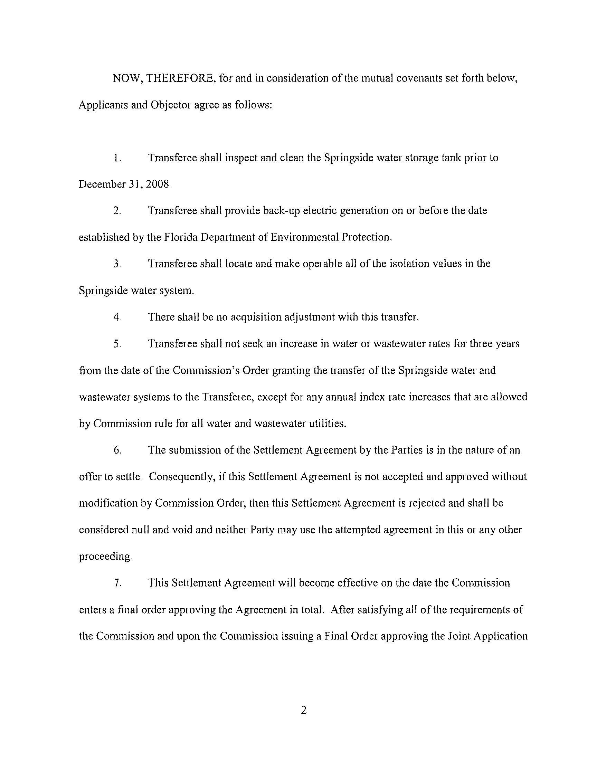
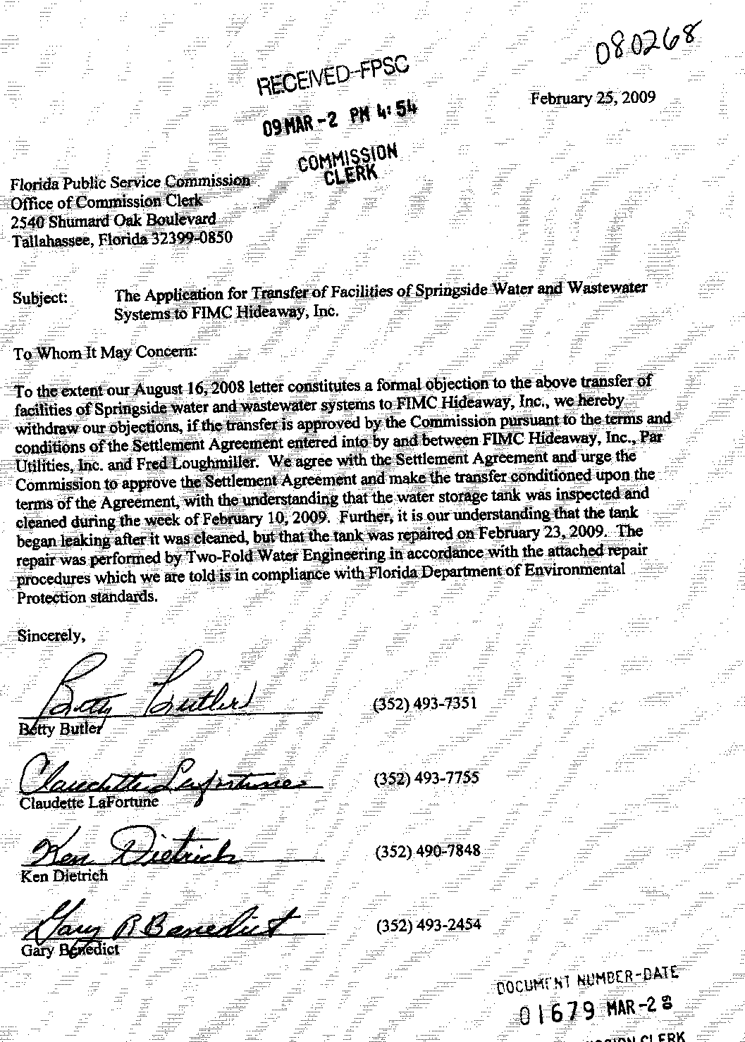
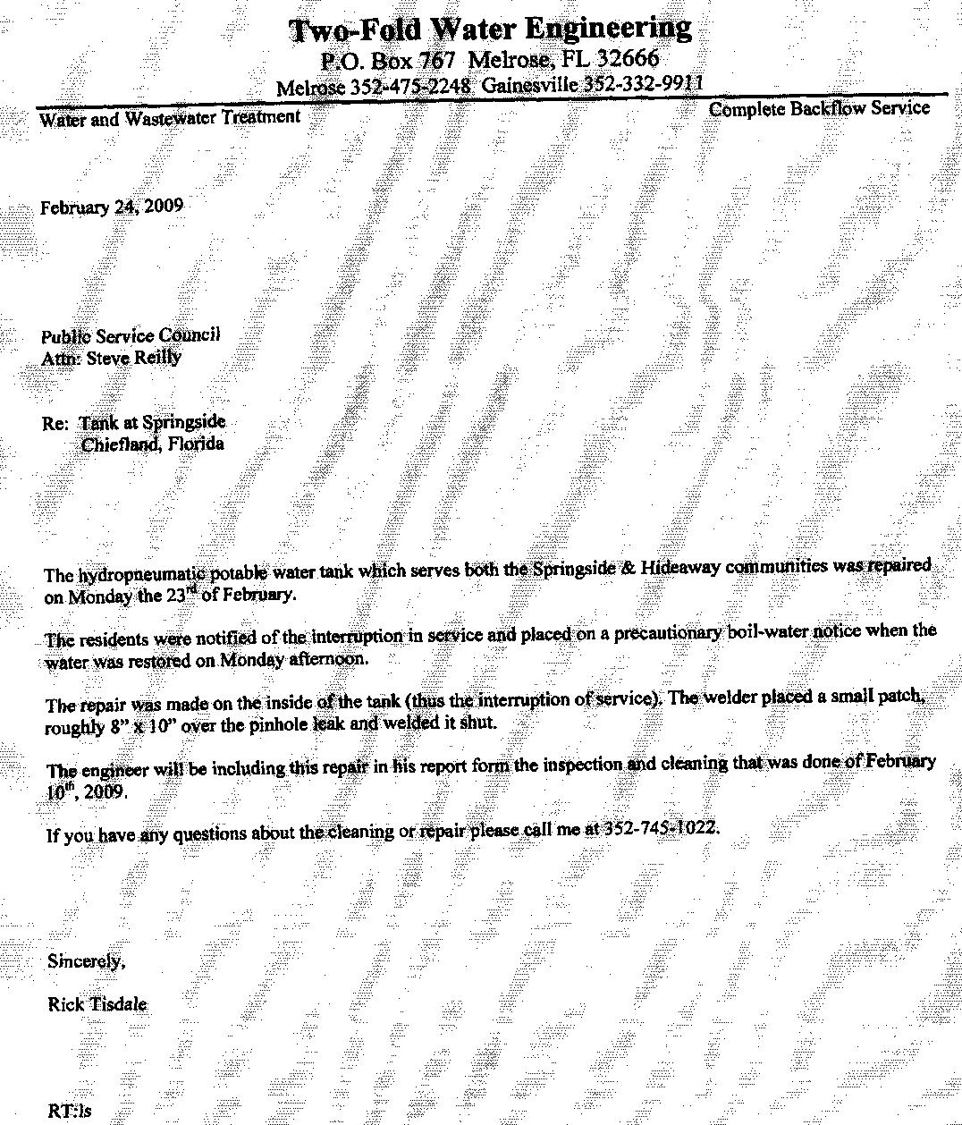
TERRITORY DESCRIPTION
FIMC HIDEAWAY, INC.
Springside System
Levy County
Water and Wastewater Service

Township 11 South, Range 13 East

Section 25

The North 75 feet of the South 1/2 of the Southeast 1/4 of said Section 25.

And

The Northwest 1/4 of the Southeast 1/4 of said Section 25.

Less

The North 790 feet of the West 760 feet of the North 1/2 of the Southeast 1/4, and the West 200 feet of the East 600 feet of the North 1/2 of the Southeast 1/4 of the said Section 25.
FLORIDA PUBLIC SERVICE COMMISSION
authorizes

Par Utilities, Inc.
pursuant to
Certificate Number 428-W

to provide water service in Levy County in accordance with the provisions of Chapter 367, Florida Statutes, and the Rules, Regulations, and Orders of this Commission in the territory described by the Orders of this Commission. This authorization shall remain in force and effect until superseded, suspended, cancelled or revoked by Order of this Commission.

Order Number Date Issued Docket Number Filing Type

13961 01/03/85 840031-WU Grandfather certificate
16863 11/19/86 860866-WU Transfer of Majority Control
PSC-00-0682-FOF-WU 04/12/00 990253-WU Transfer of Certificate
PSC-00-2093-FOF-WU 11/03/00 001557-WU Name Change
PSC-04-0610-PAA-WS 06/21/04 030407-WS Transfer of Certificates
PSC-09-0279-PAA-WS 04/29/09 080268-WS Transfer System

FLORIDA PUBLIC SERVICE COMMISSION
authorizes

FIMC Hideaway, Inc.
pursuant to
Certificate Number 426-W

to provide water service in Levy County in accordance with the provisions of Chapter 367, Florida Statutes, and the Rules, Regulations, and Orders of this Commission in the territory described by the Orders of this Commission. This authorization shall remain in force and effect until superseded, suspended, cancelled or revoked by Order of this Commission.

Order Number Date Issued Docket Number Filing Type

13497 07/10/84 830552-WS Grandfather Certificate
15432 12/09/85 840235-WS Original Certificate
23970 01/08/91 900408-WS Transfer Certificate
25584 01/08/92 910672-WS Transfer Certificate
PSC-99-2112-FOF-WS 10/25/99 991206-WS Abandonment
PSC-00-0088-PAA-WS 01/10/00 991206-WS Appointment Receiver
PSC-04-0610-PAA-WS 06/21/04 030407-WS Transfer System
PSC-05-0298-PAA-WS 03/18/05 040152-WS Transfer Majority Control
PSC-09-0279-PAA-WS 04/29/09 080268-WS Transfer System

FLORIDA PUBLIC SERVICE COMMISSION

authorizes

FIMC Hideaway, Inc.
pursuant to
Certificate Number 362-S

to provide wastewater service in Levy County in accordance with the provisions of Chapter 367, Florida Statutes, and the Rules, Regulations, and Orders of this Commission in the territory described by the Orders of this Commission. This authorization shall remain in force and effect until superseded, suspended, cancelled or revoked by Order of this Commission.

Order Number Date Issued Docket Number Filing Type

13497 07/10/84 830552-WS Grandfather Certificate
15432 12/09/85 840235-WS Original Certificate
23970 01/08/91 900408-WS Transfer Certificate
25584 01/08/92 910672-WS Transfer Certificate
PSC-99-2112-FOF-WS 10/25/99 991206-WS Abandonment
PSC-00-0088-PAA-WS 01/10/00 991206-WS Appointment Receiver
PSC-04-0610-PAA-WS 06/21/04 030407-WS Transfer System
PSC-05-0298-PAA-WS 03/18/05 040152-WS Transfer Majority Control
PSC-09-0279-PAA-WS 04/29/09 080268-WS Transfer System

Schedule 1
Page 1 of 2

FIMC HIDEAWAY, INC.

SPRINGSIDE WATER AND WASTEWATER SYSTEMS

Monthly Service Rates

Water Residential and General Service

 | Meter Size:
 | 5/8" x 3/4" | $ 8.07
 | 3/4” | 12.12
 | 1" | 20.30
 | 1 ½” | 40.36
 | 2" | 64.58
 | 3" | 129.17
 | 4” | 201.81
 | Gallonage Charge per 1,000 gallons | $2.82

Wastewater Residential Service
 | All Meter Sizes | $16.56

 | Charge per 1,000 gallons  (10,000 gallon maximum) | $5.33

Wastewater General Service

 | Meter Size:
 | 5/8" x 3/4" | $ 16.56
 | 3/4” | 24.83
 | 1" | 41.38
 | 1 ½” | 82.75
 | 2" | 132.41
 | 3" | 264.82
 | 4” | 413.78
 | Gallonage Charge per 1,000 gallons | $ 6.41

Schedule 1
Page 2 of 2

Irrigation Service
 | Charge per 1,000 gallons |  | $1.61
Miscellaneous Service Charges
 |  | Water |  |  | Wastewater
 | Initial Connection Fee | $15.00 |  |  |  | $15.00
 | Normal Reconnection Fee | 15.00 |  |  |  | 15.00
 | Violation Reconnection Fee | 15.00 |  |  |  | Actual Cost
 | Premises Visit Fee  (in lieu of disconnection) | 10.00 |  |  |  |  | 10.00
 | Late Payment Fee | 5.00 |  |  |  | 5.00

Service Availability Charges
 |  |  | Water | Wastewater
 | Meter Installation Fee 5/8”x3/4” | $100.00 |  | N/A
 | Plant Capacity Charge | $325.00 |  | $950.00
 | Per Water ERC (350 GPD) | $ 0.93
 | Per Wastewater ERC (280 GPD) |  |  |  | $ 3.39

Order No. 15432, issued December 9, 1985, in Docket No. 840235-WS, In Re: Application of Springside, Inc., for certificates to operate a water and sewer utility pursuant to Section 367.171, Florida Statutes.
Order No. 23970, issued January 8, 1991, in Docket No. 900408-WS, In Re: Application for transfer of Certificates Nos. 435-W and 366-S from Springside, Inc. to Springside at Manatee, Ltd. in Levy County.
Order No. PSC-99-2112-FOF-WS, issued October 25, 1999, in Docket No. 991206-WS, In Re: Notice of abandonment of Springside at Manatee, Ltd. in Levy County by Mr. Kenneth Drummond.
Order No. PSC-00-0088-PAA-WS, issued January 10, 2000, in Docket No. 991206-WS, In Re: Notice of abandonment of Springside at Manatee, Ltd. in Levy County by Mr. Kenneth Drummond.
Order No. PSC-04-0610-PAA-WS, issued June 21, 2004, in Docket No. 030407-WS, In Re: Application for transfer of water and wastewater facilities and Certificate No. 366-S in Levy County from Springside at Manatee, LTD. to Par Utilities, Inc. for cancellation of Certificate No. 435-W held by Springside, and for amendment of Certificate No. 428-W held by Par.
Order No. PSC-05-0298-PAA-WS, issued March 18, 2005, in Docket No. 040152-WS, In Re: Application for transfer of majority organizational control of FIMC Hideaway, Inc. in Levy County from Florida Investors Mortgage Corporation, a Florida corporation, to Robert and Janet McBride.
Order No. PSC-92-0190-FOF-WS, issued April 13, 1992, in Docket No. 910909-WS, In re: Application for a staff-assisted rate case in Levy County by Springside at Manatee, Ltd.
Order No. PSC-06-0823-TRF-WU, issued October 6, 2006, in Docket No. 060506-WU, In Re: Request for approval of tariff amendment to include a late payment fee of $5 in Osceola County by O&S Water Company, Inc.

