State of Florida   |  | Public Service Commission  Capital Circle Office Center ● 2540 Shumard Oak Boulevard  Tallahassee, Florida 32399-0850  -M-E-M-O-R-A-N-D-U-M-
DATE: | July 1, 2009 August 6, 2009
TO: | Office of Commission Clerk (Cole)
FROM: | Division of Regulatory Compliance (Bates, Watts)  Office of the General Counsel (McKay, Tan)
RE: | Docket No. 090246-TP – Notice of adoption of existing interconnection agreement between BellSouth Telecommunications, Inc. d/b/a AT&T Florida d/b/a AT&T Southeast and Cbeyond Communications, LLC by Clective Telecom Florida, LLC.
AGENDA: | 07/14/09 08/18/09 – Regular Agenda – Proposed Agency Action – Interested Persons May Participate
COMMISSIONERS ASSIGNED: |  |  | Staff All Commissioners
PREHEARING OFFICER: |  |  | Administrative
CRITICAL DATES: |  |  | None
SPECIAL INSTRUCTIONS: |  |  | None
FILE NAME AND LOCATION: |  |  | S:\PSC\RCP\WP\090246.RCM.DOC

Case Background
On April 29, 2009, Clective Telecom Florida, LLC (Clective) filed a unilateral Notice of Adoption of existing interconnection agreement between BellSouth Telecommunications, Inc. d/b/a AT&T Florida d/b/a AT&T Southeast (AT&T) and Cbeyond Communications, LLC pursuant to AT&T/BellSouth Merger Commitments and Section 252(i) of the Federal Telecommunications Act of 1996 (Act) (Cbeyond Interconnection Agreement).

In its Notice, Clective stated that effective immediately it has adopted in its entirety, the “Interconnection Agreement Between BellSouth Telecommunications, Inc. and Cbeyond Communications, LLC” pursuant to the Federal Communications Commission (FCC) approved Merger Commitment Nos. 1 and 2 under “Reducing Transaction Costs Associated with Interconnection Agreements” and 47 U.S.C. § 252(i).

On May 4, 2009, Florida Public Service Commission (Commission) staff notified AT&T in writing of Clective’s Notice of Adoption and its obligations under 47 U.S.C. § 252(i) and requested that any objections to the Notice based on 47 C.F.R. § 51.809, if they existed, be filed with the Commission no later than June 3, 2009. Staff’s May 4, 2009 letter is attached. (Attachment A)

On May 8, 2009, AT&T filed its Objection to Notice of Adoption and Petition to Cancel Clective Florida LLC's CLEC Certificate (Objection). AT&T’s objections were not based on the exceptions enumerated in 47 C.F.R. § 51.809.

On May 29, 2009, Clective filed its Response to AT&T’s objections.

On June 22, 2009, Clective filed a Motion for Sanctions against AT&T. AT&T’s response is expected filed its Response in Opposition to Clective’s Motion for Sanctions on July 6, 2009.

This matter was scheduled to be heard by the Commission at its July 14, 2009, Agenda Conference. However, it was deferred at the request of AT&T based upon two filings that it made in the docket. On July 9, 2009, AT&T filed a notice of filing additional documentation in support of its objection and petition to cancel Clective's CLEC Certificate No. 8736. Clective responded on July 10, 2009 with a letter responding to AT&T’s filings. A second notice of filing additional documentation in support of objection and petition to cancel Clective's CLEC Certificate No. 8736 and a letter to Clective from AT&T were also made on July 17, 2009 by AT&T.

The Commission is vested with jurisdiction over these matters pursuant to the provisions of Chapters 364 and 120, Florida Statutes (F.S.).
Discussion of Issues

Issue 1:1
Does AT&T have standing to request the cancellation of Clective's CLEC certificate?
Recommendation:
No, AT&T does not have standing to request the cancellation of Clective’s CLEC certificate. (Tan, McKay)
Staff Analysis:

Clective filed a unilateral Notice of Adoption of the Cbeyond Interconnection Agreement. In its Objection, filed on May 8, 2009, AT&T stated it objected to Clective’s adoption of this agreement because Clective lacked sufficient technical, financial and managerial capability pursuant to Section 364.337(3), F.S., to provide CLEC service in the state of Florida. AT&T further detailed information regarding AT&T’s relationship with Clective GA, Incorporated (Clective Georgia). AT&T alleged that the Commission should consider that AT&T will have no choice but to allow interconnection with Clective, and should Clective comport itself similarly in Florida as in Georgia, AT&T will suffer financial harm. Clective Georgia and AT&T are currently involved in a payment dispute and litigation in Georgia. In its Response to AT&T’s Objection, Clective stated that Clective Georgia and Clective Florida should not be linked together for the purposes of its Notice of Adoption, as the companies are completely separate entities, with common ownership.

Staff believes that AT&T cannot request the cancellation of Clective’s CLEC certificate because it lacks standing to do so. In order to meet the applicable legal standard to establish standing, a petitioner must explain how its substantial interest will be affected by the agency determination. Thus, the burden is upon AT&T to demonstrate that it does, in fact, have standing to participate in the case. Department of Health and Rehabilitative Services v. Alice P., 367 So. 2d 1045, 1052 (Fla. 1st DCA 1979). AT&T must demonstrate that its substantial interests have been affected. As set forth in Agrico Chemical Co. v Department of Environmental Regulation, 406 So. 2d 478, 482 (Fla. 2nd DCA 1981), rev. denied 415 So. 2nd 1359 (Fla. 1982), a party must show: “(1) that he will suffer injury in fact which is of sufficient immediacy to entitle him to a Section 120.57, Florida Statutes, hearing; and (2) that his substantial injury is of a type or nature which the proceeding is designed to protect.”

Staff believes that AT&T=s petition does not allege facts sufficient to meet the first prong of the Agrico test. AT&T=s allegations fail to demonstrate that it will suffer an injury in fact which is of sufficient immediacy to warrant a Section 120.57 hearing. As the Florida Supreme Court stated in AmeriSteel v. Clark, 691 So. 2d 473 (Fla. 1997), under the first prong of the Agrico test, a petitioner must show that the alleged harm is of sufficient immediacy to require a hearing, and loss due to economic competition is not harm of sufficient immediacy to establish standing. AT&T’s claim is speculative rather than immediate.

Staff’s belief that AT&T does not have standing is consistent with the Court’s determination that claims of future economic injury are insufficient to establish standing. See, AmeriSteel, (affirming the Commission’s decision that entity did not have standing to protest Commission order because customer’s claims of future economic harm was “not an injury in fact of sufficient immediacy to entitle” the customer to a Section 120.57 hearing) (citing International Jai-Alai Players Ass’n v. Florida Pari-Mutual Comm’n, 561 So. 2d 1224, 1225-26 (Fla. 3d DCA 1990)(per curiam)(potential economic detriment was too remote to establish standing); Florida Soc’y of Ophthalmology v. State Bd. of Optometry, 532 So. 2d 1279, 1285 (Fla.1st DCA 1988)(some degree of loss due to economic competition is not of sufficient “immediacy” to establish standing); and Village Park Mobile Home Association, Inc. v. State Dept. of Business Regulations, 506 So. 2d 426, 434 (Fla. 1st DCA 1987), rev. denied, 513 So. 2d 1063 (Fla. 1987)(speculations on the possible occurrence of injurious events are too remote to warrant inclusion in the administrative review process). In accordance with the above decisions, staff believes sSpeculation about future economic detriment is too remote for AT&T to establish standing.

In order to satisfy the second prong of the Agrico test, the nature of the injury must be of the type that the proceeding is designed to protect. Staff believes that AT&T does not meet the second prong as this proceeding was initiated to notice the Commission of an adoption of an interconnection agreement. Cancellation of a certificate is appropriately addressed in an enforcement action initiated by the Commission to address violations of Florida Statutes or Commission Rules. Therefore, staff believes AT&T fails to satisfy either prong of the Agrico test and does not have standing to request cancellation of Clective’s CLEC certificate.

Issue 2:2
Can Clective adopt the BellSouth/AT&T and Cbeyond Interconnection Agreement?
Recommendation:
Yes, there is nothing precluding Clective from adoption of the BellSouth/AT&T and Cbeyond Interconnection Agreement, pursuant to 47 U.S.C. §252(i) and 47 C.F.R. §51.809. The parties should file an executed interconnection agreement within ten days after the Consummating Order is issued. The effective date of the agreement should be the date upon which Clective filed its Notice of Adoption, April 29, 2009. (Tan)
Staff Analysis:

On May 4, 2009, Commission staff sent AT&T a letter informing the company of Clective’s unilateral Notice of Adoption and AT&T’s obligations under 47 U.S.C. § 252(i). Staff requested that any objections to the Notice be based on 47 C.F.R. § 51.809, if they existed. In its Objection, AT&T stated that the Commission should reject the Notice of Adoption filed by Clective because Clective lacks the capability to provide CLEC services pursuant to Section 364.337, F.S. and Clective failed to pay 2008 Regulatory Assessment Fees (RAFs).

Although staff believes that AT&T does not have standing to request the cancellation of Clective’s certificate, AT&T does have standing to object to Clective’s Notice of Adoption. However AT&T’s only objection is based on Clective’s ability to operate as a CLEC in Florida. It is staff’s belief that whether a telecommunications carrier may adopt an entire, effective interconnection agreement is determined by whether a genuine exception exists to §252(i). The C.F.R. rule which implements §252(i), §51.809, describes the two instances where an incumbent LEC may deny a requesting carrier the right to adopt an entire effective agreement. Section 51.809(b) provides: [t]he obligations of paragraph (a) of this section shall not apply where the incumbent LEC proves to the state commission that:

1) the costs of providing a particular agreement to the requesting telecommunications carrier are greater than the costs of providing it to the telecommunications carrier that originally negotiated the agreement, or

2) the provision of a particular agreement to the requesting carrier is not technically feasible.

Unless AT&T, as an incumbent LEC, can demonstrate its costs will be greater to provide the agreement to the new carrier, or the agreement is not technically feasible to provide to the new carrier, AT&T may not restrict the party’s right to adopt. The FCC states that it would “deem an incumbent LEC’s conduct discriminatory if it denied a requesting carrier’s request to adopt an agreement to which it is entitled under [§] 252(i) and our all-or-nothing rule.”

Since AT&T did not provide any objections based on the cost exception or the technical feasibility exception provided in §51.809, staff believes that AT&T has failed to demonstrate why Clective should not be allowed to adopt the Cbeyond Interconnection Agreement. Therefore, Clective may adopt the Cbeyond Interconnection Agreement in its entirety. The parties should file an executed interconnection agreement within ten days after the Consummating Order is issued. The effective date of the agreement should be the date upon which Clective filed its Notice of Adoption, April 29, 2009.
Issue 3:3
Should this docket be closed?
Recommendation:
No. If no person whose substantial interests are affected by the proposed agency action files a protest within 21 days of the issuance of the order, the order should become final and the docket should remain open. Upon filing of the parties executed interconnection agreement, this docket should be closed administratively. the order should become final and the docket should be closed upon issuance of a Consummating Order. If the Commission denies staff’s recommendation in Issue 2, the docket should remain open for additional Commission action. (Tan)
Staff Analysis
:
If no person whose substantial interests are affected by the proposed agency action files a protest within 21 days of the issuance of the order, the order should become final and the docket should be closed upon issuance of a Consummating Order. The party’s interconnection agreement, shall become effective upon issuance of the Consummating Order. If the Commission denies staff’s recommendation in Issue 2, the docket should remain open for additional Commission action.

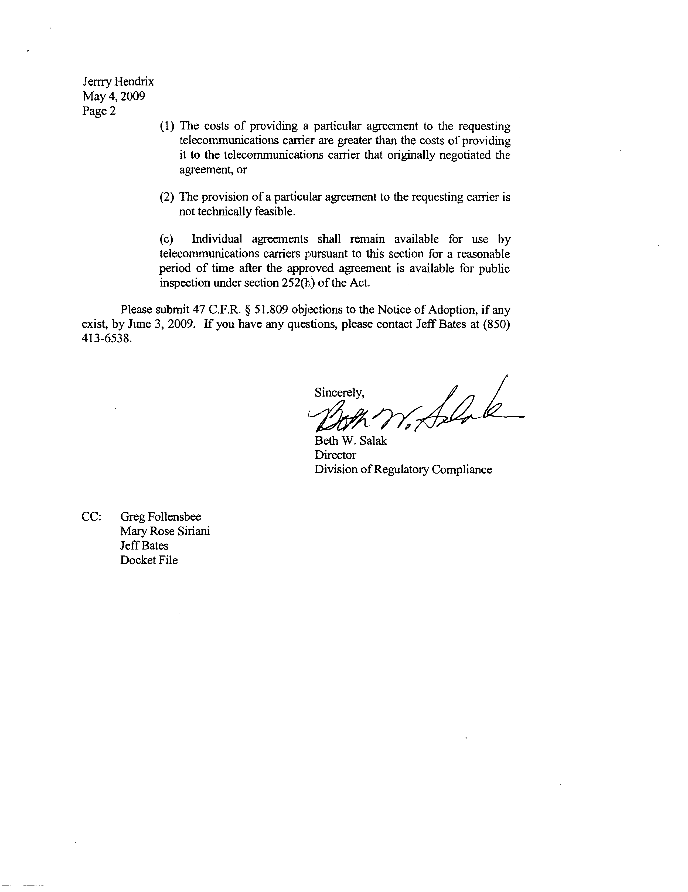

There are two ways for a telecommunications carrier to obtain an interconnection agreement with an incumbent LEC. The first method, described in §252(a), is through negotiation, and the second, detailed in §252(b), is through compulsory arbitration. In addition to the aforementioned two processes, §252(i) of the Act describes the alternative process: adoption of an existing interconnection agreement: Availability To Other Telecommunications Carriers – A local exchange carrier shall make available any interconnection, service or network element provided under an agreement approved under this section to which it is a party to any other requesting telecommunications carrier upon the same terms and conditions as those provided in the agreement.
Competitive Local Exchange Company (CLEC).
Section 364.337(3) provides that “[t]he commission shall grant a certificate of authority to provide intrastate interexchange telecommunications service upon a showing that the applicant has sufficient technical, financial, and managerial capability to provide such service in the geographic area proposed to be served.”
The Cbeyond Interconnection Agreement includes deposit requirements and provisions to suspend a CLEC’s access to AT&T’s ordering systems which appear to be designed to protect AT&T from harm.
Order No. PSC-06-0907-FOF-TP, issued October 31, 2006, in Docket No. 060308-TP. In re: Joint application for approval of indirect transfer of control of telecommunications facilities resulting from agreement and plan of merger between AT&T Inc. (parent company of AT&T Communications of the Southern States, LLC, CLEC Cert. No. 4037, IXC Registration No. TJ615, and PATS Cert. No. 8019; TCG South Florida, IXC Registration No. TI327 and CLEC Cert. No. 3519; SBC Long Distance, LLC, CLEC Cert. No. 8452, and IXC Registration No. TI684; and SNET America, Inc., IXC Registration No. TI389) and BellSouth Corporation (parent company of BellSouth Telecommunications, Inc., ILEC Cert. No. 8 and CLEC Cert. No. 4455); and BellSouth Long Distance, Inc. (CLEC Cert. No. 5261 and IXC Registration No. TI554).
The new filings proffered in this docket do not change staff’s recommendation regarding AT&T’s lack of standing to request the cancellation of Clective’s CLEC certificate.
Staff notes that the Commission, on its own initiative, may investigate whether Clective has “sufficient technical, financial, and managerial capability” pursuant to Section 364.337, F.S. Rule 25-24.820, F.A.C. enables the Commission on its own motion to revoke a company’s certification, with notice and opportunity for hearing, for violations of Statutes, Commission Rules, or terms and conditions of the certification.
AT&T and Clective Georgia are engaged in an ongoing dispute regarding payment.
On April 20, 2009, staff opened a compliance docket, Docket No. 090221-TX, against Clective for a first-time violation of non-payment of RAFs. On May 6, 2009, a Proposed Agency Action Order, PAA Order No. PSC-09-0298-PAA-TX, was issued to cancel Clective’s CLEC certificate unless payment of a penalty, cost of collection and past due fees were made prior to May 27, 2009. On May 19, 2009, Clective made a payment which satisfied the PAA Order. Consummating Order No. PSC-09-0392-CO-TX was issued June 2, 2009.
In Docket Nos. 070368-TP and 070369-TP, the Commission determined that AT&T's objections to Nextel’s Notice of Adoption lacked merit. On May 28, 2009, AT&T appealed Orders issued by the Commission in those Dockets to the United States District Court, Northern District of Florida, Case No. 4:09-cv-102 RS/WCS.
In Docket No. 090324-TP, Notice of adoption of existing interconnection, unbundling, resale, and collocation agreement between BellSouth Telecommunications, Inc. d/b/a AT&T Florida d/b/a AT&T Southeast and Cbeyond Communications, LLC by BTEL, Inc. and in Docket No. 090383-TP, Notice of adoption, with modifications, of existing interconnection, unbundling, resale, and collocation agreement between BellSouth Telecommunications, Inc. d/b/a AT&T Florida d/b/a AT&T Southeast and Cbeyond Communications, LLC by SIP Interchange Corporation, AT&T has allowed the adoption of the Cbeyond Interconnection Agreement without objection.
Second Report and Order, Review of the Section 251 Unbundling Obligations of Incumbent Local Exchange Carriers. CC Docket No. 01-338 (July 8, 2004)

