BEFORE THE FLORIDA PUBLIC SERVICE COMMISSION

In re: Joint petition for show cause proceedings against Verizon Florida LLC for apparent violation of Rule 25-4.070, F.A.C., Customer Trouble Reports, and impose fines, by the Office of the Attorney General, Citizens of the State of Florida, and AARP. | DOCKET NO. 080278-TL
In re: Implementation of Florida lifeline program involving bundled service packages and placement of additional enrollment requirements on customers. | DOCKET NO. 080234-TP  ORDER NO. PSC-09-0782A-AS-TP  ISSUED: November 24, 2009

AMENDATORY ORDER

BY THE COMMISSION:

On November 19, 2009, we issued Order No. PSC-09-0782-AS-TP. The purpose of the Order was to acknowledge and accept the Joint Settlement agreement between Verizon Florida, the Office of the Attorney General, the Office of Public Counsel and AARP in this docket and Docket No. 080234-TP. However, due to a scrivener’s error, the settlement agreement was not attached to the Final Order. Therefore, Order No. PSC-09-0782-AS-TP is amended to include the attached Settlement Agreement and the following ordering paragraph:

ORDERED that the Settlement Agreement is accepted and approved in its entirety except with the modification of $125,000 to the General Revenue Fund and $125,000 to promote the Lifeline and Linkup programs.

Based on the foregoing, it is

ORDERED by the Florida Public Service Commission that Order No. PSC-09-0782-AS-TP is hereby amended as set forth in the body of this Order. It is further

ORDERED that Order No. PSC-09-0782-AS-TP is reaffirmed in all other respects.

By ORDER of the Florida Public Service Commission this 24th day of November, 2009.

/s/ Ann Cole
ANN COLE
Commission Clerk

This is an electronic transmission. A copy of the original signature is available from the Commission's website, www.floridapsc.com, or by faxing a request to the Office of Commission Clerk at 1-850-413-7118.
( S E A L )

TLT
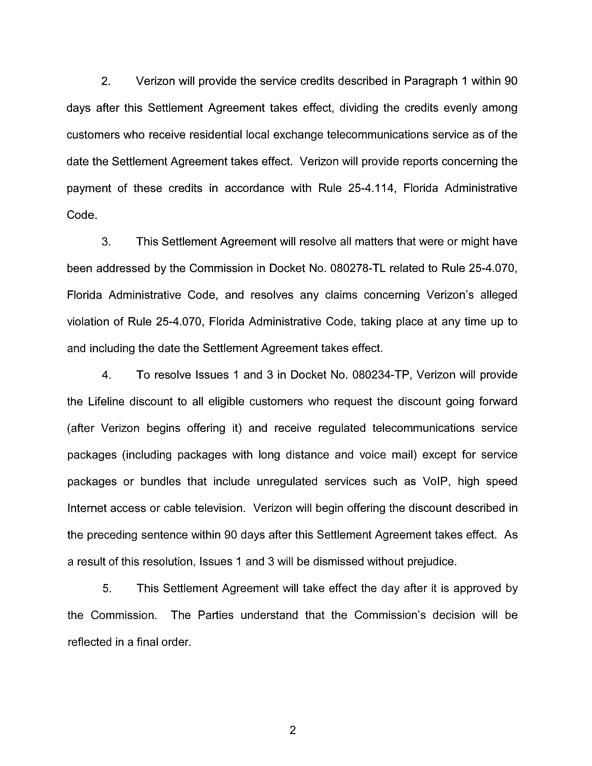
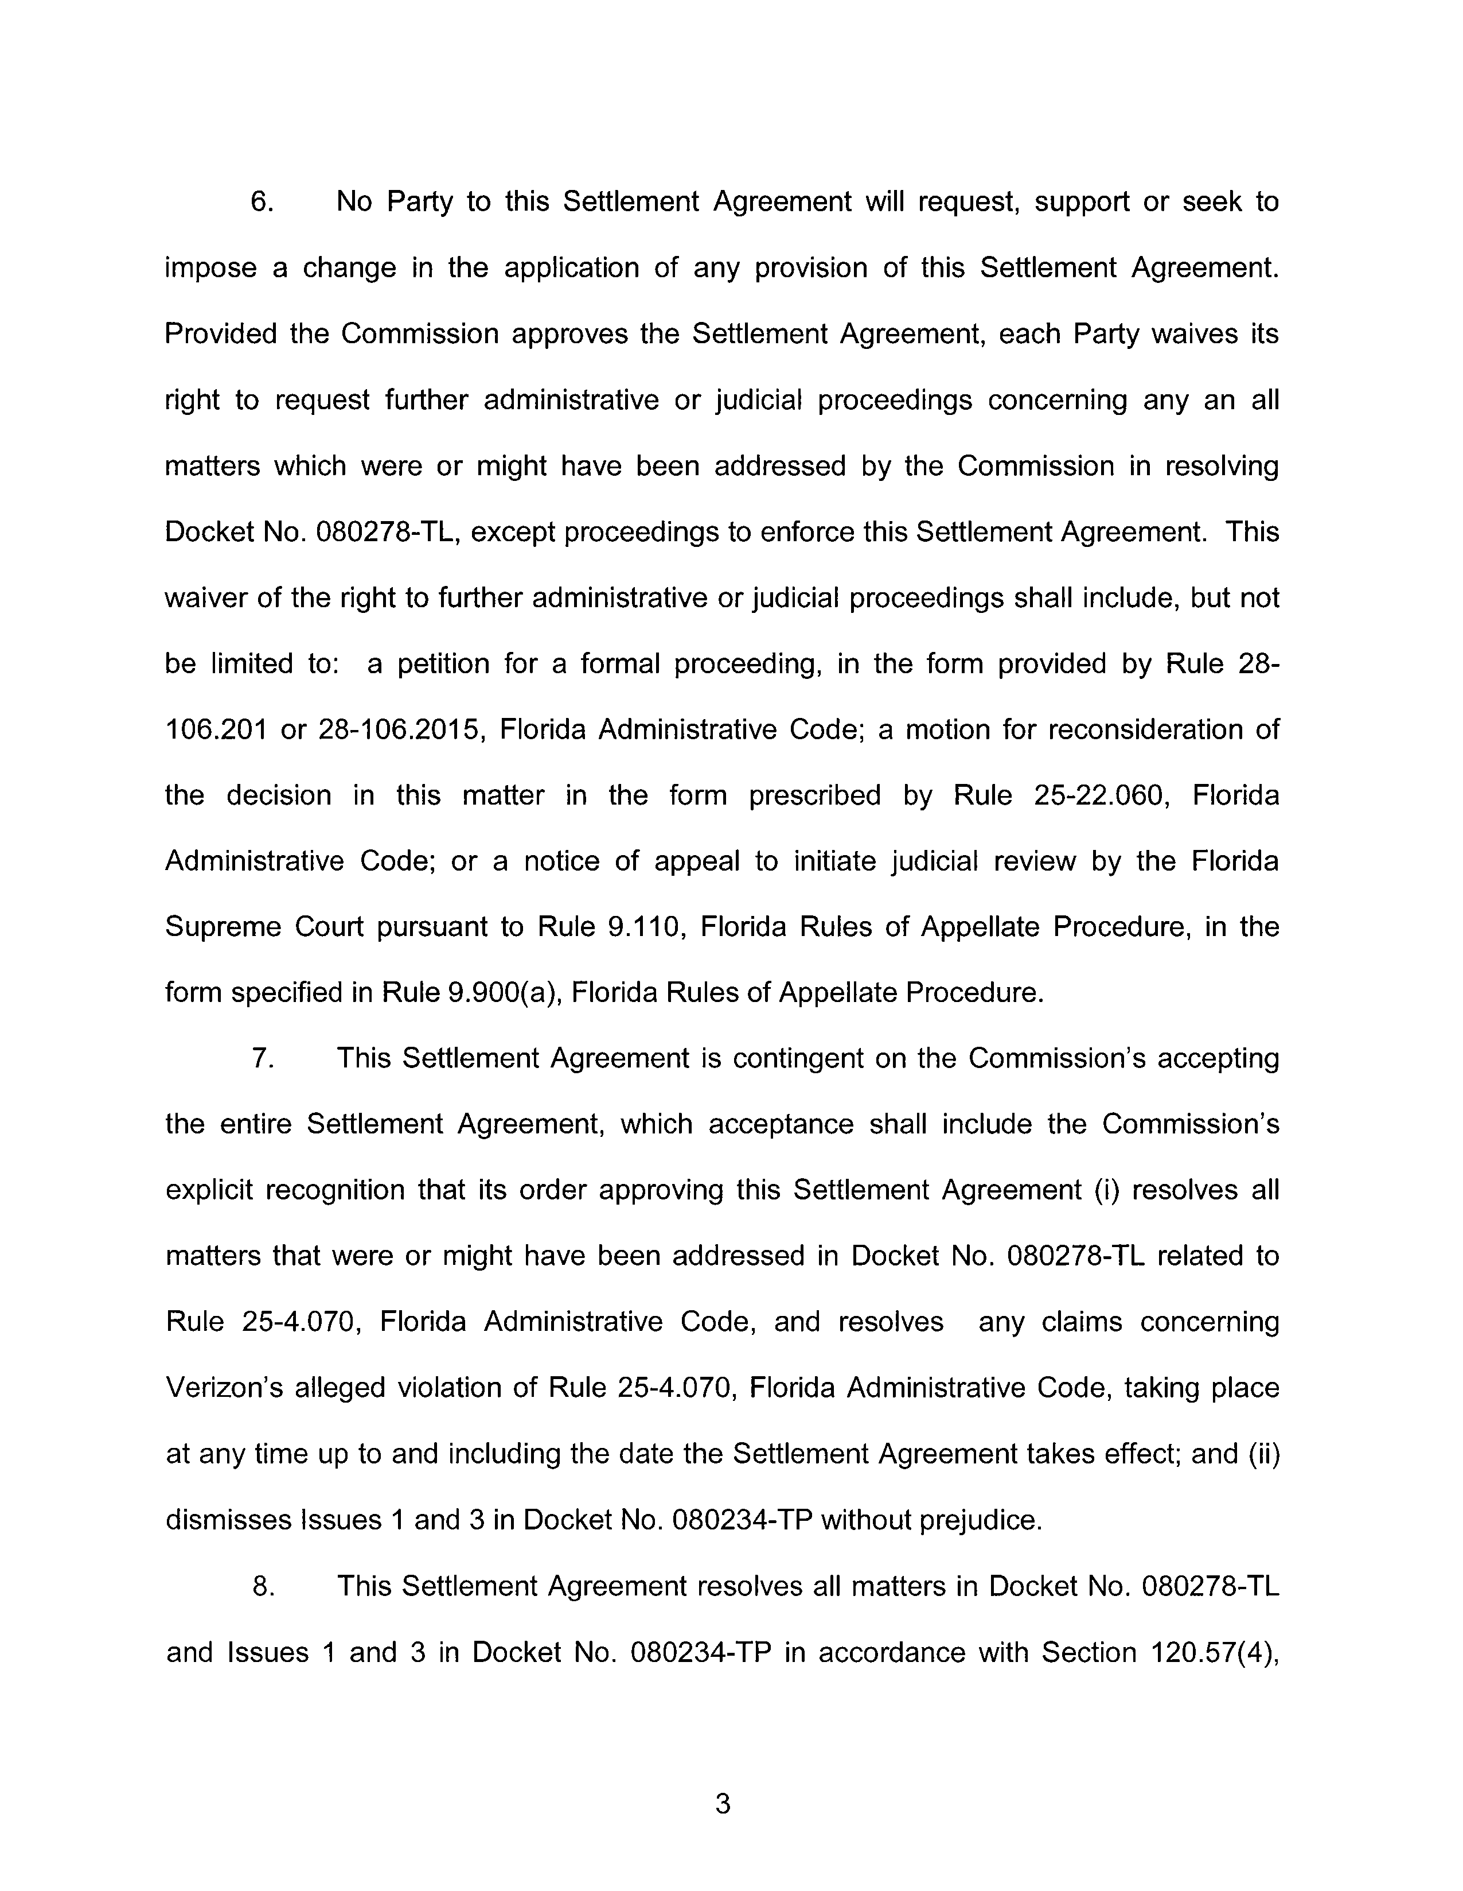
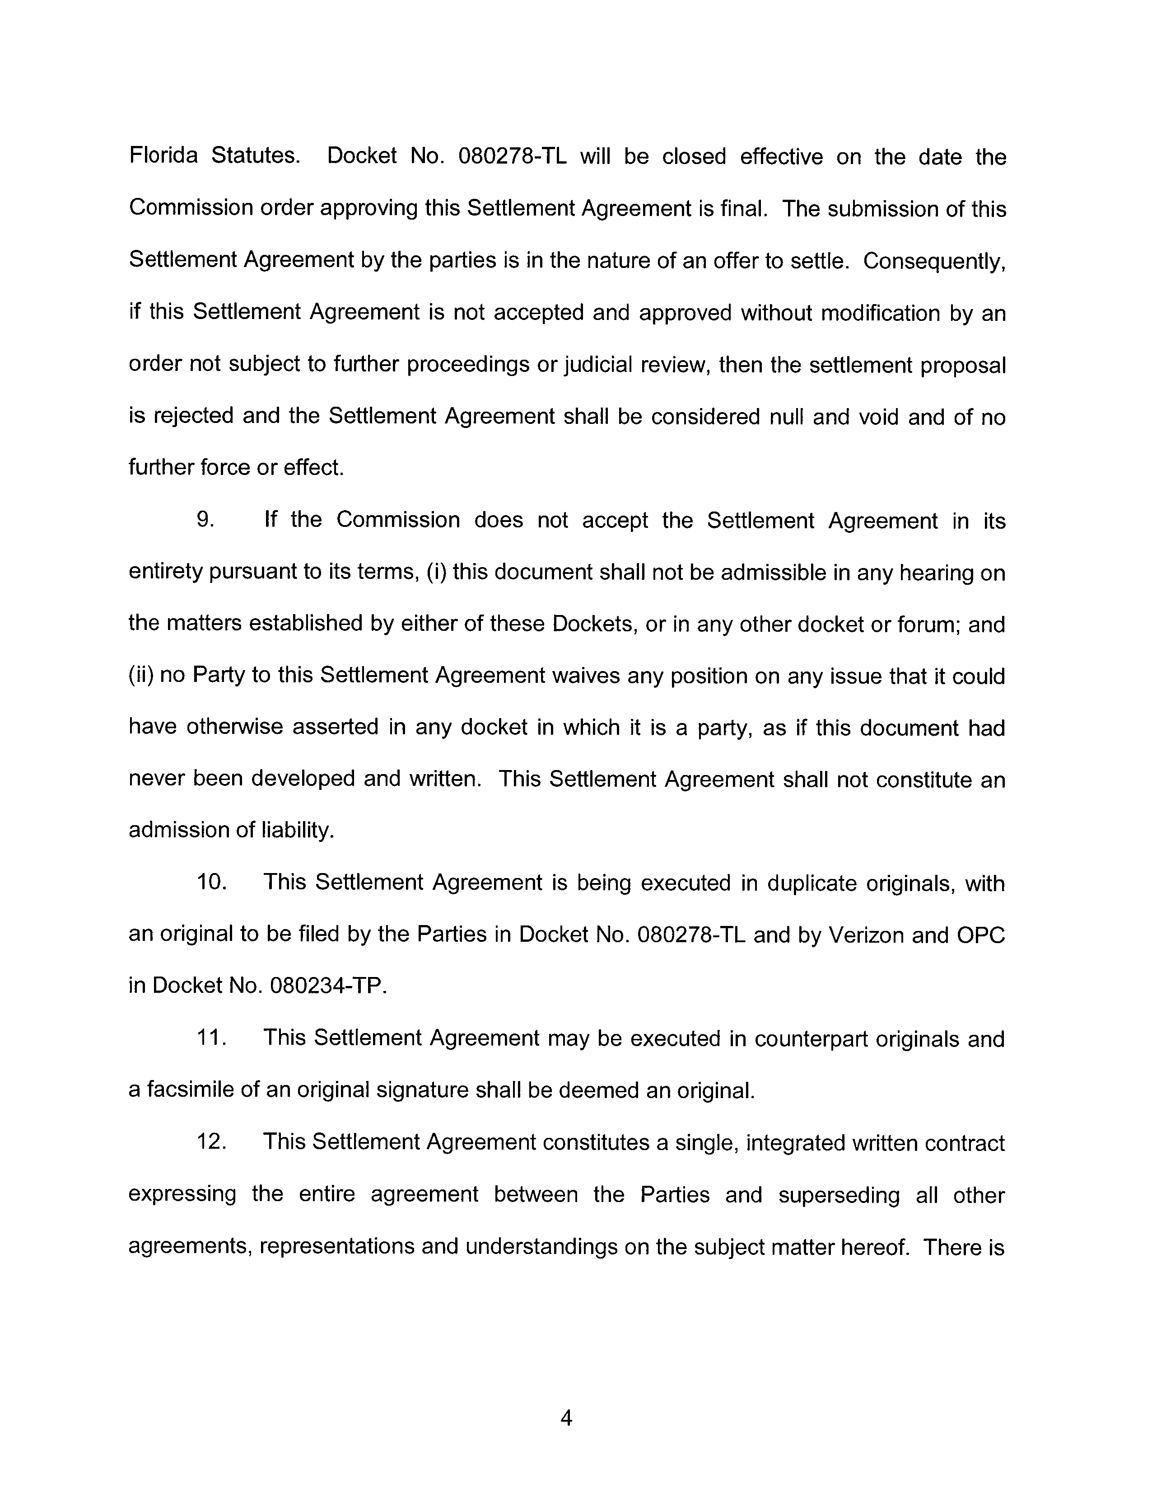
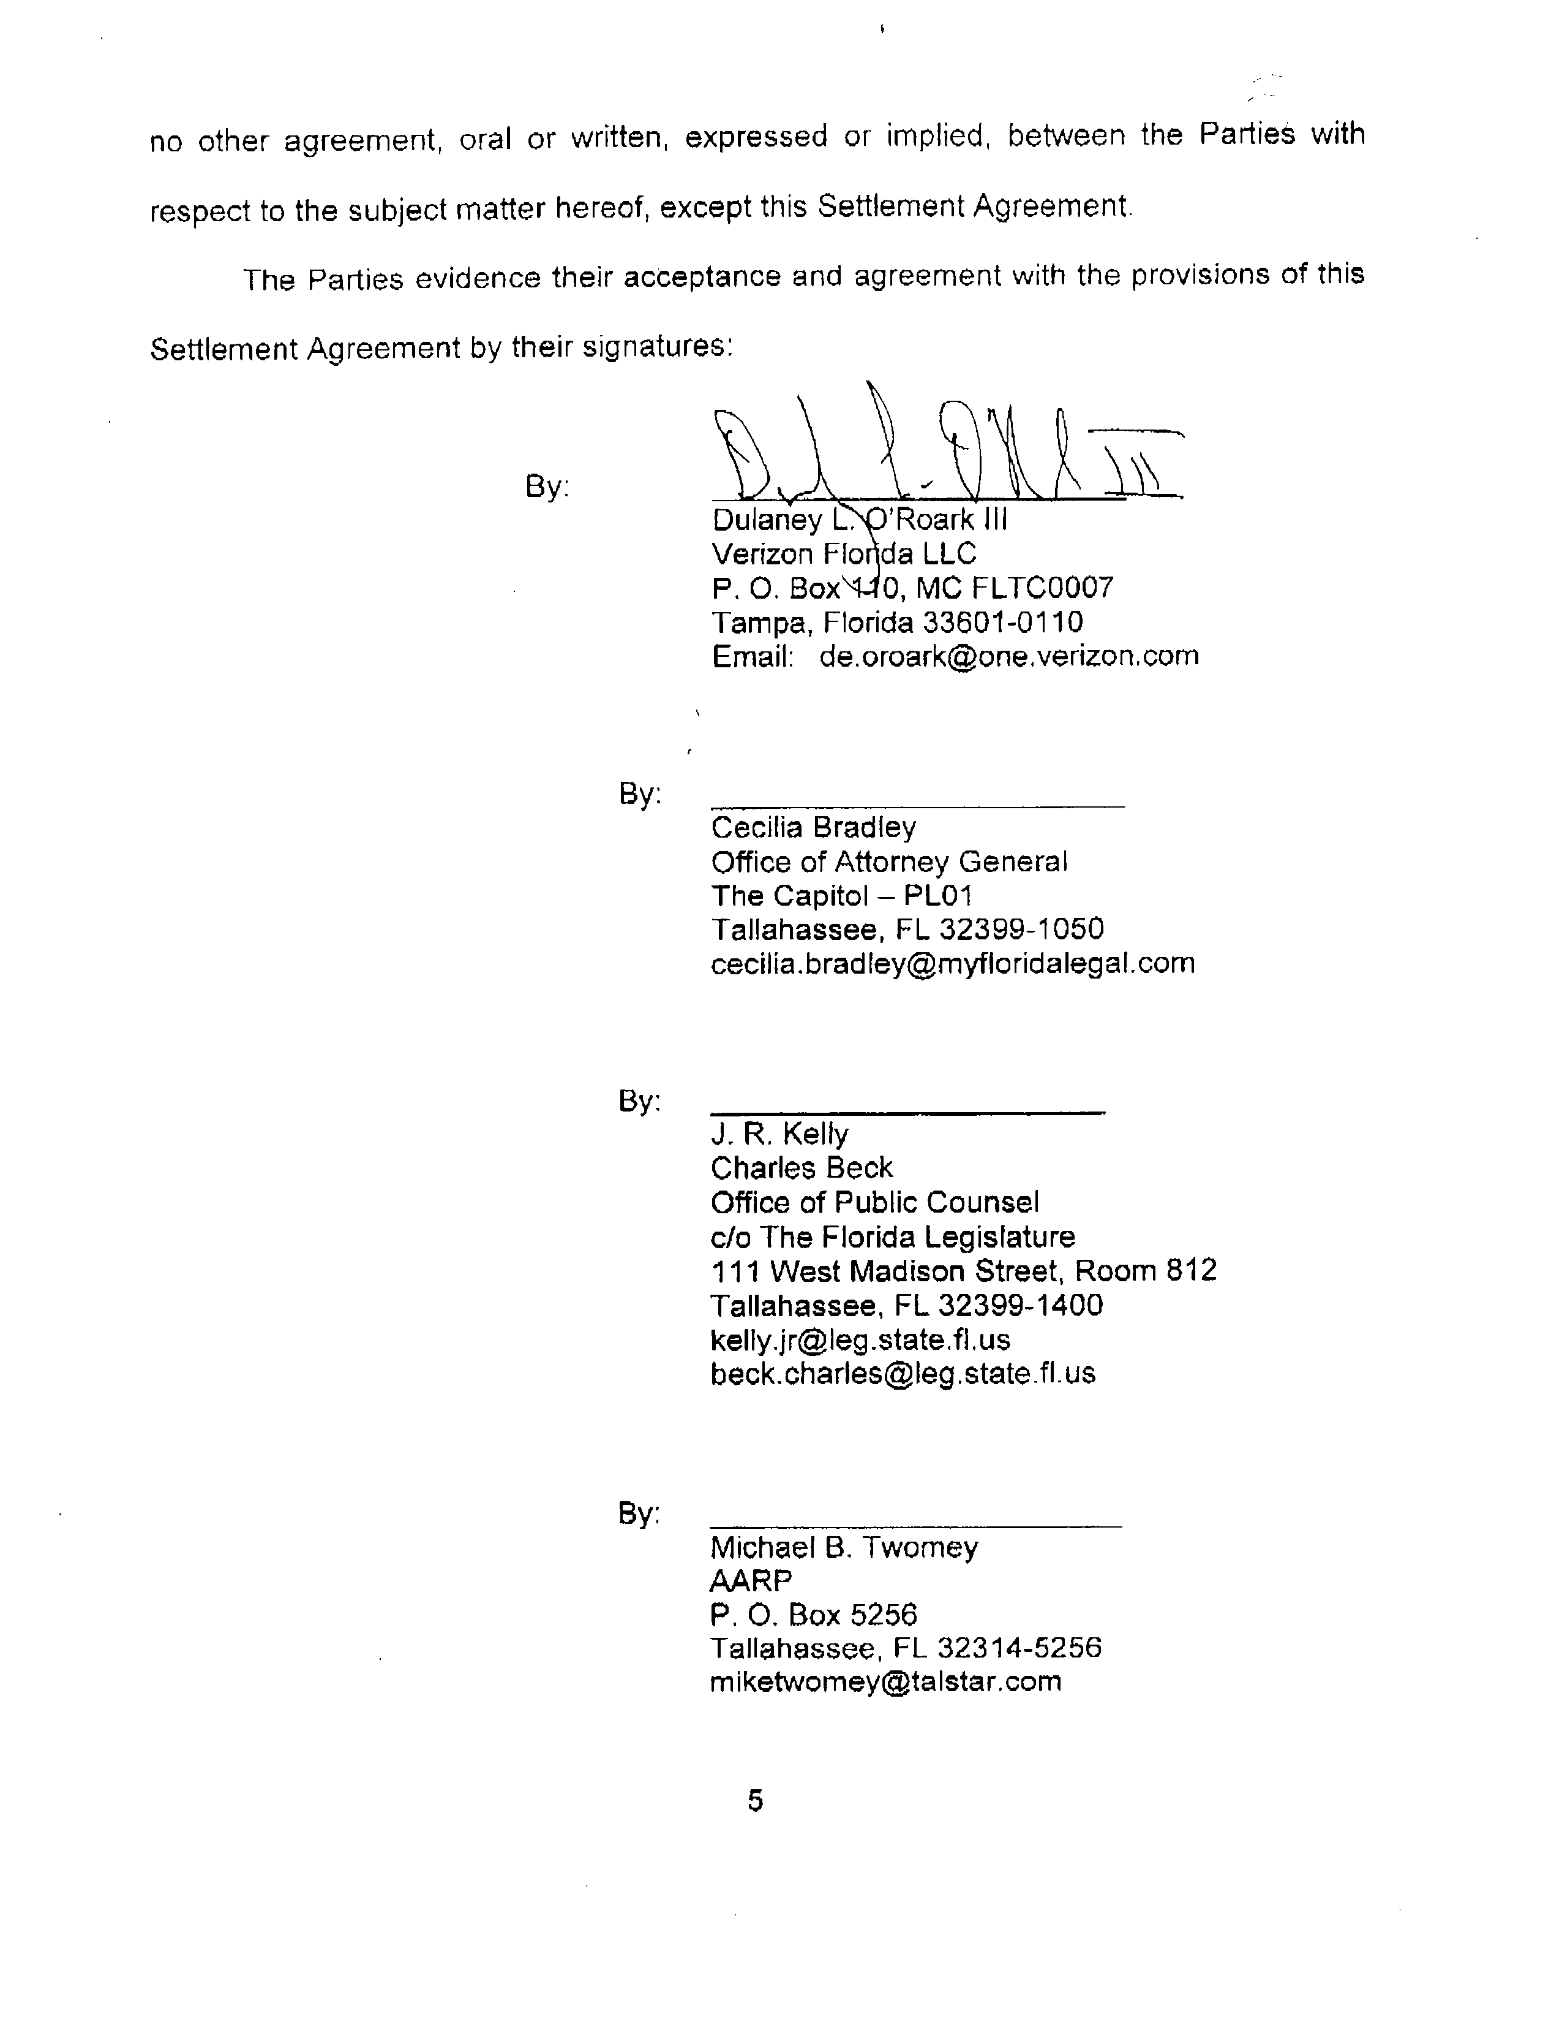
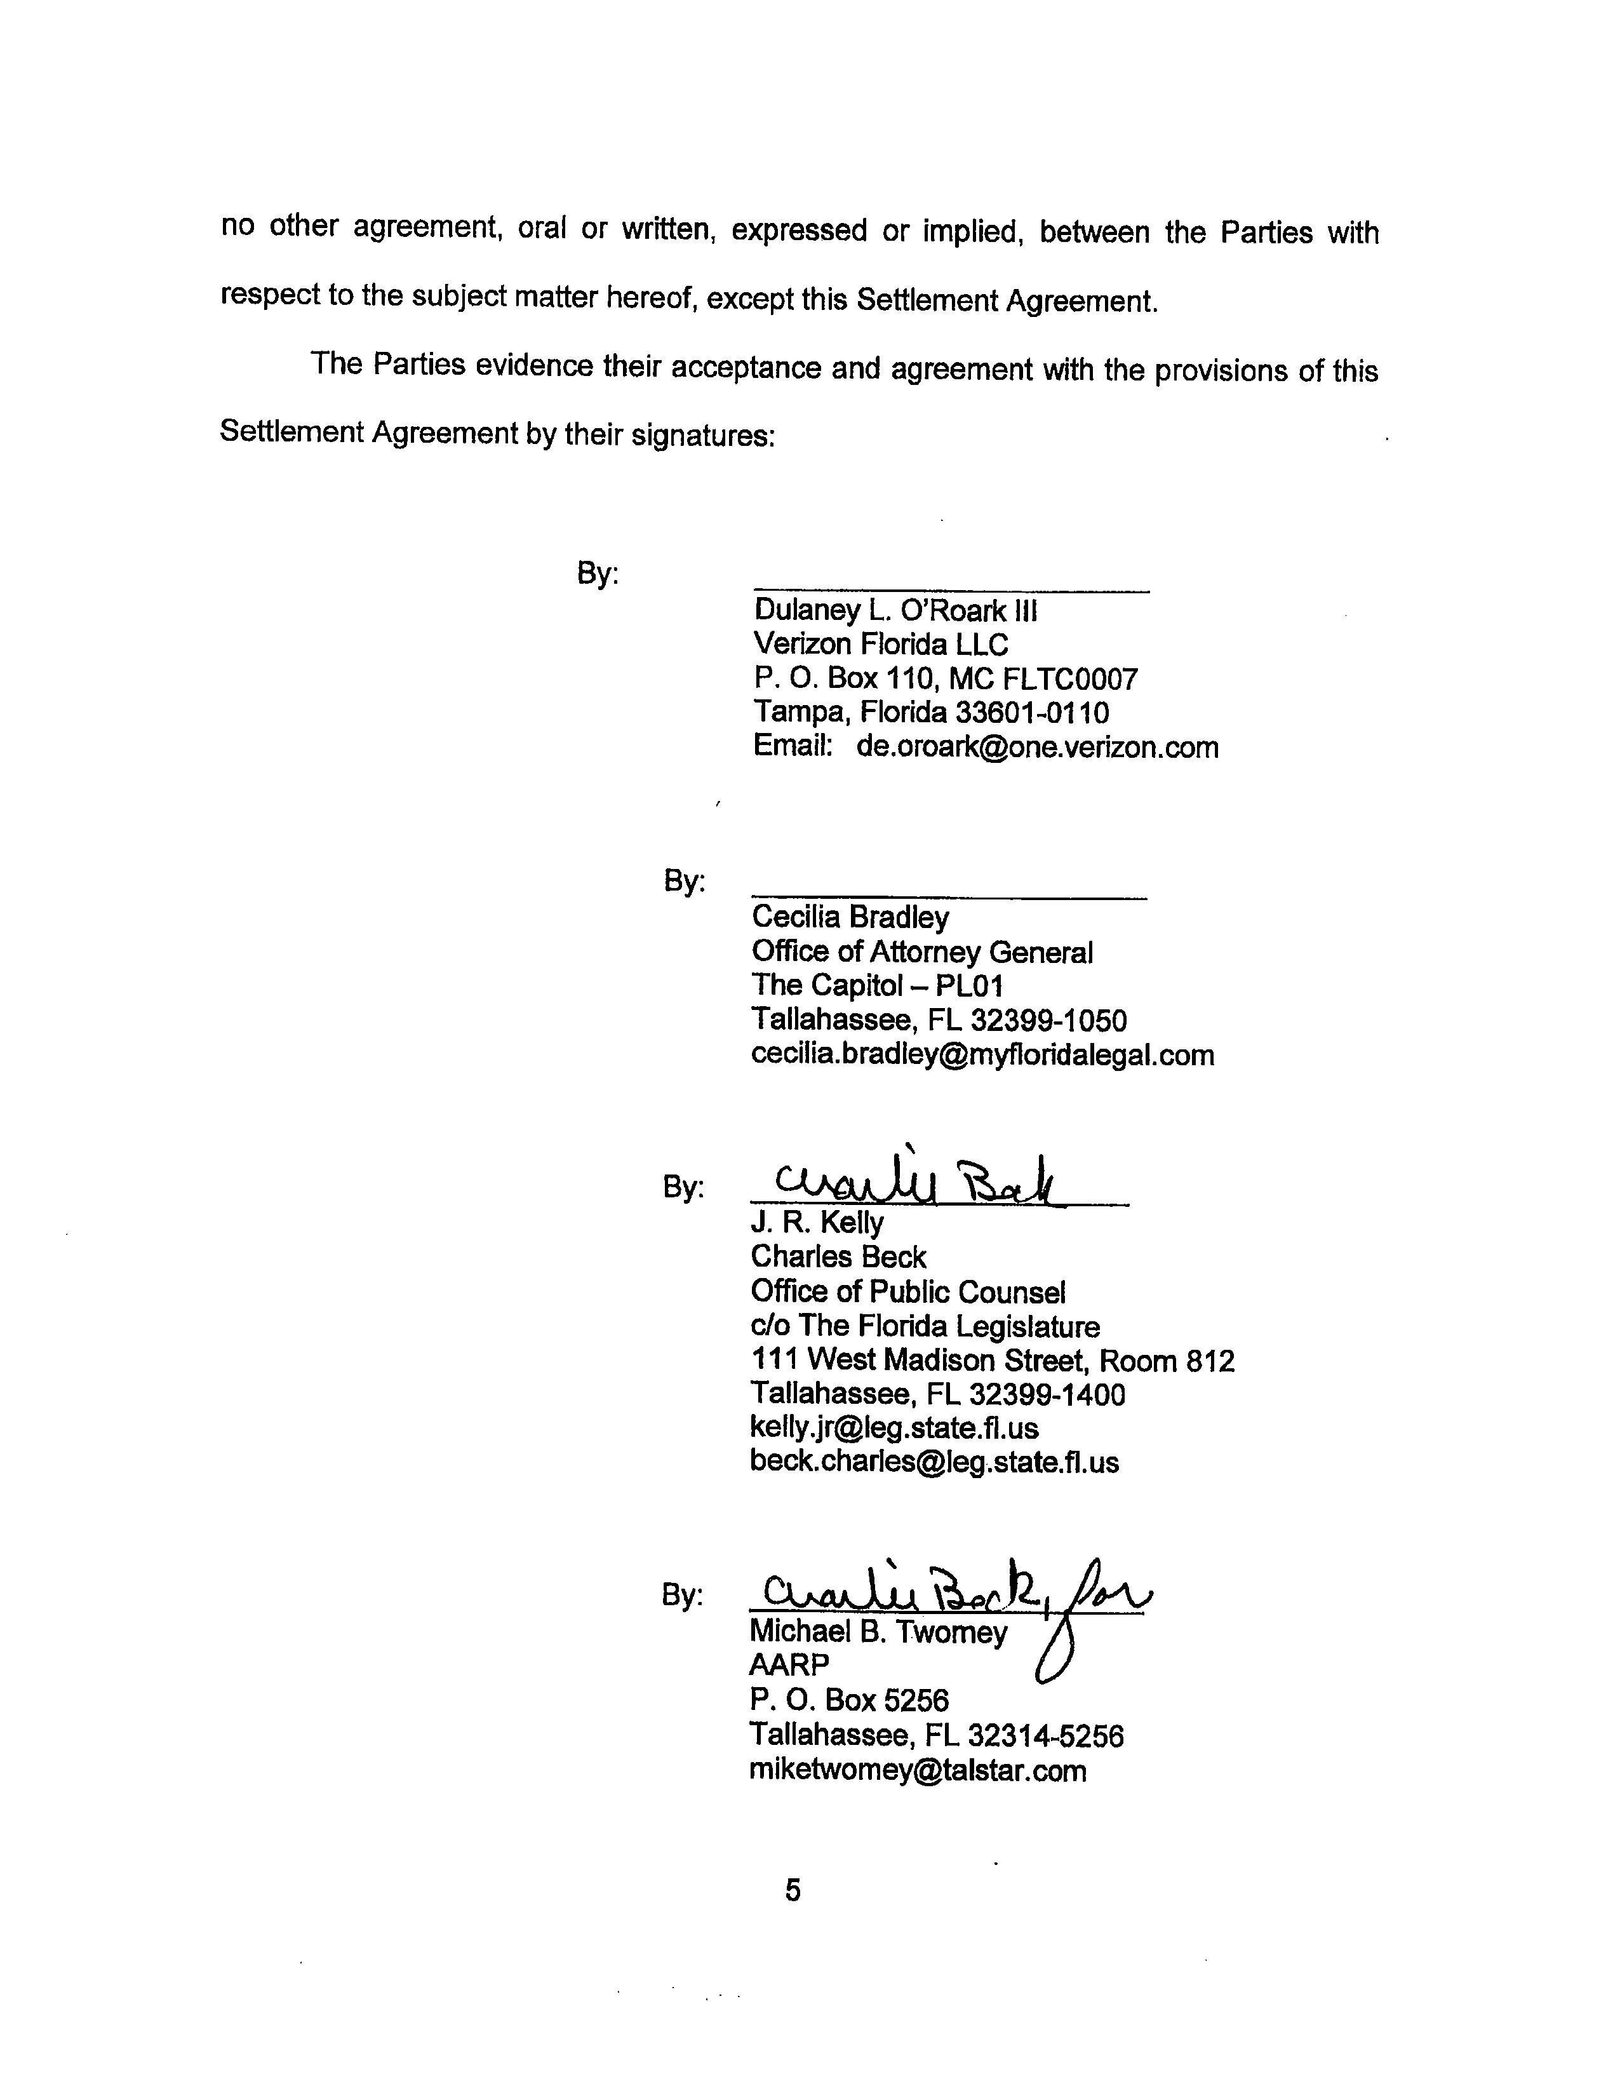
CERTIFICATE OF SERVICE

I HEREBY CERTIFY that copies of the foregoing were sent via electronic mail on
October 28, 2009 to:

Adam Teitzman, Staff Counsel
Florida Public Service Commission
2540 Shumard Oak Boulevard
Tallahassee, FL 32399-0850
ateitzma@psc.state.fl.us

Bill McCollum/Cecilia Bradley
Office of Attorney General
The Capitol – PL01
Tallahassee, FL 32399-1050
cecilia.bradley@myfloridalegal.com

J. R. Kelly
Patricia Christensen
Charles Beck
Office of Public Counsel
c/o The Florida Legislature
111 West Madison Street, Room 812
Tallahassee, FL 32399-1400
kelly.jr@leg.state.fl.us
beck.charles@leg.state.fl.us

Michael B. Twomey
AARP
P. O. Box 5256
Tallahassee, FL 32314-5256
miketwomey@talstar.com

s/ Dulaney L. O’Roark III

