State of Florida   |  | Public Service Commission  Capital Circle Office Center ● 2540 Shumard Oak Boulevard  Tallahassee, Florida 32399-0850  -M-E-M-O-R-A-N-D-U-M-
DATE: | December 3, 2009
TO: | Office of Commission Clerk (Cole)
FROM: | Division of Economic Regulation (Prestwood, Draper)  Office of General Counsel (Jaeger)
RE: | Docket No. 080366-GU – Petition for rate increase by Florida Public Utilities Company.
AGENDA: | 12/15/09 – Regular Agenda – Decision on Stipulation Prior to Hearing – Interested Persons May Participate
COMMISSIONERS ASSIGNED: |  |  | All Commissioners
PREHEARING OFFICER: |  |  | Skop
CRITICAL DATES: |  |  | None
SPECIAL INSTRUCTIONS: |  |  | None
FILE NAME AND LOCATION: |  |  | Draft FPUC Recommendation

Case Background
This proceeding commenced on December 17, 2008, with the filing of a petition for a permanent rate increase by Florida Public Utilities Company (FPUC or Company). FPUC serves gas customers through two divisions: the Central Florida Division consisting of portions of Seminole, Marion and Volusia Counties, and the South Florida Division consisting of portions of Palm Beach, Broward and Martin Counties. Together, FPUC provides service to over 51,000 residential and commercial customers.

FPUC requested an increase in its retail rates and charges to generate $9,917,690 in additional gross annual revenues. This increase would have allowed the Company to earn an overall rate of return of 8.74 percent with an 11.75 percent return on equity (range 10.75 percent to 12.75 percent). The Company based its request on a projected test year ending December 31, 2009, and requested that its petition for rate relief be processed under the Proposed Agency Action (PAA) procedure authorized by Section 366.06(4), Florida Statutes (F.S.)

FPUC also requested an interim rate increase in its retail rates and charges to generate $984,054 in additional gross annual revenues. Based on FPUC’s calculations, the increase would allow the Company to earn an overall rate of return of 7.66 percent, with a 10.25 percent return on equity, which was the minimum of what was then the authorized return on equity range of 10.25 percent to 12.25 percent. The Company based its interim request on a historical test year ended December 31, 2007. The Commission granted the interim rate increase in Order No. PSC-09-0123-PCO-GU, issued March 3, 2009. The interim rates became effective for all meter readings made on or after 30 days from the date of the vote approving the interim increase.

Using the PAA procedure, the Commission issued PAA Order No. PSC-09-0375-PAA-GU (PAA Order) on May 27, 2009, in which it proposed a revenue increase of $8,496,230, and an authorized return on equity of 10.85 percent, with a range of plus or minus 100 basis points. The PAA order did not require a refund of any revenues collected during the interim period. The PAA Order also approved new miscellaneous service charges.

However, before that PAA Order could become final, the Office of Public Counsel (OPC), who had intervened, filed its timely protest of that Order on June 17, 2009. In its protest, OPC listed 26 separate issues, but specifically noted that it was not protesting the test period, the quality of service, cost of capital, or cost of service and rate design sections. Also, FPUC timely filed its cross-petition on June 26, 2009, in which it raised two new issues, and further noted that rate case expense would have to be recalculated to reflect the cost of addressing OPC’s protest. Pursuant to the protests noted above, the petition of FPUC was set for formal hearings in accordance with Rule 25-22.029, Florida Administrative Code (F.A.C.)

Pursuant to Section 366.06(4), F.S., FPUC implemented, subject to refund with interest, the rates and charges approved by the PAA Order. Pursuant to Order No. PSC-09-0588-PCO-GU, issued August 31, 2009, the revenues subject to refund with interest for both the interim rates and the implemented PAA rates are protected by a corporate undertaking guaranteed by Florida Public Utilities Company, the consolidated entity, in the amount of $6,000,000.

On October 27, 2009, FPUC filed its Motion to Approve Stipulation and Settlement (Motion), in which FPUC requested that the Commission approve the Stipulation and Settlement which was attached and signed by both parties. The Motion, with the Stipulation and Settlement, is incorporated in this recommendation as Attachment A.
This recommendation addresses FPUC’s Motion and the parties’ Stipulation and Settlement agreement. The Commission has jurisdiction pursuant to Sections 366.06(2) and (4), and 366.07, F.S.

Discussion of Issues
Issue 1:1
Should the Commission approve the Stipulation and Settlement which was entered into between OPC and FPUC for the purpose of settling this Docket?

Recommendation:
Yes. Staff recommends that the Stipulation and Settlement (Settlement) entered into between OPC and FPUC be approved. (Prestwood)
Staff Analysis:
As noted earlier, the Commission issued PAA Order No. PSC-09-0375-PAA-GU on May 27, 2009, in which it proposed a revenue increase of $8,496,230, and an authorized return on equity of 10.85 percent, with a range of plus or minus 100 basis points. In its protest, OPC listed 26 separate issues, but specifically noted that it was not protesting the test period, the quality of service, cost of capital, or cost of service and rate design sections. FPUC’s cross-petition raised two new issues, and further noted that rate case expense would have to be recalculated to reflect the cost of addressing OPC’s protest.
The Settlement states that “OPC and FPUC agree that FPUC shall be entitled to increase its rates and charges so as to produce an additional $7,969,000 in annual revenues.” The Settlement would decrease the annual increase previously allowed by the PAA Order by $527,230 while resolving all issues raised by OPC and FPUC. Also, the parties agree in the settlement that any issues associated with the recently approved merger of Chesapeake Utilities and FPUC will be resolved in the pending Chesapeake rate case (Docket No. 090125-GU) and applied to this docket. The settlement appears to propose a reasonable resolution to the protested issues, and its approval would obviate the need for additional hearings while minimizing the time and expenses to all parties.

Staff therefore recommends that the Settlement entered into between OPC and FPUC be approved.
Issue 2: 2
Should FPUC be required to make a refund to its customers?

Recommendation:
Yes. Staff recommends that FPUC refund the difference between the rates approved by the PAA Order and the rates resulting from the Settlement, with interest, in the form of a one-time refund on customer bills. FPUC should also be required to file a report with the Division of Economic Regulation 10 business days prior to the refund being made showing the detailed calculations of the actual refund. Once staff verifies that the refund is complete, the $6,000,000 corporate undertaking guaranteed by Florida Public Utilities Company, the consolidated entity, may be released. No refund of any of the $984,054 interim rate increase is warranted. (Draper, Prestwood)

Staff Analysis:
The Settlement states that, “OPC and FPUC recognize that as a result of this Settlement, FPUC may be required to make a refund to customers. In the event the Commission requires a refund, OPC agrees that such refunds may be made over a period of time not to exceed six (6) months.”

FPUC implemented the rates and charges approved by the PAA Order on June 4, 2009. On an annual basis, the amount of revenues from the Settlement is $527,230 less than that of the PAA Order. FPUC should be required to refund the difference in the rates, plus interest, that have been collected since the PAA rates were implemented in June 2009 through the date the revised rates go into effect. The settlement would not require a refund of the interim rate relief that was granted before the PAA Order.

FPUC provided a calculation of the refund for the period June through November 2009. That refund amount is $212,605 including interest. The final refund amount will change based on the addition of December 2009 and January 2010 in the calculation.

Staff recommends that FPUC refund the difference between the rates approved by the PAA Order and the rates resulting from the Settlement, with interest, in the form of a one-time refund on customer bills. FPUC stated that it agrees with this approach and can issue the one-time refund as a credit on customer bills in February 2010. Staff also recommends that FPUC be required to file a report with the Division of Economic Regulation 10 business days prior to the refund being made showing the detailed calculations of the actual refund. Once staff verifies that the refund is complete, the $6,000,000 corporate undertaking guaranteed by Florida Public Utilities Company, the consolidated entity, should be released.

Issue 3:3
What are the appropriate rates that result from the Settlement?
Recommendation:
The appropriate rates are shown in Attachment B. FPUC should file tariffs reflecting the rates shown in Attachment B. The revised rates should go into effect 30 days after the Commission vote, which under the current schedule would mean for meters read on or after January 14, 2010. The Company should provide notice of the final approved rates as required by Rule 25-22.0406(8), F.A.C. A copy of the notice should be submitted to staff for approval prior to its use. (Draper)
Staff Analysis:
The proposed Settlement did not include revised rates. Staff requested that FPUC file revised rates and supporting documentation that implement the Settlement. FPUC provided, to OPC and staff, revised rates and supporting documentation on November 17, 2009. Staff reviewed the calculation and made a correction. FPUC agreed with staff’s correction.
OPC’s protest did not address the cost of service, rate design, or miscellaneous service charges (initial connect, disconnect, etc). Therefore, FPUC allocated the decrease in annual revenues that results from the stipulation ($527,230) to the rate classes as a percentage of total revenues from sales achieved by each rate class. The resulting rates are shown in Attachment B. The miscellaneous service charges approved in Order No. PSC-09-0375-PAA-GU shall remain unchanged.
The revised rates should go into effect 30 days after the Commission vote, which under the current schedule would mean for meters read on or after January 14, 2010. FPUC should file tariffs reflecting the rates shown in Attachment B. The Company should provide notice of the final approved rates as required by Rule 25-22.0406(8), F.A.C. A copy of the notice should be submitted to staff for approval prior to its use.
As a result of the Settlement, a residential customer using 20 therms will see a $0.39 reduction in the monthly bill when compared to a bill under the PAA rates.
Issue 4:4
Should this docket be closed?
Recommendation:
No. The docket should remain open until staff has approved the revised tariffs sheets and customer notices, and FPUC has provided staff with proof that it has made the appropriate refunds with interest. Once staff has verified all of the above actions are complete, this docket should be closed administratively. (Jaeger)
Staff Analysis:
The docket should remain open until staff has approved the revised tariffs sheets and customer notices, and FPUC has provided staff with proof that it has made the appropriate refunds with interest. Once staff has verified all of the above actions are complete, this docket should be closed administratively.
Attachment A
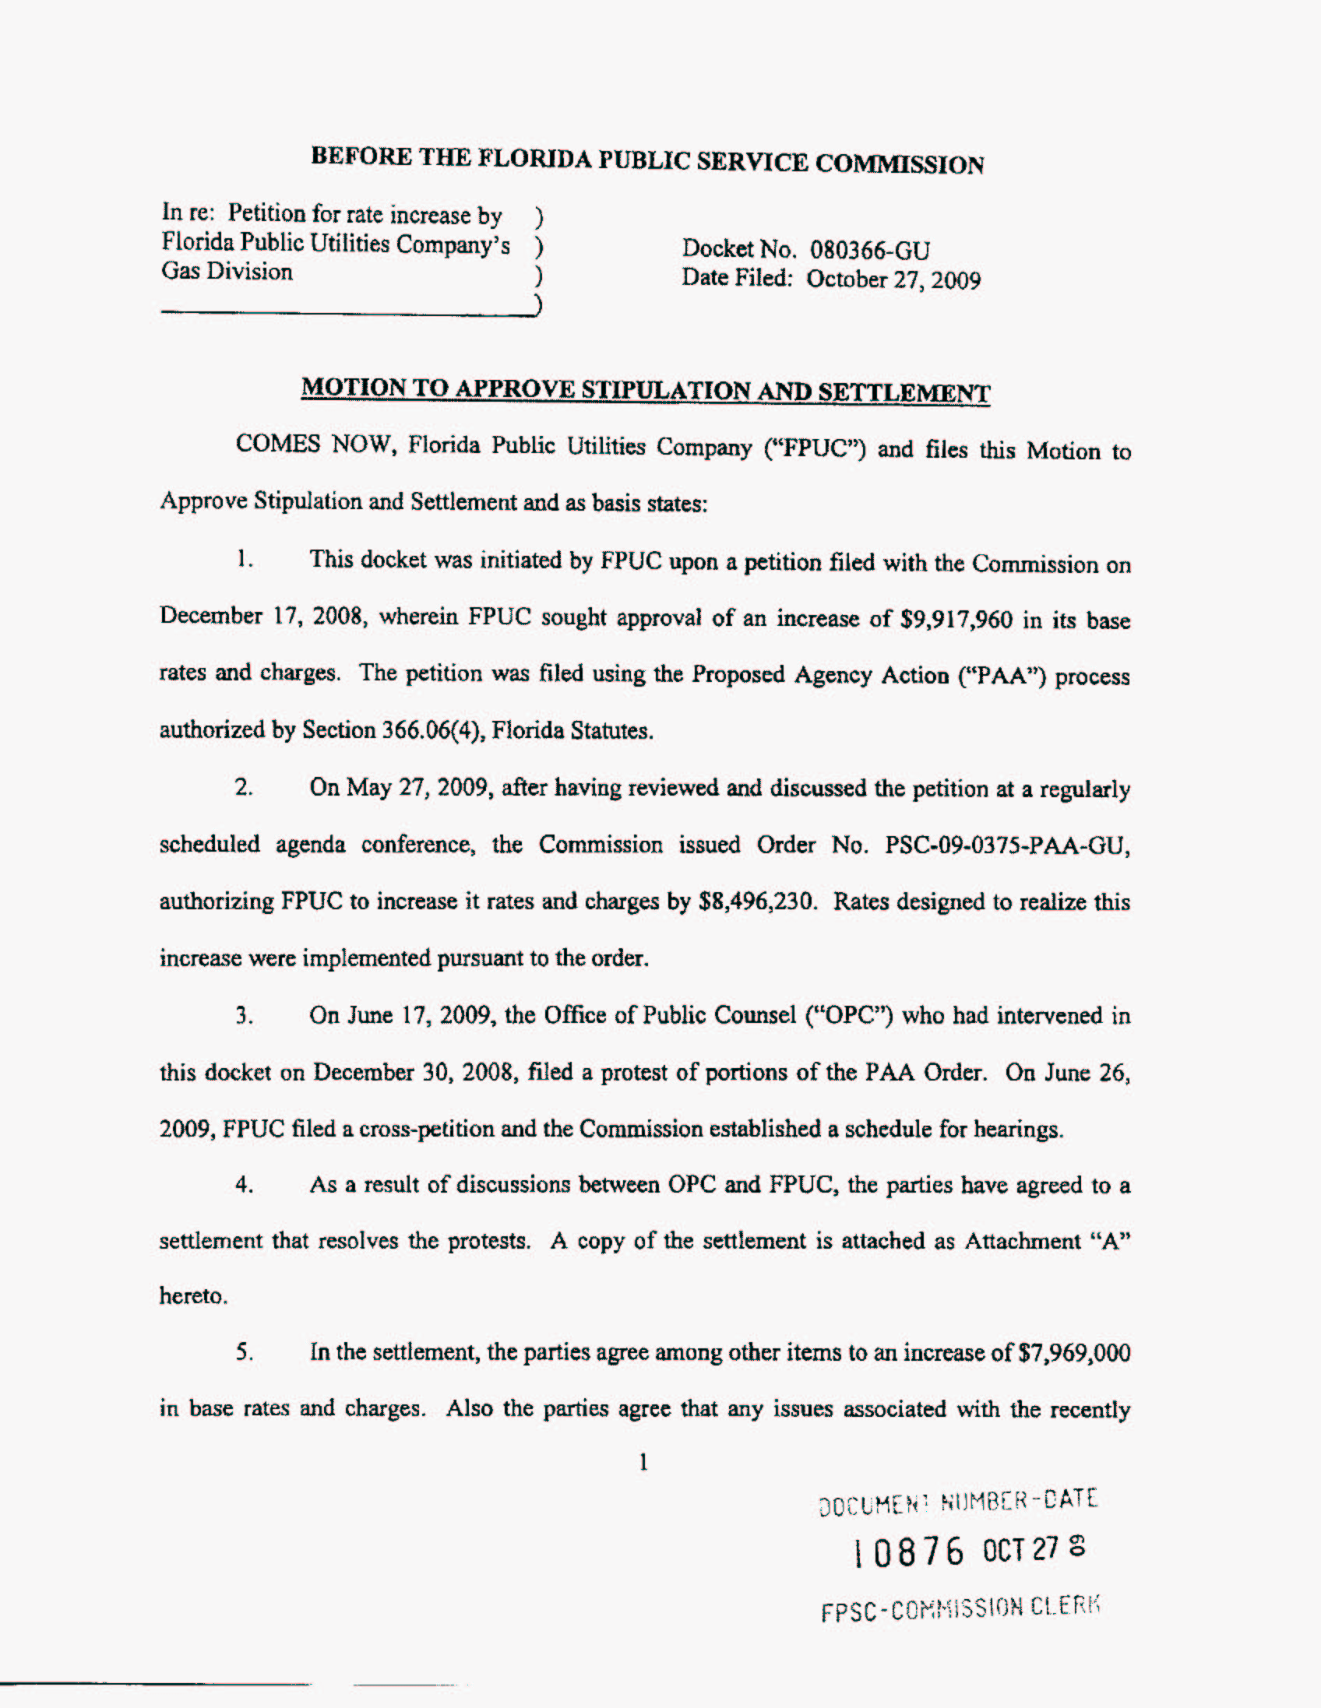
Attachment A
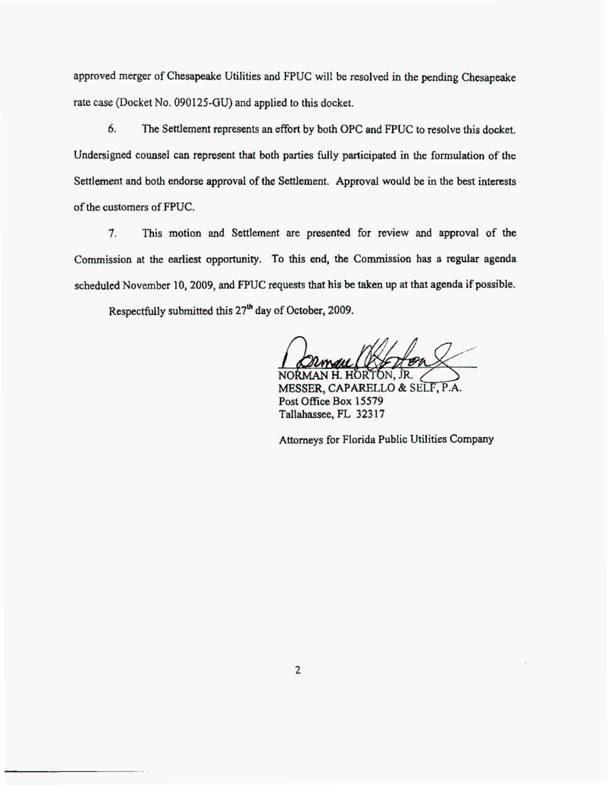
Attachment A
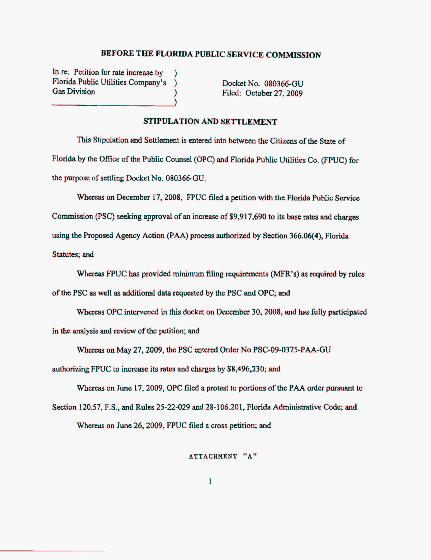
Attachment A
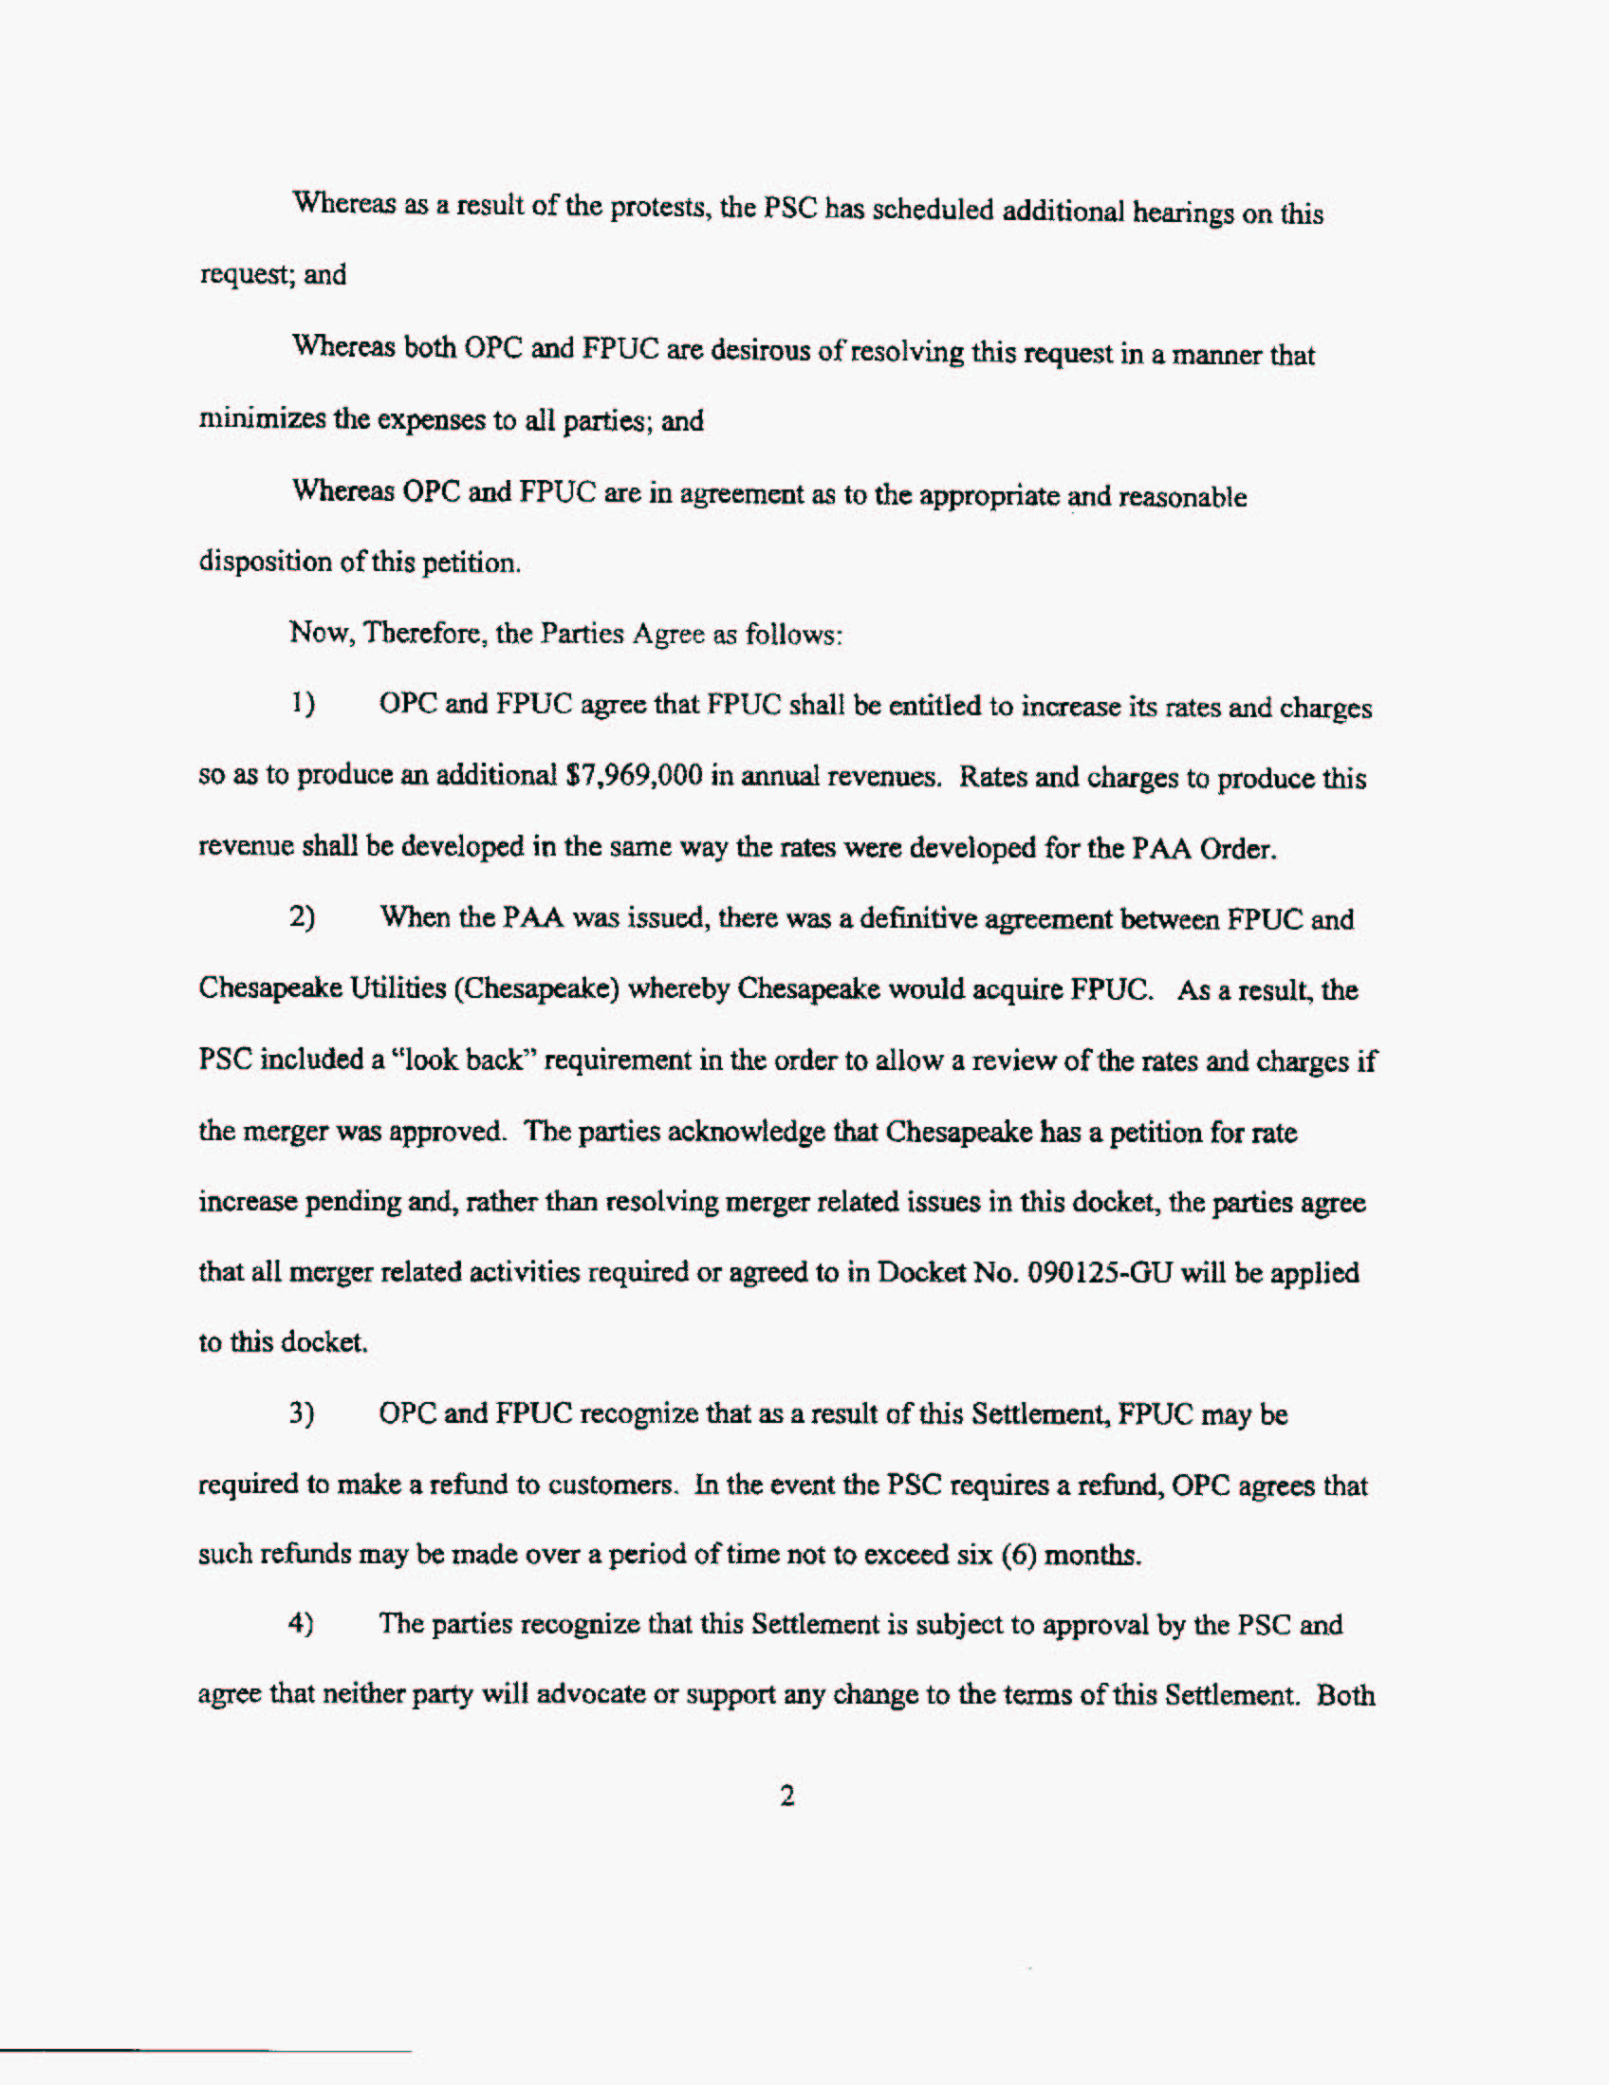
Attachment A
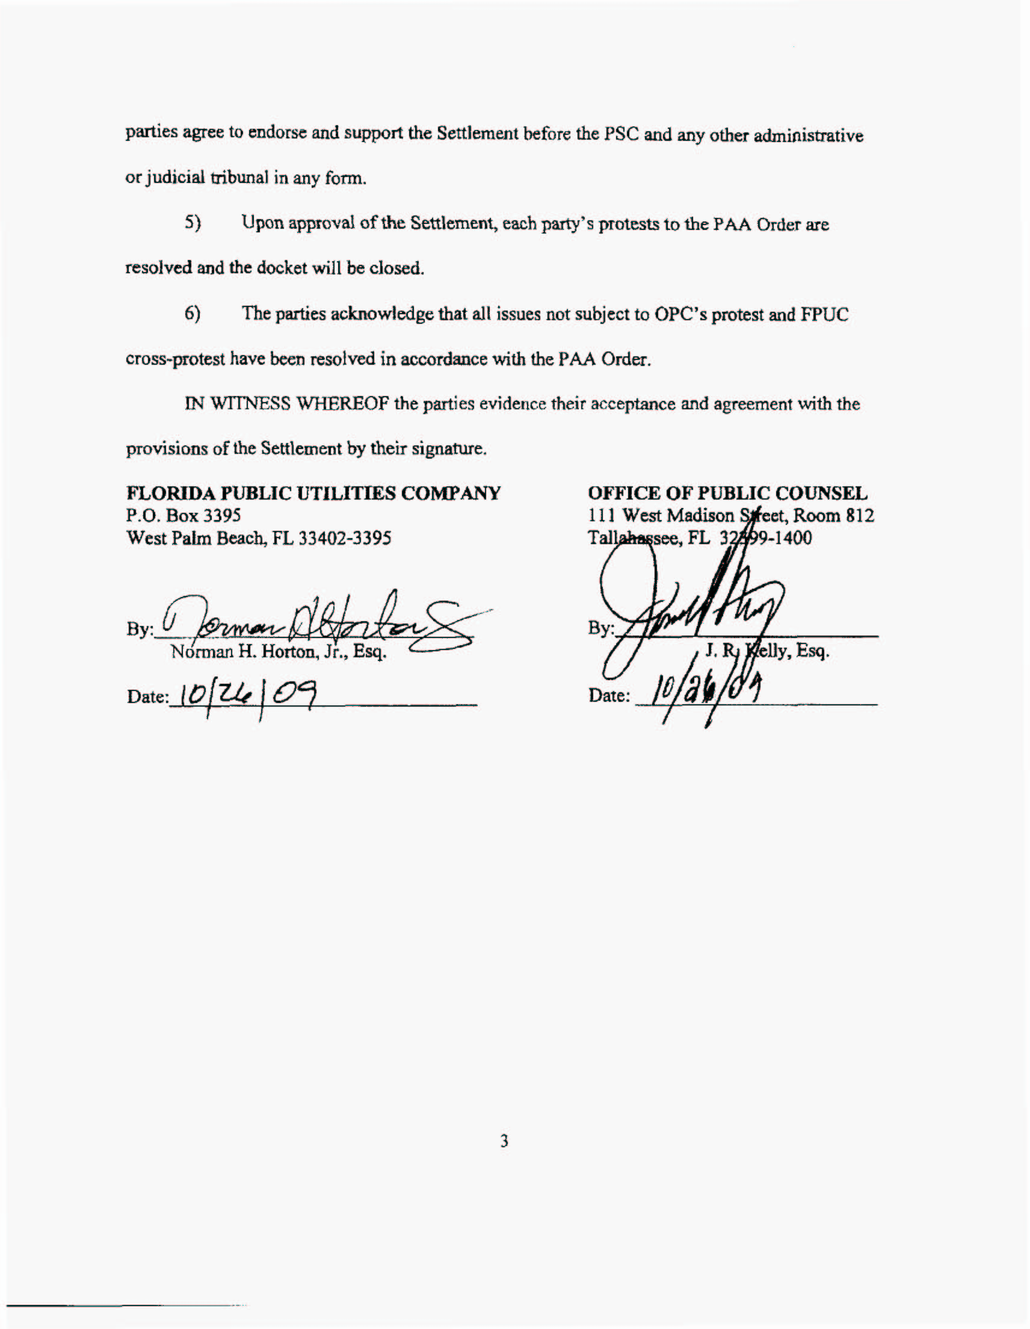
Attachment A
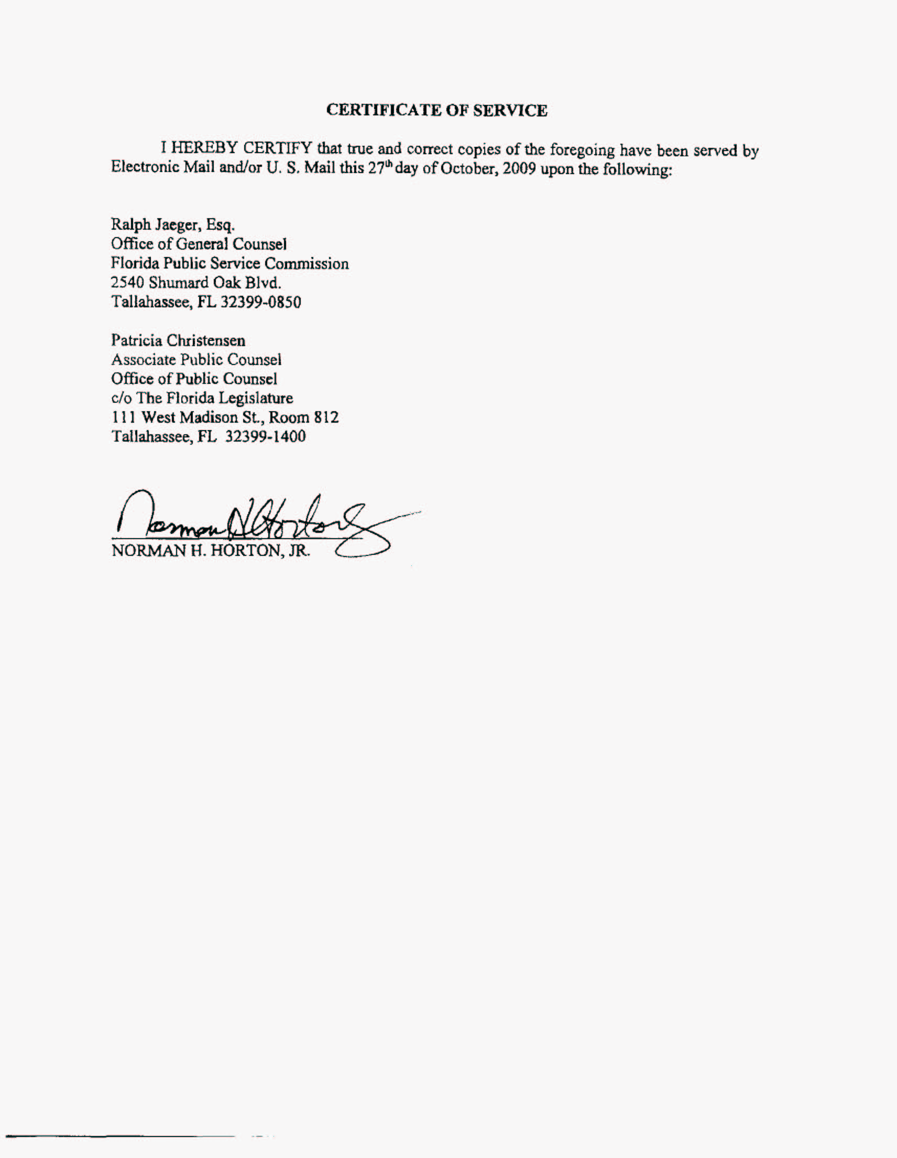

See Order No. PSC-04-1110-PAA-GU, issued November 8, 2004, in Docket No. 040216-GU, In re: Application for rate increase by Florida Public Utilities Company.
As stated earlier, these rates were implemented subject to refund with interest pursuant to Section 366.06(4), F.S.

