BEFORE THE FLORIDA PUBLIC SERVICE COMMISSION

In re: Petition for modification of Service Guarantee Program by BellSouth Telecommunications, Inc. d/b/a AT&T Florida. | DOCKET NO. 090461-TL  ORDER NO. PSC-10-0077-PAA-TL  ISSUED: February 10, 2010

The following Commissioners participated in the disposition of this matter:

NANCY ARGENZIANO, Chairman
LISA POLAK EDGAR
NATHAN A. SKOP
DAVID E. KLEMENT
BEN A. "STEVE" STEVENS III

NOTICE OF PROPOSED AGENCY ACTION
ORDER APPROVING MODIFICATION OF EXISTING SERVICE GUARANTEE PROGRAM

BY THE COMMISSION:

NOTICE is hereby given by the Florida Public Service Commission that the action discussed herein is preliminary in nature and will become final unless a person whose interests are substantially affected files a petition for a formal proceeding, pursuant to Rule 25-22.029, Florida Administrative Code.

- Case Background

On August 13, 2001, and February 13, 2002, we issued Order Nos. PSC-01-1643-AS-TL (Docket No. 991378-TL) and PSC-02-0197-PAA-TL (Docket No. 010097-TL), respectively, approving the Settlement Agreement between the Office of Public Counsel and BellSouth Telecommunications, Inc. (n/k/a BellSouth Telecommunications, Inc. d/b/a AT&T Florida d/b/a AT&T Southeast and hereinafter referred to as AT&T Florida), addressing AT&T Florida’s quality of service and granting a limited waiver of certain service quality rules. This resulted in AT&T Florida’s first Service Guarantee Program, which operated as an exemption from those quality of service rules.

On April 25, 2005, and May 20, 2005, we issued Order Nos. PSC-05-0440-PAA-TL and PSC-05-0550-CO-TL, respectively, modifying the first Service Guarantee Program and extending the rule waivers until Rule 25-4.085, Florida Administrative Code (F.A.C.), became effective on June 14, 2005. Rule 25-4.085, F.A.C., provides that a party is relieved from a set of service standard rules that is addressed in a Service Guarantee Program. The Service Guarantee Program as modified by our 2005 Orders is currently in effect. The current Service Guarantee Program may be terminated by either this Commission or the company at any time. The service quality rule waivers the company initially sought in 2001 became moot when Rule 25-4.085, F.A.C., became effective.

On September 29, 2009, AT&T Florida filed a petition for modification of its current Service Guarantee Program. In addition to other changes, AT&T Florida’s proposed Service Guarantee Program removes certain services it deems nonbasic from the protection of the existing AT&T Florida Service Guarantee Program. Removal of these services is based on the Legislature’s recently revised definitions of basic and nonbasic service in Chapter 364, Florida Statutes (F.S.). Attachment A is a list of those services that do or do not qualify for the Service Guarantee Program.

We are vested with jurisdiction over this matter pursuant to Sections 120.569, 364.01, 364.03, 364.035, 364.15, 364.17, and 364.183, F.S.

- Analysis
AT&T Florida seeks to modify its current Service Guarantee Program. Rule 25-4.085, F.A.C., states:

A company may petition the Commission for approval of a Service Guarantee Program, which would relieve the company from the rule requirement of each service standard addressed in the approved Service Guarantee Program. When evaluating a Service Guarantee Program for approval, the Commission will consider the Program’s benefits to the customers and whether the Program is in the public interest. The Commission shall have the right to enforce the provisions of the Service Guarantee Plan.

AT&T Florida’s current approved Service Guarantee Program relieves it from the requirements of Rules 25-4.066(2), 25-4.070(1)(b), 25-4.070(3)(a), and 25-4.073(1)(a)-(c), F.A.C. These rules pertain to the establishment of primary service and repair of interrupted service within specific time frames, and the measurement of answer time for subscribers who call in to the residential business or repair office.

Rule 25-4.066(2), F.A.C., provides:

Where central office and outside plant facilities are readily available, at least 90 percent of all requests for primary service in any calendar month shall normally be satisfied in each exchange or service center within an interval of three working days after receipt of application when all tariff requirements relating thereto have been complied with, except those instances where a later installation date is requested by the applicant or where special equipment or services are involved.

Rule 25-4.070(3)(a), F.A.C., provides:

Restoration of interrupted service shall be scheduled to ensure at least 90 percent shall be cleared within 24 hours of the report.

Rule 25-4.070(1)(b), F.A.C., provides:

In the event a subscriber’s service is interrupted other than by a negligent or willful act of the subscriber and it remains out of service in excess of 24 hours after being reported to the company, an appropriate adjustment or refund shall be made to the subscriber automatically, pursuant to Rule 25-4.110, F.A.C. (Customer Billing). Service interruption time will be computed on a continuous basis, Sundays and holidays included. Also, if the company finds that it is the customer’s responsibility to correct the trouble, it must notify or attempt to notify the customer within 24 hours after the trouble was reported.

Rule 25-4.073(1)(a)-(c), F.A.C., provides:

(a) At least 90 percent of all calls directed to business and repair offices for basic local telecommunications service shall be answered within 90 seconds after the last digit is dialed when no menu driven system is utilized.
(b) When a company utilizes a menu driven, automated, interactive answering system (referred to as the system or as an Integrated Voice Response Unit (IVRU)), at least 95 percent of the calls offered shall be answered within 30 seconds after the last digit is dialed. The initial recorded message presented by the system to the customer shall include the option of transferring to a live attendant within the first 60 seconds of the message.
(c) For subscribers who select the option of transferring to a live assistant, the call shall be transferred by the system to a live attendant. At least 90 percent of the calls shall be answered by the live attendant prepared to give immediate assistance within 90 seconds of being transferred to the attendant.

AT&T Florida’s current Service Guarantee Program has been in effect since May 20, 2005, and meets the quality of service provisions of Chapter 364, F.S., by giving immediate and direct compensation to customers if certain quality standards are not met. Additionally, the Service Guarantee Program imposes similarly swift penalties on AT&T Florida for not meeting objectives that are consistent with the Commission’s service rules. The rules and a Service Guarantee Program are not applied simultaneously, because doing so would constitute unfairness and an economic hardship by imposing duplicate penalties.

AT&T Florida’s proposed modified Service Guarantee Program is similar to its existing Service Guarantee Program, except for the changes summarized in Table 2-1.

Table 2-1. Comparison of AT&T Florida’s current vs. proposed Service Guarantee Program (SGP)

Repair – Out-of-Service (Restoration of Interrupted Service)
Existing SGP | Proposed Modified SGP
Where AT&T Florida fails to complete a repair within 24 hours from the time an order is received;  The customer will receive an automatic credit on the bill in the amount of $4.00, plus 3 times the daily local service charge, up to $40.00 and no less than $11.00.  Saturdays and Sundays are included in calculating service credits.  The SGP only applies to residential customers. | Identical except that the SGP applies only to residential basic local service (single line flat rate service).

Primary Service Installation
Existing SGP | Proposed Modified SGP
Where AT&T Florida fails to install a customer’s primary or additional local service on the date which the customer and AT&T Florida agree, AT&T Florida will give the customer an automatic credit of $25.00. Where AT&T Florida is offering a commitment date greater than 3 days and the customer requests an earlier date, the commitment credit will be based on the customer requested date, or on 3 days, whichever is greater. | Identical except that the SGP applies only to residential basic local service (single line flat rate service).

Term
Existing SGP | Proposed Modified SGP
No expiration date. The SGP may be terminated by either the Commission or the company at any time. The current SGP will remain in effect until Rule 25-4.085, F.A.C., becomes effective. At that time, the SGP will operate until that rule and the waivers become moot with no further Commission action. | The SGP will become effective on the day following the Commission’s vote approving the program. AT&T Florida may petition the Commission to revert back to the existing Commission rules at any time.

Force Majeure
Existing SGP | Proposed Modified SGP
In the event of an emergency, AT&T Florida will operate under Force Majeure and when it is reasonable to expect that the company will be unable to meet its installation and repair commitments, it shall be relieved of its obligations to provide credits for failure to meet the objectives for installation and repair within the affected areas. AT&T Florida will also suspend payments into the Lifeline Community Service Fund for missed answer time measurements within the affected areas. | Identical except that the SGP applies only to residential basic local service (single line flat rate service).

Answer Time
Existing SGP | Proposed Modified SGP
An answer time measurement applies to customers who call the residential business and repair offices and who do not interact with the automated answer system.  Where AT&T Florida fails to meet the answer time measurement, it will credit the Lifeline Community Service Fund.  The measurement will require at least 90% of the calls to the Business office and repair office to be answered by the live attendant prepared to give immediate assistance within 55 seconds of being transferred to the attendant. AT&T Florida will maintain 100% accessibility.  The amount of the payment of credits shall be calculated separately for the business and repair offices and shall be applied based on AT&T Florida’s performance in accordance with the following parameters:  Less than 90%, but greater or equal to 80% - $2,000  Less than 80%, but greater or equal to 70% - $5,000  Less than 70% - $7,000 | Identical for customers who do not interact with the system, except that when customers are transferred to a live attendant, the attendant must be prepared to give immediate assistance within 90 seconds of being transferred to the attendant.  Greater than 90% within 90 seconds - $0  Less than 90%, but greater or equal to 80% - $2,000  Less than 80%, but greater or equal to 70% - $5,000  Less than 70% - $7,000  The proposed SGP also provides alternatives to being placed in a queue, i.e. an interactive voice response system that will allow customers to report trouble, get a trouble ticket number and make repair appointments without ever talking to a live attendant. Additionally, the company offers an automated Right Touch System, use of its web page, and a Customer Call Back System to complete other transactions without having to talk to a live attendant.  If the customer interacts with the system in any way, answer time measurement no longer applies to the call.

AT&T Florida states that it will continue to make payments to basic residential customers based on the standards of the current Service Guarantee Program, pending completion of changes to internal operations systems to implement the proposed Service Guarantee Program changes. When the system changes are complete, AT&T Florida will notify this Commission and subsequent Service Guarantee Program payments will be made in accordance with the changes approved in this proceeding.

- Decision

Accordingly, we find it appropriate to approve AT&T Florida’s Petition for Modification of Service Guarantee Program, pursuant to the changes to the service quality rules necessitated by Chapter 2009-226, Laws of Florida.
Based on the foregoing, it is

ORDERED by the Florida Public Service Commission that AT&T Florida’s Petition for Modification of Service Guarantee Program is hereby granted as set forth in the body of this Order. It is further

ORDERED that the provisions of this Order, issued as proposed agency action, shall become final and effective upon the issuance of a Consummating Order unless an appropriate petition, in the form provided by Rule 28-106.201, Florida Administrative Code, is received by the Office of Commission Clerk, 2540 Shumard Oak Boulevard, Tallahassee, Florida 32399-0850, by the close of business on the date set forth in the “Notice of Further Proceedings” attached hereto. It is further

ORDERED that in the event this Order becomes final, this docket shall be closed.

By ORDER of the Florida Public Service Commission this 10th day of February, 2010.

/s/ Ann Cole
ANN COLE
Commission Clerk

This is an electronic transmission. A copy of the original signature is available from the Commission's website, www.floridapsc.com, or by faxing a request to the Office of Commission Clerk at 1-850-413-7118.

( S E A L )

TLT

NOTICE OF FURTHER PROCEEDINGS OR JUDICIAL REVIEW

The Florida Public Service Commission is required by Section 120.569(1), Florida Statutes, to notify parties of any administrative hearing that is available under Section 120.57, Florida Statutes, as well as the procedures and time limits that apply. This notice should not be construed to mean all requests for an administrative hearing will be granted or result in the relief sought.

Mediation may be available on a case-by-case basis. If mediation is conducted, it does not affect a substantially interested person's right to a hearing.

The action proposed herein is preliminary in nature. Any person whose substantial interests are affected by the action proposed by this order may file a petition for a formal proceeding, in the form provided by Rule 28-106.201, Florida Administrative Code. This petition must be received by the Office of Commission Clerk, 2540 Shumard Oak Boulevard, Tallahassee, Florida 32399-0850, by the close of business on March 3, 2010.

In the absence of such a petition, this order shall become final and effective upon the issuance of a Consummating Order.

Any objection or protest filed in this/these docket(s) before the issuance date of this order is considered abandoned unless it satisfies the foregoing conditions and is renewed within the specified protest period.

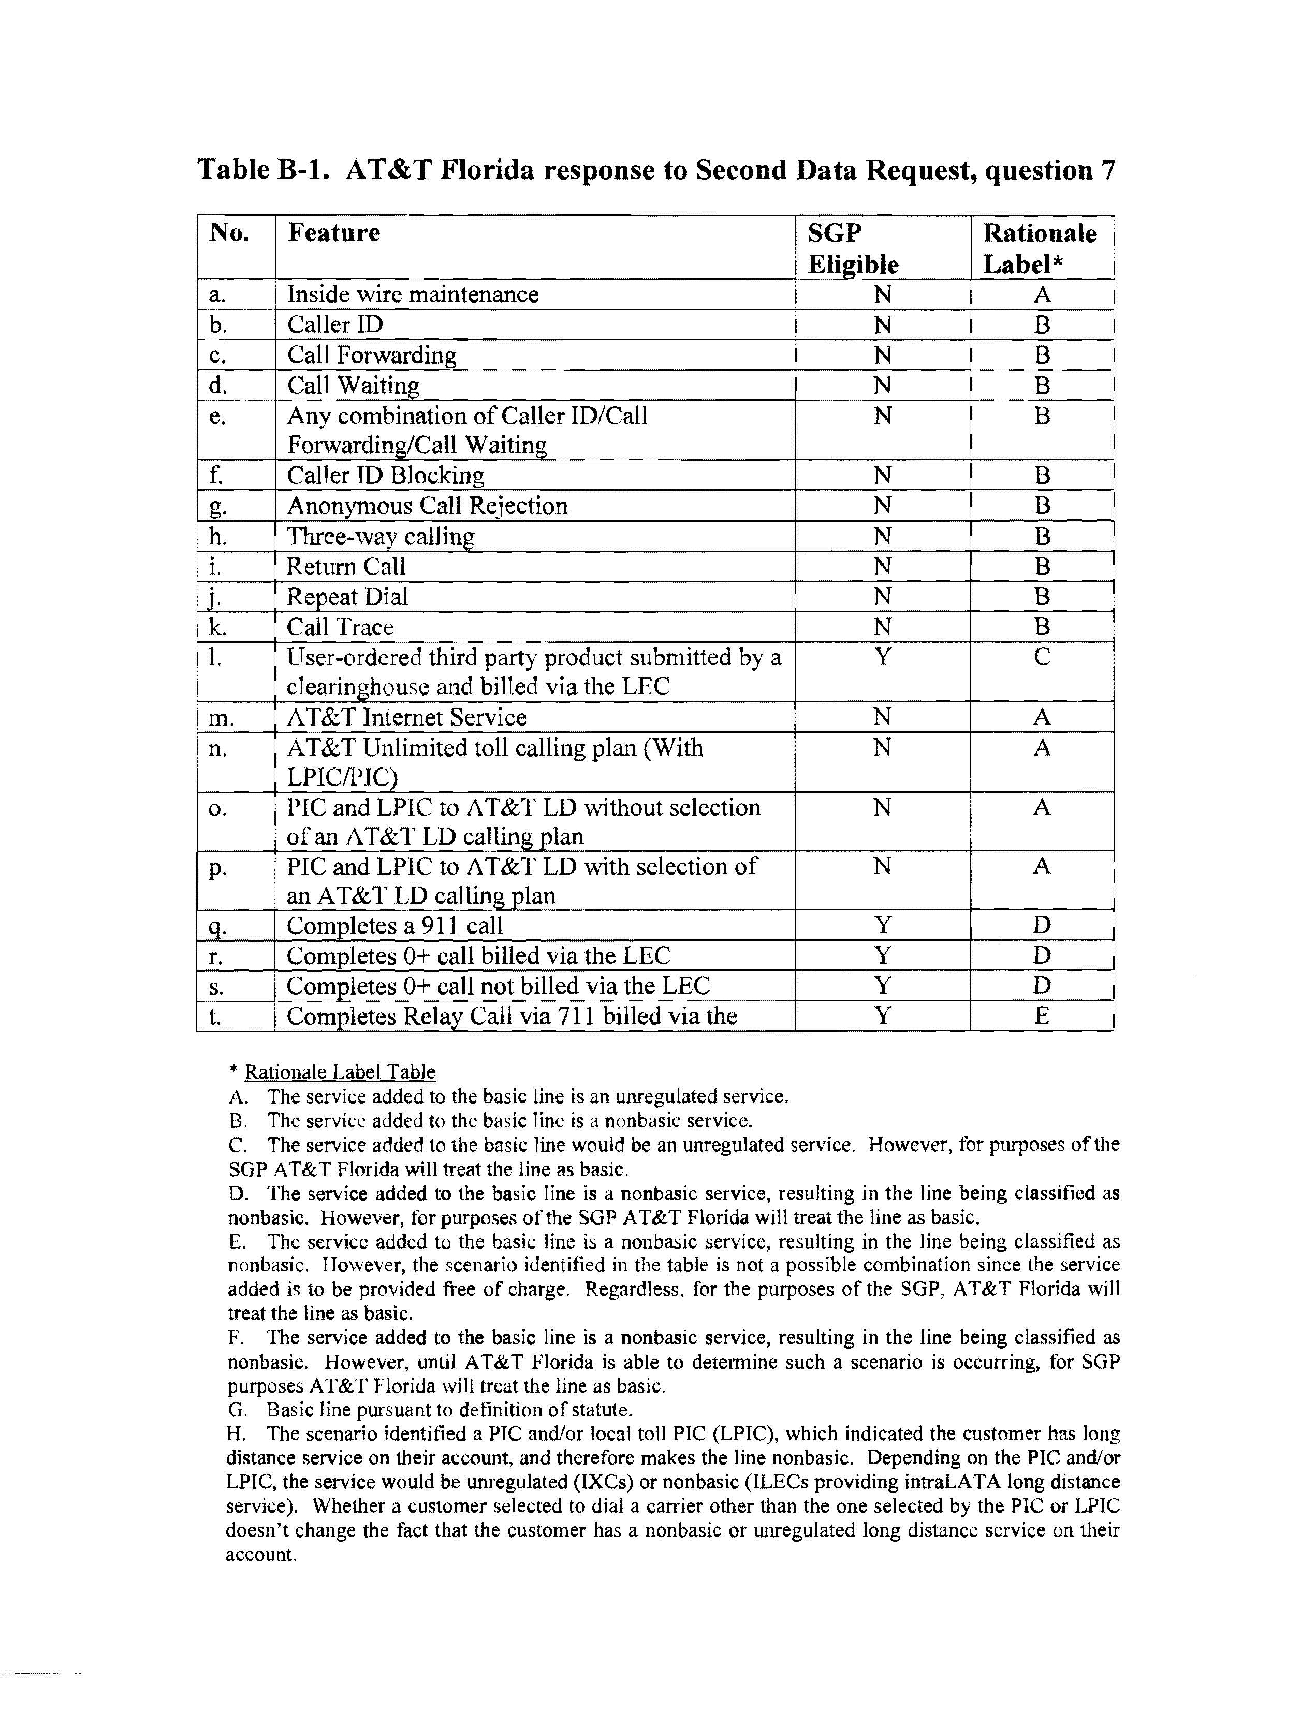

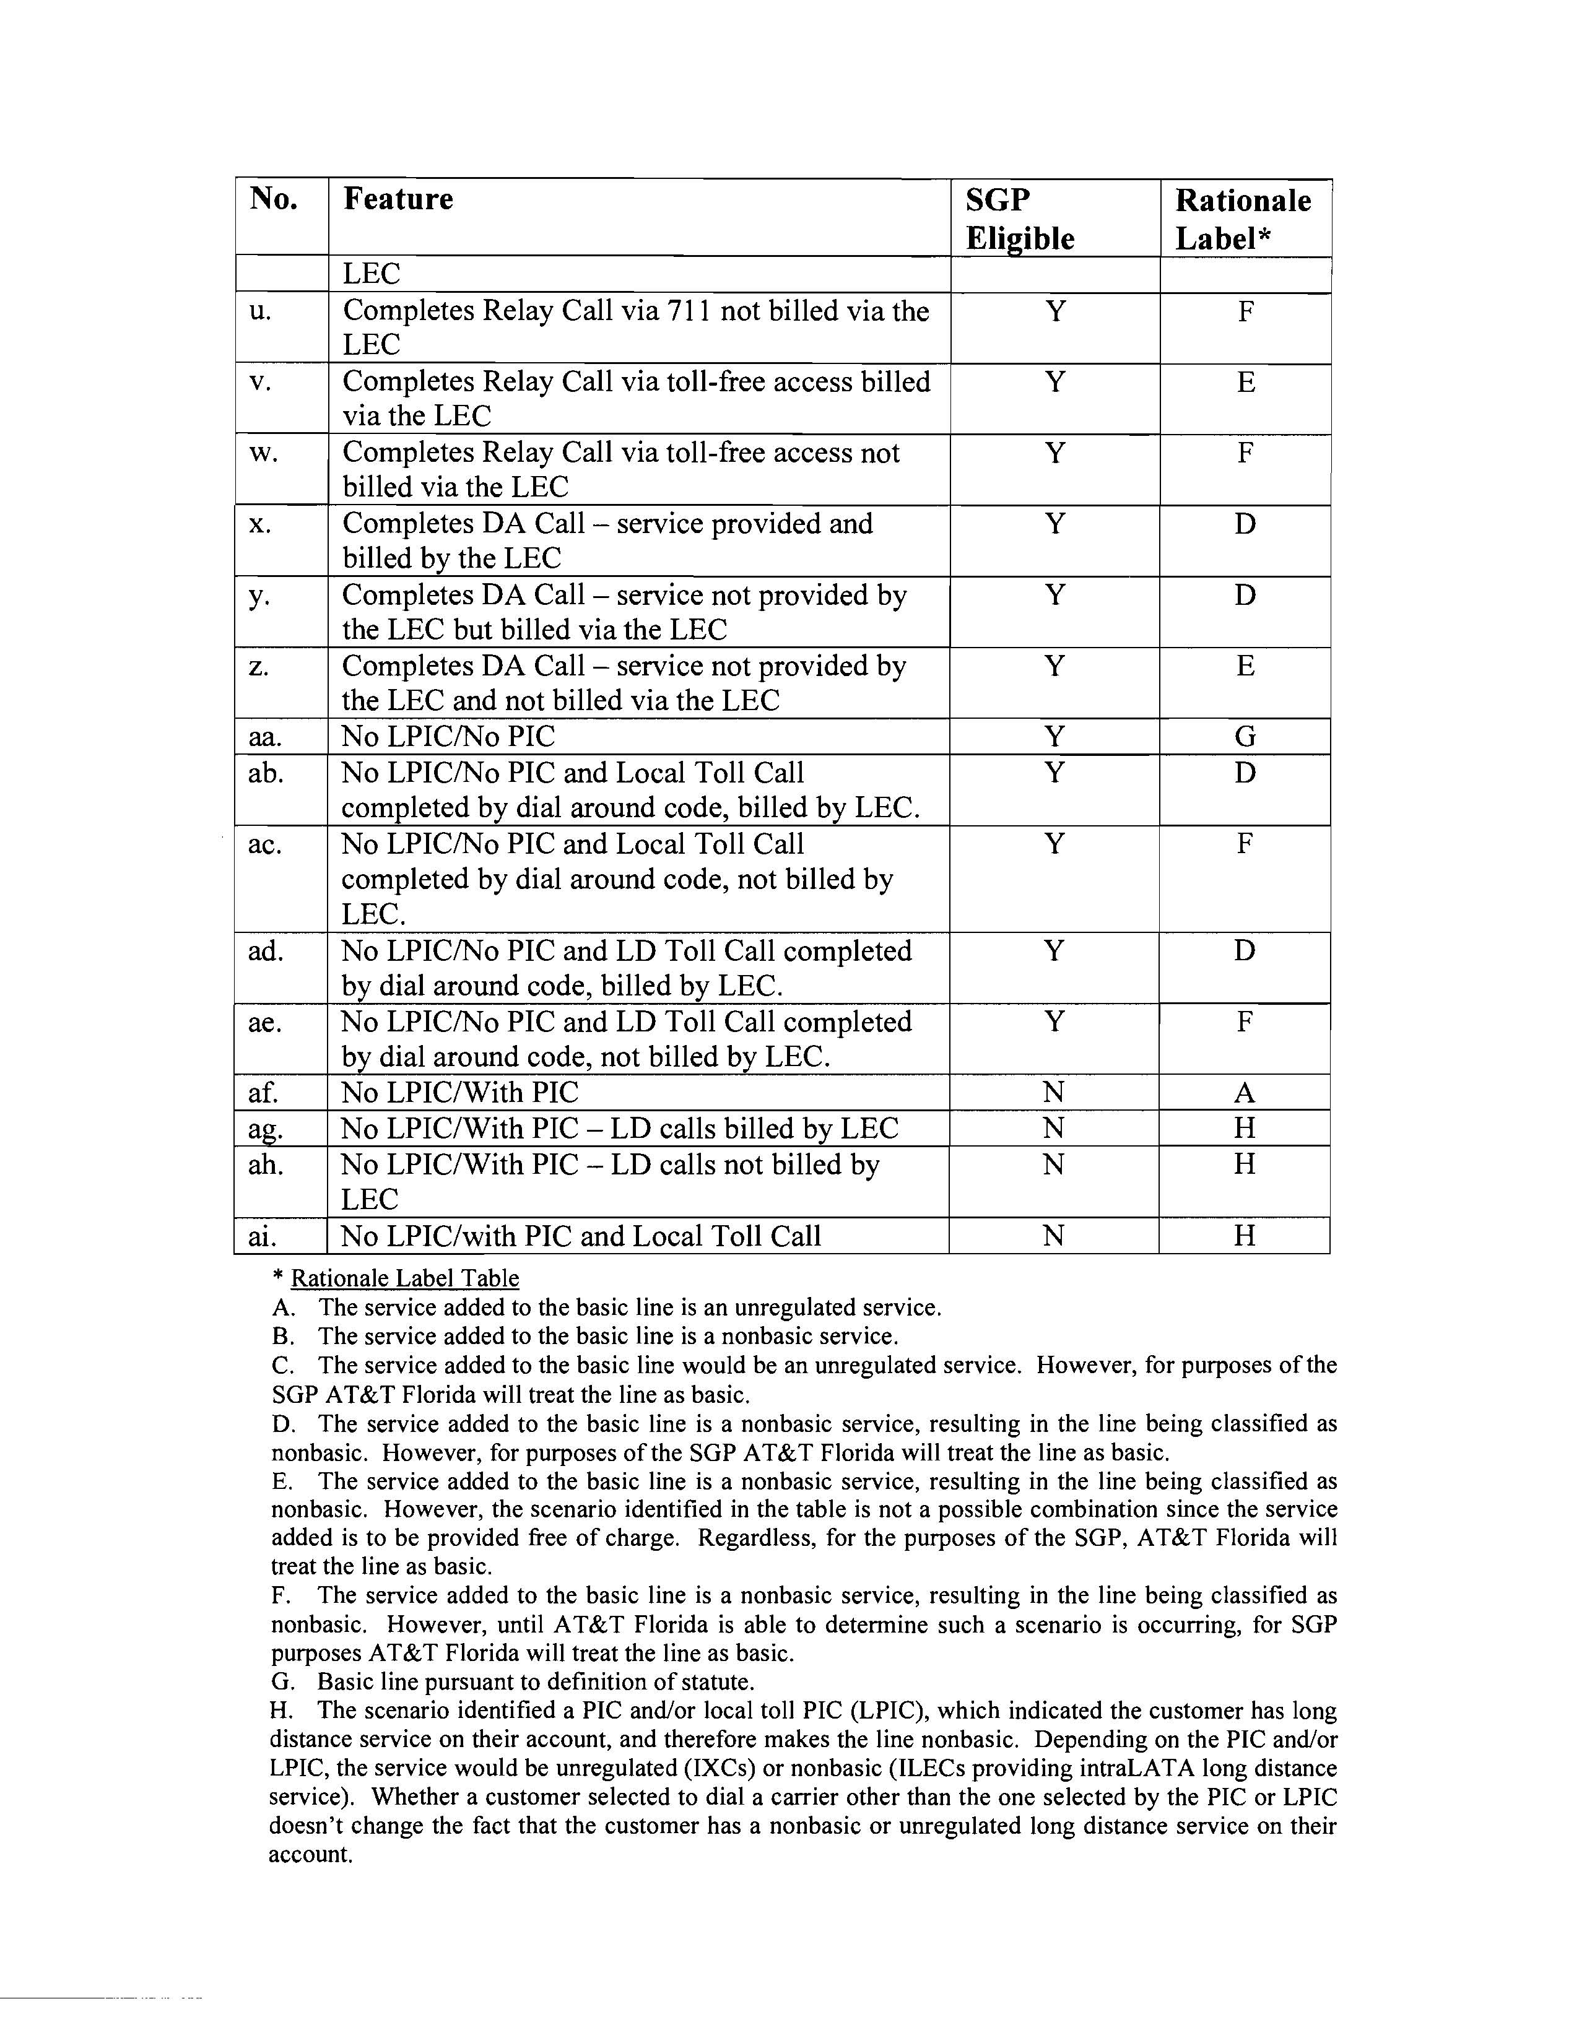

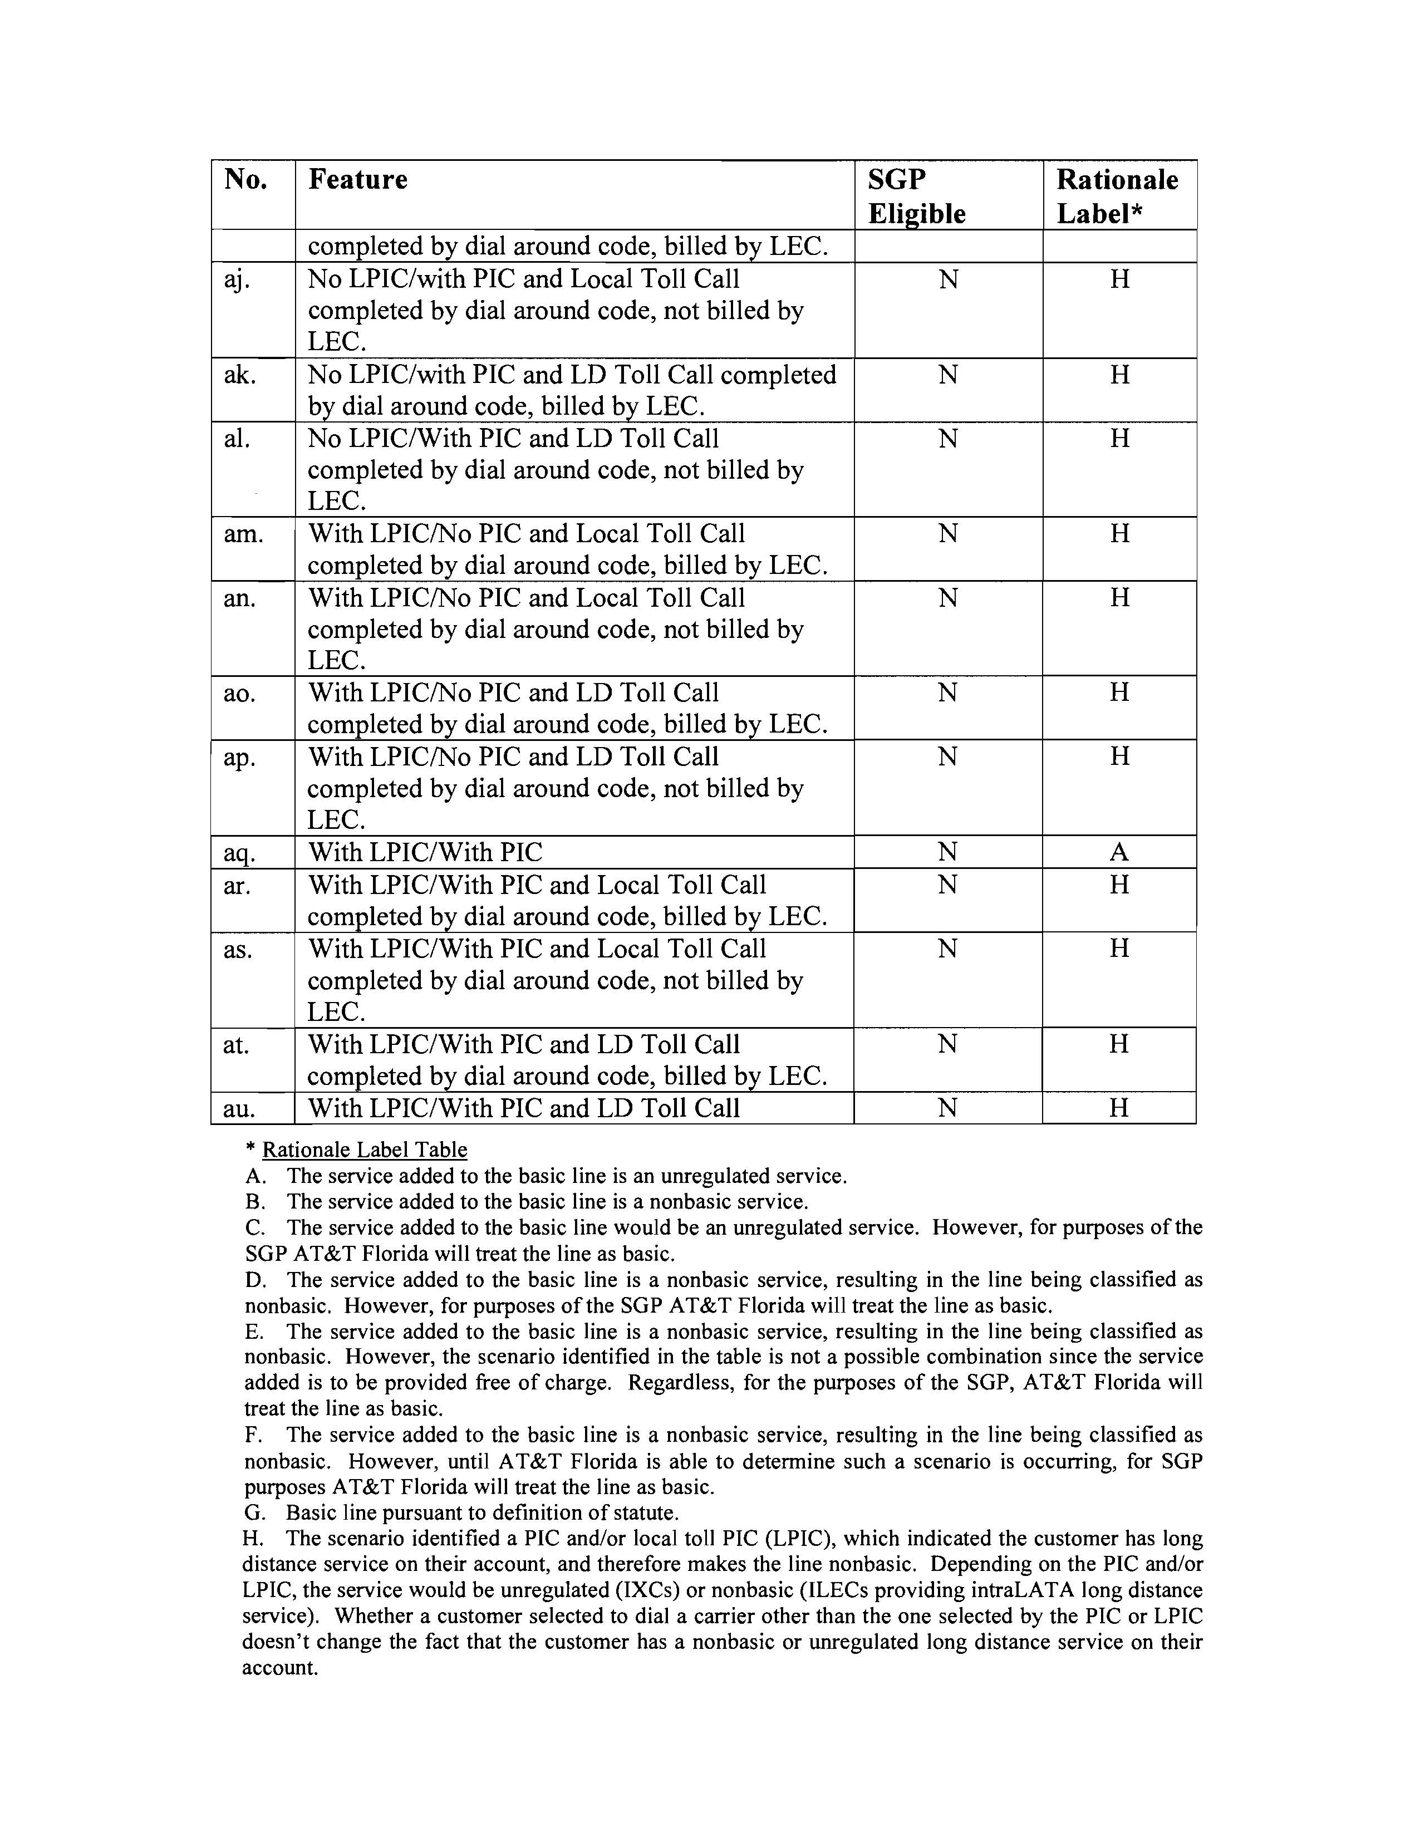

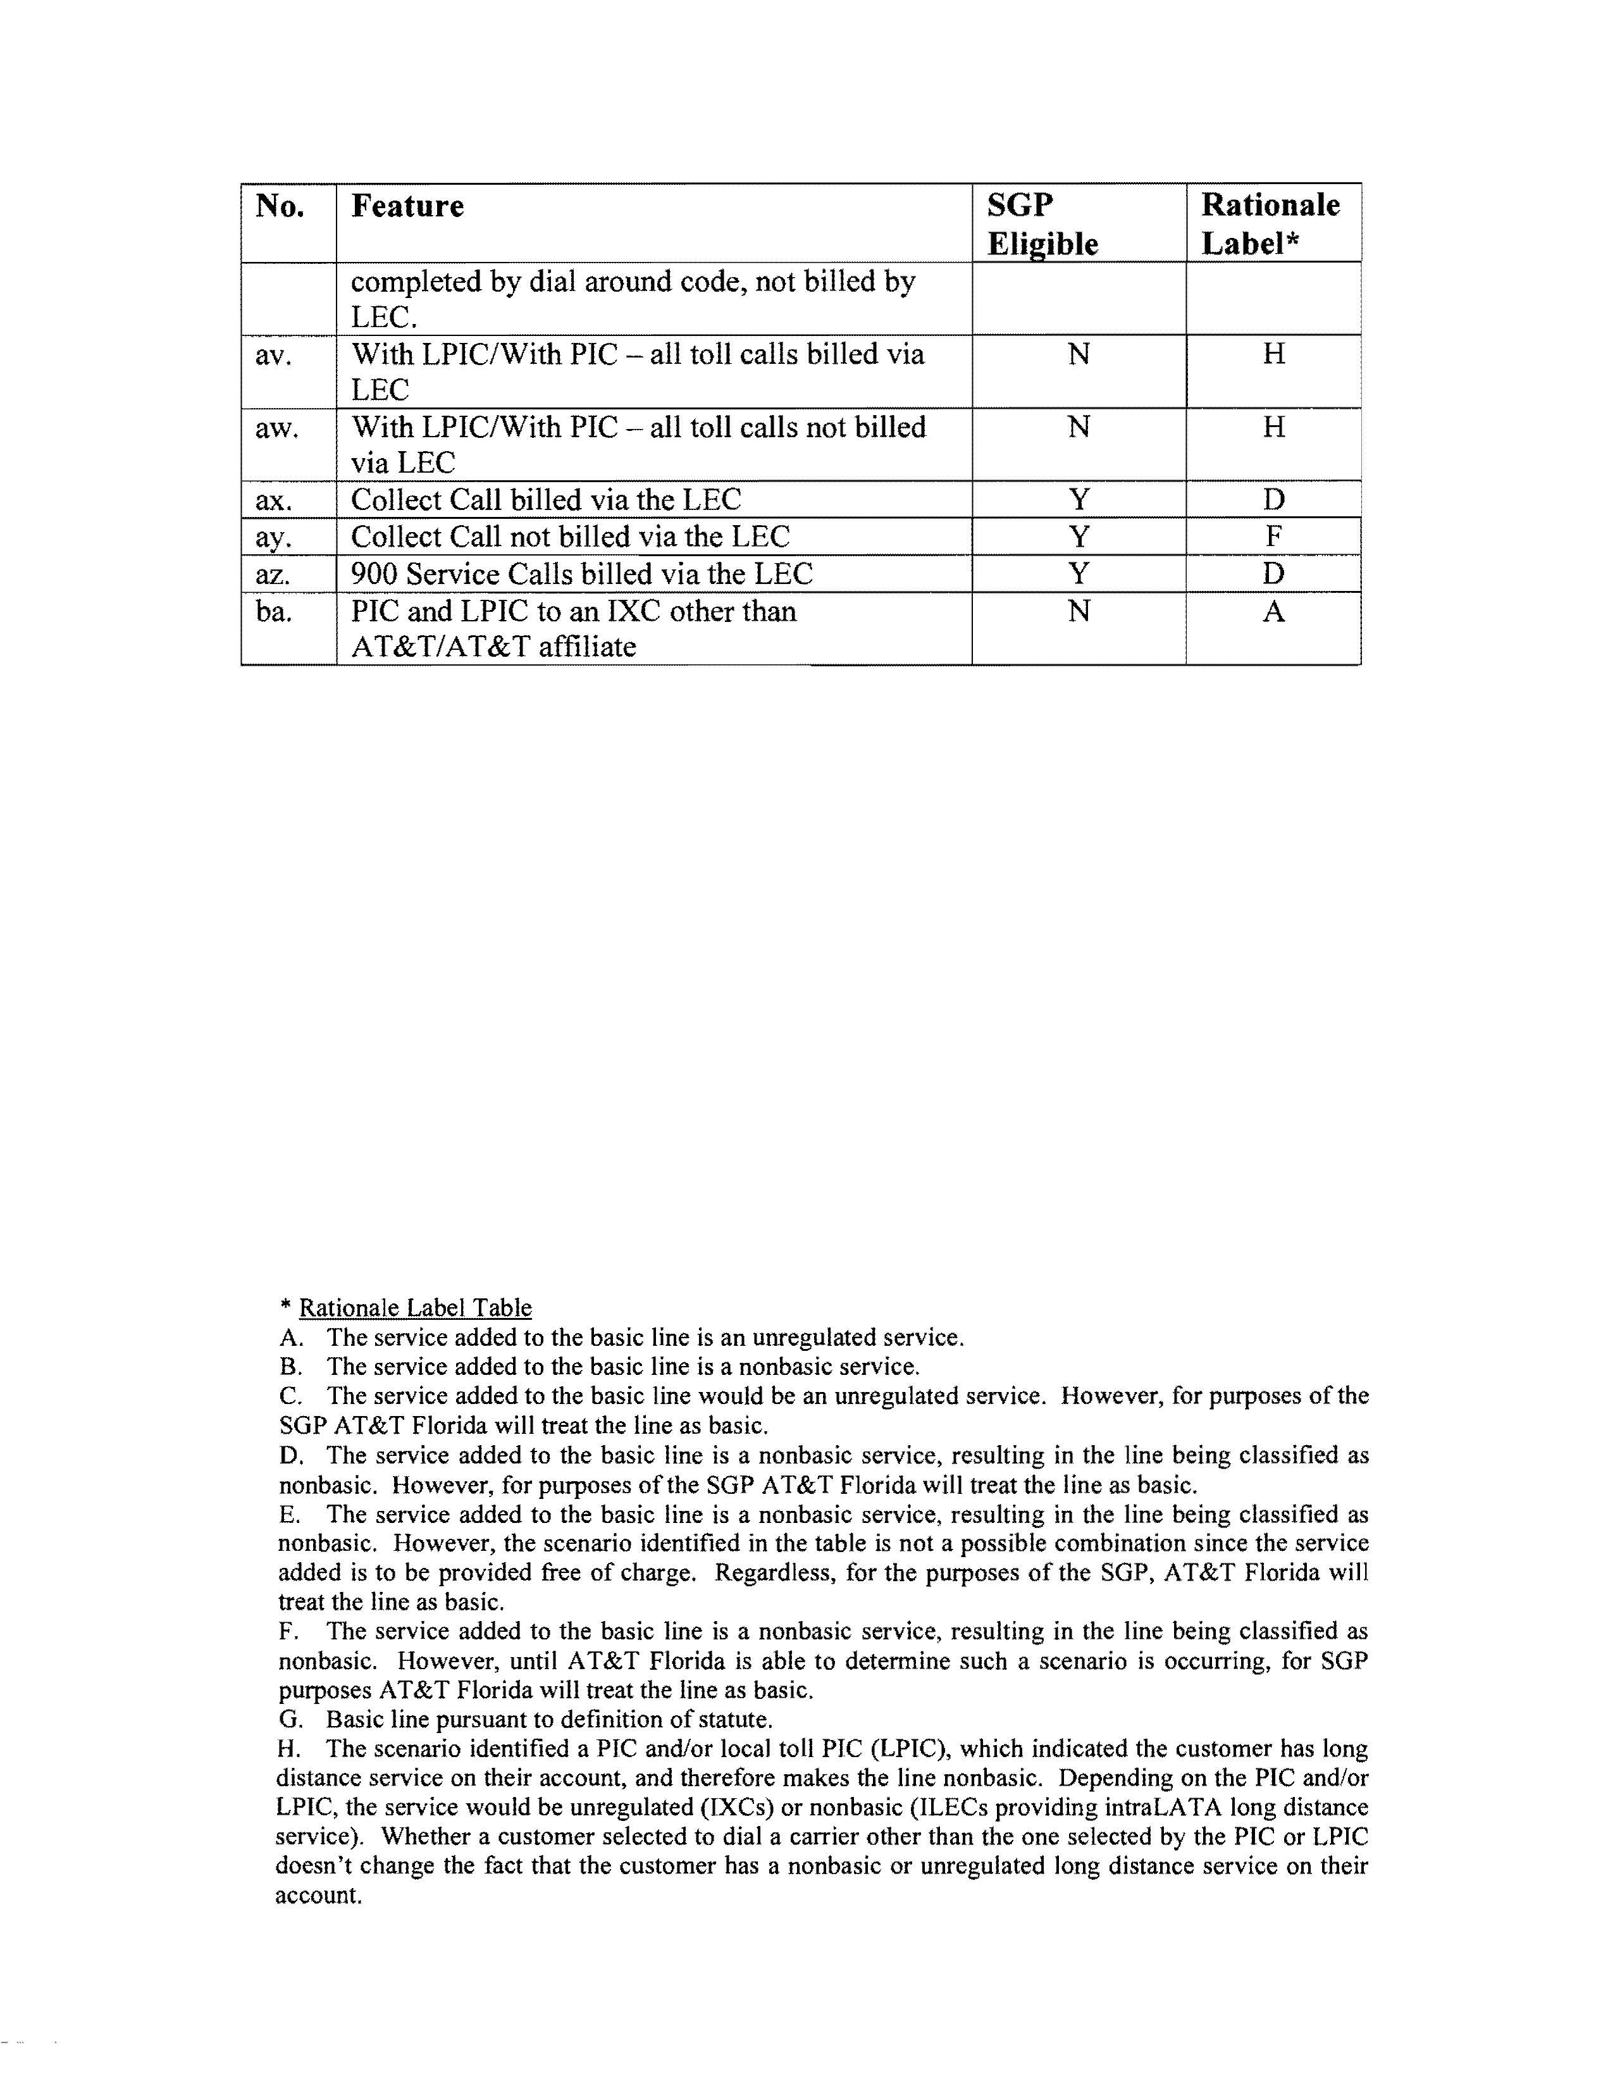

Docket No. 991378-TL - Initiation of show cause proceedings against BellSouth Telecommunications, Inc. for violation of service standards; and Docket No. 010097-TL - Compliance investigation of BellSouth Telecommunications, Inc. for violation of service standards.
Docket No. 050095-TL - Petition for extension and modification of existing Service Guarantee Program and for limited waiver of Rules 25-4.066(2), 25-4.070(1)(b), 25-4.070(3)(a), and 25-4.073(1)(d), F.A.C., by BellSouth Telecommunications, Inc.

