BEFORE THE FLORIDA PUBLIC SERVICE COMMISSION

In re: Petition for approval of 2007 revisions to underground residential and commercial distribution tariff, by Florida Power & Light Company. | DOCKET NO. 070231-EI
In re: Petition for approval of underground conversion tariff revisions, by Florida Power & Light Company. | DOCKET NO. 080244-EI
In re: Petition and Complaint of the Municipal Underground Utilities Consortium, the Town of Palm Beach, the Town of Jupiter Inlet Colony, and the City of Coconut Creek for relief from unfair charges and practices of Florida Power & Light Company. | DOCKET NO. 080522-EI  ORDER NO. PSC-10-0247-FOF-EI  ISSUED: April 22, 2010

The following Commissioners participated in the disposition of this matter:

NANCY ARGENZIANO, Chairman
LISA POLAK EDGAR
NATHAN A. SKOP
DAVID E. KLEMENT
BEN A. "STEVE" STEVENS III

FINAL ORDER approving stipulation and settlement and
approving associated tariff revisions

BY THE COMMISSION:

Background
On November 20, 2009, Florida Power & Light Company (FPL) filed a petition for approval of revised tariff sheets to implement a Stipulation and Settlement Agreement (settlement agreement) in Docket Nos. 070231-EI, 080244-EI, and 080522-EI. Applicants for underground service pay a contribution-in-aid-of-construction (CIAC) for the additional costs FPL incurs to provide underground service. All three dockets pertain to the determination of the appropriate CIAC for new underground installations and for conversions of existing overhead to underground facilities.
Rules 25-6.078 and 25-6.115, Florida Administrative Code (F.A.C.), pertain to CIAC for new underground construction and conversion of overhead facilities to underground facilities. Both rules were amended in February 2007 in a rule-making docket that addressed numerous issues related to storm hardening. Specifically, the rules were revised to require that the cost estimates used to develop the CIAC reflect two new requirements: (1) the requirements of Rule 25-6.0342, F.A.C., Electric Infrastructure Storm Hardening; and (2) the difference in the net present value of operational costs, if any, including average historical storm restoration costs over the life of the facilities, between underground and overhead systems. Prior to the rule amendments, the CIAC was based on estimated work order costs and did not include the costs of maintenance or storm restoration activities over time. We amended the rules to capture the longer-term costs and benefits of undergrounding.
Docket No. 070231-EI (new underground installations)
On April 2, 2007, FPL filed its underground residential distribution (URD) and underground commercial/industrial distribution (UCD) tariffs pursuant to Rule 25-6.078, F.A.C. This rule requires IOUs to file updated URD charges for our approval at least every three years. The URD charges represent the additional costs FPL incurs to provide underground distribution service in new residential subdivisions in place of overhead service. URD charges are calculated as the differentials between the cost of installing underground facilities and the cost of installing overhead service. The UCD tariff contains standard charges for new commercial applicants who request underground distribution service in lieu of standard overhead service.
By Order No. PSC-07-0835-TRF-EI, issued October 16, 2007, we approved the tariffs filed in Docket No. 070231-EI. However, on November 6, 2007, the Municipal Underground Utilities Consortium (MUUC) and the City of Coconut Creek (Coconut Creek) filed their timely protest of that order and request for formal proceeding. MUUC and Coconut Creek alleged in their protest that FPL’s URD and UCD tariffs should be rejected because they did not comply with Rule 25-6.078, F.A.C., which became effective two months before FPL’s April 2007 petition was filed. Also, the City of South Daytona (South Daytona) was granted intervention by Order No. PSC-08-0486-PCO-EI, issued August 1, 2008. Although the order approving the tariffs was protested, the new tariff rates remained in effect and were collected subject to refund. A formal hearing was scheduled for June 11-12, 2008, but the hearing was continued to allow FPL to file revised tariffs to reflect the changes to Rule 25-6.078, F.A.C.

On April 1, 2008, FPL filed revised URD and UCD tariffs in Docket No. 070231-EI, which FPL alleged reflected the changes in Rule 25-6.078, F.A.C. By Order No. PSC-08-0774-TRF-EI, issued November 24, 2008, we approved the April 2008 tariffs. On December 15, 2008, MUUC and Coconut Creek timely protested Order No. PSC-08-0774-TRF-EI, requesting this matter be set for a formal hearing, stating that FPL’s tariffs did not fully comply with the requirements of Rule 25-6.078, F.A.C. On December 16, 2008, South Daytona filed an untimely protest. The April 2008 tariffs superseded the April 2007 tariffs and, pending resolution of the protests, the April 2008 tariffs have remained in effect with any charges collected held subject to refund.
On May 15, 2009, South Daytona, and on June 2, 2009, MUUC and Coconut Creek, confirmed that they were withdrawing their objections to the UCD tariffs approved in this docket. As a result, only the URD tariffs remained in dispute.
Docket No. 080244-EI (underground conversion)
On April 30, 2008, FPL filed a petition requesting approval of its underground conversion tariffs, in order to implement the requirements of amended Rule 25-6.115, F.A.C. On May 28, 2008, MUUC filed a petition to intervene, which was granted by Order No. PSC-08-0460-PCO-EI, issued on July 17, 2008. On June 6, 2008, South Daytona filed a petition to intervene, which was granted by Order No. PSC-08-0461-PCO-EI, issued on July 17, 2008.
By Order No. PSC-08-0780-TRF-EI, issued November 26, 2008, we approved FPL’s underground conversion tariffs. On December 17, 2008, MUUC, Coconut Creek, the Town of Palm Beach (Palm Beach), and Town of Jupiter Inlet (Jupiter Inlet) timely protested Order No. PSC-08-0780-TRF-EI, requesting this matter be set for a formal hearing. On December 22, 2008, South Daytona filed an untimely protest. The underground conversion tariffs approved by Order No. PSC-08-0780-TRF-EI remain in effect with any collections being held subject to refund.
Consolidation of Docket Nos. 070231-EI and 080244-EI
By Order No. PSC-09-0114-PCO-EI, issued February 25, 2009, both dockets were consolidated and scheduled for a formal administrative hearing on June 3-4, 2009, with all subsequent filings to be filed in Docket No. 080244-EI.
Docket No. 080522-EI
On August 4, 2008, MUUC, Palm Beach, Coconut Creek, and Jupiter Inlet Colony, filed a petition and complaint (MUUC complaint) requesting that we conduct a hearing to determine the fair, just, and reasonable practices and charges by which FPL determines the CIAC to be paid by local government applicants who perform part or all of the construction work to convert overhead to underground. The CIAC includes charges for Direct Engineering, Supervision, and Support (DESS) costs associated with the conversion work. The MUUC complaint disputed how FPL determines the reduction in DESS when the applicant performs some or all of the work required for the conversion.
Further Proceedings
When the hearing for the consolidated undergrounding dockets was convened on June 3, 2009, the parties announced that they had reached philosophical agreement on a settlement agreement which included all three dockets discussed above. The parties requested that the hearing be held in abeyance until the parties could complete the actions contemplated under the proposed settlement agreement. The parties indicated they would formally submit the settlement agreement at a later date for our approval.
On June 9, 2009, FPL submitted a settlement agreement. On August 19, 2009, Palm Beach and Jupiter Inlet filed their resolutions approving the settlement agreement and their contingent withdrawal of protests and complaints. Further, on August 26, 2009, Coconut Creek filed its Notice of Filing Resolution Approving Settlement Agreement and Contingent Withdrawal of Protests and Complaint. Finally, on October 22, 2009, South Daytona filed its Motion for Withdrawal as an intervenor.
Based on the above, on November 20, 2009, FPL filed appropriate tariff sheets consistent with the settlement agreement. Upon review of the settlement agreement and the tariff sheets, our staff determined that it needed additional information, and, on February 12, 2010, propounded its First Set of Interrogatories, consisting of 10 interrogatories, on FPL. FPL responded to those interrogatories on March 4, 2010.
This order addresses the proposed settlement and associated tariff sheets. We have jurisdiction over this matter pursuant to Sections 366.03, 366.04, 366.05, and 366.06, Florida Statutes.
Analysis
All parties to Docket Nos. 070231-EI, 080244-EI, and 080522-EI have proffered the proposed settlement agreement (Attachment A) as a complete resolution of all matters pending in the above three undergrounding dockets. The settlement agreement will be in effect until January 1, 2013, and the parties agreed not to raise any issues until then. The major elements contained in the settlement agreement are as follows:
- FPL’s Governmental Adjustment Factor (GAF) tariff will become a permanent tariff.
- The overhead versus underground non-storm operational cost differential in the URD and the conversion tariffs is set at $0.
- Direct Engineering, Supervision, and Support (DESS) costs associated with applicant performed work is reduced by 20 percent.
GAF Tariff
FPL’s GAF tariff allows local governments a 25 percent credit against the otherwise applicable CIAC for projects which convert overhead facilities to underground. The 25 percent reduction in CIAC is based on expected savings in storm restoration costs when large contiguous areas are converted from overhead to underground service, and is designed to encourage the installation of underground facilities by reducing the CIAC the customer is required to pay FPL. The 25 percent reduction is based on FPL’s analysis of the 2004 and 2005 hurricane season. Based on the fewer interruptions experienced by underground facilities than overhead facilities, converting overhead to underground facilities in large communities is expected to reduce the amount of infrastructure damage requiring repair, thereby reducing restoration costs which are shared by all ratepayers. The proposed settlement agreement includes two changes to the GAF tariff.
First, pursuant to Section 5 of the proposed settlement agreement, FPL’s GAF tariff becomes a permanent tariff. The GAF tariff was initially approved as a pilot program with an annual renewal requirement, to review additional cost data justifying the 25 percent discount. We have approved two extensions of the GAF tariff since the initial approval of the tariff. Since the GAF tariff was approved in May 2007, there have been no substantial storms impacting FPL’s service territory. Therefore, FPL has no additional data with which to update the quantification of storm restoration benefits that it provided in support of the GAF tariff. Until additional storm restoration data is available, there is no basis to revise the 25 percent factor.
Second, the settlement agreement clarifies that the applicant must demonstrate to FPL that the sum of the GAF waiver credit plus any federal or state funds does not exceed the otherwise applicable CIAC. The current GAF tariff is not available to projects for which any state or federal funds are available to the applicant to cover any portion of the cost of conversion. This prohibition inhibited local governments, who might otherwise be eligible for state or federal grants for local infrastructure improvements, from pursuing undergrounding projects. FPL stated that to protect the general body of ratepayers, FPL wanted to ensure that the applicant does not receive more than the cost due to FPL from the combination of other funding sources and the GAF waiver credit.
Finally, our approval of the most recent GAF extension required FPL, at least 60 days prior to the current October 30, 2010, expiration date of the GAF tariff, to file a report providing an updated quantification of storm restoration benefits based on any new storm-restoration data. The report is attached to this order as Attachment B. We accept this report as fulfillment of this reporting requirement.
To support its petition to make the GAF tariff permanent, FPL stated that there have been no negative experiences with the GAF tariff since this Commission first approved it as a pilot program, and that the GAF remains in the public interest to promote local government-sponsored underground conversion projects. Furthermore, FPL stated that approval of the GAF tariff as a permanent tariff would remove uncertainty over the availability of the tariff. As with all tariffs, the GAF tariff would still be subject to our continuing authority to conduct formal investigations and proceedings on those tariffs on our own motion, and any party may raise issues after January 1, 2013.
Underground versus Overhead Non-storm Operational Cost Differential
As discussed in the case background, in Docket Nos. 070231-EI and 080244-EI, we approved FPL’s revised CIAC calculations to reflect the net present value of operational costs for comparable overhead and underground facilities. The data presented by FPL in its initial revised CIAC calculations showed that underground facilities are more expensive to operate, maintain, and repair than the overhead distribution system by $11,300 per pole-line mile over the life of the facilities. Thus, the addition of the non-storm operational cost differential in the CIAC calculation for conversions and new installations resulted in an increase in the CIAC.
On April 14, 2009, prior to the scheduled hearing on this matter, the protestors pre-filed testimony and exhibits alleging that FPL understated the cost savings from underground facilities, resulting in a higher than appropriate CIAC. The protesters presented their own quantification of FPL’s non-storm operational cost differential in a study attached to their testimony, which showed non-storm operational costs for overhead to be more costly than for underground. The protestors concluded that instead of an additional charge per pole-line mile, there should be a credit to reflect the operational benefits of underground facilities, thus reducing the underground CIAC.
The proposed settlement agreement sets the overhead versus underground differential in the conversion and URD tariffs to zero. Paragraph 12 of the settlement agreement states that FPL will not seek to revise the settlement agreement, including the non-storm operational cost differential, before January 1, 2013. After that date, any party may request that the changes be re-evaluated and adjusted if necessary.
To support the proposed settlement agreement, FPL stated in its interrogatory response that using a value of zero for the non-storm operational cost differential represents a compromise between evidence that would have been presented at hearing showing that by FPL’s calculation the value should be positive and, by MUUC’s calculation, the value should be negative.
Paragraph 16 of the settlement agreement includes a provision that the adjustment to operational costs discussed above will be applicable to all applicants who applied for underground conversions under the GAF tariff on or after April 4, 2006, as provided for in Order No. PSC-06-0339-PCO-EI. That order suspending the GAF tariff stated that “any such later-approved discount for local government-sponsored conversion projects shall apply to undergrounding contracts entered into with local governments on or after April 4, 2006.” In its interrogatory response concerning the settlement, FPL stated that 11 undergrounding projects would have refunds and the total estimated refund amount is $150,000.

Undergrounding projects have continued during the pendency of these dockets. As noted above, even if protested, once tariffs are approved, they remain in effect. The tariffs approved in the initial URD tariff in Docket No. 070231-EI and the conversion tariff in Docket No. 080244-EI were applied to projects with the requirement that any charges would be held subject to refund, pending resolution of the protest. FPL stated in its interrogatory response that refunds under this provision would affect about 140 residential underground projects for a total refund amount of about $500,000.

Direct Engineering, Supervision, and Support (DESS) costs

Rule 25-6.115(3), F.A.C., gives applicants the right to do all or part of the construction and installation work for underground conversion projects themselves, and receive a credit from FPL for the value of the work performed.

In Docket No. 080522-EI, the MUUC, Palm Beach, Coconut Creek, and Jupiter Inlet alleged that FPL did not provide an appropriate percentage reduction in the DESS costs associated with applicant performed work. In its interrogatory response, FPL stated that the 20 percent reduction in the DESS costs represents a negotiated compromise figure between FPL and the parties to the settlement agreement as part of the settlement of all outstanding issues in the three undergrounding dockets at issue. Based on the calculation for one specific undergrounding project, FPL estimated the appropriate percentage reduction at 12 percent. On the other hand, MUUC argued that the appropriate adjustment was in the range of 50 percent. Thus, FPL stated, the negotiated 20 percent reduction is well within the reasonable range of values that could be determined to be fair and reasonable, and reflective of the costs incurred and saved by FPL where an applicant performs conversion work.

Conclusion

We find that the settlement agreement is a fair and reasonable resolution of the disputed issues in Docket Nos. 070231-EI, 080244-EI, and 080522-EI. Therefore, we approve the proposed settlement agreement and associated tariff sheets. In addition, we accept the report attached to the petition in this docket as satisfaction of the reporting requirement of Order No. PSC-09-0755-TRF-EI.
Based on the foregoing, it is

ORDERED by the Florida Public Service Commission that the attached Stipulation and Settlement Agreement along with the associated Florida Power & Light Company’s tariff sheet revisions described herein are hereby approved. It is further
ORDERED that Attachment B shall satisfy the reporting requirement of Order No. PSC-09-0755-TRF-EI, issued November 17, 2009, in Docket No. 090422-EI. It is further
ORDERED that there are no further actions to be taken in Docket Nos. 070231-EI, 080244-EI, and 080522-EI, and upon expiration of the time to appeal, these dockets shall be closed.

By ORDER of the Florida Public Service Commission this 22nd day of April, 2010.

/s/ Ann Cole
ANN COLE
Commission Clerk

This is an electronic transmission. A copy of the original signature is available from the Commission's website, www.floridapsc.com, or by faxing a request to the Office of Commission Clerk at 1-850-413-7118.

( S E A L )

ELS

NOTICE OF FURTHER PROCEEDINGS OR JUDICIAL REVIEW

The Florida Public Service Commission is required by Section 120.569(1), Florida Statutes, to notify parties of any administrative hearing or judicial review of Commission orders that is available under Sections 120.57 or 120.68, Florida Statutes, as well as the procedures and time limits that apply. This notice should not be construed to mean all requests for an administrative hearing or judicial review will be granted or result in the relief sought.

Any party adversely affected by the Commission's final action in this matter may request: 1) reconsideration of the decision by filing a motion for reconsideration with the Office of Commission Clerk, 2540 Shumard Oak Boulevard, Tallahassee, Florida 32399-0850, within fifteen (15) days of the issuance of this order in the form prescribed by Rule 25-22.060, Florida Administrative Code; or 2) judicial review by the Florida Supreme Court in the case of an electric, gas or telephone utility or the First District Court of Appeal in the case of a water and/or wastewater utility by filing a notice of appeal with the Office of Commission Clerk, and filing a copy of the notice of appeal and the filing fee with the appropriate court. This filing must be completed within thirty (30) days after the issuance of this order, pursuant to Rule 9.110, Florida Rules of Appellate Procedure. The notice of appeal must be in the form specified in Rule 9.900(a), Florida Rules of Appellate Procedure.

BEFORE THE FLORIDA PUBLIC SERVICE COMMISSION

In re: Petition for Approval of Underground ) Docket No. 080244-EI
Conversion Tariff Revisions. )
)

In re: Petition for approval of 2007 )
revisions to underground residential and ) Docket No. 070231-EI
commercial distribution tariff, )
by Florida Power & Light Company. )

In Re: Petition and Complaint of the Municipal )
Underground Utilities Consortium for Relief ) Docket No. 080522-EI
from Unfair Charges and Practices of Florida )
Power & Light Company ) Filed: June 4, 2009
__________________________________________)

STIPULATION AND SETTLEMENT AGREEMENT
WHEREAS, Florida Power & Light Company has filed certain tariff revisions that are the subject of the above-styled Docket No. 070231-EI and Docket No. 080244-EI, which have been approved by the Florida Public Service Commission ("Commission") subject to the protests thereof by the Municipal Underground Utilities Consortium, the Town of Palm Beach, Florida, the City of Coconut Creek, Florida, and the Town of Jupiter Inlet Colony, Florida, and the City of South Daytona, Florida, each of the foregoing individually a "Party" and collectively the "Parties," and

WHEREAS, the Municipal Underground Utilities Consortium, the Town of Palm Beach, the City of Coconut Creek, and the Town of Jupiter Inlet Colony have filed a petition and complaint with the Commission in the above-styled Docket No. 080522-EI, asserting that FPL's treatment for certain common engineering costs, in cases where a local government applicant performs part or all of underground conversion work itself, results in unfair, unjust, and unreasonable treatment of such applicants, and

WHEREAS, the Parties have conducted discovery regarding the issues in the above-styled dockets, and

WHEREAS, the Parties have engaged in good-faith negotiations toward resolving their disputes as to the issues raised in all three of the above-styled dockets,
NOW, THEREFORE, in consideration of the covenants contained herein and of the mutual benefits to be derived from the fulfillment of those covenants, the Parties hereby agree and stipulate as follows:

1. This Stipulation and Settlement Agreement ("Agreement") will become effective when the Commission's approval of this Agreement has become final and no longer subject to challenge or appeal under governing law. The Agreement is contingent upon the Commission's approval of the Agreement, and of the actions contemplated herein, in their entirety.

2. The Parties recognize and acknowledge that the effectiveness of this Agreement is also contingent upon the approvals of the respective governing bodies of the municipalities that are Parties to this Agreement. Upon execution of the Agreement, the staff and attorneys for the municipalities that are Parties to the Agreement will move forward as quickly as practicable to place the Agreement before the municipalities' governing bodies for their approval.

3. Upon the approval of the municipalities' governing bodies, the MUUC and the respective municipal Parties will file appropriate notices of withdrawals of their protests of the tariff provisions in PSC Docket Nos. 070231-EI and 080244-EI, such withdrawals to be contingent upon the Commission's final approval of all of the actions contemplated herein.

4. The MUUC, Palm Beach, Coconut Creek, and Jupiter Inlet Colony will withdraw their complaint filed in PSC Docket No. 080522-EI, such withdrawal to be contingent upon the Commission's final approval of all of the actions contemplated herein.

5. FPL will file a petition seeking the Commission's approval of its Governmental Adjustment Factor tariff provisions as permanent tariffs of FPL, i.e., not subject to any further mandatory Commission review but remaining subject to the Commission's continuing authority to conduct informal investigations and proceedings on those tariffs on its own motion.

6. FPL will file proposed tariff provisions with the Commission setting the estimated overhead vs. underground operational cost differential on FPL's Tariff Sheet No. 6.300 to zero, replacing the value of -$11,300 per pole line mile presently in that tariff, and FPL will also file proposed revisions to FPL's Tariff Sheet No. 6.100 that will make the corresponding adjustments for the overhead vs. underground operational cost differential to be reflected in FPL's URD tariffs.

7. FPL will file proposed tariff provisions with the Commission replacing existing Section 1.e on its Tariff Sheet No. 9.725, UNDERGROUND FACILITIES CONVERSION AGREEMENT – GOVERNMENTAL ADJUSTMENT FACTOR WAIVER, with the following:

e. The Local Government Applicant must demonstrate to the reasonable satisfaction of FPL that the sum of the GAF Waiver credit plus any federal or state funds that the Local Government Applicant is able to use to support the Conversion does not exceed the otherwise applicable CIAC as calculated before application of the GAF Waiver.

8. FPL will file proposed tariffs with the Commission that will set FPL's charge for Direct Engineering, Supervision, and Support costs applicable to any Applicant-performed work at 80% of the value that would have applied if FPL performed this work.

9. The MUUC and the municipalities that are Parties to this Agreement agree that they will not, before January 1, 2013, directly or indirectly raise claims relative to the "operational cost differential" between overhead and underground facilities.

10. The MUUC and the municipalities that are Parties to this Agreement agree that they will not, before January 1, 2013, directly or indirectly seek an increase in the Governmental Adjustment Factor waiver or credit, also known as the Avoided Storm Restoration Cost credit, for underground conversion projects.

11. The MUUC and the municipalities that are Parties to this Agreement agree that they will not, before January 1, 2013, directly or indirectly raise any claims relative to the "contiguous underground facilities" or relative to FPL's proposed "tiered" GAF/ASRC credits for underground installations.

12. FPL agrees that it will not, before January 1, 2013, directly or indirectly seek to change any of the provisions agreed to in this Stipulation and Settlement Agreement, including specifically, not to seek to reduce the GAF or ASRC waiver or credit, nor to increase the "operational cost differential" applicable in calculating CIACs for underground conversion projects, nor to increase the amount that FPL collects as Direct Engineering, Supervision, and Support costs for Applicant-performed work on underground conversion projects.

13. All Parties to this Agreement acknowledge that nothing herein may be construed to prevent the Commission from conducting any proceedings that the Commission may initiate with regard to any of the tariff provisions and other matters that are the subject of this Agreement. The Parties agree and acknowledge that, in the event that the Commission or any other person initiates any proceedings relative to the matters that are the subject to this Agreement, including any matters with respect to which any Party or Parties have agreed not to initiate proceedings, then all Parties are free to participate in such Commission proceedings to protect their interests as they deem appropriate, and the Parties will not be bound by or subject to the positions stated in this Agreement.

14. The Parties will jointly move the Commission to schedule all of the petitions and withdrawals described herein for consideration at a single agenda conference, such that the Commission's action will be effective as to all of the Parties' actions contemplated above at the same time.

15. Nothing herein shall operate as a bar to any Party seeking the Commission's action to enforce any provision of this Agreement or of FPL's tariffs as they may be approved pursuant this Agreement.

16. For the avoidance of doubt, the Parties agree that the adjustments reflected in this Agreement will be applicable to all Applicants who applied for underground conversions under FPL's GAF tariff after April 4, 2006, as provided for in Commission Order No. PSC-06-0339-PCO-EI, issued on April 24, 2006.

17. The Parties further agree that the adjustments to FPL's URD tariffs reflected in this Agreement will be applicable to all underground service installations under those tariffs for which applications were made on or after October 9, 2007, which was the effective date of the initial URD tariffs pursuant to Commission Order No. PSC-07-0835-TRF-EI.

18. The Parties have agreed to the positions stated in this Stipulation and Settlement Agreement solely for the purpose of settlement, and accordingly, the Parties are not bound by or subject to the positions stated herein in the event that the Agreement is not approved in its entirety by the Commission.

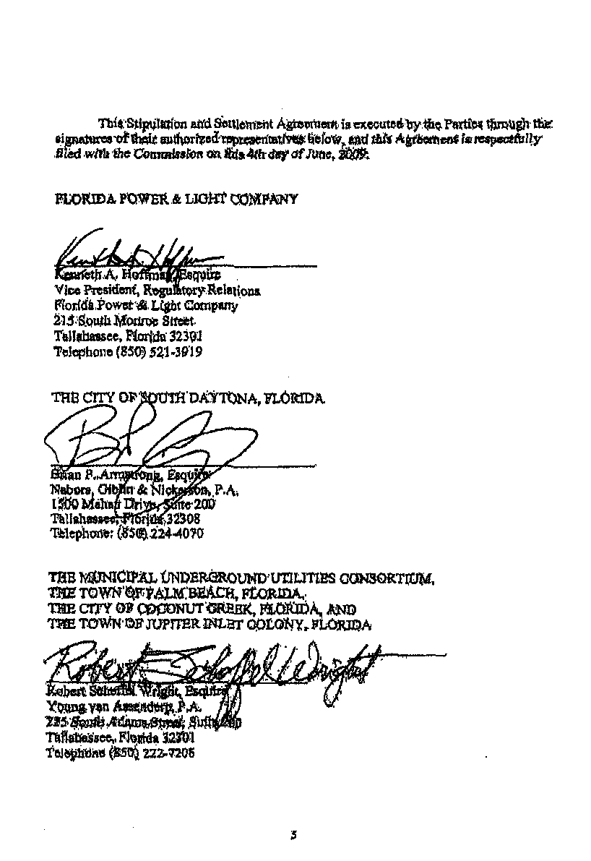
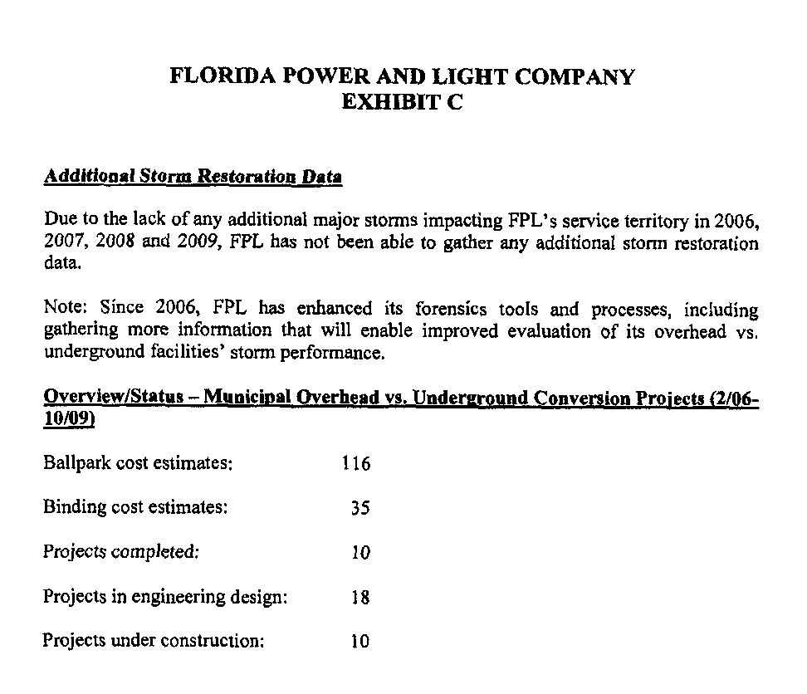

See Order No. PSC-07-0043-FOF-EU, issued January 16, 2007, in Docket No. 060172-EU, In re: Proposed rules governing placement of new electric distribution facilities underground, and conversion of existing overhead distribution facilities to underground facilities, to address effects of extreme weather events.
Docket No. 070231-EI, In re: Petition for approval of 2007 revisions to underground residential and commercial distribution tariff, by Florida Power & Light Company.
Docket No. 080244-EI, In re: Petition for Approval of Underground Conversion Tariff Revisions, by Florida Power & Light.
See Order No. PSC-07-0442-TRF-EI, issued May 22, 2007, in Docket No. 060150-EI, In re: Petition for approval of revisions to contribution-in-aid-of-construction definition in Section 12.1 of First Revised Tariff Sheet No. 6.300, by Florida Power & Light Company.
See Order No. PSC-09-0755-TRF-EI, issued November 17, 2009, in Docket No. 090422-EI, In re: Petition for extension of governmental adjustment factor tariff and approval of seventh revised tariff sheet No. 9.725 by Florida Power & Light Company.
Issued April 24, 2006, in Docket No. 060150-EI, In re: Petition for approval of revisions to contributions-in-aid-of construction definition in Section 12.1 of First Revised Tariff Sheet No. 6.300, by Florida Power & Light Company.
Order No. PSC-07-0835-TRF-EI
Order No. PSC-08-0780-TRF-EI

