State of Florida   |  | Public Service Commission  Capital Circle Office Center ● 2540 Shumard Oak Boulevard  Tallahassee, Florida 32399-0850  -M-E-M-O-R-A-N-D-U-M-
DATE: | June 30, 2010
TO: | Office of Commission Clerk (Cole)
FROM: | Division of Regulatory Analysis (Ellis)  Office of the General Counsel (Brown, Tan)
RE: | Docket No. 100164-EQ – Petition for approval of new standard offer for purchase of firm capacity and energy from renewable energy facilities or small qualifying facilities and approval of revised tariff schedule REF-1, by Gulf Power Company.
AGENDA: | 07/13/10 – Regular Agenda – Tariff Filing – Interested Persons May Participate
COMMISSIONERS ASSIGNED: |  |  | All Commissioners
PREHEARING OFFICER: |  |  | Administrative
CRITICAL DATES: |  |  | 12/01/10 (8 Month Effective Date)
SPECIAL INSTRUCTIONS: |  |  | None
FILE NAME AND LOCATION: |  |  | S:\PSC\RAD\WP\100164.RCM.7-13-10.DOC

Case Background
Since January 1, 2006, each investor-owned electric utility (IOU) has been required to continuously offer to purchase capacity and energy from specific types of renewable sources. Section 366.91(3), Florida Statutes (F.S.), specifies that the contracts for purchase must be based on the utility's full avoided cost as defined in Section 366.051, F.S., and provide a term of at least ten years. Rules 25-17.200 through 25-17.310, Florida Administrative Code (F.A.C.), implement the statutes.
In accord with the applicable statute and rules, on April 1, 2010, Gulf Power Company (Gulf or Company) filed its petition for approval of a new standard offer for purchase of firm capacity and energy from renewable energy facilities or small qualifying facilities and approval of tariff schedule REF-1.
The Commission has jurisdiction over this matter pursuant to Sections 366.04 through 366.06, 366.91, and 366.92, F.S.
Discussion of Issues
Issue 1:1
Should the Commission approve the standard offer contract filed by Gulf Power Company?
Recommendation:
Yes. The standard offer contract and related tariffs comply with Rules 25-17.200 through 25-17.310, F.A.C., and the Commission should approve it. (Ellis)
Staff Analysis:
Because the company is an IOU, Rule 25-17.250(1), F.A.C., requires Gulf to continuously make available a standard offer contract for the purchase of firm capacity and energy from renewable generating facilities and small qualifying facilities with a design capacity of 100 kilowatts (kW) or less. Based on the Ten-Year Site Plan for 2010-2019, Gulf has no fossil-fueled generating units that could qualify as an avoided unit for the standard offer contract. As a result, Gulf indicates in its petition that the next fossil-fueled generating units capable of serving as avoided units would be available in 2020.
Without an avoidable unit to serve as a basis for capacity payments, Gulf had the option of filing a standard offer contract offering energy payments only, at the as-available energy rate. In an effort to promote renewable generation, however, Gulf has identified a pair of units beyond the ten year planning horizon as the next possible avoided units. The units are a pair of natural gas-fired combustion turbines with a total rating of 365 MW, and both have a projected in-service date of June 1, 2020.
Any renewable generation facility still can elect to have no performance requirements and deliver energy on an as-available basis. If the renewable generation facility commits to certain performance requirements based on the avoided units, it can receive a capacity payment pursuant to Gulf’s proposed standard offer contract. Those performance requirements include the requirement to be operational and capable of delivering capacity by the in-service date of the avoided units. To further promote renewable generation, the Commission requires multiple options for capacity payments, including the option to receive early or levelized payments. Table 1, below, illustrates the various annual payments that would be made to a renewable facility of 50 MW running at a 90 percent capacity factor, and operational by January 1, 2011.
Table 1 – Estimated Annual Payments to a 50 MW Renewable Facility (90% Capacity Factor)
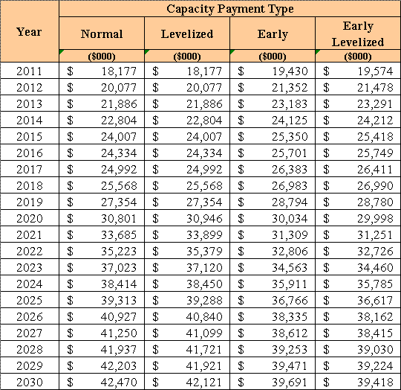
If a renewable generator elects to receive payments under the Normal or Levelized options it would receive as-available energy rates until 2020, the in-service date of the avoided units. If the Early or Early Levelized options are selected, capacity payments begin at an earlier date but tend to be less in the outer years as the net present value of payments must remain the same. In addition, capacity payments greater than those made under the Normal option require additional performance security from the renewable generator.
Gulf submitted a total of 13 revised tariff sheets, including 7 revised sheets of Gulf’s Renewable Standard Offer Contract and 4 revised sheets corresponding to Gulf’s REF-1 rate schedule. All of the revised sheets reflect the change in avoided units, with a majority of revisions related to the date. Beyond these revisions, all other terms, such as provisions for performance, payment, and security are retained from the 2009 standard offer contract and related tariffs.
The provisions of the 2010 standard offer contract and related tariffs submitted by Gulf conform to all requirements of Rules 25-17.200 through 25-17.310, F.A.C. Gulf has filed tariff sheets that reflect the economic and technical assumptions of the 2020 avoided units. The standard offer contract provides flexibility in the arrangements for payment so that a developer of renewable generation may select the payment stream best suited to its financial needs. In conclusion, staff believes that Gulf’s proposed standard offer contract is in compliance with Rules 25-17.200 through 25-17.310, F.A.C., and therefore the Commission should approve it.
Issue 2:2
Should this docket be closed?
Recommendation:
Yes. If the Commission approves staff’s recommendation to approve the proposed standard offer contract and tariffs filed by Gulf, and no person whose substantial interests are affected requests a hearing to address this matter, then Docket No. 100164-EQ should be closed, and the standard offer contracts and tariffs filed by Gulf should be effective as of the date of the Commission’s vote. If a protest is filed within 21 days of the issuance of the Commission’s order, the tariffs should remain in effect pending resolution of the protest. Potential signatories to the standard offer contract should be aware that Gulf’s tariffs and standard offer contracts may be subject to a request for hearing, and if a hearing is held, may subsequently be revised. (Brown, Tan)
Staff Analysis:
If the Commission approves staff’s recommendation to approve the proposed standard offer contract and tariffs filed by Gulf, and no person whose substantial interests are affected requests a hearing to address this matter, then Docket No. 100164-EQ should be closed, and the standard offer contracts and tariffs filed by Gulf should be effective as of the date of the Commission’s vote. If a protest is filed within 21 days of the issuance of the Commission’s order, the tariffs should remain in effect pending resolution of the protest. Potential signatories to the standard offer contract should be aware that Gulf’s tariffs and standard offer contracts may be subject to a request for hearing, and if a hearing is held, may subsequently be revised.

