State of Florida   |  | Public Service Commission  Capital Circle Office Center ● 2540 Shumard Oak Boulevard  Tallahassee, Florida 32399-0850  -M-E-M-O-R-A-N-D-U-M-
DATE: | September 1, 2010
TO: | Office of Commission Clerk (Cole)
FROM: | Office of the General Counsel (C. Miller, Sayler)  Division of Economic Regulation (Chase, Daniel, Hewitt)  Division of Regulatory Analysis (J. Miller, Shafer)
RE: | Docket No. 100338-WS – Initiation of rulemaking to amend Rule 25-30.0371, F.A.C., pertaining to acquisition adjustments for water and wastewater utilities.
AGENDA: | 9/14/10 – Regular Agenda – Rule Proposal - Interested Persons May Participate
COMMISSIONERS ASSIGNED: |  |  | All Commissioners
PREHEARING OFFICER: |  |  | Graham
CRITICAL DATES: |  |  | None
SPECIAL INSTRUCTIONS: |  |  | None
FILE NAME AND LOCATION: |  |  | S:\PSC\GCL\WP\100338.RCM.DOC

Case Background
This is a staff recommendation to address amendments to Rule 25-30.0371, Florida Administrative Code (F.A.C.), pertaining to acquisition adjustments for water and wastewater utilities, as set forth in Attachment A. The impetus to review the current rule for possible changes was a discussion at an Agenda Conference in April 2009 involving a sale of a small, new system at a large discount. During the discussion, there was a concern expressed that the benefit afforded to the purchasing utility by the current rule with regard to the negative acquisition adjustment may be too generous in this instance. The Commission ultimately decided to conduct a workshop to thoroughly review the provisions of the current rule and decide whether it was time to propose changes.

History of Acquisition Adjustment Policy

An acquisition adjustment results when the purchase price of a utility differs from the original cost of the assets adjusted to the time of the acquisition (net book value). A positive acquisition adjustment exists when the purchase price is greater than net book value, and a negative acquisition adjustment exists when the purchase price is less than net book value. If included on the books of the utility, an acquisition adjustment will impact the level of the rate base on which the purchasing utility will be permitted to earn a return. A positive acquisition adjustment will increase the rate base and a negative acquisition adjustment has the opposite effect.

From approximately 1983 until the current rule was adopted in 2002, the Commission’s policy on acquisition adjustments for water and wastewater utilities was that, absent extraordinary circumstances, the purchase of a utility system at a premium or discount does not affect rate base. This policy was intended to encourage acquisitions of smaller systems since the buyer earns a return on the entire rate base of the acquired utility, not just the purchase price. Also, the buyer receives the benefit of depreciation on the full rate base. Further, since neither rate base nor rates are generally changed upon acquisition, this policy assumes customers are not harmed. The philosophy is that customers should not experience a change in rates as a result of a change in ownership.

The fundamental principle underlying this longstanding policy was that the consolidation of water and wastewater utilities in Florida produces an overall benefit to the industry and the consumers. The Commission currently regulates approximately 150 water and wastewater utilities in Florida, with over 100 of them being Class C utilities, meaning the annual revenues are $200,000 or less. In fact, approximately 40 utilities have annual revenues of $50,000 or less. These small utilities often lack the resources and professional expertise to meet the increasingly stringent federal and state environmental and water quality standards. In addition, the pressures of aging infrastructure, higher financing costs, and the lack of economies of scale call into question the long term viability of many small systems. Consolidation of these smaller systems was seen as one way in which to address these concerns while achieving better quality of service in the long run and mitigating rate impacts to consumers.

Prior to the adoption of the current rule, the acquisition adjustment issue was a controversial one, particularly with regard to negative acquisition adjustments. In those cases, it was often argued that allowing a return on rate base rather than the amount invested by the purchasing utility is unfair to the customers. This controversy is highlighted in cases where there is an extreme difference between rate base and the purchase price. As a result, prior to the rule, there was much lengthy and costly litigation on cases involving acquisition adjustments. The rulemaking process on the treatment of acquisition adjustments was an arduous one, beginning in 1999 and lasting until 2002. There were a series of informal and formal rulemaking proceedings, coupled with careful, protracted negotiations among the stakeholders. The current rule is the result of those lengthy negotiations.

Basically, the current rule differs from the Commission’s prior non-rule policy only in the way it treats negative acquisition adjustments. The current rule provides that a negative acquisition adjustment shall not be included in rate base unless there is proof of extraordinary circumstances, or where the purchase price is less than 80 percent of net book value. If the purchase price is less than 80 percent of net book value, then the rule requires the inclusion of a negative acquisition adjustment, which is amortized over five years. This short amortization period provides an incentive to the purchasing utility to refrain from filing a rate case during that time, while allowing the utility to begin earning on the full rate base at the end of five years.

Since its adoption, the current rule has reduced controversies over acquisition adjustments in transfer proceedings before the Commission, thus reducing administrative and legal costs for all parties. It has served to balance the need for incentives for the purchase of smaller systems with a sensitivity to rate impacts on consumers. Further, it affords the industry the regulatory consistency and certainty it needs in order to negotiate the best possible purchase price for the utility and its customers. Attachment C to this memorandum provides a summary of the transfers of water and wastewater utilities since the adoption of the rule, indicating which would fall under the positive or negative acquisition adjustment categories, and which cases did not involve the setting of rate base. As shown on this summary, there have been no positive acquisition adjustments approved by the Commission since the rule was adopted, and only six negative acquisition adjustments since that time. In two of those instances where purchase price was less than net book value, the purchase price was above 80 percent of net book value, so, pursuant to the rule, no negative acquisition adjustment was booked.

In April 2009, a case came before the Commission involving the sale of a relatively new utility at a large discount. During the discussion of this item at the Agenda Conference, there was concern expressed that the benefit afforded to the purchasing utility by the current rule with regard to the negative acquisition adjustment may be too generous in this instance. It was discussed that since this particular utility system was relatively new and appeared to be in good operating condition, there may not be as great a need to encourage its purchase as with other more troubled systems. Other concerns discussed were that the current rule did not have sufficient flexibility to account for all situations, and that it contained awkward and confusing language. There was much discussion that the current rule works well in most instances; however, changes may be needed to afford more protection for the consumer, while not penalizing the purchasing utility for negotiating a good deal. The Commission ultimately decided to conduct a workshop to thoroughly review the provisions of the current rule and decide whether it was time to address changes.

The Commission held a workshop for this purpose on January 27, 2010. Commission staff and representatives from the Office of Public Counsel (OPC), Aqua Utilities Florida, Inc. (AUF), and Utilities, Inc. participated at the workshop. At the end of the workshop, staff was directed to conduct rulemaking to develop revisions to the acquisition adjustment rule, which address specific concerns but leave the fundamental purpose and structure of the rule intact. Post-Workshop Comments were filed by OPC and AUF in which they suggested certain changes to the rule.

Staff conducted a staff rule development workshop on May 20, 2010, which was attended by representatives from OPC, AUF, and Utilities, Inc. At that workshop, staff presented draft rule revisions for discussion among the stakeholders based on the Commission’s concerns and the Post-Workshop Comments from the January Commission workshop. Post-Workshop Comments from the rule development workshop were filed by OPC, AUF, and Utilities, Inc. on June 21, 2010.

This recommendation addresses whether the Commission should propose the amendment of Rule 25-30.0371, F.A.C. The Commission has jurisdiction in this matter pursuant to Sections 120.54 and Chapter 367, Florida Statutes.

Discussion of Issues

Issue 1:1
Should the Commission propose the amendment of Rule 25-30.0371, F.A.C.?
Recommendation:
Yes, the Commission should propose the amendment of this rule as set forth in Attachment A. (Chase, Daniel, Hewitt, C. Miller, J. Miller, Sayler, Shafer)
Staff Analysis: The rule recommended to be proposed for amendment is set forth in Attachment A. It is the result of the comments and concerns raised at the Commission Workshop on January 27, 2010, the staff rule development workshop held on May 20, 2010, and the Post-Workshop Comments provided after both workshops.
January 27, 2010 Commission Workshop
As mentioned in the Case Background, the Commission held a workshop on January 27, 2010, to discuss concerns with the current acquisition adjustment rule and whether changes to the rule are needed. Representatives from OPC, AUF and Utilities, Inc. participated in the discussion at the workshop. During the workshop, all of the stakeholders expressed recognition that the existing rule is the product of thoughtful and careful analysis, and strikes a balance between the interests of all stakeholders, including customers and utilities. However, most of the comments were in response to the concerns brought out by commissioners regarding the treatment of negative acquisition adjustments. Specifically, application of the existing rule may not adequately address the situation where the purchase price is significantly less than net book value, or where the system being purchased is not older or dilapidated but rather in reasonable condition. Another concern raised at the workshop was that customers of the system being acquired may not be treated fairly in cases where the system is in poor condition and the purchasing utility is awarded rate base and then also recovers their investment to bring the system up to standards.
Some of the solutions discussed at the workshop included extending the amortization period for negative acquisition adjustments beyond the current five years and implementing some sharing mechanism whereby the customers could reap a greater benefit from acquisitions in which the purchase price is significantly less than net book value. At the conclusion of the workshop, the Commission directed staff to conduct rulemaking to revise the rule to narrowly address these limited concerns while maintaining the rule’s fundamental purpose.
Post-Workshop Comments from the January 27, 2010 Workshop
Post-Workshop Comments were filed by AUF and OPC. In its Post-Workshop Comments, AUF urged the Commission to consider the fundamental principles on which the existing rule is based and the consequences of displacing those principals with something new and untested. However, AUF developed two rule options for Commission consideration that address only the concern where the negotiated purchase price is more than 50 percent below the net book value of the utility being acquired. AUF’s options are designed to provide for a sharing of the amount of the negative acquisition adjustment with the customers in these limited cases. Under AUF’s first option, at the time the Commission approves the transfer, half of the negative acquisition adjustment would be recognized on the utility’s books for ratemaking and earnings surveillance purposes and amortized over the remaining life of the assets purchased. The remaining half would not be recorded on the utility’s books for ratemaking or earnings surveillance purposes. This amortization scheme would have the effect of keeping rate base lower for an extended period of time, thus putting downward pressure on rates in future rate cases. The second option suggested by AUF would simply extend the amortization period of the negative acquisition adjustment from five years (in the current rule) to seven years, thus deterring the acquiring utility from filing a rate case for a longer period of time.
OPC filed Post-Workshop Comments which addressed an accounting issue relating to transaction costs incurred by the buyer in the purchase of a utility system. OPC also suggested rule language that would allow the Commission to require full recognition of a negative acquisition adjustment for ratemaking purposes if the Commission determines that the acquired utility system is “neither financially nor physically distressed.” In its written comments, OPC provided neither definitions nor descriptions of how the Commission could consistently and fairly determine whether a utility system was financially or physically distressed.
May 20, 2010 Staff Rule Development Workshop
Staff developed a draft revised rule based on the discussion at the January 27 Commission workshop and the post-workshop comments. The Staff Draft Rule was the subject of a staff rule development workshop held on May 20, 2010. Since no major concerns were expressed concerning positive acquisition adjustments, all of staff’s substantive revisions were related to negative acquisition adjustments. The Staff Draft Rule was similar to AUF’s sharing proposal in cases when the purchase price is more than 50 percent below net book value. In those instances, under the Staff Draft Rule, half of the negative acquisition adjustment would be spread over the remaining life of the assets, and half would be amortized over seven years, which further increases the benefit to the customers. In AUF’s proposal, half of the negative acquisition adjustment would not be recorded on the utility’s books at all. The Staff Draft Rule was also designed to clarify and simplify much of the language in the rule and eliminate the term “extraordinary circumstances,” which is difficult to objectively define.
The rule development workshop was attended by representatives of OPC, AUF, and Utilities, Inc. During the workshop, AUF expressed its support of the staff draft rule. Utilities, Inc. maintained that the current rule is good policy, provides many benefits, eliminated controversies in proceedings before the Commission, and, thus, no changes are warranted. Utilities, Inc. also argued that the revisions in the Staff Draft Rule are contrary to the Commission’s policy of encouraging the acquisition of small, poorly run or financed utility systems, and that there is no basis for a seven year amortization period for negative acquisition adjustments. Further, Utilities, Inc. asserted that in today’s environment, staying out of rate cases for five years is difficult and seven years will be practically impossible.
At the workshop, OPC expressed general support of the draft rule but had comments regarding one change and suggested several others. OPC objected to the elimination of the term “extraordinary circumstances” when referring to the positive acquisition adjustment. They argued that by deleting the term, the high bar that the utilities must meet before they may recognize a positive acquisition adjustment is removed.
OPC also suggested the addition of two factors that should be considered in determining whether a positive acquisition adjustment is warranted. First, OPC suggested that the Commission should consider all of the elements of the transaction; for example, whether the purchase is limited to the utility system or includes other assets, such as a golf course. A second factor suggested by OPC is the extent to which the purchase was made as part of an arms-length transaction. If the entities are related in some fashion, OPC argued that the purchase should receive a higher level of scrutiny to ensure the purchase price has not been artificially inflated.
Further, OPC referred to its suggestion in the Post-Workshop Comments from the Commission’s January 27 workshop, which was to allow the Commission to require full recognition of a negative acquisition adjustment for ratemaking purposes if it determines that the acquired utility system is “neither financially nor physically distressed.” Finally, OPC brought up its comment made after the January 27 workshop relating to expensing transaction and transition costs incurred in connection with the acquisition of a system.
Post-Workshop Comments from the May 20, 2010 Workshop
Post-Workshop Comments were filed by OPC, AUF, and Utilities, Inc. Utilities, Inc. filed Post-Workshop Comments similar to the comments made during the rule development workshop, which are that the current rule is good policy, and no changes are warranted.
In its Post-Workshop Comments, AUF supported the Staff Draft Rule and opposed two of the changes suggested by OPC at the workshop. First, AUF asserted that the proposal to require all transaction and transition costs be expensed and not capitalized would contradict the NARUC Uniform System of Accounts. In its Post-Workshop Comments, OPC agreed that transaction and transition costs incurred in the acquisition of a system could be addressed as part of a rate case rather than in an acquisition proceeding. Staff agrees that these types of costs are more appropriately addressed in a rate case proceeding because they are not included in the net book value of the assets being acquired.
AUF also argued against OPC’s proposal to allow the Commission to require full recognition of a negative acquisition adjustment if it determines that the system is neither financially nor physically distressed. AUF maintains that by injecting this vague and undefined burden of proof, OPC’s proposal fosters rather than diminishes controversy and would increase the cost of acquisition proceedings. AUF also argues that if this proposal is adopted, it is reasonable to expect that the purchasing utility would avoid the controversy and protracted proceeding by simply paying full rate base for the system. AUF concludes that the purchase price would therefore increase, heightening the likelihood of an earlier rate case. Staff agrees that OPC’s proposal would increase the controversy and litigation over negative acquisition adjustments, and would significantly reduce the regulatory consistency and certainty needed by the industry. Finally, staff believes that this proposal contains vague and undefined terms that are problematic in rulemaking.
In its Post-Workshop Comments, OPC reiterated its objection to removing the term “extraordinary circumstances,” and provided examples of the use of the term “extraordinary circumstances” by the Commission. OPC states that the term is used in a rule relating to need determinations for the electric industry, and in a staff recommendation in a case involving a request by a natural gas utility for a change in accounting treatment retroactively to prior years. Staff agrees with the comments by OPC on this subject, and believes that the term “extraordinary circumstances” should be retained in the rule when referring to the high bar that a purchasing utility must meet to support a positive acquisition adjustment.
OPC also reiterated its proposal that two factors be added to the list of conditions that should be considered when evaluating a positive acquisition adjustment. First, OPC suggested that the Commission should consider all of the elements of the transaction; for example, whether the purchase is limited to the utility system or includes other assets, such as a golf course. Staff does not believe that this factor should be included in the rule revision because when the purchase includes assets in addition to the utility system, it is simply assumed that the portion of the purchase price related to the utility system is equal to net book value. Therefore, there is no acquisition adjustment.
A second factor suggested by OPC to be considered in evaluating positive acquisition adjustments is the extent to which the purchase was made as part of an arms-length transaction. OPC argues that if the entities are related in some fashion, the purchase should receive a higher level of scrutiny to ensure it has not been artificially inflated. Staff believes this is a reasonable addition to the list of conditions to consider in determining whether a positive acquisition adjustment should be approved.
Staff Recommended Rule
Based on all of the comments and concerns expressed by the Commission and the stakeholders, staff has developed a recommended rule, which is appended to this memorandum as Attachment A.
The key changes to the current rule recommended by staff focus on the treatment of negative acquisition adjustments. Other changes in the staff recommended rule are designed to clarify and simplify the rule language, and to incorporate a suggestion made by OPC with regard to positive acquisition adjustments, as discussed previously. Staff’s recommended rule is designed to accomplish the following:
- Separate cases involving negative acquisition adjustments into two groups – those in which the difference between purchase price and net book value is greater than 50 percent, and those in which this difference is 50 percent or less. (See Paragraph (4)(b) of the recommended rule);
- If the purchase price is greater than 50 percent of net book value, the only change from the current rule is that the amortization period for the negative acquisition adjustment will be increased from five years to seven years. This will benefit the customers in that it provides incentive for the purchasing utility to refrain from filing a rate case for a longer period of time. (See Subparagraph (4)(b)1. of the recommended rule);
- If the purchase price is 50 percent or less of net book value, then half of the negative acquisition adjustment is amortized over seven years, and half over the remaining life of the assets being purchased. This amortization scheme provides a greater sharing of the negative acquisition adjustment with the customers. The acquisition adjustment will stay on the utility’s books for a longer period, putting downward pressure on rate base, and providing greater rate stability for customer. (See Subparagraph (4)(b)2. of the recommended rule);
- Clarify and simplify the rule language describing when a negative acquisition adjustment will be included in rate base and how the negative acquisition adjustment is calculated. (See Subsection (3) of the recommended rule); and
- Add, as an example of a circumstance that should be explored in evaluating a positive acquisition adjustment, whether the purchase was made as part of an arms-length transaction. This was incorporated into the rule at the request of OPC. (See Subsection (2) of the recommended rule)
Staff believes the recommended rule adequately addresses the concerns raised by the Commission and stakeholders at the January 27, 2010 Commission workshop and the May 20, 2010 staff rule development workshop. Staff maintains that the recommended rule addresses the concerns discussed previously, while maintaining the basic purpose and structure of the current rule.
A comparison of the current rule with staff’s recommended rule is set out in table format in Attachment B. The table provides the existing rule language, the staff recommended rule language, and an explanation of the recommended change. Staff’s recommended rule in legislative format is appended to this memorandum as Attachment A.
Statement of Estimated Regulatory Cost
The Statement of Estimated Regulatory Cost (SERC) is appended to this memorandum as Attachment D. According to the SERC, the proposed rule changes would affect any company that acquires a water or wastewater system for less than net book value. When the purchase price is greater than 50 percent of net book value, the negative acquisition adjustment would be amortized over seven years instead of five years. If the purchase price is 50 percent of net book value or less, half of the negative acquisition adjustment would be amortized over seven years, and half over the remaining life of the assets. It would take longer for the negative acquisition adjustment in rate base to flow through the accounts thereby “reducing” rates of the company. If there was a rate case filed, customers (including businesses and local governments) would have rates affected over a longer time period than five years. Small businesses that purchase a system for less than net book value could be affected by the proposed rule changes. Any ordered negative acquisition adjustment would flow through accounts thereby “reducing rates over a longer period of time. There should be no incremental costs to the Commission, but there would be benefits from clarifying and streamlining the rule language. There could potentially be less workload for Commission staff.
Conclusion
The purpose of the current acquisition adjustment rule is to encourage consolidation and acquisitions of small water and wastewater systems by well run utilities in order to take advantage of more professional management, increased ability to attract needed capital, and better quality of service in the long run, while at the same time mitigating rate impacts on customers. In addition, the current rule affords the industry the regulatory consistency and certainty it needs in negotiating the best possible purchase price for the utility and its customers. Based upon the comments and concerns expressed at the two workshops and in Post-Workshop Comments, staff believes the recommended rule changes discussed above will further this goal. Accordingly, staff recommends that the Commission propose the amendment of Rule 25-30.0371, F.A.C., as set forth in Attachment A.

Issue 2:1
Should this docket be closed?
Recommendation:
Yes, if no requests for hearing or comments are filed, the rule may be filed with the Secretary of State and this docket should be closed. (C. Miller)
Staff Analysis:
Unless comments or requests for hearing are filed, the rule as proposed may be filed with the Secretary of State without further Commission action. This docket may then be closed.
25-30.0371 Acquisition Adjustments.
(1) Definition. For the purpose of this rule, an acquisition adjustment is defined as the difference between the purchase price of utility system assets to an acquiring utility and the net book value of the utility assets. A positive acquisition adjustment exists when the purchase price is greater than the net book value. A negative acquisition adjustment exists when the purchase price is less than the net book value.
(2) Positive Acquisition Adjustments. A positive acquisition adjustment shall not be included in rate base absent proof of extraordinary circumstances. Any entity that believes a full or partial positive acquisition adjustment should be made has the burden to prove the existence of extraordinary circumstances. In determining whether extraordinary circumstances have been demonstrated, the Commission shall consider evidence provided to the Commission such as anticipated improvements in quality of service, anticipated improvements in compliance with regulatory mandates, anticipated rate reductions or rate stability over a long-term period, and anticipated cost efficiencies, and whether the purchase was made as part of an arms-length transaction. Amortization of a positive acquisition adjustment shall be pursuant to subsection (4)(a) below.
(3) Negative Acquisition Adjustments. If the purchase price is greater than 80 percent of net book value, a negative acquisition adjustment will not be included in rate base. When the purchase price is equal to or less than 80 percent of net book value, aA negative acquisition adjustment shall not be included in rate base and will be equal to 80 percent of net book value less the purchase price. Amortization of a negative acquisition adjustment shall be pursuant to subsection (4)(b)1. or (4)(b)2. below. unless there is proof of extraordinary circumstances or where the purchase price is less than 80 percent of net book value. If the purchase price is less than 80 percent of net book value then the inclusion of a negative acquisition adjustment shall be calculated pursuant to paragraph (b) below.
(a) Contested. Any entity that believes a full or partial negative acquisition adjustment should be made has the burden to prove the existence of extraordinary circumstances. Under no circumstance, however, shall the purchaser be required to record on its books more than 70 percent of a negative acquisition adjustment. In determining whether extraordinary circumstances have been demonstrated, the Commission shall consider evidence provided to the Commission such as the anticipated retirement of the acquired assets and the condition of the assets acquired.
(b) Uncontested. If the purchase price is less than 80 percent of net book value, then the amount of the difference in excess of 20 percent of net book value shall be recognized for ratemaking purposes as a negative acquisition adjustment. The negative acquisition adjustment shall not be recorded on the books for ratemaking purposes or used for any earnings review unless the purchaser files for a rate increase pursuant to Section 367.081(2), 367.0814, 367.0817 or 367.0822, F.S., that will be effective during the amortization period. The negative acquisition adjustment shall be amortized over a 5-year period from the date of issuance of the order approving the transfer of assets.
(4) Amortization Period.
(a) In setting the amortization period for a Commission approved positive acquisition adjustment pursuant to (2) or (3)(a) above, the Commission shall consider evidence provided to the Commission such as the composite remaining life of the assets purchased and the condition of the assets purchased. Amortization of the acquisition adjustment shall begin on the date of issuance of the order approving the transfer of assets.
(b) The appropriate period over which to amortize a Commission approved negative acquisition adjustment pursuant to (3) above, shall be determined as follows:
1. If the purchase price is greater than 50 percent of net book value, the negative acquisition adjustment shall be amortized over a 7-year period from the date of issuance of the order approving the transfer of assets. In this case, the negative acquisition adjustment shall not be recorded on the books for ratemaking purposes or used for any earnings review unless the purchaser files for a rate increase pursuant to Sections 367.081(2), 367.0814, 367.0817 or 367.0822, F.S., that will be effective during the amortization period.
2. If the purchase price is 50 percent of net book value or less, the negative acquisition adjustment shall be amortized from the date of issuance of the order approving the transfer of assets as follows: (i) 50 percent of the negative acquisition adjustment shall be amortized over a 7-year period; and (ii) 50 percent of the negative acquisition adjustment shall be amortized over the remaining life of the assets.
(5) Subsequent Modification. Any full or partial positive acquisition adjustment, once made by the Commission pursuant to (2) or (3)(a) above, may be subsequently modified if the extraordinary circumstances do not materialize or subsequently are eliminated or changed within 5 five years of the date of issuance of the order approving the transfer of assets.
Specific Authority 350.127(2), 367.121(1)(f) FS. Law Implemented 367.071(5), 367.081(2)(a), 367.121(1)(a), (b) FS. History–New 8-4-02, Amended.
Acquisition Adjustment Rule
Comparison of Existing and Staff Draft Rule Provisions

Existing Rule  25-30.0371 | Staff Recommended Rule  25-30.0371 | Purpose/Effect of Change
(1) Definition. For the purpose of this rule, an acquisition adjustment is defined as the difference between the purchase price of utility system assets to an acquiring utility and the net book value of the utility assets. A positive acquisition adjustment exists when the purchase price is greater than the net book value. | (1) Definition. For the purpose of this rule, an acquisition adjustment is defined as the difference between the purchase price of utility system assets to an acquiring utility and the net book value of the utility assets. A positive acquisition adjustment exists when the purchase price is greater than the net book value. | No Change.
(2) Positive Acquisition Adjustments. A positive acquisition adjustment shall not be included in rate base absent proof of extraordinary circumstances. Any entity that believes a full or partial positive acquisition adjustment should be made has the burden to prove the existence of extraordinary circumstances. In determining whether extraordinary circumstances have been demonstrated, the Commission shall consider evidence provided to the Commission such as anticipated improvements in quality of service, anticipated improvements in compliance with regulatory mandates, anticipated rate reductions or rate stability over a long-term period, and anticipated cost efficiencies. | (2) Positive Acquisition Adjustments. A positive acquisition adjustment shall not be included in rate base absent proof of extraordinary circumstances. Any entity that believes a full or partial positive acquisition adjustment should be made has the burden to prove the existence of extraordinary circumstances. In determining whether extraordinary circumstances have been demonstrated, the Commission shall consider evidence provided to the Commission such as anticipated improvements in quality of service, anticipated improvements in compliance with regulatory mandates, anticipated rate reductions or rate stability over a long-term period, anticipated cost efficiencies, and whether the purchase was made as part of an arms-length transaction. Amortization of a positive acquisition adjustment shall be pursuant to subsection (4)(a) below. | The changes to this subsection of the rule are designed to:  1. Incorporate the suggestion made by OPC to add whether the sale is an arms-length transaction to the examples of considerations in determining whether a positive acquisition adjustment would be appropriate.  2. Move the language from Subsection (4) of the current rule regarding the determination of the amortization period. There is no substantive change to the current language regarding the amortization period for positive acquisition adjustments.
(3) Negative Acquisition Adjustments. A negative acquisition adjustment shall not be included in rate base unless there is proof of extraordinary circumstances or where the purchase price is less than 80 percent of net book value. If the purchase price is less than 80 percent of net book value then the inclusion of a negative acquisition adjustment shall be calculated pursuant to paragraph (b) below. | (3) Negative Acquisition Adjustments. If the purchase price is greater than 80 percent of net book value, a negative acquisition adjustment will not be included in rate base. When the purchase price is equal to or less than 80 percent of net book value, a negative acquisition adjustment shall be included in rate base and will be equal to 80 percent of net book value less the purchase price. Amortization of a negative acquisition adjustment shall be pursuant to subsection (4)(b)1. or (4)(b)2. below. | Changes to this subsection of the rule are designed to:  1. Clearly provide that there will be no negative acquisition adjustment if the purchase price is greater than 80 percent of net book value.  2. Leave unchanged the provision that a negative acquisition adjustment will be included in rate base if the purchase price is equal to or less than 80 percent of net book value.  3. Simplify and transfer the language from Paragraph (3)(b) of the current rule, which describes how the negative acquisition adjustment is calculated.
(a) Contested. Any entity that believes a full or partial negative acquisition adjustment should be made has the burden to prove the existence of extraordinary circumstances. Under no circumstance, however, shall the purchaser be required to record on its book more than 70 percent of a negative acquisition adjustment. In determining whether extraordinary circumstances have been demonstrated, the Commission shall consider evidence provided to the Commission such as the anticipated retirement of the acquired assets and the condition of the assets acquired. | N/A | This paragraph of the current rule is deleted under the Staff Draft Rule.  Under the current rule, this paragraph would apply only to the situation when the purchase price is greater than 80 percent of net book value and a party is asserting that a negative acquisition adjustment should be included in rate base. In this circumstance, that party would have the burden to show the existence of “extraordinary circumstances”.  This provision has not been utilized since the rule was adopted. Staff’s draft rule does not provide for a negative acquisition adjustment if the purchase price is greater than 80 percent of net book value.
(b) Uncontested. If the purchase price is less than 80 percent of net book value, then the amount of the difference in excess of 20 percent of net book value shall be recognized for ratemaking purposes as a negative acquisition adjustment. The negative acquisition adjustment shall not be recorded on the books for ratemaking purposes or used for any earnings review unless the purchaser files for a rate increase pursuant to Section 367.081(2), 367.0814, 367.0817 or 367.0822, F.S., that will be effective during the amortization period. The negative acquisition adjustment shall be amortized over a 5-year period from the date of issuance of the order approving the transfer of assets. | N/A | This paragraph of the current rule is deleted under the Staff Draft Rule.  Under the current rule, this paragraph would apply to the situation when the purchase price is less than 80 % of net book value.  The portion of this paragraph that describes how the negative acquisition adjustment is calculated has been simplified and transferred to Subsection (3) of the staff draft rule.  The portion of this paragraph that addresses the amortization period of negative acquisition adjustments has been rewritten and moved to Paragraph (4)(b).
(4) Amortization Period. In setting the amortization period for a Commission approved acquisition adjustment pursuant to (2) or (3)(a) above, the Commission shall consider evidence provided to the Commission such as the composite remaining life of the assets purchased and the condition of the assets purchased. Amortization of the acquisition adjustment shall begin on the date of issuance of the order approving the transfer of assets. | (4) Amortization Period.  (a) In setting the amortization period for a Commission approved positive acquisition adjustment pursuant to (2) above, the Commission shall consider evidence such as the composite remaining life of the assets purchased and the condition of the assets purchased. Amortization of the acquisition adjustment shall begin on the date of issuance of the order approving the transfer of assets. | Subsection (4) has been rewritten to separately address the determination of amortization period for the positive and negative acquisition adjustments.  There is no change to how the amortization period for a positive acquisition adjustments will be determined, and it is described in Paragraph (4)(a).
N/A | (b) the appropriate period over which to amortize a Commission approved negative acquisition adjustment pursuant to (3) above, shall be determined as follows:  1. If the purchase price is greater than 50 percent of net book value, the negative acquisition adjustment shall be amortized over a 7 year period from the date of issuance of the order approving the transfer of assets. In this case, the negative acquisition adjustment shall not be recorded on the books for ratemaking purposes or used for any earnings review unless the purchaser files for a rate increase pursuant to Section 367.081(2), 367.0814, 367.0817 or 367.0822, F.S., that will be effective during the amortization period.  2. If the purchase price is 50 percent of net book value or less, the negative acquisition adjustment shall be amortized from the date of issuance of the order approving the transfer of assets as follows: (i) 50 percent of the negative acquisition adjustment shall be amortized over a 7 year period; and (ii) 50 percent of the negative acquisition adjustment shall be amortized over the remaining life of the assets. | Paragraph (4)(b) describes the amortization period for a negative acquisition adjustment, which has been changed to be dependent on the relationship between the purchase price and net book value.  If the purchase price is greater than 50 percent of net book value, then the amortization period will be 7 years, as described in Subparagraph (4)(b)1., which is a change from the current 5 year period.  If the purchase price is equal to or less than 50 percent of net book value, then half of the negative acquisition adjustment will be amortized over 7 years and half will be amortized over the remaining life of the assets, as described in Subparagraph (4)(b)2.
(5) Subsequent Modification. Any full or partial acquisition adjustment, once made by the Commission pursuant to (2) or (3)(a) above, may be subsequently modified if the extraordinary circumstances do not materialize or subsequently are eliminated or changed within five years of the date of issuance of the order approving the transfer of assets. | (5) Subsequent Modification. Any full or partial positive acquisition adjustment, once made by the Commission pursuant to (2) above, may be subsequently modified if the extraordinary circumstances do not materialize or subsequently are eliminated or changed within 5 years of the date of issuance of the order approving the transfer of assets. | This subsection has been changed to remove the reference to negative acquisition adjustments. Only positive acquisition adjustment may be subsequently modified if the extraordinary circumstances do not materialize or are eliminated within 5 years.

ACQUISITIONS SINCE ADOPTION OF RULE

August 19, 2010
Negative Acquisition Adjustments Per Rule 25-30.0371, F.A.C.
Docket No. | Transfer From/To | Rate Base | Purchase Price | Neg Acq Adj
080167-WS | Breeze Hill/Aqua | $98,000 | $95,000 | $0
070739-WS | Fairways/Aqua | 632,252 | 450,000 | 55,802
040951-WS | Fl Water/Aqua | 15,741,914 | 13,038,951 | 0
030407-WS | Springside/Par | 59,777 | 35,255 | 12,567
020484-WS | Labrador/Labrador | 1,151,387 | 800,000 | 351,387
020256-WS | AP/Sunshine | 19,685 | 1 | 19,684

Positive Acquisition Adjustments Not Recorded
Docket No. | Transfer From/To | Rate Base | Purchase Price | Pos Acq Adj
090232-WS | Wedgefield | ~$6,300,000 | $7,300,000 | ~$1,000,000
080268-WS | Par/FIMC | ~51,000 | 80,000 | ~29,000
080183-WU | Tamiami/Ni Florida | 66,842 | 745,000 | $678,158
070740-SU | Hudson/Ni Florida | 2,417,932 | 5,600,000 | 3,182,068
041461-WU | Floralino/Colonial Manor | 47,208 | 303,000 | 255,792
041096-WS | Buffalo Bluff/St. John Rr | 51,970 | 100,000 | 48,030
040179-WS | Columbia/Utilities, Inc | 1,531,055 | 1,900,000 | 368,945
040160-WU | Keen/Alturas | 29,874 | 45,000 | 15,126
040159-WU | Keen/Sunrise | 52,609 | 90,000 | 37,391
031042-WS | Hunter Creek/MSN | 102,932 | 229,000 | 126,068
030991-WU | Suwannee/Consolidated | 0 | 15,000 | 15,000
030656-WU | Dixie Groves/Dixie Groves | 29,186 | 115,000 | 85,814
030655-WU | Virginia/Virginia | 31,276 | 140,000 | 108,724
030471-WS | Breeze Hill/Breeze Hill | 113,809 | 200,000 | 86,191
030340-WU | Community/Sunshine | 0 | 10,000 | 10,000
030236-WS | Pennbrook/Utilities, Inc | 1,260,563 | 1,800,000 | 539,437
030102-WS | Woodlands/L.P. | 380,609 | 409,959 | 29,350
020945-SU | Creola/Francis I | 62,328 | 325,000 | 262,672

Rate Base Not Established or Purchase Price Equals Rate Base
Docket No. | Transfer From/To | Reason
080269-WU | Pine Harbour/Pine Harbour | System inherited by new owner
060703-WS | SJR/St. Johns River LLC | Utility acquired with MHP, PP=RB
060698-SU | Del Tura/NFMU | Plant to be dismantled, appears PP > RB
060169-SU | Laurel Oaks/Forest | Plant to be dismantled, appears PP > RB
050902-WS | Lake Haven/Gold Coast | Rate Base set in prior rate case, appears PP>RB
050323-SU | Herons Glen/NFMU | Plant to be dismantled, appears PP > RB
050062-WS | Mink/Silver Fox | Utility acquired with MHP, PP = RB
041394-WS | CWS/Mink | Utility acquired with MHP, PP = RB

Rate Base Not Established or Purchase Price Equals Rate Base (Continued)
030891-WS | IHC/Columbia | Utility acquired with resort, PP = RB
030747-SU | Hacienda/HV | Utility acquired with MHP, PP = RB
020892-WS | Buttonwood Bay/Sun Com | Utility acquired with MHP, PP = RB

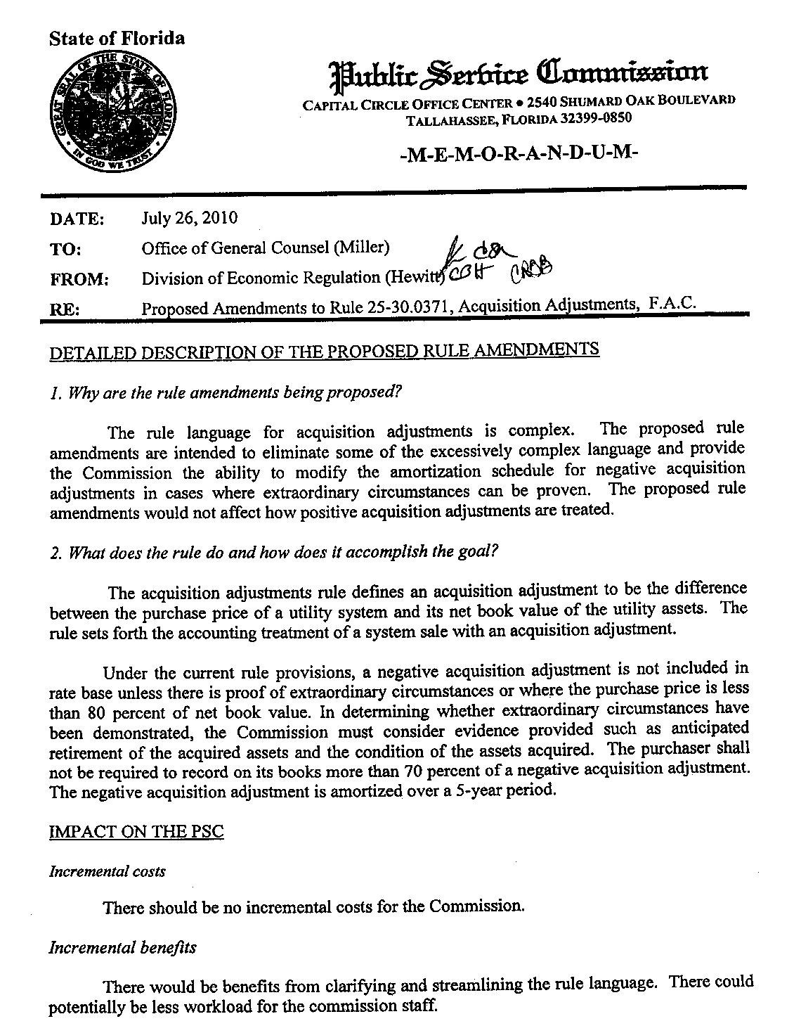
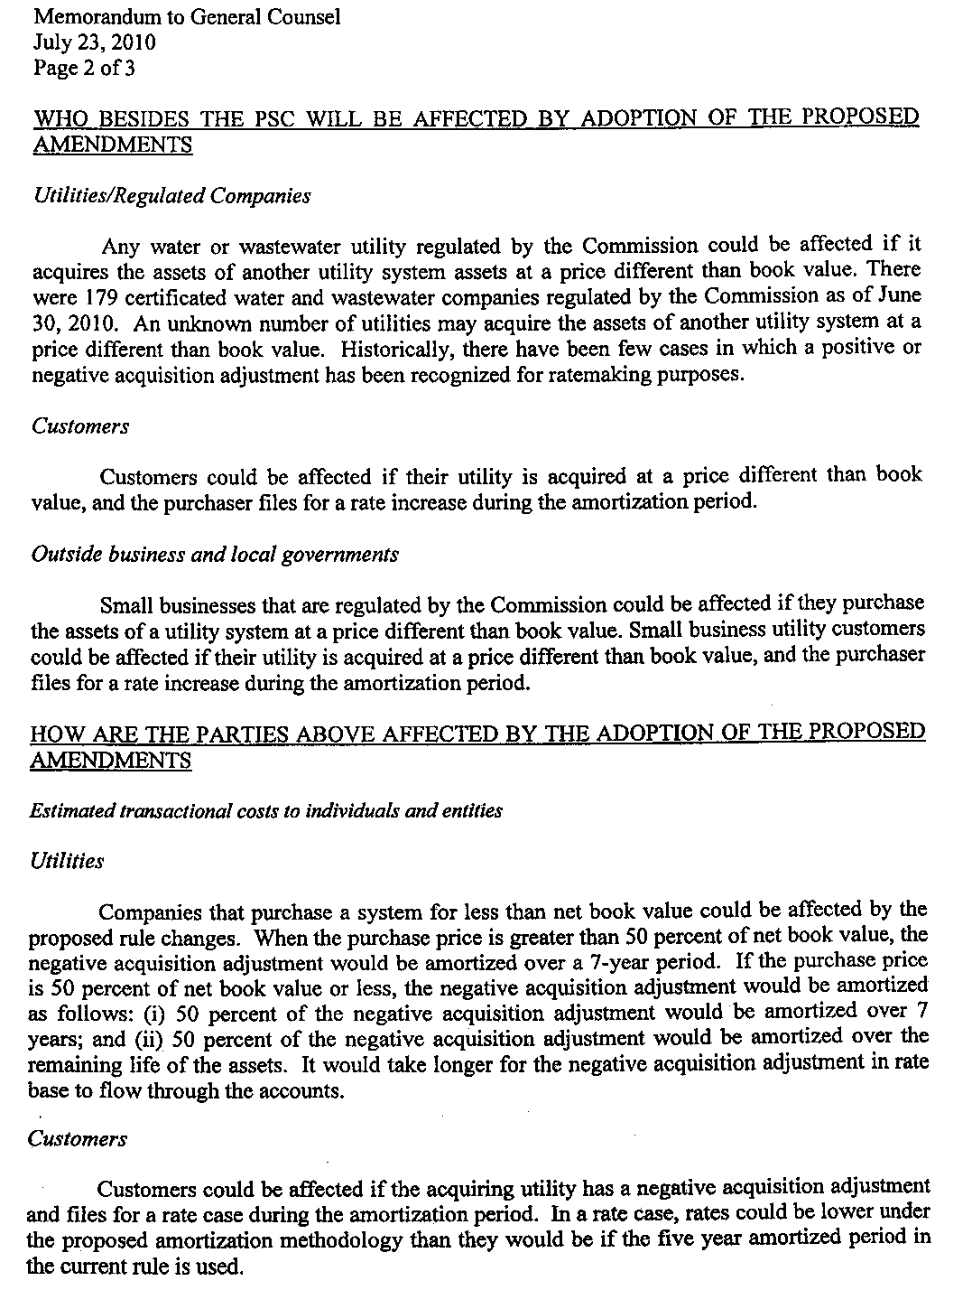
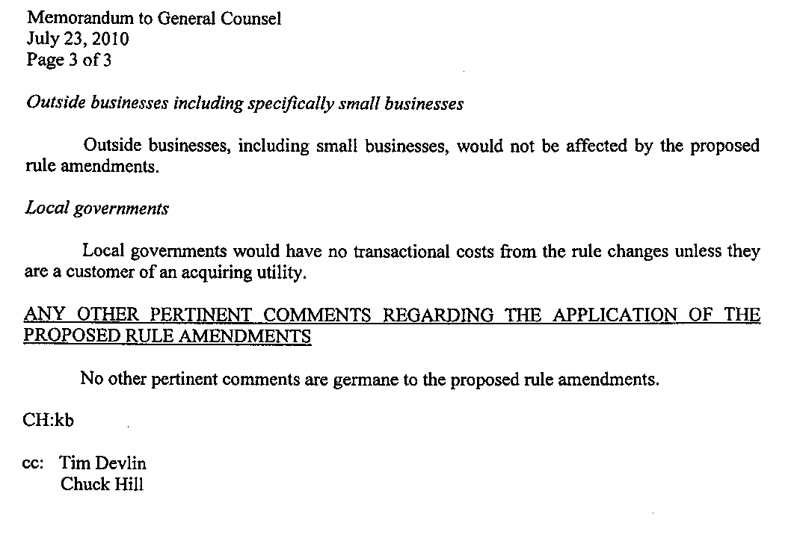

Order No. 25729, issued in Docket No. 891309-WS on February 17, 1992.
Docket No. 080517-WS – Application for approval of transfer of Horizon Homes of Central Florida, Inc. and Five Land Group LLC’s water and wastewater systems to Aqua Utilities Florida, Inc., and for amendment of Certificate Nos. 441-S and 507-W, in Sumter County.
Rule 25-22.082, F.A.C., Selection of Generating Capacity.
Docket No. 080163-GU – Petition for approval to create regulatory subaccount of meter installation to capitalize all incurred and future costs associated with installation of encoder receiver transmitters under provision of Statement of Financial Accounting Standard No. 71.
Purchase price ($95,000) was more than 80% of rate base ($78,400).
Purchase price ($13,038,951) was more than 80% of rate base ($12,593,531).

