State of Florida   |  | Public Service Commission  Capital Circle Office Center ● 2540 Shumard Oak Boulevard  Tallahassee, Florida 32399-0850  -M-E-M-O-R-A-N-D-U-M-
DATE: | January 12, 2011
TO: | Office of Commission Clerk (Cole)
FROM: | Division of Economic Regulation (Slemkewicz, Cicchetti, Draper, P. Lee, Maurey)  Office of the General Counsel (Crawford)
RE: | Docket No. 100462-GU – Joint petition of Peoples Gas System and Office of Public Counsel for approval of stipulation and settlement agreement for possible overearnings for calendar year ending December 31, 2010.
AGENDA: | 01/25/11 – Regular Agenda – Proposed Agency Action – Interested Persons May Participate
COMMISSIONERS ASSIGNED: |  |  | All Commissioners
PREHEARING OFFICER: |  |  | Administrative
CRITICAL DATES: |  |  | None
SPECIAL INSTRUCTIONS: |  |  | None
FILE NAME AND LOCATION: |  |  | S:\PSC\ECR\WP\100462.RCM.DOC

Case Background
Through the Commission’s continuing earnings surveillance program, staff noted that Peoples Gas System (PGS or Company) had reported an achieved return on equity (ROE) of 13.73 percent on its March 2010 Earnings Surveillance Report (ESR). This reported ROE exceeded the 11.75 percent maximum ROE authorized in Docket No. 080318-GU. Staff subsequently contacted PGS concerning the reported overearnings. On June 9, 2010, PGS submitted a letter to staff in which it agreed to cap its earnings at an 11.75 percent ROE for calendar year 2010. In the letter, PGS proposed applying any overearnings to increase the storm damage reserve up to the $1 million target level, and that the remainder (if any) of such overearnings be used to increase the environmental reserve, and/or other purposes benefitting both the Company and its customers before any customer refunds are ordered.
On December 16, 2010, a Joint Petition for Approval of Stipulation and Settlement Agreement (Joint Petition) was filed by PGS and the Office of Public Counsel (Joint Movants). The Stipulation and Settlement Agreement (Stipulation) is intended to resolve all of the issues relating to the Company’s overearnings for the calendar year ended December 31, 2010.
This recommendation addresses the proposed Stipulation. Jurisdiction over this matter is vested in the Commission by several provisions of Chapter 366, including Sections 366.04, 366.05 and 366.06, Florida Statutes.
Discussion of Issues
Issue 1:1
Should the Commission approve the proposed Stipulation concerning PGS' overearnings for the year ended December 31, 2010?
Recommendation:
Yes. (Slemkewicz, Draper, P. Lee)
Staff Analysis:
Through the Commission’s continuing earnings surveillance program, staff noted that PGS had reported an achieved ROE of 13.73 percent on its March 2010 ESR. This reported ROE exceeded the 11.75 percent maximum authorized ROE. Staff contacted PGS concerning the reported overearnings. On June 9, 2010, PGS submitted a letter to staff in which it agreed to cap its earnings at an 11.75 percent ROE for calendar year 2010.
Subsequently on December 16, 2010, a Joint Petition was filed by PGS and the Office of Public Counsel. The Stipulation (Attachment A) is intended to resolve all of the issues relating to the Company’s overearnings for the calendar year ended December 31, 2010. The major elements contained in the Stipulation are:
- 2010 earnings capped at an 11.75 percent ROE (Paragraph 2)
- $3 million refund as a one-time credit to customers’ bills (Paragraph 1)
- Overearnings in excess of $3 million to be used to correct or mitigate deficiencies in the depreciation reserve (Paragraph 3)
The proposed Stipulation consists of 8 paragraphs of agreement between the Joint Movants. Staff believes that several of the paragraphs merit comment or clarification. These are as follows:
Paragraph 1: Paragraph 1 provides that PGS will refund $3 million to its customers in the form of a one-time credit on customer bills. Refunds will be applied only to active bills at the time the refunds are being made, and the refund amount will be based on each customer’s cents-per-therm consumption during the month the refund is made. The refund will be made one month following the date the Commission’s order approving this agreement becomes final. PGS states that assuming the refund is made in March 2011, a residential customer using 20 therms would receive a one-time refund of $3.74.
Paragraph 2: PGS’ 2010 earnings are capped at an ROE of 11.75 percent. Per its September 2010 ESR, PGS reported an achieved ROE of 15.96 percent on an FPSC Adjusted Basis which exceeds the 11.75 percent ROE cap by 4.21 percent. However, the actual amount of any overearnings will be based on the 12-month period ended December 31, 2010. The December 2010 ESR is not due to be filed until February 15, 2011. In response to a staff data request, dated January 5, 2011, PGS estimates that the total overearnings will be approximately $11.5 million for 2010. Once the December 2010 ESR is received, an audit will be conducted to determine the actual amount of the 2010 overearnings.
Paragraph 3: PGS proposes to use any overearnings in excess of $3 million to correct or mitigate any deficiencies subsequently identified by PGS and Staff. PGS indicates that in its last depreciation study filed with the Commission, where new depreciation rates were implemented on January 1, 2007, there was a $46.5 million deficiency between the actual depreciation reserve balance and the theoretical reserve balance. Although not known with certainty, PGS anticipates that the study it files this year will show a reserve deficiency in excess of $25 million. PGS’ next depreciation study is presently scheduled to be filed with the Commission on July 13, 2011.
Staff has reviewed the terms of the Stipulation, and believes that the Stipulation provides a reasonable resolution for the disposition of any 2010 overearnings and is in the public interest. Therefore, staff recommends approval of the Stipulation.
Issue 2:2
Should this docket be closed?
Recommendation:
No. This docket should remain open until PGS files a refund report indicating that the entire $3 million refund has been completed. After the refund has been verified by staff, this docket should be closed administratively. (Crawford)
Staff Analysis:
No. This docket should remain open until PGS files a refund report indicating that the entire $3 million refund has been completed. After the refund has been verified by staff, this docket should be closed administratively.
Attachment A
Page 1 of 6
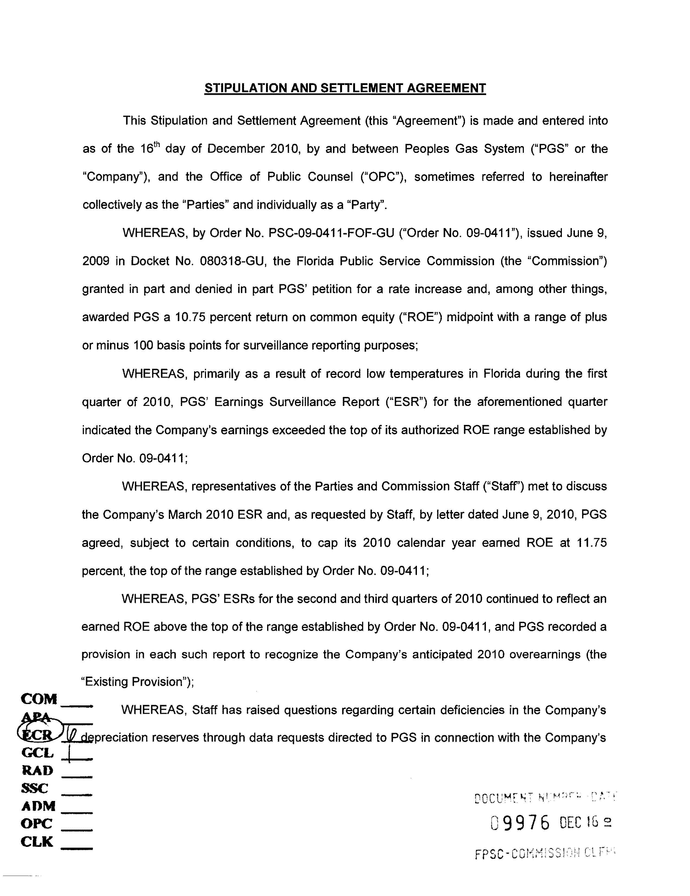
Attachment A
Page 2 of 6
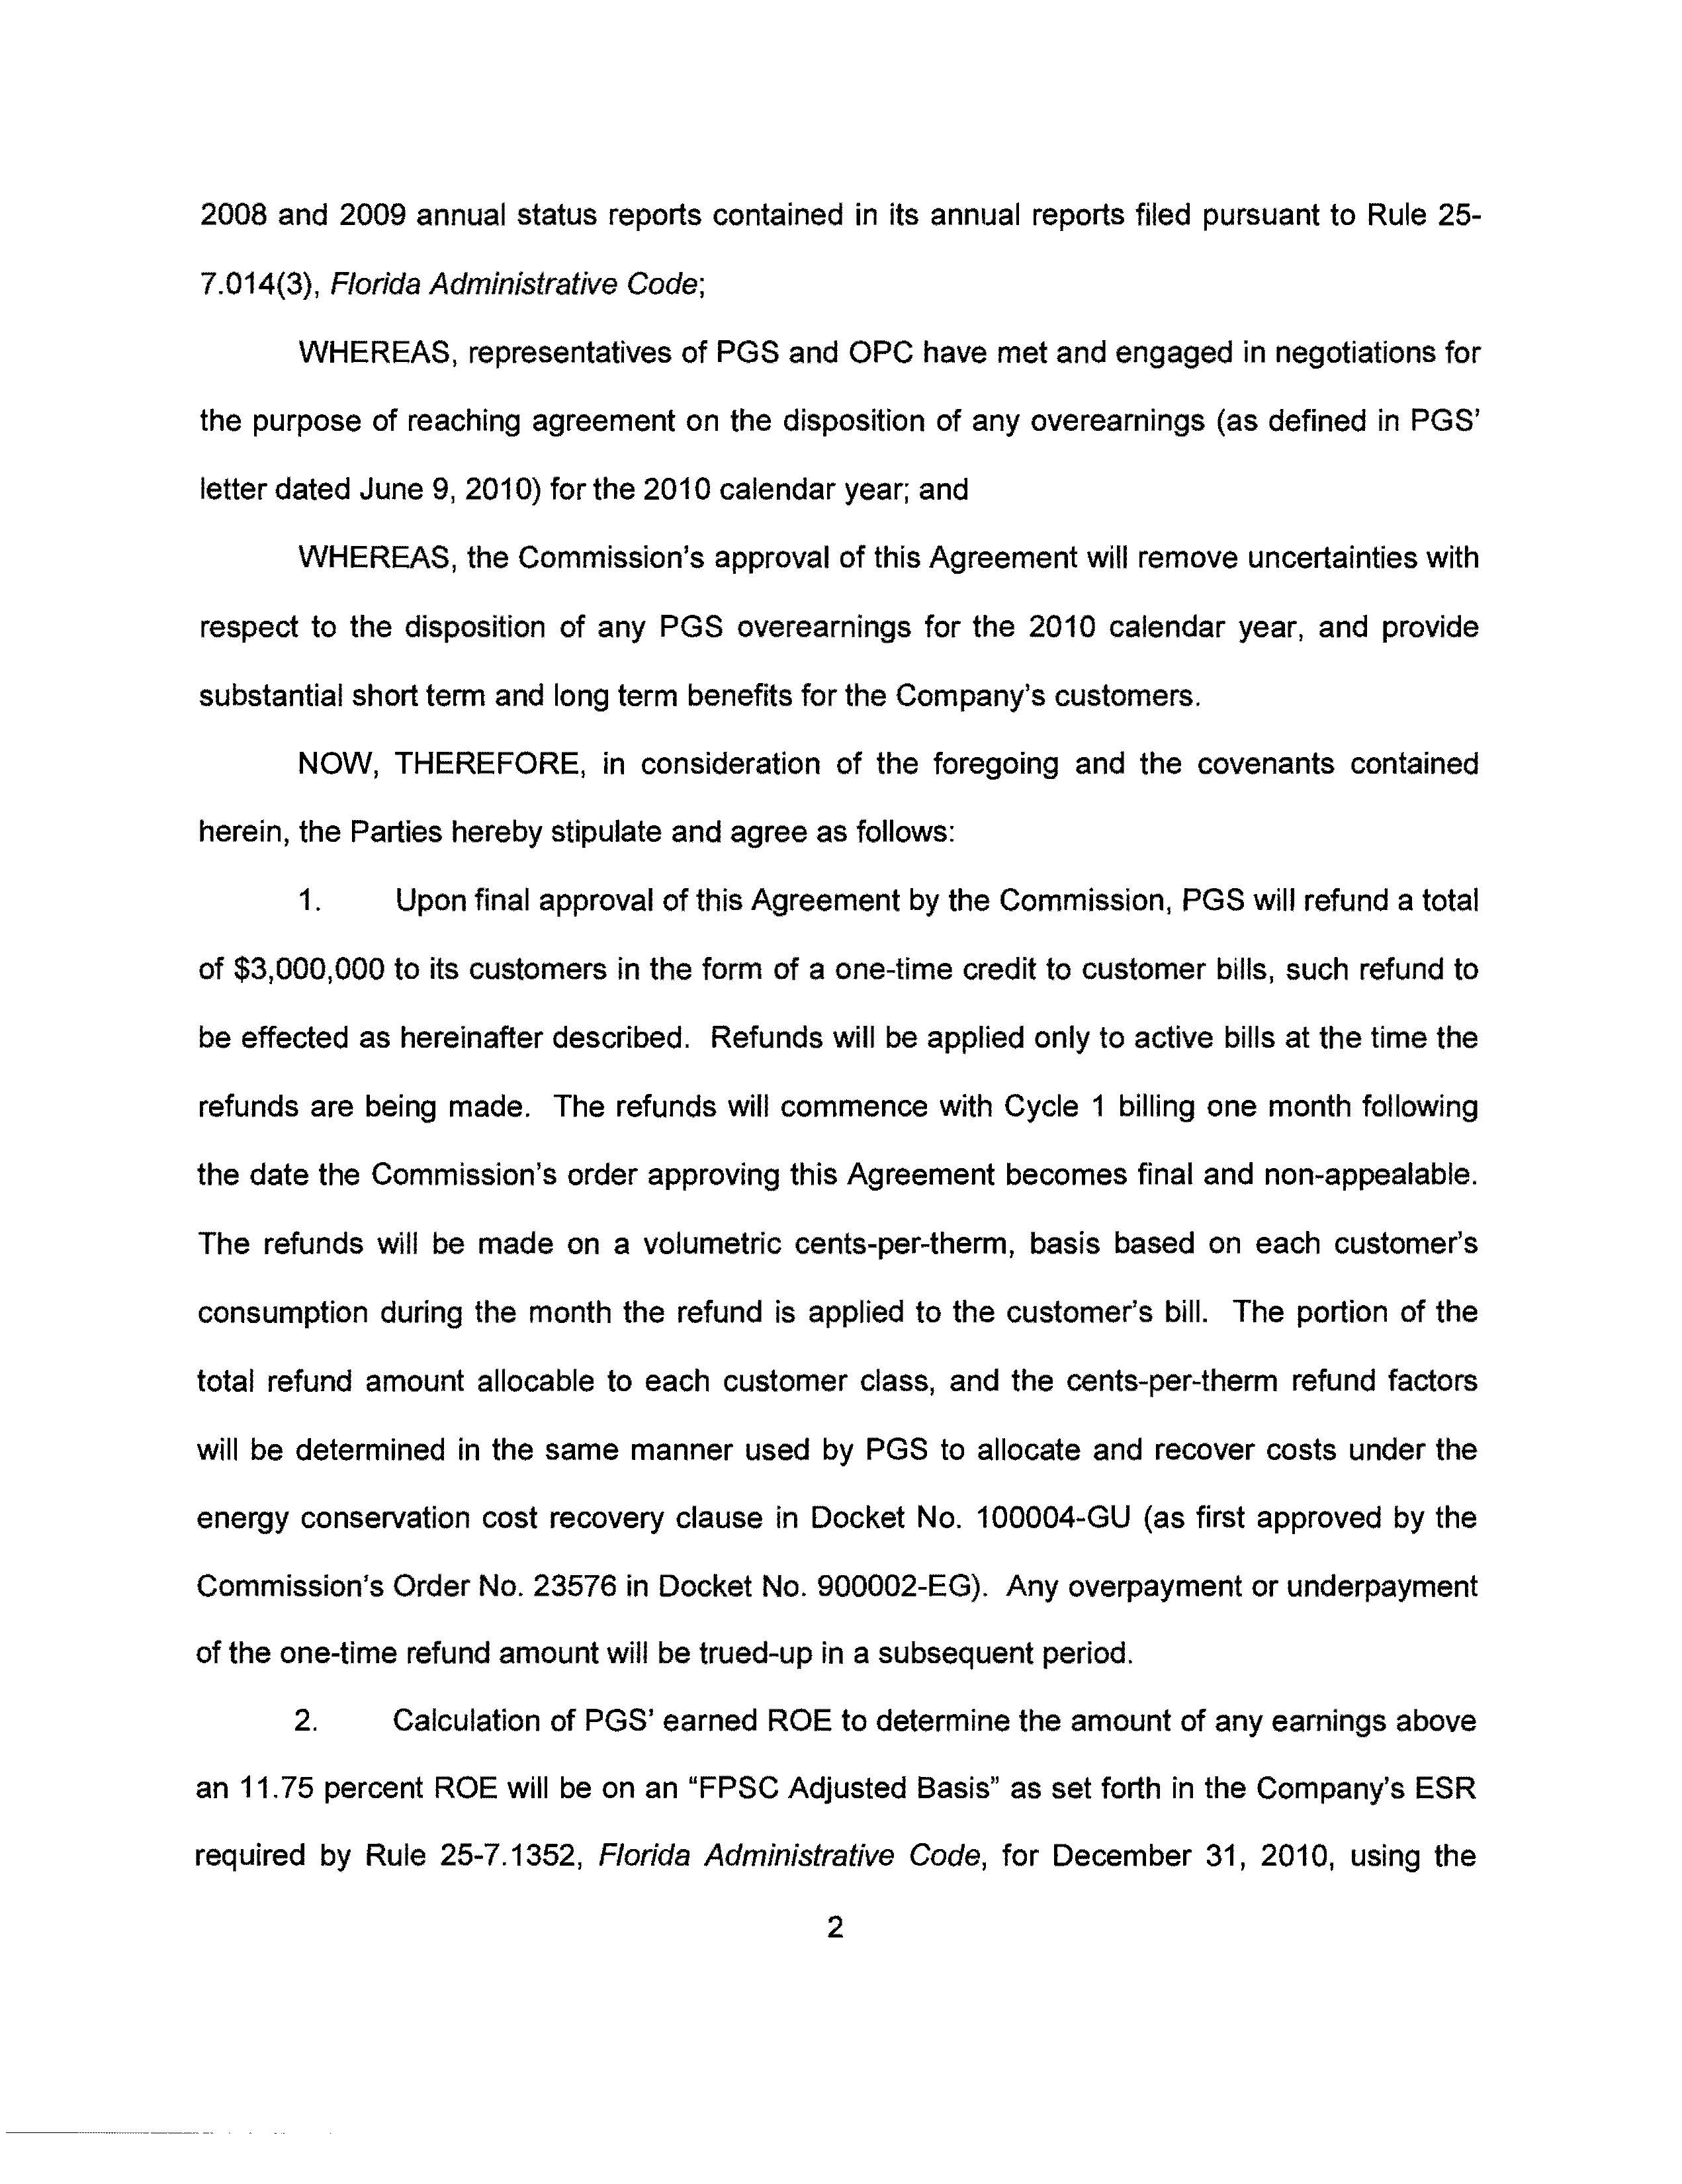
Attachment A
Page 3 of 6
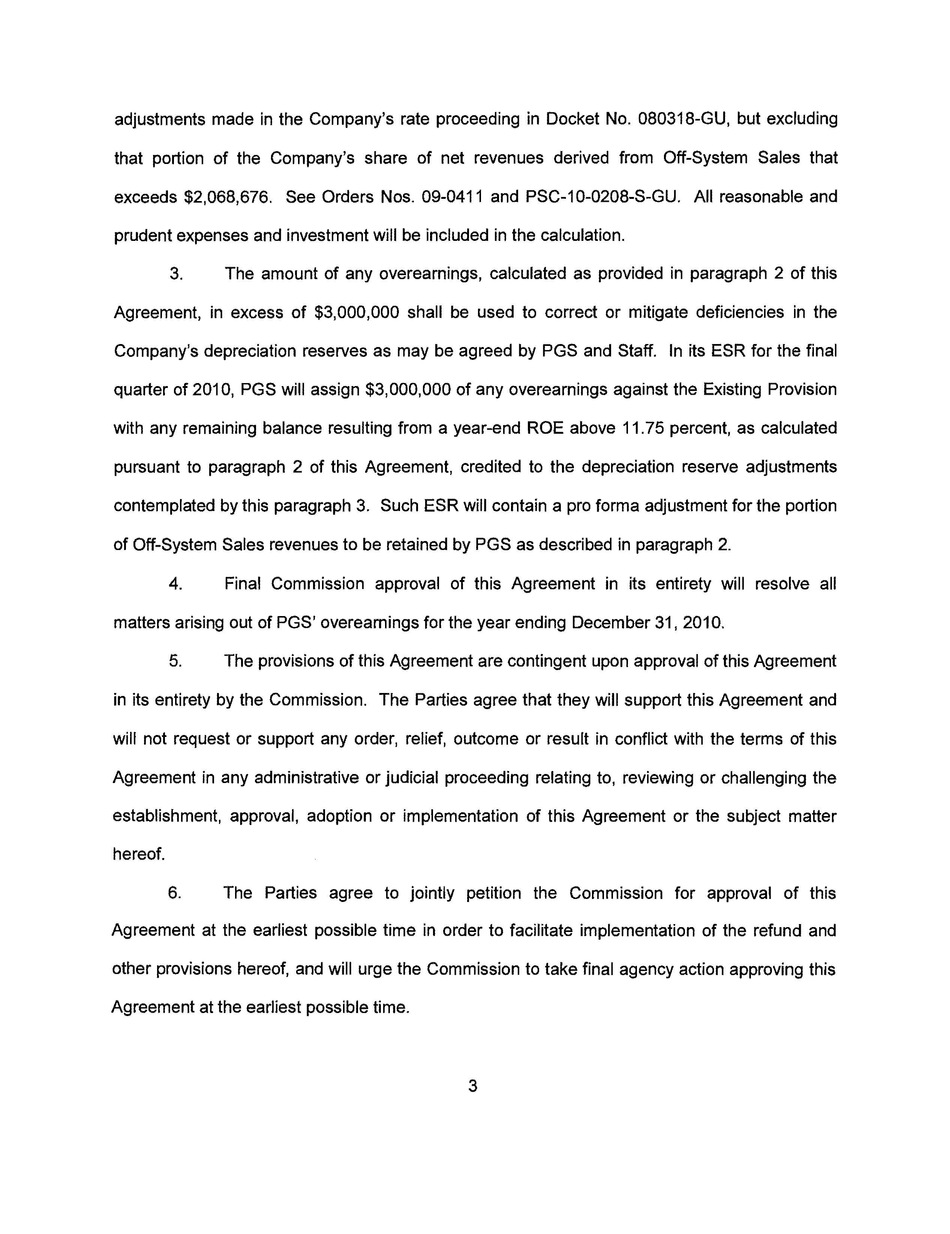
Attachment A
Page 4 of 6
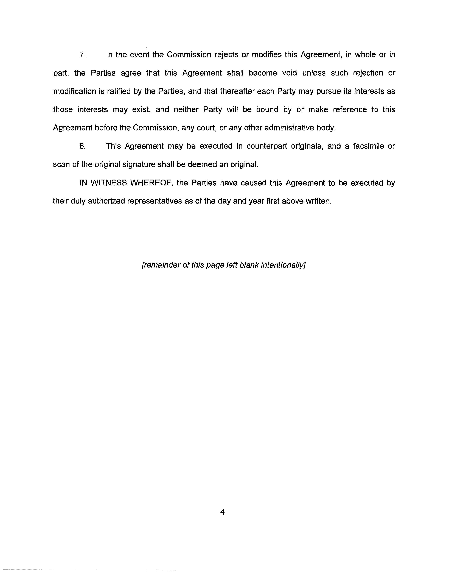
Attachment A
Page 5 of 6
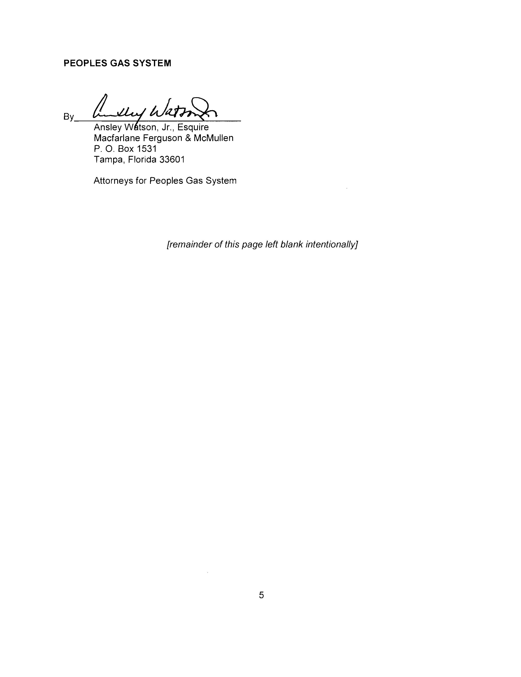
Attachment A
Page 6 of 6
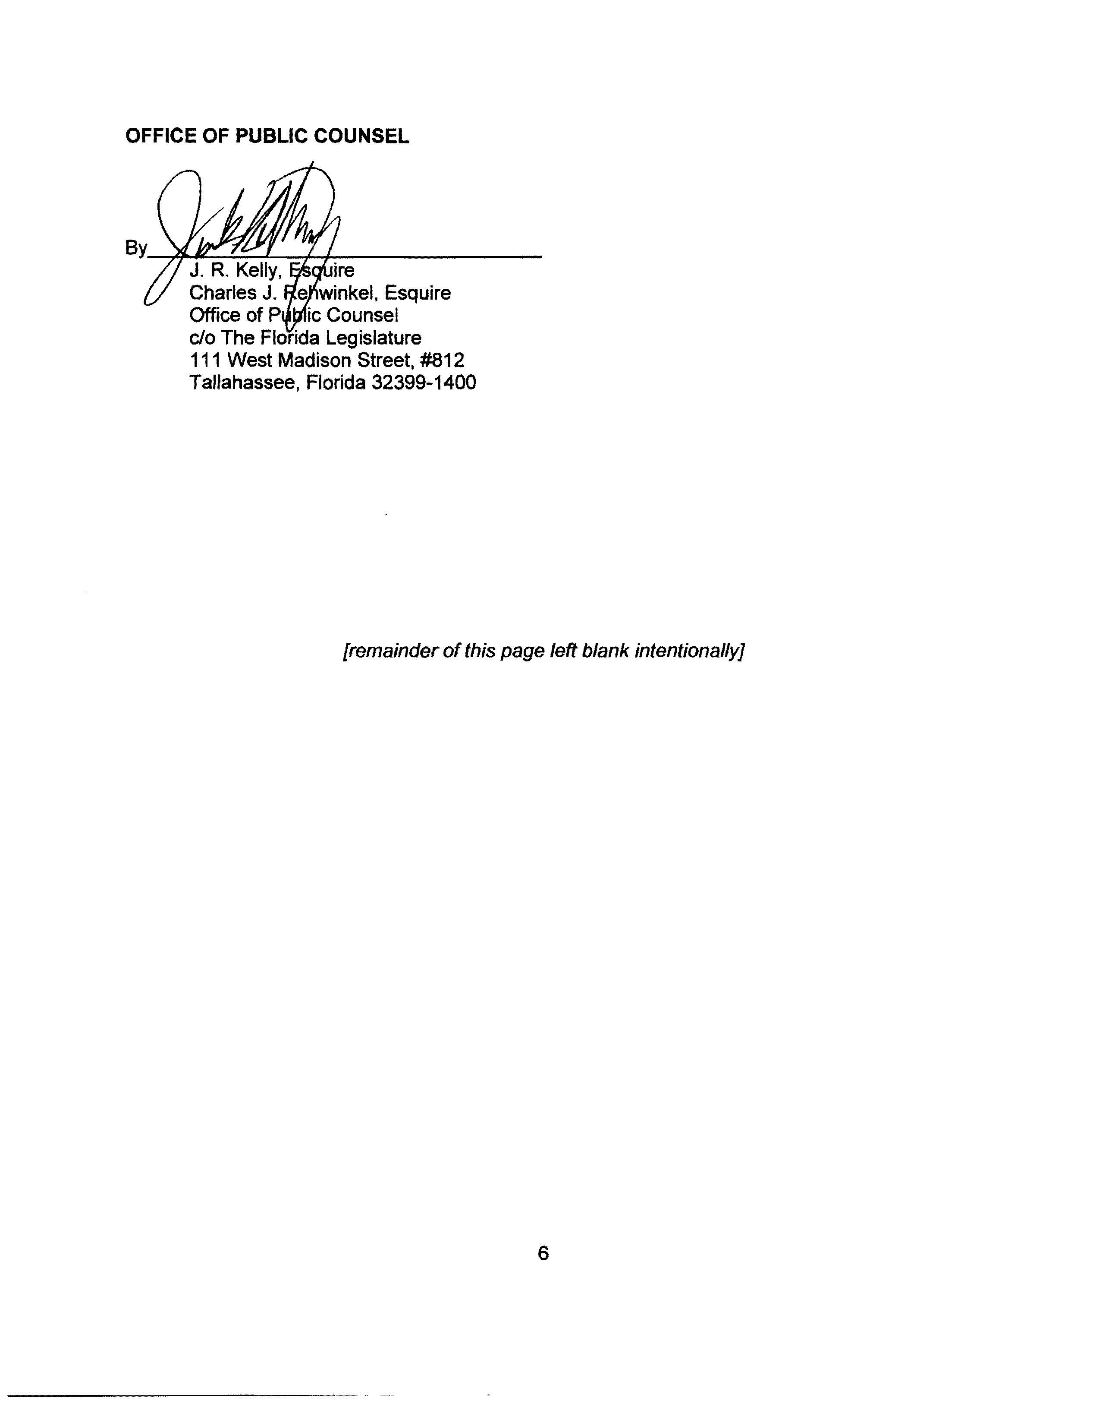

Order No. PSC-09-0411-FOF-GU, issued June 9, 2009, in Docket No. 080318-GU, In re: Petition for Rate Increase by Peoples Gas System.
Document No. 10088-10 in Docket No. 100462-GU.

