January 18, 2011
Via Electronic Delivery
Ann Cole
Commission Clerk
Florida Public Service Commission
2540 Shumard Oak Boulevard
Tallahassee, Florida 32399-0850
Re: Notification of the Indirect Transfer of Control of Saturn Telecommunication Services, Inc. d/b/a STS Telecom and STS Telecom, LLC to DeltaCom, Inc.

Dear Ms. Cole:
Saturn Telecommunication Services, Inc. d/b/a STS Telecom (“Saturn”), STS Telecom, LLC (“STS”), and DeltaCom, Inc. (collectively, the “Parties”) hereby notify the Florida Public Service Commission (“Commission”) of a transfer of control, whereby DeltaCom will acquire 100% of the shareholders’ equity interests in Saturn and STS. Saturn and STS are commonly owned by four individual shareholders: Keith Kramer, Mark Amarant, Gil Cohen and Andrew Silber. When the transfer is consummated, Saturn and STS will be wholly-owned and controlled by DeltaCom and indirectly controlled by ITC^DeltaCom, Inc. (“ITC”) and DeltaCom’s ultimate parent company, EarthLink, Inc. (“EarthLink”).
It is the Parties’ understanding that Commission approval is not required to complete the transaction described herein. Accordingly, the Parties submit this letter for information purposes only to ensure the continued accuracy of the Commission’s records.
- DESCRIPTION OF THE PARTIES
- Saturn Telecommunication Services Inc. d/b/a STS Telecom
Saturn is a privately-held corporation incorporated in Florida. Saturn is a full-service telecommunications company, providing retail voice, data and Internet services to predominantly small to medium-sized business customers in Florida and Georgia and predominantly interstate long distance services to customers in other locations. In Florida, Saturn is authorized to operate as a facilities-based competitive local exchange carrier pursuant to Certificate of Public Convenience and Necessity No. 8251 (Company Code TX698). It is also registered to operate as a reseller of interexchange services (Company Code TI292).

- STS Telecom, LLC
STS is a limited liability corporation organized in Florida. STS provides retail voice, data and Internet services to predominantly small to medium sized business customers in Florida. In Florida, STS is authorized to operate as a facilities-based Competitive Local Exchange Carrier pursuant to Certificate of Public Convenience and Necessity No. 8416 (Company Code TX749). It is also registered to operate as a reseller of interexchange services (Company Code TJ971).
- DeltaCom, Inc.

DeltaCom is a privately held corporation incorporated in Alabama. DeltaCom is a wholly-owned subsidiary of Interstate FiberNet, Inc. (“IFN”), a privately held Delaware corporation, which is a wholly-owned subsidiary of ITC, a privately held Delaware corporation. ITC is, in turn, a wholly-owned subsidiary of EarthLink, a publicly traded Delaware corporation (NASDAQ: ELNK).
DeltaCom provides competitive local exchange, exchange access and interexchange services primarily to business customers in Alabama, Florida, Georgia, Louisiana, Mississippi, North Carolina, South Carolina and Tennessee. DeltaCom and IFN hold the following certifications/registrations in Florida:
DeltaCom, Inc: CLEC CPCN No. 4764; IXC Registration TI889
Interstate FiberNet, Inc.: IXC CPCN No. 4392
II. CONTACT INFORMATION
Questions, correspondence, or other communications regarding this notification should be directed to the following:
For DeltaCom:
Jennifer P. Bagg |  | D. Anthony Mastando
Lampert, O’Connor & Johnston, P.C. |  | DeltaCom, Inc.
1776 K Street, NW, Suite 700 |  | 7037 Old Madison Pike
Washington, DC 20006 |  | Huntsville, AL 35806
Tel: | (202) 887-6230 | Tel: | 256-382-3856
Fax | (202) 887-6231 | Fax | 256-382-3936
Email: | bagg@lojlaw.com | Email: | tony.mastando@corp.earthlink.com

For Saturn and STS:
Sharon Thomas, Consultant |  | Gregg D. Josephson
Technologies Management, Inc. |  | DOWNEY BRAND LLP
2600 Maitland Center Pkwy, Suite 300 |  | 621 Capitol Mall, 18th Floor
Maitland, Florida 32751 |  | Sacramento, CA 95814
Tel: | (407) 740-3031 | Tel: | (916) 520-5428
Fax: | (407) 740-0613 | Fax: | (916) 520-5828
Email: | sthomas@tminc.com | Email: | gjosephson@downeybrand.com

The name and address of the individual who handles regulatory affairs on behalf of Saturn and STS is:
Becky West, Controller
12399 SW 53rd Street
Cooper City, FL 33330
Tel: | (954) 252-1023
Fax: | (786) 363-0147
Email: | bwest@ststelecom.com

III. DESCRIPTION OF THE TRANSACTION
On December 17, 2010, ITC and the shareholders of Saturn and STS executed and entered into a purchase agreement whereby ITC proposes to purchase all of the shareholders’ equity interests in Saturn and STS in return for a cash payment. On January 10, 2011, ITC assigned and DeltaCom assumed ITC’s right and obligations under the purchase agreement, including the right to purchase all of the Saturn and STS equity interests. As a result of the proposed transaction, Saturn and STS will be wholly-owned and directly controlled by DeltaCom and indirectly controlled by ITC and DeltaCom’s ultimate parent company, EarthLink. Diagrams depicting the pre- and post-transaction corporate structures of the companies are attached hereto as Exhibit A.
The proposed transaction does not involve the transfer of any customers between Saturn, STS and DeltaCom. Immediately following the consummation of the transaction, Saturn and STS will continue to provide service to Saturn’s and STS’s existing customers, who will continue to enjoy the same services as they do prior to closing. Accordingly, the proposed transfer of control will be transparent to Saturn and STS customers in terms of the services they receive.
Consummation of the transaction is contingent upon receipt of certain regulatory approvals and satisfaction of customary closing conditions. The transaction is expected to be completed in the first quarter of 2011, subject to all regulatory approvals.

IV. PUBLIC INTEREST IMPACT
The proposed transaction will serve the public interest by ensuring that Saturn’s and STS’s customers enjoy continued high-quality telecommunications service from a financially and managerial sound company, DeltaCom, with a long-standing track record as a provider of high-quality telecommunications services. The complementary strengths, product sets, and geographic footprints of DeltaCom and Saturn and STS should position DeltaCom to realize cost savings and achieve synergies that are expected to strengthen its ability to enhance service offerings and provide more advanced communications services to a broader customer base. Moreover, DeltaCom’s ultimate parent, EarthLink, brings considerable financial, managerial and technical resources that will further enhance the ability of Saturn and STS to continue to effectively compete in the telecommunications industry.
Although DeltaCom’s acquisition of Saturn and STS will result in a change in the ultimate ownership and control of Saturn and STS, no direct transfer of authorization, assets, or customers will occur as a result of the transfer of control. Immediately following consummation of the merger, Saturn and STS will continue to provide service to customers of Saturn and STS pursuant to their existing authorizations. The transfer of control will be transparent to Saturn’s and STS’s customers in terms of the services they currently receive.
In sum, the acquisition by DeltaCom of Saturn and STS is expected to create substantial opportunities for customers of both companies and will ultimately enhance the quality and variety of telecommunications products and services offered.
Should you have any questions with respect to this matter, please do not hesitate to contact me.

Respectfully submitted,
/s/
Jennifer P. Bagg
Counsel for DeltaCom, Inc.

EXHIBIT A

Pre- and Post- Transaction Corporate Structure Charts

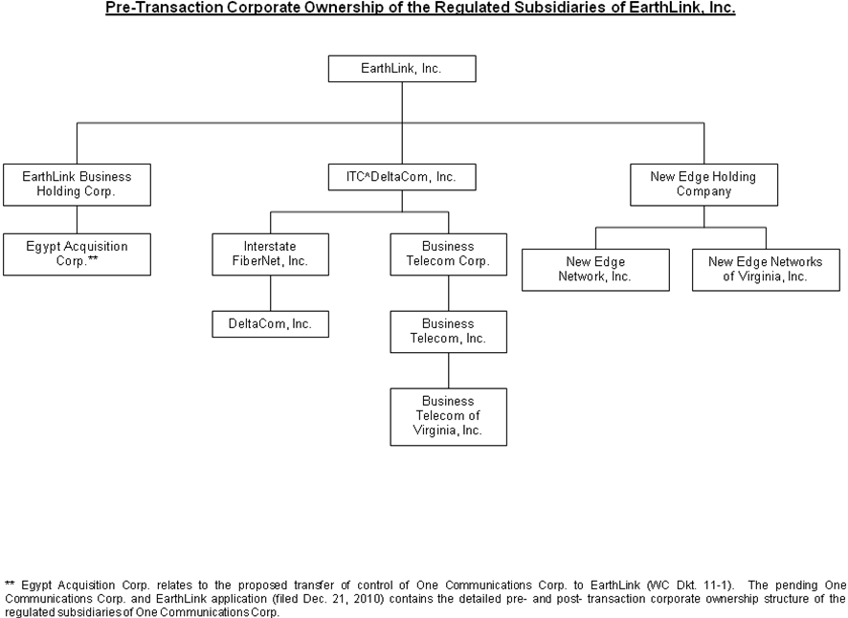

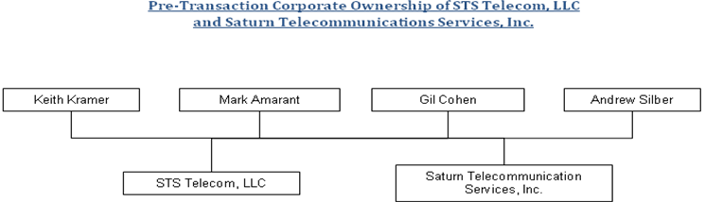

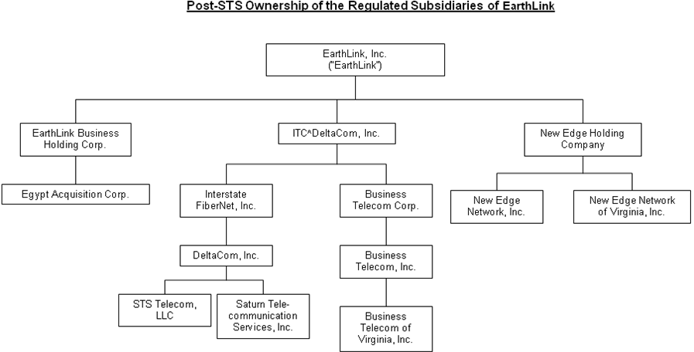

EarthLink’s regulated operating subsidiaries include DeltaCom, IFN, Business Telecom, Inc., Business Telecom of Virginia, Inc., New Edge Network, Inc., and New Edge Networks of Virginia, Inc. (collectively, the “EarthLink Licensees”). Through the EarthLink Licensees, EarthLink provides traditional and Internet Protocol voice and data services in all 50 states plus the District of Columbia. A pre-transaction corporate structure chart for EarthLink is provided as part of Exhibit A. Additional information regarding EarthLink, including its most recent SEC Form 10-Q, as filed with the Securities and Exchange Commission, is available at http://www.earthlink.net/about/investor/.

