State of Florida   |  | Public Service Commission  Capital Circle Office Center ● 2540 Shumard Oak Boulevard  Tallahassee, Florida 32399-0850  -M-E-M-O-R-A-N-D-U-M-
DATE: | May 12, 2011
TO: | Office of Commission Clerk (Cole)
FROM: | Division of Regulatory Analysis (Casey, Kennedy)  Office of the General Counsel (Miller)
RE: | Docket No. 040763-TP – Request for submission of proposals for relay service, beginning in June 2005, for the hearing and speech impaired, and other implementation matters in compliance with the Florida Telecommunications Access System Act of 1991.
AGENDA: | 05/24/11 – Regular Agenda – Interested Persons May Participate
COMMISSIONERS ASSIGNED: |  |  | All Commissioners
PREHEARING OFFICER: |  |  | Edgar
CRITICAL DATES: |  |  | July 1, 2011 - Effective date of FTRI budget. Notification of any change in the TASA surcharge must be made to carriers prior to July 1, 2011.
SPECIAL INSTRUCTIONS: |  |  | Anticipate the need for sign language interpreters and assisted listening devices. Please place near the beginning of the agenda to reduce interpreter costs.
FILE NAME AND LOCATION: |  |  | S:\PSC\RAD\WP\040763.RCM.DOC

Case Background
The Florida Relay System (FRS) provides deaf and hard of hearing persons access to basic telecommunications services by using a specialized communications assistance operator (CA) that relays information between the deaf or hard of hearing person and the other party of the call. The primary function of the FRS is accomplished by the deaf or hard of hearing person using a Telecommunications Device for the Deaf (TDD) which has a keyboard and screen. The person using the TDD types a message to the CA who in turn voices the message to the other party. The reverse of this process completes messages to the deaf or hard of hearing person. This is how the term “relay” originated.
The Telecommunications Access System Act of 1991 (TASA) established a statewide telecommunications relay system and became effective May 24, 1991. TASA is authorized under Chapter 427, Florida Statutes. Section 427.701(1), Florida Statutes, provides that the Florida Public Service Commission (FPSC or Commission) shall establish, implement, promote, and oversee the administration of the statewide telecommunications access system to provide access to telecommunications relay services by persons who are deaf, hard of hearing or speech impaired, or others who communicate with them. It is estimated that 3 million of the estimated 18.8 million persons living in Florida have been diagnosed as having hearing loss. This system provides telecommunications service for deaf or hard of hearing persons functionally equivalent to the service provided to hearing persons. TASA provides funding for the distribution of specialized telecommunications devices and provision of intrastate relay service through the imposition of a surcharge of up to $0.25 per landline access line per month. Accounts with over 25 access lines are billed for only 25 lines. Florida law does not allow a telecommunications relay service (TRS) surcharge on VoIP or wireless provider lines as the federal TRS program does. Pursuant to Section 427.704(4)(a)1, Florida Statutes, a surcharge is collected only from landline access lines. Accounts with over 25 access lines are billed for only 25 lines.
Florida Telecommunications Relay, Inc. (FTRI), a non-profit corporation formed by the local exchange telephone companies (LEC), was named by the FPSC to serve as the TASA administrator. On July 1, 1991, the LECs began collecting an initial $.05 per access line surcharge pursuant to Order No. 24581. Since that time, the surcharge has changed to reflect budgetary needs, but has been maintained at $0.11 per month since June 2007.
The purpose of this recommendation is to approve FTRI’s 2011-2012 proposed budget. The Commission is vested with jurisdiction over these matters pursuant to Chapter 427, Florida Statutes.

Discussion of Issues
Issue 1:1
Should the Commission approve FTRI’s proposed budget as outlined in Attachment A for the fiscal year 2011-2012, effective July 1, 2011, and should the Commission maintain the current Telecommunications Relay Service (TRS) surcharge of $0.11 per month?
Recommendation:
Staff recommends that the Commission approve FTRI’s proposed budget operating revenue of $9,638,400, and proposed budget expenses of $13,985,908 as outlined in Attachment A for the fiscal year 2011-2012, effective July 1, 2011, with one exception. Staff recommends an increase of $7,634 in Relay Provider Services. Staff also recommends that the TRS surcharge be maintained at $0.11 per month for the fiscal year 2011-2012, effective July 1, 2011. The Commission should order the incumbent local exchange companies, competitive local exchange companies, and shared tenant providers to continue to bill the $0.11 surcharge for the fiscal year 2011-2012, effective July 1, 2011. (Casey, Kennedy, Miller)
Staff Analysis:
As shown in Table A, minutes of use for traditional TRS has been declining. Sprint Relay, Florida’s current relay provider, projects that the traditional TRS minutes will continue to decline at a rate of approximately 1 percent per month or 11.98 percent for the 2011-2012 fiscal year. Traditional relay users are transitioning to the more efficient technologies of IP Relay, Video Relay Service (VRS), CapTel captioning service, IP Captioned Telephone Service (IP CTS), IP Speech to Speech service (IP STS), and Blackberry or Palm wireless devices.

Table A – Florida Traditional TRS Minutes March 2008 – February 2011
CapTel Service
CapTel service, is a telephone that provides captioning of the incoming call for a deaf or hard of hearing person. Sprint Relay projects that the CapTel minutes of use will increase approximately 2 percent per month or 23.84 percent for the 2011-2012 fiscal year. The CapTel cost as approved in the current Sprint Relay contract is $1.47 per minute ($1.54 per minute after June 1, 2011). Table B shows the historical CapTel minutes of use from March 2008, through February 2011.

Table B – CapTel minutes of use March 2008 – February 2011
FTRI Budget
The FTRI 2011-2012 fiscal-year budget was reviewed and approved by the FTRI Board of Directors on March 28, 2011, prior to the filing of its budget with the FPSC. The proposed budget includes an increase in expenses of approximately $833,000 from the 2010-2011 budget year. The budget projects total revenues to be $9,638,400 and total expenses to be $13,985,908. FTRI believes that the TRS surcharge can remain at $0.11 per access line for the 2011-2012 fiscal year, with its estimated revenue shortfall of $4,347,508 being covered through the surplus account.
Staff reviewed Sprint Relay’s TRS and CapTel minutes of use projections for the 2011-2012 FTRI budget period. Staff discovered a Sprint Relay multiplication error in the CapTel projected minutes of use. Staff brought this to the attention of Sprint Relay which submitted revised numbers on April 15, 2011, which included revised CapTel minutes of use. The revised CapTel estimated minutes of use are 2,704,187 at a rate of $1.54 per minute for a total of $4,164,448. Staff increased FTRI’s total proposed relay service provider cost from $5,908,164 to $5,915,798 (Captel $4,164,448 and Regular TRS $1,751,350) for the 2011-2012 fiscal year to reflect the regular TRS minutes of use and the corrected CapTel minutes of use projected for the FTRI 2011-2012 fiscal-year. (See Attachment B, Sheet 3 of 3).
After analysis of the proposed budget, staff believes FTRI should have sufficient funds for its 2011-2012 fiscal-year budget and reserve account. Therefore, staff believes that the surcharge should be maintained at $0.11 per month to cover the FTRI 2011-2012 budget. A comparison of FTRI’s 2011-2012 proposed budget, staff’s proposed 2011-2012 budget, and the current 2010-2011 estimated revenue and expenditures is shown below.

 | FTRI Proposed | Staff Proposed | Current
Operating Revenue: | 2011-2012 | 2011-2012 | 2010-2011
Surcharges | $ 9,553,960 | $ 9,553,960 | $9,849,443
Interest Income | 84,440 | 84,440 | 97,875
Total Operating Revenue | $ 9,638,400 | $ 9,638,400 | $9,947,318
Operating Expenses:
Relay Provider Services | $ 5,908,164 | $ 5,915,798 | $ 3,525,963
Equipment and Repairs | 3,804,953 | 3,804,953 | 1,497,198
Equipment Distribution And Training | 1,917,517 | 1,917,517 | 1,917,517
Outreach | 886,600 | 886,600 | 861,400
General & Administrative | 1,468,674 | 1,468,674 | 1,303,137
Total Expenses | $13,985,908 | $13,993,542 | $13,054.651
Deficit | (4,347,508) | ($4,355,142)
Projected Surplus at June 30, 2012 | $11,871,064 | $11,863,430

Conclusion
Staff has reviewed FTRI’s 2011-2012 fiscal year budget request and believes it is reasonable after staff’s adjustments for Relay Provider Services. The current TRS surcharge of $0.11 should meet FTRI’s budget needs for the 2011-2012 fiscal year. Therefore, staff recommends that the Commission approve FTRI’s proposed budget operating revenue of $9,638,400, and revised budget expenses of $13,993,542 for the fiscal year 2011-2012, effective July 1, 2011, as outlined in Attachment A. Staff also recommends that the TRS surcharge be maintained at $0.11 per month for the fiscal year 2011-2012, effective July 1, 2011. The Commission should order the incumbent local exchange companies, competitive local exchange companies, and shared tenant providers to continue to bill the $0.11 surcharge for the fiscal year 2011-2012, effective July 1, 2011.
Issue 2:2
Should this docket be closed?
Recommendation:

No. This docket should remain open for the duration of the contract period with Sprint as the relay provider. This docket is used to monitor relay and contract issues that arise during the contract term. (Miller)
Staff Analysis:
This docket should remain open for the duration of the contract period with Sprint as the relay provider. This docket is used to monitor relay and contract issues that arise during the contract term.

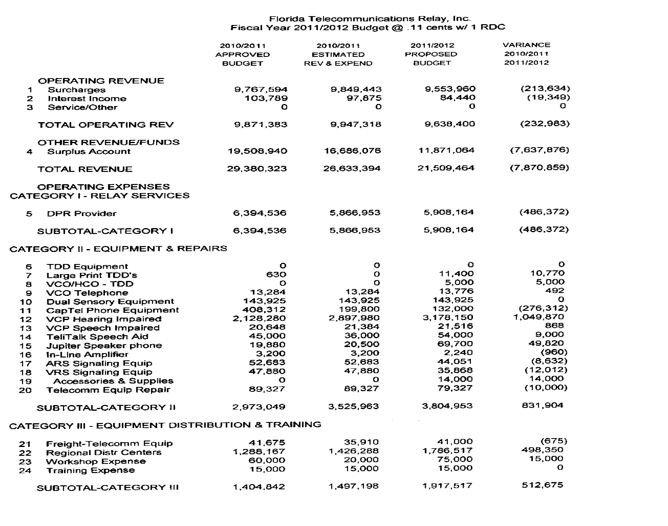
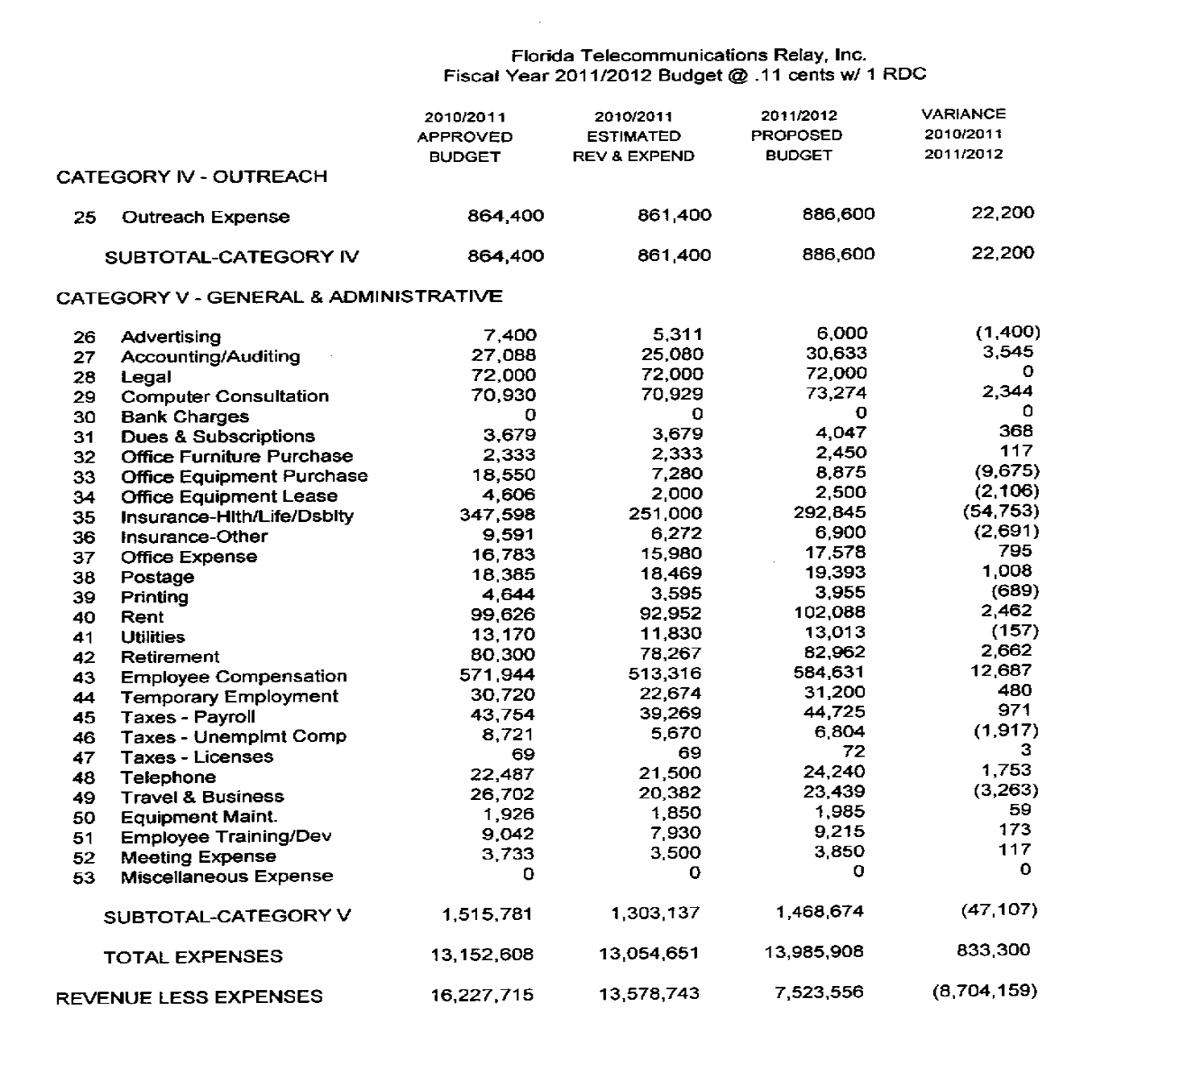

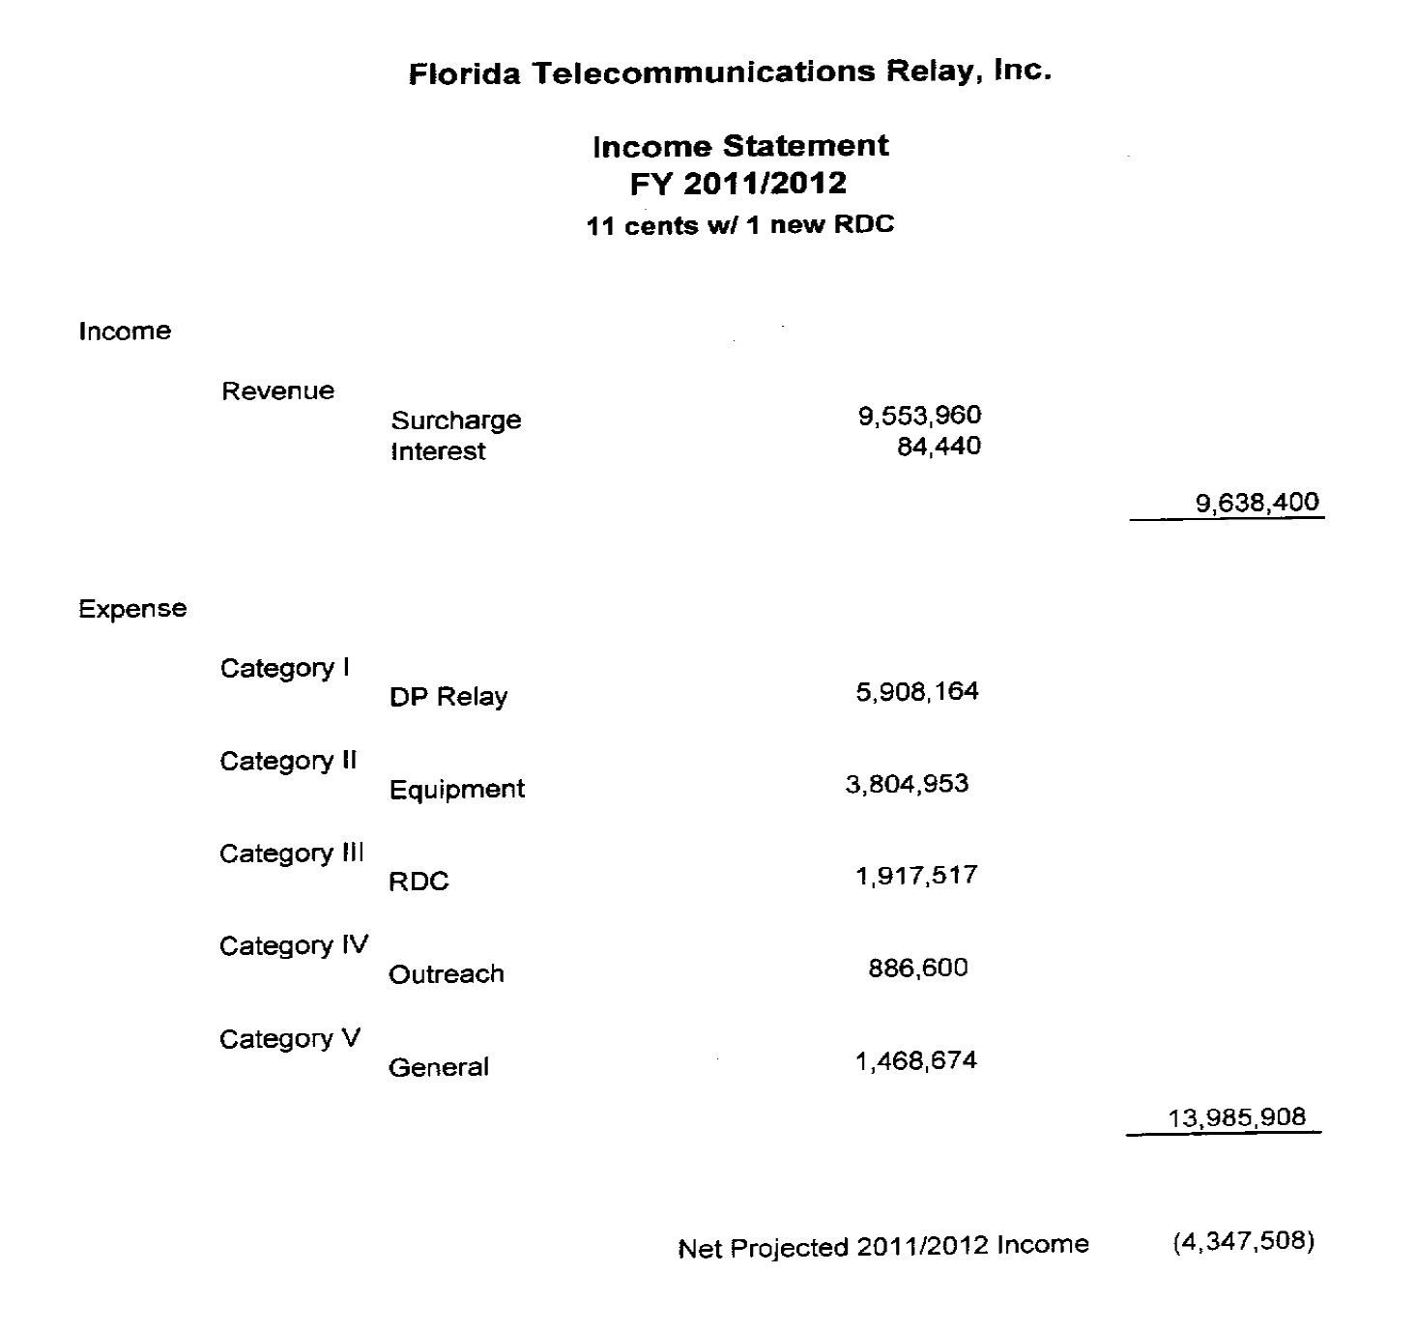

Florida Telecommunications Relay, Inc. projects another decrease in landline access lines subject to the relay surcharge for the budget year 2011-2012. In addition, with the redefinition of basic local service passed by the Legislature in 2009, some competitive local exchange companies are not collecting or paying the relay surcharges on what they now consider is a non-basic line.
IP Relay allows people who have difficulty hearing or speaking to communicate through an Internet connection using a computer and the Internet, rather than a TTY and a telephone.
Video Relay Service is a form of Telecommunications Relay Service that enables persons with hearing disabilities who use American Sign Language to communicate with voice telephone users through video equipment, rather than through typed text. Video equipment links the VRS user with a TRS operator so that the VRS user and the operator can see and communicate with each other in signed conversation. Because the conversation between the VRS user and the operator flows much more quickly than with a text-based TRS call, VRS has become a popular form of TRS.
IP captioned telephone service allows the user to simultaneously listen to, and read the text of, what the other party in a telephone conversation has said, where the connection carrying the captions between the service and the user is via an IP addressed and routed link.
Speech to Speech relay service utilizes a specially trained CA who understands the speech patterns of persons with speech disabilities and can repeat the words spoken by such an individual to the other party to the call. IP STS uses the Internet, rather than the public switched telephone network, to connect the consumer to the relay provider. Instead of using a standard telephone to make the relay call, an IP STS user can use a personal computer or personal digital assistant (PDA) device and, with the installation of softphone application software, can make a voice call via the Internet to the relay provider. The call is initiated by the user clicking on an icon on his or her computer or PDA; the relay user is then connected to a CA over the Internet and tells the CA the number to be dialed; the CA then connects the IP STS user with the called party and relays the call between the two parties.
IP Relay and VRS users are presently having their relay minutes of use paid through the interstate TRS fund. However, the Federal Communications Commission (FCC) has repeatedly stated that this arrangement is only temporary. The FCC believes Title IV of the Americans with Disabilities Act and its legislative history make it clear that Congress intended for the states to be responsible for the cost recovery for intrastate relay services provided under their jurisdiction. The FCC has not formally opined on the time frame when the IP Relay and VRS costs will shift to the states or what the intrastate/interstate cost allocation will be. Staff estimates that the total monthly responsibility of intrastate IP Relay and VRS costs would be approximately $32 million annually. The $32 million additional IP Relay and VRS costs could increase the annual budget for Florida TRS to over $46 million and likely exceed the current $0.25 cap per access line allowed by statute. If this happens, a legislative change may be necessary to either increase the present TRS cap for local exchange company lines or have all carriers such as wireless and VoIP providers charge the surcharge as the federal TRS program does. In order to minimize the impact of this change on the Florida TRS Fund, the Commission, by Order PSC-06-0469-PAA-TP, issued June 1, 2006, took action in the 2006-2007 FTRI budget year by maintaining a $0.15 per month TRS surcharge to create a reserve to handle the initial costs of the intrastate VRS and IP Relay cost burden. It is estimated that this will provide a reserve in the Florida TRS fund of $16,686,076 by the end of the current fiscal year in June 2011. This reserve amount should be enough to accommodate the initial intrastate VRS and IP Relay costs should the FCC make a decision in the next fiscal year.

