State of Florida   |  | Public Service Commission  Capital Circle Office Center ● 2540 Shumard Oak Boulevard  Tallahassee, Florida 32399-0850  -M-E-M-O-R-A-N-D-U-M-
DATE: | September 22, 2011
TO: | Office of Commission Clerk (Cole)
FROM: | Division of Economic Regulation (Brady, Deason, Kaproth, Walden)  Office of the General Counsel (Crawford)
RE: | Docket No. 100085-WU – Application for certificate to operate water utility in Lake County by Black Bear Reserve Water Corporation.  County: Lake
AGENDA: | October 4, 2011 – Regular Agenda – Proposed Agency Action for Issues 3, 5, 6, and 7 -- Interested Persons May Participate
COMMISSIONERS ASSIGNED: |  |  | All Commissioners
PREHEARING OFFICER: |  |  | Brown
CRITICAL DATES: |  |  | October 4, 2011 (Statutory deadline for original certificate pursuant to Section 367.031, Florida Statutes)
SPECIAL INSTRUCTIONS: |  |  | None
FILE NAME AND LOCATION: |  |  | S:\PSC\ECR\WP\100085.RCM.DOC

Case Background
On February 19, 2010, Black Bear Reserve Water Corporation (Black Bear or Utility), filed an application for an original water certificate in Lake County. The Utility is located in the St. Johns River Water Management District (SJRWMD) within a water resource caution area. The Utility currently provides water service to approximately 300 residential customers and a clubhouse. Wastewater treatment is provided by septic tanks.
The Utility was established in 1998 by the original developer as a corporation solely owned by a master homeowners’ association (HOA) known as Black Bear Reserve Homeowners Association, Inc. (BBRHOA). The BBRHOA Board consisted of the developer, having majority control, and the Presidents of the individual HOAs for the subdivisions of Upson Downs, Villages at Black Bear Reserve, Lakes at Black Bear, and Estates at Black Bear Reserve Phase III. Water service to the member lots was initially provided without compensation. In February 2004, the Utility installed meters and initiated conservation rates, along with the requirement for a connection fee of $2,500. Later in 2004, water from a lake in the community was made available for irrigation on separate meters with separate conservation rates. In 2004, staff began receiving inquiries from customers about rates and charges. After each investigation, staff determined that BBRHOA appeared to be exempt from Commission regulation pursuant to Section 367.022(7), Florida Statutes (F.S.), which exempts nonprofit corporations providing service solely to members which own and control the nonprofit corporation.
By 2007, a new development of 50 homes in the adjacent subdivisions of Clar Mart I and II was completed. Although the Clar-Mart Homeowner’s Association, Inc. (Clar-Mart HOA) had been established for these subdivisions by the original developer, the developer of the Clar Mart homes failed to make membership in the Clar-Mart HOA mandatory and most homeowners in the subdivisions chose not to voluntarily join. In 2008, staff received an inquiry from a Clar Mart resident about the Utility’s charges for potable water and irrigation service. As part of the investigation, staff confirmed that the Clar-Mart HOA was not active and, therefore, had no representation in the master BBRHOA. By letter dated October 20, 2009, staff advised the Board of Directors of the BBRHOA that Black Bear’s water service was no longer exempt from Commission regulation because service was being provided to non-members and requested that the BBRHOA file an application for an original water certificate for Black Bear.
On December 8, 2009, control of the BBRHOA passed from the original developer to the BBRHOA members, whose new Board of Directors filed the February 19, 2010 application in this docket for an original certificate for Black Bear. The BBRHOA and the original developer, operating as Upson Downs Limited Partnership (Upson Downs), are currently in civil litigation over ownership of the irrigation system. For a short period of time, members of the BBRHOA were being double-billed for water services by Black Bear and Upson Downs. In consultation with staff, the litigants agreed that Black Bear would bill customers pending resolution of their litigation.
On or about June 19, 2010, Black Bear noticed its application for a water certificate to which Upson Downs and three customers filed timely objections. The three customers subsequently chose not to pursue their objections to an administrative hearing. Noticed informal meetings were held on November 12 and December 7, 2010, to address the outstanding objection by Upson Downs and identify issues in anticipation of a hearing. On December 21, 2010, Order No. PSC-10-0740-PCO-WU was issued establishing procedures for an administrative hearing to be held on June 21-22, 2011.
At the joint request of Black Bear and Upson Downs, another noticed informal meeting was held on February 15, 2011, in which the two parties announced a proposed settlement agreement. On February 16, 2011, a Joint Motion for Stay was filed by the parties. By Order No. PSC-11-0155-PCO-WU, issued March 7, 2011, the proceedings were stayed for 120 days pending notification of final settlement by the parties. On March 8, 2011, the parties filed a Joint Motion Requesting Commission Approval of Stipulation and Settlement Agreement (Agreement), which is appended to this recommendation as Attachment A.
According to the Agreement, the parties agreed to place the irrigation assets into a separate corporate entity, thereby removing the issues associated with the provision of irrigation service from this docket. Section 367.022(11), F.S., provides that any entity providing nonpotable water for irrigation in a geographic area where potable water service is available from another utility is exempt from Commission regulation. Further, pursuant to the Agreement, Upson Downs does not further contest any remaining issues.
Pursuant to Section 367.031, F.S., the Commission shall grant or deny an application for a certificate of authorization within 90 days after the official filing date of the completed application. Black Bear’s application was initially completed on July 6, 2010, but was immediately protested, which stayed the 90-day clock. After the Agreement was filed in March 2011, staff requested that the Utility update the application. On September 8, 2011, the Utility completed its responses to staff’s request for updated information and provided a waiver of the statutory deadline until October 4, 2011. Therefore, this application must be ruled upon by October 4, 2011. Also, in its September 8th filing, the Utility noted that it was in the process of seeking a pass-through rate adjustment that will permit it to recover regulatory assessment fees (RAFs) from its customers, pursuant to Section 367.081(4)(b), F.S., and requested that the Commission set the starting date for payment of RAFs for the first billing cycle after the effective date of the rate adjustment.
This recommendation addresses the Agreement, water certificate, establishment of initial rates and charges, and RAFs. The Commission has jurisdiction pursuant to Section 350.113, F.S. and Sections 367.031, 367.045, 367.081, 367.091, and 367.161, F.S.
Discussion of Issues
Issue 1:1
Should the Commission order Black Bear Water Reserve Corporation to show cause, in writing within 21 days, why it should not be fined for operating a water utility without a certificate of authorization in apparent violation of Chapter 367.031, F.S.?
Recommendation:
No. Black Bear should not be ordered to show cause for operating a water utility without a certificate of authorization. (Crawford)
Staff Analysis:
Section 367.031, F.S., provides that “each utility subject to the jurisdiction of the commission must obtain from the commission a certificate of authorization to provide water or wastewater service.” Moreover, Section 367.161(1), F.S., authorizes the Commission to assess a penalty of not more than $5,000 for each offense, if a utility is found to have knowingly refused to comply with, or to have willfully violated any provision of Chapter 367, F.S. Utilities are charged with the knowledge of the Commission’s statutes and rules. Thus, any intentional act, such as Black Bear providing service to non-members without first obtaining a certificate of authorization from the Commission, would meet the standard for a “willful violation” of Section 367.161(1), F.S. In Order No. 24306, issued April 1, 1991, in Docket No. 890216-TL, In Re: Investigation Into The Proper Application of Rule 25-14.003, Florida Administrative Code (F.A.C.), Relating to Tax Savings Refund For 1988 and 1989 For GTE Florida, Inc., having found that the company had not intended to violate the rule, the Commission nevertheless found it appropriate to order the utility to show cause why it should not be fined, stating that “in our view, ‘willful’ implies an intent to do an act, and this is distinct from an intent to violate a statute or rule.” Additionally, “it is a common maxim, familiar to all minds that ‘ignorance of the law’ will not excuse any person, either civilly or criminally.” Barlow v. United States, 32 U.S. 404, 411 (1833).
Chapter 367.031, F.S., requires each utility subject to the jurisdiction of the Commission to obtain a certificate of authorization from the Commission to provide water or wastewater service. A jurisdictional utility is defined by Chapter 367.021(12), F.S., as every entity providing, or proposing to provide, water or wastewater service to the public for compensation. Although Black Bear’s failure to obtain a certificate of authorization prior to charging non-members for service is an apparent violation of Chapter 367.031, F.S., there are circumstances which mitigate the apparent violation. As noted, Black Bear, which is solely owned by the BBRHOA, began charging members for water service in 2004. Pursuant to Section 367.022(7), F.S., the BBRHOA was exempt from regulation because the Utility was providing service solely to members who owned and controlled the Utility through each subdivision’s HOA. A developer for 50 new homes in the Clar Mart I and II subdivisions failed to make membership in the Clar-Mart HOA a condition of lot ownership. Therefore, by letter dated October 20, 2009, staff advised the BBRHOA Board that Black Bear’s water service was no longer exempt from the rules and regulations of the Commission because the homes in the Clar Mart subdivisions were not members of the BBRHOA and requested that it file an application for a water certificate for Black Bear. On December 8, 2009, control of the BBRHOA Board passed from the original developer to the BBRHOA members, who filed an application for certificate for Black Bear on February 19, 2010. In light of these circumstances, staff does not believe that the apparent violation of Section 367.031, F.S., rises to the level of warranting a show cause order.
Therefore, for the reasons stated above, staff recommends that Black Bear Reserve Water Corporation should not be required to show cause for providing water service to non-members without first obtaining certificates of authorization from the Commission in apparent violation of Section 367.031, F.S.
Issue 2:2
Should the Joint Motion Requesting Commission Approval of Stipulation and Settlement Agreement and the application of Black Bear Water Reserve Corporation for a water certificate be approved?
Recommendation:
Yes. The Joint Motion Requesting Commission Approval of Stipulation and Settlement Agreement appended as Attachment A should be approved and Black Bear should be granted Certificate No. 654-W to serve the territory described in Attachment B, effective the date of the Commission’s vote. The resultant order should serve as the Utility’s water certificate and it should be retained by the Utility. (Brady, Crawford)
Staff Analysis:
On February 19, 2010, Black Bear filed an application for an original certificate to provide water service in Lake County. The application was originally completed on July 6, 2010. The application is in compliance with the governing statute, Section 367.045, F.S., and other pertinent statutes and administrative rules concerning an application for original certificate. In addition, the application contains proof of compliance with the noticing provisions set forth in Rule 25-30.030, Florida Administrative Code, (F.A.C.)
Joint Motion Requesting Commission Approval of Stipulation and Settlement Agreement
As previously mentioned, the application was timely protested by Upson Downs and three customers. The three customers chose not to pursue their objections to hearing. On March 8, 2011, Black Bear and Upson Downs filed the Joint Motion Requesting Commission Approval of Stipulation and Settlement Agreement, which is included in Attachment A. According to the Agreement, Black Bear and Upson Downs entered into the Agreement to avoid the time, expense, and uncertainty associated with adversarial litigation. In addition, the Agreement asserts that the Commission lacks jurisdiction to determine ownership of the irrigation system, which ultimately must be determined in Circuit Court. The parties agree that irrigation service will not be provided directly by Black Bear, which will transfer any rights it may have in the irrigation system to a related corporate entity and any and all references to the irrigation system in the application are deemed deleted. As noted, Section 367.022(11), F.S., provides an exemption from Commission regulation for an entity providing nonpotable water for irrigation in a geographic area where potable water service is available from another utility. In exchange, Upson Downs agrees to withdraw its objection to the remainder of Black Bear’s application and to stipulate all issues set forth in Order No. PSC-10-0740-PCO-WU, including Black Bear’s financial and technical ability, ownership of land under the potable water treatment facility, public interest, and existing potable water rates and charges. The Stipulation further provides that it must be accepted and approved by the Commission without modification, or it will be considered null and void by the parties.
Staff believes that the conditions in the Agreement are reasonable and do not conflict with the Commission’s governing statutes or implementing rules. Staff concurs that the jurisdiction to determine ownership of the irrigation system resides with a court of appropriate jurisdiction. Staff further concurs that approval of the Agreement would obviate the need for potentially costly and time-consuming litigation of Upson Downs’ remaining objections to Black Bear’s application for certificate. Therefore, staff recommends that the Joint Motion Requesting Commission Approval of Stipulation and Settlement Agreement, appended to this recommendation as Attachment A, be approved.
Certificate
A warranty deed was provided as proof that the Utility owns the land upon which the water treatment facilities are located, pursuant to Rule 25-30.033(1)(j), F.A.C. Adequate service territory and system maps along with a territory description have been provided, as prescribed by Rule 25-30.033(1)(l),(m) and (n), F.A.C. A description of Black Bear’s service territory is appended to this recommendation as Attachment B.
With regard to its financial ability, Black Bear filed an annual report for 2010 which indicates potable water revenues of $135,718 and a net operating loss of $77,906. Black Bear notes that the transition to control by the homeowners in 2010 was not amicable and expenses were incurred in connection with that transition and the subsequent efforts to identify the nature and extent of the Utility’s assets and liabilities. In addition, Black Bear indicates it incurred certification expenses and legal expenses both for litigation against the developer and to defend its application. Although Black Bear notes that these events will continue to generate expenses in 2011, the Utility believes the expenses should be reduced and eventually eliminated. In addition, the Utility indicates it has eliminated other expenses, such as building rental and office utilities, because its operations are now managed by a private contractor. Also, if necessary, Black Bear has indicated that short-term financing is available from its parent corporation, BBRHOA, and the newly related entity, Black Bear Reserve Irrigation Corporation, upon approval of those entities’ Boards of Directors. Black Bear emphasizes that it is ultimately owned by, and responsible to, the homeowners who receive its service, and so it hopes to avoid seeking a rate increase. In support of this position, Black Bear provided an estimated profit and loss statement for 2011, based on actual six-month revenues and expenses. The statement reflects an estimated 2011 net operating income in excess of $7,000. Based on the above, it appears that Black Bear has demonstrated sufficient financial ability to continue to provide service to its customers.
With regard to its technical ability, the application indicates that the Utility has been managed by a private contract operator since October 19, 2010. According to the application, the operator has been in the business of providing management and operational services to water and wastewater providers since 2003. The operator provides “turn key” management for Black Bear including accounting, operations, repair, regulatory compliance, meter reading, billing, and resolution of customer concerns. Further, the application indicates that the operator uses Department of Environmental Protection (DEP) certified water system operators and has recently increased its staffing to seven days a week. Staff notes that there have been recent customer complaints received by the Commission which were not handled in a timely manner. However, the delays appear to have been caused, in part, by confusion over contact information, which has now been corrected. Staff also had a noticed informal meeting with the Utility and its representatives on July 20, 2011, part of which covered the importance of timely responding to complaints and staff’s requests for information. At the meeting, the Utility acknowledged it was ultimately responsible for service, not its contract operator, and that it was committed to providing good service to its members and customers. Based on the above, it appears that the Utility has demonstrated sufficient technical ability to continue to provide service to its customers.
Black Bear’s potable water system consists of three ground water wells that deliver an average daily flow of 49,877 gallons per day. The ground water is chlorinated and three hydropneumatic tanks provide pressure for the distribution system. The Utility has an active consent order from the DEP related to a requirement for 99.9 percent removal of viruses. The operator and the Utility have been working with DEP to bring the system into compliance, and have been complying with the terms of the Consent Order. The Utility is currently in compliance with the potable water components of its Consumptive Use Permit issued by the SJRWMD.
Black Bear filed a 2010 annual report which shows that its books and records comply with the National Association of Regulatory Utility Commissioners’ Uniform System of Accounts (NARUC’s USOA). See Issue 3 for discussion on Annual Reports and RAFs. Black Bear is also aware that it may not change its rates, serve outside its certificated territory, or sell the utility without prior Commission approval.
Conclusion
Based on the above information, staff recommends that the Commission approve the Joint Motion Requesting Commission Approval of Stipulation and Settlement Agreement, appended as Attachment A, as staff believes it is in the public interest to grant Black Bear Reserve Water Corporation Certificate No. 654-W to serve the territory described in Attachment B, effective the date of the Commission’s vote. The resultant order should serve as the Utility’s water certificate and it should be retained by Black Bear.
Issue 3: Should Black Bear's request for a refund of its 2010 RAFs be granted?

Recommendation: No. Pursuant to Sections 367.145 and 350.113, F.S., each utility subject to Commission jurisdiction is required to submit annual reports and remit RAFs. Since Black Bear was jurisdictional during 2010, it should be required to file an annual report and to remit RAFs for 2010. In addition, Black Bear should continue to be required to file all future annual reports and remit all future RAFs by March 31 of each year. (Kaproth, Crawford)

Staff Analysis: On March 17, 2011, Black Bear was given a 15 day extension to April 15, 2011 in which to pay its 2010 RAFs. On April 15, 2011, Black Bear paid $7,185 in RAFs using the 4.5 percent of gross operating revenues as established in Rule 25-30.120(1) and (2), F.A.C., and a $53.89 extension fee, which is 0.75 percent of the $7,185 as provided in Section 350.113(5), F.S. The Commission’s legal counsel informed Black Bear of the necessity of paying the RAFs and the Utility paid the RAFs under protest. After these payments, Black Bear is current in the payment of its RAFs and no penalties and interest are owed.

As noted, Black Bear filed a 2010 annual report in a timely manner, which shows that its books and records comport with the National Association of Regulatory Utility Commissioners’ Uniform System of Accounts. Black Bear is also aware that it may not change its rates, serve outside its certificated territory, or sell the Utility without prior Commission approval. Staff recommends that the Utility continue to be responsible for submitting all future annual reports and remitting regulatory assessment fees by March 31 of each year.
Shortly after filing its application in February 2010, Black Bear inquired as to the regulation date by which RAFs would be due. After discussions with the staff counsel, Black Bear was told that decision is made by the Commission at the Agenda in which its certificates were considered. As noted, Black Bear's application was not considered filed until it gave formal notice of its application in June of 2010. Immediately after notice was given, the application was protested and the matter set for hearing in June of 2011. During the pendency of the protest, staff is not aware of any further discussions about RAFs. As noted, an Agreement was eventually filed by the parties in March of 2011, which allowed to docket to began moving forward to Agenda, again. However, due to the length of time that had elapsed, staff reconsidered its position on waiting for the Commission’s vote and requested that the Utility pay 2010 RAFs, with which the Utility complied. On August 15, 2011, Black Bear filed a pass-through request to collect an increase of $6,107 for regulatory assessment fees from the ratepayers which is based on revenues of $136,718 in its 2010 annual report. This pass-through request was approved administratively and effective on September 19, 2011. In a letter dated September 8, 2011, Black Bear Water Reserve Corporation requested the Commission apply the 2010 RAF payment to its 2011 RAFs.

The Utility contends that the loss of its exempt status was the result of a technical oversight for not mandating that all of the homeowners being served by the Utility join the HOA. Even though this technical error was made by the original developer, Black Bear filed the certification application, litigated the settlement agreement, and completed the application process in order to provide both members and nonmembers with water service. In addition, the Utility states that the 2010 income statement has shown an operating loss of $77,906 due to the initial expenses with the regulatory process and litigation costs for the irrigation revenues. The Utility believes that its customers should not be burdened with any additional expenses by having to pay the 2010 RAFs. The certification process was extended by Black Bear’s litigation with the developer and attempts to negotiate settlement of the three protests to its application.

Section 367.145, F.S., provides that the Commission shall set by rule a regulatory assessment fee that each utility must pay in accordance with Section 350.113(3), F.S. Rule 25-30.120(1), F.A.C., states that the utility shall remit a 4.5 percent fee based upon its gross operating revenue when the utility is under the Commission’s jurisdiction. Subsection (2) of the rule provides that “[t]he obligation to remit the regulatory assessment fees for any year shall apply to any utility that is subject to this Commission’s jurisdiction on or before December 31 of that year or for any part of that year, whether or not the utility has actually applied for or been issued a certificate.” Although Black Bear was not certificated during 2010, it was jurisdictional.

Section 350.113(1), F.S., notes that the Florida Public Service Regulatory Trust Fund (into which RAFs are paid) is used in the operation of the Commission in the performance of the various functions and duties required of it by law. Staff believes that regulatory time and expense thus far spent in this docket justify the payment of 2010 RAFs, because of the number of staff hours spent working with Utility representatives both years prior and subsequent to the opening of the docket on February 19, 2010. Staff recommends that the payment of 2010 RAFs is an appropriate cost of doing business, in light of the considerable expenditure of Commission time, effort, and resources in the processing of this docket during 2010.

Finally, Black Bear contends that the Commission has the discretion to set a post-certification date for RAF responsibility. In support of this contention, Black Bear cites to 7 Commission orders in its response, dated September 8, 2011, to staff’s request for additional information. These orders are addressed below.

The first Order cited concerns a certificate application filed by Zellwood Station Co-op, Inc. (Zellwood) in March 1998. Objections to the application were filed; however, pursuant to a settlement, the remaining protest was withdrawn in September 1998. The Commission found:

In the past, we have required utilities to apply for original certificates and pay regulatory assessment fees from the time that we became aware of their existence. Although we became aware of Zellwood’s existence at the end of 1997, we do not believe that Zellwood’s application for a certificate was unreasonably tardy in this proceeding.

We note that this decision is based on unique facts involving this utility. Zellwood operates as a housing cooperative and its shareholder members are assessed dues to pay for any unrecovered costs. We note that, based on remarks made by Zellwood’s counsel at the November 3, 1998 Agenda Conference, that until its proposed rates are implemented, Zellwood’s shareholders will bear the full impact of any added costs. Members of the Cooperative would experience an immediate increase in their dues to pay regulatory assessment fees for 1998. Pursuant to Section 367.145, Florida Statutes, regulatory assessment fees are calculated based on gross operating revenues. Therefore, in this case, we find it appropriate to calculate regulatory assessment fees from the issuance date of this order.

Therefore, Zellwood is required to file an annual report for the calendar year 1998, and to remit regulatory assessment fees for 1998 calculated from the issuance date of this Order.

Order No. PSC-98-1572-FOF-WS at p. 11 (emphasis added).

Zellwood’s application was filed only a few months after it’s jurisdictional status was discovered by Commission staff. The amount of time and resources expended in bringing Zellwood’s certificate application before the Commission has not been as extensive as that expended in the Black Bear docket. Black Bear states that the 2010 income statement has shown an operating loss of $77,906 due to the initial expenses with the regulatory process and litigation costs for the irrigation revenues. The Utility believes that its customers should not be burdened with any additional expenses by having to pay the 2010 RAFs. The certification process was extended by Black Bear’s litigation with the developer and the three protests of the certificate application. Although Black Bear was not certificated during 2010, it was jurisdictional. In addition, the Commission expended considerable time, effort, and resources in the processing of this docket during 2010. In staff’s opinion, Black Bear was a jurisdictional utility during 2010 and should pay the 2010 RAFs as an appropriate cost of doing business.

The remaining 6 orders all involve a series of grandfather certificates issued in June 1999. Pursuant to Section 367.171, F.S., the Commission received jurisdiction in Polk County on May 14, 1996. Commission staff met with the Polk County utilities that were potentially jurisdictional pursuant to Chapter 367, to explain the requirements of certification and options for exemption. By letter dated September 12, 1996, legal counsel for 6 potentially jurisdictional mobile home parks sent a letter to the Commission conveying an Application for Declaratory Statement Relating to Exemption from Regulation, for the purposes of gaining clarification whether the 6 utilities would be subject to regulation by the Commission. Unfortunately, the letter was misplaced for a period of time. Once it was rediscovered, it was determined that the 6 utilities would be subject to regulation pursuant to Section 367.021, F.S. By letter dated August 10, 1998, the utilities were informed of this and provided with applications for certificates.

In each of the 6 cases, the utility received an administrative pass-through for RAFs effective November 30, 1998, prior to its certificate being granted, and the utility requested that the remittance of RAFs be the first billing cycle after the effective date of the pass-through adjustment. Each of the utilities contended that paying RAFs for 1996 and 1997 would be an undue financial hardship. In each case, the Commission found as follows:

Although regulated utilities are charged with knowledge of Chapter 367, Florida Statutes, as indicated by the letter dated September 12, 1996, there was confusion on the owner’s part as to whether or not the utilities were jurisdictional. Had we responded to the letter in a timely manner, the owner would have been informed in 1996 that the utility was jurisdictional and would have filed an application for a grandfather certificate at that time. As part of the certification procedure, the owner would have been informed of the obligation to pay RAFs and could have requested a pass-though rate adjustment to recover the cost of the fees. However, at this time, the utility has no way to recoup the cost of paying RAFs for 1996 and 1997.

Based on the foregoing, we find that to require the utility to pay RAFs for 1996 and 1997 would cause Plantation Landings undue financial hardship and violate the principles of fairness. We further find that the requirement to pay RAFs shall commence on December 1, 1998. Plantation Landings shall remit any outstanding RAFs for 1998 within 30 days of the issuance date of this Order.

Order No. PSC-99-1227-PAA-WS, issued June 21, 1999, in Docket No. , In re: Application for grandfather certificates to operate water and wastewater utility in Polk County by Plantation Landings, Ltd. (staff notes that the other 5 related orders contain essentially identical language).

Staff believes there are some distinctions to be made regarding Black Bear’s comparison between itself and these 6 dockets. Black Bear is similar in the lengthy time needed to process the dockets. However, the delay in the grandfather dockets occurred due to Commission staff’s inadvertent misplacement of the September 1996 letter requesting clarification regarding the jurisdictional status of the 6 mobile home parks. The 6 utilities were informed by letter dated August 1998 that they were subject to Commission regulation, dockets were opened in October 1998 to process the certificate applications, and pass-through adjustments were made effective November 30, 1998. The instant docket has taken an extended length of time to process largely due to the civil litigation regarding ownership of the irrigation system, and in less part the time spent settling the timely protests to Black Bear’s application for certificate. In staff’s opinion, the effective date of the RAFs in the grandfather dockets were made in recognition that there was uncertainty regarding the jurisdictional status of the utilities involved, and that the delay in resolving that uncertainty was due to an inadvertent error on Commission staff’s part.

In summary, staff believes that Black Bear was subject to the Commission’s jurisdiction during the application process for an original certificate, and that 2010 RAFs are appropriately owed by Black Bear. Staff therefore recommends that Black Bear’s request to apply its payment of 2010 RAFs to those owed in 2011 should be denied. Because Black Bear was jurisdictional during 2010, Black Bear filed its 2010 annual report and paid its 2010 RAFs. In addition, Black Bear should continue to be required to file all future annual reports and remit all future RAFs by March 31 of each year.

Staff notes that the Commission has generally assessed RAFs concurrent with the time an existing utility files its application for a certificate. However, if the Commission believes that the circumstances in this case more closely resemble those cited to by the Utility, staff believes the Commission may find it appropriate that RAFs should be assessed as of the date of the Commission’s vote granting the certificate. In that case, staff recommends that Black Bear’s 2010 RAFs should be applied to the payment of 2011 RAFs. In addition, Black Bear should continue to be required to file all future annual reports and remit all future RAFs by March 31 of each year.

Issue 4:
Should the potable water service rates in effect at the time this application was filed be approved?
Recommendation:
Yes. Black Bear’s potable water service rates in effect at the time this application was filed and shown on Schedule No. 1 should be approved, adjusted for the statutory pass-through of RAFs, effective September 19, 2011, also shown on Schedule No. 1. The Utility should be required to charge its approved rates until authorized to change them by this Commission in a subsequent proceeding. (Brady, Deason, Crawford)
Staff Analysis:
Black Bear’s potable water service rates in effect at the time this application was filed are shown on Schedule No. 1. The rate structure for all meter sizes is a minimum charge of $28.05, which includes water usage up to 5,000 gallons. Usage in excess of 5,000 gallons, but less than 10,000 gallons, is billed at a rate of $5.25 per 1,000 gallons. Usage in excess of 10,000 gallons is billed at a rate of $7.50 per 1,000 gallons.
As noted in Issue 2, Black Bear’s potable water service rates were not compensatory for 2010. However, Black Bear believes the reason its 2010 costs exceeded revenues was primarily due to the costs associated with the transition from developer to homeowner control, certification, and legal matters. Black Bear believes the revenues generated from its existing rates should be sufficient to cover future expenses without the need for rate relief, as it is ultimately owned by, and responsible to, the homeowners who receive its service. Staff recommends that Black Bear’s potable water service rates in effect at the time this application was filed and shown on Schedule No. l are reasonable and be approved.
As also noted, Black Bear filed for a pass-through of RAFs on August 5, 2011, pursuant to Section 367.081(4)(b), F.S. This statute provides that the approved rates of any utility subject to regulatory assessment fees by the Commission shall be increased without action by the Commission, upon verified notice to the Commission 45 days prior to implementation. As discussed in Issue 3, Black Bear paid RAFs for 2010. Based upon the verified notice provided to the Commission on August 5, 2011, an increase in Black Bear’s service rates by 4.5 percent for the imposition of RAFs became effective on September 19, 2011. The required notice of the pass-through increase has already been provided to Black Bear’s customers. A comparison of Black Bear’s potable water service rates in effect at the time this application was filed and the rates that became effective on September 19, 2011 as a result of the pass-through of RAFs, are shown on Schedule No. 1.
Staff recommends that Black Bear’s potable water service rates in effect at the time this application was filed and shown on Schedule No. 1 should be approved, adjusted for the statutory pass-through of RAFs, effective September 19, 2011, also shown on Schedule No. 1. The Utility should be required to charge its approved rates until authorized to change them by this Commission in a subsequent proceeding.
Issue 5:
Should the Utility’s proposed service availability policy and charges be approved?
Recommendation:
Yes. The Utility’s proposed service availability policy described in staff analysis and service availability charges shown on Schedule No. 1 are consistent with the guidelines contained in Rule 25-30.580(1)(a), F.A.C., and should be approved. Black Bear should be required to apply its approved service availability policy and to collect its approved service availability charges until authorized to change them by this Commission in a subsequent proceeding. The approved policy and charges should be effective for services rendered on or after the stamped approval date on the tariff sheets, pursuant to Rule 25-30.475(1), F.A.C. (Brady, Walden, Crawford)
Staff Analysis:
Rule 25-30.580(1)(a), F.A.C., provides that the maximum amount of contributions-in-aid-of-construction (CIAC), net of amortization, should not exceed 75% of the total original cost, net of accumulated depreciation, of the utility's facilities and plant when the facilities and plant are at their design capacity. The maximum guideline is designed to ensure that the utility retains an investment in the system. Rule 25-30.580(1)(b), F.A.C., provides that the minimum amount of CIAC should not be less than the percentage of such facilities and plant that is represented by the water transmission and distribution systems.
Black Bear has already constructed the water distribution lines and provided service tap-in and meters for the homes in the subdivisions of Upson Downs, Villages at Black Bear Reserve, Lakes at Black Bear, Estates at Black Bear Reserve Phase III, and Clar Mart I and II, have been constructed. In addition, pursuant to Rule 25-30.580(1)(b), F.A.C., Black Bear has imputed the cost of the lines, tap-ins, and meter installations as CIAC. Therefore, new customers in these subdivisions should not be required to pay any service availability charges.
Service Availability Policy and Main Extension Charge

For new connections, where lines have not been constructed, Black Bear’s proposed service availability policy requires customers to either pay a main extension charge or construct the additional distribution lines and then donate the lines to the Utility. Black Bear’s proposed main extension charge is $1,689 per connection. According to the original cost study commissioned by the Utility for its 2010 annual report, the original cost of the transmission and distribution system for approximately 400 connections in the above-listed subdivisions was $675,563, resulting in the Utility’s calculation of $1,689 for a main extension charge. Staff believes the Utility’s proposed service availability policy and main extension charge of $1,689 are reasonable and should be approved.
Tap-in Charge

The Utility has also proposed a Tap-In Charge of $320 for connection to the Utility’s distribution lines, where no such connection currently exists. The charge is based on the estimated labor to locate and isolate the line, install the necessary equipment, and then restore the property. Staff believes the Utility’s proposed tap-in charge of $320 for connection to the Utility’s distribution line, where no such connection currently exists, is reasonable and should be approved.
Meter Installation Charge

Where no meters currently exist, Black Bear proposed a meter installation charge of $420 for 5/8” x 3/4” meters, with the charge for the installation of all other meter sizes at the Utility’s actual cost. The proposed meter installation charge of $420 is based on the cost of labor and parts for installing electronic transmitting meters. The Commission has recognized that the higher costs for electronic transmitting meters have offsetting cost efficiencies because the utility is able to remotely read the meters and download the information directly into its billing systems. Staff has reviewed the information provided by Black Bear and recommends that the Utility’s proposed meter installation charges of $420 for 5/8” x 3/4" meters and actual cost for all other meter sizes are reasonable and should be approved.
Conclusion
Staff recommends that the service availability policy described in staff analysis and service availability charges shown on Schedule No. 1 are consistent with the guidelines contained in Rule 25-30.580(1)(a), F.A.C., and should be approved. Black Bear should be required to apply its approved service availability policy and to collect its approved service availability charges until authorized to change them by this Commission in a subsequent proceeding. The approved policy and charges should be effective for services rendered on or after the stamped approval date on the tariff sheets, pursuant to Rule 25-30.475(1), F.A.C.
Issue 6:
Should the Utility’s proposed tariff requirements for the location and testing of backflow prevention assemblies and its proposed testing charge be approved?
Recommendation: Black Bear’s proposed tariff requirements for the location and testing of backflow prevention assemblies, and its proposed testing charge of $35 or less, are reasonable and should be approved. When available, the lesser charge should be applied to all customers who choose to have the backflow prevention assembly test performed by the Utility’s certified contractor, as well as to all customers who fail to have the test performed within the prescribed time-frame. Black Bear’s request to charge a premises visit charge of $16 when backflow prevention assemblies are being moved from the Utility’s to the customer’s side of the meter should be denied. Black Bear should be required to apply its approved tariff requirements and to collect its approved charge until authorized to change them by this Commission in a subsequent proceeding. The Utility should be required to file a proposed customer notice to reflect the Commission-approved tariff requirements and charge. The approved tariff requirements and Utility’s testing charge should be effective for services rendered on or after the stamped approval date of the tariff sheets, pursuant to Rule 25-30.475(1), F.A.C. In addition, the approved tariff provisions and charge should not be implemented until staff has approved the proposed customer notice. The Utility should provide proof of the date notice was given within ten days after the date of the notice. (Brady, Walden, Crawford)
Staff Analysis: In order to prevent potable water contamination through lawn irrigation systems, the DEP requires that homes with irrigation systems install a backflow prevention assembly on the potable water line. In addition, the DEP requires that the backflow prevention assembly be field-tested at least once a year by a certified contractor.
Backflow Prevention Assembly Installation, Repair, and Location
While backflow prevention assemblies are normally located on the customer’s side of the water meter, for some of the earlier homes in Black Bear’s service area, these devices were installed on the Utility’s side of the meter. While this practice is unusual, it does not violate DEP policy or procedures. However, during the pendency of this application, staff has received a number of complaints when the devices installed on the Utility’s side of the meter failed.
Consistent with the customer handbook that was in place at the time this application was filed and prior Commission decisions, Black Bear’s proposed tariff is clear that customers are responsible for installing, maintaining, and testing their backflow prevention assemblies. Black Bear’s proposed tariff also clarifies that all new installations of backflow prevention assemblies must be on the customer’s side of the meter. For those instances when a backflow prevention assembly installed on the Utility’s side of the meter needs to be repaired or replaced, Black Bear’s proposed tariff requires that the assembly be moved at that time to the customer’s side of the meter. It also requires that the Utility be notified in advance and approve the credentials of the entity performing the work on the Utility’s side of the line. In addition, Black Bear’s proposed tariff has the provision for the Utility to charge its approved premises visit charge of $16 for inspecting work on its lines. (See Issue 7 for discussion of premises visit charges.)
Consistent with the prior Commission decisions noted above, staff believes it is appropriate for Black Bear’s water tariff to include the requirement for the installation of any new backflow prevention assemblies to be on the customer’s side of the meter. Staff believes it is also appropriate for Black Bear’s water tariff to include the requirement for customers to move any assemblies located on the Utility’s side of the meter to the customer’s side of the meter when the backflow prevention assembly requires repair or replacement. In these instances, staff believes it is appropriate for the Utility to be notified in advance and to approve the credentials of any entity performing work on its lines. However, staff does not agree that Black Bear should be authorized to collect a premises visit charge for inspection of the work on its lines. It was the original developer on behalf of the Utility, and not the customers, that allowed the installation of backflow prevention assemblies on the Utility’s side of the meter. Also, inspecting any work on utility lines is the responsibility of the Utility as a normal cost of business.
Staff recommends that the provisions of the Utility’s tariff with regard to the installation, repair, and location of backflow prevention assemblies are reasonable and should be approved. The Utility’s request to charge a premises visit charge of $16 when backflow prevention assemblies are being moved from the Utility’s to the customer’s side of the meter should be denied.
Annual Backflow Prevention Assembly Tests
Black Bear’s proposed tariff contains the DEP requirement for customers to have their backflow prevention assemblies field-tested at least once a year. According to its proposed tariff, Black Bear will send an annual reminder notice to its customers 30 days in advance of the required testing date. The notice will indicate that the customer is responsible for the cost of the test and for ensuring that the test is performed by a certified backflow prevention assembly contractor, as required by the DEP. However, Black Bear’s proposed tariff will also give customers the choice of hiring an independent certified contractor to perform the test or having the test performed by Utility’s certified contractor. In the event that the test has not been completed within the required 30-day testing period, the Utility’s proposed tariff has the provision for the Utility’s certified contractor to perform the test for the customer and to apply the Utility’s approved charge to the customer’s following month’s water bill.
If the customer chooses to have an independent certified contractor perform the test, Black Bear’s proposed notice will require that the contractor provide evidence to the Utility evidence of its certification and give the Utility the time and date of the field test so that the Utility may have a representative present during testing. The proposed notice will also require that the results of the tests, including any repairs or replacements, be provided to the Utility, which will make the information available to the DEP.
If the customer chooses to have the Utility’s certified contractor perform the test, the Utility has proposed a charge of $35 or less for the test. The Utility’s proposed charge of $35 is based on its current operator’s charge. However, the Utility proposes to have certified contractors bid on the test each year so that its customers can benefit if the test can be performed by a qualified entity at a lesser charge. While staff is not aware of the provision for a lesser charge in a water tariff, the Commission has given gas utilities the flexibility to automatically pass on seasonal reductions in their purchased gas factor. As such, staff recommends that the Utility be allowed to either charge $35.00, or a lesser amount, when the Utility’s certified contractor performs the annual inspection of customers’ backflow prevention assemblies. When applicable, the lesser charge should be available to all customers who choose to have the test performed by the Utility’s certified contractor as well as to all customers who fail to have the test performed within the prescribed time-frame.
Staff recommends that the Utility’s proposed tariff provision for an annual notice to its customers 30-days in advance of the DEP-required backflow prevention assembly test is reasonable and should be approved. Staff also recommends that the Utility’s proposed tariff requirements for the customer’s contractor to provide to the Utility evidence of its certification, the time and date of the backflow prevention assembly test, and a record of the test and any repairs or replacements are reasonable and should be approved. Further, staff recommends that the Utility’s proposed tariff provision for customers to have the option of having the backflow prevention assembly test performed by the Utility’s certified contractor at a charge of $35.00 or less is also reasonable and should be approved. When available, the Utility should be required to apply the lesser charge to all customers who choose to have the backflow prevention assembly test performed by the Utility’s certified contractor as well as to all customers who fail to have the test performed within the prescribed time-frame.
Conclusion
Staff recommends that Black Bear’s proposed tariff requirements for the location and testing of backflow prevention assemblies, and its proposed testing charge of $35 or less, are reasonable and should be approved. When available, the lesser charge should be applied to all customers who choose to have the backflow prevention assembly test performed by the Utility’s certified contractor as well as to all customers who fail to have the test performed within the prescribed time-frame. Black Bear’s request to charge a premises visit charge of $16 when backflow prevention assemblies are being moved from the Utility’s to the customer’s side of the meter should be denied. Black Bear should be required to apply its approved tariff requirements and to collect its approved charge until authorized to change them by this Commission in a subsequent proceeding. The Utility should be required to file a proposed customer notice to reflect the Commission-approved tariff requirements and charge. The approved tariff requirements and the Utility’s testing charge should be effective for services rendered on or after the stamped approval date of the tariff sheet, pursuant to Rule 25-30.475(1), F.A.C. In addition, the approved tariff requirements and charge should not be implemented until staff has approved the proposed customer notice. The Utility should provide proof of the date notice was given within ten days after the date of the notice.
Issue 7:
Should Black Bear's request for authority to collect initial customer deposits and to apply certain miscellaneous service charges be approved?
Recommendation:
Yes. Black Bear’s request for authority to collect initial customer deposits and certain miscellaneous service charges shown on Schedule No. 1 should be approved. Black Bear should be required to collect the approved charges until authorized to change them by this Commission in a subsequent proceeding. The Utility should be required to file a proposed customer notice to reflect the Commission-approved charges for initial customer deposits and miscellaneous service charges. The approved charges should be effective for services rendered on or after the stamped approval date of the tariff sheets, pursuant to Rule 25-30.475(1), F.A.C. In addition, the approved charges should not be implemented until staff has approved the proposed customer notice. The Utility should provide proof of the date notice was given within ten days after the date of the notice. (Brady, Crawford)
Staff Analysis:
Black Bear requested authority to collect initial customer deposits and certain miscellaneous service charges, pursuant to Section 367.091, F.S.
Customer Deposits
The Utility requested an initial customer deposit of $60 for 5/8” x 3/4” meters and $80 for 1 1/2” meters, based on an estimated two months’ average bill. Rule 25-30.311, F.A.C., contains the criteria for collecting, administering, and refunding customer deposits. Customer deposits are designed to minimize the exposure of bad debt expense for the Utility, and ultimately the general body of rate payers. Historically, the Commission has set customer deposits equal to two months’ bills based on average consumption. For the initial deposit, the amount is based on the average consumption for existing customers in that class. Staff recommends that the Utility’s proposed initial customer deposits shown on Schedule No. 1 of $60 for 5/8” x 3/4” meters and $80 for 1 1/2” meters are consistent with Commission rules and should be approved.

Miscellaneous Service Charges
Black Bear also requested authority to collect certain miscellaneous service charges. Pursuant to Rule 25-30.460, F.A.C., water utilities may apply for miscellaneous service charges, including initial connection, normal reconnection, violation reconnection, and premises visit in lieu of disconnection charges.
Initial Connection, Normal Reconnection, Premises Visit, and Violation Reconnection Charges. As shown on Schedule No. 1, Black Bear requested authority to charge $16 for an initial connection, normal reconnection, and for a premises visit, both in lieu of disconnection and when the cause of the complaint is a matter that is not the Utility’s responsibility. The Commission has previously determined that premises visits, other than for purposes of disconnection, are appropriate. Black Bear also requested authority to charge $32 for a violation reconnection during normal hours. The reason given for a higher charge for this service is that it is unlikely the Utility’s operator will be unable to schedule the visit in combination with other work performed at the Utility. The Utility’s operator is located some distance from the Utility and, hence, travel expenses are a factor in its charges. The Utility’s proposed charge of $32 for a violation reconnection is also consistent with recent charges approved by the Commission. Staff has reviewed the Utility’s cost justification and recommends that the charges shown on Schedule No. 1 of $16 for an initial connection, a normal reconnection, and a premises visit and a charge of $32 for a violation reconnection during normal business hours are reasonable and should be approved.
After-Hours Charge. Black Bear has proposed an after-hours violation reconnection charge of $64 due to overtime charges and travel costs, as it is unlikely the operator will be at the Utility after-hours for any other purpose. The Utility’s proposed charge is consistent with prior Commission decisions. Therefore staff recommends that Black Bear’s proposed after-hours violation reconnection charge of $64 is reasonable and should be approved.
Home Inspection Charge. Black Bear proposed a charge of $32 for temporary home inspections. Although Rule 25-30.315, F.A.C., authorizes a temporary service charge, this appears to be the first time the Commission has been asked to approve such a charge for the purpose of home inspection. Black Bear’s reason for this charge is that there are a number of homes in the Utility’s service territory that are vacant. Realtors have occasionally requested that the Utility provide service for a brief period of time so that they may conduct a home inspection for potential buyers. Since there is no assurance that the buyer will become a customer, Black Bear believes that the cost for this service should be borne by the cost-causer. The basis for its proposed charge of $32 is the need to visit the premises twice to perform this service, first to temporarily connect service and then to disconnect the service. However, since Rule 25-30.460, F.A.C., does not specify home inspections as the purpose for initial connections and normal reconnections, therefore, the Utility has requested that the Commission approve a specific $32 charge for home inspections. Staff recommends that Black Bear’s proposed home inspection charge is reasonable and should be approved.
Late Payment and Non-Sufficient Funds Charges. Black Bear is also proposing to charge a $5 late payment charge and to charge for checks returned for non-sufficient funds, pursuant to the amount specified by authorizing statutes, Sections 68.065 and 832.08(5), F.S. Section 68.065, F.S., allows the assessment of charges for the collection of worthless checks, drafts, or orders of payment as currently set forth in Section 832.08(5), F.S. Staff recommends that a $5 late payment charge is reasonable and consistent with recent Commission orders. Staff also recommends that the appropriate charge for checks returned for non-sufficient funds should be that prescribed by the authorizing statutes, which is consistent with recent Commission orders.
Conclusion
Staff recommends that Black Bear’s request for authority to collect initial customer deposits and to charge certain miscellaneous service charges shown on Schedule No. 1 should be approved. Black Bear should be required to charge the approved charges until authorized to change them by this Commission in a subsequent proceeding. The Utility should be required to file a proposed customer notice to reflect the Commission-approved charges for initial customer deposits and miscellaneous service charges. The approved charges should be effective for services rendered on or after the stamped approval date of the tariff sheets, pursuant to Rule 25-30.475(1), F.A.C. In addition, the approved charges should not be implemented until staff has approved the proposed customer notice. The Utility should provide proof of the date notice was given within ten days after the date of the notice.
Issue 8: Should this docket be closed?
Recommendation:
Yes. If no timely protest is filed by a substantially affected person to proposed agency action issues, a consummating order should be issued upon the expiration of the protest period. The docket should be closed upon the issuance of the consummating order and verification that notice has been given to customers of the Commission-approved charges. (Crawford)
Staff Analysis:
If no timely protest is filed by a substantially affected person to proposed agency action issues, a consummating order should be issued upon the expiration of the protest period. The docket should be closed upon the issuance of the consummating order and verification that notice has been given to customers of the Commission-approved charges.
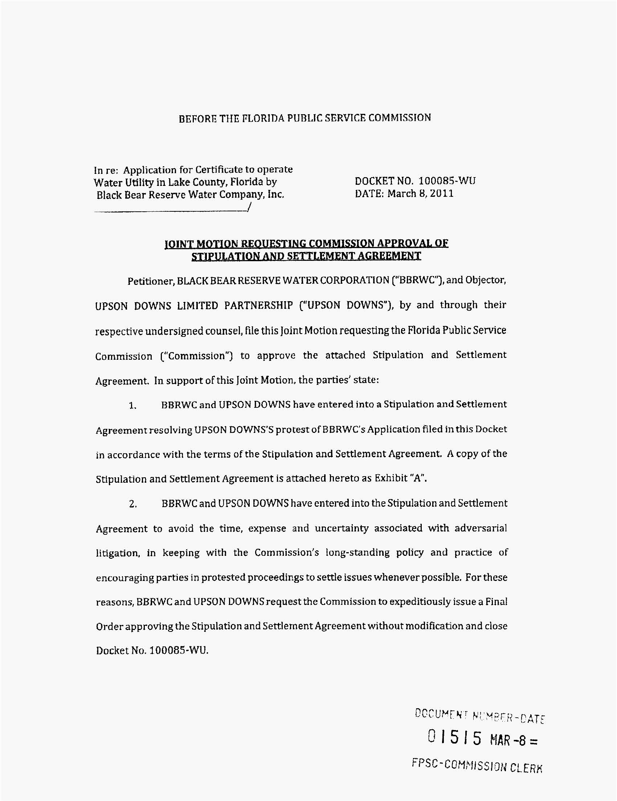
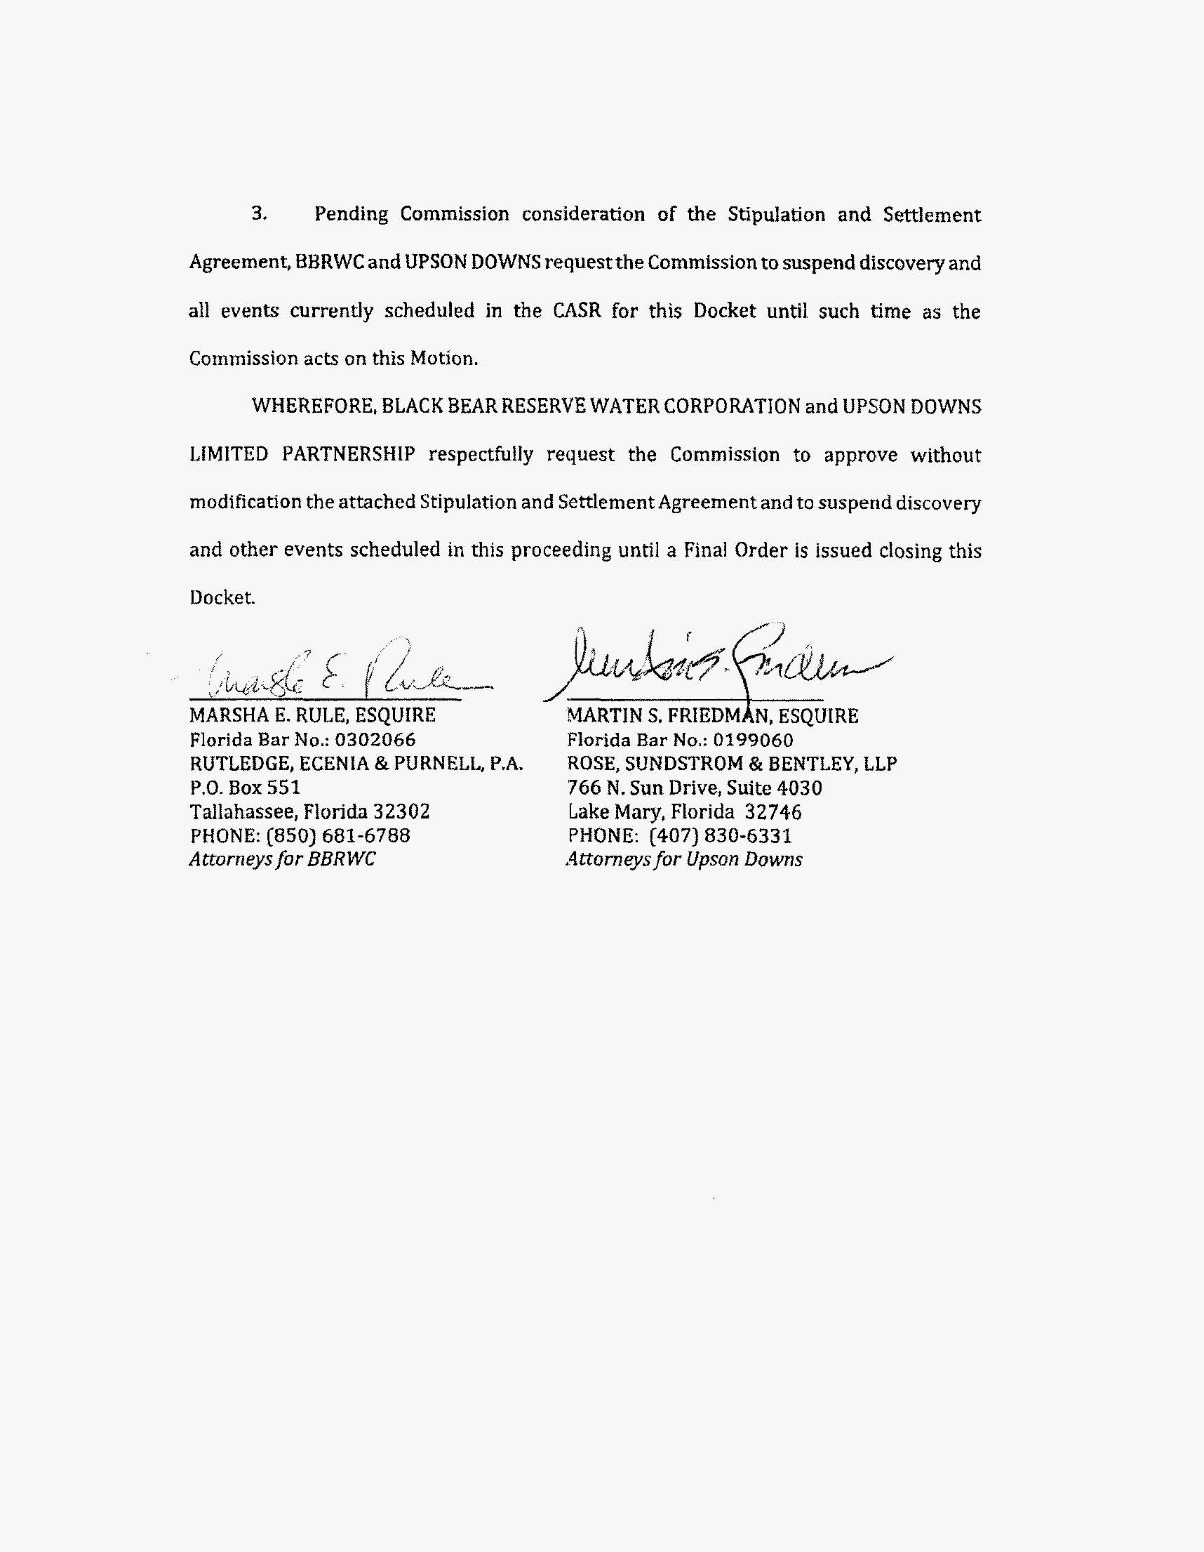
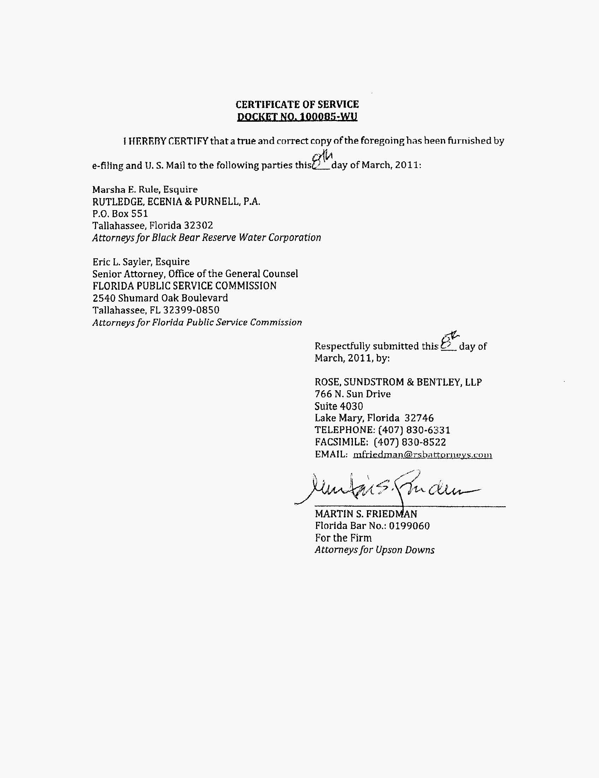
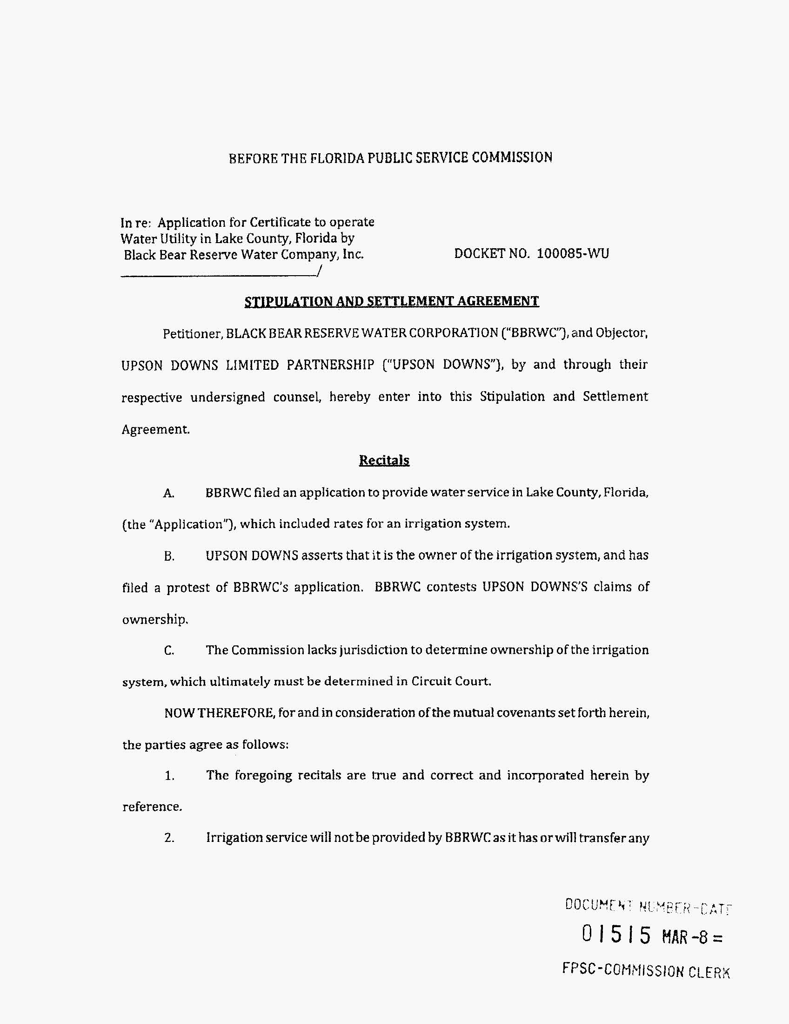
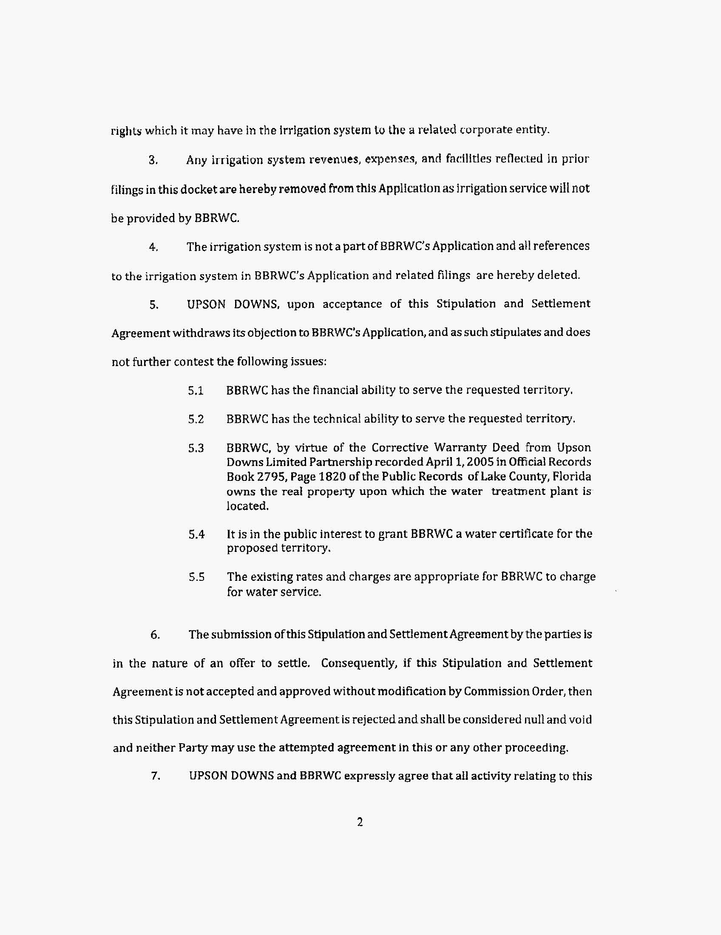
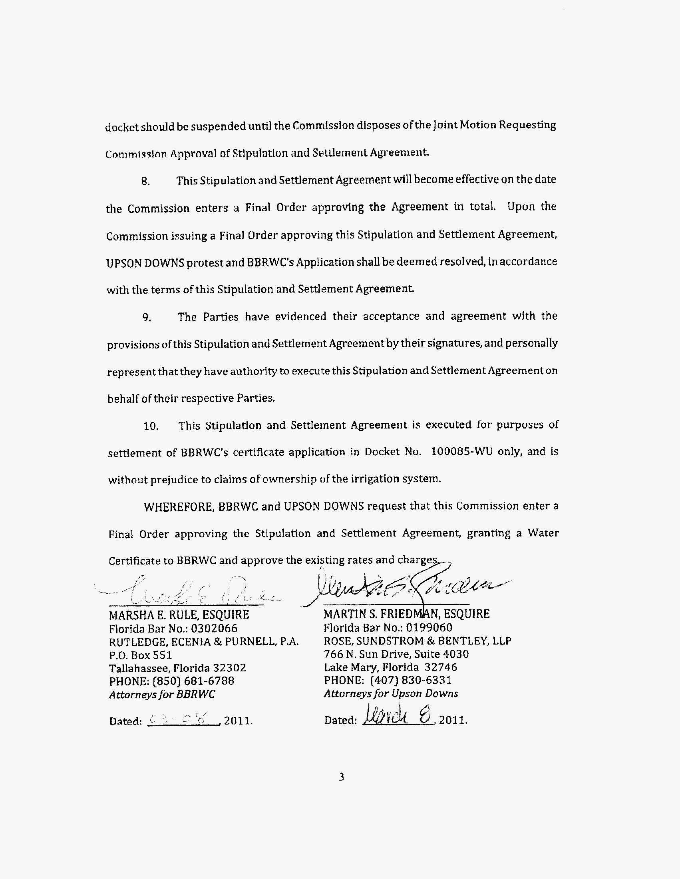
Black Bear Water Reserve Corporation
Description of Water Territory
Lake County

Township 18 South, Range 28 East
Sections 30 and 31

A parcel of land in Sections 30 and 31, Township 18 South, Range 28 East, Lake County Florida, more particularly described as follows:

Section 30: The Southwest 1/4, less the West 909.26 feet; together with the Northwest 1/4 of the Southeast 1/4 of Section 30.

Section 31: The portion of Section 31 North of County Road 44A.

FLORIDA PUBLIC SERVICE COMMISSION
authorizes
Black Bear Reserve Water Corporation
pursuant to
Certificate Number 644-W

to provide water service in Lake County in accordance with the provisions of Chapter 367, Florida Statutes, and the Rules, Regulations, and Orders of this Commission in the territory described by the Orders of this Commission. This authorization shall remain in force and effect until superseded, suspended, cancelled or revoked by Order of this Commission.

Order Number Date Issued Docket Number Filing Type

* * 100085-WU Original Certificate

*Order Number and date to be provided at time of issuance.

Black Bear Water Reserve Corporation

Monthly Service Rates
Residential and General Service

Application Rates Revised Rates
(2/19/2010) (9/19/2011)
All Meter Sizes
Up to 5,000 gallons $ 28.05 $ 29.31
5,001 to 10,000 gallons $ 5.25 per 1,000 gallons $ 5.49
In excess of 10,001 gallons $ 7.50 per 1,000 gallons $ 7.84

Initial Customer Deposits

5/8” x 3/4” meter $ 60.00
1 1/2” meter $ 80.00

Service Availability Charges

Main Extension Charge $1,689.00
Meter Installation Charge
5/8” x 3/4” meter $ 420.00
All other meter sizes Actual Cost
Tap-In Charge $ 320.00

Annual Charge

Backflow Prevention Assembly Test Charge $ 35.00

Miscellaneous Service Charges

Normal Hours After-Hours
Initial Connection Charge $16.00 N/A
Normal Reconnection Charge $16.00 N/A
Violation Reconnection Charge $32.00 $ 64.00
Home Inspection Charge $32.00 N/A
Premises Visit Charge $16.00 N/A
Late Payment Charge $ 5.00 N/A
Checks Returned for Non-sufficient
Funds Charge Pursuant to Sections 68.065 and 832.085(5), F.S.

Order No. PSC-98-1572-FOF-WS, issued November 23, 1998, in Docket No. 980307-WS, In re: Application for certificate to provide water and wastewater service in Orange County by Zellwood Station Co-Op, Inc.
Order No. PSC-99-1227-PAA-WS, issued June 21, 1999, in Docket No. 981338-WS, In re.: Application for grandfather certificates to operate water and wastewater utility in Polk County by Plantation Landings, Ltd.; Order No. PSC-99-1228-PAA-WS, issued June 21, 1999, In re: Application for grandfather certificates to operate water and wastewater utility in Polk County by Anglers Cove West, Ltd.; Order No. PSC-99-1234-PAA-WS, issued June 22, 1999, in Docket No. 981337-WS, In re: Application for grandfather certificates to operate water and wastewater utility in Polk County by S. V. Utilities, Ltd.; Order No. PSC-99-1235-PAA-WS, issue June 22, 1999, in Docket No. 981341-WS, In re: Application for grandfather certificates to operate water and wastewater utility in Polk County by CHC VII, Ltd.; Order No. PSC-99-1236-PAA-WS, issued June 22, 1999, In re: Application for grandfather certificates to operate water and wastewater utility in Polk County by Four Lakes Golf Club, Ltd.; and Order No. PSC-99-1237-PAA-WS, issued June 22, 1999, in Docket No. 981339-WS, In re: Application for grandfather certificates to operate water and wastewater utility in Polk County by Hidden Cove, Ltd.
See e.g., Order No. PSC-01-0992-PAA-WU, issued April 20, 2001, in Docket No. 001049-WU, In re: Application for original water certificate in Charlotte County by Little Gasparilla Water Utility, Inc.; Order No. PSC-01-1483-PAA-WS, issued July 16, 2001, in Docket No. 000545-WS, In re: Application for original certificates to operate a water and wastewater utility in Pasco County by Labrador Services, Inc.; Order No. PSC-99-0756-FOF-WS, issued , in Docket No. 980731-WS, In re: Application for certificate to provide water and wastewater service in Charlotte County by Hunter Creek Utilities, LLC.; Order No. PSC-97-1211-FOF-WU, issued October 7, 1997, in Docket No. 970636-WU, In re: Application for certificate to provide water service in Osceola County by Morningside Utility Inc.; and Order No. PSC-97-0568-FOF-WU, issued May 20, 1997, in Docket No. 960244-WU, In re: Application for certificate to provide water service in Highlands County by Holmes Utilities, Inc.
Order No. PSC-07-0983-PAA-WS, issued December 10, 2007, in Docket No. 060726-WS, In re: Application for certificates to provide water and wastewater service in Glades County and water service in Highlands County for Silver lake Utilities, Inc. and Order No. PSC-03-1474-TRF-WU, issued December 31, 2003, in Docket No. 030956-WU, In re: Application for approval of revised service availability charges to increase meter installation fees in Osceola County by O&S Water Company, Inc.
Order No. PSC-10-0533-TRF-WU, issued September 3, 2010, in Docket No. 100038-WU, In re: Application to implement a backflow maintenance program by Sunny Shores Water Co. and Order No. PSC-09-0146-TRF-WU, issued March 11, 2009, in Docket No. 080606-WU, In re: Application for amendment of water tariff by O&S Water Company, Inc., to implement Florida Department of Environmental Protection’s requirement under Rule 62-555.360, F.A.C., that backflow prevention devices be tested on an annual basis.
Order Nos. PSC-93-0708-FOF-GU and PSC-93-1783-FOF-GU, issued May 10, 1993 and December 13, 1993, respectively, in Docket No. 930003-GU, In re: Purchased Gas Adjustment (PGA) True-up.
Order No. PSC-10-0257-TRF-WU, issued April 26, 2010, in Docket No. 090429-WU, In re: Request for approval of imposition of miscellaneous service charges, delinquent payment charge and meter tampering charge in Lake County, by Pine Harbour Water Utilities, and Order No. PSC-08-0009-TRF-WU, issued January 2, 2008, in Docket No. 070377-WU, In re: Request for approval of change in meter installation customer deposits tariff and proposed changes in miscellaneous service charges in Marion County by Windstream Utilities Company, and Order No. PSC-05-0397-TRF-WS, issued April 18, 2005, in Docket No. 050096-WS, In re: Request for revision of Tariff Sheets 14.0 and 15.1 to change request for meter test by customer and premise visit charge, by Marion Utilities, Inc.
Order No. PSC-10-0699-TRF-WS, issued November 29, 2010, in Docket No. 100396-WS, In re: Request for approval of increase in miscellaneous service charges by Heather Hills Estates Utilities, LLC and Order No. PSC-08-0009-TRF-WU, issued January 2, 2008, in Docket No. 070377-WU, In re: Request for approval of change in meter installation customer deposits tariff and proposed changes in miscellaneous service charges in Marion County by Windstream Utilities Company.
Order Nos. PSC-08-0009-TRF-WU and PSC-10-0699-TRF-WS.
Order No. PSC-10-0699-TRF-WS.
Order No. PSC-10-0474-TRF-WS, issued July 28, 2010, in Docket No. 100313-WS, In re: Application for authority to collect non-sufficient funds charges, pursuant to Sections 68.065 and 832.08(5), F.S., by Utilities, Inc. and Order No. PSC-10-0364-TRF-WS, issued June 7, 2010, in Docket No. 100170-WS, In re: Application for authority to collect non-sufficient funds charges, pursuant to Sections 68.065 and 832.08(5), F.S., by Pluris Wedge field, Inc.

