BEFORE THE FLORIDA PUBLIC SERVICE COMMISSION

In re: Environmental cost recovery clause. | DOCKET NO. 110007-EI  ORDER NO. PSC-11-0553-FOF-EI  ISSUED: December 7, 2011

The following Commissioners participated in the disposition of this matter:

ART GRAHAM, Chairman
LISA POLAK EDGAR
RONALD A. BRISÉ
EDUARDO E. BALBIS
JULIE I. BROWN

APPEARANCES:

JAMES D. BEASLEY and J. JEFFRY WAHLEN, ESQUIRES, Ausley Law Firm, Post Office Box 391, Tallahassee, Florida 32302
On behalf of Tampa Electric Company (TECO)

JEFFREY A. STONE, ESQUIRE, Beggs & Lane Law Firm, Post Office Box 12950, Pensacola, Florida 32591-2950
On behalf of Gulf Power Company (GULF)

CAPTAIN SAM MILLER, Federal Executive Agencies, c/o AFCESAULFSC139 Barnes Drive, Suite 1, Tyndall AFB, Florida 32403-5319
On behalf of the Federal Executive Agencies (FEA)

JON C. MOYLE, JR., ESQUIRE, Keefe, Anchors, Gordon & Moyle Law Firm, 118 North Gadsden Street, Tallahassee, Florida 32301,
On behalf of the Florida Industrial Power Users Group (FIPUG)

JOHN T. BUTLER and MARIA MONCADA, ESQUIRES, Florida Power & Light Company, 700 Universe Boulevard, Juno Beach, Florida 33408-0420, Florida Power & Light Company and
KENNETH HOFFMAN, ESQUIRE, 215 South Monroe Street, Suite 810, Tallahassee, Florida 32301-1858
On behalf of FLORIDA POWER & LIGHT COMPANY (FPL)

CHARLES REHWINKEL, JOSEPH A. McGLOTHLIN, PATRICIA A. CHRISTENSEN, ESQUIRES, Office of Public Counsel, c/o The Florida Legislature, 111 W. Madison St., Room 812, Tallahassee, Florida 32399-1400
On behalf of the Citizens of the State of Florida (OPC)

GARY V. PERKO, ESQUIRE, Hopping Law Firm, Post Office Box 6526, Tallahassee, Florida 32314, JOHN T. BURNETT, ALEX GLENN, and DIANNE M. TRIPLETT, ESQUIRES, Progress Energy Service Company, LLC, Post Office Box 14042, Saint Petersburg, Florida 33733-4042
On behalf of PROGRESS ENERGY FLORIDA, INC. (PEF)

MARTHA BROWN and CHARLIE MURPHY, ESQUIRES, FPSC General Counsel's Office, 2540 Shumard Oak Boulevard, Tallahassee, Florida 32399-0850
On behalf of the Florida Public Service Commission (STAFF)

MARY ANNE HELTON, DEPUTY GENERAL COUNSEL, and SAMANTHA CIBULA, ESQUIRE, Florida Public Service Commission, 2540 Shumard Oak Boulevard, Tallahassee, Florida 32399-0850
Advisor to the Florida Public Service Commission.

FINAL ORDER APPROVING PROJECTED EXPENDITURES AND TRUE-UP
AMOUNTS FOR ENVIRONMENTAL COST RECOVERY FACTORS

BY THE COMMISSION;

I. BACKGROUND

As part of our ongoing environmental cost recovery proceedings, a hearing was held on November 1 and 2, 2011, in this docket. At the hearing, the parties addressed the issues set out in Order No. PSC-11-0505-PHO-EI, the Prehearing Order. We have authority pursuant to Section 366.8255, Florida Statutes (F.S.).

II. STIPULATED GENERIC COST RECOVERY ISSUES

A. We approve as reasonable the following final environmental cost recovery true-up amounts for the period ending December 31, 2010:

FPL: $5,036,426 over-recovery.

PEF: $6,232,839 over-recovery.

TECO: $2,616,798 under-recovery.

GULF: $861,325 over-recovery.

B. We approve as reasonable the following estimated environmental cost recovery true-up amounts for the period January 2011 through December 2011:

FPL: $8,708,673 over-recovery.

PEF: $2,552,337 over-recovery.

TECO: $464,090 under-recovery.

GULF: $14,380,513 over-recovery.

C. We approve as reasonable the following projected environmental cost recovery amounts for the period January 2012 through December 2012:

FPL: $188,014,660.

PEF: $207,302,671.

TECO: $84,067,581.

GULF: $165,075,432.

D. We approve as reasonable the following environmental cost recovery amounts, including true-up amounts, for the period January 2012 through December 2012:

FPL: $174,395,035.

PEF: $198,660,428.

TECO: $87,211,216.

GULF: $149,941,474

E. We approve as reasonable that the depreciation rates used to calculate the depreciation expense should be the rates that are in effect during the period the allowed capital investment is in service.

F. We approve as reasonable the following jurisdictional separation factors for the projected period January 2012 through December 20121:

FPL: Retail Energy Jurisdictional Factor 98.08128%
Retail CP Demand Jurisdictional Factor 98.01395%
Retail GCP Demand Jurisdictional Factor 100.00000%

PEF: The jurisdictional energy separation factor is calculated for each month based on retail kWh sales as a percentage of projected total system kWh sales.
Production Base – 92.792%
Production Intermediate – 72.541%
Production Peaking – 91.972%
Transmission – 69.516%
Distribution Primary– 99.624%
A&G – 92.374%

TECO: The demand jurisdictional separation factor is 99.58152%. The energy jurisdictional separation factors are calculated for each month based on projected retail kWh sales as a percentage of projected total system kWh sales.

GULF: The demand jurisdictional separation factor is 96.44582%. Energy jurisdictional separation factors are calculated each month based on retail KWH sales as a percentage of projected total territorial KWH sales.

G. We approve as reasonable the following environmental cost recovery factors for the period January 2011 through December 2011 for each rate group:

FPL: Rate Class Environmental Recovery
Factor ($/kWh)
RS1/RST1 .00192
GS1/GST1 .00154
GSD1/GSDT1/HLFT1 (21-499 kW) .00150
OS2 .00096
GSLD1/GSLDT1/CS1/CST1/HLFT2 (500-1,999 kW) .00151
GSLD2/GSLDT2/CS2/CST2/HLFT3 (2,000 kW+) .00129
GSLD3/GSLDT3/CS3/CST3 .00125
ISST1D .00098
ISST1T .00171
SST1T .00171
SST1D1/SST1D2/SST1D3 .00098
CILC D/CILC G .00118
CILC T .00113
MET .00154
OL1/SL1/PL1 .00039
SL2/GSCU1 .00125

PEF:

Rate Class | ECRC Factors
Residential | 0.545 cents/kWh
General Service Non-Demand  @ Secondary Voltage  @ Primary Voltage  @ Transmission Voltage | 0.539 cents/kWh  0.534 cents/kWh  0.528 cents/kWh
General Service 100% Load Factor | 0.532 cents/kWh
General Service Demand  @ Secondary Voltage  @ Primary Voltage  @ Transmission Voltage | 0.534 cents/kWh  0.529 cents/kWh  0.523 cents/kWh
Curtailable  @ Secondary Voltage  @ Primary Voltage  @ Transmission Voltage | 0.528 cents/kWh  0.523 cents/kWh  0.517 cents/kWh
Interruptible  @ Secondary Voltage  @ Primary Voltage  @ Transmission Voltage | 0.520 cents/kWh  0.515 cents/kWh  0.510 cents/kWh
Lighting | 0.529 cents/kWh

TECO: Rate Class Factor at Secondary
Voltage (¢/kWh)
RS 0.460
GS, TS 0.460
GSD, SBF
Secondary 0.458
Primary 0.453
Transmission 0.449
IS
Secondary 0.450
Primary 0.446
Transmission 0.441
LS1 0.456

Average Factor 0.459

GULF:
RATE  CLASS | ENVIRONMENTAL COST RECOVERY FACTORS  ¢/KWH
RS, RSVP | 1.294
GS | 1.286
GSD, GSDT, GSTOU | 1.273
LP, LPT | 1.245
PX, PXT, RTP, SBS | 1.227
OS-I/II | 1.233
OSIII | 1.255

H. We approve as reasonable the determination that the new factors shall be effective beginning with the first billing cycle for January 2012. The first billing cycle may start before January 1, 2012, and thereafter the environmental cost recovery factors shall remain in effect until modified by this Commission.

III. STIPULATED COMPANY-SPECIFIC ISSUES

Florida Power & Light

A. We approve as reasonable the following stipulation regarding whether FPL should be allowed to recover the costs associated with its proposed St. Lucie Cooling Water Monitoring Project:

Yes. This project is required to comply with Florida Department of Environmental Protection (FDEP) Administrative Order AO022TL (AO) and conditions in Industrial Wastewater (IWW) Permit No. FL0002208, which became effective on December 23, 2010, and relate to operation and limitations for the St. Lucie Plant Cooling Water System (CWS). The extended power uprate at St. Lucie Units 1 and 2 will result in an increased heat output which, in turn, will cause an increase in the discharge temperature of the plant’s cooling water. FPL submitted to the FDEP a request to modify the IWW Permit in this regard. The FDEP has approved an increase in the current permitted discharge temperature limit, subject to FPL’s complying with new study and monitoring requirements (and corrective action requirements if necessary) that are contained in the AO and IWW Permit. The proposed project meets the criteria for cost recovery established by the Commission in Order No. PSC-94-0044-FOF-EI. In addition, FPL's compliance with the IWW permit is legally mandated under a governmentally imposed environmental regulation.

The estimated total expenditures associated with the project are approximately $3 million, of which approximately $1.2 million has been included in the calculation of the 2012 ECRC factor. At this time, the project consists of preparing and implementing plans for (1) monitoring the ambient and CWS discharge water temperature, and (2) biological monitoring to demonstrate that conditions allow for the existence of a balanced, indigenous community of fish, shellfish and wildlife near the CWS discharge of the St. Lucie Plant. If any corrective actions are required as a result of the monitoring activities, FPL should petition the Commission to amend the project at that time for further ECRC cost recovery.

B. We approve as reasonable the following stipulation regarding how costs associated with FPL’s proposed St. Lucie Cooling Water Monitoring Project should be allocated to the rate classes:

Capital and O&M costs for FPL’s proposed St. Lucie Plant Cooling Water Discharge Monitoring Project should be allocated to the rate classes on an average 12 CP demand basis.

C. We approve as reasonable the following stipulation regarding whether FPL should be allowed to recover the costs associated with its proposed Industrial Boiler MACT Project:

Yes. This project is required by the United States Environmental Protection Agency (EPA), which regulates Hazardous Air Pollutants (HAPs) under Section 112 of the Clean Air Act (CAA) and promulgates emission standards for HAPs under 40 CFR Part 63 for stationary source categories. On February 21, 2011, the final Industrial/Commercial/Institutional Boiler Maximum Achievable Control Technology (IB MACT) rules were signed by the EPA Administrator. EPA’s two rules address boilers and process heaters under Subpart DDDDD (40 CFR 63.7480) for affected units at major sources, and under Subpart JJJJJJ (40 CFR 63.11193) for affected units at area sources. The IB MACT rules impose new emission limitations, work practice standards, and operating limits on the affected source categories to reduce the emissions of HAPs. FPL’s plans to comply with the requirements of these rules include developing site-specific monitoring plans, conducting emissions stack testing, performing fuel oil sampling and analyses, conducting biennial tune-up practices, performing one-time energy assessment, and installing emission controls or replacing existing units. Subpart JJJJJJ became effective on March 21, 2011. The EPA has stayed the effectiveness of Subpart DDDDD.

FPL estimated that the costs associated with complying with Subpart JJJJJJ are $41,453, and the costs associated with the complying with Subpart DDDDD are $337,895. FPL should be allowed to recover through the ECRC the Subpart JJJJJJ-related compliance costs. This portion of the proposed project meets the criteria for cost recovery established by the Commission in Order No. PSC-94-0044-FOF-EI. In addition, FPL's compliance with the Subpart JJJJJJ is legally mandated under a governmentally imposed environmental regulation. FPL has removed the projected Subpart DDDDD costs from its 2012 ECRC projections and will petition to recover its reasonable and prudent 2012 compliance costs under Subpart DDDDD via ECRC true-up process for 2012.

D. We approve as reasonable the following stipulation regarding how costs associated with FPL’s proposed Industrial Boiler MACT Project should be allocated to the rate classes:

Capital and O&M costs for FPL’s proposed Industrial Boiler MACT Project should be allocated to the rate classes on an average 12 CP demand basis.

E. We approve as reasonable the following stipulation regarding whether FPL should be allowed to recover the costs associated with its proposed NPDES Permit Renewal Requirement Project:

Yes. This project is designed to comply with the Federal Clean Water Act, which requires all point source discharges to navigable waters from industrial facilities to obtain permits under the National Pollutant Discharge Elimination System (NPDES) program. (33 U.S.C. Section 1342) NPDES permits must be renewed every five years. The FDEP has been delegated authority by the EPA to implement the NPDES program in Florida. The FDEP has amended Rule 62-620.620 (3), F.A.C., to require that all new or renewed wastewater discharge permits for major facilities, including power plants, contain whole effluent toxicity (WET) limits. Additionally, the FDEP has required that facilities prepare a Storm Water Pollution Prevention Plan (SWPPP) that conforms to Rule 62-620.100 (m), F.A.C., and 40 CFR Part 122.44(k) when their NDPES permits are renewed. The proposed project is associated with these new requirements for WET monitoring and reporting, as well as for preparing Storm Water Pollution Prevention Plans that are or will be contained in the latest renewals for FPL’s NPDES permits. The WET testing requirements of the project will be on-going. The estimated 2011 and 2012 O&M cost for compliance with the new WET testing requirement is approximately $77,000. The SWPPP activities of the proposed project are expected to be completed by 2014 and the current estimates of the total expenditures are $100,000 in O&M costs. The estimated 2011 and 2012 O&M costs for the development of SWPPPs at FPL’s facilities are approximately $30,000. FPL’s proposed project meets the criteria for cost recovery established by the Commission in Order No. PSC-94-0044-FOF-EI. In addition, FPL's compliance with the NPDES permit is legally mandated under a governmentally imposed environmental regulation.

F. We approve as reasonable the following stipulation regarding how the costs associated with FPL’s proposed NPDES Permit Renewal Requirement Project should be allocated to the rate classes:

Capital and O&M costs for FPL’s proposed NPDES Permit Renewal Requirements Project should be allocated to the rate classes on an average 12 CP demand basis.

G. We approve as reasonable the following stipulation regarding whether FPL should be allowed to include the costs associated with its 800 MW ESP Project in its 2012 ECRC factor:

FPL has agreed to remove the projected 800 MW ESP Project costs from the calculation of its 2012 ECRC factors.

The EPA issued the proposed Air Toxics Rule (also referred to as the MACT Rule) on March 16, 2011, which was published in the Federal Register on June 21, 2011. FPL believes that the installation of ESPs at the Martin and Manatee plants is the most effective method to comply with the requirements of the proposed rule. FPL anticipates that the EPA will finalize the Air Toxics Rule by the November 16, 2011 deadline, in compliance with the D.C Circuit Court of Appeal’s order.

In Order No. PSC-11-0083-FOF-EI, in Docket No. 100007-EI, issued January 31, 2011, Re: Environmental Cost Recovery Clause, the Commission approved a stipulation regarding whether FPL should be allowed to recover the costs associated with its proposed 800 MW ESP project for complying with the proposed MACT rule. Consistent with this order, FPL is authorized to include all the prudently incurred costs associated with the project in the normal process of ECRC recovery after the EPA publishes the final MACT rule. FPL will be allowed to recover reasonable and prudent ESP project costs via the ECRC true-up mechanism in the 2012 ECRC proceeding in the event that the final MACT rule requires ESPs and is adopted before or during 2012.

H. We approve as reasonable the following stipulation regarding whether FPL should be allowed to recover the costs associated with the additional activities required for the Manatee Temporary Heating System (MTHS) Project at Cap Canaveral Plant:

Yes. In Order No. PSC-09-0759-FOF-EI, in Docket No. 090007-EI, issued November 18, 2009, Re: Environmental Cost Recovery Clause, the Commission approved the MTHS-Cape Canaveral Plant project for cost recovery through the ECRC. FPL notified the Commission on January 4, 2011, that the heating system installed did not have enough thermal capacity to maintain the manatee embayment area at the necessary temperature to comply with the requirements of the FDEP’s Industrial Wastewater Facility Permit FL0001473 for the Cape Canaveral Plant during periods of extreme cold. FPL determined that a light oil-fired water heating system (Supplemental Heating System) was the best solution to provide the incremental heating capacity needed in the event that the thermal capacity of the existing electric heating system is exceeded. Due to the approximately two-week anticipated delivery time of the Supplemental Heating System, FPL also entered into a short-term lease for a smaller light oil-fired heater to be used at the Cape Canaveral Plant site during the extreme cold snap that Florida experienced in early December 2010. Once the reliability and effectiveness of the Supplemental Heating System was proven, FPL terminated the lease and returned the smaller heater. Other associated activities are the modification of discharge pipes in the primary heating system and the installation of booms to direct and control the flow of warm water in the embayment area.

I. We approve the following stipulation regarding whether we should approve FPL’s updated Clean Air Interstate Rule (CAIR), Clean Air Mercury Rule (CAMR) and Clean Air Visibility Rule (CAVR)/Best Available Retrofit Technology (BART) Projects that are reflected in FPL’s April 1, 2011, supplemental filing as reasonable and prudent:

Yes. Completion of the compliance activities discussed in FPL’s Supplemental CAIR/CAMR/CAVR Filing of April 1, 2011, is required by existing federal and state environmental rules and regulatory requirements at that time for air quality control and monitoring; and the associated project costs appear reasonable and prudent. On February 21, 2011, the EPA published final IB MACT rules, of which Subpart JJJJJJ became effective on March 21, 2011, and Subpart DDDDD was stayed. On March 16, 2011, the EPA issued the proposed Air Toxics Rule, also referred to as the MACT Rule. FPL anticipates that the EPA will finalize this Rule by the November 16, 2011 deadline, in compliance with the D.C Circuit Court of Appeal’s order. On July 16, 2011, the EPA issued the Cross State Air Pollution Rule (CSAPR) which serves as the replacement for the CAIR rule. FPL shall continue to file, as part of its annual ECRC final true-up testimony, a review of the efficacy of its CAIR/CAMR/CAVR compliance plans. In its review, FPL shall update the Commission on the developments of the aforementioned new and/or proposed rules, as well as the cost-effectiveness of the company’s retrofit options for each generating unit in relation to expected changes in environmental regulations. The reasonableness and prudence of individual expenditures, and FPL’s decisions on the future compliance plans made in light of subsequent developments, will continue to be subject to the Commission’s review in future ECRC proceedings on these matters.

Progress Energy Florida

A. We approve as reasonable the following stipulation regarding whether we should grant PEF’s Petition for approval of ECRC cost recovery for the National Pollutant Discharge Elimination System (NPDES) Permit Renewal Requirement Project:

Yes. This project is necessary to comply with renewed NPDES permits issued or to be issued for PEF’s facilities by the FDEP pursuant to the EPA approved NPDES permitting program in Florida and applicable FDEP regulations. The new compliance requirements included in the Bartow, Anclote, Crystal River, and Suwannee permits are composed of Thermal Studies, Aquatic Organism Return Studies & Implementation, and Whole Effluent Toxicity Testing (WET). For the Bartow Plant, there are additional regulatory requirements and activities, including a Dissolved Oxygen Study and freeboard Limitation and Related Studies. The proposed project meets the criteria for cost recovery established by the Commission in Order No. PSC-94-0044-FOF-EI. In addition, PEF's compliance with the NPDES permit is legally mandated under a governmentally-imposed environmental regulation. The Company estimated that the total costs for complying with the new NPDES permit requirements are approximately $1.5 million for the period of 2011 through 2012. PEF indicated that costs for the chronic WET testing would recur annually. It also indicated that costs for implementing the various studies cannot be estimated at this time, but would be submitted for Commission review and approval at the appropriate time in future ECRC filings.

B. We approve as reasonable the following stipulation regarding how the costs associated with PEF’s proposed NPDES Permit Renewal Requirement Project should be allocated to the rate classes:

Capital costs for the NPDES project should be allocated to rate classes on a demand basis. O&M costs for the project should be allocated to the rate classes on an energy basis.

C. We approve as reasonable the following stipulation regarding whether we should grant PEF’s Petition for approval of ECRC cost recovery for the Maximum Achievable Control Technology (MACT) Project:

Yes. On March 16, 2011, the EPA issued a proposed Electric Generating Unit (EGU) MACT Rule. In accordance with a D.C Circuit Court of Appeal’s order, the EPA Administrator will sign a final rule by November 16, 2011. Adoption of the new EGU MACT rule will require PEF to modify its Integrated Clean Air Compliance Plan, which was approved by the Commission in the previous year’s ECRC hearings, to comply with new emission standards. The proposed new activities for 2011 include diagnostic stack testing, and emissions testing at Crystal River Units 4 and 5 to assess emissions of mercury, HCl and condensable particulate matter while testing hydrated lime injection and various operational conditions. Upon issuance of the final EGU MACT rule, PEF will conduct detailed engineering and other analyses necessary to develop compliance strategies for inclusion in an updated Integrated Clean Air Compliance Plan. The proposed project meets the criteria for cost recovery established by the Commission in Order No. PSC-94-0044-FOF-EI, and is consistent with the Commission’s decision set in Order No. PSC-08-0775-FOF-EI. In addition, PEF’s proposed activities are necessary for the Company to assess the proposed rule, prepare comments to the EPA, and develop compliance strategies within aggressive regulatory timeframes. The estimates of the O&M costs associated with this Project are approximately $85,000 in 2011 and $300,000 for 2012.

D. We approve as reasonable the following stipulation regarding how the costs associated with PEF’s proposed MACT Project should be allocated to the rate classes:

O&M costs for the MACT Project should be allocated to the rate classes on an energy basis.

E. We approve as reasonable the following stipulation regarding whether we should approve PEF’s proposed treatment of its CAIR-related NOx allowances:

On July 16, 2011, the EPA issued the Cross State Air Pollution Rule (CSAPR) to replace the Clean Air Interstate Rule (CAIR) starting January 1, 2012. The new rule significantly alters the SO2 and NOx allowance programs. Under the CAIR, Florida was required to comply with the requirements related to emissions of SO2 and NOx, as well as separate requirements regulating NOx emissions during the ozone season. Under the CSAPR, Florida is no longer included in the group of states required to comply with SO2 and NOx emissions requirements; it is only subject to the ozone season portions of the rule. The effective compliance start day for Florida is May 1, 2012, when the ozone season begins. Moreover, the emission allowances previously issued to utility companies under CAIR and/or the Acid Rain Program cannot be used to comply with CSAPR requirements.

Since any NOx allowances not used by the end of 2011 are not expected to be useful for compliance with the new CSAPR rule, PEF proposes to treat its approximately $22.5 million of NOx allowances in inventory as a regulatory asset as of January 1, 2012, and amortize it over the course of 2012 until fully recovered at year end, with a return on the unamortized balance of the emission allowances during 2012. PEF asserts that all of the $22.5 million was incurred purchasing NOx allowances and represents investments PEF has made in this inventory.

CAIR established new seasonal and annual emission compliance requirements for NOx. Beginning in 2009, CAIR required affected sources to complete a seasonal NOx emission allowance submittal for the May 1 through September 30 time period and annual NOx emission allowance compliance submittal for the January 1 through December 31 time period each year. When PEF first asked the Commission to approve its Integrated Clean Air Compliance Plan in March 2006, its detailed economic analyses of five potential compliance scenarios indicated that its “Plan D,” which relied on strategic purchases of annual and seasonal NOx allowances, rather than installing NOx controls on Crystal River Units 1 and 2, was the most cost-effective option for compliance with CAIR and related regulatory requirements. In the 2007 ECRC docket, PEF submitted updated economic analyses confirming that Plan D, which included its reliance on NOx allowance purchases, was the most cost-effective option. The Commission agreed that “PEF’s Integrated Clean Air Compliance Plan represents the most cost-effective alternative for achieving compliance with CAIR, CAMR CAVR.” In the subsequent years, 2008 through 2010, PEF updated the Commission annually on its Integrated Clean Air Compliance Plan, each of which included strategic NOx allowance purchases and were granted approval. Therefore, PEF’s purchases of NOx allowances were pre-approved by the Commission.

The evidence in this docket indicates that PEF exercised a prudent NOx emissions allowance strategy. During the relevant time period, in order to determine if PEF would need to purchase seasonal and annual NOx emission allowances, the Company compared its total seasonal and annual NOx emissions projections from fuel and generation forecasts to the number of the allowances held by PEF, which included allowance allocations from the EPA, purchases made over time, and allowances carry-overs. In the aggregate, if the number of allowances that PEF would need to comply with CAIR based on forecasted emissions was greater than the number of allowances PEF held, the Company purchased additional allowances in the market. The historical data of PEF’s allowance purchases, inventories and expenses submitted by the Company, indicates that PEF acted prudently in implementing its procurement strategy of purchasing NOx allowances over time, to gradually increase inventory levels based on emission forecasts developed using the best information available at the time.

Based on the above, the $22.5 million investment associated with PEF’s NOx allowances under the CAIR was prudently incurred under a Commission-approved environmental compliance plan. It is appropriate for PEF to treat these $22.5 million now-unusable NOx allowances as a regulatory asset and recover them through the ECRC. However, the amortization period should be a three-year amortization period, so as to reduce the volatility in customer bills while balancing the level of carrying costs associated with the $22.5 million investment. Recognizing that historically many of the EPA’s final rules were subsequently challenged in court after their publication, the CSAPR rule too may be litigated and ultimately revised in the future. If there are changes to the CSAPR that result in the $22.5 million NOx allowances regaining value, PEF should refund the amount it recovered associated with these NOx allowances through the ECRC, and expense the amount into the ECRC based on actual usage consistent with current practice.

F. We approve as reasonable the following stipulation regarding whether we should approve PEF’s updated Review of Integrated Clean Air Interstate Rule Compliance Plan that was submitted on April 1, 2011:

Yes. PEF’s Updated Integrated Clean Air Compliance Plan is a reasonable means to achieve timely compliance with the applicable regulations in a cost-effective manner. All of the major components of the Crystal River Units 4 and 5 emissions control projects included in PEF’s Integrated Clean Air Compliance Plan have been completed. PEF shall continue evaluating future compliance options in light of the EPA’s recently finalized CSAPR rule and proposed EGU MACT standards for coal and oil-fired generating units. Once the EGU MACT rule is finalized and the Company determines its most cost-effective compliance options, PEF should submit revisions to PEF’s Integrated Clean Air Compliance Plan to the Commission for review. The revised Plan should discuss the impacts and estimated costs associated with PEF’s integrated strategy for complying with CSAPR, MACT and related environmental regulatory programs. The reasonableness and prudence of PEF’s decisions on the future compliance plans made in light of subsequent environmental rule and regulation developments, will continue to be subject to the Commission’s review in future ECRC proceedings on these matters.

Gulf Power Company

A. We approve as reasonable the following stipulation regarding whether Gulf should be allowed to recover the costs associated with its proposed Impoundment Integrity Inspection Project:

Yes. The proposed project addresses costs associated with Gulf's compliance with a new condition in the Plant Crist National Pollutant Discharge Elimination System (NPDES) permit renewal issued during January of 2011. This new condition requires inspection of all ash impoundments at Plant Crist annually. These inspections must include observations of dike and toe areas for erosion, cracks, or bulges, seepage, wet or soft soil, changes in geometry, the depth and elevation of the impounded water, sediment or slurry, freeboard, changes in vegetation and any other change which may indicate a potential compromise to impoundment integrity. The permit condition requires that summarized findings of all monitoring activities, inspections, and corrective actions pertaining to the impoundment integrity, and operation and maintenance of all impoundments must he documented and kept onsite and made available to FDEP inspectors. All findings and corrective actions related to impoundment integrity at Plant Crist must be complied with per the permit condition. The proposed project meets the criteria for cost recovery established by the Commission in Order No. PSC-94-0044-FOF-EI. In addition, Gulf's compliance with the NPDES permit is legally mandated under a governmentally imposed environmental regulation. The estimated costs associated with the project will total $156,000 during 2012.

B. We approve as reasonable the following stipulation regarding how the costs associated with Gulf’s proposed Impoundment Integrity Inspection Project should be allocated to the rate classes:

The costs associated with this project shall be allocated to the rate classes on an average 12 CP demand and 1/13th energy basis.

C. We approve as reasonable the eight page stipulation regarding whether Gulf should be allowed to recover the costs associated with the Plant Crist Units 6 and 7 turbine upgrades. The stipulation, filed in this docket on October 28, 2011, and assigned Document No. 07947, and is hereby incorporated in this Order by reference and attached hereto as Attachment 1.

D. We approve as reasonable the following stipulation regarding whether this Commission should approve Gulf’s proposed treatment of its CAIR-related NOx allowances:

Yes. On July 16, 2011, the EPA issued the CSAPR rule to replace the CAIR rule starting January 1, 2012. It appears that the annual NOx emission allowances previously issued to Florida utility companies under CAIR and/or the Acid Rain Program cannot be used to comply with CSAPR requirements, and Florida is no longer included in the group of states required to comply with annual NOx emissions requirements. As reported in Gulf’s Schedule 8E, filed on August 1, 2011, and Schedule 4P, filed on August 26, 2011, the Company will have approximately $1.3 million of annual NOx allowances as of December 31, 2011. Gulf indicated in its response to Staff’s Fourth Set of Interrogatories, No. 6a, that “[a] decision as to whether or not the balance of annual NOx allowances on hand at the end of 2011 will have any value in the future is yet to be determined pending potential litigation related to the new Cross State Air Pollution Rule (CSAPR). Regardless of whether these allowances are ultimately deemed to have any value or not beyond 2011, the costs of these allowances were prudently incurred expenses that are recoverable through the Environmental Cost Recovery Clause.”

It is reasonable for the Company to have a “waiting period” to obtain more information before making a decision on how to treat its CAIR-related annual NOx allowances on hand. Gulf should update the Commission, in a timely manner, on the Company’s decision on how it proposes to treat its remaining annual NOx allowances inventory in light of the future developments in the CSAPR. It is reasonable to limit this “waiting period” to a three-year time frame so that it would not result in a significant amount of carrying costs associated with this $1.3 million capital investment being incurred.

E. We approve as reasonable the following stipulation regarding whether this Commission should approve Gulf’s Environmental Compliance Program Update that was submitted on April 1, 2011:

Yes. Gulf’s updated Environmental Compliance Program reflects a comprehensive assessment of requirements Gulf and its customers face in meeting various existing environmental rules and the pending EGU MACT rule. In assessing the most cost-effective means of meeting these significant regulatory requirements, the Company considered four primary compliance options: fuel switching, purchase of allowances, retrofit installations, and retirement and replacement of existing units. Based upon comprehensive technical and economic evaluations of alternatives, Gulf assessed the best means of meeting plan-by-plan emission requirements through retrofit measures supplemented by allowance purchases and compared those options to retiring and replacing existing units. It appears that Gulf’s Environmental Compliance Program is the most reasonable and cost effective option available to Gulf under the planning assumptions at that time.

On July 16, 2011, the EPA issued the Cross State Air Pollution Rule (CSAPR) which serves as the replacement for the CAIR rule. According to the Company’s response to Staff’s Fifth Set of Interrogatories No. 10c, filed September 26, 2011, Gulf’s current strategy to comply with CSAPR relies on the ability to purchase allowances above the annual allowances provided to the company or to import power to supplement Gulf’s territorial load; Gulf will continue to evaluate these options pursuant to the development of the seasonal emission allowance market and the availability of purchased power agreements. Gulf also indicated that it is currently evaluating the existing particulate emission controls (ESPs) at Plant Crist and Daniel to determine whether they will be able to ensure compliance with the EGU MACT rule. Once the rule is finalized, Gulf will be able to determine whether or not the existing controls will be adequate or if a baghouse(s) will have to be installed.

Gulf should continue to evaluate future compliance options in light of the EPA’s recently finalized CSAPR rule and the EGU MACT standards. Once the EGU MACT rule is finalized and the Company determines its most cost-effective compliance options, Gulf should submit for the Commission’s review revisions to Gulf’s Environmental Compliance Program. The revised Program should discuss the impacts and estimated costs associated with Gulf’s integrated strategy for complying with CSAPR, EGU MACT and related environmental regulatory programs. The reasonableness and prudence of individual expenditures, and Gulf’s decisions on the future compliance plans made in light of subsequent environmental rule and regulation developments, will continue to be subject to the Commission’s review in future ECRC proceedings on these matters.

IV. CONTESTED COMPANY-SPECIFIC ISSUES

We have been asked to determine whether PEF should be permitted to recover any environmental costs related to its purchases of replacement power due to the Crystal River 3 outage. This determination affects the final calculation of numbers in stipulated issues throughout this case.

PEF is experiencing an unplanned extended outage at its Crystal River Nuclear Unit 3 (CR3) that started in mid-December 2009. FIPUG has questioned whether PEF should be permitted to recover any environmental costs related to its purchases of replacement power due to the CR3 extended outage. The environmental costs in question are emission allowances. The record reflects that no allowance purchases have been made associated with replacement power due to the CR3 extended outage and that PEF has made no allowance purchases since May of 2009. Therefore, we find that the dollar amount associated with this issue, which is the costs of the emission allowances related to the purchases of replacement power due to the CR3 extended outage, is zero.

However, during the hearing, the Consumer Intervenors – ancillary to the issue as framed - questioned whether PEF should be permitted to recover the environmental costs related to its replacement power costs incurred due to the CR3 extended outage, rather than the cost of any purchased emission allowances due to the CR3 extended outage. The replacement power costs due to the CR3 extended outage consist of two portions: the purchased replacement power and self-generated replacement power. Although there were no environmental costs incurred associated with purchases of replacement power due to the CR3 extended outage, there were environmental costs, namely the costs of the emission allowances, associated with the self-generated portion of the replacement power. The table below reflects the estimated system expense associated with previously purchased emission allowances that were used for the purpose of generating replacement power due to the CR3 extended outage. These costs were included in PEF’s projected 2012 factor. The Consumer Intervenors have not contested the amounts shown in the table below.

Emission Allowances Associated with CR3 Extended Outage
2010 | $2,453,542
2011 | $1,191,999
2012 | $(957,130)
Total | $2,688,411

The Consumer Intervenors oppose the recovery of the emission allowances related to the replacement power due to the CR3 extended outage. They assert that PEF should not be permitted to recover any further costs related to the CR3 extended outage until the prudence issues in Docket No. 100437-EI are resolved and conclude that we should deny PEF’s request to recover any costs resulting from the outage of the CR3 nuclear power plant until we determine in Docket No. 100437-EI whether the events or actions leading to the CR3 outage were reasonable and prudent.

PEF asserts that PEF’s emission allowance costs are reasonable and recoverable; that this Commission has determined that the evidence in this docket indicates that PEF followed a prudent NOx emission allowance strategy; that allowing CR3 extended outage-related environmental cost recovery prior to a determination of prudence is constitutional; that deferral of recovery of emission allowance costs associated with the CR3 replacement power would contravene established Commission precedent and policy; and that,
by approving the stipulation of [Hearing] Issue 10E in this docket, the Commission established a regulatory asset to allow PEF to recover the cost of surplus NOx allowances in its inventory over a 3 year period. . . . The establishment of the regulatory asset effectively moots any issue in this proceeding regarding NOx allowance costs because had PEF not utilized the NOx allowances associated with the CR3 replacement power, they would have remained in inventory and been recovered through the regulatory asset.
Our practice in the environmental clause proceedings, as well as our other clause proceedings, has been to allow recovery of projected costs, which are then subject to true-up adjustments based on actual costs incurred. Subsequently, we may disallow costs if a finding of imprudence is made. This practice allows cost recovery in a timely manner while protecting ratepayers by conducting a separate review for potential disallowance. Each year we determine the next year’s ECRC factor based on three types of costs: (1) final true-up amounts which are known to have been incurred during the prior year; (2) current period true-up amounts which consist of a half-year’s actual and a half-year’s estimated costs; and (3) projected amounts which are, of course, completely estimated costs. Thus, ECRC revenues, as well as those of all the other clauses, are collected from customers on a projected basis and subject to refund. We approve cost recovery amounts for the next calendar year based upon estimates of the costs that will be incurred during that year. Estimates are never exact, so it is to be expected that there will be some variance between a utility’s initial cost estimates and its actual costs. Accordingly, the cost recovery amounts approved for developing rates for the projected year will not only include the initial cost estimates for that year, but also a true-up of costs previously approved for recovery during the current year. The true-up process addresses the variances which occur between initial cost estimates and actual costs over a moving three-year period.

PEF’s Method of Accounting and Expensing of Emission Allowances
As part of its Clean Air Interstate Rule (CAIR) compliance program, PEF has maintained emission allowance inventories. Some of these allowances were allocated by the Environmental Protection Agency (EPA) to PEF at no cost, and the rest were purchased by PEF in the market. PEF books to inventory at zero cost the allowances the EPA gave to PEF at no charge, and does not impute a value for any allowances based on market conditions. PEF values its overall pool of allowances at average cost, and expenses these allowances to meet emission compliance requirements using an average cost method.
FIPUG questions the appropriateness of PEF using the average cost inventory valuation method, rather than a First In First Out (FIFO) method, for the accounting and expensing of emission allowances. PEF explains that the average cost method is recognized by the FERC and GAAP as an acceptable method of valuing inventories, and PEF uses this method not only for its emission allowance inventory, but also for its fuel inventories. PEF has employed the average cost approach for its emission allowance accounting and expensing since the beginning of the emission compliance program, and has not implemented any accounting changes related to emission allowances due to the CR3 extended outage.

The Consumer Intervenors assert that PEF has sufficient zero-cost allowances to offset all emissions related to the CR3 extended outage and that use of FIFO would result in no charge to ratepayers for these credits. The Consumer Intervenors assert that it is inappropriate for PEF to use the average market approach and allocate additional costs to ratepayers when no amount was paid for the CR3-related emission allowances. The Consumer Intervenors conclude that we should reject the average cost accounting approach used by PEF in favor of the first in, first out approach.
PEF asserts that it would be inappropriate to pick and choose an accounting methodology just to obtain the result advocated by the Consumer Intervenors. Further, PEF argues that,

even if one accepts Interveners’ [sic] argument that the allowances attributed to the CR3 extended outage should be expensed at zero, there is an impact of increased cost on PEF’s other allowances which must be taken into account. This impact to the cost of the other allowances that PEF expensed during this time period is unknown and not part of the record evidence. Thus, the Commission cannot base any decision on a FIFO methodology, even assuming that such a change in methodology could somehow be warranted.

PEF concludes that we should not arbitrarily change the established methodology used to account for its emission allowance costs. Moreover, PEF asserts that pursuant to the Order Establishing Procedure, the Consumer Intervenors waived this accounting methodology issue because they failed to raise it before the Prehearing Conference.

We note that the Order Establishing Procedure provides the following:

Any issue not raised by a party either before or during the Prehearing Conference shall be waived by that party, except for good cause shown. A party seeking to raise a new issue after the Prehearing Conference shall demonstrate each of the following:

(1) The party was unable to identify the issue because of the complexity of the matter.
(2) Discovery or other prehearing procedures were not adequate to fully develop the issue.
(3) Due diligence was exercised to obtain facts touching on the issue.
(4) Information obtained subsequent to the Prehearing Conference was not previously available to enable the party to identify the issue.
(5) Introduction of the issue would not be to the prejudice or surprise of any party.

Upon review, we find that there is no testimony or other record evidence supporting a change in PEF’s accounting practices with respect to emission allowances. Moreover, this matter was never raised as an issue at the Prehearing Conference. Thus, we find that it is appropriate and reasonable for PEF to use the average cost valuation method to manage the accounting and expensing of its emission allowance inventories.

Constitutional Issues

Upon review, we decline to address constitutional issues raised by the Consumer Intervenors. Such issues may be raised at the Florida Supreme Court, de novo, on appeal.

Regulatory Asset for the Emission Allowances
As discussed above, PEF asserts that the establishment of the regulatory asset for NOx emission allowances effectively moots any issue in this proceeding regarding NOx allowance costs. If PEF had not utilized the NOx allowances associated with the CR3 replacement power, those allowances would have remained in inventory and then been recovered through the regulatory asset. As a result, the major portion of the CR3 extended outage-related environmental expenses shown in table on page 17 of this Order will be recovered through the ECRC regardless of our decision on this issue. Upon review, we find that the amounts shown in the table shall be included in the 2012 ECRC factors.

Conclusion

Upon review, we find that, based on the record evidence, PEF did not incur any environmental costs, specifically allowance purchases, associated with purchases of replacement power due to the CR3 extended outage; therefore, there are no costs to recover. The amounts reflected in the table above shall be included in PEF’s 2012 ECRC factors

Based on the foregoing, it is

ORDERED by the Florida Public Service Commission that the stipulations and findings set forth in the body of this order are hereby approved. It is further

ORDERED that each utility that was a party to this docket shall abide by the stipulations and findings herein which are applicable to it. It is further

ORDERED that Progress Energy Florida, Inc. did not incur any environmental costs, specifically allowance purchases, associated with purchases of replacement power due to the CR3 extended outage; therefore, there are no costs to recover. It is further

ORDERED that the utilities named herein are authorized to collect the environmental cost recovery amounts and use the factors approved herein beginning with the first billing cycle for 2012. The first billing cycle may start before January 1, 2012, and thereafter, the environmental cost recovery factors shall remain in effect until modified by this Commission. It is further

ORDERED that the Environmental Cost Recovery Clause docket is an on-going docket and shall remain open.

By ORDER of the Florida Public Service Commission this 7th day of December, 2011.

/s/ Ann Cole
ANN COLE
Commission Clerk
Florida Public Service Commission
2540 Shumard Oak Boulevard
Tallahassee, Florida 32399
(850) 413-6770
www.floridapsc.com

CWM

NOTICE OF FURTHER PROCEEDINGS OR JUDICIAL REVIEW

The Florida Public Service Commission is required by Section 120.569(1), Florida Statutes, to notify parties of any administrative hearing or judicial review of Commission orders that is available under Sections 120.57 or 120.68, Florida Statutes, as well as the procedures and time limits that apply. This notice should not be construed to mean all requests for an administrative hearing or judicial review will be granted or result in the relief sought.

Any party adversely affected by the Commission's final action in this matter may request: 1) reconsideration of the decision by filing a motion for reconsideration with the Office of Commission Clerk, 2540 Shumard Oak Boulevard, Tallahassee, Florida 32399-0850, within fifteen (15) days of the issuance of this order in the form prescribed by Rule 25-22.060, Florida Administrative Code; or 2) judicial review by the Florida Supreme Court in the case of an electric, gas or telephone utility or the First District Court of Appeal in the case of a water and/or wastewater utility by filing a notice of appeal with the Office of Commission Clerk, and filing a copy of the notice of appeal and the filing fee with the appropriate court. This filing must be completed within thirty (30) days after the issuance of this order, pursuant to Rule 9.110, Florida Rules of Appellate Procedure. The notice of appeal must be in the form specified in Rule 9.900(a), Florida Rules of Appellate Procedure.

ATTACHMENT 1

STIPULATION AND AGREEMENT REGARDING ISSUES RELATED TO COST RECOVERY OF PLANT CRIST TURBINE UPGRADES
AND JOINT REQUEST FOR APPROVAL

Document No 07947-11
Filed October 28, 2011
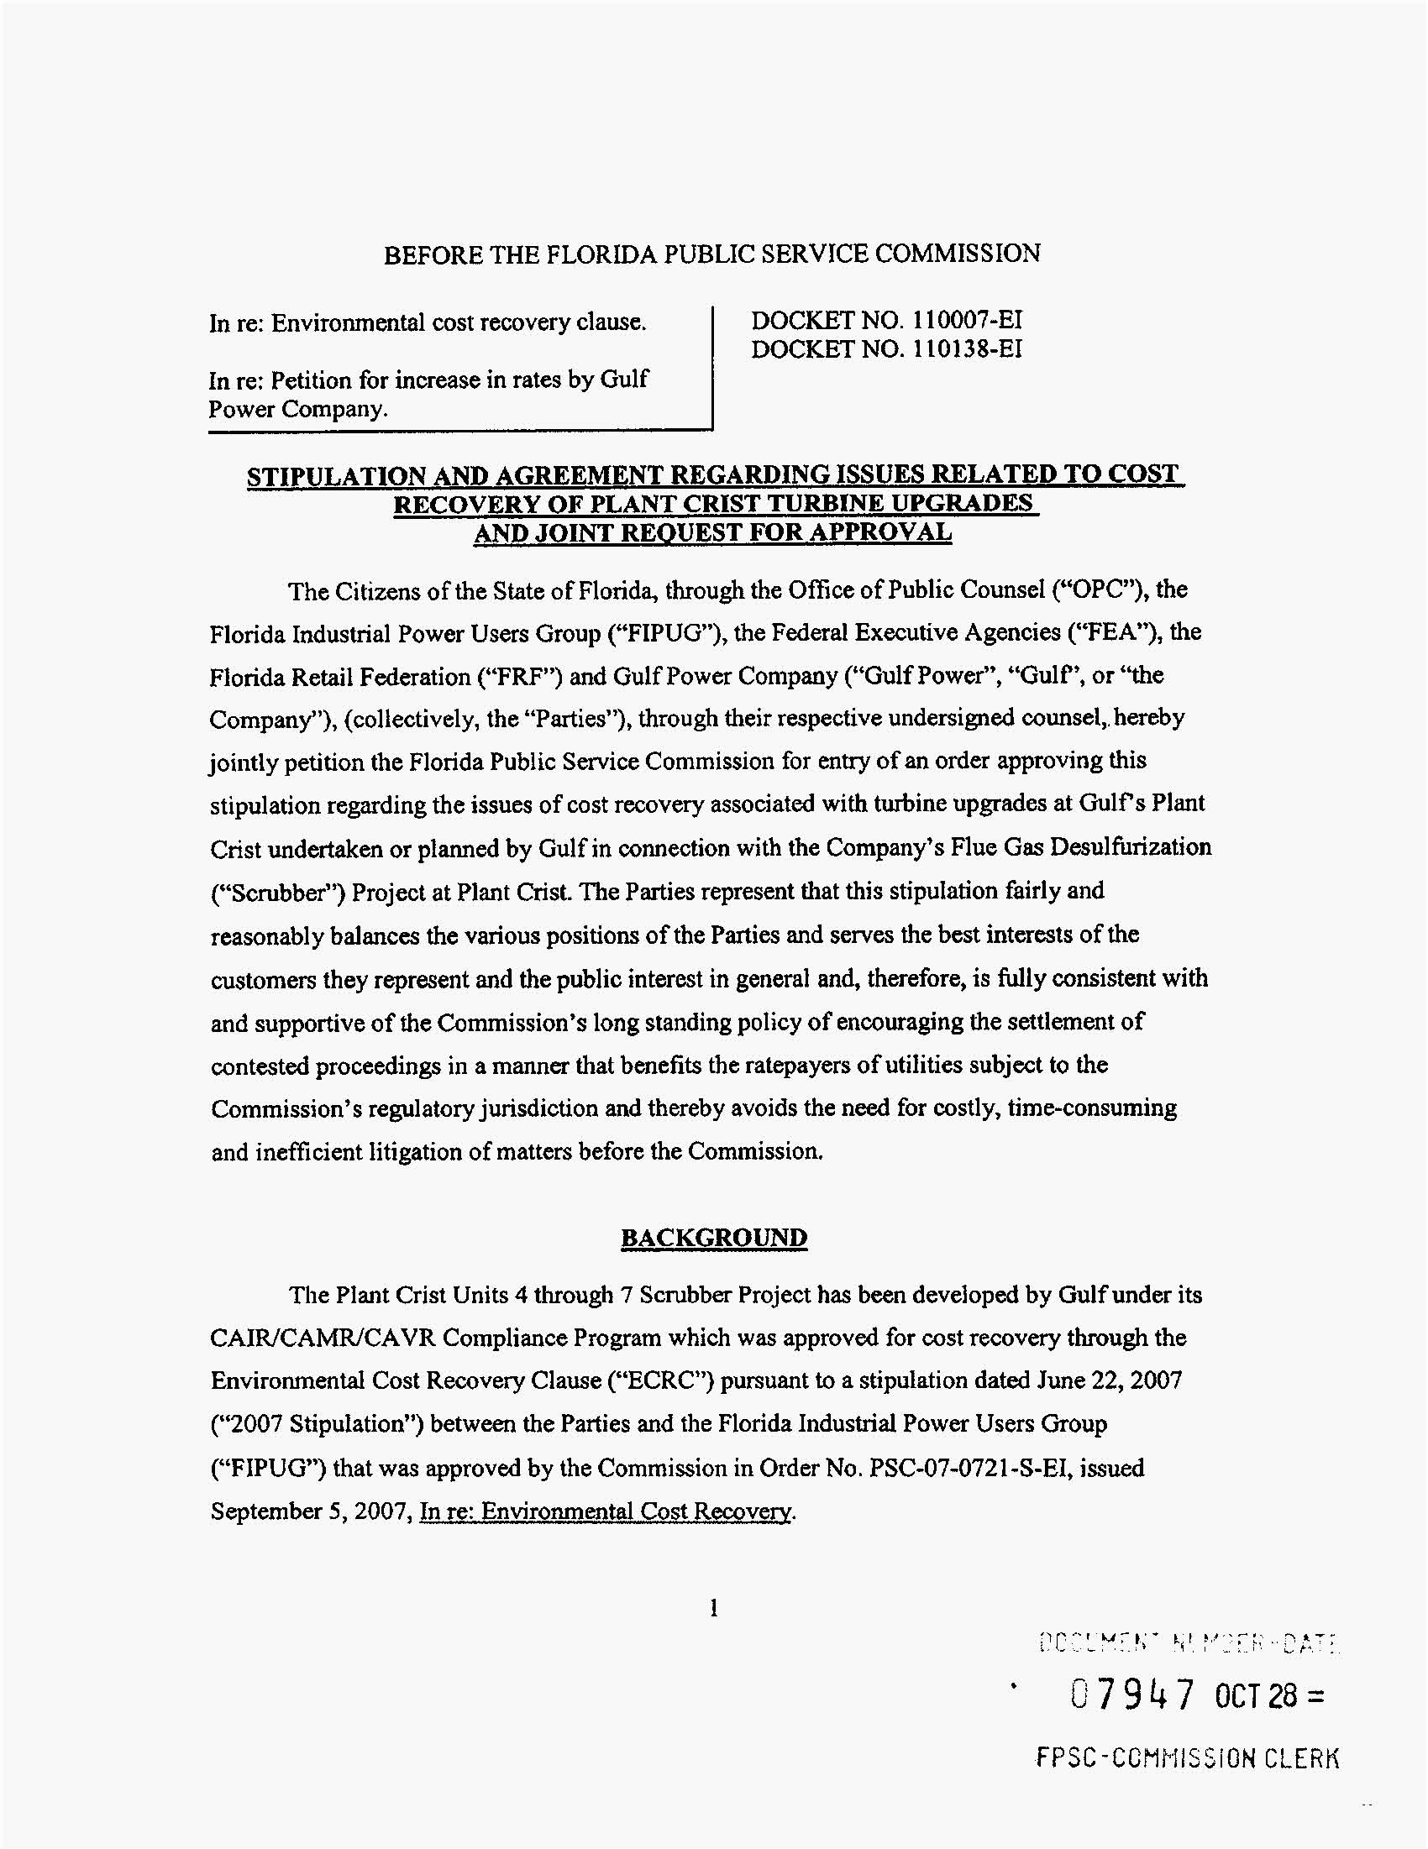
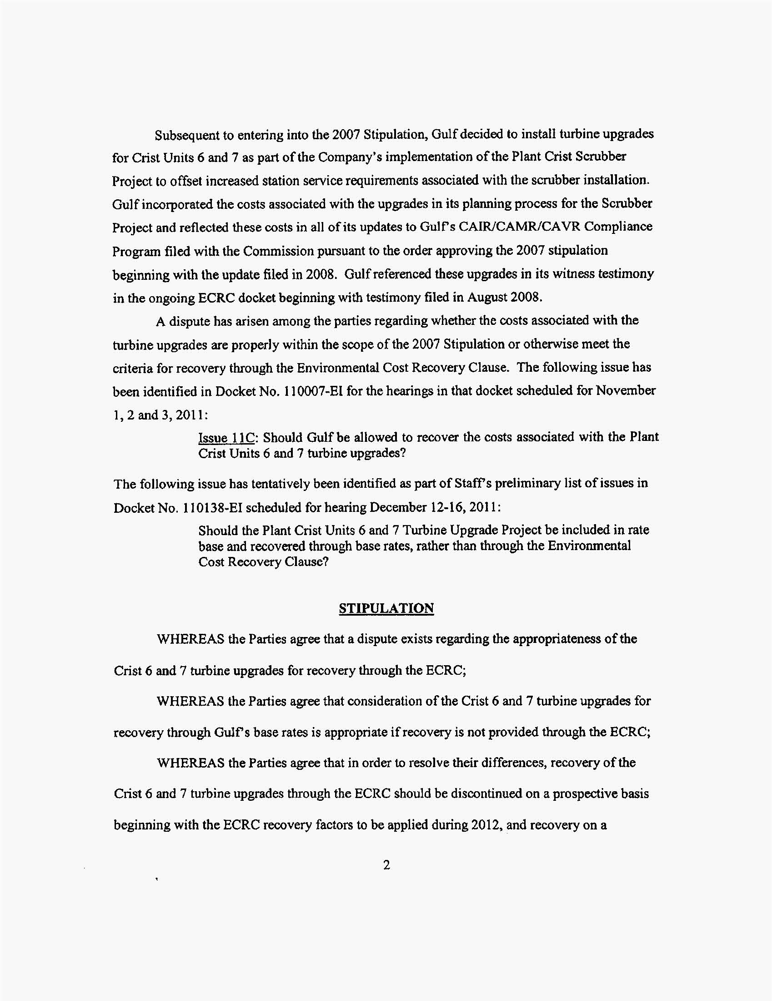
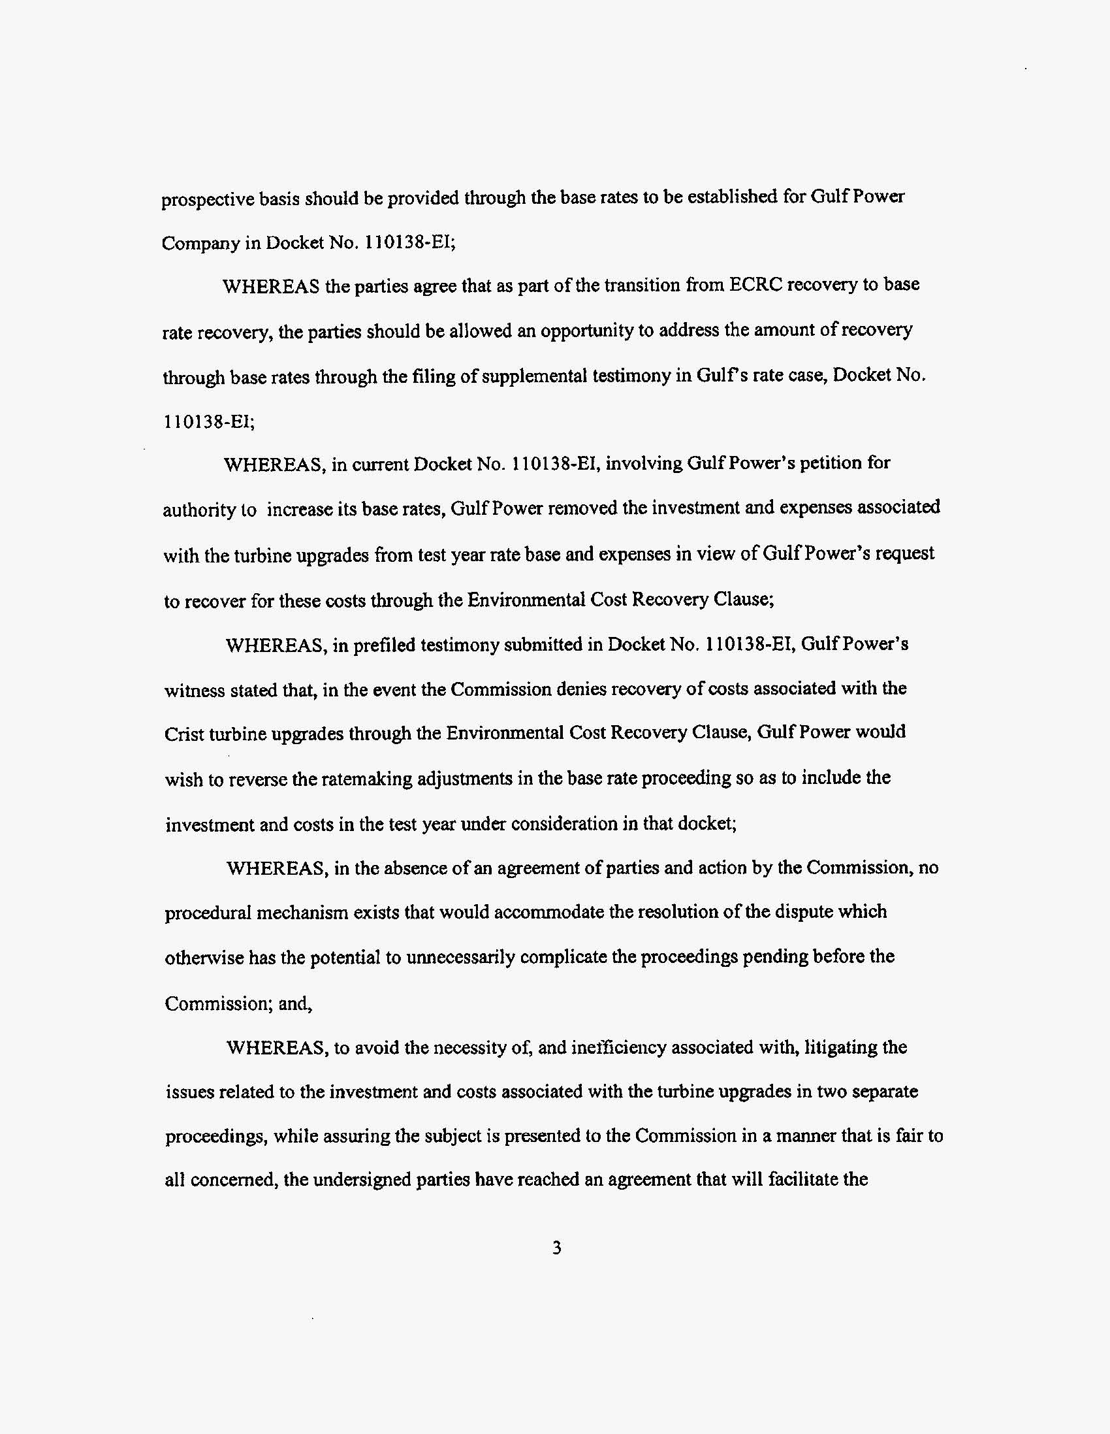
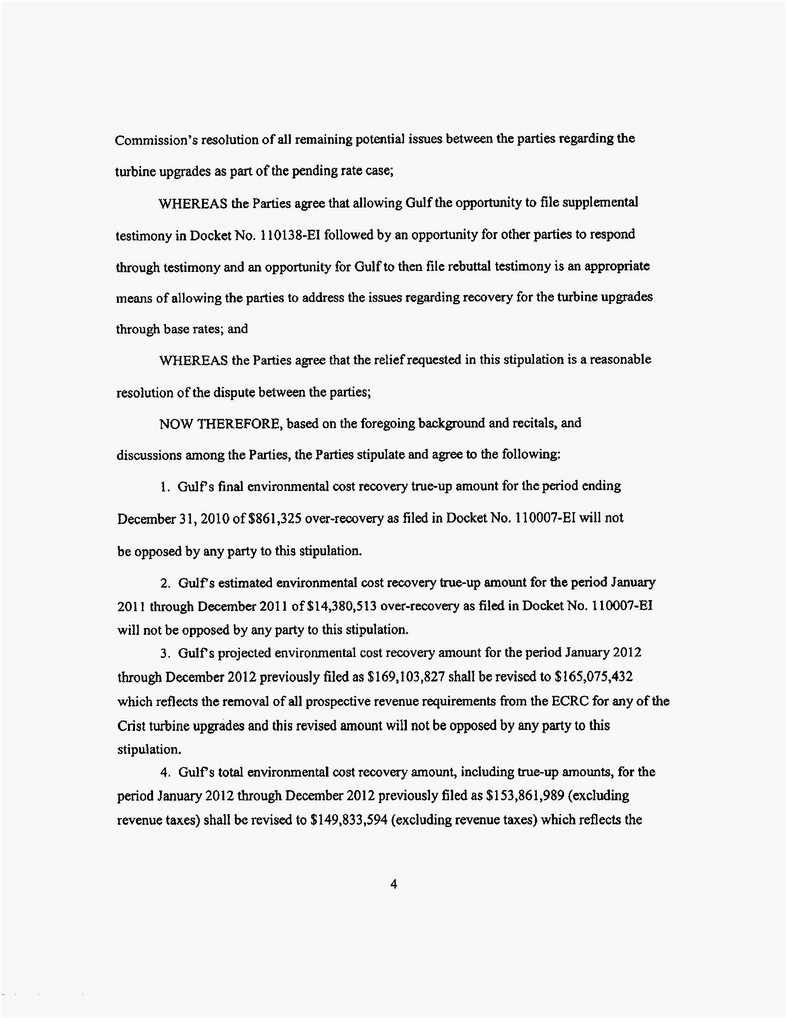
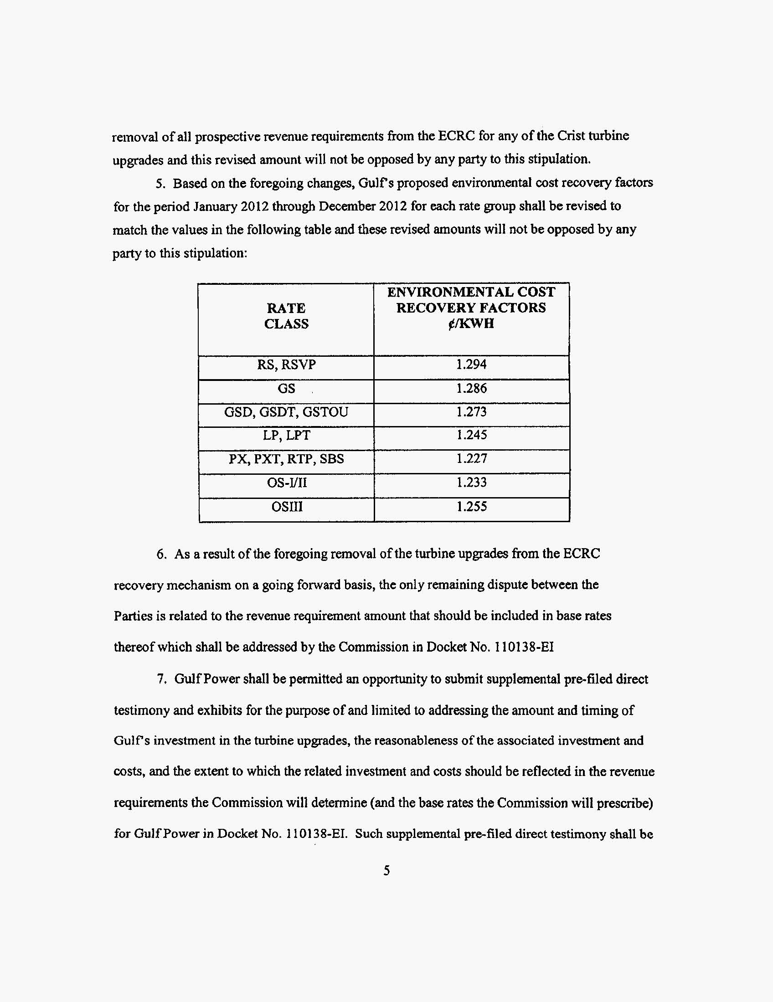
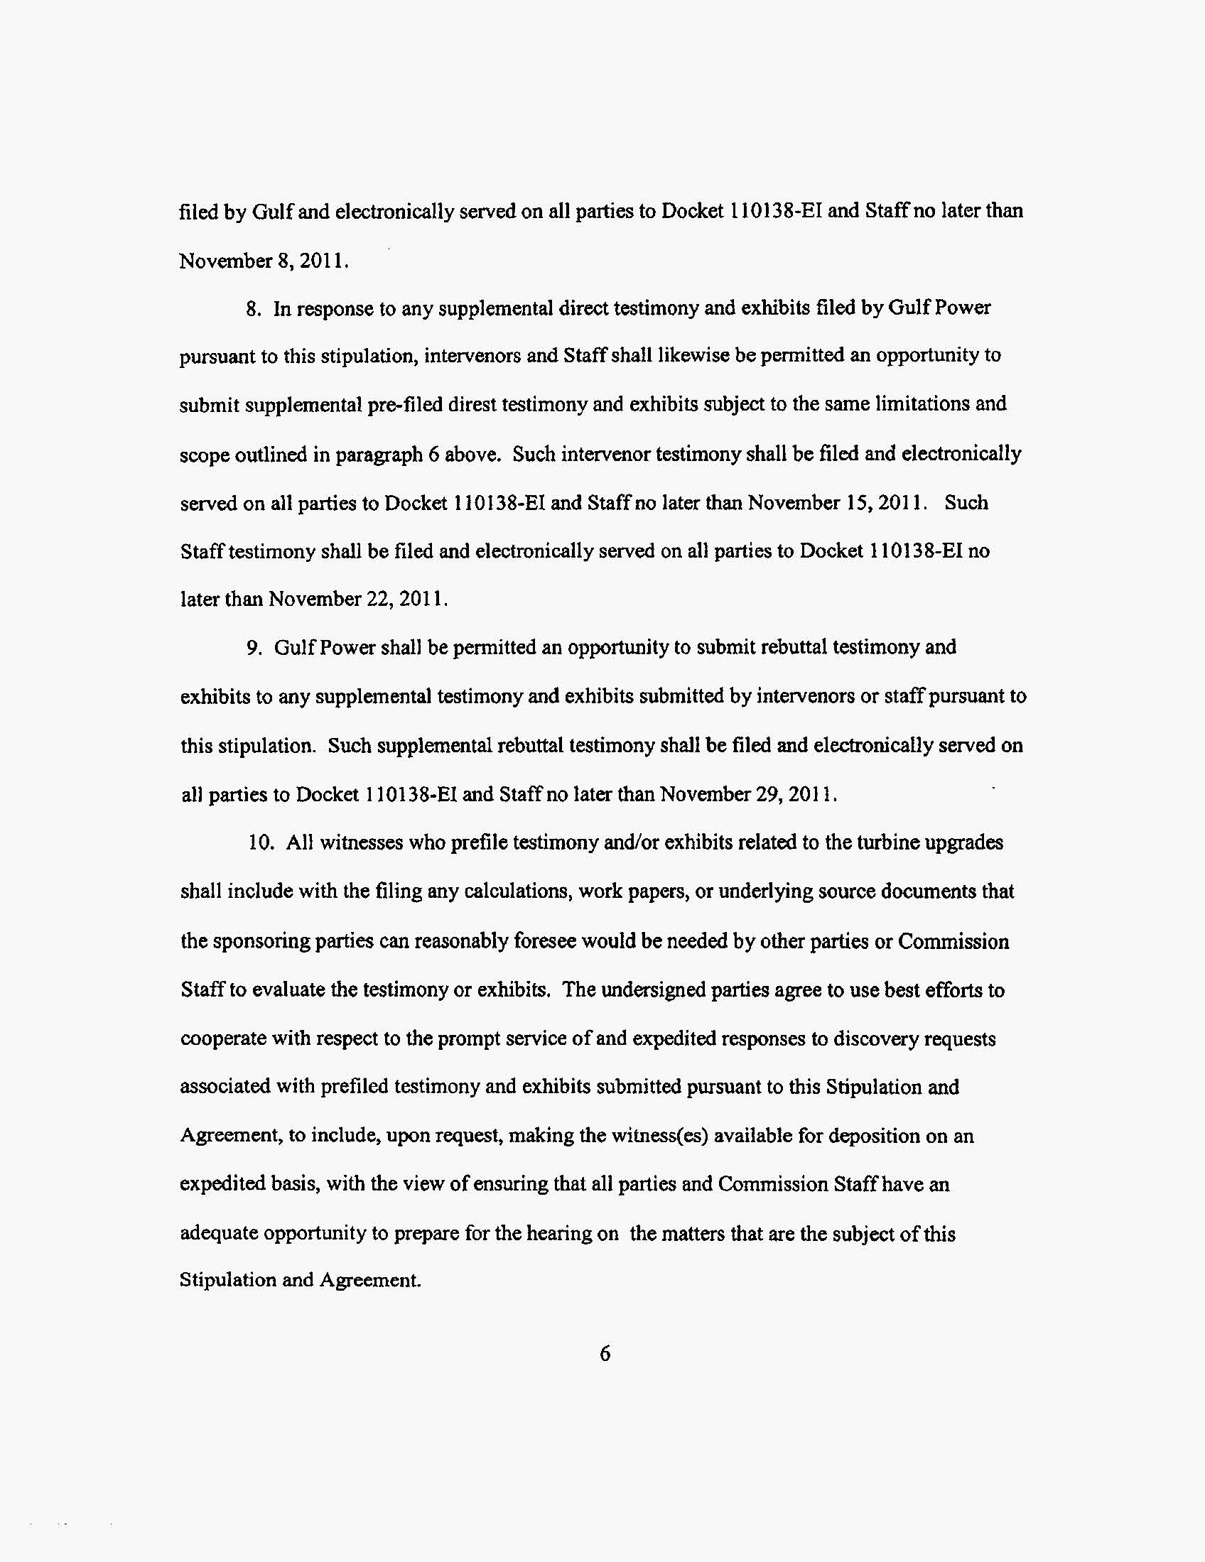
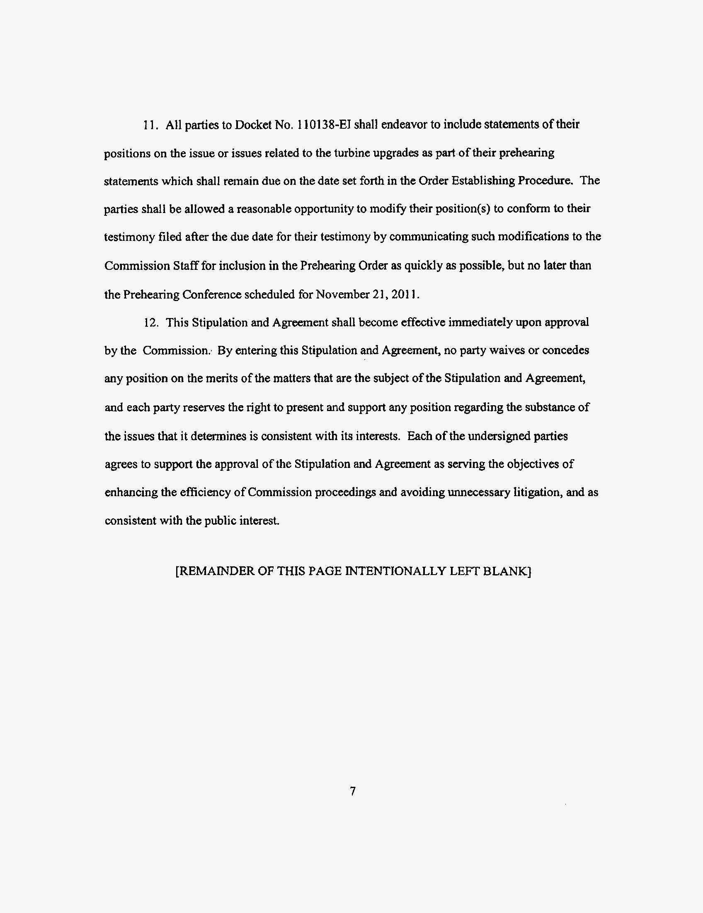
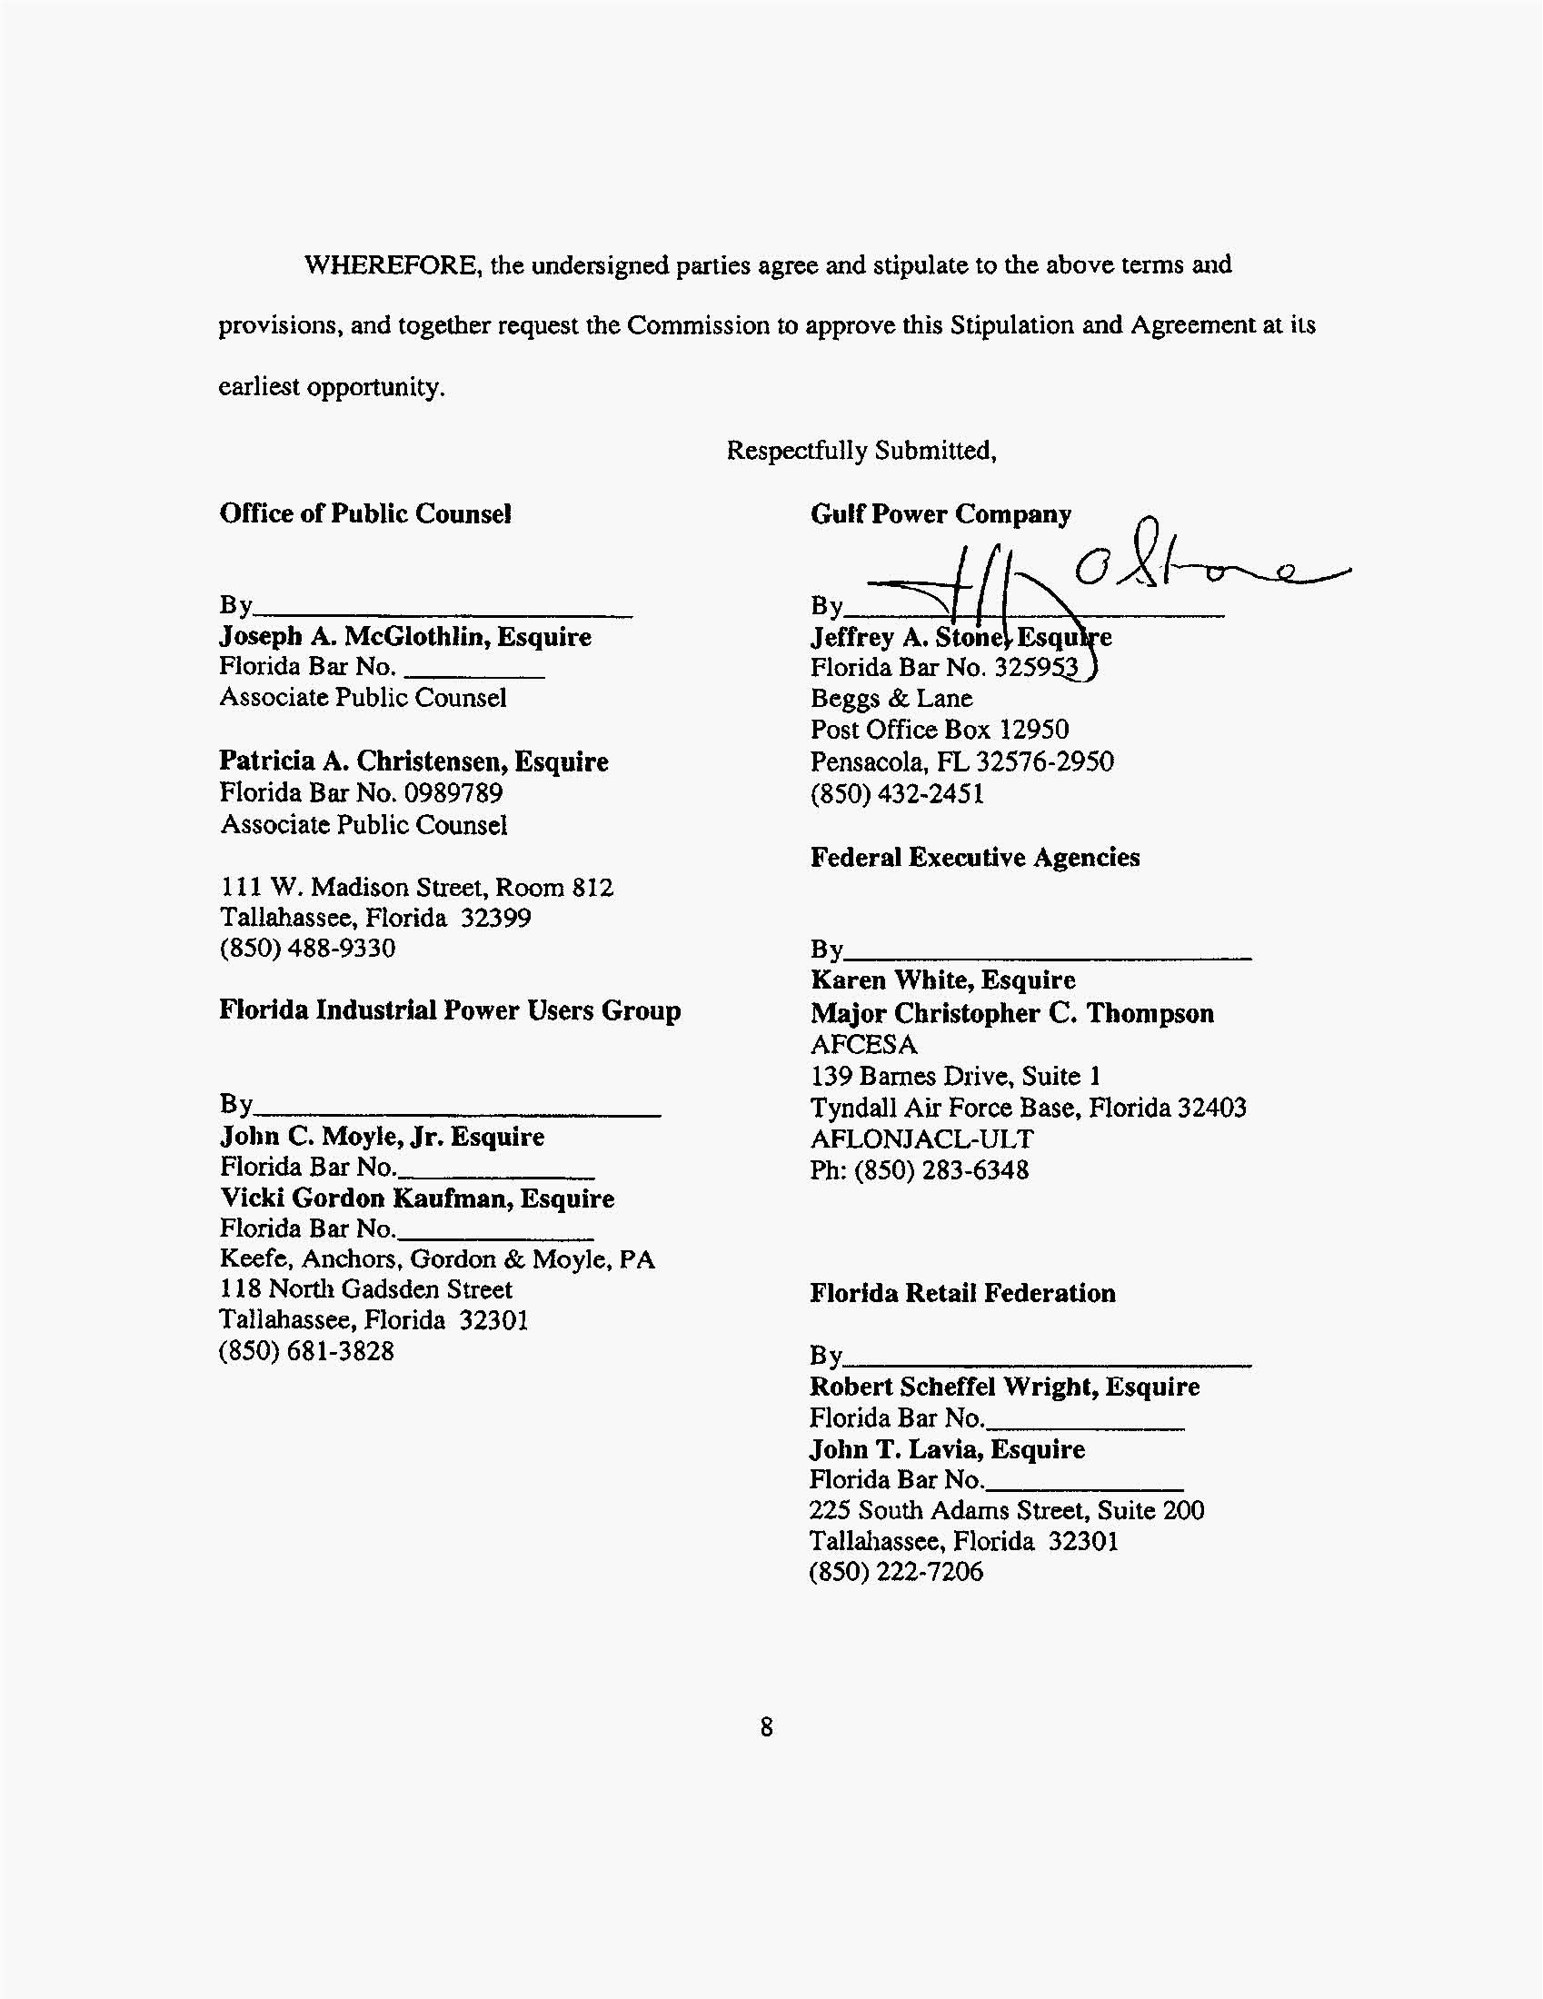
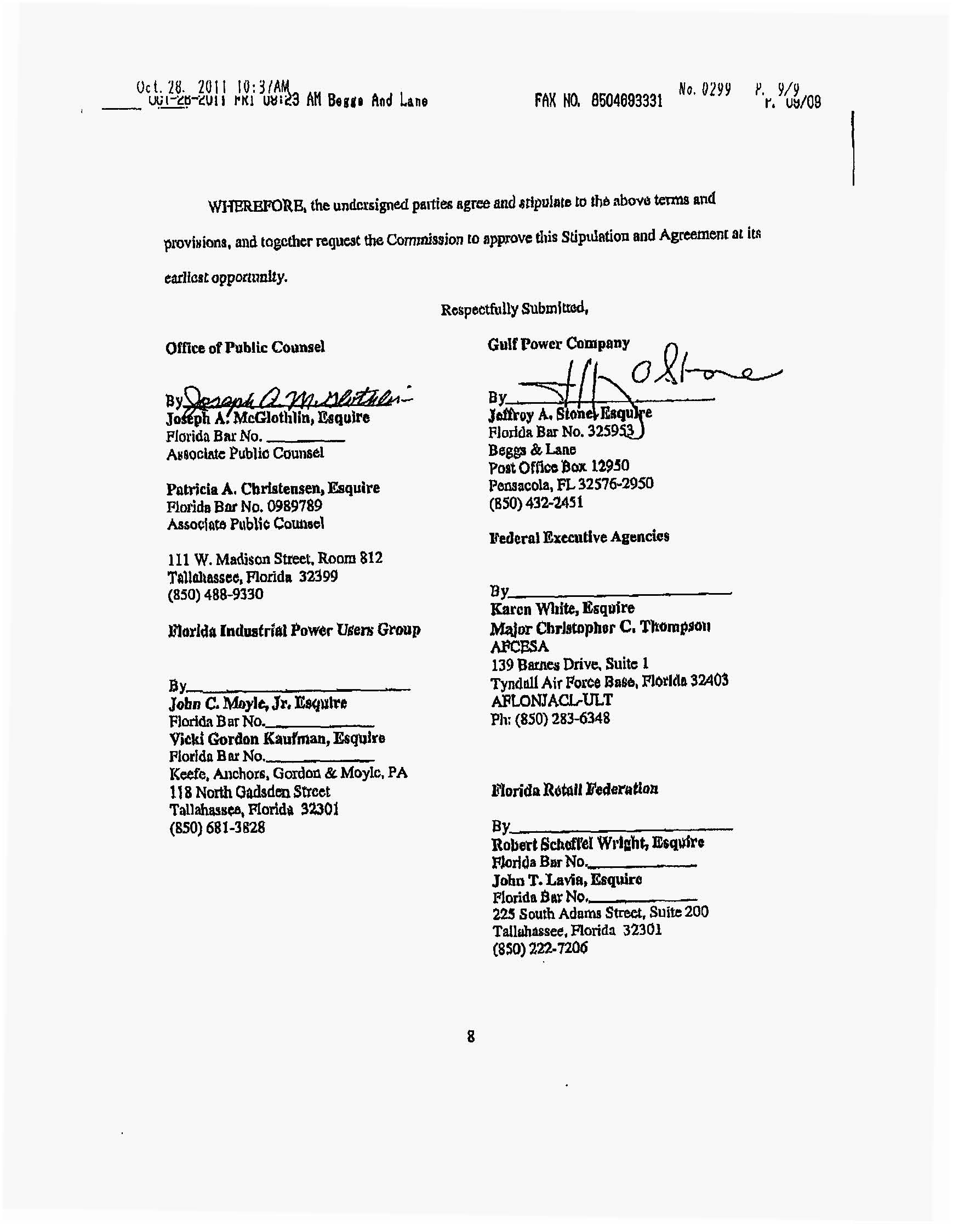
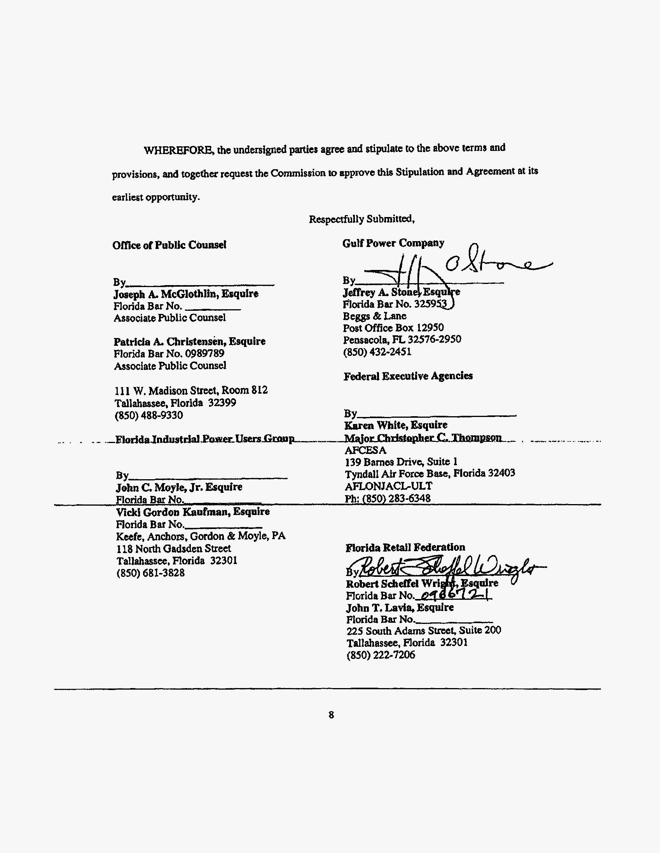
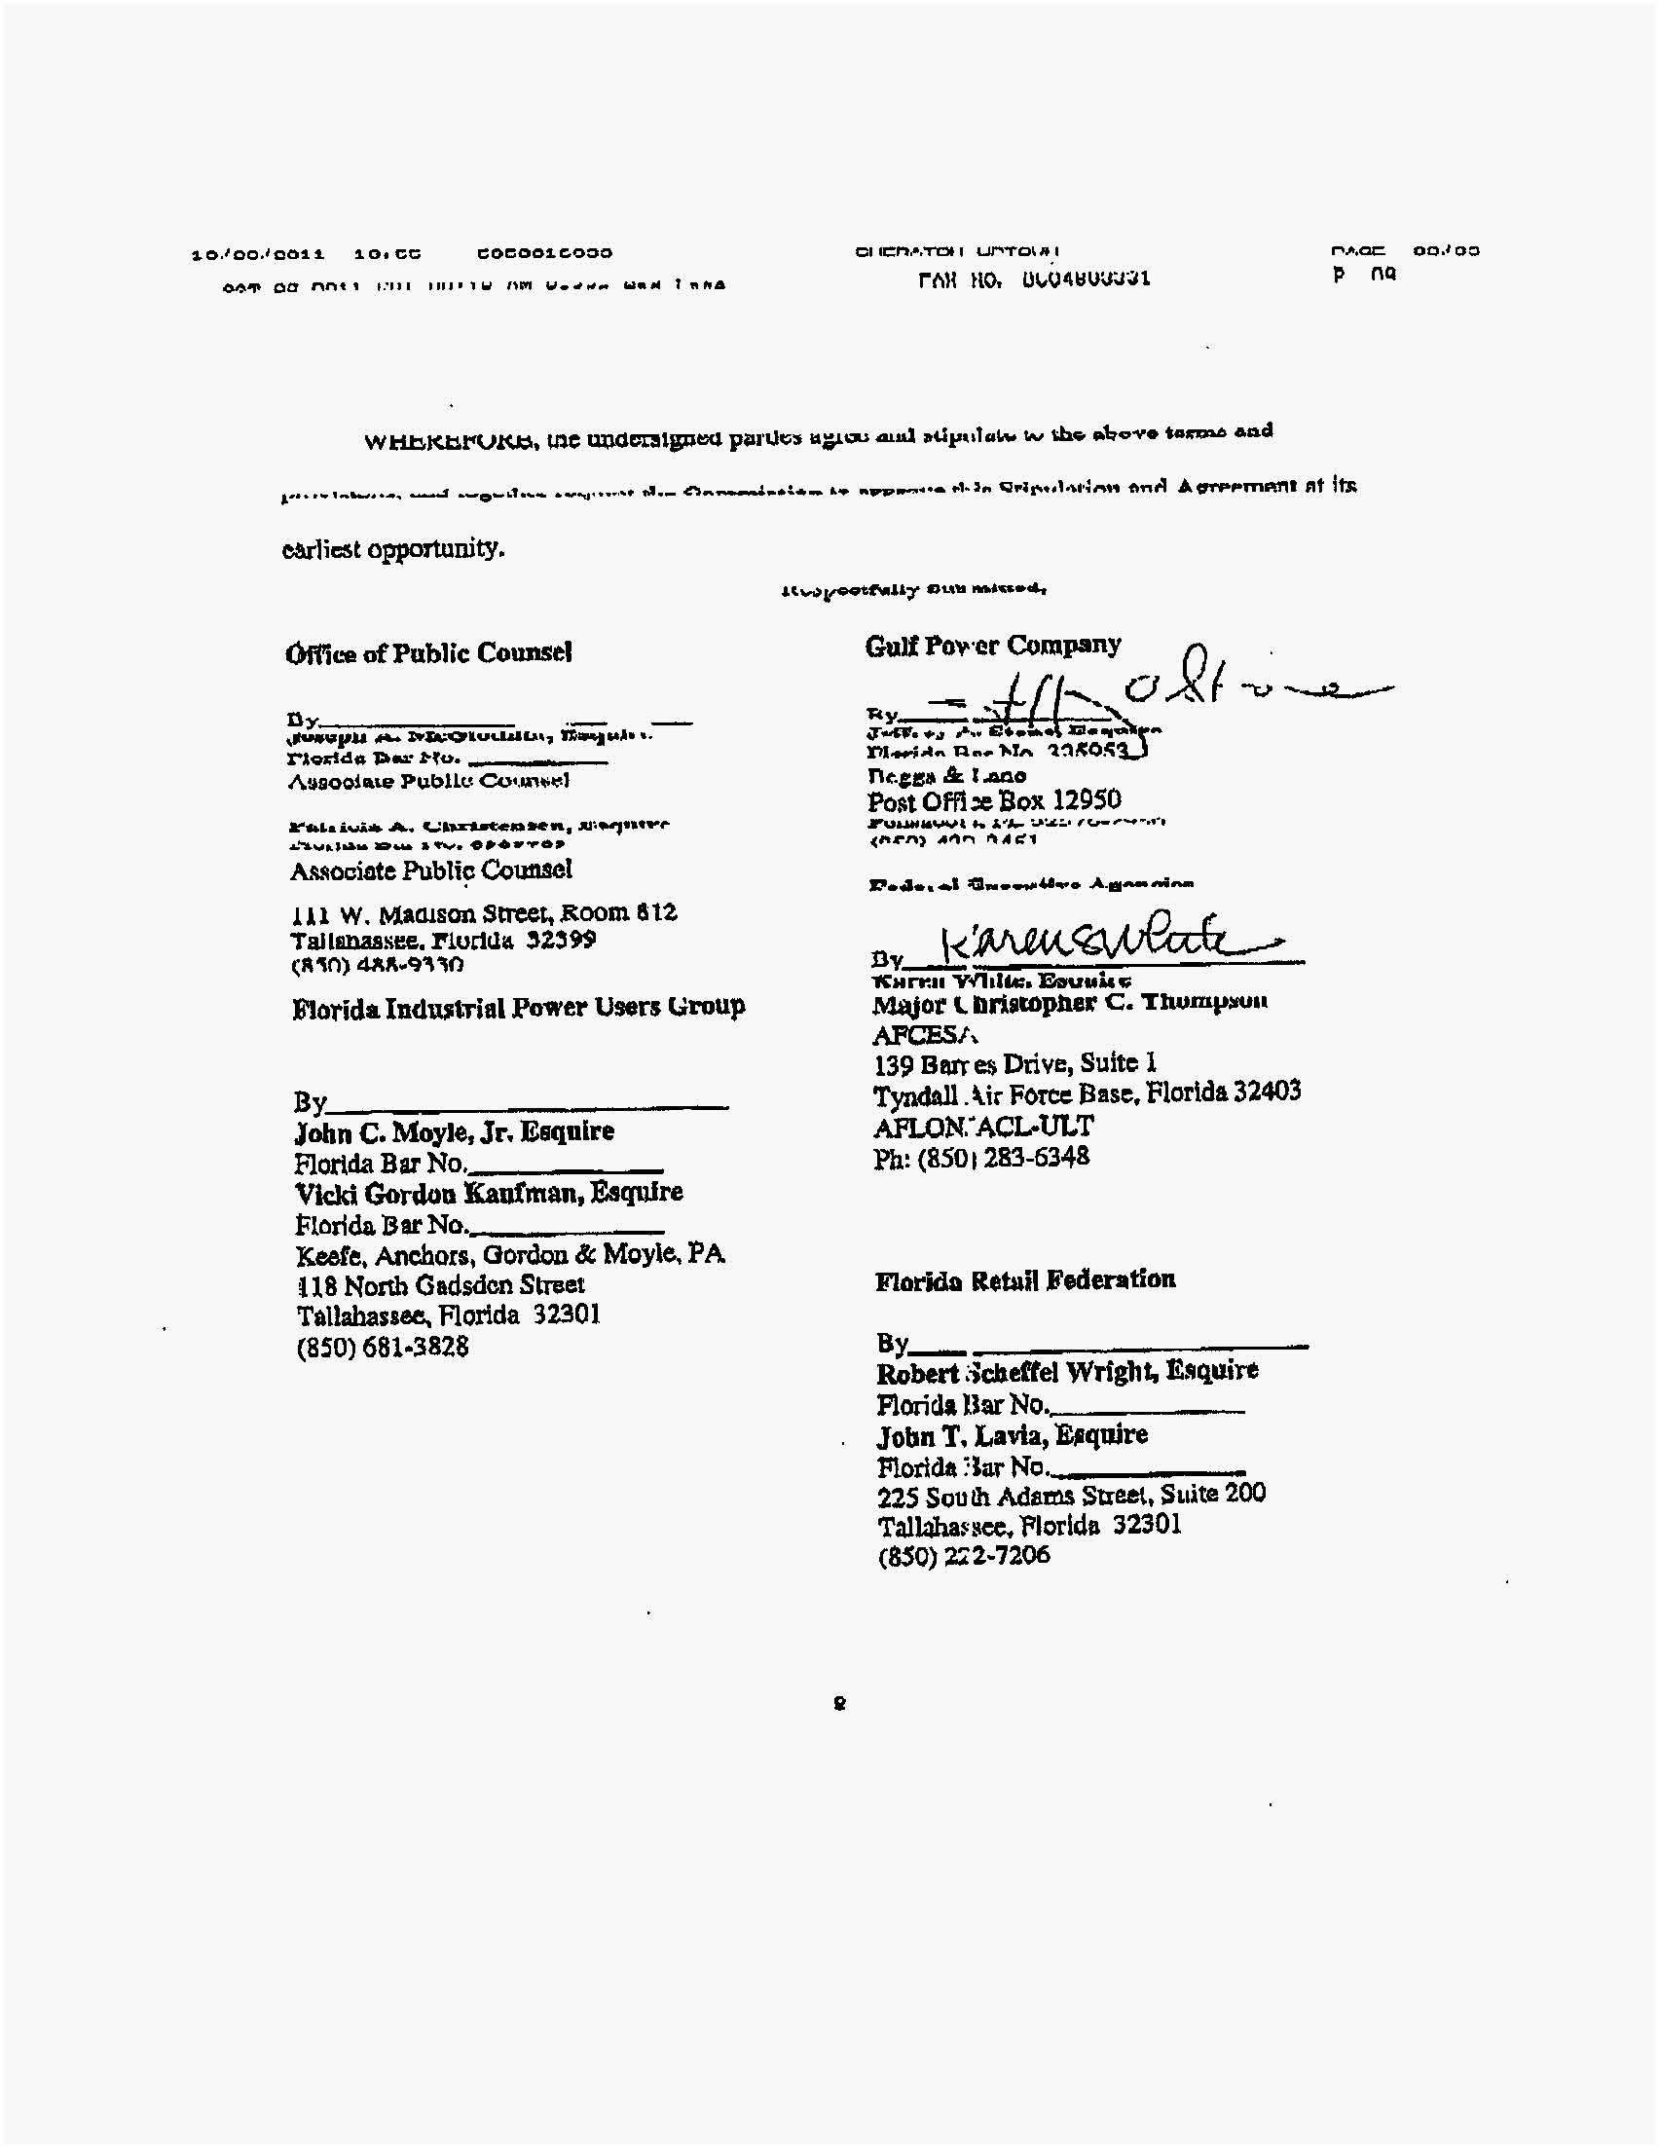
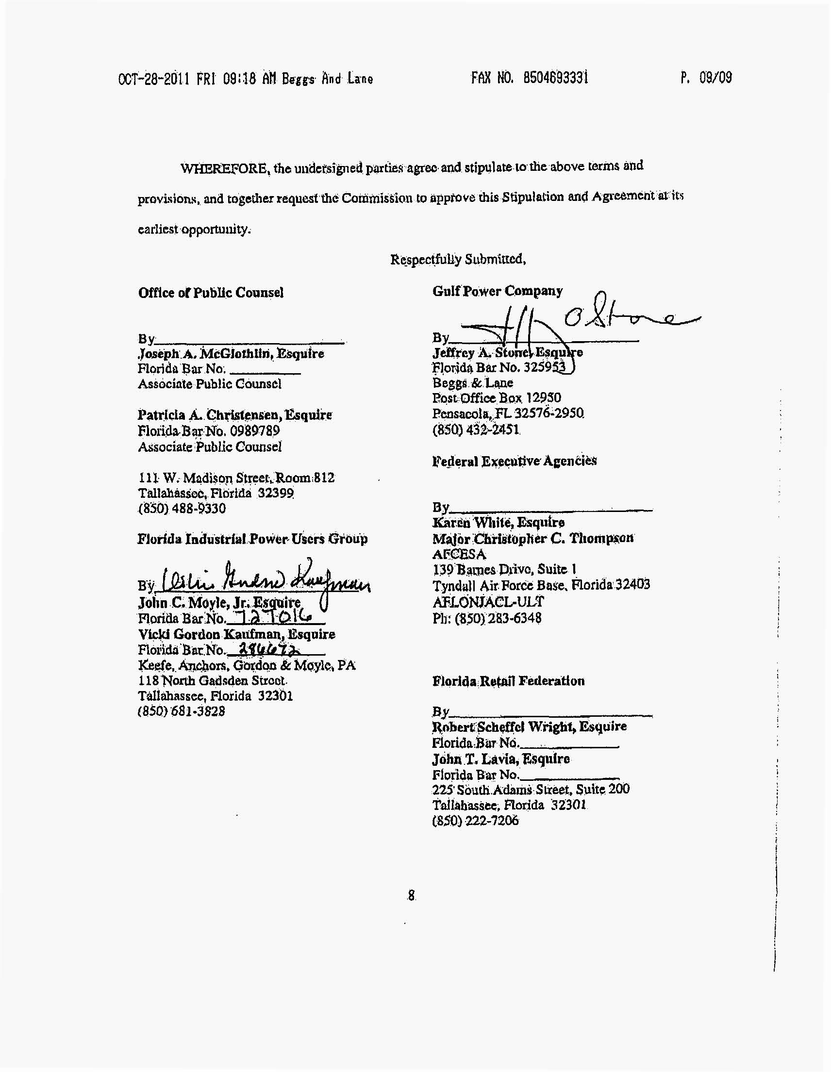
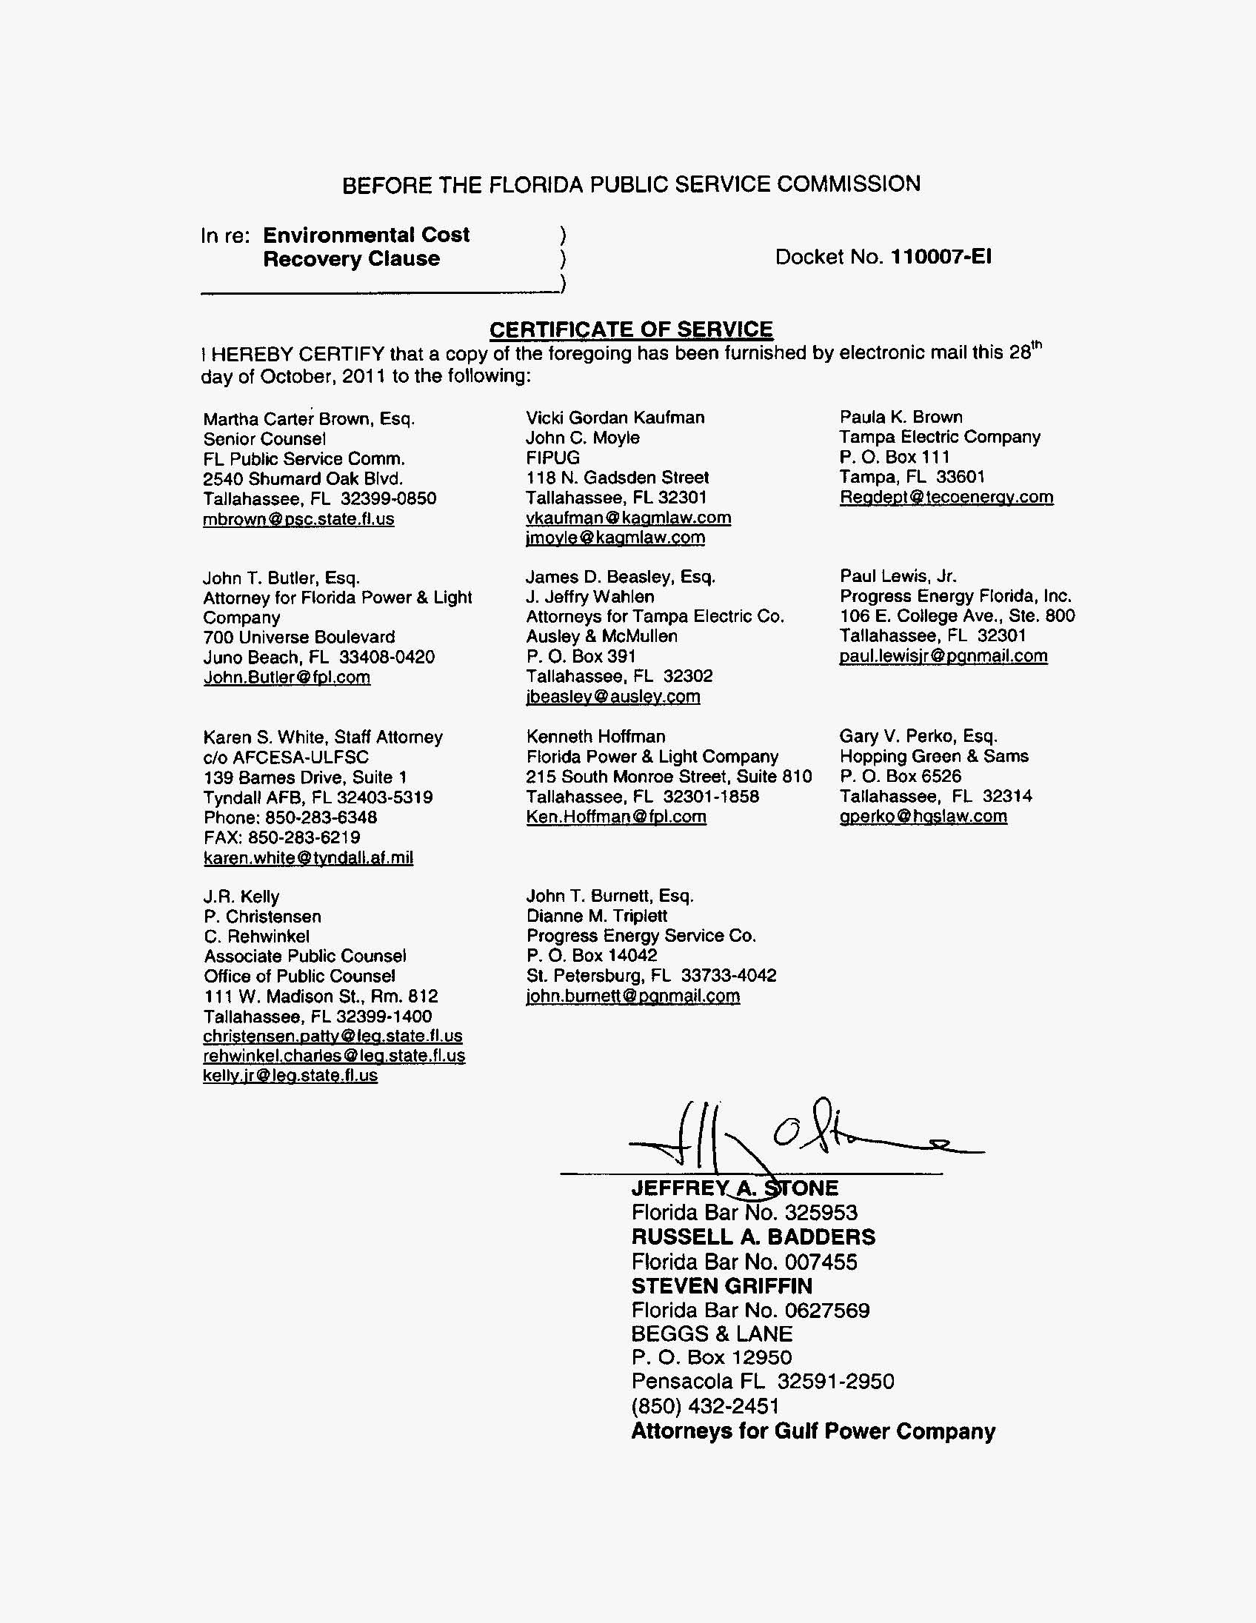
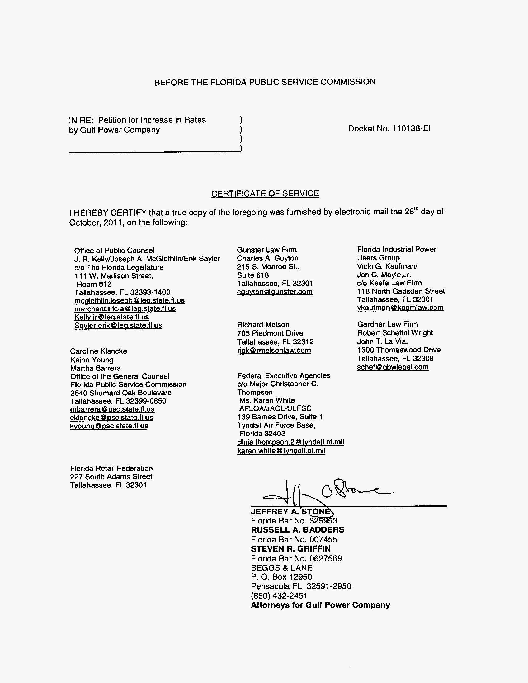

In the case of PEF, the amounts set forth in this Section II reflect fall-out calculations based on our determination of the costs associated with purchases of replacement power due to the Crystal River Unit 3 extended outage, addressed at Section IV of this Order, and related stipulations.
Issued January 12, 1994, in Docket No. 930613-EI, In re: Petition to establish an environmental cost recovery clause pursuant to Section 366.0825, Florida Statutes by Gulf Power Company.
Issued November 24, 2008, in Docket No 080007-EI, In re: Environmental cost recovery clause.
Order No. PSC-07-0922-FOF-EI, issued November 16, 2007, in Docket 070007-EI, In re: Environmental Cost Recovery.
PEF filed a Post-Hearing Brief in this docket. The Office of Public Council (OPC), FIPUG, and the Federal Executive Agencies (FEA) (collectively, Consumer Intervenors) filed a Joint Post-Hearing Brief of Intervenors (Consumers Brief) in this docket and in Docket No. 110001-EI, In re: Fuel and purchased power cost recovery clause with generating performance incentive factor.
Order No. PSC-11-0150-PCO-EI at 6, issued March 4, 2011, in this docket.

