3-month LIBOR rate on 11/11/2011 was 0.4628%. 30-day forward 3-month LIBOR rate is 0.5585%

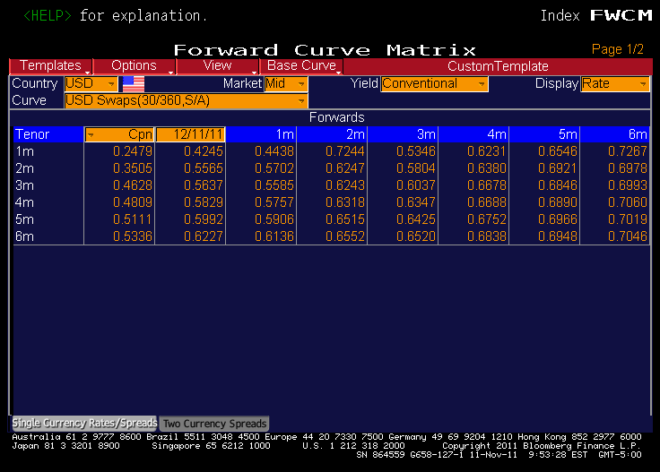

Source: Bloomberg