BEFORE THE FLORIDA PUBLIC SERVICE COMMISSION

In re: Compliance investigation of North County Communications Corporation for apparent failure to accurately disclose information on application. | DOCKET NO. 110100-TX  ORDER NO. PSC-12-0025-PAA-TX  ISSUED: January 13, 2012

The following Commissioners participated in the disposition of this matter:

RONALD A. BRISÉ, Chairman
LISA POLAK EDGAR
ART GRAHAM
EDUARDO E. BALBIS
JULIE I. BROWN

NOTICE OF PROPOSED AGENCY ACTION
ORDER APPROVING SETTLEMENT AGREEMENT

BY THE COMMISSION:

NOTICE is hereby given by the Florida Public Service Commission that the action discussed herein is preliminary in nature and will become final unless a person whose interests are substantially affected files a petition for a formal proceeding, pursuant to Rule 25-22.029, Florida Administrative Code.

Background
On August 31, 2010, North County Communications Corporation (North County) submitted an application to obtain authority to provide competitive local exchange telecommunications services in Florida. By Proposed Agency Action (PAA) Order No. PSC-10-0598-PAA-TX, issued September 30, 2010, North County was granted competitive local exchange company (CLEC) Certificate No. 8799. The Order became final and effective on October 26, 2010, upon the issuance of Consummating Order No. PSC-10-0639-CO-TX.
After the company’s certificate was granted, it was determined that North County had failed to disclose information on its CLEC application. Specifically, North County did not include information regarding the states in which the company had been involved in civil court proceedings with an interexchange carrier, local exchange company, or other telecommunications entity, and the circumstances involved as required by Part 16 question F of the CLEC application. As evidence of its managerial capabilities, North County submitted a resume for a deceased employee with its CLEC application.
Additionally, regulatory actions were taken against North County in two prior dockets for failure to pay its regulatory assessment fees (RAF). Based on the company’s failure to disclose information on its CLEC application and its two prior regulatory infractions, by PAA Order No. PSC-11-0405-PAA-TX, issued September 23, 2011, North County was advised that its CLEC Certificate No. 8799 would be cancelled for its failure to meet the managerial capability requirement of Section 364.335, Florida Statutes (F.S.). On October 10, 2011, North County protested the PAA Order and offered a proposed settlement to resolve the matter.
We are vested with jurisdiction over this matter pursuant to Sections 364.02, 364.33, and 364.335, F.S.
Discussion
Section 364.335(2), F.S., provides in part that a certificate of authority to provide telecommunications services shall be granted upon a showing that the applicant has sufficient technical, financial, and managerial capability to provide such service in the geographic area proposed to be served. Rule 25-24.810, F.A.C., Application for a Certificate, requires that an applicant for a certificate shall submit a completed Form PSC/RAD 8 (5/08) entitled “Application Form for Authority to Provide Competitive Local Exchange Service Within the State of Florida,” and the form is incorporated into the rule by reference.
As stated above, North County failed to disclose information on its CLEC application. The company resubmitted a complete CLEC application, along with the required resumes and financial statements. However, the company’s failure to disclose information on its CLEC application and its two prior regulatory infractions demonstrate that North County lacks the managerial capability required by Section 364.335(2), F.S., to operate as a CLEC in Florida.
Therefore, in PAA Order No. PSC-11-0405-PAA-TX, issued September 23, 2011, North County was advised that its CLEC Certificate will be cancelled. After the PAA Order was issued, North County submitted a settlement agreement wherein the company offered to submit a one-time voluntary payment of $2,500 to resolve the matter. The settlement agreement is attached hereto and incorporated herein. In addition to the settlement agreement, North County has retained an experienced regulatory counsel who will be responsible for ensuring that the company maintains future compliance, an act that demonstrates compliance with the managerial requirements of Section 364.335(2), F.S.
North County also stated that it had not placed the same importance on ensuring compliance in Florida (a state in which the company is non-operational) as it has on ensuring compliance in other states in which the company is operational. It is North County’s position that hiring an experienced regulatory counsel to handle the company’s regulatory matters affirms the company’s commitment to maintain future compliance. North County was also notified that even if it made the one-time voluntary payment of $2,500 as outlined in its settlement agreement and its CLEC certificate No. 8799 is not revoked, future noncompliance with or willful violation of any statute, rule, or order will subject North County to possible penalties pursuant to Section 364.285, F.S., and/or cancellation of its CLEC Certificate. If penalties are assessed in the future for noncompliance, North County was also informed that its prior regulatory violations would be considered when determining the penalty to impose.
We therefore find that North County’s attempts to resolve its regulatory violations satisfactory and that North County’s settlement agreement is consistent with our prior settlement agreements for similar violations. Furthermore, we acknowledge North County’s explanation that its failure to disclose information on its CLEC application may have resulted from a scrivener’s error rather than from an intentional or willful violation of our rules or orders. Therefore, we find it appropriate to approve North County’s settlement agreement to submit a one-time voluntary payment of $2,500.
Based on the foregoing, it is
ORDERED by the Florida Public Service Commission that the settlement agreement submitted by North County Communications Corporation, attached hereto and incorporated herein as Attachment A, is approved. It is further
ORDERED that within fourteen days of this order becoming final and non-appealable, North County Communications Corporation shall make a voluntary one-time payment of $2,500, payable to the Florida Public Service Commission and identifying the docket number and the company’s name. The payment shall be forwarded to the Division of Financial Services to be deposited into the General Revenue Fund. It is further
ORDERED that if North County fails to pay the $2,500 within fourteen (14) calendar days after the issuance of the Consummating Order, its CLEC Certificate No. 8799 shall be revoked. It is further
ORDERED that this docket shall be closed administratively upon receipt of the $2,500 or revocation of North County’s CLEC certificate.
By ORDER of the Florida Public Service Commission this 13th day of January, 2012.

/s/ Hong Wang
HONG WANG
Chief Deputy Commission Clerk
Florida Public Service Commission
2540 Shumard Oak Boulevard
Tallahassee, Florida 32399
(850) 413-6770
www.floridapsc.com

Copies furnished: A copy of this document is provided to the parties of record at the time of issuance and, if applicable, interested persons.

PER

NOTICE OF FURTHER PROCEEDINGS OR JUDICIAL REVIEW

The Florida Public Service Commission is required by Section 120.569(1), Florida Statutes, to notify parties of any administrative hearing that is available under Section 120.57, Florida Statutes, as well as the procedures and time limits that apply. This notice should not be construed to mean all requests for an administrative hearing will be granted or result in the relief sought.

Mediation may be available on a case-by-case basis. If mediation is conducted, it does not affect a substantially interested person's right to a hearing.

The action proposed herein is preliminary in nature. Any person whose substantial interests are affected by the action proposed by this order may file a petition for a formal proceeding, in the form provided by Rule 28-106.201, Florida Administrative Code. This petition must be received by the Office of Commission Clerk, 2540 Shumard Oak Boulevard, Tallahassee, Florida 32399-0850, by the close of business on February 3, 2012.

In the absence of such a petition, this order shall become final and effective upon the issuance of a Consummating Order.

Any objection or protest filed in this/these docket(s) before the issuance date of this order is considered abandoned unless it satisfies the foregoing conditions and is renewed within the specified protest period.

ATTACHMENT A
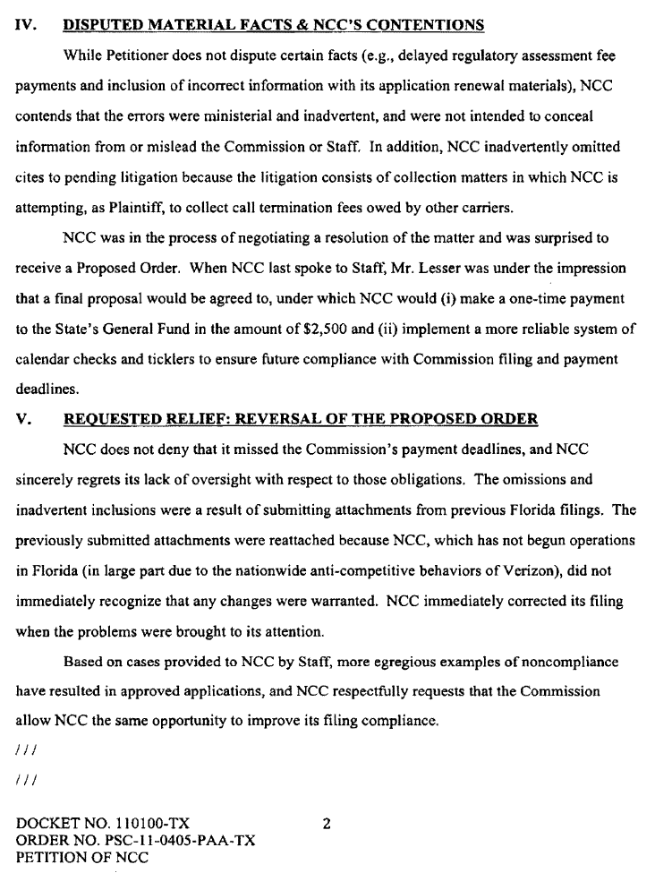
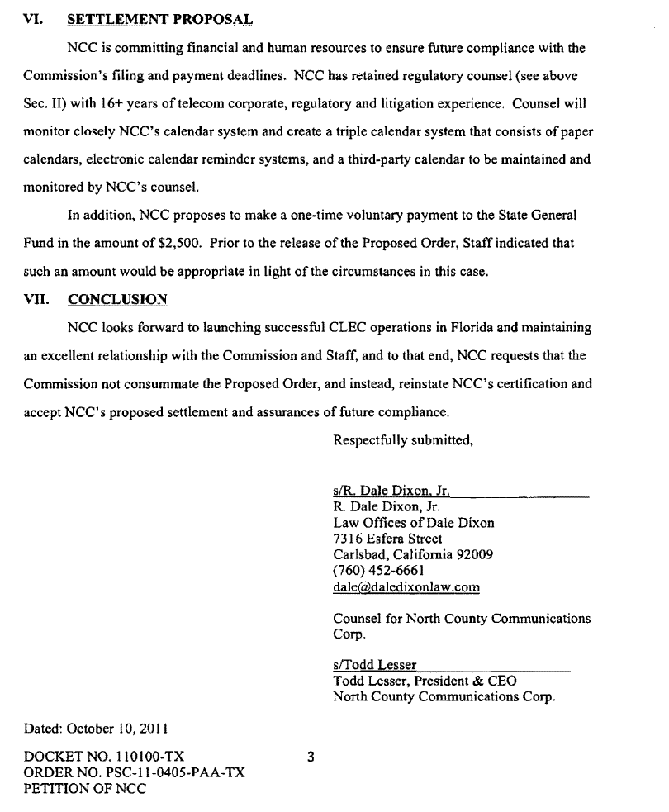

See Docket No. 020628-TX, In Re: Cancellation by the Florida Public Service Commission of ALEC Certificate No. 7764 issued to North County Communications Corporation for violation of Rule 25-4.0161, F.A.C., Regulatory Assessment Fees; Telecommunications Companies (established to address North County’s failure to pay its 2001 RAF payment). See also Docket No. 100220-TX, In Re: Compliance investigation of CLEC Certificate No. 7764, issued to North County Communications Corporation, for apparent first-time violation of Rule 25-4.0161, F.A.C., Regulatory Assessment Fees; Telecommunications Companies (established to address North County’s failure to pay its 2009 RAF payment. We ultimately cancelled North County’s initial CLEC Certificate No. 7764 for failure to pay its RAF. However, the company reapplied for a certificate and was granted its current CLEC Certificate No. 8799).
Section 364.337, F.S., was repealed effective July 1, 2011, after North County’s CLEC certificate was issued. Pursuant to Section 364.33, F.S., effective July 1, 2011, we no longer issue certificates of necessity to provide CLEC services. However, existing certificates remain valid.
See Order No. PSC-05-0734-PAA-TP, issued on July 8, 2005, in Docket No. 050363-TP, In Re: Compliance investigation of Southeastern Services, Inc. for apparent failure to disclose required information on each of its applications for alternative access vendor certificate, competitive local exchange company certificate, and interexchange company certificate (wherein Southeastern Services, Inc., inadvertently failed to disclose pertinent information on its applications. To resolve the matter Southeastern Services, Inc.’s settlement agreement to voluntarily contribute a payment of $2,500 was approved).

