BEFORE THE FLORIDA PUBLIC SERVICE COMMISSION

In re: Application for original certificates for proposed water and wastewater system and request for initial rates and charges in Indian River, Okeechobee and St. Lucie counties by Grove Land Utilities, LLC. | DOCKET NO. 090445-WS  ORDER NO. PSC-12-0224-PAA-WS  ISSUED: April 30, 2012

The following Commissioners participated in the disposition of this matter:

RONALD A. BRISÉ, Chairman
LISA POLAK EDGAR
ART GRAHAM
EDUARDO E. BALBIS
JULIE I. BROWN

NOTICE OF PROPOSED AGENCY ACTION
ORDER APPROVING RATES AND CHARGES
AND
FINAL AGENCY ACTION GRANTING WATER
AND WASTEWATER CERTIFICATES

BY THE COMMISSION:

NOTICE is hereby given by the Florida Public Service Commission that, except for the granting of water and wastewater certificates and approving the agreements with St. Lucie County and Indian River County, which are final agency action, the action discussed herein is preliminary in nature and will become final unless a person whose interests are substantially affected files a petition for a formal proceeding, pursuant to Rule 25-22.029, Florida Administrative Code (F.A.C.).

I. Background
On September 11, 2009, Grove Land Utilities, LLC (Grove Land or Utility) filed an application for original water and wastewater certificates and initial rates and charges. The Utility is an LLC which is ultimately owned by Evans Properties, Inc. (Evans) through a utility subsidiary, Evans Utilities Company, Inc. (Evans Utilities). The proposed territory consists of a total of 11,208 acres, all owned by Evans, with 3,823 acres in Indian River County (Indian River), 5,628 acres in Okeechobee County (Okeechobee), and 1,757 acres in St. Lucie County (St. Lucie). While Okeechobee and St. Lucie Counties have turned over jurisdiction of the privately owned water and wastewater utilities within their counties to this Commission, pursuant to Chapter 367.171, Florida Statutes (F.S.), Indian River has not. However, pursuant to Section 367.171(7), F.S., we have exclusive jurisdiction over all utility systems whose service transverses county boundaries, whether the counties involved are jurisdictional or nonjurisdictional; therefore, we have jurisdiction over the portion of the proposed service area in Indian River. Grove Land’s service territory is located in both the South Florida Water Management District (SFWMD) and the St. Johns River Water Management District (SJRWMD). At buildout, Grove Land proposes to serve 1,296 water and 1,286 wastewater equivalent residential connections (ERCs).
On September 25, 2009, shortly after the application in this docket was filed, a separate application was filed in Docket No. 090459-WS for original water and wastewater certificates and initial rates and charges for Bluefield Utilities, LLC (Bluefield), another LLC owned by Evans. In October of 2009, St. Lucie, Indian River, Fort Pierce Utilities Authority (FPUA), and Okeechobee filed for leave to intervene and objection to the application in this docket. Bluefield’s application received similar objections from St. Lucie, FPUA, the City of Port Lucie, and Martin County. On March 26, 2010, Indian River withdrew its objection to Grove Land’s application pursuant to an attached Agreement Between Grove Land Utilities, LLC and Indian River County (Indian River Agreement) dated March 23, 2010. The withdrawal of Indian River’s protest was conditioned on the Indian River Agreement being included as a part and condition of our approval of Grove Land’s certificates. On April 7, 2010, Order No. PSC-10-0224-PCO-WS was issued consolidating the Grove Land and Bluefield dockets and establishing the procedures for a hearing to be held in February 2011. On December 13, 2010, Order No. PSC-10-0728-PCO-WS was issued granting an emergency stipulated motion for abatement. Continued motions for abatement were granted by orders issued on February 7, March 8, and June 21, 2011.
On April 8, 2010, FPUA withdrew its objection to Grove Land’s application without conditions. On October 18, 2010, Okeechobee also withdrew its objection to Grove Land’s application without conditions. Lastly, on January 13, 2012, St. Lucie withdrew its objection to Grove Land’s application pursuant to an attached Agreement Between Grove Land Utilities, LLC, Evans Properties, Inc., and St. Lucie County, Florida (St. Lucie Agreement) dated December 6, 2011. As with Indian River’s withdrawal, St. Lucie conditioned its withdrawal on our approval of the St. Lucie Agreement. With the withdrawal of St. Lucie County’s objection on January 13, 2012, as the last remaining objection, there are no outstanding objections to Grove Land’s application. On February 24, 2012, Order No. PSC-12-0083-PCO-WS was issued rescinding the prior order consolidating the Grove Land and Bluefield applications so that Grove Land’s application could proceed to agenda.
This Order addresses the Agreements, the granting of water and wastewater certificates, and the establishment of initial rates and charges. We have jurisdiction pursuant to Sections 367.031, 367.045, 367.081, 367.091, 367.101, and 367.171, F.S.

II. The Indian River and St. Lucie Agreements
As stated above, Indian River conditioned its March 26, 2010 withdrawal of its protest to Grove Land’s application upon our approving the Indian River Agreement dated March 23, 2010 and appended to this Order as Attachment A. St. Lucie also conditioned its January 13, 2012 withdrawal of its protest upon us approving the St. Lucie Agreement dated December 6, 2011, and appended to this Order as Attachment B. Because these agreements are very similar, we shall consider them together.
A. St. Lucie Agreement
The St. Lucie Agreement contained the following three main provisions whereby the parties would be bound if we ultimately agreed that Grove Land should be granted water and wastewater certificates for the requested area.
1. Utility Boundaries
Under this provision, Grove Land agreed to not provide or seek to provide domestic utility service outside the boundaries of the service territory sought in this docket (Grove Land’s Utility Territory) and within the utility service territory of the St. Lucie County Water and Sewer District (District). This provision included the following proviso:
This paragraph shall not prohibit Grove Land from, (a) providing surface water retention and/or cleansing services that would require Grove Land to take surface water from outside of Grove Land’s Utility Territory . . ., (b) selling water retention or cleansing services or credits to customers outside of Grove Land’s Utility Territory, or (c) selling bulk potable or non-potable water to the City of Port St. Lucie or the Fort Pierce Utility Authority, or any other customers not located within the District’s utility service area . . . .
Pursuant to Section 367.045(5)(a), F.S., we “may not grant authority greater than that requested in the application . . . .” Further, the above provision does not deprive or give up any of our jurisdiction. Pursuant to Section 367.022(12), F.S., bulk sales to a governmental authority are exempt from our regulation. Further, for jurisdictional sales, pursuant to Sections 367.021 and 367.045(2), F.S., a utility may not provide service outside its certificated territory. We find there are no objectionable conditions in this provision which would warrant our disapproval.
2. County Review
This provision underscores St. Lucie’s right to review and approve the engineering plans for any water or wastewater plant to be constructed within Grove Land’s Utility Territory in St. Lucie County. The provision specifically notes that such review shall not be unreasonably withheld, and that approval or comments will be provided within 45 days of submission. Further, the provision, as an example of unreasonableness, includes requiring that the design include: (a) significant overcapacity above the capacity required by the Florida Department of Environmental Protection (FDEP); or (b) design elements that we would deem “not used or useful.” Again, we can discern no conditions which would warrant our disapproval.
3. Preemption by Public Service Commission
This provision specifically notes services that may be rendered by Grove Land which would not come under the Agreement. Further, the provision notes that Grove Land would be permitted to provide the specifically noted services “pursuant to applicable regulation by the FPSC and/or the FDEP.” As with the prior two provisions, we can discern no conditions which would warrant our disapproval.
B. Indian River Agreement
The Indian River Agreement had almost identical provisions concerning County Review and Preemption by the Public Service Commission as in the St. Lucie Agreement discussed above. However, instead of the provision concerning Utility Boundaries as described in the St. Lucie Agreement, above, the Indian River Agreement had a provision titled Compliance with Comprehensive Plan.
In this provision, Grove Land agrees that any wastewater system, water system, or development must comply with the Comprehensive Plan then in effect. As with all the other provisions, we can discern no condition which would warrant our disapproval.
C. Conclusion
It appears that the parties, after extensive negotiations, filed these Agreements to avoid the time and expense of further litigation. We find that the parties’ Agreements are a reasonable resolution of this matter. These Agreements will result in withdrawal of objections to the certificate application of Grove Land and will avert the need for a hearing. Further, if any of the above-cited provisions of the Agreements could be said to bind our authority to carry out our duties, the provisions would be unenforceable against this Commission. We have approved similar agreements in the past where we determined that the parties could not bind our authority. By Order No. PSC-99-0635-FOF-WU, issued on April 5, 1999, in Docket No. 960444-WU, In Re: Application for Rate Increase and Increase in Service Availability Charges in Lake County by Lake Utility Services, Inc., we approved a settlement agreement between the utility and the Office of Public Counsel which purported to bind us from instituting future proceedings to change the utility’s rates and charges set forth in the settlement. In approving the parties’ settlement, we noted at page six that “the specific provisions were . . . ‘not fatal flaws; they are simply unenforceable against the Commission and are void ab initio. The parties cannot give away or obtain that for which they have no authority.’” (Emphasis supplied in Commission Order.) Likewise, we find that, to the extent these Agreements may contain unenforceable language, it is still appropriate to approve the agreements.
In conclusion, we favor settlements, and find that the Agreements worked out between Grove Land, Indian River, and St. Lucie are reasonable resolutions to the controversy, are in the public interest, and shall be approved.
III. Granting of Water and Wastewater Certificates
On September 11, 2009, Grove Land filed an application for original certificates to provide water and wastewater services in Indian River, Okeechobee, and St. Lucie Counties. The application is in compliance with the governing statute, Section 367.045, F.S., and other pertinent statutes and administrative rules concerning an application for original certificates.
A. Notice
The application contains proof of compliance with the noticing provisions set forth in Rule 25-30.030, F.A.C. As noted, the application was protested by several governmental entities, all of which have subsequently withdrawn their objections, with the last objection being withdrawn on January 13, 2012. Therefore, pursuant to the statutory deadline for original certificates in Section 367.031, F.S., we must rule on the application by April 12, 2012.
B. Territory
The application contains adequate service territory and system maps, along with a territory description, as prescribed by Rule 25-30.033(1)(l),(m) and (n), F.A.C. A description of Grove Land’s water and wastewater territory is appended to this Order as Attachment C.
C. Proof of Ownership
Pursuant to Rule 25-30.033(1)(j), F.A.C., the application contains proposed water and wastewater lease agreements provided as proof that the utility will have long-term access to the land upon which the water and wastewater treatment facilities will be located. As noted, all the land is owned by Grove Land’s parent, Evans. The lease agreements are for the initial term of twenty years and provide for automatic renewals after the initial term without the necessity for the execution of any further instruments. The renewals will be in increments of 10 years, up to a maximum of 99 years. We find that the leases provide proof that the utility will have long-term access to the land upon which the water and wastewater treatment facilities will be located. The Utility shall file executed copies of its water and wastewater lease agreements, containing a legal description of the lease sites, within 30 days after the date of this Order granting the certificates, pursuant to Rule 25-30.033(1)(j), F.A.C. We note that acceptance of the leases as proof of long-term access to the land under the treatment facilities is not a determination as to the prudence of the costs of these leases.
D. Financial and Technical Ability
Rule 25-30.033(1)(e), (r), and (s), F.A.C., requires a statement showing the financial and technical ability of the applicant to provide service, a detailed financial statement, and a list of all entities upon which the applicant is relying to provide funding along with those entities’ financial statements. Since Grove Land has not been authorized by this Commission to provide service for compensation, it is relying upon the financial backing of its parent and landowner, Evans. We have traditionally allowed reliance on the parent’s financial ability in situations such as this. Our reasoning has been the logical vested interest of a parent in the financial stability of its subsidiary. The application contains Evans’ most recent financial statement as well as a funding agreement between Evans and Grove Land, whereby Evans agrees to provide reasonable and necessary funding to the Utility to build and operate the Utility systems in Indian River, Okeechobee, and St. Lucie Counties. The application indicates that Evans owns and controls 43,000 acres of real property in Florida, free and clear of debt, on which it conducts substantial commercial activities. In addition, Evans has conducted continuous and successful business operations in Florida for over fifty years. We find that Evans’ financial statement and continuous business operations in Florida show adequate and stable funding reserves for the utility. Therefore, we find that Grove Land has demonstrated that it will have access to adequate financial resources to operate the utility.
With respect to technical ability, the application indicates Grove Land’s intent to retain the best people to design the facilities, work with state and local governments in the permitting and construction of the facilities, and operate the facilities thereafter. Due to the resources Grove Land expended during the organizational phase of the certificate process, the financial resources pledged by its parent, as well as the parent’s prior experience in utilizing water resources for citrus production, we find that Grove Land has demonstrated that it will have access to adequate technical resources to operate the utility.
E. Need for Service
Rule 25-30.033(1)(e), F.A.C., also requires a showing of the need for service in the proposed area to be served, the identity of any other utilities within the proposed area that could potentially provide service, and the steps the applicant took to ascertain whether such other service is available. The proposed service area consists of three separate areas of land, all owned by Evans. According to the application, the most immediate need for service is the provision of central water service to the existing residences and shops for which Grove Land received a request for service from Evans. In addition, Evans requested that Grove Land provide service for bulk water and intensified agribusiness customers. The original application indicated that there are no central potable water or wastewater services in the area nor any other utility capable of providing the necessary level of service. In addition, because Grove Land’s parent owns all the land in its proposed service territory, Grove Land believes it would be in the best position to provide water and wastewater services in the most efficient and cost-effective manner.
Copies of letters supporting Grove Land’s application were provided by the Department of Agriculture and Consumer Services (Department of Agriculture), SFWMD, and SJRWMD. The Department of Agriculture, acknowledging the unprecedented challenges facing citrus growers due to the impacts of citrus greening and canker as well as poor market conditions and global competition, supported Evans’ efforts to diversify its business activities. The SFWMD and SJRWMD expressed their support for the public-private partnership proposed by Evans to capture excess water currently being discharged into Indian River Lagoon’s estuarine system by constructing a reservoir and stormwater treatment area located on Evans’ property. The reservoir would reduce damaging tidal discharges into the Indian River Lagoon and improve the health of the St. Lucie River and estuary while also providing a significant new source of water. Other projects under consideration for the Grove Land properties include residential and commercial development, wastewater services in response to new nutrient standards, production of biofuels, and service for onsite worker housing. We find that Grove Land has provided a demonstration of need consistent with our prior decisions.
F. Comprehensive Plan Consistency
Rule 25-30.033(1)(f), F.A.C., requires a statement that, to the best of the applicant’s knowledge, the provision of service will be consistent with the water and wastewater sections of the local comprehensive plan as approved by the Department of Community Affairs (DCA) at the time the application is filed. Grove Land’s application contains such a statement and the proposed ERCs through buildout of Phase IV are consistent with the allowed densities in the Future Land Use Maps of Indian River, Okeechobee, and St. Lucie Counties. While the DCA originally objected to the application, in a letter dated July 14, 2011, it stated it no longer had any objections to the application given its newly created role which leaves local governments with the primary role of commenting on comprehensive plan consistency. Further, Indian River, Okeechobee, and St. Lucie Counties’ objections to the application, in part based on comprehensive plan issues, have been withdrawn. Therefore, we find that Grove Land has demonstrated that the provision of potable water and wastewater services will be consistent with the local comprehensive plans.
G. Facilities Design
Rule 25-30.033(1)(g), (h), and (i), F.A.C., requires a description of when the applicant proposes to begin service, the number of ERCs proposed to be served, and the types of customers. Grove Land proposes to provide potable water and wastewater services in four phases. Construction for Phase I is intended to begin as soon as practicable after certification and be completed within six years, with 80 percent buildout in year five. In Phase I, potable water service will be provided to 195 ERCs, including the existing 10 ERCs, and wastewater service will be provided to 185 ERCs, with existing structures continuing to utilize on-site septic systems. At buildout of Phase IV in 2025, the utility proposes to serve 1,296 potable water and 1,286 wastewater ERCs. Proposed initial rates and charges are based on residential and general service customers served by 5/8” x 3/4” meters.
Rule 25-30.033(1)(o), (p), and (q), F.A.C., requires statements regarding the proposed capacities of lines and plant, types of treatment provided, and whether effluent disposal by means of reuse will be utilized. The total proposed water system capacity for Phase I is 68,250 gallons per day (gpd), which will be provided by three 12-inch wells and treated by chlorination. The total proposed wastewater system capacity for Phase I is 49,950 gpd, which will utilize a low-pressure collection system. Treatment will be by three separate wastewater treatment plants using extended aeration and nitrogen removal processes. Effluent disposal will be by means of percolation ponds and rapid infiltration basins. Reuse for effluent disposal is not financially feasible in Phase I, but will be considered for future phases.
H. Regulatory Requirements
Grove Land has indicated its intent to comport with the National Association of Regulatory Utility Commissioners’ Uniform System of Accounts. In addition, Grove Land has indicated it is aware that it may not change its rates or charges, add new services, serve outside its certificated territory, or sell the utility without our prior approval.
I. Conclusion
Based on all the above, we find it is in the public interest to grant Grove Land Certificate Nos. 658-W and 563-S to serve the territory described in Attachment C, effective April 10, 2012. This Order shall serve as the utility’s water and wastewater certificates and it shall be retained by the utility. Grove Land shall be required to file executed copies of its water and wastewater lease agreements, containing a legal description of the lease sites, within 30 days after the date of the order granting the certificates.
IV. Appropriate Water and Wastewater Rates
Rule 25-30.033(1)(t), (u), (v), and (w), F.A.C., specifies the requirements for establishing rates and charges for original certificates, including submission of a cost study, growth projections, and data related to the projected plant, capital structure, and operating expenses. As noted, Grove Land’s proposed water and wastewater rates are based on 80 percent of Phase I capacity, which is consistent with our policy for setting initial rates and charges. Grove Land anticipates that 80 percent of Phase I design capacity will occur five years after the initiation of construction. The water and wastewater facilities are conceptually designed to be in accordance with the local comprehensive plan’s density restrictions. As such, water and wastewater ERCs at 80 percent buildout of Phase I are anticipated to be 195 and 185, respectively. Water and wastewater usage per ERC is estimated at 350 gpd and 270 gpd, respectively.
A. Projected Rate Base
Consistent with our practice in applications for original certificates, projected rate base is established only as a tool to aid us in setting initial rates and is not intended to formally establish rate base. Grove Land’s projected rate base calculations are shown on Schedule No. 1 for water service and Schedule No. 2 for wastewater service.
The utility’s projected water and wastewater utility plant in service and contributions in aid of construction (CIAC) are consistent with 80 percent of design capacity for the described facilities. Accumulated depreciation and amortization of CIAC are based on the average service lives guidelines, as set forth in Rule 25-30.140, F.A.C. Working capital is based on one-eighth of the operating and maintenance expense for each service. Grove Land’s proposed rate base calculations of $321,003 for water service and $311,848 for wastewater service shown on Schedule Nos. 1 and 2, respectively, appear to be reasonable and are approved for rate setting purposes.
B. Cost of Capital.
Grove Land’s projected capital structure consists of 40 percent equity and 60 percent debt. The utility’s proposed cost of equity of 11.16 percent is consistent with our most recent leverage graph formula, and its proposed cost of debt of 6.00 percent is based on the 10-year average prime rate plus 1 percent. The utility’s cost of equity and debt are reasonable, and approval of these costs results in an overall cost of capital of 8.06 percent as shown on the table below.
Cost of Capital
Description | Amount | Weight | Cost Rate | Weighted Cost
Common Equity | $257,946 | 40% | 11.16% | 4.46%
Long and Short-Term Debt | $289,918 | 60% | 6.00% | 3.60%
Overall Cost of Capital | $664,864 | 100% |  | 8.06%
Range of Reasonableness |  |  | High | Low
Return on Common Equity |  |  | 12.16% | 10.16%

Based on the above, the appropriate return on equity for Grove Land is 11.16 percent, plus or minus 100-basis points, and the utility’s initial rates shall reflect an overall cost of capital of 8.06 percent.
C. Net Operating Income
The projected net operating incomes for potable water and wastewater services are shown on Schedule Nos. 1 and 2, respectively. They are based on the projected rate base for each system and the projected overall cost of capital of 8.06 percent. The resulting net operating incomes for potable water and wastewater services are $25,135 and $25,873, respectively.
D. Revenue Requirements
The calculations for Grove Land’s projected water and wastewater revenue requirements are also shown on Schedule Nos. 1 and 2, respectively. The revenues include operating and maintenance expenses, net depreciation and amortization expenses, taxes other than income, as well as the above return on investment. The utility’s proposed operating and maintenance expenses appear reasonable and net depreciation and amortization expenses are consistent with the guidelines in Rule 25-30.140, F.A.C. As a limited liability company, Grove Land has no income tax expense. Taxes other than income tax are based on regulatory assessments fees of 4.5 percent of the utility’s gross revenues. Based on the above, we calculate Grove Land’s revenue requirements for potable water and wastewater services to be $148,121 and $153,603, respectively.
E. Rates and Rate Structure
Grove Land has structured its rates in accordance with Rule 25-30.033(2), F.A.C., which requires that a base facility and usage rate structure, as defined in Rule 25-30.437(6), F.A.C., be utilized for metered service. Grove Land’s proposed potable water rates shown on Schedule No. 1, consist of a base facility charge of $28.49 and a usage charge per 1,000 gallons of $4.05. Proposed wastewater rates shown on Schedule No. 2 consist of a base facility charge of $31.34 and a usage charge per 1,000 gallons of $5.88, with a maximum usage cap of 8,000 gallons for residential service. We find that Grove Land’s proposed rates and rate structure are reasonable and consistent with our rules, and they are approved.
F. Conclusion
Based upon the above, Grove Land’s potable water and wastewater rates shall be as shown on Schedule Nos. 1 and 2, respectively. The approved rates shall be effective for services rendered on or after the stamped approval date on the tariff sheets, pursuant to Rule 25-30.475, F.A.C. Grove Land shall charge the approved rates until authorized to change them by this Commission in a subsequent proceeding. A return on equity of 11.16 percent, plus or minus 100-basis points is approved.
V. Appropriate Water and Wastewater Service Availability Policy and Charges
Pursuant to Rule 25-30.580(1), F.A.C., the maximum amount of CIAC, net of amortization, should not exceed 75 percent of the total original cost, net of depreciation, of the utility’s facilities and plant when the facilities and plant are at their designed capacity. Rule 25-30.580(2), F.A.C., provides that the minimum amount of CIAC should not be less than the percentage of such facilities and plant that is represented by water transmission and distribution and sewage collection systems.
Grove Land’s water and wastewater service availability policy requires developers to construct and convey all on-site distribution and off-site transmission facilities. At the utility’s option, where facilities are required to serve more than one developer, the first developer may be required to construct oversized facilities. In that event, subsequent developers, builders, and individuals who connect to those facilities, or use those facilities, may be required to pay their pro rata share of the costs of the facilities, which will be refunded to the developer who constructed the facilities. Grove Land’s proposed water and wastewater service availability charges shown on Schedule Nos. 1 and 2 include meter installation charges, as well as main extension and plant capacity charges. Grove Land’s proposed service availability charges result in net contribution levels of 72 percent for water and 66 percent for wastewater, consistent with the guidelines in our rules.
We find that Grove Land’s proposed service availability policy and charges shown on Schedule Nos. 1 and 2 are appropriate and they are approved. The approved charges shall be effective for connections made on or after the stamped approval date on the tariff sheets, pursuant to Rule 25-30.475, F.A.C. Grove Land shall collect the approved charges until authorized to change them by this Commission in a subsequent proceeding.
VI. Miscellaneous Service Charges
Rule 25-30.460, F.A.C., defines the categories of miscellaneous service charges. The purpose of these charges is to place the burden for requesting or causing these services on the cost causer, rather than the general body of ratepayers. Grove Land’s proposed charges for the four categories of miscellaneous service are shown on the table below.
Miscellaneous Service Charges
Description | Water Service | Wastewater Service
Initial Connection | $15.00 | $15.00
Normal Reconnection | $15.00 | $15.00
Violation Reconnection | $15.00 | Actual Cost
Premise Visit Charge | $15.00 | $15.00

Because the utility has not yet begun service, Grove Land’s proposed charges are based on estimated expenses; however, we have approved similar charges in past cases. When both water and wastewater services are provided, a single charge is appropriate unless circumstances beyond the control of the utility require multiple actions.
Grove Land’s proposed miscellaneous service charges shall be approved and effective for services rendered or connections made on or after the stamped approval date on the tariff sheets, pursuant to Rule 25-30.475, F.A.C. Grove Land shall charge its approved miscellaneous service charges until authorized to change them by this Commission in a subsequent proceeding.

0
VII. Allowance for Funds Used During Construction (AFUDC) Rate
Rule 25-30.033(4), F.A.C., authorizes utilities obtaining initial certificates to accrue an annual allowance for projects found eligible pursuant to Rule 25-30.116(1), F.A.C. This allows the utility to earn compensation for capital costs incurred during construction, but ratepayers are not required to pay for those capital costs until the plant is actually in service and considered used and useful. For purposes of establishing an AFUDC rate, the utility’s overall cost of capital is used. Therefore, we find that an AFUDC rate of 8.06 percent, with a discounted monthly rate of 0.64806124, is appropriate and it is approved and shall be applied to qualified construction projects beginning on or after April 10, 2012.

Based on the foregoing, it is

ORDERED by the Florida Public Service Commission that Grove Land Utilities, LLC, shall be granted Certificates Nos. 658-W and 563-S effective April 10, 2012. It is further

ORDERED that this Order shall serve as the Utility’s water and wastewater certificates and shall be retained by the utility.. It is further

ORDERED that Grove Land shall file executed copies of its water and wastewater lease agreements, containing a legal description of the lease sites, within 30 days from the date of this Order. It is further
ORDERED that the agreements between Grove Land and St. Lucie County and Indian River County are approved as set forth in the body of this Order. It is further
ORDERED that each of the findings made in the body of this Order are hereby approved in every respect. It is further

ORDERED that all matters contained in the attachments and schedules appended hereto are incorporated herein by reference. It is further

ORDERED that, except for the granting of the certificates and approving the agreements with St. Lucie County and Indian River County which are final agency action, the provisions of this Order, issued as proposed agency action, shall become final and effective upon the issuance of a Consummating Order unless an appropriate petition, in the form provided by Rule 28-106.201, F.A.C., is received by the Office of Commission Clerk, 2540 Shumard Oak Boulevard, Tallahassee, Florida 32399-0850, by the close of business on the date set forth in the "Notice of Further Proceedings" attached hereto. It is further

ORDERED that Grove Land’s potable water and wastewater rates, service availability charges, and miscellaneous service charges shall be as shown on Schedule Nos. 1 and 2, respectively. It is further

ORDERED that the approved rates and charges shall be effective for services rendered on or after the stamped approval date on the tariff sheets, pursuant to Rule 25-30.475, F.A.C. It is further

ORDERED that Grove Land shall charge the approved rates and charges until authorized to change them by this Commission in a subsequent proceeding. It is further

ORDERED that Grove Land shall be allowed to charge an Allowance for Funds Used During Construction rate of 8.06 percent, with a discounted monthly rate of 0.64806124, applied to qualified construction projects beginning on April 10, 2012. It is further

ORDERED that this docket shall remain open pending receipt of executed copies of Grove Land’s water and wastewater lease agreements, containing a legal description of the lease sites. It is further
ORDERED that if no timely protest to the proposed agency action portion of this Order with respect to initial rates and charges is filed with the Commission by a substantially affected person, a Consummating Order shall be issued. It is further
ORDERED that following the expiration of the protest period with no timely protest, the issuance of a Consummating Order, and the utility’s submission of the lease agreements, the docket shall be closed administratively.
By ORDER of the Florida Public Service Commission this 30th day of April, 2012.

/s/ Ann Cole
ANN COLE
Commission Clerk
Florida Public Service Commission
2540 Shumard Oak Boulevard
Tallahassee, Florida 32399
(850) 413-6770
www.floridapsc.com

Copies furnished: A copy of this document is provided to the parties of record at the time of issuance and, if applicable, interested persons.

RRJ

NOTICE OF FURTHER PROCEEDINGS OR JUDICIAL REVIEW

The Florida Public Service Commission is required by Section 120.569(1), Florida Statutes, to notify parties of any administrative hearing or judicial review of Commission orders that is available under Sections 120.57 or 120.68, Florida Statutes, as well as the procedures and time limits that apply. This notice should not be construed to mean all requests for an administrative hearing or judicial review will be granted or result in the relief sought.

As identified in the body of this order, our action, except for the granting of water and wastewater certificates and approving the agreements with St. Lucie County and Indian River County, which are final agency action, is preliminary in nature. Any person whose substantial interests are affected by the action proposed by this order may file a petition for a formal proceeding, in the form provided by Rule 28-106.201, Florida Administrative Code. This petition must be received by the Office of Commission Clerk, at 2540 Shumard Oak Boulevard, Tallahassee, Florida 32399-0850, by the close of business on May 21, 2012. If such a petition is filed, mediation may be available on a case-by-case basis. If mediation is conducted, it does not affect a substantially interested person's right to a hearing. In the absence of such a petition, this order shall become effective and final upon the issuance of a Consummating Order.

Any objection or protest filed in this docket before the issuance date of this order is considered abandoned unless it satisfies the foregoing conditions and is renewed within the specified protest period.

Any party adversely affected by the Commission's final action in this matter may request: (1) reconsideration of the decision by filing a motion for reconsideration with the Office of Commission Clerk, within fifteen (15) days of the issuance of this order in the form prescribed by Rule 25-22.060, Florida Administrative Code; or (2) judicial review by the Florida Supreme Court in the case of an electric, gas or telephone utility or the First District Court of Appeal in the case of a water or wastewater utility by filing a notice of appeal with the Office of Commission Clerk and filing a copy of the notice of appeal and the filing fee with the appropriate court. This filing must be completed within thirty (30) days after the issuance of this order, pursuant to Rule 9.110, Florida Rules of Appellate Procedure. The notice of appeal must be in the form specified in Rule 9.900(a), Florida Rules of Appellate Procedure.

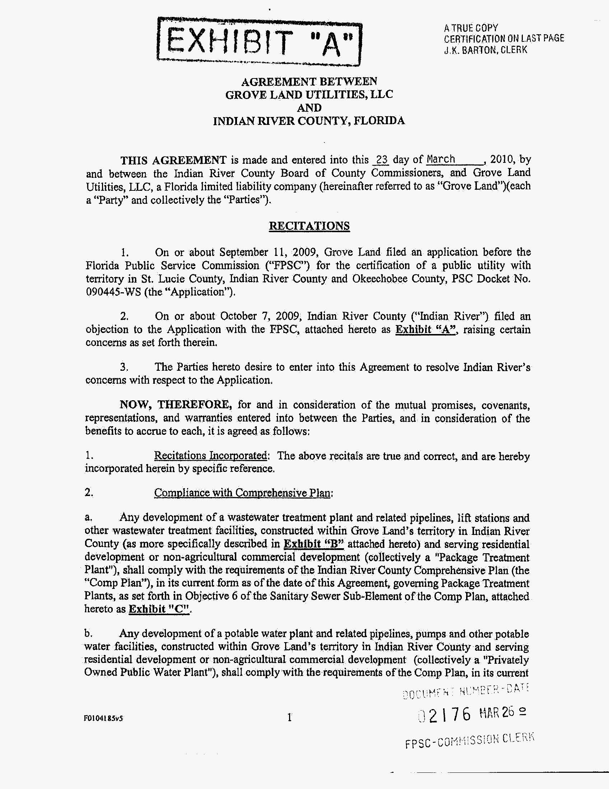
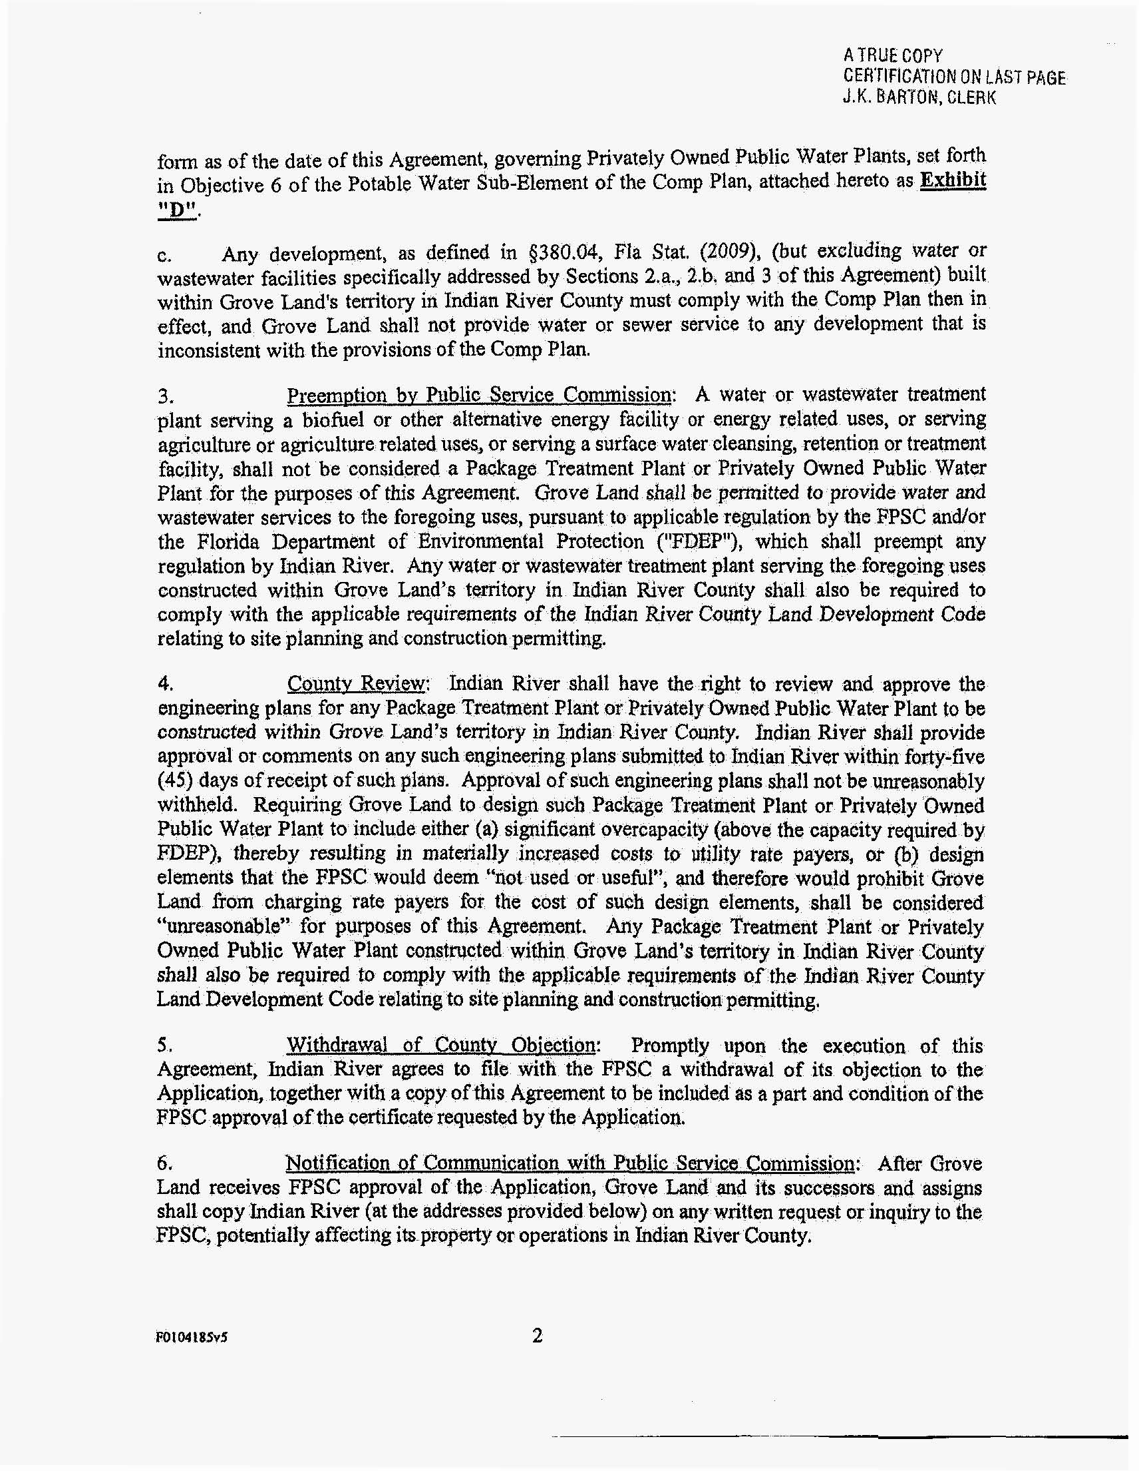
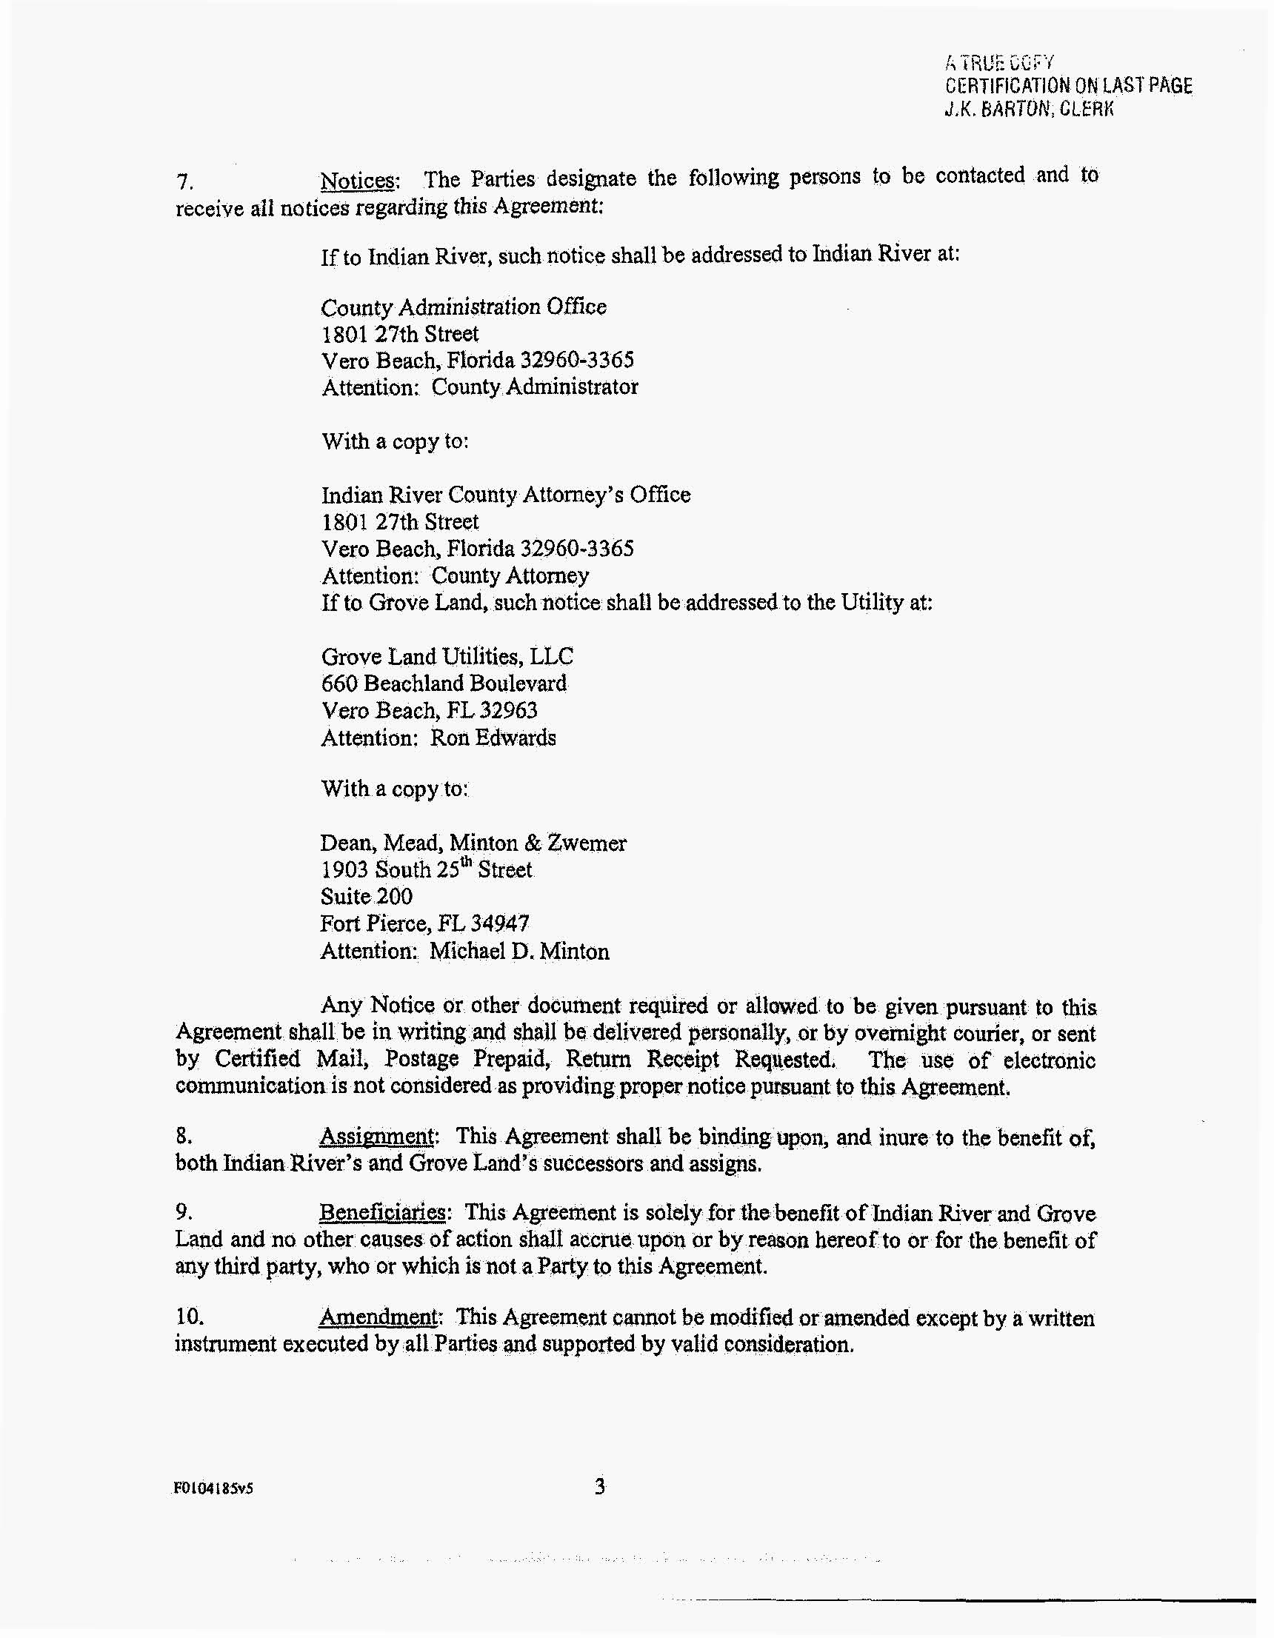
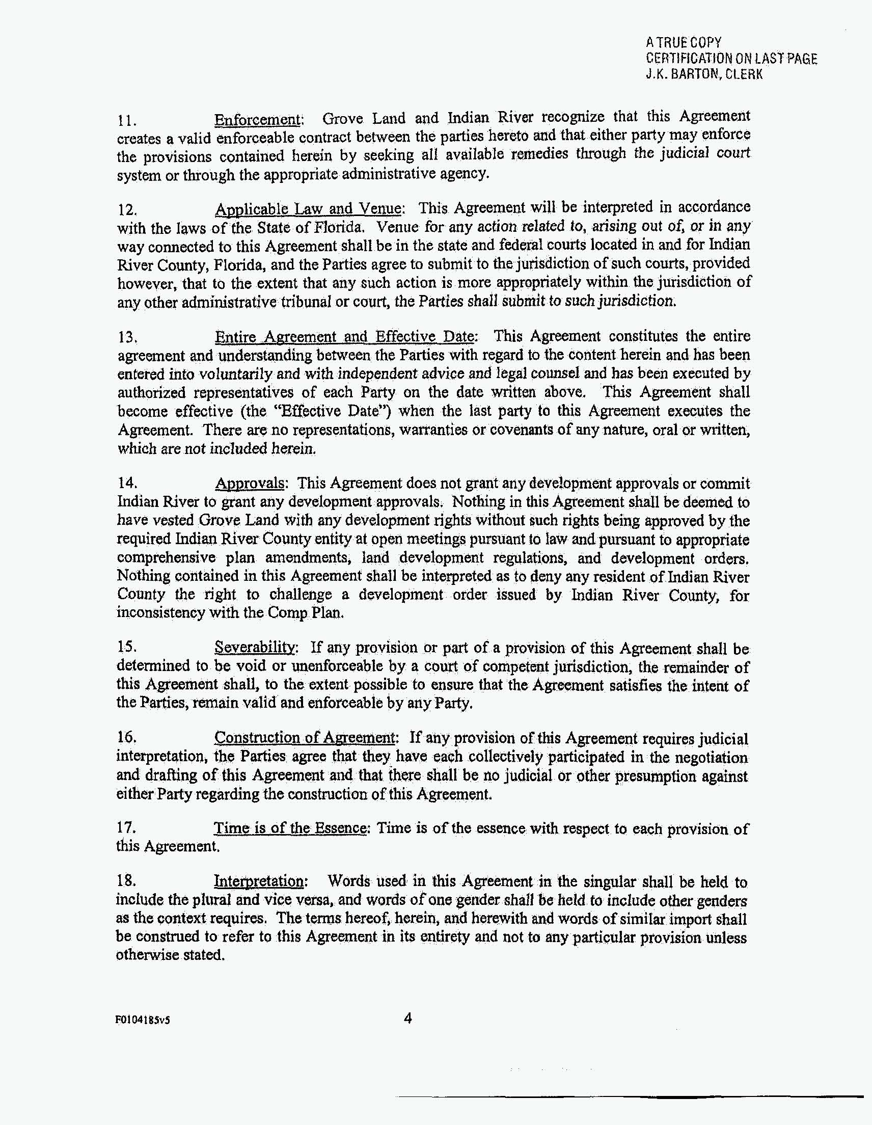
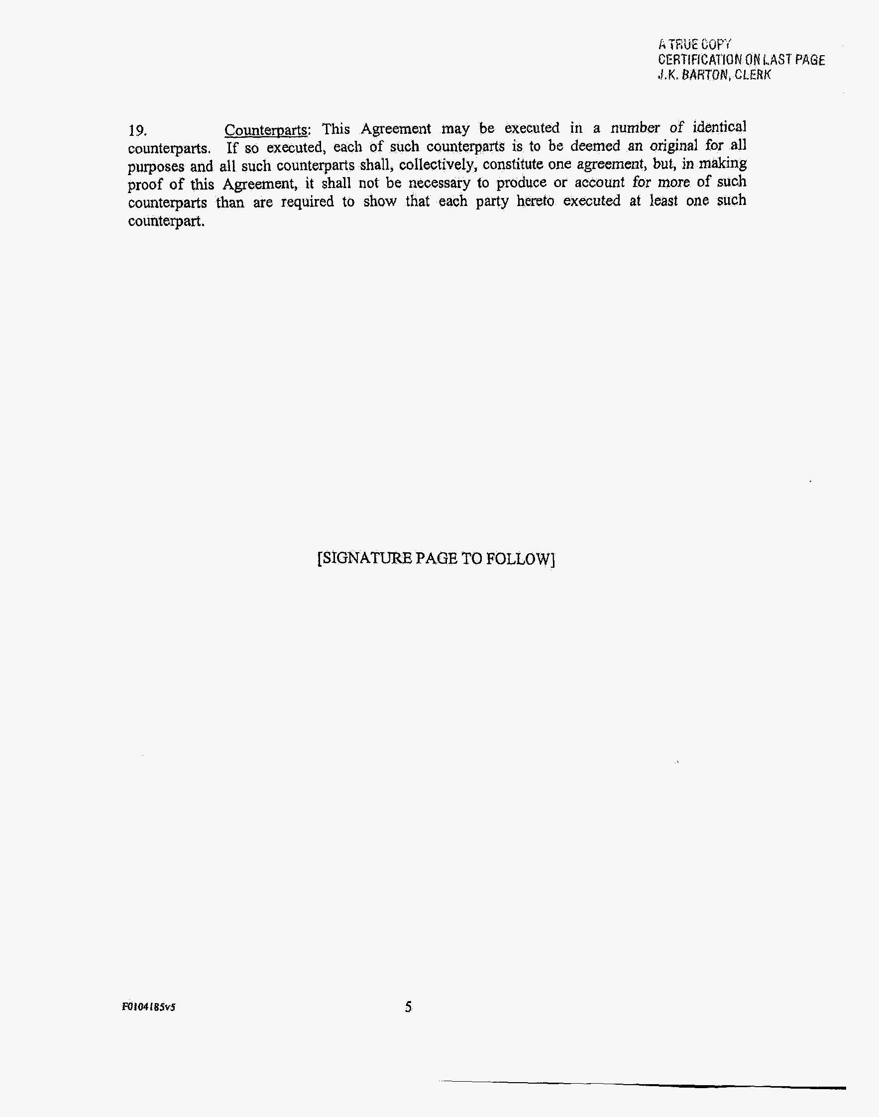
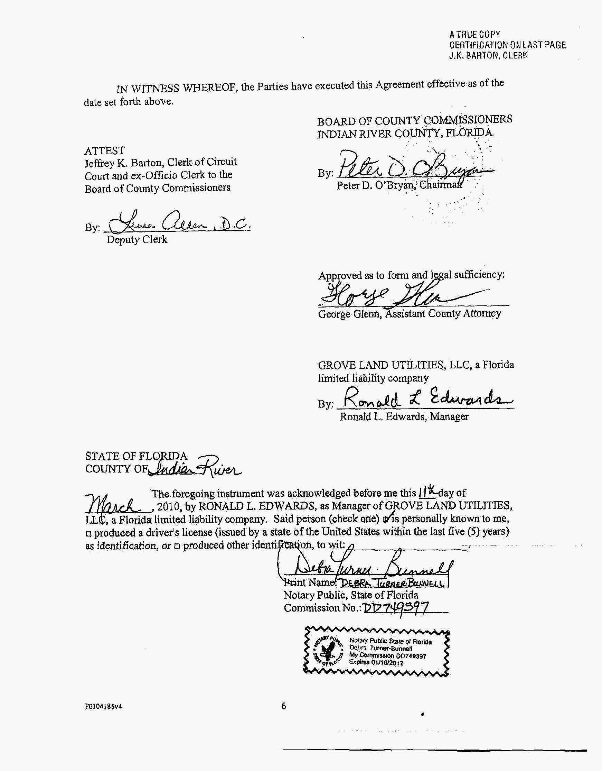
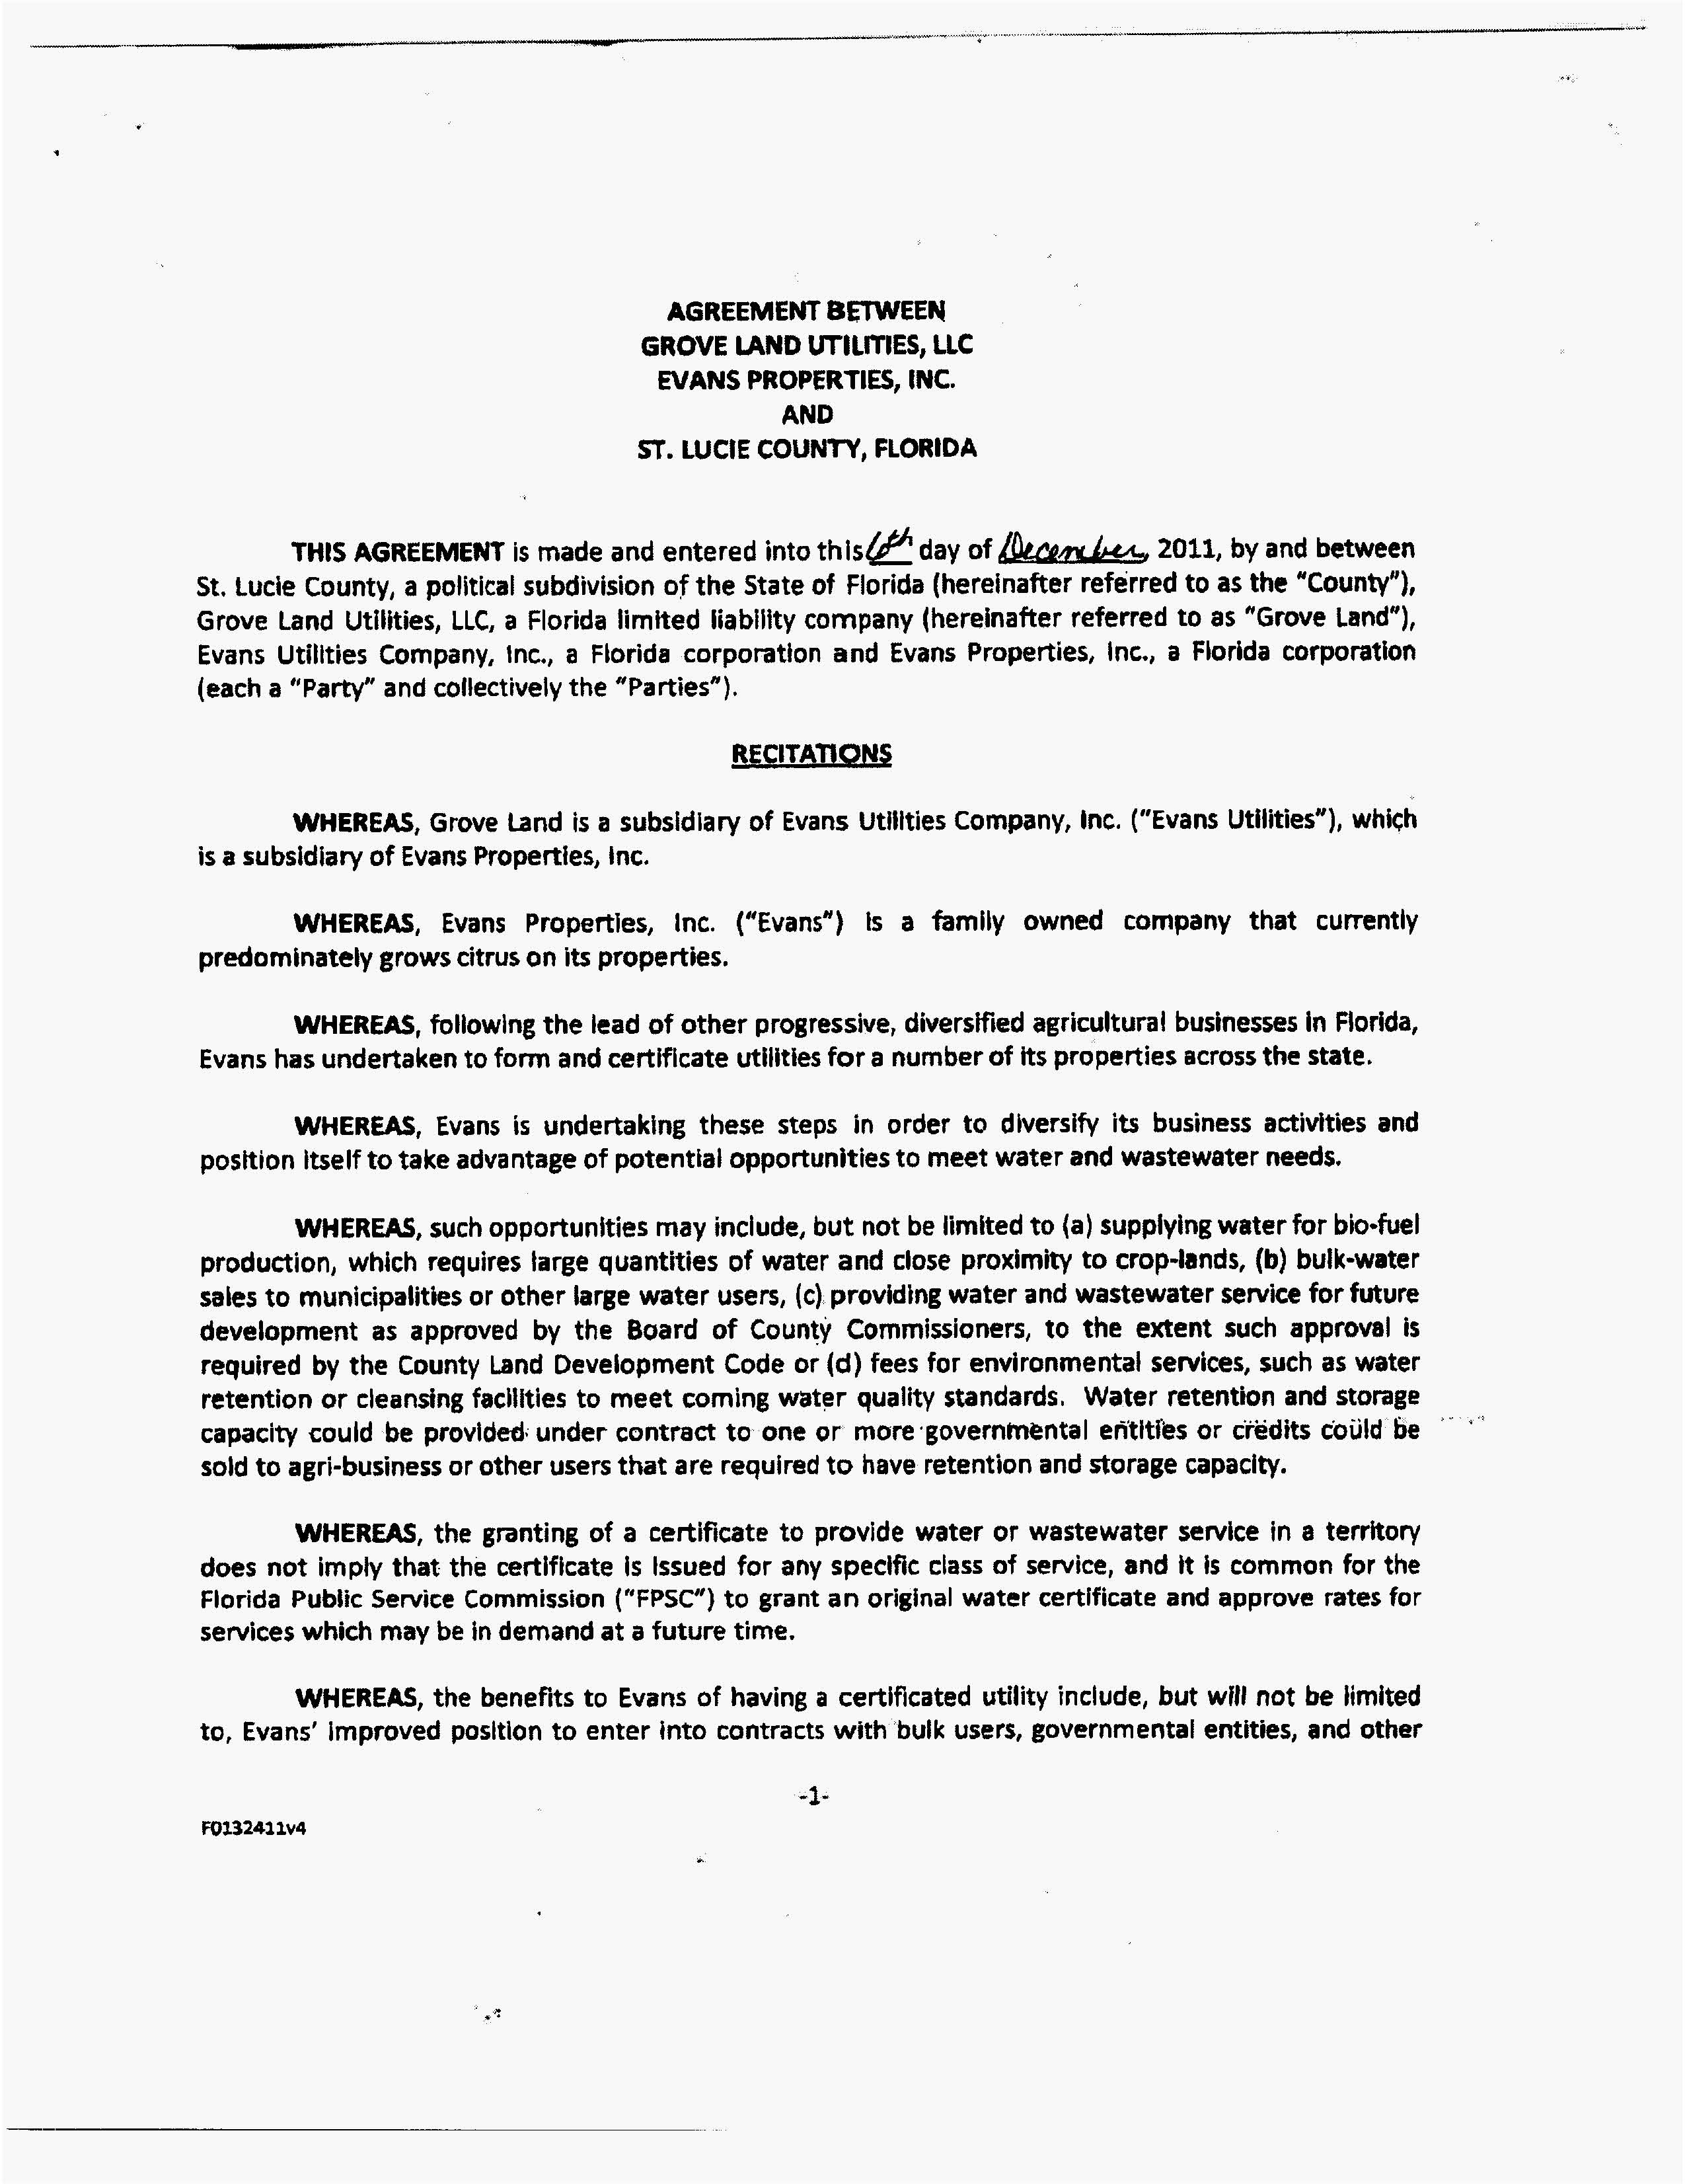
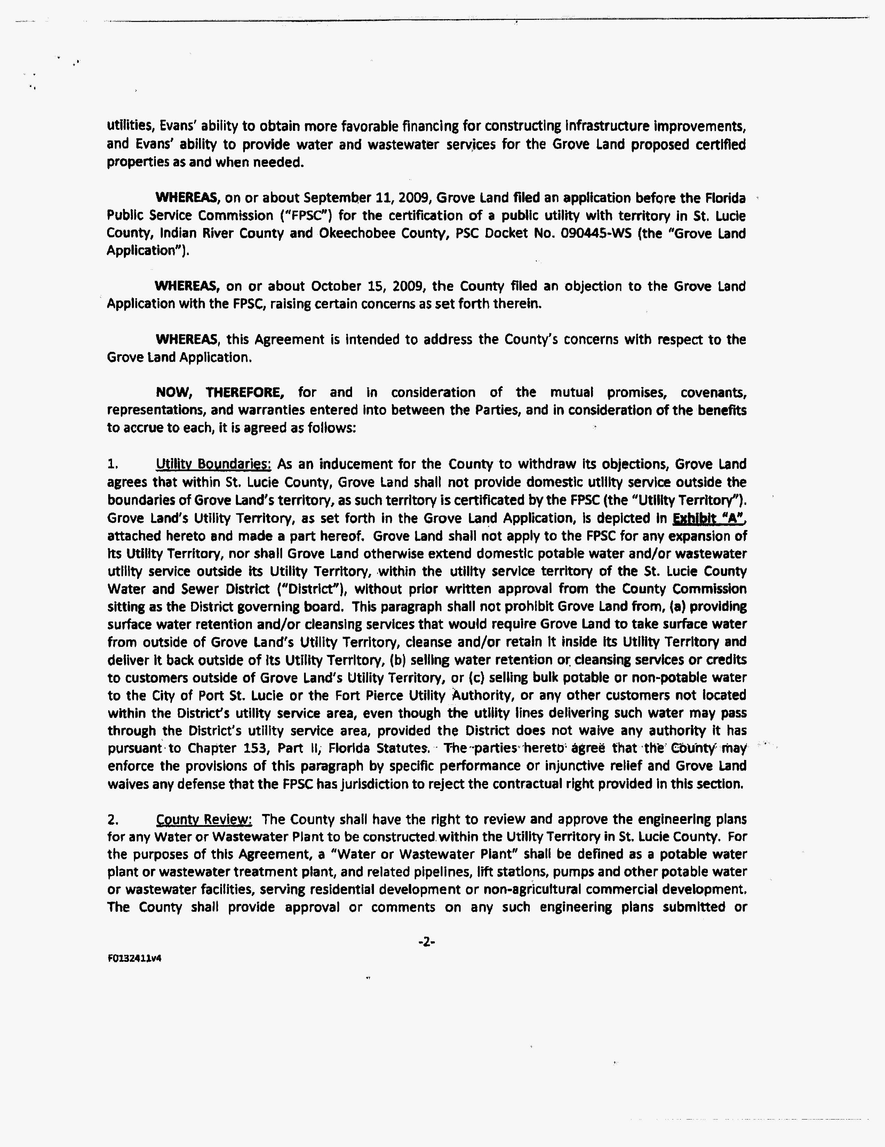
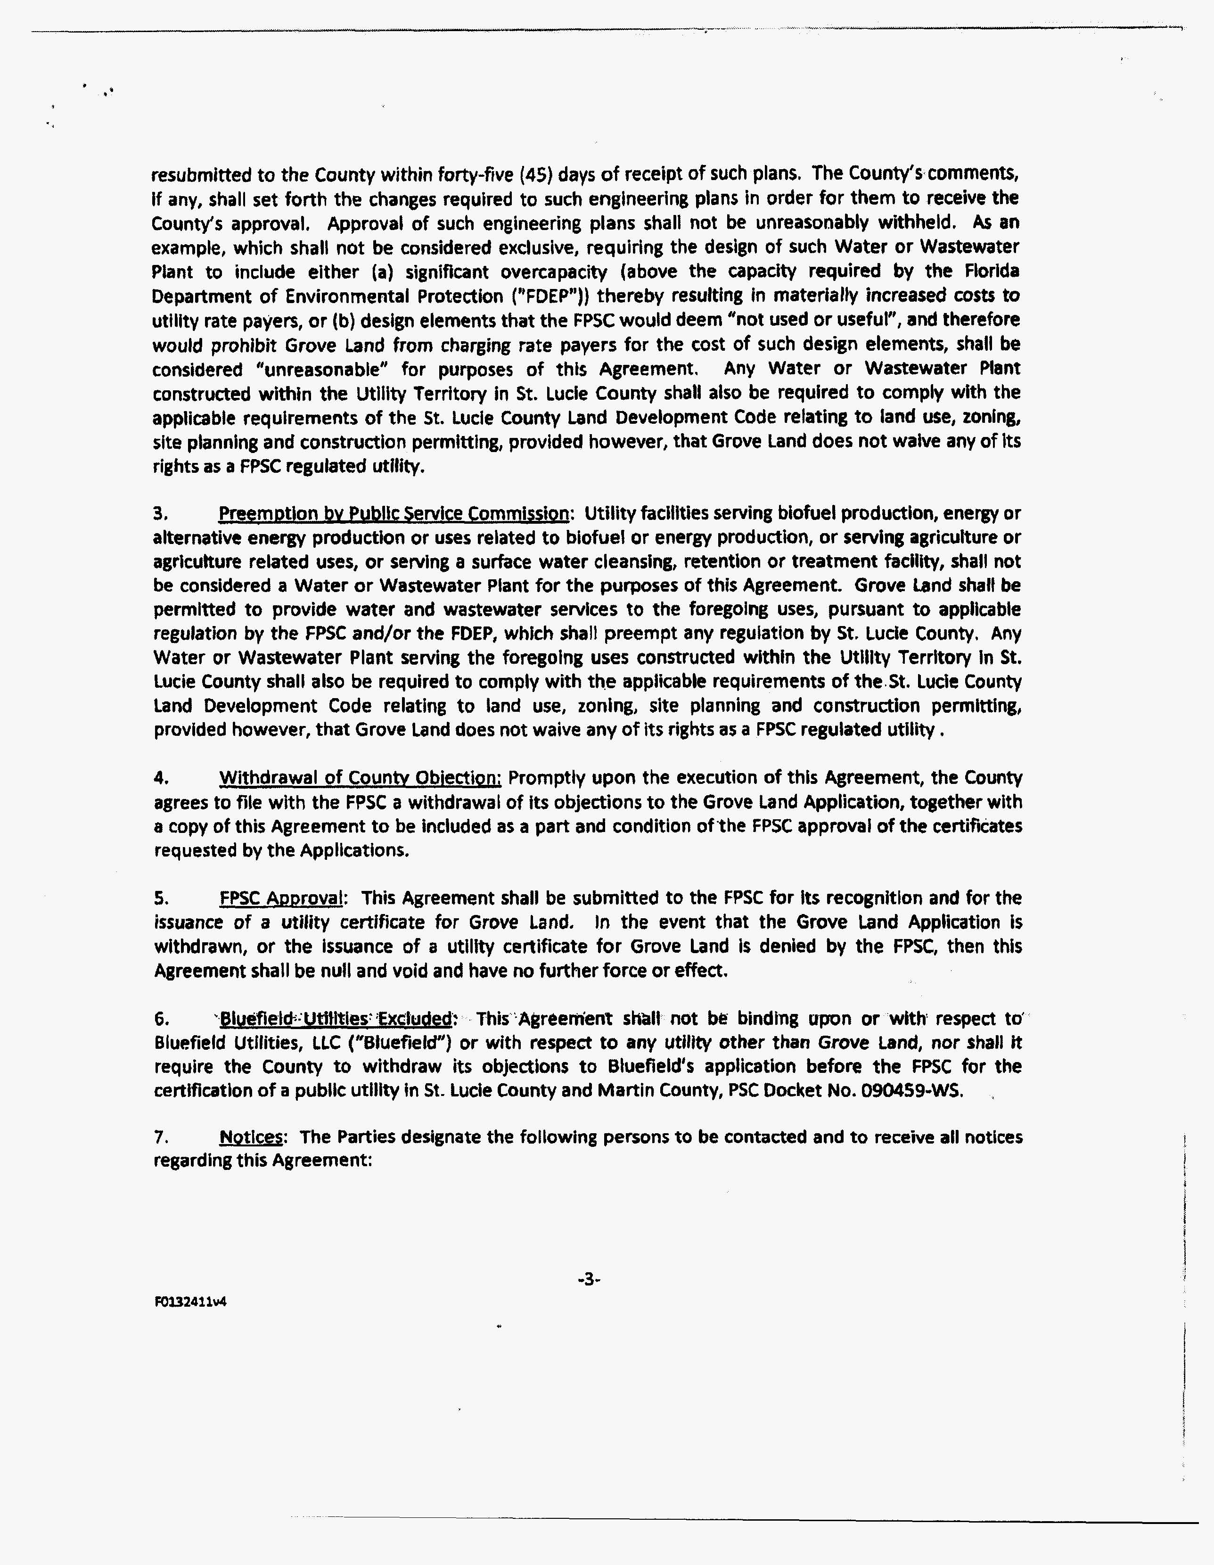
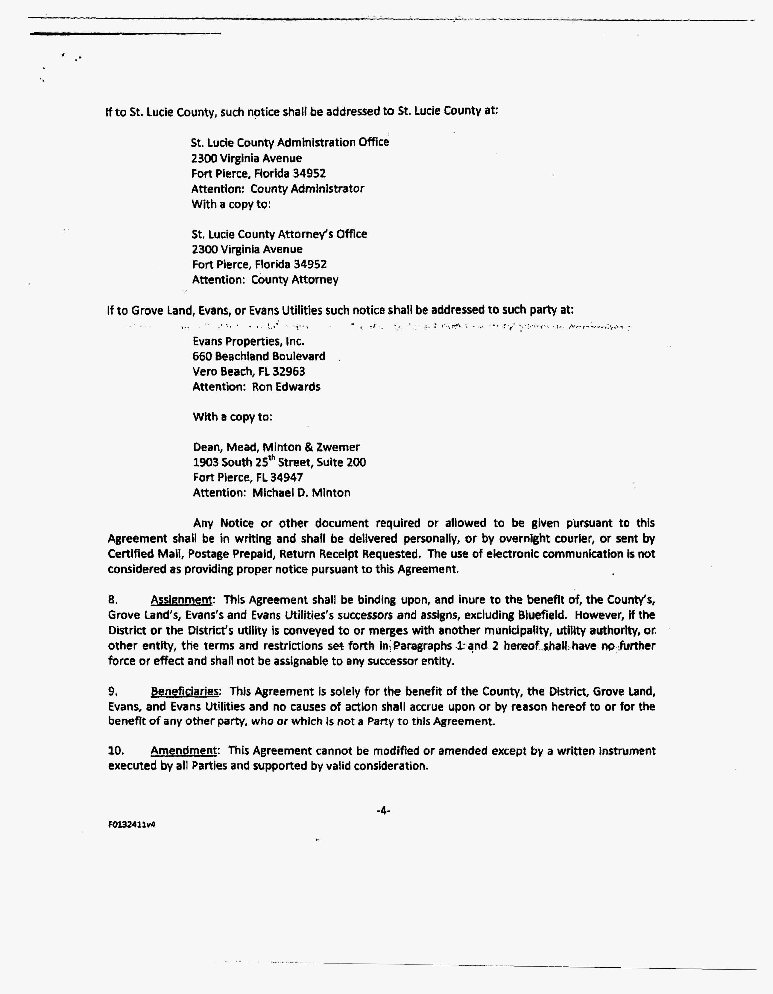
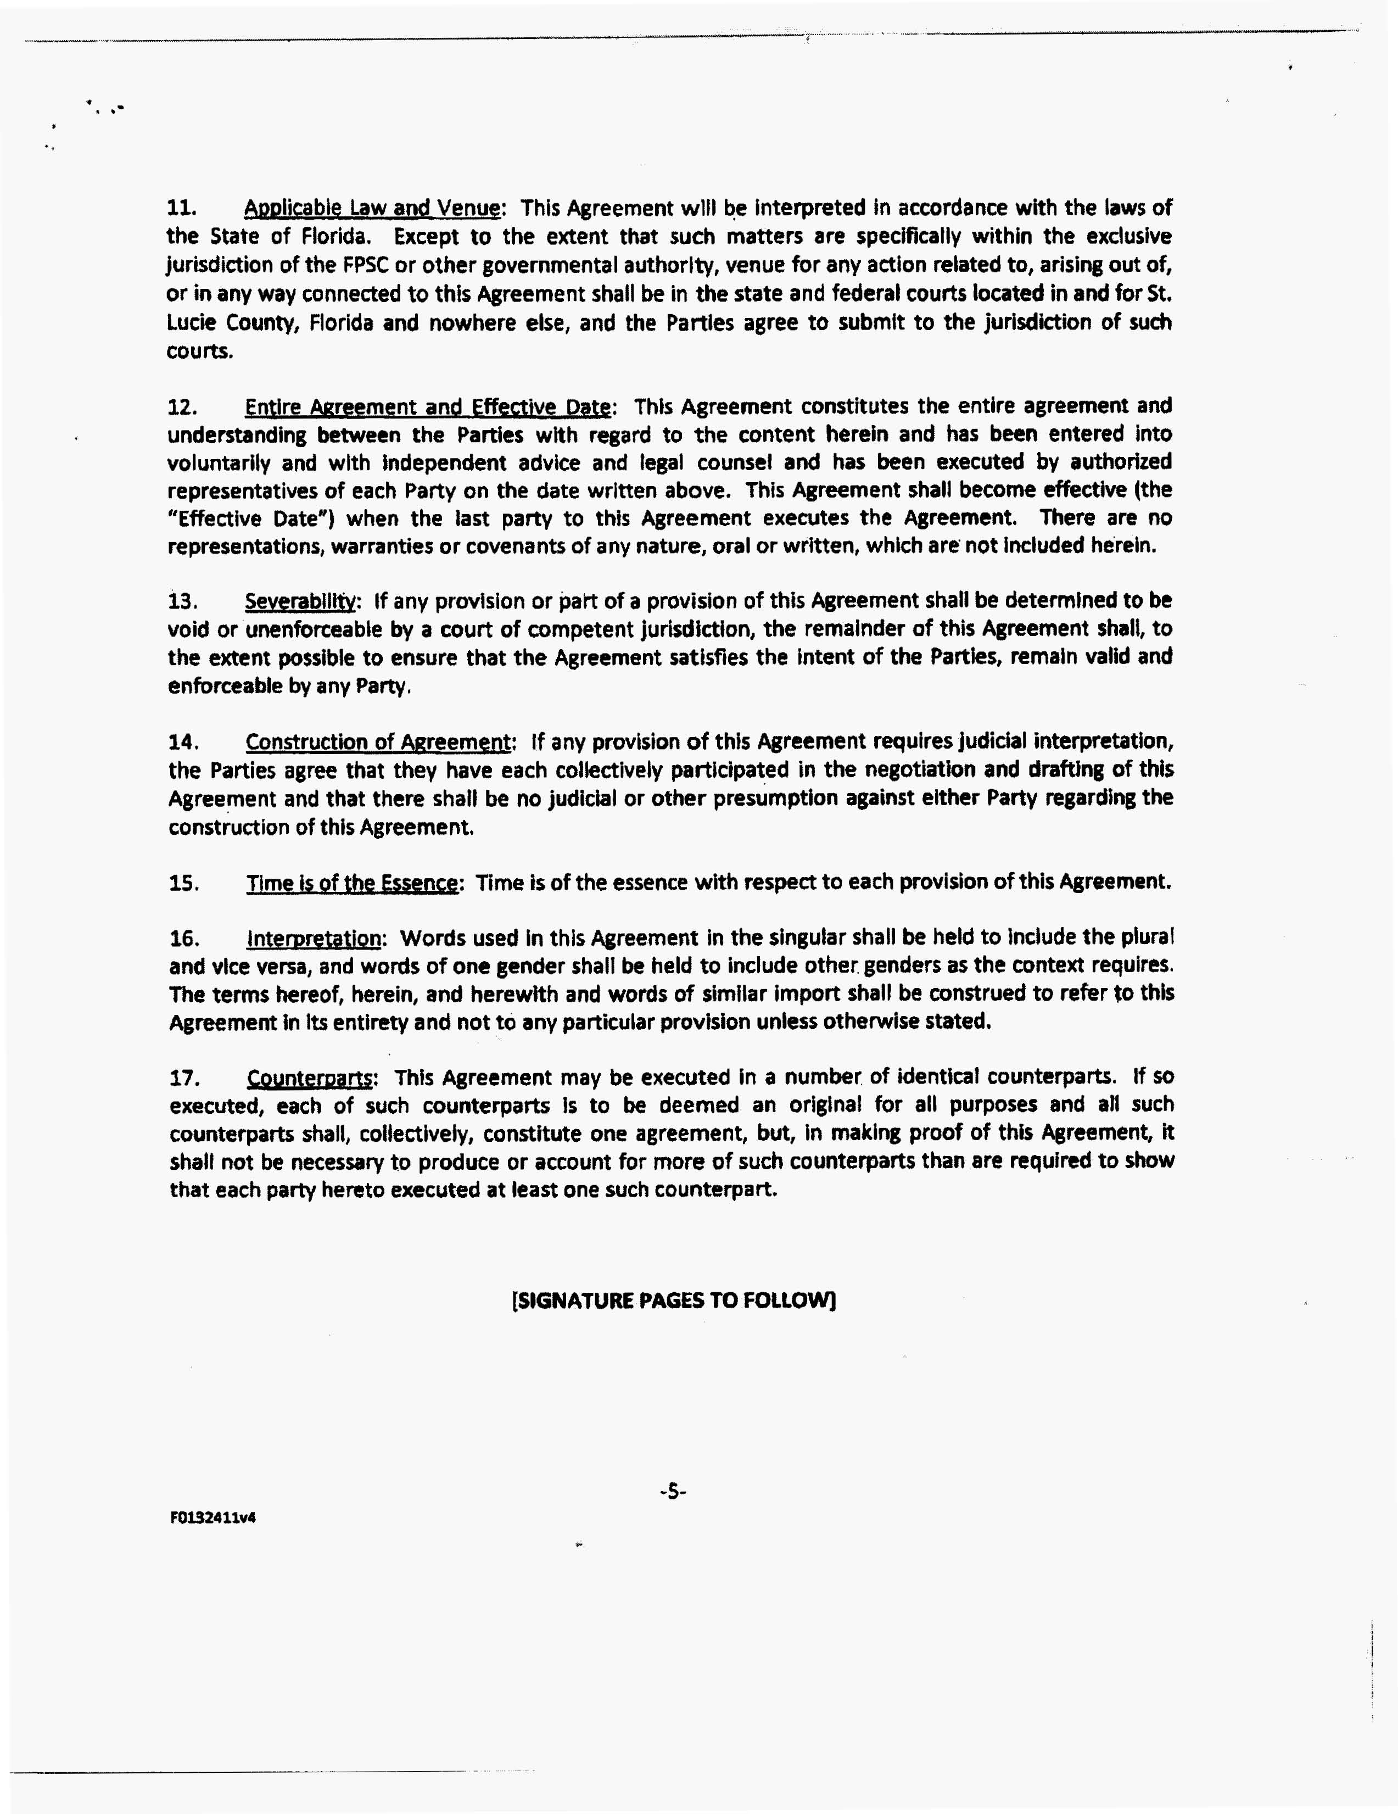
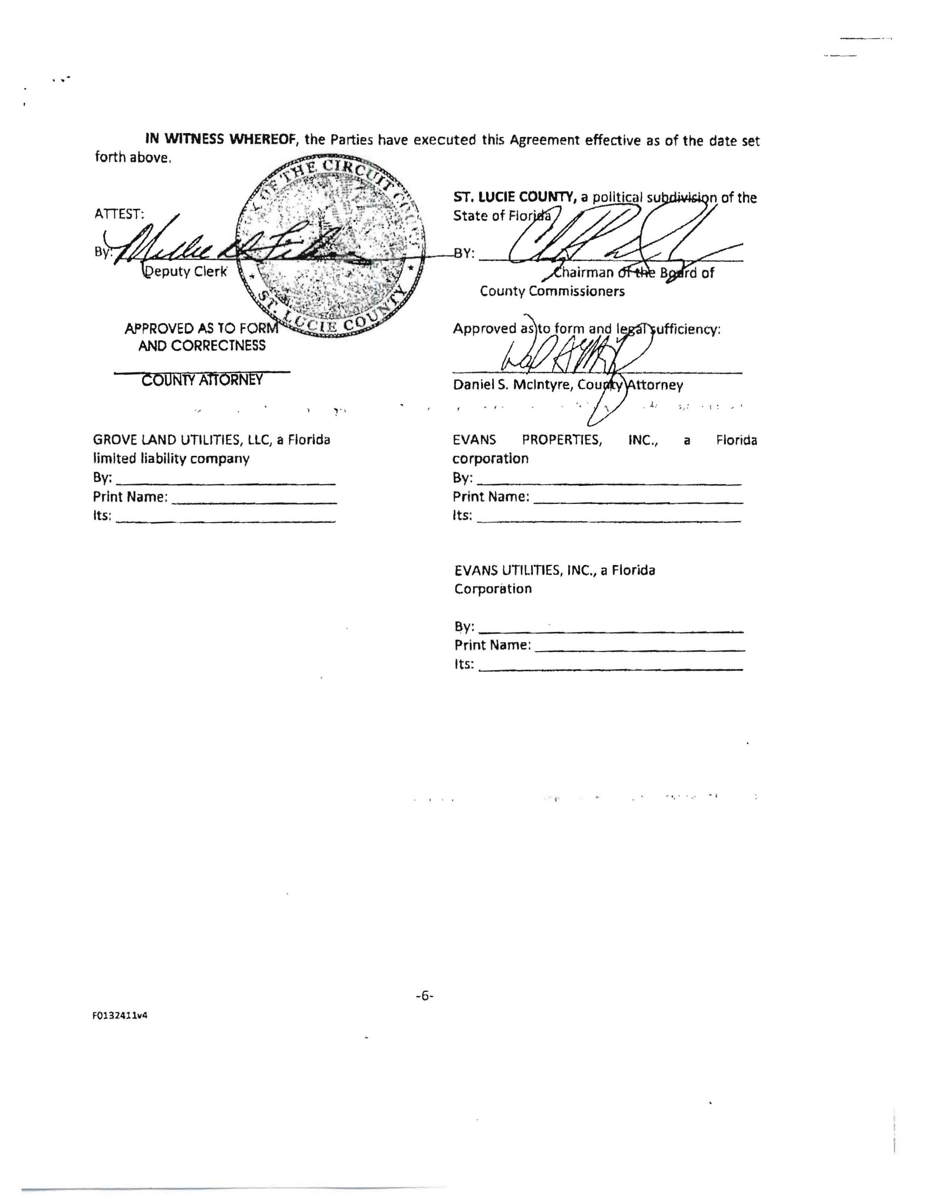
Grove Land Utilities, LLC
Description of Water and Wastewater
Indian River, Okeechobee, St. Lucie Counties

Okeechobee County
Parcel IDs 1, 5, 7 and 9
Township 34 South, Range 36 East
Sections 1, 2, 3, 10, 11, 12, 13, 14, and 15

All of Sections 1, 2, 3, 10, 11, 12 AND Sections 13 and 14 LESS the South 125 feet AND Section 15 LESS the South portion measured 145 feet North of the Southeast corner of the Section and 174.49 feet North of the Southwest corner of said Section 15, all in Township 34 South, Range 36 East, Okeechobee County.

Indian River County
Parcel ID 2
Township 33 South, Range 38 East
Section 31

Section 31, LESS the South 100 feet in Township 33 South, Range 38 East, Indian River County.

Indian River County
Parcel IDs 3, 8, and 10
Township 33 South, Range 37 East
Sections 29, 30, 31, 32, and 33 and
Township 33 South, Range 36 East
Sections 25 and 36

Section 29, LESS the North 210 feet and LESS the East 250 [feet] of the West 600 feet of the North 720 feet, Section 30 and Section 31 AND the East 1/2 of Section 32, lying North of the Turnpike, all in Township 33 South, Range 37 East.

Together with the East 1/2 of Section 25 AND the East 1/2 of Section 36, lying North of the Turnpike, all in Township 33 South, Range 36 East, Indian River County.

Together with the East 1/2 of Section 32 LESS the Legal Right of Way and LESS the South 250.00 feet thereof.

Together with the West 1/2 of Section 33 LESS the South 250.00 feet thereof, lying West of the following described line: Commence at the Southeast corner of Section 36, Township 33 South, Range 37 East, Indian River County, Florida; then West, 19,080.31 feet to the Point of Beginning; then North 5,079.50 feet to the North line of said Section 33.

St. Lucie County
Parcel IDs 4 and 6
Township 34 South, Range 38 East
Sections 6 and 7

Section 6, LESS the North 500 feet and the North 1/2 of Section 7, all in Township 34 South, Range 38 East in St. Lucie County, Florida.

St. Lucie County
Parcel ID 11
Township 34 South, Range 38 East
Sections 15, 21 and 22

The West 3/4 of the South 1/2 of Section 15 AND the East 1/2 of the Southeast 1/4 LESS the South 660 feet of Section 21 AND the West 3/4, LESS the South 660 feet of Section 22, all lying in Township 34 South, Range 38 East in St. Lucie County, Florida.

Together with the West 3/4 of the South 1/2 of Section 15 AND the East 1/2 of the Southeast 1/4 LESS the South 660 feet of Section 21 AND the West 3/4, LESS the South 660 feet of Section 22, all lying in Township 34 South, Range 38 East in St. Lucie County, Florida.

FLORIDA PUBLIC SERVICE COMMISSION

authorizes

Grove Land Utilities, LLC
pursuant to
Certificate Number 658-W

to provide water service in Indian River, Okeechobee, and St. Lucie Counties in accordance with the provisions of Chapter 367, Florida Statutes, and the Rules, Regulations, and Orders of this Commission in the territory described by the Orders of this Commission. This authorization shall remain in force and effect until superseded, suspended, cancelled or revoked by Order of this Commission.

Order Number Date Issued Docket Number Filing Type

PSC-12-0224-PAA-WS 04/30/2012 090445-WS Original Certificate

FLORIDA PUBLIC SERVICE COMMISSION

authorizes

Grove Land Utilities, LLC
pursuant to
Certificate Number 563-S

to provide wastewater service in Indian River, Okeechobee, and St. Lucie Counties in accordance with the provisions of Chapter 367, Florida Statutes, and the Rules, Regulations, and Orders of this Commission in the territory described by the Orders of this Commission. This authorization shall remain in force and effect until superseded, suspended, cancelled or revoked by Order of this Commission.

Order Number Date Issued Docket Number Filing Type

PSC-12-0224-PAA-WS 04/30/2012 090445-WS Original Certificate

GROVE LAND UTILITIES, LLC
WATER SYSTEM

Water Rate Base
Utility Plant in Service |  | $ 1,273,379
Accumulated Depreciation |  | (191,040)
Contributions in Aid of Construction (CIAC) |  | (862,543)
Accumulated Amortization of CIAC |  | 79,224
Working Capital Allowance |  | 12,828
Water Rate Base |  | $ 311,848

Water Revenue Requirement
Operating Revenue |  | $ 148,121
Operation and Maintenance Expense |  | 102,627
Net Depreciation Expense |  | 13,694
Taxes Other Than Income |  | 6,665
Total Operating Expense |  | 122,986
Net Operating Income |  | $ 25,135
Water Rate Base |  | $ 311,848
Rate of Return |  | 8.06%

Monthly Water Service Rates – Residential and General Service
Base Facility Charge
5/8 x 3/4" | $ 28.49
3/4" | 42.74
1.0" | 71.23
1.5" | 142.45
2.0" | 227.92
3.0" | 455.84
Charge per 1,000 gallons |  | $ 4.05

Comparison Residential Water Service Bills
5,000 gallons | $ 48.74
7,500 gallons | $ 58.87
10,000 gallons | $ 68.99

Water Service Availability Charges
Plant Capacity Charge (ERC = 350 gpd) |  | $ 1,675.00
All Other – per gallon |  | 4.79
Main Extension Charge (ERC = 350 gpd) |  | $ 734.00
All Others – per gallon |  | 2.10
Meter Installation Charge
5/8” x 3/4” |  | $ 230.00
3/4" |  | 280.00
1” |  | 330.00

GROVE LAND UTILITIES, LLC
WASTEWATER SYSTEM

Wastewater Rate Base
Utility Plant in Service |  | $ 1,151,661
Accumulated Depreciation |  | (249,899)
Contributions in Aid of Construction (CIAC) |  | (669,324)
Accumulated Amortization of CIAC |  | 76,258
Working Capital Allowance |  | 12,307
Water Rate Base |  | $ 321,003

Wastewater Revenue Requirement
Operating Revenue |  | $ 153,603
Operating and Maintenance Expense |  | 98,453
Net Depreciation Expense |  | 22,365
Taxes Other Than Income |  | 6,912
Total Operating Expense |  | 127,730
Net Operating Income |  | $ 25,873
Water Rate Base |  | $ 321,003
Rate of Return |  | 8.06%

Monthly Wastewater Service Rates – Residential Service
Base Facility Charge | $ 31.34
Charge per 1,000 gallons  (8,000 gallon maximum) | $ 5.88

Monthly Wastewater Service Rates – General Service
Base Facility Charge
5/8 x 3/4" | $ 31.34
3/4" | 47.01
1.0" | 78.35
1.5" | 156.70
2.0" | 250.72
3.0" | 501.44
Charge per 1,000 gallons |  | $ 5.88
Comparison Residential Wastewater Service Bills
5,000 gallons | $ 60.74
7,500 gallons | $ 75.44
10,000 gallons | $ 90.14

Wastewater Service Availability Charges
Plant Capacity Charge
Residential (ERC = 350 gpd) | $ 2,005.00
All Others – per gallon | 7.43
Main Extension Charge
Residential (ERC = 270 gpd) |  | $ 561.00
All Others – per gallon |  | 2.08

Order Nos. PSC-11-0102-PCO-WS, PSC-11-0160-PCO-WS, and PSC-11-0268-PCO-WS, respectively.
Order No. PSC-08-0540-PAA-WS, issued August 18, 2008, in Docket No. 080103-WS, In re: Application for certificates to provide water and wastewater service in Hardee and Polk Counties by TBBT Utility LLC; Order No. PSC-07-0076-PAA-SU, issued January 29, 2007, in Docket No. 060602-SU, In re: Application for certificate to provide wastewater service in Lee and Charlotte Counties by Town and Country Utilities Company; and Order No. PSC-07-0274-PAA-WS, issued April 2, 2007, in Docket No. 060694-WS, In re: Application for certificates to provide water and wastewater service in Flagler and Volusia Counties by D & E Water Resources.
Order No. PSC-04-0980-FOF-WU, p. 7, issued October 8, 2004, in Docket No. 021256-WU, In re: Application for certificate to provide water service in Volusia and Brevard Counties by Farmton Water Resources, LLC and Order No. PSC-92-0104-FOF-WU, p. 19, issued March 27, 1992, in Docket No. 910114-WU, In re: Application of East Central Services, Inc., for an original certificate in Brevard, Orange and Osceola Counties.
Order No. PSC-11-0287-PAA-WS, issued July 5, 2011, in Docket No. 110006-WS, In re: Water and wastewater industry annual reestablishment of authorized rate of return on common equity for water and wastewater utilities pursuant to Section 367.081(4)(f), F.S.
Order No. PSC-05-0309-PAA-WU, issued March 21, 2005, in Docket No. 040160-WU, In re: Application for transfer of portion of Certificate No. 582-W by Keen Sales, Rentals and Utilities, Inc. in Polk County.

