BEFORE THE FLORIDA PUBLIC SERVICE COMMISSION

NOTICE OF DEVELOPMENT OF RULEMAKING

TO
ALL INTERESTED PERSONS
UNDOCKETED
IN RE: INITIATION OF RULEMAKING TO AMEND RULES 25-4.004 and 25-4.005,
AND TO REPEAL RULES 25-24.565, 25-24.567, 25-24.568, 25-24.569, 25-24.572, 25-24.705, 25-24.710, 25-24.715, 25-24.720, 25-24.725, 25-24.730, 25-24.735, 25-24.800, 25-24.805, 25-24.810, 25-24.815, AND 25-24.820, F.A.C.

ISSUED: June 1, 2012
NOTICE is hereby given pursuant to Section 120.54, Florida Statutes, that the Florida Public Service Commission staff has initiated rulemaking to amend Rules 25-4.004 and 25-4.005, and to repeal Rules 25-24.565, 25-24.567, 25-24.568, 25-24.569, 25-24.572, 25-24.705, 25-24.710, 25-24.715, 25-24.720, 25-24.725, 25-24.730, 25-24.735, 25-24.800, 25-24.805, 25-24.810, 25-24.815, and 25-24.820, Florida Administrative Code, to implement changes made to chapter 364, Florida Statutes, by the Regulatory Reform Act of 2011.

The attached Notices of Development of Rulemaking will appear in the June 8, 2012 edition of the Florida Administrative Weekly. If requested in writing and not deemed unnecessary by the agency head, a rule development workshop will be scheduled and noticed in the next available Florida Administrative Weekly. Written requests for a rule development workshop must be submitted to Kathryn G.W. Cowdery, Florida Public Service Commission, Office of the General Counsel, 2540 Shumard Oak Blvd., Tallahassee, FL 32399-0850, (850) 413-6216, kcowdery@psc.state.fl.us by June 29, 2012. A copy of the preliminary draft of the rules is attached.

By DIRECTION of the Florida Public Service Commission this 1st day of June, 2012.

/s/ Ann Cole
ANN COLE
Commission Clerk
Florida Public Service Commission
2540 Shumard Oak Boulevard
Tallahassee, Florida 32399
(850) 413-6770
www.floridapsc.com

Copies furnished: A copy of this document is provided to the parties of record at the time of issuance and, if applicable, interested persons.

KC

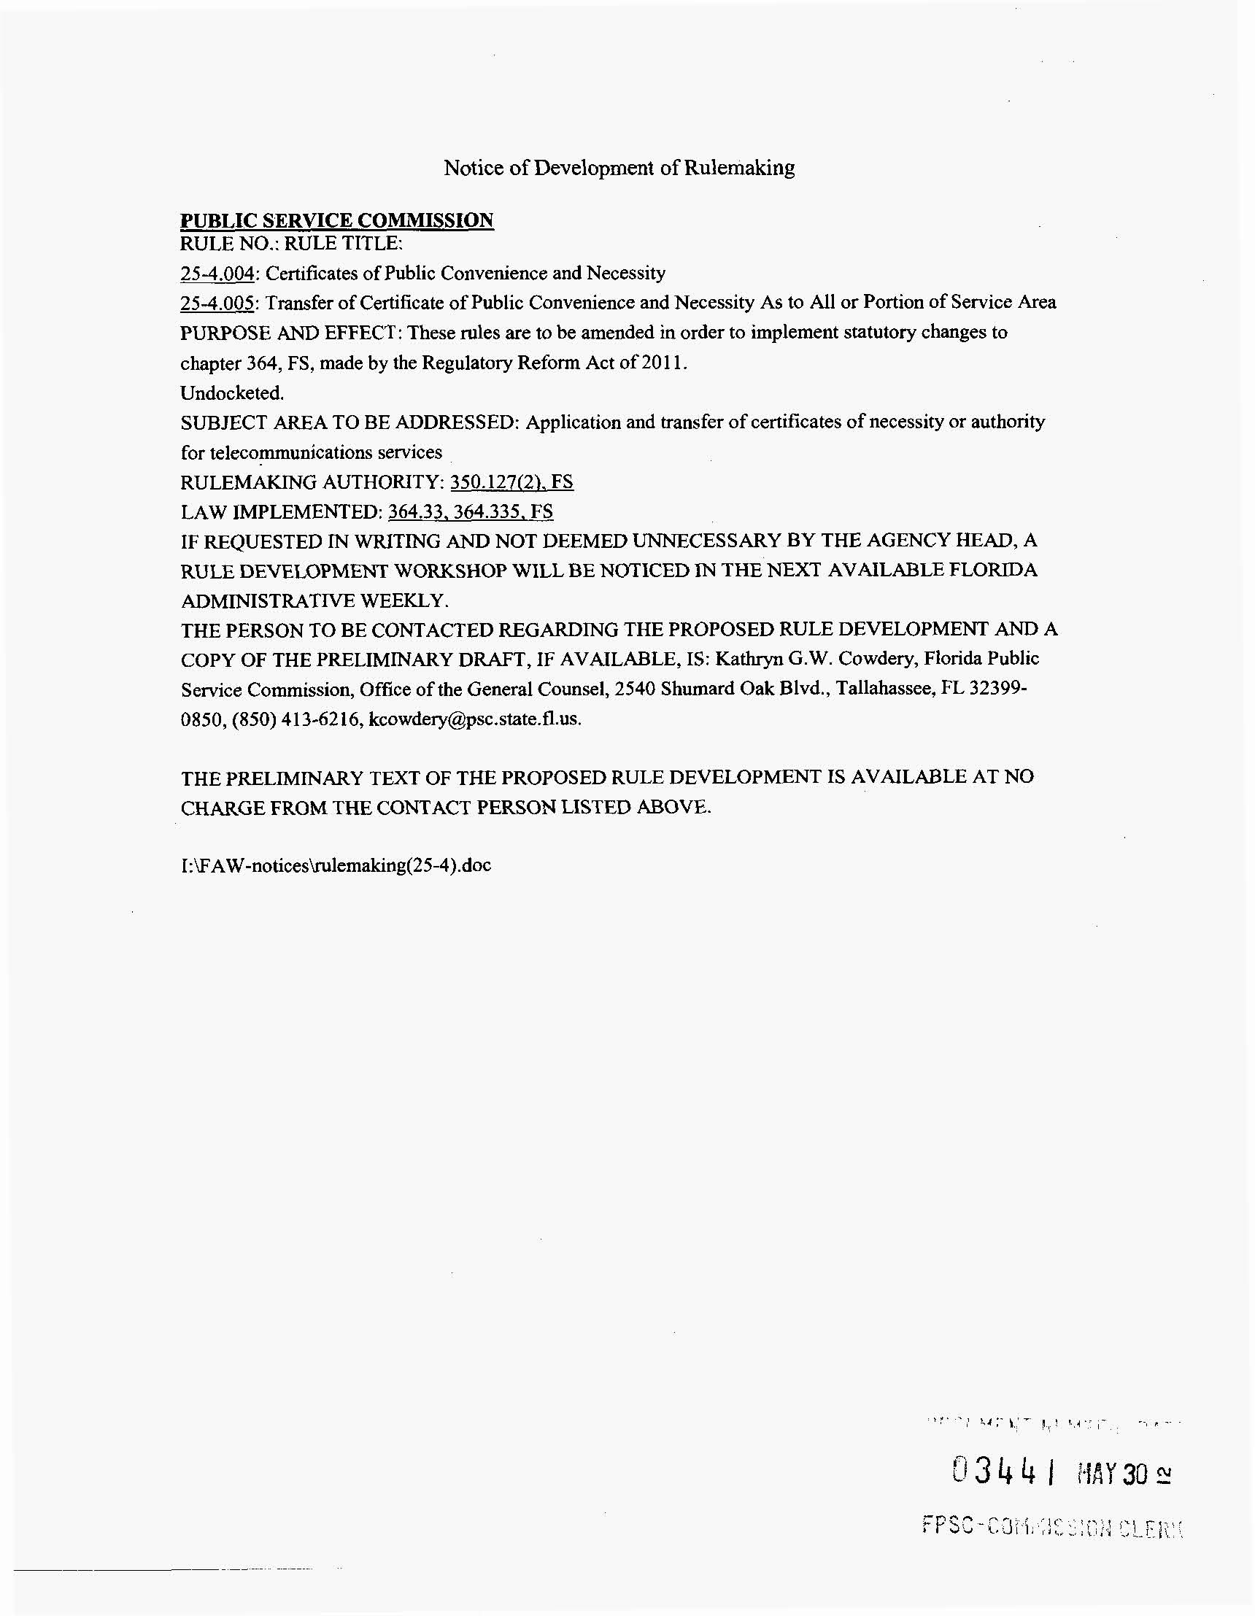
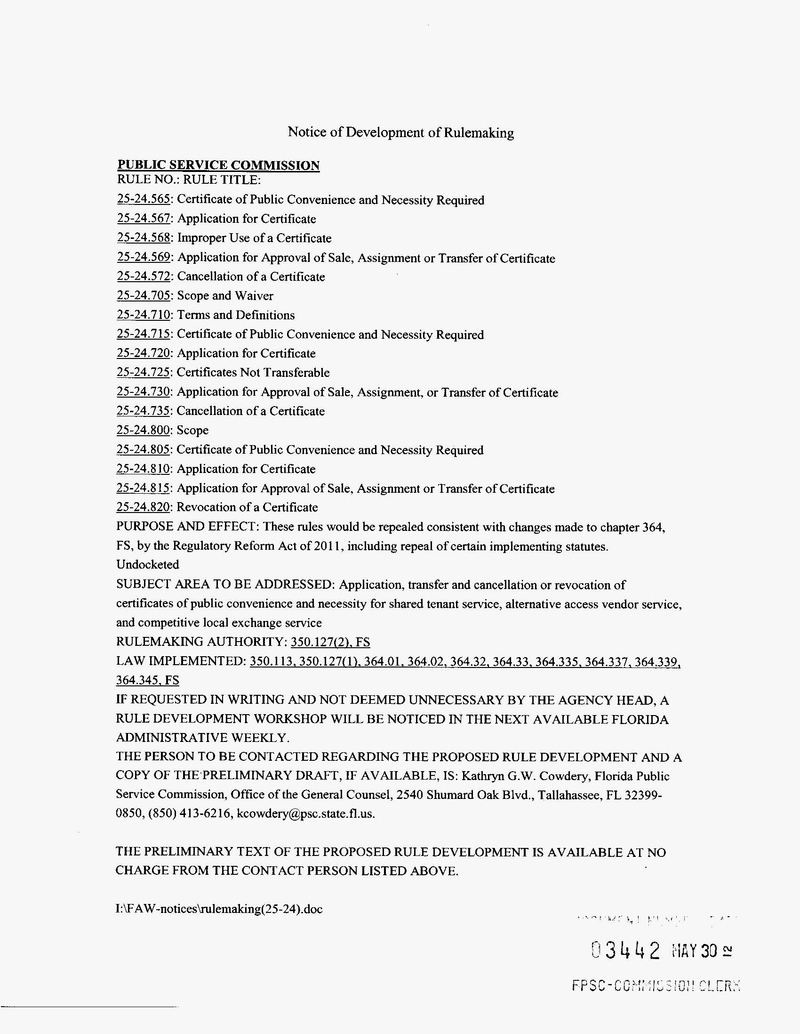
25-4.004 Certificates of Public Convenience and Necessity or Authority; Application.
(1) No person shall provide telecommunications services to the public without either a certificate of necessity issued prior to July 1, 2011, or a certificate of authority issued after July 1, 2011. Services may not be provided, nor may deposits or payment for services be collected, until the effective date of a certificate. However, marketing and development activities may begin prior to the effective date of the certificate at the applicant’s risk that the certificate may not be granted. Prior to certification, the applicant must advise the public in any customer contacts or advertisements that certification has not and may not be granted.
(2) Each applicant for a certificate of authority shall submit an application on Form PSC/RAD 162 (X/XX), entitled “Application Form for Authority to Provide Telecommunications Company Service Within the State of Florida,” which is incorporated into this rule by reference and which is available at http://www.flrules.org/Gateway/reference.asp?No_Ref – XXXXX, from the Commission’s website at www.floridapsc.com/utilities/telecomm/, or by contacting the Commission’s Division of Regulatory Analysis. A non-refundable application fee of $500.00 must accompany the filing of each application.
(3) An application for certificate of authority shall be filed with the Office of Commission Clerk, Florida Public Service Commission, 2540 Shumard Oak Boulevard, Tallahassee, Florida 32399-0850.
(4) Each holder of a certificate of necessity or authority shall file with the Commission’s Office of Commission Clerk updated information for the following items within ten days after a change occurs:
(a) The street address of the certificate holder including number, street name, city, state and zip code, and the mailing address if it differs from the street address.
(b) Name, title, and phone number of the individual responsible for contact with the Commission.
Except as provided in Chapter 364, F.S., no person shall begin the construction or operation of any telephone line, plant or system or an extension thereof or acquire ownership or control thereof, either directly or indirectly, without first obtaining from the Florida Public Service Commission a certificate that the present or future public convenience and necessity require or will require such construction, operation or acquisition.
Rulemaking Authority 350.127(2) FS. Law Implemented 350.127(1), 364.33, 364.335, FS. History–Revised 12-1-68, Formerly 25-4.04, Amended_____________.
25-4.005 Transfer of Certificate of Public Convenience and Necessity or Authority As to All or Portion of Service Area.
(1) Except as provided in section 364.33, F.S., a certificate holder and the person seeking to obtain the certificate by transfer from the holder shall submit a joint application on Commission Form PSC/RAD 162 (X/XX), entitled “Application Form for Authority to Provide Telecommunications Company Service Within the State of Florida,” incorporated by reference into Rule 25-4.004, F.A.C. The application shall be filed with the Office of Commission Clerk. A nonrefundable application fee of $500.00 must accompany the filing of each application to cover processing costs. The Commission’s acceptance of the application fee does not imply that the application for transfer of a certificate will be granted.
(2) The company transferring the certificate shall pay to the Commission all regulatory assessment fees owed pursuant to sections 350.113 and 364.336, F.S., and Rule 25-4. 0161, Florida Administrative Code.
(1) Request for approval by the Commission of transfer of any certificate of public convenience and necessity (or portion thereof) shall be made by joint petition of the certificate holder and transferee after reasonable notice has been given to all subscribers affected by the proposed transfer. Requests for approval shall be accompanied by an affidavit that notice of intention to file the petition has been given:
(a) By mail or personal delivery to the governing bodies of the counties and municipalities affected, to the public counsel, and to the Commission,
(b) By a legal advertisement in a newspaper of general circulation in the area affected and published on two (2) separate occasions at least two (2) weeks prior to the filing of the joint petition on the proposed transfer, and
(c) By written notice subject to Commission approval, issued to each subscriber in the area to be transferred concurrent with the filing of the petition.
(2) Upon approving a transfer of certificate, or portion thereof, the Commission will cancel same and reissue in the name of the transferee or amend the description of the service area or both.
(3) Such joint petitions shall include detailed descriptions of the affected boundaries; the number of subscribers, if any, in each petitioned area; changes in rates; service being provided by either petitioner in areas to be transferred; pending applications for service held by either petitioner; changes in calling scope; customers to be transferred; deposits and deposit interest; any financial exchange or consideration for the proposed change, and a list by name and telephone number of all customers who will be exempt from the proposed change.
(4) Any subscriber or group of subscribers of a telephone company may petition the Commission for transfer from the service area of such telephone company to that of another telephone company serving contiguous territory.
(5) If a customer survey is conducted by a telephone company among customers affected by the proposed transfer, return postage shall be paid by the company serving the affected customer and survey ballots shall be returnable to the Public Service Commission, Attention: Division of Regulatory Analysis, for tabulation.
Rulemaking Authority 350.127(2) FS. Law Implemented 350.113, 364.335, 364.336 FS. History–New 12-1-68, Amended 5-4-81, Formerly 25-4.05, Amended 9-16-99, ___________.
25-24.565 Certificate of Public Convenience and Necessity Required.
(1) No person shall provide shared tenant service without first obtaining a certificate of public convenience and necessity from the Commission. Services may not be provided, nor may deposits or payment for services be collected, until the effective date of a certificate, if granted. However, acquisition of equipment and facilities, as well as advertising and other promotional activities, may begin prior to the effective date of the certificate at the applicant’s risk that it may not be granted. In any customer contracts for advertisements prior to certification, the applicant must advise the customer that certification has not and may never be granted.
(2) On or after January 1, 1996, STS providers with certificates granted prior to January 1, 1996, are authorized to provide shared tenant service statewide to tenants as defined in subsection 25-24.560(10), F.A.C.
Rulemaking Authority 350.127(2) FS. Law Implemented 364.33, 364.335, 364.339 FS. History–New 1-28-91, Amended 7-29-97
25-24.567 Application for Certificate.
(1) An applicant desiring to provide shared tenant service shall submit an application on Commission Form PSC/RAD 37 (5/08), which is incorporated into this rule by reference. Form PSC/RAD 37 (5/08), entitled “Application Form for Authority to Provide Shared Tenant Service Within the State of Florida,” may be obtained from the Commission’s website at www.floridapsc.com/utilities/telecomm/ or by contacting the Commission’s Division of Regulatory Analysis. A non-refundable application fee of $250.00 must accompany the filing of all applications.
(2) An original and one copy of the application shall be filed with the Office of Commission Clerk.
(3) A certificate will be granted if the Commission determines that such approval is in the public interest.
(4) Any shared tenant service authority granted hereafter is subject to the following:
(a) Shared tenant authority granted to all companies is on a statewide basis and is restricted to tenants as defined in subsection 25-24.560(10), F.A.C.
(b) Each shared tenant service applicant shall:
1. Advise all customers of its current rates and conditions for resold local exchange service and its quality of service standards.
2. Inform each customer in advance of agreement to provide service, that the Florida Public Service Commission will not set rates or regulate the service quality standards.
(c) A certificate to provide shared tenant service does not carry with it the authority to provide competitive local exchange telecommunication, alternative access vendor, interexchange or pay telephone service. A separate application must be made for such authority.
Rulemaking Authority 350.127(2) FS. Law Implemented 364.33, 364.335, 364.339, 364.345 FS. History–New 1-28-91, Amended 5-8-91, 11-20-91, 7-29-97, 1-5-06, 5-29-08
25-24.568 Improper Use of a Certificate.
No certificate of public convenience and necessity authorizing shared tenant service may be assigned or transferred by the holder to another without prior Commission approval. No certificate shall be used as collateral for any purpose.
Rulemaking Authority 350.127(2) FS. Law Implemented 364.33, 364.335, 364.339, 364.345 FS. History–New 1-28-91, Amended 7-29-97
25-24.569 Application for Approval of Sale, Assignment or Transfer of Certificate.
(1) A company desiring to obtain a certificate by sale, assignment or transfer from the holder thereof shall submit an application jointly with the certificate holder on Commission Form PSC/RAD 37 (5/08), which is incorporated into this rule by reference. Form PSC/RAD 37 (5/08) is entitled “Application Form for Authority to Provide Shared Tenant Service Within the State of Florida.” The application form may be obtained from the Commission’s website at www.floridapsc.com/utilities/telecomm/ or by contacting the Commission’s Division of Regulatory Analysis. A nonrefundable application fee of $250.00 must accompany each application. The Commission’s acceptance of the application fee does not imply that the application for sale, assignment or transfer of a certificate will be granted.
(2) An original and one copy of the application shall be filed with the Office of Commission Clerk.
(3) An application for sale, assignment or transfer of a certificate will be granted if the Commission determines that such approval is in the public interest.
(4) A certificate may be sold, assigned or transferred only as a whole.
Rulemaking Authority 350.127(2) FS. Law Implemented 364.32, 364.33, 364.335, 364.337, 364.339, 364.345 FS. History–New 1-28-91, Amended 11-20-91, 7-29-97, 1-5-06, 5-29-08.
25-24.572 Cancellation of a Certificate.
(1) The Commission may cancel a company’s certificate for any of the following reasons:
(a) Violation of the terms and conditions under which the authority was originally granted;
(b) Violation of Commission rules or orders; or
(c) Violation of Florida Statutes.
(2) If a certificated company desires to cancel its certificate, it shall request cancellation from the Commission in writing. Cancellation of a certificate shall be ordered subject to the holder providing the following information:
(a) Statement of intent and date to pay Regulatory Assessment Fee.
(b) Statement of why the certificate is proposed to be cancelled.
(c) Proof of individual customer notice regarding discontinuance of service.
(d) Statement on treatment of customer deposits and final bills.
Rulemaking Authority 350.127(2) FS. Law Implemented 350.113, 350.127(1), 364.285, 364.339, 364.345 FS. History–New 1-28-91, Amended 7-29-97.
25-24.705 Scope and Waiver.
(1) This part applies to every person or company providing Alternative Access Vendor (AAV) service. Chapters 25-4, 25-9 and 25-14, F.A.C., shall apply to Alternative Access Vendor service only as provided in this part.
(2) An AAV service provider may petition for a waiver of any provision of this part. The Commission may grant a waiver to the extent that it determines that a waiver is in the public interest. The Commission may grant the petition in whole or in part and may prescribe different requirements than are set forth in this part. In disposing of a petition, the Commission shall consider the factors enumerated in Section 364.337(4), Florida Statutes (1995).
Rulemaking Authority 350.127(2) FS. Law Implemented 364.01, 364.337(1), (2), (6) FS. History–New 1-8-95
25-24.710 Terms and Definitions.
For purposes of this part the following definitions apply:
(1) “Affiliated Entity.” An entity (whether corporation, partnership, proprietorship or other form of business organization) is affiliated with another entity if one has a majority ownership interest in the other.
(2) “Alternative Access Vendor (AAV).” A provider, other than a local exchange telecommunications company, of Alternative Access Vendor Service.
(3) “Alternative Access Vendor Service.” The provision of local private line service between an entity and its own facilities or the facilities of an affiliated entity at another location or the provision of special access service between an end-user and an interexchange company.
(4) “Private line service.” Any point-to-point or point-to-multipoint service dedicated to the exclusive use of the end-user for the transmission of any telecommunications service.
(5) “Special Access Service.” Private line service which is connected from the end user’s premises to an interexchange company.
Rulemaking Authority 350.127(2) FS. Law Implemented 364.01, 364.02, 364.337 FS. History–New 1-8-95.
25-24.715 Certificate of Public Convenience and Necessity Required.
(1) No person shall provide Alternative Access Vendor Service without first obtaining a Certificate of Public Convenience and Necessity from the Commission.
(2) A certificate authorizes the vendor to provide Alternative Access Vendor Service statewide as well as authority to provide interexchange private line service.
(3) A certificate to provide Alternative Access Vendor Service does not authorize provision of interexchange switched service, shared tenant service, pay telephone service or any other telecommunications services requiring certification by this Commission. A separate application must be made for such authority.
(4) Applicants for a certificate shall not provide service, collect deposits or collect payment for services until a certificate becomes effective. However, at their own risk, applicants may acquire equipment and facilities and may advertise and engage in promotional activities before a certificate becomes effective. In contacts with potential customers or advertisements before certification, applicants shall advise the potential customer that certification has not and may never be granted.
Rulemaking Authority 350.127(2) FS. Law Implemented 364.33, 364.335, 364.337 FS. History–New 1-8-95
25-24.720 Application for Certificate.
(1) An applicant seeking to provide Alternative Access Vendor service shall submit an application on Commission Form PSC/RAD 43 (5/08), entitled “Application Form for Authority to Provide Alternative Access Vendor Service within the State of Florida,” which is incorporated into this rule by reference. The form may be obtained from the Commission’s website at www.floridapsc.com/utilities/telecomm/ or by contacting the Division of Regulatory Analysis. A nonrefundable application fee of $250.00 must accompany each application to cover processing costs. The Commission’s acceptance of the application fee does not imply that a certificate will be granted.
(2) An original and one copy of the application shall be filed with the Office of Commission Clerk.
(3) A certificate will be granted if the Commission determines that such approval is in the public interest.
Rulemaking Authority 350.127(2) FS. Law Implemented 364.33, 364.335, 364.337, 364.345 FS. History-New 1-8-95, Amended 1-5-06, 5-29-08.
25-24.725 Certificates Not Transferable.
Certificates of public convenience and necessity authorizing Alternative Access Vendor service may not be sold, assigned or transferred by the holder without prior Commission approval. Certificates shall not be used as collateral for any purpose.
Rulemaking Authority 350.127(2) FS. Law Implemented 364.33, 364.335, 364.337, 364.345 FS. History–New 1-8-95
25-24.730 Application for Approval of Sale, Assignment, or Transfer of Certificate.
(1) A person seeking to obtain a certificate by sale, assignment or transfer from the holder shall submit an application jointly with the certificate holder on Commission Form PSC/RAD 43 (5/08) (entitled “Application Form for Authority to Provide Alternative Access Vendor Service within the State of Florida”). The application form may be obtained from the Commission’s website at www.floridapsc.com/utilities/telecomm/ or the Division of Regulatory Analysis. A nonrefundable application fee of $250.00 must accompany each application to cover processing costs. The Commission’s acceptance of the application fee does not imply that the application for sale, assignment or transfer of a certificate will be granted.
(2) An original and one copy of the application shall be filed with the Office of Commission Clerk.
(3) An application for sale, assignment or transfer of a certificate will be granted if the Commission determines that such approval is in the public interest.
(4) A certificate may be sold, assigned or transferred only as a whole.
Rulemaking Authority 350.127(2) FS. Law Implemented 364.32, 364.33, 364.335, 364.337, 364.345 FS. History–New 1-8-95, Amended 1-5-06, 5-29-08
25-24.735 Cancellation of a Certificate.
(1) The Commission may cancel an AAV service provider’s certificate for any of the following reasons:
(a) Violation of the terms and conditions under which the authority was originally granted;
(b) Violation of Commission rules or orders;
(c) Violation of Florida statutes; or
(d) Failure to provide service for a period of 6 months.
(2) If a certificated AAV service provider seeks to cancel its certificate, it shall request cancellation from the Commission in writing and shall provide the following information with its request:
(a) The date the final Regulatory Assessment Fee was paid;
(b) A statement of the reasons for cancellation;
(c) A statement on the treatment of customer deposits and final bills; and
(d) A representative copy of a customer notice regarding discontinuance of service.
Rulemaking Authority 350.127(2) FS. Law Implemented 350.113, 350.127(1), 364.285, 364.337, 364.345 FS. History–New 1-8-95.
25-24.800 Scope.
(1) This part applies only to Competitive Local Exchange Companies. The provisions of Chapter 25-4, 25-9 or 25-14, F.A.C., shall not apply to Competitive Local Exchange Companies, unless specifically provided by this part.
(2) In addition to the rules contained in this part, any Competitive Local Exchange Company which provides operator services in a call aggregator context shall also comply with the rules contained in Part XIII of Chapter 25-24, F.A.C.
Rulemaking Authority 350.127(2) FS. Law Implemented 364.01, 364.337 FS. History–New 12-27-95, Amended 2-1-99.
25-24.805 Certificate of Public Convenience and Necessity Required.
(1) No person shall provide competitive local exchange telecommunications service without first obtaining a certificate of public convenience and necessity from the Commission. The certificate shall be for statewide authority, unless precluded by Section 364.337(1), F.S., to provide all Commission approved telecommunications services. Services may not be provided, nor may deposits or payment for services be collected, until the effective date of a certificate. However, marketing and development activities may begin prior to the effective date of the certificate at the applicant’s risk that it may not be granted. Prior to certification, the applicant must advise the public in any customer contacts or advertisements that certification has not and may not be granted.
(2) Any Alternative Access Vendor certificated prior to July 1, 1995, may become a Competitive Local Exchange Company by filing with the Commission’s Office of Commission Clerk a letter of intent to provide local exchange service. An application fee is not required to be paid in conjunction with such filing. Authorization associated with such letter of intent shall be effective January 1, 1996, or upon receipt by the Commission, whichever is later. Competitive Access Vendors authorized pursuant to this section shall be subject to all rules applicable to Competitive Local Exchange Telecommunications Companies.
Rulemaking Authority 350.127(2) FS. Law Implemented 364.01, 364.337 FS. History–New 12-27-95.
25-24.810 Application for Certificate.
(1) An applicant for a certificate shall submit an application on Form PSC/RAD 8 (5/08), which is incorporated into this rule by reference. Form PSC/RAD 8 (5/08), entitled “Application Form for Authority to Provide Competitive Local Exchange Service Within the State of Florida”, may be obtained from the Commission’s website at www.floridapsc.com/utilities/telecomm/ or by contacting the Commission’s Division of Regulatory Analysis. A non-refundable application fee of $400.00 must accompany the filing of each application.
(2) An original and one copy of the application shall be filed with the Office of Commission Clerk.
Rulemaking Authority 350.127(2) FS. Law Implemented 364.335 FS. History–New 12-27-95, Amended 1-5-06, 5-29-08.
25-24.815 Application for Approval of Sale, Assignment or Transfer of Certificate.
(1) A person obtaining a certificate by sale, assignment or transfer from the holder thereof shall submit jointly with the certificate holder an application on Form PSC/RAD 8 (5/08), which is incorporated into this rule by reference. Form PSC/RAD 8 (5/08), entitled “Application Form for Authority to Provide Competitive Local Exchange Service Within the State of Florida”, may be obtained from the Commission’s website at www.floridapsc.com/utilities/telecomm/ or by contacting the Commission’s Division of Regulatory Analysis. A non-refundable application fee of $400.00 must accompany the filing of each application.
(2) An original and one copy of the application shall be filed with the Office of Commission Clerk.
(3) An application for sale, assignment or transfer of a certificate will be granted if the Commission determines that such approval is in the public interest.
(4) A certificate may be sold, assigned or transferred only as a whole.
(5) In the case of sale, assignment or transfer where the assignor and assignee or transferor or transferee are all currently certificated by the Commission and there are no pending actions against them, a sale, assignment or transfer shall be considered effective upon filing. Any party protesting the sale, assignment or transfer shall be required to prove why the sale, assignment or transfer is not in the public interest.
Rulemaking Authority 350.127(2) FS. Law Implemented 364.335, 364.345(2) FS. History–New 12-27-95, Amended 1-5-06, 5-29-08.
25-24.820 Revocation of a Certificate.
(1) The Commission may on its own motion, after notice and opportunity for hearing, revoke a company’s certificate for any of the following reasons:
(a) Violation of a term or condition under which the authority was originally granted;
(b) Violation of Commission rule or order;
(c) Violation of Florida Statute; or
(d) Violation of a price list standard.
(2) If a certificated company desires to cancel its certificate, it shall request cancellation from the Commission in writing and shall provide the following with its request. Cancellation of a certificate shall be ordered subject to the holder providing the required information.
(a) A statement of intent and date certain to pay regulatory assessment fee.
(b) A statement of why the certificate is proposed to be cancelled.
(c) A statement as to how customer deposits and final bills will be handled.
(d) Proof of individual customer notice regarding discontinuance of service.
Rulemaking Authority 350.127(2) FS. Law Implemented 364.345 FS. History–New 12-27-95

Florida Public Service Commission

Division of Regulatory Analysis

Application Form
for
Authority to Provide Telecommunications Company Service
Within the State of Florida

Instructions

- This form is used as an application for an original certificate and for approval of transfer of an existing certificate. In the case of a transfer, the information provided shall be for the transferee (See Page 8).

- Print or type all responses to each item requested in the application. If an item is not applicable, please explain.

- Use a separate sheet for each answer which will not fit the allotted space.

- Once completed, submit the original and one copy of this form along with a non-refundable application fee of $500.00 to:

Florida Public Service Commission
Office of Commission Clerk
2540 Shumard Oak Blvd.
Tallahassee, Florida 32399-0850
(850) 413-6770

- A filing fee of $500.00 is required for the transfer of an existing certificate to another company.

- If you have questions about completing the form, contact:

Florida Public Service Commission
Division of Regulatory Analysis
2540 Shumard Oak Blvd.
Tallahassee, Florida 32399-0850
(850) 413-6600
  - This is an application for (check one):

Original certificate (new company).

Approval of transfer of existing certificate: Example, a non-certificated company purchases an existing company and desires to retain the original certificate of authority rather that apply for a new certificate.

  - Name of company:

  - Name under which applicant will do business (fictitious name, etc.):

  - Official mailing address:

Street/Post Office Box:
City:
State:
Zip:

  - Florida address:

Street/Post Office Box:
City:
State:
Zip:

  - Structure of organization:

Individual Corporation
Foreign Corporation Foreign Partnership
General Partnership Limited Partnership
Other, please specify:

If individual, provide:

Name:
Title:
Street/Post Office Box:
City:
State:
Zip:
Telephone No.:
Fax No.:
E-Mail Address:
Website Address:

  - If incorporated in Florida, provide proof of authority to operate in Florida. The Florida Secretary of State corporate registration number is:

  - If foreign corporation, provide proof of authority to operate in Florida. The Florida Secretary of State corporate registration number is:

  - If using fictitious name (d/b/a), provide proof of compliance with fictitious name statute (Chapter 865.09, FS) to operate in Florida. The Florida Secretary of State fictitious name registration number is:

  - If a limited liability partnership, please proof of registration to operate in Florida. The Florida Secretary of State registration number is:

  - If a partnership, provide name, title and address of all partners and a copy of the partnership agreement.

Name:
Title:
Street/Post Office Box:
City:
State:
Zip:
Telephone No.:
Fax No.:
E-Mail Address:
Website Address:

  - If a foreign limited partnership, provide proof of compliance with the foreign limited partnership statute (Chapter 620.169, FS), if applicable. The Florida registration number is:
  - Provide F.E.I. Number:

  - Who will serve as liaison to the Commission in regard to the following?

(a) The application:

Name:
Title:
Street Name & Number:
Post Office Box:
City:
State:
Zip:
Telephone No.:
Fax No.:
E-Mail Address:
Website Address:

(b) Official point of contact for the ongoing operations of the company:

Name:
Title:
Street Name & Number:
Post Office Box:
City:
State:
Zip:
Telephone No.:
Fax No.:
E-Mail Address:
Website Address:

(c) Where will you officially designate as your place of publicly publishing your schedule (a/k/a tariffs or price lists)?

Florida Public Service Commission

Website – Website address:

Other – Please provide address:

  - List the states in which the applicant:

(a) has operated as a telecommunications company.

(b) has applications pending to be certificated as a telecommunications company.

(c) is certificated to operate as a telecommunications company.

(d) has been denied authority to operate as a telecommunications company and the circumstances involved.

(e) has had regulatory penalties imposed for violations of telecommunications statutes and the circumstances involved.

(f) has been involved in civil court proceedings with another telecommunications entity, and the circumstances involved.

  - Have any of the officers, directors, or any of the ten largest stockholders previously been:

(a) adjudged bankrupt, mentally incompetent (and not had his or her competency restored), or found guilty of any felony or of any crime, or whether such actions may result from pending proceedings. Yes No

If yes, provide explanation.
(b) granted or denied a certificate in the State of Florida (this includes active and canceled certificates). Yes No

If yes, provide explanation and list the certificate holder and certificate number.

(c) an officer, director, partner or stockholder in any other Florida certificated or registered telephone company. Yes No

If yes, give name of company and relationship. If no longer associated with company, give reason why not.

  - Submit the following:

(a) Managerial capability: resumes of employees/officers of the company that would indicate sufficient managerial experiences of each. Please explain if a resume represents an individual that is not employed with the company and provide proof that the individual authorizes the use of the resume.

(b) Technical capability: resumes of employees/officers of the company that would indicate sufficient technical experiences or indicate what company has been contracted to conduct technical maintenance. Please explain if a resume represents an individual that is not employed with the company and provide proof that the individual authorizes the use of the resume.

(c) Financial Capability: applicant’s audited financial statements for the most recent three (3) years. If the applicant does not have audited financial statements, it shall so be stated. Unaudited financial statements should be signed by the applicant’s chief executive officer and chief financial officer affirming that the financial statements are true and correct and should include:

  - the balance sheet,
  - income statement, and
  - statement of retained earnings.

Note: It is the applicant’s burden to demonstrate that it possesses adequate managerial capability, technical capability, and financial capability. Additional supporting information can be supplied at the discretion of the applicant.
This Page Must Be Completed And Signed

Regulatory Assessment Fee: I understand that all telephone companies must pay a regulatory assessment fee. Regardless of the gross operating revenue of a company, a minimum annual assessment fee, as defined by the Commission, is required.

Receipt and Understanding of Rules: I acknowledge receipt and understanding of the Florida Public Service Commission's rules and orders relating to the provisioning of telecommunications company service in Florida.

Applicant Acknowledgement: By my signature below, I, the undersigned officer, attest to the accuracy of the information contained in this application and attached documents and that the applicant has the technical expertise, managerial ability, and financial capability to provide telecommunications company service in the State of Florida. I have read the foregoing and declare that, to the best of my knowledge and belief, the information is true and correct. I attest that I have the authority to sign on behalf of my company and agree to comply, now and in the future, with all applicable Commission rules and orders.

Further, I am aware that, pursuant to Chapter 837.06, Florida Statutes, "Whoever knowingly makes a false statement in writing with the intent to mislead a public servant in the performance of his official duty shall be guilty of a misdemeanor of the second degree, punishable as provided in s. 775.082 and s. 775.083."

I understand that any false statements can result in being denied a certificate of authority in Florida.

Company Owner or Officer

Print Name:
Title:
Telephone No.:
E-Mail Address:

Signature: |  | Date:

Certificate Transfer

As current holder of Florida Public Service Commission Certificate Number , I have reviewed this application and join in the petitioner's request for a transfer of the certificate.

Company Owner or Officer

Print Name:
Title:
Street/Post Office Box:
City:
State:
Zip:
Telephone No.:
Fax No.:
E-Mail Address:

Signature: |  | Date:

