BEFORE THE FLORIDA PUBLIC SERVICE COMMISSION

In re: Petition for approval of revisions to renewable energy tariff, by Florida Public Utilities Company. | DOCKET NO. 120069-EQ  ORDER NO. PSC-12-0331-TRF-EQ  ISSUED: June 26, 2012

The following Commissioners participated in the disposition of this matter:

RONALD A. BRISÉ, Chairman
LISA POLAK EDGAR
ART GRAHAM
EDUARDO E. BALBIS
JULIE I. BROWN

ORDER APPROVING STANDARD OFFER CONTRACT AND TARIFFS

BY THE COMMISSION:

Case Background
Florida Public Utilities Company (FPUC or Company) filed its petition for approval of an amended standard offer contract on March 30, 2012, in accordance with Rules 25-17.200 through 25-17.310, Florida Administrative Code (F.A.C.). Section 366.91(3), Florida Statutes (F.S.), requires that each investor-owned utility (IOU) continuously offer to purchase capacity and energy from renewable energy generators, and Rules 25-17.200 through 25-17.310, F.A.C., require each IOU to file by April 1 of each year, a standard offer contract based on the next avoidable generating unit or planned purchase.
Because FPUC does not own or operate any electric generating plants, FPUC does not have any planned generating unit that can be avoided. Therefore, Rule 25-17.250(1), F.A.C., requires FPUC to base the standard offer contract on avoiding or deferring a planned purchase. FPUC currently has purchased power agreements with Gulf Power Company (Gulf) for the Northwest Division and JEA for the Northeast Division. The rate schedules submitted, REN-1 and REN-2, reflect pricing for each division in accordance with the purchased power agreements for that region.
We have jurisdiction over the standard offer contract and tariffs pursuant to Sections 366.04 through 366.06, and 366.91, F.S.
Analysis
Since FPUC does not generate any electric energy for sale to retail customers, FPUC does not file a Ten-Year Site Plan and has no planned unit that can serve as an avoided unit. Therefore, Rule 25-17.250(1), F.A.C., requires that the standard offer be based on avoiding or deferring a planned purchase. The standard offer contract provided by FPUC meets this requirement as it is based on avoiding or deferring planned purchases under the current electric purchased power agreements FPUC has with its suppliers, Gulf Power Company for the Northwest Division and JEA for the Northeast Division.
Northwest Division
FPUC submitted proposed revisions to the renewable energy tariff for the Northwest Division consisting of Sheet Nos. 18, 20, 21, and 23. These revisions are provided in type-and-strike form in Attachment A to this Order. The proposed rate schedule REN-1 (energy only pricing) for the Northwest Division is unchanged in all respects with one exception. The base fuel cost in the energy rate for FPUC’s wholesale supplier was reduced from 5.056 cents per kWh ($50.56 per MWh) to 4.840 cents per kWh ($48.40 per MWh). The rate schedule REN-2 (energy and firm capacity pricing) for the Northwest Division remains the same. Payments for firm capacity from FPUC to the renewable provider remain at $0.00 per kW of billing capacity.
FPUC’s original contract with Gulf for delivery of power to the Northwest Division has no capacity payments to a renewable tariff for this region. The original purchased power agreement was executed in December 2006 and became effective January 1, 2008. The terms of the purchased power agreement between FPUC and Gulf included a ratchet provision for computing the minimum capacity purchase, and as a result, the capacity payment to Gulf would not decrease from the amount initially established, even if the overall demand was subsequently reduced by conservation or the addition of renewable resources.
On January 26, 2011, FPUC filed a petitioned for approval of Amendment No. 1 to this contract which, among other modifications, lowered the minimum purchase threshold to 91 MW and eliminated the ratchet provision, allowing a renewable energy provider to contribute to avoiding additional capacity over and above 91 MW. On June 14, 2011, we approved FPUC’s petition for Amendment No. 1 to its purchased power contract for generation services between FPUC and Gulf.
On July 12, 2011, the City of Marianna filed a petition for formal proceeding protesting the order approving Amendment No. 1. The City of Marianna’s petition was dismissed with prejudice. Subsequently, the City of Marianna filed an administrative appeal to the Supreme Court on March 19, 2012, which is currently under review.
On January 5, 2012, FPUC and Gulf filed a letter of agreement that Gulf would continue to invoice FPUC for capacity payments according to the rates and terms in the original purchased power agreement pending the outcome of the City of Marianna’s appeal of the order approving Amendment No. 1. Thereafter, payments will be subject to true-up if the order is affirmed.
Table 1 below shows the estimated payments to a renewable energy provider in the Northwest Division generating 50 MW at a capacity factor of 70 percent. This analysis assumes the original purchased power agreement at which Gulf is currently invoicing FPUC, pending appeals to Amendment No. 1, including the use of the existing ratchet provision discussed previously. Although no capacity payment was made for firm energy in the Northwest Division, the minimum performance requirement for the standard offer contract in the Northeast Division was used for this example. Because the original purchased power agreement between FPUC and Gulf ends in 2017, payments beyond 2017 cannot be calculated.
Table 1 - Estimated Annual Payments to a 50 MW Renewable Facility (70% Capacity Factor)
in FPUC’s Northwest Division
Year | Energy | Renewable Provider Payments
Year | Energy | Capacity Rate | Total Capacity Payments | Energy Rate | Total Energy Payments | Total Payments to Renewable Provider
Year | MWh | ($/kW-mo) | ($000) | ($/MWh) | ($000) | ($000)
2013 | 306,600 | 0.00 | 0.00 | 51.25 | 15,713 | 15,713
2014 | 306,600 | 0.00 | 0.00 | 51.25 | 15,713 | 15,713
2015 | 306,600 | 0.00 | 0.00 | 51.25 | 15,713 | 15,713
2016 | 306,600 | 0.00 | 0.00 | 51.25 | 15,713 | 15,713
2017 | 306,600 | 0.00 | 0.00 | 51.25 | 15,713 | 15,713

Pending the final approval of Amendment No. 1, FPUC will be required to file, in a subsequent docket, a revision to its rate schedule REN-2 to offer capacity payments to renewable providers in its Northwest Division in the event its overall demand exceeds the contract minimum of 91 MW.
Northeast Division
FPUC submitted proposed revisions to the renewable energy tariff for the Northeast Division consisting of Sheet Nos. 24, 26, 27, and 29. These revisions are provided in type-and-strike form in Attachment A of this Order. The proposed rate schedule REN-1 (energy only pricing) for the Northeast Division is unchanged in all respects with one exception. The base fuel cost in the energy rate for FPUC’s wholesale supplier was reduced from 5.064 cents per kWh ($50.64 per MWh) to 4.774 cents per kWh ($47.74 per MWh). The rate schedule REN-2 (energy and firm capacity pricing) for the Northeast Division also remains the same. Payments for firm capacity from FPUC to the renewable provider remain at the previous year’s amount of $11.38 per kW of billing capacity.
Table 2 below shows estimated payments to a renewable energy provider in the Northeast Division generating 50 MW at a capacity factor of 70 percent, the minimum performance requirement for the standard offer contract in the Northeast Division. As in the Northwest Division with Gulf, the term of the contract with JEA is limited such that only the amounts shown below can be determined at this time.

Table 2 - Estimated Annual Payments to a 50 MW Renewable Facility (70% Capacity Factor)
in FPUC’s Northeast Division
Year | Energy | Renewable Provider Payments
Year | Energy | Capacity Rate | Total Capacity Payments | Energy Rate | Total Energy Payments | Total Payments to Renewable Provider
Year | MWh | ($/kW-mo) | ($000) | ($/MWh) | ($000) | ($000)
2013 | 306,600 | 11.38 | 6,828 | 47.74 | 14,637 | 21,465
2014 | 306,600 | 11.38 | 6,828 | 47.74 | 14,637 | 21,465
2015 | 306,600 | 11.38 | 6,828 | 47.74 | 14,637 | 21,465
2016 | 306,600 | 11.38 | 6,828 | 47.74 | 14,637 | 21,465
2017 | 306,600 | 11.38 | 6,828 | 47.74 | 14,637 | 21,465
2018 | 306,600 | 11.38 | 6,828 | 47.74 | 14,637 | 21,465

The payments for capacity and energy provided in the tariffs revisions are representative of FPUC’s avoided cost. The payments for capacity and energy are based on FPUC avoiding or deferring planned purchases it would otherwise make from its wholesale suppliers. The provisions of the standard offer contract, including the tariffs revisions, are in compliance with Rules 25-17.200 through 25-17.310, F.A.C. Therefore, we find it appropriate to approve FPUC’s standard offer contract and related tariffs.
Based on the foregoing, it is

ORDERED by the Florida Public Service Commission that Florida Public Utilities Company’s standard offer contract and related tariffs are hereby approved, effective June 19, 2012. It is further

ORDERED that the provisions of this Order, shall become final and effective upon the issuance of a Consummating Order unless an appropriate petition, in the form provided by Rule 28-106.201, Florida Administrative Code, is received by the Commission Clerk, 2540 Shumard Oak Boulevard, Tallahassee, Florida 32399-0850, by the close of business on the date set forth in the "Notice of Further Proceedings" attached hereto. It is further

ORDERED that if a protest is filed within 21 days of the issuance of the Order, the tariffs shall remain in effect pending resolution of the protest. Potential signatories to the standard offer contract shall be aware that Florida Public Utilities Company’s standard offer contract and tariffs may be subject to a request for hearing, and if a hearing is held, may subsequently be revised. It is further

ORDERED that if no timely protest is filed and this Order becomes final, then this docket shall be closed upon the issuance of a Consummating Order.

By ORDER of the Florida Public Service Commission this 26th day of June, 2012.

/s/ Ann Cole
ANN COLE
Commission Clerk
Florida Public Service Commission
2540 Shumard Oak Boulevard
Tallahassee, Florida 32399
(850) 413-6770
www.floridapsc.com

Copies furnished: A copy of this document is provided to the parties of record at the time of issuance and, if applicable, interested persons.

PER

NOTICE OF FURTHER PROCEEDINGS

The Florida Public Service Commission is required by Section 120.569(1), Florida Statutes, to notify parties of any administrative hearing or judicial review of Commission orders that is available under Sections 120.57 or 120.68, Florida Statutes, as well as the procedures and time limits that apply. This notice should not be construed to mean all requests for an administrative hearing or judicial review will be granted or result in the relief sought.

Mediation may be available on a case-by-case basis. If mediation is conducted, it does not affect a substantially interested person's right to a hearing.

The Commission's decision on this tariff is interim in nature and will become final, unless a person whose substantial interests are affected by the proposed action files a petition for a formal proceeding, in the form provided by Rule 28-106.201, Florida Administrative Code. This petition must be received by the Office of Commission Clerk, 2540 Shumard Oak Boulevard, Tallahassee, Florida 32399-0850, by the close of business on July 17, 2012.

In the absence of such a petition, this Order shall become final and effective upon the issuance of a Consummating Order.

Any objection or protest filed in this docket before the issuance date of this order is considered abandoned unless it satisfies the foregoing conditions and is renewed within the specified protest period.

ATTACHMENT “A”

Revised Tariff Sheets
Sheet Nos. 9.455, 9.457, 9.458, 9.467, 9.468
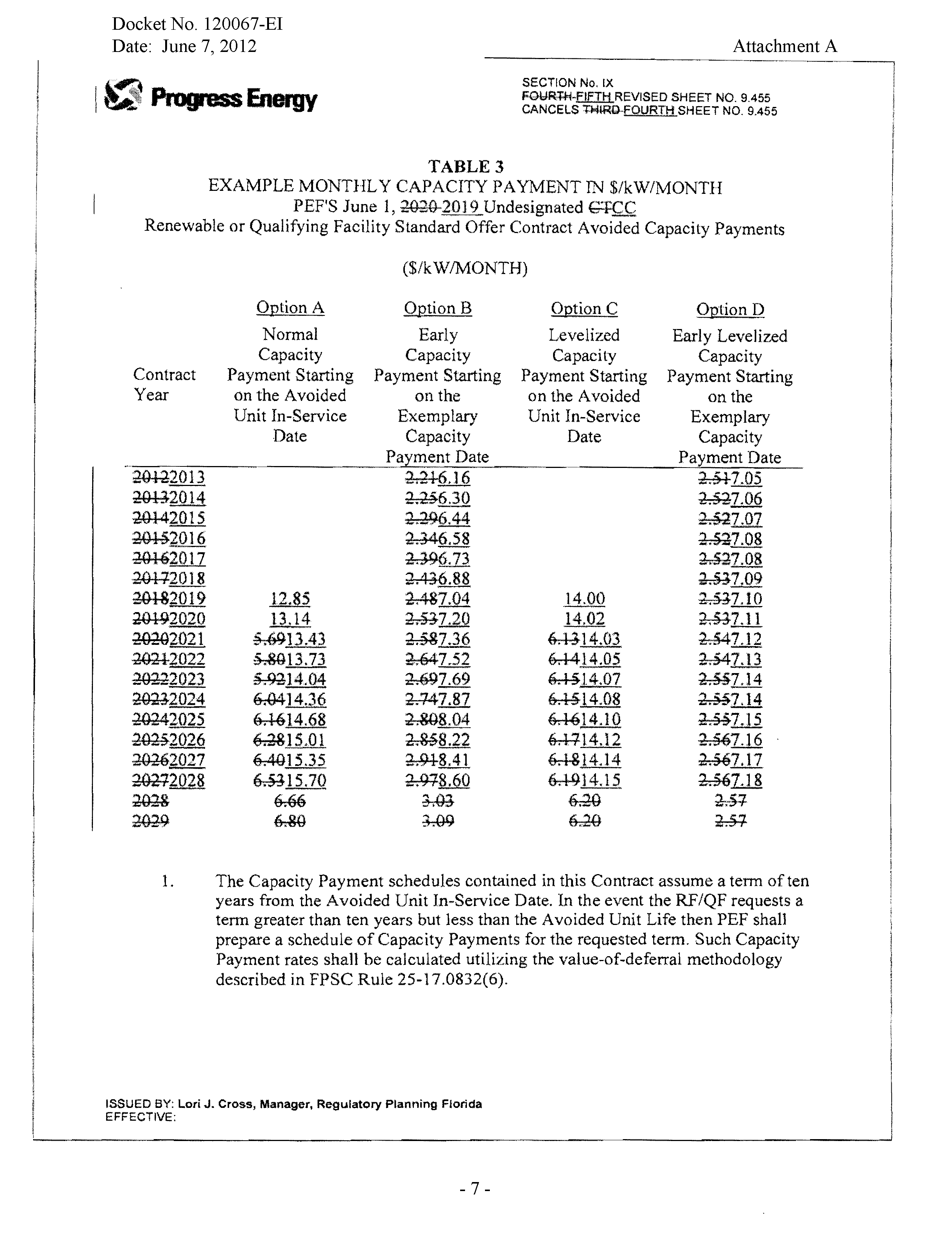
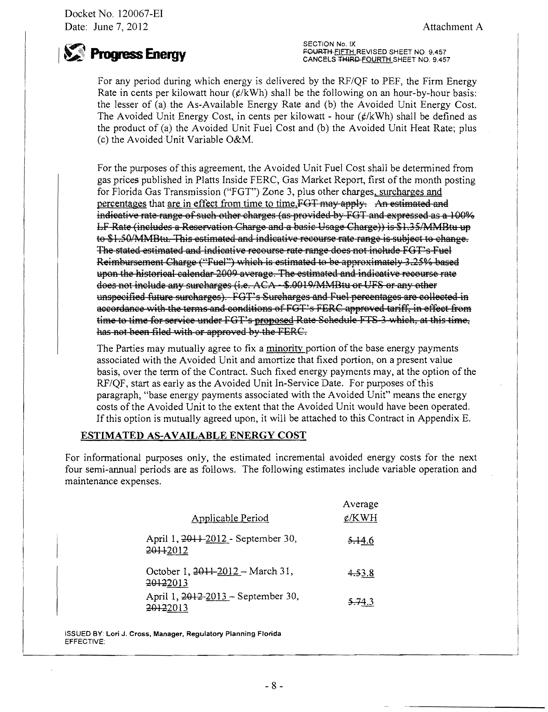
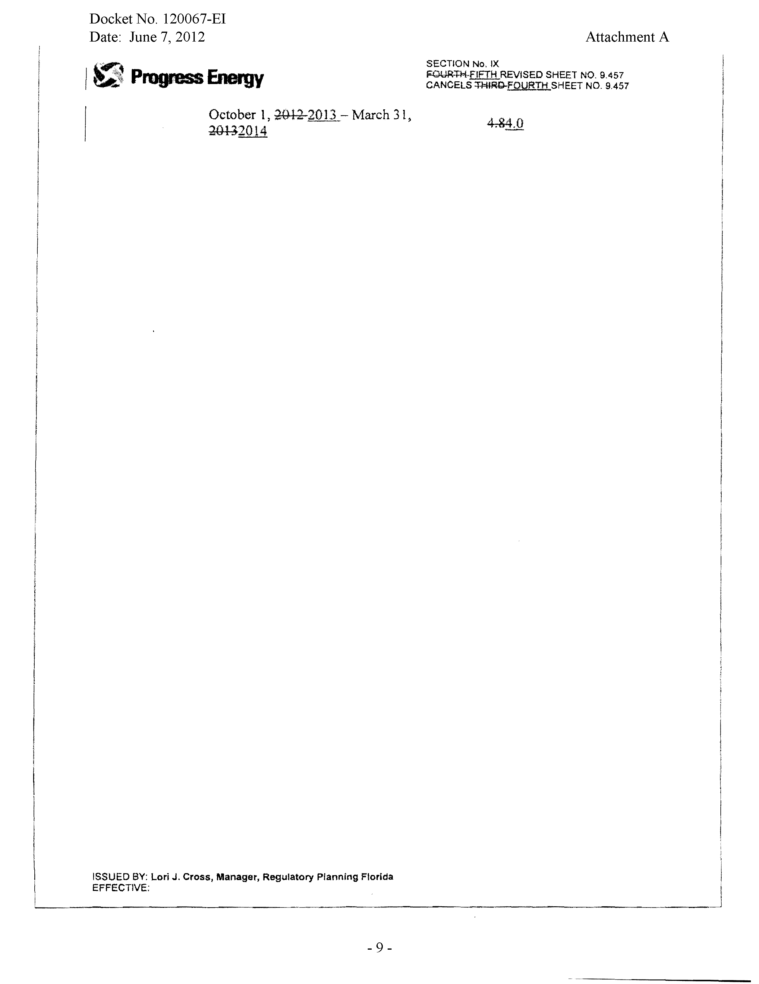
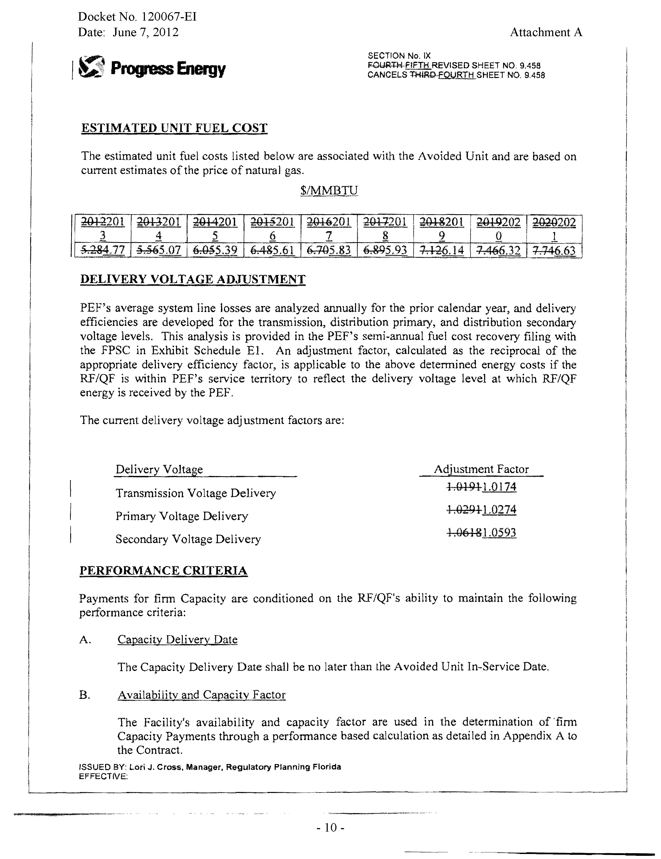
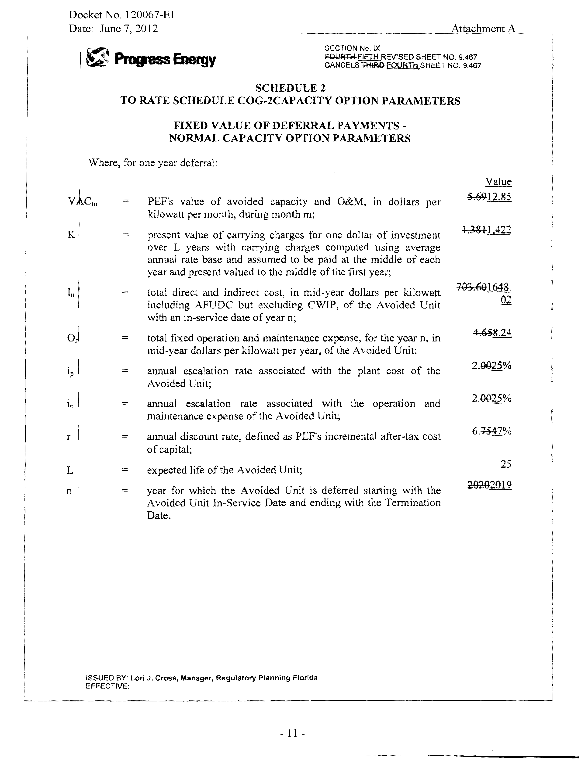
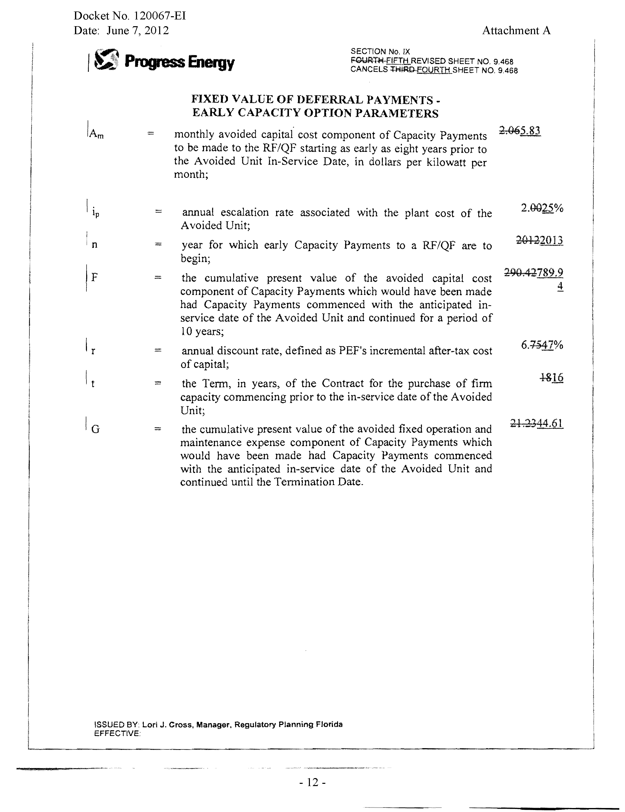

See Order No. PSC-07-0476-PAA-EI, issued June 6, 2007, in Docket No. 070108-EI, In re: Petition for approval of agreement for generation services and related terms and conditions with Gulf Power Company for Northwest Division (Marianna) beginning 2008, by Florida Public Utilities Company.
See Docket No. 110041-EI, In re: Request for Approval of Amendment No. 1 to the Agreement for Generation Services Between Gulf Power Company and Florida Public Utilities Company, by Florida Public Utilities Company.
See Order No. PSC-11-0269-PAA-EI, issued June 21, 2011, in Docket No. 110041-EI, In re: Request for Approval of Amendment No. 1 to the Agreement for Generation Services Between Gulf Power Company and Florida Public Utilities Company, by Florida Public Utilities Company.
See Order No. PSC-12-0056-FOF-EI, issued February 9, 2012, in Docket No. 110041-EI, In re: Request for Approval of Amendment No. 1 to the Agreement for Generation Services Between Gulf Power Company and Florida Public Utilities Company, by Florida Public Utilities Company.
See Order No. PSC-11-0296-TRF-EQ, issued July 8, 2011, in Docket No. 110089-EI, In re: Petition for Approval of Revisions to Renewable Energy Tariff, by Florida Public Utilities Company.

