BEFORE THE FLORIDA PUBLIC SERVICE COMMISSION

In re: Petition for approval of renewable energy tariff and standard offer contract, by Florida Power & Light Company. | DOCKET NO. 120072-EQ  ORDER NO. PSC-12-0336-TRF-EQ  ISSUED: June 27, 2012

The following Commissioners participated in the disposition of this matter:

RONALD A. BRISÉ, Chairman
LISA POLAK EDGAR
ART GRAHAM
EDUARDO E. BALBIS
JULIE I. BROWN

ORDER APPROVING STANDARD OFFER CONTRACT AND TARIFFS

BY THE COMMISSION:

Case Background
On April 2, 2012, Florida Power & Light Company (FPL or Company) filed its petition for approval of an amended standard offer contract and revised tariffs in accordance with Rules 25-17.200 through 25-17.310, Florida Administrative Code (F.A.C.). Section 366.91(3), Florida Statutes (F.S.), requires that each investor-owned utility (IOU) continuously offer to purchase capacity and energy from renewable energy generators, and Rules 25-17.200 through 25-17.310, F.A.C., require each IOU to file by April 1 of each year, a standard offer contract based on the next avoidable generating unit or planned purchase.

We have jurisdiction over the standard offer contract and tariffs pursuant to Sections 366.04 through 366.06, and 366.91, F.S.
Analysis
Because FPL is an IOU, Rule 25-17.250, F.A.C., requires that FPL continuously make available a standard offer contract for the purchase of firm capacity and energy from renewable generating facilities and small qualifying facilities with a design capacity of 100 kilowatts or less.
FPL’s 2011 standard offer contract, filed on April 1, 2011, was based on a 1,191 megawatt (MW) natural gas-fired combined cycle unit with an in-service date of June 1, 2016. We approved FPL’s 2011 standard offer contract on October 4, 2011. On November 21, 2011, FPL filed a petition seeking an affirmative determination of need for modernization of its Port Everglades Energy Center with a proposed in-service date of June 1, 2016. The Port Everglades Energy Center (1,277 MW) represented FPL’s natural gas-fired combined cycle unit, previously identified in its 2011 standard offer contract.
With the filing of the need determination, FPL’s next avoided unit changed and most of the cost data in its 2011 standard offer contract was revised to reflect the new next avoided unit. On November 28, 2011, FPL filed a revised 2011 standard offer contract, which was based on a 1,262 MW combined cycle unit at a greenfield site with an in-service date of June 1, 2021. On March 27, 2012, we approved FPL’s determination of need for the Port Everglades Energy Center and its revised standard offer contract.
FPL filed its 2012 Ten-Year Site Plan (TYSP) on April 2, 2012, which did not contain the aforementioned 2021 combined cycle unit or any other avoidable fossil fueled generating unit. Pursuant to Rule 25-17.250(1), F.A.C., each investor-owned utility with no planned generating unit identified in its Ten-Year Site Plan shall submit a standard offer contract based on avoiding or deferring a planned purchase. FPL has determined that a need for additional capacity in 2021 remains; however, FPL is currently assuming its 2021 need will be met with a one-year, 250 MW, power purchase agreement. Table 1 below provides a summary of FPL’s recent standard offer contract related filings.
Table 1: Summary of Recent Filings
 | Date Filed | Date Approved
2011 Standard Offer Contract | 4/1/2011 | 10/4/2011
PEEC Need Determination | 11/21/2011 | 3/27/2012
2011 Revised Standard Offer Contract | 11/28/2011 | 3/27/2012
2012 Standard Offer Contract | 4/2/2012 | 6/19/2012
Following the one-year power purchase agreement, the projected addition of Turkey Point Nuclear Units 6 and 7 will provide an additional 1,110 MW of capacity in 2022 and 2023, thus maintaining FPL’s 20 percent reserve margin. Subsequent to the addition of Turkey Point Units 6 and 7, FPL’s next avoidable fossil fuel-fired generating unit has a projected in-service date in 2025, which is beyond the ten-year planning horizon.
In its petition, FPL submitted a total of 5 revised tariff sheets, including 1 revised sheet of FPL’s renewable standard offer contract and 4 revised sheets corresponding to FPL’s QS-2 rate schedule. All of the revised sheets reflect changes associated with the planned purchase. Beyond these revisions, all other terms, such as provisions for performance, payment, and security are retained from the 2011 standard offer contract and related tariffs. The revised tariff sheets filed by FPL are included as Attachment A to this Order.
A renewable generator can elect to have no performance requirements and simply deliver energy on an as-available basis. If the renewable generator commits to certain performance requirements based on the planned purchase, including being online and delivering capacity by the in-service date, it can receive a capacity payment under the standard offer contract or a separately negotiated contract. Because the planned purchase is for one year only, election of a normal capacity payment will result in a capacity payment for only one year, and revenue for all other years will be received based on as-available energy payments, as illustrated in Table 2 below. Standard offer contracts often serve as a starting point for negotiated contracts by providing information regarding payments.
To promote renewable generation, we require multiple options for capacity payments. If a renewable generator elects to receive Normal or Levelized capacity payments, it would receive those payments starting on the in-service date of the avoided planned purchase.
If Early or Early Levelized capacity payments are selected, those payments would begin at an earlier date but tend to be less in the outer years as the net present value of payments must remain the same. In addition, capacity payments greater than those made under the Normal option require additional performance security from the renewable generator. Table 2 estimates the annual payments that will be made to a renewable facility of 50 MW running at a 94 percent capacity factor, with an in-service date of 2012.
Table 2 - Estimated Annual Payments to a 50 MW Renewable Facility (94% Capacity Factor)
Year | Energy Payment | Capacity Payment by Type ($000)
Year | Energy Payment | Normal | Levelized | Early | Early Levelized
2013 | 15,843 | 0 | 0 | 0 | 0
2014 | 16,530 | 0 | 0 | 0 | 0
2015 | 17,167 | 0 | 0 | 0 | 0
2016 | 19,906 | 0 | 0 | 0 | 0
2017 | 21,528 | 0 | 0 | 0 | 0
2018 | 23,234 | 0 | 0 | 0 | 0
2019 | 24,761 | 0 | 0 | 0 | 0
2020 | 27,753 | 0 | 0 | 191 | 223
2021 | 30,062 | 2,114 | 252 | 197 | 223
2022 | 30,656 | 0 | 252 | 203 | 223
2023 | 30,895 | 0 | 252 | 209 | 223
2024 | 33,524 | 0 | 252 | 215 | 223
2025 | 34,578 | 0 | 252 | 222 | 223
2026 | 34,973 | 0 | 252 | 229 | 223
2027 | 35,996 | 0 | 252 | 235 | 223
2028 | 36,685 | 0 | 252 | 242 | 223
2029 | 35,930 | 0 | 252 | 250 | 223
2030 | 35,646 | 0 | 252 | 257 | 223
2031 | 35,804 | 0 | 252 | 265 | 223
2032 | 36,131 | 0 | 252 | 273 | 223
Total (2012 NPV) | 269,567 | 1,122 | 1,122 | 1,122 | 1,122

The provisions of the 2012 standard offer contract and related tariffs conform to all requirements of Rules 25-17.200 through 25-17.310, F.A.C. The standard offer contract provides flexibility in the arrangements for payments so that a developer of renewable generation may select the payment stream best suited to its financial needs. Therefore, we find it appropriate to approve the revised standard offer contract and tariffs filed on April 2, 2012, by FPL.
Based on the foregoing, it is

ORDERED by the Florida Public Service Commission that Florida Power & Light Company’s standard offer contract and related energy tariffs are hereby approved, effective June 19, 2012. It is further

ORDERED that this Order, shall become final and effective upon the issuance of a Consummating Order unless an appropriate petition, in the form provided by Rule 28-106.201, Florida Administrative Code, is received by the Commission Clerk, 2540 Shumard Oak Boulevard, Tallahassee, Florida 32399-0850, by the close of business on the date set forth in the "Notice of Further Proceedings" attached hereto. It is further

ORDERED that if a protest is filed within 21 days of the issuance of the Order, the tariffs shall remain in effect pending resolution of the protest. Potential signatories to the standard offer contract shall be aware that Florida Power & Light Company’s standard offer contract and energy tariffs may be subject to a request for hearing, and if a hearing is held, may subsequently be revised. It is further

ORDERED that if no timely protest is filed and this Order becomes final, then this docket shall be closed upon the issuance of a Consummating Order.

By ORDER of the Florida Public Service Commission this 27th day of June, 2012.

/s/ Ann Cole
ANN COLE
Commission Clerk
Florida Public Service Commission
2540 Shumard Oak Boulevard
Tallahassee, Florida 32399
(850) 413-6770
www.floridapsc.com

Copies furnished: A copy of this document is provided to the parties of record at the time of issuance and, if applicable, interested persons.

PER

NOTICE OF FURTHER PROCEEDINGS

The Florida Public Service Commission is required by Section 120.569(1), Florida Statutes, to notify parties of any administrative hearing or judicial review of Commission orders that is available under Sections 120.57 or 120.68, Florida Statutes, as well as the procedures and time limits that apply. This notice should not be construed to mean all requests for an administrative hearing or judicial review will be granted or result in the relief sought.

Mediation may be available on a case-by-case basis. If mediation is conducted, it does not affect a substantially interested person's right to a hearing.

The Commission's decision on this tariff is interim in nature and will become final, unless a person whose substantial interests are affected by the proposed action files a petition for a formal proceeding, in the form provided by Rule 28-106.201, Florida Administrative Code. This petition must be received by the Office of Commission Clerk, 2540 Shumard Oak Boulevard, Tallahassee, Florida 32399-0850, by the close of business on July 18, 2012.

In the absence of such a petition, this Order shall become final and effective upon the issuance of a Consummating Order.

Any objection or protest filed in this docket before the issuance date of this order is considered abandoned unless it satisfies the foregoing conditions and is renewed within the specified protest period.

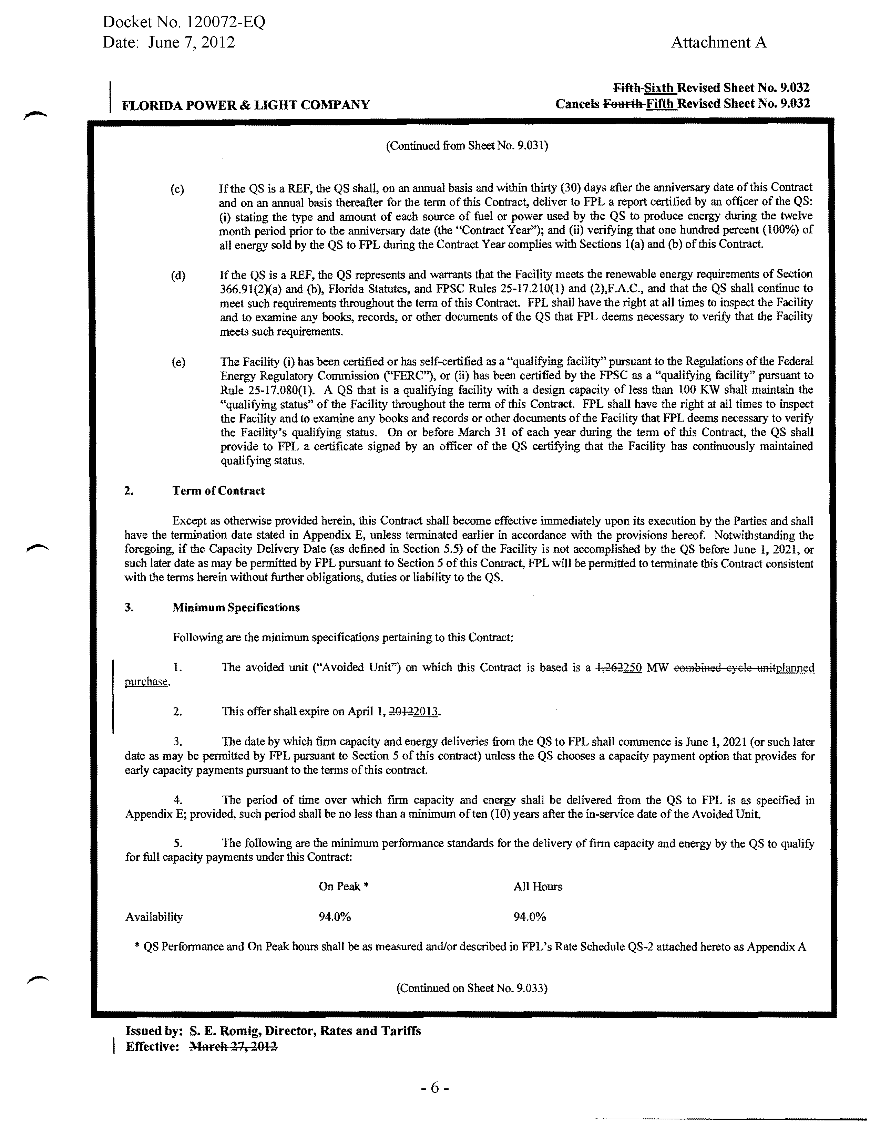
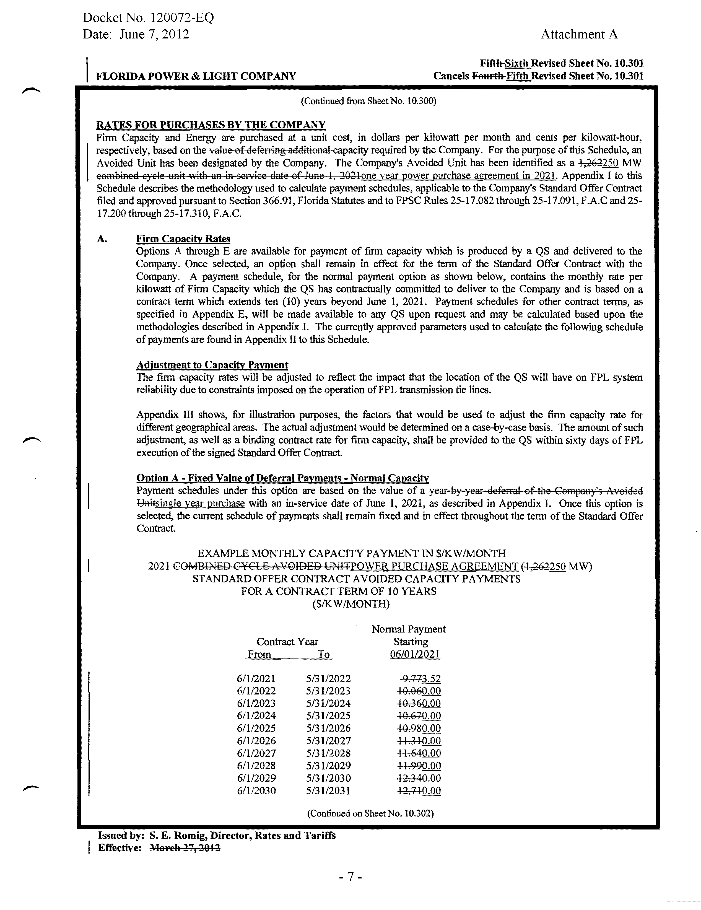
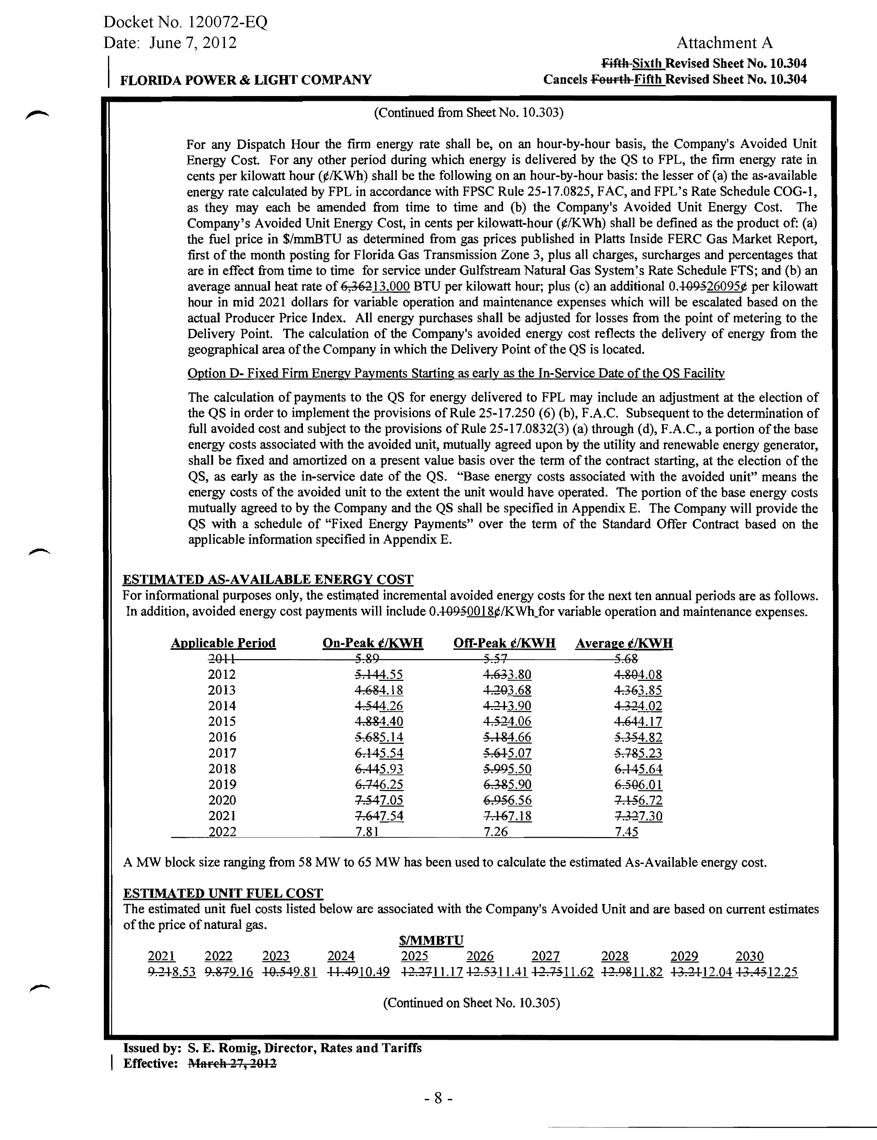
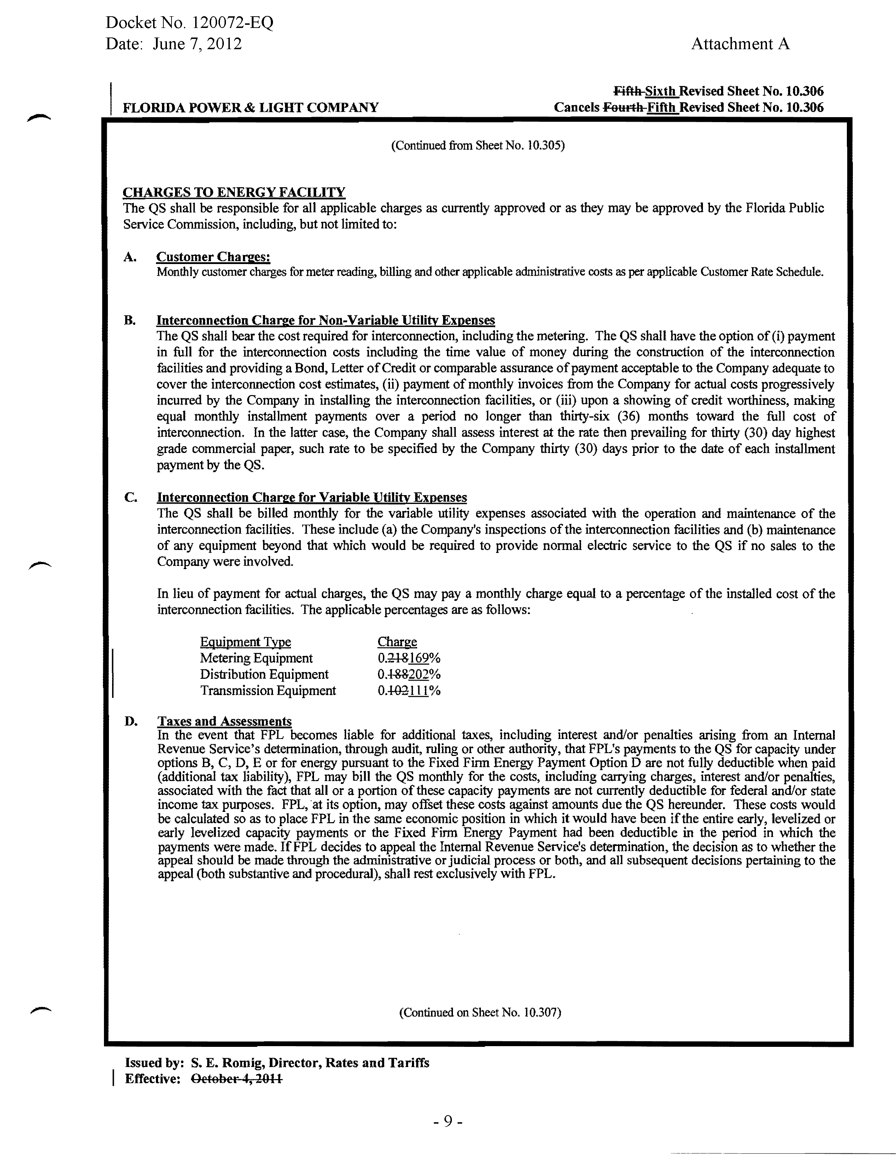
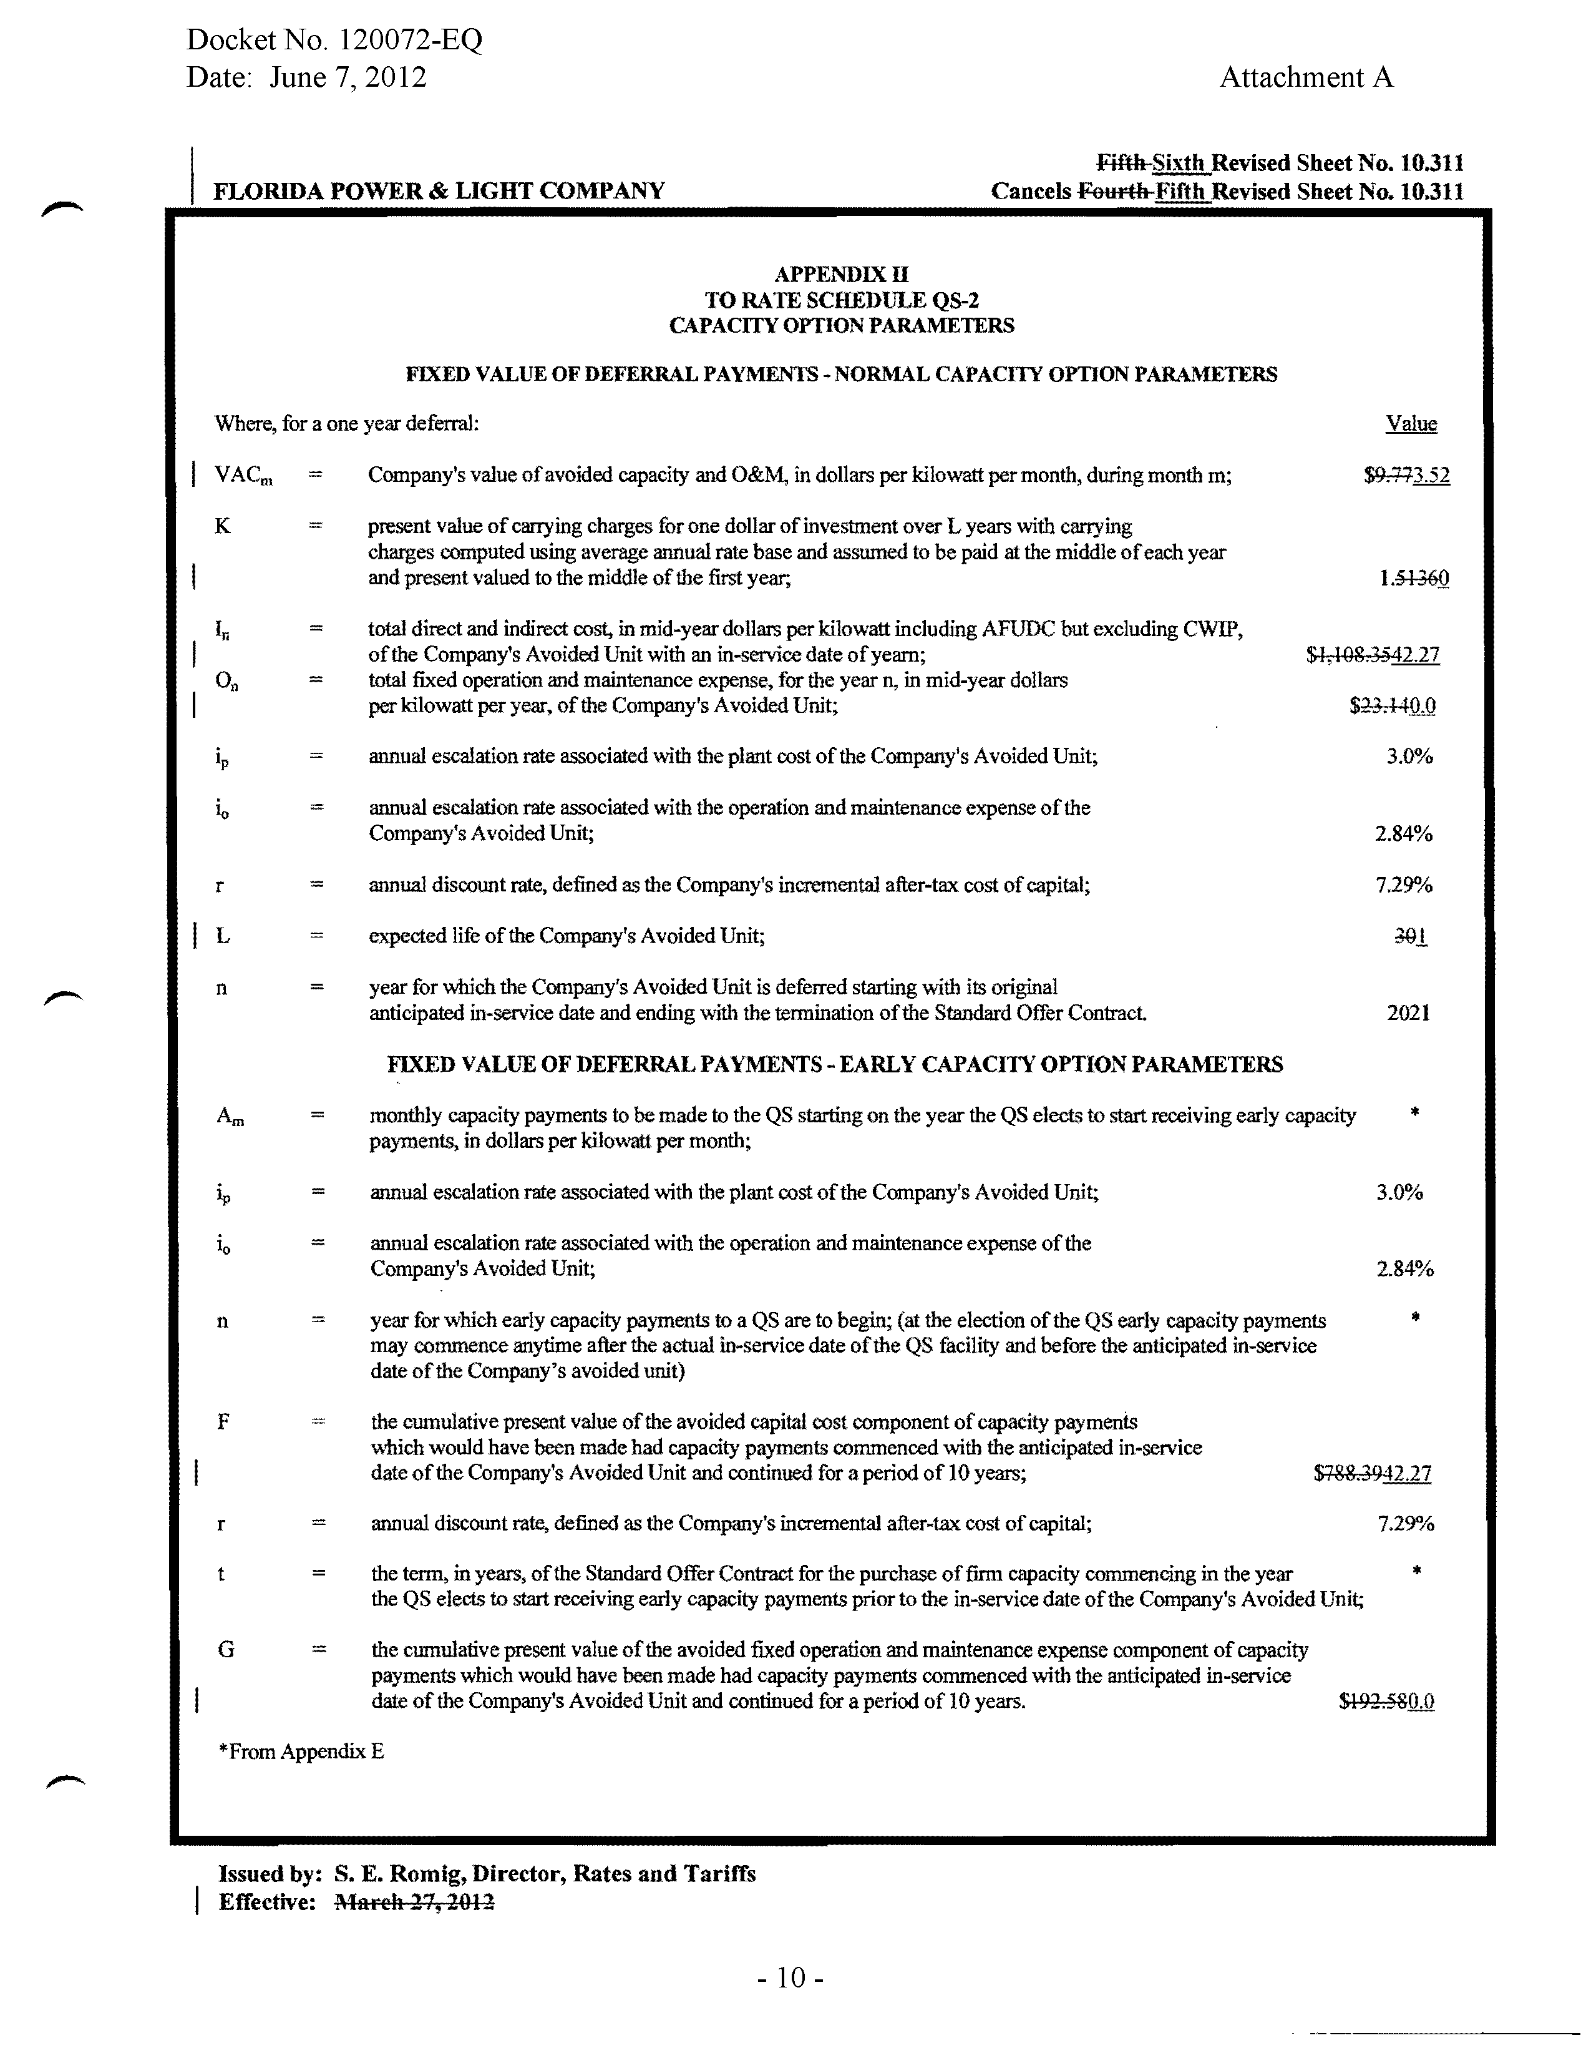

See Order No. PSC-11-0466-TRF-EQ, issued on October 13, 2011, in Docket No. 110091-EQ, In re: Petition for approval of renewable energy tariff and standard offer contract by Florida Power & Light Company.
See Order No. PSC-12-0187-FOF-EI, issued on April 9, 2012, in Docket No. 110309-EI, In re: Petition to determine need for modernization of Port Everglades Plant by Florida Power & Light Company.

