BEFORE THE FLORIDA PUBLIC SERVICE COMMISSION

NOTICE OF DEVELOPMENT OF RULEMAKING

TO
ALL INTERESTED PERSONS
UNDOCKETED
IN RE: INITIATION OF RULEMAKING TO ADOPT RULE 25-4.0051, F.A.C., RELATED TO CERTIFICATE HOLDER INFORMATION, AND TO REPEAL RULES 25-24.585 AND 25-24.835, F.A.C., RELATING TO RULES INCORPORATED

ISSUED: August 24, 2012
NOTICE is hereby given pursuant to Section 120.54, Florida Statutes, that the Florida Public Service Commission staff has initiated rulemaking to repeal Rules 25-24.585 and 25-24.835, Florida Administrative Code, and to adopt Rule 25-4.0051, F.A.C., to require all certificated telecommunication providers to keep their contact information current with the Public Service Commission.

The attached Notices of Development of Rulemaking will appear in the August 31, 2012 edition of the Florida Administrative Weekly. If requested in writing and not deemed unnecessary by the agency head, a rule development workshop will be scheduled and noticed in the next available Florida Administrative Weekly. Written requests for a rule development workshop must be submitted to Cindy Miller, Florida Public Service Commission, Office of the General Counsel, 2540 Shumard Oak Blvd., Tallahassee, FL 32399-0850, (850) 413-6082, cmiller@psc.fl.state.us by September 14, 2012. A copy of the preliminary draft rules is attached.

By DIRECTION of the Florida Public Service Commission this 24th day of August, 2012.

/s/ Ann Cole
ANN COLE
Commission Clerk
Florida Public Service Commission
2540 Shumard Oak Boulevard
Tallahassee, Florida 32399
(850) 413-6770
www.floridapsc.com

Copies furnished: A copy of this document is provided to the parties of record at the time of issuance and, if applicable, interested persons.

CM

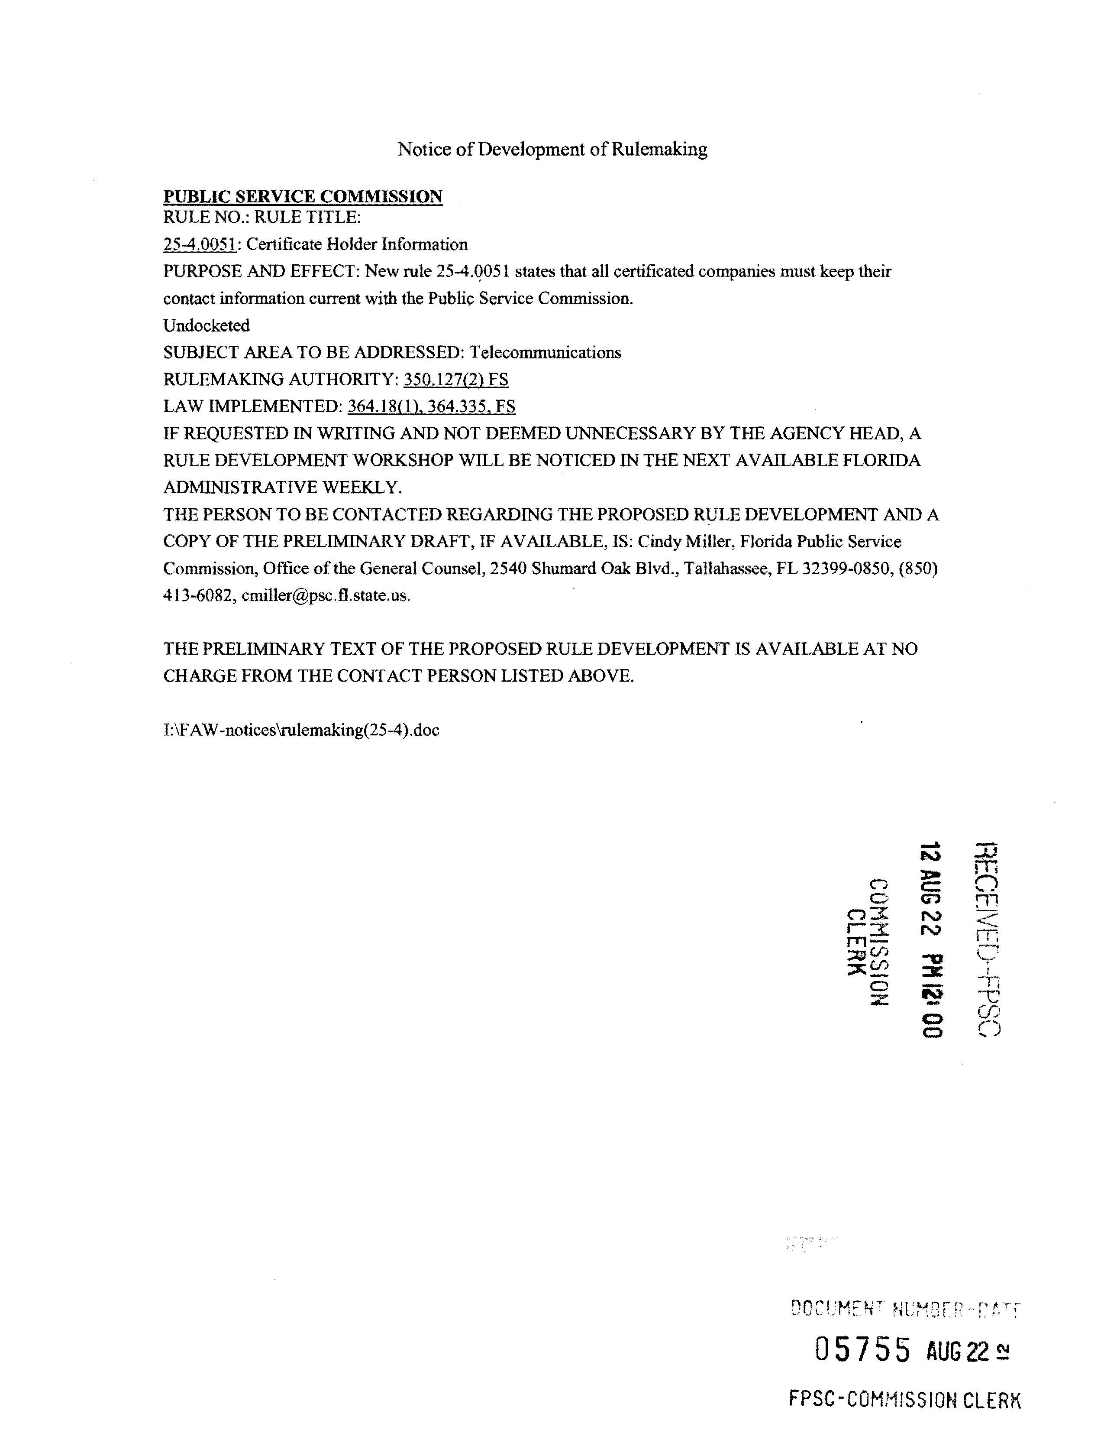
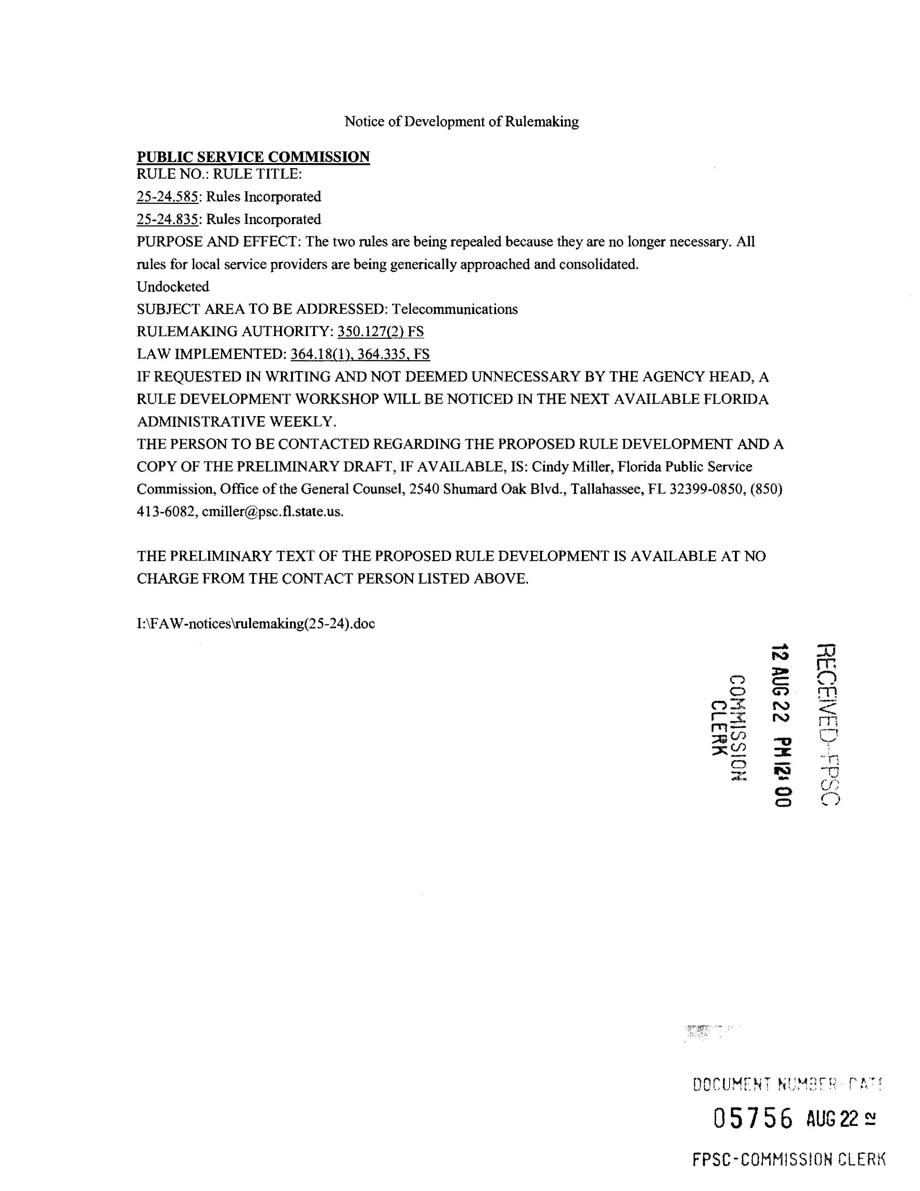
25-24.585 Rules Incorporated.
(1) The following rules are incorporated herein by reference and apply to shared tenant service companies:
Section | Title | Portions Applicable
25-4.019 | Records and Reports in General | All
25-4.020 | Location and Preservation of Records | All except (1) and (3)
25-4.036 | Design and Construction of Plant | All
25-4.043 | Response to Commission Staff Inquiries | All
25-4.0161 | Regulatory Assessment Fees; Telecommunication Companies | All
25-4.110 | Customer Billing | Subsections (11) and (12)
25-4.160 | Operation of Telecommunications Relay Service | All
(2) Each shared tenant service company shall file with the Commission’s Office of Commission Clerk updated information for the following items within ten days after either such change occurs.
(a) The mailing address of the certificate holder.
(b) Name, title, and phone number of individual responsible for Commission contacts.
Rulemaking Authority 350.127(2), 427.704(8) FS. Law Implemented 350.113, 364.016, 364.17, 364.18, 364.183, 364.185, 364.339 FS. History–New 1-28-91, Amended 12-29-91, 11-13-95, 7-29-97, 4-8-98, 12-23-02, 11-16-03.
25-24.835 Rules Incorporated.
(1) The following rules are incorporated herein by reference and apply to competitive local exchange companies.

Section | Title | Portions Applicable
25-4.0161 | Regulatory Assessment Fees | All
25-4.020 | Location and Preservation of Records | (2)
25-4.043 | Response to Commission Staff Inquiries | All
25-4.036 | Design and Construction of Plant | All
25-4.038 | Safety | All
25-4.160 | Operation of Telecommunications Relay Service | All

(2) Each company shall file updated information for the following items with the Office of Commission Clerk within 10 days after any changes to the following:
(a) The address of the certificate holder’s main corporate and Florida offices (if any) including street name and address and post office box, city, state and zip code; or
(b) Telephone number, name, and address of the individual who is to serve as primary liaison with the Commission in regard to the ongoing Florida operations of the certificated company.
Rulemaking Authority 350.127(2), 364.337(2), 427.704(8) FS. Law Implemented 364.016, 364.183, 364.336, 364.337(2) FS. History–New 12-27-95, Amended 4-8-98, 6-24-99, 8-25-05.
25-4.0051 Current Certificate Holder Information,
(1) Each company shall file updated information for the following items with the Office of Commission Clerk within 10 days after any changes to the following:
(a) The address of the certificate holder’s main corporate and Florida offices (if any) including street name and address and post office box, city, state and zip code; or
(b) Telephone number, name, and address of the individual who is to serve as primary liaison with the Commission in regard to the ongoing Florida operations of the certificated company.
Rulemaking Authority 350.127(2), 364.337(2), 427.704(8), FS. Law implemented 364.016, 364.183, 364.336, 364.337(2) FS. History-New xx-xx-xx.

