State of Florida   |  | Public Service Commission  Capital Circle Office Center ● 2540 Shumard Oak Boulevard  Tallahassee, Florida 32399-0850  -M-E-M-O-R-A-N-D-U-M-
DATE: | September 6, 2012
TO: | Office of Commission Clerk (Cole)
FROM: | Office of Telecommunications (Beard, Casey)  Office of the General Counsel (Teitzman)
RE: | Docket No. 120165-TP – Application for designation as an Eligible Telecommunications Carrier (ETC) pursuant to Section 214(e)(2) of the Communications Act of 1934 for the limited purpose of receiving federal Universal Service Low Income support for providing Lifeline service to qualified households in its non-rural service territory, by Cox Florida Telecom, LP.
AGENDA: | 09/18/12 – Regular Agenda – Proposed Agency Action – Interested Persons May Participate
COMMISSIONERS ASSIGNED: |  |  | All Commissioners
PREHEARING OFFICER: |  |  | Brown
CRITICAL DATES: |  |  | None
SPECIAL INSTRUCTIONS: |  |  | None
FILE NAME AND LOCATION: |  |  | S:\PSC\TEL\WP\120165.RCM.DOC

Case Background
On May 31, 2012, Cox Florida Telecom, L.P. d/b/a Cox Florida Telecom, LP (Cox) filed an application for designation as an eligible telecommunications carrier (ETC) in the State of Florida, for the limited purpose of receiving federal Universal Service Low Income support for providing Lifeline service to qualified households in its non-rural service territory.
Cox is certificated as a competitive local exchange carrier (CLEC) at the Florida Public Service Commission (FPSC or the Commission) and has been providing local and long distance telephone service to residential and commercial customers in the State of Florida since 2005. Cox provides service in the Pensacola, Ft. Walton Beach and Gainesville/Ocala areas. Cox states its application that its service territory includes significant areas where low income families live. The application also states that while Cox serves many business customers, its customer base is primarily residential and the vast majority of Cox’s customers are families and individuals.
Cox states that it is a facilities-based telecommunications company that provides services through local subsidiaries and its parent company, Cox Communications, Inc., over its own telephone facilities, including switches, loops and intercarrier transport. Services offered in Florida include voice products as well as video and high speed Internet. Cox is the nation’s third-largest provider of video and broadband services, with more than six million customers nationwide. Cox has a choice of different plans in Florida that include local telephone usage, call waiting, voicemail and long distance.
Cox seeks designation as a competitive ETC under the federal programs that support service to low income customers in Florida. Cox states it is qualified to be an ETC under both the terms of the Federal Communications Act and the relevant Federal Communications Commission (FCC) guidelines and requirements for the federal Universal Service low income program throughout Cox’s non-rural service territory in Florida.
Cox has been an ETC since 2004 in Rhode Island, parts of Oklahoma, Nebraska, and Iowa. Cox has also been designated as an ETC in Louisiana in 2005, Connecticut in 2008, Georgia in 2009, and Kansas in 2011. Cox was approved as an ETC in Arkansas and Arizona in 2011 but has not yet received any reimbursement from Universal Service Administrative Company (USAC) for those states.
The Commission is vested with jurisdiction in this matter pursuant to 47 CFR §54.201, and Section 364.10, Florida Statutes.

Discussion of Issues
Issue 1:1
Should Cox be designated as an ETC throughout its non-rural service territory in the State of Florida?
Recommendation:
Yes, staff recommends that Cox be granted ETC designation in the non-rural service areas listed in Attachment B of this recommendation for the sole purpose of offering Lifeline discounts to qualifying consumers in Florida. If there is a future change of company ownership, the new owners should be required to file a petition with the FPSC and make a showing of public interest to maintain the company’s ETC designation. If Cox should decide in the future to seek high cost universal service funds, it should be required to file a petition and make a showing that it would be in the public interest to grant such a request. (Beard)
Staff Analysis:
Under FCC rules, the state commissions have the primary responsibility to designate providers as ETCs. Designation as an ETC is required in order for a provider to be eligible to receive monies directly from the Federal Universal Service Fund (USF). Section 254(e) of the Telecommunications Act of 1996 (Act) provides that “only an eligible telecommunications carrier designated under Section 214(e)…shall be eligible to receive specific Federal universal service support.” According to Section 214(e)(1), a common carrier designated as an ETC must offer and advertise the services supported by the federal universal service mechanisms throughout a designated service area.
ETC Certification Requirements
C.F.R. Rule 54.201(c), addresses a state commission’s responsibilities related to ETC designation, stating:
Upon request and consistent with the public interest, convenience, and necessity, the state commission may, in the case of an area served by a rural telephone company, and shall, in the case of all other areas, designate more than one common carrier as an eligible telecommunications carrier for a service area designated by the state commission, so long as each additional requesting carrier meets the requirements of paragraph (d) of this section. Before designating an additional eligible telecommunications carrier for an area served by a rural telephone company, the state commission shall find that the designation is in the public interest.
To qualify as an ETC, telecommunications carriers must provide the services identified in C.F.R. Rule 54.101.
(a) Services designated for support. Voice telephony services shall be supported by federal universal service support mechanisms. Eligible voice telephony services must provide voice grade access to the public switched network or its functional equivalent; minutes of use for local service provided at no additional charge to end users; access to emergency services provided by local government or other public safety organizations, such as 911 and enhanced 911, to the extent the local government in an eligible carrier’s service area has implemented 911 or enhanced 911 systems; and toll limitation services to qualifying low-income consumers as provided in subpart E of this part.
(b) An eligible telecommunications carrier must offer voice telephony service as set forth in paragraph (a) of this section in order to receive federal universal service support.
In addition ETCs must advertise the availability of such services and the associated charges using media of general distribution.
Additional ETC Certification Requirements
47 C.F.R. §54.202(a) includes the following additional requirements for designation as an ETC.
In order to be designated an eligible telecommunications carrier under section 214(e)(6), any common carrier in its application must:
(1)(i) Certify that it will comply with the service requirements applicable to the support that it receives.
(ii) Submit a five-year plan that describes with specificity proposed improvements or upgrades to the applicant's network throughout its proposed service area. Each applicant shall estimate the area and population that will be served as a result of the improvements. Except, a common carrier seeking designation as an eligible telecommunications carrier in order to provide supported services only under subpart E of this part does not need to submit such a five-year plan.
(2) Demonstrate its ability to remain functional in emergency situations, including a demonstration that it has a reasonable amount of back-up power to ensure functionality without an external power source, is able to reroute traffic around damaged facilities, and is capable of managing traffic spikes resulting from emergency situations.
(3) Demonstrate that it will satisfy applicable consumer protection and service quality standards. A commitment by wireless applicants to comply with the Cellular Telecommunications and Internet Association's Consumer Code for Wireless Service will satisfy this requirement. Other commitments will be considered on a case-by-case basis.
(4) For common carriers seeking designation as an eligible telecommunications carrier for purposes of receiving support only under subpart E of this part, demonstrate that it is financially and technically capable of providing the Lifeline service in compliance with subpart E of this part.
(5) For common carriers seeking designation as an eligible telecommunications carrier for purposes of receiving support only under subpart E of this part, submit information describing the terms and conditions of any voice telephony service plans offered to Lifeline subscribers, including details on the number of minutes provided as part of the plan, additional charges, if any, for toll calls, and rates for each such plan. To the extent the eligible telecommunications carrier offers plans to Lifeline subscribers that are generally available to the public, it may provide summary information regarding such plans, such as a link to a public Web site outlining the terms and conditions of such plans.
Staff has reviewed Cox’s petition for designation as an ETC in certain non-rural areas in Florida, as well as additional documents filed with the FPSC. Staff has verified that Cox has complied with the above requirements to be eligible as an ETC in Florida. Cox has also demonstrated its ability to provide the voice telephony services identified in 47 C.F.R. §54.101 using its own facilities.
Public Interest Determinations
Under Section 214 of the Act, the FCC and state commissions must determine that an ETC designation is consistent with the public interest, convenience, and necessity for rural areas. They also must consider whether an ETC designation serves the public interest. Congress did not establish specific criteria to be applied under the public interest tests in Section 214. The public interest benefits of a particular ETC designation must be analyzed in a manner that is consistent with the purposes of the Act itself, including the fundamental goals of preserving and advancing universal service; ensuring the availability of quality telecommunications services at just, reasonable, and affordable rates; and promoting the deployment of advanced telecommunications and information services to all regions of the nation, including rural and high-cost areas. The FPSC has determined that before designating a carrier as an ETC, it should make an affirmative determination that such designation is in the public interest, regardless of whether the applicant seeks designation in an area served by a rural or non-rural carrier.
Beyond the principles detailed in the Act, the FCC and state commissions have used additional factors to analyze whether the designation of an ETC is in the public interest. A rigorous ETC designation process ensures that only fully qualified applicants receive designation as ETCs and that all ETC designees are prepared to serve all customers within the designated service area.
Staff recommends that if there is a future change of company ownership, the new owners should be required to file a petition with the FPSC and make a showing of public interest to maintain the company’s ETC designation. This will ensure that only carriers that are financially viable, likely to remain in the market, willing and able to provide supported services throughout the designated service area, and able to provide an evolving level of universal service are designated as ETCs.
Impact on Universal Service Funds
The USF programs, which are administered by USAC, ensure that consumers in all regions of the nation have access to telecommunications services that are reasonably comparable to those services provided in urban areas and at rates reasonably comparable to those charged in urban areas. Cox believes that its designation as an ETC will not adversely impact the USF as Cox is not seeking high-cost reimbursement, just Lifeline support.
Cox’s Lifeline Offering
Cox states that it will pass through all applicable state and federal service discounts and mandated service support to its Lifeline customer, thus reducing the price of access to telecommunications services for the Lifeline eligible customers in Florida. Cox’s Lifeline offering includes the following:
- Lifeline customers will receive a monthly discount of $12.75 off of their monthly bill for services;
- Lifeline customers will have a choice of applying the Lifeline discount to a basic local service plan or any of Cox’s packages, which may include local features such as call waiting and voicemail, a specific number of domestic long distance minutes with various calling features, and unlimited local calling within a local calling area. Cox also offers toll limitation on various packages, but toll limitation is available on any of its packages for Lifeline customers;
- Cox does not offer, nor does it plan to offer Lifeline specific plans. A Cox Lifeline customer will be able to choose any of Cox’s current offerings and the monthly discount will be applied.
Transitional Lifeline
Transitional Lifeline requires that ETCs offer discounted residential basic local telecommunications service at 70 percent of the residential local telecommunications service rate for any Lifeline subscriber who no longer qualifies for Lifeline. A Lifeline subscriber who requests such services receives the discounted price for a period of one year after the date the subscriber ceases to be qualified for Lifeline. Cox understands that it must provide a 30 percent monthly discount off its local rate to that customer for a period of 12 months at its expense.
Lifeline Advertising
Upon designation as an ETC, Cox states that it will participate in, and offer Lifeline to qualifying low-income consumers and publicize the availability of Lifeline services in a manner reasonably designed to reach those likely to qualify for those services. Cox’s advertising will increase the awareness of the Lifeline program and of the discounts that the program offers to make telephone service more affordable to the low income consumers. The awareness could likely lead to additional low income consumers seeking to obtain telephone service from Cox or other ETCs.
47 C.F.R. §54.405 requires that materials describing the service shall use easily understood language and indicate that: 1) the service is a Lifeline service; 2) that Lifeline is a government assistance program; 3) that the service is non-transferable; 4) that only eligible consumers may enroll; and 5) that the program is limited to one discount per household.
Cox advertises using its own cable operations, newspapers, billboards, direct mail and other media intended to reach a wide audience in its service area in Florida. Cox will comply with any additional requirements that may be added by the FCC or the FPSC in the future that are required of all designated ETCs.
Facilities Requirement
In accordance with 47 C.F.R. 54.201(d)(1), a company must offer the services that are supported by the federal universal service support mechanisms either using its own facilities or a combination of its own facilities and resale of another carrier’s services. Cox states that as a telecommunications company, it intends to offer all of the supported services enumerated under Section 254(c) of the Act through its own facilities.
Conclusion
Based on staff’s review, along with Cox’s commitment to abide by both state and federal rules and procedures (See Attachment A), staff believes that Cox’s petition for ETC status is in the public interest and should be approved. Upon a decision by the Commission, staff will continue the necessary oversight to ensure that Cox, along with other ETCs in Florida, are upholding these principles and attaining the goals and objectives of both the state and federal universal service programs. Therefore, staff recommends that Cox be granted ETC designation in the non-rural service areas listed in Attachment B of this recommendation for the sole purpose of offering Lifeline discounts to qualifying consumers in Florida. If there is a future change of company ownership, the new owners should be required to file a petition with the FPSC and make a showing of public interest to maintain the company’s ETC designation. If Cox should decide in the future to seek high cost universal service funds, it should be required to file a petition and make a showing that it would be in the public interest to grant such a request.
Issue 2:2
Should this docket be closed?
Recommendation:
If no person whose substantial interests are affected by the proposed agency action files a protest within 21 days of the issuance of the order, this docket should be closed upon issuance of a consummating order. (Teitzman)
Staff Analysis:
At the conclusion of the protest period, if no protest is filed this docket should be closed upon the issuance of a consummating order.
Attachment A
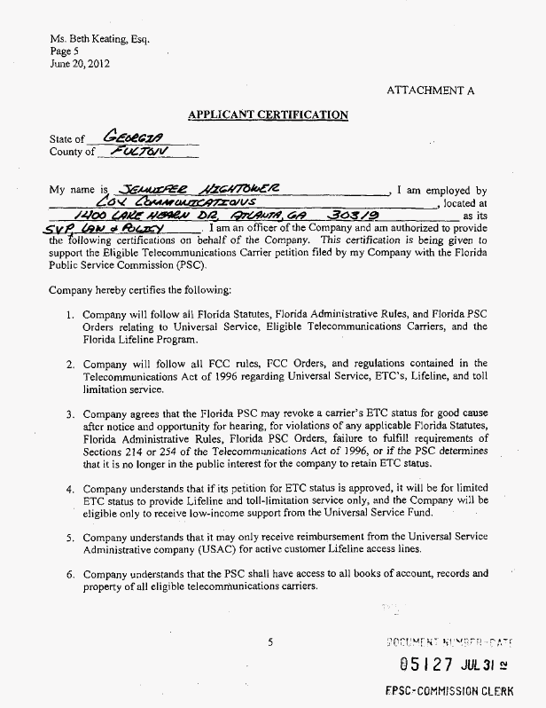
Attachment A

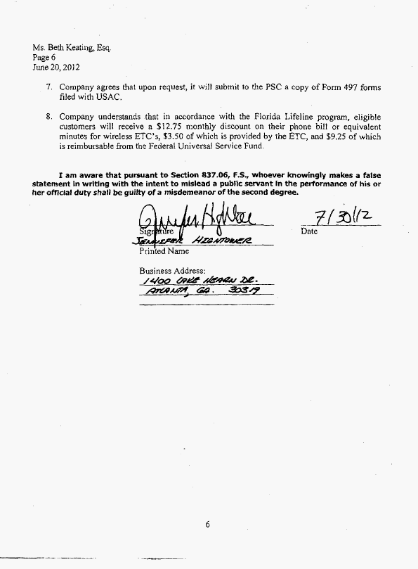
Attachment B
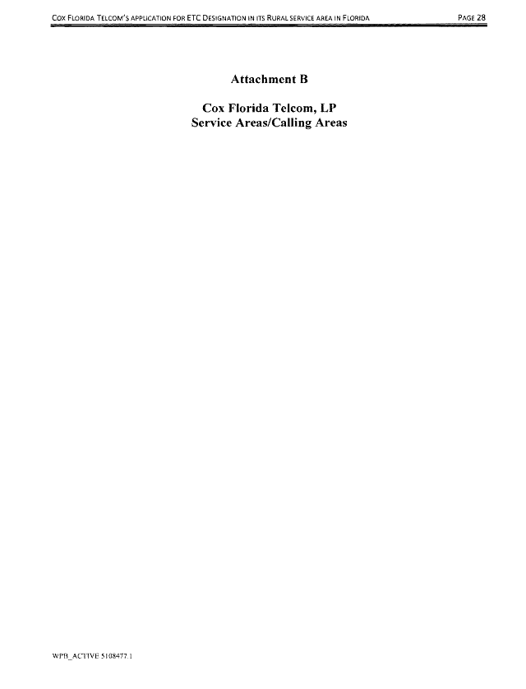
Attachment B
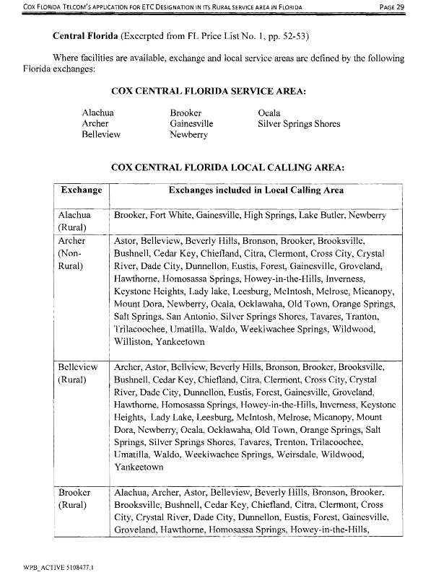
Attachment B
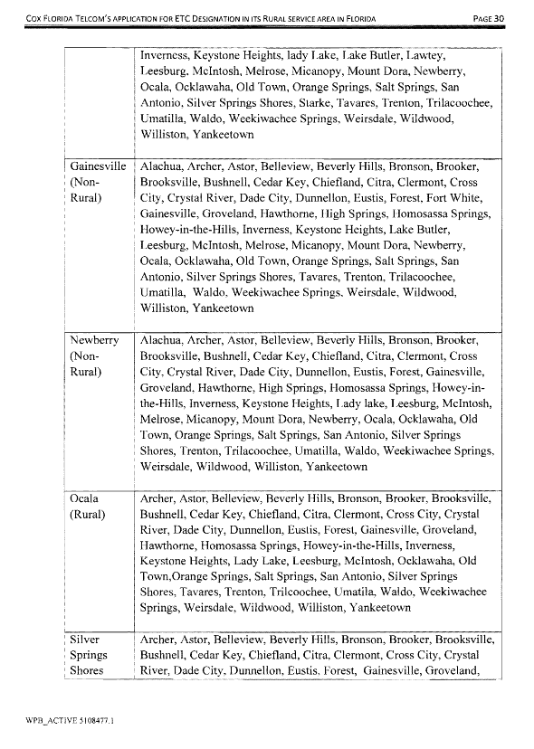
Attachment B
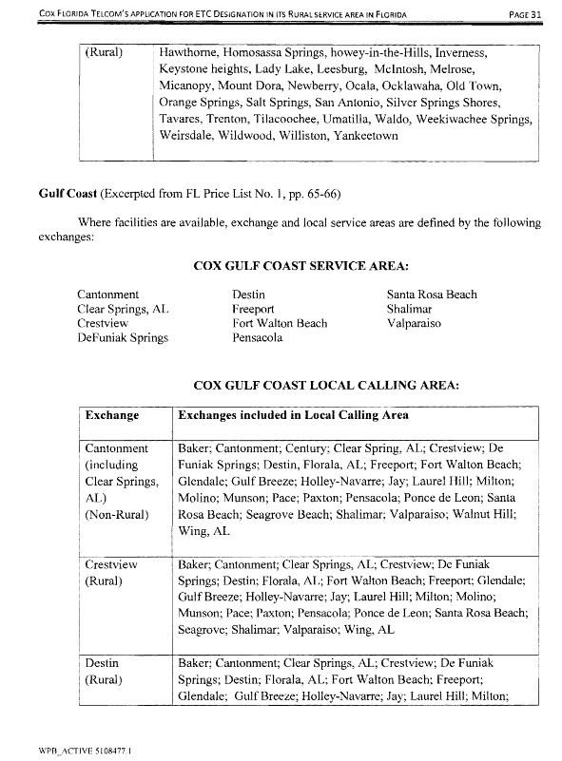
Attachment B
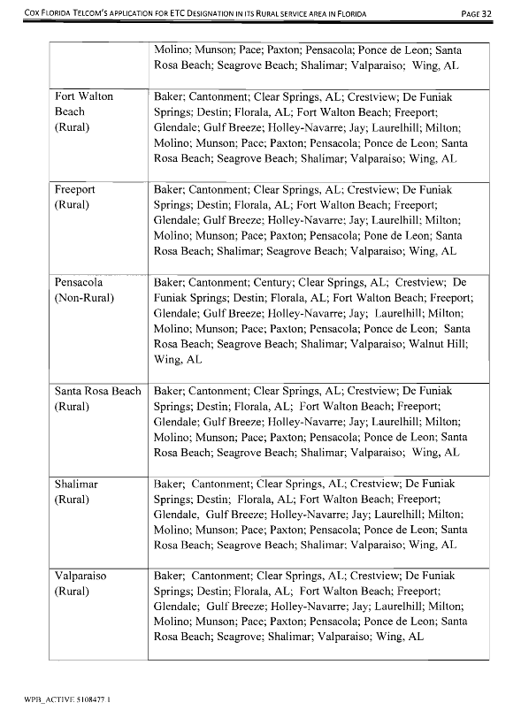

47 U.S.C. § 214(e)(2), 47 C.F.R. § 54.201
47 U.S.C. § 254
47 U.S.C. § 254(e)
47 C.F.R. § 54.201(c)
Cross-referencing 47 C.F.R. § 54.101
Subpart E addresses Universal Service Support for Low-Income Consumers. See 47 C.F.R. §54.400 through §54.422.
47 U.S.C. §214(e)(1)(B)
The five-year plan required in 47 C.F.R. §54.202 (a)(1)(ii) is not required by the FCC for Lifeline-only ETCs.
In the Matter of Federal-State Joint Board on Universal Service, CC Docket No. 96-45, Order FCC 0546 (¶40), Adopted: February 25, 2005 Released March 17, 2005.
See Docket No. 100124-TX, In RE: Petition for designation as eligible telecommunications carrier by Sun-Tel USA, Inc., Order No. PSC-10-0634-PAA-TX, issued October 25, 2010.
Section 364.105, Florida Statutes

