State of Florida   |  | Public Service Commission  Capital Circle Office Center ● 2540 Shumard Oak Boulevard  Tallahassee, Florida 32399-0850  -M-E-M-O-R-A-N-D-U-M-
DATE: | November 13, 2012
TO: | Office of Commission Clerk (Cole)
FROM: | Office of the General Counsel (M. Brown)  Division of Economics (Garl, Draper)  Division of Engineering (Lee, Watts)
RE: | Docket No. 120248-EU – Joint petition for approval of territorial agreement between Tampa Electric Company and Peace River Electric Cooperative, Inc.
AGENDA: | 11/27/12 – Regular Agenda – Proposed Agency Action – Interested Persons May Participate
COMMISSIONERS ASSIGNED: |  |  | All Commissioners
PREHEARING OFFICER: |  |  | Brown
CRITICAL DATES: |  |  | None
SPECIAL INSTRUCTIONS: |  |  | Place this item before Docket No. 120247-EU on the Agenda.
FILE NAME AND LOCATION: |  |  | S:\PSC\GCL\WP\120248.RCM.DOC

Case Background
On May 22, 1987, the Commission approved a 25-year Territorial Agreement (Existing Agreement) between Tampa Electric Company (TECO) and Peace River Electric Cooperative, Inc. (PRECO) The Existing Agreement expired in May of this year and the parties have been operating under the Existing Agreement on a year-to-year basis.
On October 3, 2012, TECO and PRECO jointly filed a petition requesting Commission approval of a new long-term territorial agreement (Agreement) rather than continuing the year-to-year term of the Existing Agreement.
The Commission has jurisdiction over this matter pursuant to Section 366.04, Florida Statutes (F.S.).
Discussion of Issues
Issue 1:1
Should the Commission approve the joint petition for a territorial agreement between Tampa Electric Company and Peace River Electric Cooperative, Inc.?
Recommendation:
Yes. The joint petition of a territorial agreement between Tampa Electric Company and Peace River Electric Cooperative, Inc. is in the public interest and should be approved. (Garl, M. Brown)
Staff Analysis:
On October 3, 2012, TECO and PRECO filed a joint petition for approval of a new territorial agreement to replace the Existing Agreement which expired in May 2012. The new Agreement, as well as associated maps and territory description, are included as Attachment A. The parties have been operating on a year-to-year basis since the Existing Agreement expired; however, for long-term planning purposes, both parties wish to have a new long-term agreement. Accordingly, the parties entered into the Agreement as of September 28, 2012.
Pursuant to Section 366.04(2)(d), F.S., the Commission has jurisdiction to approve territorial agreements between and among rural electric cooperatives, municipal electric utilities, and other electric utilities. Pursuant to Rule 25-6.0440(2), F.A.C., in approving territorial agreements, the Commission may consider the reasonableness of the purchase price of any facilities being transferred, the likelihood that the agreement will not cause a decrease in the reliability of electric service to existing or future ratepayers, and the likelihood that the agreement will eliminate existing or potential uneconomic duplication of facilities. Unless the Commission determines that the agreement will cause a detriment to the public interest, the agreement should be approved. Utilities Commission of the City of New Smyrna v. Florida Public Service Commission, 469 So. 2d 731 (Fla. 1985).
The Agreement is essentially a slightly modified version of the Existing Agreement. The maps the parties provided with their joint petition are the same as the maps incorporated in the Existing Agreement and reflect the same boundaries. With minor clarifications and adjustments, the terms and conditions of the Agreement are the same as the Existing Agreement it will supersede. There are no new customer transfers affected by the Agreement, so there was no need to contact any customers to explain differences in rates. Likewise, there are no existing facilities being transferred and there is no reasonable likelihood that the Agreement, in and of itself, will cause a decrease in the reliability of electric service to existing or future customers of either party. The parties state that the Agreement will avoid confusion and potential uneconomic duplication of facilities and that the Agreement is in the public interest.
The Agreement includes a provision that allows for certain variances to the Agreement, subject to Commission approval, such as the one addressed in Docket 120247-EU involving the provision of transmission level service to phosphate load. The Agreement also preserves TECO’s right to continue serving transmission level phosphate load in the area of Polk and Hillsborough Counties.
The Agreement will remain in effect for a period of 25 years from the date of Commission approval.
Based on the above, staff recommends that the new territorial agreement between TECO and PRECO is in the public interest and should be approved.
Issue 2:2
Should this docket be closed?
Recommendation:
Yes. If no person whose substantial interests are affected files a protest to the Commission’s proposed agency action order within 21 days, the docket may be closed upon issuance of a consummating order. (M. Brown)
Staff Analysis:
If no person whose substantial interests are affected files a protest to the Commission’s proposed agency action order within 21 days, the docket may be closed upon issuance of a consummating order.
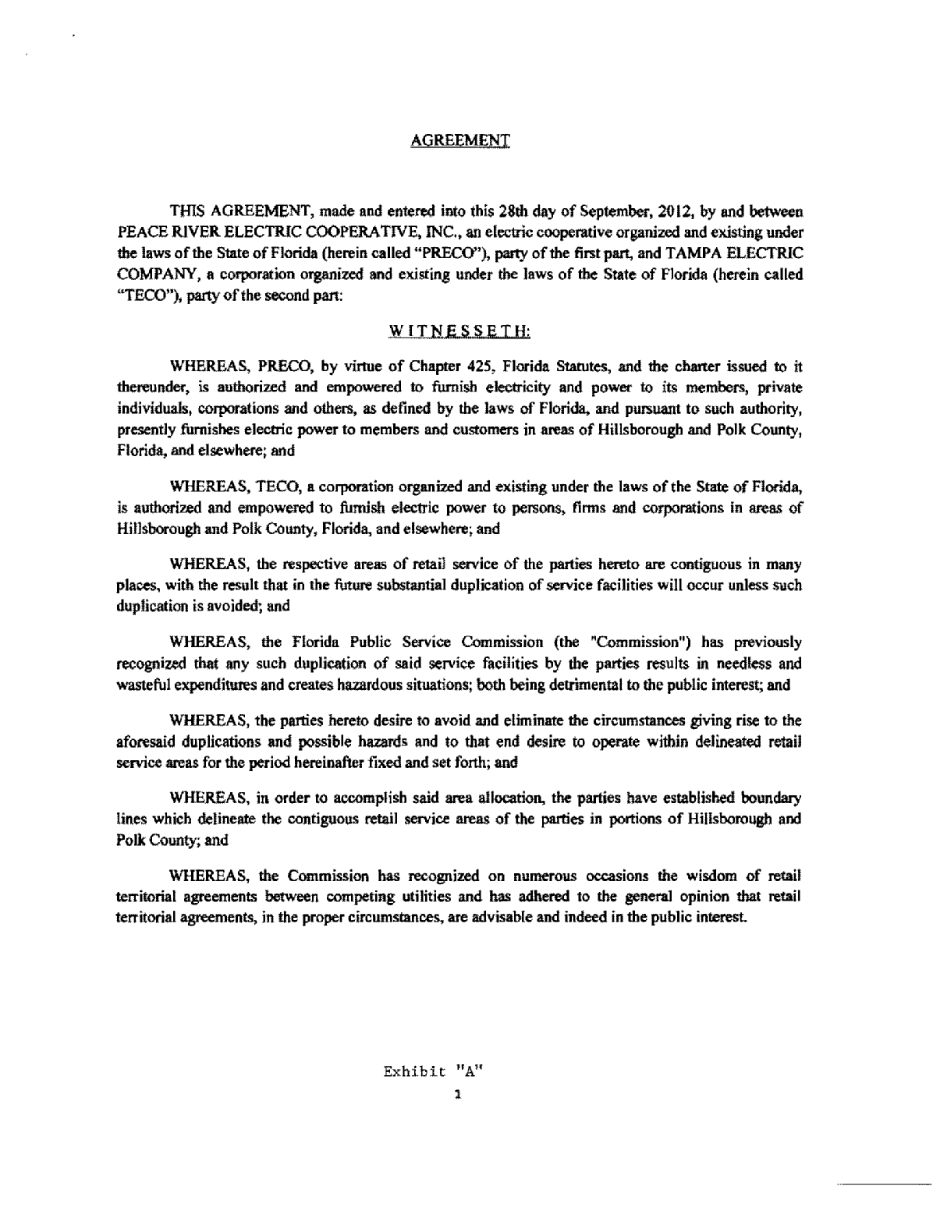

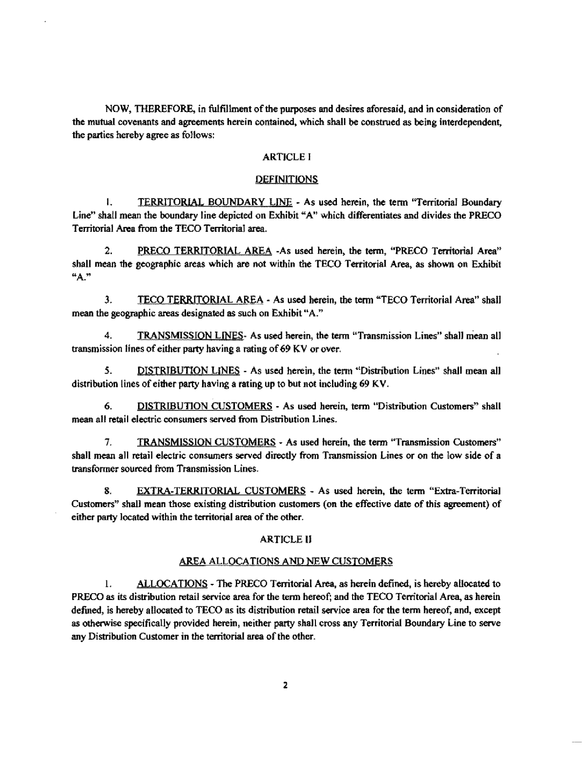
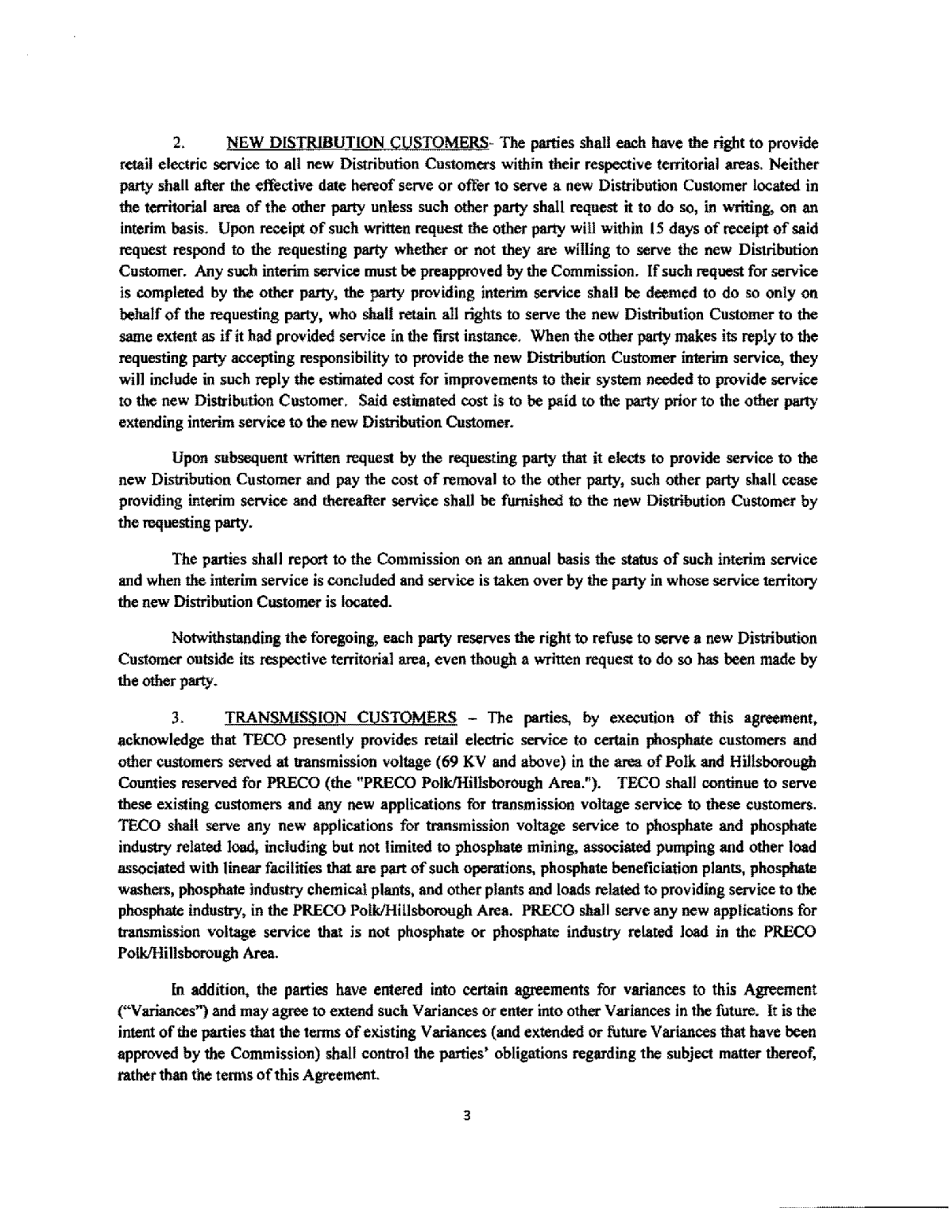

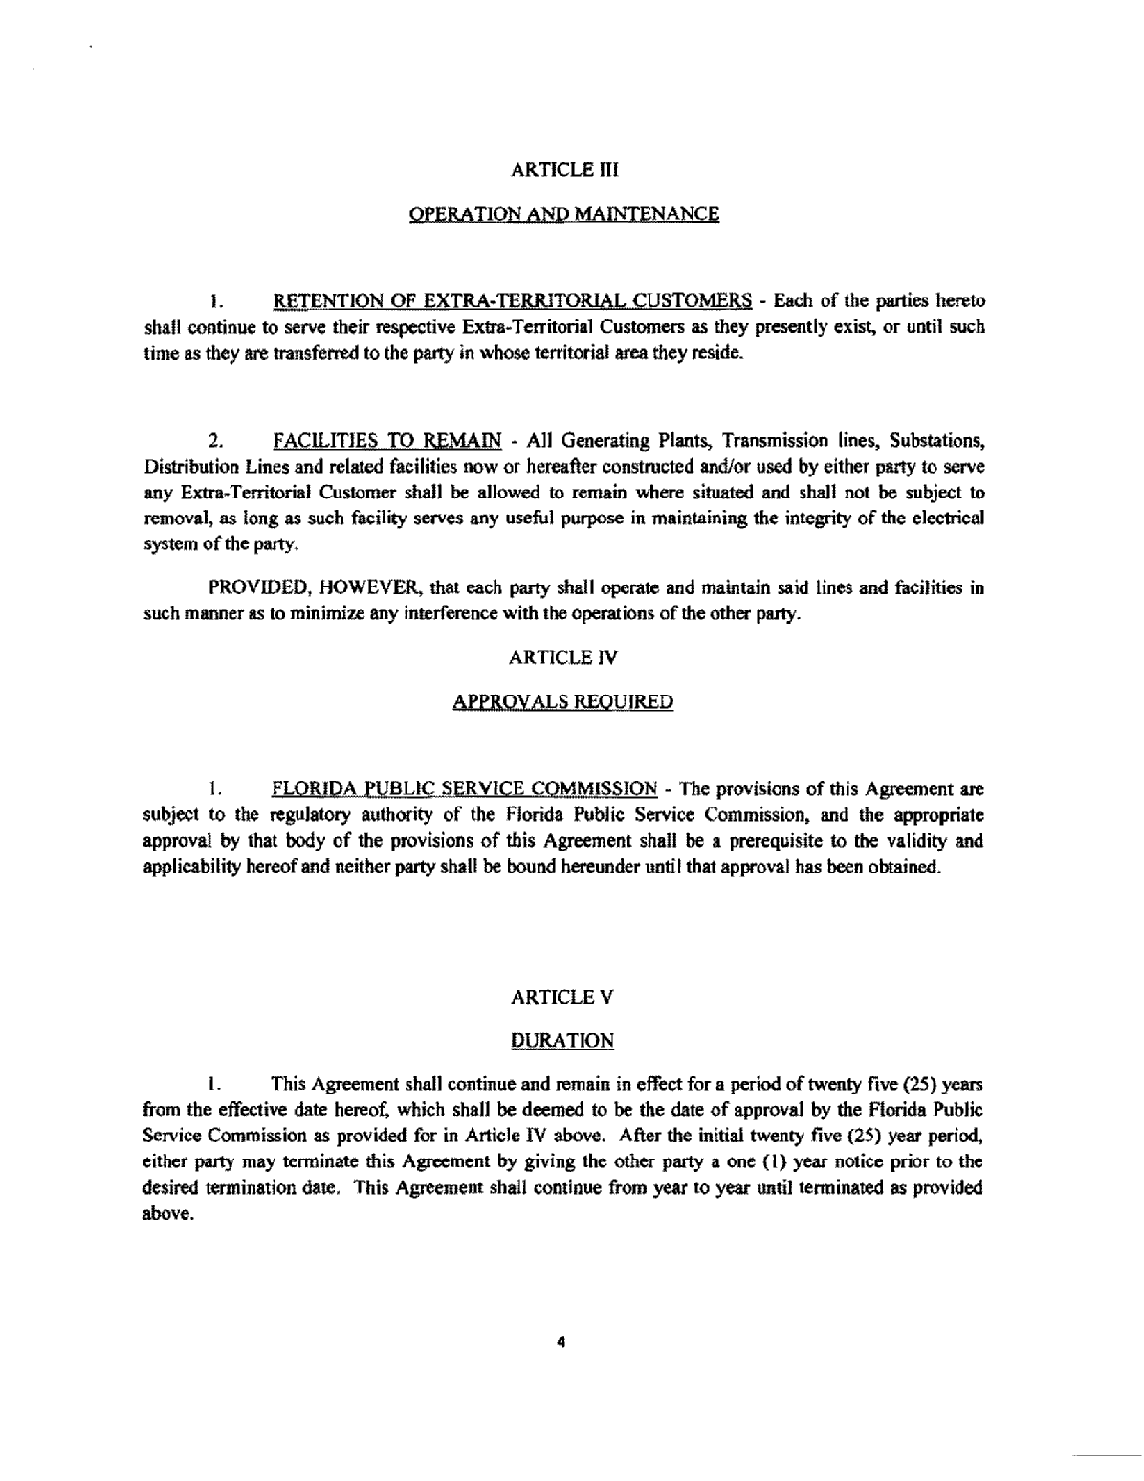
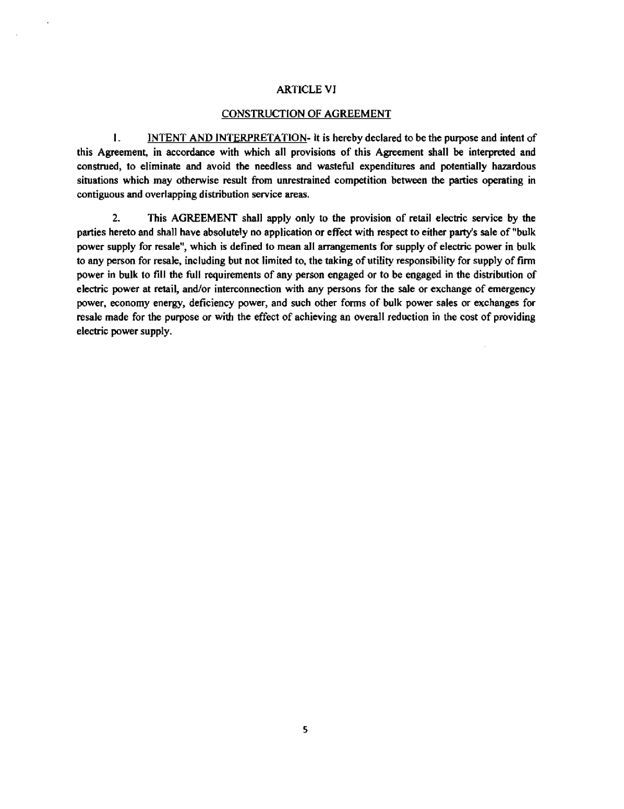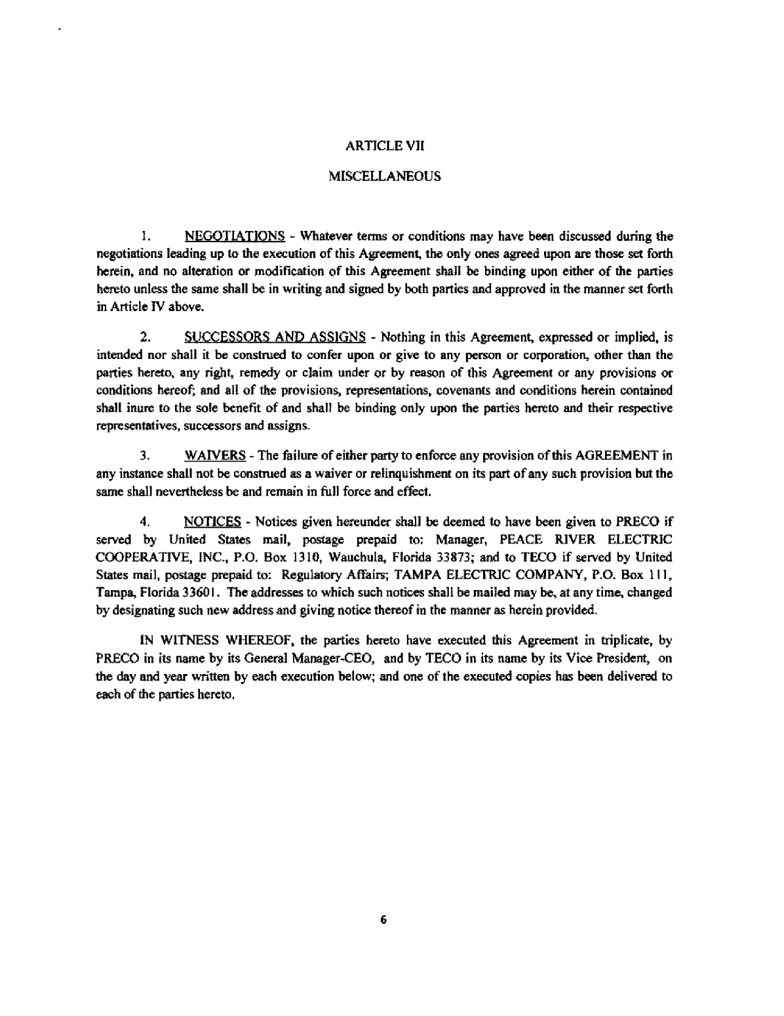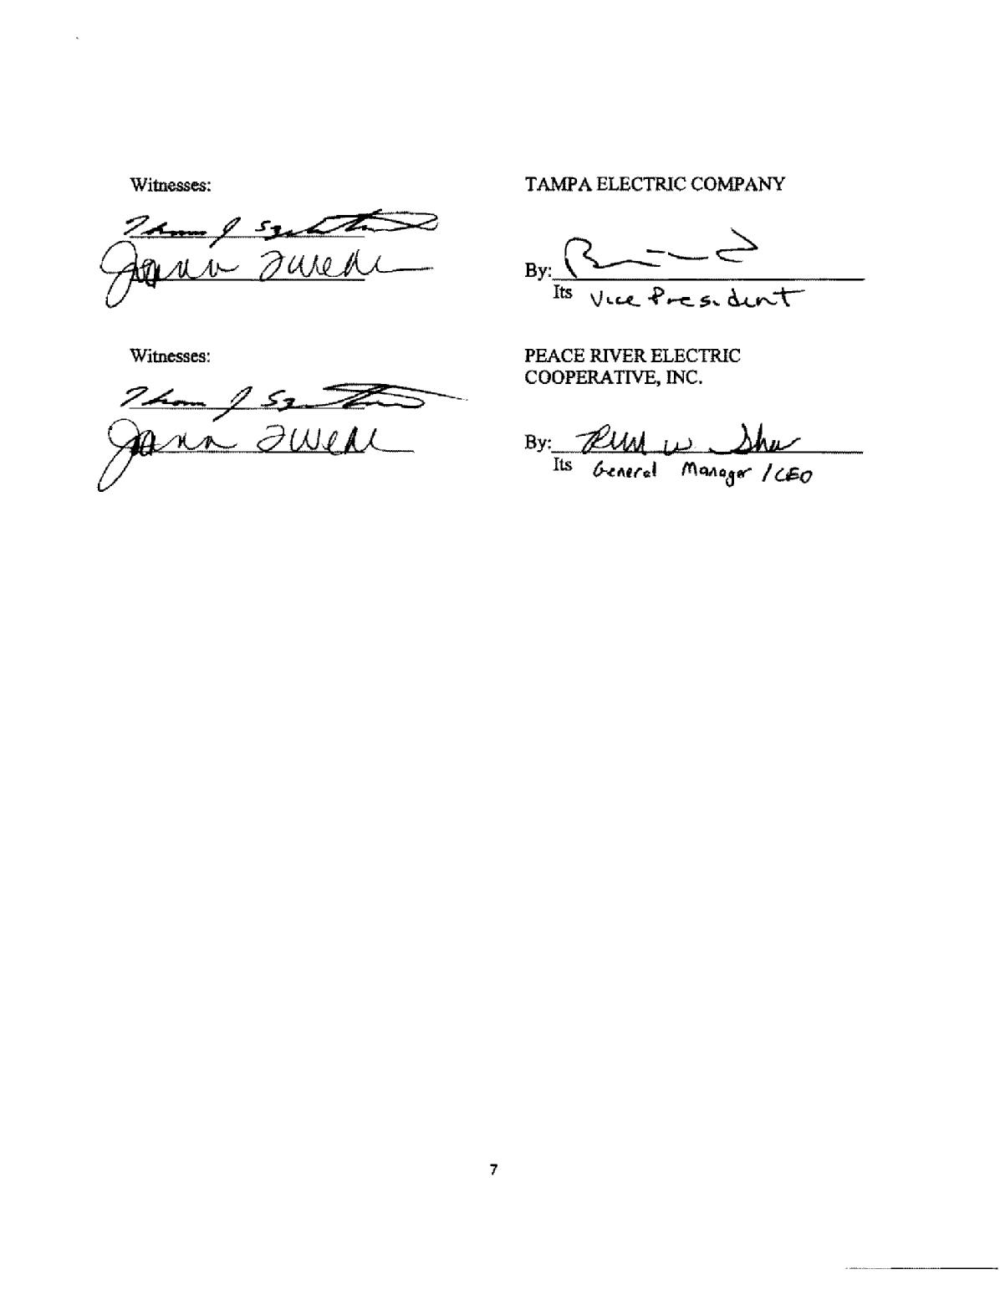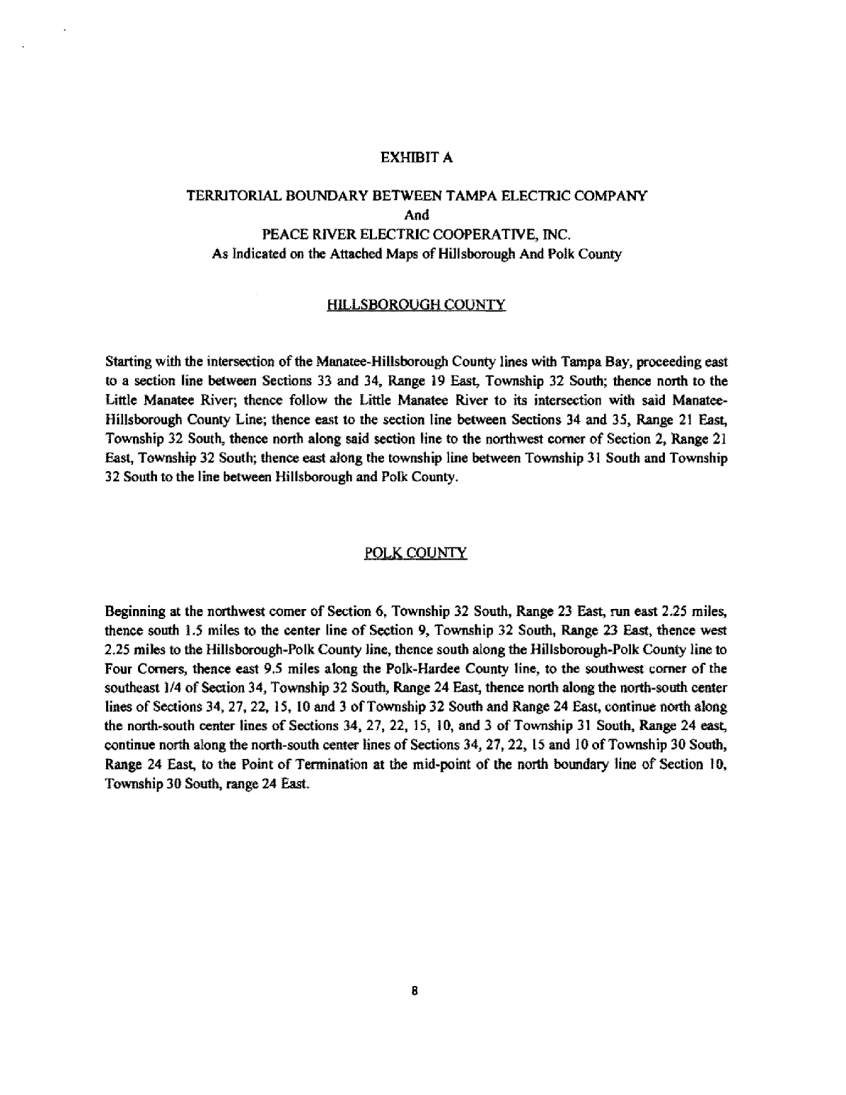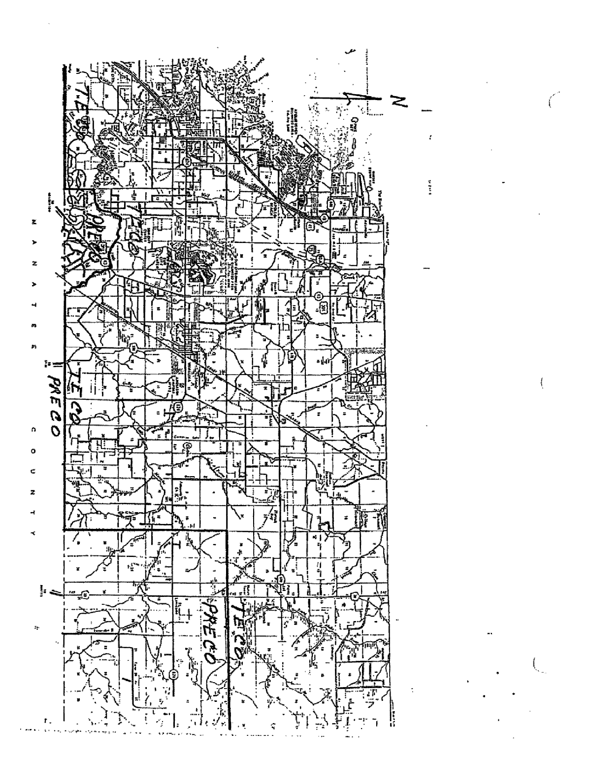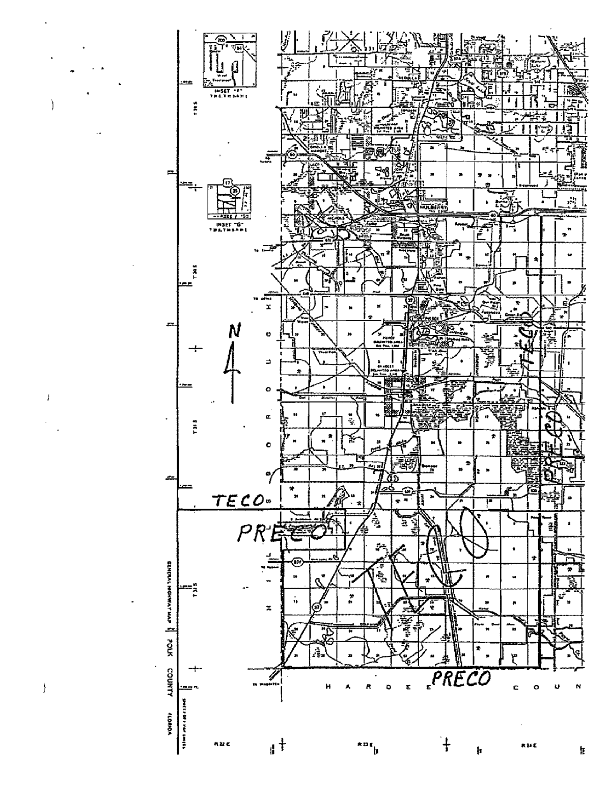

See Order No. 17585, issued May 22, 1987, in Docket No. 870303-EU, In re: Joint Petition of Tampa Electric Company and Peace River Electric Cooperative, Inc. for Approval of a Territorial Agreement.

