BEFORE THE FLORIDA PUBLIC SERVICE COMMISSION

In re: Request for approval of amendment to connection/transfer sheets, increase in returned check charge, amendment to miscellaneous service charges, increase in meter installation charges, and imposition of new tap-in fee, in Marion County, by East Marion Sanitary Systems Inc. | DOCKET NO. 080562-WU  ORDER NO. PSC-12-0635-FOF-WU  ISSUED: November 30, 2012

The following Commissioners participated in the disposition of this matter:

RONALD A. BRISÉ, Chairman
LISA POLAK EDGAR
ART GRAHAM
EDUARDO E. BALBIS
JULIE I. BROWN

FINAL ORDER

BY THE COMMISSION:

East Marion Sanitary Systems Inc. (East Marion or Utility) is a Class C utility providing water and wastewater service to approximately 96 customers in Marion County. Water and wastewater rates were last established for this Utility in a staff-assisted rate case in 2002. On August 19, 2008, the Utility filed an application for approval to amend its tariff sheets to reflect the following: an amendment to its tariff to require each customer to provide his social security number to obtain service, an increase in returned check charge, an amendment to miscellaneous service charges, an increase in meter installation charges, and the imposition of a new tap-in fee. By Order No. PSC-09-0263-TRF-WU, issued April 27, 2009, we denied in part and granted in part the Utility’s application. Specifically, we ordered that any customer who has requested an irrigation meter from East Marion prior to April 7, 2009, shall only be charged the rates in effect at the time of the customer’s application.
The Utility timely protested the portion of our order addressing previous applications for irrigation meters. East Marion protested our requirement that the Utility install irrigation meters at its prior tariffed rate for certain customers. Seven customers and the Office of Public Counsel (OPC) were granted intervention in the docket. On September 29, 2011, East Marion, a majority of the intervenors, and OPC on behalf of all ratepayers entered into a Settlement Agreement. Intervenors Terry Will and Millicent Mallon did not enter into the Settlement Agreement. We approved the Settlement Agreement by Order No. PSC-11-0566-AS-WU, issued December 12, 2011. Intervenors Will and Mallon and the Utility requested that their dispute continue to hearing.
We transferred the dispute to the Division of Administrative Hearings (DOAH). The case was assigned DOAH Docket No. 12-0909, East Marion Sanitary Services, Inc. v. Public Service Commission, and the Administrative Law Judge set the matter for a June 12, 2012 hearing in Ocala, Florida. Intervenors Will and Mallon attended the hearing and presented evidence and testimony, as did our staff on behalf of the Commission. East Marion did not attend the hearing in person, by attorney, or by qualified representative. The Utility did send a messenger, Mike Smallridge, to convey a message to the Administrative Law Judge that the Utility would install meters for Intervenors Will and Mallon, but the message did not include the cost at which the Utility would install the meters. Accordingly, the hearing was held and the Administrative Law Judge submitted the attached Recommended Final Order (see Attachment A).
On October 2, 2012, Marty Smith, attorney for East Marion, filed a Notice of Appearance and Petitioner’s Exceptions to Recommended Order in this docket. No other party filed exceptions.
We have jurisdiction pursuant to Sections 120.57 and 367.091, Florida Statutes (F.S.). Pursuant to Section 120.57(1)(k), F.S., after the hearing the Administrative Law Judge must file a Recommended Final Order with us for our consideration in issuing our Final Order. The Administrative Law Judge issued his Recommended Final Order in Division of Administrative Hearings Case No. 12-0909, East Marion Sanitary Systems, Inc. v. Public Service Commission on September 17, 2012. The Administrative Law Judge recommends that we enter a Final Order dismissing Petitioner’s protest and ordering the Utility to install irrigation meters with a dedicated line for Intervenors Will and Mallon at the prior tariffed rate of $70.
When considering a Recommended Final Order, and exceptions thereto, we are governed by Section 120.57(1)(l), F.S. We may adopt the recommended order as our final order, Section 120.57(1)(l), F.S. Alternately, we may modify or reject an Administrative Law Judge’s Recommended Final Order. Modification or rejection of a Recommended Final Order is limited as specifically set forth in Section 120.57(1)(l), F.S., and as discussed more thoroughly below.
As stated above, East Marion filed exceptions to the Recommended Final Order. East Marion alleges that it chose not to defend the proceeding against it because it believed that the maximum exposure it faced was connection of irrigation meters in the same manner as it agreed to in the Settlement Agreement. East Marion points to one paragraph in the Order approving the Settlement Agreement that the Utility asserts it relied upon to limit its exposure. Additionally, the Utility asserts that the Notice of Hearing entered by the Administrative Law Judge specifically identified the issue for hearing as follows: “Are Intervenors Mallon and Will entitled to an irrigation meter at the prior tariffed rate?” East Marion contends that a detailed review of the documents and pleadings, from the inception of the case until the Recommended Order, showed no mention of a dedicated irrigation line. East Marion contends that because we did not identify a dedicated irrigation line as an issue in the proceeding, the issue was not properly before the Hearing Officer.
East Marion contends that the record before the Hearing Officer reflects that a dedicated line is a more expensive installation. East Marion states that if this had been a specified issue for determination, the Utility would have taken a different approach and defended the case. The Utility concludes that it relied upon our Order, and the Notice of Hearing in deciding to minimally defend Intervenor Will and Mallon’s claim.
East Marion asks that Paragraphs 26 and 37 be stricken in their entirety. East Marion asks that Paragraph 36, to the extent it references a configuration other than the one imposed by the Settlement Agreement, be removed from the Final Order. East Marion recommends that the portion of Paragraph 39 regarding a dedicated line be stricken. East Marion asks that Paragraph 40 and the Hearing Officer’s concluding recommendation be modified by removing reference to a dedicated line. Instead, according to East Marion, Intervenors Will and Mallon should be entitled to an irrigation line in accordance with the Settlement Agreement signed by the other intervenors.
We adopt the Administrative Law Judge’s findings of fact. According to the Florida Administrative Procedures Act, we may not reject or modify the recommended findings of fact unless we first determine from a review of the entire record, that the findings of fact were not based upon competent substantial evidence or that the proceedings on which the findings were based did not comply with essential requirements of law. Section 120.57(1)(l), F.S.
East Marion’s argument is that the notice was ineffective and therefore the order, to the extent it calls for a separate dedicated irrigation line, does not comply with the requirements of law. However, the record reflects that East Marion was on notice that a separate dedicated irrigation line was a subject of the proceeding. East Marion had actual notice that a separate dedicated irrigation line might be required of the Utility. The Order approving the Settlement Agreement, Order No. PSC-11-0566-AS-WU on page 5, paragraph 3, references the installation of an irrigation meter with a dedicated line when it states:
The remaining non-signatory parties are advised that the maximum relief we will be able to grant either intervenor was that set forth in the original order, an irrigation meter at the cost of $70. … If either party fails to convince us that they properly requested the meter, then they would be obligated to pay for the meter at the new meter installation fee of $195 and the applicable tap-in fees of $1,400, $1,800, and $2,600 for the short, long, and extra-long irrigation service line installation, respectively.
(Emphasis added). East Marion stated in its petition protesting Order No. PSC-11-0566-AS-WU that it was protesting the Order’s page 5, paragraph 5. This paragraph in the Order states:
Furthermore, the Utility is advised that it must bear the burden of proving that Ms. Mallon and Mr. Will did not request a meter. If the Utility is unsuccessful, it will be required to connect the two customers at the $70.00 fee and any additional costs it incurs will likely not be considered a prudent expenditure.
(Emphasis added.)
Additionally, in East Marion’s original Petition protesting Order No. PSC-09-0263-TRF-WU, East Marion specifically stated that its interests would be substantially affected by requiring the installation of irrigation meters because the meter installation required additional piping, valves and meter boxes and would cost $1400 or more. Thus, East Marion was fully aware that the issue in this Docket for Will and Mallon specifically involved the installation of irrigation meters with a dedicated line for Will and Mallon and was the reason Will and Mallon did not settle for the meter without a dedicated line. East Marion cannot now say it did not know this was the subject of the action.
Both East Marion and Intervenor Will protested the Order approving the Settlement Agreement as it related to Intervenors Will and Mallon’s interests. Intervenor Will’s protest included all of pages 3, 5, and 6 of the Order Approving the Settlement Agreement. Thus the paragraph that East Marion states it relied upon to decide not to participate in the hearing was protested. From the date that East Marion protested the Order Approving the Settlement Agreement forward, it did nothing to inquire as to the nature of Intervenor Will’s protest of the Order. Moreover, based upon evidence produced at the hearing, East Marion had previously stated to us that there was no way an irrigation meter could be installed on existing lines. See, Recommended Order Paragraph 9. Accordingly, East Marion had actual notice that the installation of an irrigation meter inclusive of a separate dedicated line would be the subject of the hearing on the protest of our order approving the Settlement Agreement.
Having reviewed the Recommended Final Order, the findings of fact are consistent with the evidence presented by both our staff, and Intervenors Will and Mallon. As referenced previously, the Utility did not participate in or submit any evidence at the hearing. Further, we find that the proceedings before the Administrative Law Judge comported with essential requirements of law. All parties were afforded notice and an opportunity to be heard before the Administrative Law Judge. Intervenors Will and Mallon took advantage of the opportunity. The Utility did not. Accordingly, we adopt the findings of fact without modification. We reject each of East Marion’s exceptions regarding the findings of fact, as follows:
Paragraph 26, the issue of whether an irrigation meter could be installed without a separate irrigation line was disputed by Intervenors Will and Mallon and was properly before the Prehearing Officer.
According to statutes, we may reject or modify the conclusions of law or the interpretation of administrative rules over which we have substantive jurisdiction. When doing so, we must state with particularity our reasons for modifying or rejecting the conclusion or interpretation. In addition, we must make a finding that our substituted conclusions of law or interpretations of rule are as, or more reasonable than, that of the Administrative Law Judge. Section 120.57(1)(l), F.S. We have reviewed the conclusions of law and believe that those conclusions are consistent with our prior interpretations and decisions. Accordingly, we adopt the Administrative Law Judge’s conclusions of law without modification. We reject East Marion’s exceptions as follows:
Paragraph 36. Will protested our order, including the configuration of the irrigation meters. Accordingly, the issue of the configuration of installation of the irrigation meter was properly before the Hearing Officer.
Paragraph 37. Will protested our order including the manner of the installation of the irrigation meter. Therefore the conclusion regarding a dedicated line is relevant as it was properly before the Hearing Officer. The protest of the settlement agreement included a protest of the irrigation meter configuration.
Paragraph 39. No portion of this recommended conclusion should be stricken. The configuration of the irrigation meter was protested and properly before us.
Paragraph 40 and the Administrative Law Judge’s concluding recommendation should not be modified as it relates to a dedicated line. As set forth above, the protest of our order approving the settlement agreement placed the configuration of the line squarely before the Hearing Officer. The Utility’s prior position before us in Docket No. 080064-WU was that a dedicated line was necessary for the installation of an irrigation meter. Therefore, the utility had actual notice that the Hearing Officer may rule in favor of Will and Mallon and require that an irrigation meter with a separate dedicated line be installed.
Based on the foregoing, we adopt the Recommended Final Order of the Administrative Law Judge, found in Attachment A, as our Final Order regarding the petition.
East Marion shall install irrigation meters with a dedicated line for Intervenors Will and Mallon at the prior tariff rate of $70. East Marion shall install the dedicated line and irrigation meters within 60 days of the issuance of this order. East Marion shall file confirmation that the irrigation meters and lines were installed for Intervenors Will and Mallon upon completion of the work.
Based on the foregoing, it is

ORDERED by the Florida Public Service Commission that the Recommended Final Order found in Attachment A of this Order is adopted as the Florida Public Service Commission’s Final Order. It is further

ORDERED that East Marion Sanitary Services, Inc. shall install a dedicated line and irrigation meter for Intervenors Will and Mallon at the prior tariff rate of $70 within 60 days of the issuance of this order. It is further

ORDERED that East Marion Sanitary Services, Inc. shall file confirmation with the Commission that the irrigation meters and lines were installed for Intervenors Will and Mallon upon completion of the work. It is further

ORDERED that upon issuance of this Order, the Utility’s protest shall be dismissed and this docket closed.
By ORDER of the Florida Public Service Commission this 30th day of November, 2012.

/s/ Ann Cole
ANN COLE
Commission Clerk
Florida Public Service Commission
2540 Shumard Oak Boulevard
Tallahassee, Florida 32399
(850) 413-6770
www.floridapsc.com

Copies furnished: A copy of this document is provided to the parties of record at the time of issuance and, if applicable, interested persons.

LCB

NOTICE OF FURTHER PROCEEDINGS OR JUDICIAL REVIEW

The Florida Public Service Commission is required by Section 120.569(1), Florida Statutes, to notify parties of any administrative hearing or judicial review of Commission orders that is available under Sections 120.57 or 120.68, Florida Statutes, as well as the procedures and time limits that apply. This notice should not be construed to mean all requests for an administrative hearing or judicial review will be granted or result in the relief sought.

Any party adversely affected by the Commission's final action in this matter may request: 1) reconsideration of the decision by filing a motion for reconsideration with the Office of Commission Clerk, 2540 Shumard Oak Boulevard, Tallahassee, Florida 32399-0850, within fifteen (15) days of the issuance of this order in the form prescribed by Rule 25-22.060, Florida Administrative Code; or 2) judicial review by the Florida Supreme Court in the case of an electric, gas or telephone utility or the First District Court of Appeal in the case of a water and/or wastewater utility by filing a notice of appeal with the Office of Commission Clerk, and filing a copy of the notice of appeal and the filing fee with the appropriate court. This filing must be completed within thirty (30) days after the issuance of this order, pursuant to Rule 9.110, Florida Rules of Appellate Procedure. The notice of appeal must be in the form specified in Rule 9.900(a), Florida Rules of Appellate Procedure.

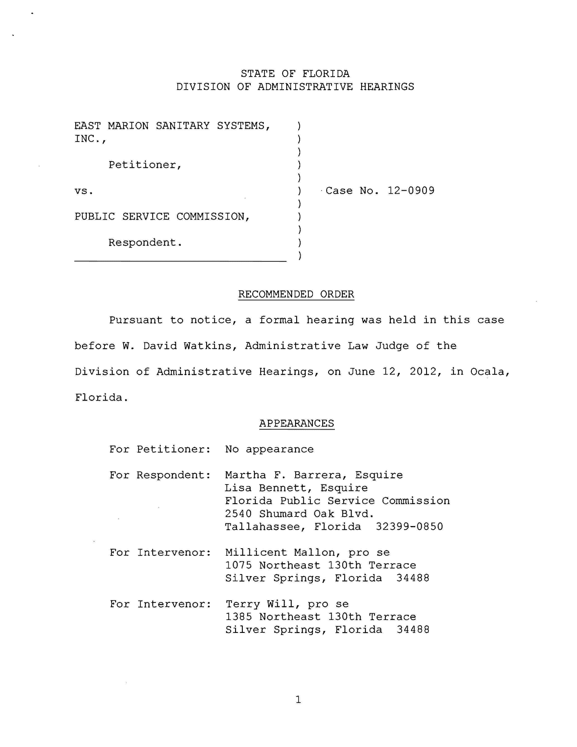
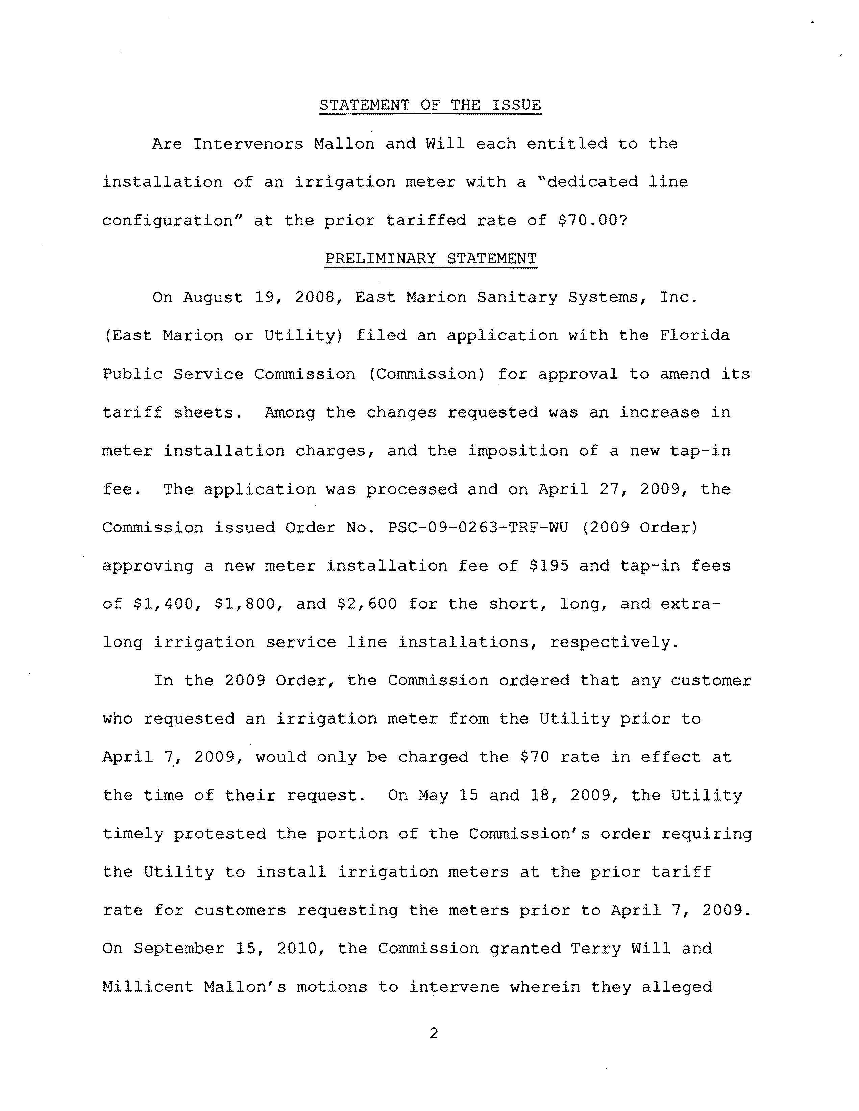
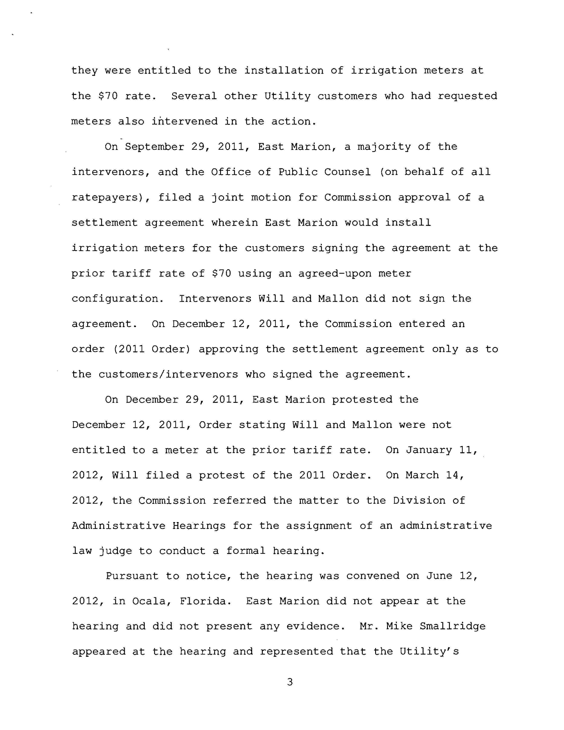
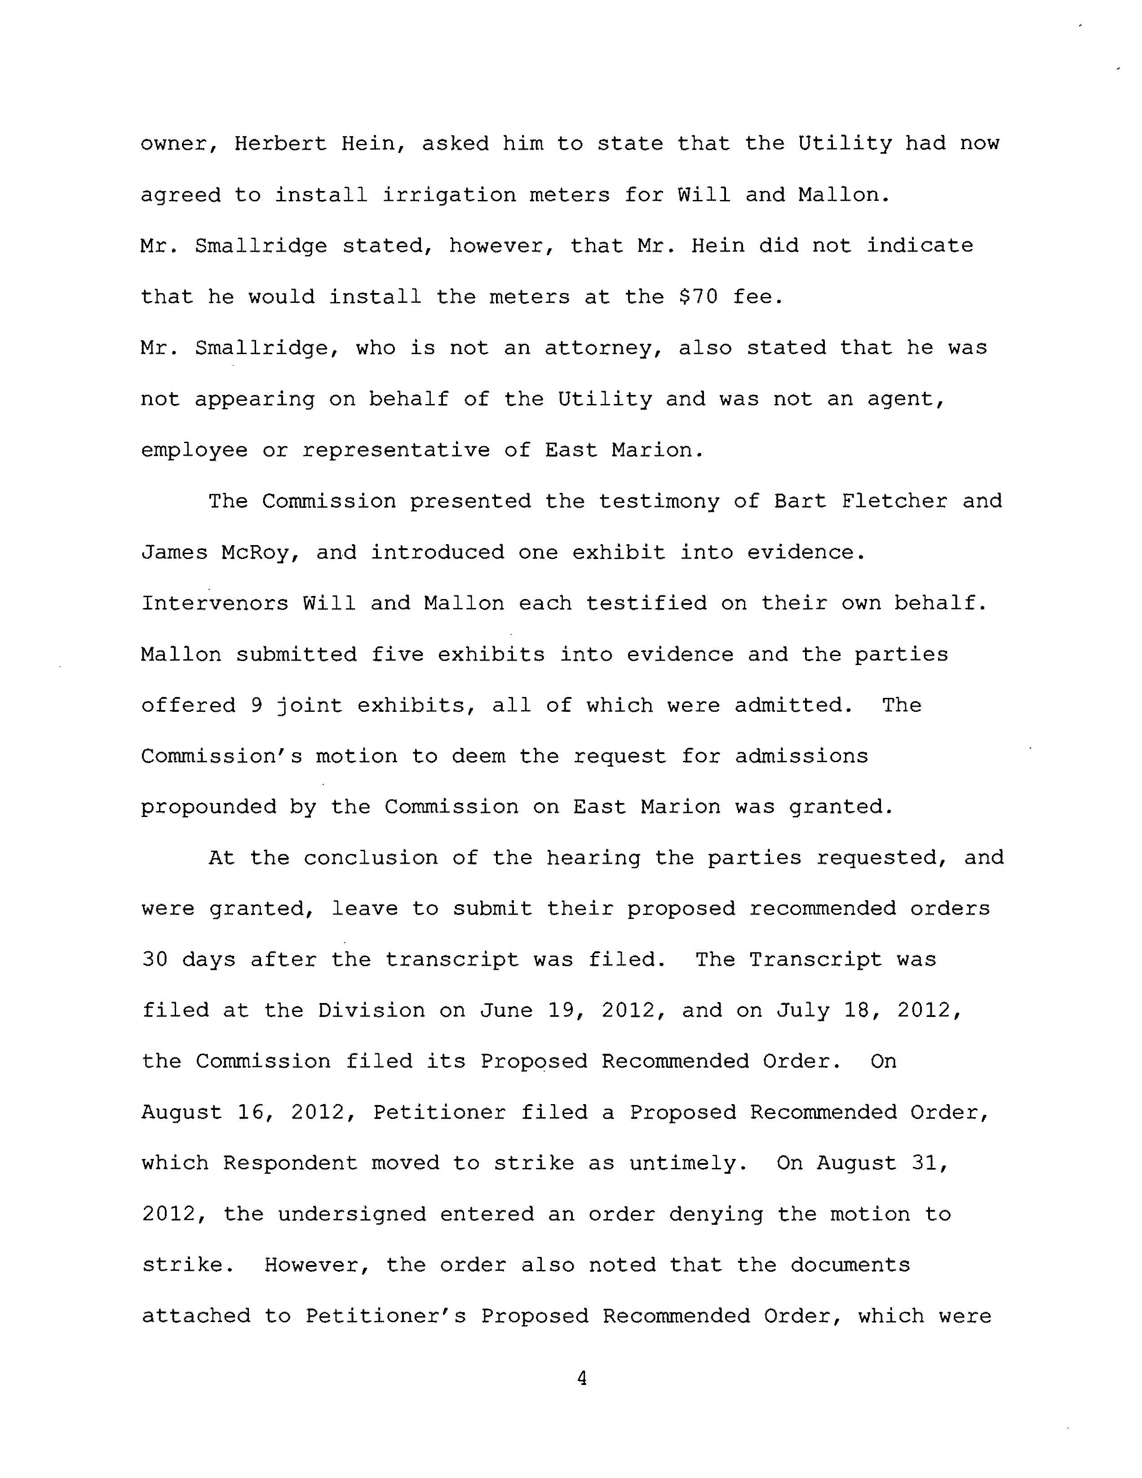
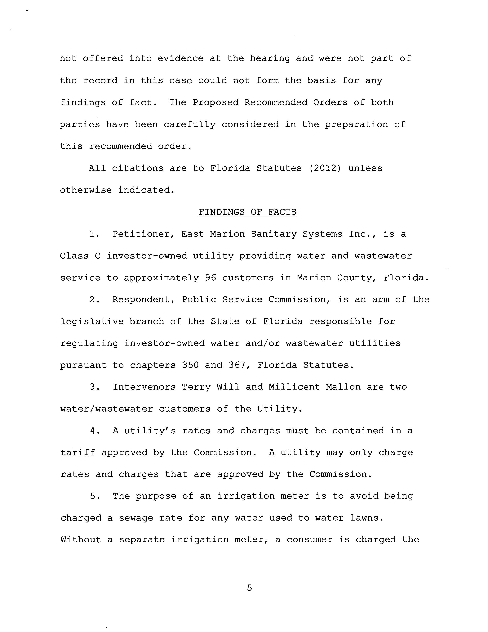
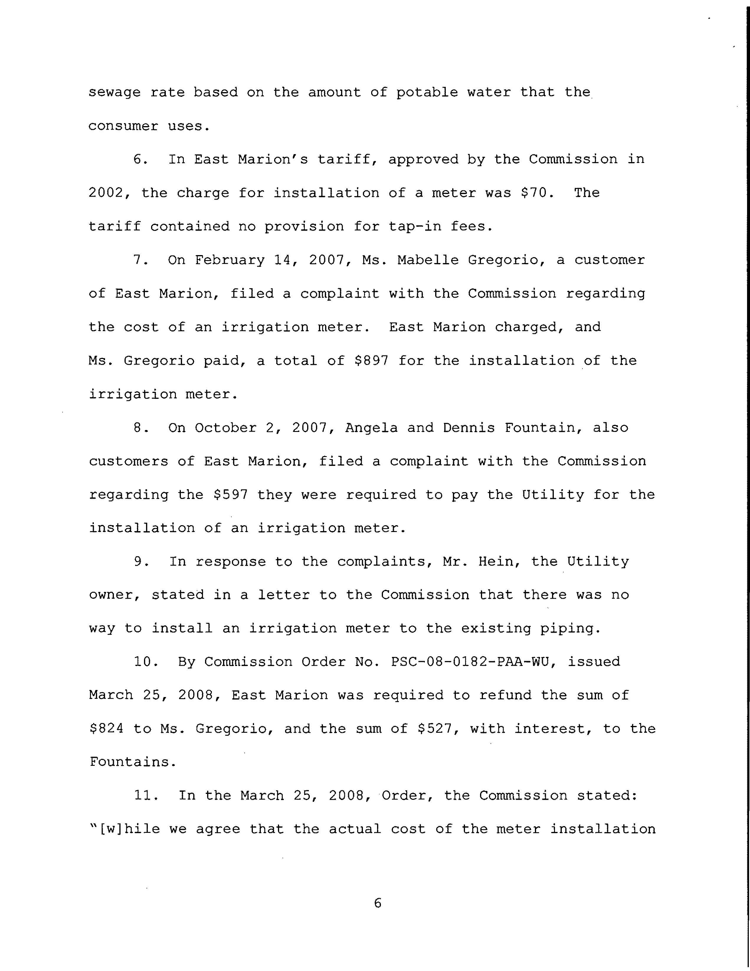
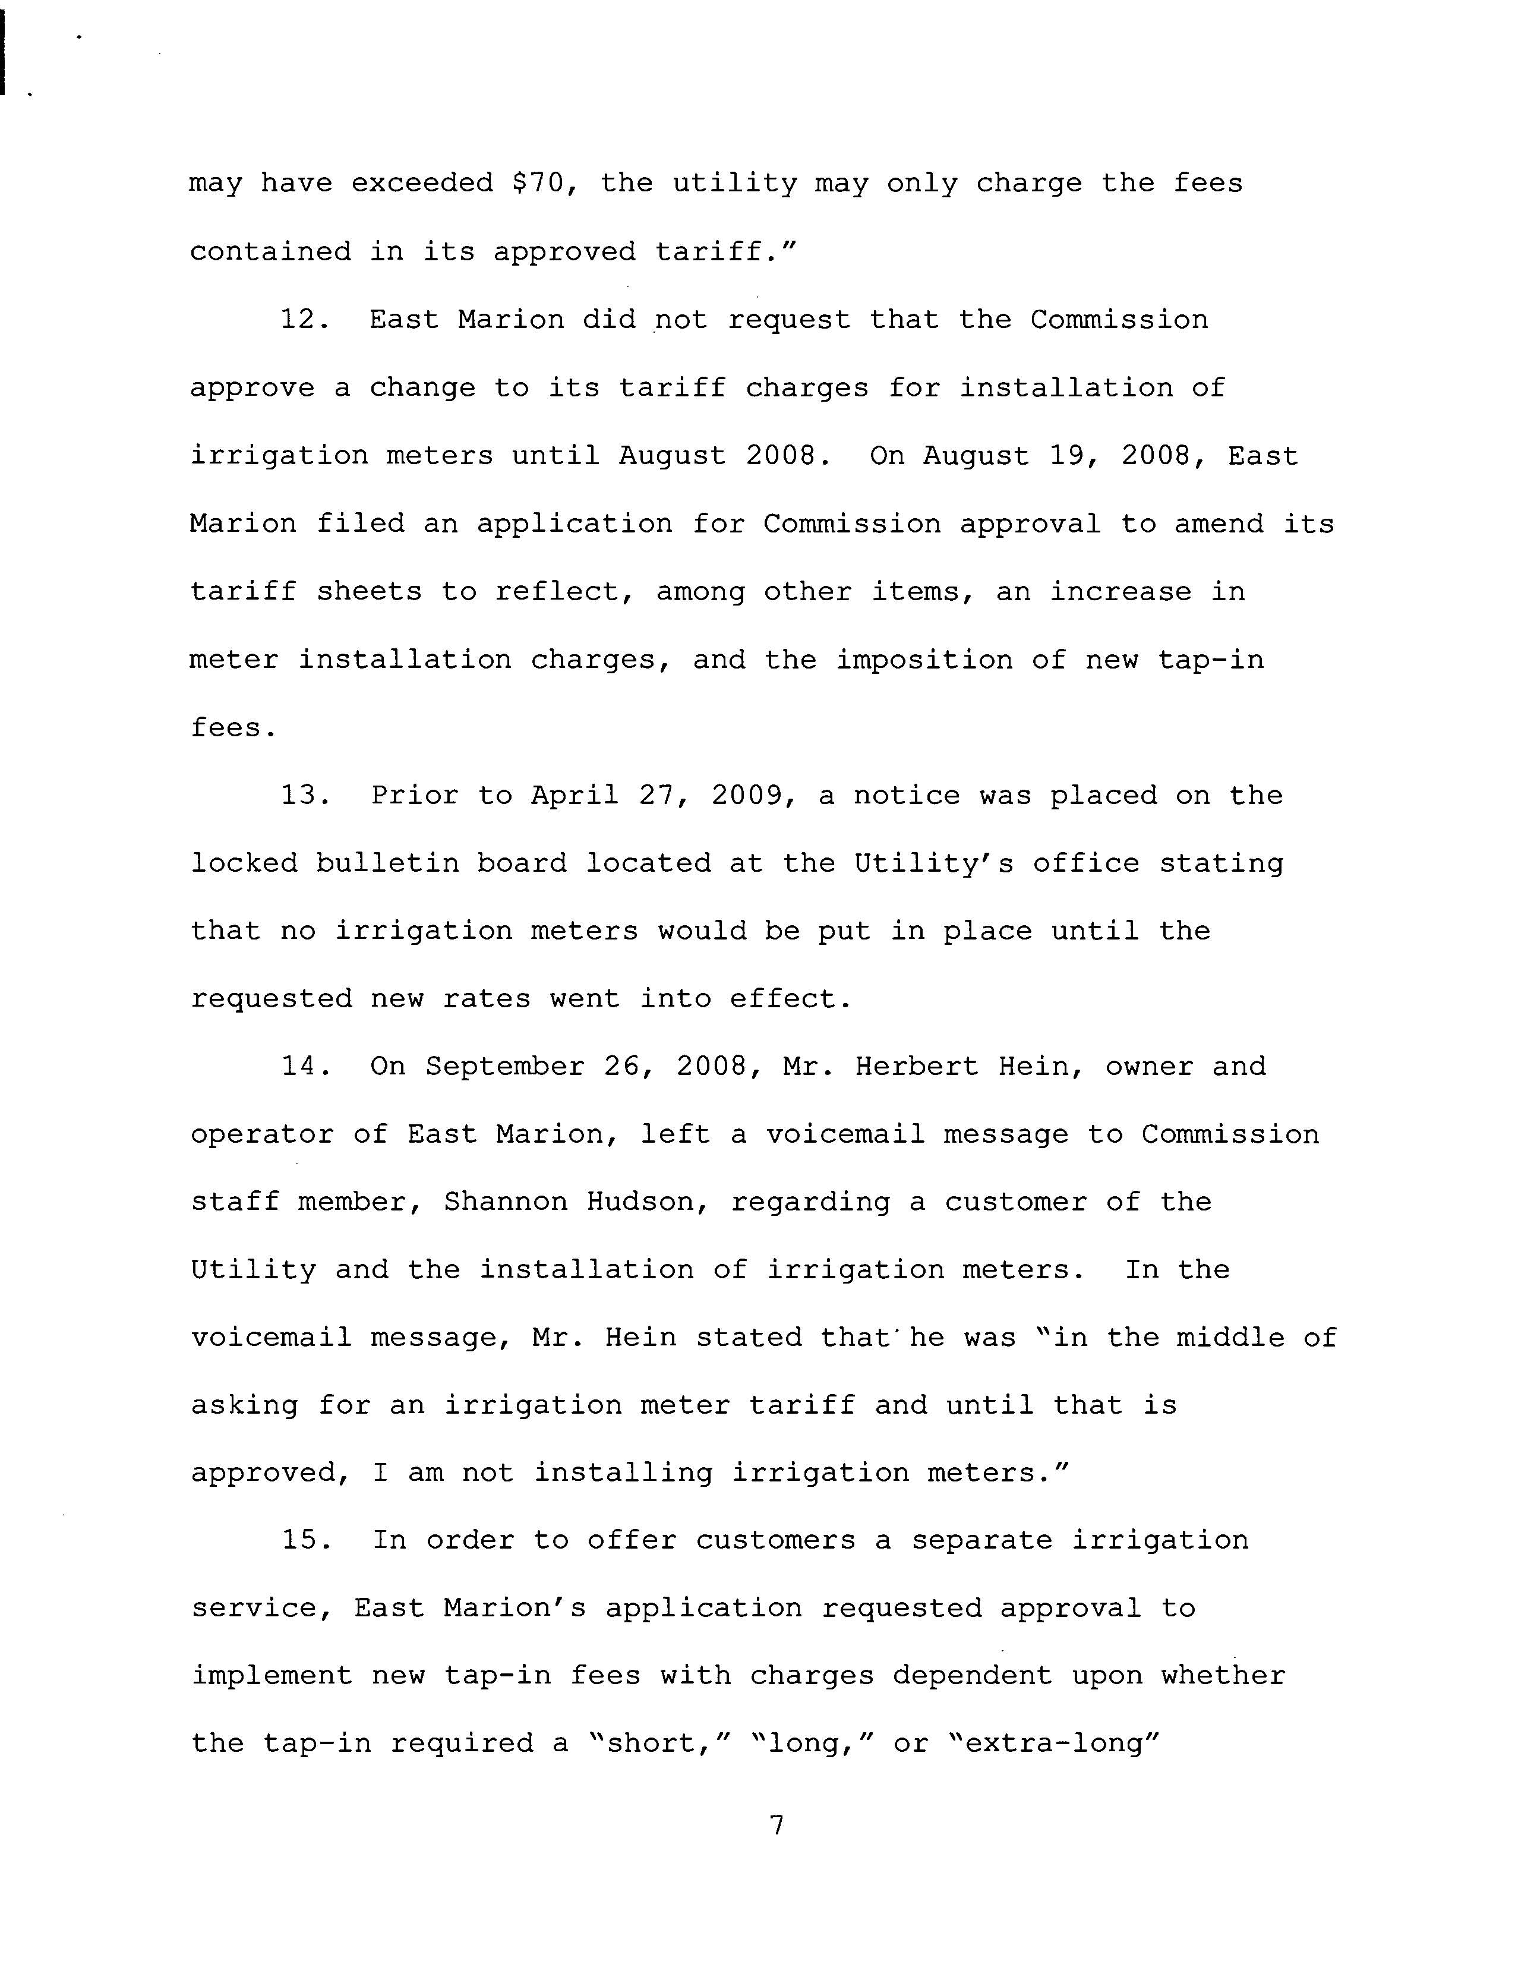
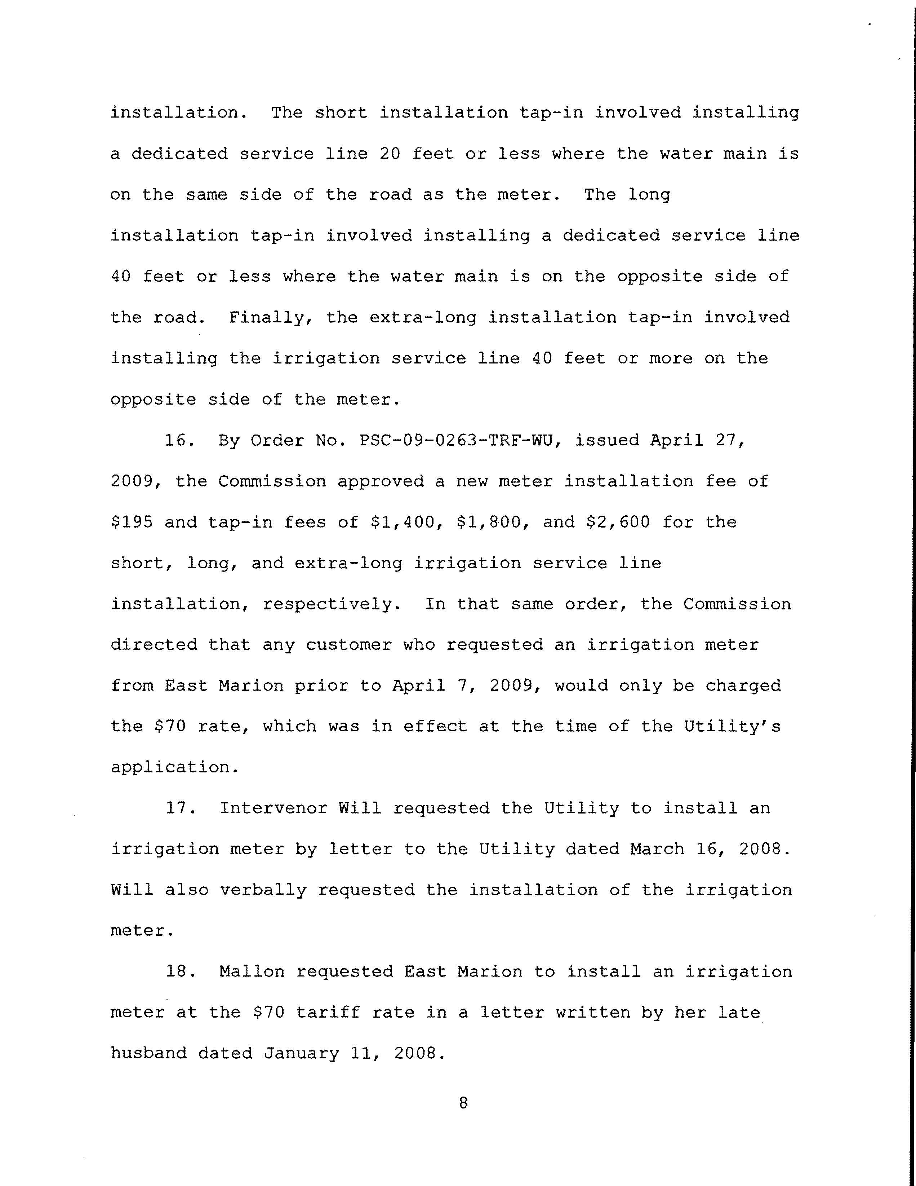
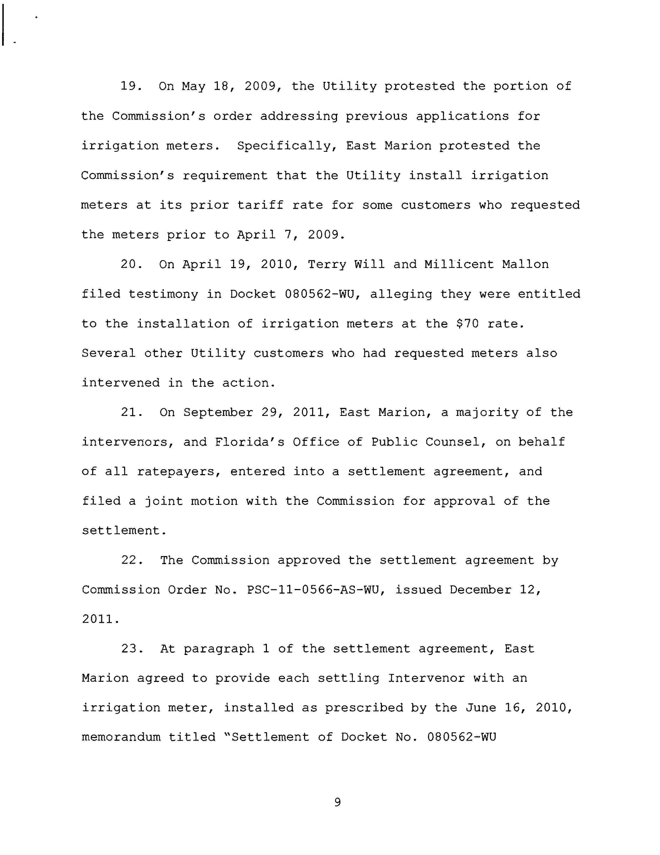
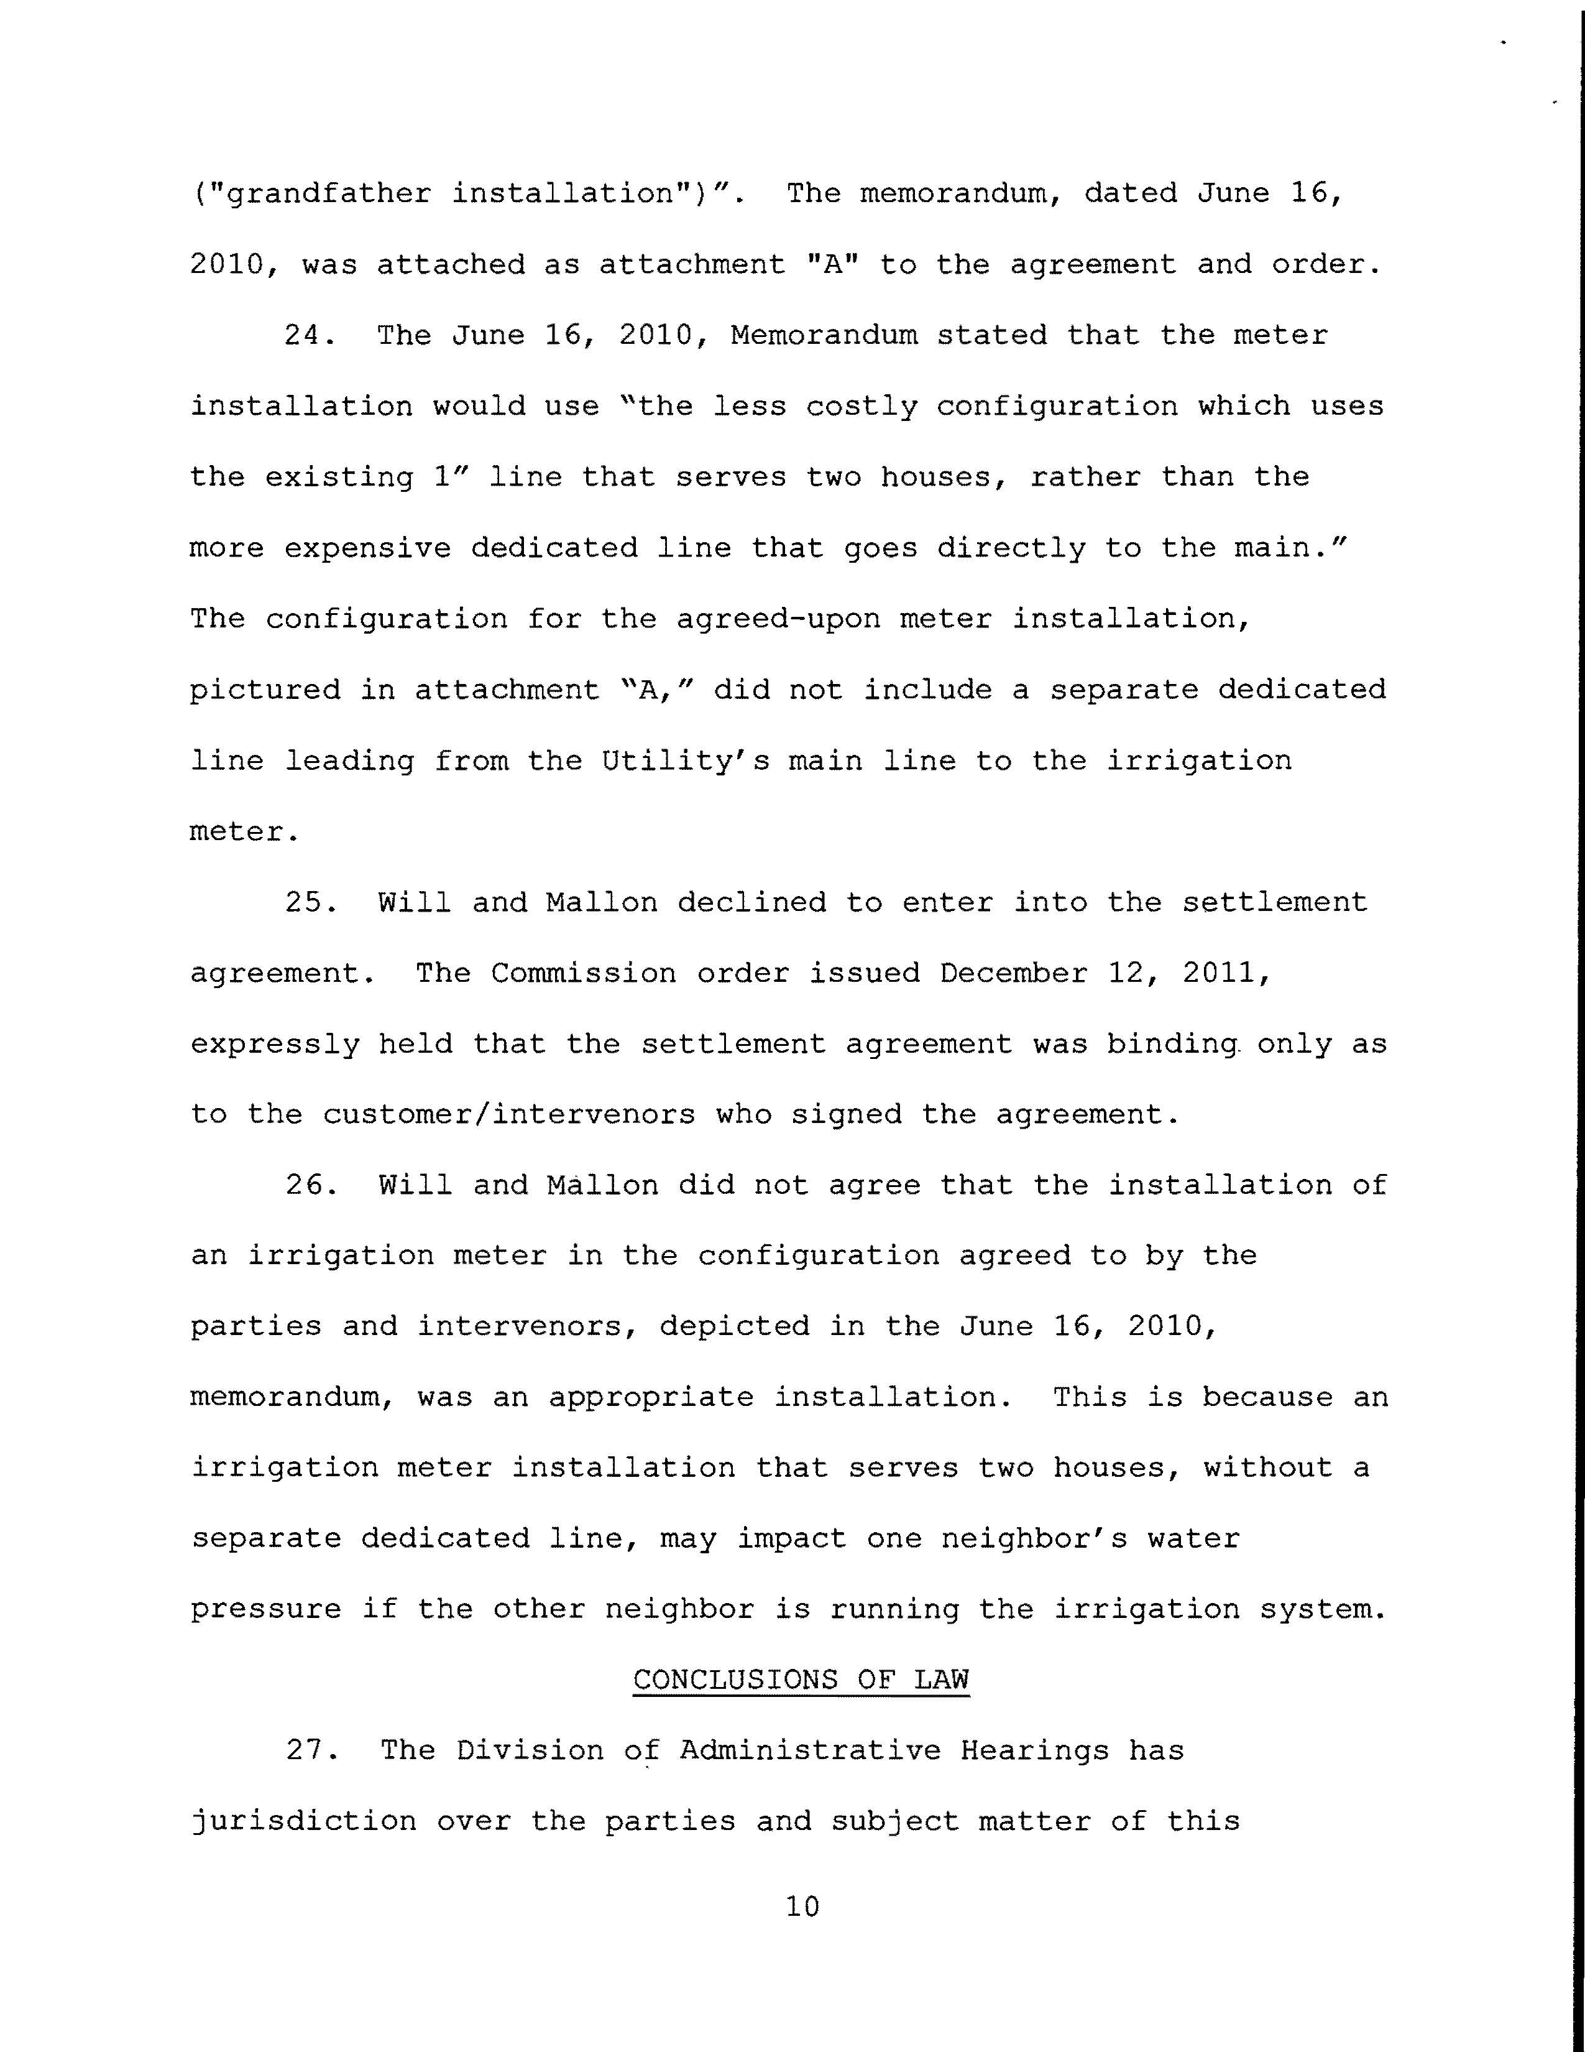
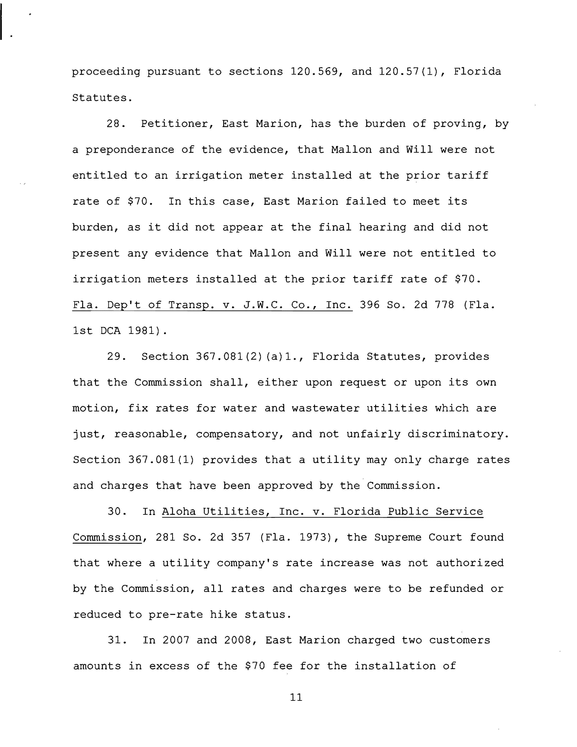
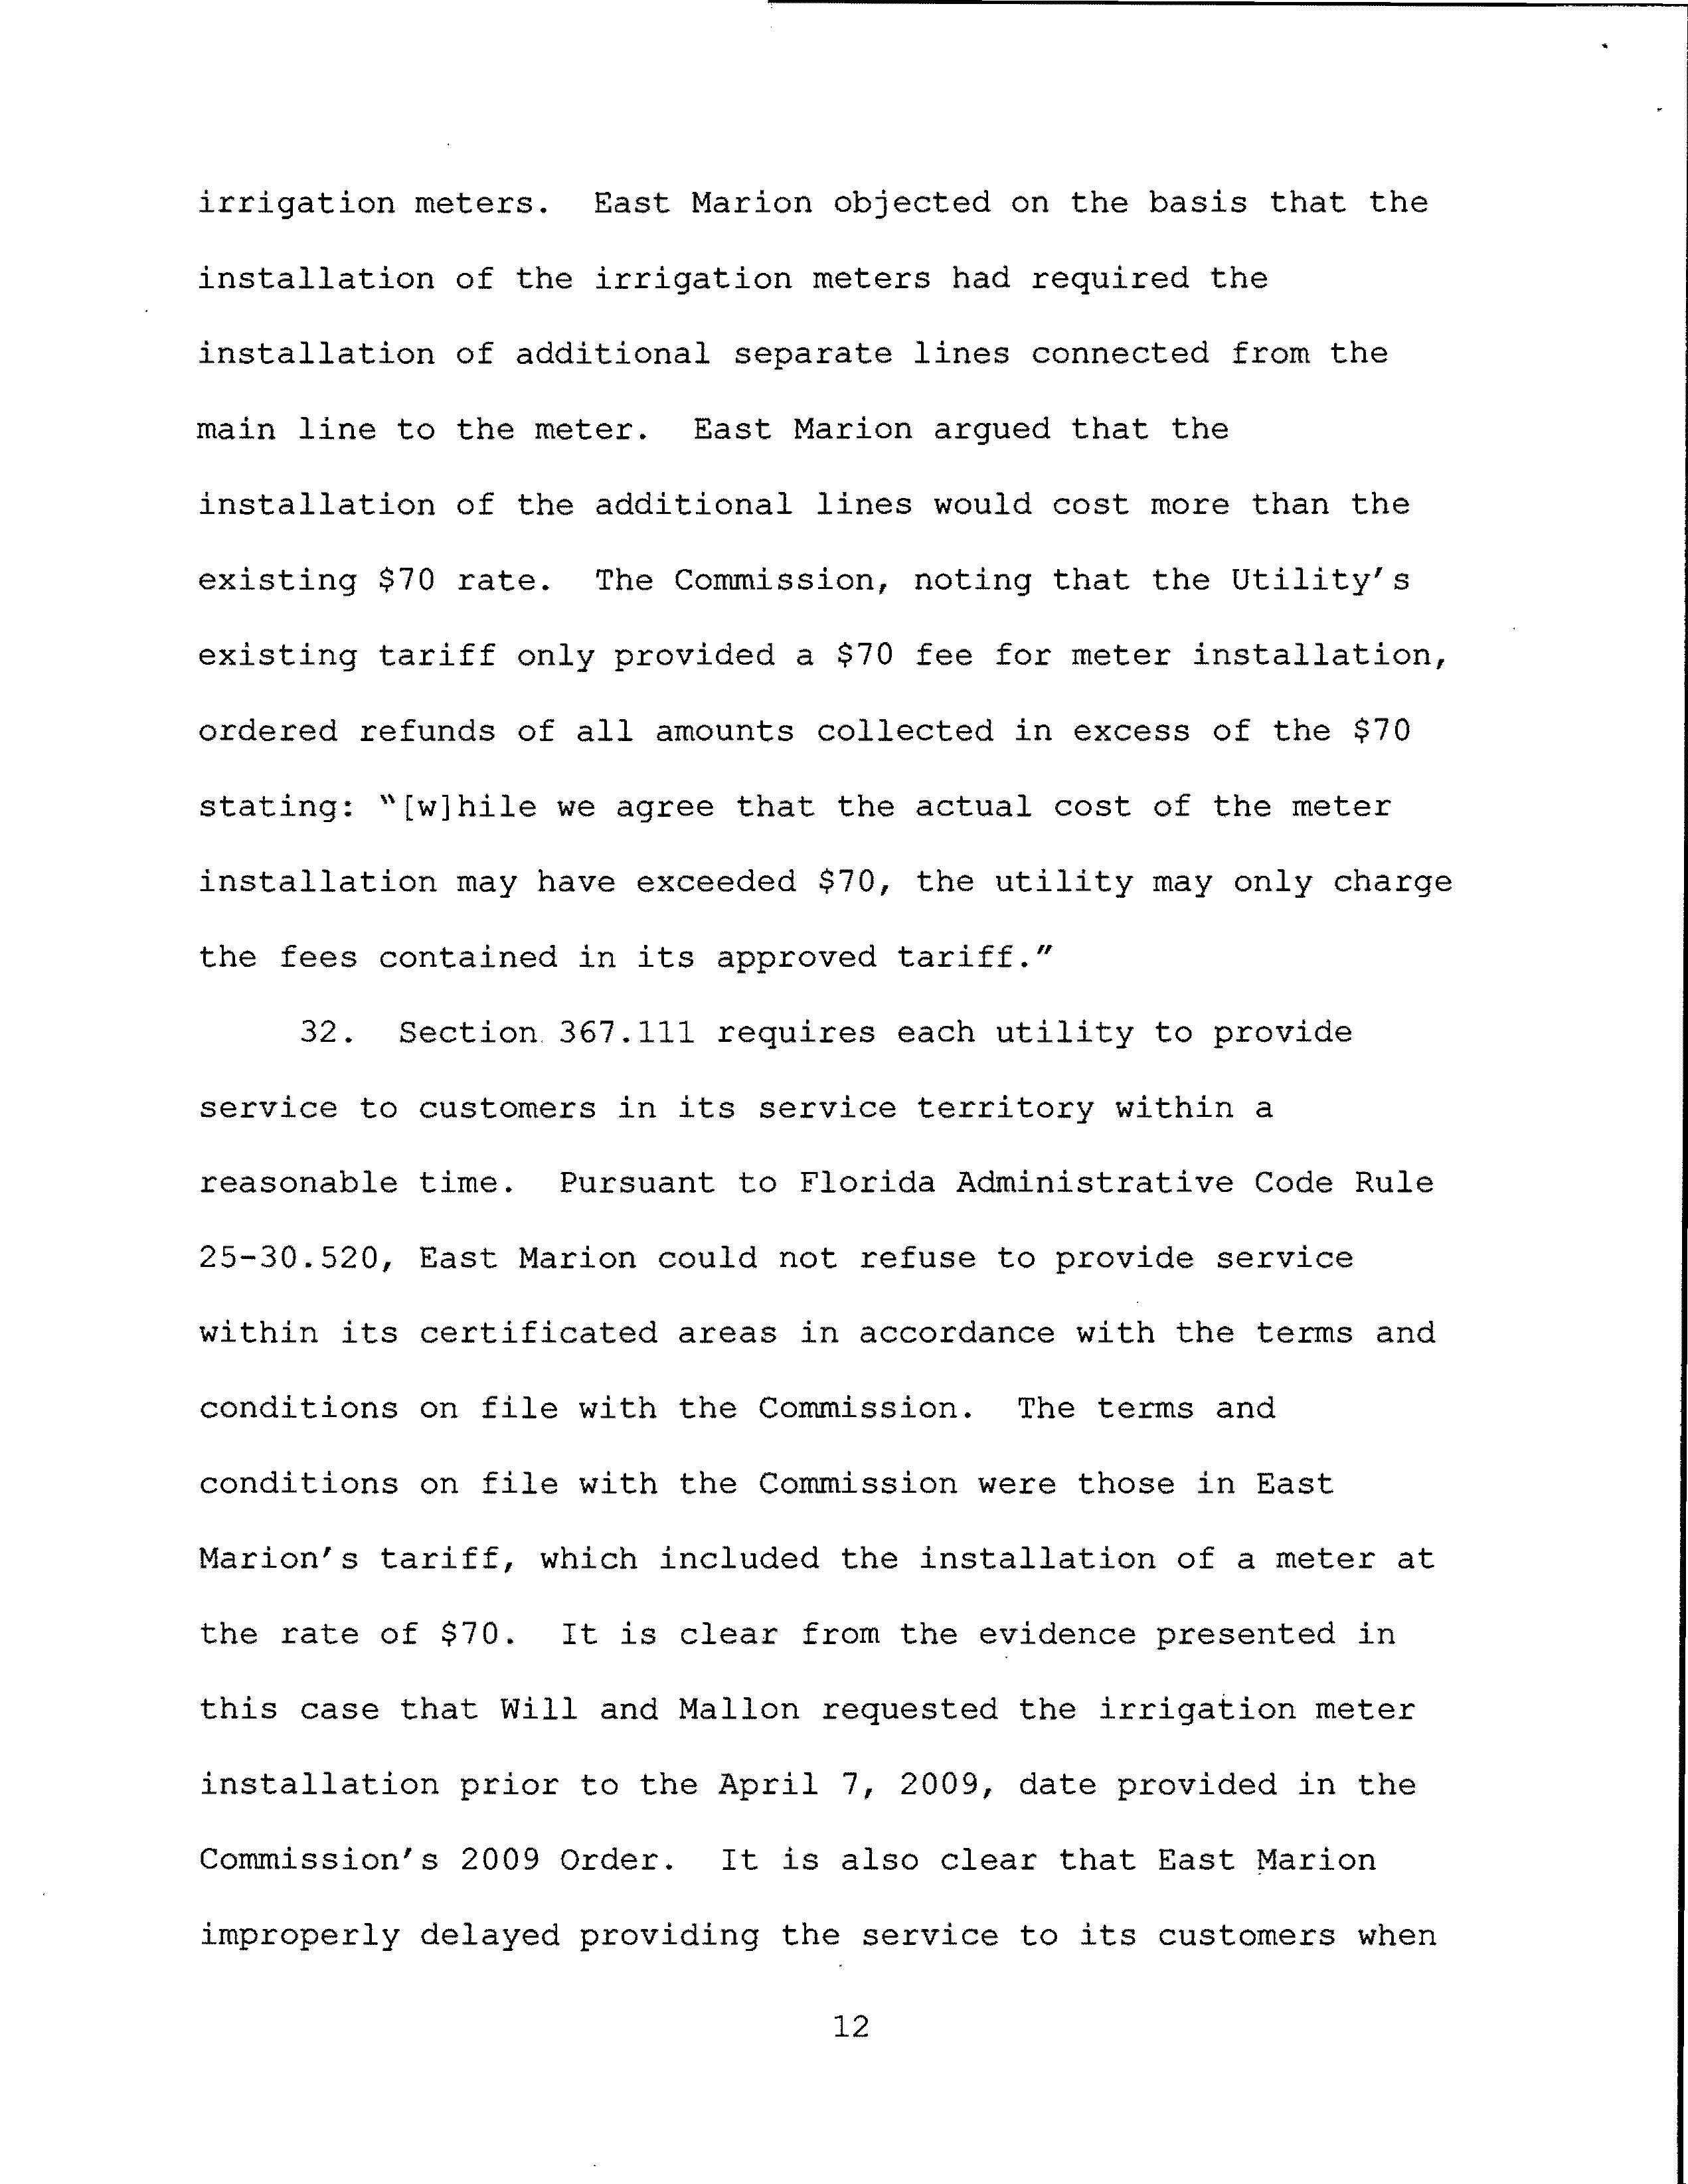
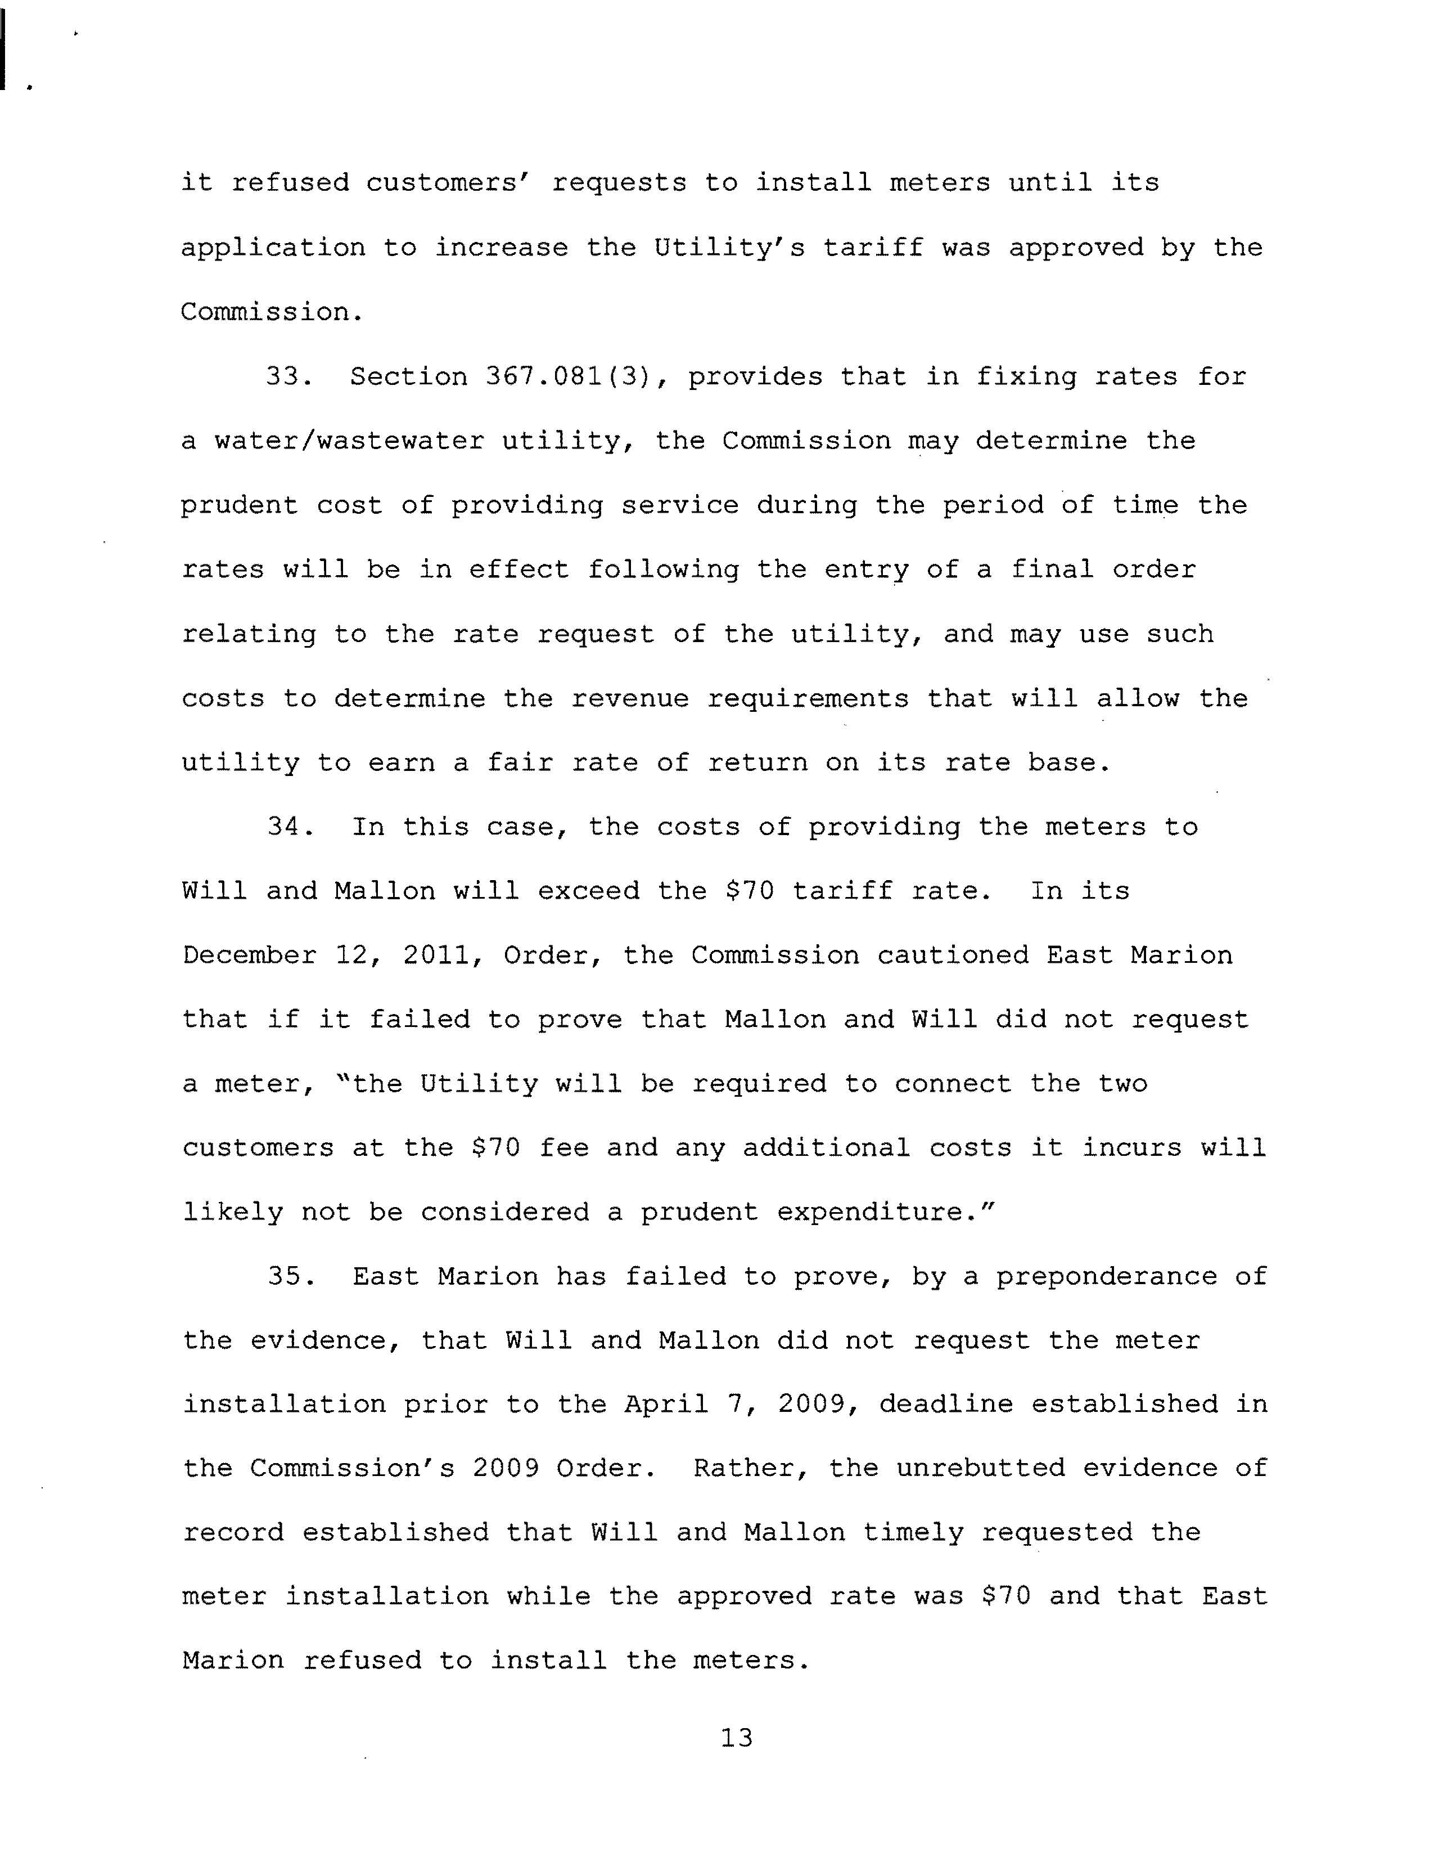
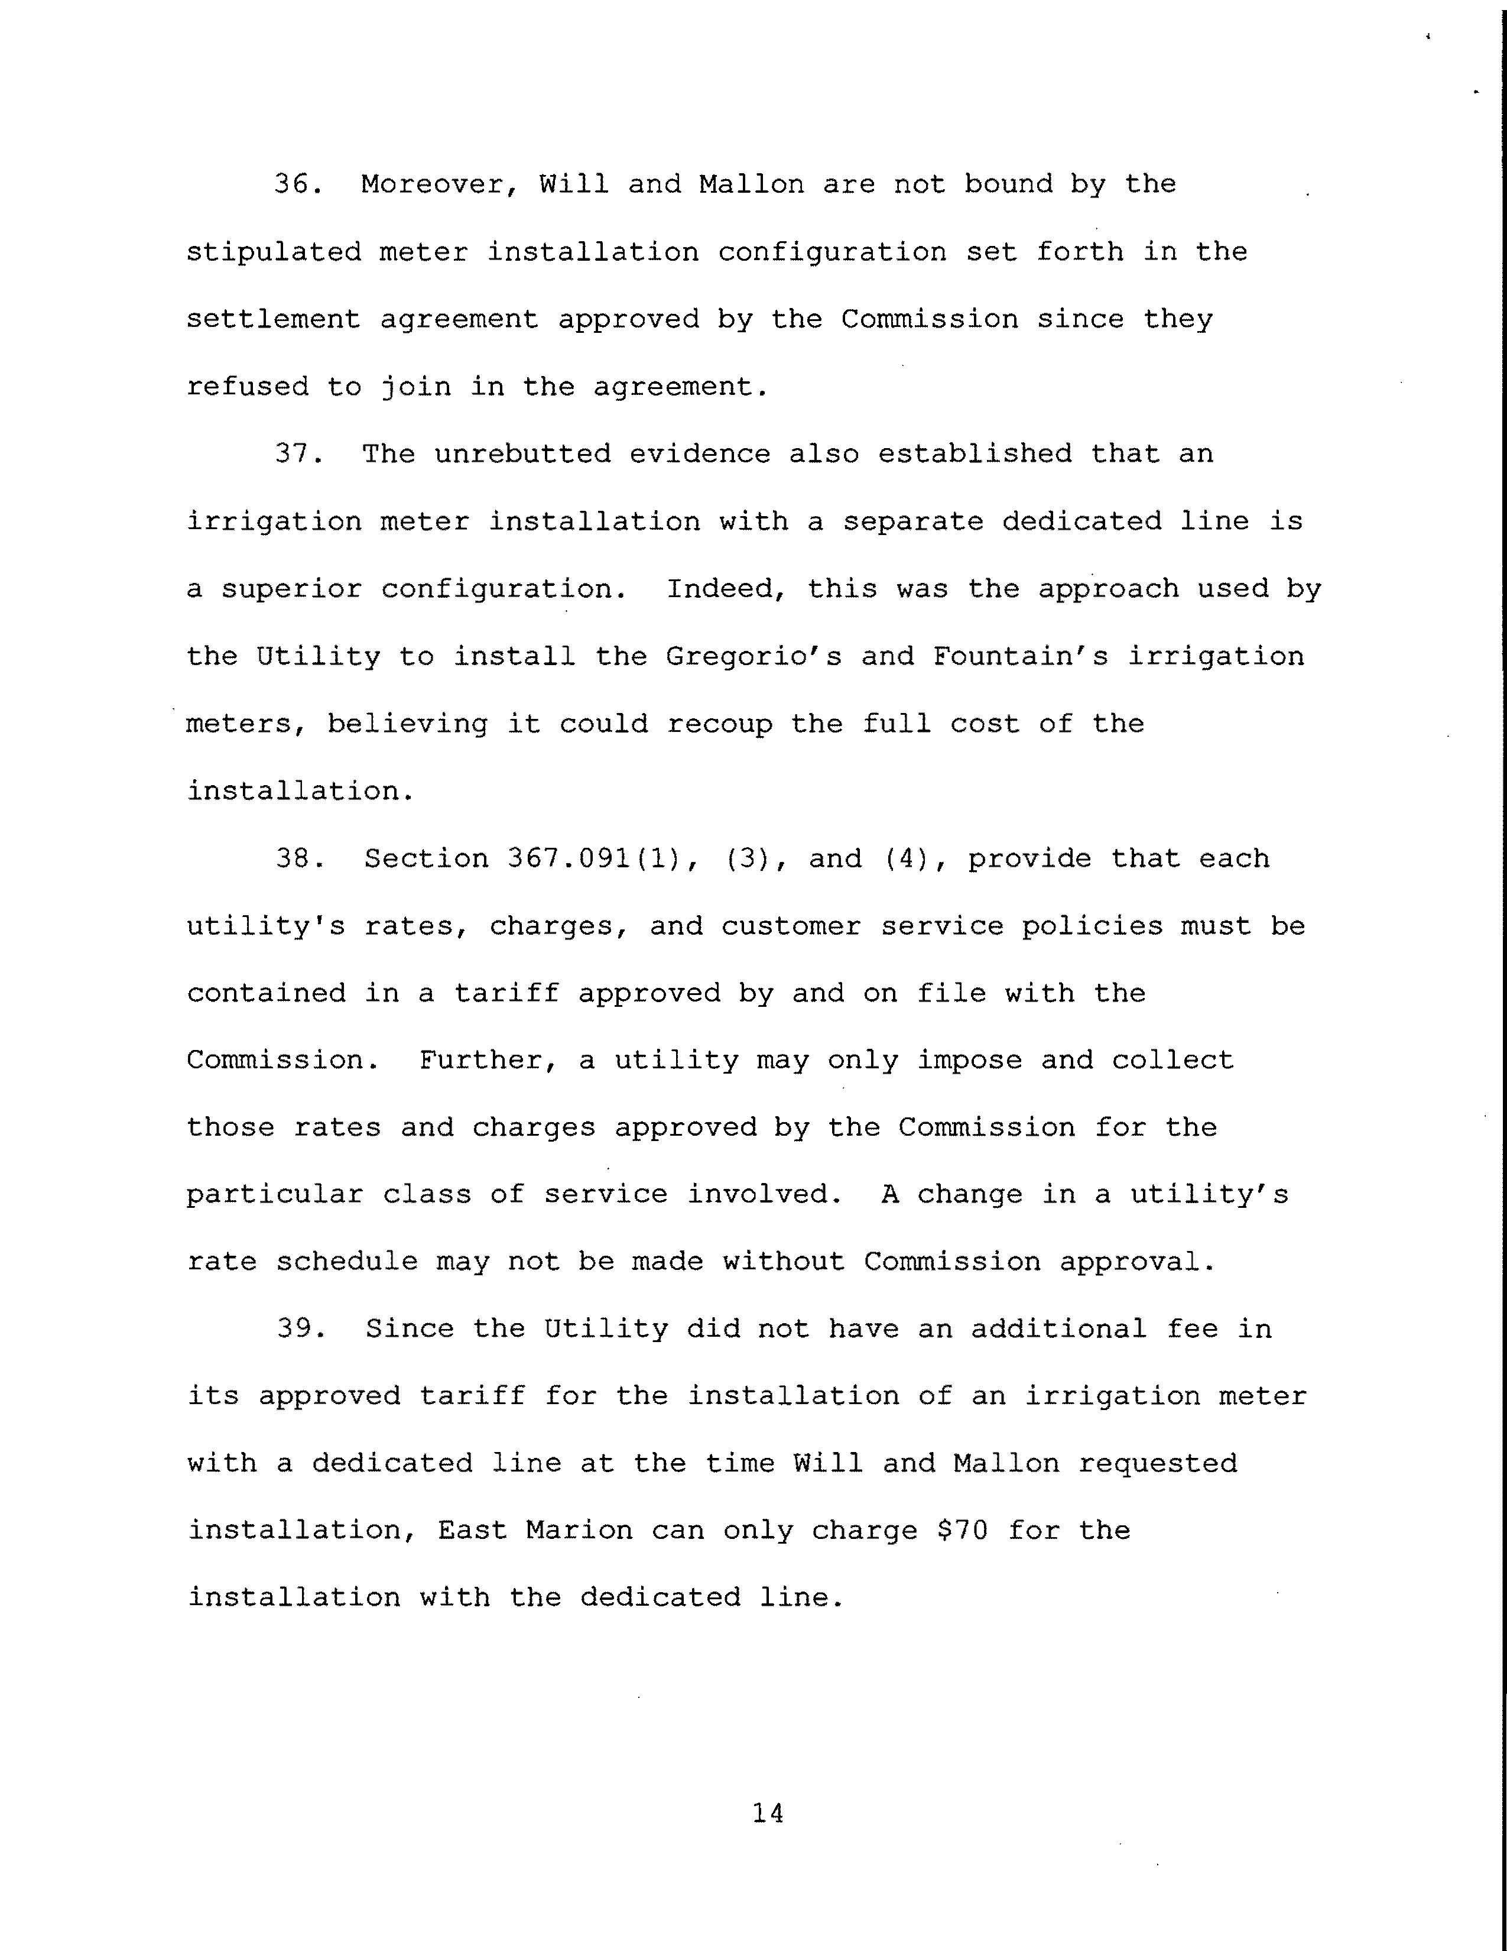
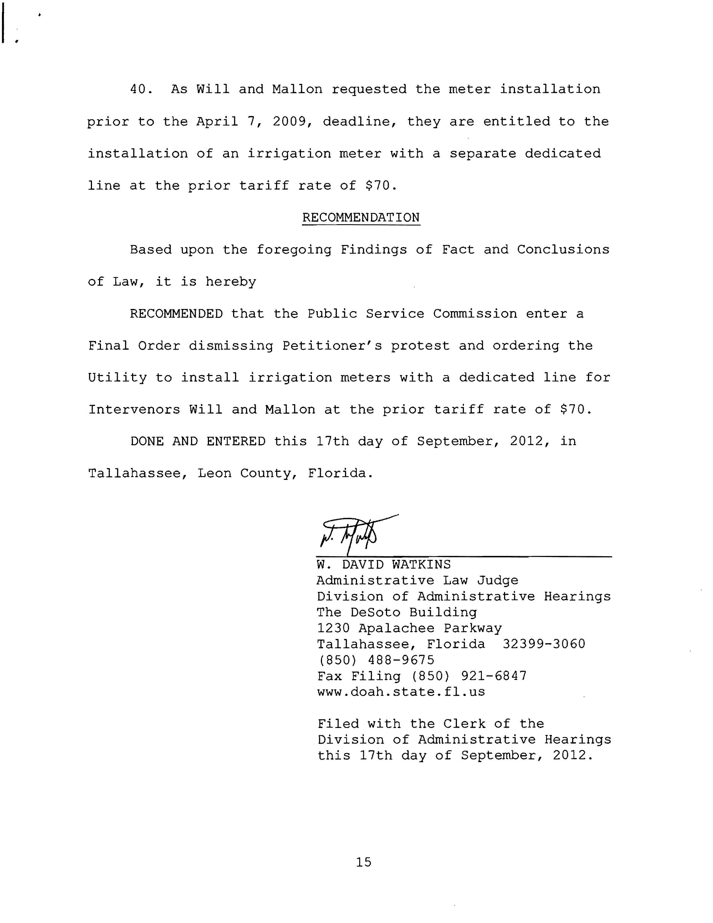

See Order No. PSC-02-1168-PAA-WS, issued August 26, 2002, in Docket No. 010869-WS, In re: Application for staff-assisted rate case in Marion County by East Marion Sanitary Systems, Inc.
“The remaining non-signatory parties are advised that the maximum relief that we will be able to grant either Intervenor was that set forth in the original Order, an irrigation meter at the cost of $70.00. In other words, if either or both Mr. Will or Ms. Mallon is successful in proving that they properly requested a meter, the only advantage they would gain over not signing the Settlement Agreement is that they will not be obligated to keep the irrigation meter for three years.” Order No. PSC-11-0566-AS-WU, issued December 12, 2012, in this docket.

