BEFORE THE FLORIDA PUBLIC SERVICE COMMISSION

In re: Petition for approval of revised lighting tariffs by Tampa Electric Company. | DOCKET NO. 130019-EI  ORDER NO. PSC-13-0138-TRF-EI  ISSUED: March 25, 2013

The following Commissioners participated in the disposition of this matter:

RONALD A. BRISÉ, Chairman
LISA POLAK EDGAR
ART GRAHAM
EDUARDO E. BALBIS
JULIE I. BROWN

ORDER APPROVING TAMPA ELECTRIC COMPANY’S REVISED LIGHTING TARIFFS

BY THE COMMISSION:
Background
Tampa Electric Company (TECO or company) began investigating light-emitting diode (LED) outdoor lighting approximately five years ago. At that time TECO found LED fixtures cost as much as ten times more than equivalent high pressure sodium fixtures which are currently the company's most energy efficient lighting options. In addition, there were no standards for manufacturers and no data on reliability or operation and maintenance costs of LED fixtures.
Approximately three years ago, TECO installed several LED fixtures at company facilities and began evaluating them. TECO reports that there have been significant improvements in LED technology over this relatively short period of time, particularly in equipment uniformity and cost reduction. The company is now prepared to offer LED lighting service to customers under its lighting tariff and has identified several LED fixtures that satisfy the company's performance expectations.
On January 11, 2013, TECO filed a petition requesting Commission approval of its new lighting tariff for eight LED lighting fixtures for roadway and outdoor lighting. TECO submitted revised filings that included minor corrections on January 28 and February 4, 2013. We have jurisdiction over this matter pursuant to Section 366.06(1), Florida Statutes.
Decision
TECO petitioned this Commission for approval to add a new LED lighting category to its rate schedule Lighting Service (LS-1). The LED lighting category shall be a standard tariff which offers TECO’s customers a selection of lower energy use outdoor lighting products. The proposed fixtures will be available in three styles and multiple wattages. TECO has stated that the LED options are approximately fifty percent more efficient than equivalent metal halide lighting options currently offered under the LS-1 rate schedule. Tariff Sheet No. 6.808, reflecting the proposed tariff change which is approved herein, is shown as Attachment A.
The charges for the new LED lighting category are comprised of three components: a fixture charge, a maintenance charge, and a non-fuel energy charge, consistent with TECO’s other lighting options. The fixture charges were developed based on material costs plus labor and vehicle costs associated with installation, times TECO’s 14.56 percent 15-year fixed charge rate. The maintenance charges were developed based on TECO’s estimated maintenance costs by fixture type; primary elements of expected maintenance costs pertain to the luminaire unit, luminaire parts, and the photo cell. The non-fuel energy charge is determined by multiplying the estimated kilowatt-hour (kWh) usage by fixture type by the non-fuel energy charge as approved in TECO’s most recent rate proceeding. TECO’s currently approved non-fuel energy charge is 2.462 cents per kWh. All other Commission-approved LS-1 recovery clause factors will be applied to the estimated usage.
In conjunction with its petition TECO submitted supporting cost information that included a presentation of the following: individual tariff calculations; installation, maintenance, labor and vehicle costs; calculation of the fixed charge rate; overhead cost factors; and monthly energy consumption charges. We have reviewed the cost information submitted with TECO’s petition and find the charges are reasonable and appropriate. Therefore we approve TECO’s proposed new tariff for LED fixtures, maintenance, and base energy charges.
Based on the foregoing, it is

ORDERED by the Florida Public Service Commission that Tampa Electric Company’s proposed new tariff for LED fixtures, maintenance, and base energy charges is approved. It is further

ORDERED that the tariff shall become effective on March 5, 2013. It is further

ORDERED that if a protest is filed within 21 days of issuance of the Order, the tariff shall remain in effect with any charges held subject to refund pending resolution of the protest. It is further

ORDERED that if no timely protest is filed, this docket shall be closed upon the issuance of a Consummating Order.

By ORDER of the Florida Public Service Commission this 25th day of March, 2013.

/s/ Ann Cole
ANN COLE
Commission Clerk
Florida Public Service Commission
2540 Shumard Oak Boulevard
Tallahassee, Florida 32399
(850) 413-6770
www.floridapsc.com

Copies furnished: A copy of this document is provided to the parties of record at the time of issuance and, if applicable, interested persons.

MTL

NOTICE OF FURTHER PROCEEDINGS

The Florida Public Service Commission is required by Section 120.569(1), Florida Statutes, to notify parties of any administrative hearing or judicial review of Commission orders that is available under Sections 120.57 or 120.68, Florida Statutes, as well as the procedures and time limits that apply. This notice should not be construed to mean all requests for an administrative hearing or judicial review will be granted or result in the relief sought.

Mediation may be available on a case-by-case basis. If mediation is conducted, it does not affect a substantially interested person's right to a hearing.

The Commission's decision on this tariff is interim in nature and will become final, unless a person whose substantial interests are affected by the proposed action files a petition for a formal proceeding, in the form provided by Rule 28-106.201, Florida Administrative Code. This
petition must be received by the Office of Commission Clerk, 2540 Shumard Oak Boulevard, Tallahassee, Florida 32399-0850, by the close of business on April 15, 2013.

In the absence of such a petition, this Order shall become final and effective upon the issuance of a Consummating Order.

Any objection or protest filed in this docket before the issuance date of this order is considered abandoned unless it satisfies the foregoing conditions and is renewed within the specified protest period.

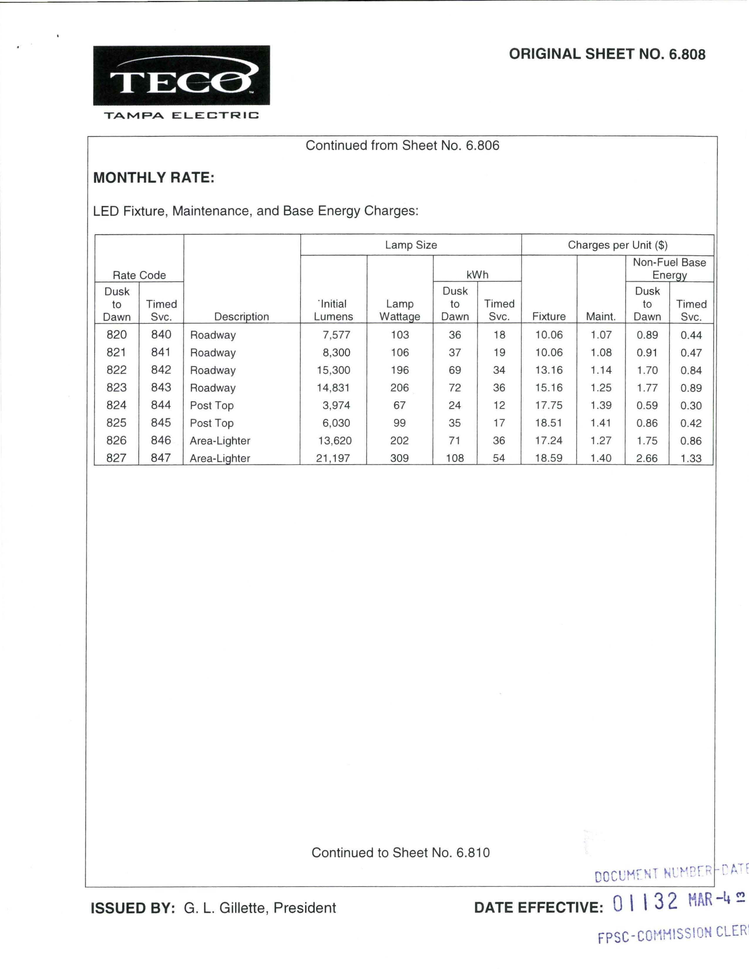

See Order No. PSC-10-0572-FOF-EI, issued September 16, 2010, in Docket No. 090368-EI, In re: Review of the continuing need and costs associated with Tampa Electric Company's 5 Combustion Turbines and Big Bend Rail Facility.

