State of Florida   |  | Public Service Commission  Capital Circle Office Center ● 2540 Shumard Oak Boulevard  Tallahassee, Florida 32399-0850  -M-E-M-O-R-A-N-D-U-M-
DATE: | March 28, 2013
TO: | Office of Commission Clerk (Cole)
FROM: | Office of the General Counsel (Harris)  Office of Consumer Assistance and Outreach (Forsman, Hicks)  Division of Economics (Rome)
RE: | Docket No. 120297-EI – Complaint of Marlowe Ragland against Progressive Energy for alleged disconnections and high bills.
AGENDA: | 04/09/13 – Regular Agenda – Proposed Agency Action - Interested Persons May Participate
COMMISSIONERS ASSIGNED: |  |  | All Commissioners
PREHEARING OFFICER: |  |  | Edgar
CRITICAL DATES: |  |  | None
SPECIAL INSTRUCTIONS: |  |  | None
FILE NAME AND LOCATION: |  |  | S:\PSC\GCL\WP\120297.RCM.DOC

Case Background
In April 2012, Mr. Marlowe and Mrs. Natalie Ragland (the Raglands) filed an informal complaint against Progress Energy Florida, Inc. (PEF). The informal complaint alleged improper disconnection of service, in that the Raglands asserted that while they had received monthly bills, they had not received notices of disconnection prior to their service being disconnected for non-payment. The Raglands’ informal complaint implied that PEF’s failure to provide disconnection notices constituted a violation of Commission rules. Three separate Commission staff worked with the Raglands and PEF on the informal complaint, but were unable to resolve the situation to the Raglands’ satisfaction.
On June 27, 2012, staff sent the Raglands a letter, detailing the findings of his review of the informal complaint and the Commission staff’s activities. A copy of this letter is attached as Attachment A to this recommendation. The Administrator concluded: “[m]y administrative review and resultant conclusion is that it does not appear that PEF has violated any jurisdictionally applicable provision of the Florida Statutes, the Florida Administrative Code, or its tariff in the handling of your account. The FPSC is unable to grant you the redress you are seeking from PEF.” The letter went on to state that if the Raglands disagreed with this final disposition of their informal complaint, they had a right to initiate formal proceedings, and detailed the requirements that a petition to initiate such proceedings must comply with.
On November 20, 2012, the Raglands filed a “Formal Complaint” (Complaint) against “Progressive Energy.” The Raglands advise they had “completed the steps in filing an informal complaint with your company and have been advised to now file a formal complaint.” In the Complaint, the Raglands indicated they are primarily concerned with having had their electricity disconnected four times since March 2012 “without receiving a disconnection notice.” The Complaint also states that the Raglands do not understand why their bills are higher than their neighbors, whom they state have similarly sized houses. The Raglands indicate they “receive poor service” from Progress Energy, and believe they are being “retaliated” against for filing a complaint.
The Raglands indicate that after their four disconnections, they have been asked to pay additional security deposits, and having to come up with the money to re-establish service and the additional deposits had caused them to be in arrears on other bills, and created a severe financial hardship for them. The Raglands go on to state: “[w]e are asking for someone to look at our bills and compare the amount used with other homes in the area with the same amount of people or more. We would like the deposit to be waved because they did not provide us with notification as the law requires. We are asking for any and all legal services we are allowed to be put into place.”
On December 7, 2012, PEF filed a Motion to Dismiss and Response in Opposition (Motion to Dismiss). In summary, PEF states that all but one of the claims in the Raglands’ Complaint fail to cite any statute, rule or order which PEF allegedly violated, and should therefore be dismissed for failure to meet the pleading requirements of Rule 25-22.036, Florida Administrative Code (F.A.C.). With respect to the Raglands’ claim that PEF has disconnected service without providing disconnection notices, PEF maintains that it has sent late payment/disconnection notices to the Raglands, and details the dates the notices were mailed. PEF notes that none of the correspondence has been returned as undelivered, and therefore, suggests that this claim is factually unfounded and the Complaint should be denied as to this claim. In conclusion, PEF maintains that the Complaint should be dismissed in part, and that any remaining requests for relief (regarding disconnection without proper notice) should be denied.
Subsequent to the receipt of PEF’s Motion to Dismiss, staff continued to attempt to resolve the dispute between the Raglands and Progress. Staff was able to arrange for a meter test, supervised by a Commission field engineer, and a home energy audit. Staff also worked with the Raglands to explain the billed amounts and charges in detail. After these activities, staff believed it had informally resolved the Raglands’ concerns, and via email, asked the Raglands whether they would be willing to voluntarily dismiss their Complaint.
The Raglands replied, also via email, that they were not willing to voluntarily dismiss the Complaint. The Raglands maintain that they have not received disconnection notices from PEF prior to their service being disconnected, which they allege is a violation of law. They indicate that some or all of the reconnection fees and additional deposits should be waived, and their outstanding balance should be reduced. Accordingly, the Raglands requested this matter go before the Commission for resolution.
On February 8, 2013, staff was contacted by a representative of Progress, who stated that the Raglands were due to be disconnected for a fifth time for non-payment of billed amounts. Staff made a number of back-and-forth contacts with both the Raglands and Progress, and as a result, the Raglands’ service was not disconnected on that date. As of March, 22, 2013, the outstanding balance on the Raglands’ account is $285.78.
The Commission has jurisdiction pursuant to Chapters 120 and 366, Florida Statutes (F.S.), and Chapters 25-6, 25-22, and 28-106, F.A.C.
Discussion of Issues
Issue 1:1
What is the appropriate disposition of the Raglands’ Formal Complaint?
Recommendation:
The Raglands’ Formal Complaint should be denied and they should pay the entire outstanding account balance of $285.78 as previously billed by the utility. It appears that the Raglands’ account was properly billed in accordance with Commission statutes, rules, and PEF's tariffs. Based on documentation provided, an audit of the account indicates that the account balance is accurate. The additional deposit has been accurately calculated and assessed. Furthermore, it does not appear that PEF has violated any jurisdictionally applicable provision of the Florida Statutes, the Florida Administrative Code, or its tariff in the handling of the Raglands’ account. (Harris, Forsman)
Staff Analysis:

Motion to Dismiss
PEF has filed a Motion to Dismiss the Raglands’ Formal Complaint in Part, due to the Raglands’ failure to follow applicable pleading requirements. Specifically, PEF avers “[t]he Petitioner’s Complaint does not cite any rule, order, or statute that the Company allegedly violated with respect to all but one of his claims as set forth below. As to those claims, the Complaint fails to meet the requirements of Rule 25-22.036 and should be dismissed in part.”
For formal administrative proceedings authorized by Chapter 120, F.S., the Uniform Rules of Procedure contained in Chapter 28-106, F.A.C., apply. In addition to the Uniform Rules which govern all administrative proceedings, the Commission has adopted specific procedural rules to govern proceedings before it, which are contained in Chapter 25-22, F.A.C. As correctly cited by PEF, the Commission’s procedural Rule 25-22.036, F.A.C., requires pleadings to substantially comply with Uniform Rule 28-106.201, F.A.C. A review of the Raglands’ Petition reveals that it is not in substantial compliance with either of these rules.
Section 120.569(2)(c), F.S., states, in part, that this Commission shall dismiss a petition for failure to substantially comply with the uniform rules. Pursuant to this statute, the dismissal of a petition should, at least once, be without prejudice to the petitioner to allow the filing of a timely amended petition curing the defect, unless it conclusively appears from the face of the petition that the defect cannot be cured.
However, staff believes the facts and law are clearly developed and a properly plead complaint is not necessary in order for the Commission to make a decision at this time. As discussed in the case background, the extensive documentation in this docket, including the informal complaint file, the Raglands’ formal Complaint, PEF’s Motion to Dismiss in Part, and the email correspondence between staff and the Raglands provides significant information about the Raglands’ factual assertions and requested relief. Staff believes this information is sufficient to allow the Commission to make a decision on the substance of the Raglands’ Complaint, and does not believe it would be an efficient use of the parties’ resources to require the Raglands to amend their Complaint merely to comply with technical pleading rules. Furthermore, the Commission has previously held pro se litigants such as the Raglands to a relaxed pleading standard, in order to prevent delay and promote resolution of litigants’ claims. Therefore, staff recommends that Progress Energy Florida’s Motion to Dismiss in Part should be denied. Instead, staff recommends that the Commission should proceed to make a decision on the substance of the Raglands’ Complaint.
Electricity Consumption
The Raglands assert that their electrical consumption is higher then their neighbors, who have similarly sized houses. In order to address this area of concern, staff arranged for two acts: the Raglands received a Home Energy Audit, and the Raglands’ meter was tested. With regard to the Energy Audit, PEF’s auditor did not find any conditions which would explain abnormally high usage. Staff notes, however, that while a contrary finding may have assured the Raglands that their personal consumption habits were not to blame for their high bills, it would not have provided a basis to not pay the charges assessed for such consumption.
On rare occasions, a defective or malfunctioning electric meter can contribute to unusually high or low electric bills. In accordance with Rule 25-6.060, F.A.C., Meter Test – Refereed Dispute, at the request of staff, on January 10, 2013, a witnessed inspection and meter test was performed on the Raglands’ meter. This test was supervised by a PSC field engineer. The results of the test confirmed that the meter was functioning properly within Commission guidelines. Accordingly, there is no evidence that the Raglands’ electrical consumption is abnormally high, nor that the Raglands’ meter incorrectly recorded their electrical consumption.
Alleged Improper Disconnection
When the informal complaint was filed in April, 2012, the Raglands indicated that their electric service had been improperly disconnected without notice four times. Rule 25-6.105(5)(g), F.A.C., authorizes PEF or any other regulated electric utility to discontinue or refuse service for non-payment after a diligent attempt has been made to collect the unpaid amount, including at least five working days written notice to the customer. In its Motion to Dismiss in Part and Response in Opposition, PEF details the efforts it made to notify the Raglands of past due account balances. PEF further maintains that all of the Raglands’ billing statements for the periods in question included a statement: "[y]our account has a past due amount of ___ and electric service may be disconnected. Please pay immediately." PEF further states that payments were not received in time to avoid disconnection of service.
Staff thoroughly investigated the Raglands’ assertions that they had not received notice prior to any of the four disconnections, including PEF’s documentation of the attempts it made to notify the Raglands of past due balances. Staff has found no evidence to support the Raglands’ claims, nor has it identified any action or failure to act by PEF that would constitute a violation of any statute or rule. Therefore, it appears that service was properly disconnected all four times in compliance with the rule.
Alleged Unjustified and Excessive Deposit
The Raglands’ Formal Complaint maintains that they have been unjustly assessed additional deposit amounts as a result of the disconnection of service. These new deposits are in addition to an earlier deposit that was required at the time service commenced.
As authorized by Rule 25-6.097(3), F.A.C., Customer Deposits, a utility may at any time require a new or additional deposit in order to secure payment of current bills. In doing so, the utility must provide at least 30 days written notice separate and apart from any bill for service and shall explain the reason for the new or additional deposit. Furthermore, the new or additional deposit may not exceed an amount equal to twice the average charges for actual electric usage for the twelve month period immediately prior to the date of notice. PEF's Tariff Section No. IV, Third Revised Sheet No. 4.070, section 7.03, reflects Rule 25-6.097(3), F.A.C., by stating that “The Company (PEF) may require upon written notice of not less than thirty (30) days a new deposit, where previously waived or returned, or additional deposit in order to secure payment of current bills.”
Based on information received during the processing of the informal complaint, as well as provided by PEF in its Response in Opposition, it appears that PEF sent separate notices to the Raglands assessing the additional deposit amounts, based on the fact that the Raglands’ payment history warranted an additional deposit to secure payment for current services. Therefore, it does not appear that PEF was in violation of Rule 25-6.097(3), F.A.C., or its tariff in assessing the Raglands additional deposit amounts.
Conclusion
While the Raglands’ Complaint does not comply with technical pleading rules, the Commission has significant information before it upon which it can make a decision on the substance of the Raglands’ Complaint. Staff believes that PEF’s Motion to Dismiss in Part should be denied, and the Commission should in fact make a decision on the Raglands’ Complaint.
Staff conducted a thorough and complete investigation of this matter and believes that PEF has complied with its tariff and all applicable statutes and rules of the Commission. Based on the information obtained by staff, it appears that the Raglands’ account was properly billed in accordance with Commission rules, statutes, and PEF's tariffs. An audit of the account, including review of the documentation provided, indicates that the account balance is accurate. The Raglands have presented no documentation or evidence that supports their contention that they were improperly billed or that their electric consumption is excessive. Staff believes the additional deposit assessment has been accurately calculated and assessed. Furthermore, it does not appear that PEF has violated any jurisdictionally applicable provision of the Florida Statutes, the Florida Administrative Code, or its tariff in the handling of the Raglands’ account. Therefore, staff recommends that the Commission should deny the Raglands’ Formal Complaint.
Issue 2:2
Should this docket be closed?
Recommendation:
Yes. If no person whose substantial interests are affected files a protest of the Commission’s proposed agency action order within 21 days, the docket may be closed upon issuance of a consummating order. (Harris)
Staff Analysis:
If no person whose substantial interests are affected files a protest of the Commission’s proposed agency action order within 21 days, the docket may be closed upon issuance of a consummating order.
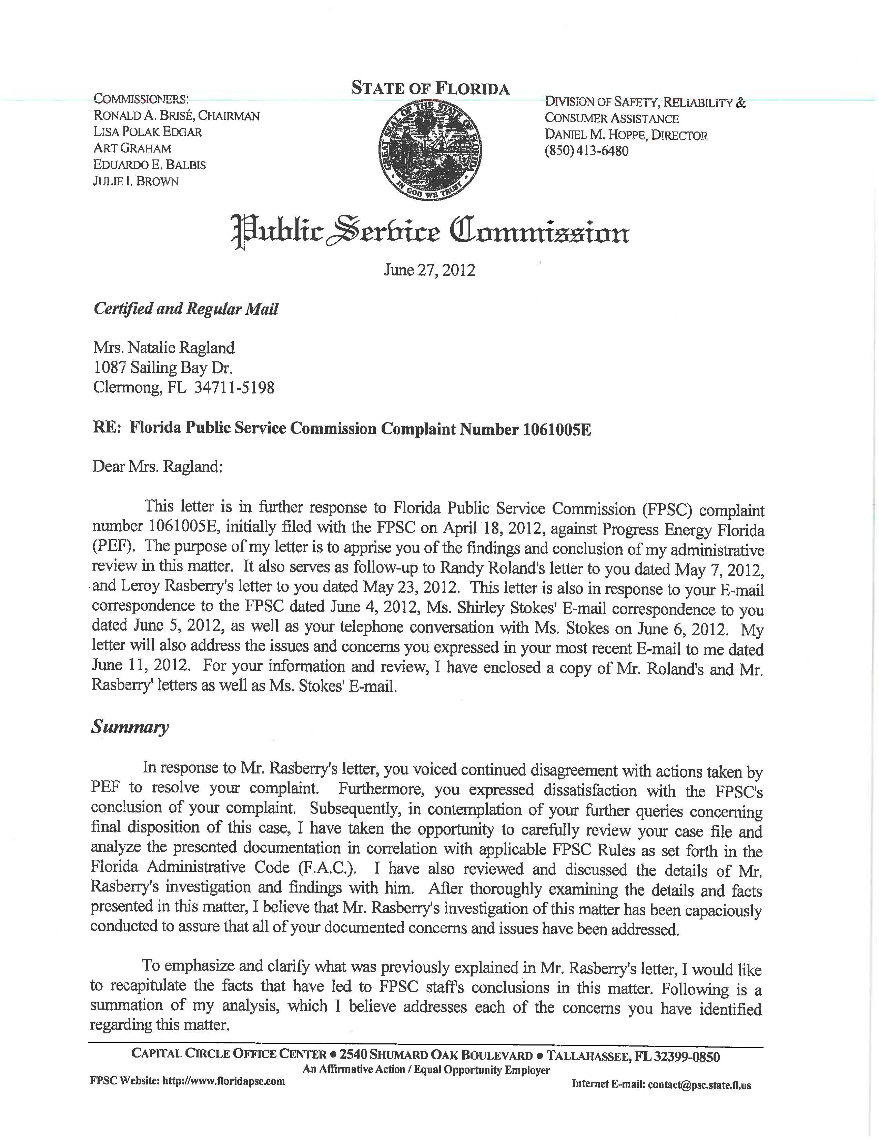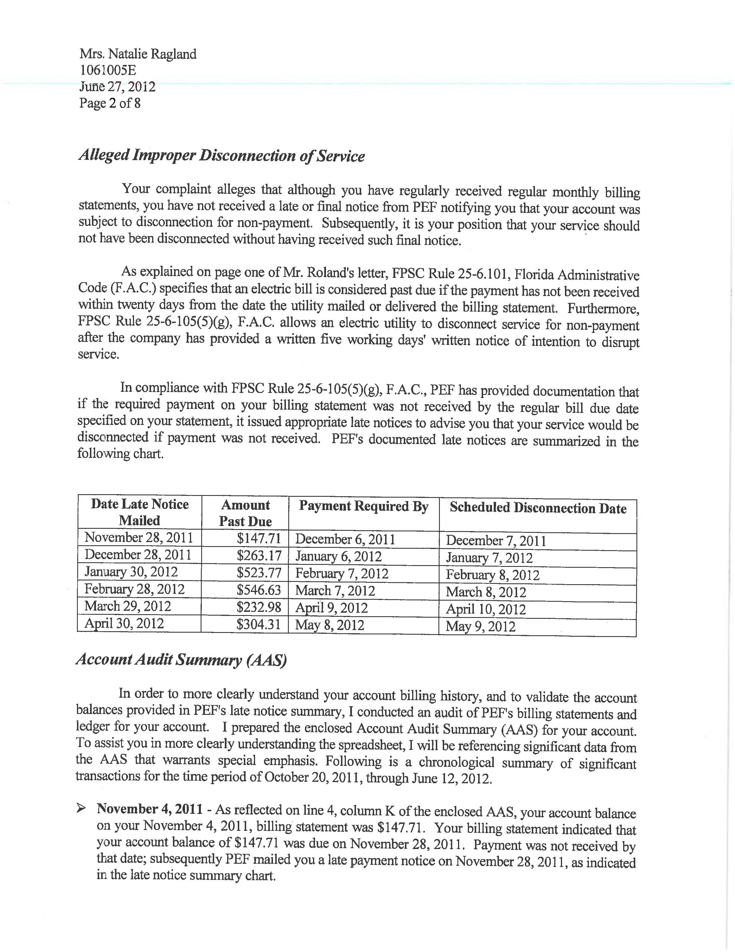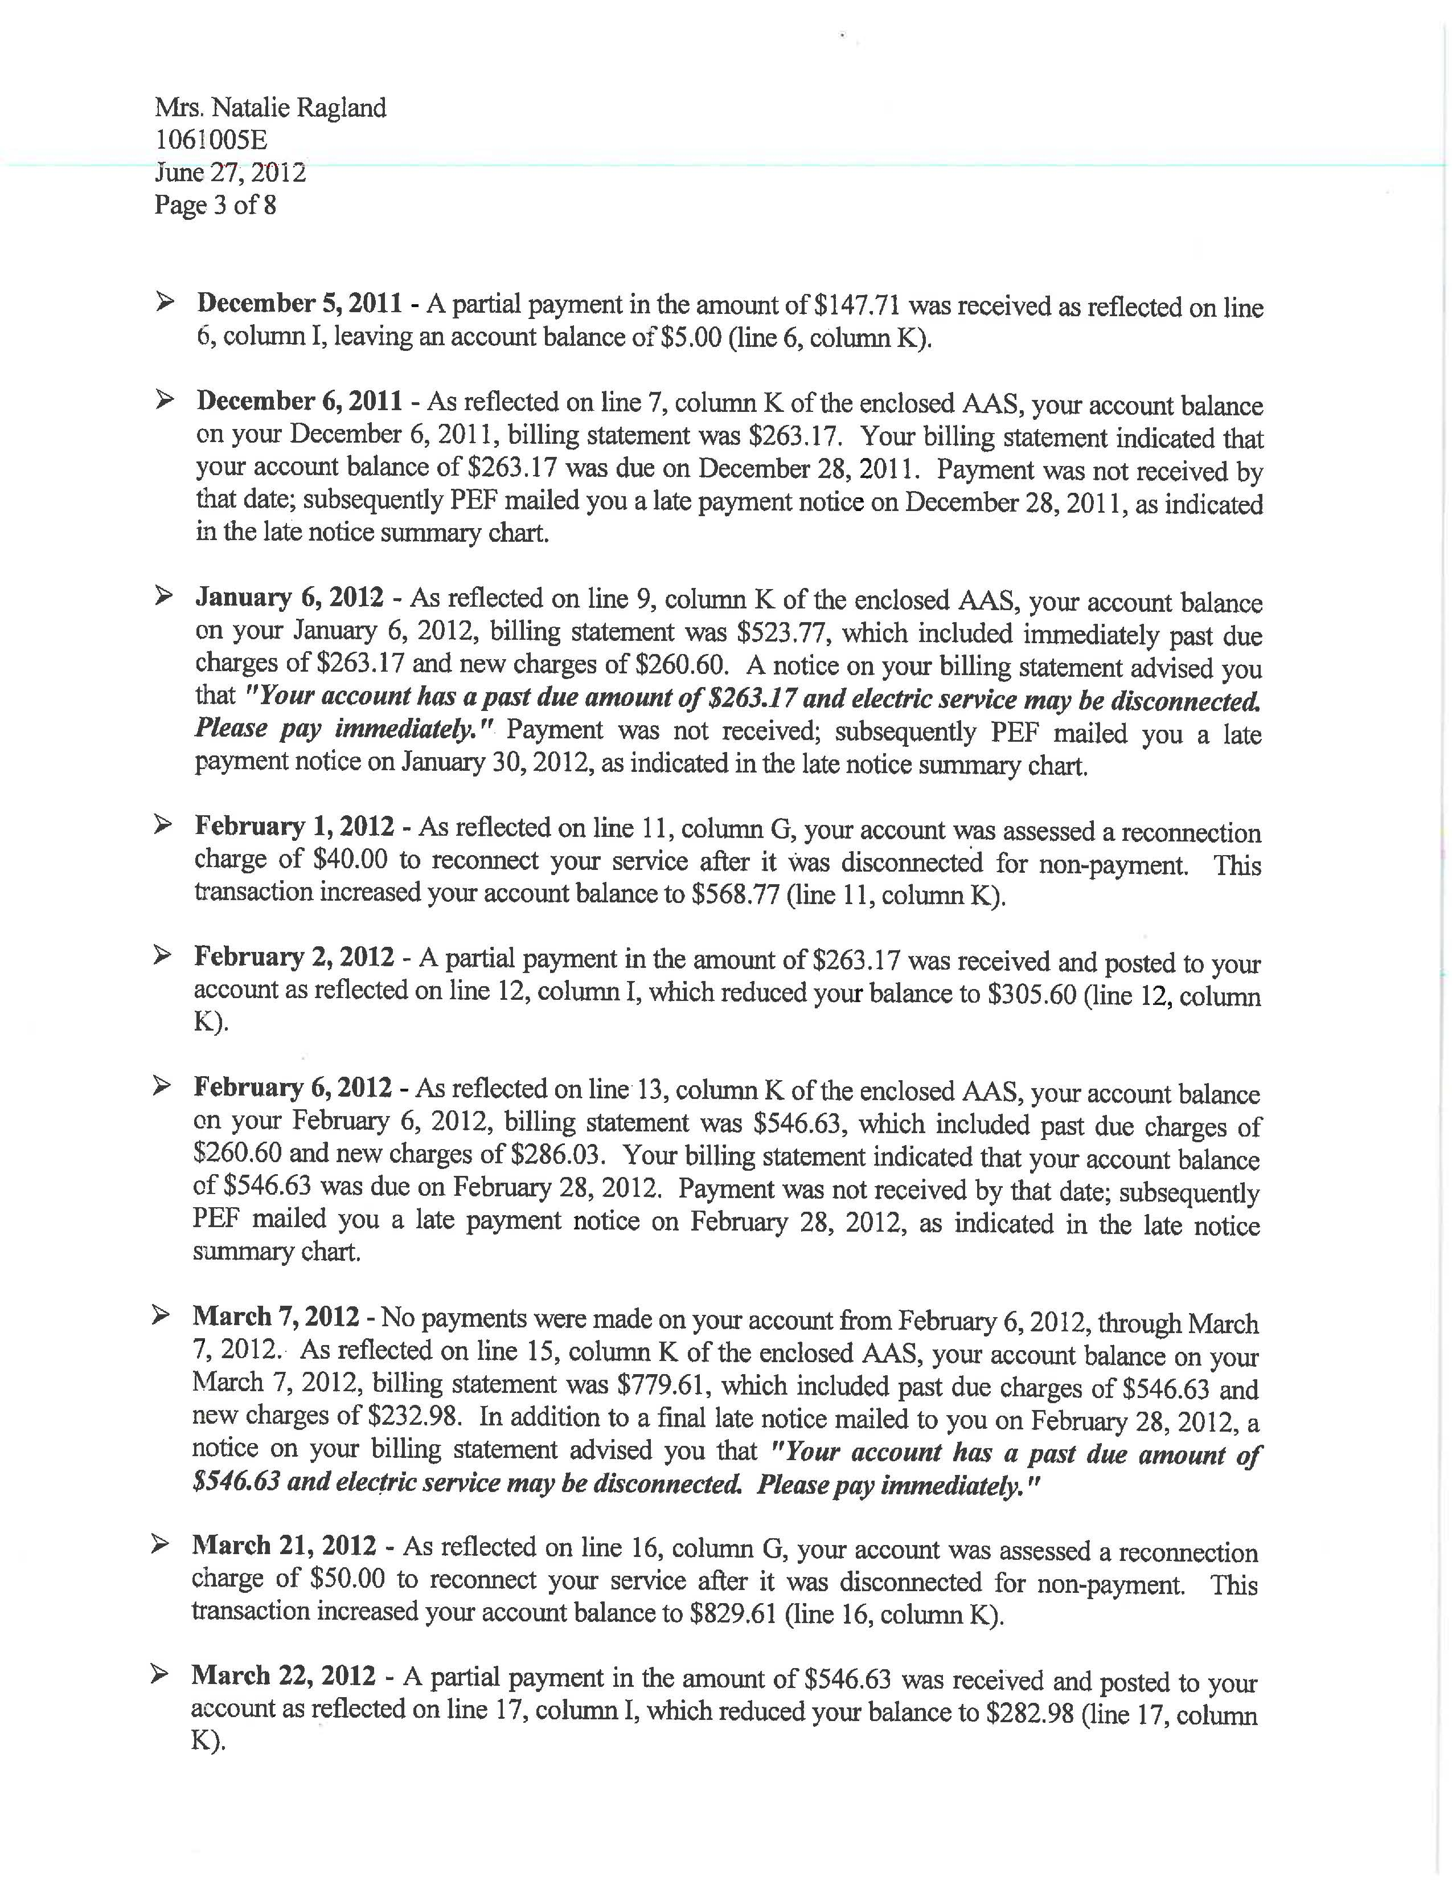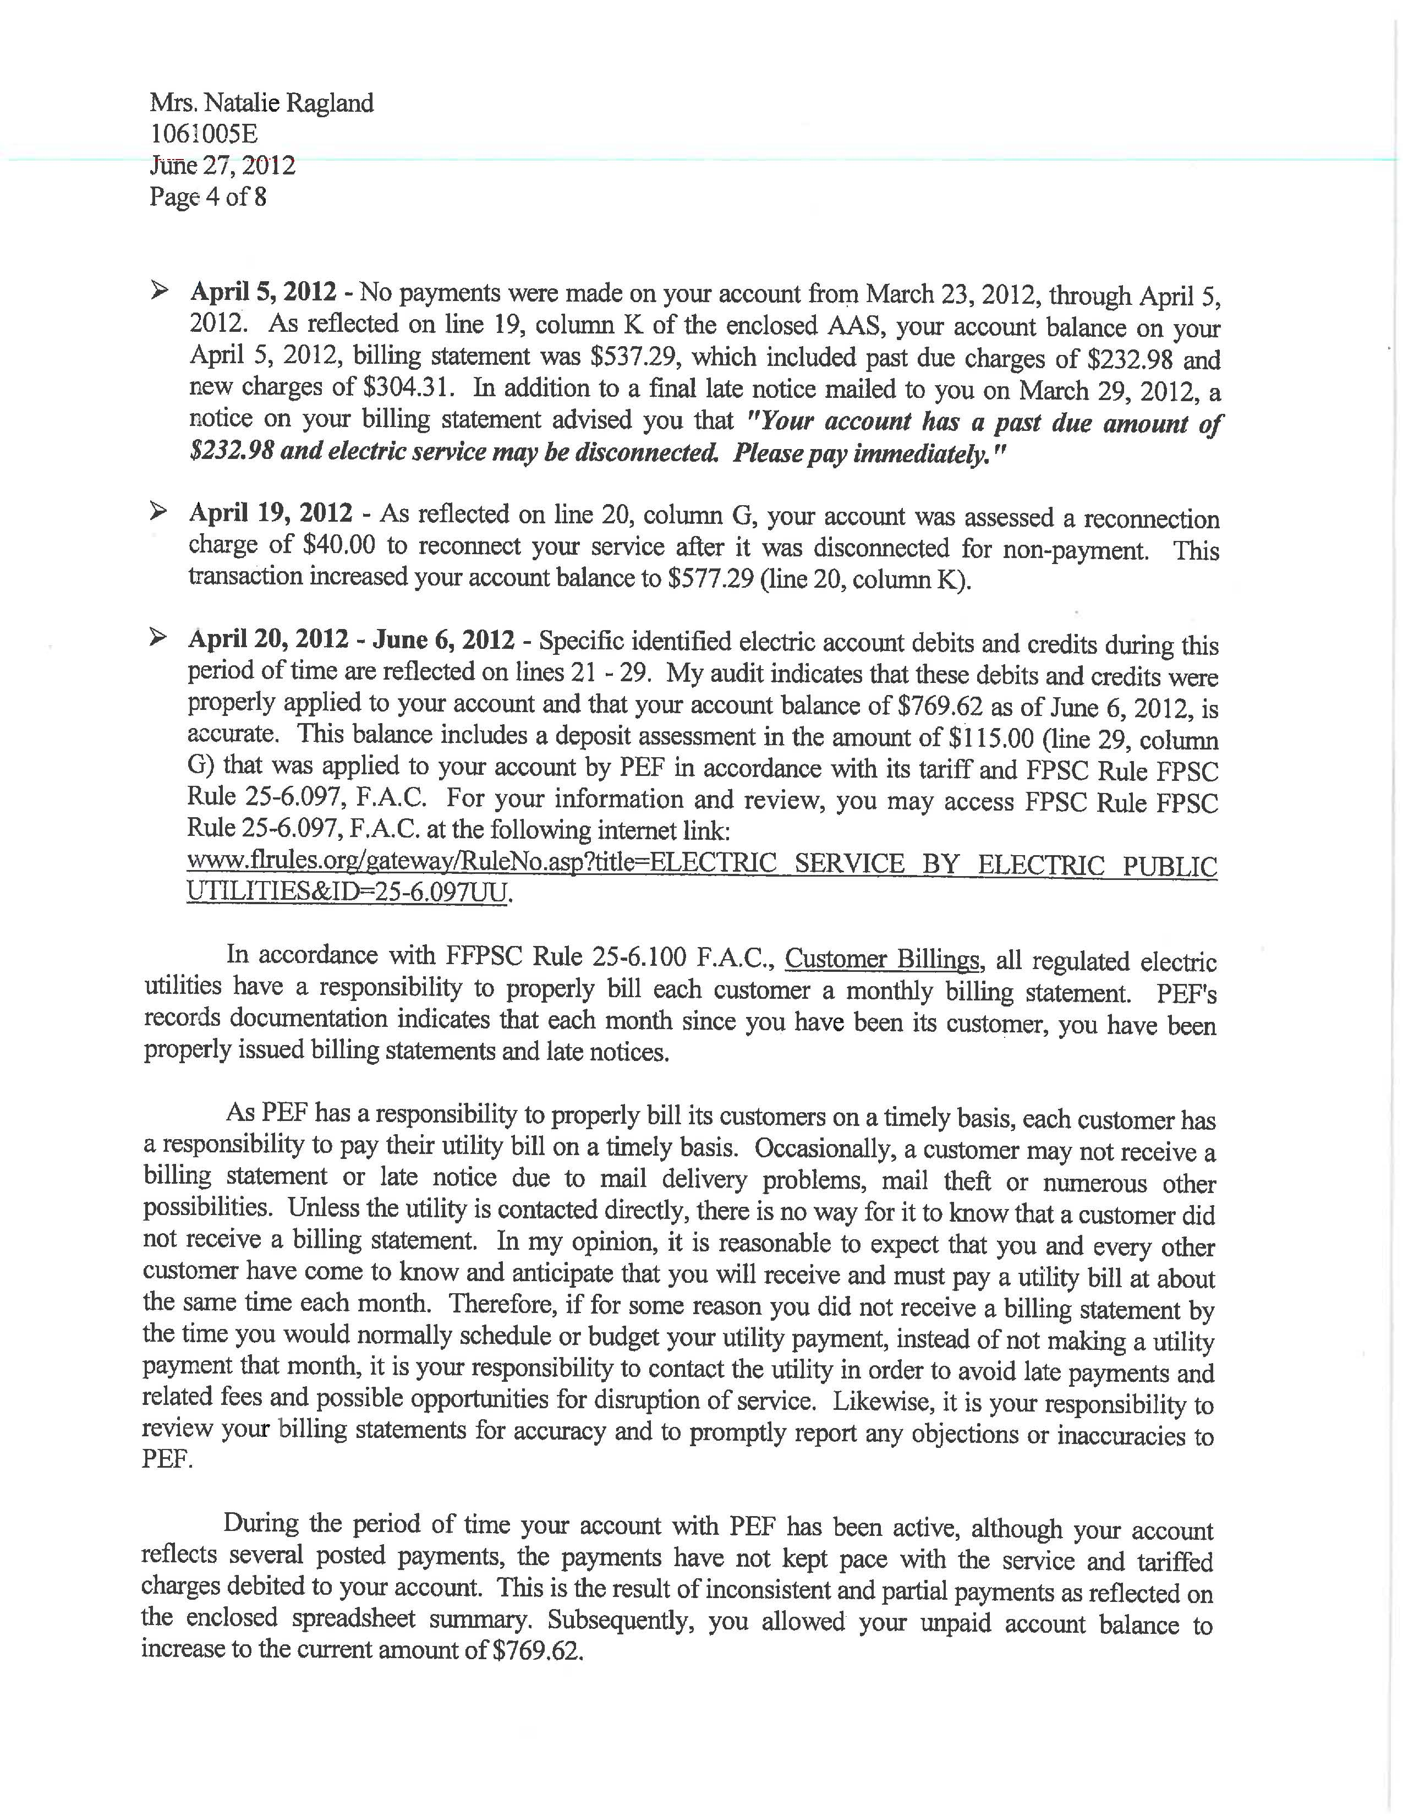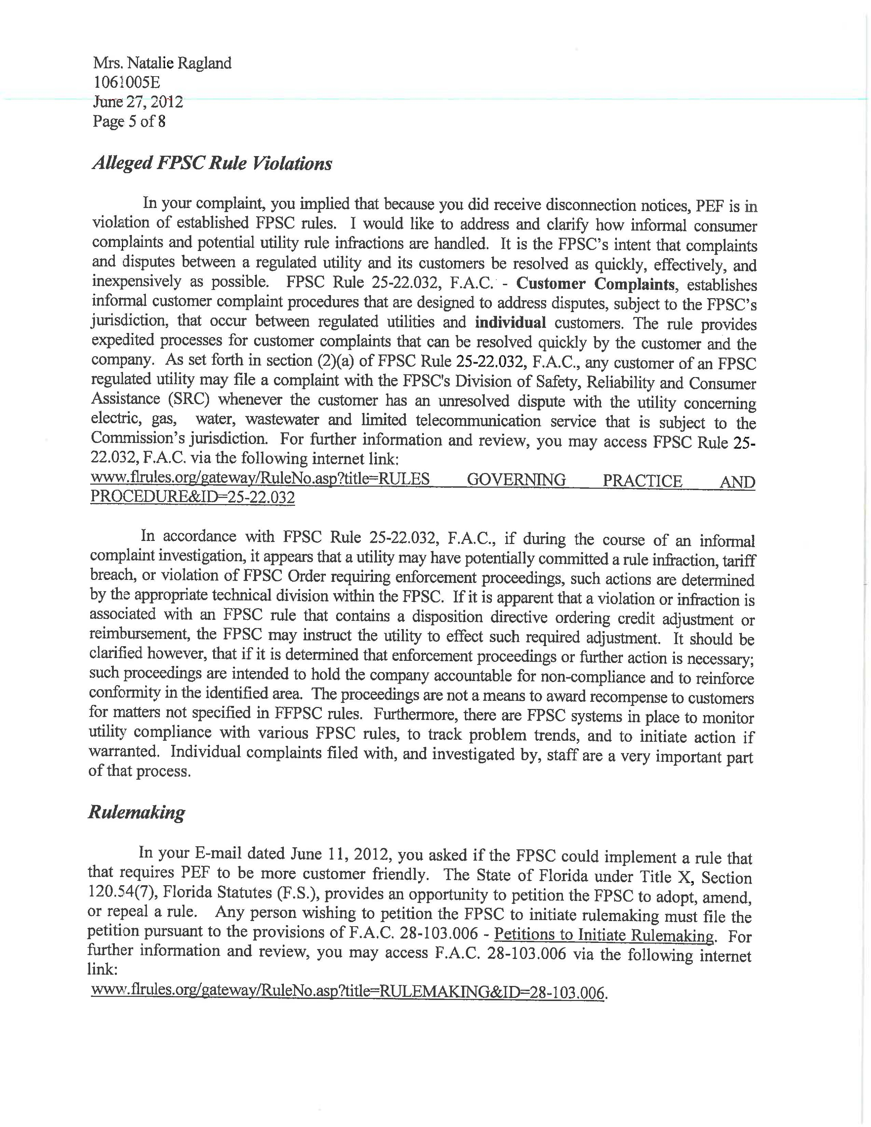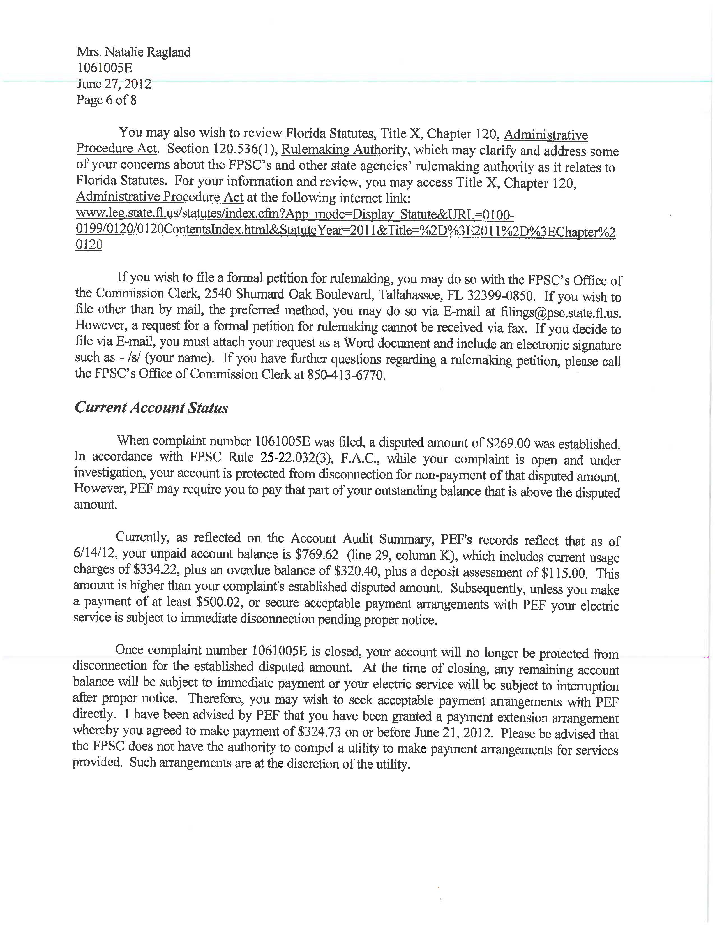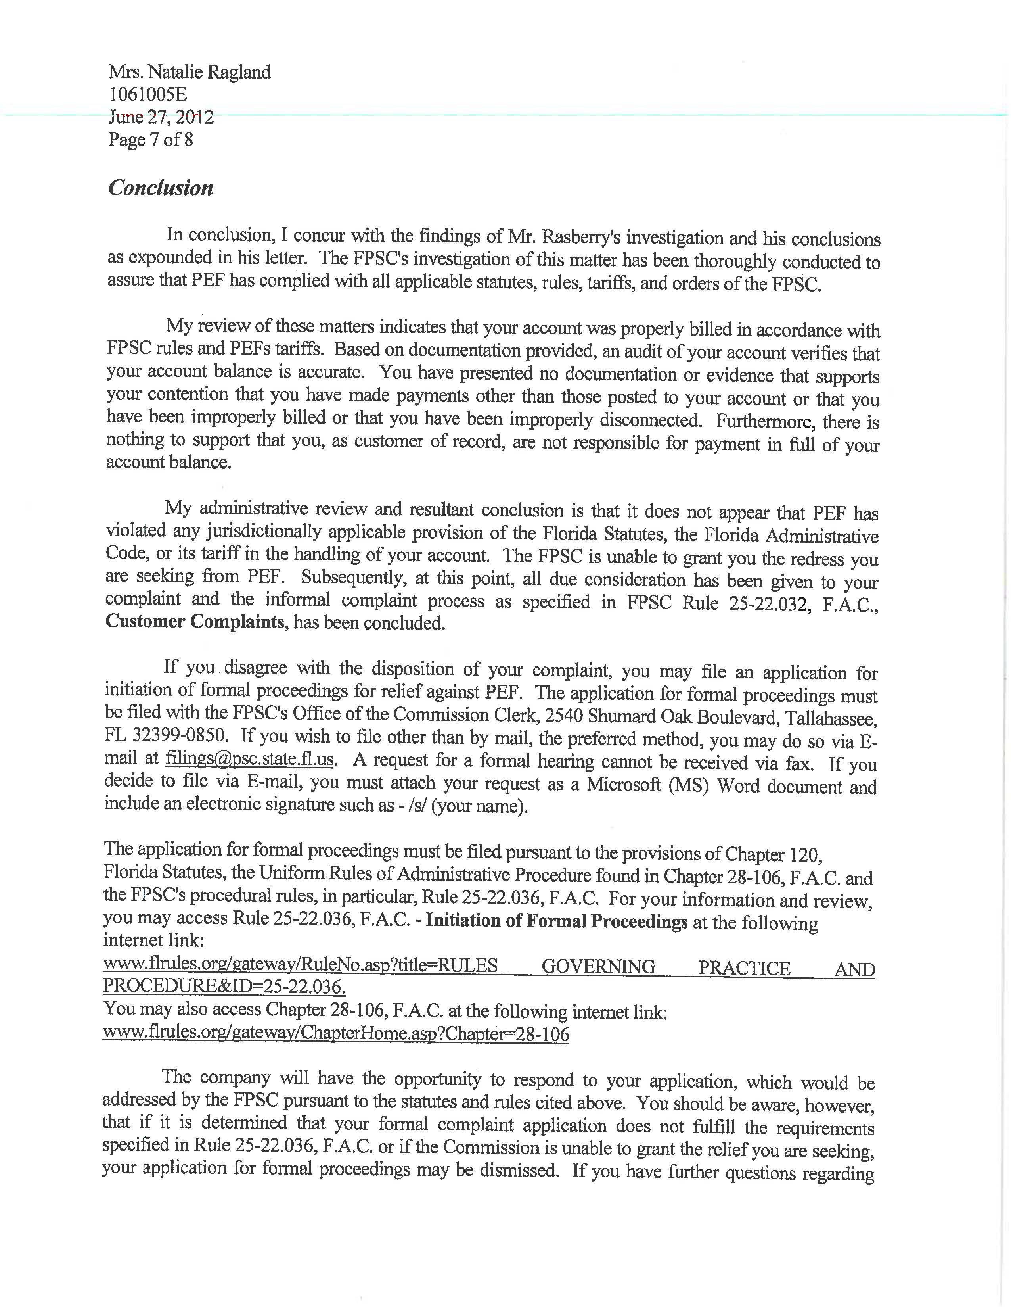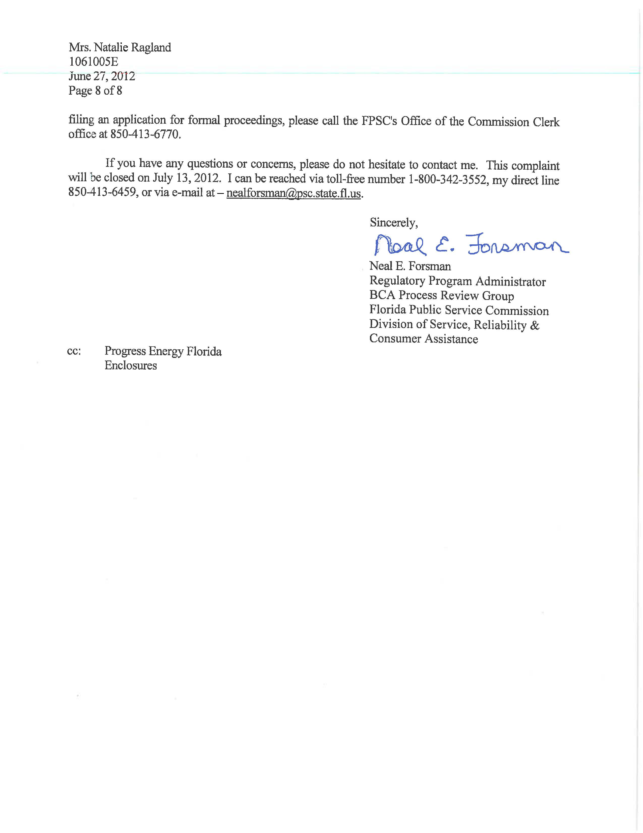

This informal complaint was assigned number 1061005E in the Commission’s Consumer Activity Tracking System (CATS).
These requirements include the requirements of Chapter 120, Florida Statutes, and rules contained in Chapters 28-106 and 25-22, Florida Administrative Code.
It is clear the Raglands made an error in referring to Progress Energy, Florida, Inc. incorrectly as “Progressive Energy.”
As stated in the Case Background, PEF’s Motion to Dismiss requests that the Raglands’ claims regarding payment arrangements and assistance, a home energy audit, and additional deposits should be dismissed. The Motion states that the Raglands’ claim regarding PEF’s alleged failure to provide a disconnection notice should be denied.
In addition to omitting a statement of the disputed issues of material fact, the Raglands have failed to provide a statement of the specific rules or statutes that they contend PEF violated, or any explanation of how their alleged facts relate to any specific rules or statute violations.
See Order No. PSC-07-0724-PCO-EQ, issued on September 5, 2007, in Docket No. 070234-EQ, In re: Petition for approval of renewable energy tariff standard offer contract by Florida Power & Light Company (dismissing the petition for failure to meet the pleading requirements contained in Rule 28-106.201, F.A.C.).
See, e.g. Order No. PSC-11-0117-FOF-PU, issued February 17, 2011, in Docket Nos. 100175-TL and 100312-EI, Complaint against AT&T d/b/a BellSouth for alleged violations of various sections of Florida Administrative Code, Florida Statutes, and AT&T regulations pertaining to billing of charges and collection of charges, fees, and taxes; In re: Complaint against Florida Power & Light Company for alleged violations of various sections of Florida Administrative Code, Florida Statutes, and FPL tariffs pertaining to billing of charges and collection of charges, fees, and taxes; Order No. PSC-02-1344-FOF-TL, issued October 3, 2002, in Docket No. 020595-TL, In re: Complaint of J. Christopher Robbins against BellSouth Telecommunications, Inc. for violation of Rule 25-4.073(1)(c), F.A.C., Answering Time; Order No. PSC-12-0252-FOF-EI, issued May 23, 2012, in Docket No. 110305-EI, In re: Initiation of formal proceedings of Complaint No. 1006767E of Edward McDonald against Tampa Electric Company, for alleged improper billing.

