BEFORE THE FLORIDA PUBLIC SERVICE COMMISSION

In re: Joint petition for approval of territorial agreement in Orange County by Peoples Gas System and The Lake Apopka Natural Gas District. | DOCKET NO. 130166-GU  ORDER NO. PSC-13-0345-PAA-GU  ISSUED: July 31, 2013

The following Commissioners participated in the disposition of this matter:

RONALD A. BRISÉ, Chairman
LISA POLAK EDGAR
ART GRAHAM
EDUARDO E. BALBIS
JULIE I. BROWN

NOTICE OF PROPOSED AGENCY ACTION
ORDER APPROVING TERRITORIAL AGREEMENT

BY THE COMMISSION:

NOTICE is hereby given by the Florida Public Service Commission that the action discussed herein is preliminary in nature and will become final unless a person whose interests are substantially affected files a petition for a formal proceeding, pursuant to Rule 25-22.029, Florida Administrative Code (F.A.C.).

BACKGROUND

On June 17, 2013, Peoples Gas System (Peoples) and the Lake Apopka Natural Gas District (Lake Apopka) filed a joint petition for approval of a territorial agreement in Orange County. Peoples is a public utility regulated by this Commission pursuant to Chapter 366, Florida Statues (F.S.). It provides natural gas to approximately 345,000 customers throughout the State of Florida, including customers in Orange County. Lake Apopka is an independent special district of the State of Florida created by the Legislature in 1959. It was created for the purpose of constructing and operating one or more natural gas transmission and distribution systems for its member municipalities of Apopka, Winter Garden, and Clermont, and also for the benefit of nearby municipalities and unincorporated areas and the public within the statutory area of service of the district. Lake Apopka is not a public utility as defined by Section 366.02(1), F.S., but it is a natural gas utility subject to our jurisdiction under Section 366.04(3), F.S., for the purpose of resolving territorial disputes and approving territorial agreements. We do not have jurisdiction over Lake Apopka’s rates and charges. Lake Apopka provides natural gas service to approximately 15,000 customers in Orange and Lake Counties.

In the 1990s, Peoples and Lake Apopka entered into transfer agreements which specified that Peoples would provide natural gas service to certain customers in Orange County, and that Lake Apopka would have an option to purchase the facilities when it was ready to provide such service. Upon Lake Apopka's purchase of the facilities, at their depreciated book value, the customers served by those facilities would be transferred to Lake Apopka. In July 2012, Peoples was notified that Lake Apopka wanted to acquire all the facilities installed by Peoples pursuant to the transfer agreements.

In order to complete the purchase and sale of the facilities, Peoples and Lake Apopka have entered into an Asset Purchase and Sale Agreement which provides for the transfer of the facilities as well as approximately 144 accounts that may receive natural gas service through those facilities from Peoples to Lake Apopka. Peoples and Lake Apopka seek our approval of the Territorial Agreement (Attachment A), which will become effective only upon the closing of the purchase and sale as outlined in the Asset Purchase and Sale Agreement. The map attached to the Agreement and Attachment B show the area in which the facilities to be transferred are located. We have jurisdiction over this matter pursuant to Section 366.04, F.S.

DECISION

Pursuant to Section 366.04(3)(a), F.S., we have jurisdiction to approve territorial agreements between and among natural gas utilities. Rule 25-7.0471(2), F.A.C., states that in approving territorial agreements, we may consider the reasonableness of the purchase price of any facilities being transferred, the likelihood that the agreement will not cause a decrease in the reliability of gas service to existing or future ratepayers, and the likelihood that the agreement will eliminate existing or potential uneconomic duplication of facilities. Unless we determine that the agreement will cause a detriment to the public interest, the agreement should be approved. Utilities Commission of the City of New Smyrna v. Florida Public Service Commission, 469 So. 2d 731 (Fla. 1985).
As stated above, based upon transfer agreements executed in the 1990s, the petitioners agreed that Peoples would provide natural gas service to certain customers in Orange County, and that Lake Apopka would have an option to purchase, at depreciated book value, the facilities installed to serve such customers when it was ready to provide such service. In July 2012, Lake Apopka notified Peoples that it was ready to purchase the facilities. The companies have now entered into an Asset Purchase and Sale Agreement which provides for the transfer from Peoples to Lake Apopka of the facilities as well as the approximately 144 accounts that receive natural gas service through those facilities. If approved, the territorial agreement would become effective upon the closing of the purchase and sale called for by the Asset Purchase and Sale Agreement.

The approximately 144 accounts that would be transferred from Peoples to Lake Apopka have been provided notice of the possible transfer. The notice informed customers that Lake Apopka will apply the same rates as charged by Peoples through September 30, 2014. The notice also provided a telephone number for customers to call for additional information. Prior to the notices being sent and Lake Apopka agreeing to charge the same rates as Peoples, a handful of customers had expressed opposition to being transferred based on the difference in rates between the two utilities. Our staff also spoke to one customer who expressed concern regarding the rate difference between the companies. However, since the notices have been sent, Lake Apopka and our staff have not received any calls or inquiries from customers. One residential customer contacted Peoples opposing the transfer.

Peoples and Lake Apopka represent that approval and implementation of the territorial agreement will not cause a decrease in the availability or reliability of natural gas service from either company, or to the existing or future ratepayers. In addition, they assert that approval of the territorial agreement by the Commission will assist in avoiding future uneconomic duplication of facilities by the parties, and will expedite the handling of applications for service by future potential natural gas customers. For these reasons they assert that the agreement is in the public interest.

It appears that the proposed agreement eliminates the potential uneconomic duplication of facilities and will not cause a decrease in the reliability of gas service. In addition, the purchase price of the facilities (at their depreciated book value) appears reasonable. Therefore, based on the above, we find that the proposed territorial agreement will not cause a detriment to the public interest and we approve it.

Based on the foregoing, it is

ORDERED by the Florida Public Service Commission that Joint petition for approval of territorial agreement in Orange County by Peoples Gas System and The Lake Apopka Natural Gas District is approved. It is further

ORDERED that the provisions of this Order, issued as proposed agency action, shall become final and effective upon the issuance of a Consummating Order unless an appropriate petition, in the form provided by Rule 28-106.201, Florida Administrative Code, is received by the Commission Clerk, 2540 Shumard Oak Boulevard, Tallahassee, Florida 32399-0850, by the close of business on the date set forth in the “Notice of Further Proceedings” attached hereto. It is further

ORDERED that in the event this Order becomes final, this docket shall be closed.

By ORDER of the Florida Public Service Commission this 31st day of July, 2013.

/s/ Ann Cole
ANN COLE
Commission Clerk
Florida Public Service Commission
2540 Shumard Oak Boulevard
Tallahassee, Florida 32399
(850) 413-6770
www.floridapsc.com

Copies furnished: A copy of this document is provided to the parties of record at the time of issuance and, if applicable, interested persons.

MCB

NOTICE OF FURTHER PROCEEDINGS OR JUDICIAL REVIEW

The Florida Public Service Commission is required by Section 120.569(1), Florida Statutes, to notify parties of any administrative hearing that is available under Section 120.57, Florida Statutes, as well as the procedures and time limits that apply. This notice should not be construed to mean all requests for an administrative hearing will be granted or result in the relief sought.

Mediation may be available on a case-by-case basis. If mediation is conducted, it does not affect a substantially interested person's right to a hearing.

The action proposed herein is preliminary in nature. Any person whose substantial interests are affected by the action proposed by this order may file a petition for a formal proceeding, in the form provided by Rule 28-106.201, Florida Administrative Code. This petition must be received by the Office of Commission Clerk, 2540 Shumard Oak Boulevard, Tallahassee, Florida 32399-0850, by the close of business on August 21, 2013.

In the absence of such a petition, this order shall become final and effective upon the issuance of a Consummating Order.

Any objection or protest filed in this/these docket(s) before the issuance date of this order is considered abandoned unless it satisfies the foregoing conditions and is renewed within the specified protest period.
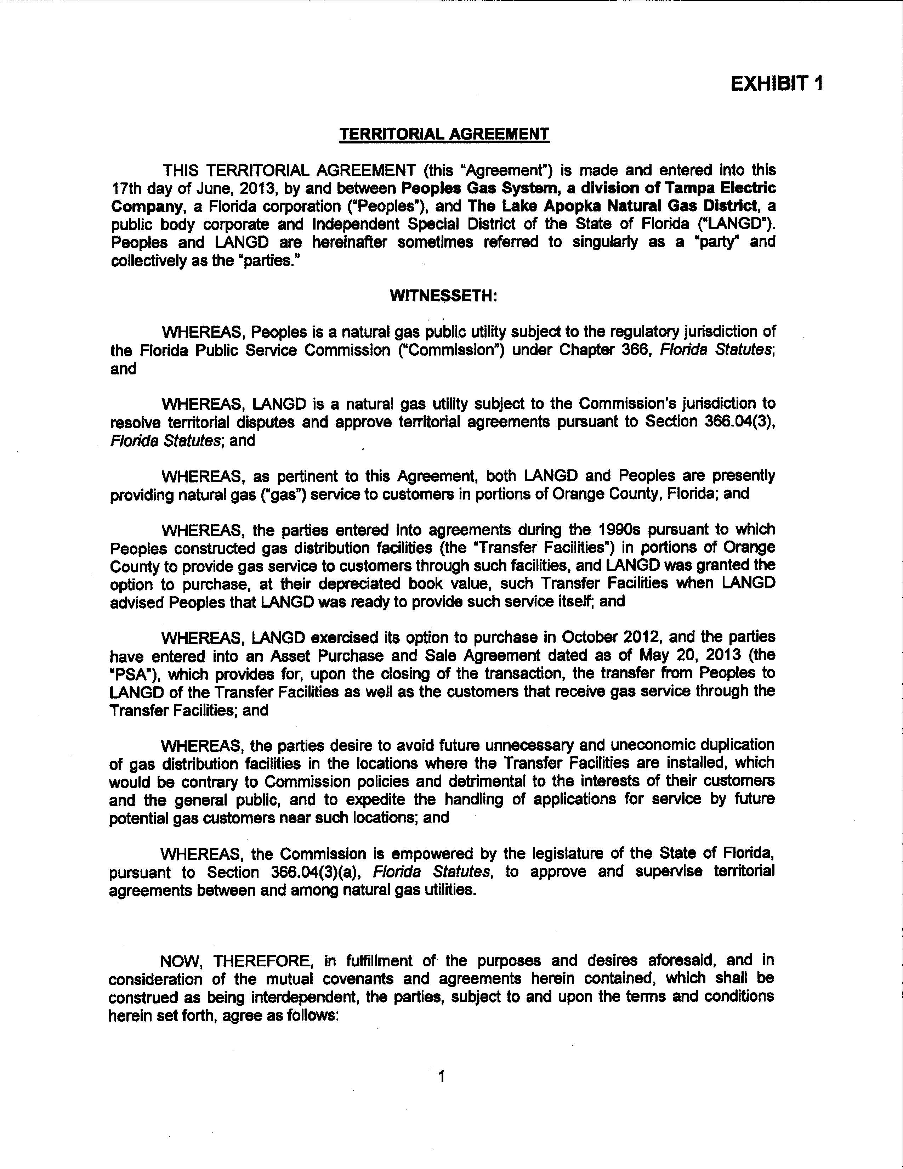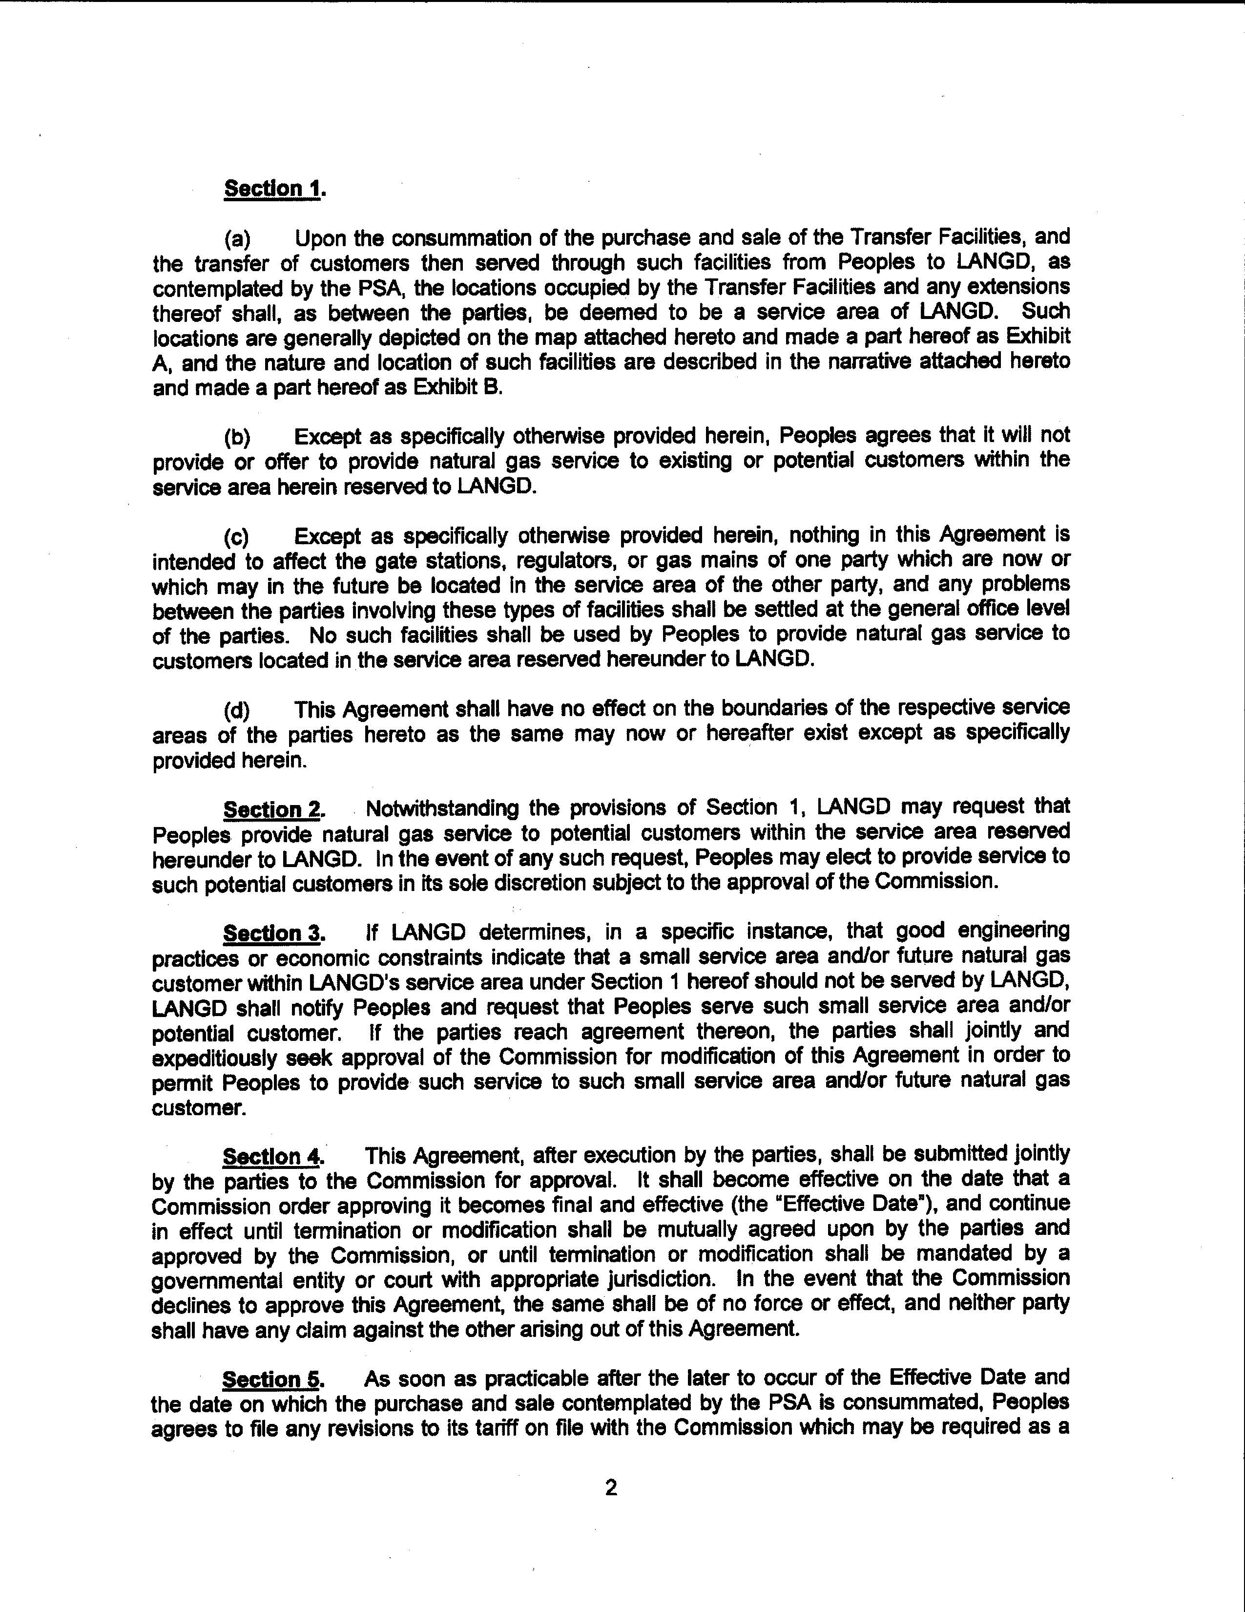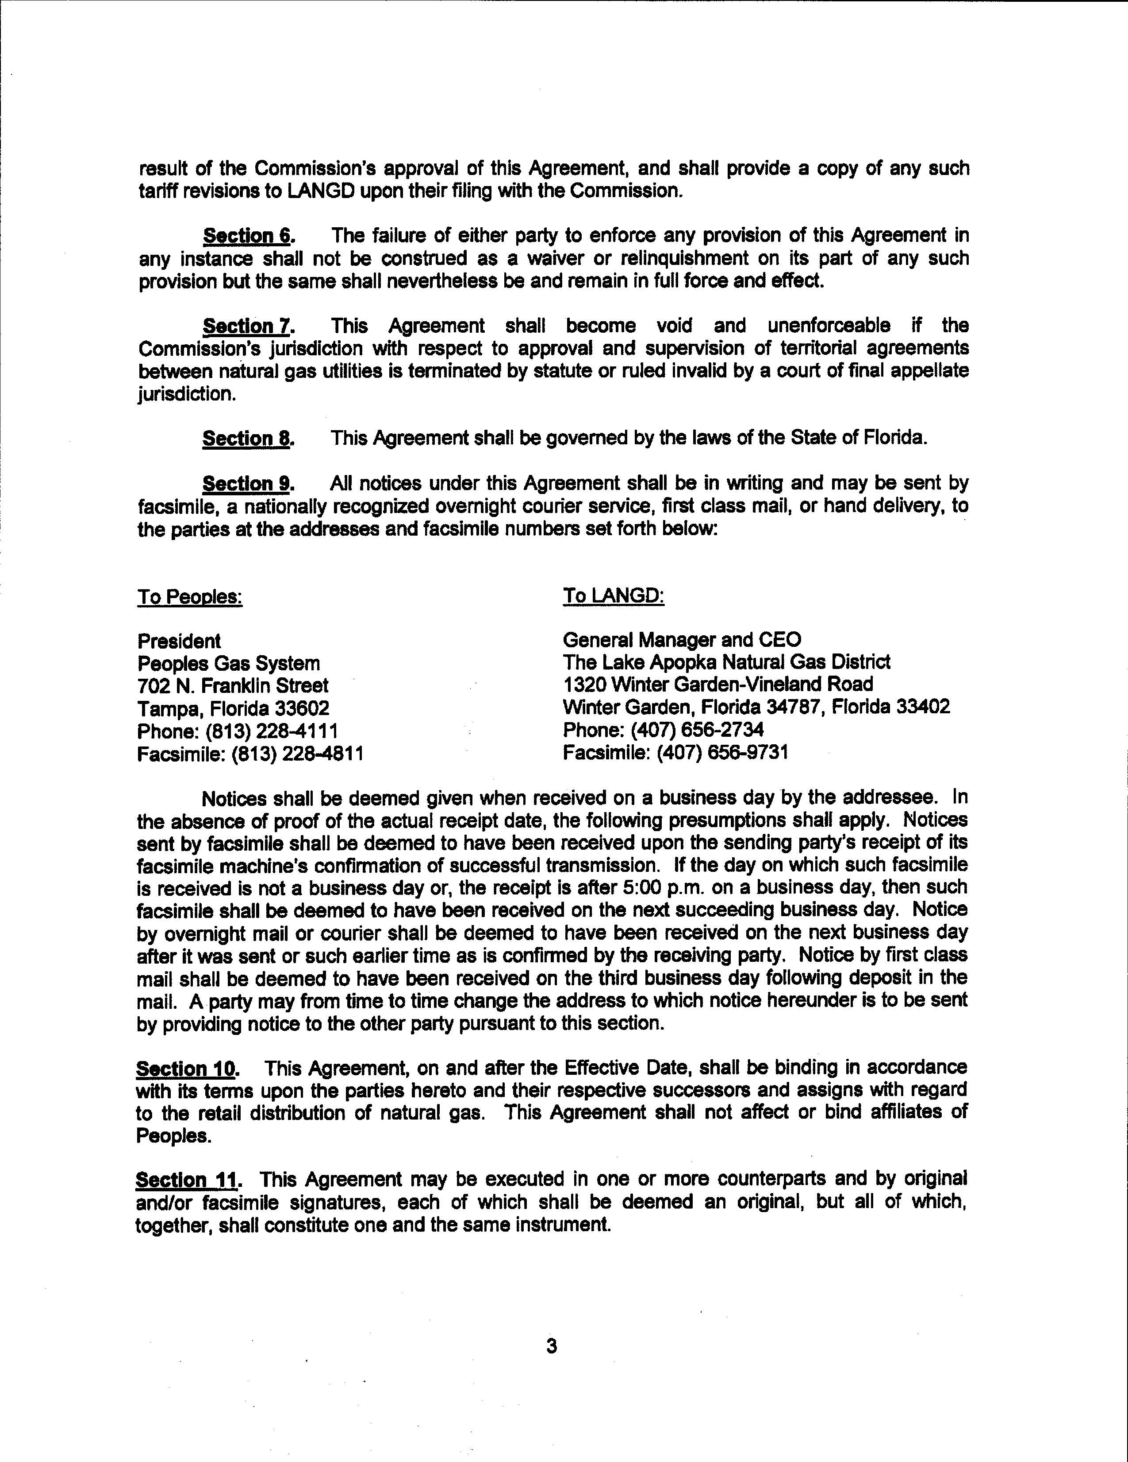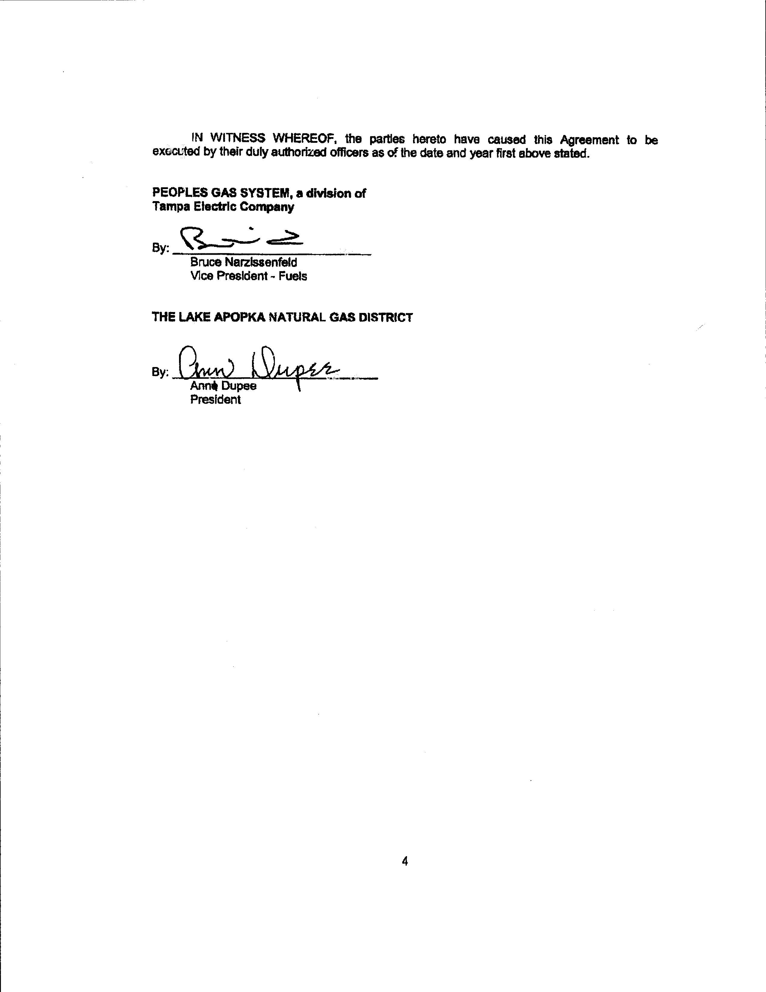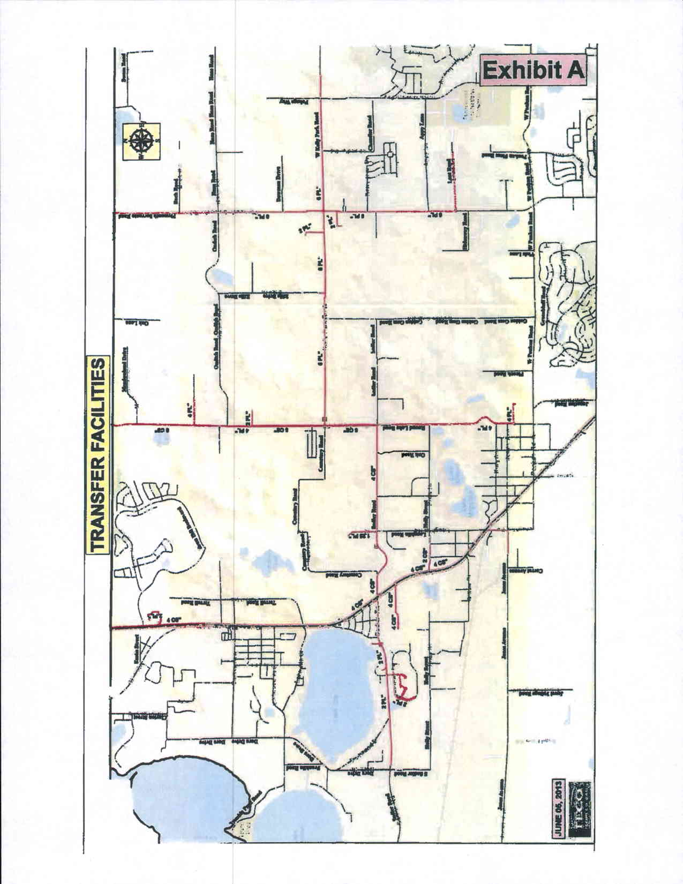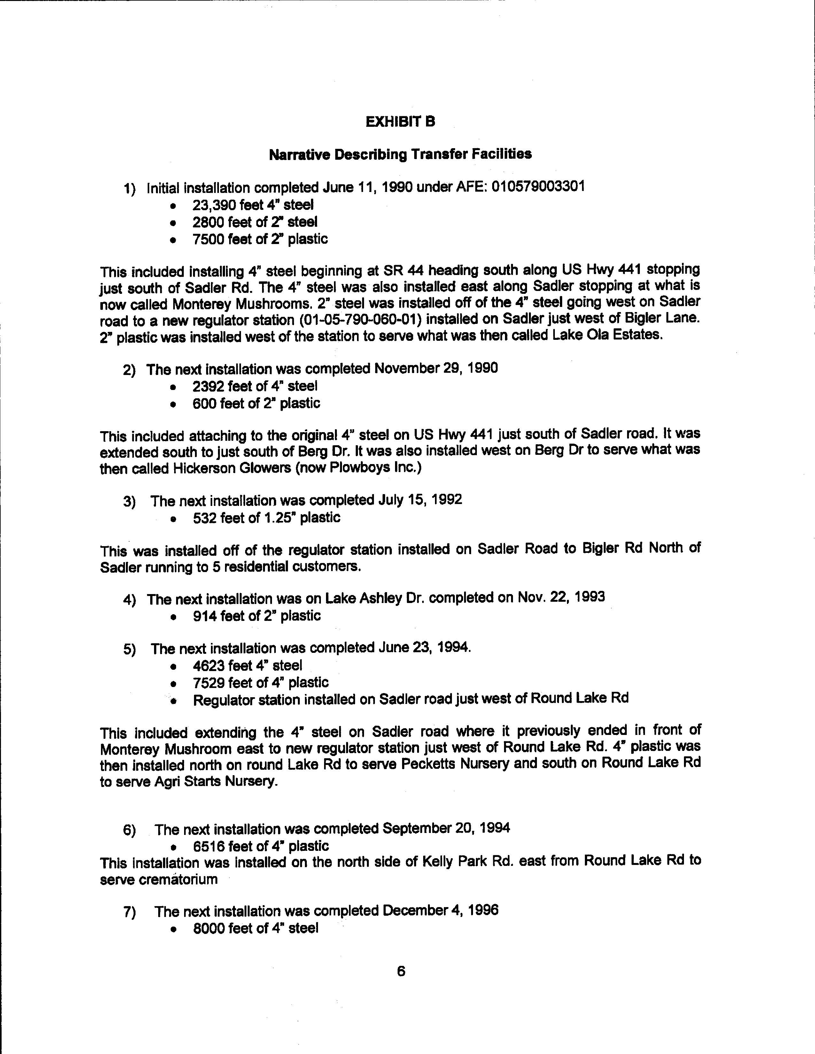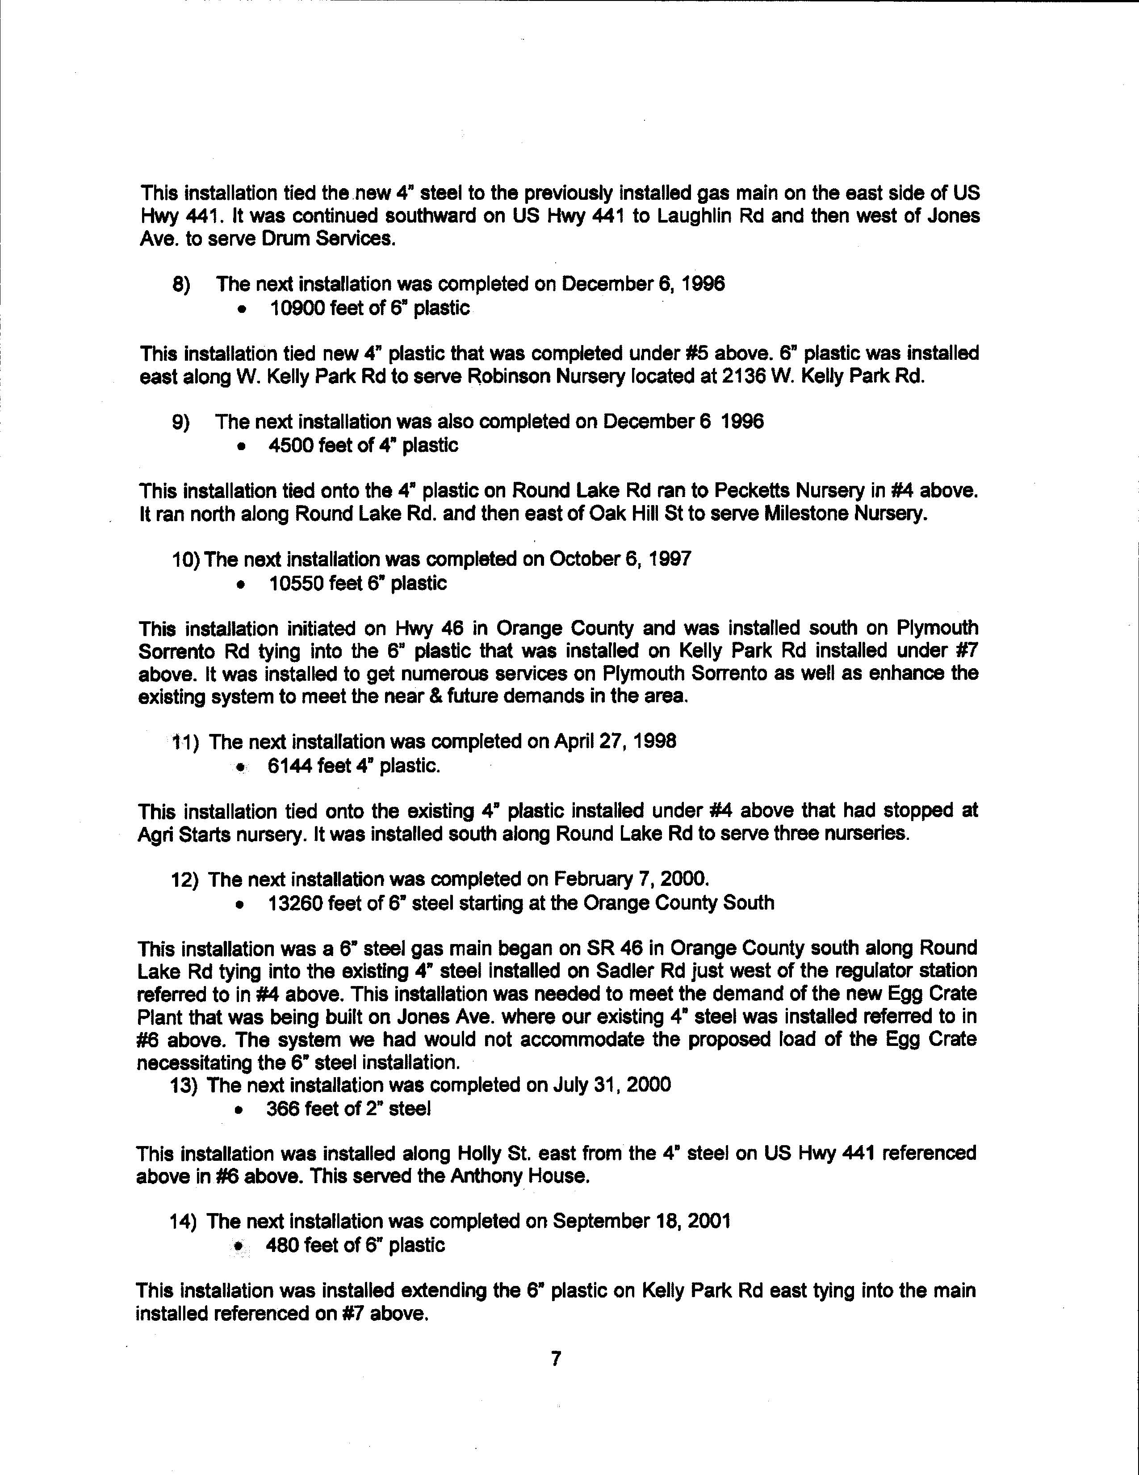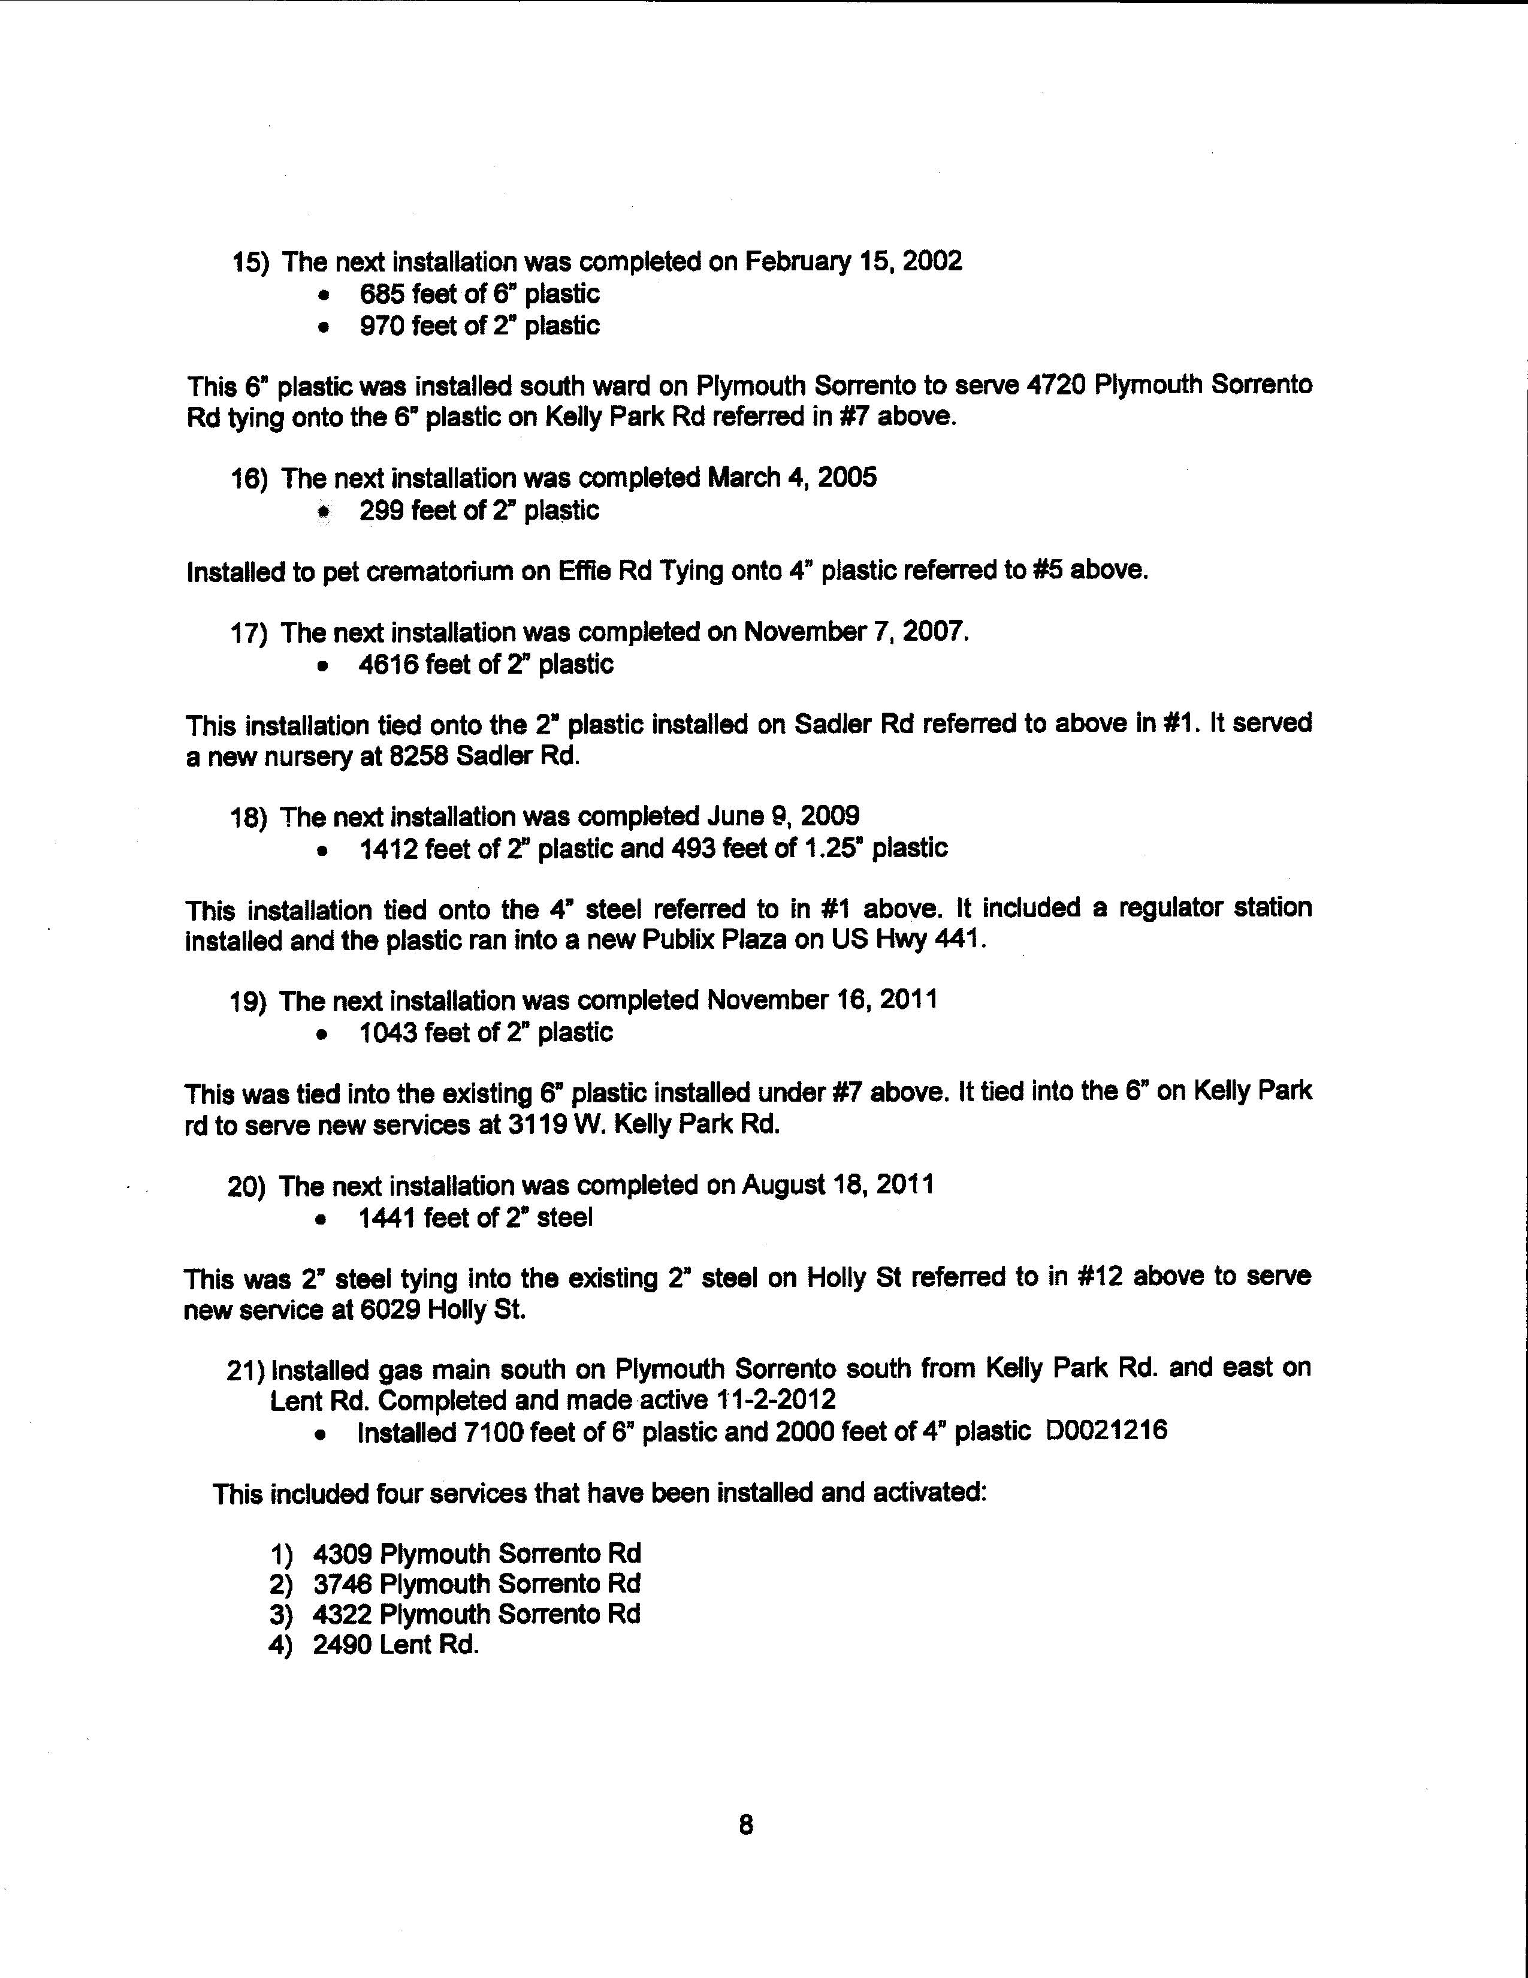
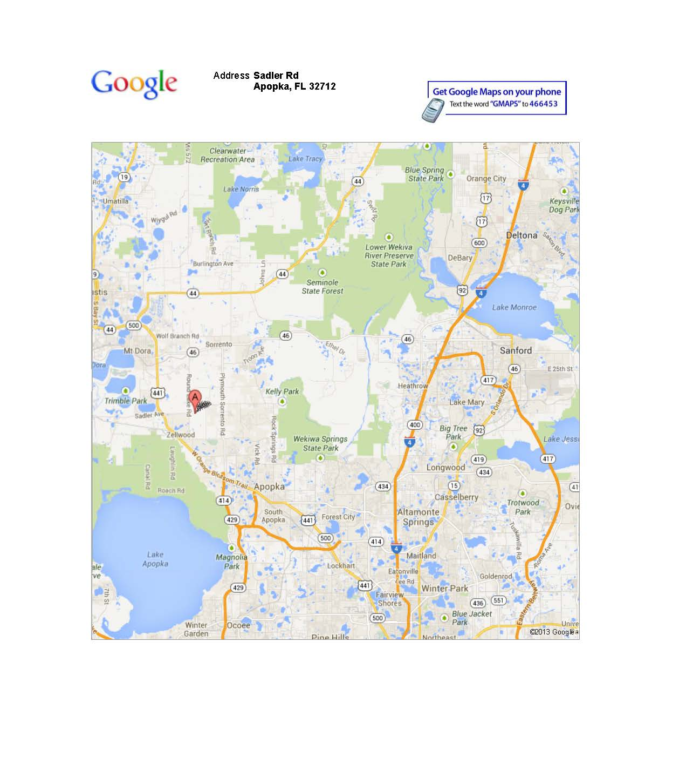

Of the 144 total accounts, 67 are residential and 77 are commercial. Not all of the 144 accounts are currently “active.”

