BEFORE THE FLORIDA PUBLIC SERVICE COMMISSION

In re: Petition for prudence determination regarding new pipeline system by Florida Power & Light Company. | DOCKET NO. 130198-EI  ORDER NO. PSC-13-0505-PAA-EI  ISSUED: October 28, 2013

The following Commissioners participated in the disposition of this matter:

RONALD A. BRISÉ, Chairman
LISA POLAK EDGAR
ART GRAHAM
EDUARDO E. BALBIS
JULIE I. BROWN

PROPOSED AGENCY ACTION ORDER ON FLORIDA POWER & LIGHT COMPANY’S PROPOSED SABAL TRAIL TRANSMISSION, LLC AND FLORIDA SOUTHEAST CONNECTION PIPELINES

BY THE COMMISSION:

NOTICE is hereby given by the Florida Public Service Commission that the action discussed herein is preliminary in nature and will become final unless a person whose interests are substantially affected files a petition for a formal proceeding, pursuant to Rule 25-22.029, Florida Administrative Code.

Case Background
On July 26, 2013, Florida Power & Light Company (FPL) filed its petition in this docket requesting a determination by the Florida Public Service Commission (Commission), that its decision to enter into long-term natural gas transportation contracts is prudent, and that the associated costs are eligible for recovery through the Fuel and Purchased Power Cost Recovery Clause (Fuel Clause). The petition included testimony from five witnesses, with exhibits outlining FPL’s need for additional firm natural gas transportation, a description of its request for proposals (RFP) process and the resulting contracts, and a request for approval of its planned cost recovery method. The petition was filed following FPL’s selection of two projects to develop new natural gas transportation infrastructure into southern Florida, offering the most cost-effective alternative for its customers. These projects are referred to individually in the petition as the Northern Pipeline Project and the Southern Pipeline Project. The two projects are wholly separate pipelines owned and operated by different entities, and therefore are referred to collectively as a matter of convenience.
The instant docket is the culmination of a process, which began in 2009 when FPL petitioned us to develop, build, and operate the Florida EnergySecure Line. On April 7, 2009, FPL filed its petition in Docket No. 090172-EI requesting a determination of need for its proposed Florida EnergySecure Line, a 280-mile long, 30-inch diameter high pressure natural gas transmission pipeline that FPL sought to own and operate primarily for supplying natural gas to its newly modernized Cape Canaveral and Riviera Beach generating units. By Order No. PSC-09-0715-FOF-EI, we denied the petition finding that FPL had failed to adequately demonstrate that its Florida EnergySecure Line was the most cost-effective alternative for providing additional natural gas transmission capacity. However, we agreed that additional gas capacity was necessary for assuring the reliability of Florida’s electric generating system in the future. In Order No. PSC-09-0715-FOF-EI, we stated, “we agree with the parties that increased gas transportation infrastructure is needed to meet future electricity needs, given the uncertainty surrounding both coal-fired and nuclear generation in the state.” Our Order directed FPL to “renew its request for proposals to fulfill its gas transportation capacity needs,” and further stated that the “new RFP shall contain a specific, detailed request for proposals for a new pipeline, and specifications of the long term natural gas needs of FPL.” In addition, the Order stated that “[t]he RFP shall be provided to our staff for review prior to its issuance to ensure it is clear and complete.”
FPL provided the RFP for review on November 13, 2012. A public meeting was held on November 26, 2012 so that our staff and any other interested parties could have an opportunity to discuss and review FPL’s RFP document prior to its issuance. In addition to our staff, representatives of the Office of Public Counsel (OPC) as well as potential project participants and other interested groups were present at the meeting. There were no objections to FPL issuing the RFP.
FPL issued its RFP on December 19, 2012. The RFP was noticed three times in Platt’s Gas Daily, a widely distributed industry publication. FPL provided an internet website where interested persons could gather information and ask questions. FPL also held a workshop to facilitate understanding of the RFP and the bidding process prior to the April 3, 2013 due date for responses. An additional meeting was held on June 13, 2013 to discuss the results of the RFP solicitation, FPL’s evaluation of the proposals, and the next steps to be taken in the process. Attendees included our staff, OPC, and representatives of the Florida Industrial Power Users Group (FIPUG). Based on discussion at the meeting, FPL provided an outline of topics that would be covered in the direct testimony filed with its petition.
FPL is not obligated by law to obtain our approval to enter into a long-term gas transportation contracts for the projects, as both contracts are governed by the Federal Energy Regulatory Commission (FERC). The contracts would only trigger our action at the time FPL seeks recovery of costs in the fuel clause proceeding. However, due to the substantial financial commitments involved, FPL is seeking our determination that FPL’s decision to enter into long-term gas transportation contracts is prudent and that the associated costs are eligible for recovery through the fuel clause. FPL included a provision in its precedent agreement with each pipeline that requires our approval of the agreements. The contracts may be terminated without financial penalty if we do not make a prudency determination satisfactory to FPL. We have jurisdiction over the subject matter by the provisions of Chapter 366, Florida Statutes.
- Additional Firm Natural Gas Transportation
Description of FPL’s Existing Pipeline Capacity
Peninsular Florida is currently served by only two major natural gas pipelines. Florida Gas Transmission Company, LLC (FGT) is the larger of the two pipelines with approximately 3,100 million cubic feet per day (MMcf/day) of total gas deliverability. The second of the two pipelines is owned by Gulfstream Natural Gas System, LLC (Gulfstream) and has a maximum 1,300 MMcf/day of gas deliverability. Currently, FPL has firm contracts with Gulfstream for 53 percent of the design capacity of its system which is 695 MMcf/day. By 2017, FPL will have firm transportation contracts with FGT for 41 percent of its design capacity, a total of 1,274 MMcf/day. The FGT capacity serves approximately 65 percent of FPL’s current total gas supply requirements, and Gulfstream serves the remaining 35 percent. However, FPL is not the only firm shipper for either system. The remaining capacity of Gulfstream is currently fully subscribed, and only 6 percent of FGT’s capacity (approximately 184 MMcf/day), will potentially be available on a long-term firm contractual basis within the 2017 time frame. Additional natural gas transportation capacity will be necessary as FPL’s and all of Florida’s electric generation systems continue to grow. Nearly 68 percent of the state’s electric generation, and more than 72 percent of FPL’s total energy, was fueled by natural gas in 2012.
In general, natural gas pipeline transportation capacity availability is firm or non-firm. Firm transportation capacity is acquired through a contract for reservation of a certain portion of a pipe’s daily throughput, which is continuously available to a utility to provide fuel for its generators. Utilities typically acquire non-firm transportation capacity by purchasing pipeline capacity that has been temporarily released by another customer, or by purchasing non-reserved capacity. Released capacity becomes available when another customer’s need for gas is below their reserved portion. However, this type of capacity cannot be relied upon as it is not guaranteed. If a sufficient supply of fuel is not available when required to meet load, a utility risks a situation where it may be unable to fully utilize its generating assets, and it could be forced to increase its use of more expensive alternative fuels, demand response, or even load shedding. For this reason, it is important for FPL to have adequate gas transportation capacity available on a firm basis.
Description of Proposed Pipeline Projects
In its petition, FPL states that 400 MMcf/day of additional firm natural gas transportation capacity is required beginning in 2017. The primary factors driving this increased need are the three modernization projects currently in progress at FPL’s Cape Canaveral, Riviera Beach, and Port Everglades natural gas plants to upgrade older, 1960’s-era steam combustion turbine generating units to modern, and more efficient combined cycle technology. FPL proposes to meet this need by implementing two new contracts for firm pipeline capacity within the northern and southern portions of the state.
The Northern Pipeline project consists of a joint venture between a subsidiary of Spectra Energy Corporation, called Sabal Trail Transmission, LLC (Sabal Trail) and a newly formed subsidiary of FPL’s parent company, Next-Era Energy, called U.S. Southeastern Gas Infrastructure LLC (USSGI). The Southern Pipeline project will be owned by another newly formed affiliate of FPL, called the Florida Southeast Connection (FSC). FPL has signed precedent agreements with these two companies for the initial 400 MMcf/day beginning in 2017, with options to provide additional increments of 200 MMcf/day in 2020 and beyond.
Our review of FPL’s need for additional natural gas transportation capacity began by analyzing its customer load forecast for the period 2013 through 2032. Then we evaluated the planned generation resource portfolio identified to meet customer demand and energy requirements. The resulting natural gas requirement was then compared to both existing pipeline resources and the proposed contracts with Sabal Trail and FSC. In addition to a review of the current proposal, we compared each of the current forecasts with those presented in the request for a determination of need for the Florida EnergySecure Line, which proposed a 600 MMcf/day pipeline with a 2014 in-service date.
Load Forecasting
The load forecast contained in FPL’s petition consists of two components: a base case forecast for both net energy for load (NEL) and summer peak demand, and a risk adjustment component for both NEL and summer peak demand that increases FPL’s base-case forecast in order to reduce the risk of under forecasting FPL’s future load growth.
FPL’s base case forecast for NEL and summer peak demand are based upon three econometric models: a customer forecast model, a net energy for load per customer model, and a summer peak demand per customer model. These three models are the same as those used by FPL in their normal annual planning cycle and are used to produce projections of anticipated load growth for FPL’s Ten-Year Site Plans (TYSPs) and other proceedings before the Commission. Our staff analyzed these models, including replicating the estimated model coefficients and associated statistics, and find them to be appropriate for forecasting purposes. Our staff also reviewed the forecast assumptions of anticipated economic and demographic conditions in FPL’s service territory. These assumptions are drawn from reputable independent third party sources, including the University of Florida’s Bureau of Economic and Business Research, the Florida Legislature’s Office of Economic and Demographic Research, and IHS Global Insight. We reviewed these forecast assumptions and find them to be appropriate. Finally, the forecast produced by these models are adjusted to incorporate the effects of incremental wholesale and retail contracts, as well as the incremental load resulting from electric plug-in vehicles and Economic Development and Existing Facility Riders, which are not otherwise included in FPL’s historical load levels.
The second component of FPL’s load forecast is a risk adjustment factor designed to reduce the risk of under forecasting future load growth. The company indicated in its petition that because FPL is so highly dependent on natural gas-fired generation, the company’s long term system reliability could be jeopardized if actual load growth exceeds forecasted growth. To quantify this risk of under forecasting, FPL analyzed the long term forecasts contained in its TYSPs from 1988 through 2012 and compared these forecasts to actual load growth. In particular, for each year of the ten-year forecast horizon contained in the TYSPs, FPL calculated the differences between the forecasted values of NEL and summer peak demand and their corresponding actual values. From these differences, FPL was able to calculate a confidence interval of forecast accuracy for each of the ten years in the forecast horizon. These ten confidence intervals allow FPL to calculate how much their base case forecasts must be increased so that there is a 75 percent probability that actual NEL and summer peak demand will be less than or equal to their risk-adjusted forecasts. For the forecasts beyond the ten-year forecast horizon covered by the Ten-Year Site Plans (years 2023 through 2032), FPL utilized a constant adjustment factor associated with the ten-year forecast horizon for its NEL and summer peak demand forecasts. We reviewed the data from which FPL derived its risk adjustment factors and confirmed that the data was correctly taken from prior TYSPs and that the resultant forecast errors, variances, and confidence intervals were appropriately calculated.
In its response to a data request regarding the use of the risk-adjusted forecasting methodology, FPL stated that this project is the first time it has built contingencies into its gas transportation forecasting. FPL responded that “[t]he recent growth in gas usage and FPL’s significant dependence on gas as a primary fuel dictate a measure of conservatism is employed in procuring gas transportation as we go forward.” FPL further explained that between 2010 and 2012, it exceeded its natural gas consumption forecasts generated that year by 114 MMcf/day, and anticipated this variation to increase to 140 MMcf/day in 2013.
Although we are unaware of any prior proceeding in which a risk-adjusted load forecast was utilized, we find that FPL’s risk adjustment methodology does reasonably account for and adjust for the risk of under forecasting future load growth. This finding is predicated on two factors. First, the specifications of FPL’s three forecasting models discussed above have not significantly changed since 1988. This fact implies that the forecast errors upon which the risk adjustment factors are based must be applicable to the current base case forecasts presented in FPL’s petition. Second, FPL’s methodology of basing the risk adjustment factors on historical forecast accuracy means that the risk adjustment factors include not only the modeling error (the error associated with reducing the complexities of consumer purchasing decisions regarding electricity to a relatively simple econometric model), but also the error associated with not being able to specify precisely what future economic/demographic conditions will prevail over the forecast period. FPL’s proposed risk-adjusted methodology appropriately accounts for both sources of error, and we find it is a reasonable approach for controlling the risk of under forecasting future load growth.
FPL’s choice of selecting a 75 percent confidence interval for its risk adjustment factor is somewhat subjective. For example, FPL could have selected a different confidence interval such as 67 percent confidence interval (with an attendant 33 percent chance of under forecasting), which would lower their risk adjusted forecasts. However, the intuitive appeal of FPL’s selection of a 75 percent confidence interval is that it does reduce by half the risk of under forecasting load growth compared to the base case forecasts.
Overall, FPL’s base case forecast for summer peak demand is down from that presented in the Florida EnergySecure Line proceeding. As illustrated in Figure 1, the base case forecast for summer peak demand in 2017 is 7.4 percent lower than the risk-adjusted forecast and 3.7 percent lower than the Florida EnergySecure Line forecast. By 2040, this gap increases to 13.0 percent for the risk-adjusted forecast and 6.3 percent for the Florida EnergySecure Line forecast.
Figure 1: Summer Peak Demand Forecasts (2013 – 2042)
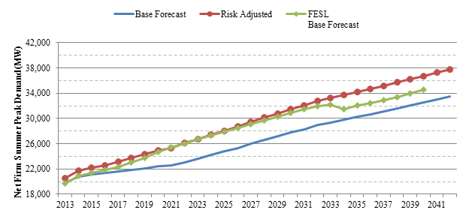

Generation Resource Portfolios
After forecasting the increased future system load, the next step in determining FPL’s future natural gas requirements was to develop projections of the generation resources that will be required to meet the increased load.
In its petition, FPL prepared two generation resource plans to analyze the effects of a potential delay in the construction of the new Turkey Point nuclear units 6 and 7 on natural gas requirements. The first (or base) case is consistent with FPL’s 2013 TYSP and assumes Turkey Point units 6 and 7 enter service in 2022 and 2023, respectively. The second case, called nuclear delay, assumes these two units come into service four years later, in 2026 and 2027. Outside of the ten-year planning horizon, the next planned generating unit is a 3x1 greenfield combined cycle unit, similar in size to the Cape Canaveral, Riviera Beach, and Port Everglades modernized units, with an in-service date of 2025. The nuclear delay case accelerates the need for this unit, moving its in-service date up to 2022. All further need for new generation is projected to be met by building smaller natural gas-fired combined cycle units. These ‘filler’ units appear for planning purposes, and do not represent any specific unit planned by FPL. We find the use of filler units and the proposed in-service dates for both cases to be reasonable and we expect the resource plans to meet reserve margin requirements over the period reviewed.
Table 1 illustrates the in-service dates of new generating units under both the base case and nuclear delay case scenarios.
Table 1: Generation Addition Forecasts (2013 – 2030)
Planned Generation Additions By Year
Year | Base Case | Nuclear Delay
2013 | Cape Canaveral | Cape Canaveral
2014 | Riviera Beach | Riviera Beach
2015
2016 | Port Everglades | Port Everglades
2017
2018
2019
2020
2021
2022 | Turkey Point unit 6 | 3x1 CC (1,269 MW)
2023 | Turkey Point unit 7
2024 |  | Filler CC (635 MW)
2025 | 3x1 CC (1,269 MW) | Filler CC
2026 | Filler CC (635 MW) | Turkey Point unit 6
2027 | Filler CC | Turkey Point unit 7
2028 | Filler CC
2029 | Filler CC | Filler CC
2030 | Filler CC | Filler CC
Natural Gas Transportation Requirement
As discussed above, additional natural gas transportation capacity will be necessary within the next few years as more natural gas-fired generating capacity is added. In 2012, FPL consumed more than 600,000 MMcf of natural gas. By 2017, this figure is expected to increase to at least 718,685 MMcf. The total percentage of FPL’s electric power generated by natural gas is expected to be somewhat lower in the next few years, due primarily to increased nuclear production from the recently completed uprate projects of FPL’s nuclear units. However, without having additional gas transportation infrastructure available in South Florida, FPL’s natural gas-fired generating units will not be able to serve its customers efficiently and reliably.
Using the forecast load cases and generation resource portfolios previously discussed, FPL was able to develop forecasts of the resulting natural gas requirements on both an annual and a peak day basis. As only a finite amount of gas can be transported during any one period and no significant storage capacity for natural gas exists at FPL’s plant sites, natural gas pipelines must be sized to meet peak daily loads.
FPL developed three forecasts for natural gas transportation requirements. We compared the first two forecasts by using the base generation resource plan with the base and risk-adjusted customer load forecasts. As a worst-case scenario for need, we compared the risk adjusted customer load forecast with the nuclear delay generation resource plan. These three scenarios were also compared to the Florida EnergySecure Line base forecast for natural gas requirements. Figure 2 details the peak day natural gas requirements for each of the scenarios.
Figure 2: Natural Gas Peak Day Requirements (MMcf/day)
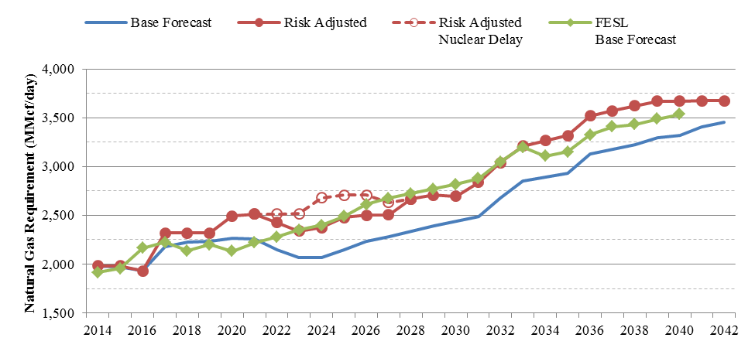
The base forecast projects a substantial increase in natural gas need in 2017 associated with the addition of the Port Everglades Energy Center and the loss of 375 MW of coal-fired capacity from St. John’s River Power Park. The base forecast then indicates a slow increase until 2022, when nuclear generation from Turkey Point unit 6 reduces the need for natural gas. The risk-adjusted case projects a similar trend but gas needs rise to a slightly higher level, about 250 MMcf/day above the base forecast. The risk-adjusted nuclear delay case illustrates the additional fuel that will be required if Turkey Point units 6 and 7 are delayed by four years. These two forecasts differ by up to 300 MMcf/day in 2024, but become equivalent again in 2028 when both new nuclear units are in-service. The Florida EnergySecure Line gas requirement was included as an additional comparison. The lower rate of natural gas demand for the years 2017 through 2021 seen in the Florida EnergySecure Line forecast is primarily due to the earlier in-service date for Turkey Point units 6 and 7 discussed previously. Excepting the earlier inclusion of nuclear generation, the trends for increasing gas requirements are similar.
As seen in each of these scenarios, FPL’s natural gas requirements exceed its existing firm contracted transportation capacity beginning in 2017. Figure 3 provides a closer look at the incremental firm natural gas transportation requirements for the period 2014 through 2030. The proposed contracts match the additional capacity required under the risk adjusted case, with the first optional incremental capacity addition in 2020 matching both risk adjusted cases. This increased gas requirement in 2020 is a result of all three modernization projects (Cape Canaveral, Riviera Beach, and Port Everglades) being online, as well as the loss of coal-fired generation at St. John’s River Power Park.
Figure 3: Incremental Firm Gas Transportation Requirements (MMcf/day)
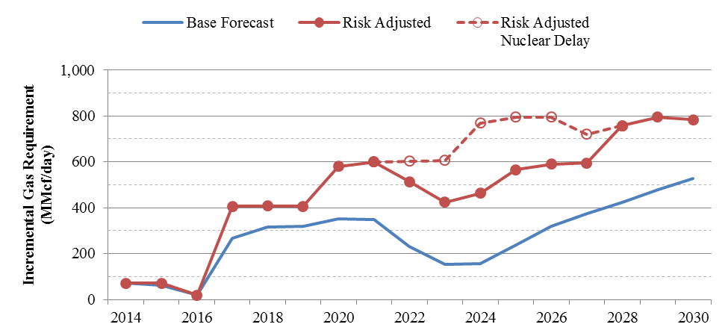
Decision
We reviewed FPL’s forecast for customer load, its proposed generation resource portfolios, and the comparison of its resulting natural gas requirements with its existing natural gas transportation contracted capacity. Based on this review, we find that FPL has adequately demonstrated a need for an additional 400 MMcf/day of firm natural gas transmission capacity by 2017.
- Most Cost-Effective Solution
Following the conclusion of the RFP process, FPL began the evaluation of the proposals it received as a result. In order to determine whether the projects selected by FPL were the most cost-effective, our staff reviewed the RFP and the selection process that resulted in FPL signing precedent agreements with Sabal Trail and FSC.
Evaluation of Project Proposals
The RFP requested that bidders provide proposals for 400,000 MMBtu/day (approximately equal to 400 MMcf/day) of firm gas transportation capacity in 2017 with an incremental 200,000 MMBtu/day of firm capacity in 2020. In addition, FPL requested that the bidders include an optional incremental capacity of up to 400,000 MMBtu/day beyond the 2020 time period. Bidders could submit pricing on either a fixed or an adjustable demand charge, although FPL expressed its strong preference for fixed pricing in order to obtain pricing security for its customers. Any adjustable pricing had to include a price cap in order to limit exposure to price index volatility.
FPL received four bids for the Northern pipeline and one joint bid for the Northern and Southern pipelines. No separate bids for the Southern portion were received. The entities submitting bids (some of which were joint proposals from companies bidding as partners) represent all active pipelines in the Southeastern U.S. FPL also considered three self-build alternatives for the Southern pipeline, consisting of three configurations of pipe diameters: all 30-inch pipe (labeled proposal Ai), a combination of 30-inch and 36-inch pipe (labeled proposal Aii), and all 36-inch pipe (labeled proposal Aiii). Although FPL had specified its strong preference for fixed pricing, all proposals except the self-build options were based on adjustable demand charges. However, to meet bid requirements, all adjustable pricing included a price cap. The joint proposal for the Northern and Southern pipelines had significant deficiencies, which the bidder elected not to modify, so FPL eliminated it from further consideration. This situation left four proposals for the Northern pipeline and the three FPL self-build options for the Southern pipeline.
Table 2 illustrates the combined project reference numbers assigned by FPL during its evaluation of the RFP responses. Each of the four proposals for the Northern pipeline were evaluated using the three configurations of the pipe diameters for the Southern pipeline (proposals Ai, Aii, and Aiii) and assigned reference numbers 1 through 12.
Table 2 – Combined Project Numbers
Combined Project | 1 | 2 | 3 | 4 | 5 | 6 | 7 | 8 | 9 | 10 | 11 | 12 | 13
Northern Proposal | 1 | 2 | 3 | 4 | 1 | 2 | 3 | 4 | 1 | 2 | 3 | 4 | 1
Southern Proposal | Aii (36”/30”) |  |  |  | Ai (30”) |  |  |  | Aiii (36”) |  |  |  | B
Combined project 13 consists of the Sabal Trail proposal for the Northern pipeline, and the non-compliant bid for the Southern pipeline. It is included for reference purposes only.
The economic evaluation was primarily concerned with a Cumulative Present Value of Revenue Requirements (CVPRR) analysis over a 40-year project term. This type of analysis required that the entire system (including a Northern and a Southern pipeline) be taken into consideration, so FPL created a matrix consisting of each of the four proposals for the Northern pipeline that met the minimum requirements paired with each of the three self-build options submitted by Next-Era Energy for the Southern system. In order to perform the analysis, FPL evaluated the economics of gas transportation using production-cost simulations of its power supply system, including the costs and volumes of gas.
Because only one proposal received for the Southern pipeline was not an FPL self-build option, in order to ensure that the gas transportation charges for the self-build project were reasonably consistent with market prices, FPL performed an economic analysis of the non-compliant proposal using the indicative, non-firm pricing included in that proposal. The result of this analysis was that the non-compliant bid would be between $69 and $105 million more expensive than the best of the three compliant proposals.
The simulation model used in the economic analysis employed the same risk-adjusted load forecast utilized for determining the incremental gas transportation capacity requirement. This analysis took into consideration the fixed and variable costs, as well as the volume and timing of the needed gas transportation. After quantifying fuel and other variable costs, a production-cost modeling program was run in order to determine the differences in the CPVRR for each combined project. The analysis was performed under two different generation resource planning scenarios. The first is the base resource plan, and the second is the nuclear delay resource plan. As previously discussed, the nuclear delay case assumes that the in-service dates of the Turkey Point units 6 and 7 will be delayed by four years, meaning the units will come online in 2026 and 2027 instead of 2022 and 2023, respectively.
The evaluation of FPL’s CVPRR analysis concluded that the combination of projects selected by FPL is indeed the most cost-effective. The magnitude of savings between the selected project’s cost and that of the other potential projects depends on which resource plan, load forecast, and gas price forecast is utilized in the analysis.
The smallest margin of savings between the selected project and the next-most cost-effective project is $34 million (using a 40-year term). This comparison is, however, made using the same Northern pipeline proposal paired with two of the FPL self-build options. In fact, the differences between each of the three FPL self-build options are small enough to be insignificant. When using only the FSC for the Southern pipeline, the net present value cost differential between Sabal Trail and the next best Northern pipeline is about $450 million for a 25-year term and about $580 million for a 40-year term. Although the results of the various economic analyses differ widely, the conclusion remains the same: the combination of the Sabal Trail and FSC project is clearly the best alternative in terms of cost.
Cost-Effectiveness of Proposals
Figure 4 shows the cost differentials between the selected combination of projects and the other combined projects for the period 2017 through 2057. The horizontal axis shows the combined project numbers from Table 2. This chart clearly shows the relatively small differences in cost between the three FPL self-build alternatives when compared to the differences between the four Northern project proposals. In general, most of the proposals are also slightly more cost-effective for the nuclear delay case, but the overall difference is small.
Figure 4: Comparison of the Cost-Effectiveness of the Combined Project Numbers
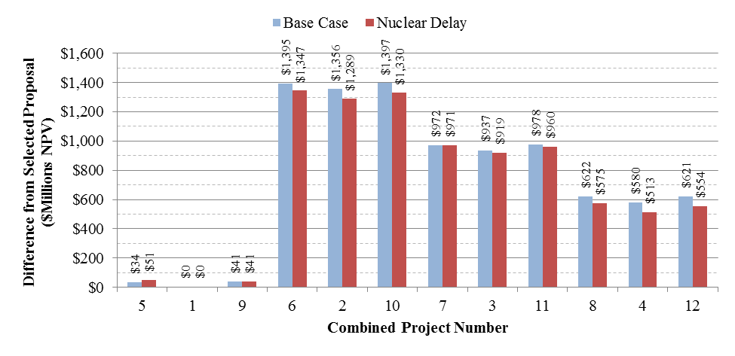
Source: FPL’s response to our staff’s second data request, no. 8
As illustrated above, the most cost-effective proposal is combined project 1, the proposed Sabal Trail and the FSC hybrid Aii combination. Using figures provided by FPL in a data request, we evaluated the savings for the various Northern pipeline proposals on an annual basis for the initial 25-year contract term, using the same FSC proposal for the southern segment. The baseline for the comparison is combined project 1. Positive values indicate higher costs, and negative values indicate savings. Only combined project 2 shows savings in any year when compared to combined project 1, but it is higher than the other two alternative proposals over the full contract term. Figure 5 shows the differences in total cost between combined projects 2, 3, and 4 using combined project 1 as a baseline.
Figure 5: Difference in Costs from Combined Project 1 Baseline
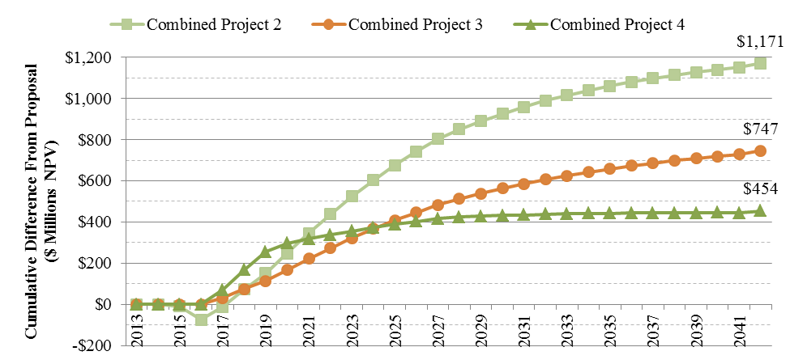
Source: FPL’s response to our staff’s second data request, no. 8
In addition to the economic evaluation, FPL also conducted a non-economic evaluation based on a comparative analysis of each project with respect to attributes that could not be measured in terms of cost. These attributes, while perhaps not as crucial in the overall evaluation, are also important components of the project and must therefore be taken into consideration. For example, a project that offers more opportunities for future expansion would offer a non-economic benefit. The selected Sabal Trail and FSC combined project meets FPL’s strong preferences for Greenfield infrastructure and increased diversity of natural gas supply. In addition, the throughput volumes of the selected projects are easily increased using compression. However, in light of the considerable margin of cost-effectiveness for the Sabal Trail and FSC combined project, the significance of any non-economic factors was minimal.
Description of the Proposed Pipeline System
The Sabal Trail and FSC projects will provide FPL with approximately 400 MMcf/day additional capacities beginning in 2017, with an expansion to 600 MMcf/day in 2020. Optional expansions, each for an incremental 200 MMcf/day, are available to FPL, but must be elected by 2020 and 2024, respectively. These additions would become available to FPL between four and five years after the options have been taken.
The commencement point specified for the Sabal Trail pipeline system is identical to that designated in FPL’s 2009 Florida EnergySecure Line project. Transcontinental Pipe Line Company’s Compressor Station 85 (“Transco Station 85”) in Choctaw County, Alabama provides access to non-traditional, onshore suppliers of natural gas, which is an important element to FPL because it introduces supply diversity into the system. Because FPL is currently served by only two natural gas companies, each of which provides gas mostly from Gulf of Mexico and Mobile, Alabama Bay area suppliers, gaining more diversity in its supply is an important component of the project and a primary concern to FPL.
The 2009 Florida EnergySecure Line project specified the “connection point” for the northern and southern parts of the system to be in Bradford County, Florida, near FGT Station 16. However, during the development of the RFP, several interested pipeline companies expressed the opinion that a better option was for a “hub” in the Orlando area due to the large potential customer base for contract opportunities. Therefore, in order to not only meet the primary goal of the RFP to fulfill FPL’s increased need for natural gas transportation capacity, but also to further increase the diversity of the supply and to promote competition among suppliers, the chosen termination point is what will become the Central Florida Hub (CFH). The CFH, which is part of the contract for the Sabal Trail pipeline and will be constructed and operated by the same provider, will be an interconnection point between the Northern and Southern pipelines as well as with existing Gulfstream and FGT systems. The CFH will include facilities needed to provide hub wheeling services to deliver contracted capacities interchangeably between and among each of the pipelines, which further increases the flexibility and possible diversity for all the gas shippers in the area.
The Southern pipeline commences at the CFH and terminates at the existing natural gas yard at FPL’s Martin Clean Energy Center (Martin), in Martin County, Florida. This terminus location allows for connectivity with the modernized generation plants at Cape Canaveral and Riviera Beach, and because both FGT and Gulfstream currently serve the Martin plant, the addition of the FSC will increase the supply alternatives available to FPL in the event of a pipeline disruption.
Cost Recovery
In response to its RFP, FPL received a total of four proposals for the Northern Pipeline Project and one joint proposal from two companies for the Southern Pipeline Project. Based on FPL’s economic and non-economic evaluations, the Sabal Trail proposal was selected for the Northern Pipeline Project and the FSC proposal for the Southern Pipeline Project. Next-Era Energy is an equity stakeholder in Sabal Trail, and has agreed to operate Sabal Trail as a joint venture between Spectra and a newly formed Next-Era Energy subsidiary called USSGI. Also, FSC is a wholly owned subsidiary of Next-Era Energy, and an affiliate of FPL. FPL does not anticipate any charges coming from USSGI associated with the Northern Pipeline Project. However, FPL stated in a data request response that any costs incurred by FPL for goods or services provided to USSGI or FSC, will be charged in accordance with FPL’s Cost Allocation Manual or through an Affiliate Management Fee, and would be subject to internal company review and audits to ensure compliance with Rule 25-6.1351 F.A.C. We have the authority to review any transactions with affiliated companies to ensure compliance with Rule 25-6.1351 F.A.C.
Based on Order Nos. 12645 and 14546, prudent and reasonable transportation charges incurred in the delivery of fuel are allowable expenses in the fuel and purchased power cost recovery clause. Therefore, pipeline charges associated with the delivery of natural gas to FPL’s generating stations are eligible for recovery through the fuel clause. While we find that this project is cost effective relative to alternatives, we retain authority to determine the prudent cost and reasonableness of expenses charged to the fuel clause and will review these expenses annually as part of the fuel clause proceedings.
In its response to a data request regarding its plans for dispensing of any unused gas, FPL stated that, in periods of idle capacity due to lower loads, it “can pursue opportunities to release capacity on the new pipelines (or to release capacity on FGT and/or Gulfstream) to other shippers. All revenues generated from the capacity release transactions would be credited back to the customers through the Fuel Clause.”
Decision
Upon review, FPL’s decision to enter into long-term natural gas transportation contracts with Sabal Trail and FSC was based on a fair and open RFP process. The contracts are projected to save up to $450 million over the term of the contracts when compared to the next most cost-effective proposal. We find that FPL is eligible to seek recovery of costs associated with the firm natural gas transportation contracts with Sabal Trail and FSC in the fuel clause, where they will be reviewed annually. The prudence of the actual transportation costs will be examined in the annual Fuel Docket proceedings.
Based on the foregoing, it is

ORDERED by the Florida Public Service Commission that Florida Power & Light Company has demonstrated a need for 400 MMcf/day of additional firm natural gas transmission capacity by 2017. It is further

ORDERED that Florida Power & Light is eligible to seek recovery of costs associated with firm natural gas transportation contracts in the fuel clause, where they will be reviewed annually. It is further

ORDERED that the provisions of this Order, issued as proposed agency action, shall become final and effective upon the issuance of a Consummating Order unless an appropriate petition, in the form provided by Rule 28-106.201, Florida Administrative Code, is received by the Commission Clerk, Division of the Commission Clerk, 2540 Shumard Oak Boulevard, Tallahassee, Florida 32399-0850, by the close of business on the date set forth in the “Notice of Further Proceedings” attached hereto. It is further
ORDERED that in the event this Order becomes final, this docket shall be closed.
By ORDER of the Florida Public Service Commission this 28th day of October, 2013.

/s/ Ann Cole
ANN COLE
Commission Clerk
Florida Public Service Commission
2540 Shumard Oak Boulevard
Tallahassee, Florida 32399
(850) 413-6770
www.floridapsc.com

Copies furnished: A copy of this document is provided to the parties of record at the time of issuance and, if applicable, interested persons.

TLT

NOTICE OF FURTHER PROCEEDINGS OR JUDICIAL REVIEW

The Florida Public Service Commission is required by Section 120.569(1), Florida Statutes, to notify parties of any administrative hearing that is available under Section 120.57, Florida Statutes, as well as the procedures and time limits that apply. This notice should not be construed to mean all requests for an administrative hearing will be granted or result in the relief sought.

Mediation may be available on a case-by-case basis. If mediation is conducted, it does not affect a substantially interested person's right to a hearing.

The action proposed herein is preliminary in nature. Any person whose substantial interests are affected by the action proposed by this order may file a petition for a formal proceeding, in the form provided by Rule 28-106.201, Florida Administrative Code. This petition must be received by the Office of Commission Clerk, 2540 Shumard Oak Boulevard, Tallahassee, Florida 32399-0850, by the close of business on November 18, 2013.

In the absence of such a petition, this order shall become final and effective upon the issuance of a Consummating Order.

Any objection or protest filed in this/these docket(s) before the issuance date of this order is considered abandoned unless it satisfies the foregoing conditions and is renewed within the specified protest period.

Order No. PSC-09-0715-FOF-EI, issued October 28, 2009, in Docket No. 090172-EI, In re: Petition to determine need for Florida EnergySecure Pipeline by Florida Power & Light Company, page 5.
Id., page 6.
Id., page 6.
See Document Number 05759-13, in Docket No. 130198-EI, FPL’s response to Staff’s Second Data Request, number 7, page 1 of 1, issued September 26, 2013.
The quantity “MMBtu/day” is equivalent to one million British thermal units of heat energy per day. Because FPL is ultimately concerned with the energy content of the gas, not the volumetric quantity, the contracts will be for units of MMBtu/day rather than MMcf/day (million cubic feet per day). Although the typical heat energy content of one cubic foot of natural gas is approximately one thousand Btus, consistent with industry practice FPL is requiring a quantity of energy to be delivered in its contracts to ensure the necessary amount of electric power can be generated.
Order No. 12645, issued November 3, 1983, in Docket No. 830001-EU, In re: Investigation of Fuel Adjustment Clauses of Electric Utilities.
Order No. 14546, issued July 8, 1985, in Docket No. 850001-EI, In re: Cost Recovery Methods for Fuel Related Expenses.
FPL’s response to Staff’s second data request, no. 5, filed on September 26, 2013.

