State of Florida   |  | Public Service Commission  Capital Circle Office Center ● 2540 Shumard Oak Boulevard  Tallahassee, Florida 32399-0850  -M-E-M-O-R-A-N-D-U-M-
DATE: | November 19, 2013
TO: | Office of Commission Clerk (Cole)
FROM: | Office of the General Counsel (Cowdery)  Division of Economics (Rome)  Office of Industry Development and Market Analysis (Breman, Futrell, Hinton, Laux, Lewis)
RE: | Docket No. 130222-EI – Proposed amendment of Rule 25-6.0423, F.A.C., Nuclear or Integrated Gasification Combined Cycle Power Plant Cost Recovery.
AGENDA: | 12/03/13 – Regular Agenda – Rule Proposal – Interested Persons May Participate
COMMISSIONERS ASSIGNED: |  |  | All Commissioners
PREHEARING OFFICER: |  |  | Edgar
RULE STATUS: |  |  | Proposal may be deferred
SPECIAL INSTRUCTIONS: |  |  | None
FILE NAME AND LOCATION: |  |  | S:\PSC\GCL\WP\130222.RCM.DOC

Case Background
Rule 25-6.0423, Florida Administrative Code (F.A.C.), adopted in 2007, establishes alternative cost recovery mechanisms for the recovery of costs incurred in the siting, design, licensing, and construction of nuclear or integrated gasification combined cycle power plants in order to promote electric utility investment in nuclear or integrated gasification combined cycle power plants and allow for the recovery in rates of all such prudently incurred costs. The rule implements Section 366.93, Florida Statutes (F.S.).
In 2013, the Legislature amended Section 366.93, F.S., which changed statutory provisions relating to permitted carrying costs; added restrictions on costs recovered during the license/certification application process; added requirements for obtaining Commission approval prior to commencing certain activities and making certain purchases; added requirements which apply if the utility has not begun construction within certain time frames after obtaining a combined operating license; and added requirements for the Commission’s determination of a utility’s intent to construct a power plant. These amendments are set forth in Chapter 2013-184, Laws of Florida, appended hereto as Attachment C. This rulemaking docket was opened to amend Rule 25-6.0423, F.A.C., in order to implement these Legislative changes.
The Notice of Rule Development was published in the August 28, 2013, Florida Administrative Register, Vol. 39/168. No rule development workshop was requested, and none was held.
This recommendation addresses whether the Commission should amend Rule 25-6.0423, F.A.C., to implement the 2013 amendments to Section 366.93, F.S. The Commission has jurisdiction pursuant to Sections 120.54 and 366.93(2), F.S.
Discussion of Issues
Issue 1:1
Should the Commission amend Rule 25-6.0423, F.A.C., Nuclear or Integrated Gasification Combined Cycle Power Plant Cost Recovery?
Recommendation:
Yes, the Commission should amend Rule 25-6.0423, F.A.C., as set forth in Attachment A.
Staff Analysis:
Staff recommends that Rule 25-6.0423, F.A.C., should be amended in order to implement the 2013 Legislative amendments to Section 366.93, F.S., as set forth in Attachment A. For clarity, unnecessary acronyms would be eliminated from paragraphs 25-6.0423(2)(h) and 25-6.0423(7)(b), F.A.C. Paragraph and statutory references throughout the rule would be renumbered and updated as appropriate, consistent with the 2013 Legislative amendments and these recommended rule amendments. Certain provisions of the rule would be amended to delete unnecessary, duplicative language or to clarify or update existing language. Staff’s recommended amendments to the rule are discussed in more detail below.

Recommended amendments to subsection 25-6.0423(2), F.A.C., Definitions
Staff recommends that subsection (2) of Rule 25-6.0423, F.A.C., Definitions, should be amended for consistency with the specific language of Section 366.93(1), F.S. The definition for “Carrying Costs” is added in order to streamline the rule by allowing the term to be used throughout the rule without needing additional clarification. The term incorporates the language of the 2013 amendment to Section 366.93(2)(b), F.S., which states that carrying costs must be equal to the most recently approved pretax AFUDC at the time an increment of cost recovery is sought. Existing subsections 25-6.0423(3), (5)(a), and (5)(b)1. and 2., F.A.C., would be amended consistent with this recommendation.
Recommended new subsection 25-6.0423(3), F.A.C.
Section 366.93(3), F.S., was substantially amended to require utilities to petition the Commission for approval before proceeding with pre-construction work beyond those activities necessary to obtain or maintain a license or certificate. In addition, after obtaining approval to proceed with postlicensure or postcertification pre-construction work, a utility must petition the Commission for approval of any preconstruction materials or equipment purchases that exceed 1 percent of the total projected cost for the project. Further, a utility must petition the Commission for approval before beginning the construction phase. In order to implement these statutory changes, staff recommends that a new subsection (3) be added to the rule to provide that after the Commission has issued a final order granting a determination of need for a power plant, a utility may file a petition for Commission approvals pursuant to Section 366.93(3), F.S., in the annual nuclear or integrated gasification combined cycle cost recovery proceeding or in a separate proceeding limited in scope to address only the petition for approval.
Recommended amendments to subsection 25-6.0423(5), F.A.C., Pre-Construction Costs and Carrying Costs on Construction Cost Balance
Paragraph (a) of subsection 25-6.0423(5), F.A.C., addresses pre-construction costs, paragraph (b) addresses carrying costs on construction balance, and paragraph (c) addresses cost recovery for nuclear or integrated gasification combined cycle power plant costs. Staff recommends that the title to existing paragraph 25-6.0423(5)(c) be changed for accuracy to refer to “Cost Recovery” rather than “Capacity Cost Recovery Clause” because the filings identified in that paragraph are made in the separate nuclear cost recovery clause proceeding and not in the capacity cost recovery clause proceeding.
As part of this rulemaking, staff is recommending that subsection (5) be streamlined by eliminating duplicative language. Subparagraph 25-6.0423(5)(c)4., F.A.C., provides that the final true-up for the previous year, actual/estimated true-up for the current year, and subsequent year’s projected power plant costs as approved by the Commission pursuant to subparagraph (5)(c)2. will be included for cost recovery purposes as a component of the following year’s capacity cost recovery factor in the fuel and purchased power cost recovery clause. This language is duplicated in subparagraphs 25-6.0423(5)(a)2. and (c)3., F.A.C. Because this duplication is unnecessary, staff recommends deleting subparagraphs 25-6.0423(5)(a)2. and (c)3., F.A.C.
Prior to the 2013 Legislative amendments, Section 366.93(2)(b) stated that for nuclear or integrated gasification combined cycle power plant need petitions submitted on or before December 31, 2010, associated carrying costs were required to be equal to the pretax AFUDC in effect upon the act becoming law (June 12, 2007). Section 366.93(2)(b) further stated that for nuclear or integrated gasification combined cycle power plants for which need petitions are submitted after December 31, 2010, the utility’s existing pretax AFUDC rate was presumed to be appropriate unless determined otherwise by the Commission in the determination of need for the nuclear or integrated gasification combined cycle power plant. The 2013 Legislative amendments deleted reference to the December 31, 2010 threshold date, along with references to the AFUDC rate applied based upon that threshold. Staff recommends that subparagraphs 25-6.0423(5)(b)1. and 2., F.A.C., should be deleted as obsolete because those subparagraphs are based on the Section 366.93(2)(b), F.S., language deleted by the 2013 Legislature.
Staff recommends that subparagraph 25-6.0423(5)(c)1., F.A.C., be amended for clarity to provide that each year, pursuant to the order establishing procedure in the annual cost recovery proceeding, a utility shall submit the filings described in subparagraph (5)(c)1.a. and b. for Commission review and approval as part of its cost recovery filings. In addition, staff recommends deletion of the due dates for each filing identified in subparagraphs (5)(c)1., 4. and 5., and the hearing date deadline and 15-day deadline for the Commission order identified in subparagraph (5)(c)2. Deletion of these provisions would update the rule to provide flexibility to the Commission for establishing the docket schedule. Further, staff recommends that reference to the annual prudence determination, found in subparagraph (5)(c)2., be deleted as unnecessary because it is duplicative of other language found in that subparagraph.
Section 366.93(3)(f)3., F.S., was added by the 2013 Legislature and states that beginning January 1, 2014, in making its determination for any cost recovery under this paragraph, the Commission may find that a utility intends to construct a nuclear or integrated gasification combined cycle power plant only if the utility proves by a preponderance of the evidence that it has committed sufficient, meaningful, and available resources to enable the project to be completed and that its intent is realistic and practical. To implement this new statutory provision, staff recommends that subparagraph 25-6.0423(5)(c)5., F.A.C., be amended to provide that the annual utility-filed analysis of the long-term feasibility of completing the power plant shall include evidence that the utility intends to construct the nuclear or integrated gasification combined cycle power plant by showing that it has committed sufficient, meaningful, and available resources to enable the project to be completed and that its intent is realistic and practical. The showing of intent language would be included in subparagraph (5)(c)5. because it best fits within the pre-existing consideration of long-term feasibility.
Statement of Estimated Regulatory Costs
Pursuant to Section 120.54, F.S., agencies are encouraged to prepare a statement of estimated regulatory costs (SERC) before the adoption, amendment, or repeal of any rule. The SERC is appended as Attachment B. The SERC analysis includes whether the rule amendment is likely to have an adverse impact on growth, private sector job creation or employment, or private sector investment in excess of $1 million in the aggregate within five years after implementation.
The SERC concludes that the amendment of Rule 25-6.0423, F.A.C., will likely not directly or indirectly increase regulatory costs in excess of $200,000 in aggregate in Florida within one year after implementation. Further, the SERC concludes that the rule amendment will not likely have an adverse impact on economic growth, private-sector job creation or employment, private-sector investment, business competitiveness, productivity, or innovation in excess of $1 million in the aggregate within five years of implementation. Thus, the rule amendment does not require legislative ratification pursuant to Section 120.541(3), F.S. In addition, the SERC states that amendment of Rule 25-6.0423, F.A.C., would not have an adverse impact on small business, and would have no impact on small cities or small counties.
The SERC notes that the purpose of the recommended amendments to Rule 25-6.0423, F.A.C., is to implement the changes made to Section 366.93, F.S., passed during the 2013 legislative session by Chapter 2013-184, Laws of Florida, and that, therefore, any economic impacts that might be incurred by affected entities would be as a result of changes to Section 366.93, and would not be caused by the recommended rule amendments. Staff recommends that Rule 25-6.0423 should be amended as set forth in Attachment A.
Issue 2:2
Should this docket be closed?
Recommendation:
Yes. If no requests for hearing or comments are filed, the rule should be filed with the Department of State, and the docket should be closed. (Cowdery)
Staff Analysis:
If no requests for hearing or comments are filed, the rule should be filed with the Department of State, and the docket should be closed.

25-6.0423 Nuclear or Integrated Gasification Combined Cycle Power Plant Cost Recovery.
(1) Purpose. The purpose of this rule is to establish alternative cost recovery mechanisms for the recovery of costs incurred in the siting, design, licensing, and construction of nuclear or integrated gasification combined cycle power plants in order to promote electric utility investment in nuclear or integrated gasification combined cycle power plants and allow for the recovery in rates of all such prudently incurred costs.
(2) Definitions. As used in this rule, the following definitions shall apply:
(a) “Nuclear power plant” is an electrical power plant which that utilizes nuclear materials as fuel, as defined in Sections 403.503(13) and 366.93(1)(c), F.S.
(b) “Integrated gasification combined cycle power plant” is an electrical power plant which that uses synthesis gas produced by integrated gasification technology, as defined in Sections 403.503(14)(13) and 366.93(1)(c), F.S.
(c) “Power plant” or “plant” means a nuclear power plant or an integrated gasification combined cycle power plant.
(d) “Cost” includes, but is not limited to, all capital investments including rate of return, any applicable taxes, and all expenses, including operation and maintenance expenses, related to or resulting from the siting, licensing, design, construction, or operation of the nuclear power plant, including new, expanded, or relocated electrical transmission lines or facilities of any size which are necessary thereto, or of the integrated gasification combined cycle power plant, as defined in Section 366.93(1)(a), F.S.
(e) “Site selection.” A site will be deemed to be selected upon the filing of a petition for a determination of need for a nuclear or integrated gasification combined cycle power plant pursuant to Section 403.519, F.S.
(f) “Site selection costs” are costs that are expended prior to the selection of a site.
(g) “Pre-construction costs” are costs that are expended after a site has been selected in preparation for the construction of a nuclear or integrated gasification combined cycle power plant, incurred up to and including the date the utility completes site clearing work.
(h) Site selection costs and pre-construction costs include, but are not limited to: any and all costs associated with preparing, reviewing and defending a Combined Operating License (COL) application for a nuclear power plant; costs associated with site and technology selection; costs of engineering, designing, and permitting the nuclear or integrated gasification combined cycle power plant; costs of clearing, grading, and excavation; and costs of on-site construction facilities (i.e., construction offices, warehouses, etc.).
(i) “Construction costs” are costs that are expended to construct the nuclear or integrated gasification combined cycle power plant including, but not limited to, the costs of constructing power plant buildings and all associated permanent structures, equipment and systems.
(j) “Carrying Costs” shall be calculated using the utility’s most recently approved pretax allowance for funds used during construction (AFUDC) rate at the time an increment of cost recovery is sought.
(3) After the Commission has issued a final order granting a determination of need for a power plant pursuant to 403.519, F.S., a utility may file a petition for Commission approvals pursuant to Section 366.93(3), F.S., in the annual nuclear or integrated gasification combined cycle cost recovery proceeding, or a separate proceeding limited in scope to address only the petition for approval.
(4)(3) Deferred Accounting Treatment. Site selection and pre-construction costs shall be afforded deferred accounting treatment and shall, except for projected costs recovered on a projected basis in one annual cycle, accrue a carrying costs charge equal to the utility’s allowance for funds used during construction (AFUDC) rate until recovered in rates.
(5)(4) Site Selection Costs. After the Commission has issued a final order granting a determination of need for a power plant pursuant to Section 403.519, F.S., a utility may file a petition for a separate proceeding, to recover prudently incurred site selection costs. This separate proceeding will be limited to only those issues necessary for the determination of prudence and alternative method for recovery of site selection costs of a power plant.
(6)(5) Pre-Construction Costs and Carrying Costs on Construction Cost Balance. After the Commission has issued a final order granting a determination of need for a power plant pursuant to Section 403.519, F.S., a utility may petition the Commission for recovery of pre-construction costs and carrying costs of construction cost balance as follows:
(a) Pre-Construction Costs. A utility is entitled to recover, through the Capacity Cost Recovery Clause, its actual and projected pre-construction costs. The utility may also recover the related carrying costs charge for those costs not recovered on a projected basis. Such costs will be recovered within 1 year, unless the Commission approves a longer recovery period. Any party may, however, propose a longer period of recovery, not to exceed 2 years. Actual pre-construction costs incurred by a utility prior to the issuance of a final order granting a determination of need pursuant to Section 403.519, F.S., shall be included in the initial filing made by a utility under this subsection for review, approval, and a finding with respect to prudence.
1. Actual pre-construction costs incurred by a utility prior to the issuance of a final order granting a determination of need pursuant to Section 403.519, F.S., shall be included in the initial filing made by a utility under this subsection for review, approval, and a finding with respect to prudence.
2. The Commission shall include pre-construction costs determined to be reasonable and prudent in setting the factor in the annual Capacity Cost Recovery Clause proceedings, as specified in subparagraph (5)(c)3. of this rule. Such costs shall not be subject to disallowance or further prudence review.
(b) Carrying Costs on Construction Cost Balance. A utility is entitled to recover, through the utility’s Capacity Cost Recovery Clause, the carrying costs on the utility’s annual projected construction cost balance associated with the power plant. The actual carrying costs recovered through the Capacity Cost Recovery Clause shall reduce the allowance for funds used during construction (AFUDC) that would otherwise have been recorded as a cost of construction eligible for future recovery as plant in service.
1. For power plant need petitions submitted on or before December 31, 2010, the associated carrying costs shall be computed based on the pretax AFUDC rate in effect on June 12, 2007;
2. For power plant need petitions submitted after December 31, 2010, the utility’s pretax AFUDC rate in effect at the time the petition for determination of need is filed is presumed to be appropriate unless the Commission determines otherwise in its need determination order;
3. The Commission shall include carrying costs on the balance of construction costs determined to be reasonable or prudent in setting the factor in the annual Capacity Cost Recovery Clause proceedings, as specified in paragraph (5)(c) of this rule.
(c) Capacity Cost Recovery Clause for Nuclear or Integrated Gasification Combined Cycle Power Plant Costs.
1. Each year, pursuant to the order establishing procedure in the annual cost recovery proceeding, a utility shall submit, for Commission review and approval, as part of its cost recovery Capacity Cost Recovery Clause filings:
a. True-Up for Previous Years. By March 1, Aa utility shall submit its final true-up of pre-construction expenditures, based on actual preconstruction expenditures for the prior year and previously filed expenditures for such prior year and a description of the pre-construction work actually performed during such year; or, once construction begins, its final true-up of carrying costs on its construction expenditures, based on actual carrying costs on construction expenditures for the prior year and previously filed carrying costs on construction expenditures for such prior year and a description of the construction work actually performed during such year.
b. True-Up and Projections for Current Year. By May 1, Aa utility shall submit for Commission review and approval its actual/estimated true-up of projected pre-construction expenditures based on a comparison of current year actual/estimated expenditures and the previously-filed estimated expenditures for such current year and a description of the pre-construction work projected to be performed during such year; or, once construction begins, its actual/estimated true-up of projected carrying costs on construction expenditures based on a comparison of current year actual/estimated carrying costs on construction expenditures and the previously filed estimated carrying costs on construction expenditures for such current year and a description of the construction work projected to be performed during such year.
c. Projected Costs for Subsequent Years. By May 1, A a utility shall submit, for Commission review and approval, its projected pre-construction expenditures for the subsequent year and a description of the pre-construction work projected to be performed during such year; or, once construction begins, its projected construction expenditures for the subsequent year and a description of the construction work projected to be performed during such year.
2. The Commission shall, prior to October 1 of each year, conduct an annual a hearing to and determine the reasonableness of projected pre-construction expenditures and the prudence of actual pre-construction expenditures expended by the utility; or, once construction begins, to determine the reasonableness of projected construction expenditures and the prudence of actual construction expenditures expended by the utility, and the associated carrying costs. Within 15 days of the Commission’s vote, the Commission shall enter its order. Annually, the Commission shall make a prudence determination of the prior year’s actual construction costs and associated carrying costs. To facilitate this determination, tThe Commission shall conduct an on-going auditing and monitoring program of prior year actual construction costs and related contracts pursuant to Section 366.08, F.S. In making its determination of reasonableness and prudence the Commission shall apply the standard provided pursuant to Section 403.519(4)(e), F.S.
3. The Commission shall include those costs it determines, pursuant to this subsection, to be reasonable or prudent in setting the Capacity Cost Recovery Clause factor in the annual Fuel and Purchased Power Cost Recovery proceedings. Upon a determination of prudence, Such prior year actual costs associated with power plant construction subject to the annual proceeding shall not be subject to disallowance or further prudence review.
4. The final true-up for the previous year, actual/estimated true-up for the current year, and subsequent year’s projected power plant costs as approved by the Commission pursuant to subparagraph (6)(5)(c)2. will be included for cost recovery purposes as a component of the following year’s capacity cost recovery factor in the Fuel and Purchased Power Cost Recovery Clause. The utility must file all necessary revisions to the fuel and purchased power cost recovery filings no later than eight business days after the Commission’s vote October 15 of the current year.
5. By May 1 of each year, Aalong with the filings required by this paragraph, each year a utility shall submit for Commission review and approval a detailed analysis of the long-term feasibility of completing the power plant. Such analysis shall include evidence that the utility intends to construct the nuclear or integrated gasification combined cycle power plant by showing that it has committed sufficient, meaningful, and available resources to enable the project to be completed and that its intent is realistic and practical.
(7)(6) Failure to Enter Commercial Service. Following the Commission’s issuance of a final order granting a determination of need for the power plant, in the event the utility elects not to complete or is precluded from completing construction of the power plant, the utility shall be allowed to recover all prudent site selection costs, pre-construction costs, and construction costs.
(a) The utility shall recover such costs through the Capacity Cost Recovery Clause over a period equal to the period during which the costs were incurred or 5 years, whichever is greater.
(b) The amount recovered under this subsection will be the remaining unrecovered Construction Work in Progress (CWIP) balance at the time of abandonment and future payment of all outstanding costs and any other prudent and reasonable exit costs. The unrecovered balance during the recovery period will accrue interest at the utility’s overall pretax weighted average midpoint cost of capital on a Commission adjusted basis as reported by the utility in its Earnings Surveillance Report filed in December of the prior year, utilizing the midpoint of return on equity (ROE) range or ROE approved for other regulatory purposes, as applicable.
(8)(7) Commercial Service. As operating units or systems associated with the power plant and the power plant itself are placed in commercial service:
(a) The utility shall file a petition for Commission approval of the base rate increase pursuant to Section 366.93(4), F.S., separate from any cost recovery clause petitions, that includes any and all costs reflected in such increase, whether or not those costs have been previously reviewed by the Commission; provided, however, that any actual costs previously reviewed and determined to be prudent in the Capacity Cost Recovery Clause shall not be subject to disallowance or further prudence review except for fraud, perjury, or intentional withholding of key information.
(b) The utility shall calculate the increase in base rates resulting from the jurisdictional annual base revenue requirements for the power plant in conjunction with the Capacity Cost Recovery Clause projection filing for the year the power plant is projected to achieve commercial operation. The increase in base rates will be based on the annualized base revenue requirements for the power plant for the first 12 months of operations consistent with the cost projections filed in conjunction with the Capacity Cost Recovery Clause projection filing.
(c) At such time as the power plant is included in base rates, recovery through the Capacity Cost Recovery Clause will cease, except for the difference between actual and projected construction costs as provided in subparagraph (6)(5)(c)4. above.
(d) The rate of return on capital investments shall be calculated using the utility’s most recent actual Commission adjusted basis overall weighted average rate of return as reported by the utility in its most recent Earnings Surveillance Report prior to the filing of a petition as provided in paragraph (8)(7)(a). The return on equity cost rate used shall be the midpoint of the last Commission approved range for return on equity or the last Commission approved return on equity cost rate established for use for all other regulatory purposes, as appropriate.
(e) The jurisdictional net book value of any existing generating plant that is retired as a result of operation of the power plant shall be recovered through an increase in base rate charges over a period not to exceed 5 years. At the end of the recovery period, base rates shall be reduced by an amount equal to the increase associated with the recovery of the retired generating plant.
(9)(8) A utility shall, contemporaneously with the filings required by paragraph (6)(5)(c) above, file a detailed statement of project costs sufficient to support a Commission determination of prudence, including, but not limited to, the information required in paragraphs (9)(8)(b) – (9)(8)(e), below.
(a) Subject to suitable confidentiality agreements or, to the extent necessary, protective orders issued by the Commission, a utility will ensure reasonably contemporaneous access, which may include access by electronic means, for review by parties of all documents relied on by utility management to approve expenditures for which cost recovery is sought. Access to any information that is “Safeguards Information” as defined in 42 U.S.C. 2167 and 10 C.F.R. 73.21, incorporated by reference into this Rule, shall only be in accordance with applicable Nuclear Regulatory Commission requirements. 42 U.S.C. §2167 (2012) may be accessed at http://www.flrules.org[hyperlink address]. 10 C.F.R. §73.21 (2013) may be accessed at http://www.flrules.org[hyperlink address].
(b) Regarding technology selected, a utility shall provide a description of the technology selected that includes, but is not limited to, a review of the technology and the factors leading to its selection.
(c) The annual true-up and projection cost filings shall include a list of contracts executed in excess of $1 million to include the nature and scope of the work, the dollar value and term of the contract, the method of vendor selection, the identity and affiliation of the vendor, and current status of the contract.
(d) Final true-up filings and actual/estimated true-up filings will include monthly expenditures incurred during those periods for major tasks performed within Site Selection, Preconstruction and Construction categories. A utility shall provide annual variance explanations comparing the current and prior period to the most recent projections for those periods filed with the Commission.
(e) Projection filings will include monthly expenditures for major tasks performed within Site Selection, Preconstruction and Construction categories.
(f) Annual Reports Required by Rule 25-6.135, F.A.C. On an annual basis following issuance of the final order granting a determination of need and until commercial operation of the power plant, a utility shall include the budgeted and actual costs as compared to the estimated in-service costs of the power plant as provided in the petition for need determination in its annual report filed pursuant to Rule 25-6.135, F.A.C. The estimates provided in the petition for need determination are non-binding estimates. Some costs may be higher than estimated and other costs may be lower. A utility shall provide such revised estimated in-service costs as may be necessary in its annual report.
Specific Authority 350.127(2), 366.05(1), 366.93(2) FS. Law Implemented 366.93 FS. History–New 4-8-07, Amended 2-3-08, __________.

State of Florida
Public Service Commission
Capital Circle Office Center ● 2540 Shumard Oak Boulevard
Tallahassee, Florida 32399-0850
-M-E-M-O-R-A-N-D-U-M-

DATE: | October 17, 2013
TO: | Kathryn G.W. Cowdery, Senior Attorney, Office of the General Counsel
FROM: | C. Donald Rome, Jr., Public Utility Analyst II, Division of Economics
RE: | Statement of Estimated Regulatory Costs for Proposed Amendments to Rule 25-6.0423, Florida Administrative Code (F.A.C.), Nuclear or Integrated Gasification Combined Cycle Power Plant Cost Recovery

The purpose of existing Rule 25-6.0423, F.A.C., is to establish alternative cost recovery mechanisms for the recovery of costs incurred in the siting, design, licensing, and construction of a nuclear or integrated gasification combined cycle power plant, as required by Section 366.93, Florida Statutes (F.S.). The rule amendments will implement changes to Section 366.93, F.S., passed during the 2013 legislative session by Chapter 2013-184 Laws of Florida. These changes to Rule 25-6.0423, F.A.C., are being recommended so that agency rules will continue to be consistent with the requirements of the empowering statute. Therefore, any economic impacts that might be incurred by affected entities would be a result of changes to Section 366.93, F.S., and not caused by the recommended changes to Rule 25-6.0423, F.A.C. Key changes that are discussed in the attached Statement of Estimated Regulatory Costs (SERC) are summarized below.

Draft Paragraph 25-6.0423(2)(j), F.A.C., is being recommended to implement changes to Subsection 366.93(2), F.S. In accordance with the statutory changes effective July 1, 2013, carrying costs shall be calculated using a utility’s most recently approved allowance for funds used during construction (AFUDC) rate at the time an increment of cost recovery is sought. Therefore, affected investor-owned utilities are required to apply a different AFUDC rate subsequent to July 1, 2013, than they were required to apply prior to the revision to statute.

Draft Subsection 25-6.0423(3), F.A.C., provides that a utility may file a petition for Commission approval pursuant to Subsection 366.93(3), F.S., in the annual nuclear or integrated gasification combined cycle cost recovery (NCRC) proceeding, or in a separate proceeding limited in scope to address only the petition for approval. The draft rule does not require utilities to file petitions for approval outside of the Commission’s annual NCRC process; it merely offers utilities that option if they wish to choose it.

In accordance with the changes to Subsection 366.93(3), F.S., effective July 1, 2013, affected utilities are required to submit additional petitions to the Commission for approval. Paragraph 366.93(3)(c), F.S., provides that after a utility obtains a plant license or certification, it must petition the Commission for approval before proceeding with preconstruction work beyond those activities necessary to obtain or maintain a license or certificate. Paragraph 366.93(3)(d), F.S., provides that after a utility obtains approval to proceed with preconstruction work, it must petition the Commission for approval of any preconstruction materials or equipment purchases that exceed one percent of the total projected cost for the project. Paragraph 366.93(3)(e), F.S., provides that a utility must petition the Commission for approval before beginning the construction phase. Subparagraph 366.93(3)(f)1.a., F.S., provides that ten years after the date on which the utility obtains a license or certification, the utility must submit a petition demonstrating that it remains intent upon building the plant. Amended Subparagraph 25-6.0423(6)(c)5., F.A.C., is being recommended in order to implement Subparagraph 366.93(3)(f)3., F.S., which provides that the utility must demonstrate in each cost recovery filing that it has committed sufficient, meaningful, and available resources to enable the project to be completed and that its intent is realistic and practical. It is anticipated that most of the foregoing petitions will be handled in conjunction with the annual NCRC filings.

No workshop was requested in conjunction with the recommended rule revisions. No regulatory alternatives were submitted pursuant to Paragraph 120.541(1)(a), F.S. None of the impact/cost criteria established in Paragraph 120.541(2)(a), F.S., will be exceeded as a result of the recommended revisions.

cc: (Draper, Daniel, Dean, Hinton, Cibula, SERC file)
FLORIDA PUBLIC SERVICE COMMISSION
STATEMENT OF ESTIMATED REGULATORY COSTS
Section 25-6.0423, F.A.C.

- Will the proposed rule have an adverse impact on small business? [120.541(1)(b), F.S.] (See Section E., below, for definition of small business.)

Yes No

If the answer to Question 1 is “yes”, see comments in Section E.

- Is the proposed rule likely to directly or indirectly increase regulatory costs in excess of $200,000 in aggregate in this state within 1 year after implementation of the rule? [120.541(1)(b), F.S.]

Yes No

If the answer to either question above is “yes”, a Statement of Estimated Regulatory
Costs (SERC) must be prepared. The SERC shall include an economic analysis
showing:

- Whether the rule directly or indirectly:

- Is likely to have an adverse impact on any of the following in excess of $1 million in the aggregate within 5 years after implementation of the rule? [120.541(2)(a)1, F.S.]

Economic growth Yes No

Private-sector job creation or employment Yes No

Private-sector investment Yes No

(2) Is likely to have an adverse impact on any of the following in excess of $1 million in the aggregate within 5 years after implementation of the rule? [120.541(2)(a)2, F.S.]

Business competitiveness (including the ability of persons doing
business in the state to compete with persons doing business in other
states or domestic markets) Yes No

Productivity Yes No

Innovation Yes No

(3) Is likely to increase regulatory costs, including any transactional costs, in
excess of $1 million in the aggregate within 5 years after the implementation of the rule? [120.541(2)(a)3, F.S.]

Yes No

Economic Analysis: A summary of the recommended rule revisions is included in the attached memorandum to Counsel. Specific elements of the associated economic analysis are discussed below in Sections B through F of this SERC.

The recommended rule amendments will implement changes to Section 366.93, Florida Statutes (F.S.), that were enacted during the 2013 legislative session. These changes to Rule 25-6.0423, Florida Administrative Code (F.A.C.), are being recommended so that agency rules will continue to be consistent with the requirements of the empowering statute as revised during the 2013 legislative session. Therefore, any economic impacts that might be incurred by affected entities would be a result of statutory changes to Section 366.93, F.S., and not caused by the recommended changes to Rule 25-6.0423, F.A.C.

Staff submitted a data request to entities that would be required to comply with the draft rule revisions. Based upon the information provided in response to the data request, staff believes that none of the impact/cost criteria established in Paragraph 120.541(2)(a), F.S., will be exceeded as a result of the recommended revisions.

- A good faith estimate of: [120.541(2)(b), F.S.]

(1) The number of individuals and entities likely to be required to comply with the rule.

Potentially affected entities include two investor-owned electric utilities in Florida with nuclear generation facilities that serve a total of approximately 6.29 million retail Florida customers. Other Florida investor-owned electric utilities also would be affected if they seek to add nuclear or integrated gasification combined cycle power plants in the future.

(2) A general description of the types of individuals likely to be affected by the rule.

Staff sent a data request to two investor-owned electric utilities (Duke and FPL) that would be required to comply with the draft rule revisions. The response provided by Duke indicated that the utility did not have any projects that would be affected by the recommended rule amendments. Therefore, the statutory changes underlying the recommended rule changes are currently expected to affect one investor-owned utility, FPL, that serves approximately 4,617,500 retail customers. Of this total, approximately 4,085,000 customers are residential, 519,900 are commercial, and 12,600 are industrial and miscellaneous "other" customers. [Source: FPL 2013-2022 Ten-Year Site Plan]

C. A good faith estimate of: [120.541(2)(c), F.S.]

(1) The cost to the Commission to implement and enforce the rule.

None. To be done with the current workload and existing staff.

Minimal. Provide a brief explanation.

Other. Provide an explanation for estimate and methodology used.

(2) The cost to any other state and local government entity to implement and enforce the rule.

None. The rule will only affect the Commission.

Minimal. Provide a brief explanation.

Other. Provide an explanation for estimate and methodology used.

(3) Any anticipated effect on state or local revenues.

None

Minimal. Provide a brief explanation.

Other. Provide an explanation for estimate and methodology used.

D. A good faith estimate of the transactional costs likely to be incurred by individuals and entities (including local government entities) required to comply with the requirements of the rule. “Transactional costs” include filing fees, the cost of obtaining a license, the cost of equipment required to be installed or used, procedures required to be employed in complying with the rule, additional operating costs incurred, the cost of monitoring or reporting, and any other costs necessary to comply with the rule. [120.541(2)(d), F.S.]
None. The rule will only affect the Commission

Minimal. Provide a brief explanation.

Other. Provide an explanation for estimate and methodology used.

The statutory changes that triggered the initiation of the current rulemaking effort have two primary effects related to transactional costs on the affected utility and its customers: (1) changes in carrying cost rates to be used at the time cost recovery is sought by the utility from the Commission, and (2) requirements for additional information to be submitted by the utility in nuclear cost recovery filings with the Commission.

(1) Changes in carrying cost rates

Rule Paragraph 25-6.0423(2)(j), F.A.C., is being recommended to implement changes to Subsection 366.93(2), F.S. In accordance with the statutory changes effective July 1, 2013, carrying costs shall be calculated using the utility's most recently approved pretax allowance for funds used during construction (AFUDC) rate at the time an increment of cost recovery is sought. FPL's response to staff's data request states that the utility currently applies a lower AFUDC rate as a result of the statutory changes. Thus, for the projects on which FPL calculates carrying costs, the amount of carrying costs recoverable by the utility from its customers through the utility's capacity cost recovery clause is reduced.

Prior to July 1, 2013, FPL applied a pretax AFUDC rate of 11.04 percent. Subsequent to July 1, 2013, the applicable pretax AFUDC rate is 9.63 percent. This translates into an estimated reduction in recoverable carrying costs from utility customers of $5,715,995 through 2018 as shown below:

Year 2013: $598,316
Year 2014: $1,025,133
Year 2015: $992,636
Year 2016: $1,024,068
Year 2017: $1,035,755
Year 2018: $1,040,087
Total reduction: $5,715,995 [Source: FPL response to staff data request]

[NOTE: For purposes of this example, the current pretax AFUDC rate was assumed to be constant through 2018. Also, the potential impacts of over- or under-recoveries (e.g., for a given year) were not considered. These estimates are based on projected pre-construction costs and are subject to future revision.]

Although FPL's allowable recovery of carrying costs is reduced, all of the utility's customers may benefit by paying less through their electric bills. Therefore, changes to Subsection 366.93(2), F.S., and the recommended rule paragraph 25-6.0423(2)(j), F.A.C., are not anticipated to result in additional transactional regulatory costs.

(2) Additional Transactional Costs Associated with Cost Recovery Proceedings

(a) Option of Filing Separate Limited Proceedings for Cost Recovery Approval

Recommended Rule Subsection 25-6.0423(3), F.A.C., provides that a utility may file a petition for Commission approval pursuant to Section 366.93(3), F.S., in the annual nuclear or integrated gasification combined cycle cost recovery (NCRC) proceeding, or in a separate proceeding limited in scope to address only the petition for approval. As such, a utility has the option of when it may choose to file a petition for approval with the Commission pursuant to Section 366.93(3), F.S. To the extent that statutory changes might cause possible incremental transactional costs to the utility in association with its petitions for approval, it is anticipated that in most cases, any incremental transactional costs that might be incurred by the utility would be less in conjuction with the annual NCRC proceeding than what they potentially could be in a separate proceeding.

In its response to staff's data request, FPL stated that there are two general sets of circumstances which could affect the decision as to whether a limited proceeding outside of the annual NCRC proceeding might be pursued: (1) the relative timing of the receipt of the final license or certification of a project with the annual NCRC filing, and (2) the relative duration of a limited proceeding in comparison to the annual NCRC filing.

FPL stated that it might be granted licenses or other certifications out of synchronization with the Commission's NCRC cycle, which potentially could make it advantageous to file a separate request for approval to proceed. It also is possible that project benefits would be deferred by some period of time if the utility were to wait for the next annual NCRC cycle, in which case the utility might choose to initiate a separate approval proceeding.

In deciding whether to initiate a separate proceeding, FPL stated it would consider whether it would be more advantageous for its customers if it were to proceed with a limited petition outside of the NCRC process. In such a case, the utility might pursue approval on a time frame that is shorter than the annual NCRC proceeding.

Recommended Subsection 25-6.0423(3), F.A.C., does not require utilities to file petitions for approval outside of the Commission's annual NCRC process; it merely offers utilities that option. Based on FPL's response to staff's data request, it appears that the utility would choose the option of a separate limited proceeding only in situations where the benefits of doing so would warrant it. Therefore, it appears to be unlikely that the possibility of potential incremental transactional costs would pose a significant barrier to utilities that might wish to exercise their choice to file separate limited proceedings.

(b) Additional Filings Required by Statutory Changes

Revisions to Commission rules are being recommended to implement changes to Subsection 366.93(3), F.S. Effective July 1, 2013, statutory changes require an affected utility to make the following filings with the Commission for approval:

-- Approval to proceed with preconstruction work [366.93(3)(c), F.S.]
-- Approval of any preconstruction materials or equipment purchases that exceed one percent of the total projected cost for the project [366.93(3)(d), F.S.]
-- Approval to proceed with the construction phase [366.93(3)(e), F.S.]
-- Approval of a petition demonstrating that the utility remains intent upon building the plant, if construction has not begun with 10 years of receipt of a combined operating license [366.93(3)(f)1.a., F.S.]
-- Approval of a demonstration by the utility in each cost recovery filing that it has committed sufficient, meaningful, and available resources to enable the project to be completed and that its intent is realistic and practical [366.93(3)(f)3., F.S.]

In its response to staff's data request, FPL stated that it potentially could incur some incremental transactional costs when seeking Commission approval of petitions to proceed with preconstruction work, for purchases that exceed 1 percent of total projected costs, and to proceed with the construction phase. FPL states that the incremental costs associated with such filings would depend on the nature and extent of the request and related regulatory proof required (witnesses, documentation), the extent of discovery, and other Commission requirements. To the extent that approval is sought during the course of FPL's annual NCRC proceeding, some of these costs may be avoided.

Regarding petitions submitted for Commission approval pursuant to Subparagraph 366.93(3)(f)1.a., F.S., and to Subparagraph 366.93(3)(f)3., F.S., (as implemented by recommended Rule Subparagraph 25-6.0423(6)(c)5., F.A.C.), FPL stated that the Commission's review was anticipated to occur in conjunction with the annual NCRC proceedings, during which the utility would demonstrate continued feasibility of the project. FPL indicated that it did not expect that compliance with the "intent to build" and "intent to construct" provisions of the statutes would result in material additional transactional costs to the company's annual NCRC filings.

Although FPL was unable to provide an estimate of potential incremental transactional costs at this time, none of the information presented in the response to staff's data request indicated that the utility anticipated any significant economic impacts. Also, as noted in Section A, above, any economic impacts that might be incurred by affected entities would be a result of statutory changes to Section 366.93, F.S., and not caused by the recommended changes to Rule 25-6.0423, F.A.C.

E. An analysis of the impact on small businesses, and small counties and small cities: [120.541(2)(e), F.S.]

(1) “Small business” is defined by Section 288.703, F.S., as an independently owned and operated business concern that employs 200 or fewer permanent full-time employees and that, together with its affiliates, has a net worth of not more than $5 million or any firm based in this state which has a Small Business Administration 8(a) certification. As to sole proprietorships, the $5 million net worth requirement shall include both personal and business investments.

No adverse impact on small business.

Minimal. Provide a brief explanation.

Other. Provide an explanation for estimate and methodology used.

It is difficult to estimate the number of the affected utility's customers that would meet the definition of "Small Business" as defined in Section 288.703, F.S. However, as indicated in Section D, above, significant incremental transactional costs that potentially might be passed on to utility customers are not anticipated. Also, as noted in Section A, above, any economic impacts that might be incurred by affected entities would be a result of statutory changes to Section 366.93, F.S., and not caused by the recommended changes to Rule 25-6.0423, F.A.C.

(2) A “Small City” is defined by Section 120.52, F.S., as any municipality that has an unincarcerated population of 10,000 or less according to the most recent decennial census. A “small county” is defined by Section 120.52, F.S., as any county that has an unincarcerated population of 75,000 or less according to the most recent decennial census.

No impact on small cities or small counties

Minimal. Provide a brief explanation.

Other. Provide an explanation for estimate and methodology used.

"Small cities" and "small counties" as defined by Section 120.52, F.S., are not expected to be affected other than in the unlikely scenario where such entities might be direct customers of the affected utility. However, as indicated in Section D, above, significant incremental transactional costs that potentially might be passed on to utility customers are not anticipated. Also, as noted in Section A, above, any economic impacts that might be incurred by affected entities would be a result of statutory changes to Section 366.93, F.S., and not caused by the recommended changes to Rule 25-6.0423, F.A.C.

F. Any additional information that the Commission determines may be useful. [120.541(2)(f), F.S.]

None.

Additional Information:

G. A description of any regulatory alternatives submitted and a statement adopting the alternative or a statement of the reasons for rejecting the alternative in favor of the proposed rule. [120.541(2)(g), F.S.]

No regulatory alternatives were submitted.

A regulatory alternative was received from

Adopted in its entirety.

Rejected. Describe what alternative was rejected and provide a statement of the reason for rejecting that alternative.

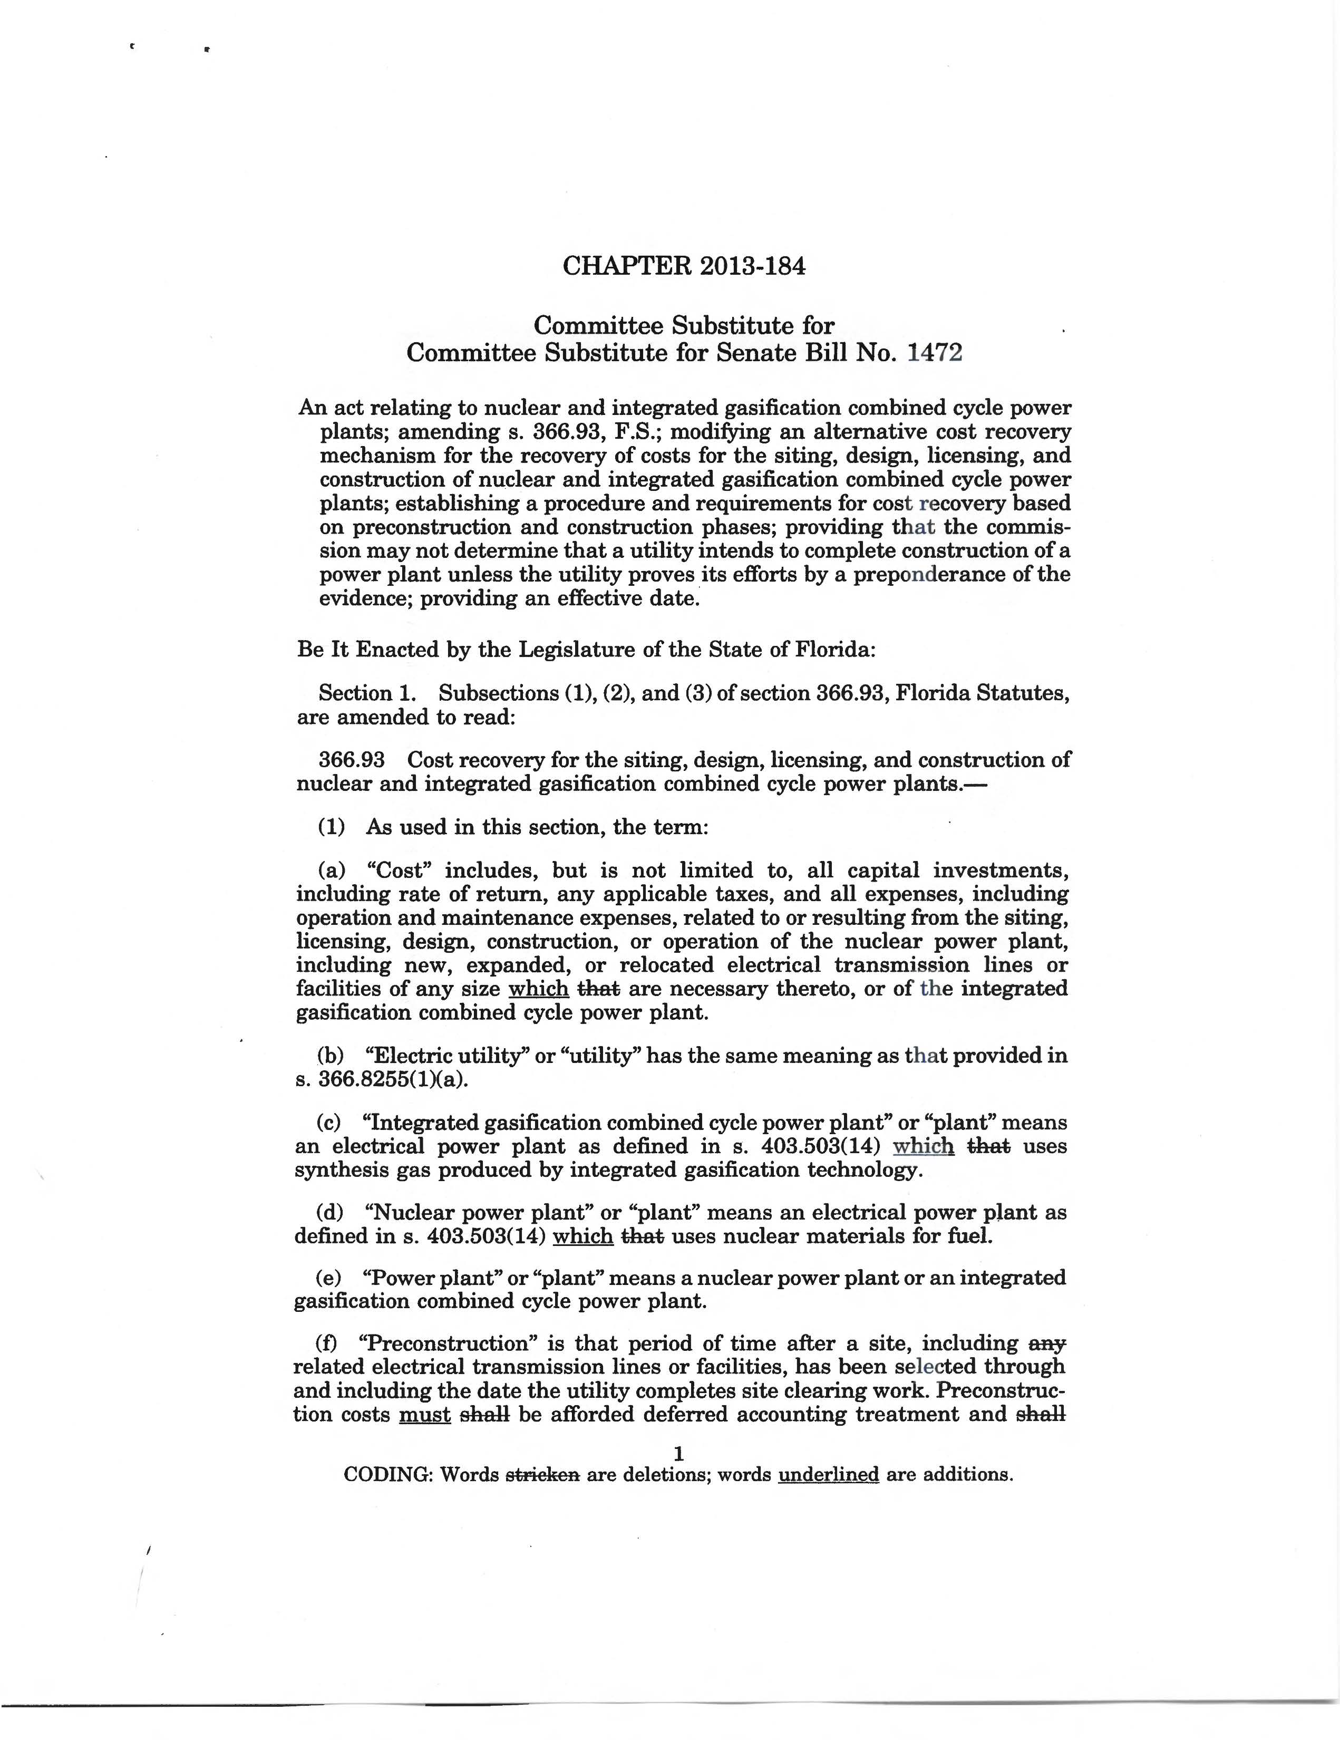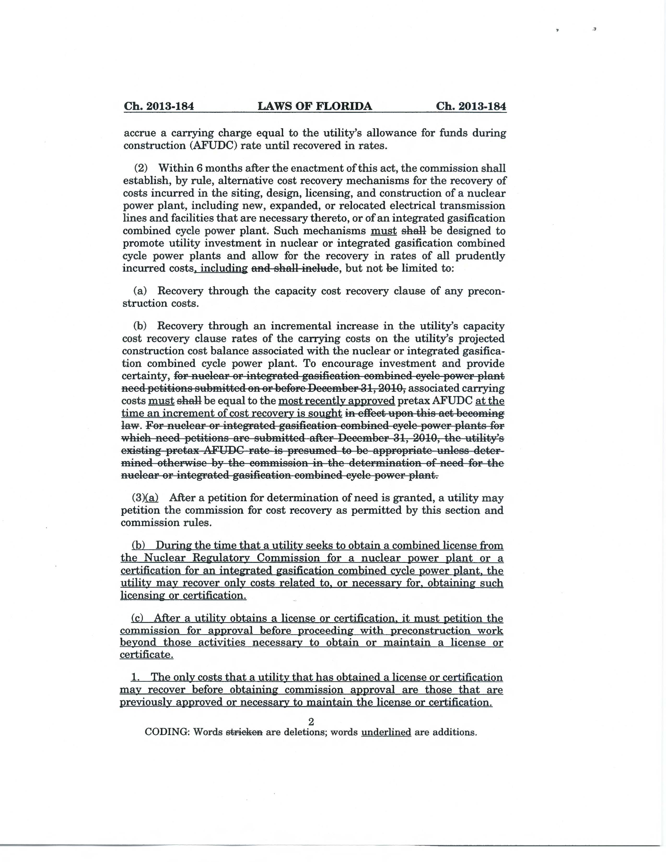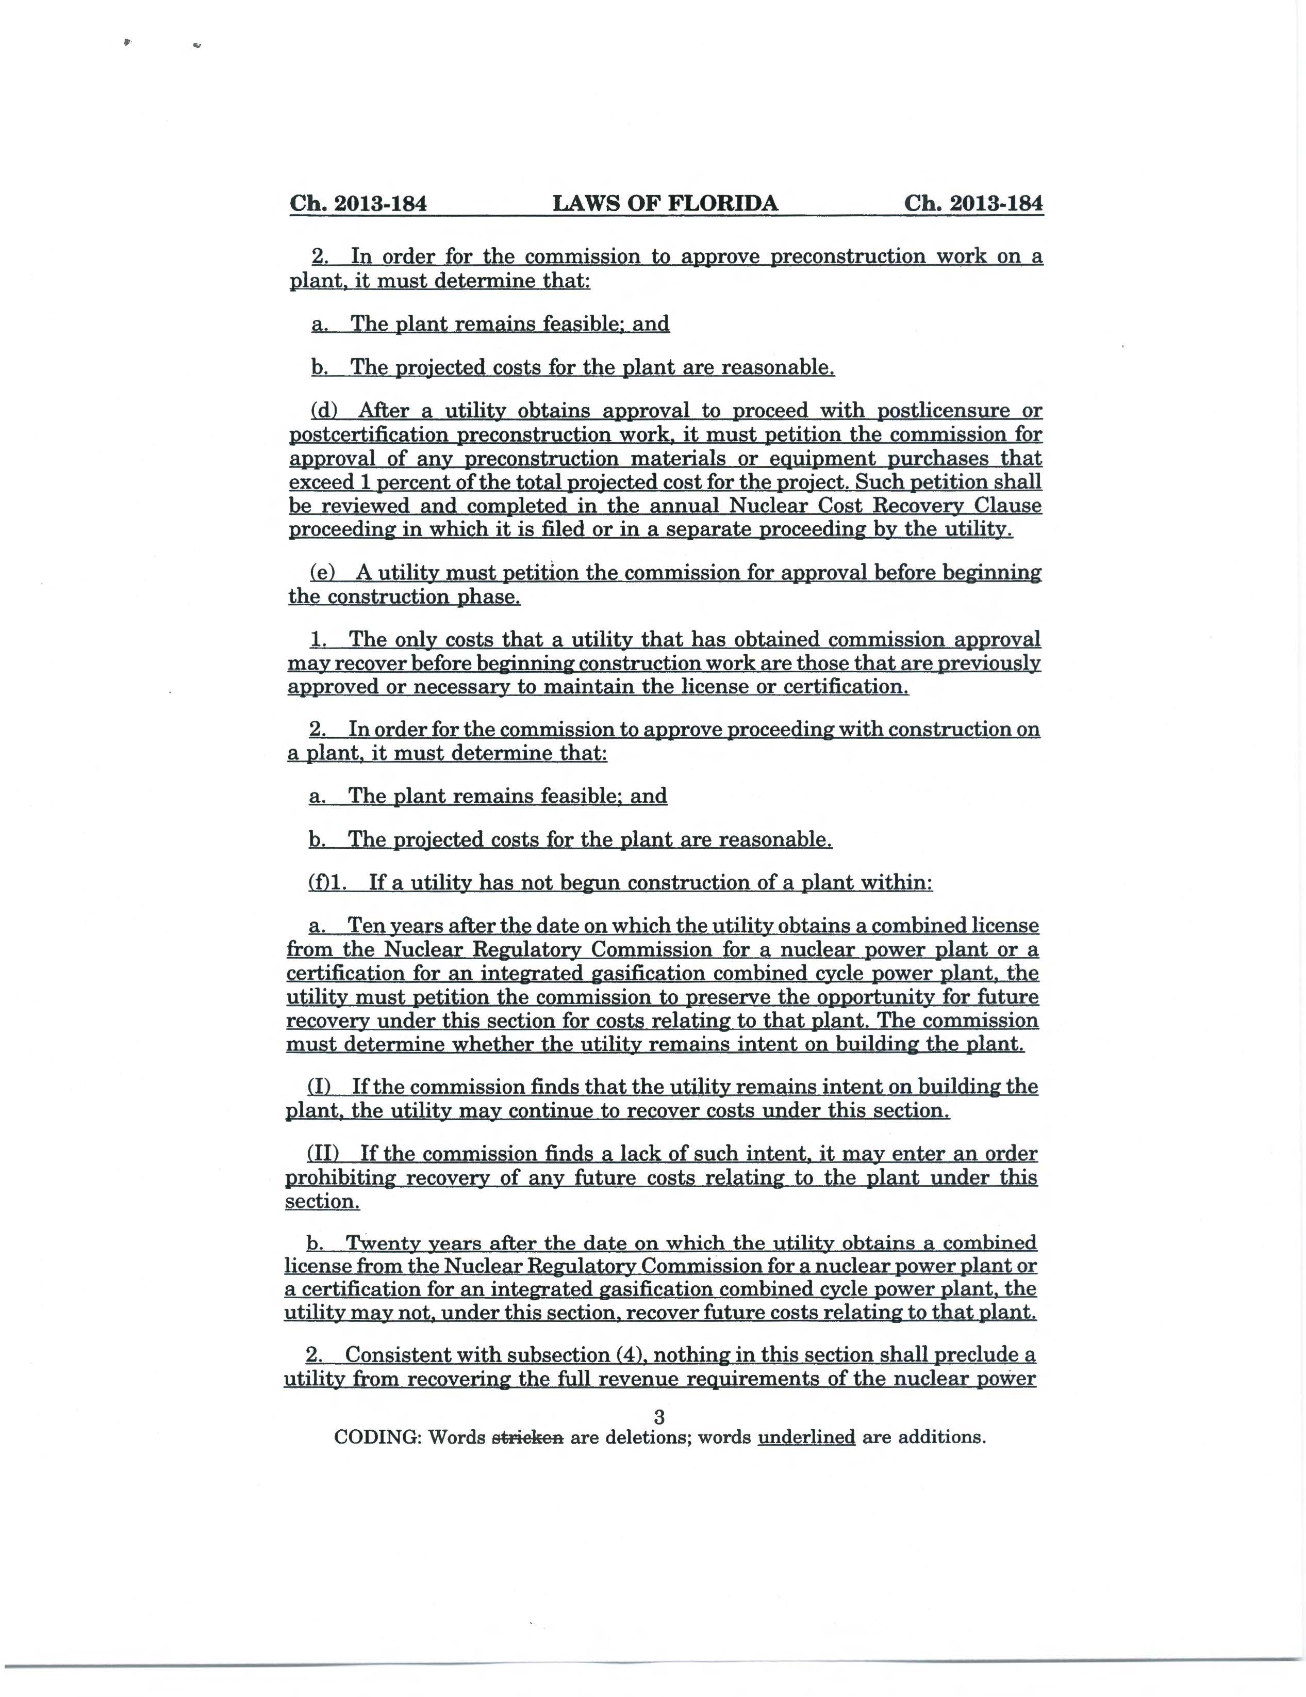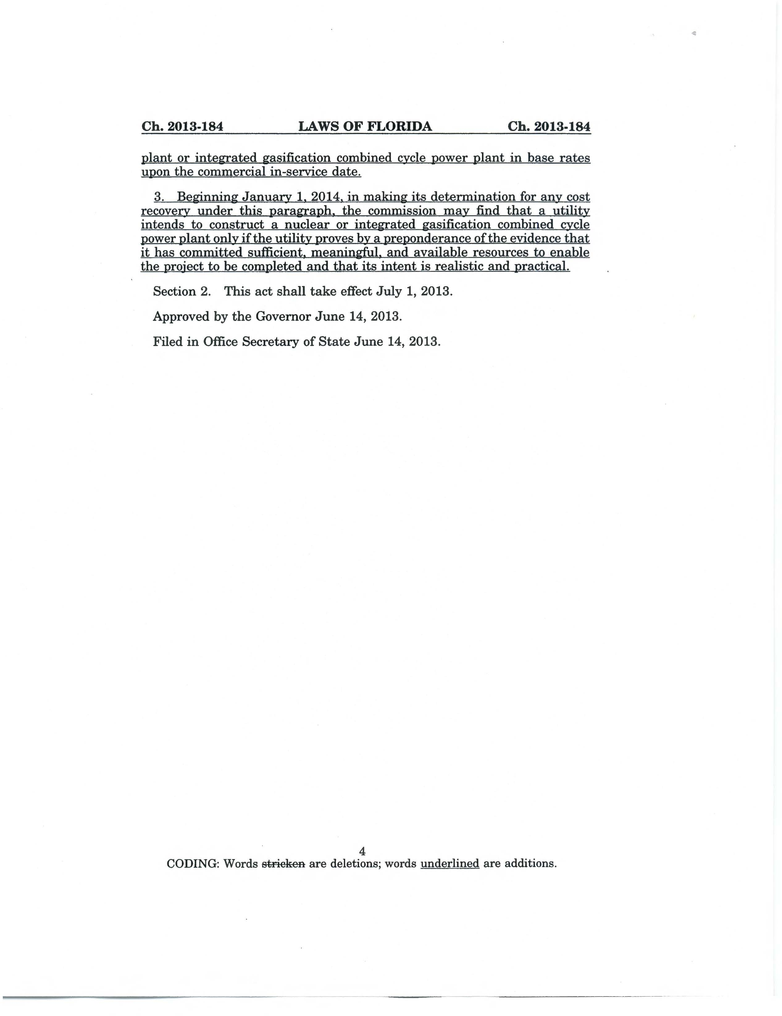

Section 25-6.0423(1), F.A.C.
Section 366.93(3)(c), F.S. (2013)
Section 366.93(3)(d), F.S. (2013)
Section 366.93(3)(e), F.S. (2013)
Subsection (5) of Rule 25-6.0423 would be renumbered to subsection (6) as part of these amendments.
Section 366.93(2)(b), F.S., was amended to state that associated carrying costs must be equal to the most recently approved pretax AFUDC at the time an increment of cost recovery is sought. Staff is recommending that this language be added to new subsection (j) of Rule 25-6.0423(2), F.A.C., “Carrying Costs,” as discussed above.
Section 120.541(2), F.S.

