GULF POWER COMPANY

Before the Florida Public Service Commission

Prepared Direct Testimony of

Michael L. Burroughs

Docket No. 130140-EI

In Support of Rate Relief

Date of Filing: July 12, 2013

Q. Please state your name and business address.

A. My name is Michael Burroughs. My business address is One Energy Place, Pensacola, Florida 32520.

Q What is your position?

A. I am Vice President of Gulf Power Company (Gulf or the Company) with responsibility for Power Generation, and in that capacity I am Senior Production Officer.

Q. What are your responsibilities as Vice President of Power Generation and Senior Production Officer?

A. I am responsible for Power Generation, Fuel, Supply Side Renewable Energy Development and Generation Planning. This includes responsibilities for all of Gulf’s wholly owned and jointly owned plants and all power purchase agreements.

Q. Please state your prior work experience and responsibilities.

A. I was hired by Alabama Power Company in 1991 as a Junior Engineer at Plant Barry in Mobile, Alabama. I progressed through various positions

until I transferred to Gulf, assuming the role of Planning and Engineering Manager at Plant Smith in Panama City, Florida in 1999. During the following seven years, I held positions of Maintenance Manager as well as Compliance and Engineering Manager. In May 2006 I was selected to be the Assistant to the Executive Vice President and Chief Production Officer of Southern Company Generation and Alabama Power Company. In September 2007 I was named Plant Manager of Yates Generating Plant in Newnan, Georgia with Georgia Power Company. I assumed my current position as Vice President of Power Generation and Senior Production Officer of Gulf in August 2010.

Q. What is your educational background?

A. I graduated with a Bachelor of Science degree in Mechanical Engineering from the University of Alabama – Birmingham in 1990.

Q. What is the purpose of your testimony?

A. My testimony discusses Gulf’s Production resources used and useful in the provision of electric service to our customers and the excellent performance of those resources. My testimony also explains fuel inventory levels necessary for Gulf’s continued provision of reliable generation. Gulf Witness Grove provides detail regarding Gulf’s Production resources, Production investment, Production O&M expenses and the resource planning process.

Q. Are you sponsoring any exhibits?

A. Yes. I am sponsoring Exhibit MLB-1, Schedules 1 through 5. Exhibit

MLB-1 was prepared under my direction and control, and the information contained therein is true and correct to the best of my knowledge and belief.

Q. Are you sponsoring any of the Minimum Filing Requirements (MFRs) submitted by Gulf?

A. Yes. A list of MFRs I sponsor or co-sponsor is included on Schedule 1 of my Exhibit MLB-1. The information contained in the MFRs I sponsor or co-sponsor is true and correct to the best of my knowledge and belief.

**I. GULF’S GENERATION RESOURCES**

Q. Please describe Gulf’s generating resources.

A. Gulf generates or purchases electricity from a diverse group of resources, including: (a) units owned solely by Gulf; (b) units owned jointly with other operating companies within the Southern electric system (SES); (c) units in the SES available to Gulf through the SES Intercompany Interchange Contract (IIC); and (d) units available to Gulf under power purchase agreements (PPAs). The fuels used for the generation resources available to Gulf include coal, oil, natural gas, landfill gas and municipal solid waste.

Q. Please describe the generation forecasted to be owned, operated and used by Gulf to serve its retail customers in 2014.

A. Exhibit MLB-1, Schedule 2 provides a list of the units owned and operated or co-owned by Gulf.

Q. What PPAs will Gulf have in place and use to provide electric service in 2014?

A. Schedule 3 of Exhibit MLB-1 provides a list of the power purchase resources available to Gulf during 2014 and information regarding the fuels and technologies used by these generating resources. All of these agreements have been approved by the Florida Public Service Commission (FPSC or the Commission).

Q. Other than the environmental capital projects addressed through Gulf’s Environmental Cost Recovery Clause (ECRC), what major changes have been made to Gulf’s generating resources since Gulf’s last base rate proceeding?

A. There have been several generating resource changes during the period from Gulf’s last rate case through the 2014 test year. In addition, Gulf forecasts another change in generation resources in 2015 shortly after the close of the test year. I will summarize each of the major changes.

In June 2013 Gulf began maintaining a natural gas inventory for the Central Alabama facility. It did so to be able to maximize fuel savings for Gulf’s customers. As I explain later in my testimony, Gulf would have been required to maintain this natural gas inventory in 2014 to have it treated as a

firm resource. An inventory for the Central Alabama facility was not required in Gulf’s last rate case.

In the 2014 test year there are several changes to Gulf’s generating resources. Their treatment for purposes of the rate case are addressed below.

* The Commission-approved PPAs for Coral Baconton and Dahlberg will expire at the end of May 2014. As a result Gulf has included in rate base the oil inventory for these two facilities only for the months through May 2014.
* The Commission-approved PPA with Bay County will expire in July 2014. There will be no base rate impact because all costs are being recovered through the fuel and purchase power cost recovery.

While it will happen after the 2014 test year, Gulf will be removing from service two coal units at Plant Scholz in April 2015. That decision was made due to environmental compliance issues and the associated costs that would have to be incurred if these units were to continue to operate in April 2015 and beyond. Mr. Grove has reduced forecasted O&M expenses for the Scholz units in his projection of 2013-2017 Production O&M expenses to recognize the retirement of these two coal units.

**II. GULF’S PLANT PERFORMANCE**

Q. Please address the performance of Gulf’s power plants.

A. Gulf uses a number of indicators to measure the performance of its units/plants. They include Equivalent Availability Factor (EAF), heat rate, Equivalent Forced Outage Rate (EFOR) (both annual and peak season), and OSHA recordable incidents. Both EAF and heat rate are tracked in the Commission’s Generation Performance Incentive Factor (GPIF) program. Gulf considers heat rate and EFOR to be the primary indicators of efficiency and reliability, respectively, and uses them to evaluate the effectiveness of our planned outage and maintenance programs.

Q. What does EFOR measure?

A. EFOR measures a generating unit’s inability to provide electricity when dispatched and is the primary tool used by Gulf to track unit reliability. EFOR is reported in terms of the hours when a generating unit could not deliver electricity as a percentage of all the hours during which that unit was called upon to deliver electricity.

Q. What is economic dispatch?

A. Economic dispatch is the process of dispatching units based on cost. Gulf has units committed and on line to serve existing load in addition to spinning reserves. The spinning reserves are units that are on line (running at less than full load) to support the loss of another unit in the event a unit is forced off line. Spinning reserves are a critical part of ensuring the reliability of the system. As customer demands increase, Gulf commits additional resources to serve those demands using the most economical units first. As customer demands decrease, Gulf takes the highest cost units off line first. Economic dispatch is designed to ensure the customers receive the benefits of the most economic units, that is, the units with the lowest incremental operating costs.

Q. Why is it important to ensure units are available for economic dispatch?

A. By dispatching the least-cost units first, Gulf ensures our customers receive the lowest cost resources. This is why it is critical to maintain a low EFOR, particularly in the peak months. Whenever a more economical unit is forced off line, the replacement energy will likely be more expensive, and this may impact our customers through higher fuel costs.

Q. What EFOR measures does Gulf track, and why?

A. Gulf tracks both Annual EFOR and Peak Season EFOR. Plant performance goals are set around Peak Season EFOR. Gulf has historically tracked Peak Season as the period from May 1 through September 30 each year when typically the demand for electricity has been the highest.

Q. What is a heat rate?

A. Heat rate is a measure of a unit’s efficiency in converting fuel to electricity. It is a measure of the amount of fuel required to generate a kilowatt hour (kWh). The lower a unit’s heat rate, the more efficiently it converts fuel to electricity.

Q. Please address why EFOR and heat rate performance are important to customers.

A. EFOR is a measure of a unit’s reliability. A low EFOR ensures that the lowest cost units are producing electricity when called upon to meet the demands of customers. Also, maintaining a low EFOR ensures that units are available to make wholesale power sales when opportunities arise. This results in a reduced fuel cost to our retail customers since most of the gain from these sales is applied as a credit to fuel expense. As discussed earlier in my testimony, heat rate is an efficiency measure. The lower the heat rate, the less fuel consumed to generate electricity. The customer benefits by paying less in fuel costs and having lesser amounts of fuel required in inventory.

Q. What are the Annual and Peak Season EFOR for Gulf’s generating units?

A. Exhibit MLB-1, Schedule 4 shows Gulf’s Annual and Peak Season EFOR.

Q. How does Gulf’s EFOR compare to others in the industry?

A. As shown on Schedule 4, Gulf’s Annual and Peak EFOR performances compare extremely favorably with peer utilities. Schedule 4, pages 1 and 2 show graphically how Gulf’s actual Annual and Peak Season EFOR compare to the peer group averages from 2002 through 2011. Schedule 4, pages 3 and 4 show where Gulf’s actual average performance for the same period compares to each of the peer utilities. While 2012 data for the peer industry group is not yet available, Gulf achieved, and customers benefited from, record-setting EFOR rates in 2012, as shown on Schedule 4 pages 1 and 2. Gulf’s results are exceptional, despite three major hurricane events that impacted our plants. Gulf’s excellent performance is indicative of Gulf’s management and employees’ commitment in serving our customers.

Q. What is the source of the data Gulf has used to compare its EFOR performance to that of other utilities?

A. Gulf obtained Annual and Peak Season EFOR data from the North American Electric Reliability Corporation (NERC). This was the most current available data at the time this testimony was drafted.

**III. GULF’S 2014 FUEL INVENTORY**

Q. What amount is Gulf requesting for total fuel inventory, including fuel stock and in-transit fuel?

A. Gulf is requesting a total fuel inventory of $96,026,000 to be included in its 2014 rate base. This includes $85,217,000 for fuel stock and $10,809,000 for in-transit fuel. The request exceeds the amount allowed in the last rate case by $10,031,000.

Q. Please explain the reason for the requested increase in fuel inventory working capital.

A. The increase in the amount requested in this case is primarily due to a higher projected market price for coal being delivered to Gulf generating

plants. The remainder of the increase is the result of Gulf’s need to add

808,252 Mcf or $3,598,000 of natural gas inventory for the Central Alabama facility. As I discuss below, Gulf is adding natural gas inventory for the Central Alabama facility to allow that facility to maximize customer fuel savings and to be a firm generation resource.

Q. Please describe Gulf’s coal inventory policy.

A. Gulf’s policy is to maintain coal inventory levels sufficient to safeguard against disruptions in supply, inconsistencies in delivery of coal due to weather conditions and other factors affecting the coal transportation sector. Coal inventory levels for each generating plant are evaluated, and targets are established, based on a number of factors such as: plant specific coal handling and storage limitations; market intelligence on coal supply availability; coal transportation/logistics information; and the historical perspective obtained through considerable experience developed in coal stockpile management by the Southern Company fuel organization. The Operating Companies of the Southern Company are one of the largest coal consumers in the nation and have a long history of successfully operating coal fired generating plants.

These established coal stockpile targets are further evaluated using the Utility Fuel Inventory Model (UFIM) developed by the Electric Power Research Institute (EPRI) and the electric utility industry. The UFIM model evaluates, among other factors, the economic cost of not being able to serve customer load if coal inventory is depleted and the economics associated with being forced to procure coal and/or replacement energy in the spot market during periods when coal supply is disrupted versus the financial costs associated with carrying various levels of coal inventory. The economic cost results derived from the UFIM model runs are then evaluated along with specific plant coal logistics issues and other coal market inputs to determine the most economic target plant coal inventory level for a specific plant.

Once the target coal inventory levels are validated, they are formally approved by the Vice President of Power Generation for use as an input in the SES fuel budgeting model, FUELPRO, to develop a fuel cost of generation budget for all plants in the SES. The fuel burn derived from the hourly load dispatch of each generating unit in the SES fleet and the current fuel price forecast for each fuel type, including transportation rates, are also inputs to the FUELPRO model. The output of FUELPRO is a fuel budget for each plant, which includes monthly fuel purchases, burn and ending inventory expressed in units of measure (quantity), total dollars, and dollars per unit. For the test year, the coal inventory policy evaluation resulted in average inventory targets for Gulf’s barge-served coal fired plants (Crist and Smith) of approximately 35 normal full load (NFL) burn days and for Gulf’s rail-served plants (Scholz and Daniel), 20 and 40 NFL days respectively.

Q. What is a normal full load (NFL) burn day?

A. A NFL burn day is a method of expressing units of inventory relative to the

normal maximum consumption of fuel at a specific generating facility over a 24 hour period. Normal maximum consumption does not include output maximums that can be achieved for short periods by using supplemental firing to operate at “full pressure” on traditional steam and combined cycle units. The use of NFL burn days allows for the expression of inventory units in common terms so that fuel inventories of generating plants with various capacity sizes (MW) and capacity factors can be compared on an “apples to apples” basis.

A NFL burn day is calculated by multiplying the total daily energy output (kilowatt hours or kWh) of a generating plant by the weighted average heat rate (British thermal units per kWh or Btu/kWh) of the units at that generating plant. Both the total daily energy output and the unit heat rates are determined by actual plant performance measurements over a period of time. The resulting calculated Btus per day are then converted to standard units for each fuel type such as tons for coal and gallons or barrels for oil. This method explicitly recognizes Gulf’s heat rate performance in establishing its requested fuel inventory levels. As an example, the NFL day burn for Plant Smith Unit 1 would be calculated as follows:

A = Normal Hourly Full Load Rating = 162,000 kWh

B = Average Unit Heat Rate = 10,422 Btu/kWh

C = Fuel Heating Value = 11,714 Btu/lb

(A x B) / (C x 2,000 lbs/ton) = 72.07 tons/hour

NFL day burn = 72.07 tons/hour x 24 hours/day = 1730 tons/day

Q. How does the current coal inventory policy compare to the policy used in the last case?

A. There is no change in coal inventory policy from the last rate case.

Q. Based on this policy, what is Gulf’s forecasted coal inventory level for the test year?

A. For all Gulf plants (excluding Scherer), the 13 month average of the monthly ending coal inventory levels, not including in-transit coal, for the test year, is a stockpile of 708,532 tons, $74,738,000, or 34.7 days NFL burn supply. This compares to a total of 693,196 tons, $67,958,000, or 34 days NFL burn supply allowed in the last rate case. The increase in coal inventory value (dollars) is due primarily to an increase in the projected delivered market price of coal since the last rate case.

Q. How does the average unit cost of coal inventory compare to the amount used in the last rate case?

A. In Gulf’s last rate case, the weighted average unit cost of coal in inventory was $98.04 per ton. The current weighted average unit cost of coal used to project the total cost of Gulf coal inventory in the test year is $105.48 per ton. The increase is due to an increase in the projected market price of coal and coal transportation in 2014.

Q. How has actual coal inventory compared to the amount allowed in the last rate case?

A. The average 13 month actual ending coal inventory as of December 31,

2012 was $94,116,000. This exceeded the amount allowed in the last rate case of $67,958,000 by $26,158,000. This is primarily due to coal inventory

quantity being above target levels as coal burn quantity was significantly below projected amounts. The lower than expected coal consumption is due to lower customer loads and low natural gas prices shifting the generation mix to lower cost natural gas fired generation. Gulf expects to return coal inventory levels to the target quantity in 2014 by reducing the amount of projected coal purchases to match the lower expected coal burn for the period.

Q. If Gulf is projecting lower coal consumption in this case than its last case, why hasn’t the volume of coal held in inventory declined?

A. The simple answer is that Gulf’s coal stockpiles are tied to NFL days rather than projected burn days.

Coal stockpile levels based upon NFL are an assurance of reliability to Gulf’s customers. If Gulf’s coal units have to run at full load for an extended period of time to assure customer reliability, Gulf needs to be able to assure two factors: (1) unit availability and (2) sufficient fuel supply. As I discussed previously, Gulf is an industry leader in unit availability. Gulf also follows a coal inventory policy that assures when its coal units are needed to serve our customers, there is enough fuel on site to assure performance.

Extended coal unit performance can be needed to serve our customers for a variety of reasons. Of course, swings in the relative prices of coal and gas can result in greater coal dispatch. However, beyond economics, there are a host of reasons that Gulf’s coal units may be needed for reliability purposes: outages at gas fired units, transmission outages on lines from gas units, or natural gas supply interruptions. In addition, disruptions in the supply or transportation of coal, which can also be caused by barge or train interruptions, also dictate a need to assure adequate coal stockpiles.

Having an adequate supply of coal on hand for events that trigger reliability challenges is not unlike having a reserve margin in place for generation. We have more capacity available than is needed to just meet needs because sometimes units are not available. Limitations on fuel create the same reliability threats. It does not benefit Gulf’s customers to have generation in reserve to meet reliability issues if those units do not have sufficient fuel to operate as needed. So inventory levels are determined not by projected burn, but by amounts necessary to assure reliability.

Q. Why does Gulf include an amount in working capital for in-transit coal inventory?

A. Gulf pays its coal suppliers upon loading of the coal into Gulf’s transportation equipment at the coal supplier’s originating facility. Therefore, capital is invested in coal that has not yet been received at the destination generating plants. A major portion of Gulf’s coal supply is delivered by rail to an intermediate coal blending/transfer facility located in Mobile, Alabama and then by barge to the Crist and Smith generating plants. A considerable amount of time is involved in the process of transporting coal from the origin mine to the intermediate blending and barge loading location and then transporting the coal to the final destination plant stockpile. This investment in coal that is in-transit should be included in the working capital component of Gulf’s rate base.

Q. How does the amount for in-transit coal that you included in your request for working capital compare to the amount included in the previous rate case?

A. The amount of in-transit coal included in the test year fuel inventory request is $10,809,000. This compares to $10,368,000 included in the previous rate case. The increase is due primarily to an increase in the projected market price of coal in 2014 offset by a lower projected quantity of coal in-transit.

Q. What is Gulf’s natural gas storage policy?

A. Gulf’s Natural Gas Policy requires that base load combined cycle units have firm gas storage capacity and gas transportation for system reliability purposes. The gas storage capacity requirement must be met before a gas fired combined cycle unit will be accepted as electric generating capacity for purposes of meeting an operating company’s reserve capacity margin obligation. The purpose of the policy is to maintain a certain portion of a generating plant’s natural gas supply requirement in storage to provide natural gas supply during gas supply interruptions caused by pipeline and compressor station failures, hurricanes, well freezes, etc. In addition, having available gas storage capacity for pipeline balancing is necessary to avoid penalties imposed by pipelines for large swings in daily and hourly demands when the generating unit is economically dispatched or when other sudden changes, like plant outages, cause a swing in demand.

As was approved in the previous rate case, Gulf has a target of 15 NFL burn days of natural gas storage capacity for Smith Unit 3. To meet the storage capacity needs of Smith Unit 3, Gulf currently has contract capacity rights in two salt dome gas storage facilities, Bay Gas Storage located near McIntosh, Alabama and Southern Pines Energy Center located near Richton, Mississippi. The Bay Gas Storage agreement provides 915,501 Mcf of gas storage capacity and the Southern Pines Energy Center provides 355,190 Mcf of gas storage capacity. This provides Smith Plant with 15 NFL burn days of storage capacity.

Gulf has completed a contract for gas storage capacity with Leaf River Energy Center, a salt dome storage facility located near Taylorsville, Mississippi. This agreement provides 10 NFL days or 1,265,823 Mcf of gas storage capacity for the Central Alabama facility and is effective April 1, 2013 through May 31, 2023 when the PPA expires.

Q. What is Gulf’s forecasted natural gas inventory level for the test year?

A. Gulf projects a 13 month average natural gas inventory of 1,619,613 Mcf for the test year and has included $7,210,000 in working capital for this gas storage amount. This quantity of gas inventory is equal to 10 NFL burn days for Gulf’s Smith Plant Unit 3 and six NFL burn days for Gulf’s PPA with Central Alabama combined cycle units.

Q. Why are the 13 month average natural gas inventory levels of approximately 10 NFL burn days at Plant Smith and six NFL burn days at the Central Alabama facility lower than the contracted gas storage capacities of 15 and 10 NFL burn days, respectively?

A. There are different target gas inventory amounts for each month of the year

depending on the different supply risk for that month, but the average quantity of gas inventory of all months in the test year is eight NFL burn days.  Gulf maintains a lower quantity of natural gas in inventory than the capacity of the storage facility under contract at any point in time because the open storage space is needed for supply balancing.  In other words, Gulf needs open space in the storage facility to allow for the injection of excess gas into storage if there is an operational issue at the plant and Gulf cannot consume the scheduled amount of gas at the generating plant. The ability to place the excess gas into the storage facility is necessary to avoid violating the natural gas pipeline flow balancing requirements and avoid monetary penalties or losses on a forced sale of the excess gas.

Q. How does the 13 month average natural gas inventory for the test year compare to the approved inventory from the last case?

A. Gulf was allowed an inventory 835,702 Mcf and $4,300,000 in working capital for gas inventory in the last rate case. Gulf is requesting a natural gas fuel inventory of 1,619,613 Mcf and $7,210,000 in this case. The amount of natural gas inventory in the test year is 783,911 Mcf and $2,910,000 higher than the amount approved in the last case. The costs associated with this higher volume of inventory are somewhat offset by a lower average unit cost of gas than in Gulf’s last rate case.

Q. Please explain the increase in the volume of natural gas inventory in this case compared to Gulf’s last rate case.

A. As shown on Exhibit MLB-1 Schedule 5, the higher volume of natural gas

inventory in this rate case is due to the Central Alabama facility being used to reduce customer fuel costs and the Central Alabama facility having been added as a firm generating resource.

In June 2014, the Central Alabama facility will be added as a firm generating resource for Gulf. Under that PPA, Gulf has the responsibility for providing natural gas supply for unit operation and as a result natural gas inventory has been included in the test year for this generating unit. However, in June 2013 Gulf began carrying a gas inventory for the Central Alabama facility to enhance customer fuel savings. The efficiency of the unit combined with low gas prices warranted a much higher dispatch. Such a dispatch achieved significant fuel savings, which have been and  
will continue to be passed on to customers in the fuel clause.   
This decision simply advanced in time the firm resource inventory requirement.

Q. How does the 13 month average unit cost of natural gas inventory for the test year compare to the amount used in the last rate case?

A. In the last rate case the average unit cost of natural gas in inventory was $5.15 per Mcf. Since the last rate case the market price of natural gas has decreased due to a higher supply of natural gas in the market. The current

average unit cost of natural gas used to calculate the total cost of Gulf natural gas inventory in the test year is $4.45 per Mcf.

1. What is Gulf’s forecast distillate oil inventory level for the test year?
2. Gulf’s projected distillate oil inventory level, including both lighter oil and

combustion turbine generating fuel, for the test year (excluding Scherer) is 32,713 barrels. An amount of $3,269,000 has been included in working capital for distillate oil inventory.

Q. How does this oil inventory request compare to the oil inventory amount approved in Gulf’s last rate case?

A. The amount of distillate oil inventory included in the last rate case was 49,850 barrels or $3,370,000. In May 2014 two of the three PPAs in which Gulf has the fuel supply responsibility (Baconton and Dahlberg) will expire. The oil inventory for these two facilities is being removed at the expiration date of the two PPAs in May 2014.

Q. How does the average unit cost of distillate oil inventory compare to the amount used in the last rate case?

A. In Gulf’s last rate case the average unit cost of distillate oil in inventory was $67.60 per barrel. Since the last rate case, the market price of distillate oil has increased due to higher worldwide demand for all oil products. The current average unit cost of distillate oil used to project the total cost of Gulf’s oil inventory in the test year is $99.93 per barrel.

**IV. SUMMARY**

Q. Please summarize your testimony.

A. Gulf maintains and operates generation resources designed to serve our customers economically and reliably. Gulf’s Generation operation has continued to provide economical, reliable electricity to our customers. The reliability of Gulf’s generating units and low EFOR are clear indications that Gulf has executed an effective maintenance program that continues to provide our customers with reliable service.

The fuel inventory requested by Gulf is reasonable, prudent and necessary to provide fuel inventory levels that will ensure Gulf’s units are prepared to meet the needs of our customers with the lowest cost generation available.

Q. Does this conclude your testimony?

A. Yes.

AFFIDAVIT

STATE OF FLORIDA ) Docket No. 130140-EI

)

COUNTY OF ESCAMBIA )

Before me the undersigned authority, personally appeared Michael L. Burroughs, who being first duly sworn, deposes, and says that he is the Vice President of Power Generation and Senior Production Officer for Gulf Power Company, a Florida corporation, and that the foregoing is true and correct to the best of his knowledge, information, and belief. He is personally known to me.

The signed original affidavit is attached to the

original testimony on file with the FPSC.

s/___________________________________

Michael L. Burroughs

Vice President of Power Generation and

Senior Production Officer

Sworn to and subscribed before me this ______ day of ______________, 2013.

________________________________________

Notary Public, State of Florida at Large

Commission No. ___________________________

My Commission Expires _____________________

Responsibility for Minimum Filing Requirements

Schedule Title

B-16 Nuclear Fuel Balances

B-18 Fuel Inventory by Plant

C-42 Hedging Costs

F-4 NRC Safety Citations

F-5 Forecasting Models

F-8 Assumptions

Owned and Operated or Jointly Owned Generating Capacity

|  |  |  |
| --- | --- | --- |
| Unit Description | Net Generation  (MW) | Commercial  Operation Date |
| Crist Unit 4 | 75 | Jul 1959 |
| Crist Unit 5 | 75 | Jun 1961 |
| Crist Unit 6 | 299 | May 1970 |
| Crist Unit 7 | 475 | Aug 1973 |
| Smith Unit 1 | 162 | Jun 1965 |
| Smith Unit 2 | 195 | Jun 1967 |
| Smith Unit 3 | 556 | Apr 2002 |
| Smith Unit A | 32 | May 1971 |
| Scholz Unit 1 | 46 | Mar 1953 |
| Scholz Unit 2 | 46 | Oct 1953 |
| Pea Ridge Unit 1 | 4 | May 1998 |
| Pea Ridge Unit 2 | 4 | May 1998 |
| Pea Ridge Unit 3 | 4 | May 1998 |
| Perdido Unit 1 | 1.6 | Oct 2010 |
| Perdido Unit 2 | 1.6 | Oct 2010 |
| Daniel Unit 1 | 255 | Sep 1977 |
| Daniel Unit 2 | 255 | Jun 1981 |

Power Purchase Agreements

|  |  |  |  |  |  |
| --- | --- | --- | --- | --- | --- |
| Agreement | Technology | Fuel | MW | Start Date | End Date |
|  |  |  |  |  |  |
| Bay County | Steam | MSW | 11 | Jul 2008 | Jul 2014 |
|  |  |  |  |  |  |
| Coral Baconton | CT | Gas/Oil | 195 | Jun 2009 | May 2014 |
|  |  |  |  |  |  |
| Dahlberg | CT | Gas/Oil | 299 | Jun 2009 | May 2014 |
|  |  |  |  |  |  |
| Central Ala. | CC | Gas | 885 | Nov 2009 | May 2023 |

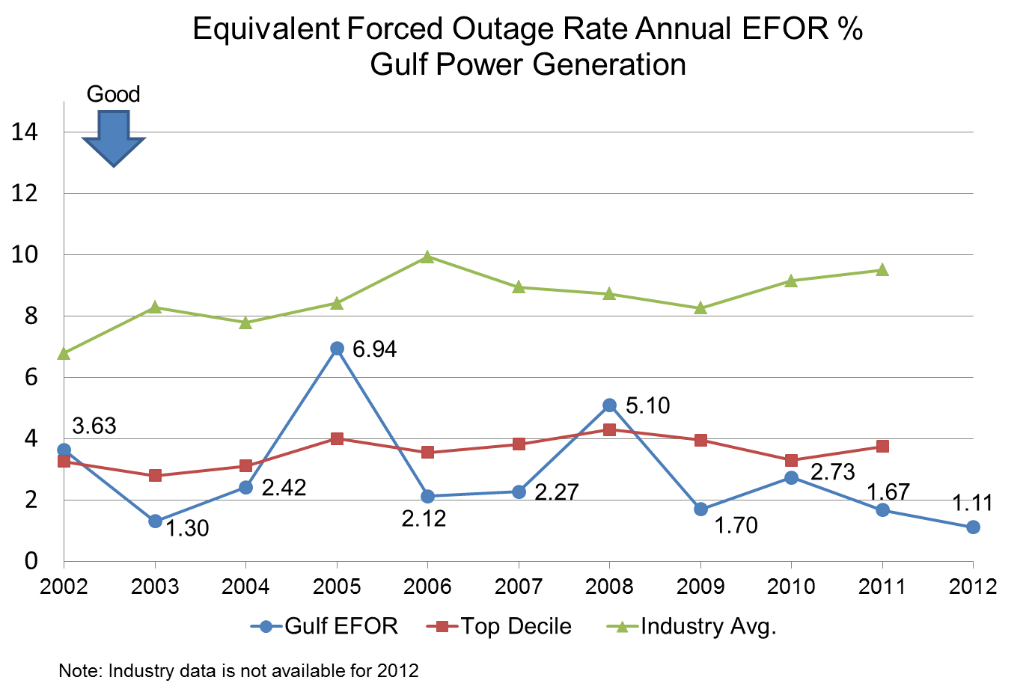

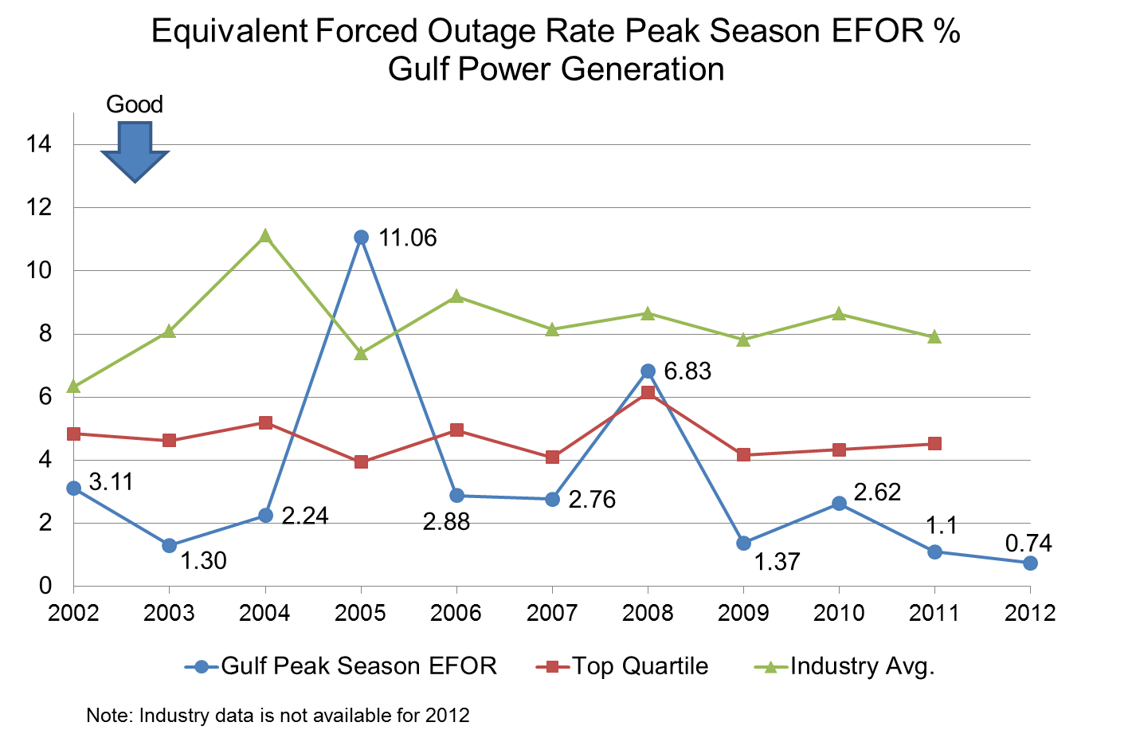

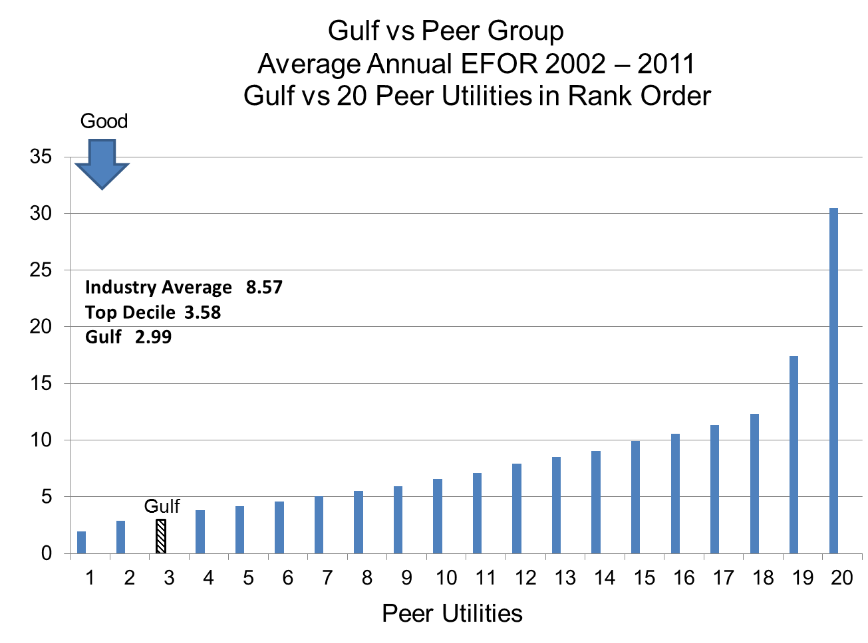

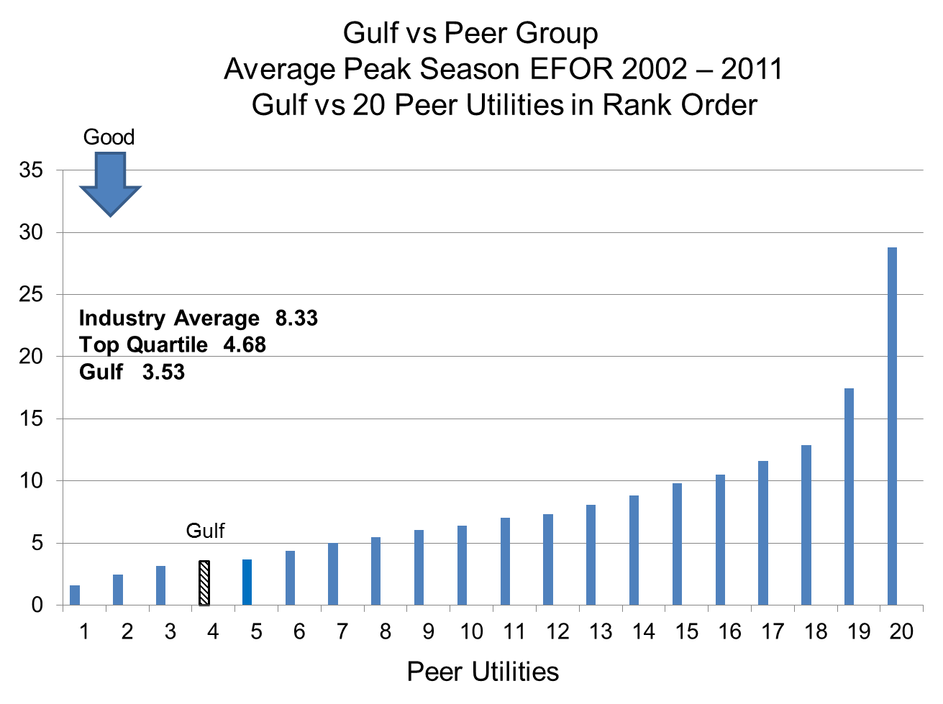

Gulf Power Company

Natural Gas Inventory Comparison

2012 vs. 2014 Test Year

**$4,300,000**

**$3,612,000**

**$3,598,000**

Smith 3

Smith 3 & Central AL

Dollar Value Comparison

Smith 3

Central AL

2014

201

2

Gas Value, Volume and Commodity Comparison

|  |  |  |  |  |  |  |
| --- | --- | --- | --- | --- | --- | --- |
| 2012 | | | | 2014 | | |
| Facility | Volume Mcf | Price Per Mcf | Total Value | Volume Mcf | Price  Per Mcf | Total  Value |
| Smith 3 | 835,702 | $5.15 | $4,300,000 | 811,361 | $4.45 | $3,612,000 |
| Central AL | 0 | 0 | 0 | 808,252 | $4.45 | $3,598,000 |
| Totals | 835,702 | $5.15 | $4,300,000 | 1,619,613 | $4.45 | $7,210,000 |