State of Florida   |  | Public Service Commission  Capital Circle Office Center ● 2540 Shumard Oak Boulevard  Tallahassee, Florida 32399-0850  -M-E-M-O-R-A-N-D-U-M-
DATE: | December 23, 2013
TO: | Office of Commission Clerk (Stauffer)
FROM: | Division of Engineering (Matthews, Mtenga)  Office of the General Counsel (Tan)
RE: | Docket No. 130249-EI – Petition for approval of amended standard offer contract and rate schedule (Schedule COG-2), by Duke Energy Florida, Inc.
AGENDA: | 01/07/14 – Regular Agenda – Proposed Agency Action – Interested Persons May Participate
COMMISSIONERS ASSIGNED: |  |  | All Commissioners
PREHEARING OFFICER: |  |  | Brown
CRITICAL DATES: |  |  | None
SPECIAL INSTRUCTIONS: |  |  | None

Case Background
Section 366.91(3), Florida Statutes (F.S.), requires that each investor-owned utility (IOU) continuously offer to purchase capacity and energy from renewable energy generators. Commission Rules 25-17.200 through 25-17.310, Florida Administrative Code (F.A.C.), require each IOU to file with the Commission by April 1 of each year a standard offer contract based on the next avoidable generating unit or planned purchase. On March 28, 2013, Duke Energy Florida (DEF) filed two petitions; one for approval of an amended standard offer contract based on a combined cycle (CC) avoided unit, and another for approval of a new standard offer contract based on a combustion turbine (CT) avoided unit. By Order No. PSC-13-0313-PAA-EI, issued July 11, 2013, in consolidated Docket Nos. 130068-EI AND 130069-EI, these two standard offer contracts were approved by the Commission.

When a request for proposals (RFP) has been issued for an avoided unit, the standard offer contract must be amended to reflect the change pursuant to Rule 25-17.250(2)(a) and (b), F.A.C. In October 2013, DEF issued a RFP for the previously identified avoided CC unit. On October 8, 2013, DEF filed the instant petition requesting approval of an amended standard offer contract using the next combined cycle avoided unit contained in its Ten-Year Site Plan, which reflects the change in the size and in-service date. The new avoided unit is a 793 megawatt (MW) CC with an in-service date of June 1, 2021.

The Commission has jurisdiction over these standard offer contracts pursuant to Sections 366.04 through 366.06, and 366.91, F.S., and Commission Rules 25-17.200 through 25-17.310, F.A.C.

Discussion of Issues
Issue 1: Should the Commission approve the amended standard offer contract filed by Duke Energy Florida, Inc.?

Recommendation: Yes. The provisions of the amended standard offer contract and associated schedules, as filed October 8, 2013, conform to all requirements of Rules 25-17.200 through 25-17.310, F.A.C. The amended standard offer contract provides flexibility in the arrangements for payments so that a developer of renewable generation may select the payment stream best suited to its financial needs. (Mtenga, Matthews)

Staff Analysis: Because Duke Energy Florida (DEF) is an IOU, Rule 25-17.250, F.A.C., requires that it continuously make available a standard offer contract for the purchase of firm capacity and energy from renewable generating facilities (RF) and small qualifying facilities (QF) with design capacities of 100 kilowatts (kW) or less. Pursuant to Rule 25-17.250, F.A.C., the standard offer contract must provide a term of at least ten years, and separate contracts must be available based on the utility’s next avoidable fossil-fueled generating units of each technology type identified in its most recent Ten-Year Site Plan. If no avoided unit is identified, the standard offer contract is based on the utility’s next avoidable planned purchase.

On March 28, 2013, DEF filed two petitions for approval of standard offer contracts based on two avoided units of different technology types. In Docket No. 130068-EI, the avoided unit was a 1,189 MW natural gas-fired CC unit with an in-service date of June 1, 2018. In Docket No. 130069-EI, the avoided unit was a 187 MW CT unit with a June 1, 2022 in-service date. In the instant docket, DEF revised its avoided unit for the CC technology type to be a 793 MW natural gas-fired CC unit with a projected in-service date of June 1, 2021. The standard offer contract for the CT unit is not affected and remains in place and unchanged by this docket.
Rule 25-17.250(2) states, in pertinent part:

(a) In order to ensure that each utility continuously offers a purchase contract to producers of renewable energy, each standard offer contract shall remain open until:
1. A request for proposals (RFP) pursuant to Rule 25-22.082, F.A.C., is issued for the utility’s planned generating unit; . . .
(b) Before a standard contract offering is closed, the utility shall file a petition for approval of a new standard offer contract based on the next unit of the same generating technology, if any, in its Ten-Year Site Plan.
DEF issued an RFP in October 2013 for the CC unit previously identified as the avoided unit. Therefore, it is obligated by Rule 25-17.250 to file an amended standard offer contract based on the next CC unit contained in its Ten-Year Site Plan, which is the 793 MW unit identified in this docket.
Revised Standard Offer Contract
DEF submitted a total of seven revised sheets of the standard offer contract corresponding to Rate Schedule COG-2. The type-and-strike format versions of the revised tariff sheets are included as Appendix A to this recommendation. All the changes made to the tariff sheets are consistent with the updated avoided unit. Revisions include an updated example of monthly capacity payments, updates to calendar dates, as-available energy costs, estimated unit fuel costs, line loss data, and performance security.
The RF/QF operator may elect to make no commitment as to the quantity or timing of its deliveries to DEF, and to have a committed capacity of zero (0) MW. Under such a scenario, the energy is delivered on an as-available basis and only an energy payment is made. Alternatively, the RF/QF operator may elect to commit to certain minimum performance requirements based on the avoided unit, such as being operational and delivering the agreed upon amount of capacity by the in-service date. The operator thereby becomes eligible for capacity payments in addition to those made for energy. If the RF/QF operator wishes to have contract terms that are different from those offered under the standard offer contract, the parties may enter into a negotiated contract instead.
In order to promote renewable generation, the Commission requires the IOU to offer multiple options for capacity payments, including the options to receive early and/or levelized payments. If the RF/QF operator elects to receive capacity payments under the normal or levelized contract options, it will receive as-available energy payments only until the in-service date of the avoided unit (revised in this case to June 1, 2021), and thereafter begin receiving capacity payments in addition to the energy payments. If either the early or early levelized option is selected, the operator will begin receiving capacity payments earlier than the in-service date of the avoided unit. However, payments made under the early capacity payment options tend to be lower in the later years of the contract term because the net present value (NPV) of the total payments must remain equal for all contract options. In addition, any capacity payments made which are greater than those called for under the normal option require additional performance security from the RF/QF operator.

Table 1 shows estimates of the annual payments for all payment options that could be made under the amended standard offer contract, using an RF/QF operator with a 50 MW facility with an in-service date of January 1, 2014, and operating at a capacity factor of 87 percent as an example. The lowest capacity factor required to qualify for a full capacity payment is 87 percent, and the minimum capacity factor required to qualify for any capacity payment is 67 percent. The capacity factor requirements are based on the projected availability of the avoided unit. Table 1 includes the net present values, in 2013 dollars, for each of the contract payment options. The discount rate used for calculating the NPV is 6.46 percent.

Table 1 – Estimated Annual Payments to a 50 MW Renewable Facility (87% Capacity Factor)

Year | Energy Payment | Capacity Payment (By Type)
Year | Energy Payment | Normal | Levelized | Early | EarlyLevelized
Year | $(000) | $(000) | $(000) | $(000) | $(000)
2014 | 15,311 | - | - | 2,804 | 3,365
2015 | 16,323 | - | - | 2,874 | 3,370
2016 | 17,131 | - | - | 2,946 | 3,374
2017 | 18,685 | - | - | 3,020 | 3,379
2018 | 19,528 | - | - | 3.095 | 3,384
2019 | 20,783 | - | - | 3,173 | 3,389
2020 | 21,605 | - | - | 3,252 | 3,395
2021 | 22,115 | 5,938 | 6,713 | 3,333 | 3,400
2022 | 23,072 | 6,086 | 6,723 | 3,417 | 3,405
2023 | 24,408 | 6,238 | 6,733 | 3,502 | 3,411
2024 | 25,425 | 6,394 | 6,744 | 3,590 | 3,417
2025 | 26,012 | 6,554 | 6,754 | 3,679 | 3,423
2026 | 27,432 | 6,718 | 6,765 | 3,771 | 3,429
2027 | 27,922 | 6,886 | 6,776 | 3,866 | 3,435
2028 | 28,406 | 7,058 | 6,787 | 3,962 | 3,441
2029 | 28,910 | 7,235 | 6,799 | 4,061 | 3,448
2030 | 30,170 | 7,416 | 6,811 | 4,163 | 3,455
2031 | 31,622 | 7,601 | 6,823 | 4,267 | 3,462
2032 | 33,033 | 7,791 | 6,836 | 4,374 | 3,469
2033 | 34,344 | 7,986 | 6,849 | 4,483 | 3,476
Total | $492,231 | 89,910 | 88,113 | 71,632 | 68,327
NPV |  | 37,714 | 37,714 | 37,714 | 37,714

Conclusion

The provisions of the amended standard offer contract and related schedules conform to all requirements of Rules 25-17.200 through 25-17.310, F.A.C. The amended standard offer contract provides flexibility in the arrangements for payments so that a developer of renewable generation may select the payment stream best suited to its financial needs. As such, staff believes the amended standard offer contract and related schedules as filed on October 8, 2013, should be approved.
Issue 1:1
Should this docket be closed?
Recommendation:

Yes. This docket should be closed upon issuance of a Consummating Order, unless a person whose substantial interests are affected by the Commission’s decision files a protest within 21 days of the issuance of the Commission’s Proposed Agency Action Order. Potential signatories should be aware that, if a timely protest is filed, DEF’s standard offer contract may subsequently be revised. (Tan)

Staff Analysis:
This docket should be closed upon issuance of a Consummating Order, unless a person whose substantial interests are affected by the Commission’s decision files a protest within 21 days of the issuance of the Commission’s Proposed Agency Action Order. Potential signatories should be aware that, if a timely protest is filed, DEF’s standard offer contract may subsequently be revised.

APPENDIX A
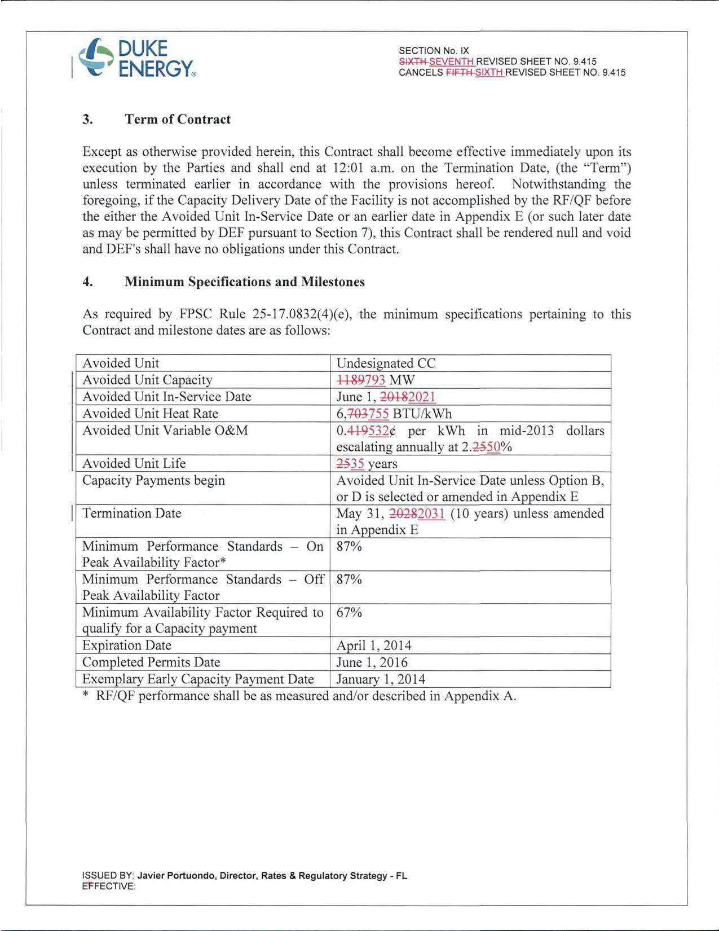
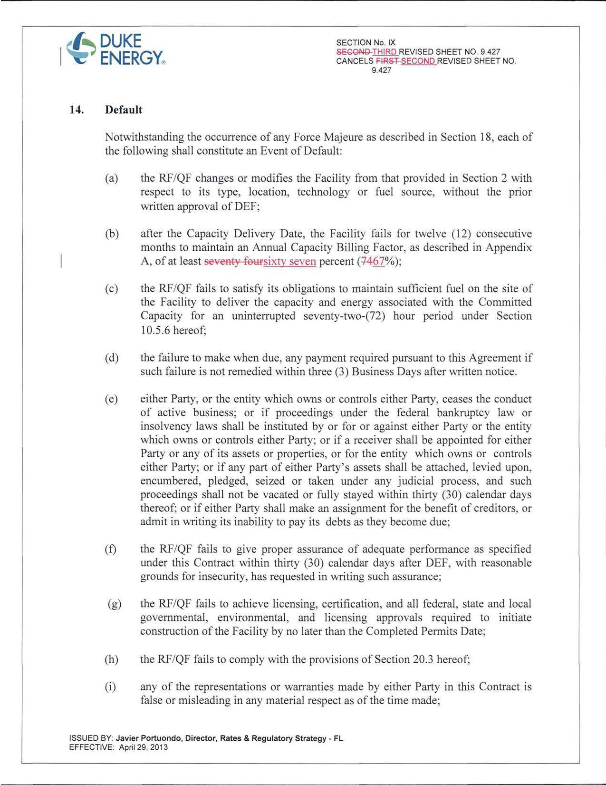
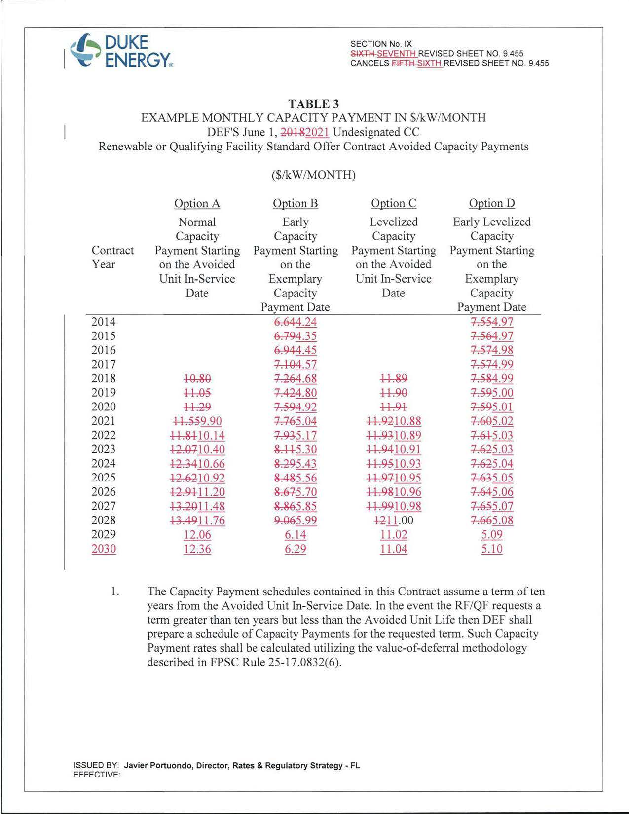
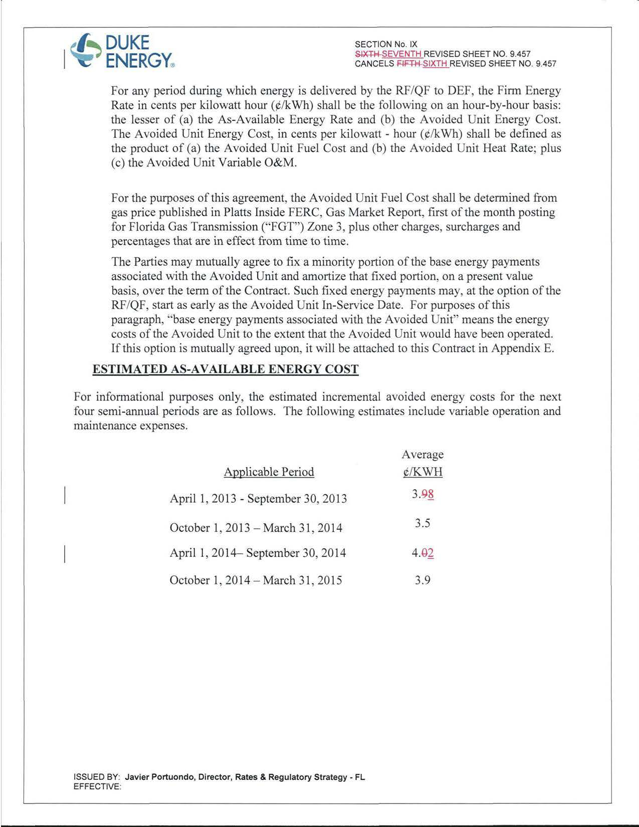
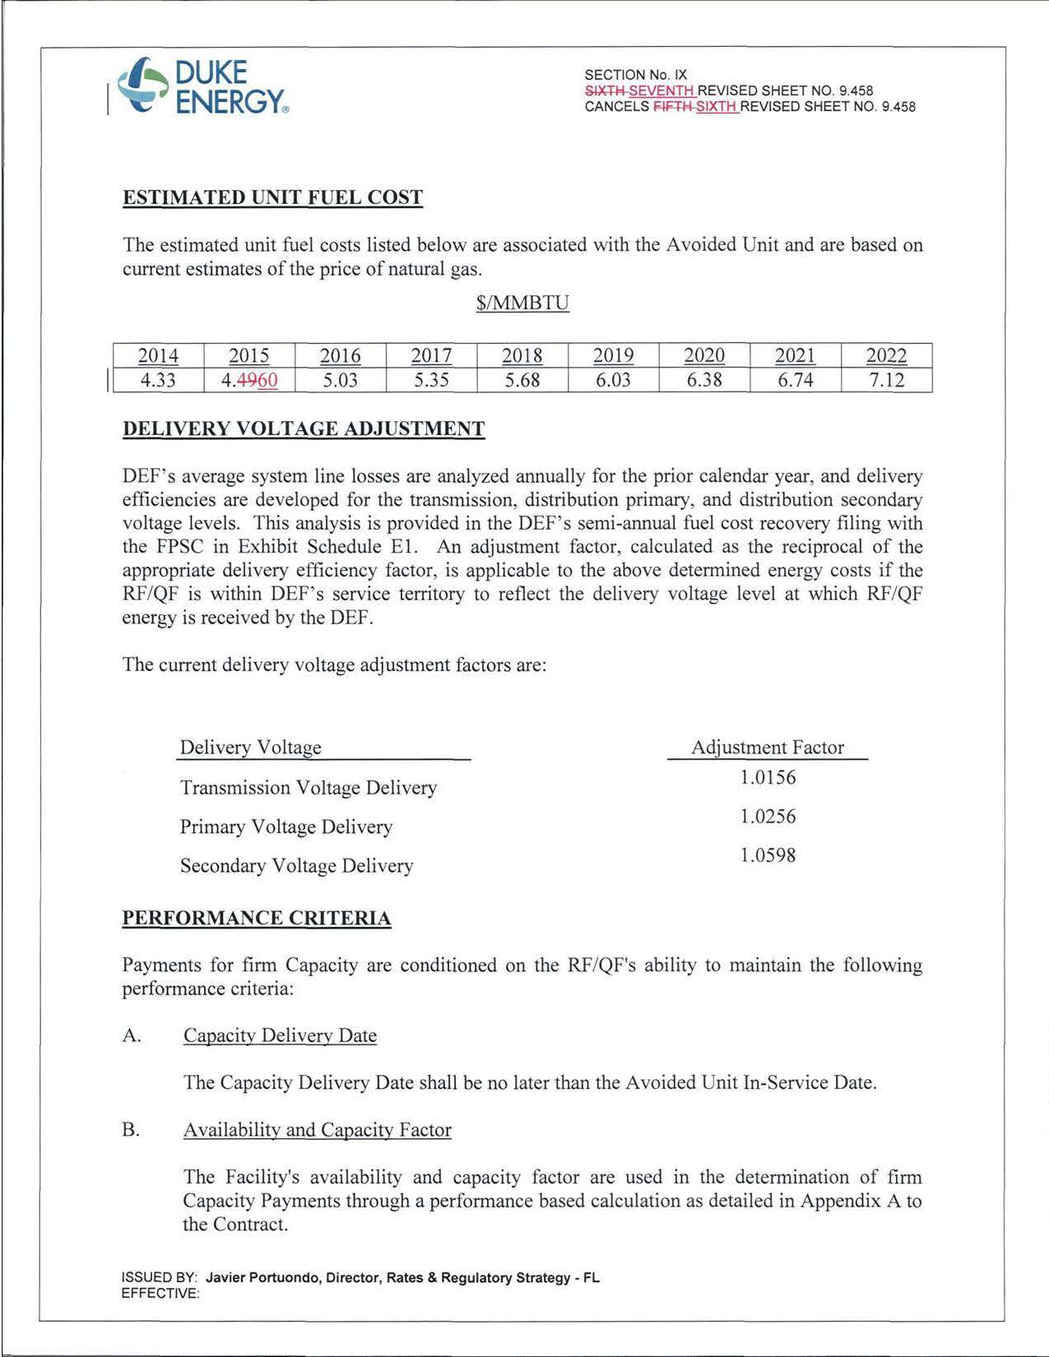
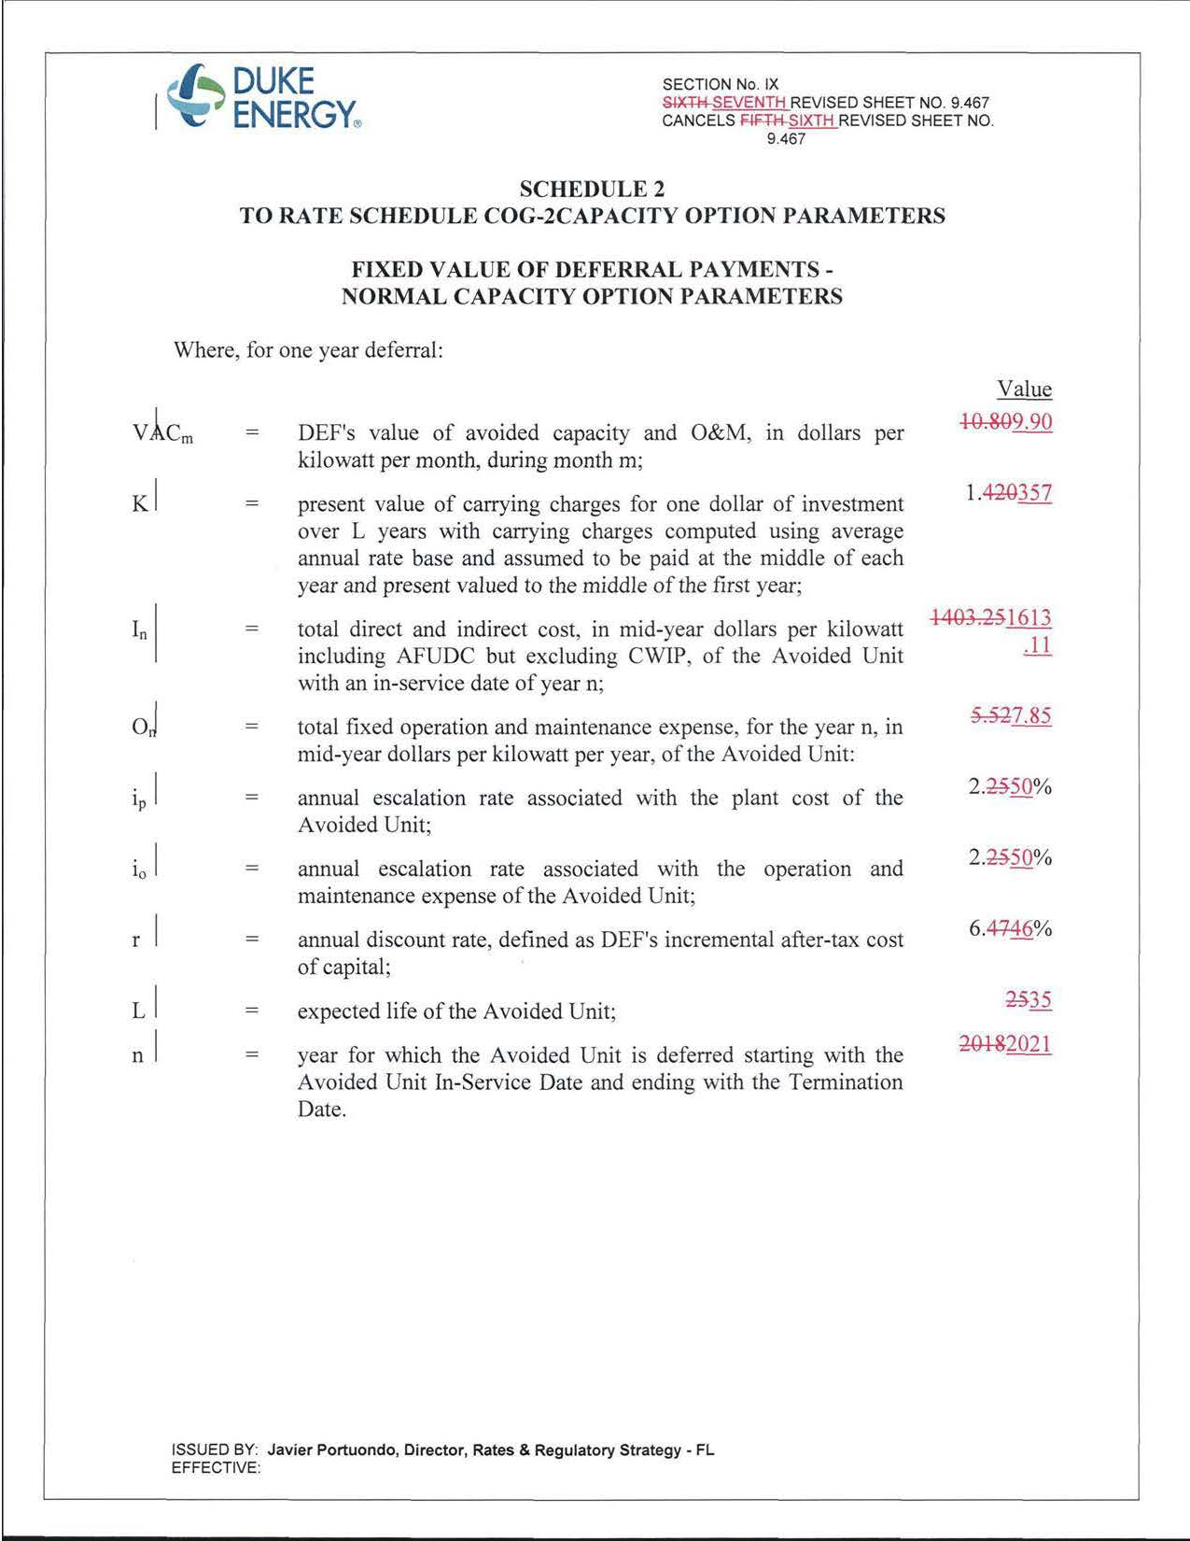
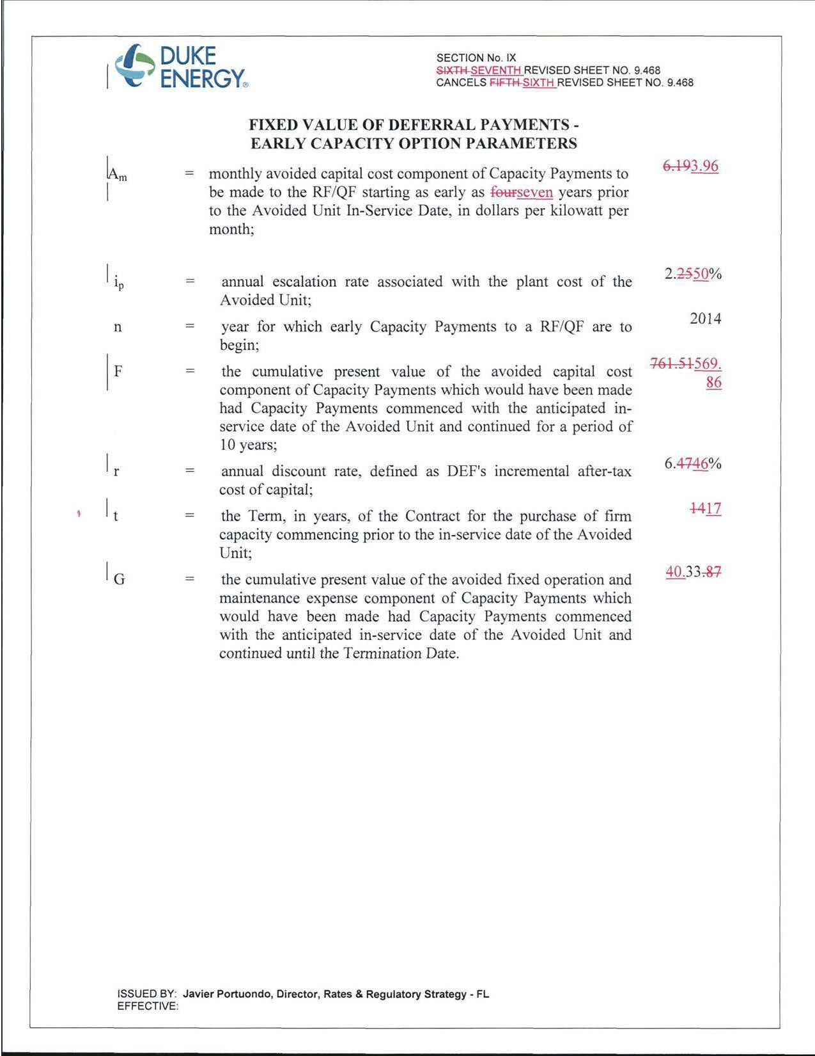

Docket No. 130068-EI, In re: Petition for approval of amended standard offer contract (Schedule COG-2), by Progress Energy Florida, Inc.
Docket No. 130069-EI, In re: Petition for approval of new standard offer contract (Schedule COG-2A), by Progress Energy Florida, Inc.

