State of Florida   |  | Public Service Commission  Capital Circle Office Center ● 2540 Shumard Oak Boulevard  Tallahassee, Florida 32399-0850  -M-E-M-O-R-A-N-D-U-M-
DATE: | April 24, 2014
TO: | Office of Commission Clerk (Stauffer)
FROM: | Office of the General Counsel (Page, Cowdery)  Division of Economics (King)  Office of Telecommunications (Bates, Fogleman)
RE: | Docket No. 120208-TX – Petition to initiate rulemaking to revise and amend Rule 25-22.0365, F.A.C., by Competitive Carriers of the South, Inc.
AGENDA: | 05/09/14 – Regular Agenda – Interested Persons May Participate
COMMISSIONERS ASSIGNED: |  |  | All Commissioners
PREHEARING OFFICER: |  |  | Balbis
CRITICAL DATES: |  |  | None
SPECIAL INSTRUCTIONS: |  |  | None

Case Background
On July 31, 2012, Competitive Carriers of the South, Inc., (CompSouth) filed a Petition to Initiate Rulemaking to revise and amend portions of Rule 25-22.0365, F.A.C., Expedited Dispute Resolution Process for Telecommunications Companies. CompSouth requested that rulemaking be initiated to amend Rule 25-22.0365, Florida Administrative Code (F.A.C.), revising certain portions of the rule to establish a mechanism for a more expedited resolution of such proceedings.
On October 3, 2012, by Order No. PSC-12-0528-NOR-TX, the Commission granted CompSouth’s Petition to Initiate Rulemaking. Notices of development of rulemaking were published in the October 3, 2012 and March 28, 2014 editions of the Florida Administrative Register (F.A.R.). Rule development workshops were held on November 15, 2012 and August 20, 2013, at which CompSouth presented its suggested rule amendments. Verizon Florida LLC, Embarq Florida, Inc. d/b/a CenturyLink, BellSouth Telecommunications, LLC d/b/a AT&T Florida, the Florida Cable Telecommunications Association (FCTA), and Sprint participated at the workshops.
This recommendation addresses whether the Commission should amend Rule 25-22.0365, Florida Administrative Code (F.A.C). The Commission has jurisdiction pursuant to Sections 120.54, 350.127(2), and 364.16(6), Florida Statutes (F.S).

Discussion of Issues
Issue 1:1
Should the Commission amend Rule 25-22.0365, F.A.C., Expedited Dispute Resolution Process for Telecommunications Companies?
Recommendation:
Yes, the Commission should amend Rule 25-22.0365, F.A.C., as set forth in Attachment A. (Bates, Fogleman, King, Page, Cowdery)
Staff Analysis:
Subsection 364.16(6), F.S., provides that, upon petition, the Commission may conduct a “limited or expedited proceeding to consider and act upon any matter under this section.” The statute requires the Commission to “adopt rules to administer this subsection.”
Rule 25-22.0365, F.A.C., Expedited Dispute Resolution Process for Telecommunications Companies, implements Section 364.16(6), F.S., and provides for an expedited hearing schedule for resolution of intercarrier disputes. Subsection 25-22.0365(9), F.A.C., sets out an expedited time schedule for filing motions to dismiss, petitions to intervene and for intervenor, staff, and respondent testimony. The rule states that this time frame is to be followed unless otherwise provided by order of the Prehearing Officer, based on the unique circumstances of the case. Further, subsection 364.16(6), F.S., and Rule 25-22.0365(11), F.A.C., require the Commission to make a decision on the dispute within 120 days of the complainant company’s filing of the request for expedited proceeding, direct testimony and exhibits. Although there have been a few requests for expedited relief filed under this rule since it was adopted in 2004, the expedited process was not used either because the dispute was settled, or the complainant filed a notice of voluntary dismissal.

Stakeholder’s General Positions on the Amendment of Rule 25-22.0365, F.A.C.
It is CompSouth’s position that Rule 25-22.0365, F.A.C., has likely been underutilized because a 120-day process is not expeditious enough to address disputes that directly impact a customer’s service. CompSouth believes that, because of this, the dispute is either resolved between the carriers involved or the customer is lost because of the unresolved service problem. Thus, CompSouth seeks to amend Rule 25-22.0365, F.A.C., to expressly recognize that circumstances may arise for which a shorter process is more appropriate.
AT&T takes the position that no changes to Rule 25-22.0365, F.A.C., are needed. However, with the exception of comments on specific rule subsections identified below, AT&T has no objections to the current draft amended rule. CenturyLink similarly supports the suggested amendments to subsections (2) and (4)(d), and does not object to the suggested amendments to subsections (7) and (13). Verizon believes that the proposed revisions strike the right balance by adopting changes on which workshop participants reached consensus and excluding revisions that it believes would have created an unworkable process. CenturyLink and Verizon both have specific comments on or objections to certain suggested amendments, as explained below.
Staff’s Recommended Amendments to the Rule
Staff believes that the Commission should amend Rule 25-22.0365, F.A.C., as set forth in Attachment A. The following is an overview of staff’s recommended amendments to the rule.
Mandatory informal meeting with staff
Current subsection 25-22.0365(2), F.A.C., provides that, to be considered for an expedited proceeding, the companies involved in the dispute must have attempted to “resolve their dispute informally.” CompSouth suggests the addition of language stating that in the event the parties are unable to resolve their dispute themselves, a party intending to invoke the expedited dispute resolution process must notify Commission staff of the dispute and request that staff conduct an informal meeting within 7 days. Under CompSouth’s suggested amendment, this meeting must be conducted prior to invoking the expedited dispute resolution process. CompSouth proposed this change to allow an early informal resolution of the dispute without affecting the customer’s service. CompSouth believes that the new informal meeting requirement may serve as an added incentive to all parties in a dispute to find a mutually beneficial, negotiated solution to customer-impacting disputes.
Staff recommends the amendment of subsection 25-22.0365(2), F.A.C., as requested by CompSouth. A new subsection (3) would mandate an informal meeting between the companies and staff within seven days of the request for the meeting and prior to initiation of the expedited dispute resolution process. Such an amendment reflects the current practice of staff and the companies to conduct an informal meeting in most situations where there is a dispute between telecommunications companies. This informal meeting would also apprise the companies of each others’ positions and may facilitate more efficient use of the expedited dispute resolution process.
Creation of new subsection (3) would result in the subsequent subsections being renumbered as shown in Attachment A. This staff recommendation will discuss the rule subsections based upon their current subsection numbers.
Requirement to follow interconnection agreement dispute resolution provisions
Current subsection 25-22.0365(4), F.A.C., lists the information that must be included in a request for expedited proceeding. Paragraph (4)(d) requires a statement that the complainant company attempted to resolve the dispute informally. Workshop participants generally agreed to an amendment to paragraph (4)(d) requiring a statement that the “dispute is not otherwise governed by dispute resolution provisions contained in the parties’ relevant interconnection agreement.” The reason for this change is to encourage the early resolution of disputes through the various carrier dispute mechanisms contemplated by interconnection agreements. Staff recommends this amendment to subsection (4)(d) because the inclusion of this provision will facilitate the use of the dispute resolution process contained in the parties’ interconnection agreements and enhance the opportunity for informal resolution of the dispute.
Contents of the response to request for expedited proceeding
Paragraph (7)(b) of the Rule 25-22.0365, F.A.C., lists information which may be included in the response to assist the Prehearing Officer in deciding whether use of the expedited dispute resolution process is appropriate. The first item listed is the respondent’s willingness to participate in the expedited dispute resolution process. Staff does not believe that the respondent’s willingness to participate in the expedited dispute resolution process is necessary or relevant to a determination of whether an expedited process would be appropriate under the facts of the case and that this language should be deleted from the rule. If a party believes that extenuating circumstances exist, it may include them in its pleadings. No workshop participants objected to deleting this subparagraph. Staff therefore recommends deleting this paragraph.
Expedited proceeding time schedule
Current subsections (7), (8), and (9) of Rule 25-22.0365, F.A.C., address the time schedule to be followed after a request for expedited proceeding is filed. This includes a requirement that a response to the request for expedited proceeding be filed within 14 days (subsections (7) and (9)(b)), that the Prehearing Officer must decide whether use of the expedited proceeding is appropriate no sooner than 14 days after the request is filed (subsection (8), that a motion to dismiss must be filed within 14 days of the request being filed (subsection (9)(b)), and that a response to a motion to dismiss must be filed within 21 days of the request being filed (subsection (9)(c)). Staff believes that shortening the time frames identified above would be consistent with statutory intent and with staff’s other recommended changes to the rule.
Verizon does not believe the time frames in subsections (7) and (9)(b) should be shortened, and suggests that to do so would increase the risk that parties would file motions to dismiss, responses to requests for expedited proceedings, or responses to motions to dismiss on an emergency basis before the Prehearing Officer has ruled on the request for expedited proceeding. CenturyLink expressed concern that if the Commission shortens these time frames, it might be challenging at times to meet the deadlines, particularly if a company’s employees or subject matter experts who are critical to preparing a filing are unavailable. For this reason CenturyLink suggests that, if the time frames are shortened, language should be added to subsection (7) and at the end of paragraphs (9)(b) and (c) stating that a party may request an extension of the deadline upon a demonstration of good cause justifying the extension.
Section 364.16(6), F.S., states that any proceeding “shall, to the greatest extent feasible, minimize the time necessary to reach a decision on a dispute….” Staff’s recommended amendment to subsection (2), creating a new subsection (3) requiring a mandatory pre-filing meeting among the parties and staff, should fully inform a respondent of the issues and basic positions of the complaint. Thus, 7 days, rather than 14, would give sufficient time to file a motion to dismiss and a response to the request. Further, changing the response time from 14 to 7 days would allow the Prehearing Officer to analyze the pleadings sooner to determine whether an expedited hearing would be appropriate, and, if so, what time schedule would be appropriate. For these reasons, staff recommends that subsections 25-22.0365(7) and (9)(b), F.A.C., be amended to require a motion to dismiss and a response to a request for expedited proceeding to be filed within 7 days of the date a request for expedited proceeding is filed. Staff further recommends that the paragraph (9)(c) deadline for filing a response to any motion to dismiss should, accordingly, be changed from “Day 21” to “Day 14.” The actual time for preparing the response to the motion to dismiss would not change.
Current subsection 25-22.0365(8), F.A.C., provides that no sooner than 14 days after filing the request for expedited proceeding, but promptly thereafter, the Prehearing Officer will decide whether use of the expedited proceeding is appropriate. Verizon and AT&T suggest that this time frame be changed from 14 days to 7 days. They believe that the recommended amendment to subsection (7) that requires a response to be filed within 7 days of the filing of a request for expedited proceeding dispenses with the need to require the Prehearing Officer to wait another 7 days before a ruling on the request for expedited proceeding. AT&T also noted that, because a petition to intervene is due 14 days after filing the request for expedited proceeding, potential interveners would be required to file before there was a ruling on whether there would be an expedited proceeding. Changing the time frame from 14 to 7 days would allow potential interveners the opportunity to know whether there will be an expedited proceeding prior to making the determination of whether to file a petition to intervene. For these reasons, staff recommends that subsection 25-22.0365(8), F.A.C., be amended to state that the Prehearing Officer will decide whether use of the expedited proceeding is appropriate no sooner than 7 days after the request for expedited proceeding is filed, but promptly thereafter.
Service of documents
Existing subsection 25-22.0365(13), F.A.C., provides that service of documents on the parties may be made by facsimile, and that an additional copy shall be furnished by hand delivery, overnight mail or U.S. mail if the initial service was by e-mail or facsimile. Staff believes that reference to service by facsimile is outdated technology and inconsistent with current Commission practice. Additionally, there is no reason to require a party to provide an additional copy if service is by e-mail. Therefore, staff recommends the language of subsection (13) concerning service by facsimile and additional copy requirements be deleted.
Additional Suggested Amendment by CompSouth
Current subsection (11) of Rule 25-22.0365, F.A.C., states that the Commission shall make a decision on the dispute within 120 days of the complainant company’s filing of the request for expedited proceeding, direct testimony and exhibits. CompSouth is concerned that the draft rule amendments do not explicitly recognize that a proceeding shorter than 120 days may, in certain circumstances, be appropriate. CompSouth suggests that the following language be added to the end of that sentence: “unless the Prehearing Officer decides that a more expedited schedule is appropriate under paragraphs (8) and (9).” CompSouth believes that such a change would be consistent with subsections (8) and (9) of the rule and would reflect the suggestion of other stakeholders that the Prehearing Officer is authorized to establish a more expedited time frame. In response, CenturyLink, Verizon, and AT&T all filed comments stating that under the current rule the Prehearing Officer has the authority and discretion to set a more expedited schedule depending on the particular facts of the case.
Staff does not recommend that subsection (11) be amended as suggested by CompSouth. Subsection 25-22.0365(9), F.A.C., which establishes a streamlined schedule for the expedited dispute resolution, states that the time schedule for an expedited case will be as set forth therein “[u]nless otherwise provided by order of the Prehearing Officer, based on the unique circumstances of the case.” The Commission is directed by Section 364.16(6), F.S., to minimize the time necessary to reach a decision on a dispute. Subsection (11) of the rule provides that the Commission shall make its decision within 120 days of the filing of the request for expedited proceeding. Further, Rule 28-106.211, F.A.C., provides that the presiding officer “may issue any orders necessary to . . . prevent delay, and to promote the just, speedy, and inexpensive determination of all aspects of the case.” Because the prehearing officer currently has the discretion to set a time schedule which is more expedited than that set forth in paragraphs (9)(a) through (e) based upon the specific facts of each case, staff does not recommend that subsection (11) be amended as suggested by CompSouth.
Statement of Estimated Regulatory Costs
Pursuant to Section 120.54, F.S., agencies are encouraged to prepare a statement of estimated regulatory costs (SERC) before the adoption, amendment, or repeal of any rule. The SERC is appended as Attachment B. The SERC analysis includes whether the rule amendment is likely to have an adverse impact on growth, private sector job creation or employment, or private sector investment in excess of $1 million in the aggregate within five years after implementation.
The SERC concludes that the amendment of Rule 25-22.0365, F.A.C., will likely not directly or indirectly increase regulatory costs in excess of $200,000 in aggregate in Florida within one year after implementation. Further, the SERC concludes that the rule amendment will not likely have an adverse impact on economic growth, private-sector job creation or employment, private-sector investment, business competitiveness, productivity, or innovation in excess of $1 million in the aggregate within five years of implementation. Thus, the rule amendment does not require legislative ratification pursuant to Section 120.541(3), F.S. In addition, the SERC states that amendment of Rule 25-22.0365, F.A.C., would not have an adverse impact on small business, and would have no impact on small cities or small counties.
Based on the foregoing, staff recommends that Rule 25-22.0365, F.A.C., be amended as set forth in Attachment A.
Issue 2:2
Should this docket be closed?
Recommendation:
Yes. If no requests for hearing or comments are filed, the rule should be filed with the Department of State, and the docket should be closed. (Page, Cowdery)
Staff Analysis:
If no requests for hearing or comments are filed, the rule should be filed with the Department of State, and the docket should be closed.
25-22.0365 Expedited Dispute Resolution Process for Telecommunications Companies.
(1) The purpose of this rule is to establish an expedited process for resolution of disputes between telecommunications companies (“companies”).
(2) To be considered for an expedited proceeding, the companies involved in the dispute must have attempted to resolve their dispute themselves informally.
(3) If the companies are unable to resolve their dispute themselves, the complainant company must, prior to filing a request under subsection (5), notify Commission staff of the dispute and request that Commission staff conduct an informal meeting. The informal meeting shall be conducted within 7 days of the request for the purpose of discussing the matters in dispute, the positions of the parties, possible resolution of the dispute, any immediate effect on customers’ ability to receive service, anticipated discovery needs, and case scheduling.
(4)(3) To initiate the expedited dispute resolution process, the complainant company must file with the Commission a request for expedited proceeding, direct testimony, and exhibits, and must simultaneously serve the filing on the other company involved in the dispute. The request for expedited proceeding is in lieu of the petition required by Rule 28-106.201, F.A.C.
(5)(4) The request for expedited proceeding must include:
(a) The name, address, telephone number, facsimile number and e-mail address of the complainant company and its representative to be served, if different from the company;
(b) A statement of the specific issue or issues to be litigated and the complainant company’s position on the issue or issues;
(c) The relief requested;
(d) A statement attesting to the fact that the complainant company attempted to resolve the dispute informally and the dispute is not otherwise governed by dispute resolution provisions contained in the parties’ relevant interconnection agreement; and
(e) An explanation of why the use of this expedited process is appropriate. The explanation of why use of the expedited process is appropriate shall include a discussion of the following:
1. The number and complexity of the issues;
2. The policy implications that resolution of the dispute is expected to have, if any;
3. The topics on which the company plans to conduct discovery, including a description of the nature and quantity of information expected to be exchanged;
4. The specific measures taken to resolve the dispute informally; and
5. Any other matter the company believes relevant to determining whether the dispute is one suited for an expedited proceeding.
(6)(5) Any petition for intervention shall provide the information required by paragraphs (5)(4)(a)-(c) and (e) as it applies to the intervenor.
(7)(6) The request for expedited proceeding shall be dismissed if it does not substantially comply with the requirements of subsections (2), (3), and (4), and (5), above. The first dismissal shall be without prejudice.
(8)(7) The respondent company may file a response to the request. The response must be filed within 7 14 days of the filing of the request for expedited proceeding.
(a) The response shall include the name, address, telephone number, facsimile number and e-mail address of the respondent and the respondent’s representative to be served, if different from the respondent.
(b) The response to the request may include any information that the company believes will help the Prehearing Officer decide whether use of the expedited dispute resolution process is appropriate. Such information includes, but is not limited to:
1. The respondent’s willingness to participate in this process;
1.2. Statement of the specific issue or issues to be litigated from the respondent’s perspective, and the respondent’s position on the issue or issues; and
2.3. A discussion of the topics listed in subparagraphs (5)(4)(b)-(e)1.-5. above.
(9)(8) No sooner than 7 14 days after the filing of the request for expedited proceeding, but promptly thereafter, the Prehearing Officer will decide whether use of the expedited proceeding is appropriate. The decision will be based on the factors provided in Section 364.16(6) 364.058(3), F.S., the materials initially filed by the complainant company and, if a response is filed, the materials included in the response.
(10)(9) Unless otherwise provided by order of the Prehearing Officer, based on the unique circumstances of the case, the schedule for each expedited case will be as follows:
(a) Day 0 – request for expedited proceeding, direct testimony and exhibits are filed;
(b) Day 7 14 – deadline for filing a motion to dismiss, and a response to the request for expedited proceeding;
(c) Day 14 21 – deadline for filing a response to the motion to dismiss, if one is filed; and,
(d) Day 21 - deadline for filing petitions to intervene, and intervenor testimony and exhibits;
(e) (d) Day 42 – deadline for the Commission staff to file testimony; and
(f) (e) Day 56 – deadline for the respondent to file rebuttal testimony.
(11)(10) The Prehearing Officer shall decide whether post-hearing briefs will be filed or if closing arguments will be made in lieu of post-hearing briefs. In making this decision the Prehearing Officer will consider such things as the number of parties, number of issues, complexity of issues, preferences of the parties, and the amount of testimony stipulated into the record.
(12)(11) The Commission shall make a decision on the dispute within 120 days of the complainant company’s filing of the request for expedited proceeding, direct testimony and exhibits.
(13)(12) Responses to discovery requests shall be made within 15 days of service of the discovery requests, unless the Prehearing Officer decides otherwise based on the unique circumstances of the case.
(14)(13) Service of all documents on the parties shall be by e-mail, facsimile or hand delivery. An additional copy shall be furnished by hand delivery, overnight mail or U.S. mail if the initial service was by e-mail or facsimile. Filing of all documents with the Commission shall be by hand delivery, overnight mail or any method of electronic filing authorized by the Commission.
(15)(14) The applicability of this rule to the proceeding will be reassessed as factors affecting the complexity of the case, number of issues, or number of parties change during the proceeding.
(16)(15) Once the Prehearing Officer has determined that use of an expedited proceeding is appropriate, nothing in this rule shall prevent the Prehearing Officer from making a later determination that the case is no longer appropriate for an expedited proceeding based on the number of parties, number of issues or the complexity of the issues. Nothing in this rule shall prevent the Commission from initiating an expedited proceeding on its own motion.
Rulemaking Authority 350.127(2), 364.16(6) FS. Law Implemented 364.16(6) FS. History–New 8-19-04, Amended __________.
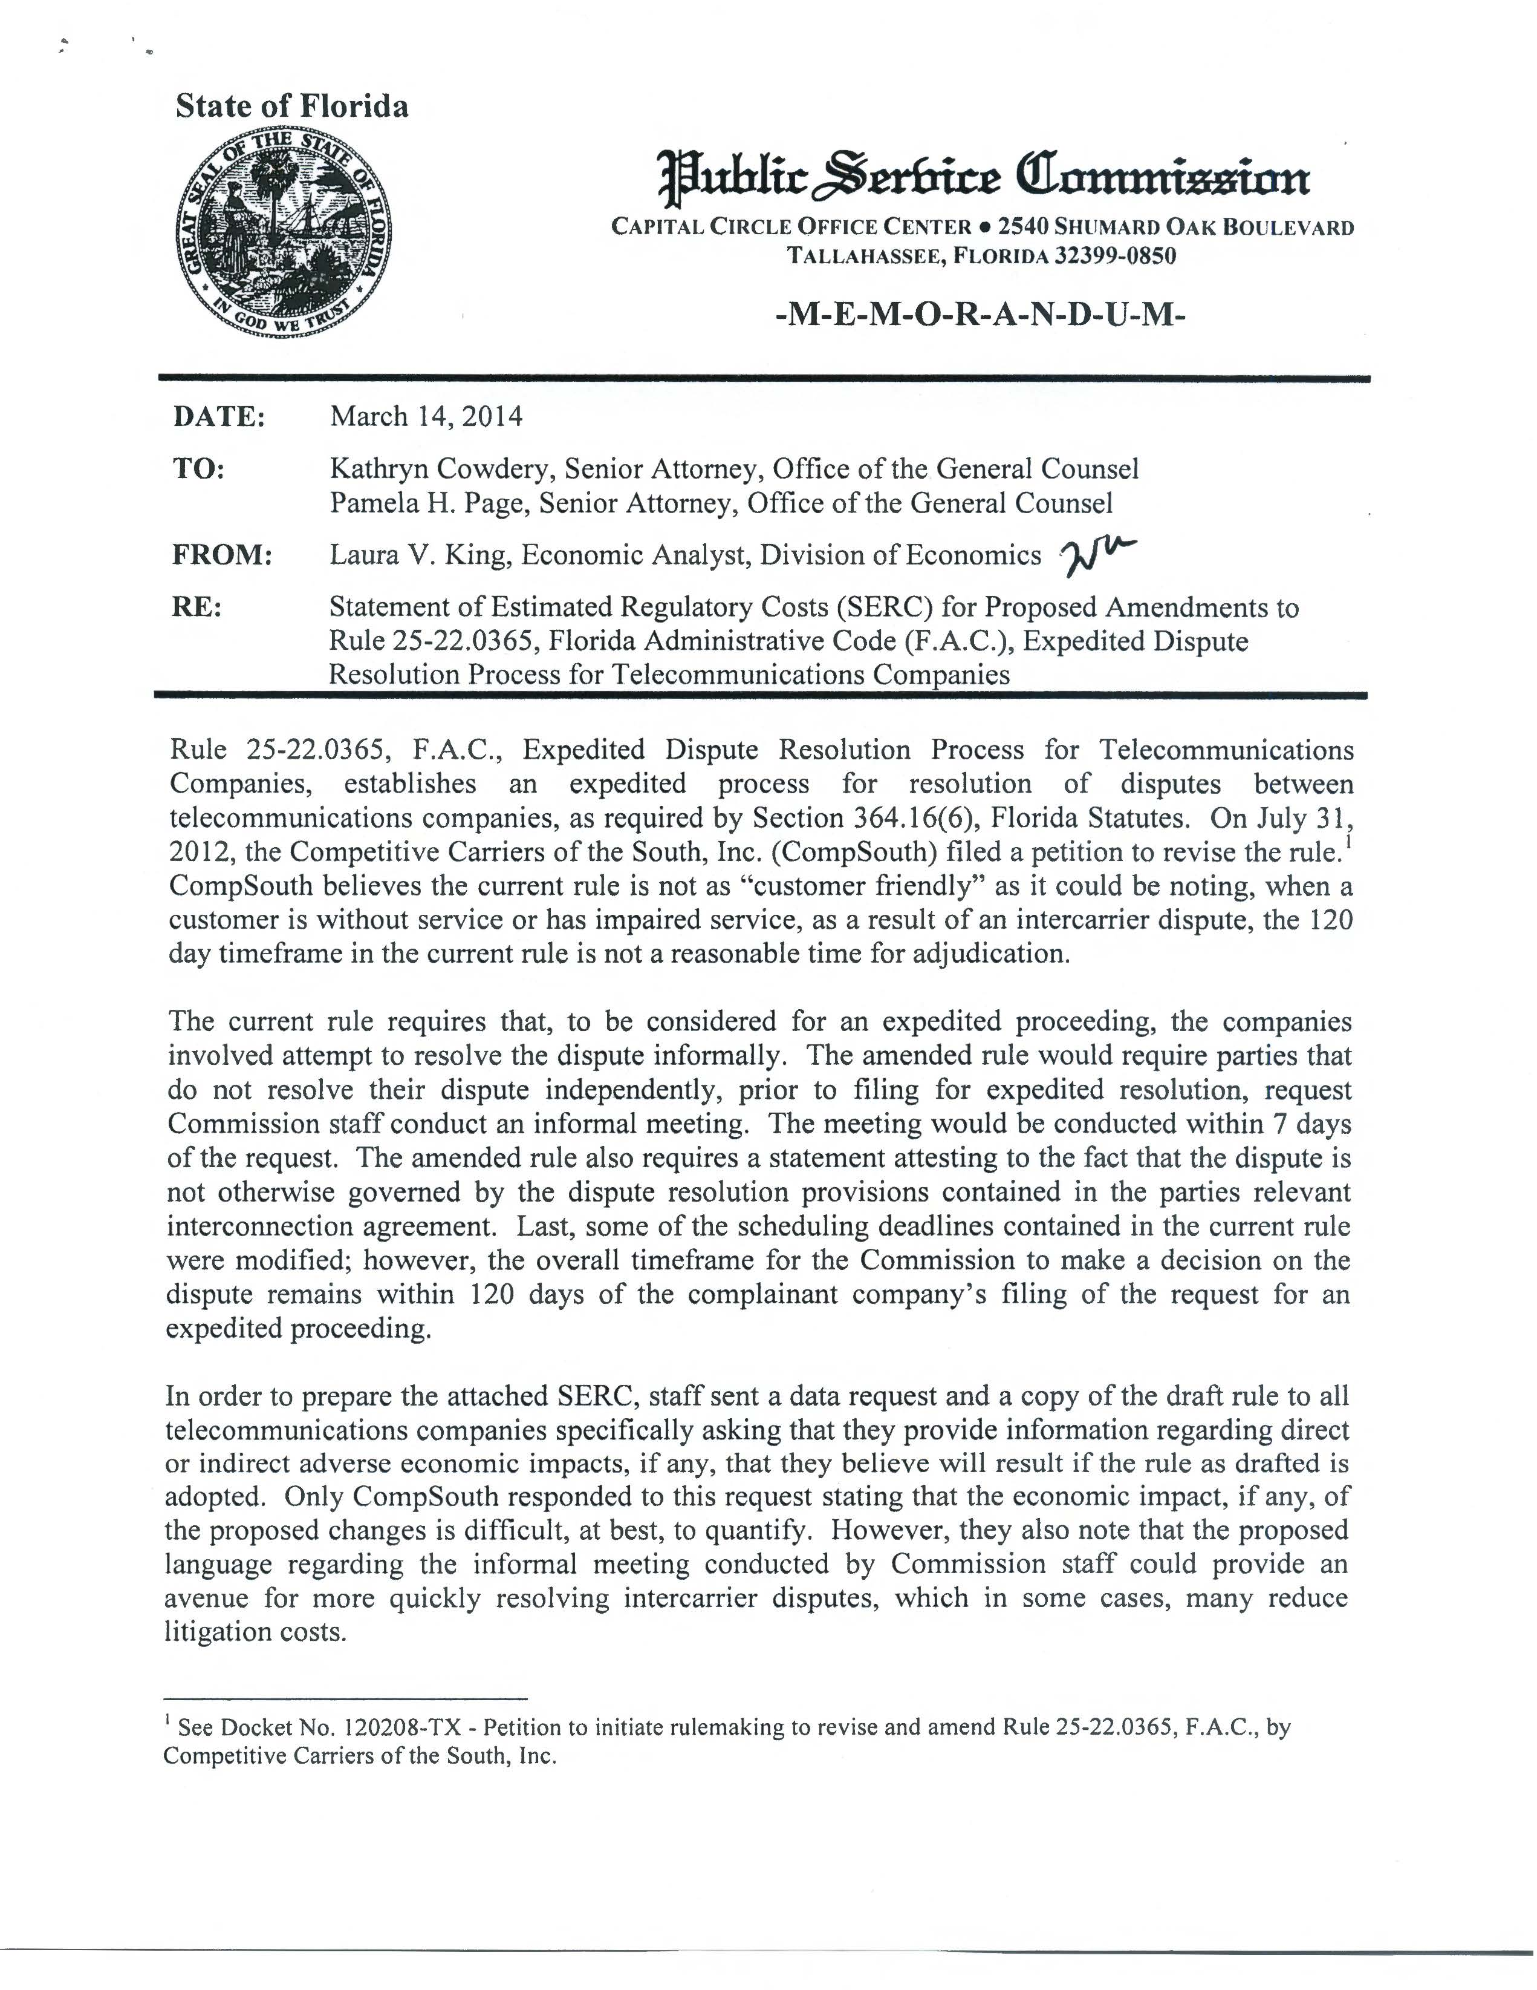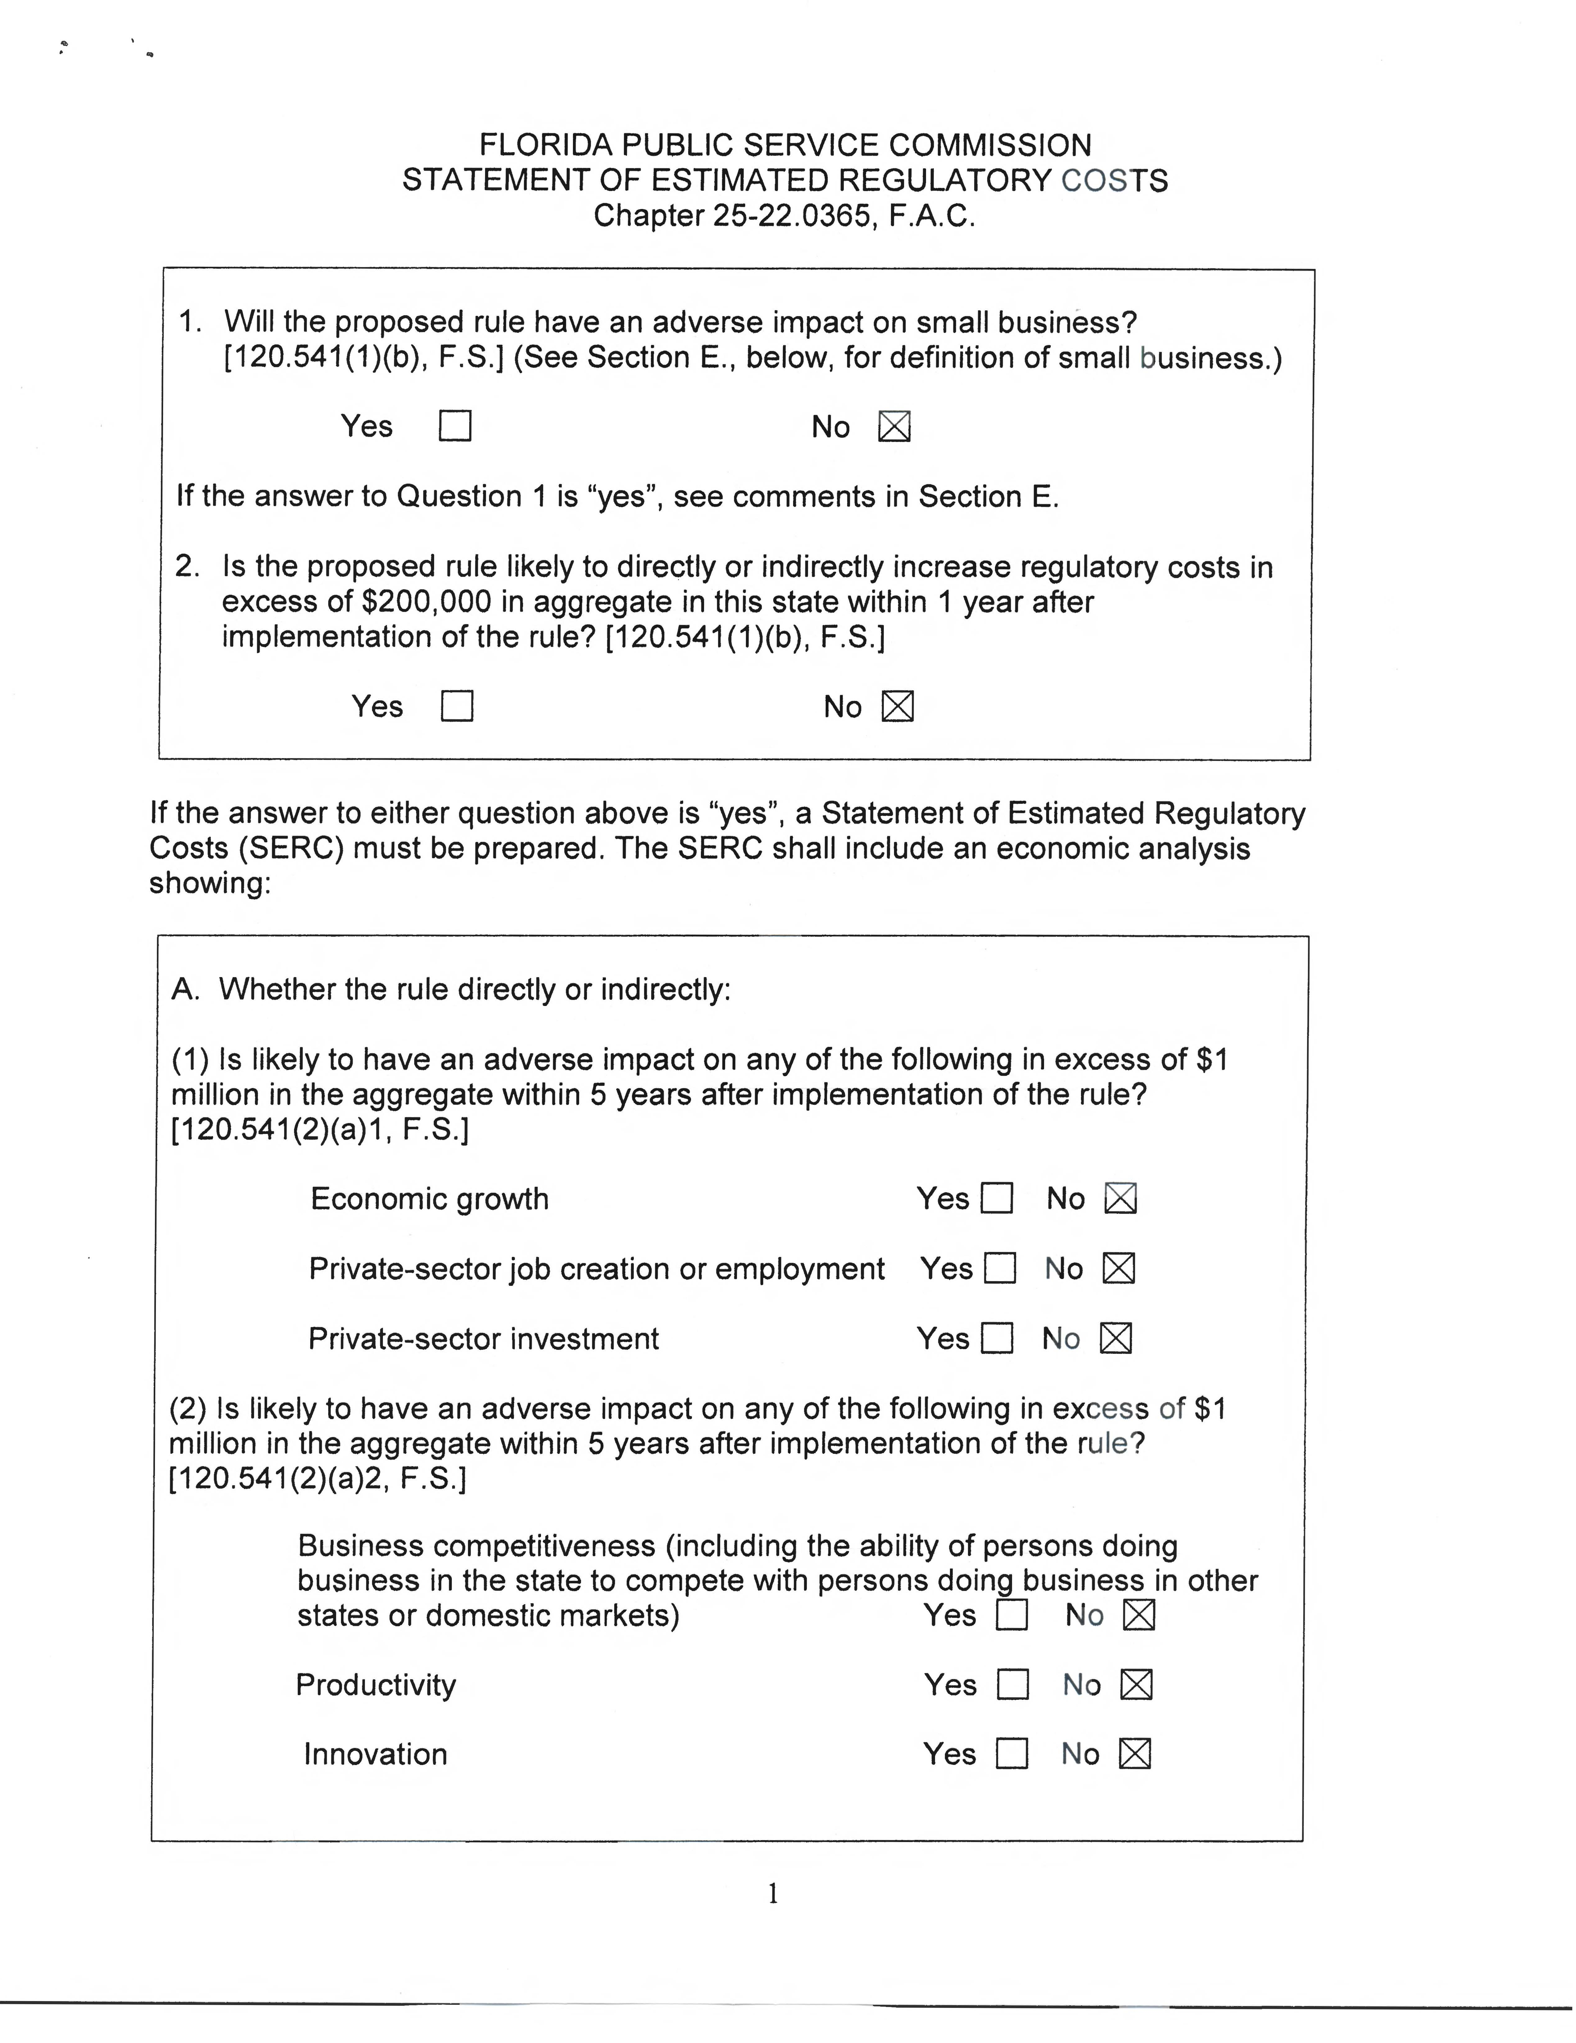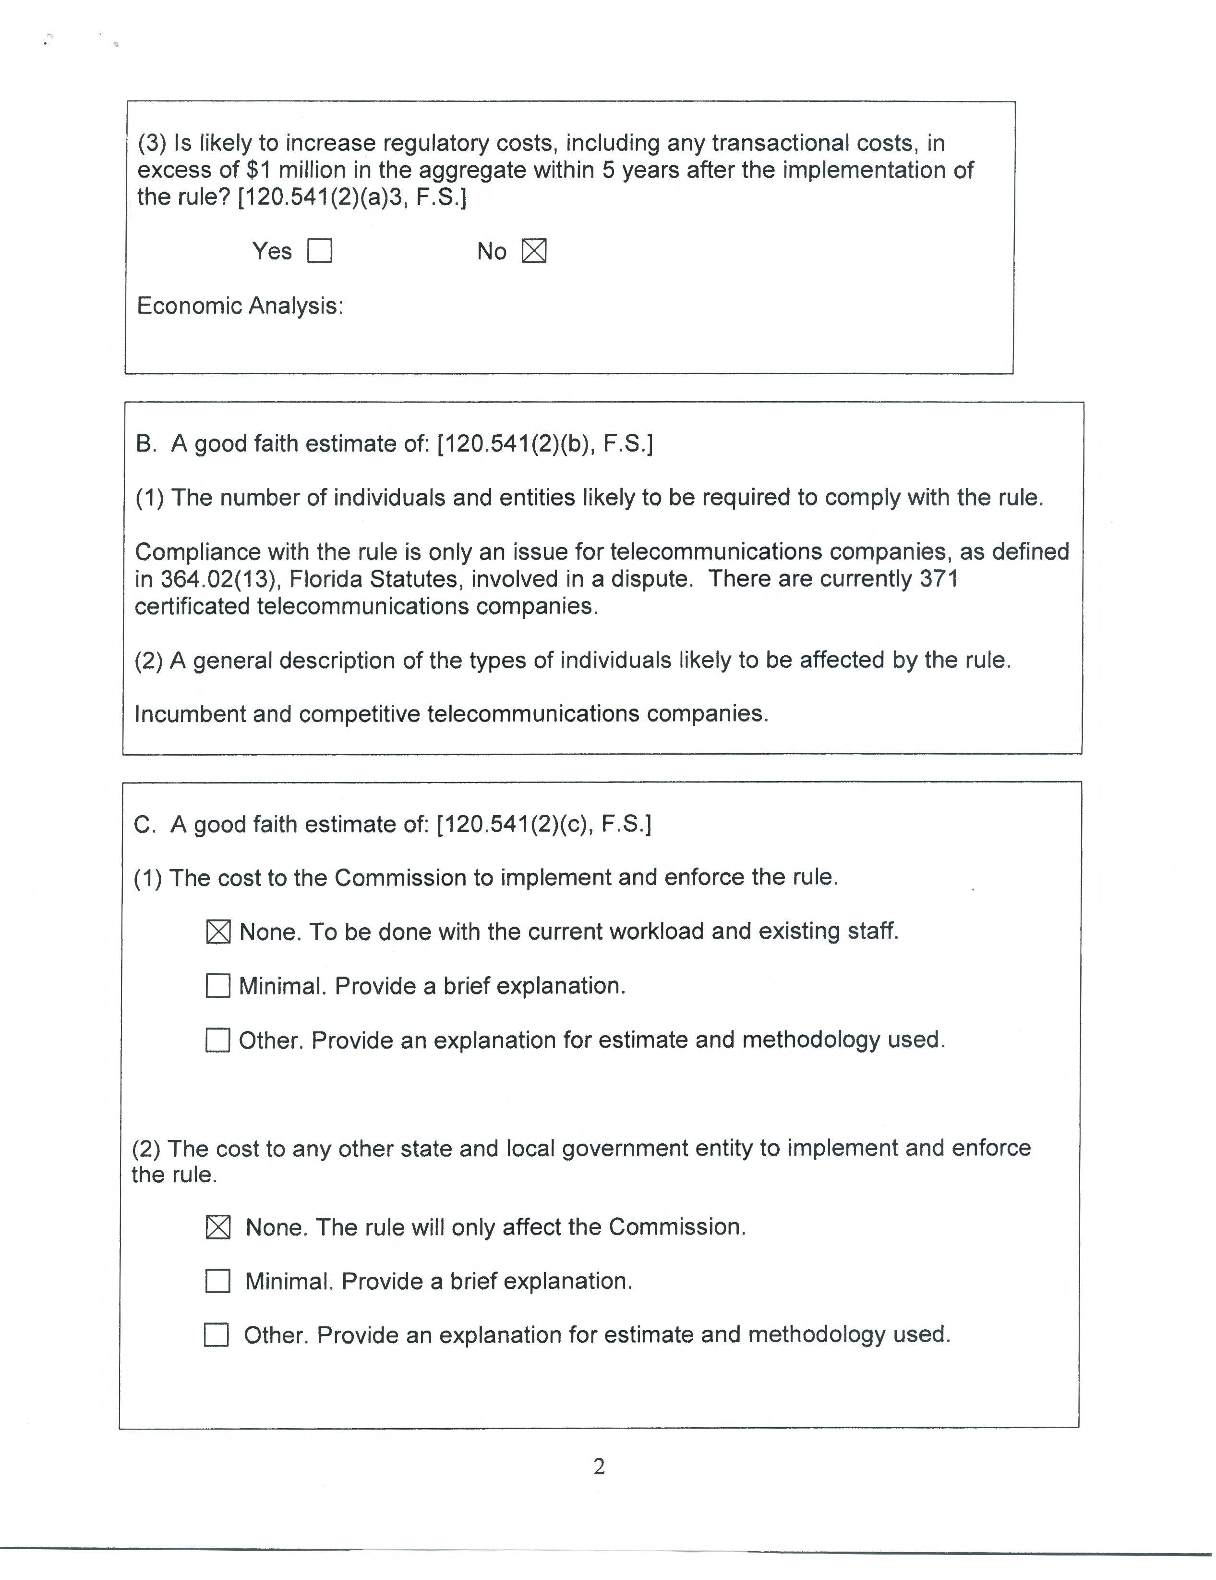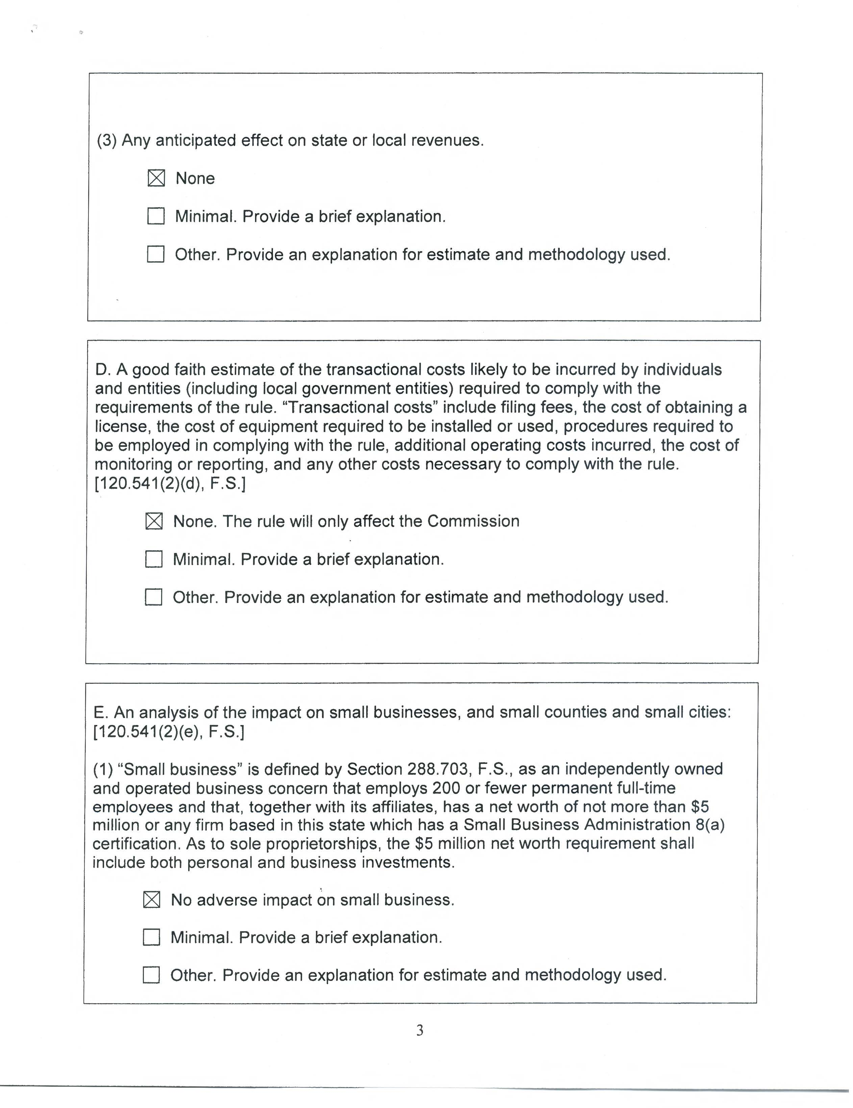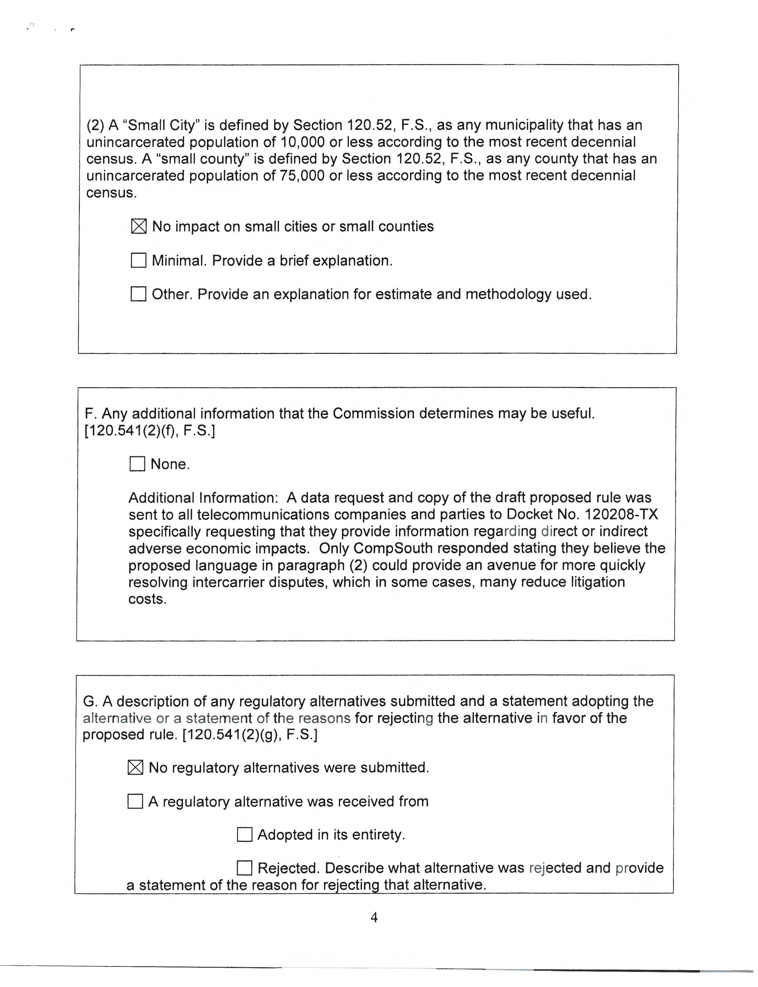

See Docket No. 100295-TP, In re: Complaint by Intrado Communications, Inc. against BellSouth Telecommunications, Inc. d/b/a/ AT&T Florida for alleged failure to comply with Order PSC-08-0798-FOF-TP, and request for expedited treatment, pursuant to Section 364.058, F.S. and Rule 25-22.0365, F.A.C.; Docket No. 070127-TX, In re: Petition for interconnection with Level 3 Communications and request for expedited resolution, by Neutral Tandem, Inc.; Docket No. 041114-TP, In re: Complaint of XO Florida, Inc. against BellSouth Telecommunications, Inc. for alleged refusal to convert circuits to UNEs; and request for expedited processing; and Docket No. 040301-TP, In re: Complaint of Supra Telecommunications and Information Systems, Inc. against BellSouth Telecommunications, Inc.
In addition, staff recommends amending subsection 25-22.0365(8), F.A.C., to reference Section 364.16(6), F.S., which is the correct statutory reference.
Section 120.541(2), F.S.

